Original Research Article

Effects of Ginger Extract on Quality and Shelf Life of Tilapia (Oreochromis niloticus) Fish Nuggets During Cold Storage

ABSTRACT

Fish nuggets are commodities prone to quality degradation caused by biological, enzymatic, physical, or chemical processes. On the other hand, ginger contains enough bioactive substances to be used as a natural preservative. This study aimed to determine the effect of ginger extract addition on the quality of fish nuggets during cold storage and determine the best quality nugget. The materials used in this study were tilapia fish (Oreochromis niloticus) and ginger extract. The method used was a laboratory experiment using a complete random sampling technique that employed a factorial pattern with three repetitions. The first factor observed was the nugget concentration with the addition of ginger extract in two variations: control nugget with 0% ginger extract and nugget with 3% ginger extract, which were then compared with commercial nuggets. The second factor was the storage duration of three variations: 0, 6, and 12 days. Testing parameters included antioxidant activity, total colony bacteria, the contents of ash, moisture, fat, and protein, as well as a sensory test. The data gathered were then analyzed using analysis of variance, followed by an Honestly Significant Difference (HSD) test. Sensory data were tested using the Kruskal Wallis test and then continued with Duns Multiple comparison test using SPSS. The results showed that the addition of ginger extract significantly affected (p<0, 05) the antioxidant activity, total colony bacteria, ash content, moisture, fat, protein, and sensory properties. Tilapia fish nugget supplemented with 3% ginger extract was the best product that could last up to the sixth day of storage.

Keywords: Tilapia, Nugget, Extract ginger, Cold storage

- INTRODUCTION
Fish nuggets are small bite-sized pieces of fish that are typically breaded and deep-fried. It is made from fish fillets or minced fish that are seasoned and coated with batter or breadcrumbs before cooking. Fish nuggets are popular snacks or fast-food items and can be found in many restaurants and grocery stores. They are often served with various dipping sauces (Amalia, 2012; Biswas et al. 2024). Fish nuggets are currently less favored than chicken nuggets because of several reasons. First, fish typically contain approximately 70–80% water, whereas chickens have a water content of about 65–70% (Petenuci, 2016), rendering them more susceptible to spoilage. Second, the elevated carbon content in fish can adversely affect the texture and flavor of fish nuggets. In addition, fish require meticulous handling during processing and storage. Furthermore, there are challenges associated with serving fish nuggets, as they may be more difficult to serve appropriately than chicken nuggets (Kim et al., 2018). Finally, fish nuggets are at a greater risk of spoilage owing to microbial activity and chemical reactions. The utilization of chemical preservatives, such as nitrites, nitrates, and sorbates, in the processing of fish nuggets is prevalent because of their potent antibacterial properties (Yu et al., 2021). However, the safety of these preservatives is frequently questioned, as certain studies have associated specific preservatives, such as nitrites used in processed meats, with adverse health effects including cancer (Cedillo-Olivos et al., 2024). The potential negative impacts of synthetic preservatives have prompted a shift towards natural alternatives. Consumers are increasingly skeptical of synthetic additives and show a preference for products that are perceived as healthier and safer. Consequently, there is growing interest in natural preservatives, such as plant-based phenolic compounds (e.g., flavonoids and phenolic acids), which have strong antimicrobial and antioxidant properties owing to their chemical structure (Beya et al., 2021). These compounds are often extracted from natural sources, such as olives, fruits, vegetables, and herbs, providing an effective alternative to synthetic preservatives (Beya et al., 2021).
Ginger (Zingiber officinale Roxb) has shown promise as an effective preservative for food products, particularly in extending the shelf life of meat and fish (Islam et al., 2022; Huynh et al., 2024). The bioactive compounds in ginger, including gingerols and shogaols, have potent antioxidant and antimicrobial properties (Zia‐Ur‐Rehman et al. 2003). When added to foods, such as fish nuggets, ginger extract can inhibit lipid oxidation and suppress the growth of spoilage bacteria, thereby maintaining quality and safety during storage. Studies have found that incorporating ginger extract at concentrations of 1-3% can significantly improve antioxidant activity and reduce total bacterial counts in products such as fish nuggets compared to untreated controls (Bakr et al., 2020). The phenolic compounds in ginger also contribute to pleasant flavor notes while masking off-odors that develop during storage. As a natural preservative, ginger offers a safe alternative to synthetic additives, which aligns with consumer preferences for clean label products. However, the optimal concentrations need to be determined for different food applications to balance the preservation effects with sensory acceptability. The objective of this study was to investigate the effects of incorporating ginger extracts on the quality attributes of fish nuggets during cold storage. The results of this preservation technique may contribute to the evaluation of the overall acceptability of chilled ready-to-cook fish nuggets from an economic perspective.

- MATERIALS AND METHODS

2.1 Material

Tilapia fish, fresh ginger, and other ingredients used in fish nugget manufacturing were procured from a local supermarket in Semarang, Indonesia. All other chemicals were of analytical grade and were sourced from CV Santoso (Semarang, Indonesia).

  - Method

Ginger Extraction
Fresh ginger, cultivated for a period–8-9 months, was sourced from a traditional market in Sumowono in the Semarang Region. The ginger was thoroughly washed and sliced into thin pieces before being subjected to sun-drying in a room equipped with a transparent roof. Subsequently, the dried ginger was ground using a blender, and the resulting powder was filtered to obtain fine consistency. Ginger was extracted using the maceration method with distilled water, as described by Amiri et al. (2018). The ginger extract (100 g) was placed in a glass jar, and 1000 ml of distilled water was added. The jar was sealed with brown paper to prevent sunlight exposure and was left to stand for 24 h. The subsequent step involved filtration using Whitman paper no. 1 followed by vaporization of the solution using a rotary evaporator, resulting in a brownish ginger extract.

Phytochemical Content of Ginger Extract

Flavonoids
A powdered sample weighing 0.1 grams was dissolved in 1 ml of distilled water. Subsequently, 0.5 ml of the sample solution was combined with 1.5 ml of 95% alcohol, 0.1 ml of 10% AlCl3, 0.1 ml of 1 M CH3CO2K, and 2.8 ml of distilled water. The mixture was incubated at room temperature for 30 min, after which the absorbance was measured using a spectrophotometer at a wavelength of 415 nm with distilled water serving as the standard blank. The data are expressed in milligrams of quercetin equivalents (QE/100 g).

Phenol
powder sample was dissolved in 1 ml of distilled water (filtrate), then 0.1 ml of the filtrate (2.8 ml of distilled water, 2 ml of 2% sodium carbonate solution, and 50% Folin-Ciocalteu reagent (0.1 mL). The mixture was then incubated at room temperature for 30 min. The absorbance was read using a spectrophotometer at a wavelength of 750 nm, and distilled water was used as a standard blank. Data are expressed as milligrams of Gallic Acid Equivalent (GAE/100 g).

Preparation of Fish Nugget with Ginger Extracts Addition
The preparation of fish nuggets in this study adhered to the methodology outlined by Gonçalves et al. (2016) with certain modifications. Briefly, fresh tilapia fish (40%) were cleaned, filleted, and minced. Subsequently, garlic (1%), sugar (1%), salt (1.5%), black pepper (2%), sesame oil (2%), white egg flour (1.5%), crushed ice (1%), and tapioca (30%) were added and thoroughly mixed. Ginger extract was then added at three distinct concentrations, 1% (X), 2% (Y), and 3% (Z), immediately after the ingredients were fully combined. As a control (C), a fish nugget devoid of ginger extract was prepared. The mixture was then placed on brass paper and steamed for 10–15 min. Subsequently, the mixture was molded into uniform pieces, coated with a batter mix (2%), and subsequently covered with breadcrumbs (3%).
Fish nuggets with the best sensory, antioxidant, and physicochemical characteristics from this first stage were stored for 12 days, with observations on days 0, 6, and 12.

Experimental Design of Treated Fish Nugget in Cold Storage
Fish nuggets were wrapped in 25 × 16 cm polyethylene plastic and placed in a refrigerator at 4 °C for 12 days. Storage at cold temperature for 12 days refers to the serving suggestions of several commercial nuget products listed on each package, where the packaging label states that ready-to-cook nuggets purchased in frozen conditions have different durability, including being able to last for only 1 d at room temperature, for 5 days at cold temperatures (0-5 ℃), and above 5 days with storage at -18 ℃.
In the second stage, fish nuggets undergo quality testing for antioxidant activity, number of bacterial colonies, and physicochemical and sensory properties. These tests were conducted as well as in the first stage of the experiment, which were days 0, 6, and 12.

Antioxidant Content of Fish Nuggets
The antioxidant activity was assessed using the DPPH (2,2-diphenyl-1-picrylhydrazyl) method at a wavelength of 515 nm. DPPH is a stable synthetic radical that is soluble in polar solvents, such as methanol and ethanol. The absorbance of the solution was measured at a wavelength of 517 nm. The absorbance of the blank was also measured (Rohman & Slamet, 2005).

Water content (AOAC, 2005)
The total moisture content was measured using the thermogravimetric method (oven method). Samples (2 g) were weighed on a cup with a known weight and then dried in an oven at 105º C for 3 h. Subsequently, it was cooled in an exicator and weighed until a fixed weight was obtained. The moisture content was calculated by multiplying the weight of the sample before drying and the weight lost after drying by 100%.

Protein content (AOAC, 2005)
Samples, each weighing approximately 1 g, were placed in a Kjeldahl flask. Subsequently, 1 g of selenium and 15 ml of concentrated H2SO4 were added to the samples. The mixture was then heated in a clear light-green acid chamber. Following this, the sample was transferred into a 100-ml volumetric flask and diluted to the calibration mark. A 10 ml aliquot of the solution was pipetted into a Kjeldahl distillation apparatus, to which 10 ml of 50% NaOH was added. The distillate was collected using 10 ml of 2% boric acid, along with three drops of methyl red and bromocresol green indicators. Distillation was continued until the reservoir volume reached 100 ml. The distillate was then titrated with 0.02 N HCl until a pink endpoint was achieved. This procedure was also applied to the blank samples. The nitrogen content (mgN/100 g or 100 mL sample) was calculated using the following formula:
Protein nitrogen = [(b – a) x 0.1 x 14.00/Ws] x 100
The protein nitrogen (mgN/100 g or 100 mL sample) can also be expressed as a percentage of the protein nitrogen fraction, as follows:
% protein ={[(b – a) x 0.1 x 14.00]/Ws} x 100 x 6.25/1000
Where Ws: weight (g) or volume (mL) of sample
a: volume (mL) of 0.1N H2SO4 used in blank titration
b: volume (mL) of 0.1N H2SO4 used in sample titration
14.00: atomic weight of nitrogen
1000: the conversion of mgN/100 g to gN/100 g sample
6.25: the protein-nitrogen conversion factor for fish and its by-products.

Fat content (AOAC, 2005)
Fat content was determined according to AOAC (2005). A total of 5 g of sample (y) was wrapped in filter paper and put into a Soxhlet flask (the flask is previously dried in the oven, put in a desiccator, and then weighed (x). Hexane was added to the flask, and reflux was performed for 6 h. Then, the flask containing the reflux results was heated in an oven to 105 °C. Subsequently, they were cooled in a desiccator and weighed (z). The fat content was determined by the following formula:
Fat content (%) (wb) = (z−x)/y x 100
Fat content (%) (db) = Fat content based on wet weight/ (100−Water content) x 100

Ash content (AOAC, 2005)
The sample from which water was evaporated was placed in a furnace at 600°C. Prior to this, the weights of both the dry cup and the sample were recorded. The evaporation process continued until the material underwent a color change to gray, indicating complete conversion to ash, at which point the sample was weighed. The ash content was determined using the following equation: ash content (%) = (ash weight (g) × 100%) / (sample weight (g)).

Total plate count (TPC)
The number of bacterial colonies present in the sample was calculated using dilution if necessary, and was duplicated in the TPC analysis process. To avoid unwanted contamination, every work is done aseptically, and repeated observations can increase accuracy. A Petri dish containing between 30 and 300 bacterial colonies contained the number of bacterial colonies that could be counted. Before usage, the petri dishes, test tubes, and pipettes were disinfected for two hours at 180 °C in an oven. The medium underwent a 15-minute autoclaving process at 121°C and 1 atm of pressure to sterilize it. Following sterilization, the temperature of the media was maintained in a water bath between 45 and 55°C to prevent freezing. One liter of aquadest was sterilized in an autoclave for 15 min at 121 ℃after 8.5 grams of NaCl was dissolved to create the diluent solution. To create a dilution of 10-1, the 10-gram sample was first mashed and then dissolved in a sterile diluent solution containing a volume of up to 100 ml. To obtain a 10-2 dilution, 1 mL of the solution was pelleted and placed in a test tube containing 9 ml of sterile diluent solution. Therefore, a dilution of 10–5. Using a 1 ml pipette, the dilution reaction was removed from each tube and placed in a sterilized petri plate. Each dilution was performed twice. The plate count agar (PCA) medium was then uniformly distributed by moving each cup in a circle on the table. Following freezing of PCA, the Petri dish was incubated at 30°C for 48 h while being inverted in the incubator.

Sensory Characteristic of Fish Nugget
A sensory test is a quality assessment of a material conducted using human sensory organs. The sensory evaluation of fish nuggets adheres to Indonesian National Standard No. 7758:2013. Twenty panelists were semi-trained in this study. After a brief explanation, the panelists were asked to rate the randomized fish nuggets from each treatment based on a sensory rating paper for fish nuggets. The scoring system ranges from 3, 5, 7, to 9 for each specification of appearance, odor, taste, and texture of fish nuggets, indicating that a higher score is the most feasible sensory value of fish nuggets (National Standardization Agency, 2013).

Data analysis
All research data were analyzed using GraphPad Prism 10.1.0 through analysis of variance (ANOVA), followed by the Honestly Significant Difference (HSD) test to ascertain differences. In contrast, data processing for the sensory test employed non-parametric statistical methods, specifically the Kruskal-Wallis’s method.

3. RESULTS AND DISSCUSSIONS
3.1 Quantitative Phytochemicals of Ginger Extracts

The phytochemical composition of ginger is complex and varies based on the form (fresh or dried) and extraction methods used. In the present study, ginger extracts were obtained from fresh ginger using the maseration method, and their phytochemical properties are shown in Table 1.
Table 1. Quantitative photochemistry of fresh and extracted ginger
No. | Sample | Bioactive Substance
No. | Sample | Total Phenol (%) | Total Flavonoid (%)
1. | Fresh Ginger | 0.176±0.006 | 0.061±0.029
2. | Ginger Extracts | 0.349±0.007 | 0.075±0.015

Table 1 shows that the total phenol content in the ginger extracts was higher than that in the ginger extracts. The amount of flavonoids in fresh ginger was similar to that in the ginger extract. The primary antioxidant abilities of these two components were analyzed. Phenolic and flavonoid contents are crucial for the health-promoting properties of ginger, particularly in terms of antioxidant and anti-inflammatory actions (Zammel et al., 2022). The presence of these phytochemicals suggests significant therapeutic potential, emphasizing the importance of consuming natural extracts for maximal health benefits (Gundala et al., 2014).

3.2 Antioxidant Activity of Fresh and Ginger Extracts
Table 2 shows the antioxidant capabilities of the fresh ginger and ginger extracts.
Table 2. Antioxidant Activity in Fresh and Ginger Extracts
No. | Sample | Antioxidant (%) | IC₅₀ (ppm)
1. | Fresh Ginger | 73.421±0.166 | 2.615
2. | Ginger Extract | 79.734±0.332 | 2.824

The antioxidant activity of the ginger extracts was 79.734%, which was higher than that of fresh ginger (73.421 %), with IC50 values 2.615 ppm and 2.824 ppm, respectively. According to Mustafa and Chin (2023), ginger extracts generally demonstrate higher antioxidant activity than fresh ginger extracts. Phenol is important for improving antioxidant activity. Therefore. This helps prevent the degradation of food products, especially fishery products.

3.3. Characteristics of Fish Nugget with Ginger Extracts Addition
The antioxidant activity is shown in Table 3. proximate content. and sensory value of nuggets treated with ginger extracts.

Table 3. Characteristics of fish nugget with ginger extracts (GE) addition
Characteristics | Fish Nuggets
Characteristics | C (without GE) | X (1% GE) | Y (2% GE) | Z (3% GE)
Ash content (%) | 2.46±0.11^{c} | 2.45±0.24^{c} | 2.29±0.03^{b} | 1.53.04±0.07ª
Moisture content (%) | 53.36±0.23ª | 53.65±0.31ª | 54.41±0.39^{b} | 55.45±0.11^{c}
Fat content (%) | 6.15±0.02^{c} | 4.99±0.12^{b} | 4.75±0.20ª | 4.64±0.33ª
Protein content | 10.49±0.08ª | 10.72±0.02^{b} | 10.84±0.08^{b} | 11.28±0.01^{c}
Antioxidant activity | 20.48±0.45ª | 34.18±0.24^{b} | 39.53±0.24^{c} | 48.56±0.42^{d}
Sensory | 7.12±0.59ª | 8.40±0.64^{b} | 8.42±0.68^{b} | 8.42±0.62^{b}

As shown in Table 3, the addition of ginger extracts to the manufacturing of fish nuggets resulted in significant differences in ash, moisture, fat, protein, and antioxidant activity (p<0.05). The ash content from all treatments was still in line with the tolerance in Indonesian National Standard No. 7758:2013 for fish nuggets, which is at a maximum of 2.5%. The addition of ginger extracts in this study could reduce fish nugget ash content owing to their biofunctional properties (Ersedo et al., 2023). The highest moisture content of the fish nugget was 55.45%, with the addition of 3% ginger extract. This is still within the normal range mentioned in SNI 7758:2013 for fish nuggets, which is a maximum of 60%. This high moisture content is caused by the fact that the addition of ginger extract leads to changes in the water content of fish nuggets. This result is in line with previous research, in which honey supplemented with ginger extract increased its water content (Ng et al., 2023).
The addition of ginger extract to the preparation of fish nuggets in this study was closely related to its antioxidant ability. Therefore, the fat content in all treatments was very low and still within the limit stipulated in SNI 7758:2013 for fish nuggets, which is a maximum of 15%. Additional ginger extract causes lower fat content as it prevents oxidation. As reported by Mattje et al. (2019), ginger extract is a viable alternative to commercial antioxidants in meat and fish products. This is in line with the antioxidant content, fish nuggets with the addition of ginger extract (X, Y, Z) have a very significant difference compared to those without ginger extract (C) where the antioxidant range is 34.18 - 48.56%, while for fish nuggets control is 20.48%. The protein contents from all treatments were still within the limits referred to in Indonesian National Standard No. 7758:2013 for fish nugget, which is a minimum of 5%. The highest protein content was found in fish nuggets treated with 3% ginger extract (11.28%). Ginger contains bioactive compounds, such as gingerols and shogaols, which have positive effects on health. The increase in protein content with the addition of ginger extract in fish nuggets is thought to be due to the bioactive compounds of ginger being able to play a role in the absorption of nutrients. This finding was supported by Zagórska et al. (2023), who stated that ginger content can interact with fiber components that affect protein bioavailability.
Based on sensory assessment, the addition of ginger extract to fish nuggets at different concentrations had no effect, but when compared to the control, there was a difference (p<0.05). Overall, 3% ginger extract was able to improve the quality of fish nuggets both in terms of chemistry and sensory properties; therefore, these fish nuggets were selected for microbiological quality assessment after 12 days of storage and compared with the control fish nuggets.

Antioxidant Activity & Total Colony of Fish Nuggets during Cold Storage

The antioxidant activity and total colony of fish nuggets treated with 3% ginger extract (GE) compared to control fish nuggets (without GE) during cold storage is shown in Figure 1.

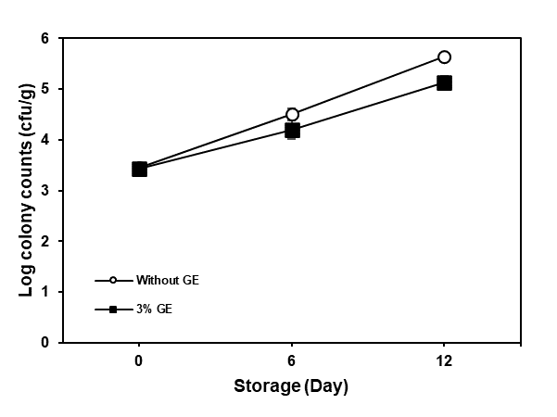
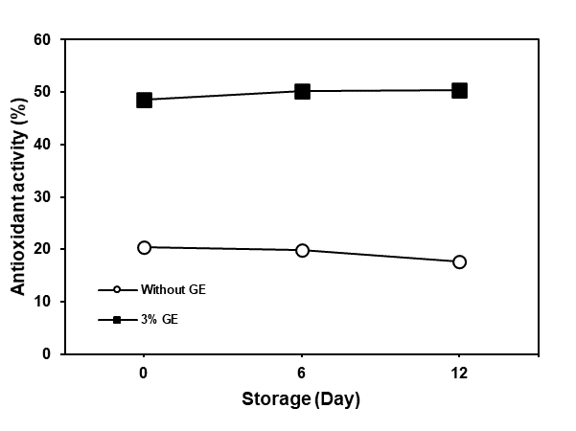

Figure 1. Antioxidant activity of fish nuggets (a); Total colony of fish nuggets

The results indicated that the incorporation of 3% ginger extract significantly enhanced the antioxidant activity of fish nuggets, increasing it from 48.5% to 50.40%. Conversely, a decline in antioxidant activity was observed from day 0 to day 12, decreasing from 20.5% to 17.7%. This finding substantiates the potential of ginger extract (GE) as a natural preservative in food manufacturing. The combination of GE with cold storage presents an effective strategy for extending shelf life and preserving quality. Ginger is rich in bioactive compounds such as gingerols and shogaols, which possess potent antioxidant (Sang et al., 2008; Brown et al., 2008) and antimicrobial properties. When integrated into food products like fish or meat, ginger extract can inhibit lipid oxidation and suppress the proliferation of spoilage microorganisms during refrigerated storage. Studies have demonstrated that the addition of 1-3% ginger extract to products such as fish nuggets can significantly enhance antioxidant activity (Figure 1(a)) and reduce total bacterial counts compared to untreated controls stored at cold temperatures (Figure 1(b)). In terms of reducing microbial colonies, ginger extract has exhibited anti-quorum sensing and anti-biofilm activity against multidrug-resistant bacterial strains such as Pseudomonas aeruginosa. This is critical because quorum sensing and biofilm formation are pivotal in bacterial pathogenicity and resistance development. The methanol extract of ginger was shown to significantly inhibit biofilm formation and other virulence factors in a concentration-dependent manner, suggesting its potential as an alternative antimicrobial agent (Sagar et al., 2023).
The phenolic compounds present in ginger contribute to its pleasant flavor profile while effectively masking undesirable odors that may develop during storage. Additionally, low temperatures decelerate both chemical and microbial degradation processes. The combined application of ginger extract and refrigeration can synergistically enhance food quality and safety over extended periods, surpassing the efficacy of either method used independently. As reported by Zia‐Ur‐Rehman et al. (2003), ginger extract demonstrates significant antioxidant activity, comparable to synthetic antioxidants such as BHA and BHT. For example, ginger extract effectively reduced lipid oxidation in sunflower oil over a six-month storage period, resulting in lower peroxide values and free fatty acid contents compared to untreated samples.
According to Indonesian National Standard No. 7758:2013, the permissible limit for total bacterial colony count in fish nuggets is 5 x 10⁴ cfu/g. This standard serves as a benchmark for evaluating the efficacy of ginger extract in ensuring the microbiological safety of fish nugget products.

3.6. Physicochemical and Sensory Characteristics of Fish Nugget

Figure 2 depicts the chemical contents in fish nuggets with and without 3% ginger extract during cold storage.

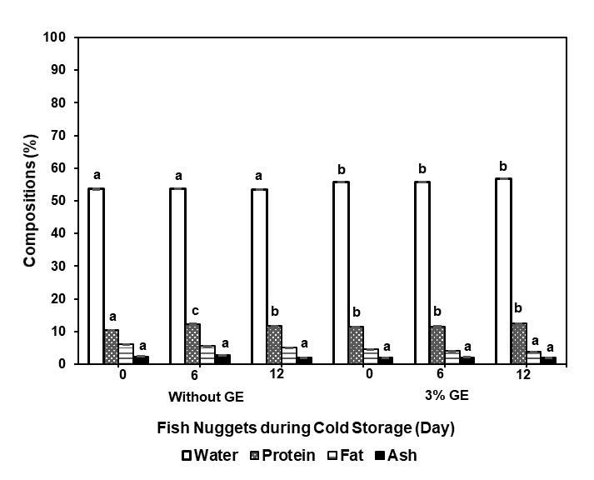

Figure 2. Chemical content of fish nuggets with and without 3% ginger extract during cold storage.
As illustrated in Figure 2, the combination of GE and cold storage significantly enhances the quality of fish nuggets (p<0.05). On the 12th day of storage under cold conditions, fish nuggets containing 3% GE continued to meet the required values for water, protein, fat, and ash content, which were 56.8%, 12.5%, 3.8%, and 1.9%, respectively. Furthermore, the sensory evaluations (Figure 3) appear to corroborate the data presented in Figure 2.

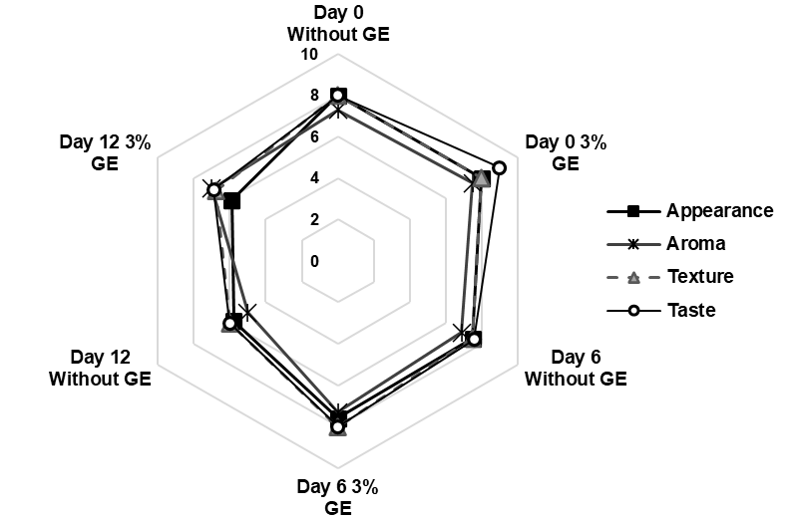

Figure 3. Characteristic sensory evaluation of fish nuggets with and without 3% ginger extract during cold storage.

a. Appearance
The incorporation of 3% ginger extract did not significantly influence the storage duration concerning physical appearance. Initially, both the ginger extract nuggets and the control nuggets received a score of 8. By day 6, the panelists assigned scores ranging from 7.5 to 7.6, and by day 12, the scores decreased to 5.80 to 5.9. This decline indicates that the fish nuggets were no longer suitable for consumption on day 12, as evidenced by the presence of wet bread crumb layering. The appearance of fish nuggets containing 3% ginger extract was less appealing than that of the control nuggets, attributable to enzymatic processes. The nuggets exhibited a brownish hue compared to the brighter appearance of the control nuggets. A lower sensory score for appearance suggests the occurrence of spoilage during storage. As noted by Zang et al. (2021), the visual appearance of food can serve as an initial indicator of spoilage. Changes in color or texture often become apparent when microbial activity begins to degrade the food's components. For example, in food products such as fish or meat, specific spoilage organisms can induce significant visual changes that are detectable through sensory evaluation.

b. Aroma
The addition of 3% ginger extract did not significantly impact the aroma of fish nuggets during the storage period, with aroma scores ranging from 6.9 to 7.5. However, a significant difference in aroma scores was observed between fish nuggets without ginger extract and those with 3% ginger extract on day 12, with scores of 5 and 7, respectively. At the start of the storage period, the aroma of fish nuggets with 3% ginger extract was noticeable. On day 6, the scores were 6.9 for the control fish nuggets and 7.3 for those with 3% ginger extract. The aroma of the fish nuggets was assessed based on our sense of smell. This study used tilapia fish as the main ingredient and found that the addition of ginger extract significantly influenced the flavor profile. However, previous research by Mattje et al. (2019) indicated that the intensity of ginger and its distinctive scent might overpower the neutral flavor of fish. This highlights the importance of using ginger extract judiciously, especially if the aim is to preserve the subtlety of the fish's original flavors while introducing the desired aromatic enhancement.

c. Taste
The incorporation of three percent ginger extract (GE) into fish nuggets, stored at cold temperatures for a duration of 12 days, influenced the taste evaluation. Initially, both the ginger extract nuggets and the control nuggets received a flavor score of 8, consistent with the specifications outlined in the Indonesian National Standard No. 7758-2013 by the National Standardization Board (2013). By day 6, the scores ranged from 7.6 for the control nuggets to 8 for the fish nuggets with 3% GE. On day 12, the scores decreased to 6 and 6.9, respectively, indicating that the fish nuggets were no longer suitable for consumption due to a slightly sour taste. The ginger extract fish nuggets exhibited a less sour flavor compared to the control nuggets, which was consistent with their aroma. The active compounds in ginger, such as gingerol and shogaols, contribute to its strong flavor and preservative properties, making it a valuable additive in food products (Shahrajabian et al., 2019). However, this sensory assessment revealed a contrary outcome, likely due to the limited shelf life of fish nuggets at cold temperatures, which is approximately 5 days. Consequently, the addition of GE effectively maintained the flavor of the fish nuggets until day 6. The integration of ginger extracts, particularly when combined with controlled cold storage conditions, offers a promising strategy for developing fish nuggets with enhanced taste and extended shelf stability (Aqmasjed et al., 2023; Shahrier et al., 2023).

d. Texture
To evaluate the effect of incorporating 3% ginger extract on the texture of fish nuggets during cold storage, we examine how the texture changes over time. At the start, both the ginger extract (GE) fish nuggets and the control group shared an identical texture score of 8.00, reflecting comparable initial texture quality. By the sixth day, although both samples showed some texture decline, the ginger extract sample retained a slightly higher score of 8, compared to the control's 7.5. This indicates that ginger extract might offer some protective or stabilizing benefits in the early stages of cold storage. However, by the twelfth day, both samples experienced further texture deterioration, with scores falling to 6 for the control and 6.9 for the ginger extract group. Despite this reduction, the ginger extract sample maintained a higher score, suggesting less degradation than the control. The term "flabby" implies that the nuggets' structural integrity was compromised over the extended storage period. In summary, the 3% ginger extract appears to offer initial advantages in preserving texture during cold storage, though by day 12, the texture in both samples had significantly declined. Further investigation could determine if altering the ginger extract concentration or adjusting storage conditions might improve texture stability over longer durations.

- Conclusions
The impact of ginger extract on fish nuggets during storage can be attributed to several potential mechanisms, primarily arising from the antioxidant properties of ginger and its influence on lipid oxidation, which subsequently affects texture. The application of ginger extract, in conjunction with optimal storage conditions, can further enhance its effectiveness.

In summary, the antioxidant properties of ginger extract are pivotal in its capacity to influence the texture of fish products during storage. By mitigating oxidative stress and potentially stabilizing pH and water content, ginger extract contributes to preserving the fresh-like characteristics of fish products, thereby extending their shelf life.

References

Amalia. U. (2012). Shelf-Life Estimation of “So Lite’ Fish Nugget. SAINTEK PERIKANAN Indonesian Journal of Fisheries Science and Technology. 8(1). 27–31. https://doi.org/10.14710/ijfst.8.1.27-31

Amiri. Z.. Mohammadi. M.. Najafpour. G.. Moghadamnia. A. (2018). Subcritical Water Extraction of Bioactive Compounds from Ginger (Zingiber officinale Roscoe). International Journal of Engineering. 31(12). https://doi.org/10.5829/ije.2018.31.12c.01

Aqmasjed, B.S., Sajjadi, M. M., Falahatkar, B., & Safari, R. (2023). Effects of dietary ginger (Zingiber officinale) extract and curcumin on growth, hematology, immunity, and antioxidant status in rainbow trout (Oncorhynchus mykiss). Aquaculture Reports, 32, 101714. https://doi.org/10.1016/j.aqrep.2023.101714

National Standardization Agency. 2013. Indonesian National Standard Number 7758 : 2013. Fish Nugget. National Standardization Agencyd. Jakarta.

Bakr. A.. Abdelgayed. S.. El-Tawil. O.. & Bakeer. A. (2020). Ginger Extract and Ginger Nanoparticles; Characterization and Applications. International Journal of Veterinary Science. 9(2). https://doi.org/10.37422/ijvs/20.021
Biswas. O.. Biswas. S.. & Gurunathan. K. (2024). Quality of Fish Nuggets Fortified with Guava Peel Powder During Storage in a Fabricated Solar Cooler. Journal of Aquatic Food Products Technology. 33(10). https://doi.org/10.1080/10498850.2025.2464025

Beya. M. M.. Netzel. M. E.. Smyth. H.. Hoffman. L. C.. & Sultanbawa. Y. (2021). Plant-Based Phenolic Molecules as Natural Preservatives in Comminuted Meats: A Review. Antioxidants. 10(2). 263. https://doi.org/10.3390/antiox10020263
Brown, A. C., Zhang, J. G., Pham, J. T. H., Liu, J., Shah, C., & Jadus, M. R. (2008). Ginger’s (Zingiber officinale Roscoe) inhibition of rat colonic adenocarcinoma cells proliferation and angiogenesis in vitro. Phytotherapy Research, 23(5), 640–645. https://doi.org/10.1002/ptr.2677

Cedillo-Olivos. A. E.. Juárez-Chairez. M. F.. Cid-Gallegos. M. S.. Sánchez-Chino. X.. & Jiménez-Martínez. C. (2024). Natural preservatives used in foods: a review. Critical Reviews in Food Science and Nutrition. ahead-of-print(ahead-of-print). 1–17. https://doi.org/10.1080/10408398.2024.2403000

Ersedo, L.T., Teka, T. A., Fikreyesus Forsido, S., Dessalegn, E., Adebo, J. A., Tamiru, M., & Astatkie, T. (2023). Food flavor enhancement, preservation, and bio-functionality of ginger (Zingiber officinale): A review. International Journal of Food Properties, 26(1), 928–951. https://doi.org/10.1080/10942912.2023.2194576

Gonçalves A.. T.. Costa. H. S.. Sanches-Silva. A.. Cristina Bento. A.. & Oliveira. M. B. P. P. (2016). Effect of cooking methods on the nutritional quality and safety of chicken breaded nuggets. Food & Function. 7(6). 2736–2746. https://doi.org/10.1039/c6fo00353b
Gundala, S. R., Mukkavilli, R., Tandon, V., Prakash, S., Yang, C., Aneja, R., Yadav, P., & Vangala, S. (2014). Enterohepatic recirculation of bioactive ginger phytochemicals is associated with the enhanced tumor growth-inhibitory activity of ginger extract. Carcinogenesis, 35(6), 1320–1329. https://doi.org/10.1093/carcin/bgu011

Huynh. TPL.. Nguyen Tong Ngoc. N.. Doan Ngoc Thach. K.. & Pham Duy. S. (2024). Preservation of chicken breast meat with ginger extract and essential oil. Heavy metal and arsenic concentrations in water. Agricultural Soil. and Rice in Ngan Son District. Bac Kan Province. Vietnam. 7(4). 575–588. https://doi.org/10.47866/2615-9252/vjfc.4418

Islam. M.. Rahman. M. A.. Shahjalal. M.. Huque. R.. Hossain. A.. Hossain. M. A.. Khatun. M. A.. & Munshi. M. K. (2022). Potential of ginger extract as a natural preservative for raw tilapia fish (Oreochromis mossambicus ) during storage at refrigerated temperatures. Journal of Food Processing and Preservation. 46(7). https://doi.org/10.1111/jfpp.16729

Kim. H.-T.. Loftus. J. P.. Mann. S.. & Wakshlag. J. J. (2018). Evaluation of Arsenic. Cadmium. Lead and mercury contamination in over-the-counter available dry dog foods containing different animal ingredients (red meat. poultry. and fish). Frontiers in Veterinary Science. 5. https://doi.org/10.3389/fvets.2018.00264

Mattje, L. G. B., Bainy, E. M., Tormen, L., Bombardelli, M. C. M., & Corazza, M. L. (2019). Ginger essential oil and supercritical extracts are natural antioxidants found in tilapia fish burgers. Journal of Food Processing and Preservation, 43(5), e13942. https://doi.org/10.1111/jfpp.13942

Mustafa, I., & Chin, N. L. (2023). Antioxidant Properties of Dried Ginger (Zingiber officinale Roscoe) var. Bentong. Foods, 12(1), 178. https://doi.org/10.3390/foods12010178

Ng, W. J., Ee, K. Y., Hew, P. S., Chin, H. Y., & Chin, R. (2023). Sensory, physicochemical, and antioxidant properties coupled with chemometric analysis of ginger (Zingiber officinale Roscoe var. Bentong)-enriched Apis cerana honey. Food Chemistry Advances, 3, 100459. https://doi.org/10.1016/j.focha.2023.100459

Palve. R. D.. Pathan. D. I.. Yadav. B. M.. Mohite. A. S.. & Chogale. N. D. (2025). Effect of ginger extract on the quality of pangasius fish streaks during cold storage. Probe: Food Science Research. 7(1). https://doi.org/10.18686/fsr2294

Petenuci. M. E.. Rocha. I.D.N. A.. Visentainer. J. V.. Schneider. V. V. A.. De Sousa. S. C.. & Da Costa. L. A. M. A. (2016). Seasonal Variations in Lipid Content. Fatty acid composition and nutritional profiles of five freshwater fish species from the Amazon Basin. Journal of the American Oil Chemists’ Society. 93(10). 1373–1381. https://doi.org/10.1007/s11746-016-2884-8.

Sagar, P. K., Sharma, P., & Singh, R. (2023). Anti-Quorum Sensing and Anti-Biofilm Activity of Ginger (Zingiber officinale) Rhizomes against Multidrug-Resistant Clinical Isolates of Pseudomonas aeruginosa. Avicenna Journal of Medical Biotechnology, 16(1). https://doi.org/10.18502/ajmb.v16i1.14171
Sang, S., Hong, J., Yang, C. S., Ho, C.-T., Badmaev, V., Wu, H., Pan, M.-H., & Liu, J. (2009). Increased growth inhibitory effects on human cancer cells and anti-inflammatory potency of shogaols from Zingiber officinale relative to gingerols. Journal of Agricultural and Food Chemistry, 57(22), 10645–10650. https://doi.org/10.1021/jf9027443
Shahrier, J., Rasul, G., Afrin, F., Islam, R., & Shah, A. K. M. A. (2023). Extension of shelf life of Nile tilapia (Oreochromis niloticus) fillets using seaweed extracts during refrigerated storage. Food Science & Nutrition, 11(11), 7430–7440. https://doi.org/10.1002/fsn3.3673

Yu. H. H.. Chin. Y.-W.. & Paik. H.-D. (2021). Application of Natural Preservatives for Meat and Meat Products against Food-Borne Pathogens and Spoilage Bacteria: A Review. Foods. 10(10). 2418. https://doi.org/10.3390/foods10102418
Zammel, N., Jedli, O., Jamal, A., Elkahoui, S., Badraoui, R., Alam, J. M., Siddiqui, A. J., Alreshidi, M. M., Adnan, M., Naïli, H., Rebai, T., & Hamadou, W. S. (2022). Kidney injury and oxidative damage alleviation by Zingiber officinale: Pharmacokinetics and protective approach in a combined murine model of osteoporosis. 3 Biotech, 12(5). https://doi.org/10.1007/s13205-022-03170-x

Zia‐Ur‐Rehman. Z.. Salariya. A. M.. & Habib. F. (2003). Antioxidant activity of ginger extract in sunflower oil. Journal of Science of Food and Agriculture. 83(7). 624–629. https://doi.org/10.1002/jsfa.1318
Zhang, Z., Wu, R., Gui, M., Jiang, Z., & Li, P. (2021). Identification of the Specific Spoilage Organism in Farmed Sturgeon (Acipenser baerii) Fillets and Its Associated Quality and Flavour Change during Ice Storage. Foods, 10(9), 2021. https://doi.org/10.3390/foods10092021

