Synthesis of Zeolite X From Locally Sourced Clay and Its Application in Catalytic Pyrolysis of Waste Plastics

Abstract
The growing challenge of plastic waste pollution, coupled with the limited efficiency of conventional waste management techniques in Nigeria, drives the exploration of thermal and catalytic pyrolysis. These methods present an alternative, more efficient solution for plastic waste conversion into valuable hydrocarbons, with the catalyst improving product yield and quality. However, commercial zeolites presently used are often expensive and require complex synthesis procedures, thus limiting their widespread use in industrial applications. This study investigates the thermal and catalytic pyrolysis of waste plastic bags from polythene and Styrofoam food packaging made from polystyrene into liquid fuel using Zeolite X synthesized from clay sourced locally from konno-boue in Khana local government area of Rivers State. The study commenced with the synthesis of Zeolite X through pretreatment the kaolin clay and calcination processes. The synthesized Zeolite X catalyst was characterized using X-ray diffraction (XRD), X-ray fluorescence (XRF), and scanning electron microscopy (SEM) to confirm its structural integrity and catalytic potential. The catalytic and thermal pyrolysis of polythene and polystyrene was conducted in a fixed-bed pyrolysis reactor, with temperatures ranging from 300 °C to 600 °C. Parameters such as the catalyst-to-plastic ratio and reaction temperatures were varied to optimize the product yield. The products obtained include: liquid oil, solid char, and gases, with their resultant yields specified. Results indicated that thermal pyrolysis in the absence of catalyst yielded 66.5% liquid fuel, while catalytic pyrolysis produced a lower yield of 28 % liquid but significantly increased the gas output to 61 %. This enhanced gas production with Zeolite X is attributed to the catalyst's role in breaking down larger hydrocarbon chains more effectively. The liquid fuel product obtained from the catalytic pyrolysis of polythene and polystyrene shows that catalyst to feed stock ratio of 1:4 was effective. This increased the yield of gas from 7.0 % to 61 %. The temperature range for catalytic pyrolysis was 200 °C to 280 °C, while thermal pyrolysis required higher temperatures of 300 °C to 395 °C, highlighting the energy savings afforded by catalytic processes. Further analysis using Fourier Transform Infrared Spectroscopy (FTIR) and Gas Chromatography (GC) Total Petroleum Hydrocarbons (TPH) indicated the fuel quality, with a higher content of light hydrocarbons such as alkanes and alkenes in catalytic pyrolysis, suitable for use as an alternative fuel. The locally sourced Zeolite X catalyst demonstrated strong potential for improving the efficiency and selectivity of the pyrolysis process, making it a viable solution for plastic waste management and fuel production.
Keywords: Catalytic pyrolysis, Zeolite X, Polystyrene, Polythene, X-ray
Introduction
The increasing accumulation of plastic waste has emerged as a significant environmental and economic challenge globally (Nwafor, 2024; Evode et al., 2021). As of 2023, it is estimated that over 380 million tons of plastic are produced annually worldwide, with a substantial portion of this plastic ending up in landfills, oceans, and ecosystems where it can persist for hundreds of years due to its non-biodegradable nature. The persistent accumulation of plastic waste has led to widespread environmental contamination, adversely affecting wildlife, marine life, and human health (Thushari and Senevirathna, 2020). Moreover, microplastics, which result from the degradation of larger plastic materials, have been detected in air, water, and even food supplies, underscoring the urgency of finding sustainable solutions to manage plastic waste (Ali et al., 2024; Ghosh et al., 2023).
Conventional waste management approaches such as landfilling and incineration present ecological hazards, including soil contamination, water pollution, and the release of toxic emissions. They have proven insufficient in curbing the escalating plastic pollution problem. Landfilling occupies vast amounts of land and contributes to soil and groundwater contamination, while incineration generates harmful emissions such as dioxins and furans (Abubakar et al., 2022). While recycling efforts have gained momentum, many types of plastic remain non-recyclable or difficult to process, leading to a growing interest in alternative methods for plastic waste conversion. These constraints highlight the need for alternative, more efficient, and environmentally friendly technologies to manage plastic waste.
Among the various alternatives, thermochemical conversion technologies, such as pyrolysis, gasification, and hydrocracking, have emerged as promising approaches to convert plastic waste into valuable fuels and chemicals (Nanda et al., 2023). Pyrolysis, in particular, has garnered attention for its ability to break down plastic waste into liquid, gaseous, and solid products that can serve as feedstocks for the petrochemical industry or as alternative fuels. The advantage of pyrolysis lies in its capacity to process mixed and contaminated plastics, which are typically difficult to recycle mechanically (Guillermo, et al., 2024). However, despite its potential, pyrolysis as a standalone thermal process often suffers from low efficiency, high energy requirements, and poor product selectivity. These challenges led this research to explore catalytic pyrolysis, where the use of catalysts can enhance the reaction efficiency and improve product quality. The effectiveness of catalytic pyrolysis can enhance the reaction rate, lower the required temperature, and influence the yield and quality of the products. The present work focuses on evaluating the catalytic performance of Zeolite X synthesized from locally sourced clay in the pyrolysis of waste polythene and polystyrene into valuable hydrocarbons.
Materials and Methods

Plastics
Two different types of waste plastics were considered for this study which are low density polythene (LDPE) and polystyrene (PS). They were identified by determining melting points. The decomposition patterns were done in a UW_MSE TA instruments TGA Q50 in a crucible with varied temperature. The waste polythene and polystyrene were collected from various dump sites within and outside the premises of the Federal University Otuoke, Bayelsa State, Nigeria.
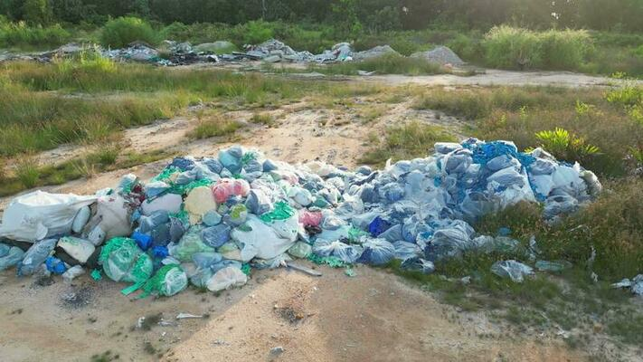
Figure 1: Plastics at dump site
Clay
The clay samples were sourced from Kono-Boue Town, Khana Local Government of Rivers State, Nigeria. Rivers State lies in the Niger Delta region of Nigeria, which is known for its diverse geological composition, rich in various minerals and natural resources, including clay deposits.
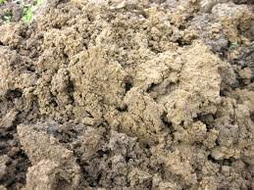

Figure 2: Raw clay

Clay samples Pre-treatment
The synthesis of Zeolite X began with pre-treatment of Kono-Boue clay, which served as the raw material for the production of the aluminosilicate framework required for Zeolite formation. The clay was first pre-treated to remove impurities and improve its chemical composition. Initially, the clay was air-dried to reduce its moisture content, followed by drying at 100°C in an oven for 24 hours to ensure complete dehydration. This step was important for eliminating any excess water that could interfere with the subsequent reactions. After drying, the clay was ground into a fine powder using a ball mill and sieved to achieve a uniform particle size of less than 75 microns. This fine powder allowed for better dispersion of the clay particles during the synthesis process. To further purify the clay and remove contaminants such as iron oxides and other metal impurities, the powdered clay was treated with different concentrations of Sodium hexametaphosphate solution followed by 2 M tetraoxosulphate (vi) acid (H₂SO₄). Acid treatment helps dissolve undesirable impurities that can affect the quality of the zeolite product. After acid treatment, the clay was thoroughly washed with deionized water to remove any residual acid and was then dried at 105 °C for further use.
Filtration, Washing, and Drying
After the hydrothermal treatment, the solid product (crystalline Zeolite X) was recovered by filtration. The zeolite crystals were separated from the remaining solution and were washed several times with deionized water to remove any untreated sodium hydroxide or other impurities that may have formed during the synthesis process. The washing process continued until the pH of the wash water reached a neutral value, indicating that all residual alkali had been removed. Once the Zeolite was thoroughly washed, it was dried at 110°C for 12 hours to remove any remaining moisture.

Beneficiation of the pre-treatment clay
100 g of raw sieved clay was weighed and dispersed in 100ml (2.5 w/v, 2.0 w/v and 1.5 w/v) sodium hexametaphosphate solution respectively. The mixtures were stirred and allowed to stand for three days. The solutions were separated into three layers; the supernatant at the top followed by the pure clay and sand at the bottom. The supernatant liquids were decanted and the clay was separated from the sand by sieving with the 45µm mesh. The separated pure clay was transferred in a crucible and placed in an oven to dry at 110⁰C for 48 hours. The dried clay was later placed in a desiccator to cool.
Zeolitazation
40 g of the beneficiated clay (metakaolin) was weighed and dissolved in 500 ml 2M tetraoxosulphate(vi) acid (H₂SO₄). The mixture was stirred with the magnetic stirrer at 80 ºC for 4 hours. The resulting mixture was allowed to cool and filtered through the filter paper. The residue was transferred into an evaporating dish and dried in an oven overnight at 100 ºC. The dried clay (Zeolite) was mixed with 48g of the sodium hydroxide (NaOH) pellets. The mixture was then ball milled at 300rpm for 30 minutes to obtain a homogenous fusion of solid
Calcination of Zeolite X catalyst
Zeolite X was subjected to calcinations at a temperature of 500 C for 6 hours in a muffle furnace to improve the crystallinity and stability of the Zeolite materials. The high temperature during calcinations helped to remove any residual organic materials or unreacted precursors that may been present in the Zeolite. The calcined solid was then mixed with 300ml distilled water, cured (stirred at room temperature) for 24 hours and filtered with several times washing with distilled water to obtain a neutral pH and oven dried at 100 ºC overnight.
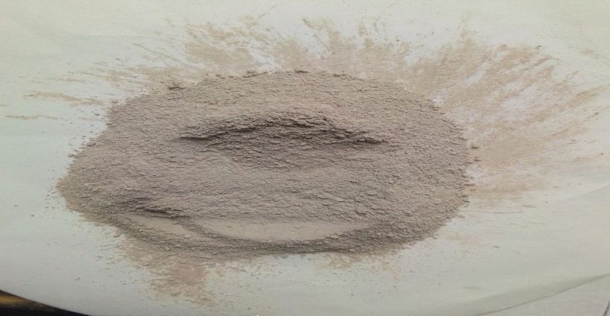
Figure 3: Calcined Zeolite X
X-Ray Diffraction (XRD) Analysis
X-Ray Diffraction was used to determine the crystalline structure of the purified clay as well as the synthesized Zeolite Powdered samples were pelletized and subsequently sieved to 0.07 mm. The samples were further compacted and run through the Rigaku D/Max-111C diffractometer.
Scanning Electron Microscopy (SEM) Analysis
Scanning Electron Microscopy was used to determine the morphological, quantitative and qualitative of the purified clay and the synthesized Zeolite The clay samples were carried out using SEM Model JEOL 766 F. The Mineral Analysis of the purified clay and Zeolite X were conducted in two stages. All the samples were carbon coated to make the minerals surface conductive. In the first stage, crushed carbon coated minerals were examined directly with SEM without polishing. The second stage was to identify the mineral phases present within the samples.
Pre-treatment of Waste Plastics (Polythene and Polystyrene)
The first stage in this process was the collection and sorting of waste polythene and polystyrene, as shown in Fig 3. Different types of plastics, such as polythene (PE), and polystyrene (PS) were collected from refuse dumps in and around Federal University Otuoke. The waste plastics were primarily sourced from food packaging materials and pure water sachets disposed of. After sorting, the plastics were cleaned to remove contaminants such as dirt, labels, and residues from food or chemicals. After washing, the plastics were dried to remove moisture content. Once clean and dry, the plastics were shredded into smaller pieces to facilitate efficient thermal degradation. The size reduction was achieved using mechanical shredders, which reduced the plastics to a uniform size, typically between 2 mm to 5 mm.
Thermal Pyrolysis Process
The pyrolysis process began with the introduction of 200g of the prepared waste plastic into the reactor. The reactor was then sealed. The heating system was activated, and the temperature of the reactor was gradually increased until it reached the target temperature, between 300 °C and 600 °C, depending on the type of plastic being pyrolyzed. The pyrolysis process was completed within 2 hours, After the process was complete, the reactor was allowed to cool to room temperature, and the solid residue (char) was removed and weighed to determine the yield.
Catalytic Pyrolysis
The Zeolite X catalyst was added to the waste plastic samples in different catalysts to feedstock ratio (1:1,1:2,1:3 and 1:4) in the reactor setup and heated to the desire temperature. The condensed liquid products were collected through the condenser and weighed. then the solid(char) inside the reactor was weighed and the weight of the gaseous product was calculated from the materials balance. After the pyrolysis process, the liquid, gas, and solid products were collected and analyzed to assess the catalytic performance of Zeolite X. The pyrolysis oils were analyzed using specialized analytical techniques such as Gas Chromatography (GC), Fourier Transform Infrared (FTIR) and physical properties (ASTM).
Analysis of Liquid fuel obtained from the pyrolysis of waste Plastics (Polythene and Polystyrene)
The composition of the pyrolysis oil was determined using Gas Chromatography (GC), Fourier transformation infrared spectroscopy (FTIR). Physical properties such as density, viscosity, flash point, pour point and ash content were also analysed using ASTM method.
Fourier transformation infrared spectroscopy (FTIR)
FTIR of the pyrolysis
oil obtained at different temperatures were taken in a Perkin-Elmer 3000 MX Fourier transformed Spectrometer Fourier transformed infrared spectrophotometer with resolution of 4 cm⁻¹ in the range of 400-4000 cm⁻¹ using to know the functional group composition.
Results and Discussions
The result on X- Ray Fluorescence analysis on the basic properties of Zeolite X is presented in Table 1. Data showed that the raw clay primarily contains 55.35% silica (SiO₂) and 30.27% alumina (Al₂O₃), with lower amounts of Fe₂O₃ (3.6%), CaO (1.94%), and trace elements like TiO₂ (1.05%) and K₂O (0.98%). The synthetic Zeolite X shows similar major components, with 52.54% SiO₂ and 28.85% Al₂O₃, but exhibits significant enhancements in trace metals such as Ba (460 ppm), Rb (95 ppm), and Cr (105 ppm), compared to the clay. In contrast, the commercial Zeolite has a higher SiO₂ content (67%) but much lower Al₂O₃ (14.5%), while Fe₂O₃ and CaO are found in comparable amounts (6.78% and 3.24%, respectively). Other oxides such as MgO, Na₂O, and K₂O differ largely, with the commercial Zeolite containing higher levels of Na₂O (1.63%) and K₂O (1.65%). Elements like P₂O₅ and some trace metals are either absent or not detected in certain samples. The loss on ignition (LOI) is highest in the raw clay (10.55%), slightly lower in the synthetic Zeolite (10.2%), and unspecified for the commercial variant.

Table 1: Comparison of Chemical composition of Kono-Boue Clay, Synthetic Zeolite and Commercial Zeolite.

Component X | Composition in raw clay (%) | Composition in synthetic Zeolite (%) | Composition in commercial Zeolite (%)
SiO2 | 55.35 | 52.54 | 67
Al2O3 | 30.27 | 28.85 | 14.5
Fe2O3 | 3.6 | 3.65 | 6.78
MnO | 0.01 | 0.01 | -
CaO | 1.94 | 1.94 | 3.24
P2O5 | 0.01 | - | -
K2O | 0.98 | 0.95 | 1.65
TiO2 | 1.05 | 1.17 | 0.23
MgO | 0.44 | 0.08 | 1.24
Na2O | 0.3 | 0.05 | 1.63
LOI | 10.55 | 10.2 | -
Ba | 422 | 460 | -
Ce | 20 | 58 | -
Rb | 0.36 | 95 | -
Zr | ND | 70 | -
Cr | 0.57 | 105 | -
Cu | 0.02 | 35 | -
Ni | 0.33 | 40 | -
Pb | 0.24 | 10 | -

Results of the mineralogical analyses presented in Figure 4 show that Quartz is the dominant clay mineral in the sample. Quartz is the major non-clay constituent reflected in the diffractograms. Distinctive Calcite peaks are recorded at 2theta values of 12.40, 20.00 and 25.00. High value of 44% was seen above the quartz with small amount of ferrite and muscovite, especially in solid waste bodies, is the major disparities between the investigated clay bodies. Both the anatase, a part of the Aluminum silicates and the microcline are valued at low percent of 2% and 2% respectively.

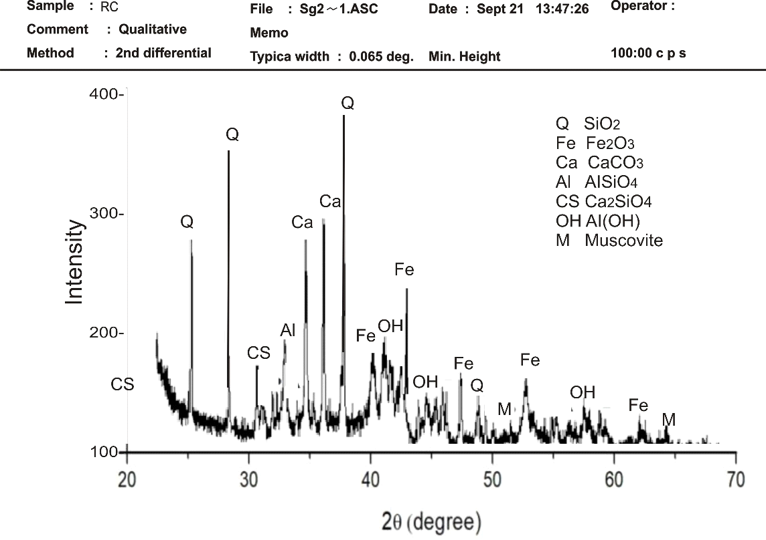
Figure 4: X- Ray Diffraction spectrum of Raw Clay
Figure 4 revealed that Silicate and Aluminum-Silicate peaks are most prominent at 20.90 and 26.70. 2theta values in the Bentonite. Monthmorillite, Illite and smectites peaks are detected at 2theta values of 8.00 and 5.80 respectively. The mineralogical compositions of the clay bodies at the Laterite sample are essentially mineralized and similar to that of the sample A. They are however different from the other clay bodies. Kaolinite commonly constitutes 35% and 39%, in both bodies respectively, while quartz, a non-clay mineral. However, the content in Figure 4 is higher than the value of 4% for sample in Figure 5 body. This indicates a lower degree of chemical decomposition of the primary mineral in sample Figure 5. Illite peaks of about 3% to 3% are identified, while mullite constitute 4% on the average in sample Figure 4. The XRD mineralogical composition showed that X-ray diffraction curves were interpreted by comparing peaks of notable intensities with those of standard minerals established by Carrol (1971). The area method was also employed in calculating the relative proportions of the identified minerals.
SEM Analysis
The result of Scanning Electron Microscopy (SEM) in as presented in Figures 5 A, B & C. The scan report showcases the magnification of SEMs of sandy material with abundant pore space held together by a meshwork of clay coatings over relatively fresh quartz (Si) as the dominant element of 53.0% and feldspar grains. The clay itself was composed of a crinkled mass of flat, platy particles, often with curled edges, about 20, 50 and l00 μm diameter. There was abundant micro-pore space between the platy particles. The clay-rich nature of sample is evident from low magnification SEMs, the whole consisting of crinkled flakes and aggregates arranged in sub- parallel fashion and with abundant void space. The constituent particles were mostly of an equant, platy shape. Grains are moderately well sorted.
The clay was observed to coat relatively fresh surfaces of high silicate. Moderately higher magnification revealed that the coatings consisted of spherical micro- aggregates about 5 μm diameter and consisted of radially- arranged tube-like or lath-like particles that imparted a pin-cushion appearance to the micro-aggregate as a whole. Individual particles are l50 μm long showing dominance of kaolinite over halloysite. Quqrtz (Si) showed high dominancy of 64.3l% followed by aluminum of 22.06% which can be describe as aluminium-silicate. The Calcite content was detected in minute proportions has been reduced by calcium-silicate. The clay-rich nature of sample RC is evident from high magnification SEMs, the whole consisting of crinkled flakes and aggregates arranged in sub- parallel fashion and with abundant void space . The constituent particles were mostly of an equant, platy shape, often bent or sinuous with curled edges, and ranged from 0.5 to 2 μm diameter. There was abundant micro-pore space between the platy particles. The clay-rich nature of sample is evident from low magnification SEMs, the whole consisting of crinkled flakes and aggregates arranged in sub- parallel fashion and with abundant void space. The constituent particles were mostly of an equant, platy shape. Grains are moderately well sorted.
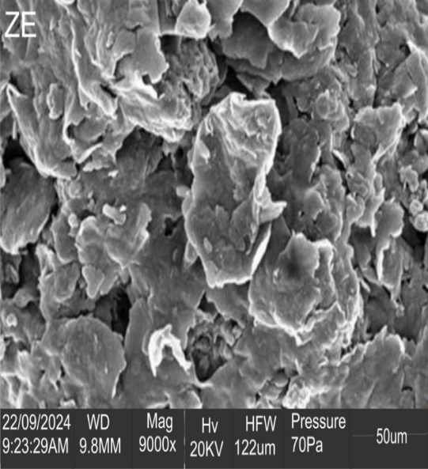
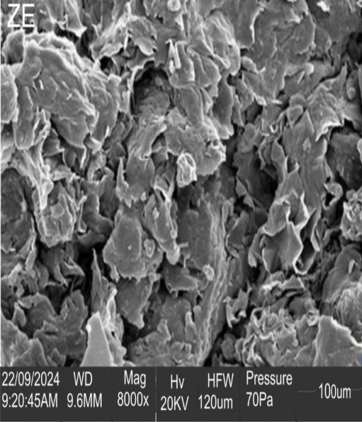
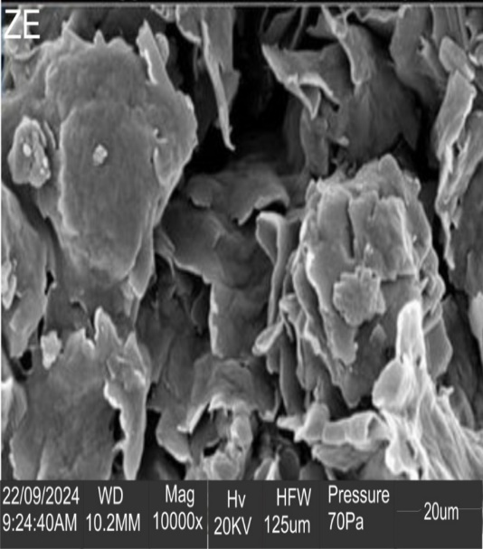
5A
5B
5C
Figure 5 A, B & C: SEM Micrographs of the clay

Thermagravimetric Analysis
The Thermagravimetric Analysis (TGA) curves for the analyzed plastics (combined mixture (CM) of polythene and Polystyrene, combined mixture with catalyst (CMC) of polythene and Polystyrene, polythene with catalyst (PEC) and Polystyrene with catalyst (PSC) are presented in Figures 6A, E & F.
The non-catalytic (thermal) pyrolysis of combined polythene and Polystyrene mixture (CM) has initial weight loss of about 1.3% at around 98 °C as shown in Figures 6B, C & D are likely due to the evaporation of moisture or volatile components present in the sample. The significant weight loss of 68.3% between 300 °C and 350 °C indicates the main decomposition or degradation of the sample. This could be attributed to the breakdown of the material's chemical bonds or the release of gaseous products. The final residual weight of around 30% suggests that a portion of the sample remains stable at the maximum temperature of 600 °C. This could be inorganic components or a more resistant part of the material. The heating rate of 5 °C/min is a relatively slow rate, which allows for better control and observation of the decomposition process. The static air atmosphere means that the sample is heated in a controlled environment without any external gas flow, which can influence the decomposition behavior. The "ΔQ" label indicates the heat flow associated with the process. A positive ΔQ suggests an exothermic process (releasing heat), while a negative ΔQ indicates an endothermic process (absorbing heat). The arrows pointing "exo" and "endo" likely correspond to exothermic and endothermic regions of the plot, respectively. However, without more context, it's difficult to determine the exact temperature ranges associated with these processes.

In the catalytic pyrolysis of polythene (Figures 6B, C & D), the initial weight loss of the sample of about 0.3% observed at 98 °C is likely due to the evaporation of moisture or volatile components present in the sample. The significant weight loss of 89.6% between 300 °C and 332 °C indicates the main decomposition or degradation of the sample. This could be attributed to the breakdown of the material's chemical bonds or the release of gaseous products. The final residual weight of 10.4% suggests that a portion of the sample remains stable at the maximum temperature of 600 °C. This could be inorganic components or a more resistant part of the material. The heating rate of 5 °C/min is a relatively slow rate, which allows for better control and observation of the decomposition process. The static air atmosphere means that the sample is heated in a controlled environment without any external gas flow, which can influence the decomposition behavior. The "ΔQ" label indicates the heat flow associated with the process. A positive ΔQ suggests an exothermic process (releasing heat), while a negative ΔQ indicates an endothermic process (absorbing heat).
In the catalytic pyrolysis of combined polythene and polystyrene, the initial weight loss of about 0.3 % at 98 °C is likely due to the evaporation of moisture or volatile components present in the sample. The significant weight loss of 70.5% between 300 °C and 332 °C indicates the main decomposition or degradation of the sample. This could be attributed to the breakdown of the material's chemical bonds or the release of gaseous products. The final residual weight of 29.5% suggests that a portion of the sample remains stable at the maximum temperature of 600 °C. This could be inorganic components or a more resistant part of the material. The heating rate of 5 °C/min is a relatively slow rate, which allows for better control and observation of the decomposition process. The static air atmosphere means that the sample is heated in a controlled environment without any external gas flow, which can influence the decomposition behavior. A positive ΔQ suggests an exothermic process (releasing heat), while a negative ΔQ indicates an endothermic process (absorbing heat).
In the catalytic pyrolysis of polystyrene, the initial weight loss of about 0.3% at 98°C is likely due to the evaporation of moisture or volatile components present in the sample. The significant weight loss of 70.5% between 300 °C and 395 °C indicates the main decomposition or degradation of the sample. This could be attributed to the breakdown of the material's chemical bonds or the release of gaseous products.
The final residual weight of 12.46% suggests that a portion of the sample remains stable at the maximum temperature of 600 °C. This could be inorganic components or a more resistant part of the material. The heating rate of 5 °C/min is a relatively slow rate, which allows for better control and observation of the decomposition process. The static air atmosphere means that the sample is heated in a controlled environment without any external gas flow, which can influence the decomposition behavior. The "ΔQ" label indicates the heat flow associated with the process. A positive ΔQ suggests an exothermic process (releasing heat), while a negative ΔQ indicates an endothermic process (absorbing heat).
In the non-catalytic(thermal) pyrolysis of polystyrene, the initial weight loss of about 0.8% at 98 °C is likely due to the evaporation of moisture or volatile components present in the sample. The significant weight loss of 68.5% between 200 °C and 280 °C indicates the main decomposition or degradation of the sample. This could be attributed to the breakdown of the material's chemical bonds or the release of gaseous products. The final residual weight of around 30.5% suggests that a portion of the sample remains stable at the maximum temperature of 600 °C. This could be inorganic components or a more resistant part of the material. The heating rate of 5 °C/min is a relatively slow rate, which allows for better control and observation of the decomposition process. The static air atmosphere means that the sample is heated in a controlled environment without any external gas flow, which can influence the decomposition behavior. A positive ΔQ suggests an exothermic process (releasing heat), while a negative ΔQ indicates an endothermic process (absorbing heat).

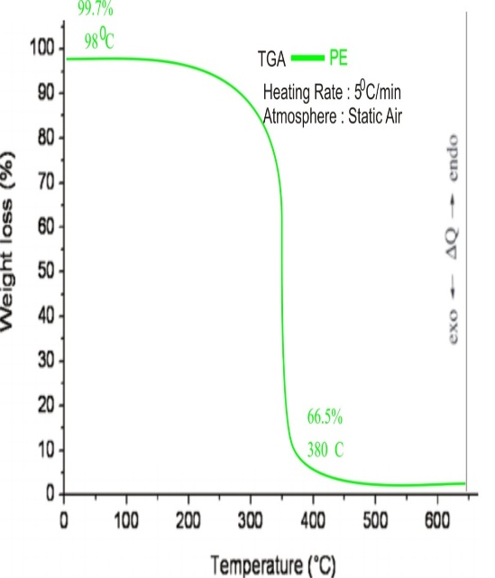
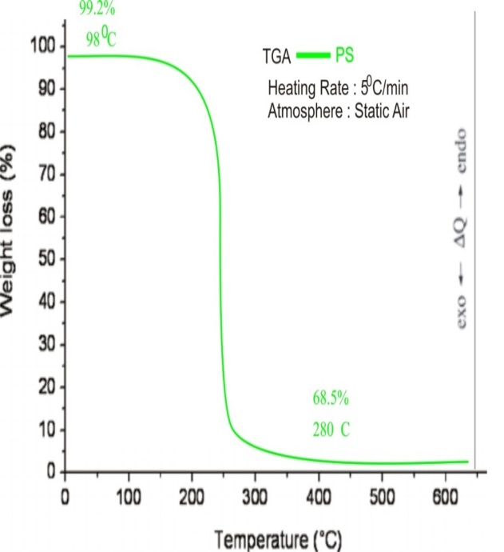
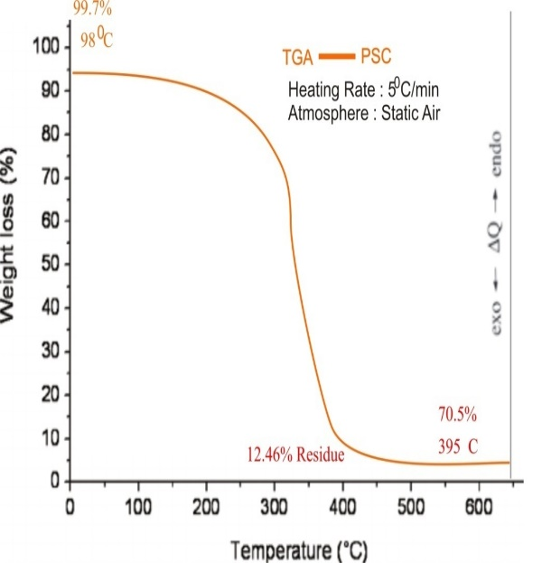
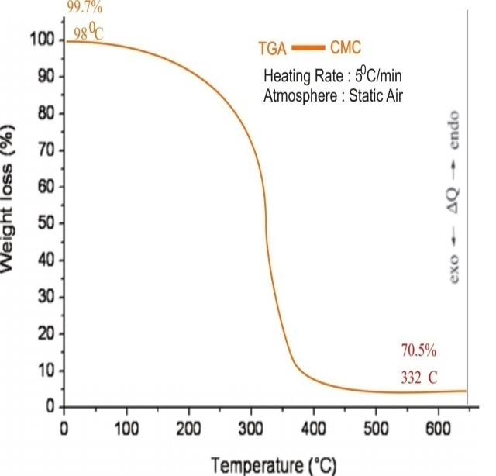
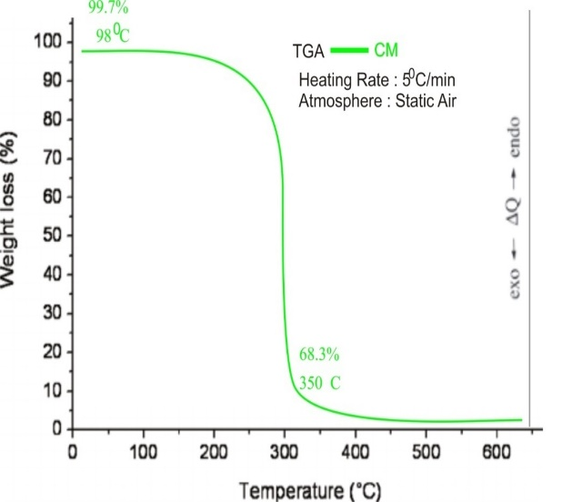
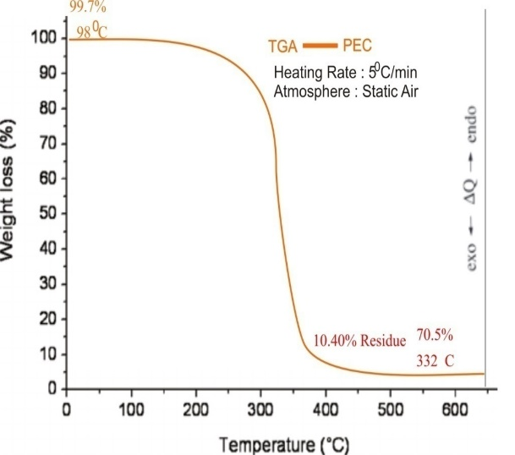

6 B
6 A
6 F
6 E
6 D
6 C

Fig .6 Thermogravimetric Analysis (TGA) curves of the analyzed plastics: combined mixture (CM) of polythene and polystyrene, combined mixture with catalyst (CMC), polythene with catalyst (PEC), and polystyrene with catalyst (PSC)

Products | PE | PS | C(PE/PS) | % Yield (PE) | % Yield (PS) | % Yield (PE/PS)
Liquid Oil | 54 | 133 | 126 | 27 | 66.5 | 63
Solid (Char) | 130 | 53 | 58 | 65 | 26.5 | 29
Gas | 16 | 14 | 16 | 8 | 7 | 8
Table 2: Percentage yield of Products
PE: polythene, PS: polystyrene, C: Polythene and polystyrene

Product | Liquid Oil |  | Solid (Char) |  | Gas
Product | Quantity (g) | % Yield | Quantity (g) | % Yield | Quantity (g) | % Yield
PS (1:4) | 11 | 28 | 4.41 | 11 | 24.59 | 61
PS (1:3) | 8 | 27 | 3.41 | 11 | 18.59 | 62
PE (1:4) | 1.2 | 3 | 19.92 | 50 | 18.88 | 47
PE (1:3) | 0.2 | 0.7 | 14.59 | 49 | 15.21 | 50.3
PS/PE (1:4) | 4.5 | 11 | 17.7 | 44 | 17.8 | 45
PS/PE (1:3) | 1 | 3 | 9.04 | 30 | 19.96 | 67
Table 3: Catalytic pyrolysis product

Characterization of Pyrolytic Oil products
The result of the physical properties of the waste polythene (PE) polystyrene (PS) and the mixture of the polythene and polystyrene (PE+PS) i.e. C is presented in Table 3. The liquid fuel obtained by catalyzed process at optimum condition of catalyst- to- plastic ratio of 1:3 and 1:4 was characterized to determine their solubility for use as fuel. The liquid products from thermal cracking have low ash content, low viscosity, low density and high flash point. Density is the weight occupied by a substance per unit volume, it is a properly which determine the injection and ignition quality of a fuel (Bilal et al., 2013). The density of the thermal cracking liquid product obtained in this study was 0.750 g/ml (PE), 0.926 g/ml (PS) and 0.886 g/ml (PE+PS). Comparison with gasoline with a reported density range of 0.72 – 0.78 g/ml and diesel oil with density range of 0.82 - 0.90 g/ml. The thermal cracking liquid oil of PE, PS and PE+PS are between the reported density range of gasoline and diesel. The liquid product densities from the study indicate that there are more breaking of the polythene (PE), polystyrene (PS) and polythene and polystyrene C-C covalent bonds to a remarkable extent during the cracking process.
Viscosity is an important properly which measures the resistance of the fluid flow which is related directly to pressure, temperature, and film formation (Gao, 2010). Its high viscous fluid is not good for automobile engines as it can cause mechanical inefficiency, also a low viscous fluid is not also recommended as the fuel will drain away faster in engine (Musa et al., 2015).
Flash point is defined as the minimum temperature at which the vapour from a liquid is sufficient to ignite when exposed to flame (Musa et al., 2015). Fire point is the temperature at which the vapour formed as a result of ignition continues to burn for at least 5 s.

Table 4: Comparison of Physical Properties of Pyrolysis oil with Commercial Gasoline and Diesel
Physical Property | Method | Gasoline | Diesel Oil | PE | PS | C
Density at 30 ºC | ASTM D4052 | 0.72- 0.78 | 0.82- 0.90 | 0.75 | 0.926 | 0.886
Viscosity at 30 ºC | ASTM D445 | 1 – 2.1 | 2.0 – 4.5 | 1.002 | 1.002 | 1.005
Flash Point (0 ºC) | ASTM D93 | 37-42 | 55- 80 | 70 | 71 | 70
Fire Point (0 ºC) | ASTM D93 | 42-47 | 60- 90 | - | - | -
Pour Point (0 ºC) | ASTM D97 | -12 | -40 TO (-15) | -2 | -8 | -16
Calorific Value (MJ/Kg) | ASTM D4809 | 42.702 | 45.815 | - | - | -
Cloud point |  | - | - | -1 | -4 | 0

Flash point and fire point are significant at high temperature. They indicate the maximum temperature at which fuel can be stored and handled without serious fire hazard. Flash point of 70 ºC, 71 ºC and 70 ºC for PE, PS, and PE + PS were obtained for the pyrolytic liquid this is within the flash point range of 55-80 ºC of diesel. The results in Table 4 indicate that pyrolytic fuel has low flash point and as such should be handled with care to avoid serious fire hazard. The low flash point confirms the suitability of the liquid product as fuel for automobile engine consumption. Pour point is a measure of fluid flow ability under colder operating temperature and condition. Pour point for the pyrolytic liquid were -2.00, -8.00 and -16.00 for PE, PS, PE + PS respectively. The Pour point of PE and PS are higher than that of gasoline (-12 ºC), and diesel (-40 ºC to -15 ºC), which implies that, it is suitable for use in cold temperature regions.

Conclusion

The research work focused on the synthesis of Zeolite X from locally sourced clay for enhanced catalytic pyrolysis of waste plastics into fuel has successfully demonstrated the feasibility of using locally available materials as a cost-effective alternative for catalyst production. The study highlights the growing environmental and energy challenges posed by plastic waste accumulation and explore the potential of thermochemical processes like catalytic pyrolysis as a solution to these problems.
The synthesized Zeolite X exhibited desirable catalytic properties such as high surface area, thermal stability, and tunable pore sizes, making it suitable for the pyrolysis of plastic waste. Its application in catalytic pyrolysis significantly improved the conversion efficiency of plastic waste into valuable hydrocarbons, enhancing the production of liquid fuels while reducing the formation of undesirable byproducts like char and non-condensable gases. In particular, the use of Zeolite X increased the yield of light hydrocarbons, such as alkenes and alkanes, which are crucial components of high-quality fuel products.
The pyrolysis experiments, conducted under varying conditions, revealed that Zeolite X synthesized from local clay is a viable catalyst that can optimize the pyrolysis process by lowering the activation energy required for the breakdown of polymers, enhancing product selectivity, and improving the overall yield of liquid fuel from plastic waste. The results validate the supposition that locally sourced clay can serve as a sustainable and cost-effective material for Zeolite synthesis, offering a promising avenue for large-scale plastic waste management and fuel production.
The research also underscores the environmental significance of using such innovative waste-to-energy technologies to address both plastic waste pollution and the growing demand for alternative energy sources.
References
Abdul Khaleeq, M., Mosruck, M., Mosruck, A., Mozammel, H. S. M., Yahid, B. H., Bentuo, X., Yohir, N. A. H., Aneek, K. K., Zhou, J. L., Mohammad, B. A., & Mohammad, A. M. (2020). Zeolite synthesis from low-cost materials and environmental applications. Environmental Advances, 2, 1000019.
Abimbola, S., van der K., J., Joni, L., Lekha, R., Kerstin, K., van der G., R., & Himani, B. (2024). Unfair knowledge practices in global health: A realist synthesis. Health Policy and Planning, 39(6), 636–650.
Al-Rumaihi, A., Mohammad, S., Gordon, M., Hamish, M., & Tariq, A. (n.d.). A review of pyrolysis technologies and feedstock: A blending approach for plastic and biomass towards optimum biochar yield. Renewable and Sustainable Energy Reviews, 167(C). 1364032122006049. Doi: 10.1016/j.rser.2022.112715
Alabi, O., Ologbonjaye, K., Awosolu, O., & Alalaade, O. (2019). Public and environmental health effects of plastic wastes disposal: A review. Journal of Toxicology and Risk Assessment, 5, 21.
Alex, L., Isabel, M., Caballero, B. M., & Asien, A. (n.d.). Catalytic pyrolysis of plastic wastes with two different catalysts, ZSM-5 zeolite and red mud. Applied Catalysis B Environmental, 104 (3-4), 211-219.
Al-Salem, S. M., Lettieri, P., & Baeyens, J. (2009). Recycling and recovery routes of plastic solid waste (PSW): A review. Waste Management, 29(10), 2625–2643.
Andrade, H., Glüge, J., Herzke, D., Ashta, N. M., Nayagar, S. M., & Scheringer, M. (2021). Oceanic long-range transport of organic additives presents in plastic products: An overview. Environmental Sciences Europe, 33, 85.
Atlas, R. M., & Hazen, T. C. (2011). Oil biodegradation and bioremediation: A tale of the Deepwater Horizon oil spill. Environmental Science & Technology, 45(16), 6709–6715. https://doi.org/10.1021/es2013227
Avery-Gomm, S., Provencher, J. F., Morgan, K. H., & Bertram, D. F. (2013). Plastic ingestion in marine-associated bird species from the Eastern North Pacific. Marine Pollution Bulletin, 72, 257–259.
Ayesha Siddiqua, John, N. H., & Nadha, A. K. A. (2022). An overview of the environmental pollution and health effects associated with waste landfilling and open dumping. National Library of Medicine. https://doi.org/10.3390/ijerph191811936
Azevedo-Santos, V. M., Brito, M. F. G., Manoel, P. S., Perroca, J. F., Rodrigues-Filho, J. L., Paschoal, L. R. P., Gonçalves, G. R. L., Wolf, M. R., Blettler, M. C. M., Andrade, M. C., Nobile, A. B., Lima, F. P., Ruocco, A. M. C., Silva, C. V., Perbiche-Neves, G., Portinho, J. L., Giarrizzo, T., Arcifa, M. S., & Pelicice, F. M. (2021). Plastic pollution: A focus on freshwater biodiversity. Ambio, 50, 1313–1324.
Benchaar, C., Hassanat, F., Beauchemin, K. A., Gislon, G., & Ouellet, D. R. (2020). Diet supplementation with canola meal improves milk production, reduces enteric methane emissions, and shifts nitrogen excretion from urine to feces in dairy cows. Journal of Dairy Science, 104(9), 9645-9663. doi:10.3168/jds.2020-20053
Bergmann, M., & Bruno, A. W. (2022). Plastic solutions of four understudied marine ecosystems: A review of mangrove, seagrass meadows, the Arctic Ocean, and deep seafloor. Emerging Topics in Life Sciences, 6(4), 1-17.
Bezergianni, S., Dimitriadis, A., Faussone, G.-C., & Karonis, D. (2017). Alternative diesel from waste plastics. Energies, 10, 1–12.
Boerger, C. M., Lattin, G. L., Moore, S. L., & Moore, C. J. (2010). Plastic ingestion by planktivorous fishes in the North Pacific Central Gyre. Marine Pollution Bulletin, 60, 2275–2278.
Borsella, E., Aguado, R., De-Stefanos, A., & Olazar, M. (2018). Comparison of catalytic performance of an iron-alumina pillared montmorillonite and HZSM-5 zeolite on a spouted bed reactor. Journal of Analytical and Applied Pyrolysis, 130. Doi: 10.1016/j.jaap.2017.12.015
Bourka, A., Themelis, N. J., & Psomopoulos, C. S. (2009). Waste-to-energy: A review of the status and benefits in USA. Waste Management, 29(5), 1724.
Browne, M. A., Niven, S. J., Galloway, T. S., Rowland, S. J., & Thompson, R. C. (2013). Microplastic moves pollutants and additives to worms, reducing functions linked to health and biodiversity. Current Biology, 23, 2388–2392.
Cai, M., Wu, Y., Qi, H., He, J., Wu, Z., Xu, H., & Qiao, M. (2021). Improving the level of the tyrosine biosynthesis pathway in Saccharomyces cerevisiae through HTZ1 knockout and atmospheric and room temperature plasma (ARTP) mutagenesis. ACS Synthetic Biology, 10(1), 49–62.
Chanashetty, V. B., & Patil, B. M. (2015). International Journal of Emerging Technologies, 6(2), 121–128.
Chandran, M., Tamilkolundu, S., & Murugesan, C. (2020). Conversion of plastic waste to fuel. In Plastic Waste Recycling (Vol. 14, pp. 385–399).
Chavaparit, O. (2019). 3Rs policy and plastic waste management in Thailand.
Chen, R., Li, Q., Xu, X., & Zhang, D. (2019). Comparative pyrolysis characteristics of representative commercial thermosetting plastic waste in inert and oxygenous atmosphere. Fuel, 246, 212–221.
Chiappone, M., Dienes, H., Swanson, D. W., & Miller, S. L. (2005). Impacts of lost fishing gear on coral reef sessile invertebrates in the Florida Keys National Marine Sanctuary. Biological Conservation, 121, 221–230.
Santella, C., Lorenzo, C., & De- A., D. (2016). Thermal and catalytic pyrolysis of a mixture of plastics from small waste electrical and electronic equipment (WEEE). Waste Management. https://doi.org/10.1016/j.wasman.2016.05.005
Cocchi, M., Doina, D., Laure, M., Piergianni, N., Vincenzo, P., Ricardo, T., & Stefano, V. C. (n.d.). Catalytic pyrolysis of a residual plastics waste using zeolite produced by coal fly ash. Fuel, 224, 764-773. https://doi.org/10.1016/j.fuel.2018.03.113
Daligaux, V., Romain, R., & Marie-Helene, M. (n.d.). Deactivation and regeneration of zeolite catalyst used in pyrolysis of plastic wastes. Catalyst, 11(7), 3390. Doi:10.3390/catal110770
Değirmenci, N. (2008). Use of natural zeolite in cement production. Construction and Building Materials, 22(8), 1857–1862. https://doi.org/10.1016/j.conbuildmat.2007.04.024
Degli, E. M., Morselli, D., Fava, F., Bertin, L., Cavani, F., Viaggi, D., & Fabbri, P. (2021). The role of biotechnology in the transition from plastics to bioplastics: An opportunity to reconnect global growth with sustainability. FEBS Open Bio, 11, 967–983.
Achilias, D. S., Maria-A., C., & Stefano, V. C. (2024). Thermal and catalytic recycling of plastics from waste electrical and electronic equipment—Challenges and perspectives. Polymers, 16(17), 2538. https://doi.org/10.3390/polym16172538
Eriksen, M., Lebreton, L. C. M., Carson, H. S., Thiel, M., Moore, C. J., Borerro, J. C., Galgani, F., Ryan, P. G., & Reisser, J. (2014). Plastic pollution in the world’s oceans: More than 5 trillion plastic pieces weighing over 250,000 tons float at sea. PLOS ONE, 9(12).
Espinosa, C., Cuesta, A., & Esteban, M. Á. (2017). Effects of dietary polyvinylchloride microparticles on general health, immune status and expression of several genes related to stress in gilthead seabream (Sparus aurata L.). Fish & Shellfish Immunology, 68, 251–259.
Fadillah, G., Is, F., Imam, S., Muhammad, M. M., Teuku, M., Indra, M., & Oki, M. (2021). Recent progress in low-cost catalysts for pyrolysis of plastic waste to fuels. Catalysts, 11(7): 3390. https://doi.org/10.3390/catal11070837
Eze, W. U., Umunakwe, R., Obasi, H. C., Ugbaja, M. I., Uche, C. C., & Madufor, I. C. (2021). Plastics waste management: A review of pyrolysis technology. Clean Technologies and Recycling, 1(1), 50–69.
Faisal, F., Rasul, M. G., Jahirul, M. I., & Chowdhury, A. A. (2023). Waste plastics pyrolytic oil as a source of diesel fuel: A recent review on diesel engine performance, emissions, and combustion characteristics. Science of The Total Environment, 886, 163758. https://doi.org/10.1016/j.scitotenv.2023.1633756
Fivga, A., & Dimitriou, I. (2018). Pyrolysis of plastic waste for production of heavy fuel substitute: A techno-economic assessment. Energy. https://doi.org/10.1016/j.energy.2018.02.094
Gabbott, S., Key, S., Russell, C., Yonan, Y., & Zalasiewicz, J. (2020). The geography and geology of plastics. Plastic Waste Recycling, 3, 33–63.
Geyer, R., Jambeck, J. R., & Law, K. L. (2017). Production, use, and fate of all plastics ever made. Science Advances, 3(7), e1700782.
Gunawardhana, G. M. S. S., Perera, U. L. H. P., & Ratnayake, A. S. (2023). Sources and fate of plastics into microplastics: Degradation and remediation methods. In Maritime Accidents and Environmental Pollution: The X-Press Pearl Disaster (Vol. 8, pp. 155–170).
Guillermo, G.-G., Maria, A., Martin-Lara, M. C., & Gabriel, B. (2024). Environmental impact of different scenarios for the pyrolysis of contaminated mixed plastic wastes. Royal Society of Chemistry. Green Chemistry, 26, 3853-3862.
Haseeb, Y., Sann, T., Hafiz, M. C., Hwai, C. O., Muhammad, A. J., & Muhammad, U. F. (2024). Sustainable energy generation from plastic waste: An in-depth review of diesel engine application. Environmental Technology & Innovation, 34(1), 103467. https://doi.org/10.1016/j.eti.2023.103467
Jones, E. S., Ross, S. W., Robertson, C. M., & Young, M. (2022). Distribution of microplastic and larger anthropogenic debris in Norfolk Canyon, Baltimore Canyon, and the adjacent continental slope (Western North Atlantic margin, U.S.A.). Marine Pollution Bulletin, 174, 113047. https://doi.org/10.1016/j.marpolbul.2021.113047
Kaimal, V. K., & Vijayabalan, P. (2015). A detailed study of combustion characteristics of a DI diesel engine using waste plastic oil and its blends. Energy Conversion and Management, 105, 951–956.
Karad, R. T., & Havalammanavar, S. (2017). Waste plastic to fuel-petrol, diesel, kerosene, 641–545.
Karim, E., Eldahshory, A. I., Abd-Elhady, M. S., & Isma, M. A. (2023). Catalytic pyrolysis of waste polypropylene using low-cost natural catalysts. Scientific Reports, 13(1). https://doi.org/10.1038/s41598-023-37769-8
Kane, A. I., & Claire, M. A. (2019). Dispersion, accumulation, and the ultimate fate of microplastics in deep-marine environments: A review and future directions. Sedimentology, Stratigraphy and Diagenesis, 7, 00080. https://doi.org/10.3389/feart.2019.00080
Kedzierski, M., Frère, D., Le Maguer, G., & Bruzaud, S. (2020). Why is there plastic packaging in the natural environment? Understanding the roots of our individual plastic waste management behaviours. Science of the Total Environment, 740, 139985.
Khan, F., Ahmed, W., & Najmi, A. (2019). Understanding consumers’ behavior intentions towards dealing with plastic waste: Perspective of a developing country. Resources, Conservation and Recycling, 142, 49–58.
Khoaele, K. K., Gbadeyan, O. J., Chunilall, V., & Sithole, B. (2023). The devastation of waste plastic on the environment and remediation processes: A critical review. Sustainability, 15, 5233.
Kumar, R., Verma, A., Shome, A., Sinha, R., Sinha, S., Jha, P. K., Kumar, R., Kumar, P., Shubham, Das, S., Sharma, P., & Vara Prasad, P. V. (2021). Impacts of Plastic Pollution on Ecosystem Services, Sustainable Development Goals, and Need to Focus on Circular Economy and Policy Interventions. Sustainability, 13(17), 9963. https://doi.org/10.3390/su13179963
Kremer, I., Tihonir, T., & Zvonimir, K. (n.d.). Catalytic pyrolysis and kinetic study of real-world waste plastic: Multi-layered and mixed resin types of plastics. Clean technologies and Environmental policy, 24(2): 10098. https://doi.org/10.1007/s10098-021-02196-8
Laist, D. W. (1997). Impacts of marine debris: Entanglement of marine life in marine debris including a comprehensive list of species with entanglement and ingestion records. In J. M. Coe & D. B. Rogers (Eds.), Marine Debris (pp. 99–139). Springer.
Latifah, H., Karna, W., & Akhmad, S. (2019). Hydrocracking of LDPE waste into liquid fuel over sulphated zirconia from a commercial zirconia nano powder. Oriental Journal of Chemistry, 35(1): 350113.10.13005
Lebreton, L., & Andrady, A. (2019). Future scenarios of global plastic waste generation and disposal. Palgrave Communications, 5, 6.
Leilei, D., Nam, Z., Yuancai, L., & Roger, R. (n.d.). Pyrolysis catalysis for waste polyolefin conversion into low aromatic naphtha.
Li, G., Lin, Y., Yang, J., Anderson, C. S., Chen, C., Liu, F., & Billot, L. (n.d.).
Li, Y., Zhang, X., & Lu, W. (2022). Characterization of microplastics in environmental samples. Environmental Science and Pollution Research.

Marcilla, A., Gomis, B., & Navarro, R. (2009). Evolution of products during the degradation of polyethylene in a batch reactor. Journal of Analytical and Applied Pyrolysis 86, 1, 14-21, https://doi.org/10.1016/j.jaap.2009.03.004
MacArthur, E. (2017). Beyond plastic waste. American Association for the Advancement of Science, 358,843-843, DOI:10.1126/science.aao6749
McGain, F., McAlister, S., McGavin, A., & Story, D. (2010). The financial and environmental costs of reusable and single-use plastic anaesthetic drug trays. Anaesthesia and Intensive Care, 38, 538–544.
Martin, C., Hanan, A., & Carlos, M. D. (2019). Mangrove forests as traps for marine litter. Environmental Pollution, 247.
Martín, A. J., Cecilia, M., Dutta, J. S., & Pérez-Ramírez, J. (2021). Catalytic processing of plastic waste on the rise. Chem, 7 (6), 1487-1533, https://doi.org/10.1016/j.chempr.2020.12.006.
Manzoor, M. F., Tayyaba, T., Fatima, B., Sahar, A., Tariq, F., Munir, S., Khan, S., Nawaz Ranjha, M. M. A., Sameen, A., Zeng, X.-A., & Ibrahim, S. A. (n.d.). An insight into bisphenol A, food exposure and its adverse effects on health: A review. PMC9671506. https://pubmed.ncbi.nlm.nih.gov/36407508/
Naima, K., & Liazid, A. (2013). Waste oils as alternative fuel for diesel engine: A review. Journal of Petroleum Technology and Alternative Fuels, 4(3), 30–43.
Napper, I. E., & Thompson, R. C. (2020). Plastic debris in the marine environment: History and future challenges. Global Challenges, 4, 1900081.
Narancic, T., Cerrone, F., Beagan, N., & O’Connor, K. E. (2020). Recent advances in bioplastics: Application and biodegradation. Polymers, 12, 920.
Rathore N, Panwar NL. Environmental impact and waste recycling technologies for modern wind turbines: An overview. Waste Management & Research. 2022;41(4):744-759. doi:10.1177/0734242X221135527
Niyintenga, E., Samad, A. Q., Mohammed, B. D. B., & Hafiz, M. N. I. (2021). Case Study in Chemical and Environmental Engineering
Nriagu, J. O., & Pacyna, J. M. (1988). Quantitative assessment of worldwide contamination of air, water, and soils by trace metals. Nature, 333(6169), 134–139. https://doi.org/10.1038/333134a0
Obire, O., & Nwaubeta, O. (2001). Biodegradation potentials of indigenous and exogenous microorganisms in petroleum-polluted soils under laboratory conditions. Nigerian Journal of Microbiology, 15(2), 75–82.
Oehlmann, J., Schulte-Oehlmann, U., Kloas, W., Jagnytsch, O., Lutz, I., Kusk, K. O., Wollenberger, L., Santos, E. M., Paull, G. C., Van Look, K. J. W., & Tyler, C. R. (2009). A critical analysis of the biological impacts of plasticizers on wildlife. Philosophical Transactions of the Royal Society B: Biological Sciences, 364, 2047–2062.
- Okan, O., Ulrich, B., & Paulo, P. (2019). International Handbook of Health Literacy: Research, Practice and Policy across the Life-Span. Policy Press Bristol, ISBN: 978-1447344513
Okoro, D. (2020). Environmental impacts of petroleum hydrocarbon contamination in the Niger Delta. Environmental Science and Pollution Research, 27(11), 11321–11335. https://doi.org/10.1007/s11356-020-07798-8
Omidi, A., Naeemipoor, H., & Hosseini, M. (2012). Plastic debris in the digestive tract of sheep and goats: An increasing environmental contamination in Birjand, Iran. Bulletin of Environmental Contamination and Toxicology, 88, 691–694.
Oyedun, A. O., Tesfaldet, G., Ng, D. K. S., & Hui, D. (2014). Mixed-waste pyrolysis of biomass and plastics waste – A modelling approach to reduce energy usage. Energy, 75, 127-135, https://doi.org/10.1016/j.energy.2014.05.063.
Pan, D., Su, F., Liu, C., & Guo, Z. (2020). Research progress for plastic waste management and manufacture of value-added products. Advanced Composites and Hybrid Materials, 3, 443–461.
Panda, A. K., Singh, R. K., & Mishra, D. K. (2010). Thermolysis of waste plastics to liquid fuel: A suitable method for plastic waste management and manufacture of value-added products – A world perspective. Renewable and Sustainable Energy Reviews, 14, 233–248. https://doi.org/10.1016/j.rser.2009.07.005
Park, J. W., Kim, J. H., & Song, G. (2002). Effect of pore shape in the catalytic performance of zeolite in the liquid-phase degradation of HDPE. Polymer Degradation and Stability 76, 495-501
Pawar, P. R., Shirgaonkar, S. S., & Patil, R. B. (2016). Plastic marine debris: Sources, distribution, and impacts on coastal and ocean biodiversity. Oceanography, 3, 40–54.
Perera, U. L. H. P., Subasinghe, H. C. S., Ratnayake, A. S., Weerasingha, W. A. D. B., & Wijewardhana, T. D. U. (2022). Maritime pollution in the Indian Ocean after the MV X-Press Pearl accident. Marine Pollution Bulletin, 182, 114301.
Pérez-López, R., Álvarez-Valero, A. M., & Nieto, J. M. (2007). Journal of Hazardous Materials, 148, 745.
Rashid, Y., Ammar, R., Muhammad, A. W., Sana, S. S., & Ansar, W. (2019). Case study method: A step-by-step guide for business researchers, International Journal of Qualitative Methods, 18. https://doi.org/10.1177/1609406919862424
Raman Sharma, Meenakshi, S., Ratika, S., & Vivek, S. (2013). The impact of incinerators on human health and environment. Rev Environ Health. 2013;28(1):67-72. doi: 10.1515/reveh-2012-0035.
Shen, W. (2025). Exploring the versatility of plastic pyrolysis fuel: Uses of plastic pyrolysis fuel.
Steven, J. R., Richard, C. T., Tamara, S. G., Rei, Y., Daisuke, O., Yutaka, W. I., Charles, M., Pham, H. W., Touch, S. T., Maricar, P., Ruchaya, B., Mohamad, P. Z., Kongsap, A., Yuko, O., Hisashi, H., Satoru, I., Kaoruko, M., Yuki, H., Ayako, I., Mahua, S., & Hideshige, T. (2009). Transport and release of chemicals from plastics to the environment and to wildlife. Philos Trans R Soc Lond B Biol Sci. 2009 Jul 27;364(1526):2027-45. doi: 10.1098/rstb.2008.0284.
Thushari, G. G. N., & Senevirathna, J. D. M. (2020). Plastic pollution in the marine environment. Heliyon, 6(11), e04709. https://doi.org/10.1016/j.heliyon.2020.e04709
Tiwari, R., Azad, N., Dutta, D., Yadav, B. R., & Kumar, S. (2023). A critical review and future perspective of plastic waste recycling. Science of the Total Environment, 881, 163433. https://doi.org/10.1016/j.scitotenv.2023.163433
Torres-Agullo, A., Karanasiou, A., Moreno, T., & Lacorte, S. (2021). Overview on the occurrence of microplastics in air and implications from the use of face masks during the COVID-19 pandemic. Science of the Total Environment, 800, 149555. https://doi.org/10.1016/j.scitotenv.2021.149555
Townsend, T. G. (2011). Environmental issues and management strategies for waste electronic and electrical equipment. Journal of the Air & Waste Management Association, 61(6), 587–610. https://doi.org/10.3155/1047-3289.61.6.587
van Sebille, E., Wilcox, C., Lebreton, L., Maximenko, N., Hardesty, B. D., van Franeker, J. A., Eriksen, M., Siegel, D., Galgani, F., & Law, K. L. (2015). A global inventory of small floating plastic debris. Environmental Research Letters, 10(12), 124006. https://doi.org/10.1088/1748-9326/10/12/124006
van Sebille, E., Wilcox, C., Lebreton, L., Maximenko, N., Hardesty, B. D., van Franeker, J. A., Eriksen, M., Siegel, D., Galgani, F., & Law, K. L. (2015). A global inventory of small floating plastic debris. Environmental Research Letters, 10(12), 124006. https://doi.org/10.1088/1748-9326/10/12/124006
Walter, A., & Bruno, Bergmann, M. (2022). Plastic solutions of four understudied marine ecosystems: A review of mangrove, seagrass meadows, the Arctic Ocean, and deep seafloor. Emerg Top Life Sci. 2022 Dec 1;6(4):371-387. doi: 10.1042/ETLS20220017.
Wang, J., Liu, X., & Li, Y. (2021). Degradation behaviors of microplastics in different environments. Environmental Chemistry Letters, 19, 3417–3435. https://doi.org/10.1007/s10311-021-01208-9
Wang, X., Li, P., Su, M., Zou, X., Duan, L., & Zhang, H. (2021). Characteristics of plastic pollution in the environment: A review. Bulletin of Environmental Contamination and Toxicology, 107(4), 577–584. https://doi.org/10.1007/s00128-021-03147-8
Wang, Y., & Qian, H. (2021). Phthalates and their impacts on human health.
Wang, Z., Stout, S. A., & Fingas, M. (2011). Forensic fingerprinting of petroleum hydrocarbons. In M. Fingas (Ed.), Oil spill environmental forensics (pp. 205–278). Elsevier. https://doi.org/10.1016/B978-1-85617-943-0.10008-4
Welden, N. A. (2020). The environmental impacts of plastic pollution. In Plastic waste recycling (pp. 195–222). Elsevier. https://doi.org/10.1016/B978-0-12-817880-5.00009-2
Wu, H., Hou, J., & Wang, X. (2023). A review of microplastic pollution in aquaculture: Sources, effects, removal strategies and prospects. Ecotoxicology and Environmental Safety, 252, 114567. https://doi.org/10.1016/j.ecoenv.2022.114567
Wu, J., Eduard, P., Thiyagarajan, S., Noordover, B. A. J., van Es, D. S., & Koning, C. E. (2015). Semi-aromatic polyesters based on a carbohydrate-derived rigid diol for engineering plastics. ChemSusChem, 8(1), 67–72. https://doi.org/10.1002/cssc.201402734
Xue, Y., Lv, J., Zhang, C., Wang, L., Ma, D., & Liu, F. (2017). The vascular niche regulates hematopoietic stem and progenitor cell lodgment and expansion via klf6a-ccl25b, Dev Cell. 2017 Aug 21;42(4):349-362.e4. doi: 10.1016/j.devcel.2017.07.012.
Yansaneh, O. Y., & Sharif, H. Z. (2022). Latest advances in waste plastic pyrolytic catalysis.
Zhang, F., Zhao, Y., Wang, D., Yan, M., Zhang, J., Zhang, P., Ding, T., Chen, L., & Chen, C. (2021). Current technologies for plastic waste treatment: A review. Journal of Cleaner Production, 282, 124523. https://doi.org/10.1016/j.jclepro.2020.124523
Zhou, R., Bi, J., & others. (2021). Pollution degree and characteristics of heavy metals in soil of a coal mine area in western Chongqing. Journal of Southern Agriculture, 52, 1905–1911.

