IoT-BASED SOIL MOISTURE, HUMIDITY AND TEMPERATURE MONITORING SYSTEM WITH WEBGIS VISUALIZATION

ABSTRACT
The design and deployment of a real-time environmental monitoring system that combines WebGIS for data visualization with Internet of Things technologies is described in this paper. The NodeMCU ESP8266 microcontroller is used in the hardware setup to interact with sensors to detect the temperature, humidity, and moisture content of the soil. At regular intervals, the captured data is wirelessly sent and saved in a MySQL database. Users may interact with and see the environmental factors on a map with a dynamic web interface created with HTML, CSS, JavaScript, and Leaflet. A smooth user experience and rapid data retrieval are guaranteed by the combination of PHP and AJAX. Through interactive and intuitive interfaces, the system facilitates effective decision-making by supporting environmental data monitoring and geographical visualization.

Keywords: IoT, NodeMCU ESP8266, Soil Moisture, Humidity, Temperature, WebGIS, Real- Time Data, Leaflet, AJAX, MySQL, Environmental Monitoring, Dynamic Visualization.

INTRODUCTION
The incorporation of contemporary technology such as the Internet of Things (IoT) into farming systems has been prompted by the growing need for sustainable agricultural methods. With real-time environmental monitoring, the "IoT-Based Soil Moisture, Humidity and Temperature Monitoring System with WebGIS Visualization" showcases a state-of-the-art method to improve precision agriculture. In order to effectively manage crops and schedule irrigation, this system continually gathers vital data on temperature, ambient humidity, and soil moisture using IoT-enabled sensors. The system's integration of WebGIS (Web-based Geographic Information System) visualization guarantees effective data collection while also enabling interactive mapping and spatial analysis of environmental conditions across agricultural areas. With the help of this combination of WebGIS and IoT, farmers and other agricultural stakeholders may make better decisions, maximize crop yields, and encourage ecologically friendly farming methods. Monitoring environmental factors like soil moisture, humidity, and temperature has been completely transformed by the introduction of the Internet of Things (IoT) into agriculture. Plant health and agricultural production are significantly influenced by these factors. Conventional techniques for tracking these factors are time-consuming and often ineffective. In contrast, real-time monitoring and data gathering are made possible by IoT-based solutions, which empower farmers and agricultural researchers to make well-informed choices. These monitoring systems are built on top of soil moisture sensors (such capacitive or resistive sensors), DHT11/DHT22 for temperature and humidity, and microcontroller units like Arduino or Raspberry Pi (Kamilaris et al., 2017). After being placed in the field, these sensors use communication protocols like Wi-Fi, LoRa, or GSM to continually gather data and send it to a central system. The sensors' analogue or digital data is read by the microcontroller, which then transforms it into information that may be used. Depending on how the system is designed, these measurements may be set up to be broadcast continually or recorded at predetermined intervals. IoT-enabled machine-to-machine (M2M) connectivity allows devices to function independently with little assistance from humans. Environmental monitoring is now more scalable and efficient thanks to this automation. The development of precision agriculture may also be aided by the analysis of the data gathered to investigate plant behavior, seasonal patterns, and soil health (Nandurkar et al., 2014). Cloud platform integration makes it possible to store data centrally and make it instantly available from any location. These systems often come with dashboards that use tables and graphs to display important information. Web-based Geographic Information Systems, or WebGIS, are essential for visualizing geographical data gathered by Internet of Things sensors. By displaying sensor data on an interactive map interface, it closes the gap between real-time data capture and actionable insights. Users of WebGIS may examine environmental characteristics at certain geographic coordinates, such as temperature, humidity, and soil moisture. This skill is particularly crucial in dispersed farms or big agricultural areas where productivity may be greatly impacted by microclimate differences (Wang et al., 2024). The temporal sensor data collected by Internet of Things devices is superimposed on top of the geographical data layer in the design of a WebGIS-enabled monitoring system. GPS modules included into the Internet of Things devices are used to geotag these data points. After being sent to a cloud server, the gathered data is processed for spatial visualization using programs like ArcGIS Online, Leaflet, or Open Layers. Better agricultural planning, including targeted fertilization, irrigation, and pest management, is made possible by this kind of geographical visualization. For instance, regions with consistently low soil moisture levels may be given priority irrigation, which would save water and increase agricultural productivity. Additionally, the WebGIS interface has the ability to send out real-time warnings depending on thresholds that may be set by the user or discovered using machine learning methods based on past trends (Chlingaryan et al., 2018). Additionally, WebGIS facilitates group decision-making. Farmers, agronomists, and government organizations are among the stakeholders who may access the same data remotely and in real time since it is web-based. Data-driven agricultural governance and transparency are promoted by this accessibility. Forecasting and anomaly identification are aided by the contextual richness that WebGIS's connection with historical datasets and weather APIs brings to the visualizations. Although WebGIS and IoT integration has the potential to revolutionize agriculture, a number of obstacles currently prevent its widespread use. The dependability and robustness of sensors under challenging field settings are among the main concerns. Changes in temperature, moisture content, and salinity make soil sensors especially vulnerable to deterioration. Due to a lack of technical know-how at the local level, maintenance and calibration are often disregarded even though they are essential (Wolfert et al., 2017). Connectivity and power supply are still another major obstacle. It might be challenging to provide real-time data to cloud platforms from remote farms as they do not have dependable internet access or energy. Although LoRa-based communication systems and solar-powered nodes have surfaced as partial solutions, they also have scalability and cost constraints (Rawat et al., 2014). Additionally, privacy and data security are important issues, particularly when processing and storing data on cloud systems. Sustaining stakeholder confidence requires protecting the confidentiality and integrity of agricultural data. Creating a WebGIS system that can effectively manage massive amounts of real-time data while facilitating seamless user interaction is a challenging task from a software perspective. It necessitates integration across many levels, including user administration, processing, visualization, and data collecting. Real-time decision-making may suffer from latency in data updates and map display. WebGIS-based monitoring systems and the Internet of Things have a bright future despite these obstacles. Many of the current constraints will be addressed with the introduction of 5G, edge computing, and AI-enhanced analytics. For example, edge computing may analyze data locally at the sensor node, minimizing latency and reliance on internet access. In the meanwhile, anomaly detection, predictive analytics, and system optimization may all benefit from the use of AI and machine learning (Khanna & Kaur, 2019). Salam (2024) investigated in the areas of infrastructure and natural resource management, the two- thirds of the world's population who will live in cities by 2050 present a number of concerns (e.g., water and food shortages, growing global temperatures, and energy issues). Strong potential exists for resource management in both urban and rural areas that is informed, sustainable, and resilient thanks to the Internet of Things' integrated sensing and communication capabilities. This chapter discusses the key ideas of sustainable community development. Communication technologies and the Sustainable Development Goals (SDGs) are highlighted in the explanation of the relationship between the Internet of Things and sustainability. Furthermore, the topic of sustainable community development is brought up while discussing the benefits and problems presented by IoT. Today's ecologically sensitive world, with air, water, and radiation hazards, makes rigorous monitoring more important than ever. The fast development of the Internet of Things (IoT) and novel sensor technologies has led to sophisticated and intelligent environmental monitoring (Ramani et al., 2025). Panduman et al., (2024) created the SEMAR (Smart Environmental Monitoring and Analytics in Real-Time) IoT application server platform for quick IoT application system deployments. It integrates sensor data collecting, presentation, and analysis on a single platform. Recently, AI has been popular and extensively employed in IoT and other applications. To enable this expansion, SEMAR must integrate AI to improve its capabilities after detecting IoT AI technology trends. Our study begins with a detailed literature overview of AI-based IoT applications. They include predictive analytics, picture classification, object identification, text spotting, aural perception, NLP, and collaborative AI. Next, we examine crucial criteria including software requirements, I/O data formats, processing techniques, and calculations to determine each technique's features. Third, we use the insights to create SEMAR's AI integration. We conclude with SEMAR IoT AI use examples. The suggested design for SEMAR and IoT applications will be implemented later. Soni et al., (2025) presented a Self-Regulating Particle Swarm Optimization-based Chebyshev Functional Link Artificial Neural Network model for predicting soil moisture conditions in precision agriculture. The model uses perceptions to select cognitive and social parameters, and inertia weight optimization functions to optimize particle position and velocity. It integrates multiple climatic variables to improve prediction accuracy. The approach improves agricultural efficiency by optimizing irrigation timing, maximizing resource utilization, and minimizing water wastage. The model is compared with other methods and tested using non-parametric statistical tests. The model's robustness is also evaluated across diverse datasets to ensure its effectiveness. Torres-Quezada et al., (2025) results showed that soil moisture data from sensors at 30 cm depth strongly correlated with satellite-derived estimates, reflecting avocado trees' root zone dynamics. The study demonstrates the potential of remote sensing technologies for large-scale water stress assessment, offering a scalable and cost-effective solution for optimizing irrigation practices in water-limited regions. Despite advances in IoT-based environmental monitoring, real-time soil moisture, humidity, and temperature data integration with WebGIS systems for complete visualization and decision-making has major research gaps. Smart environmental monitoring systems, AI- integrated IoT platforms, and predictive modelling for soil moisture and climate variables have been studied, but few have seamlessly combined sensor data acquisition, intelligent analysis, and spatial visualization in a WebGIS-accessible system. Remote sensing and machine learning have improved large-scale prediction accuracy, but their real-time applicability at the micro- level (e.g., farm plots or localized regions) is underexplored, especially for actionable outputs for farmers and water resource managers. Existing models generally disregard sensor-based deployment concerns such secure data transfer, network efficiency, and energy optimization. These limitations suggest a complete, safe, and scalable IoT-based monitoring system with WebGIS visualization for precision agriculture and sustainable micro and macro water management. Furthermore, open-source platforms and inexpensive hardware are democratizing IoT technologies, increasing the accessibility of these systems. In order to speed up adoption, governments and non-governmental organizations are increasingly stepping in to finance smart agricultural projects. Adaptive WebGIS interfaces that can learn from user interaction and self- healing, energy-efficient sensors are still being researched.

MATERIALS

IoT-based environmental sensors are integrated with a WebGIS platform as part of the study's approach to develop a real-time soil moisture, humidity, and temperature monitoring and visualization system. A methodical procedure that included hardware setup, sensor calibration, software programming, database administration, and frontend web development was used to create the system. Through the use of a dynamic online interface and map visualization, this method guaranteed precise data gathering, effective storage, and user-friendly access.

METHODOLOGY

Hardware Configuration
A NodeMCU ESP8266 microcontroller was first connected to a soil moisture sensor and a DHT11 temperature and humidity sensor to begin the hardware configuration. The sensors' data pins were linked to digital I/O ports, and their VCC and GND pins were connected to the
NodeMCU's respective power and ground connections. An embedded C++ application was uploaded to the NodeMCU using the Arduino IDE. To communicate with the sensors and gather data, this application made use of libraries such as DHT.h, Arduino.h, and Adafruit_Sensor.h. The sensor data was sent to a distant server every 15 seconds by the NodeMCU, which was set up to connect to a Wi-Fi network.

Data Transmission and Database Management
Using HTTP requests managed by PHP scripts, the NodeMCU sent the gathered sensor data to a server-side MySQL database. Each data record was stored in a specific database table that included columns for temperature, humidity, soil moisture, and date. PHP scripts made it possible to get data in JSON format and to put data into the database in real-time. By dynamically obtaining pertinent facts, this organized backend made it possible to handle environmental data with ease and guaranteed that the system could effectively fulfil customer requirements.

User Interface Development
To provide consumers an engaging experience, a responsive web interface was created using HTML, CSS, JavaScript, and AJAX. The interface had a user dashboard for data monitoring, a login page for authentication, and a registration page for new users. Updated sensor values were retrieved and shown without the need for page reloads thanks to the use of AJAX, which allowed for asynchronous connection with the server. Users may effortlessly observe the current environmental conditions linked to their individual monitoring stations thanks to the user interface's optimization for both desktop and mobile platforms.

WebGIS Integration
In order to spatially visualize sensor data, the WebGIS component of the system was created using Leaflet.js and OpenStreetMap (OSM). A point on the map indicated each monitoring station, and popup windows showed the most recent soil moisture, humidity, and temperature readings that were taken from the MySQL database. Users may now interact with the Leaflet map in real time thanks to PHP scripts that dynamically retrieved and delivered this data. By enabling users to evaluate geographical variability in environmental circumstances, this geographic visualization improved environmental monitoring and agricultural decision- making.

Summary of Methodological Steps
The steps in this paper were straightforward and logical: setting up a MySQL database and PHP backend for data storage and access; configuring and connecting the hardware (NodeMCU and sensors); programming the microcontroller for data acquisition and transmission; creating an intuitive web interface for data monitoring; and integrating Leaflet- based WebGIS to display real-time environmental data on an interactive map. Every part was examined for responsiveness, compatibility, and usefulness to make sure the system worked well on all platforms.

Tools and Technologies Used
The NodeMCU ESP8266 microcontroller, DHT11 and soil moisture sensors for gathering environmental data, Arduino IDE and embedded C++ for device programming, MySQL for database administration, PHP for server-side scripting, and HTML, CSS, JavaScript, and AJAX for frontend development were among the many tools and technologies used in the study. The backend services were hosted in XAMPP or a comparable local server environment, and the geographical data visualisation was done using Leaflet.js and OpenStreetMap. Together, these technologies helped create an IoT-WebGIS system that is effective, scalable, and easy to use.

RESULT

The results of each step were described from configuring the hardware to build a webGIS application which is portable and responsive for all mobile devices.

Hardware setup
First, establish the hardware setup by connecting the NodeMCU ESP8266 board to the soil moisture, humidity, and temperature sensors. Use jumper wires to connect the respective VCC and GND pins of each sensor to the corresponding pins on the NodeMCU ESP8266. Connect the data pins of the sensors to available digital input pins on the NodeMCU ESP8266. In an Arduino IDE-based project for soil moisture, humidity, and temperature monitoring system using the DHT11 sensor, you would typically include the necessary libraries: DHT.h, Arduino.h, and Adafruit_Sensor. The DHT.h library enables communication and data retrieval from the DHT11 sensor, allowing you to read humidity and temperature values. Arduino.h is the core library that provides fundamental functionalities for Arduino boards. The data feed is sent to the designated database through Wi-Fi data transfer feature in the module at an interval of fifteen seconds. An algorithm written in embedded C++ language on Arduino IDE aids here. The hardware system follows the above procedures to get and transfer the soil moisture, humidity and temperature data experiments under standard conditions. They worked well to fulfill the requirements in the hardware part of the project.
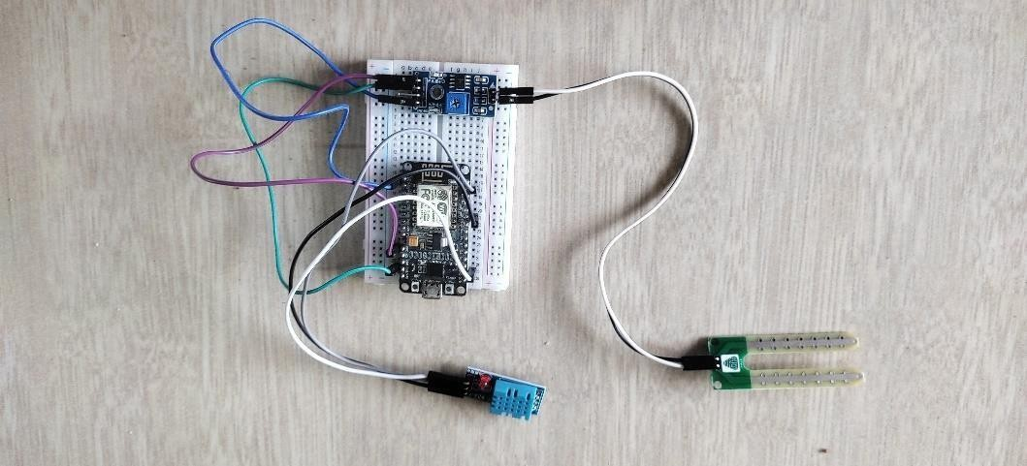
Fig. 1 Hardware Setup

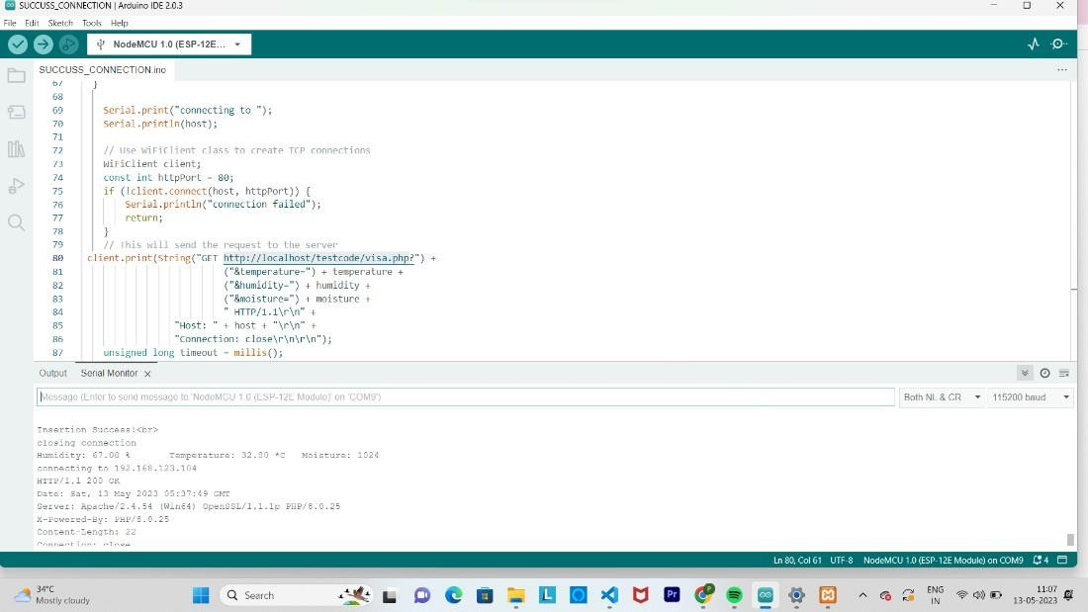
Fig. 2 Successful Hardware connection

This is a page in Arduino IDE, which shows the successful connection (Figure 2). "Insertion successful" or "Closing connection" in the serial monitor would indicate that the hardware connection and communication process between the device and the computer have been successfully established and terminated, respectively.

Database management
Create a MySQL database and table to store the data collected by the IoT device. A table to record the data feed and dispersing the data based on client request is formulated using PHP. The data dispersion is received in Json file format to the client. MySQL database is used here and has the functionalities to record, manage and retrieve data based on user queries.

User interface

A web-based platform is used to create an interface for the users to monitor the real- time soil moisture, humidity, temperature data in their fields. HTML, CSS and Javascript and Leaflet are used in frontend to develop the user interaction side like registration page, login page and visualization page in a responsive manner. For dynamic active response of the user interface for the queries of users AJAX is used enhance the user interface experience. The soil moisture, humidity and temperature data retrieved from server at a specified interval is displayed in the respective division representing the different stations. Also, the monitoring stations can be envisioned in an interactive web map. The users can click a monitoring station to view its status. This enhances the user to experience the monitoring job in a much easier way. The monitoring stations can be envisioned in an interactive web map. The users can click a

monitoring station to view its status. This view shows the spatial location of the stations.

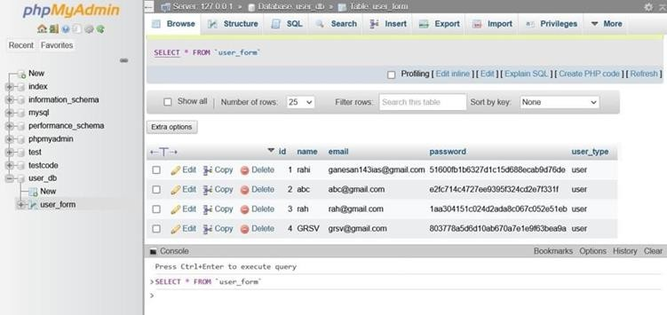
Fig.3 Registration Page
Fig. 4 Database- User Details


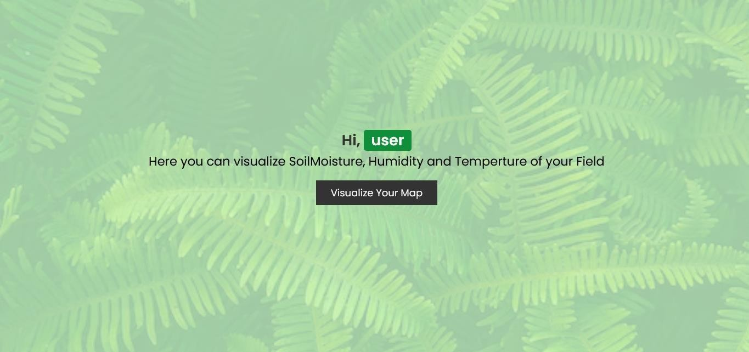
Fig. 5 Login Page

Fig. 6 User Page

The user should register the details asked in the registration page (Figure 3) and a sample database page (Figure 4). This is how our registered details store in the database and once the user has registered, then they have to login to get the required data about their field (Figure 5). After logged in, the next page is displayed as above image. By clicking on Visualize your map, you can view the below dynamic map (Figure 6).

WebGIS

WebGIS, also known as Web Geographic Information System, is a technology that combines geographic information system (GIS) capabilities with web mapping technologies to enable the visualization, analysis, and sharing of geospatial data and maps over the internet. It allows users to access and interact with spatial data through a web browser without the need for specialized GIS software.

VISUALIZATION OF DYNAMIC MAP

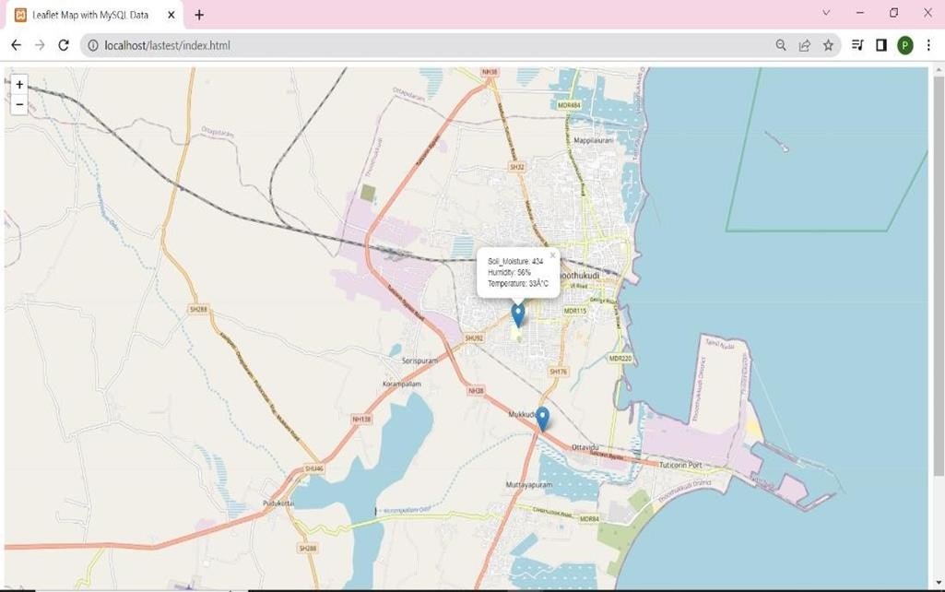
Fig. 7 VISUALIZATION OF DYNAMIC MAP

The dynamic map that shows the Leaflet library uses an OpenStreetMap (OSM) base map, along with fetching data from a MySQL database (Fig. 7) storing IoT data using php language
and display the IoT data on the map by creating markers and popup visual elements. Thus, this Dynamic Map shows the data of desired station,
    - Soil Moisture: 434

    - Humidity: 56%

    - Temperature: 32C

Discussion
The solution shows how contemporary web technologies and embedded hardware systems may be used to provide real-time environmental parameter monitoring and visualization. The NodeMCU ESP8266 validates the dependability of Wi-Fi-enabled microcontrollers for remote sensing applications by reliably gathering data from several sensors and transmitting it wirelessly. Efficient client-server data processing and interchange is ensured by the use of PHP for server-side scripting and JSON for data formatting. The platform's usability is improved by the dynamic frontend driven by AJAX, which enables real-time user interaction without page reloads. Furthermore, understandable geographic representation of sensor data is made possible by the WebGIS platform's integration of Leaflet with OpenStreetMap. When combined, these components provide a scalable and efficient way to monitor the environment remotely while gaining geographic insights.

Conclusion
The system uses a small and effective IoT setup to enable precise and dependable monitoring of three important environmental variables: temperature, humidity, and soil moisture. Users are guaranteed timely and geographically relevant insights via the wireless transfer of sensor data to a centralized database and dynamic visualization via a responsive web interface. The platform's capacity to integrate spatial representation via WebGIS with sensor data improves the information's usefulness for well-informed analysis. The results validate the system's role in facilitating data-driven environmental assessment using integrated IoT and web technologies by confirming its functionality, responsiveness, and user accessibility.

References:
Chlingaryan, A., Sukkarieh, S., & Whelan, B. (2018). Machine learning approaches for crop yield prediction and nitrogen status estimation in precision agriculture: A review. Computers and electronics in agriculture, 151, 61-69.
Kamilaris, A., Kartakoullis, A., & Prenafeta-Boldú, F. X. (2017). A review on the practice of big data analysis in agriculture. Computers and electronics in agriculture, 143, 23-37.
Khanna, A., & Kaur, S. (2019). Evolution of Internet of Things (IoT) and its significant impact in the field of Precision Agriculture. Computers and electronics in agriculture, 157, 218-231.
Nandurkar, S. R., Thool, V. R., & Thool, R. C. (2014). Design and development of precision agriculture system using wireless sensor network. In 2014 First international conference on automation, control, energy and systems (ACES) (pp. 1-6). IEEE.
Panduman, Y. Y. F., Funabiki, N., Fajrianti, E. D., Fang, S., & Sukaridhoto, S. (2024). A survey of AI techniques in IoT applications with use case investigations in the smart environmental monitoring and analytics in real-time IoT platform. Information, 15(3), 153.
Ramani, D. R., Sujitha, B. B., & Tangade, S. (2025). Smart Environmental Monitoring Systems: IoT and Sensor‐Based Advancements. Environmental Monitoring Using Artificial Intelligence, 45-60.
Rawat, P., Singh, K. D., Chaouchi, H., & Bonnin, J. M. (2014). Wireless sensor networks: a survey on recent developments and potential synergies. The Journal of supercomputing, 68, 1-48.
Salam, A. (2024). Internet of things for sustainable community development: introduction and overview. In Internet of Things for Sustainable Community Development: Wireless Communications, Sensing, and Systems (pp. 1-31). Cham: Springer International Publishing.
Soni, P., Kumar, R., Mishra, S., Swain, S., Mishra, P., & Kumar, S. S. (2025). Optimized neural network for soil moisture prediction in precision agriculture. Measurement, 252, 117380.
Torres-Quezada, E., Fuentes-Peñailillo, F., Gutter, K., Rondón, F., Marmolejos, J. M., Maurer, W., & Bisono, A. (2025). Remote Sensing and Soil Moisture Sensors for Irrigation Management in Avocado Orchards: A Practical Approach for Water Stress Assessment in Remote Agricultural Areas. Remote Sensing, 17(4), 708.
Wang, J., Wang, Y., Li, G., & Qi, Z. (2024). Integration of remote sensing and machine learning for precision agriculture: a comprehensive perspective on applications. Agronomy, 14(9), 1975.
Wolfert, S., Ge, L., Verdouw, C., & Bogaardt, M. J. (2017). Big data in smart farming–a review. Agricultural systems, 153, 69-80.

