# A Narrative Review on Transforming Finger millets (*Eleusine coracana*) into a Superfood through Germination

Review Article

**ABSTRACT**

Millets are a staple grain for ages, they are essential for maintaining food security in semiarid region. They are considered as functional food because of their low glycemic index, gluten free status and high dietary fibre and mineral content. Millets are of two types namely major mille ts and minor millets. Major millets include finger millet, sorghum, and pearl millet whereas minor millet include kodo millet, barnyard millet, little millet, foxtail millet and foxtail millet. finger millet is a type of major millet. It is known by different names in different regions. Finger millet is one of the most nutrient dense grain because of its high protein content and well balanced amino acid profile. It contains high level of various micronutrients, includ ing vitamins and minerals such as riboflavin, nicotinic acid, thiamine, calcium, phosphorus, iron etc. Although finger millet is more nutritious than other cereal grain, it is not widely utilized. Various processing techniques such as popping, roasting, germination, fermentation etc have been found to reduce anti-nutritional factor and enhance nutritional profile. Finger millet consumed in numerous ways from ancient times. By applying these processing techniques, sensory aspect as well as nutritional composition improves which helps in development of various food products with improved sensory attributes and nutritional composition. This review talks about millets, finger millet, its nutritional composition, different processing techniques used for finger millet. A special focus on the effect of germination on finger millet and development of value added product with it is given.

**KEYWORDS**

Finger Millet, Functional Properties Germination, Millets, and Nutritional Composition,

**INTRODUCTION**

### Millets

The word "millet" comes from the French word "mille," which means "thousand," because as many as 1,000 grains can be found in a handful of millet. These tiny-seeded crops, which are part of an agronomic functional group, can be fed to people or used as fodder. The grass family includes the tiny, delicious seeds known as millets (Rajkumar et al., 2024). The Poaceae family

includes a variety of small grains regarded as millets. Small seeds and the capacity to flour ish in less fertile soils are characteristics of these annual cereal grasses. They have evolved to survive in hot, dry conditions. Millets are often considered a food refuge crop due to their resilience in harsh agro-climatic conditions (Patil et al., 2023). Millets are of two types namely major millets and minor millets. Major millets include Sorghum (*Sorghum bicolor* L.), Pearl millet (*Pennisetum glaucum*), Finger millet (*Eleusine coracana*), whereas minor millet includes Kodo millet (Paspalum setaceum), Proso millet (Penicum miliaceum), Foxtail millet (*Setaria italic*), Little millet (*Panicum sumatrense*), and Barnyard millet (*Echinochloa species*). Millets are a staple grain for ages, they are essential for maintaining food security in semiarid areas. They are considered functional foods because of their low glycemic index, gluten- free status, and high dietary fiber and mineral content (Kumar et al., 2021). Millets also include ẞ-glucan and water-soluble gums, which help to improve glucose metabolism (Vya, n.d.). They provide a balanced nutritional profile that can greatly improve the nutritio nal security of many people because they are high in protein, minerals, and dietary fiber (Rajkumar et al., 2024). Millets can contribute to food security and diversity in the food supply in terms of nutrition. They can help in managing diseases like diabetes, obesity, and hyperlipide mia along with several health benefits. Millets have high mineral content, which may aid in preserving the acid-base balance of body, and this high mineral content makes them regarded as "cool" meal. Compared to people who eat food other than millets, millet eaters typically reported as feeling more hydrated and less thirsty (Patil et al., 2023).

Millets are consumed in numerous ways from ancient times. Millets are sometimes parboiled, rolled into balls, eaten as flour, and served as milk-based porridge (FAO 2009). To prevent their antinutritional features and enhance their edible qualities, the FAO advises using traditional food processing techniques such decortications, milling, germination fermentat io n, malting, and roasting of millets. Functional properties, such as water and oil holding capacity, viscosity, foaming activity, bulk density, and swelling power of millets are the fundame ntal physicochemical properties that reveal the intricate relations between the structure molecular components and composition and physicochemical properties of food components. The aim of present study is understand about finger miller, the effect of germination on the nutritio nal composition, anti-nutritional factors and functional properties of finger millet along with the application of germinated and value added products.

### Finger Millet

Finger millet was referred to as "nrttakondaka," or "dancing grain," in ancient Indian Sanskrit literature. It was also termed as "rajika" and "markataka". Among other Indian states, it is called as "umi" in Bihar and "nachni" (meaning "dancer") in Maharashtra, (Patil et al., 2023). India is one of the world's biggest producers of finger millet. With approximatly 1,138.2 thousand hectares of land devoted to its cultivation and a production of roughly 1,821.9 thousand tons in 2015-16 was made (Kumar et al., 2021). The taxonomical classification of finger millet in presented in figure 1.

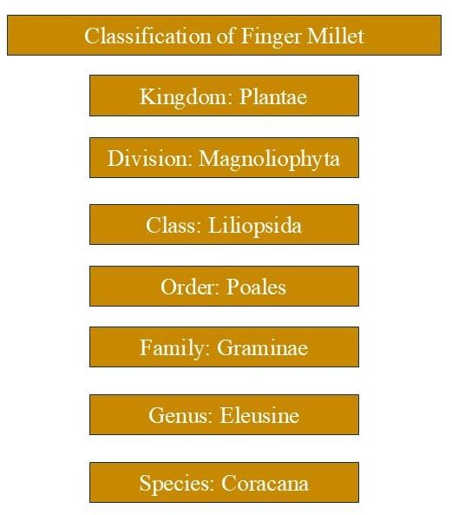

**Figure1:** Taxonomical classification of Finger millet

The morphological features of finger millet are diverse. The testa, is a seed coat that covers the embryo and endosperm of finger millet. It is a single-seeded, tiny grain with a kernel that is categorized as an achene rather than a normal caryopsis. The grains are rubbed and then immersed in water to remove the small seed covering. The kernels range in size from 1 to 1.8 mm and could be globular, round, or oval in shape (Rajkumar et al., 2024). This crop has a variety of colours, including white, red, yellow, violet, tan, and brown. Finger millets are cultivated in 25 countries across Asia and Africa, occupying about 12% of the land dedicated to millet crops. Finger millet is also a drought-tolerant crop that grows well in salty soils with a pH between 5.0 and 8.2, which makes it appropriate for dryland farming. It is one of the most nutrient-dense grains because of its high protein content and well-balanced amino acid profile. Although finger millet is more nutritious than other cereal grains, it is not widely utilized (Rajkumar et al., 2024). However, they are frequently disregarded and misused in tropical and semi-arid areas. Further, varieties of finger millets and their area of adaptation are presented in Table 1.

### Table 1: Variety of finger millet along with Year of release and Area of adaptation

|  |  |  |
| --- | --- | --- |
| **Variety** | **Year of release** | **Area of adaptation** |
| Finger Millet VL Mandua 149 | 1991 CVRC | Uttarakhand Hills & all millet growing areas except Tamil Nadu & A.P. |
| Finger Millet VL Mandua  146 | 1996 CVRC | UP, Orissa, South Bihar, Maharashtra and  Karnataka |
| Finger Millet VL Mandua 315 | 2006 SVRC | Uttarakhand Hills |
| Finger Millet VL Mandua  324 | 2006 SVRC | Uttarakhand Hills |
| Finger Millet VL Mandua  347 | 2012 CVRC | Bihar, Gujarat, Jharkhand, Karnataka,  Madhya Pradesh and Uttarakhand |

|  |  |  |
| --- | --- | --- |
| Finger Millet VL Mandua  352 | 2014 CVRC | All finger millet growing state except Tamil  Nadu and Maharashtra |
| Finger Millet VL Mandua  348 | 2016 SVRC | Uttarakhand Hills |
| Finger Millet VL Mandua 376 | 2018 CVRC | Andhra Pradesh, Bihar, Gujarat, Jharkhand, Karnataka, Madhya Pradesh, Odhisa, Uttarakhand, Maharashtra and Tamil Nadu |
| Finger Millet VL Mandua 379 | 2018 CVRC | Uttarakhand, Bihar, Jharkhand, NE States and Madhya Pradesh |
| Finger Millet VL Mandua  380 | 2019 SVRC | Uttarakhand |
| Finger Millet VL Mandua 378 | 2021 SVRC | Uttarakhand |
| Finger Millet VL Mandua  382 | 2021 SVRC | Uttarakhand |

Finger millet is traditionally processed in India using a variety of techniques, includ ing grinding, malting, and fermentation, to create dishes such as porridges, drinks, sand roti (unleavened flatbread), idli, and dosa. The grain of finger millet is gluten-free (Rajkumar et al., 2024). Compared to regular cereal rice, it is more nutrient-dense and has higher levels of protein, fat, minerals, and dietary fiber. It’s nutritional profile is presented in table 2. Finger millet is an easy-to-digest grain that doesn't generate acid and has low allergenicity (Vya, n.d.). This grain is regarded as one of the most nutrient-dense grains because of its high protein content and balanced amino acid composition (Kumar et al., 2021). (Vya, n.d.). Finger millet contains high levels of various micronutrients, including vitamins and minerals such as riboflavin, nicotinic acid, thiamine, calcium, phosphorus, and iron (Rajkumar et al., 2024). Furthermore, finger millet contains a significant amount of bioactive substances that support its antibacterial and antioxidant qualities (Kumar et al., 2021). The calcium level of finger millet ranges from 300 to 400 mg, which is around ten times that of typical grains like rice and wheat (Patil et al., 2023). However, its nutritional value may be limited by the presence of anti-nutrients such phytic acid, trypsin inhibitors, and certain phenolic chemica ls. These substances can interfere with the absorption of vital nutrients like proteins and chelate minerals.

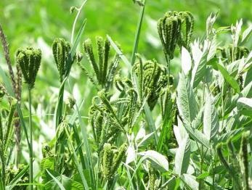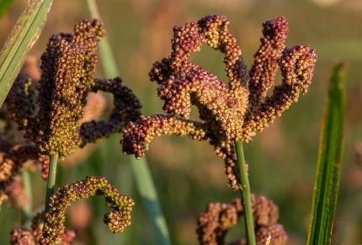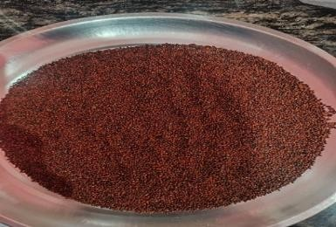

**Figure 2:** Represents Underripe Finger Millet (left), Ripe Finger Millet (middle), Grains of Finger Millet (right)

**Image(left)** [**https://images.app.goo.gl/8BqyePHoZPtUZzri9**](https://images.app.goo.gl/8BqyePHoZPtUZzri9)

**Image(middle)** [**https://www.google.com/imgres?imgurl=https%3A%2F%2Fbold.croptrust.org%2Ffileadmin%2Fuploads%2Fcroptrust%2FPhoto**](https://www.google.com/imgres?imgurl=https%3A%2F%2Fbold.croptrust.org%2Ffileadmin%2Fuploads%2Fcroptrust%2FPhotos%2FCWR%2F1_3CWRFingerMillet.jpg&tbnid=RIEdgnWBWhJ3kM&vet=1&imgrefurl=https%3A%2F%2Fbold.croptrust.org%2Fcrops%2Ffinger-millet%2F&docid=j9r49NpT9QJZfM&w=7415&h=5020&itg=1&hl=en-IN&source=sh%2Fx%2Fim%2Fm1%2F4&kgs=ca67f98b3190246f)[**s%2FCWR%2F1_3CWRFingerMillet.jpg&tbnid=RIEdgnWBWhJ3kM&vet=1&imgrefurl=https%3A%2F%2Fbold.croptrust.org**](https://www.google.com/imgres?imgurl=https%3A%2F%2Fbold.croptrust.org%2Ffileadmin%2Fuploads%2Fcroptrust%2FPhotos%2FCWR%2F1_3CWRFingerMillet.jpg&tbnid=RIEdgnWBWhJ3kM&vet=1&imgrefurl=https%3A%2F%2Fbold.croptrust.org%2Fcrops%2Ffinger-millet%2F&docid=j9r49NpT9QJZfM&w=7415&h=5020&itg=1&hl=en-IN&source=sh%2Fx%2Fim%2Fm1%2F4&kgs=ca67f98b3190246f)

[**%2Fcrops%2Ffinger-millet%2F&docid=j9r49NpT9QJZfM&w=7415&h=5020&itg=1&hl=en-**](https://www.google.com/imgres?imgurl=https%3A%2F%2Fbold.croptrust.org%2Ffileadmin%2Fuploads%2Fcroptrust%2FPhotos%2FCWR%2F1_3CWRFingerMillet.jpg&tbnid=RIEdgnWBWhJ3kM&vet=1&imgrefurl=https%3A%2F%2Fbold.croptrust.org%2Fcrops%2Ffinger-millet%2F&docid=j9r49NpT9QJZfM&w=7415&h=5020&itg=1&hl=en-IN&source=sh%2Fx%2Fim%2Fm1%2F4&kgs=ca67f98b3190246f)[**IN&source=sh%2Fx%2Fim%2Fm1%2F4&kgs=ca67f98b3190246f**](https://www.google.com/imgres?imgurl=https%3A%2F%2Fbold.croptrust.org%2Ffileadmin%2Fuploads%2Fcroptrust%2FPhotos%2FCWR%2F1_3CWRFingerMillet.jpg&tbnid=RIEdgnWBWhJ3kM&vet=1&imgrefurl=https%3A%2F%2Fbold.croptrust.org%2Fcrops%2Ffinger-millet%2F&docid=j9r49NpT9QJZfM&w=7415&h=5020&itg=1&hl=en-IN&source=sh%2Fx%2Fim%2Fm1%2F4&kgs=ca67f98b3190246f)

Fortunately, various processing techniques such as popping, roasting, germination, and fermentation have been found to reduce these anti-nutritional factors to safe levels. Among these methods, germination is considered an important and cost-effective approach to enhance the digestibility of finger millet while decreasing its anti-nutritional content (Kumar et al., 2021). Conventional techniques such as steeping, germination, and fermentation are employed to enhance the nutritional composition of grains. Among these, the germination process is particularly important for both practicality and improving nutritional value. The nutritio nal benefits of germinated millets arise from the significant changes that occur during the germination process, which enhance their nutrient profile (Rajkumar et al., 2024).

**Table 2: Nutritional composition of finger millets**

|  |  |  |  |
| --- | --- | --- | --- |
| **Nutritional value** | **% or mg/100g** | **g/100g or mg/100g** | **g/100g or mg/100g** |
| **Protein content** | 6.04±0.14 % | 7.16 g | 6.3 ± 0.2 g |
| **Fat content** | 0.57±0.02 % | 1.92 g | 1.3± 0.2 g |
| **Ash content** | 2.27±0.12 % | 2.04 g | 2.8± 0.17 g |
| **Crude fibre content** | 3.74±0.16 % | - | 18.9 ± 0.2 g |
| **Carbohydrate content** | - | 66.82 g | 71.9± 1.9 g |
| **Starch** | 62.83±0.65 % | - | - |
| **Calcium content** | 193.5 + 0.9 mg/100g | 364 mg | 342.4 ± 1.36 mg |
| **Iron content** | 5.56±0.39 mg/100g | 4.62 mg | 3.7 ± 0.06 mg |
| **Phosphorus content** | 219.7±0.6 mg/100g | 210 mg | 280.1± 1.23 mg |
| **Magnesium content** | - | 146 mg | - |
| **Vitamin C content** | 9.76±0.24 mg/100g | - | 0.04 ± 0.01 mg |
| **Reference** | Kumar et al., 2021 | Bisht Jawaharlal  Nehru Krishi Vishwa Vidyalaya et al., 2023 | (Chauhan et al.,  2018) |

## PROCESSING TECHNIQUES FOR FINGER MILLETS

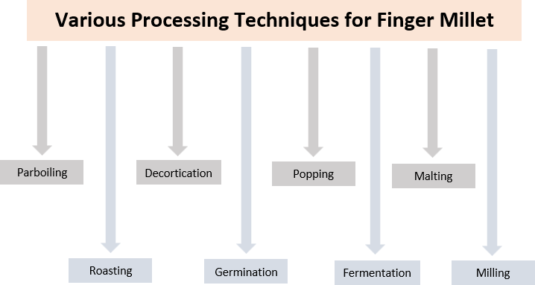

**Figure 3**: Processing techniques for finger millets

### Parboiling

In order to maximize grain recovery without nutrient loss, parboiling is a hydrothermal treatment applied to cereals and millets before decortications. Soaking, heating, and drying are the methods used. In addition to increasing endosperm hardness compared to unparboiled grains, parboiling aids in the penetration of water-soluble nutrients from the outside layer of the grain seed coat to the inner layer of the grain. As a result, during the decortication process, the nutrients found in the grains' outer layer remain intact (Rathore et al., 2019)

### Roasting

Roasting is a most widely used cooking method where hot air cooks the food material evenly from all sides at around 150°C temperature in an open pan. grinding and roasting enhances grain digestibility and prevent nutrients losses (Rathore et al., 2019). Roasting is similar to puffing process but differs in the volume expansion which is higher in puffing. Roasting improves the nutritional quality and increases the shelf-life of the roasted grains. Tryptin inhibitors, hemagglutinin, alkaloids, glycosides, gioterogenic compounds, saponins, and other substances with toxic or antinutritional effects are eliminated during roasting (Ramashia et al., 2019).

### Decortication

Decortication is a process that involves mechanically removing the outer layer of the grains' seed coat to debran the grains. The presence of a seed coat affixed to delicate endosperm makes decortication of finger millet challenging. Therefore, hydrotherma l treatments like hydration, steaming, and drying are used to decorticate finger millet. This makes the endosperm texture harder and the nutritional value of the finger millet grains higher (Rathore et al., 2019). The small millets can be dehulled and decorticated using a centrifugal sheller (Jaybhaye et al., n.d.). It was previously impossible to cook the decorticated millet as separate grains like rice and achieve a soft, edible texture in just five minutes. To enhance their edible and sensory qualit ies as well as the visual appeal of their food items, they are decorticated prior to eating (Saleh et al., 2013).

### Germination

The process through which the embryo in the seed is activated and starts to develop into a new seedling is known as germination. The growth of a plant inside a seed, known as germinat io n, produces a seedling. It also involves the reactivation of the seed's metabolic machinery, which leads to the appearance of a plumule and radicle. Germination is a process by which the embryo in the seed becomes activated and begins to grow into a new seedling. Germination is usually the growth of a plant contained within a seed; it results in the formation of the seedling; it is also the process of reactivation of metabolic machinery of the seed resulting in the emergence of radicle and plumule. The process of germination, which involves the seed entering a vital active state, is a biochemical enrichment tool (Chauhan et al., 2018). It improves nutritive value of seed and reduces the levels of anti-nutriental factor as well as maximise the optimum level of absorbable nutrients. It is a traditional and economical processing technique which is used to improve or enhance the nutritional and functional properties of grains including their digestibility (Nefale & Mashau, 2018).

### Popping

Popping is a type of starch cookery which is the simplest, inexpensive and fastest traditiona l method. It is a procedure of dry heat application on kernels of seeds until internal moisture expands, for preparation of healthy ready-to-eat snack products as well as making weaning foods. In addition to being crunchy, porous, and precooked, popped grain adds flavor to food. Upon popping, finger millet develops a very palatable flavour.

### Fermentation

A metabolic process called fermentation uses microorganisms to break down complex materials into simpler forms. Changes during fermentation, such as the degradation of protein, the increase in amino nitrogen, and the removal of inhibitors, it is the oldest and most efficie nt food processing and preservation technique (Rathore et al., 2019). Fermentation reduces antinutrient factors in millets. When microorganisms proliferate and break down starch during fermentation, they create their own byproducts, including acids or antibiotics (Ramashia et al., 2019). One method that improves protein availability, in vitro protein digestibility (IVPD), and nutritional value while lowering antinutrient levels in dietary grains is fermentation (Saleh et al., 2013). Fermentation enhances food's flavor and reduces antinutrients while raising its protein and calcium content (Birania et al., 2020). Depending on the product or beverages to be made, finger millet can be fermented for 24 to 72 hours at room temperature (Ramashia et al., 2019).

### Malting

To attain excellent nutritional quality, improved starch digestibility, improved sensory qualities, and decreased anti-nutritional activities, malting combines the steps of steeping, germination, drying, toasting, grinding, and sieving. While the antinutritional properties of tannins and phytic acid in brown millet are greatly reduced, malting enhances the grain's fiber, crude fat, vitamin B, vitamin C, and mineral content. Other advantages of malting include the elaboration of vitamin C, the increase in phosphorus availability, and the synthesis of lysine and tryptophan (Sahoo et al., 2010). Ragi is the best millet in terms of product quality and the release of enzymes during the malting process (Rao & Muralikrishna, n.d.). An added advantage of malting of ragi is in the production of an agreeable odour developed during the kilning of germinated grain (Malleshi and Desikachar, 1981).

### Milling

The pericarp, seed coat, nucellar epidermis, and aleurone layer are all typically removed during milling. The finger millet's soft, friable endosperm is firmly attached to its seed coat. Colored pigments are present in finger millet. It has been discovered that using abrasive-type milling equipment to debran finger millet is inefficient (Birania et al., 2020). Using a wooden or stoned mortar and pestle, this is the most popular traditional processing method for turning dried and moistened cereal grains into flour. The primary purpose of milling is to eliminate the grain's seed coat or fibrous coarse bran (Ramashia et al., 2019). Particularly in rural areas, millet grains are often ground for domestic consumption using a hand-cranked, non-motorized grain mill or another non-electric method. It is also possible to use a manual grain mill that has been connected to an electric or gas motor via a pulley system (Saleh et al., 2013). Finger millet grain requires dehulling and debranning before consumption because grain contains large portions of husk and bran. About 10% water is added to the grain during the milling process to

help remove the fibrous husk. Furthermore, removal of some phytochemicals such as phytates and tannin during milling improves the bioavailability of iron (Pragya Singh, 2012). Finger millet flours prepared in different type of cereal pulverizes differ in the digestible. Further, Table 3 present impact of various processing techniques on the nutritional profile of finger millet.

### Table3: Impact of Different Processing Techniques on the Nutritional Composition of Finger Millet

|  |  |  |  |  |  |  |
| --- | --- | --- | --- | --- | --- | --- |
| **Parameter** | **Roasting** | **Popping** | **Germina- tion (96h)** | **Parboiling/ hydro-**  **thermal treatment** | **Decortication** | **Malting (36h)** |
| **Moisture** | ↓ | ↓ | - | NC | ↓ | ↑ |
| **Total Solid** | ↑ | - | - | - | - | - |
| **Carbohydrate/**  **Total Sugar** | ↑ | ↑ | ↑ | ↑ | ↑ | ↑ |
| **Ash** | ↑ | ↑ | ↓ | - | ↓ | ↓ |
| **Crude Fibre** | ↑ | - | ↑ | ↓ | ↓ | ↑ |
| **Crude Fat** | ↓ | ↓ | ↑ | - | - | ↓ |
| **Protein** | ↓ | ↑ | ↓ | ↓ | ↓ | ↓ |
| **Iron** | ↑ | ↑ | ↓ | NC | ↓ | - |
| **Calcium** | ↑ | ↑ | ↑ | ↓ | ↓ | - |
| **Total Phenol** | ↓ | - | ↓ | - | - | - |
| **Antioxidant**  **Activity** | ↓ | - | ↑ | - | - | - |

↑- increase, ↓- decrease, NC- No Change

*Sources- Singh et al., 2018; Kumar et al., 2021; Dharmaraj & Malleshi, 2011; and Banusha & Vasantharuba, 2013*

## IMPACT OF GERMINATION ON NUTRITIONAL COMPOSITION

Through the process of germination, the embryo in the seed is activated and starts to develop into a new seedling. Germination is often the process by which a plant grows inside a seed, producing a seedling. It is also the process by which the seed's metabolic machinery is reactivated, causing a radicle and a plumule to develop (Abaye & Wulchafo, 2020). The process of germination, which involves the seed entering a vital active state, is a biochemic a l enrichment tool. It increases the optimal amount of absorbable nutrients, decreases anti- nutritional compounds, and improves the nutritious value of the seed (Chauhan et al., 2018). The nutritional and functional qualities of grains, especially their digestibility, can be improved or enhanced using this time-honored and cost-effective processing method (Nefale & Mashau, 2018). During germination, various biochemical changes occur, leading to increased levels of essential nutrients and bioactive compounds. This includes the activation of enzymes, which hydrolyze complex compounds such as starch, proteins, and fats into simpler forms like sugars, amino acids, and fatty acids. Additionally, the levels of certain bioactive constituents, includ ing

phenolics, flavonoids, and antioxidants, are enhanced through germination (Rajkumar et al., 2024). When a portion of the embryo, typically the radicle, extends to penetrate the surrounding structures, germination is complete. Germination begins when the dry seed absorbs water, a process known as imbibition. The radicle's penetration of the surrounding structures is typically the obvious indication that germination is complete; this process is frequently referred to as visible germination (Bewleyl, 1997).

(Abayechaw & Wulchafo, 2020) The following five modifications or actions are part of the seed germination process. During seed germina tion, these five modifications or processes take place:

1. Imbibition
2. Respiration
3. Effect of Light on Seed Germination
4. Mobilization of Reserves during Seed Germination and Role of Growth Regulators
5. Development of Embryo Axis into Seedling. (Bareke 2018) STAGES OF SEED GERMINATION

1st Stage

* + Imbibition - initial absorption of water to hydrate seed
  + Activation of metabolism - increased respiration and protein synthesis. 2nd Stage
  + Digestion of stored food- for example, starch to sugars in cotyledon or endosperm
  + Translocation to embryo- sugars move to embryo for growth 3rd Stage:
  + Cell division and growth-development of seedling.

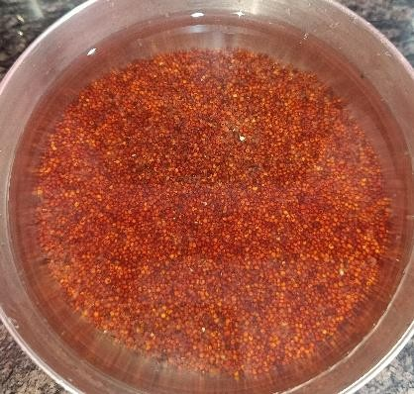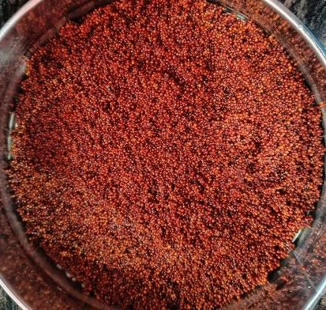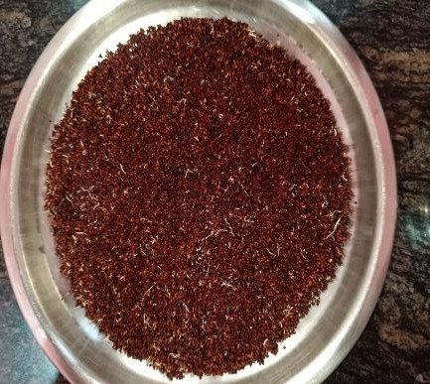

**Figure 4** Represents soaking (left), after 12 h soaking (middle), 24h germination (right)

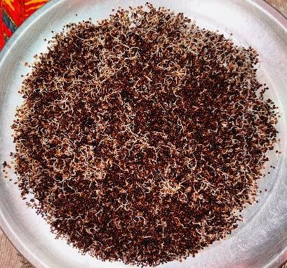 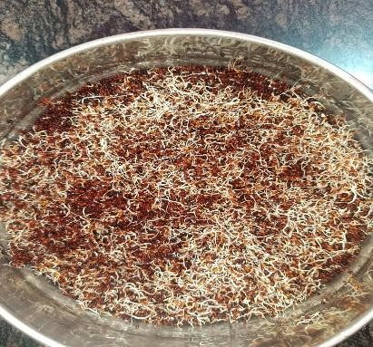 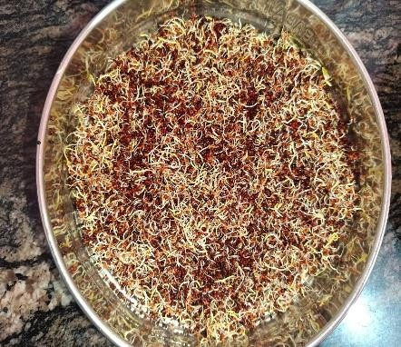

**Figure 5** Represents 48 h germination (left), 72 h germination (middle), 168 h germination (RIGHT)

## IMPACT OF GERMINATION ON SUGAR OR CARBOHYDRATE CONTENT

(Kumar et al., 2021) observed after 96 hours of germination, reducing sugars rose from the initial 0.86% to 10.54% and total sugars from 1.70% to 16.10%, indicating a positive linear relationship between germination time and sugar content. This increase in sugars and decrease in starch may be the result of starch being broken down into sugars during germinat io n. (Mbithi-Mwikya et al., 2000) mentioned Over the first 36 hours of germination, the amount of starch gradually decreased. A significant rise in sugars and a matching drop in starch content occurred between 36 and 48 hours. Between 0 and 96 hours, the total amount of starch dropped from 71.3% to 35.1%. The abrupt alterations that occur between 36 and 48 hours may be the result of a type of loss of dormancy, in which amylolytic enzymes that are produced in the aleurone layer move to the endosperm and initiate the hydrolysis of the starch granules. In other study (Chauhan et al., 2018) noticed a drop in the amount of carbohydrates follow ing germination. The decrease in carbohydrate content may be the result of increased α-amylase activity and its use as an energy source to start the germina tion process. The complex carbohydrates are broken down into simple sugar by the enzyme α-amylase, which is used to develop seeds during the initial stage of germination. (VF et al., 2018) discovered a similar outcome a drop in the amount of carbohydrates after 96 hours of germination. (Owheruo et al., 2019) agree on decrease of carbohydrate content after germination.

## IMPACT OF GERMINATION ON PROTEIN CONTENT

(Kumar et al., 2021) reported that the protein content gradually decreases as the germina t ion time increases. The protein level decreased from 6.04% to 3.41% after 96 hours of germinat io n. The decrease in protein content during germination might be due to the outpacing of protein synthesis by proteolysis, and hence, an increase in free amino acid content (lysine, tryptophan, methionine and cysteine) and migration of seed nitrogenous matter to the growing embryo . (Banusha & Vasantharuba, 2013) had similar finding of decreased protein content. Conversely, (Chauhan et al., 2018) coated the protein content rose dramatically from 6.3±0.20 g/100g to

7.1±0.30 g/100g during the germination period. Similar findings were reported by (VF et al., 2018), who noted that the protein concentration increased as the germination period increased and ranged from 8.57% to 9.80%. (Mbithi-Mwikya et al., 2000) agrees that germination led to a small rise in protein content. The germination rate increases from 6.1% to 7.9% after 96 hours. Overall, there was a 29.5% gain. This rise has been linked to respiration-induced dry matter loss, especially of carbs, which appears to increase other nutrients like protein.

## IMPACT OF GERMINATION ON FAT CONTENT

(Kumar et al., 2021) observed that after 48 hours of germination, the crude fat level dropped from 0.57% to 0.41%, then gradually increased to 0.85% in samples that germinated for 96 hours. It's possible that fat oxidizes to fatty acids and water and is used as a carbon source, which explains why fat decreases as germination increases. During extended germination, the amount of fat in the grains may rise as a result of the substitution of sugars as an energy source and the depletion of carbs. (Banusha & Vasantharuba, 2013) had an observation, total fat content in un-germinated and 36 hrs after germinated finger millet was found as 1.42% and 1.32%, respectively. A decrease was observed. (Owheruo et al., 2019) agrees on the decrease of fat content upon germination. In other research, the opposite outcome is seen. (Chauhan et al., 2018) mentioned the fat content of GFMF (germinated finger millet flour) is 2.0±0.2 g/100g, while that of WRFMF (whole raw finger millet flour) is 1.3±0.2 g/100g. Following germination, it was discovered that the fat content rose. Similar result was obtained by (VF et al., 2018). As the germination period grew, so did the fat content.

## IMPACT OF GERMINATION ON CRUDE FIBRE CONTENT

(Kumar et al., 2021) found that crude fiber significantly increased with germination lasting longer than 24 hours. The crude fibre increased from initial 3.74% to 5.09% after 96 h of germination. The increase in crude fibre content might be due to rapid loss of starchy components. Parts of roots and shoots that remain adhered to millet grains after deculming can also increase the crude fibre content. (Chauhan et al., 2018) According to previous research, finger millet's moderate amount of crude fiber contributes to its low energy content and high fiber content. Crude fiber values for WRFMF (whole raw finger millet flour) and GFMF (germinated finger millet flour) were 18.9±0.2 and 20.0±0.3, respectively. The crude fiber content rose noticeably in the germinated samples. (VF et al., 2018) mentioned, the longer the germination period, the higher the fiber content. After germination, it rose from 2.30% to 2.65%. (Banusha & Vasantharuba, 2013) had similar finding of gradual increase in crude fibre content. The production of structural carbohydrates like cellulose and hemicelluloses could be the cause of this rise. (Owheruo et al., 2019) found a significant increase in the fibre content of finger millet.

## IMPACT OF GERMINATION ON MOISTURE CONTENT

(Chauhan et al., 2018) Reported WRFMF (whole raw finger millet flour) and GFMF (germinated finger millet flour) had moisture contents of 13.1±0.1 and 16.25±0.25 (g/100g), respectively. The moisture content of GFMF was significantly higher than that of WRFMF. (VF et al., 2018) mentioned The moisture content increased as the germination period increased and ranged from 9.20% to 8.87%. This makes it clear that there are noticeable increases in moisture content during germination, which could be explained by the fact that the entire grains take up moisture from the soaking media to start metabolism, which in turn affects the grain's structure. A greater number of the seeds' cells become hydrated as the soaking period increases. On the other hand, (Banusha & Vasantharuba, 2013) found no significant change in the moisture content of the finger millet. Similarly, (Owheruo et al., 2019) had no signific ant change in moisture content.

## IMPACT OF GERMINATION ON ASH CONTENT

(Kumar et al., 2021) observed that the amount of ash decreased from 2.27% at the beginning of germination to 1.24% after 96 hours. The utilization of certain minerals in the metabolis m of seed sprouting may be the cause of the reduced ash content of germinated grains. Mineral loss may also be caused by abrasion during the removal of germinated grains' roots and shoots, which removes the bran layer. On the contrary, (Chauhan et al., 2018) mentioned WRFMF (whole raw finger millet flour) and GFMF (germinated finger millet flour) had respective total ash contents of 2.8±0.17 and 2.7±0.10 (g/100g). Following processing, GFMF (Germina ted Finger Millet Flour) and WRFMF (Whole Raw Finger Millet Flour) did not significantly differ in terms of ash concentration. (VF et al., 2018) coated, a rise in ash content as the germina t ion time increases. After germination, it rose from 3.47% to 3.73%. (Banusha & Vasantharuba, 2013) found no significant difference in the ash content of the finger millet. Simila r ly, (Owheruo et al., 2019) had no significant change in ash content.

## IMPACT OF GERMINATION ON VITAMIN C

(Kumar et al., 2021) found that after 96 hours of germination, the finger millet's ascorbic acid level rose from 9.76 to 17.40 mg/100 g. Vegetative growth, which is known to increase ascorbic acid content, may be the cause of the ascorbic acid rise. (Chauhan et al., 2018) mentioned that Vitamin C concentration is greatly increased during the germination phase, rising from 0.04 to

0.06 mg/100 g.

## IMPACT OF GERMINATION ON MINERAL CONTENT CALCIUM

(Kumar et al., 2021) found that after soaking, the calcium content of non-germinated finger millet decreased, and then increased linearly as the germination period increased. The loss of organic dry matter from the grains during germination may be the cause of the rise in calc ium, which would raise the grains' calcium percentage. (Chauhan et al., 2018) found comparable outcomes, showing a substantial rise in calcium content during germination. (Owheruo et al., 2019) found a significant increase in the calcium content of finger millet after germination.

## IRON

(Kumar et al., 2021) found that the iron concentration was negatively impacted by germinat io n. After 96 hours of germination, the iron content decreased by 63.7%. On the contrary, (Chauhan et al., 2018) found the opposite: following germination, the finger millet's iron concentration rises noticeably. (Owheruo et al., 2019) found a significant decrease in the iron content of finger millet after germination.

## PHOSPHORUS

(Kumar et al., 2021) found that phosphorus decreased linearly as germination time increased, with a 28% phosphorus loss detected after 96 hours of germination. (Chauhan et al., 2018) found similar results that the phosphorus content significantly decreased during germination.

## IMPACT OF GERMINATION ON ANTINUTRIENT COMPOUND

(Kumar et al., 2021) found that as time increases, the tannin content decreases. Another study had similar findings. (Chauhan et al., 2018) mentioned During the germination process, the tannin content dramatically dropped. It was discovered that leaching caused a decrease in tannin during germination. (Mbithi-Mwikya et al., 2000) mentioned similar result. Reduction in tannin content was recorded. It has been determined that the reported decrease in tannin concentration in germinated seeds is not the result of tannin loss or degradation, but rather of the hydrophobic interactions that tannins make with seed proteins and enzymes. (Owheruo et al., 2019) had a similar finding, reduction in tannin content was observed. (Chauhan et al., 2018) The phytic acid content significantly decreases because phytase activity during germination hydrolyzes phytate to phosphate and myoinositol phosphates, increasing the availability of phosphorus over phytate, the meal becomes more nutritious. (Owheruo et al., 2019) found a significant reduction in the amount of phytate after germination. (Chauhan et al., 2018) The use of trypsin inhibitor as an energy source and its breakdown by peptic and pancreatic hydrolytic enzymes may be the causes of the apparent drop in trypsin inhib itor activity that was seen during germination. A decrease in the level of trypsin is observed in another study by (VF et al., 2018)

## IMPACT OF GERMINATION ON FUNCTIONAL PROPERTIES

(Kumar et al., 2021) mentioned after 96 hours of germination, WSI rose from 3.64% to 15.73%, a substantial rise with an increase in germination period. The breakdown of starch into smaller granules and an increase in sugar content could be the cause of the WSI increase. (Kumar et al., 2021) After 60 hours of germination, WAI and OAI rose before declining linearly. The rise in surface area and damaged starch is the cause of this increase in WAI and OAI. Damaged starch absorbs more water because it is more hygroscopic than native starch. After 60 hours of germination, the breakdown of starch to sugars and a decrease in starch content may be the cause of the drop in WAI and OAI. (VF et al., 2018) coated an increase in oil absorption capacity. Similar results were observed by (Nefale & Mashau, 2018) and (Yenasew & Urga, 2023) observed an increase in water absorption capacity and oil absorption index. After 60 hours of germination, the breakdown of starch to sugars and a decrease in starch content may be the cause of the drop in WAI and OAI. (Kumar et al., 2021) Up to 36 hours after germination, foam capacity rose; after that, it significantly decreased. A similar pattern was seen in the stability of the foam, and as the germination time increased, so did the foam's stability, which may have been brought on by the higher concentration of salts and sugars. The loss of foaming capabilities may be caused by a decrease in protein content. (VF et al., 2018) observed an increase in bulk density after 96 hours. The bulk density is generally affected by the particle size and the density. Similar results were obtained by (Yenasew & Urga, 2023) He also observed a decrease in bulk density after 72 hours of germination. (Nefale & Mashau, 2018)Also observed the similar result. (VF et al., 2018) Found a decrease in swelling capacity after 96 hours of germination. The swelling capacity of flour depends on the size of particles, type of variety and type of processing method. Similar results were obtained by (Yenasew & Urga, 2023) and (Nefale & Mashau, 2018) after 72 hours of germination.

## VALUE ADDED PRODUCTS OF GERMINATED FINGER MILLET

As the world is switching to more of nutritious food, millets offer the required nutrition. Finger millet is one of the most nutrient rich millet among all. It's nutrition and sensory properties are improved by germination. Germinated finger millet possess more of nutrients and less of anti- nutrients. Germinated finger millet can be used in the development of various kind of value added food products. It offers the development of different types of value-added food products such as bread, premix, cookies, noodles, porridge etc as mentioned in the table no. 4.

**Table 4: Value Added Products Developed with Germinated Finger Millet.**

|  |  |  |  |
| --- | --- | --- | --- |
| **Product name** | **Optimum germination time/Optimum ratio** | **Outcomes** | **Reference** |
| **Porridge** | _ | * Finger millet porridge's   physico-chemical functional and sensory qualities were positively impacted by germination.   * The flour's pH, viscosity, solubility, and bulk density all decreased as a result of germination. * With germination time, finger millet flour's TTA and   lightness value improved noticeably. | (Nefale &  Mashau, 2018) |
| **Ragi based premix** | 48 hrs | * The nutritional value enhanced with germination. * Increased the premix's energy density while decreasing its bulk density. | (Chaudhary et al., n.d.) |
| **Finger Millet**  **cum Wheat Bread** | 70:30  (Ragi flour: Wheat flour) | * In order to improve the   functional qualities, decrease antinutrients, and increase nutritional quality,  germination was essential.   * Germination improved all the required properties of the   product. | (Aanchal et al.,  2024) |
| **Malted Ragi Cookies** | _ | * When compared to the unmalted control sample,   cookies made with malted ragi flour performed better and had higher nutritional  benefits. | (Kokani et al., 2016) |

|  |  |  |  |
| --- | --- | --- | --- |
|  |  | * Iodine, minerals (Fe, Ca, P), fiber, and vitamins are   abundant in it. |  |
| **Malted Ragi Flour supplemented Noodle** | 70:30  (Wheat flour: Ragi flour) | * Compared to the control sample, it has greater values   for protein, fat, and minerals like calcium, iron, and phosphorus.   * It will be an excellent source of RTE for kids, teens, athletes, and women who are pregnant or breastfeeding. | (S et al., 2012) |
| **Weaning**  **food premix** | 25:37.5:37.5  (Rice: Green gram: finger millet) | * A high-quality, nutrient-dense   malt weaning food with  pleasing sensory qualities is  made. | (Jadhavar et al.,  2022) |

## CONCLUSION

Millets are a staple grain for ages, they are essential for maintaining food security in semiarid areas. These tiny-seeded crops, which are part of an agronomic functional group, can be fed to people or used as fodder. They are considered functional foods because of their low glycemic index, gluten- free status, and high dietary fiber and mineral content. Millets are of two types namely major millets and minor millets. Finger millet or "ragi" is one of the most nutrient - dense grains because of its high protein content and well-balanced amino acid profile. Finger millet contains high levels of various micronutrients, including vitamins and minerals such as riboflavin, nicotinic acid, thiamine, calcium, phosphorus, and iron. Furthermore, finger millet contains a significant amount of bioactive substances that support its antibacterial and antioxidant qualities. Various processing techniques such as popping, roasting, germinat io n, and fermentation have been found to reduce these anti-nutritional factors to safe levels. This review conclude, among these methods, germination is considered an important and cost- effective approach to enhance the nutritional composition, functional properties of finger millet while decreasing its anti-nutritional content. The nutritional benefits of germinated millets arise from the significant changes that occur during the germination process, which enhance their nutrient profile. Germination also improves the sensory attributes of finger millets which facilitates the development of various value added products. Finger millet is a nutrient dense grain consisting various health benefits. Research in this section need to be done as millets are the future food.

**REFERENCES**

1. Abayechaw, Desta & Wulchafo, Kedir. (2020). International Journal of Current Research and Academic Review The Concept and Process of Seed Germination -A Review. 100-112. 10.20546/ijcrar.2020.805.011.
2. Aanchal, R., Bansal, U., Bansal, V., Sobti, A. K., & Pradhan, R. (2024). Study on the Effect of Germination on the Nutritive Value of Finger Millet-Cum-Wheat for Developing Bread. *R&D of Functional Food Products*, *1*(5), 15–32. https://doi.org/10.31989/RDFFP.v1i5.1343
3. Banusha, S., & Vasantharuba, S. (2013). Effect of Malting on Nutritional Contents of Fingermillet and Mungbean. *J. Agric. & Environ. Sci*, *13*(12), 1642–1646. <https://doi.org/10.5829/idosi.aejaes.2013.13.12.12285>
4. Bareke, T. (2018). Biology of seed development and germination physiology. Advances in Plants & Agriculture Research, 8(4). <https://doi.org/10.15406/apar.2018.08.00335>
5. Bewley J. D. (1997). Seed Germination and Dormancy. The Plant cell, 9(7), 1055–1066. <https://doi.org/10.1105/tpc.9.7.1055>
6. Birania, S., Rohilla, P., Kumar, R., & Kumar, N. (2020). Post harvest processing of millet s :

A review on value added products. *International Journal of Chemical Studies*, *8*(1), 1824– 1829. https://doi.org/10.22271/chemi.2020.v8.i1aa.8528

1. Bisht Jawaharlal Nehru Krishi Vishwa Vidyalaya, K., Gudadhe, N., Raut, A. A., Bisht, K.,

Bisht, K., Gudadhe, N. N., Raut, A., & Dobhal, N. (2023). Nutritional Composition, Health Benefits, Production, Processing and Marketing of Finger Millet. In *Indian Journal of Fertilisers* (Vol. 19, Issue 10). https://[www.researchgate.net/publication/374730425](http://www.researchgate.net/publication/374730425)

1. Chaudhary, N., Vyas, S., & Joshi, I. (n.d.). *NUTRITIONAL COMPOSITION & ANTI- NUTRITIONAL CONTENT OF RAGI BASED AMYLASE RICH PREMIXES*.
2. Chauhan, E. S., & Sarita, S. (2018). Effects of processing (Germination and popping) on the nutritional and Anti-Nutritional properties of finger millet (Eleusine coracana). Current Research in Nutrition and Food Science Journal, 6(2), 566–572. <https://doi.org/10.12944/crnfsj.6.2.30>
3. Dharmaraj, U., & Malleshi, N. G. (2011). Changes in carbohydrates, proteins and lipids of finger millet after hydrothermal processing. *LWT*, *44*(7), 1636–1642. https://doi.org/10.1016/j.lwt.2010.08.014
4. Jadhavar, R. S., Jaiswal, S. G., & Bornare, D. T. (2022). Development of Weaning Food Premixes for Infants Based on Ragi, Green Gram and Rice. *International Journal of Food and Nutritional Sciences |*, *11*(6). https://doi.org/10.4103/ijfans_173_22
5. Jaybhaye, R. V, Pardeshi, I. L., Vengaiah, P. C., & Srivastav, P. P. (n.d.). Processing and Technology for Millet Based Food Products: A Review. In *Journal of Ready to Eat Food* (Issue 2). [www.jakraya.com/journal/jref](http://www.jakraya.com/journal/jref)
6. Kokani, R. C., Pournima Bharat, H., & Sakharam, K. S. (2016). Studies on Utilization of Ragi for Preparation of Malted Ragi Cookies. *International Journal of Science and Research*, *7*, 2319–7064. https://doi.org/10.21275/ART2018273
7. Kumar, A., Kaur, A., Gupta, K., Gat, Y., & Kumar, V. (2021). *Current Science Association Assessment of germination time of finger millet for value addition in functional foods*. *120*(2), 406–413. https://doi.org/10.2307/27310197
8. Mbithi-Mwikya, Stephen & Camp, John & Yiru, Y. & Huyghebaert, André. (2000). Nutrient and Antinutrient Changes in Finger Millet (Eleusine coracan) During Sprouting. LWT - Food Science and Technology. 33. 9-14. 10.1006/fstl.1999.0605.
9. Nefale, F. E., & Mashau, M. E. (2018). Effect of Germination Period on the Physicochemical, Functional and Sensory Properties of Finger Millet Flour and Porridge. In *Asian Journal of Applied Sciences*. [www.ajouronline.com](http://www.ajouronline.com/)
10. Owheruo, Joseph & Ifesan, Beatrice & Kolawole, Ayodele. (2018). Physicochemic a l properties of malted finger millet (Eleusine coracana) and pearl millet (Penniset um glaucum). Food Science & Nutrition. 7. 10.1002/fsn3.816.
11. Patil, P., Singh, S. P., & Patel, P. (2023). Functional properties and health benefits of finger millet (Eleusine coracana L.): A review. *The Journal of Phytopharmacology*, *12*(3), 196–

202. https://doi.org/10.31254/phyto.2023.12308

1. Pragya Singh. (2012). Finger millet for food and nutritional security. *African Journal of Food Science*, *6*(4). https://doi.org/10.5897/ajfsx10.010
2. Rajkumar, H., Muthu, I., James, P., Baskaran, S., Lakshmanan, K., Vellaichamy, M., Jeyaraj, S., & Pandi, P. (2024). “Enhancing Nutritional Profile, Functional Properties, Therapeutic Attributes of Finger Millet (Eluesinecoracana) by Germination: A Comprehensive Exploration.” In *Natural Product Communications* (Vol. 19, Issue 12). SAGE Publications Inc. https://doi.org/10.1177/1934578X241293027
3. Ramashia, S. E., Anyasi, T. A., Gwata, E. T., Meddows-Taylor, S., & Jideani, A. I. O. (2019). Processing, nutritional composition and health benefits of finger millet sub-Saharan Africa. *Food Science and Technology (Brazil)*, *39*(2), 253–266. https://doi.org/10.1590/fst.25017
4. Rao, $ M V S S T Subba, & Muralikrishna, G. (n.d.). *Non-starch polysaccharides and bound phenolic acids from native and malted ®nger millet (Ragi, Eleusine coracana, Indaf- 15)*. [www.elsevier.com/locate/foodchem](http://www.elsevier.com/locate/foodchem)
5. Rathore, T., Rakhi Singh, I., Dinkar Kamble, I. B., Upadhyay, A., Thangalakshmi, I. S., Correspondence Rakhi Singh, I., Singh, R., Kamble, D. B., & Thangalakshmi, S. (2019a). Review on finger millet: Processing and value addition. *~ 283 ~ The Pharma Innovation Journal*, *8*(4), 283–291. [www.thepharmajournal.com](http://www.thepharmajournal.com/)
6. S, K. S., D, D. A., C, R. R., & K, S. A. (2012). Development of nutrient rich noodles by supplementation with malted ragi flour. In *International Food Research Journal* (Vol. 19, Issue 1).
7. Sahoo, A. K., Desai, A. D., Kulkarni, S. S., Ranveer, R. C., & Dandge, P. B. (2010). Effect of Supplementation of Malted Ragi Flour on the Nutritional and Sensorial Quality Characteristics of Cake. *Advance Journal of Food Science and Technology*, *2*(1), 67–71.
8. Saleh, A. S. M., Zhang, Q., Chen, J., & Shen, Q. (2013). Millet grains: Nutritional quality, processing, and potential health benefits. *Comprehensive Reviews in Food Science and Food Safety*, *12*(3), 281–295. https://doi.org/10.1111/1541-4337.12012
9. Singh, N., Rajput Chhatrapati Shahu Ji, H., Morya, S., Singh Scholar, N., David Professor, J., Thompkinson Professor Emeritus, D., Sagar Seelam Scholar, B., Rajput Scholar, H., Morya Scholar, S., Neha Singh Scholar, C., David, J., Thompkinson, D., Sagar Seelam, B., & Rajput, H. (2018). *Effect of roasting on functional and phytochemical constituents of*

*finger millet (Eleusine coracana L.) The Pharma Innovation Journal 2018; 7(4): 414-418 Effect of roasting on functional and phytochemical constituents of finger millet (Eleusine coracana L.)*. *7*(4), 414–418. https://[www.researchgate.net/publication/349713343](http://www.researchgate.net/publication/349713343)

1. VF, A., GO, O., & G, T. (2018). Effect of Germination on Anti-oxidant Activity, Total Phenols, Flavonoids and Anti-nutritional Content of Finger Millet Flour. *Journal of Food Processing & Technology*, *09*(02). https://doi.org/10.4172/2157-7110.1000719
2. Vya, S. (n.d.). *INTERNATIONAL JOURNAL OF FOOD AND NUTRITIONAL SCIENCES EFFECT OF GERM I N ATI ON ON PROXI M ATE COM POSI TI ON AN D AN TI N UTRI TI ON AL FACTOR OF M I LLET ( RAGI ) BASED PREM I XES N idh i Ch a u dh*

*a r*. http:/[www.ijfans.com/currentissue.html](http://www.ijfans.com/currentissue.html)

1. Yenasew, A., & Urga, K. (2023). Effect of the germination period on functional properties of finger millet flour and sensorial quality of porridge. *Food Science and Nutrition*, *11*(5), 2336–2343. <https://doi.org/10.1002/fsn3.3240>