***Original Research Article***

**Effect of *Pongamia pinnata* Leaf Extract as a Priming Agent on The Growth and Development of The Spinach (*Spinacia oleracea)***

**ABSTRACT**

Seed priming is an effective technique to enhance seed germination, seedling vigor, and crop productivity. This study investigates the effects of *Pongamia pinnata* leaf extract as a natural priming agent on the growth and development of spinach *(Spinacia oleracea).* Spinach seeds were primed with the extract and compared with non-primed control seeds through laboratory and field trials. Laboratory tests assessed germination percentage, speed, and uniformity on germination sheets, while field trials measured agronomic traits including germination rate, plant height, no of leaf, leaf surface area, leaf length and width and yield traits at 30, 45, and 60 days after sowing (DAS). Results showed that seed priming with *Pongamia pinnata* extract significantly improved germination rate and seedling uniformity. Primed seeds demonstrated faster and more consistent germination, while the resulting plants exhibited enhanced vegetative growth, including greater plant height, larger leaves, increased leaf area, and improved root development. Additionally, foliar application of the extract at 15-day intervals post-germination further boosted plant growth, indicating a synergistic effect of priming and foliar spraying. This study concludes that *Pongamia pinnata* leaf extract is an eco-friendly, sustainable alternative to synthetic treatments, promoting early plant establishment and sustained growth. Its dual application through priming and foliar spraying holds potential for improving spinach cultivation, with broader agricultural applications warranting further research**.**

***Keywords:*** *Seed priming, Germination, Pongamia pinnata leaf extract, foliar application, Agronomic and yield traits*

1. **INTRODUCTION**

Spinach (*Spinacia oleracea*) is a globally cultivated leafy vegetable recognized not only for its rapid growth and adaptability but also for its exceptional nutritional profile. An annual crop belonging to the Amaranthaceae family and the subfamily Chenopodioideae, spinach traces its origins to ancient Persia, now modern-day Iran. Over centuries, it has spread throughout the world and become an essential component of various cuisines and farming systems. Its tender, edible leaves, ranging from smooth to crinkled in texture depending on the cultivar, are favored for both culinary and health applications. As a cool-season crop, spinach thrives in temperatures ranging from 15°C to 20°C. (Roughani *et al.,* 2019). In temperate zones, it is typically cultivated during the spring and autumn seasons, while in tropical and subtropical climates, it is commonly grown throughout the winter. The plant shows optimal performance in well-drained loamy soils rich in organic matter, particularly where soil pH is slightly acidic to neutral (6.0 to 7.5). Although it prefers full sunlight, spinach can tolerate partial shade, making it flexible for diverse cropping environments. India, being predominantly agrarian, relies heavily on crops like spinach to ensure nutritional security. However, increasing population pressure, limited cultivable land, and deteriorating soil health pose significant challenges to agricultural productivity. Unsustainable farming practices have led to soil degradation, including nutrient depletion, loss of organic matter, salinization, acidity, chemical pollution, and waterlogging (Bhattacharyya *et al.,*2015). These issues not only reduce crop yields but also threaten long-term soil fertility and biodiversity. Therefore, adopting sustainable agricultural practices such as natural seed treatments, crop rotation, and organic inputs is crucial for maintaining soil quality and enhancing crop resilience (Arumugam *et al.,* 2023).

Seed priming is an effective pre-sowing technique that involves controlled hydration of seeds to initiate vital metabolic processes without allowing radicle emergence. This method enhances seed performance by improving germination speed, uniformity, and seedling vigor (Farooq *et al.,* 2019) Various priming techniques include hydropriming (using water), osmopriming (using osmotic solutions like polyethylene glycol), halopriming (using salt solutions), and biopriming (using beneficial microorganisms). These methods activate key enzymes, repair cellular structures, and promote nutrient mobilization, resulting in improved stress tolerance and better crop establishment (Anjos Neto *et al.,* 2020). In crops like spinach, which are sensitive to environmental stresses, seed priming can facilitate faster emergence, uniform growth, and higher yields, making it a valuable practice in sustainable agriculture. Among the natural agents explored for seed priming, *Pongamia pinnata* (commonly known as karanja) has garnered significant attention due to its bioactive properties. Native to the Indian subcontinent and parts of Southeast Asia, *Pongamia pinnata* is a leguminous tree well-known for its antifungal, antibacterial, and insecticidal compounds, notably karanjin and pongamol (Purkait *et al*., 2021). Traditionally used in agroforestry and organic farming, the leaf extract of *Pongamia pinnata* has shown potential as both a seed priming agent and a foliar spray. These bioactive compounds enhance seed germination, reduce disease incidence, and promote early-stage plant vigor, making them particularly beneficial for organic and low-input farming systems. Incorporating *Pongamia pinnata* into spinach cultivation, especially through seed priming and foliar application, holds immense potential. Spinach, being susceptible to early-stage diseases, pests, and inconsistent germination under suboptimal conditions, can benefit significantly from natural treatments derived from Pongamia. The bioactive compounds not only enhance seedling resilience but also minimize the need for synthetic agrochemicals, aligning well with organic farming principles and sustainable agriculture. (Alam *et al.,* 2013)

Key field parameters such as soil type, water availability, sunlight, temperature, and nutrient content directly impact spinach growth and productivity. Optimal conditions include loamy, well-drained soil with sufficient organic matter and nutrients—especially nitrogen, phosphorus, and potassium (Nkcukankcuka *et al.,* 2020). Maintaining soil moisture and exposure to sufficient light is crucial for photosynthesis and metabolic activity. Foliar application of biostimulants like *Pongamia pinnata* enhances physiological processes by directly supplying nutrients and bioactive compounds to plant tissues (Rouphael *et al.,* 2020).

Integrating *Pongamia pinnata* extract as a natural priming agent and foliar spray represents a sustainable approach to enhancing spinach cultivation. This method promotes faster germination, strengthens seedling vigor, and supports robust plant growth while reducing reliance on chemical fertilizers and pesticides. As agriculture faces increasing pressure to boost productivity while minimizing environmental impacts, natural solutions like *Pongamia pinnata* offer practical, ecofriendly alternatives. Adopting such innovations can make spinach cultivation more resilient, sustainable, and environmentally responsible, contributing significantly to food security and ecological sustainability. (Narayanan *et al.,* 2025).

1. **MATERIAL AND METHODS**

**2.1 Experimental Location and Soil Conditions**

The research experiment was conducted during the Rabi season at the field of the Department of Amity Institute of Organic Agriculture, Amity University, Noida, Uttar Pradesh (28.5439° N, 77.3331° E). The experiment was carried out on silt loam soil that contains 15–25% clay. This soil is deep, drains slowly, and was formed from layers of fine lake sediments. It is well-suited for organic farming and for testing natural treatments like *Pongamia pinnata* extract on spinach growth (Degani *et al.,* 2022); (Joshi et al., 2021).

**2.2 Collection and Preparation of *Pongamia pinnata* Leaf Extract**

Fully matured, disease-free leaves of *Pongamia pinnata* (100 g) were collected from the field of Amity Institute of Organic Agriculture, Noida. The leaves were washed thoroughly with clean water to remove dirt and contaminants and then air-dried in a shaded area to preserve bioactive compounds (Singh *et al.,* 2021). After drying, the leaves were ground into a fine powder using an electric grinder. The powdered leaves were then mixed with distilled water in a 1:1 ratio (100 g powder to 100 ml water) to form a consistent paste (sole sap). This extract was utilized for both seed priming and foliar application.

**2.3 Seed Treatment**

Commercial spinach seeds *(Spinacia oleracea)* were procured from the Manipur Private Agro Service Shop. The seeds were washed to eliminate surface contaminants and subsequently coated with the freshly prepared sole sap by thoroughly mixing them to ensure complete surface coverage. Soaking the coated seeds for 2 hours allowed for the absorption of bioactive compounds, which can enhance germination and early seedling vigor (Salam *et al,* 2022). After soaking, the treated seeds were spread out in a cool, shaded area and allowed to air dry overnight, ensuring uniform coating adhesion.

**2.4 Germination Test**

The germination test was conducted under controlled laboratory conditions to assess the effect of *Pongamia pinnata* extract on seed germination. Four germination sheets were evenly moistened with distilled water. Treated and untreated seeds (100 each) were placed on separate sheets, covered with an additional moistened layer, and gently rolled The rolled sheets were placed upright in separate beakers to prevent cross-contamination and kept in a dark, stable environment. After 7 days, germinated seeds were counted, and the germination percentage was calculated according to standard protocols.

**2.5 Field Preparation and Sowing**

The field was prepared manually using a hand hoe to ensure optimal soil conditions. Deep ploughing was performed to loosen compact soil layers and promote aeration. Residual plant material was removed to achieve a fine tilth. The field was divided into 12 equal-sized plots (2 m × 2 m), arranged in a Randomized Block Design (RBD) to accommodate four treatments (T1, T2, T3, T4) with three replications each. Each plot was labelled accordingly (e.g., T1R1, T1R2, T1R3) and contained five straight rows with 15 cm inter-row spacing. Treated and untreated seeds were sown on December 26th, 2024, using the line sowing method to maintain uniform plant population and spacing (10 cm between plants and 15 cm between rows.

**2.6 Foliar Application of *Pongamia pinnata* Extract**

To prepare the foliar extract, 100 g of mature *Pongamia pinnata* leaves were collected, washed, dried, and ground into a fine powder. Two concentrations (1:5 and 1:10, leaf powder to water) were prepared by mixing the powder with water and filtering through Whatman filter paper No. 40 to obtain a clear extract. Foliar spraying commenced on February 8th, 2025, after spinach germination, and continued at 15-day intervals throughout the growing season. The purpose was to control pests and provide growth-promoting nutrients (Krishnasamy *et al.,* 2024).

**2.7 Statistical Analysis**

Data were analysed using one-way Analysis of Variance (ANOVA) to determine the effect of treatments on spinach growth parameters. When significant differences (p < 0.05) were found, Duncan’s Multiple Range Test (DMRT) was used for mean separation. The statistical software OPSTAT was used for data analysis, with treatment means considered significantly different when they did not share a common letter.

1. **RESULTS AND DISCUSSION**

This study examined how *Pongamia pinnata* leaf extract, applied as both a seed treatment and foliar spray, affected the growth of spinach *(Spinacia oleracea).* Various growth traits were measured, including seed germination in the lab, plant height, number of leaves, leaf length and width, root length, fresh leaf weight, and dry leaf weight at 30, 45, and 60 days after sowing. The average values for each treatment, shown with graphs, clearly demonstrated differences among treatments using ANOVA analysis. To find which treatments were significantly different, Duncan’s Multiple Range Test (DMRT) was used. DMRT is a trusted method for comparing multiple groups while reducing errors and accurately identifying significant differences (Gomez *et al.,* 1984). Presenting the data with averages and graphs made the results easy to understand and reliable (Vasav *et al.,* 2011).

**3.1 Germination and Seedling Vigor**

The germination rate was significantly higher in treated seeds compared to the control (T1). The combined application (T4) exhibited the highest germination percentage (88.89%) at 60 DAS, followed by seed priming only (T2) with 61%. The control (T1) had the lowest germination rate (46%). This result indicates that seed priming with *Pongamia pinnata* extract improves germination by enhancing enzyme activation, water uptake, and membrane stability during the early stages. The synergistic effect observed in T4 (combined priming and foliar application) could be attributed to the combined benefits of early metabolic activation through priming and enhanced nutrient uptake through foliar feeding **(Akpor *et al.,* 2022)**. Previous studies have reported similar improvements in germination when combining seed treatment with foliar application of bioactive extracts (Fig.1).

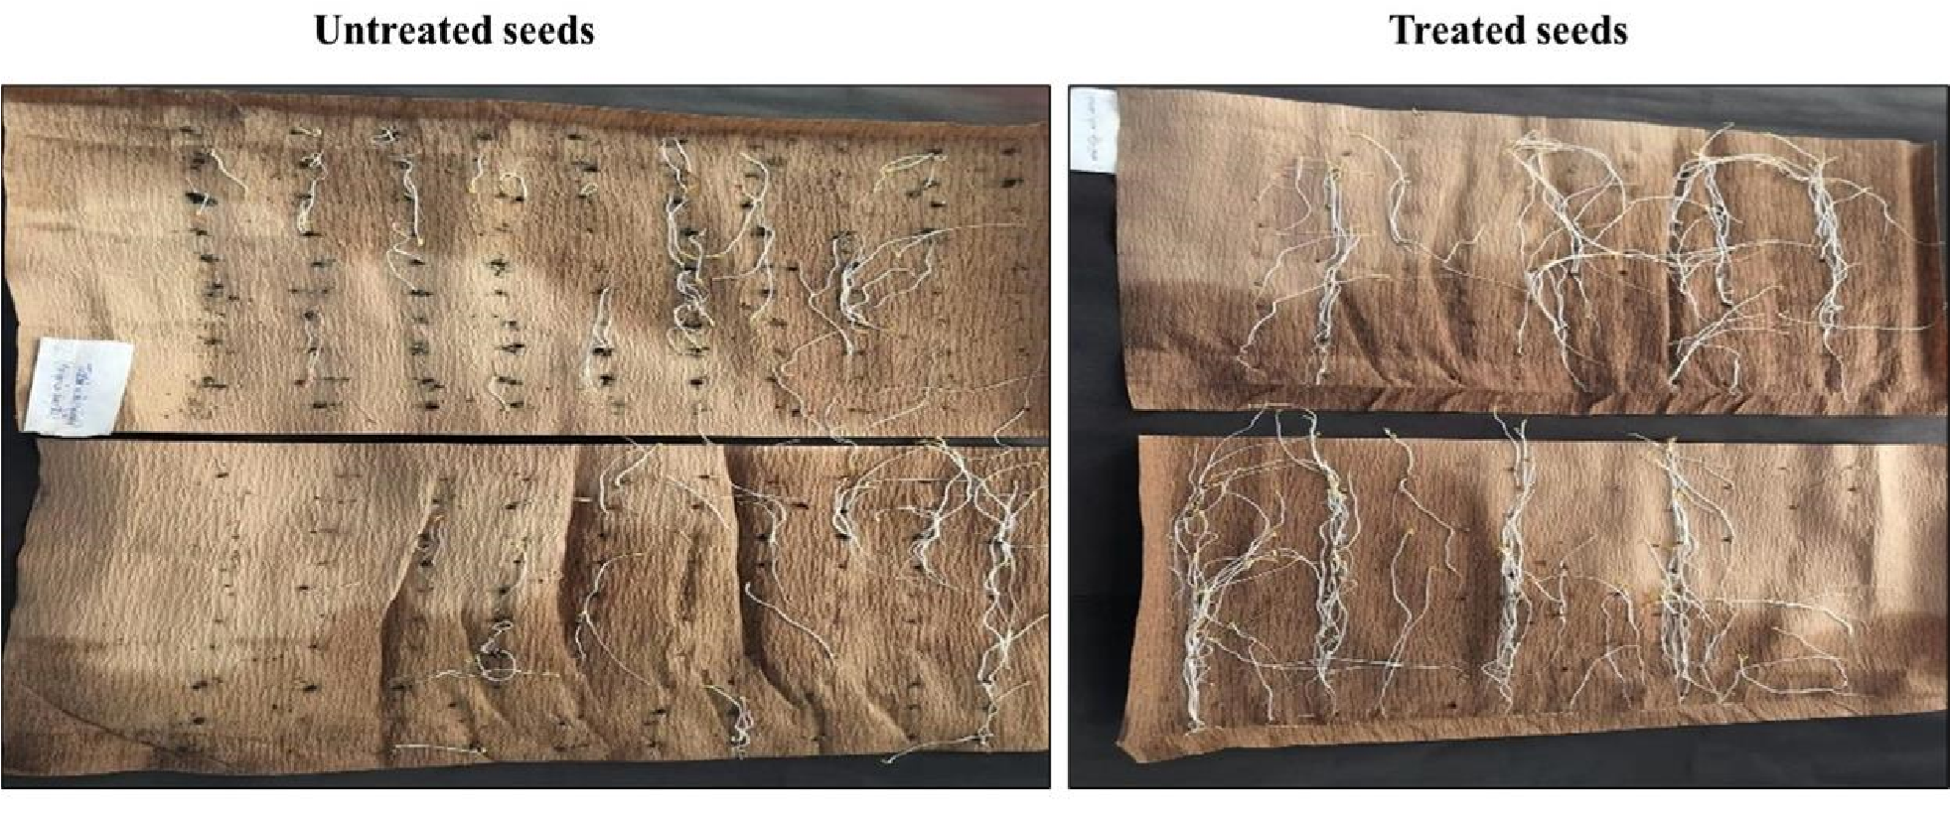

**Fig.1.** The seed quality parameters

**3.2 Plant Height**

Across all growth stages (30, 45, and 60 DAS), T4 consistently recorded the highest plant height, followed by T3 (foliar application only), while T1 (control) showed the lowest values. The significant increase in plant height under T4 is likely due to the dual action of enhanced seedling vigor from priming and direct nutrient absorption from foliar spraying. Plant height improvements can be linked to the bioactive compounds (karanjin and pongamol) present in *Pongamia pinnata* extract, which may enhance chlorophyll synthesis and promote photosynthetic efficiency (Bajpai *et al.,* 2009) (Table. 1). The combined application also likely stimulated the production of growth-promoting hormones, such as auxins and gibberellins, resulting in more vigorous stem elongation. (Prakash *et al*., 2021) (Fig.2).

**3.3 Leaf Characteristics (Number, Length, Width, and Surface Area)**

The number of leaves, leaf length, and leaf surface area were significantly higher in Treatment 4 (T4) compared to the other treatments. T4, which combined seed priming and foliar spray, resulted in healthier and larger leaves due to increased leaf length and width. Among the individual treatments, Treatment 2 (Seed priming only) showed the highest leaf surface area, suggesting that seed priming helps promote leaf expansion. This may be due to the early activation of growth processes that encourage cell division and enlargement (Farooq *et al.,* 2019 and Khan *et al.,* 2015) (Table 1). Although leaf size in Treatment 3 (Foliar spray only) was similar to T4, the difference was not statistically significant. This indicates that foliar spray alone can improve leaf growth, but combining it with seed priming offers additional benefits (Fig.2).

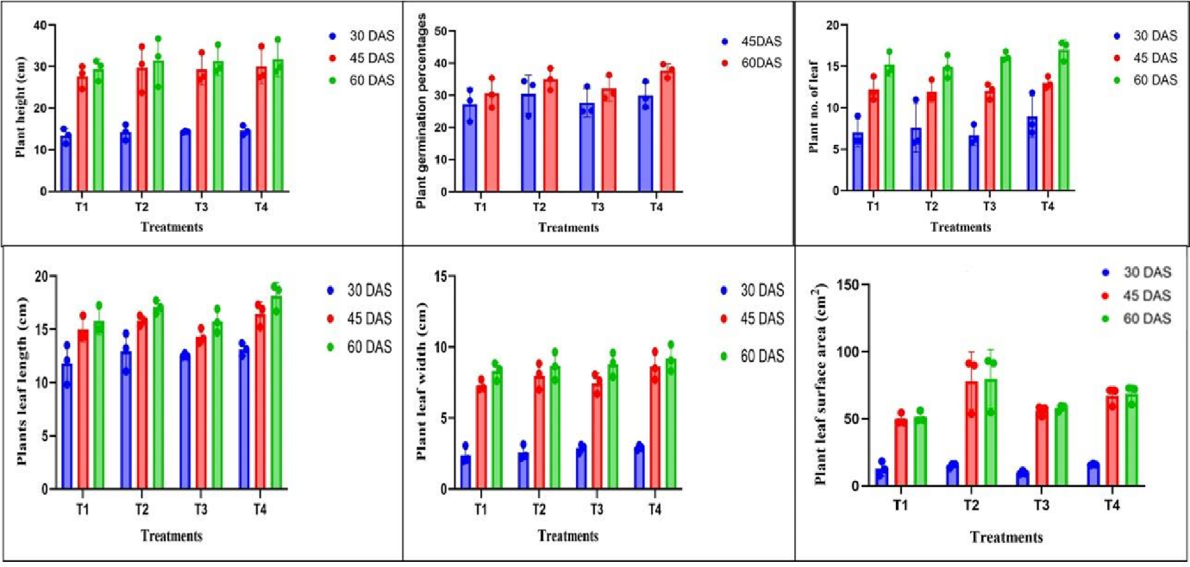

**Fig. 2.** Yield quality attributes under different DAS duration

**3.4 Biomass Production (Fresh and Dry Leaf Weight)**

The highest fresh and dry leaf weights were recorded in T4, followed by T3, T2, and T1. Although all treatments showed an increase compared to the control, T4 exhibited a significantly higher biomass. The improved leaf biomass under T4 can be attributed to the dual benefits of early germination vigor and sustained nutrient supply from foliar application. The significant increase in fresh and dry leaf weight under combined treatments may be due to enhanced physiological activity and better nutrient translocation facilitated by the bioactive compounds in *Pongamia pinnata.* Similar effects have been reported with plant-based biostimulants that stimulate biomass accumulation by improving metabolic efficiency and photosynthetic capacity (Du Jardin *et al*., 2015) (Table.2 and Fig.3).

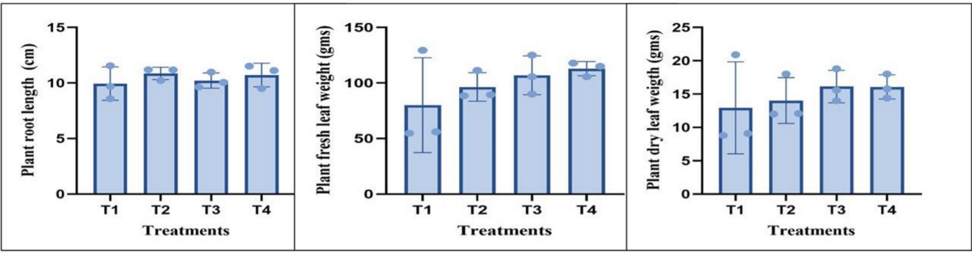

**Fig. 3.** Biomass production in different treatments.

**3.5 Root Development**

Root length did not show a significant difference between treatments, indicating that *Pongamia pinnata* extract mainly promotes shoot growth rather than root development. This supports the idea that foliar application primarily enhances the above-ground parts of the plant. The limited effect on root length could also be due to nutrient competition between shoots and roots. These findings agree with previous studies showing that biostimulants often improve above-ground biomass more than root growth under certain conditions (Calvo *et al.,* 2014 and Gokulapriya *et al.,* 2022).

**3.6 Statistical Significance and Correlation**

The analysis of variance (ANOVA) revealed significant differences (p < 0.05) between treatments for most growth parameters, particularly plant height, leaf number, and leaf area. DMRT results indicated that T4 had significantly superior performance compared to other treatments, especially in leaf biomass and height. The correlation analysis also showed a strong positive relationship between seed priming and enhanced leaf area, indicating that initial seed treatment plays a crucial role in determining vegetative growth potential**.**

**Table 1: Growth parameters**

|  |  |  |  |  |  |  |  |  |
| --- | --- | --- | --- | --- | --- | --- | --- | --- |
|  | **At 30 DAS** | | | |  | |  | |
| **Treatment** | **Plant height** | **Plant number of**  **leaf** | | **Plant leaf length** | **Plant leaf width** | | **Plant leaf surface area** | |
| T1 | 13.3a | 7a | | 11.807a | 2.387a | | 12.773ab | |
| T2 | 14.2a | 7.6a | | 12.96a | 2.567a | | 15.217ab | |
| T3 | 14.3a | 6.667a | | 12.547a | 2.867a | | 9.717b | |
| T4 | 14.58a | 8.933a | | 13.12a | 2.92a | | 15.83a | |
|  | **45 DAS** | | | |  | |  | |
| **Treatments** | **Germination%** | | **Plant height** | **Plant number of lengths** | **Plant leaf length** | **Plant leaf width** |  | **Plant leaf surface area** |
| T1 | 27.267a | | 27.66a | 12.2a | 14.993a | 7.293a |  | 49.72b |
| T2 | 30.4a | | 29.7a | 11.933a | 15.807b | 7.987a |  | 78.22a |
| T3 | 27.667a | | 29.267a | 12a | 14.32b | 7.467a |  | 55.997ab |
| T4 | 2.933a | | 30.067a | 13a | 16.467a | 8.627a |  | 67.05ab |
|  | **A t 60 DAS** | | | |  | |  | |
| **Treatments** | **Germination%** | | **Plant height** | **Plant number of lengths** | **Plant leaf length** | **Plant leaf width** |  | **Plant leaf surface area** |
| T1 | 46.004b | | 29.333a | 15.2a | 15.773b | 8.313a |  | 51.277b |
| T2 | 88.891b | | 31.427a | 14.933a | 17.1b | 8.66a |  | 79.753a |
| T3 | 57.81b | | 31.287a | 16.2a | 15.757b | 8.8a |  | 58.03ab |
| T4 | 197.705a | | 31.733a | 17a | 18.14a | 9.187a |  | 68.52ab |

**Table 2. Yield parameters (After harvesting)**

|  |  |  |  |
| --- | --- | --- | --- |
| **Treatments** | **Root length** | **Fresh leaf weight** | **Dry leaf weight** |
| T1 | 9.943a | 80.1a | 80.1a |
| T2 | 10.863a | 96.433a | 96.433a |
| T3 | 10.223a | 106.93a | 106.933a |
| T4 | 10.717a | 112.9a | 112.9a |

1. **CONCLUSION**

This study shows that applying *Pongamia pinnata* leaf extract both as a seed treatment and as a foliar spray significantly improves the growth of spinach plants. The combined treatment (T4) was the most effective, leading to faster germination, taller plants, more leaves, larger leaf area, and greater overall biomass compared to single treatments or no treatment. Treating the seeds helps seedlings start strong, while spraying the leaves supports continued growth by providing extra nutrients. The natural compounds in *Pongamia pinnata*, like karanjin and pongamol, likely help increase chlorophyll and improve photosynthesis, which boosts leaf and shoot growth. Although root growth did not change much, the increase in shoot size shows that this extract can be a good natural alternative to chemical growth enhancers. Because these results are promising, more studies are needed to confirm the benefits in different environments and with other crops. Using *Pongamia pinnata* leaf extract in spinach cultivation not only improves plant growth but also supports sustainable farming practices.

**DISCLAIMER (ARTIFICIAL INTELLIGENCE)**

Author(s) hereby declare that NO generative AI technologies such as Large Language Models (ChatGPT, COPILOT, etc) and text-to-image generators have been used during writing or editing of this manuscript.

**Competing interests**

Authors have declared that no competing interests exist.

**REFERENCES**

Akpor, O. B., Maxwell, M. M., Evbuomwan, I. O., Olaolu, T. D., Adeyonu, A. G., & Osemwegie, O. O. (2022). Growth promotion and protective potentials of leaf infusions of Parkia biglobosa, Moringa oleifera and Vernonia amygdalina on Abelmoschus esculentus seeds*. Scientific reports*, 12(1), 14106.

Alam, A., Amin, N., Ara, N., Ali, M., and Ali, I. (2013). Effect of various sources and durations of priming on spinach seeds. *Pakistan Journal of Botany*, 45(3), 773-777.

Anjos Neto, A. P. dos, et al. (2020). Seed priming with seaweed extract mitigates heat stress in a crop Spinach: effect on germination, seedling growth and antioxidant capacity. Bragantia 79(3), 321-330.

Arumugam, U., and Manida, M. (2023). Sustainable Farming Management in India. *Shanlax Int. J. Manag.*, 11(1), 54-60.

Bhattacharyya, R., Ghosh, B.N., Mishra, P.K., Mnadal, B., Rao, C.S., Sarkar, D., and Franzluebbers, A. J. (2015). Soil degradation in India: Challenges and potential solutions. *Sustainability*, 7(4) 3528-3570.

Calvo, P., Nelson, L., & Kloepper, J. W. (2014). Agricultural uses of plant biostimulants. *Plant and soil*, 383, 3-41.

Degani, E., Prasad, M. V. R., Paradkar, A., Pena, R., Soltangheisi, A., Ullah, I., and Tibbett, M. (2022). A critical review of *Pongamia pinnata* multiple applications: from land remediation and carbon sequestration to socioeconomic benefits. J. Environ. Manag, 324, 116297.

Du Jardin, P. (2015). Plant biostimulants: Definition, concept, main categories and regulation. *Scientia horticulturae*, 196, 3-14.

Farooq, M., Usman, M., Nadeem, F., ur Rehman, H., Wahid, A., Basra, S. M., & Siddique, K. H. (2019). Seed priming in field crops: potential benefits, adoption and challenges. *CROP PASTURE SCI*, 70(9), 731-771.

Gokulapriya, T., Janavi, G. J., Nageswari, K., & Kavitha, M. P. (2022). Effect of foliar application of organic inputs on leaf biomass production and quality of Annual Moringa (*Moringa oleifera* Lam.) var. PKM. *The Pharma Innovation Journal*, 11(9), 480-487.

Gomez, K. A., & Gomez, A. A. (1984). Statistical procedures for agricultural research. John wiley & sons.

Khan, D., Zaki, M. J., Shaukat, S. S., & SAHITIO, Z. A. (2015). Seedling characteristics of *Pongamia pinnata* (L.) Pierre (Papilionaceae). *Int. J. Biol. Biotech*, 12(3), 457-479.

Krishnasamy, R., Natesh, R., & Obbineni, J. M. (2024). Efficient ROS scavenging improves the growth and yield in black gram (Vigna mungo (L.) Hepper) after seed priming and treatment using biosynthesized silver nanoparticles with *Pongamia pinnata* (L.) Pierre leaf extract. *J. Plant Growth Regul.,* 43(7), 2422-2438.

Narayanan, G.S., Prakash, M., and Reka M. (2025). Influence of the seed hardening cum foliar spray treatments on the biometric, physiological, and yield parameters in a black gram under the dryland condition.  *ASD*. 35(1), 1–6.

Nkcukankcuka, M. (2020). *Growth of Tetragonia decumbens (dune spinach) in response to different PH and electrical conductivity levels in hydroponics* (Doctoral dissertation, Cape Peninsula University of Technology).

Joshi, B., Rai, P. K., & Pandey, V. (2021). Impact of Various Sources of Seed Priming on Growth, Yield and Quality of Spinach Local (*Spinacia oleracea*) in-vitro and in-vivo Condition. International Journal of Plant & Soil Science, 33(21), 1–8.

Prakash, M., Pallavamallan, S., Sathiyanarayanan, G., & Rameshkumar, S. (2021). Effect of seed pelleting with botanicals on germination and seedling growth of clusterbean under induced saline condition. *Legume Res.,* 44(1), 88-93.

Purkait, A., Mukherjee, A., Hazra, D. K., Roy, K., Biswas, P. K., and Kole, R. K. (2021). Encapsulation, release and insecticidal activity of *Pongamia pinnata* (L.) seed oil. *Heliyon*, *7*(3). 8. Ray, P. K., & Bharti, P. (2023). Biochar: A quality enhancer for fruit crops. IYoM, 77.

Roughani, A., & Miri, S. M. (2019, March). Spinach: An important green leafy vegetable and medicinal herb. In The 2nd international conference on medicinal plants, organic farming, natural and pharmaceutical ingredients (pp. 1-6).

Rouphael, Y., & Colla, G. (2020). Biostimulants in agriculture. *Frontiers in plant science*, 11, 40.

Salam, A., Afridi, M. S., Javed, M. A., Saleem, A., Hafeez, A., Khan, A. R., and Gan, Y. (2022). Nano-priming against abiotic stress: A way forward towards sustainable agriculture. *Sustainability*, 14(22), 14880.

Singh, S., Nwabor, O. F., Titilope, J. J., & Olatunde, O. O. (2025). Biopolymers in Phytomedicines, Preparations, and Applications. In Smart Ways of Biomaterial Designing Synthesis and Characterization (pp. 247-276). *CRC Press*.

Vasav, V. P., Narkhede, S. S., Rane, A. D., Gunaga, R. P., Rewale, A. P., & Bhave, S. G. (2011). Evaluation of progenies of candidate plus trees of *Pongamia pinnata* (L.) Pierre. for seed germination and seedling vigour. *Current Science*, 100(4), 465-467.