**ORIGINAL RESEARCH ARTICLE**

**Computational Analysis of Blast-Responsive *Pi9* Gene Family in Finger Millet *(Eleusine coracana)***

**Abstract:**

The *Pi9* gene, an element belonging to Nucleotide-Binding Site Leucine-Rich Repeat (*NBS-LRR*) family, a positive regulator and critical in plant defence mechanism against blast fungus in millets & rice. Despite the fact that NBS-LRR genes are found across various plant species, including millets, no studies have specifically investigated *Pi9* gene in *Eleusine coracana* genome that can be used effectively to combat blast disease causing up to 80% yield loss. Upon infection, the pathogen secretes the Avr protein into the host cell, where it interacts with Pi9 to disrupt the stability of WRKY transcription factors, via *ANIP1* disassociation thereby weakening the host immunity. Previous findings regarding the *Pi9* gene in rice may not be directly applicable to finger millet as they are different genomes and the distinct evolutionary origins of *Magnaporthe grisea* strains affecting them. Subsequently, research on *Pi9* gene in finger millet in the view of breeding, marker development, allele mining are present but our study provides foundation for deeper understanding of the gene family members which is essential to develop tolerant varieties. Here, we identified nine *EcPi9* gene homologs and divided into three clades based on their ancestral cleavage. Various Insilco tools were used to determine gene and protein assets including subcellular localisation, cis regulating elements, conserved motif and domain analysis, etc. *EcPi9* homologs are closely related to rice and sorghum with reference to evolutionary and synteny analysis. CpG island prediction revealed that methylated sites present align according to their phylogeny. Functional validation of transcripts was done through GO studies and TFs prediction. Current study characterized *EcPi9* gene members, their roles in defence against blast and provides valuable resources for future research.

**Key words:** *Pi9* Gene, *Eleusine coracana,* Computational Analysis, Blast disease, Biotic Stress.

**Background:**

*Magnaporthe grisea* (anamorph*: Pyricularia grisea*) a hemi-biotrophic fungus (Takan *et al*., 2012) also known cereal killer causes blast disease (Fernandez *et al*., 2018). One such super cereal is finger millet (*Eleusine coracana),* an important C4 crop renowned for its great nutritional content and resilience in unfavourable environments. Its productivity is hindered up to 90% by blast disease and threatening world food safety (Navya *et al*., 2023). Blast disease was first detected in rice and host-pathogen interactions were highly explored (Cho *et* *al*., 2007) for development of blast resistant varieties. According to previous reports blast disease in finger millet is originated from wild grasses. Blast pathotypes infecting finger millet may or may not be present in rice, determining its infectivity is specific to the individual hosts thereby host cell response to the pathogen may also differ (Nayaka *et al.*, 2021). Moreover, finger millet is a highly self-pollinated crop which limits hybridisation and traditional breeding (Nagaraja *et al*., 2025). Hence there is a need to uncover molecular mechanisms causing resistance and susceptibility for the blast disease in finger millet (Mane *et al.*, 2024).

Plants evolved immunity towards pathogens via Pattern-triggered immunity and resistance or R-protein mediated immunity. Plant resistance genes (*R*-genes) which directly or indirectly identify effector proteins of pathogen and initiates second layer immunity (ETI) when pathogen escapes first line defence (PTI) (Qian *et al*., 2021). One such *R* gene is *Pi9,* originated from *Oryza minuta*, a Nucleotide-binding site leucine-rich repeat (NBS-LRR) gene family member belongs to class 2 of *R*-genes according to Martin et al. 2003, specifically coiled-coil group (CNL) (Shi *et al.,* 2023). It is one of the genes that display widespread resistance which confer durable resistance to numerous strains of blast fungus (Li *et al.*, 2019). *Pi9* detects the pathogen and interacts with Avr-Pi9, an effector protein produced by *M. oryzae* in the vicinity of host cell in order to disturb the PTI. Avr-Pi9 maintains its stability by associating with *ANIP1*, ubiquitin-like protein degrading TFs like WRKY in rice thereby weakens host immune response during infection. Pi9 stabilizes this protein while *Avr-Pi9* dissociates them making *Pi9* available (Shi *et al*., 2023). *Pi9* have been targeted for genetic improvement in rice for enhanced blast resistance conferring the importance of *Pi9* gene towards blast resistance (Tian *et al*., 2019). Recent report says that Avr-pi9 protein may get mutated to make host more vulnerable and gets unnoticed by host and escapes PTI (Lu *et al.,* 2023). Even though *Pi9* gene is well-explored in rice, number of homolog genes, cellular location, functional aspects, and binding sites may differ from genome to genome but are mostly conserved (Lyons *et al*., 2008). Hence, studying *Pi9* gene in finger millet is essential due to the crop's unique genetic and ecological characteristics, its susceptibility to blast disease, and its growing importance in food security. Moreover, recent advances in omics and availability of whole genome sequence of *Eleusine coracana* (Sood *et al*., 2024) and In-silico studies paves foundation for further exploration and deeper understanding of host resistance mechanisms which helps in development of blast resistant varieties by molecular breeding and genome editing.

**Materials and Methods**

Gene characterisation:

In Finger millet, *EcPi9* genes were identified using protein sequences which are retrieved from Phytozome database, *OsPi9* (DQ285630- GenBank) gene from *Oryza sativa* used for blast P against *Eleusine coracana* protein database. The selection criteria for the hits were >50% similarity and an E value below 1E-5. To anticipate the domain present, the potential *EcPi9* genes were uploaded in motif finder tool. Among outcomes, the genes containing the NB-LRR Domain were selected, while remaining genes were considered unnecessary.

Gene structure prediction:

Required genomic sequences, CDS sequences data of *Eleusine coracana* were collected from Phytozome database. Exon- Intron structure patterns were predicted.

Sub cellular localization:

Subcellular localization of the *EcPi9* protein homologs were identified to predict their accumulation sites in cell.

Motif & conserved domain analysis:

To predict conserved motif patterns, unlike default parameters we applied 10 number of motifs, 2 to 20 motif places, and 6 to 20 widths (Bailey *et al*.,2010). The functional domain analysis was done and the data was represented using Tbtool II.0.

Physical mapping:

The location of genes was noted and used for mapping them on chromosome. The evolutionary relationship was done by aligning the amino acid sequences of the *EcPi9* genes from *Eleusine coracana* with *Sorghum bicolor, Zea mays, Oryza sativa, Panicum virgatum, Seteria viridis*, *Arabidopsis thaliana, Paspalum vaginatum, Brassica rapa, Brachypodium distachyon, Prunus persicum, Populus trichocarpa, Hordeum vulgare* for construction of Newick Phylogenetic tree employing neighbour joining method with selecting 1000 bootstrap replicates (Kumar *et al*.,2016) and this tree was developed.

Collinearity among species:

Synteny analysis between *Eleusine coracana vs O. sativa, S. bicolor,P. virgatum, S. italica,A. thaliana, P. vaginatum, B. rapa, B. distachyon, P. persicum, P. trichocarpa, H. vulgare* was done using dual synteny plot by Tbtool II.0.

Promoter element prediction:

Promoter sequences which are 1500 bp upstream to genomic sequences of all candidate genes were taken from Phytozome database. Cis regulatory elements are predicted with these downloaded promoter sequences.

Protein parameters:

Various protein parameters like aliphatic indexes, isoelectric point, size and length of protein, gravy (grand average of hydropathy) was determined.

Protein structure:

The 2- dimensional structures of homologues protein were predicted (Viswanadha *et al*., 2025). The 3-dimensional protein structures of *EcPi9* transcripts were predicted. For evaluating and analysing the stability of the protein structure predicted was done via Ramachandran plots. SOUSI server determined the presence of transmembrane structures in proteins.

Prediction of protein-protein interactions:

The PPI (protein-protein interactions) of these homologs have been observed to understand their binding affinities and regulatory mechanisms.

Transcriptional factor prediction:

All *EcPi9* genes transcription factor link sites were predicted. The data was saved and represented as a network connecting *EcPi9* genes & TFs.

Gene Ontology:

GO analyses were conducted to explore diverse functions, encompassing Biological Process, Molecular Function, and Cellular Component categories.

CpG Islands prediction:

To analyse the presence of methylated regions in the promoter regions (upstream 2000 bp of genomic sequence) of homolog genes (Li *et al*., 2002) and results were noted.

The tools/ databases/websites used in this study are provided as supplementary material Table1.

**Results:**

**Computational Study of Gene Assets: An In-Silico Approach**

After searching a publicly accessible database - Phytozome against *Eleusine coracana* genome with a characterised *OsPi9* gene sequence, the study identified nine sequence entries with a predicted *Pi9* gene. Repeated sequences carrying the same proteins as well as non-representative transcripts were eliminated from the study to reduce redundancy. After eliminating less comparable proteins and ones having anticipated E-values over <1E-5, we identified nine homolog genes in finger millet genome. Table 1 includes more details about the selected transcripts.

The basic gene characteristics like location of gene, subcellular localisation, chromosome number, exons/ introns and pseudo names given were tabulated (Table 1) for better understanding.

Notably, Except for *EcPi9*.1, which had a single UTR region near the 3' end of the strand, the gene architecture of these comprised exclusively exons and introns and no untranslated regions. (Fig 1a). The NB-ARC and Leucine Rich Repeats superfamily of functional domains, as well as their sequence patterns, were discovered when the gene sequences were further examined for motif patterns and conserved domain analysis. The evolutionary groups of gene homologs coincide with the motif patterns (Fig 1b & 1c).

The study used Tbtool for retrieving the chromosome lengths of complete finger millet genome in order to ascertain the chromosomal positioning of the *EcPi9* homologs. All the genes are highly concentrated on 6 & 7 chromosomes only (Fig. 2a). During the chromosomal evolution, it was more likely that homolog genes came from the identical progenitor gene.

To look into the patterns of evolution among *Pi9* members in finger millet, we employed nine *EcPi9* genes to build a hierarchy of these in MEGA 11.0 using 1000 bootstraps and complete deletion parameters. The phylogenetic tree (Fig. 2b) categorized the 9 homolog genes into three clans, suggesting unique phylogenetic lines of descent, with bootstrap values verifying each. One group had five members, while other two groups each had two members. Some genes on the identical chromosome grouped together in the evolutionary tree, suggesting that tandem duplication occurrences had possibly taken place on the same chromosome.

In order to fully investigate the family's evolutionary relationships, species with thorough annotations (*Eleusine coracana, Sorghum bicolor, Seteria viridis*, *Arabidopsis thaliana, Paspalum vaginatum, Oryza sativa, Brassica rapa, Brachypodium distachyon, Prunus persicum, Panicum virgatum, Populus trichocarpa, Zea mays, Hordeum vulgare*) were chosen in our study. 32 sequences overall that displayed more than 50% similarity to *EcPi9* genes were chosen, aligned using the MUSCLE multiple alignment method, and then utilized to build a collective Newick tree (Fig. 2c) via the Neighbour-joining method. These are divided into three groups, and the concentration of all *EcPi9* homologs in a single clade demonstrates their unique genetic connection with other closely related species. *S. viridis, H. vulgare, P. vaginatum, O. sativa* formed a clade with *E. coracana.*

In order to find and subsequently analyse intraspecies syntenic genes, Tbtool II.0 was opted to create this graphic (Fig. 3a) According to the research results, for these gene pairs, a total of three distinct syntenic blocks were found with the genomes of *S. bicolor* and two with *O. sativa*, for other related species that were opted, no syntenic lines were generated.

The distribution of cis elements in promoter regions were predicted. Light responsive, methyl jasmonate responsive, hormonal responsive, other stress responsive along with wound responsive elements were generated (Fig. 3b). Light responsive elements are highly occurred in them among all elements followed by MeJA ones. The number of occurrences for each promoter element in homolog genes were displayed as a heatmap (Fig. 3c). Methylated regions in the promoter regions were analysed through CpG Island prediction. four islands found in *EcPi9.1* and *EcPi9.3*. *EcPi9.4, EcPi9.5, EcPi9.8, EcPi9.9* have one methylated island region each while *EcPi9.6* and *EcPi9.7* had no islands. It's interesting to note that methylated sections of proteins that are paralog pairs based on evolutionary study are similar (Table 2), (supplementary material fig.1). The CpG Islands observed for *EcPi9.1* was displayed as (Fig. 5b).

**Insights into Gene Regulation and Protein Aspects:**

The properties such as Gravy, length, size and isoelectric point of proteins were determined (Table 3). The 2D structure of *Pi9.1* is shown in (Fig. 4a) (Viswanadha *et al.,* 2025), and their features, such as the percentage of random coils, beta turns, and alpha helices, are recorded in Table 4 with 984 a.as, *EcPi9.1* is the longest protein, while *EcPi9.3* is the shortest with 220 a.as. Compared to *EcPi9.1, EcPi9.3* has a greater proportion of alpha helices while being smaller. The protein with highest alpha helices is *EcPi9.8.* Interestingly, *EcPi9* transcripts have no beta turns in their protein forms. There are no transmembrane structures involved, and the 3D-structure (Fig. 4b) predictions also yielded disease resistant protein, pathogen interacting protein from rice, NB-ARC-containing forms which correspond to their conserved domains and functional properties. The templates, their similarity % and description are provided in (Table 5) Ramachandran plots served to check these structures, where all proteins fall in 80–94% allowed regions (supplementary material fig. 2).

The study predicted the protein-protein interaction networks of *EcPi9* proteins. *EcPi9* homologs did not interact with one another, although *EcPi9.1* did interact with three clusters of proteins in the network. Other NB-ARC domain containing and F- box containing proteins were interacted (Fig. 4c). Furthermore, the interaction network assessment revealed that *Pi9* members have roles in a variety of biological processes, especially plant natural immune responses, cellular process regulation and defence mechanisms.

As there is no related expression data available for finger millet, Functional aspects were analysed by gene ontology studies and transcriptional factor predictions. Diverse TFs, such as WRKY, MYB, MYB-related, NAC, bHLH, YABBY, LFY, WOX, and others (Fig. 5), were present, suggesting that it serves as a resistant gene and is engaged in defence processes in plants.

Relating with predicted function based on TFs binding gene ontology studies also revealed the same. *EcPi9.1* demonstrated every molecular function, biological process involved, and cellular component. While certain proteins, such as *EcPi9.3, EcPi9.8, and EcPi9.9,* are uncharacterized and lack GO-Ids, others include the NB-ARC domain properties and contribute to disease resistance (Table 6).

**Discussion:**

Cereals constitute a significant portion of feedstock and are essential parts of the human meal. It's vital to continue producing enough to satisfy demand. *Pi9* genes aid in plant adaptation to blast-stress conditions and are engaged in a number of biological and developmental processes (Chen *et al*., 2025). Prior studies focused solely on NBS-LLR domain proteins, identifying 116 genes in finger millet that are involved in plant development (Balamurugan *et al*., 2024). Research on *EcPi9* class members in *E. coracana* is less so far. Here, we explored *EcPi9* in *E. coracana* for the first time. New avenues for enhancing *E. coracana* productivity and increasing its resilience to blast stress will be made possible by the current investigation of *EcPi9* gene activities.

The distribution of *EcPi9* genes across chromosomes 6 and 7 was revealed by the chromosomal localization analysis which is similar in rice (Saxena *et al*., 2025). There is a substantial correlation between the number of tandem repeat events and the closeness and complexity of the gene family. The growth and functional variation among gene family are significantly impacted by these occurrences (Cannon *et al*., 2004).

According to our data, the majority of proteins have the NBS-ARC domain and the six motifs in their N-terminal regions, which is in line with earlier research (Balamurugan *et al.*, 2024). Functional diversity of them is further supported through the presence of 3–10 motifs in protein paralogs. Interestingly, the motif NBS-ARC was found primarily in the Pi9 subfamily, indicating that it may play a part in the functioning of this subgroup. Similar results have already been documented in rice, where particular motifs were linked to genes that respond to stress (Sinha *et al*., 2023) and in soyabean (Afzal *et al*., 2022). Nine of the 153 cis-acting regions found in nine *EcPi9* genes in this study are linked to MYB proteins, suggesting that MYB might act as an upstream transcriptional modulator of *EcPi9* expression**.** As frequently observed in a variety of plant species, we also discovered 9 promoters with 61 light response elements and 33 methyl jasmonate responsive elements, suggesting such genes could be linked to biotic stress responses (Singh *et al*., 2024). light responsive elements also contribute towards broad spectrum resistance as studied earlier by Liu *et al*., 2019 in rice. Additionally, we discovered CREs within promoter regions of Pi9 homologs linked with responsiveness to gibberellin, ABA, auxin, salicylic acid, and ATP-binding. Numerous studies have shown that phytohormones and cis-acting regions affected by MeJA are essential for regulating the expression of *EcPi9* genes.

Phylogeny analysis revealed that all homologs of *E. coracana* formed clade with rice which shows that role of *EcPi9* genes may be correlated with that of *O. sativa* ones and these genes showed synteny blocks with only *O. sativa* and *S. bicolor.*

Remarkably, *EcPi9*s were recently hypothesized as mediator of pathogen infection and PAMP-induced plant immunity in rice (Zhai *et al*., 2022). Avr-Pi9 also affects the transcription factor WRKY, blocking the subsequent process of phytoalexin synthesis, which serves as an antifungal (Nguyen-Ngoc *et al*., 2023). Presence of other TFs like MeJA, bHLH, MYB & related, NAC, YABBY are both biotic and abiotic stress responsive involving methyl jasmonate mediated plant pathogen interaction pathway and production of monoterpenoids are related to homologs (Jain *et al*., 2017). Monoterpenoids also acts as fungicides which is crucial for plants under infection (Huang *et al*., 2025).

Incorporating comprehensive and long-lasting resistance is now a key focus for breeders to combat rice blast (Pedrozo *et al*., 2025). We detected 11 potential protein-protein interactors for *EcPi9*.1. These members were found to be abundant in GO such as 'response to stress', 'defence responsive', and 'response to pathogen infection', indicating that *EcPi9*.1 may serve in these physiological functions. GO analysis further indicates that finger millet Pi9 family gene products have nucleotide binding activity and contribute in disease resistance via NB-ARC domain-containing proteins. This shows that the Pi9 genes have a role in metabolic processes and immunology, ultimately affecting the plant's overall strength when exposed to pathogens.

This research contributed to a better understanding of Pi9's involvement in regulating the resistance in plants. The constituent proteins of *EcPi9* gene family were determined using Insilico, and their gene structures, protein characteristics, functional aspects, and significance were examined. In recent times, Pi9 family members have been expressed and described in most crops, and some of their cellular functions have been investigated. Numerous research has pointed out Pi9's contribution to blast control (Soujanya *et al*., 2023), leading to a better knowledge and awareness of Pi9's significance in plant development and defence systems. There have been very few studies on the role of Pi9 in controlling plant stress tolerance, though, with most of the appropriate research concentrating on plant species like rice (Tang *et* *al*., 2024) and minimal on other impacted crops like millets. On the other hand, our research has limitations as well. Our study's main goal is to find and forecast the activity of Pi9 gene family members in finger millet with the help of computational biology. In addition, the discovery of *EcPi9* upstream regulators offers novel concepts and emphatical support for downstream target genes and TFs that control plant growth, development along with response to biotic stress. Clarifying about characteristics of gene role and elucidating the process of gene functional expression require more investigation. These methods will enable the deployment of *EcPi9* genes in E. coracana genome editing programs and offer an in-depth comprehension of the regulatory networks comprising these genes. After identifying more detailed processes, the phenotypic effect of particular Pi9 genes under blast infection scenarios can be evaluated using CRISPR/Cas9, Prime tool, genetic manipulation, or RNAi (RNA interference) techniques.

**Conclusion:**

Blast stress drastically decreased ragi quality and productivity while also having a detrimental impact upon Terpenoids, antioxidants, phytoalexins, and lipids in the ragi plant. In particular, this work was the first to identify and comprehensively examine the *Pi9* gene family in *Eleusine coracana*, identifying nine genes that are likely to be centered in nucleus and cytoplasm. With respect to exon–intron distribution and motif composition, members of every subset in *EcPi9*s exhibit a high degree of conservation, according to gene organization and conserved motif study. In phylogenetic analysis, the nine candidate genes—which are found on chromosome 6 and 7—are separated into three clusters. There are plenty of cis-elements associated with biotic stress responses, indicating that finger millet responds to pathogen infections in a variety of ways. The comprehensive genome-wide analysis of the finger millet *Pi9* genes is revealed by this investigation. Our results support further research exploring their action and mechanisms for regulation based on transcription factors of *EcPi9*s in *Eleusine coracana* defence mechanisms under biotic stress as well as additional development and abiotic stresses.

**Data availability:**

The dataset supporting the findings of this article are included within the article.

**Statements and declaration:**

No conflict of interest is there among authors in any aspects.

**Acknowledgments:**

Mr. J. Viswanadha Naik expresses gratitude to the University Grants Commission (UGC) for providing research fellowship. Ms. K. Anjana Priyadarshani acknowledges the DBT-JRF Programme for funding her research fellowship.

**Funding:**

No additional financial resources were provided or obtained.

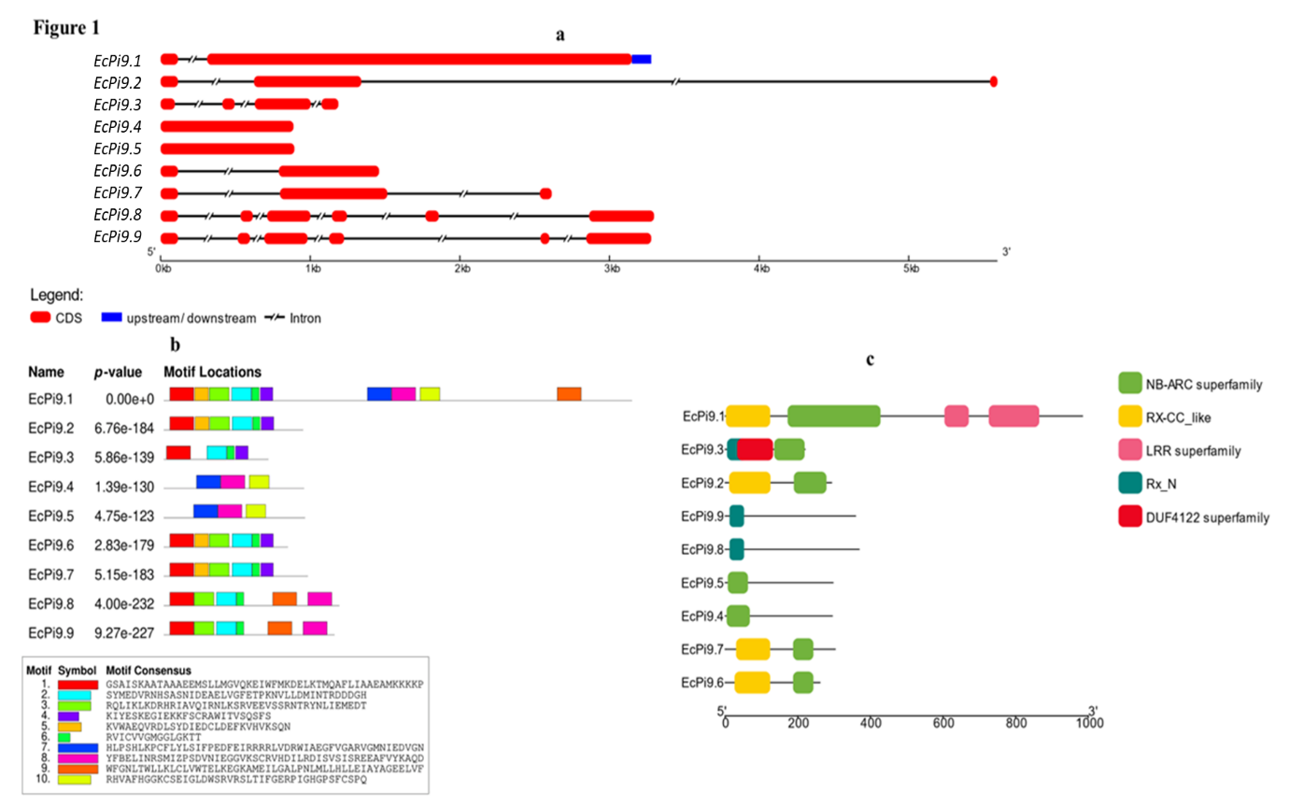**Figures:**

**Figure 1- a) Gene structure analysis showing CDS (red), UTRs (blue), introns as split lines. b) distribution of motifs across protein sequences of *EcPi9*transcripts. c)conserved domain analysis of all genes where NB-ARC domain is present in all.**

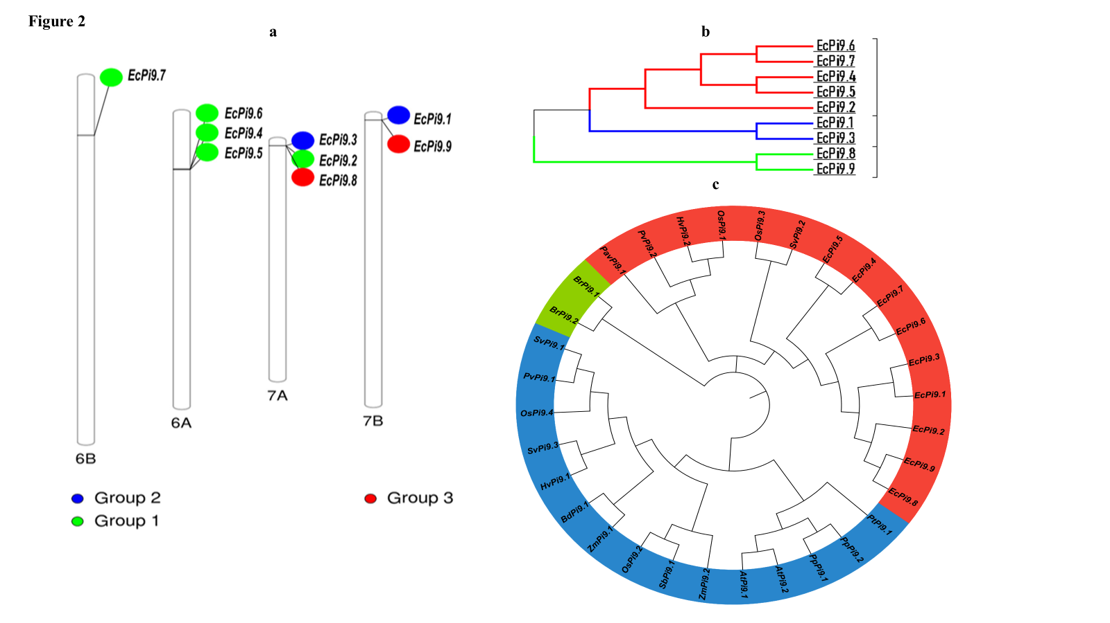

**Figure 2 – a) distribution of genes across finger millet genome, genes are concentrated on 6 and 7 chromosomes. b) tree showing ancestral relationships among themselves, each colour represents a group. c) evolutionary analysis of *EcPi9*genes with other related species.**

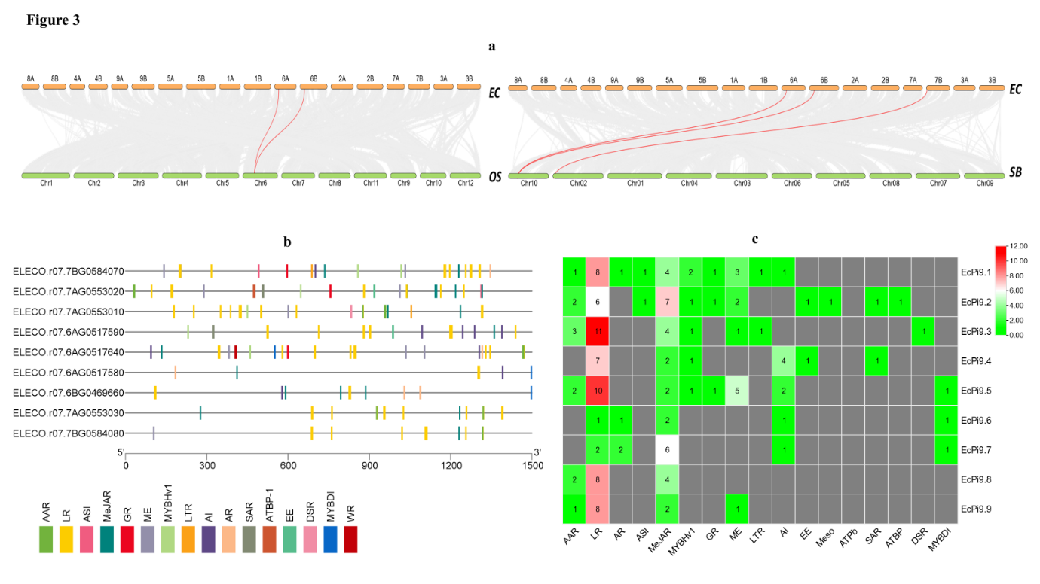

**Figure 3 – a) collinearity of *E. coracana* with *O. sativa* and *S. bicolor*, pink lines indicates synteny blocks among species. b) the distribution of cis regulatory elements in the promoter regions of *EcPi9* homologs. c) the heatmap showing frequency of specific cis elements occurrence for each homolog.**

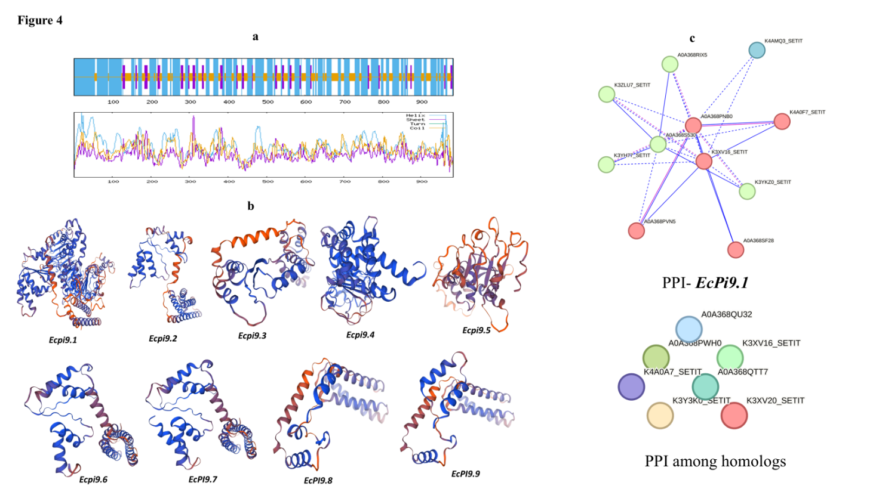

**Figure 4 – a) 2D structure of *EcPi9.1* protein each coloured peaks indicates the pattern of components. b) predicted 3D models of all candidate proteins. c) network showing protein- protein interactions among all selected proteins and also that of *EcPi9*.1 protein.**

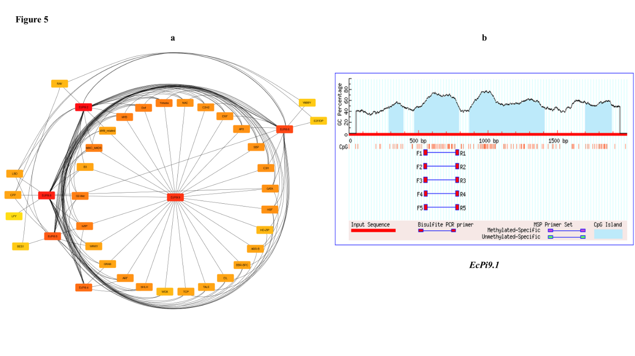

**Figure 5- a) Network showing Tfs predicted for *EcPi9* genes. b) graph showing methylated regions in the promoter region of *EcPi9.1* gene where blue colour indicates CpG islands.**

**Tables:**

**Table 1- Gene Characters of *EcPi9* Homologs Selected.**

|  |  |  |  |  |  |  |  |
| --- | --- | --- | --- | --- | --- | --- | --- |
| **Transcript ID** | ***EcPi9* Gene name** | **Exon/Intron** | **Chromosome** | **Start** | **End** | **Strand** | **Localization** |
| ELECO.r07.7BG0584070 | *EcPi9.1* | 2/1 | 7B | 1029396 | 1032546 | reverse | Plasma Membrane |
| ELECO.r07.7AG0553020 | *EcPi9.2* | 3/2 | 7A | 1038696 | 1044289 | reverse | Cytoplasm |
| ELECO.r07.7AG0553010 | *EcPi9.3* | 4/3 | 7A | 1032958 | 1034146 | reverse | Chloroplast |
| ELECO.r07.6AG0517590 | *EcPi9.4* | 1/0 | 6A | 11456404 | 11457292 | forward | Cytoplasm |
| ELECO.r07.6AG0517640 | *EcPi9.5* | 1/0 | 6A | 11485862 | 11486756 | forward | Nucleus |
| ELECO.r07.6AG0517580 | *EcPi9.6* | 2/1 | 6A | 11454737 | 11456197 | forward | Nucleus |
| ELECO.r07.6BG0469660 | *EcPi9.7* | 3/2 | 6B | 11806582 | 11809196 | forward | Nucleus |
| ELECO.r07.7AG0553030 | *EcPi9.8* | 6/5 | 7A | 1048662 | 1051960 | reverse | Cytoplasm |
| ELECO.r07.7BG0584080 | *EcPi9.9* | 6/5 | 7B | 1039812 | 1043091 | reverse | Cytoplasm |

**Table 2- Details Regarding CpG Islands**

**Predicted.**

|  |  |  |  |  |  |  |
| --- | --- | --- | --- | --- | --- | --- |
| **S. No** | **Transcript ID** | **Gene name** | **Island** | **Start** | **End** | **Length** |
| 1 | ELECO.r07.7BG0584070 | *EcPi9.1* | 1 | 287 | 393 | 107 bp |
| 2 | 472 | 791 | 320 bp |
| 3 | 867 | 1048 | 542 bp |
| 4 | 1700 | 1892 | 193 bp |
| 2 | ELECO.r07.7AG0553020 | *EcPi9.2* | 1 | 447 | 618 | 172 bp |
| 2 | 1180 | 1439 | 260 bp |
| 3 | 1661 | 1875 | 215 bp |
| 3 | ELECO.r07.7AG0553010 | *EcPi9.3* | 1 | 47 | 306 | 260 bp |
| 2 | 699 | 1174 | 476 bp |
| 3 | 1339 | 1536 | 198 bp |
| 4 | 1627 | 1775 | 149 bp |
| 4 | ELECO.r07.6AG0517590 | *EcPi9*.4 | 1 | 203 | 574 | 372 bp |
| 5 | ELECO.r07.6AG0517640 | *EcPi9*.5 | 1 | 600 | 710 | 111 bp |
| 6 | ELECO.r07.6AG0517580 | *EcPi9*.6 | 0 | No CpG Islands found | | |
| 7 | ELECO.r07.6BG0469660 | *EcPi9*.7 | 0 |
| 8 | ELECO.r07.7AG0553030 | *EcPi9*.8 | 1 | 1653 | 1896 | 244 bp |
| 9 | ELECO.r07.7BG0584080 | *EcPi9*.9 | 1 | 1661 | 1895 | 235 bp |

**Table 3- Protein Parameters of *EcPi9* Transcripts.**

|  |  |  |  |  |
| --- | --- | --- | --- | --- |
| **Gene** | **No. of a.a's** | **Molecular Weight** | **PI** | **GRAVY** |
| *EcPi9.1* | 984 | 111008 | 8.61 | -0.182 |
| *EcPi9.2* | 293 | 33408.7 | 8.79 | -0.365 |
| *EcPi9.3* | 220 | 25088.9 | 6.01 | -0.26 |
| *EcPi9.4* | 295 | 33407.1 | 8.7 | -0.002 |
| *EcPi9.5* | 297 | 33882.6 | 8.24 | -0.332 |
| *EcPi9.6* | 261 | 29339.7 | 7.6 | -0.317 |
| *EcPi9.7* | 303 | 34010.9 | 7.6 | -0.36 |
| *EcPi9.8* | 369 | 42388.3 | 6.13 | -0.293 |
| *EcPi9.9* | 359 | 41393.1 | 7.75 | -0.383 |

**Table 4- 2D Structure Prediction Results.**

|  |  |  |  |  |  |
| --- | --- | --- | --- | --- | --- |
| **Gene** | **Sequence Length** | **Alpha Helix %** | **Extended Strand %** | **Beta Turn %** | **Random Coil %** |
| *EcPi9.1* | 984 | 55.39 | 9.04 | 0 | 35.57 |
| *EcPi9.2* | 293 | 66.53 | 8.53 | 0 | 29.91 |
| *EcPi9.3* | 220 | 63.18 | 11.36 | 0 | 25.45 |
| *EcPi9.4* | 295 | 51.19 | 9.83 | 0 | 38.98 |
| *EcPi9.5* | 297 | 52.86 | 10.1 | 0 | 37.04 |
| *EcPi9.6* | 261 | 67.82 | 8.05 | 0 | 24.14 |
| *EcPi9.7* | 303 | 67.33 | 8.25 | 0 | 24.42 |
| *EcPi9.8* | 369 | 73.44 | 4.88 | 0 | 21.68 |
| *EcPi9.9* | 359 | 67.97 | 3.06 | 0 | 28.97 |

**Table 5- 3D Structure Prediction and Their Description.**

|  |  |  |  |
| --- | --- | --- | --- |
| **Gene** | **Template** | **% Identity** | **Description** |
| *EcPi9.1* | A0A5J9TPM6.1.A | 71.35% | NB-ARC domain-containing protein |
| *EcPi9.2* | A0A453QFD7.1.A | 70.07% | Disease resistance protein RPM1 |
| *EcPi9.3* | A0A5J9TPR9.1.A | 74.77% | NB-ARC domain-containing protein |
| *EcPi9.4* | Q5VN81.1.A | 70.51% | Pathogen interacting protein from rice |
| *EcPi9.5* | 9fyc.1.A | 42.06% | CSEP0372 putative effector protein |
| *EcPi9.6* | A0A6G1CY30.1.A | 80.77% | AAA+ ATPase domain-containing protein |
| *EcPi9.7* | A0A6G1CY30.1.A | 81.88% |
| *EcPi9.8* | A0A4U6UYJ6.1.A | 73.10% |
| *EcPi9.9* | A0A4U6UYJ6.1.A | 71.57% |

**Table 6- Gene Ontology Studies of *EcPi9* Genes.**

|  |  |  |  |  |
| --- | --- | --- | --- | --- |
| **Gene** | **Biological Process** | **Molecular Function** | **Cellular Component** | **Description** |
| *EcPi9.1* | GO:0006952 | GO:0043531 | GO:0016020 | NBS-LRR type R protein Pizh-1 |
| *EcPi9.2* | GO:0006952 | GO:0043531 | - | Rx N-terminal domain-containing protein |
| *EcPi9.3* | - | - | - | Uncharacterized protein |
| *EcPi9.4* | GO:0006952 | GO:0043531 | - | NB-ARC domain-containing protein |
| *EcPi9.5* | GO:0098542 | GO:0043531 | - | NB-ARC domain-containing protein |
| *EcPi9.6* | GO:0006952 | GO:0043531 | - | Disease resistance N-terminal domain-containing protein (Fragment) |
| *EcPi9.7* | GO:0006952 | GO:0043531 | - | AAA+ ATPase domain-containing protein |
| *EcPi9.8* | - | - | - | Uncharacterized protein |
| *EcPi9.9* | - | - | - | Uncharacterized protein |

Author(s) hereby declares that NO generative AI technologies such as Large Language Models (ChatGPT, COPILOT, etc.) and text-to-image generators have been used during the writing or editing of this manuscript.

**References –**

Afzal, M., Alghamdi, S. S., Nawaz, H., Migdadi, H. H., Altaf, M., El-Harty, E., ... & Sohaib, M. (2022). Genome-wide identification and expression analysis of CC-NB-ARC-LRR (NB-ARC) disease-resistant family members from soybean (*Glycine max* L.) reveal their response to biotic stress. *Journal of King Saud University-Science*, *34*(2), 101758.

Bailey, T. L., Bodén, M., Whitington, T., &Machanick, P. (2010). The value of position-specific priors in motif discovery using MEME. *BMC bioinformatics*, *11*, 1-14.

Balamurugan, A., Mallikarjuna, M. G., Bansal, S., Nayaka, S. C., Rajashekara, H., Chellapilla, T. S., & Prakash, G. (2024). Genome-wide identification and characterization of NBLRR genes in finger millet (*Eleusine coracana* L.) and their expression in response to Magnaporthe grisea infection. *BMC Plant Biology*, *24*(1), 75.

Cannon, S. B., Mitra, A., Baumgarten, A., Young, N. D., & May, G. (2004). The roles of segmental and tandem gene duplication in the evolution of large gene families in *Arabidopsis thaliana*. *BMC plant biology*, *4*, 1-21.

Chen, Q., Hu, Y., Shen, W., & Zhang, A. (2025). Evaluation of Rice Blast Resistance and R Gene Analysis in Japonica Rice Varieties Tested in the Anhui Region. *Agronomy*, *15*(5), 1008.

Cho, Y. C., Kwon, S. W., Choi, I. S., Lee, S. K., Jeon, J. S., Oh, M. K., ... & Kim, Y. G. (2007). Identification of major blast resistance genes in Korean rice varieties (*Oryza sativa* L.) using molecular markers. *Journal of crop science and biotechnology*, *10*(4), 265-276.

Fernandez, J., & Orth, K. (2018). Rise of a cereal killer: the biology of *Magnaporthe oryzae* biotrophic growth. *Trends in microbiology*, *26*(7), 582-597.

Huang, H., Huang, C., Fang, Q., Wu, Y., Kuang, Y., Zhang, J., ... & Peng, D. (2025). Novel Design of Pyrazolyl-Containing Monoterpene Compounds to Enhance Antifungal Efficacy Against *Rhizoctonia solani*. *Journal of Agricultural and Food Chemistry*.

Jain, P., Singh, P. K., Kapoor, R., Khanna, A., Solanke, A. U., Krishnan, S. G., ... & Sharma, T. R. (2017). Understanding host-pathogen interactions with expression profiling of NILs carrying rice-blast resistance Pi9 gene. *Frontiers in Plant Science*, *8*, 93.

Kumar, A., Mishra, P., Baskaran, K., Shukla, A. K., Shasany, A. K., & Sundaresan, V. (2016). Higher efficiency of ISSR markers over plastid psbA‐trnH region in resolving taxonomical status of genus *Ocimum* L. *Ecology and evolution*, *6*(21), 7671-7682.

Li, L. C., & Dahiya, R. (2002). MethPrimer: designing primers for methylation PCRs. *Bioinformatics*, *18*(11), 1427-1431.

Li, W., Chern, M., Yin, J., Wang, J., & Chen, X. (2019). Recent advances in broad-spectrum resistance to the rice blast disease. *Current opinion in plant biology*, *50*, 114-120.

Liu, M., Zhang, S., Hu, J., Sun, W., Padilla, J., He, Y., ... & Zhang, Z. (2019). Phosphorylation-guarded light-harvesting complex II contributes to broad-spectrum blast resistance in rice. *Proceedings of the National Academy of Sciences*, *116*(35), 17572-17577

Lu, L., Wang, Q., Shi, Z., Li, C., Guo, Z., & Li, J. (2023). Emergence of rice blast AVR-Pi9 resistance breaking haplotypes in Yunnan province, China. *Life*, *13*(6), 1320.

Lyons, E., & Freeling, M. (2008). How to usefully compare homologous plant genes and chromosomes as DNA sequences. *The Plant Journal*, *53*(4), 661-673.

Mane, Rushikesh Sanjay, Bishun Deo Prasad, Sangita Sahni, and Zeba Quaiyum. 2024. “Biotechnological Approaches Toward Blast Disease Resistance in Finger Millet”. International Journal of Plant & Soil Science 36 (7):422-28. https://doi.org/10.9734/ijpss/2024/v36i74749.

Martin, G. B., Bogdanove, A. J., & Sessa, G. (2003). Understanding the functions of plant disease resistance proteins. *Annual review of plant biology*, *54*(1), 23-61.

Nagaraja, T. E., Bhat, S., & Nandini, C. (2025). Current Scenario of Crop Improvement of Finger Millet [*Eleusine coracana* (L.)] in India: A Review. *Agricultural Reviews*, *46*(1).

Navya HM, Karibasappa, Jahanara K, Tathagath W, Prabhurajeshwar (2023) Bioagents for the Management of Blast Disease of Finger Millet (*Eleusine coracana*): *A Brief Review. Agricultural Reviews*. https://doi.org/doi 10.18805/ag.R-2633

Nayaka, S. C., Hosahatti, R., Prakash, G., Satyavathi, C. T., & Sharma, R. (Eds.). (2021). Blast Disease of Cereal Crops. *Fungal Biology*. doi:10.1007/978-3-030-60585-8

Nguyen-Ngoc, H., Nguyen, C. Q., Vo, K. A. T., Nguyen, T. T. T., Nghiem, D. T., Ha, N. T., ... & Le Dang, Q. (2023). Insight into the role of phytoalexin naringenin and phytohormone abscisic acid in defense against phytopathogens *Phytophthora infestans* and *Magnaporthe oryzae*: *In vitro* and in silico approaches. *Physiological and Molecular Plant Pathology*, *127*, 102123.

Pedrozo, R., Osakina, A., Huang, Y., Nicolli, C. P., Wang, L., & Jia, Y. (2025). Status on Genetic Resistance to Rice Blast Disease in the Post-Genomic Era. *Plants*, *14*(5), 807.

Qian, L. H., Wang, Y., Chen, M., Liu, J., Lu, R. S., Zou, X., ... & Zhang, Y. M. (2021). Genome-wide identification and evolutionary analysis of NBS-LRR genes from Secale cereale. *Frontiers in Genetics*, *12*, 771814.

Saxena, H., Murugaiyan, V., Ghimire, B., Robiso, C. J., De Asis, E. J., Yanoria, M. J., ... & Ali, J. (2025). Unravelling Candidate Genes Associated With Blast Disease Resistance in an Elite Green Super Rice Varietal Panel Using Genome‐Wide Association Study. *Plant Pathology*.

Shi, X., Xiong, Y., Zhang, K., Zhang, Y., Zhang, J., Zhang, L., ... & Liu, W. (2023). The ANIP1-OsWRKY62 module regulates both basal defense and Pi9-mediated immunity against *Magnaporthe oryzae* in rice. *Molecular plant*, *16*(4), 739-755.

Singh, K., Gupta, R., Shokat, S., Iqbal, N., Kocsy, G., Pérez‐Pérez, J. M., &Riyazuddin, R. (2024). Ascorbate, plant hormones and their interactions during plant responses to biotic stress. *Physiologia Plantarum*, *176*(4), e14388.

Sinha, P., Kumar T, D., Sk, H., Solanki, M., Gokulan, C. G., Das, A., ... & Sundaram, R. M. (2023). Fine mapping and sequence analysis reveal a promising candidate gene encoding a novel NB-ARC domain derived from wild rice (*Oryza officinalis*) that confers bacterial blight resistance. *Frontiers in Plant Science*, *14*, 1173063.

Sood, S., Babu, K., Joshi, D. C., &Pattanyak, A. (2024). Allele Mining for Key Traits in Finger Millet. In *Allele Mining for Genomic Designing of Cereal Crops* (pp. 239-250). CRC Press.

Soujanya, T., Madamsetty, S. P., Hemalatha, V., KN, Y., Bandela, E., AS, H. P., ... &Ponnuswamy, R. (2023). Improving hybrid rice parental lines for blast resistance by introgression of broad‐spectrum resistance genes Pi54 and Pi9 by marker‐assisted selection. *Plant Breeding*, *142*(3), 300-311.

Takan, J. P., Chipili, J., Muthumeenakshi, S., Talbot, N. J., Manyasa, E. O., Bandyopadhyay, R., ... &Sreenivasaprasad, S. (2012). Magnaporthe oryzae populations adapted to finger millet and rice exhibit distinctive patterns of genetic diversity, sexuality and host interaction. *Molecular biotechnology*, *50*, 145-158.

Tang, L., Song, J., Cui, Y., Fan, H., & Wang, J. (2024). Detection and Evaluation of Blast Resistance Genes in Backbone Indica Rice Varieties from South China. *Plants*, *13*(15), 2134.

Tian, D., Guo, X., Zhang, Z., Wang, M., & Wang, F. (2019). Improving blast resistance of the rice restorer line, Hui 316, by introducing Pi9 or Pi2 with marker-assisted selection. *Biotechnology & Biotechnological Equipment*, *33*(1), 1195-1203.

Zhai, K., Liang, D. I., Li, H., Jiao, F., Yan, B., Liu, J., ... & He, Z. (2022). NLRs guard metabolism to coordinate pattern-and effector-triggered immunity. Nature, 601(7892), 245-251.

**Supplementary material**

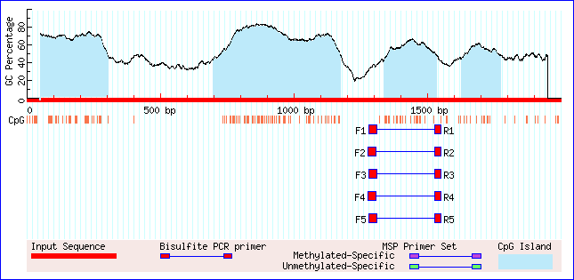**Figure 1: CpG Islands**

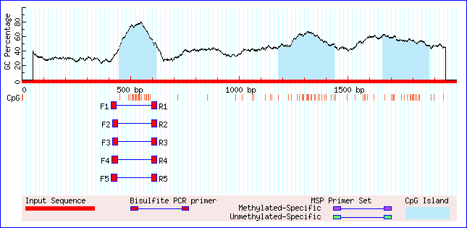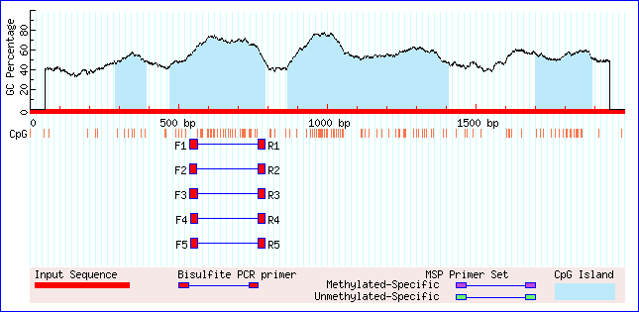

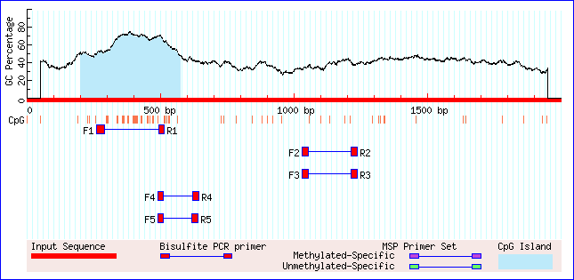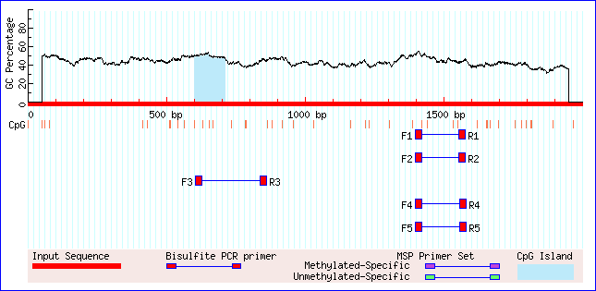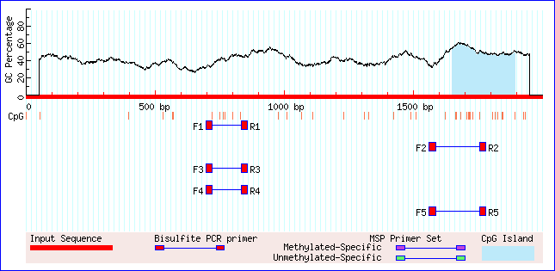*EcPi9.1 EcPi9.2 EcPi9.3*

*EcPi9.4 EcPi9.5 EcPi9.8*

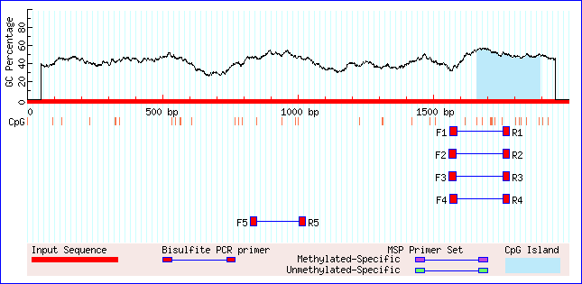

*EcPi9.9*

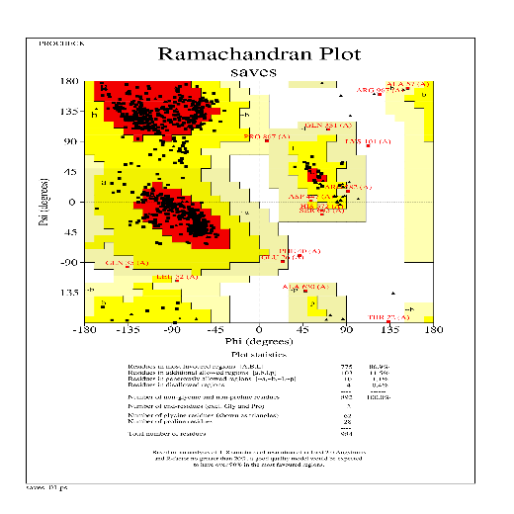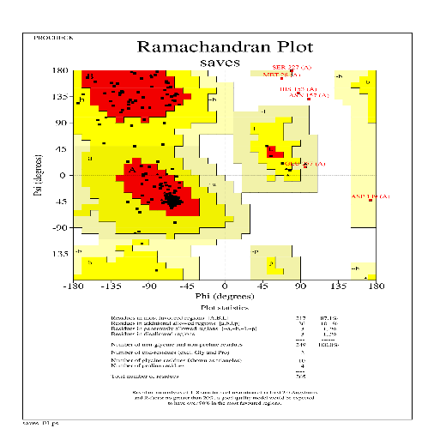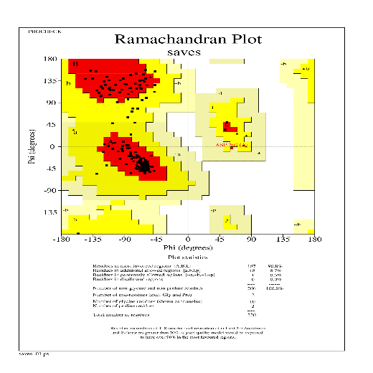Figure 2- Ramachandran plots

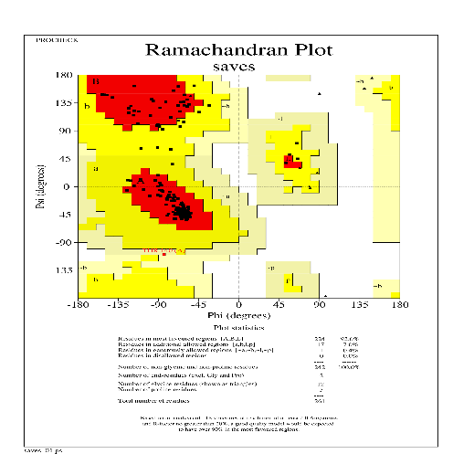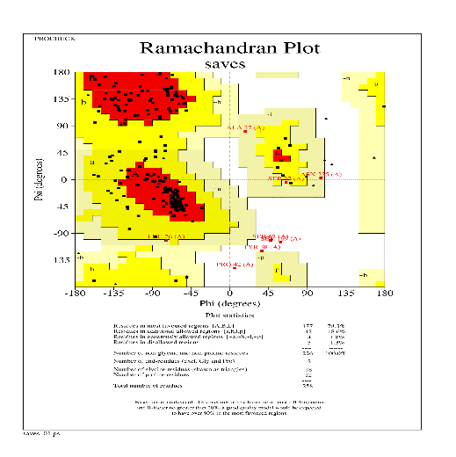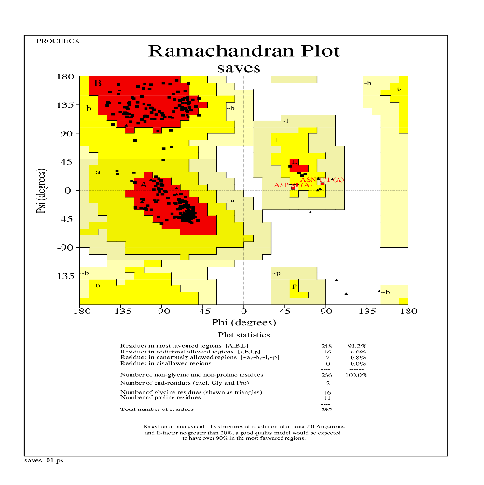*EcPi9.1 EcPi9.2 EcPi9.3*

*EcPi9.4 EcPi9.5 EcPi9.6*

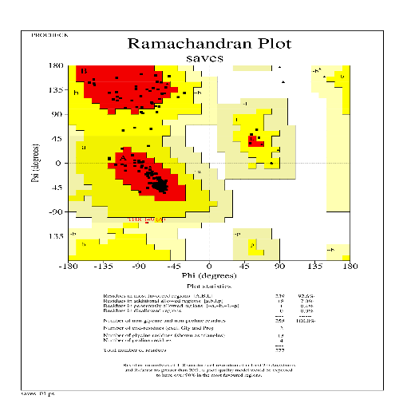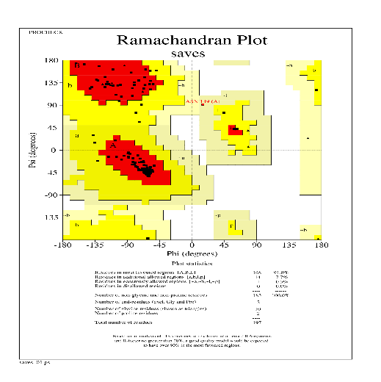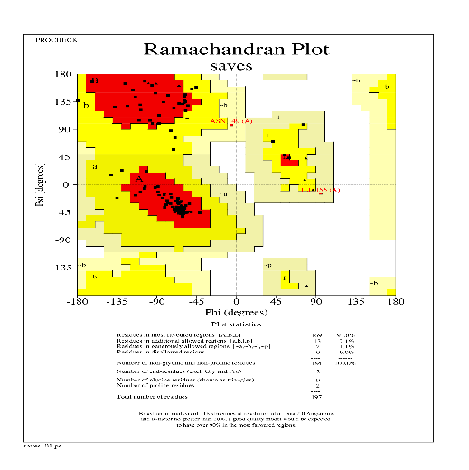

*EcPi9.7 EcPi9.8 EcPi9.9*

**Table 1- Web servers or tools or databases used in materials and methods.**

|  |  |  |
| --- | --- | --- |
| **Method** | **Web tool/ Database/ Server** | **Web link** |
| Gene structure prediction | Gene Structure Display Server 2.0 | (http://gsds.cbi.pku.edu.cn/index.php) |
| Subcellular localization | [WOLFPSORT](https://www.genscript.com/wolf-psort.html) | [(https://www.genscript.com/wolf-psort.html)](https://www.genscript.com/wolf-psort.html) |
| Motif pattern | [MEME](http://meme-suite.org/tools/meme) | (http://meme-suite.org/tools/meme) |
| Conserved domain analysis | [NCBI-CDD batch search](https://www.ncbi.nlm.nih.gov/Structure/bwrpsb/bwrpsb.cgi) | (https://www.ncbi.nlm.nih.gov/Structure/bwrpsb/bwrpsb.cgi) |
| Physical mapping | [Phenogram](https://visualization.ritchielab.org/phenograms/plot) | (https://visualization.ritchielab.org/phenograms/plot) |
| Sequence alignment and phylogeny | Mega version 11.0 | (http://www.megasoftware.net) |
| Phylogeny | iTOL | (https://itol.embl.de/upload.cgi) |
| Promoter elements prediction | PLANT CARE tool | (http://bioinformatics.psb.ugent.be/webtools/plantcare/html/) |
| Protein parameters | ProtParam software | (https://web.expasy.org/protparam/) |
| 2D structure of protein | SOPMA server | (https://npsa-prabi.ibcp.fr/cgi-bin/npsa_automat.pl?page=/NPSA/npsa_sopma.html) |
| 3D structure of protein | Expasy Swiss model server | (https://swissmodel.expasy.org/) |
| Ramachandran plot | PSVS -protein structure verification server | (https://saves.mbi.ucla.edu/) |
| PPI | STRING data base | (https://string-db.org/) |
| Transcriptional factor prediction | PTFDB- plant transcriptional factors database | (http://planttfdb.gao-lab.org/) |
| Gene ontology | Pannzer 2 | (http://ekhidna2.biocenter.helsinki.fi/sanspanz/) |
| CpG Island prediction | MethPrimer | (https://www.methprimer.com/cgi-bin/methprimer/methprimer.cgi) |
| Network preparation of TFs | Cytoscape | (https://cytoscape.org/) |

**Abbreviations**

|  |  |
| --- | --- |
| NBS-LRR | Nucleotide-Binding Site Leucine-Rich Repeat |
| PTI | Pattern Triggered Immunity |
| coiled-coil group (CNL) | CC-NBS-LRR protein |
| NB LRR | Nucleotide Binding, Leucine Rich Repeats |
| CDS | Coding DNA sequence |
| PI | Isoelectric Point |
| NB ARC | Nucleotide-binding domain, Apaf-1, R proteins, and Ced-4. |
| AAR | cis-acting element involved in the abscisic acid responsiveness |
| AI | cis-acting regulatory element essential for the anaerobic induction |
| AR | auxin-responsive element |
| CC | cis-acting regulatory element involved in circadian control |
| DSR | cis-acting element involved in defence and stress responsiveness |
| EE | cis-regulatory element involved in endosperm expression |
| GR | gibberellin-responsive element |
| LR | part of a conserved DNA module involved in light responsiveness |
| LTR | cis-acting element involved in low-temperature responsiveness |
| MeJAR | cis-acting regulatory element involved in the MeJA-responsiveness |
| ME | cis-acting regulatory element related to meristem expression |
| Meso | element involved in differentiation of the palisade mesophyll cells |
| MYBDI | MYB binding site involved in drought-inducibility |
| MYBHv1 | MYBHv1 binding site |
| SAR | cis-acting element involved in salicylic acid responsiveness |
| PB | protein binding site |
| WR | wound-responsive element |
| MYBLR | MYB binding site involved in light responsiveness |
| ASI | enhancer-like element involved in anoxic specific inducibility |
| ATBP-1 | binding site of AT-rich DNA binding protein (ATBP-1) |