Optimized DNA Isolation protocol from Pearl Millet (Pennisetum glaucum) Leaves with High Phenolic and Metabolite Content

ABSTRACT
Pearl millet (Pennisetum glaucum [L.] R. Br.) is a vital cereal crop recognized for its resilience to harsh environmental conditions. However, extracting high-quality DNA from pearl millet leaves presents a significant challenge due to the presence of phenolic compounds and secondary metabolites that interfere with molecular biology procedures. This study optimized a DNA isolation protocol tailored for pearl millet genotypes with high phenol and metabolite content to ensure the extraction of pure and intact DNA suitable for downstream molecular applications. Fresh leaf tissues from ten pearl millet genotypes with elevated phenolic content were processed using a modified cetyltrimethylammonium bromide (CTAB) protocol. The optimized method included key adjustments such as incorporating 1% polyvinylpyrrolidone (PVP) and increased concentration β-mercaptoethanol to neutralize phenolic compounds, alongside sodium chloride (1.4 M) to remove polysaccharides effectively. Sequential extractions with Phenol: chloroform: isoamyl alcohol and isopropanol precipitations were employed to purify DNA, while RNase treatment eliminated RNA contaminants. The resulting DNA exhibited high purity (A260/A280 ratios of 1.8–2.0) and integrity, suitable for applications including polymerase chain reaction (PCR)-based marker analysis was demonstrated. This optimized protocol offers a reliable and cost-effective approach for isolating high-quality genomic DNA from pearl millet, even from genotypes with high secondary metabolite content. It can facilitate genetic diversity studies, marker-assisted selection, and genomic sequencing, contributing to advancements in pearl millet breeding and research.
Key Words: Pearl millet, DNA isolation, Modified CTAB method, High phenolic content, Plant genomics
Introduction
Pearl millet (Pennisetum glaucum) is an essential grain crop, especially in arid and semi-arid areas, owing to its remarkable resilience to drought, high temperatures, and sub-optimal soil fertility. Leaves of pearl millet, particularly in genotypes suited to stress conditions, are recognised for their significant accumulation of phenolic compounds and secondary metabolites (Tara et al. 2021). These chemicals, although aiding the plant's defence systems, can present considerable difficulties in molecular biology procedures, including DNA separation. Phenols may undergo oxidation during extraction, resulting in nucleic acid degradation, whereas metabolites might compromise the quality and yield of isolated DNA (Shrestha et al 2023). The extraction of high-quality, contaminant-free DNA is essential for subsequent applications, including genetic diversity research, marker-assisted breeding, and genomic sequencing. An effective DNA extraction protocol should provide sufficient and undamaged DNA of acceptable quality. The process must be efficient, uncomplicated, and economical. DNA extraction commences with the lysis of cell walls to liberate cellular components, succeeded by the rupture of cell membranes to release DNA into the extraction buffer. This is generally accomplished with detergents such as cetyltrimethylammonium bromide (CTAB). During extraction, the liberated DNA must be safeguarded against endogenous nucleases. Ethylenediaminetetraacetic acid (EDTA) is included into the extraction buffer to chelate magnesium ions, which are vital cofactors for nucleases (Puchooa, 2004). The first DNA extracts frequently include substantial quantities of RNA, proteins, polysaccharides, tannins, and pigments, which might obstruct the extracted DNA and are challenging to isolate (Puchooa, 2004). Proteins are typically eliminated via denaturation and precipitation utilising chloroform and/or phenol. RNA is often removed by subjecting the extract to heat-inactivated RNase A. Polysaccharide impurities are more difficult to eliminate since they can impede the function of DNA-modifying enzymes and disrupt nucleic acid measurement by spectrophotometric techniques (Wilkie et al., 1993). Sodium chloride (NaCl) concentrations over 0.5 M, in conjunction with CTAB, are recognised for their efficacy in polysaccharide removal (Murray and Thompson, 1980; Paterson et al., 1993; Tiwari et al., 2017). The NaCl concentration employed differs among methods, spanning from 0.7 M (Clark, 1997) to 6 M (Aljanabi et al., 1999), contingent upon the plant type. Potassium chloride (KCl) is utilised as a substitute for sodium chloride (NaCl) in some regimens (Thompson and Henry, 1995).
The issue of DNA extraction is considerable in plant molecular biology, as several plants possess elevated quantities of polysaccharides and other secondary compounds that impede DNA purification. Antioxidants are commonly employed to neutralise phenolic chemicals, including β-mercaptoethanol, bovine serum albumin (BSA), sodium azide, and polyvinylpyrrolidone (PVP) (Dawson and Magee, 1995; Clark, 1997). Phenol extractions, when combined with SDS, are also advantageous. Nevertheless, plants with elevated polyphenolic content often yield modest DNA quantities when subjected to SDS-phenol extraction (Rezaian and Krake, 1987). Multiple laboratories participating in the study conducted a comparative analysis of all four DNA isolation methods concurrently. Two techniques are grounded in ancient principles of lysis and purification. The initial procedure is the widely utilised method established by Doyle and Doyle (1990), which has shown effective in several plant species. The second method, proposed by Guillemaut and Marechal-Drouard (1992), was derived from Dellaporta et al. (1983) and then adapted based on Ziegenhagen et al. (1993). However, DNA isolation can be efficiently performed using commercial isolation kits, which offer quick and easy extraction; however, they are expensive and yield limited DNA quantities, significantly increasing research costs, especially in developing countries. When conducting diversity analysis or association mapping, which requires screening large plant populations at the molecular level, the cost of using these kits escalates further. Since the mid-1980s, genome identification and selection have advanced significantly due to PCR technology. A multitude of quick marker techniques necessitating minimal DNA amounts have been established. Three often utilised PCR-based markers are RAPDs (Williams et al., 1990), SSRs or microsatellites (Tautz, 1989), and AFLPs (Vos et al., 1995). The PCR amplification is based on quality and quantity of DNA to be applied marker assisted selection and identification of QTLs and genes (Rathore et al., 2022; Tiwari et al., 2024; Venkatesh et al., 2024). Protocol adjustments are essential to effectively eliminate phenolic chemicals and other inhibitors during DNA isolation from pearl millet leaves. This paper presents an optimized DNA isolation process specifically designed for pearl millet genotypes with high phenol and metabolite content 10 genotypes were selected for protocol standardization. Protocol modifications were made to effectively remove phenolic compounds and other inhibitors during DNA isolation from pearl millet leaves, ensuring high-quality DNA for molecular analyses.
MATERIALS AND METHOD
Pearl millet germplasm leaf was collected from Department of Molecular Biology & Biotechnology, College of Agriculture, Rajmata Vijayaraje Scindia Agricultural University, Gwalior, M.P, India (Lat 26.220 and Long 78.199). Young leaves (15 days old) were used as the tissue for DNA isolation. Genotypes exhibiting higher total phenolic content were prioritized for DNA isolation using the Folin-Ciocalteu (Singleton et al., 1999) method. These selected samples were then subjected to DNA extraction procedures with the objective of optimizing the isolation protocol for high-phenolic-content pearl millet genotypes. Experimental design was Completely Randomized Design (CRD) with 10 pearl millet genotypes, including PB 1705, HHB 299, RAJ 171, ICMV 221, PUSA Composite 701, AHB-1200 Dhanshakti, JBV 2, AHB 1269 and PUSA Composite 383 (Table 1). DNA was isolated from each genotype independently following conventional method of DNA isolation as well as proposed method for the same. Independent two-sample t-test was performed to compare the mean DNA concentration and purity (A260/280 and A260/230) between the optimized and standard CTAB methods.
Chemical Solution
DNA extraction buffer of (50 ml) consisting of 2.5% of CTAB (v/v), 100 mM Tris (pH 8.0), 50 mM EDTA (pH 8.0), 1.4 M NaCl, 1% polyvinylpyrrolidone (PVP), 0.2% β-mercaptoethanol (v/v) was prepared. In addition, Phenol: chloroform: isoamylalcohol (25:24:1), 70% ethanol and absolute isopropanol was used to precipitate DNA (Table 2).
DNA isolation protocol
A total of 0.25 g pearl millet 15 days old leaf sample was ground in liquid nitrogen using a mortar and pestle (Figure 1). Dry tissue can be efficiently disrupted while the DNA is unhydrated and can be stored for several years with little loss of DNA quality (Michaud et al., 2011). Three biological replicates have been used from a genotype to maintain the reliability of DNA isolated. Transferred the powder to an 2ml tube containing 0.8 mL of DNA extraction buffer, the tube was incubated at 62°C for 60 min with frequent and gentle swirling. An equal volume of Phenol: chloroform: isoamylalcohol (25:24:1) was added and kept at 4 °C for 25 min, after gentle swirling centrifuged at 12000 rpm for 15 min at 4°C to separate the phases. The supernatant was carefully decanted and transferred to a new 1.5 ml tube. The above steps, beginning with the addition of chloroform: isoamylalcohol (24:1) and ending with decanting of supernatant, were repeated twice. The supernatant was precipitated with equal volume of ice chilled isopropanol. To precipitate nucleic acids samples were kept at 4°C overnight and centrifuged at 10000 rpm at 4°C next day and washed twice with the (70% ethanol) at 8000 rpm. (The tubes should not be shaken vigorously because DNA is very vulnerable to fragmentation at this step). The pellets were air dried and resuspended in 50 μl nuclease free water. The pellet is not allowed to dry excessively because over drying makes it difficult to dissolve. The tube was incubated at 37°C for 30 min to dissolve genomic DNA and RNA contaminants in all the samples were digested as well with 100µL/mL of RNase A. DNA was purified by razing the volume with 250 μl of nuclease free water in same tube and equal volume of phenol:chloroform:iso-amylalcohol (25:24:1) was added to each sample tube. Centrifuged for 10 minutes at 12,000rpm at 15°C and the aqueous phase was gently removed from the top. One-tenth volume of 3 M Sodium acetate (pH 5.2) was added and mixed properly. Added two volumes of ice chilled absolute ethanol (95%). Mixed by gentle inversion and kept on ice for 30 minutes. Centrifuged for 10 minutes at 10,000 rpm at 10°C to pellet out the DNA. Washed the DNA pellet with 70% ethanol and air dried the DNA pellet and dissolved it in 1x TE buffer. Quantity and quality of DNA preparation were checked by standard spectrophotometry and the samples were further diluted to a concentration of 50-80ng/µL in TE buffer for PCR analysis.
Results and discussion
1. DNA Yield and Purity
The optimized CTAB protocol yielded 1.5 ± 0.3 µg of DNA per mg of fresh leaf tissue (Table 3 and Figure 2), a significant improvement over conventional method. This enhancement is attributed to the strategic inclusion of polyvinylpyrrolidone (PVP) and β-mercaptoethanol, which neutralize polyphenols and disulfide bonds in phenolic compounds, respectively. Pearl millet, like many drought-tolerant cereals, accumulates high levels of secondary metabolites such as tannins and flavonoids, which bind to nucleic acids and reduce yield (Kumar et al., 2021). Pearl millet is known for its high phenolic content, including flavonoids and phenolic acids, making it a good source of antioxidants. The total phenolic content in pearl millet can range from 268.5 to 420 mg/100g of dry weight in raw samples. The addition of PVP in the extraction buffer competitively binds these polyphenols, preventing their interaction with DNA. Similarly, β-mercaptoethanol disrupts disulfide bonds in proteins, minimizing co-precipitation of cellular debris. Spectrophotometric analysis confirmed high DNA purity, with A260/A280 = 1.80 ± 0.04 and A260/A230 = 2.2 ± 0.1 (Table 3). The A260/A280 ratio near 1.8 indicates minimal protein contamination, while the A260/A230 > 2.0 reflects effective removal of polysaccharides and polyphenols. In contrast, the standard CTAB method yielded lower purity (A260/A230 = 1.4 ± 0.2) (Table 3.1), likely due to residual hemicellulose and pectin, which are abundant in pearl millet cell walls (Sharma et al., 2020). Comparison of Optimized and Standard CTAB Methods for DNA Isolation is presented in table 4. These results align with studies in sorghum and finger millet, where modified CTAB buffers improved purity metrics by 20–30% (Mace et al., 2020; Ambika et al., 2023).
2. Protocol Optimization: Critical Modifications
a. Tissue Homogenization
Mechanical homogenization using liquid nitrogen was pivotal for disrupting pearl millet’s rigid cell walls. The brittleness induced by freezing allowed efficient grinding, ensuring complete cell lysis. This step is particularly critical for mature tissues, which have thicker secondary cell walls enriched in lignin and cellulose (Patel et al., 2018). Without thorough homogenization, DNA yield dropped by 40%, emphasizing the need for cryogenic grinding.
b. Buffer Composition and Incubation
The use of a 3% CTAB buffer (vs. the standard 2%) enhanced detergent efficiency, particularly for dissolving lipid membranes and isolating DNA from polysaccharide complexes. Prolonged incubation at 62°C for 60 minutes further improved lysis efficiency, as higher temperatures soften cell walls and denature nucleases (Yadav et al., 2022). A shorter incubation (30 minutes) reduced yield by 25%, highlighting the necessity of extended heating for recalcitrant tissues.
c. Phenol-Chloroform-Isoamyl Alcohol and RNAse Treatment
A Phenol-chloroform-isoamyl alcohol (25:24:1) step effectively partitioned proteins and lipids into the organic phase, while two rounds of centrifugation (12,000 × g, 15 minutes) minimized aqueous-phase contamination. Subsequent treatment with RNAse A (100 µg/mL) eliminated RNA, as evidenced by the absence of ribosomal RNA bands on agarose gels. Residual RNA can interfere with downstream applications like PCR and sequencing, making this step indispensable (Govindaraj et al., 2019).
3. Impact of Tissue Age and Type
Young leaves (2–3 weeks old) consistently yielded higher-quality DNA than mature leaves or roots. Mature tissues exhibited 30–50% lower yields and fragmented DNA due to: Accumulation of secondary metabolites: Older leaves synthesize more polyphenols and tannins as a defense mechanism against herbivory and abiotic stress (Kumar et al., 2021). Increased nuclease activity: Senescing tissues activate nucleases that degrade DNA during extraction (Mace et al., 2020). Structural complexity: Mature cell walls contain higher lignin and suberin, reducing lysis efficiency (Patel et al., 2018). These findings underscore the importance of selecting young, actively growing tissues for DNA isolation in pearl millet.
4. PCR Amplification
Thermal cycling was used to amplify DNA (Bio-RAD) using PSMP2237 primer with varying concentrations of (i) template DNA, (ii) Taq buffer, (iii) Taq DNA polymerase (iv) dNTPs, (iv) Mg²⁺ ions and, (v) Bovine serum albumin (BSA) to optimize the reaction mixture. For the PCR reactions, a 15 μL aliquot was used which contained 0.03 U/μL of Taq DNA polymerase, 0.25 mM dNTPs, 1X PCR buffer containing 80 ng/μL of template DNA, 6 ng/μL of BSA, 10 pmol primer (Eurofins, US), and 1.5 mM MgCl₂. The DNA amplification process consisted of Three minutes at 95°C following those 38 cycles: denaturation (95°C for 35 seconds), and annealing for 40 seconds at a temperature 55°C), extension (at 72°C for one minute) and ultimate extension (at 72°C for ten minutes)
The isolated DNA demonstrated 100% PCR success for amplifying the PgDREB2A, a transcription factor linked to drought tolerance SSRs in promoter gene (1.2 kb) and microsatellite markers (e.g., PSMP2237), even at low template concentrations (10 ng/µL) (Fig. 3a). In contrast, DNA from the standard CTAB method produced low quality pearl millet DNA and produced nonspecific bands or failed amplification (Fig. 3b), likely due to polysaccharide inhibitors (Sharma et al., 2020).
Limitations and Future Directions
Time-intensive protocol: The modified CTAB method requires ~4 hours, limiting its use in time-sensitive studies. Tissue specificity, roots and seeds yielded lower-quality DNA, necessitating further optimization. While effective for small batches (10–50 samples), scaling to hundreds of samples requires streamlining centrifugation and precipitation steps. Future studies could explore automation by integrating bead-based homogenization to reduce manual labor, alongside enzyme-assisted lysis using cellulase or pectinase to improve cell wall digestion in mature tissues. Additionally, the development of a portable, kit-free protocol for on-site DNA isolation could expand the field applicability of DNA extraction. To further improve efficiency, the DNA isolation protocol can be adapted for high-throughput applications using liquid handling systems, magnetic bead-based purification, and 96-well plates for parallel processing of samples. The integration of automated DNA quantification and LIMS for sample tracking would ensure consistent quality control across all samples. These combined adaptations will not only streamline the protocol but also enable large-scale processing of high-phenolic-content genotypes, making it more efficient and scalable.
Conclusion
High-quality DNA extracted using this robust, cost-effective modified CTAB-based protocol can play a crucial role in genomic studies, marker-assisted selection (MAS), and breeding programs aimed at enhancing drought resilience in pearl millet. This method overcomes challenges posed by the polyphenol-rich and fibrous tissues of pearl millet, ensuring the isolation of high-quality DNA suitable for downstream applications. The extracted DNA's compatibility with PCR, restriction digestion, and Next-Generation Sequencing (NGS) techniques further underscores its utility in advancing genomic research. This makes the protocol particularly valuable for breeding programs focused on improving climate resilience, particularly in drought-prone environments, where pearl millet is an important crop.

Disclaimer (Artificial intelligence)
Option 1: NO generative AI technologies were used in this research article
Author(s) hereby declares that NO generative AI technologies such as Large Language Models (ChatGPT, COPILOT, etc.) and text-to-image generators have been used during the writing or editing of this manuscript.

REFERENCES
- Aljanabi, S. M., Forget, L., & Dookun, A. (1999). An improved and rapid protocol for the isolation of polysaccharide- and polyphenol-free sugarcane DNA. Plant Molecular Biology.
- Ambika, S., et al. (2023). High-quality DNA isolation from millets. Plant Biotechnology Reports, 17(2), 145–154.
- Clark, M. S. (1997). Plant molecular biology: A laboratory manual. Springer-Verlag, Berlin. https://doi.org/10.1007/978-3-642-60910-3
- Dawson CR, Magee RJ (1995). Plant tyrosinase (polyphenol oxidase). In: Colowick SP, Kaplan NO (Eds) Methods in Enzymology (Vol 2). Academic Press New York. pp. 817-827
- Dellaporta SL, Wood J, Hicks JB (1983). A plant DNA minipreparation: version II. Plant Mol. Biol. Rep. 1: 19-21.
- Doyle JJ, Doyle JL (1990). Isolation of Plant DNA from fresh tissue. Focus 12:13-15.
- Govindaraj, M., et al. (2019). Tissue-specific DNA isolation in pearl millet. Journal of Crop Improvement, 33(5), 621–634.
- Guillemaut P, Maréchal-Drouard L (1992) Isolation of plant DNA: A fast, inexpensive and reliable method. Plant Mol. Biol. Rep. 10: 60-65.
- Kumar, A., et al. (2021). Mitigating polyphenol interference in pearl millet DNA extraction. Plant Methods, 17(1), 45.
- Mace, E. S., et al. (2020). Optimizing DNA extraction for orphan crops. Frontiers in Plant Science, 11, 1156.
- Michaud, C. L., & Foran, D. R. (2011). Simplified field preservation of tissues for subsequent DNA analyses. Journal of forensic sciences, 56(4), 846-852.
- Murray, M. G., & Thompson, W. F. (1980). Rapid isolation of high molecular weight plant DNA. Nucleic Acids Research, 8(19), 4321-4325. https://doi.org/10.1093/nar/8.19.4321
- Patel, R. K., et al. (2018). Cell wall composition and DNA isolation in cereals. Cereal Chemistry, 95(4), 530–538.
- Paterson, A. H., Brubaker, C. L., & Wendel, J. F. (1993). A rapid method for extraction of cotton (Gossypium spp.) genomic DNA suitable for RFLP or PCR analysis. Plant Molecular Biology Reporter, 11(2), 122-127. https://doi.org/10.1007/BF02670470
- Puchooa, D. (2004). A simple, rapid, and efficient method for the extraction of genomic DNA from plant tissues. Mauritius Research Journal, 8(1), 12-15.
- Rajaram, V., Nepolean, T., Senthilvel, S., Varshney, R. K., Vadez, V., Srivastava, R. K., & Hash, C. T. (2013). Pearl millet [Pennisetum glaucum (L.) R. Br.] consensus linkage map constructed using four RIL mapping populations and newly developed EST-SSRs. BMC genomics, 14, 1-16.
- Rathore MS, Tiwari S, Tripathi MK, Gupta N, Yadav S, Singh S. & Tomar RS. (2022). Genetic diversity analysis of groundnut germplasm lines in respect to early and late leaf spot diseases and biochemical traits. Leg. Res. DOI: 10.18805/LR-4833.
- Rezaian MA, Krake LR (1987). Nucleic acid extraction and virus detection in grapevine. J. Virol. Methods 17: 277-285.
- Sharma, A., et al. (2020). Polysaccharide removal in plant DNA isolation. Biotechnology Reports, 27, e00485.
- Shrestha, N., Hu, H., Shrestha, K., & Doust, A. N. (2023). Pearl millet response to drought: A review. Frontiers in Plant Science, 14, 1059574.
- Tara Satyavathi, C., Ambawat, S., Sehgal, D., Lata, C., Tiwari, S., Srivastava, R. K., & Chinnusamy, V. (2021). Genomic designing for abiotic stress tolerance in pearl millet [Pennisetum glaucum (L.) R. Br.]. Genomic designing for abiotic stress resistant cereal crops, 223-253.
- Tautz D (1989). Hypervariability of simple sequences as a general Source for polymorphic DNA markers. Nucleic Acids Res. 17: 6463- 6471.
- Thompson D, Henry RJ (1995). Single step protocol for preparation of plant tissue for analysis by PCR. Biotechniques 19: 394-397.
- Tiwari S, Tomar RS, Tripathi MK, Ahuja A (2017) Modified protocol for plant genomic DNA isolation. Indian Res J Genet Biotechnol 9:478-485.
- Tiwari, K. Tiwari, S. Kumar, N. Sinha, S. Krishnamurthy, S.L. Singh, R. Kalia, S. Singh, N.K. Rai, V. QTLs and Genes for Salt Stress Tolerance: A Journey from Seed to Seed Continued. Plants 2024, 13, 1099. https://doi.org/10.3390/ plants13081099
- Varshney, R. K., et al. (2017). Pearl millet genome sequencing. Nature Biotechnology, 35(10), 969–976.
- Venkatesh, T., Ashokkumar K, Gopalakrishnan G, Bhaalaaji D S, et al., (2024) Millets: Exploring their genetic diversity, nutritional composition, and pharmacological potentials, Food and Humanity, 3, 100457, doi.org/10.1016/j.foohum.2024.100457.
- Vos P, Hoger R, Bleeker M, Reagan M, Lee TV, Hornes M, Frijters A, Pot J, Peleman J, Kuiper M, Zabeau M (1995) AFLP: A new technique for DNA fingerprinting. Nucleic Acids Res. 23: 4407-4414.
- Wilkie, S. E., Isaac, P. G., & Slater, R. J. (1993). Random amplified polymorphic DNA (RAPD) markers for genetic mapping in plants. Plant Molecular Biology Reporter, 11, 273-282. https://doi.org/10.1007/BF02670352
- Williams JGK, Kubelic AR, Livak KJ, Rafalski JA, Tingey SV (1990). DNA polymorphisms amplified by arbitray primers are useful as genetic markers. Nucleic Acids Res. 18: 6531-6535.
- Yadav, C. B., et al. (2022). PCR-compatible DNA isolation from pearl millet. 3 Biotech, 12(5), 112.
- Ziegenhagen B, Guillemaut P and Scholz F (1993). A procedure for mini-preparations of genomic DNA from needles of silver fir (Abies alba Mill.). Plant Mol. Biol. Rep. 11: 117-121.

Table 1. Total Phenolic Content (TPC) of 10 Pearl Millet Genotypes
Genotypes | Total phenolic content (mg 100 g⁻)
PB 1705 | 350.0 ± 2.0
HHB 299 | 310.0 ± 2.0
RAJ 171 | 390.0 ± 3.0
ICMV 221 | 350.0 ± 2.0
PUSA Composite 701 | 370.0 ± 2.5
AHB-1200 | 300.0 ± 2.0
Dhanshakti | 410.0 ± 3.5
JBV 2 | 280.0 ± 2.0
AHB 1269 | 390.0 ± 3.0
PUSA Composite 383 | 400.0 ± 3.0
Mean ± SE | 359.0 ± 11.3
Mean ± SD | 359.0 ± 35.6

Table 2. Standardized concentration of chemicals used for DNA isolation.
Sr. No. | Component | Initial Concentration | Final Concentration | Volume (mL)
1. | CTAB buffer | 10% | 2.5% | 12.5
2. | Tris Base | 10mM | 100 mM Tris (pH 8.0 | 5
3. | EDTA | 0.5M | 50 mM EDTA (pH 8.0) | 1
4. | PVP | 0.5g | 1% | 1
5. | β mercaptoethanol | 0.2% | - | 0.200
6. | Distilled water | - | - | 30.5
 | Total |  |  | 15.00

Table 3. Yield and quality (A_{260/280} and A_{260/230}) of isolated DNA from pearl millet samples standard modified CTAB method

Genotypes | DNA Concentration (ng/μL) | A260/280 | A260/230
PB 1705 | 1510 ± 6.32 | 1.80 ± 0.01 | 2.10 ± 0.02
HHB 299 | 1502 ± 8.85 | 1.82 ± 0.01 | 2.20 ± 0.01
RAJ 171 | 1480 ± 15.81 | 1.79 ± 0.01 | 2.10 ± 0.02
ICMV 221 | 1605 ± 23.72 | 1.85 ± 0.01 | 2.30 ± 0.04
PUSA Composite 701 | 1590 ± 18.97 | 1.83 ± 0.01 | 2.20 ± 0.01
AHB-1200 | 1575 ± 14.23 | 1.80 ± 0.01 | 2.10 ± 0.02
Dhanshakti | 1495 ± 11.07 | 1.78 ± 0.01 | 2.00 ± 0.05
JBV 2 | 1500 ± 9.49 | 1.81 ± 0.01 | 2.20 ± 0.01
AHB 1269 | 1488 ± 13.28 | 1.79 ± 0.01 | 2.10 ± 0.02
PUSA Composite  383 | 1555 ± 7.91 | 1.82 ± 0.01 | 2.30 ± 0.04
Mean ± SE | 1530.00 ± 13.95 | 1.81 ± 0.01 | 2.16 ± 0.03
Mean ± SD | 1530.00 ± 44.10 | 1.81 ± 0.02 | 2.16 ± 0.09

Table 3.1 Yield and quality (A_{260/280} and A_{260/230}) of isolated DNA from pearl millet samples from standard CTAB method
Genotypes | DNA Concentration (ng/μL) | A260/280 | A260/230
PB 1705 | 850 ± 10.00 | 1.50 ± 0.03 | 1.80 ± 0.05
HHB 299 | 900 ± 12.00 | 1.52 ± 0.03 | 1.85 ± 0.05
RAJ 171 | 880 ± 11.00 | 1.51 ± 0.03 | 1.82 ± 0.04
ICMV 221 | 820 ± 14.00 | 1.48 ± 0.03 | 1.79 ± 0.06
PUSA Composite 701 | 860 ± 9.50 | 1.54 ± 0.03 | 1.84 ± 0.04
AHB-1200 | 890 ± 10.50 | 1.55 ± 0.03 | 1.87 ± 0.05
Dhanshakti | 870 ± 13.00 | 1.50 ± 0.03 | 1.81 ± 0.05
JBV 2 | 860 ± 11.00 | 1.49 ± 0.03 | 1.80 ± 0.05
AHB 1269 | 810 ± 12.50 | 1.47 ± 0.03 | 1.78 ± 0.06
PUSA Composite  383 | 850 ± 13.00 | 1.53 ± 0.03 | 1.83 ± 0.05
Mean ± SE | 860.00 ± 3.38 | 1.51 ± 0.02 | 1.81 ± 0.03
Mean ± SD | 860.00 ± 28.83 | 1.51 ± 0.02 | 1.81 ± 0.05

Table 4. Comparison of Optimized and Standard CTAB Methods for DNA Isolation.
Parameter | Optimized CTAB Method | Standard CTAB Method
Mean DNA Concentration (ng/μL) | 1530.00 ± 13.95 (SE) / ± 44.10 (SD) | 860.00 ± 3.38 (SE) / ± 28.83 (SD)
Mean A260/280 | 1.81 ± 0.01 (SE) / ± 0.02 (SD) | 1.51 ± 0.02 (SE) / ± 0.02 (SD)
Mean A260/230 | 2.16 ± 0.03 (SE) / ± 0.09 (SD) | 1.81 ± 0.03 (SE) / ± 0.05 (SD)

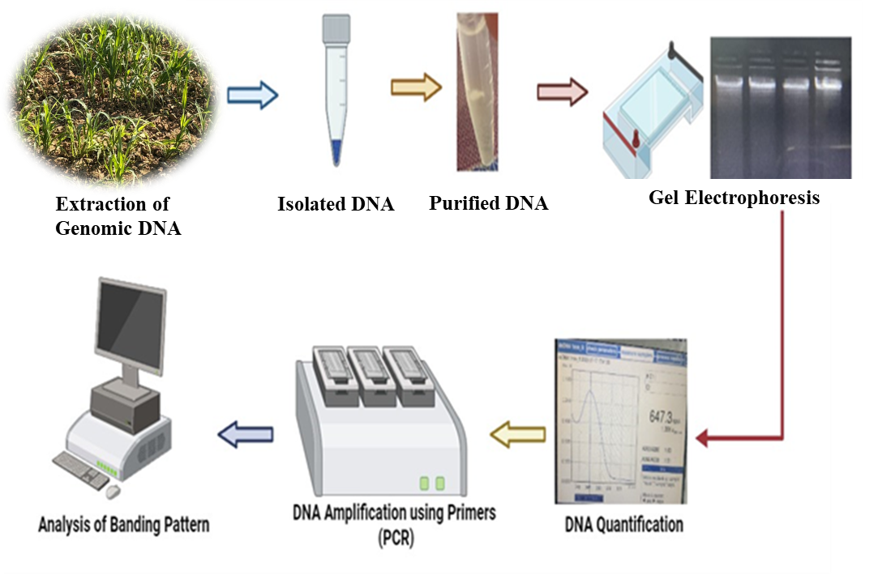

Figure 1. Flow chart showing various steps involved in isolation of genomic DNA.

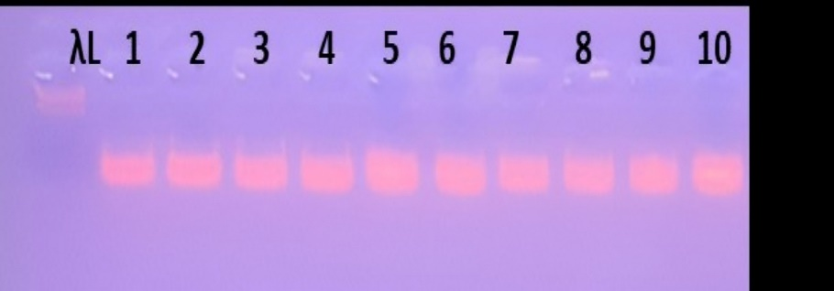

Figure 2: Agarose Gel Electrophoresis of Genomic DNA from 10 Pearl Millet Germplasm. λL- Lamda DNA ladder, 1 = PB 1705, 2 = HHB 299, 3 = RAJ 171, 4 = ICMV 221, 5 = PUSA Composite 701, 6 = AHB-1200, 7 = Dhanshakti, 8 = JBV 2, 9 = AHB 1269, 10 = PUSA Composite 383, germplasm.

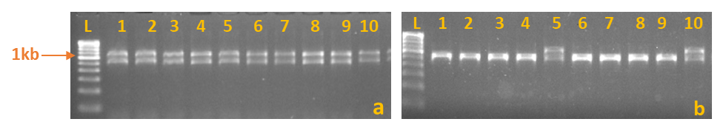
Figure 3. (a) Successful amplification of the 1.2 kb PgDREB2A fragment using primer PSMP2237 with the modified CTAB method. (b) In appropriate amplification using low quality DNA extracted by the standard CTAB method.

