**Environmental Impact of Petroleum Hydrocarbons from Artisanal Refineries on Surface Water in the Niger Delta**

**Abstract**

Artisanal petroleum refining in Nigeria is considered as an organized and well-orchestrated environmental crime with propelling disagreements and security problems within the Niger Delta. The study was aimed at quantifying the level of petroleum hydrocarbons that artisanal refineries release into the marine environments that surround them. Water samples were taken from rivers in four different LGAs in Rivers State: Omuma, Emuoha, Etche, and Eleme. The samples were sent to the lab to undergo hydrocarbon analysis. Agilent 6890N Gas Chromatograph - Flame Ionization Detector (GC-FID) was used to measure polycyclic aromatic hydrocarbons (PAHs) and total petroleum hydrocarbon (TPH). Samples from an artisanal refining area in Emuoha had the highest TPH content of 1,913.6 mg/l; highest phenanthrene PAH concentration of 172.42 mg/l recorded in Etche, Data gathered revealed possible pollution hotspots in Eleme and Etche, where greater amounts of certain PAHs were reported, thereby illuminating the varied distribution of PAHs across diverse water sources. While the impacted regions of Eleme and Etche are in dire need of environmental and health remedies, the risk in Emohua is lesser. To lessen the impact on public health, identified regions should enact effective regulations, pollution control measures, and community health protection programs.

**Keywords:** Total petroleum hydrocarbons (TPH); Polycyclic Aromatic Hydrocarbons (PAHs); Artisanal refining petroleum; Rivers State; Niger Delta; Surface water quality

**1.0 Introduction**

Surface water is the primary source of water for many uses, including human consumption, agricultural and industrial production, gardening, animal husbandry, and conservation of aquatic life (including fisheries) (Syeed et al., 2023). The degradation of surface water has assumed a worldwide dimension, and significantly impact the hydrological cycle (Chapman, 1996; Olubukola, 2021). One of the most significant vectors for the transmission of illness is water pollution. Every year, water-related illnesses claim the lives of almost 1.8 million individuals in underdeveloped nations, the vast majority of whom are children (WHO, 2004). Socioeconomic conditions deteriorate due to the menace of polluted surface water (Dojlido and Best, 1993; DeZuane, 1997). Many forms of environmental degradation have emerged as a result of man’s insatiable need for resources and the lightning-fast pace of urbanization. (Osuji and Achugasim, 2007)

The Niger Delta area, which is extremely rich in petroleum hydrocarbon reservoirs has been the most severely affected by oil and gas related operations in Nigeria. For many decades, ever since the commercialization of crude oil in Nigeria in 1956, the Niger Delta province has been linked to the extraction and production of crude oil (Ogbuigwe, 2018; Little et al., 2018; Obida et al., 2021; Anyanwu et al., 2023; Saunders et al., 2023; Onojake et al., 2024; Jato, 2024). Protests, both peaceful and violent, have traditionally been sparked by the marginalized host communities. Oil installation sabotage, oil theft and artisanal processing of illegally tapped crude oil by local small-scale entrepreneurs have been the aftermath of many violent protests in the region. Oil theft accounts for 84% of oil spills, with the largest rate occurring in the first half of 2024, according to Nigeria's National Oil Spill Detection and Response Agency (NOSDRA, 2025). Significant problems on both land and water ecosystems arise as a result of crude oil theft and its effects (Collins and Wali, 2020).

The emergence of artisanal refineries in the Niger Delta is a direct outcome of the processing of stolen crudes, and the aquatic systems near the facilities have been contaminated as a result of this (Collinns and wali, 2020; Sam et al., 2024; NOSDRA, 2025). These water bodies, which make up the Niger delta's blue space provide habitat for a variety of wildlife and recreational opportunities. It has been reported that every year, water-related illnesses claim the lives of almost 1.8 million individuals in underdeveloped nations, the vast majority of whom are children (WHO, 2014; Richard et al., 2023).

Hydrocarbons from petroleum are the most mobile and widely distributed contaminant linked to artisanal refining. Paraffinic, naphthenic, and aromatic hydrocarbons make up the bulk of these complicated chemical molecules. Particularly persistent among aromatics are polycyclic aromatic hydrocarbons, or PAHs, which can disperse through the air and end up in bodies of water (Sam et al., 2023). Measuring water quality is an important part of water management because it provides a sensitive and practical indicator of changes in the general biological, chemical, and physical composition of water (Cambers and Ghina, 2005). Therefore, the aim of the study was to evaluate whether or not surface water in several river basins related with artisanal refining contained petroleum hydrocarbons. Decisions pertaining to public health and the environment can benefit from data collected through water quality assessments and monitoring.

**2.0 Materials and Methods**

**2.1 Description of the study area**

**2.1.1 Geo-characteristics of study area**

Out of the 25 constituent local governments of Rivers State, four—Emuoha, Etche, Eleme and Omuma—were chosen (Fig. 1). Comprising 61% of the state's total territory, these areas are under the drier "upland" sector. There are two main seasons in this region: dry and wet; yearly rainfall amounts to 3,600 mm, and the average humidity is 88%. The coastal lowlands and tidal systems are traversed across the state by a complex network of rivers, lakes, streams, lagoons, and marshes. Heavy precipitation is typical in the region; however, it gradually lessens as one travels northward. In the far north of the state, the yearly rainfall drops from over 4,700 mm along the coast to around 1,700 mm.

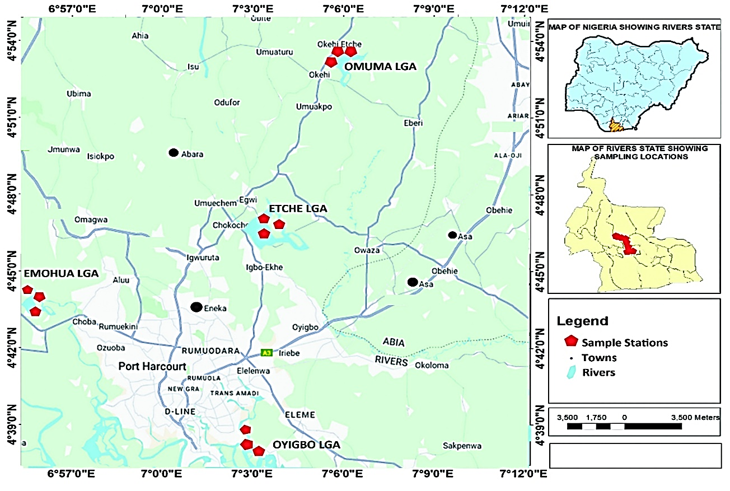

**Fig. 1. Map of study area showing the location where samples were collected**

Mean monthly temperatures can reach between 28 and 33 degrees Celsius, with high relative humidity all year round and a little reduction during the dry season. Craft fishermen make up nearly the whole fishing population in the study region, while farming is the main occupation of the vast majority of the people living there (Ogbonna et al., 2023).

**2.1.2 Field reconnaissance survey and sample collection**

With an eye toward locating areas of artisanal refining (Kpo-fire), in the Sothern Niger Delta area of Nigeria, researchers conducted field reconnaissance surveys of the following LGAs: Omuma, Etche, Eleme, and Emoha (Fig. 1). Ogbonna et al. (2023) mapped out probable sample locations within these vicinities, which included bodies of water. Following proper permission from security, sampling was then conducted at the specified sites with the help of a field Guide. Since reconnaissance had shown that the Omuma LGA was not prone to artisanal petroleum refining, it was adopted as control for the three other LGAs where samples were taken.

Afterwards, water samples were taken at the specified spots along the streams. Plate 1 is a cross-sectional image of one of the research locations. Before collection, the sterile sample vials were washed three times with water sample. The pH was then adjusted to below 2 for preservation by adding nitric acid (HNO3). The samples were transferred to the laboratory in corked bottles with clear labels and kept at 4°C until analysis.

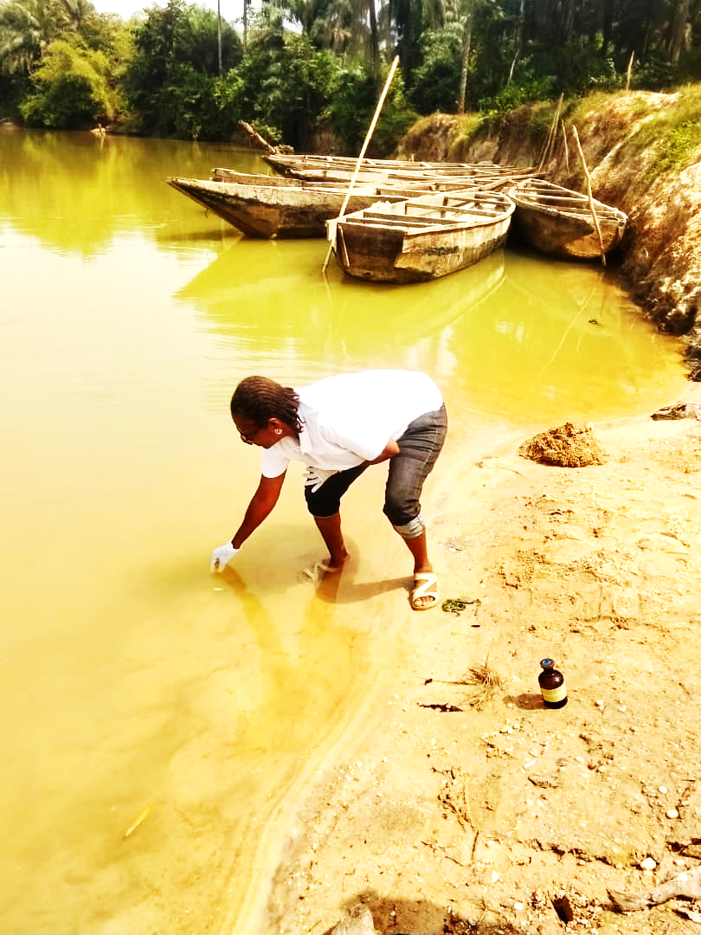

**Plate 1: A cross-sectional view of one the study sites in Rivers State, Nigeria**

**2.2 Description of artisanal petroleum refinery**

Artisanal refining, or "Kpofire" as it's more often known, is the process of making kerosene, fuel, and diesel from crude petroleum by distilling it on a small scale or continuously over a variety of boiling points (Oke, 2020). An artisanal refining camp in Rivers State is depicted in Figure I. The crude oil is first stored for three hours at this camp (Fig. 2) to reduce its gas content by evaporation. Then, it is heated to varying degrees in the refining oven, which allows the distillation process to separate mixture into fractions according to boiling points. Figure 1 shows the process of removing vapours from boiling crude oil using a condenser or cooler. Later, a single larger-diameter pipe carries out condensed product on receiver where the required products are collected.

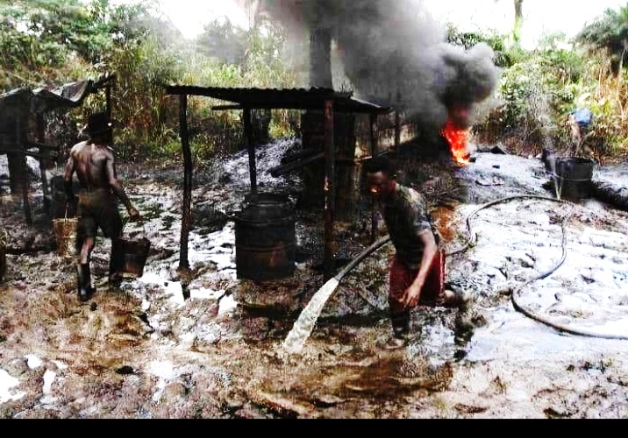

**Plate 2. An artisanal refining site in the study area of Rivers State in Niger Delta, Nigeria**

The Niger Delta is experiencing escalating disagreements and security issues due to this sort of illegal oil refining activity seen in Plate 2. It is regarded as a well-orchestrated environmental crime and main source of water and air pollution in this area. llegal refining activities harm human health and the general bionetwork system (UNEP, 2011). In addition to destroying fish habitats in the Niger Delta's mangroves, artisanal refining has contaminated marshes and rivers to an unhealthy degree, rendering them unfit for fishing (Bebeteidoh et al., 2020).

**2.3 Petroleum hydrocarbon analyses**

A measuring cylinder was used to transfer fifty milliliters (50 ml) of the water sample into a separatory flask. An equal volume of 50 ml of DCM was added. Before letting it settle for two minutes, the sample was subjected to a vigorous shaking and a vent to eliminate any excess pressure. Five grams of anhydrous sodium sulfate were added to the sample after solvent phase extraction to help dry it. Gently passing the sample through a rotary evaporator or nitrogen gas stream condensed it into a 2ml amount. Then, using silica gel and glass wool packed column chromatography, it was segregated into Aliphatic and Aromatic. A hexane preconditioning step was performed on the packed column. Two milliliters of the concentration was loaded onto the column for aliphatic (TPH) and ten milliliters of hexane were used for elution. Finally, the eluent was concentrated to a final amount of 2 milliliters. I transferred the last 2 milliliters into a vial and sealed it. The sample was prepared for GC analysis. The same column was used to elute 10 ml of DCM, which was used for Aromatics (PAH). An additional 2 milliliters of the eluents were extracted from the 10 milliliters. I transferred the last 2 milliliters into a vial and sealed it. The sample was prepared for GC analysis.

**2.2.1 Sample separation and detection**

The gas chromatography-flame ionization detector (GC-FID Agilent 6890N GC model), was employed to separate and identify compounds present in the samples. At a specific chromatogram, the PAH and TPH concentrations were resolved in parts per million (mg/l)

**2.2.2 Quality Control**

1. We let device get to temperature we had specified for the procedure.
2. Bake column by applying oven temperature to GC; after that, make sure the temperature doesn't go beyond the oven's maximum setting. Return the oven temperature to its original setting after baking for 1 hour
3. The instrument was permitted to reach set temperature.
4. The method to be examined was run in a solvent blank with DCM as PAH, hexane as TPH, and methanol as BTEX.
5. The instrument was calibrated using a previously ran standard, and the current result was checked against that standard to ensure it matched.
6. Every six months or after a significant maintenance that impacts hardware or software, or whenever the calibration material differs from recorded calibration, the gas chromatograph equipment must be calibrated.
7. My goals The low range quality control requirements were set at 5.0mg/l (or 50mg/kg), whereas the high range standards were set at 20mg/l (or 200mg/kg).
8. Based on the concentration range of the samples examined, one spike analysis was performed for each batch, either low or high.

A spiky: Up to a specified sample weight, say 5 grams

To make it ten times stronger than the MDL, a TPH or PAH concentration of at least 0.5 mg was added to the sample and processed in the same manner.

Expected Concentration = 0.5mg /5g X 1000

= 100mg/kg

Percentage Recovery = (Spike sample result – Sample result) / Expected result X 100

1. in order to make a duplicate for every ten samples (or batch of samples, either was smaller), a low-concentration sample and a high-concentration sample were each tested. A range of 75% to 125% is considered acceptable for low concentration samples, whereas a range of 90 to 110% is considered acceptable for high concentration samples (repeatability). The analysis was redone if the number of duplicates over the threshold.

Repeatability = [1 - (X1 - X2)/Mean] x 100%

Where:

Mean = (X1 + X2)/2, mg/kg

X1 = TPH content in sample, mg/kg

X2 = TPH content in duplicate sample, mg/kg

To ensure that the calibration has not deviated, a mid-point check standard or another standard was verified for every ten samples (or smaller batch of samples). A fresh analysis was carried out where it was determined that the mid-point check standard was more than the projected concentration range of 95% to 105%,

**3.0 Results and Discussion**

Results of the polycyclic aromatic hydrocarbons (PAHs) are found in Table 2, while the total petroleum hydrocarbon (TPH) concentrations recorded across the sample locations in Omuma, Eleme, Etche, and Emohua are presented in Table 1. Hydrocarbon pollution, including oil spills and industrial discharges, is commonly associated with total petroleum hydrocarbon concentrations (TPH), a metric for petroleum contamination in environmental samples. Eleme Downstream typically has the highest TPH value (8626 mg/l), which indicates that there is a lot of petroleum contamination there. The Main Stream had the lowest TPH levels of any of the locations tested. This may indicate that the main stream is mostly uncontaminated by hydrocarbons, thanks to improved dilution and self-purification mechanisms. There may be an upstream source of pollution, as the Omuma region had the highest TPH value at 4,636 mg/l. Omuma Midstream (4,149 mg/l) and Omuma Downstream (4,147 mg/l) demonstrated much reduced contamination levels, with a small drop downstream suggesting hydrocarbons may have been naturally degraded, diluted, or sedimented. The Eleme Downstream has the highest total phosphorus content (8,626 mg/l) of any dataset site, suggesting that this area is a significant source or deposit of pollution. Similarly, Eleme Midstream had a high TPH level of 4814 mg/l and Eleme Upstream had a high level of 5,630 mg/l; however, there is a little drop in the middle, followed by a steep increase downstream. The increasing contamination downstream suggests that the sources of the pollution may be located midstream, with the accumulation occurring in the downstream stretch.

The TPH measurements in Etche were 6,343 mg/l in both the midstream and downstream sections, indicating that the pollution levels were steady. The far lower TPH values in Etche Upstream (3,403 mg/l) suggest that there is a contamination source between upstream and midstream locations. The region in Emohua with the lowest TPH value was Emohua Upstream, at 2,859 mg/l, whereas the region in the middle, at 3,710 mg/l, exhibited a rise, suggesting that hydrocarbons may have been inputted between the two locations.

**3.1 TPH levels across sampled locations**

The numerical values shown in Table 1 and Figures 2–5 indicate concentrations of substances or measures taken at distinct sample points. These data are provided across multiple locations and categories. Some important points become apparent while looking at the sums. The dataset indicates a notable rise in concentration at Eleme Downstream (*n*-C18), where the highest recorded value is 1,914 mg/l. Along with 1,614 mg/l at Eleme Downstream (*n*-C10) and 1,479 mg/l at Eleme Upstream (*n*-C15), there are other high measurements at Eleme, further confirming its status as a hotspot for elevated levels. Looking at different places, Eleme Downstream always has higher numbers in a bunch of different categories, which might mean that there are a lot of pollutants or materials there. The midstream and downstream Etche also show somewhat high values, especially in the *n*-C9, *n*-C13, *n*-C15, *n*-C18, and *n*-C19 categories. There is a range of levels in Omuma Upstream and Downstream, from moderate to high; significant results in Omuma Upstream are 8,91.3 mg/l (*n*-C8) and 9,86.1 mg/l (*n*-C10).

The opposite extreme is when you see numerous dashes at the same spot, which means the element is either not present or is present at undetectable amounts. Very little is present in that category, as the lowest documented positive figure is 26.85mg/l at Main Stream (*n*-C12). Main Stream has consistently lower values across most categories when looking at distribution patterns, which suggests it has negligible influence. The intensity of the peaks in Omuma, Etche, and Emohua varies throughout measurements rather than being consistent across all of them. Among these sites, Eleme Downstream seems to have been hit the worst, with the highest values and several peaks in several categories. While the Main Stream has rather steady values, Omuma, Etche, and Emohua have intensities that fluctuate. The data indicates that there may be a higher concentration of industrial or human activity in the Eleme and Etche areas, if these statistics represent pollution levels.

**Table 1: TPH LEVELS ACROSS SAMPLED LOCATIONS**

|  |  |  |  |  |  |  |  |  |  |  |  |  |
| --- | --- | --- | --- | --- | --- | --- | --- | --- | --- | --- | --- | --- |
|  | Omuma Down Stream | Omuma Midstream | Omuma Upstream | Eleme Upstream | Eleme Mid-stream | Eleme Downstream | Etche Downstream | Etche Mid Stream | Etche Upstream | Emohua Upstream | Emohua Midstream | Main stream |
| *n*-C8 | - | - | 891.35159 | - | - | 847.25136 | - | - | - | - | - | - |
| *n*-C9 | - | - | - | 1210.7481 | 748.4931 | - | 548.36119 | 548.36119 | - | - | 755.4154 | 63.63721 |
| *n*-C10 | 1114.47217 | 1012.47311 | 986.05894 | - | - | 1613.86942 | - | - | 551.6849 | 411.5371 | - | - |
| *n*-C11 | - | - | - | - | 490.1527 | - | - | - | - | - | - | - |
| *n*-C12 | 858.24859 | 788.24859 | - | 578.87362 | - | - | - | - | 782.1421 | 719.8563 | 973.5831 | 26.85396 |
| *n*-C13 | - | - | - | - | 926.2186 | 1146.14251 | 864.49281 | 864.49281 | - | - | - | - |
| *n*-C14 | - | - | 774.13683 | 791.38496 | - | - | - | - | - | 315.1396 | 669.1427 | - |
| *n*-C15 | - | - | - | 1479.1453 | - | - | 713.37853 | 713.37853 | 974.7319 | - | 524.9535 | 42.13014 |
| *n*-C16 | 317.15291 | 501.15091 | 652.47118 | - | 839.442 | 1552.96802 | 421.01462 | 421.01462 | - | 530.4131 | - | - |
| Pr | - | - | - | - | - | - | - | - | - | - | 349.0139 | 33.52583 |
| *n*-C17 | - | - | 420.21542 | - | - |  | 895.85735 | 895.85735 | - | 395.3179 | - | - |
| *n*-C18 | - | - | 911.85351 | 678.59785 | 1042.257 | 1913.62835 | 767.13043 | 767.13043 | - | - | - | 46.17461 |
| Ph | - | - | - | - | - | - | - | - | - | - | - | - |
| *n*-C19 | 575.41305 | 475.41305 | - | - | - | 1552.14871 | 978.85138 | 978.85138 | 653.241 | 487.2135 | 438.3518 | 37.95538 |
| *n*-C20 | - | - | - | 891.14628 | - | - | - | - | 441.4296 | - | - | - |
| *n*-C21 | 1281.64711 | 1051.64712 | - | - | 767.3586 | - | 1154.24167 | 1154.24167 | - | - | - | - |

**3.2 Levels of PAHs across study locations**

Table 2 shows measurements obtained upstream, midstream, and downstream within each area, while the tables following show the concentration levels of distinct PAHs across sample locations, which are Omuma, Eleme, Etche, and Emohua. Table 2 lists the PAHs, which include naphthalene, acetaminophene, benzo(a)anthracene, chrysene, benzo(b)fluoranthene, benzo(k)fluoranthene, phenanthrene, fluorene, pyrene, and acetaminophene.

Eleme Midstream had the highest concentration of naphalene at 136.6 mg/l, while Emohua Midstream had the second-highest value at 148.7 mg/l. Omuma Upstream, Etche Upstream and Midstream, Eleme Downstream lack it. Most sites detect acenaphthylene, with Etche Upstream having the highest concentration at 139.6 mg/l; however, neither Eleme Midstream nor Emohua Midstream nor Downstream detect it. Upstream Etche (44.30 mg/l), Upstream Emohua (94.30175 mg/l), and Downstream Emohua (134.4 mg/l) are the only locations where acenaphthene is detected, indicating that it is present in small quantities.

While fluorene is present at high concentrations in Omuma Upstream (98.04 mg/l) and Eleme Midstream (82.91 mg/l), it is not present at all places in Emohua and Eleme Upstream. Meanwhile, Etche Upstream reaches a maximum of 172.4 mg/l and Midstream reaches 152.4 mg/l, whilst Eleme Upstream and Downstream and Omuma Midstream do not detect phenanthrene. Upstream, Eleme had 96.24 mg/l and midstream, Etche had 82.85 mg/l and midstream, and 83.62 mg/l, respectively, and a few other spots are where you may find anthracene, but it's not present anywhere else.

The concentrations of fluoranthene are 54.15 mg/l at Eleme Midstream and 111.2 mg/l at Etche Downstream. There is a noticeable lack of pyrene in some places and a high of 157.9 mg/l and 124.1 mg/l, respectively, before and after Omuma, there is Emohua. No benz(a)anthracene was found in either of the Omuma or Eleme sites, yet it was 42.06 mg/l at Etche Downstream, 40.06 mg/l at Etche Midstream, and 115.5 mg/l at Emohua Upstream.

While certain places, such Emohua Downstream, do not have chymene, it is present everywhere else and can be found in significant concentrations in places like Omuma Upstream (189.4 mg/l), Etche Downstream (171.2 mg/l), and Eleme Midstream (116.3 mg/l). In every single place, benzo(b)fluoranthene has not been discovered. Except for Omuma Downstream and Midstream, where it is present at 21.95 mg/l and 19.85 mg/l, respectively, benzo(k)fluoranthene is not present anywhere else. Lastly, while most Omuma sites do not contain benzo(a)pyrene, it is detected in certain sections of Eleme Upstream (81.51 mg/l) and Midstream (152.54 mg/l), Etche Midstream (72.15 mg/l), and Upstream (75.15 mg/l).

This data reveals possible contamination hotspots, especially in Eleme and Etche, where greater amounts of certain PAHs are seen, therefore illuminating the diverse distribution of PAHs among various water sources.

**Fig 2: Levels naphthalene across the sampled stations**

**Fig 3: Levels of acenapthene across the sampled stations**

**Fig 4: Levels of phenanthrene across the sampled stations**

**Fig 5: Levels benzo(a)pyrene across the sampled stations**

Figures 2 and 5 show the sampled regions for PAHs with low molecular weights (like napthalene) and PAHs with high molecular weights (like benzopyrene), respectively.

Figures 6 and 7 respectively display the chromatograms for total petroleum hydrocarbons and polycyclic aromatic hydrocarbons.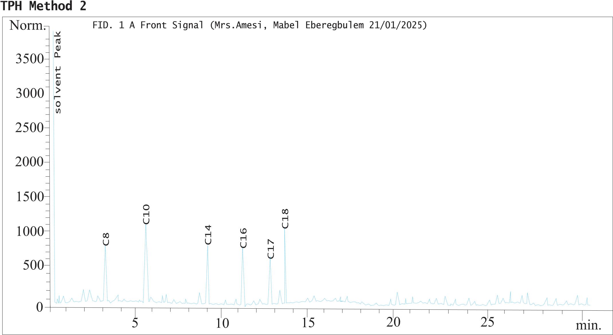

**Fig 6: Representative chromatogram of TPH of one of the sampled stations**

50

0

5

10

15

20

25

30

min.

100

150

200

250

300

350

~~.~~

Norm

Acenapthylene

Naphthalene

Solvent peak

Benzo(a)pyrene

Anthracene

Pyrene

Chrysene

FID. 1 A Front Signal (Mrs. Amesi Mabel Eberegbulem 20/01/2025)

**Fig. 7: Representative chromatogram of PAHs of one of the sampled stations**

**Table 2:** **Summary of PAHs Levels across Study Locations**

|  |  |  |  |  |  |  |  |  |  |  |  |  |
| --- | --- | --- | --- | --- | --- | --- | --- | --- | --- | --- | --- | --- |
|  | Omuma Downstream | Omuma Midstream | Omuma Upstream | Eleme Upstream | Eleme Mid-stream | Eleme Downstream | Etche Down Stream | Etche Midstream | Etche Upstream | Emohua Upstream | Emohua Midstream | Emohua Downstream |
| Naphthalene | 53.85902 | 56.95902 | - | 86.73918 | 136.6027 | - | 53.64283 | - | - | 36.25039 | 148.712 | - |
| Acenapthylene | 71.35181 | 69.35181 | 132.8632 | 131.8018 | - | 3.17401 | 48.21305 | 39.58193 | 139.58193 | - | - | 72.85613 |
| Acenapthene | - | - | - | - | - | - - | - | 44.30175 | 94.30175 | - | - | 134.35726 |
| Fluorene | 40.73615 | 38.70655 | 98.04156 | - | 82.90638 | 8.53185 | 76.73513 | - | - | - | - | - |
| Phenanthrene | 26.09804 | 24.19704 | 77.25146 | - | 121.2514 | - | - | 152.41859 | 172.41859 | 84.59183 | 95.40185 | - |
| Anthracene | - | - | - | 96.24108 | 98.69301 | - | 82.85498 |  | 83.62513 | - | 69.71636 | - |
| Fluoranthene | - | - | - | - | 54.14638 | - | 111.1572 | - | - | - | - | - |
| Pyrene | 32.37102 | 30.35102 | 157.9401 | 75.35171 | 78.01627 | - | - | - | - | 52.36054 | 124.0826 | 98.21048 |
| Benz(a)anthracene | - | - | - | - | - | - | 42.05803 | 40.05643 | - | 115.4822 | - | - |
| Chrysene | 64.54726 | 62.34726 | 189.4369 | 68.0592 | 116.2691 | 5.95083 | 171.1675 | 151.94174 | 151.94174 | 61.63958 | 87.5161 | 87.51847 |
| Benzo(k)fluoranthene | 21.95017 | 19.85217 | - | - | - | - | - | - | - | - | - | - |
| Benzo(a)pyrene | - | - | - | 81.51471 | 152.5385 | - | - | 72.14628 | 75.14628 | - | 119.7433 | - |

**4.0 Conclusion and recommendations**

These findings highlight the need for environmental and health interventions in the Eleme Downstream, Etche Downstream, and Omuma Upstream zones immediately. Hydrocarbon exposure can lead to serious health issues, such as respiratory problems from breathing in volatile mixtures, skin and eye irascibility from direct contact, and long-term unsafe effects from extended disclosure to polycyclic aromatic hydrocarbons (PAHs). A better grasp of these risk differences allows for the implementation of more effective policies, strategies, and initiatives to safeguard the health of communities. The downstream and main streams of Emohua do not appear to be very dangerous. Internal organ damage and gastrointestinal difficulties are two of the many health concerns that water pollution may induce. Contamination can originate from a multitude of sources and affect Eleme Downstream, Etche Downstream, and Omuma Upstream. Some examples of this kind of contamination are hydrocarbon-laden runoff from towns or farms and oil spills and pipeline breaches in oil-rich regions. Stricter pollution control regulations for industrial and petroleum discharges, as well as routine environmental monitoring to detect contamination trends, are necessary to lessen the impact of these dangers. It is important to educate local residents about the hazards of hydrocarbon exposure and precautionary measures, and to develop water treatment procedures to guarantee that drinking water is safe.

***Acknowledgements***

The authors gratefully acknowledge all those who assisted in the fieldwork. Additionally, we would like to express our gratitude to the University of Port Harcourt's Institute of Natural Resources(INRES), Environment, and Sustainable Development, for providing the needed platform for this work. To all anonymous Reviewers, we say “Thank You”

Disclaimer (Artificial intelligence)

Option 1:

Author(s) hereby declare that NO generative AI technologies such as Large Language Models (ChatGPT, COPILOT, etc.) and text-to-image generators have been used during the writing or editing of this manuscript.

Option 2:

Author(s) hereby declare that generative AI technologies such as Large Language Models, etc. have been used during the writing or editing of manuscripts. This explanation will include the name, version, model, and source of the generative AI technology and as well as all input prompts provided to the generative AI technology

Details of the AI usage are given below:

1.

2.

3.

**REFERENCES**

Anyanwu, I.N., Beggel, S., Sikoki, F.D., Okuku, E.O., Unyimadu, J-P. and Geist, J., 2023. Pollution of the Niger Delta with total petroleum hydrocarbons, heavy metals and nutrients in relation to seasonal dynamics. Scientific Reports 13, 14079. https:/ doi.org/10.1038/s4159 8-023-40995-9

Bebeteidoh, O.L., Kometa, S., Pazouki, K., Norman, R., 2020. Sustained impact of the activities of local crude oil refiners on their host communities in Nigeria. Heliyon, 6 (6), e04000, <https://doi.org/10.1016/j.heliyon.2020.e04000>.

Cambers G., Ghina, F., 2005. Water Quality, an Introduction to Sandwatch. An Educational Tool for Sustainable Development. United Nations Educational, Scientific and Cultural Organization (UNESCO): Paris, France. p. 25-31.

Chapman D, (ed.). 1996.Water Quality Assessments: A Guide to the Use of Biota, Sediments and Water. Environmental Monitoring. Second Edition. UNESCO, WHO, and UNEP. E&FN Spon, London UK. <https://doi.org/10.1201/9781003062103>

Collins, W., Wali, E., 2020. Crude Oil Theft in the Niger Delta: The Oil Companies and Host Communities Conundrum. International Journal of Research and Scientific Innovation (IJRSI) 7(I), 22-32

DeZuane, J., 1997. Handbook of Drinking Water Quality. John Wiley & Sons. 575p. <https://doi.org/10.1002/9780470172971>

Dojlido, J., Best, G.A., 1993. Chemistry of Water and Water Pollution. Ellis Horwood Limited. New York. 544p. <https://books.google.com.ng/books?id=hCRSAAAAMAAJ>

Jiang, J., Tang, S., Han, D., Fu, G., Solomatine, D., Zheng, Y., 2020. A comprehensive review on the design and optimization of surface water quality monitoring networks. Environmental Modelling & Software, 132, 104792. <https://doi.org/10.1016/j.envsoft.2020.104792>.

NOSDRA., 2025. Oil theft responsible for most crude spills. A publication of the National oil Spill Response and Detection Agency, January 26, 2025.

Jatto, A.L.A., 2024. Impact of oil and gas infrastructure in Bayelsa, Niger Delta. In: Oil and Gas Pipeline Infrastructure Insecurity. New Security Challenges. Palgrave Macmillan, Cham. Pp. 55-80. <http://doi.org/10.1007/978-3-031-56932-6_3>

Little, D.L., Holtzman, K., Gundlach, E.R., Galperin, Y., 2018. Sediment hydrocarbons in former mangrove areas, southern Ogoniland, Eastern Niger Delta, Nigeria. In Threats to Mangrove Forests: Hazards, Vulnerability and Management Solutions. Coastal Research Library 25, 267–321.

Obida, C.B., Blackburn, G.A., Whyatt, J.D. and Semple, K.T., 2021. Counting the cost of the Niger Delta’s largest oil spills: Satellite remote sensing reveals extensive damage with >1 million people in impact zone. Science of The Total Environment 775, 145854. <https://doi.org/10.1016/j.scitotenv.2021.145854>

Ogbonna, D.N., Anthony, E.M., Kpormon, L.B., 2023. Physicochemistry and Microbiological Quality of Surface Water Body around Port Terminals in Southern Nigeria. Microbiol. Res, 33(2),.54-60.

Ogbuigwe, A. Refining in Nigeria: history, challenges and prospects. Appl Petrochem Res 8, 181–192 (2018). <https://doi.org/10.1007/s13203-018-0211-z>

Oke, M. (2020). Investigation of air emissions from artisanal petroleum refineries in the Niger-Delta Nigeria. Heliyon. <https://doi.org/10.1016/J.HELIYON.2020.E05608>

Olubukola A.A.R, Edet, E.E., Emmanuel, G.O., 2021. Application of Water Quality Index for the Assessment of Water from Different Sources in Nigeria. Promising Techniques for Wastewater Treatment and Water Quality Assessment. <http://dx.doi.org/10.5772/intechopen.98696>.

Onojake, M.C, Nkanta, M.E, Osakwe, J.O., Akpuluma, D.A., Ohenhen, I., Osuji, L.C., 2024. Organic geochemical evaluation of crude oils from some producing fields in the Niger Delta basin, Nigeria. Journal of Petroleum Exploration and Production Technology. <https://doi.org/10.1007/s13202-024-01799-3>

Onuigbo, B.S., Osuji, L.C., Onojake, M.C., 2025b. Petroleum hydrocarbon pollution in Bonny creek six months after the oil spill from the Fusokiri-6 manifold in the Niger Delta. Asian Journal of Current Research 1-(1), 202-21616 (2), 1-9. [https://doi.org/10.56557/ajocr/2025/ v10i19155](https://doi.org/10.56557/ajocr/2025/%20v10i19155)

Osuji, L. C. and Achugasim, O. 2007. Environmental degradation of polluting aromatic and aliphatic hydrocarbons: A case study Chemistry and Biodiversity 4, 424-429. [https://doi.org/ 10.1002/cbdv.200790034](https://doi.org/%2010.1002/cbdv.200790034)

Richard, G., Izah, S., Raimi, M., Austin-Asomeji, I., 2023. Public and environmental health implications of artisanal petroleum refining and risk reduction strategies in the Niger Delta region of Nigeria. Bio-research 21(1):2705-3822. <https://doi.org/10.4314/br.v21i1.12>

Sam, K.S., Onyena, A.P., Zabbey, N., Odoh, C.K., Nwipie, G.N., Nkeeh, D.K., Osuji, L.C., Little, D.I., 2023. Prospects of emerging PAH sources and remediation technologies: insights from Africa. Environmental Science and Pollution Research 30 (14), 39451-39473. <https://doi.org/10.1007/s11356-023-25833-9>

Sam, K., Pegg, S., Oladejo, A.O., 2024. Mining from the pipeline: Artisanal oil refining as a consequence of failed CSR policies in the Niger Delta. Journal of Environmental Management, 352. <https://doi.org/10.1016/j.jenvman.2024.120038>

Saunders, D., Carrillo, J.C., Gundlach, E.R., Iroakasi, O., Visigah, K., Zabbey, N., Bonte, M. (2022).Analysis of polycyclic aromatic hydrocarbons (PAHs) in surface sediments and edible aquatic species in an oil-contaminated mangrove ecosystem in Bodo, Niger Delta, Nigeria: Bioaccumulation and human health risk. Science of the Total Environment 832, 15480 <http://dx.doi.org/10.1016/j.scitotenv.2022.154802>

Syeed, M.M.M., Hossain, Md.S., Karim, Md.R., Uddin, M.F., Hasan, M., Khan, R.H., 2023. Surface water quality profiling using the water quality index, pollution index and statistical methods: A critical review. Environmental and Sustainability Indicators, 18, 100247. <https://doi.org/10.1016/j.indic.2023.100247>.

[UNEP., 2011. Report on Environmental Assessment of Ogoniland. United Nations Environmentak Programme Repot. https://www.unep.org.](C:\\Users\\PAC2\\Desktop\\bluetooth downloads\\UNEP. 2011. United Nations Environmentak Programme Repot.  https:\\www.unep.org)

World Health Organization. Water, sanitation and hygiene links to health. 2004. Available at: [www.who.int/water_sanitation-health/publications/facts2004/en/index.html](http://www.who.int/water_sanitation-health/publications/facts2004/en/index.html)