**Characterizing Spatio-temporal Dynamics of Land Use and Land Cover in Urban Environment of Chhatrapati Sambhajinagar.**

.

**Abstract**

Urban areas in India are growing rapidly along with increase in industrial expansions and installation of modern infrastructural facilities which creates a demographical pressure and bring changes urban environment. The Land Use and Land Cover (LULC) are the parameters changes in due course of time and places. Therefore, LULC analysis is essential to know the developmental trends in urban areas through the change in land use patterns of Chhatrapati Sambhajinagar. In present study the Spatio-temporal LULC changes were analyzed in the study area by using GIS tools and techniques. Maximum likelihood supervised classification is used to produce LULC maps, backed by statistical and analytical methods of confusion matrix or error matrix to gain precise outcomes. The results revealed that, the land use land cover changed significantly from year 2011 to 2023 especially in built-up area in city area which was increased by 1.6% and agricultural land decreased by 6.8%. There was a significant increase of 8.7% in barren land in and around city area and tree cover has been dropped by 3.6%. Overall accuracy of the error matrix is 83% and 90% respectively. The downslide of agricultural land and tree cover is the result of an upswing of urbanization and confirming degradation of natural vegetation in study area.

Keywords – Land Use, Land Cover, Urbanization, Spatio-temporal, Confusion Matrix, LULC, Kappa Coefficient, Accuracy Assessment.

1. **Introduction**

The land is one of the precious natural resources to mankind. The increase in human population is increasing the pressure over the land and is being used for different purposes, forcing the change in land cover patterns. The rate of change in land use and land cover is converting the natural environment into man modified system and disturbing the natural environmental balance structurally and functionally. If environmental balance is to be maintained in balance or in equilibrium, then maintenance of the environment in its natural condition is essential. Therefore, for the conservation of environment and for maintaining the sustainable human development, there is a need to keep the natural environment with minimum human interference. The earth surface land cover changes by natural phenomenon and due to human impact and were recorded by remote sensing sensors installed on satellites. The observation from space provides information of land cover & land use in time intervals. The mapping of change in land use and land cover along the manmade infrastructure and which predicts environmental changes through the change in watershed and change in urban infrastructure (Rao and Narendra, 2006).

The study of changes in land use and land cover pattern indicated the degraded or changed environmental components, hence the present effort is applied to study the temporal and spatial changes in land use and land cover of selected urban study area. Presently, the major changes in our environment are due to urbanisation and industrialisation along with human’s prominent activities such as agricultural practices along with other human developmental activities. Now a day’s there is one kind of race in the human society to use the natural resources and environmental components for rapid human development. Hence to identify the threshold points for sustenance of environment and for sustainable human development, the change in LULC is important as reported by Pandian et. al (2014).

Land being a fundamental resource plays significant role in human's economic development and which may trigger the rapid urbanization. With the increasing pace urbanization, it is imperative to understand the intricate human-nature linkages and land use land cover patterns which forms the basis for urbanization. Through spatiotemporal analysis of LULC, valuable insights about urbanization, agricultural land degradation, deforestation, desertification etc. can be obtained. Studies of LULC are paramount for environmental monitoring in urban planning and sustainable development. The proper LULC maps are necessary for policy makers, urban planners, and environmentalists to make the correct decisions for sustainable development of the urban area as system. There are different methods used in the analysis of satellite images for understanding LULC of the study area, one of which is supervised and unsupervised classification method through the use of identified labelled data as trainee points and used for the classification of satellite image for LULC map making as reported by M. M. H. Sayam et al (2023). They have studied the change in land use land cover at Bhaluka from Mymensingh, Bangladesh and reported urbanization processes has fostered and changed landscape by changing land use pattern specially the built-up area was increased significantly due to urbanization an industrialization. The people use natural resources from our environment making change in land cover pattern. During exploitation & utilization of natural resources, the surface features of land is referred as land use and for fulfilment of their developmental needs uses land surface features and resources along with the time. An overall feature on land area reflects its land use and clearly reflects relationship between land cover and human activities. Hence, to track the human's past activities, the temporal study of land use land cover is important and can be used for the proper resources management and for the sustainable development of man. The environmental modelling of land use is a need of time and for development of the same statistics of land use can be used Karishma et al, (2022).

Chhatrapati Sambhajinagar (Aurangabad) is one of the fastest growing cities from Maharashtra, India. The rapid industrialization in and in vicinity of city area has brought the significant changes in land use and land cover. Therefore, to study the sustenance of urban environment and to identify and confirm the causative factors for the change in environment, through the study of the change in land use and land cover has been undertaken. The spatial and temporal changes taken place in an area will be studied similar to that of the work of Sarma et. al. (2001).

The remotely sensed data by using satellite-based sensors and the tools developed under Geographic Information system (GIS) were identified and recognised as an important tool for monitoring large or small areas LULC accurately for long period (LU et al, 2004). In present study of change in LULC study at Chhatrapati Sambhajinagar (Aurangabad) sub urban area RS, GIS based technique were used and detected the changes. As LULC change has been associated with human’s interaction with environment hence in present study at Chhatrapati Sambhajinagar (Aurangabad) urban area where how the LULC changes has been taken place and to know the current scenario of LULC the present work has been carried out. The study may forecast the negative impact on urban ecosystem and on the natural ecosystem present in vicinity of city area as reported by Matsa et al (2020)

The main objectives of present study of LULC at Chhatrapati Sambhajinagar (Aurangabad) in period between 2011 to 2023 by using remotely sensed data is to differentiate and classify the various LULC classes and identify the intensity of change in them and use this data for managing urban environment by adopting an appropriate LULC model useful for urban sustenance as worked out by Attna and fisher (2011)

1. **Materials and methods**.
   1. **Study Area**

Chhatrapati Sambhajinagar, formerly known as Aurangabad, is one of the fastest-developing cities in the state of Maharashtra. The city is also known as the "City of Gates" due to its 52 historic gates. Geographically, it lies around the 19.88° N latitude and 75.32° E longitude, with an average elevation of 568 meters above mean sea level as shown in Figure 1. The urban centre occupied about 138.5 km² of land area, holding the city population of 1,175,116 individuals according to the 2011 Census of India.

The average rainfall of Chhatrapati Sambhajinagar District is 734 mm. The city is the industrial and commercial hub of the Marathwada region, primarily surrounded by three industrial clusters namely Chikhalthana, Waluj and Shendra MIDC, agricultural land and hills to the northwest and south, contributing to its diverse landscape. Additionally, the Delhi-Mumbai Industrial Corridor (DMIC) is establishing a new industrial belt known as the Shendra-Bidkin industrial park, which is expected to further enhance the city's economic growth. This industrial development has led to a high inflow of migrant workers, further contributing to the city’s rapid urban expansion and bring the change in land use land cover patterns



Figure 1. Study Area Location (Chhatrapati Sambhajinagar City, Maharashtra, India.)

* 1. **Data sources and software’s used for data processing**

The study utilizes data from IRS-P6 Resourcesat – 2 LISS 4, offering fine spatial resolution with three spectral bands: green (0.52-0.59), red (0.62-0.68), and NIR (0.77-0.86). The imagery comes with a swath width of 70 km in Mono Mode and 23.9 km in MX Mode, referenced to WGS\_1984\_UTM\_zone\_43N. The images of year 2011 and 2023 in the month of May &

April was downloaded Table 1. List of data used and used for the study of change in LULC.

The pre-monsoon dataset was chosen to represent mature trees and dense vegetation cover. Supervised LULC Classification of the composite dataset was conducted using Arc GIS version 10.3 and QGIS 3.28.9 for analysis, while Google Earth Pro 7.3.6 aided in the ground truthing process along with field visits for confirmation of existing land cover.

|  |  |  |  |  |
| --- | --- | --- | --- | --- |
| Sr. No. | Data Type | Satellite/  Data Source | Year & Month | Details |
| 1. | Satellite Imagery | RS2 / LIS 4 | May 2011 | Path-96; Scene no-58  Roll-8461380 |
| 2 | Satellite Imagery | RS2 / LIS 4 | April 2023 | Path-96; Scene no-58  Roll-250861 |
| 3 | Guide Map | Survey of India | 1995 | Survey of India Guide Map 1:20000 No- |

Table 1. List of data used

* 1. **Data classification**

Based on the intricate characteristics of the study area, and the specific land use the LULC classes were prepared as reported by Karishma et al (2022) and Attna and fisher, (2011). The flowchart given Figure 2 was followed for preprocessing of images (Xiuwan, 2002; Rao and Narendra, 2006; Mas, 2010; Chalkaew, 2019; Sharafat Chowdhury, 2023).

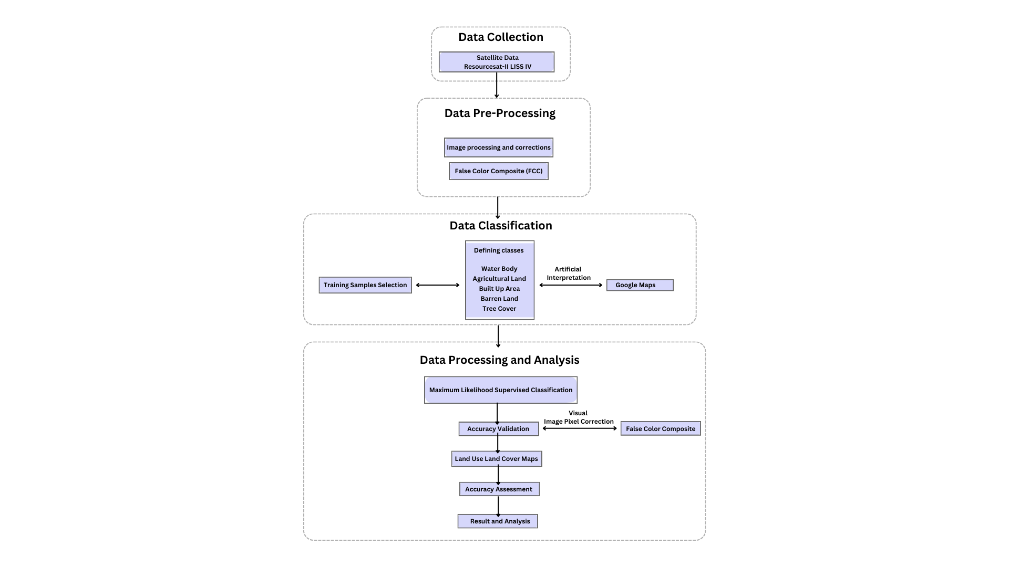

Figure 2. Flowchart indicating processing of images and steps followed during LULC study

* 1. **Methodology**

The IRS P-6 Resourcesat-2 LISS 4 data of year 2011 and 2023 of pre monsoon season were collected and subjected to digital image processes for image correction and image enhancement. The image processing GIS software such as QGIS and ARC GIS were used. The projected FCC images then clipped for study area and subjected LULC classification by following steps given in flow chart Figure 2. By considering the specific land use and land cover pattern in study area, the different classes were prepared and listed. The maps of LULC were prepared by using GIS software in the scale by supervised classification method and depicted maps by using colour code Prakasam (2010); Rawat and Kumar (2015). The prepared maps were confirmed by ground troughing by visiting the study area and by using Google Earths maps. The metadata of the classes was obtained and used for comparison and for understanding the temporal change in land use pattern in selected urban area.

* 1. **Accuracy Assessment:**

Maximum likelihood supervised classification algorithm has been used against the random training samples to generate spectral signatures of each pixel pertaining to known classes. The algorithm assigns a pixel value to each class depending upon the spectral information with highest likelihood (Matsa et al, 2020). The maps each class were prepares. The prepared map is superimposed on false color composite map to check the accuracy validation and corrected to the best of visual capability. The data produced more precisely furthermore, subjected to accuracy assessment by using statistical tools, such as tests like error matrix that includes user’s accuracy, producer’s accuracy, overall accuracy and kappa coefficient has been performed to get the factual data [Congalton and Green (2009) and Liu et al (2007)].

1. **Results and Discussion**

The remotely sensed satellite images of IRS P-6 Resourcesat-2, (LISS 4 images) of year 2011 and 2023 were processed digitally (DIP) and classified for Land use and Land cover (LULC) by using supervised classification and their major classes were recorded in Table 2

|  |  |
| --- | --- |
| **Classes** | **Description** |
| Water Body | This refers to area covered by water bodies, there three major water bodies in the study area and rest are seasonal catchment areas. |
| Agricultural Land | This refers the land uses for agricultural practice. The study area is majorly surrounded by the agricultural land. |
| Built Up Area | This refers to area used for construction of building and artifacts including residential and commercial buildings, roads, railway track etc. |
| Bare Land | This refers to the areas with least to no vegetation mainly consists of bare soil and hilly areas with rocky terrain. |
| Tree Cover | This refers to the areas consisting trees only. |

Table 2. LULC classes in study area

The Land Use Land Cover maps of Chhatrapati Sambhajinagar city area were prepared by using GIS software (GIS and ArcGIS) by processing satellite images of IRS P-6 Resourcesat-2, (LISS 4 images) of year 2011 and 2023 and shown in Figure 3. The land use of year 2011 and 2023 were observed for identifying major land-use pattern and found that, bare land area found major land cover around the city area where as in city area the built-up land was found major land use type. The Rao and Narendra (2006) reported that, the built- up area in sub urban area was found major land use type along with other uses.

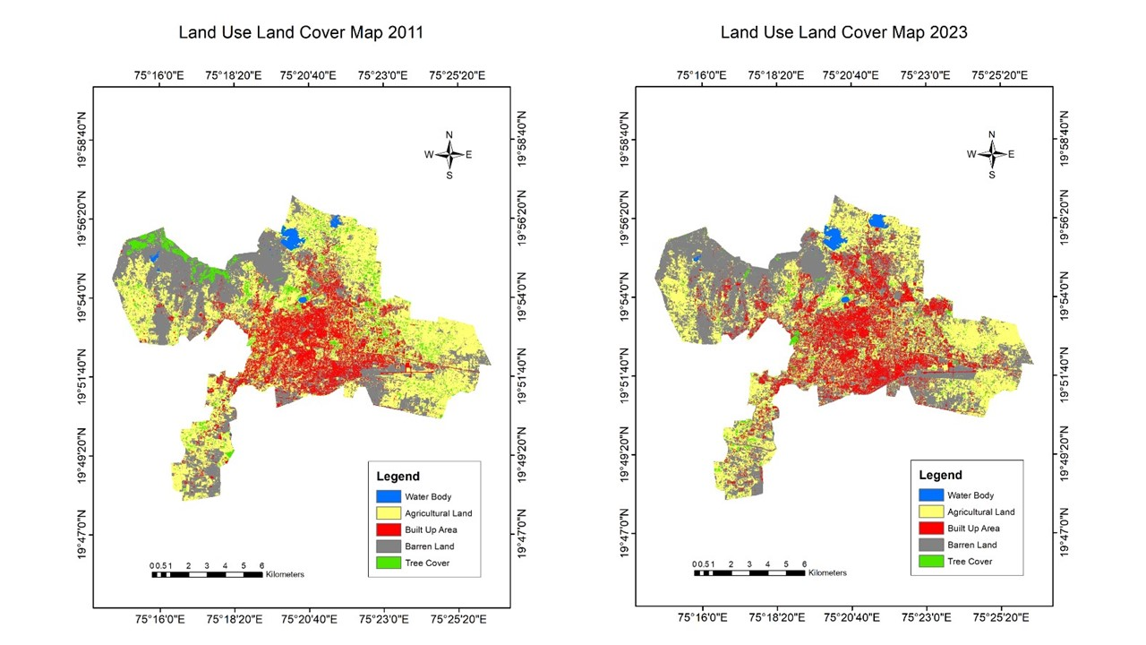

Figure 3. LULC Map of 2011 and 2023

To understand the temporals changes in land use at Chhatrapati Sambhajinagar urban area the land-use map of year 2011 was compared with land use map of year 2023, for which the meta data of both the map were obtained with help of ArcGIS software and given in Table 2. The area occupied by specific land use in square meter and in percentage is listed in observation table. Total five land use classes are classified, analyzed and represented such as agricultural land, bare land, built-up area, tree cover and water body were made and whose meta data was listed as observations and used for understanding the changes taken place in city area.

|  |  |  |  |  |
| --- | --- | --- | --- | --- |
|  | **Year 2011** | | **Year 2023** | |
| Classes | Area Covered (Sq. M) | Area in Percentage (%) | Area Covered (Sq. M) | Area in Percentage (%) | |
| Agricultural Land | 59026697.40 | 41.3% | 49411551.50 | 34.5% | |
| Bare Land | 51269300.91 | 35.8% | 63605272.38 | 44.5% | |
| Built Up Area | 22065954.20 | 15.4% | 24362297.12 | 17.0% | |
| Tree Cover | 9149255.20 | 6.4% | 3972012.75 | 2.8% | |
| Water Body | 1532714.64 | 1.1% | 1691434.63 | 1.2% | |
| Total Area | 143043922.4 | 100% | 143042568.4 | 100% | |

Table 3. Area and cover percentage of LULC

A notable alteration is seen in the agricultural land within the study area (Figure. 3 and Figure 4). The proportion of agricultural land has decreased from 41.3% to 34.5%, resulting in a reduction of 6.8% over the past 12 years Table 2. Additionally, the tree cover in the city has reduced from 6.4% to 2.8%, representing a 3.6% decrease. The water bodies have experienced minimal change, with only a 0.1% variation attributed to unseasonal rainfall. Conversely, there has been a noteworthy increase in barren land from 34.8% to 44.5%, indicating an 8.7% expansion in the city. Furthermore, the built-up area has grown from 15.4% to 17%, showing a 1.6% increase over the same 12-year period Figure 4

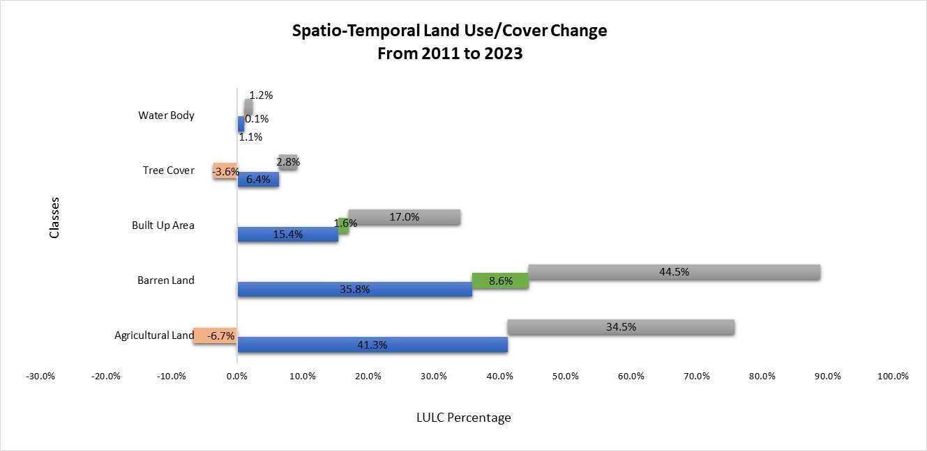

Figure 4. Spatio-Temporal Changes in LULC from 2011 to 2023

Prakasam (2010) has studied the changes in land use land cover Kodaikanal taluka from Tamil Nadu State of India and reported human’s activities are principally responsible for change in land cover pattern along with the time.

Gondwe et al (2021) has analysed the land use and land cover of urban area of Blantyre city by using remotely sensed data and reported wide range of changes in LULC. They have studied the changes in 20 years period by using landsat 7 data (ETM +) and reported built-up land was increased and decreased bare land, forest land and land occupied by water body and commented that, the urbanisation increase along with increase in human population and their economic growth may be responsible for change in LULC

In present study at Chhatrapati Sambhajinagar the built-up area was increased and it is due to urbanization as reported by Seyam et al (2023) who has studied changes in land use land cover at Bhaluka from Mymensingh, Bangladesh and reported urbanisation process has fostered and changed landscape by changing land use pattern, especially the built-up area was increased significantly due to urbanization and industrialisation. Wang & Murayama (2017) has studied the change in LULC in Tianjin City based on Mairkov and Cellular automata models and reported that, the economic development of human society along with increase in human population are causing major changes in LULC in urban & sub urban areas and which helps in satisfying the demands of people living in urban areas.

In present study, the anthropogenic activities in and in vicinity of city area are bringing the changes in land cover pattern due to specific land use. The anthropogenic activities have changed the natural landscape with typical features, substantially in large areas. The change in land features & land use were extremely influenced by rapid population growth. Therefore, observed land use and land cover changes in Chhatrapati Sambhajinagar (Aurangabad) area are in agreement with the reasoning for rapid change in LULC as reported by Sekela Twisa & Manfred F. Buchroithner (2019).

* 1. **Accuracy assessment by Confusion matrix analysis**

The accuracy assessment of LULC maps prepared for year 2011 was carried out by using confusion matrix and given in Table 4. The Producers accuracy and Users accuracy in percentage were determined for every land use class and listed in observation table. The overall accuracy for every class with Kappa coefficient was calculated and recorded in Table 4.

|  |  |  |  |  |  |  |
| --- | --- | --- | --- | --- | --- | --- |
| *Classes* | Water | Agricultural Land | Built Up Area | Bare Land | Tree Cover | Total User’s |
| Water | **18** | 0 | 0 | 2 | 0 | 20 |
| Agricultural Land | 0 | **15** | 2 | 3 | 1 | 21 |
| Built-Up Area | 0 | 0 | **18** | 1 | 0 | 19 |
| Bare Land | 0 | 0 | 1 | **19** | 0 | 20 |
| Tree Cover | 0 | 2 | 1 | 4 | **13** | 20 |
| Total Producer’s | 18 | 17 | 22 | 29 | 14 | **100** |
| *Accuracy* |  |  |  |  |  |  |
| User's Accuracy % | Water | Agricultural Land | Built Up Area | Barren Land | Tree Cover |  |
|  | 90 | 71.43 | 94.74 | 95 | 65 |  |
| Producer's Accuracy % | Water | Agricultural Land | Built Up Area | Barren Land | Tree Cover |  |
|  | 100 | 88.24 | 81.82 | 65.52 | 92.86 |  |
|  |  |  |  |  |  |  |
| Error of Omission | 0 | 5.88 | 18.18 | 27.59 | 7.14 |  |
| Error of Commission | 10 | 28.57 | 5.26 | 5 | 35 |  |
| Overall Accuracy % | 83% |  |  |  |  |  |
| Kappa Coefficient % | 78.76 |  |  |  |  |  |

Table 4. Confusion Matrix - Supervised Maximum Likelihood Classification of LULC 2011

In present study the overall accuracy is 83 percent during the year 2011. The Kappa Coefficient is 78.76 percent. The accuracy assessment was determined by using kappa coefficient; overall accuracy for producers and users was derived from the confusion (error) matrix and is found in acceptable range as reported by Congalton and Green (2009). The accuracy assessment of LULC maps prepared for year 2023 was carried out by using confusion matrix and given in Table 5. The Producers accuracy and Users accuracy in percentage were determined for every land use class and listed in observation table. The overall accuracy for every class with Kappa coefficient was calculated and recorded in Table 5.

|  |  |  |  |  |  |  |
| --- | --- | --- | --- | --- | --- | --- |
| *Classes* | Water | Agricultural Land | Built Up Area | Barren Land | Tree Cover | Total User’s |
| Water | **18** | 0 | 0 | 2 | 0 | 20 |
| Agricultural Land | 0 | **15** | 0 | 4 | 1 | 20 |
| Built-Up Area | 0 | 0 | **19** | 1 | 0 | 20 |
| Barren Land | 0 | 1 | 0 | **18** | 1 | 20 |
| Tree Cover | 0 | 0 | 0 | 0 | **20** | 20 |
| Total Producer’s | 18 | 16 | 19 | 25 | 22 | **100** |
| *Accuracy* |  |  |  |  |  |  |
| User's Accuracy % | Water | Agricultural Land | Built Up Area | Barren Land | Tree Cover |  |
|  | 90 | 75 | 95 | 90 | 100 |  |
| Producer's Accuracy % | Water | Agricultural Land | Built Up Area | Barren Land | Tree Cover |  |
|  | 100 | 93.75 | 100 | 72 | 90.91 |  |
|  |  |  |  |  |  |  |
| Error of Omission | 0 | 6.25 | 0 | 28 | 9.09 |  |
| Error of Commission | 10 | 25 | 5 | 10 | 0 |  |
| Overall Accuracy % | 90% |  |  |  |  |  |
| Kappa Coefficient % | 87.50 |  |  |  |  |  |

Table 5. Confusion Matrix - Supervised Maximum Likelihood Classification of 2023

The users accuracy for year 2023 was determined and ranged from 75 to 100 percent. The producer’s accuracy was ranged from 72 to 100 percent. The overall accuracy is 90 percent and Kappa Coefficient found 87.50%. The overall accuracy assessment value of year 2023 indicate that determined LULC map is appropriate and acceptable as reported by Liu et al (2007) In present study there is a clear connection observed between the decrease in agricultural land and the increase in barren land and urban development. This phenomenon stems from the fact that farming has traditionally been the main occupation in the city. In the current age study of environmental monitoring of natural or urban areas, the study of land use and land cover is an integral part. Specifically, to study or to monitor the changes in surrounding environment due to anthropogenic activities, the study of change in LULC is found important. To study such changes, the remotely sensed data and GIS technology are proved to be best for covering large area and even to study the past conditions (Rawat et. al; 2013)

With agricultural land surrounding the city, factors such as irregular rainfall patterns, diminished groundwater levels, and reduced crop yields have led many farmers and landowners to abandon their land, leaving it barren. Furthermore, in anticipation of the growing demands brought on by population growth and infrastructural expansions, a significant portion of the city's agricultural and barren land has been bought up by land developers and investors. The city's tree cover has also been dwindling due to illicit tree cutting activities and the ongoing construction of new buildings, roads, and other development projects within the city.

The study classifies five major LULC classes (Water, Tree Cover, Barren Land, Built-up Area and Agricultural Land) see Table 2. There are three water bodies in city includes lakes and rivers streams shown in cyan blue colour, Tree cover in the city is represented as forest green colour that includes tree cover which includes open forest and large trees in the city. The barren land in represented as grey includes, fallow land, play grounds, rocky and hilly land without vegetation cover. The built-up area shown in red includes areas of residential, commercial, industrial, airports, railways, and other facilities. The agricultural land shown in citrine yellow includes cultivated and uncultivated lands, the seasonal cultivation has been observed in the lands. From 2011 to 2023 there has been noticeable reduction of 6.7% in Agricultural Land. The barren land has been increased by 8.6%. One of the probable reasons for this shift is conversion of agricultural land to barren land due to climate change and water scarcity. The study shows signs of positive correlation between reduction of agricultural land and tree cover with increasing barren land and built-up area in Chhatrapati Sambhajinagar city. The overall accuracy of 83% with kappa coefficient 78.76% for 2011 and overall accuracy of 90% with the kappa coefficient of 87.50% are within the acceptable range and shows strong and consistent agreement Tadese et. al (2020) with the present study. The results are supported by ground checks and previous knowledge A. K. Taloor et at. (2020) Climate change & change of land use practices leads to altering landscape structure Turner MG and Gardner RH (2015) which directly or indirectly affects the LULC and its ecosystem distribution. Several hypotheses and predictions theories can be put forth pertaining to the environmental, ecological and social impact. Being a growing city and industrial hub, there is a complex change driving mechanism observed that includes urbanization, industrialization, growing population and migration, water scarcity etc. One of the major change drivers is the population growth Chenli Liu et. al. 2020and inflow in the city which leads to change in LULC dynamics. According to the data of Census of India, the growth rate of population of Chhatrapati Sambhajinagar District is increase by 28% approx. is supporting the fact that demand for urban built-up is happening on large scale which will ultimately affect the LULC dynamics. The study shows significant change and relation Agegnehu Taye et al. (2023) with respect to built-up expansion and agricultural land reduction. Major urbanization is observed in the outskirts of the city boundary making boundaries to expand the build-up areas resulting in conversion of agriculture & barren land to buildings and living colonies. The study gives insights in predicting the areas which needs sustainable development and management in coming years based on the classification and field assessment. A. Hailu, et al. (2020) shows similar finding that growing population is one of the responsible drivers for converting areas of tree cover to barren land. A. Yadav et. al (2024) found that the agricultural land and tree cover are more responsive towards changes in LULC ecosystem services.

The LULC classification datasets provides latest valuable inputs for future monitoring studies, prediction models and policy making to the concerned stakeholders. Furthermore, indicator-based approach can be used to validate the studied parameters on the ground Mengistie Kindu et al. (2013) in order to compensate the remotely sensed data. This data may prove to be useful in the continuous monitoring of LULC dynamics

.

1. **Conclusion**

The study revealed that, LULC as a dynamic parameter, its temporal and spatial changes were recorded at Chhatrapati Sambhajinagar from year 2011 to 2023 indicating conversion of agricultural land to barren land and conversion of barren land to construction area and the changes in land use land cover are indicating the changes of natural ecosystem to man modified ecosystem. The percentage of tree cover in the city is very less due to unplanned development. The Kappa statistics shows the acceptable accuracy of the maps Tadese et. al. (2020). Water scarcity directs to the clear indication that agricultural practices are getting reduced in and around the city and the land is converting to barren land leading it to be the potential area for construction and development sites. Most of the people prefer to move out of the main city area for residence as there is land availability in cheap economy. The city has faced reduction in tree cover due to construction and road widening activities. Therefore, it is recommended to increase tree plantations in adjoining areas like open spaces, road sides, municipal corporation parks etc. Over the period of time mass movement of peoples from main city area to outer boundaries have expanded the city resulting in continuous decrease in agricultural productive land. As a result, substantial amount land has been transformed into built-up area.

**References**

Md. Mahadi Hasan Seyam; Md Rashedul Heque and Md. Mostafizur Rahman (2023): “Identifying the land use land cover (LULC) changes using remote sensing and GIS application: Case study at Bhaluka in Mymensingh Bangladesh”. *Case Studies in Chemical and Environmental Engineering*; Vol -07; 100293

R. Wang and Y. Muravama (2017): “Change of land use/ cover in Tianjin City based on Markov and cellular automata models”. *International Journal of Geo-information*: Vol-6; No-5; PP-150

Foody, G. M. (2002): “Status of land cover classification accuracy assessment”. *Remote Sensing of Environment*: 80(1); PP 185-201.

Seto, K. C., Güneralp, B., & Hutyra, L. R. (2011): “Global forecasts of urban expansion to 2030 and direct impacts on biodiversity and carbon pools”. *Proceedings of the National Academy of Sciences*: 109(40); PP 16083-16088.

Congalton, R. G. (1991): “A review of assessing the accuracy of classifications of remotely sensed data”. *Remote Sensing of Environment*: 37(1); PP 35-46.

Stehman, S. V. (1997): “Selecting and interpreting measures of thematic classification accuracy”. *Remote Sensing of Environment*: 62(1)’ PP 77-89.

Angel, S., Parent, J., Civco, D. L., Blei, A., & Potere, D. (2011): “The dimensions of global urban expansion: Estimates and projections for all countries, 2000–2050”. *Progress in Planning*: 75(2): 53-107.

Jane Ferah, Gondwe; Sun Lin and Rodger Miller Munthali (2021): “Analysis of land use and land cover changes in urban areas using remote sensing: Case of Blanyre city” *Discrete Dynamics in Nature & Society:* Vol-2021: Article ID 8011565- 17 Pages (Hindawi)

Sekela Twisa & Manfred F. Buchroithner (2019): “Land use Land cover (LULC) change detection in Wami river basin, Tanzania”. *Land*;8;136; PP: 1-15.

Md. Mahadi Hasan Seyam; Md. Rashedul Haque & Md. Mostafizur Rahman (2023): “Identifying the land use land Cover (LULC) changes using Remote sensing and GIS approach: A case study at Bhaluka in Mymenshing Bangladesh.” *Case studies in Chemical and Environmental Engineering; vol- 7: 100293, PP:*

Liu, C.; Frazier, P and Kumar L. (2007): “Comparative assessment of the measures of thematic classification accuracy” *Remote Sensing & Environment*:107; PP-606-616.

Congalton R. and Green K. (2009): “Assessing the accuracy of remotely sensed data: Principle and practices”; Second Edition; Taylor and Francis Group LLC.

Mengistie Kindu et al. (2013): Land Use/ Land Cover Change Analysis Using Object-Based Classification Approach in Munessa-Shashemene Landscape of the Ethiopian Highlands

Attna, E. M. and J. B. Fisher (2011): “Historical and future land cover change in municipality of Ghana”. *Earth Interactions*: Vol- 15; No09; PP-1-26.

P. Chalkaew (2019): “Land use changes monitoring and modelling using GIS and remote sensing data for watershed scale in Thailand”. Intech Open; London, London, UK.

Xiuwan C. (2002): “Using remote sensing and GIS to analyse land cover change and its impact on regional sustainable development”. *International Journal of Remote Sensing*: Vol-23; No-1; PP-107-124.

Alka Yadav et. al. (2024): “Land use and land cover dynamics in Upper Ganga Riverine Wetland: unravelling ecosystem services over two decades” *Environ Monit Assess:* 196:590

Md. Sharafat Chowdhury (2023): “GIS based method for mapping actual LULC by combining seasonal LULC’s”. *Journal of Method X*: 11; 102472.

Census of India 2011: District Census Handbook Aurangabad*, Directorate of Census Operations Maharashtra 2011, Series-28.*

M. Matsa; O. Mupepi; T. Musosa and R. Defe (2020); "A GIS and remote sensing aided assessment of land use / cover changes in resettlement areas: A case of ward 32 of Mazowa district Zimbabwe". *Journal of Environmental Management*: Vol-276; Article ID 111312

Mas J.F. (2010): "Monitoring land cover changes: A comparison of change detection technique". *International Journal of Remote Sensing:* Vol-20; No-1: PP- 139-1520

Rao. K. N. and Narendra K. (2006): “Mapping evaluation of urban sprawling in Mehadrigedda watershed in Vishakhapatnam metropolitan region using remote sensing and GIS”. *Current Science*: 91(11); PP-1552-1557

LU. D; Mausal P.; Brondizio B. And Moran E. (2004): “Change detection techniques” *International Journal of Remote Sensing*: Vol- 25; PP-2365-2460.

Rawat, J. S.; Biswas V. and Kumar M. (2013): “Change in land use/ cover using geospatial techniques: A case study of Ramnagar town area; dist Nainital, Uttarakhand, India”. *Egyptian Journal of Remote Sensing and Space Sciences*: Vol- 16; PP-111-117.

Karishma C. G; Balaji Kanan; K. Nagrajan; S. Panneerselvam & S. Pazhanivelam (2022): “Land use land cover change detection in the lower Bhavani basin, Tamil Nadu, using geospatial techniques”; *Journal of Applied and Natural Science*; Spl Issue 14 (51); PP -58-64.

Tadese M, Kumar L, Koech R, Kogo BK (2020): “Mapping of land-use/land-cover changes and its dynamics in Awash River basin using remote sensing and GIS”. *Remote Sensing Applications: Society and Environment, 100352.*

Pandian M.; Rajgopal N.; Sakthivel G. and Amrutha D.E (2014): “Land use and land cover change detection using remote sensing and GIS in parts of Coimbatore and Tiruppa districts Tamil Nadu, India”. *International Journal of Remote Sensing and Geoscience* (IJRSG): 3(1): PP-15-20

Turner MG and Gardner RH (2015) Landscape dynamics in a rapidly changing world. Landscape ecology in theory and practice. Springer, Berlin, pp 320-379.

Sarma V.V.I.N; Murli Krishna G.; Hema Malini G. and Nageshwar Rao (2001): “Land use/Land cover change detection through remote sensing and its climatic implications in the Godavari delta region” *Journal of Indian Society of Remote Sensing:* Vol 29; No. 1 & 2.

C. Prakasam (2010): “Land use and Land cover change detection through remote sensing approach: A case study of Kodaikanal taluka, Tamil Nadu”. *International Journal of Geomatics Geoscience*: 1(2); PP 150-158.

Chenli Liu, Wenlong Li, Gaofeng Zhu, Huakun Zhou, Hepiao Yan and Pengfei Xue. (2020): “Land Use/ Land Cover Changes and Their Driving Factors in the Northeastern Tibetan Plateau Based in Geographical Detectors and Google Earth Engine: A Case Study in Gannan Prefecture”. *Remote sens.,* 12(19), 3139.

Semih Sami Akay (2024): “Exploring Land Use/ Land Cover Dynamics and Statistical Assessment of Various Indicators”. *Appl. Sci. 14, 2434*

Rawat, J.S. and Kumar, M. (2015): “Monitoring Land Use/ Cover Change Using Remote Sensing and GIS Techniques: A Case Study of Hawalbagh Block, District Almora, Uttarakhand, India”. *The Egyptian Journal of Remote Sensing and Space Science,* Vol-18, PP-77-84.

A. Hailu, et al. (2020): “Dynamics of land use, land cover change trend and its drivers in Jimma Geneti District, Western Ethiopia”. *Land Use Policy*: 99-105011.

A. K. Taloor et al. (2020): “Land Use Land Cover Dynamics Using Remote Sensing and GIS Techniques in Western Doon Valley, Uttarakhand, India” *Geoecology of Landscape Dynamics*, DOI: 10.1007/978-981-15-2097-6_4

Agegnehu Taye et al. (2023): “Land Use and Land Cover Dynamics: Deriving Foreces and Perceptions of Local Community in Derashe, Southern Ethiopia” *Hindaw,* Vol 2023,6905404