***Original Research Article***

**Assessment of the Global Climatic Impacts due to El Nino and La Nina Events**

**ABSTRACT**

The El Niño-Southern Oscillation (ENSO), a naturally occurring coupled ocean-atmosphere phenomenon centered in the tropical Pacific Ocean, constitutes a primary driver of interannual climate variability on a global scale. Characterized by its warm (El Niño) and cool (La Niña) phases, ENSO involves significant anomalies in sea surface temperatures (SSTs) and a concomitant disruption of the Pacific trade wind system, which ordinarily governs oceanic upwelling and global atmospheric circulation. This cutting-edge research synthesizes a comprehensive body of existing knowledge, derived from an exhaustive literature review across prominent academic and research repositories, to delineate the complex interplay between El Nino and La Nina and their far-reaching impacts on worldwide weather regimes and climate patterns. The study elucidates the mechanisms through which ENSO-induced perturbations in oceanic upwelling and the resultant SST anomalies act as critical instigators of global extreme weather events. The analysis shows that a significant reorganization of tropical convective patterns occurs during El Nino occurrences due to the unusual eastward displacement of warm oceanic waters. In the central and eastern equatorial Pacific and along the western coast of South America, this eastward shift increases precipitation, which frequently results in episodes of catastrophic floods and coastal erosion. On the other hand, in the western Pacific, which includes places like Australia and Indonesia, it suppresses rainfall, which frequently leads to severe and protracted drought conditions, water scarcity, and increased wildfire hazards. Moreover, the course and intensity of upper-level jet streams are altered by these ENSO-driven changes in atmospheric circulation patterns. In the Northern Hemisphere winter, El Nino conditions are associated with the development of the Pacific North American (PNA) teleconnection pattern, which typically manifests as milder winter temperatures across western North America and Canada, while the southeastern United States experiences increased rainfall and cooler temperatures. The study also highlights the observed attenuation of the Indian monsoon rainfall during El Nino events, underscoring the extensive reach of ENSO's atmospheric teleconnections. Conversely, the La Niña phase, characterized by anomalously cool SSTs in the central and eastern equatorial Pacific, generally intensifies the Walker circulation. In Australia and Southeast Asia, this intensification frequently results in increased monsoonal rainfall, raising the risk of flooding. At the same time, La Nina's influence frequently causes extended periods of dryness and drought-like conditions in places like Peru and Ecuador along the western coast of South America. While the Pacific Northwest and western Canada typically experience harsher and stormier winter conditions, the Southern United States frequently experiences winter droughts during La Nina episodes. Notably, because of less vertical wind shear in the tropical Atlantic basin, La Nina is often linked to more active Atlantic hurricane seasons. This research emphasizes that both El Nino and La Nina serve as significant amplifiers of natural climate variability, increasing the frequency and intensity of extreme weather events globally. In certain places, El Nino can make heat waves and heavy rains worse, but in other places, it can make droughts and wildfires more likely. More active Atlantic hurricane seasons and a higher danger of flooding in Australia and Southeast Asia are associated with La Nina. Developing successful adaptation and mitigation strategies to counteract ENSO's detrimental global climatic effects requires an understanding of the complex dynamics of ENSO, including its teleconnections and impacts on temperature, precipitation, and storm activity, especially in the context of long-term anthropogenic climate change. Clarifying the intricate relationship between ENSO and climate change, enhancing the accuracy and lead time of ENSO forecasts by integrating observational data and improved climate models, and examining the regional implications and predictability of ENSO-linked extreme weather events for better disaster preparedness and resilience should be the main goals of future research.

**KEYWORDS**

Climate, El Nino, ENSO, Extreme Weather, Global Climate, Global Warming, Global Weather, La Nina, Trade Wind, Worldwide.

**INTRODUCTION**

El Niño and La Niña are like two opposite sides of a coin, representing warm and cool periods in the Pacific Ocean that greatly affect weather around the world. These changes are mainly caused by the Pacific trade winds, which usually blow steadily from east to west near the equator, bringing rain. Sailors like Christopher Columbus noticed these winds long ago. However, when El Nino happens, the Pacific Ocean gets warmer, leading to warmer winds and hotter temperatures globally. On the other hand, La Nina cools the Pacific, often bringing colder winds. This back-and-forth between El Nino and La Nina messes with normal weather patterns, causing big swings in climate and weather across the planet. So, these events in the Pacific Ocean have a powerful impact on the weather we experience everywhere (Ahmad et al., 2022). "Little baby boy and Little baby girl" are the two distinct hot and cold temperature trends that are compared to El Nino and La Nina. Scientists have noticed that winds in the Southern Hemisphere cause cold water from deep in the Pacific Ocean to rise to the surface. This process, called upwelling, is part of a bigger climate pattern known as the El Nino Southern Oscillation (ENSO) (Correlation in Seasonal Variations of Weather, IX, 1924). The warm (El Nino) and cool (La Nina) phases of ENSO can change weather patterns around the world, impacting economies, natural environments, increasing wildfires, and leading to droughts and floods (Meehl et al., 2006). These El Nino and La Nina events usually happen every two to seven years and can last for about eight to twelve months, though sometimes they can last a whole year. Since 1950, there have been roughly 23 El Nino and 14 La Nina events (Ahmad et al., 2022).

**LITERATURE REVIEW**

It's now well understood that the planet is being warmed by human actions, and this is seen as a major global threat that international efforts are focused on limiting. One of the main ways this gradual human-caused climate change is being experienced, and will continue to be experienced, is through the impacts of the natural ups and downs in the climate being made stronger. A really important source of these natural climate changes is what's called the El Nino-Southern Oscillation, or ENSO. Every few years, the eastern Pacific Ocean near the equator is seen to change between unusually cold conditions (La Nina) and warm conditions (El Nino). These temperature changes are accompanied by shifts in the deeper parts of the ocean, a strengthening and weakening of the winds that blow from east to west near the equator, and changes in where big areas of rising air and clouds form. Because of this, weather patterns and rainfall are changed in many parts of the world through global connections in the atmosphere.

The simplest idea about the future of things like ENSO is that the normal ups and downs in weather and climate will just keep happening as they always have, but with the overall temperature of the planet being gradually warmed. However, it's not certain that the climate system will work in such a straightforward way. The average conditions of both the atmosphere and the ocean in the tropical Pacific could be changed, and this might alter how strong El Nino and La Nina are, how often they occur, or when they occur during the year. Also, even if ENSO itself doesn't change, the way its effects are felt in faraway places outside the tropical Pacific could be different.

Through a clearly defined process, the tropical Pacific's El Niño-Southern Oscillation (ENSO) is a major contributor to global climate variability. With its eastward-moving warm sea surface temperature anomalies, El Niño amplifies convection over the central and eastern Pacific, causing droughts in Australia and Indonesia and more rainfall and flooding in western South America. By modifying jet streams to deliver milder winters to western North America and wetter, colder temperatures to the southeastern United States, these oceanic shifts also change the patterns of global atmospheric circulation and even reduce the activity of Atlantic hurricanes. By strengthening the Walker circulation, La Niña, on the other hand, contributes to drier conditions in western South America and increases monsoonal rainfall in Southeast Asia and Australia due to its lower eastern Pacific temperatures. In addition to a more active Atlantic hurricane season, its atmospheric effects include warmer, drier winters in the southern United States and colder, stormier winters in the Pacific Northwest. The complex relationship between global atmospheric reactions and Pacific Ocean temperatures highlights how widely-ranging and intertwined ENSO's impact on regional climates throughout the world is.

**MATERIALS AND METHODS**

This research aimed to provide a comprehensive assessment of the global climatic impacts of El Niño and La Niña events through a rigorous and systematic review of the existing scientific literature. The methodology employed involved a multi-stage approach encompassing literature identification, selection, data extraction, synthesis, and analysis.

1. **Literature Identification:** To find pertinent academic publications, studies, and articles, a thorough and methodical search strategy was created. This required using well-known scholarly and research databases, such as but not restricted to:

* **Grey Literature Sources:** Reports and publications from reputable governmental and international organizations such as the National Oceanic and Atmospheric Administration (NOAA), the Intergovernmental Panel on Climate Change (IPCC), the World Meteorological Organization (WMO), and relevant United Nations agencies.
* **Multidisciplinary Databases:** Scopus, Google Scholar, Web of Science.
* **Subject-Specific Databases:** PubMed (for health-related impacts), ResearchGate, Academia.edu.

Boolean operators and keywords were combined in the search method to provide a comprehensive yet focused retrieval of pertinent literature. These were the main search terms: "El Niño," "La Niña," "ENSO," "global climate impacts," "weather patterns," "teleconnections," "extreme weather," "drought," "flood," "heatwave," "hurricane," "monsoon," "climate change," and combinations of these conditions. To increase the effectiveness of retrieval, the search queries were modified for every database. To find more pertinent sources that might not have been found in the first database searches, citation tracking was also used, which involved looking through the reference lists of important papers and studies.

1. **Literature Selection:** The identified literature underwent a rigorous two-stage selection process based on predefined inclusion and exclusion criteria.
2. **Inclusion Criteria:**

* Publications focusing on the mechanisms, global impacts, socio-economic consequences, and political ramifications of El Niño and La Niña events.
* Peer-reviewed journal articles, book chapters, and reputable reports from recognized organizations.
* Studies providing empirical evidence, modeling results, and comprehensive reviews related to ENSO and its global effects.
* Literature published in English.
* Studies addressing the interaction between ENSO and anthropogenic climate change.

1. **Exclusion Criteria:**

* Studies focusing solely on regional or local impacts without discussing broader global teleconnections.
* Publications with a narrow focus unrelated to the primary objectives of this research.
* Non-scholarly articles, opinion pieces, and conference abstracts without full text.

To determine relevance, the selection method first screened titles and abstracts. Next, the complete texts of articles that might be relevant were carefully reviewed. To decide whether to include or exclude unclear articles, the research team discussed them (Research Guides: Systematic Reviews: Study Selection and Appraisal, n.d.).

1. **Data Extraction and Synthesis:**

A structured approach was used to extract pertinent information from the selected literature. Key data points extracted included:

* The mechanisms of El Niño and La Niña formation and their evolution.
* The primary global atmospheric teleconnections are associated with each ENSO phase.
* Specific regional climate anomalies (temperature, precipitation, storm activity) are attributed to El Niño and La Niña.
* Reported socio-economic impacts (agriculture, health, infrastructure, etc.).
* Discussed political ramifications (instability, migration, resource management).
* Findings related to the influence of climate change on ENSO.
* Identified limitations and future research directions are highlighted in the reviewed studies.

To determine broad trends, important discoveries, and points of agreement and disagreement in the literature, the retrieved data were then combined and arranged thematically. To create a thorough grasp of the topic, data from many sources were compared, contrasted, and integrated using a qualitative analysis approach.

1. **Analysis and Interpretation:**

The synthesized information was critically analyzed to address the research objectives. This involved:

* Identifying the well-established global climatic impacts of El Niño and La Niña.
* Examining the consistency and variability of these impacts across different regions and events.
* Exploring the reported socio-economic and political consequences.
* Discussing the current understanding of the interplay between ENSO and anthropogenic climate change.
* Highlighting the limitations of current knowledge and identifying key areas for future research.

Using this systematic and thorough literature review methodology, this research offers a solid and perceptive assessment of the global climatic impacts of El Niño and La Niña events, contributing to a broader understanding of this crucial aspect of global climate variability. The results of the literature review were presented in an organized manner throughout the paper, supported by direct citations to the original sources. Flowcharts and schematic diagrams were used to visually represent complex mechanisms and relationships for enhanced clarity.

**WHAT IS EL NINO?**

The term "El Niño" originates from Spanish, meaning "Little Boy" or is often associated with the Christ Child. It's also considered the counterpart to La Niña ("Little Girl"). Back in the 1960s, fishermen in South America first noted the presence of unusually warm waters in the Pacific Ocean, a phenomenon they named El Niño, or "Navidad" (Christmas). Primarily, "El Niño" describes the warmer phase of a broader climate pattern in the Pacific Ocean known as the "El Niño Southern Oscillation (ENSO)." This warmer period develops across the equatorial Pacific region, roughly around 120° West of the International Date Line. This oceanic cycle results in a pattern of lower atmospheric pressure in the eastern Pacific and higher atmospheric pressure in the western Pacific, as indicated by Sea Surface Temperatures (SSTs) (Ahmad et al., 2022). These pressure shifts can trigger abrupt alterations in weather conditions worldwide (NASA, n.d.). In essence, El Niño represents the warmer phase of ENSO, in direct contrast to La Niña, which represents the colder phase, leading to opposing effects on the global climate system. Figure 01 below illustrates both normal and El Niño conditions.

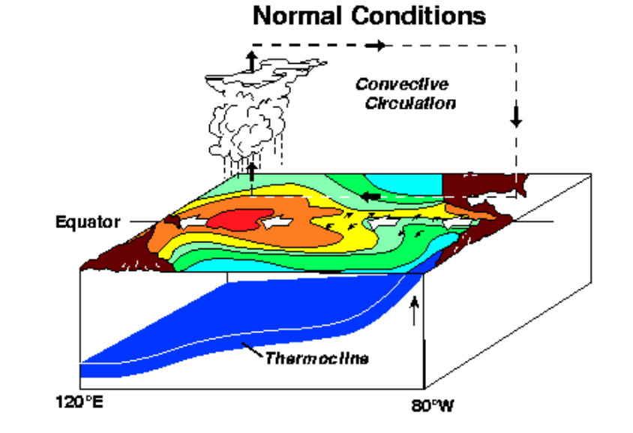

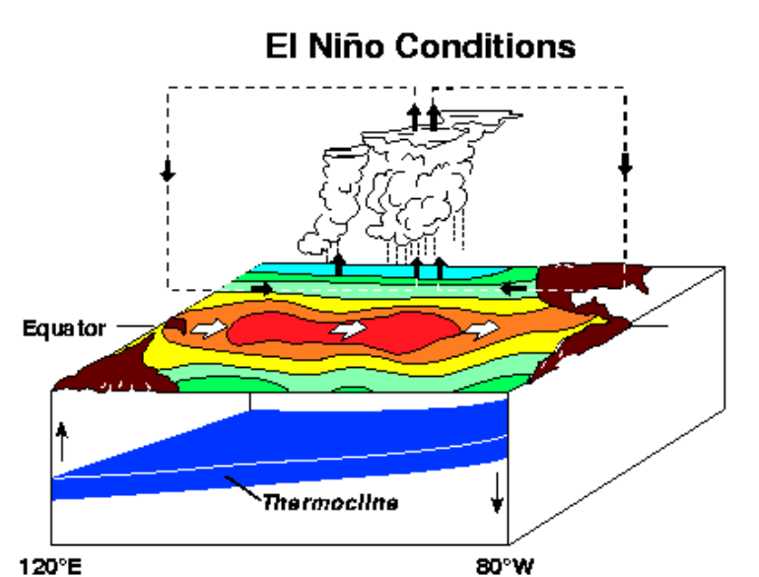

Figure 01: Normal and El Nino Conditions (Source: Schematic Diagrams, El Nino Theme Page - a Comprehensive Resource, n.d.).

## FORMATION OF EL NINO

The development of the El Nino phenomenon commences with a discernible reduction in atmospheric pressure that extends across the vast expanse of the Central Pacific Ocean and the western coastline of South America. Simultaneously, the normally robust low-pressure system that is a consistent feature over the Western Pacific region undergoes a significant change, giving way to the establishment of a weaker high-pressure system in its place. This fundamental shift in the typical pressure configuration of the tropical Pacific atmosphere subsequently triggers a weakening of the Walker Circulation's trade winds, those reliable surface winds that ordinarily traverse the equatorial Pacific. This weakening of the trade winds then allows the warm waters carried eastward by the Equatorial Countercurrent to accumulate along the coastal regions of Ecuador and Peru. The resulting concentration of this substantial volume of warmer surface water in the eastern Pacific leads to a deepening of the thermocline, which acts as a transitional layer separating the warmer surface waters from the cooler, deeper ocean layers. The far-reaching consequences of the El Nino event include the emergence of drier conditions and a scarcity of rainfall in the Western Pacific and along the equatorial coast of South America, while, in contrast, the Central Pacific region experiences periods of intense and prolonged rainfall, and there is also an observed increase in the frequency and intensity of storms and hurricanes within this central oceanic area.

## IMPACTS OF EL NINO

The El Nino phenomenon exerts a significant influence on the dynamics of ocean currents, the temperature of ocean waters, and the overall health and productivity of coastal fisheries, while also triggering widespread disruptions to established weather patterns that extend from the Australian continent to the western coast of South America. A key mechanism through which El Nino impacts global weather is the intensification of atmospheric convection occurring above areas of warmer-than-usual surface water, which subsequently leads to a notable increase in precipitation levels (Wikipedia contributors, 2025b). In South America, this effect has manifested as heightened rainfall, often resulting in severe coastal flooding and significant erosion of shorelines. Furthermore, regions already grappling with the aftermath of natural disasters such as extensive flooding and prolonged drought become considerably more susceptible to the rapid spread of various infectious diseases. Numerous reports from affected areas indicate a clear correlation between El Nino-induced flooding events and a subsequent rise in the incidence of diseases, including serious ailments like cholera, dengue fever, and malaria, as well as other conditions that can lead to significant respiratory complications.

Conversely, El Niño conditions often bring about pronounced dryness in regions such as Australia and Indonesia. This lack of rainfall leads to the depletion of water levels in reservoirs and a diminished capacity of rivers to transport adequate volumes of water, ultimately causing severe water scarcity that impacts both human populations and natural ecosystems. Moreover, agricultural activities in these drought-stricken areas are significantly jeopardized due to the essential need for water to effectively irrigate cultivated fields (F. a. S. Islam, 2023). Interestingly, the El Niño phenomenon has also been linked to a decrease in the frequency of hurricane formation in the Atlantic Ocean, suggesting a complex and geographically varied influence on global weather systems. Historically, some of the most intense El Niño events on record occurred between 1982 and 1983, and again between 1997 and 1998. During the 1982-83 episode, sea surface temperatures in the Eastern Tropical Pacific were recorded as being a remarkable 9 to 18 degrees Fahrenheit above the normal average. The El Nino event of 1997-98 holds the distinction of being the first such occurrence to be scientifically monitored comprehensively from its initial development through its eventual dissipation. The widespread impacts of the 1997-98 El Nino event were felt across numerous regions globally. Countries such as the Philippines, Malaysia, and Indonesia experienced severe drought conditions that significantly impacted agriculture and water resources. Simultaneously, areas like Peru and the state of California in the United States were subjected to periods of exceptionally heavy rainfall and widespread flooding, highlighting the diverse and often contrasting effects of El Nino across different geographical locations.

**WHAT IS LA NINA?**

The term "La Niña" originates from Spanish, meaning "Little Girl" or is often associated with the Christ Child. It was first observed by fishermen in South America. "La Niña" is linked to the cooling phase of the Southern Oscillation, sometimes abbreviated as LNSO, in the Pacific Ocean, which is caused by the upwelling of colder water. During a La Niña phase, the Sea Surface Temperature along the eastern part of the central Pacific is typically lower by 5.4 to 9 degrees Fahrenheit (3 to 5 degrees Celsius) (Ahmad et al., 2022). The development of La Niña can last for five to seven months. It can have significant adverse effects on global weather and climate, potentially leading to severe hurricanes in the Pacific, tornadoes in the Atlantic, and cyclones and tsunamis in the Indian-Pacific Oceans (Cai & Cowan, 2009). La Niña significantly contributes to challenging weather conditions worldwide and has effects that are opposite to those of El Nino (How ENSO Leads to a Cascade of Global Impacts, 2014). The La Nina conditions are depicted in Figure 02 below.

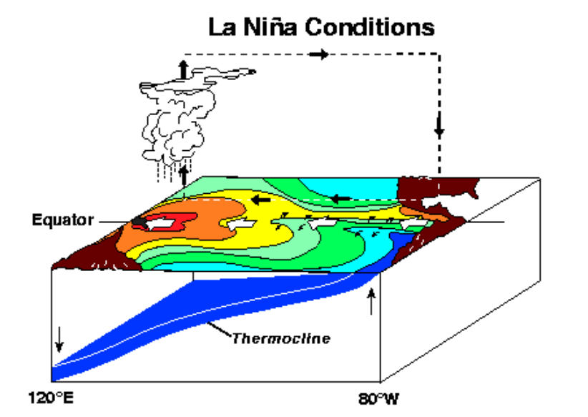

Figure 02: La Nina Conditions (Source: Schematic Diagrams, El Nino Theme Page - a Comprehensive Resource, n.d.).

## EFFECTS OF LA NINA

The climatic phenomenon known as La Nina triggers a diverse array of identifiable global weather patterns, one prominent consequence being the generation of substantial and often intense monsoonal rainfall that sweeps across the Indian subcontinent and the diverse landscapes of Southeast Asia (F. a. S. Islam, 2025). In stark contrast, La Nina frequently instigates the development of prolonged periods of dryness, often escalating into significant drought-like conditions and a notable scarcity of water resources in regions such as Peru and Ecuador, situated along the western edge of the South American continent. For the southeastern parts of the African continent, La Nina typically correlates with the occurrence of winter seasons characterized by increased rainfall and cooler temperatures than usual, while the eastern territories of Australia tend to experience weather conditions marked by unusually high levels of precipitation during La Nina years. The Southern United States often finds itself facing the development of winter droughts under the influence of La Nina, marked by extended periods of significantly reduced rainfall. Conversely, the northwestern states of the United States and the western provinces of Canada frequently encounter colder than average winter conditions when La Nina is in effect. Australia, beyond the generally wetter conditions observed in its eastern regions, also exhibits an increased susceptibility to significant and potentially devastating heavy flooding events during La Nina episodes. Moreover, La Nina contributes to the establishment of higher than normal temperature regimes across the vast expanse of the Western Pacific Ocean, the extensive waters of the Indian Ocean, and the coastal areas extending off the shores of Somalia in East Africa. Lastly, this climatic phase is also strongly associated with the intensification and augmentation of the already substantial monsoon rains that typically occur across the entirety of India, significantly influencing agricultural cycles and the availability of water resources throughout the region.

**MAJOR DIFFERENCES BETWEEN EL NINO AND LA NINA**

El Nino and La Nina differ primarily in the following ways:

|  |  |
| --- | --- |
| **EL NINO** | **LA NINA** |
| The wind speed is low during an El Nino. | The wind speed is extremely high during La Nina. |
| Over the western Pacific, high air surface pressure ladened the El Nino. | Low air surface pressure over the eastern Pacific Ocean is a feature of La Nina. |
| In the eastern Pacific Ocean and neighboring nations like Peru, Ecuador, and Chile, El Nino produces a lot of rainfall. | In neighboring nations like Peru, Ecuador, and Chile, La Nino causes drought-like conditions over the eastern Pacific Ocean. |
| The east-west trade winds become weaker during an El Nino. | The trade winds that blow from east to west intensify during La Nina. |
| El Nino reduces the Coriolis force's strength. | On the other hand, the Coriolis force becomes stronger during La Nina. |
| The eastern Pacific Ocean experiences an accumulation of warm waters during an El Nino. | The western Pacific Ocean experiences an accumulation of warm water during La Nina. |

Table 01: The major differences between EL NINO and LA NINA.

**TRADE WIND**

While "trade" generally refers to the buying, selling, or exchange of goods and services, the term "Trade Wind" specifically describes a consistent pattern of air movement near the Earth's equator. This term gained prominence through the voyages of the explorer Christopher Columbus (1451-1506) as he sailed the Atlantic Ocean towards the Pacific, ultimately reaching the Americas with the assistance of these reliable winds (Xie, 1998). Trade winds are characterized by their flow from high-pressure areas towards the low-pressure belt situated around the equator, specifically between approximately 30° North and 40° South latitude (Ahmad et al., 2022). They are also known as tropical easterlies due to their prevailing direction from the east. These winds tend to be stronger during the winter months and can be drier and warmer in the summer (Wikipedia contributors, 2025). Globally, winds are categorized into primary (planetary), secondary (regional), and tertiary (local) systems. The behavior of trade winds is influenced by phenomena like El Niño. During an El Niño phase, the warmer waters in the Pacific can lead to a weakening of these trade winds. Conversely, along the equator in the Atlantic Ocean, there exists a zone of low and variable wind pressure known as the doldrums. In this region, characterized by stillness and unpredictable storms, the interaction between the atmosphere and ocean surface currents can give rise to large, rotating ocean current systems called gyres. In meteorological terms, the trade winds, originating near the equator, can contribute to storm formation and play a role in the transport of particles such as nitrates and phosphates. They are also involved in carrying Saharan dust across continents, which can introduce airborne pollutants into the atmosphere, sometimes altering the sky's color and potentially negatively impacting air quality and the global ecosystem. Historically, the understanding and utilization of trade winds were instrumental in facilitating colonial expansion worldwide. They enabled the establishment of permanent sea routes for both trade and warfare across the oceans and aided in the exploration of continents such as Africa, the Arctic, the Antarctic, Asia, and the Americas. This development consequently had significant and often negative socio-economic and political impacts on coastal states (Ahmad et al., 2022).

**MAKING A CLEAR CONNECTION BETWEEN EL NINO AND LA NINA AND THEIR EFFECTS ON THE GLOBAL CLIMATE**

One of the main drivers of global climate variability is the El Niño-Southern Oscillation (ENSO), a potent linked ocean-atmosphere phenomenon in the tropical Pacific. The warm (El Niño) and cool (La Niña) phases, which are marked by notable variations in sea surface temperature and disturbances to the Pacific trade winds, set off a series of atmospheric teleconnections that result in different regional climatic effects across the globe. Warm sea surface temperatures moving eastward over the equatorial Pacific during El Niño directly increase air convection over the central and eastern Pacific. Countries like Peru and Ecuador are affected by the higher rainfall and increased risk of flooding along the western coast of South America caused by this enhanced convection. The usual areas of strong atmospheric ascent in the western Pacific are also displaced by this eastward shift, which directly results in extended periods of less rainfall, leading to extreme drought conditions and an increased danger of bushfires throughout Australia and Indonesia. The mid-latitude jet streams are directly impacted by the changed heat distribution in the tropics. This frequently results in milder-than-normal winter temperatures by weakening cold air intrusions into western Canada and the northwest United States. In the southeastern United States, on the other hand, the altered jet stream patterns may result in more storms and colder, wetted winters. Additionally, El Niño-related climatic changes directly enhance vertical wind shear over the tropical Atlantic, which prevents hurricanes from forming and intensifying and results in a suppressed Atlantic hurricane season. The effects are also seen on the Indian Subcontinent, where El Niño occurrences frequently occur in tandem with a weakened summer monsoon circulation, leading to less consistent and unpredictable rainfall in India and the neighboring areas.

On the other hand, a different set of direct regional climate effects are brought on by La Niña, which is marked by lower-than-normal sea surface temperatures in the central and eastern equatorial Pacific and a strengthening of the westward trade winds. The Walker circulation is strengthened by the cooler eastern Pacific seas, which directly increase the temperature differential throughout the tropics. Increased atmospheric rise over the western Pacific and increased monsoonal rainfall result from this, increasing the likelihood of widespread floods in Australia and Southeast Asia. On the other hand, drier conditions and a higher danger of drought in nations like Peru and Ecuador are directly caused by the intensification of the trade winds and the ensuing upwelling of cold, dry air along the South American coast. This also suppresses convection. La Niña's impact on the jet stream in North America intensifies the upper-level wave pattern, which directly causes storms to go southward and causes the Pacific Northwest to experience colder than usual winter weather with heavier snowfall. A more stable and drier atmospheric regime over the southern United States may result from the changed jet stream patterns, which could also bring warmer and drier winter weather. Notably, La Niña's decreased vertical wind shear across the tropical Atlantic directly promotes a more favorable climate for the formation and strengthening of tropical cyclones, which frequently leads to a busier Atlantic hurricane season. El Niño and La Niña's effects are not merely statistical correlations; rather, they are the direct outcome of physical processes that connect Pacific oceanic shifts to particular atmospheric reactions and, in turn, to real-world weather anomalies. In a world where climate variability is becoming more and more prevalent, an understanding of these direct mechanistic pathways is essential for precise climate forecasting, efficient resource management, and focused disaster planning. Understanding these direct connections enables the creation of more effective and knowledgeable strategies to lessen the negative effects of these potent natural climate oscillations on populations and vulnerable areas around the world, especially in light of a changing climate where ENSO's influence may be further increased or altered.

**“EL NINO AND LA NINA” OCCURRENCE**

From a geological perspective, El Niño typically reaches its maximum intensity around December, subsequently diminishing as water temperatures decline. This cooling effect leads to a westward displacement of warmer waters towards the American landmasses (December’s ENSO Update: Close, but No Cigar., 2014). Considering the role of warm Pacific waters in driving the jet stream, a southward deviation of the El Niño jet stream from its average location is observed, significantly influencing prevailing weather patterns. Through this interplay of oceanic and atmospheric dynamics, sudden alterations in climatic behavior become evident (Wikipedia contributors, 2025b). In contrast, La Niña, the antithetical condition to El Niño, arises during the El Niño Southern Oscillation (ENSO) cycle. This phase is marked by an upwelling of colder waters in the Pacific, resulting in below-average sea surface temperatures and an intensification of the easterly trade winds. Generally persisting for a period of three to four months, La Niña is associated with harsh weather conditions worldwide and a heightened occurrence of hurricanes, tornadoes, and tsunamis across the Indian, Atlantic, and Pacific oceans. The ENSO cycle is understood to consist of three distinct phases: El Niño, La Niña, and a neutral intermediary period.

**CHANGES IN MEAN CLIMATE**

The mean state of the tropical Pacific climate involves a time-averaged, seasonally varying condition, distinct from El Niño-Southern Oscillation (ENSO) anomalies. Global climate change, driven by increased greenhouse gases, consistently shows global surface and sea surface temperature warming across climate models. A robust response is the increase in global mean saturated water vapor pressure, rising about 7% per degree Kelvin of warming, mirrored by the global mean vapor pressure if relative humidity remains constant. However, global mean precipitation increases at a much slower rate (1.2% per degree Kelvin), suggesting a reduction in the vertical mixing of air in the tropics and a weakening of the large-scale atmospheric circulation (Collins et al., 2010).

This weakening of the vertical circulation is expected to lead to reduced surface trade winds associated with a weaker Walker circulation, a trend supported by both observations and models showing a decreased east-west sea level pressure gradient across the tropical Pacific. In climate models, these weaker trade winds drive a decline in equatorial oceanic circulation, including reduced upwelling in the equatorial Pacific. While the thermocline tends to flatten under climate change, it paradoxically also shoals due to dynamical adjustments to weaker winds and faster warming of surface waters compared to deeper layers. Projections indicate a more zonally-symmetric warming on the equator compared to off-equatorial regions, driven by a weaker Walker circulation reducing heat transport away from the equator. Despite a consistent weakening of the equatorial Pacific Sea level pressure gradient, observed trends in the east-west SST gradient are less clear due to data limitations and significant ENSO variability. The term "El Niño-like" climate change may be an oversimplification if the expected relationship between weakened trades and SST gradients seen on shorter timescales doesn't hold for long-term changes (Collins et al., 2010). Climate models, while providing a consistent narrative of mean tropical Pacific climate change, still exhibit biases and may not fully capture all aspects of present-day global circulation, such as the Madden-Julian Oscillation or tropical cyclones, potentially complicating the details of projected mean changes.

**GLOBAL WEATHER IMPACT OF EL NINO**

When El Niño happens, the rain that usually falls over Australia, Indonesia, and nearby countries moves eastward along the equator. This causes these areas to become very dry, leading to drought. At the same time, islands in the middle of the Pacific and the west coast of South America get a lot more rain, often causing floods. The areas of heavy rainfall that are normally found a bit north and south of the equator, called the Intertropical Convergence Zone and the South Pacific Convergence Zone, also move closer to the equator when the ocean surface gets warmer. This shift brings a lot of extra rain near the equator in the central and eastern Pacific. However, it also means that places further away from the equator, like New Caledonia and Fiji in the south, and Hawaii in the north, experience drier conditions and drought (McPhaden, 2001). The PNA pattern's schematic diagram is displayed in Figure 03 below.

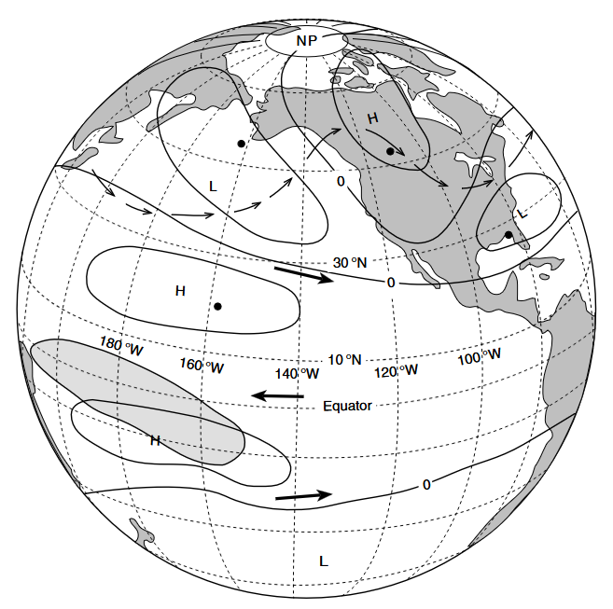

Figure 03: Schematic diagram of the PNA pattern (Source: McPhaden, 2001).

During Northern Hemisphere winters coinciding with El Niño, a characteristic atmospheric pressure pattern called PNA develops over North America. This involves stronger subtropical westerly winds and a weakened upper branch of the equatorial Walker circulation. The altered pressure systems distort mid-tropospheric airflow, leading to enhanced rainfall and cloudiness in the equatorial Pacific's shaded region. This illustrates how El Niño influences distant weather patterns through atmospheric teleconnections (Figure 03). El Niño shifts tropical heat sources, causing global weather changes called teleconnections, strongest in winter. In the Northern Hemisphere, it triggers the **Pacific North American (PNA) pattern**, a specific arrangement of high- and low-pressure centers over the North Pacific and North America. This PNA pattern results in a stronger Aleutian Low, high pressure in western North America, and low pressure in the southeastern US. Consequently, western North America and Canada often experience milder winters, while the southeastern US sees wetter, cooler conditions. Weaker and more variable effects occur in the Southern Hemisphere. The far-reaching impacts of El Nino, known as teleconnections, extend to the high-altitude subtropical jet streams, powerful air currents encircling the globe. The eastward displacement of intense tropical convection during El Niño leads to an intensification and southeastward shift of the core of these jet streams in the central and eastern Pacific. Given the significant influence of jet streams on storm tracks, regions such as southern California and northern Chile typically experience increased storminess and wetter winter seasons during El Niño events.

These teleconnections also modify surface conditions across both land and ocean. In the extratropical regions of the North and South Pacific, for example, sea surface temperatures tend to decrease in response to intensified westerly winds during winter. Over land, alterations in temperature and precipitation can affect soil moisture content and evapotranspiration rates. These changes at the surface can subsequently influence the atmosphere, contributing to the overall climatic response to the initial forcing from El Nino (McPhaden, 2001). Figure 04 below illustrates how El Niño affects the climate year-round.

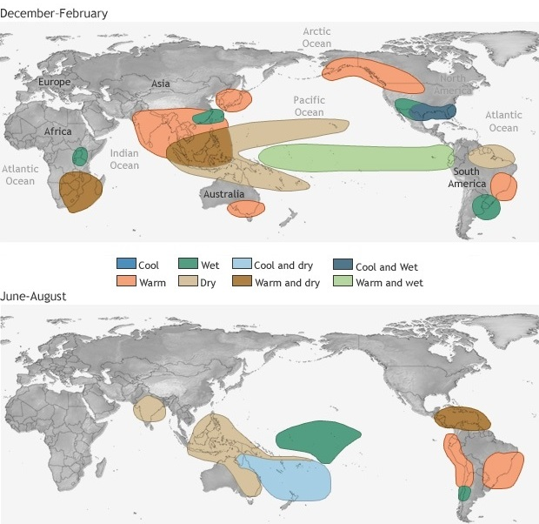

Figure 04: Climate effects of EL NINO throughout the year (Source: Impacts, El Nino Theme Page - a Comprehensive Resource, n.d.).

El Nino years often bring wetter conditions to Peru, Uruguay, southern Brazil, and equatorial East Africa, and drought to northeastern Brazil, southern Africa, and the western Pacific (Ropelewski & Halpert, 1987). The substantial correlation between the Southern Oscillation and Indian monsoon rainfall is consistent with the fact that Indian monsoon summer rains are often weaker during El Nino occurrences. El Nino's effects stretch along the American coasts from Alaska to central Chile. Waves created by weakened Pacific winds travel eastward, warming coastal waters and raising sea levels within a couple of months after reaching South America. North of California, winds related to a North American pressure pattern (PNA) also contribute to this warming. The warmer, higher seas, combined with stronger winter storms and high tides linked to El Nino's intensified jet streams, can cause severe coastal erosion and damage, especially in developed areas. During El Nino, the west coast's abnormally thick layer of warm surface water raises sea levels 15–30 cm near shore. While El Nino's weather impacts are most reliable near the tropical Pacific, its influence on other parts of the world is less predictable due to local factors, meaning the actual weather experienced can vary even during similar El Nino events.

**PHYSICAL SIGNS OF LA NINA**

The start of La Nina is often signaled by colder waters in the central and eastern equatorial Pacific, along with a specific air pressure pattern: lower in the western Pacific and higher in the eastern Pacific. The Southern Oscillation Index (SOI) becomes positive, and the westward trade winds strengthen. In the ocean, more cold water rises to the surface off Peru and along the central/eastern equator. This pushes warm water and heavy rainfall to the western Pacific, causing sea levels to rise there and fall in the east. The ocean's warm-cold water dividing line (thermocline) deepens in the west, and western Pacific storms become more concentrated (Glantz et al., 2001). Strong surface winds further drive warm water westward.

**GLOBAL WEATHER IMPACT OF LA NINA**

La Nina is the cooler phase of the El Niño-Southern Oscillation (ENSO), a natural climate cycle centered in the tropical Pacific Ocean. Originating in these equatorial waters, La Nina's effects radiate outwards, significantly altering weather patterns across the globe. Recognizing these widespread consequences is increasingly important as the world grapples with growing climate variability. The onset of La Nina is marked by specific changes in the Pacific. Sea surface temperatures in the central and eastern equatorial Pacific become notably colder than usual. This cooling is fueled by stronger easterly trade winds, which intensify the westward flow of surface waters and boost the upwelling of frigid, nutrient-rich water from the deep ocean along the South American coast and the equatorial Pacific. The year-round climate effects of LA Nina are seen in Figure 05 below.

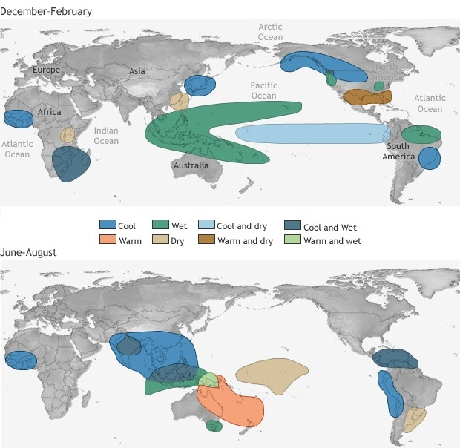

Figure 05: Climate effects of LA NINA throughout the year (Source: Impacts, El Nino Theme Page - a Comprehensive Resource, n.d.).

Atmospheric pressure also shifts, with lower pressures typically developing over the western Pacific and higher pressures over the eastern Pacific. This pressure difference results in a positive reading of the Southern Oscillation Index (SOI), a key indicator for ENSO monitoring. One of the most direct outcomes of these Pacific shifts is a substantial change in global rainfall distribution. The area of warm water, the primary driver of tropical thunderstorms and rainfall, migrates westward towards Indonesia and the western Pacific. This often leads to increased precipitation and a greater chance of floods in these regions, encompassing Southeast Asia and parts of Australia. Conversely, areas in the central and eastern Pacific, including the western coast of South America, frequently experience drier conditions and a heightened risk of droughts.

La Nina's influence extends to the mid and high latitudes through atmospheric teleconnections- long-distance atmospheric links that transmit the impact of unusual tropical Pacific Sea surface temperatures to other parts of the world. While the precise effects can vary based on the intensity and timing of a La Niña event, some general trends are observed. In North America, La Nina winters often bring colder and stormier weather to the Pacific Northwest and western Canada, while the southern United States tends to be warmer and drier. The Atlantic hurricane season also frequently sees more activity during La Niña years due to weaker wind shear in the tropical Atlantic, allowing developing storms to strengthen more easily. Europe is also affected by La Niña, although the impacts can be more intricate and less consistent compared to other regions. Some research suggests a tendency for colder winters in Northern Europe, but this influence is often shaped by other atmospheric patterns.

In the Southern Hemisphere, Australia often experiences increased rainfall and a higher likelihood of cyclones during La Nina. Southern Africa can see more rain in certain areas, while parts of South America may face drier conditions. It's crucial to understand that while La Nina increases the likelihood of specific weather patterns, it does not guarantee them. Local climate variations and other atmospheric factors also play significant roles in determining regional weather (Ropelewski & Halpert, 1987). Nevertheless, understanding the typical global footprint of La Nina provides valuable information for forecasting seasonal weather and preparing for potential impacts across various sectors, including agriculture, water resources, and disaster preparedness. As our knowledge of this powerful climate driver continues to grow, so will our ability to anticipate and lessen its widespread effects. The anomalies in a year with La Nina in 1974 are depicted in Figure 06 below.

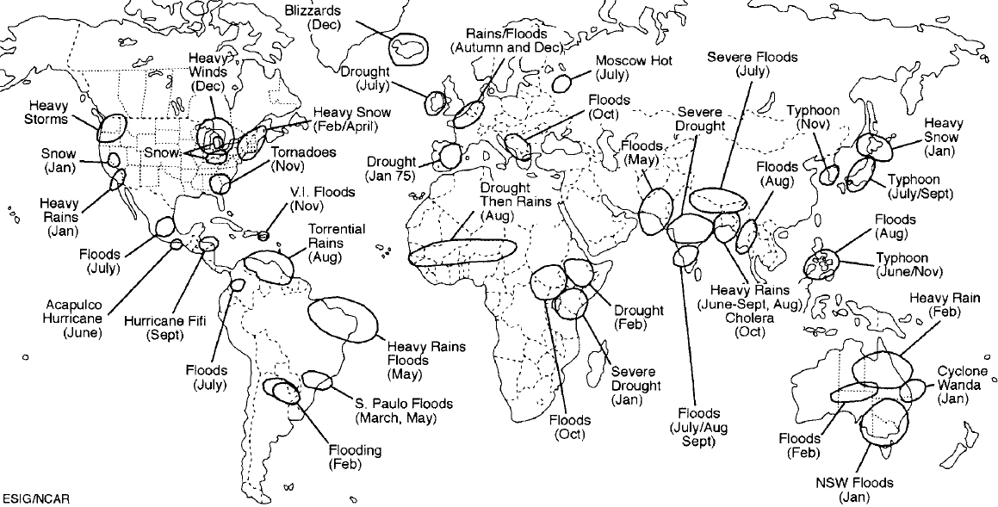

Figure 06: peculiarities in a year with La Nina in 1974 (Source: Trenberth, 1997).

One La Nina event started in June 1973 and ended in 1974, and another one started in September 1974 and concluded in April 1976, according to Trenberth (1997).

**INTENSIFIED WEATHER: HOW EL NINO AND LA NINA FUEL GLOBAL EXTREMES**

El Nino and La Nina, the warm and cool phases of the El Nino-Southern Oscillation (ENSO) in the tropical Pacific, are key drivers of amplified global weather extremes. El Nino's eastward shift of warm waters alters atmospheric pressure and jet streams, increasing heatwaves and intense rainfall in some regions, strengthening cyclones in the eastern Pacific, and contributing to droughts and wildfires in areas like Australia and Asia.

La Nina, with its cooler central and eastern Pacific waters, also intensifies severe weather. It often leads to more active Atlantic hurricane seasons due to reduced wind shear. Regions like Southeast Asia and Australia face increased rainfall and flood risk, while the southern US can experience drier, warmer conditions and potential drought. La Nina also influences winter storm tracks in North America and Europe, potentially increasing intense snowfall or ice storms.

In essence, both ENSO phases amplify natural climate variability, increasing the frequency and intensity of extreme weather events globally. Their specific impacts vary geographically and by event strength, but they significantly modulate global weather patterns, posing increasing challenges for societies. Understanding and predicting these ENSO-driven extremes is critical for effective disaster preparedness and climate adaptation.

**SOCIO-ECONOMIC AND POLITICAL RAMIFICATIONS OF "EL NINO AND LA NINA" ON GLOBAL WEATHER CONDITIONS**

The climatic seesaw of "El Nino and La Nina" exerts a demonstrably detrimental influence on global atmospheric conditions and the broader phenomenon of climatic change, primarily through the intricate mechanisms of the El Nino-Southern Oscillation (ENSO) and the oceanic upwelling process. During periods characterized by intensified upwelling, the cooler subsurface waters of the ocean ascend towards the surface, a process that, while bringing vital nutrients to the upper layers, concurrently disrupts marine ecosystems and frequently coincides with an escalation in natural disasters, amplified rainfall, and widespread flooding events. This dynamic tends to precipitate arid conditions and water scarcity in the Southern United States, while simultaneously unleashing torrential rains across the Northwest Pacific region. In the eastern equatorial Pacific, sea surface temperatures characteristically register a significant depression, typically falling by 3 to 5 degrees Celsius below their usual average, whereas the oceanic expanse extending towards Asia experiences a marked increase in sea surface temperatures, fostering an environment conducive to the formation of destructive cyclonic storms, the premature onset of monsoonal rains, severe flooding, dust storms, intense heat waves, and a discernible augmentation of the overall global temperature (Ahmad et al., 2022). Despite its origin as a singular, albeit complex, climatic phenomenon, the occurrence of ENSO demonstrably triggers a cascade of disruptions to the established equilibrium of global weather conditions, underscoring its pivotal role in shaping planetary climate dynamics.

Given the amplified intensity of easterly winds during its manifestation, the El Nino phase precipitates a spectrum of adverse health consequences, including the heightened prevalence of disease outbreaks, the exacerbation of heat-related stress, an increase in respiratory ailments, and the widespread issue of malnutrition, often compounded by the infliction of severe drought conditions, escalating food insecurity, and extensive flooding accompanied by intense rainfall across vast geographical areas. In its broader context, El Nino generally correlates with a significant elevation in global temperatures, leading to drier conditions and a pronounced shortage of water resources compared to typical climatic norms. Conversely, the La Nina phase is typically associated with episodes of intense rainfall and devastating water-induced flooding. Throughout the La Nina cycle, sea surface temperatures exhibit considerable fluctuation on a worldwide scale, contributing to a complex mosaic of regional climatic responses. These extreme meteorological conditions have demonstrably impacted a wide array of nations spanning the Asian continent, Australia, African territories, European countries, and both North and South American nations, manifesting in various forms such as a notable increase in average temperatures, an elevated frequency of hurricane activity in the Americas, a higher incidence of tornado formation across Europe, and a surge in cyclonic events in South Asia, alongside episodes of intense rainfall, widespread flooding, and temperature elevations exceeding normal levels, particularly in regions such as Bangladesh, Indonesia, Pakistan, the Philippines, Malaysia, Sri Lanka, and in India, while simultaneously exacerbating drought conditions in many African countries (Ramp et al., 1997). In certain geographical zones, winter seasons have become uncharacteristically frigid and excessively wet, while summers have transformed into periods of extreme heat and pronounced aridity, with the specific nature of these deviations heavily contingent upon geographical location. Consequently, these severe weather patterns engender significant economic repercussions, adversely affecting agricultural productivity through reduced crop yields and leading to food shortages, which in turn drive up the prices of essential commodities and ignite elevated rates of inflation, ultimately contributing to social unrest on a global scale, particularly within those nations most severely affected and heavily reliant on imported food supplies (Robert, 2005). These interconnected socio-economic impacts inevitably culminate in political instability, fueled by substantial economic losses and large-scale migrations of populations from the most severely impacted areas towards less affected regions and major metropolitan centers. Furthermore, the delicate balance of marine life within the world's oceans and the integrity of the global ecosystem are also significantly influenced by these phenomena. The processes associated with El Nino disrupt established oceanic behavior, instigating a gradual transformation of global atmospheric and weather conditions. The upwelling mechanism, while crucial for nutrient cycling, can also displace tropical marine species, such as albacore tuna and yellowtail, into regions where temperatures are normally too low for their survival, thereby placing tropical marine populations in a precarious and potentially dangerous situation.

**ECONOMIC CONSEQUENCES OF “EL NINO AND LA NINA”**

The severe meteorological conditions instigated by "El Nino and La Nina" engender profoundly destructive economic repercussions across the globe, as the pervasive influence of altered weather patterns transcends national boundaries, thereby posing a uniform threat to the prosperity of all nations. While a limited number of states may possess a degree of resilience in managing certain aspects of these impacts, none are entirely immune to their pervasive consequences. Cognizant of these critical concerns, economic analysts are increasingly forecasting a substantial and ultimately detrimental effect of "El Nino and La Nina" on the overall economic performance of individual states. According to a comprehensive report issued by the International Monetary Fund (IMF), key sectors such as agricultural production, commodity pricing, labor force activity, public health, and the industrial economy are anticipated to experience significant disruptions stemming from episodes of extreme rainfall, prolonged droughts, uncharacteristic fluctuations in temperature (both excessively low and high), and the increasing prevalence of unpredictable storm events. The cumulative effect of these widespread impacts is projected to substantially undermine the economic well-being of the global community, culminating in staggering financial losses amounting to trillions of dollars for affected nations. For instance, Australia and New Zealand frequently encounter exceptionally hot and arid summer seasons, which not only amplify the intensity and frequency of devastating bush fires but also precipitate a considerable decline in wheat exports, consequently leading to a measurable contraction in the Gross Domestic Product (GDP) of these nations. As a direct consequence of this climatic phenomenon, the adverse economic effects are not confined to these specific countries; rather, the prices of wheat and various other essential commodities experience significant global escalation (Historical Atlas of the North Pacific Ocean, n.d.). South Asia also bears the brunt of El Nino conditions, with unseasonal pre-monsoon rainfall and abrupt downpours leaving a trail of devastating impacts across Pakistan, India, and Bangladesh, further illustrating the far-reaching economic vulnerabilities associated with these powerful climatic oscillations.

**SOCIAL CONSEQUENCES OF LA NINA AND EL NINO**

In addition to the considerable economic losses they precipitate across the globe, the unusual and often extreme climatic conditions that arise as a consequence of the El Nino and La Nina phenomena also generate substantial and far-reaching social repercussions, negatively impacting fundamental aspects of human existence such as the means of earning a living, the availability and functionality of essential public services, the overall state of public health, the accessibility and quality of educational opportunities, the provision of clean and reliable water sources, the effectiveness of sanitation systems, the productivity and sustainability of agricultural practices, the assurance of adequate food supplies, and numerous other interconnected sectors that underpin societal well-being (Do Recent Global Precipitation Anomalies Resemble Those of El Niño?, 2015b). These diverse yet interdependent areas of human life are particularly susceptible to the damaging effects of widespread flooding events, the increased transmission and prevalence of various diseases, and the pervasive problem of inadequate nutrition, all of which unfortunately contribute to a discernible rise in the rates of mortality within affected communities (Muller & Grymes, 2006). As clearly articulated in a comprehensive report issued by the United Nations, the situation in Eastern and Southern Africa is particularly dire, with approximately 50.2 million individuals currently facing a precarious state of food insecurity, a crisis largely attributed to prolonged periods of drought that have been intensified by the effects of El Nino, or a complex interplay of drought conditions occurring in regions already afflicted by ongoing conflicts; alarmingly, this already substantial number is anticipated to escalate significantly as the year progresses (Larkin & Harrison, 2005). Moreover, the report emphasizes that the drought conditions, flooding incidents, and other extreme weather events directly caused or exacerbated by El Nino have a disproportionately significant and distinct impact on women and girls, highlighting the critical need for a thorough understanding of these specific vulnerabilities to be fully integrated into the planning and implementation of both immediate humanitarian aid efforts and longer-term development interventions aimed at building resilience (Ahmad et al., 2022). Undeniably, both El Nino and La Nina exert profound and detrimental social impacts that permeate every dimension of human life, directly and indirectly influencing the fundamental nature of daily existence and contributing to a tangible lowering or degradation of the overall quality of life experienced by affected populations worldwide.

**EL NINO AND LA NINA'S POLITICAL RAMIFICATIONS**

The inevitable and often widespread disruption of fundamental socio-economic sectors within nations experiencing the severe and unusual weather patterns brought about by the El Nino and La Nina phenomena ultimately sets in motion significant and consequential repercussions for the stability and effectiveness of their political institutions. When communities are confronted with the devastating effects of extremely high or low temperatures, catastrophic floods that inundate vast territories, prolonged and debilitating periods of drought that cripple agricultural production, or intense and destructive storm events that ravage infrastructure, a common response among affected populations is to seek refuge and security by migrating away from these afflicted areas towards regions perceived as more environmentally stable and offering greater opportunities for sustenance and safety. This resulting large-scale displacement of people, often involving significant numbers, invariably places considerable strain and pressure on the existing political landscape of both the areas from which people are departing and the areas to which they are relocating, potentially leading to the overextension of resources, significant alterations in established demographic compositions, and a noticeable reshaping of traditional patterns of political participation and engagement within the affected regions. As a direct consequence of these challenges, the level of confidence and trust that citizens hold in the capacity of their governing bodies to effectively manage such widespread crises, provide adequate support and resources to those in need, and ensure the overall well-being and security of the population can be substantially diminished, thereby creating an environment conducive to social unrest, political dissatisfaction, and a potential erosion of governmental legitimacy. Furthermore, the intricate web of socio-economic hardships, including food shortages, economic instability, and the breakdown of essential services, coupled with the continuously emerging and often unpredictable challenges posed by the destructive natural forces directly linked to the cyclical "El Nino and La Nina" climate patterns, emphatically contributes to an overarching atmosphere of instability, particularly within those geographical regions that are most directly and severely impacted by these recurring and often intensifying climatic oscillations, potentially leading to long-term political fragility and hindering sustainable development efforts.

**NAVIGATING THE FUTURE: KEY RESEARCH DIRECTIONS FOR EL NINO AND LA NINA**

Future research on the El Niño-Southern Oscillation (ENSO) must prioritize several crucial avenues to enhance our comprehension and predictive skills. A central focus should be on dissecting the complex interplay between ENSO and the evolving climate. Although indications suggest that a warming planet may be amplifying ENSO events and modifying their regularity, further investigation is essential to fully elucidate these intricate connections and their regional expressions.

Improving the precision and extending the lead time of ENSO forecasts represents another vital area of inquiry. This necessitates refining climate models to more accurately replicate the dynamics of the tropical Pacific and its interactions with the global atmosphere. Research should also concentrate on integrating a variety of observational data, encompassing satellite measurements and ocean buoys, to optimize forecast models.

Furthermore, forthcoming studies should explore the regional ramifications of El Niño and La Niña in greater depth. While general patterns are recognized, the specific consequences can differ substantially across various geographical areas and sectors. More granular research is needed to unravel these regional nuances and formulate customized adaptation strategies. This includes examining the effects on water availability, agriculture, ecosystems, and human health at the local level.

Finally, research should investigate the predictability of extreme weather occurrences linked to ENSO. Understanding the processes through which El Nino and La Nina influence the probability and intensity of heatwaves, droughts, floods, and storms in different global locations is paramount for effective early warning systems and disaster preparedness. This interdisciplinary endeavor, integrating climate modeling, statistical analysis, and impact assessments, will be indispensable for bolstering resilience against ENSO-driven climate variability in the years to come.

**NAVIGATING THE FUTURE: KEY RESEARCH DIRECTIONS FOR EL NINO AND LA NINA**

Building upon the thorough analysis of El Niño and La Niña's global climate impacts provided in this research, several important research directions become apparent to improve our knowledge, strengthen our ability to predict the future, and increase societal resilience to these major climate oscillations.

1. **Political and Socioeconomic Aspects of ENSO's Effects:** Building on the topic of political and socioeconomic repercussions, these aspects could be further investigated in future studies:

* **Impacts of ENSO on the Economy:** Creating advanced economic models to estimate the direct and indirect expenses of El Niño and La Niña events in different industries and geographical areas. Cost-benefit evaluations of mitigation and adaptation measures can be influenced by this.
* **Equity and Social Vulnerability:** Examining how ENSO affects increase preexisting inequities and disproportionately harm disadvantaged people. The creation of equitable adaptation and catastrophe relief strategies should be the main emphasis of research.
* **Governance and Policy Responses:** Examining how well various governance frameworks and legislative initiatives manage ENSO-related risks and foster long-term resilience on a local, national, and worldwide scale.

1. **Breaking Down ENSO Impacts' Regional Specificity:** Even while this analysis has highlighted broad global trends, further research is required to fully understand the complex regional effects of El Niño and La Niña. That comprises:

* Assessing the precise effects of ENSO on vital industries including infrastructure, public health, agriculture, fisheries, and water resources management at the regional and local levels through in-depth research is known as high-resolution impact assessments.
* Compound severe Events: Examining how ENSO may intensify or combine with other climatic drivers to cause compound severe events (such as droughts and heatwaves occurring at the same time or coastal floods made worse by storm surges during El Niño).
* Assessing communities and regions that are especially susceptible to climate extremes brought on by ENSO and creating specialized adaptation plans to increase their resilience are known as vulnerability and resilience assessments. Interdisciplinary research combining social scientists, climate scientists, and policymakers is necessary for this.

1. **Improving Lead Time and Forecasting Accuracy for ENSO:** Effective early warning systems and proactive adaptation measures continue to depend on increasing the accuracy and lead time of ENSO forecasts. Priorities for future research should be:

* **Quantifying Uncertainty and Forecasting Probabilistically:** Developing more dependable techniques for measuring and lowering forecast errors at longer lead times, as well as enhancing the communication of forecast uncertainty through probabilistic approaches, are the goals of probabilistic forecasting and uncertainty quantification.
* **Climate Modeling Advancements:** Concentrating on improving the dynamical representations of important processes in climate models, including air-sea interactions, ocean-atmosphere coupling in the tropical Pacific, and the role sub-seasonal oscillations (like Madden-Julian Oscillation) play in causing and regulating ENSO events.
* **Integration of Diverse Observational Data:** To improve forecast initialization, more advanced techniques are being developed for incorporating a greater variety of observational data into climate models, such as satellite altimetry, ocean buoys (such as the TAO/TRITON array), and subsurface ocean temperature measurements.

1. **Expanding Knowledge of the Interaction between ENSO and Climate Change:** Although the possible modification of ENSO by anthropogenic climate change has been mentioned in this research, further research is needed to fully understand the complex mechanisms behind this connection. In particular, inquiries must concentrate on:

* **Forecasting ENSO Behavior in the Future:** Generating more accurate predictions of how ENSO might change under various future emission scenarios by using high-resolution climate models that better depict the tropical Pacific. This entails evaluating possible modifications to the El Niño-La Niña cycle as well as the appearance of new ENSO flavors.
* **Attribution Studies:** Using statistical methods and sophisticated climate models, it is possible to more conclusively link observed changes in ENSO characteristics to human forcing as opposed to natural variability.
* **Regional ENSO Manifestations under Climate Change:** Examining how a warmer planet may change ENSO's teleconnections, either intensifying or reducing regional climate impacts. This calls for merging local observational data with estimates from global climate models that have been downscaled to regional scales.

1. **ENSO-Related Extreme Weather Predictability:** Improving the forecasting of extreme weather events linked to various ENSO phases is an important field for future research. This includes:

* **Application and Communication of Forecast Information:** To support proactive readiness and reaction measures, researchers are looking into efficient methods to inform stakeholders, such as legislators, disaster management organizations, and the general public, about ENSO forecasts and the hazards they pose.
* **Early Warning Systems for ENSO-Driven Extremes:** Creating more precise and timely early warning systems for ENSO-related extreme weather events by combining enhanced ENSO predictions with regional climate and impact models.
* **Statistical and Dynamical Modeling of Extremes:** Using climate models and sophisticated statistical models, we can gain a better understanding of the physical mechanisms by which ENSO affects the likelihood and severity of heatwaves, droughts, floods, and storms in particular areas.

By concentrating on these important research avenues, the scientific community can keep improving our knowledge of the El Niño-Southern Oscillation and its far-reaching effects, which will ultimately lead to better ways to lessen its negative effects and create a more resilient global society in the face of climate change and variability.

**SECONDARY DATA SOURCES AND LIMITATIONS OF THIS RESEARCH**

This research has synthesized a comprehensive understanding of the El Niño-Southern Oscillation (ENSO) and its global climatic consequences through an extensive review of existing literature. As such, the study primarily relies on secondary data sources, including peer-reviewed scientific articles, reports from meteorological and climate organizations (e.g., NOAA, IPCC), and established scientific literature on ENSO. The strength of this approach lies in its ability to integrate a vast body of knowledge accumulated over decades of ENSO research, providing a broad and well-supported overview of the phenomenon and its far-reaching impacts. By drawing upon the findings of numerous studies employing diverse methodologies, including observational analyses, climate modeling, and remote sensing data, this synthesis aims to present a robust and holistic perspective on the tangible links between ENSO phases and regional climate anomalies.

However, the reliance on secondary data inherently presents certain limitations. Firstly, the interpretation and synthesis of findings from various sources can be subject to the biases and perspectives of the original authors. While this study has strived for an objective and balanced representation, the selection and emphasis of specific findings are inevitably influenced by the researchers' understanding of the literature. Secondly, the spatial and temporal resolution of the data and analyses presented in the reviewed literature can vary significantly. This heterogeneity can make it challenging to draw direct comparisons or identify nuanced regional impacts with consistent levels of detail across all parts of the globe. Furthermore, the reviewed studies themselves may have their limitations related to data availability, model uncertainties, and the inherent complexity of the climate system.

The fact that climate science and ENSO research are fields that are constantly changing presents another obstacle. Although the goal of this study was to take into account recent results, the understanding of ENSO and its effects is always being improved due to the ongoing publication of new studies. Very recent research or new viewpoints may exist that were not adequately covered in this overview. Furthermore, the emphasis on well-established teleconnections and typical ENSO impacts may not adequately take into consideration the expanding amount of research on how climate change modulates ENSO, including possible changes in its frequency, intensity, and spatial patterns, as well as how these changes may affect future regional responses.

Lastly, this work does not give new primary data or innovative modeling results because it is a synthesis of the literature already in existence. As a result, the findings are predicated on the strength of the evidence found in the sources that were examined. Although this offers a solid basis, it also implies that the study is constrained by the breadth and depth of prior research. Future studies could expand on this synthesis by adding new analyses, making use of the most recent satellite data, using high-resolution climate models to look more closely at regional effects, and focusing on the changing connection between ENSO and long-term climate change.

In acknowledging these limitations, this study provides a valuable synthesis of current understanding regarding the mechanisms and global consequences of ENSO. It highlights the well-established links between this Pacific phenomenon and regional climate anomalies worldwide, while also recognizing the ongoing nature of ENSO research and the need for continued investigation to further refine our understanding and predictive capabilities.

**RESULT AND DISCUSSION**

The intricate dance between the El Nino-Southern Oscillation (ENSO) and the global climate system, as illuminated by the findings herein, unequivocally establishes this naturally occurring Pacific phenomenon as a pivotal orchestrator of worldwide weather anomalies, with the alternating warm (El Nino) and cool (La Nina) phases acting as primary instigators of significant inter-annual climate fluctuations across diverse geographical regions. The evidence meticulously gathered and synthesized within this study compellingly demonstrates the far-reaching teleconnections emanating from the tropical Pacific, whereby shifts in sea surface temperatures instigate a cascade of atmospheric perturbations that ripple across continents and oceans, profoundly reshaping established patterns of precipitation and temperature. Specifically, the eastward migration of anomalously warm waters during El Nino episodes demonstrably engenders a substantial reorganization of typical atmospheric circulation cells, most notably exerting a discernible influence on the trajectory and intensity of upper-level jet streams, thereby triggering a complex web of interconnected climatic responses across distant locales; for instance, the observed propensity for severe and protracted droughts to afflict regions such as Australia and Indonesia during El Nino events can be directly attributed to the eastward displacement of conventional rainfall zones, while concurrently, the central and eastern Pacific basin, alongside the western seaboard of South America, frequently experiences episodes of heightened precipitation and consequential flooding, a direct consequence of these large-scale atmospheric adjustments. Furthermore, the characteristic development of the Pacific North American (PNA) teleconnection pattern during Northern Hemisphere winters coinciding with El Nino events invariably precipitates milder winter conditions across western North America and Canada, in stark contrast to the southeastern United States, which typically encounters periods of augmented rainfall and depressed temperatures, thus underscoring the intricate and geographically varied impacts of this climatic oscillation. The observed attenuation of the Indian monsoon's vigor during El Nino occurrences provides yet another compelling illustration of the expansive reach of these atmospheric teleconnections, extending even to critical seasonal weather patterns in distant parts of the globe. Moreover, the documented warming of coastal waters and the attendant rise in sea levels along the American littoral, coupled with the intensification of winter storm activity, serve as tangible reminders of the heightened potential for significant coastal erosion and infrastructure damage during El Nino's active phase.

Conversely, the antithetical La Nina phase, characterized by the emergence of cooler-than-average sea surface temperatures across the central and eastern equatorial Pacific, generally acts to amplify pre-existing atmospheric circulation patterns, thereby instigating a distinct, yet equally pervasive, set of global weather impacts; for example, regions encompassing Southeast Asia and Australia frequently experience an augmentation of rainfall and a heightened susceptibility to flooding under La Nina conditions, while the southern United States often grapples with drier and warmer climatic regimes, a stark reversal of the El Nino-associated patterns. The notable intensification of Atlantic hurricane activity during La Nina years, a phenomenon largely attributed to diminished vertical wind shear within the tropical Atlantic basin, poses a significant threat to vulnerable coastal communities, highlighting the critical role of this ENSO phase in modulating high-impact weather events. The observed tendency for colder and stormier winter conditions to prevail across the Pacific Northwest and western Canada during La Nina further underscores its geographically specific and contrasting influence on global weather dynamics. The fundamental mechanisms underpinning these impacts, namely the strengthening of westward trade winds and the consequent upwelling of frigid, nutrient-rich waters in the equatorial Pacific, serve as the initial impetus for the cascade of atmospheric adjustments that ultimately manifest as these widespread weather anomalies.

It is particularly noteworthy that both the warm and cool phases of ENSO function as significant amplifiers of natural climate variability, demonstrably increasing both the frequency and the intensity of extreme weather events across the globe; El Nino's influence is strongly correlated with an increased incidence of heatwaves and intense precipitation in certain regions, alongside the intensification of cyclonic activity in the eastern Pacific, while paradoxically contributing to the exacerbation of drought and wildfire risks in other areas, such as Australia and parts of Asia. Similarly, La Nina's presence is frequently associated with more active Atlantic hurricane seasons, an elevated risk of flooding in Southeast Asia and Australia, and the potential for severe winter storms, including intense snowfall and ice storms, in regions of North America and Europe. This dual capacity of ENSO to exacerbate a spectrum of extreme weather phenomena underscores its critical role in shaping the planet's climate landscape and presents escalating challenges for societies worldwide, demanding proactive strategies for disaster preparedness and climate adaptation. While the primary focus of this investigation rests upon the profound influence of natural ENSO variability, it is imperative to acknowledge the overarching context of long-term global climate change, primarily driven by anthropogenic emissions of greenhouse gases; the projected weakening of the walker circulation, coupled with the attendant modifications in trade wind patterns and equatorial upwelling, suggests a complex and potentially synergistic interplay between natural climate oscillations and the longer-term trends induced by human activities. The possibility of a more zonally-symmetric warming pattern emerging in the equatorial Pacific, potentially driven by a diminished Walker circulation, could have significant ramifications for the characteristics and impacts of future ENSO events. However, it is crucial to recognize the inherent complexities and potential oversimplifications in characterizing these protracted changes as merely "El Nino-like," emphasizing the ongoing need for sophisticated research and the refinement of climate models to more accurately capture the intricate interactions within the Earth's climate system.

In summation, the findings of this research unequivocally corroborate the established understanding of the El Nino-Southern Oscillation as a dominant modulator of global weather patterns, with its alternating phases instigating a diverse array of temperature and precipitation anomalies, as well as significantly influencing the intensity and frequency of extreme weather events across a multitude of geographical regions. While discernible general patterns of influence have been identified and elucidated, the specific manifestations of El Nino and La Nina's impacts can exhibit considerable variability, contingent upon the unique characteristics of individual events and the complex interplay of other regional and global climate factors that concurrently shape atmospheric dynamics. Consequently, the sustained scientific endeavor to enhance our comprehension and predictive capabilities concerning these pivotal Pacific oscillations remains of paramount importance in the context of proactively anticipating and effectively mitigating the diverse and far-reaching impacts on global weather systems. In an era increasingly defined by accelerating climatic change, a comprehensive and nuanced grasp of ENSO's intricate dynamics is undeniably crucial for the formulation and implementation of informed adaptation and resilience strategies across the globe, enabling societies to better prepare for and respond to the inherent challenges posed by this powerful natural climate driver.

**CONCLUSION**

In essence, the El Nino-Southern Oscillation (ENSO), a naturally occurring phenomenon within the central Pacific Ocean, is recognized as a significant modulator of global weather conditions. This oscillation manifests in two primary phases: El Nino, characterized by warmer-than-average sea surface temperatures, and La Nina, distinguished by cooler-than-average temperatures. These oceanic shifts instigate alterations in established atmospheric circulation patterns, thereby exerting considerable influence on weather phenomena across various regions worldwide. During an El Nino event, a displacement of the typical warm waters of the western Pacific towards the east is observed. This oceanic redistribution disrupts normative upper-atmospheric air flows, consequently perturbing weather systems in numerous locations. For instance, regions such as Indonesia and Australia may be subjected to prolonged periods of aridity and drought conditions. Conversely, the western littoral of South America can experience episodes of intense precipitation and flooding. Over the North American continent, El Nino winters are often associated with milder temperatures in northern latitudes, while the southern states may encounter increased rainfall and cooler temperatures. Furthermore, a suppressive effect on the intensity of the Atlantic hurricane season can also be attributed to El Nino conditions.

Conversely, La Nina is characterized by an anomaly of cooler-than-usual waters prevailing in the central and eastern Pacific. This oceanic state tends to amplify existing atmospheric circulation patterns, resulting in a distinct set of global weather impacts. Frequently, La Nina conditions correlate with augmented rainfall in areas including Southeast Asia and Australia, while the southern United States may experience drier and warmer climatic regimes. Notably, an enhancement of activity within the Atlantic hurricane season is also commonly associated with La Nina. Moreover, the Pacific Northwest region of North America may be subjected to colder and wetter winter conditions. It is important to acknowledge that while these general patterns of influence have been identified, the precise manifestation of El Nino and La Nina's effects can exhibit variability, contingent upon the specific characteristics of each event and the interplay of other regional and global climate factors. Nevertheless, the ongoing scientific endeavor to enhance the understanding and predictive capabilities concerning these Pacific oscillations remains of paramount importance in the context of anticipating and mitigating the diverse impacts on global weather systems. In an era marked by increasing climate change, a comprehensive grasp of ENSO's dynamics is crucial for informed adaptation and resilience strategies across the globe.

Disclaimer (Artificial Intelligence): The Author hereby declares that no generative AI technologies, such as large language models and text-to-image generators, have been used during the writing or editing of this manuscript.

**REFERENCES**

Ahmad, K., Zafar, A., & Ayaz, N. (2022). The impacts of El Nino and La Nina on the global weather condition and possible remedial measures. Global Social Sciences Review, VII(I), 316–322. <https://doi.org/10.31703/gssr.2022(vii-i).30>

April 2025 ENSO update: La Niña has ended. (2025, April 10). NOAA Climate.gov. <https://www.climate.gov/news-features/blogs/enso/april-2025-enso-update-la-nina-has-ended>

Blogs: ENSO. (n.d.). NOAA Climate.gov. <https://www.climate.gov/news-features/blogs/enso>

Cai, W., & Cowan, T. (2009). La Niña Modoki impacts Australia autumn rainfall variability. Geophysical Research Letters, 36(12). <https://doi.org/10.1029/2009gl037885>

Collins, M., An, S., Cai, W., Ganachaud, A., Guilyardi, E., Jin, F., Jochum, M., Lengaigne, M., Power, S., Timmermann, A., Vecchi, G., & Wittenberg, A. (2010). The impact of global warming on the tropical Pacific Ocean and El Niño. Nature Geoscience, 3(6), 391–397. <https://doi.org/10.1038/ngeo868>

December’s ENSO Update: Close, but no cigar. (2014, December 4). NOAA Climate.gov. <https://www.climate.gov/news-features/blogs/enso/decembers-enso-update-close-no-cigar>

Do recent global precipitation anomalies resemble those of El Niño? (2015b, February 11). NOAA Climate.gov. <https://www.climate.gov/news-features/blogs/enso/do-recent-global-precipitation-anomalies-resemble-those-el-ni%C3%B1o>

Glantz, M. H., McPhaden, M. J., O’Brien, J., Tribbia, J., Kiladis, G., Trenberth, K. E., Hoerling, M., Meehl, G., Graham, N. E., Zebiak, S., Busalacchi, A. J., Brunner, A. D., Garnett, R., Shabbar, A., Roos, M., Mantua, N., Wooster, W., Pielke, R. A., Landsea, C. W., . . . Penland, C. (2001). La Niña and its Impacts: facts and speculation. In M. H. Glantz (Ed.), United Nations University Press. United Nations University Press.

<https://i.unu.edu/media/unu.edu/publication/2319/1071-la-nina-overview-w-cover-contents-leaflet.pdf>

Historical Atlas of the North Pacific Ocean. (n.d.). Google Books.

<https://books.google.com.bd/books/about/Historical_Atlas_of_the_North_Pacific_Oc.html?id=zmItJhso1EIC&redir_esc=y>

How ENSO leads to a cascade of global impacts. (2014, May 19). NOAA Climate.gov.

<https://www.climate.gov/news-features/blogs/enso/how-enso-leads-cascade-global-impacts>

IRI – International Research Institute for Climate and Society | April 2025 Quick look.

<https://iri.columbia.edu/our-expertise/climate/forecasts/enso/current/>

Islam, F. S. (2015). The engineers role in climate change mitigation. *Journal of Modern Science and Technology*, *3*(1), 117-124.

<https://www.researchgate.net/publication/276206146_The_Engineers_Role_in_Climate_Change_Mitigation>

Islam, F. A. S. (2025). Global Impact of Climate Change: Glacial Melt, Sea Level Rise, Water Salinization and Emergent Pathogen Risks. *Asian Journal of Environment & Ecology*, *24*(5), 91–113. <https://doi.org/10.9734/ajee/2025/v24i5697>

Islam, N. F. a. S. (2025b). The impact of plastic waste on ecosystems and human health and strategies for managing it for a sustainable environment. *International Journal of Latest Technology in Engineering Management & Applied Science*, *14*(3), 706–723.

<https://doi.org/10.51583/ijltemas.2025.140300075>

Islam, F. a. S. (2025a, April 17). *Enhancing Indoor Environmental Air Quality through Smoke Ventilation in Buildings*. <https://journals.e-palli.com/home/index.php/ajcec/article/view/4739>

Islam, F. A. S. (2025). The Role of Artificial Intelligence in Environmental Monitoring for Sustainable Development and Future Perspectives. *Journal of Global Ecology and Environment*, *21*(2), 164–179. <https://doi.org/10.56557/jogee/2025/v21i29272>

Islam, S. (2022). DETERMINATION OF WATER QUALITY PARAMETERS AND IDENTIFY POLLUTION SOURCES OF UTTARA LAKE AND GULSHAN LAKE IN DHAKA CITY OF BANGLADESH. *World Journal of Engineering Research and Technology*, *8–8*(1), 208–218.

<https://www.wjert.org/download/article/48122021/1643276562.pdf>

Impacts | El Nino Theme Page - A comprehensive Resource. (n.d.). <https://www.pmel.noaa.gov/elnino/impacts-of-el-nino>

Karnauskas, K. B., & Karnauskas, K. B. (2025, January 28). *Three studies point to El Niño as key to 2023 record global heat*. Eos. <https://eos.org/editor-highlights/three-studies-point-to-el-nino-as-key-to-2023-record-global-heat>

Larkin, N. K., & Harrison, D. E. (2005). On the definition of El Niño and associated seasonal average U.S. weather anomalies. Geophysical Research Letters, 32(13). <https://doi.org/10.1029/2005gl022738>

Liu, X., Wigneron, J., Fan, L., Frappart, F., Ciais, P., Baghdadi, N., Zribi, M., Jagdhuber, T., Li, X., Wang, M., Bai, X., & Moisy, C. (2021). ASCAT IB: A radar-based vegetation optical depth retrieved from the ASCAT scatterometer satellite. *Remote Sensing of Environment*, *264*, 112587. <https://doi.org/10.1016/j.rse.2021.112587>

McPhaden, M. J. (2001). El niño and la niña: causes and global consequences. In M. C. MacCracken, J. S. Perry, & Ted Munn (Eds.), Encyclopedia of Global Environmental Change (Vol. 1, pp. 353–370). Unknown. <https://tao.ndbc.noaa.gov/proj_overview/pubs/ElNinoLaNina.pdf>

McCoy, I. L., Wyant, M. C., Blossey, P. N., Bretherton, C. S., & Wood, R. (2024). Aitken Mode Aerosols buffer decoupled Mid‐Latitude boundary layer clouds against precipitation depletion. *Journal of Geophysical Research Atmospheres*, *129*(12). <https://doi.org/10.1029/2023jd039572>

Meehl, G. A., Teng, H., & Branstator, G. (2006). Future changes of El Niño in two global coupled climate models. Climate Dynamics, 26(6), 549–566. <https://doi.org/10.1007/s00382-005-0098-0>

Muller, R. A., & Grymes, J. M. (2006). Water Budget analysis. In Springer eBooks (pp. 798–805).

<https://doi.org/10.1007/1-4020-3266-8_224>

NASA Earth Observatory. (n.d.). *World of change*. <https://earthobservatory.nasa.gov/world-of-change/elnino>

NCEI.Monitoring.Info@noaa.gov. (n.d.). *El Niño / Southern Oscillation (ENSO) | National Centers for Environmental Information (NCEI)*. <https://www.ncei.noaa.gov/access/monitoring/enso/sst>

Ramp, S. R., McClean, J. L., Collins, C. A., Semtner, A. J., & Hays, K. a. S. (1997). Observations and modeling of the 1991–1992 El Niño signal off central California. Journal of Geophysical Research Atmospheres, 102(C3), 5553–5582. <https://doi.org/10.1029/96jc03050>

Research Guides: *Systematic Reviews: Study selection and appraisal*. (n.d.).

<https://guides.himmelfarb.gwu.edu/systematic_review/study-selection-and-appraisal>

Robert R. S. (2005). The Ocean's Influence on North American Drought." Texas A & M University.

Ropelewski, C. F., & Halpert, M. S. (1987). Global and Regional Scale Precipitation Patterns Associated with the El Niño/Southern Oscillation. AMETSOC. <https://doi.org/10.1175/1520-0493(1987)115>

Samiul Islam, F. A. (2023). “The Samiul Turn”: An Inventive Roadway Design Where No Vehicles Have to Stop Even for a Second and There is No Need for Traffic Control. *European Journal of Engineering and Technology Research*, *8*(3), 76–79. <https://doi.org/10.24018/ejeng.2023.8.3.3063>

### Samiul Islam, F. A. (2023). Solid Waste Management System through 3R Strategy with Energy Analysis and Possibility of Electricity Generation in Dhaka City of Bangladesh. American Journal of Environment and Climate, 2(2), 23–32. <https://doi.org/10.54536/ajec.v2i2.1767>

### Samiul Islam, F. A. (2025). Clean Coal Technology: The Solution to Global Warming by Reducing the Emission of Carbon Dioxide and Methane. American Journal of Smart Technology and Solutions, 4(1), 8–15. <https://doi.org/10.54536/ajsts.v4i1.4021>

Samborska, V., & Ritchie, H. (2025, March 3). *“Cool” years are now hotter than the “warm” years of the past: tracking global temperatures through El Niño and La Niña*. Our World in Data. <https://ourworldindata.org/global-temperatures-el-nino-la-nina>

### Samiul Islam, F. A. (2025). Impact of Climate Change and Sea Level Rise on Coastal Zone of Bangladesh. American Journal of Innovation in Science and Engineering, 4(1), 112–122.

### <https://doi.org/10.54536/ajise.v4i1.4556>

Samiul Islam, F. A. (2025). Future Aspects and Environmental Benefits of Renewable Energy in Bangladesh. *Journal of Sustainable Engineering & Renewable Energy*, *1*(1), 1–17. Retrieved from <https://journals.e-palli.com/home/index.php/jsere/article/view/4771>

Schematic Diagrams | El Nino Theme Page- A comprehensive Resource. (n.d.).

<https://www.pmel.noaa.gov/elnino/schematic-diagrams>

Search | NASA Jet Propulsion Laboratory (JPL). (n.d.). NASA Jet Propulsion Laboratory (JPL). <https://www.jpl.nasa.gov/search?query=El+Ni%C3%B1o&filter=site:www.jpl.nasa.gov&x=0&y=0>

### Trenberth, K. E., & Hoar, T. J. (1996). The 1990–1995 El Niño‐Southern Oscillation event: longest on record. Geophysical Research Letters, 23(1), 57–60. <https://doi.org/10.1029/95gl03602>

Trenberth, K., 1997: The definition of El Nin˜ o. Bulletin of the American Meteorological Society, 78(12), 2771–7. [https://doi.org/10.1175/1520-0477(1997)078<2771:TDOENO>2.0.CO;2](https://doi.org/10.1175/1520-0477(1997)078%3c2771:TDOENO%3e2.0.CO;2)

*Turag River’s Water Could be a Possible Source for Supplying Water through Dhaka during Monsoon‬*. (2014).

<https://www.researchgate.net/publication/278037871_Turag_River's_Water_Could_be_a_Possible_Source_for_Supplying_Water_through_Dhaka_during_Monsoon>

Walker, G. T. (1924). "Correlation of seasonal variations in weather IX.

<https://books.google.com.bd/books/about/Correlation_in_Seasonal_Variations_of_We.html?id=jqgXNQAACAAJ&redir_esc=y>

Wikipedia contributors. (2025, April 21). Trade winds. Wikipedia. <https://en.wikipedia.org/wiki/Trade_winds>

Wikipedia contributors. (2025b, April 24). El Niño–Southern oscillation. Wikipedia.

<https://en.wikipedia.org/wiki/El_Ni%C3%B1o%E2%80%93Southern_Oscillation>

Winner or bust? Did La Niña shape North American precipitation this winter as expected? (2025, March 27). NOAA Climate.gov. <https://www.climate.gov/news-features/blogs/enso/winner-or-bust-did-la-nina-shape-north-american-precipitation-winter>

Xie, Shang-Ping. (February 1, 1998). “Ocean- Atmosphere Interaction in the Making of the Walker Circulation and Equatorial Cold Tongue”. Journal of Climate. 11 (2), 189–201.

<https://journals.ametsoc.org/view/journals/clim/11/2/1520-0442_1998_011_0189_oaiitm_2.0.co_2.xml>