Original Research Article
Investigating the inheritance patterns of yield traits in bottle gourd using Hayman’s diallel analysis

Abstract
The objective of this study was to evaluate the genetic parameters of nine inbred bottle gourd and its 36 F₁’s and 36 F₂’s [Lagenaria siceraria (Mol.) Standl.] developed using half-diallel crosses. The experiment was conducted at Instructional Farm, College of Agriculture, Junagadh Agricultural University, Junagadh. Data from generation F₁ and F₂ sets were analyzed using the Hayman method. The results indicated that both additive and dominance components were important in the inheritance of the studied traits. However, additive component was lower in magnitude than dominance component for all the characters in both the generations, which revealed pre-dominance of dominance. Over dominance was registered in both F₁ and F₂ generations for fruit yield and its components. The ‘F’ component has positive as well as negative values in both F₁ and F₂ generations. Environmental component (E) was non-significant for all the characters except for vine length and number of fruits per plant in F₁ generation, as well as vine length in F₂ generation. Number of gene groups (h²/H₂) showed that inheritance of most of the characters was generally governed by more genes or group of genes in F₁ generation, while single gene or gene group was responsible for controlling the traits in F₂ generation. Heritability (ns) estimates was low for fruit yield per plant and vine length in both F₁ and F₂ generations; high for fruit length in F₁ and F₂. On other hand, number of nodes on main vine, number of fruits per plant and total soluble solids exhibited moderate heritability in F₁ but low in F₂. Further, average fruit weight showed low heritability in F₁ but moderate in F₂, while fruit girth exhibited low heritability in F₁ but high in F₂. The study indicated that genetic improvement in bottle gourd can be done by either employing heterosis breeding or population improvement by recurrent selection for sca.
Introduction
Bottle gourd is one of the important cucurbits with high economic values and nutritional values (Saryam et al., 2024). This plant is well developed in the tropical and sub-tropical parts of the world (Patel and Mehta, 2021b). In India, current production level of vegetables is over 189.46 million tons from an area of 10.32 million hectares with productivity of 18.40 tons/ha. Out of these, area and production of bottle gourd was 1.57 million hectares and 26.83 million tons, respectively (Anonymous, 2020a). In Gujarat, vegetable production level is about 132 lakh metric tons with an area of 6.5 lakhs hectares and productivity of 20.22 metric tons/ha (Anonymous, 2020b). Bottle gourd’s tender fruits are harvested for human consumption according to the preferences of the consumer while the seeds of bottle gourd are utilized for animal feed. Bottle gourd is highly rich in various essential mineral nutrients including vitamin B, C and E. Leaves of bottle gourd are having nutrients like zinc, nitrogen, manganese, and copper and the seeds are rich in crude protein, crude lipids, crude fiber, and carbohydrates (Keshari and Singh, 2024).
To meet the increasing demand, various efforts in improving the productivity are much needed. High fruit yield of superior varieties is one of the factors influencing the success of agricultural production, including bottle gourd. One effort to improve bottle gourd production is through a breeding program. Before planning out the breeding and selection methods, we need to correct the character of genetic information. One way to obtain genetic information is the diallel cross analysis (Patel and Mehta, 2021a). According to Johnson (1963), this method is experimentally a systematic approach, and analytically a comprehensive genetic evaluation approach that is useful in identifying potential cross for the best selection in early generations.
Diallel analysis is useful in intersecting the suspect of the general combining ability (GCA) and the specific combining ability (SCA). This analysis is also useful to predict additive and dominant effects of a population which can then be used to predict the genetic variability and heritability. The combining ability analysis can be conducted using the Griffing Method (Griffing, 1956), whereas to study the action of genes, genetic components and heritability can use the Hayman Method (Hayman, 1954). Griffing and Hayman data analysis are often used together for complementary data interpretation.
This study was to obtain information about the genetic parameters of yield components of bottle gourd using half-diallel analysis of Hayman method to know the action of genes, genetic components and heritability of the yield components of the bottle gourd as shown in the Image 1.
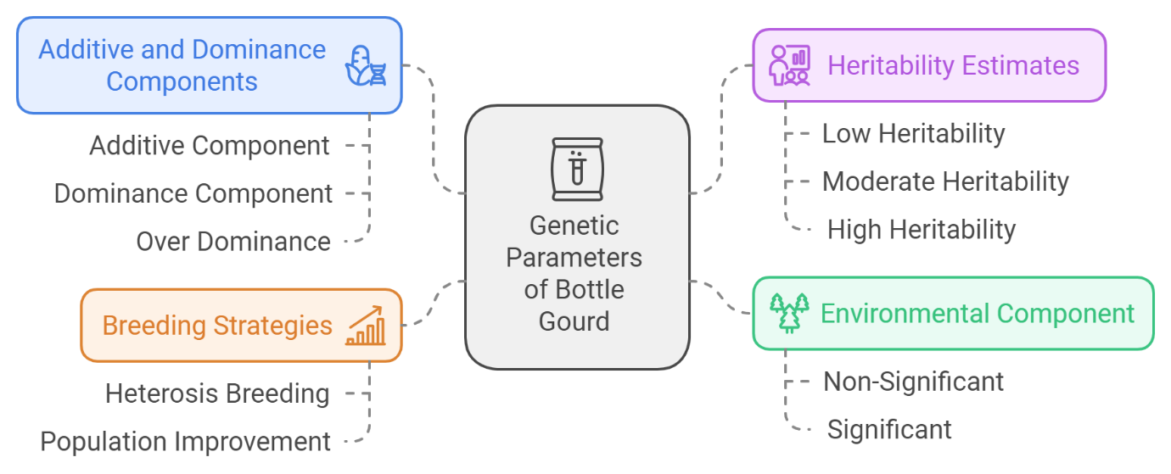
Image 1: Conceptual framework of the study
Materials and Methods
The experimental material consists of nine diverse parents viz., Pusa Naveen, Arka Bahar, Aruna, Punjab Long, NDBG-15, Santosh, JBOGL-01-42, JBGL-43 and PBOG-88 to develop thirty-six F₁’s during Summer 2019 and F₂’s during Kharif 2019 at Vegetable Research Station, Junagadh Agricultural University, Junagadh. The final evaluation trial comprised of parents along with F₁’s, F₂’s and standard check (GABGH-1) in Randomized Block Design (RBD) with two replications during Summer 2020 at the Instructional Farm, College of Agriculture, Junagadh Agricultural University, Junagadh. The parents, F₁’s and F₂’s were grown in plot with spacing 2.0 m x 1.0 m. The trial was conducted in Randomized Block Design (RBD) with two replications. Each replication was consisted of 82 genotypes. Each plot of parents and F₁’s was consisted of a single row of 10 plants, while F₂ was consisted of three rows of 10 plants for each genotype. The recommended package of practices and necessary plant protection measures imperative to raise a good crop was timely and uniformly adopted. Observations were recorded on five competitive plants excluding border ones and was selected randomly from each single row plot of each parents and F₁’s as wells as 20 competitive plants of F₂’s were selected in each replication for fruit yield per plant and its components viz., days to first pistillate flower, days to first staminate flower, node number upto first pistillate flower, node number upto first staminate flower, number of nodes on main vine, vine length (m), days to first fruit picking, days to last fruit picking, number of picking, number of fruits per plant, fruit length (cm), fruit girth (cm), average fruit weight (g) and total soluble solids (˚Brix). The entire methodology applied in this research is shown in the Image 2.
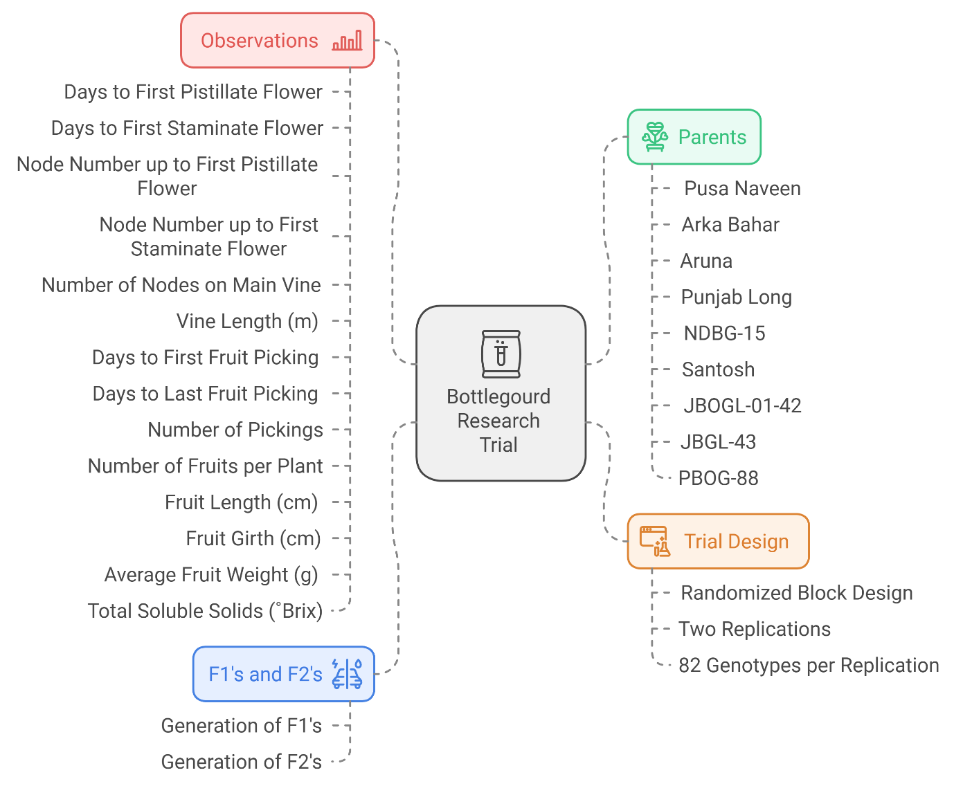
Image 2: Mind map illustrating the structure of the Research trial for this study
The components of genetic variation for various traits were worked out following standard procedure as suggested by Hayman (1954) as well as Jinks (1954) for F₁’s and F₂’s sets, respectively as described in details by Mather and Jinks (1982) and Singh and Chaudhary (1985).
Graphical analysis was performed followed by determination of genetic components and ratios. The uniformity of Wr-Vr graph indicates the validity of the assumptions made by Hayman (1954). The Wr-Vr values were calculated for all the fifteen characters and their homogeneity was tested by calculating t² test.
Results and Discussion
Assumptions underlying diallel analysis are parental homozygosity, diploid segregation, absence of reciprocal effects, absence of multiple alleles, uncorrelated gene distribution and independent action of non-allelic genes (Hayman, 1954a). Failure of any one invalidates the inferences drawn to a certain extent. Therefore, t² test as given by Hayman (1954a) was employed to determine the assumptions basic to diallel analysis for each of the characters studied. The t² values were calculated for all the characters and are presented in Table 1 to 5. The results indicated that t² values in F₁ generation were non-significant for all the characters except average fruit weight and fruit yield, whereas in F₂ generation, t² values were non-significant for days to first pistillate flower, days to first staminate flower, number of nodes, vine length, days to last fruit picking and number of fruits per plant. Overall brief account on genetic components and ratios (Table 1 to 5) are discussed as under:
The estimates of ‘D’ which measures variance due to additive genetic effect as well as ‘H₁’ and ‘H₂’, which measures the variance due to non-additive effects were significant for all the characters in both F₁ and F₂ generations except for number of picking, average fruit weight and fruit yield in both the generations for ‘D’ and number of fruits per plant for ‘D’ in F₂ generation. The above findings indicated that both additive and dominance components were important in the inheritance of these traits. However, additive component was lower in magnitude than dominance component for all the characters in both the generations, which revealed pre-dominance of dominance. Similar findings were reported by Dubey and Ram (2008), Ghughe (2015) and Quamruzzaman et al. (2020) in bottle gourd; Poshiya (2011) in ridge gourd; Radharani (2014) in bitter gourd and Chauhan et al. (2018) in sponge gourd for fruit yield and its component traits.
The overall dominance effect (h²) over all loci in heterozygous phase for all crosses in F₁ generation was found significant for all the characters, while in F₂ generation, none of the characters was found significant for ‘h²’. This indicated that there is an involvement of dominant gene in the expression of the traits in F₁ generation for the studied traits, while in F₂ generation; recessive genes were more prevailed in the traits inheritance. Significant ‘h²’ values were reported by Quamruzzaman et al. (2020) in bottle gourd for days to first fruit picking, fruit length, fruit girth, total soluble solids, vine length, number of fruits per plant, average fruit weight and fruit yield per plant. Chauhan et al. (2018) reported significant ‘h²’ values in sponge gourd for days to first pistillate flower, days to first staminate flower and non-signifcant ‘h²’ values for node number upto first pistillate flower, node number upto first staminate flower, fruit length and vine length.
The positive value of ‘F’ in F₁ generation was reported for days to first pistillate flower, node number upto first pistillate flower, node number upto first staminate flower, days to first fruit pcking, days to last fruit picking, number of picking, number of fruits per plant and fruit girth which indicated more proportion of dominant alleles among the parents, while the days to first staminate flower, number of nodes, vine length, fruit length, average fruit weight, fruit yield per plant and total soluble solids reported negative ‘F’ values indicated more proportion of recessive alleles among the parents. Likewise, in F₂ generation, positive values were observed for number of nodes, vine length, days to first fruit picking, days to last fruit picking, number of picking, number of fruits per plant, fruit length and total soluble solids which indicated presence of dominant alleles, while negative values were exhibited by days to first pistillate flower, days to first staminate flower, node number upto first pistillate flower, node number upto staminate flower, fruit girth, average fruit weight and fruit yield per plant which indicated presence of recessive alleles among the parents. The positive as well as negative values were observed for an estimate ‘F’ in F₁ and F₂ generations for the traits under studied showed that there is an equivalent proportion of dominant and recessive genes in the inheritance of the studied traits among the parents. This finding is in accordance with the results of Dubey and Ram (2008) and Quamruzzaman et al. (2020) in bottle gourd; Chowdhury and Sikdar (2005), Radharani (2014) and Tiwari et al. (2018) in bitter gourd; Chauhan et al. (2018) in sponge gourd and Poshiya (2011) in ridge gourd.
The non-significant estimate of ‘E’ for all the characters (except for days to first staminate flower, vine length, days to first fruit picking and number of fruits per plant in F₁ generation, while vine length in F₂ generation) suggested that there was no considerable environmental influence in modifying their expression. Ghughe (2015) in bottle gourd observed non-significant value for fruit length, while significant values for days to first staminate flower, days to first pistillate flower, days to first fruit picking, fruit girth, average fruit weight and number of fruits per plant. Radharani (2014) in bitter gourd reported significant ‘E’ value for days to first staminate flower. Quamruzzaman et al. (2020) in bottle gourd reported significant ‘E’ value for days to first fruit picking, fruit length, fruit girth, number of fruits per plant, average fruit weight, total soluble solids and fruit yield per plant, while non-significant value for vine length.
The average degree of dominance (H₁/D)^{1/2} was found in the range of partial dominance to over dominance for the fifteen characters in both the generations. Over dominance was registered in both F₁ and F₂ generations for the traits viz., node number upto first pistillate flower, node number upto first staminate flower, number of nodes, vine length, days to last fruit picking, number of picking, number of fruits per plant, fruit length, fruit girth, average fruit weight, fruit yield per plant and total soluble solids. On the other hand, days to first pistillate flower, days to first staminate flower and days to first fruit picking had partial dominance in F₁ and over dominance in F₂ generation. Quamruzzaman et al. (2020) in bottle gourd reported over dominance for days to first fruit picking, vine length, number of fruits per plant, average fruit weight and fruit yield per plant. Hedau and Sirohi (2004) in bottle gourd noticed over dominance for fruit girth, number of fruits per plant, while partial dominance for fruit length and average fruit weight. Chauhan et al. (2018) in sponge gourd and Tiwari et al. (2018) in bitter gourd observed over dominance for days to first staminate flower, days to first pistillate flower, node number upto first staminate flower, node number upto first pistillate flower, fruit length, fruit girth, number of fruits per plant and fruit yield per plant.
The equal distribution of positive and negative genes in the parents was revealed from the estimate, H₂/4H₁ and helps the plant breeders in selecting a particular desirable trait without losing other traits of interest. In the present study, asymmetrical distribution of positive and negative genes in the parental lines was observed in both the generations for all the characters except number of nodes, vine length and number of fruits per plant in F₁ generation, whereas days to first pistillate flower, days to first staminate flower, vine length, days to first fruit picking and number of fruits per plant in F₂ generation showed symmetrical distribution of alleles among the parents. Quamruzzaman et al. (2020) in bottle gourd reported asymmetrical distribution of alleles for days to first fruit picking, fruit length, total soluble solids, vine length, number of fruits per plant, average fruit weight and fruit yield per plant (except fruit girth). Chauhan et al. (2018) in sponge gourd also observed asymmetrical results for days to first pistillate flower, days to first staminate flower, node number upto first staminate flower, node number upto first pistillate flower and fruit girth. Naliyadhara (2005) in sponge gourd reported symmetrical distribution of alleles for days to last fruit picking.
The ratio of number of dominant to recessive alleles in the parents (K_{D}/K_{R}) indicated unequal frequency of dominant and recessive genes. In F₁ generation, more number of dominant genes was found in the traits except for days to first staminate flower, number of nodes, vine length, fruit length, average fruit weight, fruit yield per plant and total soluble solids in which proportion of recessive genes were more. Similarly in F₂ generation, proportion of dominant genes were found in most of the traits except for days to first pistillate flower, days to first staminate flower, node number upto first pistillate flower, days to first staminate flower, fruit girth, average fruit weight and fruit yield per plant. More proportion of dominant genes for the traits days to first staminate flower, node number upto first pistillate flower and fruit weight was reported by Dubey and Ram (2008) and Quamruzzaman et al. (2020) in bottle gourd. Poshiya et al. (2011) in ridge gourd reported more number of dominant genes for days to first staminate flower, number of fruits per plant, node number upto first pistillate flower, vine length, fruit length and fruit yield per plant, while more number of recessive genes for days to first fruit picking and node number upto first staminate flower. In sponge gourd, Chauhan et al. (2018) observed more proportion of dominant genes for days to first staminate fower, days to first pistillate flower, node number upto first staminate flower, node number upto first pistillate flower, vine length, fruit length, number of fruits per plant and fruit yield per plant.
Knowledge of number of gene groups responsible for a particular trait is important for the genetic progress through selection. In the present study, the value of h²/H₂ was more than unity in F₁ generation for all the traits (except days to last fruit picking and total soluble solids), whereas the value of h²/H₂ was less than unity in F₂ generation for all the traits (except average fruit weight). This indicated more genes or group of genes were exhibited dominance and controlling the traits in F₁ generation Quamruzzaman et al. (2020) in bottle gourd observed more genes or group of genes for fruit length and fruit yield per plant, while single gene group was found for days to first fruit picking, fruit girth, total soluble solids, vine length, number of fruits per plant and average fruit weight. Tiwari et al. (2018) in bitter gourd reported more genes group for days to first pistillate flower, days to first staminate flower, node number upto first staminate flower, node number upto first pistillate flower and average fruit weight, while single gene group for number of fruits per plant, vine length, fruit length, fruit girth and fruit yield per plant.
Narrow sense heritability in F₁ generation was low for node number upto first staminate flower, vine length, days to last fruit picking, number of picking, fruit girth, average fruit weight and fruit yield per plant. Moderate heritability was revealed for node number upto first pistillate flower, number of nodes, number of fruits per plant and total soluble solids. Further, high heritability was observed for days to first pistillate flower, days to first staminate flower, days to first fruit picking and fruit length in F₁ generation. On the other hand, in F₂ generation, low heritability was observed in respect of days to first pistillate flower, days to first staminate flower, number of nodes, vine length, days to first fruit picking, days to last fruit picking, number of picking, number of fruits per plant, fruit yield per plant and total soluble solids; moderate values for node number upto first pistillate flower, node number upto first staminate flower and average fruit weight and high values for fruit length and fruit girth. Low heritability estimates indicated a major role of non-additive gene action in the inheritance of characters studied and hence there is a limited scope for genetic improvement through direct selection. Low heritability values were noticed for vine length, days to last fruit picking, number of picking and fruit yield by Quamrummani et al. (2020) in bottle gourd; Sundaram (2006) and Radharani (2014) in bitter gourd and Naliyadhara (2005) in sponge gourd, while low to moderate heritability values were reported by Quamrummani et al. (2020) in bottle gourd; Chowdhury and Sikdar (2005), Sundaram (2006) and Radharani (2014) in bitter gourd and Naliyadhara (2005) in sponge gourd for node number upto first pistillate flower, node number upto first staminate flower, number of nodes, number of fruits per plant, average fruit weight and total soluble solids. Low to high heritability values were observed by Quamrummani et al. (2020) in bottle gourd; Sundaram (2006) in bitter gourd and Naliyadhara (2005) in sponge gourd for days to first pistillate flower, days to first staminate flower, days to first fruit picking, fruit girth. On the other hand, high heritability was reported in fruit length by Quamrummani et al. (2020) in bottle gourd; Sundaram (2006) and Radharani (2014) in bitter gourd and Poshiya (2011) in ridge gourd.

Graphical analysis (Hayman’s approach)
The uniformity of Wr-Vr graph indicates the validity of the assumptions made by Hayman (1954). The Wr-Vr values were calculated for all the fifteen characters and their homogeneity was tested by calculating t² test.
The values of points of interception, regression coefficient of Wr on Vr (b) along with their standard errors, deviation of b from zero (b-0/SEb) and unity (1-b/SEb) are presented in Table 6. The value of ‘b’ for each trait is expected to be significantly deviates from zero and approach unity. The array points in all the graphs are 1 (Pusa naveen), 2 (Arka Bahar), 3 (Aruna), 4 (Punjab Long), 5 (NDBG-15), 6 (Santosh), 7 (JBOGL-01-42), 8 (JBGL-43) and 9 (PBOG-88). The character-wise graphical presentation and findings are presented as follows:
Days to first pistillate flower (Fig. 1)
Graphical analysis of the data displayed that the regression line of Vr-Wr of the parental arrays in F₁ intercepted the ‘Y’ axis above the origin which showed the presence of partial dominance and below the origin in F₂, which showed the presence of over dominance and the slope of the regression line was less than unity for F₁ (b = 0.932 ± 0.087) and F₂ (b = 0.270 ± 0.186). From the distribution of parents in F₁, it was apparent that maximum dominant alleles were present in Santosh and JBGL-43 and maximum recessive alleles were present in NDBG-15 and Aruna for this trait. On the other hand in F₂, parent PBOG-88 and Pusa Naveen contained maximum dominant alleles and parent Santosh and Aruna contained maximum recessive alleles.
Days to first staminate flower (Fig. 2)
The regression line of variance-covariance graph for days to first staminate flower was found to pass above the point of origin in F₁ generation, which showed the presence of partial dominance, while it passes below the origin in F₂, indicated the presence of over dominance in controlling the expression of this trait. The slope was less than one in F₁ (b = 0.929 ± 0.065) and F₂ (b = 0.345 ± 0.173). In F₁, the parental arrays Aruna and NDBG-15 were found away from point of origin of regression line, while parent Santosh and JBGL-43 were found near the origin of regression line. Whereas in F₂, Arka Bahar and Santosh occupied the farthest position, while PBOG-88 and Pusa Naveen occupied the nearest position from the origin.
Node number upto first pistillate flower (Fig. 3)
The slope of regression line of Wr (covariance) on Vr (variance) in F₁ (b = 0.856 ± 0.115) significantly deviated from zero but not from unity indicated involvement of additive gene action. Whereas in F₂ (b = 0.578 ± 0.078), slope of unity significantly deviated from zero as well as unity, indicated inter-allelic interations for the expression of this trait. The regression line intercepted W-axis below the origin in both generations which showed presence of over dominance involved in the expression of this trait. A perusal of Vr-Wr graph in F₁ reported that Santosh and JBGL-43 had more dominant genes, occupied the position nearest to the origin, while Aruna and NDBG-15 had more recessive genes, and occupied farthest position from the origin. On contrary in F₂, PBOG-88 and JBOGL-01-42 had more dominant genes and occupied the nearest position to the origin, while Santosh and Arka Bahar had more recessive genes and occupied the farthest position from the origin.
Node number upto first staminate flower (Fig. 4)
The variance-covariance graph for node number upto first staminate flower revealed that the regression line intercepted the ‘Y’ axis below the origin indicated the presence of over dominance in F₁ and F₂ generations. The slope of the regression line was less than unity in F₁ (b = 0.704 ± 0.107) and F₂ (b = 0.559 ± 0.084) generations and deviated significantly from zero as well as unity in both generations, suggesting presence of non-allelic interaction. Distribution of array points depicted that genotypes PBOG-88 and JBOGL-01-42 had maximum dominant genes in both F₁ and F₂ generation, respectively. However, Arka Bahar, NDBG-15 and Aruna had maximum recessive genes being farthest from the origin in both generations.
Number of nodes on main vine (Fig. 5)
The point of interception of regression line of Wr-Vr graph for number of nodes on main vine in F₁ and F₂ generation was found to pass below the point of origin indicated the over dominance for the inheritance of the expression of these trait. The slope of the regression line was less than one in both the generations (b = 0.548 ± 0.212 in F₁ and b = -0.136 ± 0.289 in F₂). The array points Santosh contained maximum dominant genes, while Punjab Long contained maximum recessive genes in F₁ generation. However, in F₂, Aruna and Arka Bahar had maximum and minimum dominant genes, respectively, while rest of the arrays in both F₁ and F₂ generations occupied intermediate positions.
Vine length (m) (Fig. 6)
Variance-covariance relationship for vine length revealed that the regression line intercepted the ‘Y’ ordinate below the origin in both F₁ and F₂ generation, indicated presence of over dominance. The slope of regression line differed significantly from zero but not from unity in F₁ (b = 0.628 ± 0.174), indicating presence of additive gene action. However, slope of regression line was neither significant from zero nor from unity in F₂ generation (b = 0.688 ± 0.342). A perusal of graph suggested that JBOGL-01-42 and NDBG-15 had more number of dominant genes in F₁ and F₂ generations, respectively, while Santosh had more number of recessive genes in both the generations.
Days to first fruit picking (Fig. 7)
The slope of regression line was deviated significantly from zero but not from unity in F₁ (b = 0.924 ± 0.118), showed presence of additive gene action, while it was differed significantly from zero as well as unity in F₂ generation (b = 0.426 ± 0.149), indicated inter-allelic interactions for controlling this trait. Graphical analysis of the data displayed that the regression line intersects the Wr-axis above the origin and below the origin in F₁ and F₂ generations, respectively, which indicated the presence of partial dominance in F₁ generation and over dominance in F₂ generation. Distribution of array points in F₁ depicted that parent Santosh and JBGL-43 carried maximum number of dominant genes, while parent NDBG-15 and Aruna carried maximum number of recessive genes. However, array points in F₂, depicted that parent PBOG-88 and JBGL-43 were nearer to the orign and parent Arka Bahar and Santosh being farthest from the origin.
Days to last fruit picking (Fig. 8)
The Vr-Wr graph for days to last fruit picking revealed that the regression line intercepted the ‘Y’ axis below the origin indicated the presence of over dominance in F₁ and F₂ generations. The slope of the regression line differed significantly from unity but not from zero in both F₁ (b = 0.315 ± 0.203) and F₂ (b = 0.360 ± 0.202) generations, indicated inter-allelic interactions for the expression of this trait. In F₁, parent JBOGL-01-42 followed by Punjab Long, Santosh and JBGL-43 contained larger proportions of dominant genes as they are nearer to the orign, while parent PBOG-88 being the farthest and contained maximum recessive genes. However in F₂, parent Aruna followed by Arka Bahar, Pusa Naveen and JBGL-43 had maximum dominant genes, while parent PBOG-88 and NDBG-15 had maximum recessive genes.
Number of picking (Fig. 9)
Graphical analysis of the data displayed that the regression line of Vr-Wr of the parental arrays in F₁ and F₂ intercepted the ‘Y’ axis below the origin which represented the presence of over dominance for the expression of this trait. The slope of the regression line was significantly deviated from unity but not from zero in both F₁ (b = 0.269 ± 0.191) and F₂ (b = 0.078 ± 0.152) generations indicated presence of non-allelic interactions in the expression of this trait. From the distribution of parents in F₁, it was apparent that maximum dominant genes were present in JBOGL-01-42 and Santosh, while maximum recessive genes were present in PBOG-88 and Pusa Naveen for this trait. On the other hand in F₂, parent Aruna, JBGL-43 and Pusa Naveen contained maximum dominant genes and parent PBOG-88 contained maximum recessive genes.
Number of fruits per plant (Fig. 10)
The slope of regression line of Wr (covariance) on Vr (variance) in F₁ (b = 0.338 ± 0.310) was not significantly deviated from zero and unity. Whereas in F₂ (b = 0.126 ± 0.214), slope of unity significantly deviated from unity but not from zero, indicated inter-allelic interactions for the expression of this trait. The regression line intercepted W-axis below the origin in both generations which showed presence of over dominance involved in the expression of this trait. A perusal of Vr-Wr graph in F₁ reported that PBOG-88 and NDBG-15 had more dominant genes and occupied the position nearest to the origin, while Pusa Naveen and Santosh had more recessive genes and occupied farthest position from the origin. On contrary in F₂, only one parent JBOGL-01-42 had more dominant genes and occupied the nearest position to the origin, while PBOG-88 had more recessive genes and occupied the farthest position from the origin.
Fruit length (cm) (Fig. 11)
The point of interception of regression line of Wr-Vr graph for fruit length in F₁ and F₂ generation was found to pass below the point of origin indicated the presence of over dominance in the expression of this trait. Deviation of slope of the regression line differed significantly from zero as well as from unity in F₁ (b = 0.479 ± 0.183) generation, while it differed significantly from unity but not from zero in F₂ (b = 0.174 ± 0.120), indicated presence of inter-allelic interactions in both the generations. Most nearest to the origin was array point in case of Punjab Long and contained maximum dominant genes, while array point Santosh being the farthest from origin and contained maximum recessive genes. However, in F₂, cluster of five array points was observed viz., Pusa Naveen, JBGL-43, Aruna, PBOG-88 and Arka Bahar which were nearer to the origin, while Santosh and JBOGL-01-42 occupied the farthest position from the origin point in F₂.
Fruit girth (cm) (Fig. 12)
The regression line cutting the ‘Y’ ordinate below the origin in F₁ generation which showed over dominance and had a slope of less than one (b = 0.471 ± 0.221) which differed significantly from unity, indicated interaction between genes were inter-allelic. Similarly in F₂, regression line also intercepts below the origin which indicated over dominance and had a slope of less than (b = 0.308 ± 0.107) which differed significantly from zero and unity, indicated epistatis in expression of this trait. In the F₁, the array points Arka Bahar, Pusa Naveen and Aruna were found nearer to the basal end of the regression line and the array point PBOG-88 was at the distal end of regression line. However in F₂, JBGL-43, Aruna and Pusa Naveen occupied the position nearer to the origin, while array point Santosh and Punjab Long occupied the position farthest from the origin.
Average fruit weight (g) (Fig. 13)
Graphical analysis of the data displayed that the intercept of the regression line was positive and cuts Wr-axis below the point of origin indicated the presence of over dominance in both F₁ and F₂ generations. The estimated regression line was deviated significantly from unity in F₁ (b = 0.110 ± 0.117) and F₂ (b = 0.089 ± 0.091) generations, indicated that this trait was governed by inter-allelic interactions. Distribution of array points depicted that Pusa Naveen, Arka Bahar, Aruna, JBGL-43 and PBOG-88 had maximum dominant genes as they were clustered nearer to the origin in both the generations, while array point Santosh had maximum recessive genes as it was farthest from the origin in both F₁ and F₂ generations.
Fruit yield (kg/plant) (Fig. 14)
The variance-covariance relationship was graphically presented for F₁ and F₂ generations which showed that the regression line of Wr-Vr of the parental arrays in both F₁ and F₂ generation intercepted the ‘Y’ axis below the origin, which showed the presence of over dominance for expression of this trait. The slope of the regression line was less than unity for F₁ (b = 0.086 ± 0.130) and F₂ (b = 0.089 ± 0.135) generations and it differed significantly from unity in both generations and showed that inter-allelic interactions were responsible for controlling this trait. In F₁, parent Pusa Naveen and PBOG-88 falling towards origin indicated the presence of greater proportion of dominant genes, whereas parent Punjab Long and Santosh being far away from origin indicated presence of recessive genes controlling this trait. On the other hand in F₂, parent Pusa Naveen, NDBG-15 and JBGL-43 are falling towards origin, showed more dominant genes, while JBOGL-01-42, Santosh and Punjab Long being far away from origin which indicated the presence of recessive genes, while rest of the parents occupying intermediate position and contained equal proportion of dominant and recessive genes in both generations.
Total soluble solids (˚Brix) (Fig. 15)
The Vr-Wr graph for total soluble solids revealed that the regression line intercepted the ‘Y’ axis below the origin indicated the presence of over dominance in both F₁ and F₂ generations. The slope of the regression line differed significantly from unity but not from zero in both F₁ (b = 0.107 ± 0.195) and F₂ (b = -0.010 ± 0.167) generations indicated inter-allelic interactions for the expression of this traits. In F₁, parent JBGL-43 and JBGOGL-01-42 contained larger proportions of dominant genes as they were nearer to the orign, while parent Punjab Long, Santosh and Arka Bahar being the farthest, contained maximum recessive genes. However in F₂, six parents clustered near to the origin viz., JBGL-43, PBOG-88, Aruna, Pusa Naveen, NDBG-15 and JBOGL-01-42 and had maximum dominant genes, while parent Punjab Long and Santosh had maximum recessive genes.
OR
Graphical analysis (Hayman’s approach)
The uniformity of Wr-Vr graph indicates the validity of the assumptions made by Hayman (1954). The Wr-Vr values were calculated for all the fifteen characters and their homogeneity was tested by calculating t² test.
The values of points of interception, regression coefficient of Wr on Vr (b) along with their standard errors, deviation of b from zero (b-0/SEb) and unity (1-b/SEb) are presented in Table 6. The value of ‘b’ for each trait is expected to be significantly deviates from zero and approach unity. The array points in all the graphs are 1 (Pusa naveen), 2 (Arka Bahar), 3 (Aruna), 4 (Punjab Long), 5 (NDBG-15), 6 (Santosh), 7 (JBOGL-01-42), 8 (JBGL-43) and 9 (PBOG-88). The graphical presentation and findings are presented as follows:
Graphical analysis of the data displayed that the regression line of Vr-Wr of the parental arrays in F₁ intercepted the ‘Y’ axis above the origin which showed the presence of partial dominance in the characters viz., days to first pistillate flower, days to first staminate flower and days to first fruit picking and rest of the characters, while the regression line was below the origin for rest of the characters, which showed the presence of over dominance. On the other hand, in F₂ generation, the regression line of variance-covariance graph was found to pass below the origin indicated the presence of over dominance in controlling the expression of all the studied traits.
The slope of the regression line deviated significantly from unity for all the characters in both F₁ and F₂ generation, except for days to first pistillate flower and days to first fruit picking in F₁ generation and for vine length in F₂ generation. A deviation of the regression slope from unity (b = 1) in diallel graph, generally indicates the presence of epistatis, although other causes such as correlated gene distribution among the parental cultivars cannot be excluded. Ghughe (2015) and Quamruzzaman et al. (2020) in bottle gourd and Sundaram (2006) and Radharani (2014) in bitter gourd reported similar results for the graphical analysis.
The positive correlation coefficient (r) for majority of the traits in both F₁ and F₂ generation, (except for number of nodes and total soluble solids in F₂ generation) indicated the direction of dominance towards positive side. These findings are in agreement with Ghughe (2015) in bottle gourd and Sundaram (2006) and Tiwari et al. (2018) in bitter gourd.
Discussing the array points for fruit yield and its component traits:
Number of nodes on main vine
The array point Santosh contained maximum dominant genes, while Punjab Long contained maximum recessive genes in F₁ generation. However, in F₂, Aruna and Arka Bahar had maximum and minimum dominant genes, respectively, while rest of the arrays in both F₁ and F₂ generations occupied intermediate positions.
Vine length (m)
A perusal of graph suggested that JBOGL-01-42 and NDBG-15 had more number of dominant genes in F₁ and F₂ generations, respectively, while Santosh had more number of recessive genes in both the generations.
Number of fruits per plant
A perusal of Vr-Wr graph in F₁ reported that PBOG-88 and NDBG-15 had more dominant genes and occupied the position nearest to the origin, while PusaNaveen and Santosh had more recessive genes and occupied farthest position from the origin. On contrary in F₂, only one parent JBOGL-01-42 had more dominant genes and occupied the nearest position to the origin, while PBOG-88 had more recessive genes and occupied the farthest position from the origin.
Fruit length (cm)
Most nearest to the origin was array point in case of Punjab Long and contained maximum dominant genes, while array point Santosh being the farthest from origin and contained maximum recessive genes. However, in F₂, cluster of five array points was observed viz., Pusa Naveen, JBGL-43, Aruna, PBOG-88 and Arka Bahar which were nearer to the origin, while Santosh and JBOGL-01-42 occupied the farthest position from the origin point in F₂.
Fruit girth (cm)
In the F₁, the array points Arka Bahar, Pusa Naveen and Aruna were found nearer to the basal end of the regression line and the array point PBOG-88 was at the distal end of regression line. However in F₂, JBGL-43, Aruna and Pusa Naveen occupied the position nearer to the origin, while array point Santosh and Punjab Long occupied the position farthest from the origin.
Average fruit weight (g)
Distribution of array points depicted that Pusa Naveen, Arka Bahar, Aruna, JBGL-43 and PBOG-88 had maximum dominant genes as they were clustered nearer to the origin in both the generations, while array point Santosh had maximum recessive genes as it was farthest from the origin in both F₁ and F₂ generations.
Fruit yield (kg/plant)
In F₁, parent Pusa Naveen and PBOG-88 falling towards origin indicated the presence of greater proportion of dominant genes, whereas parent Punjab Long and Santosh being far away from origin indicated presence of recessive genes controlling this trait. On the other hand in F₂, parent Pusa Naveen, NDBG-15 and JBGL-43 are falling towards origin, showed more dominant genes, while JBOGL-01-42, Santosh and Punjab Long being far away from origin which indicated the presence of recessive genes, while rest of the parents occupying intermediate position and contained equal proportion of dominant and recessive genes in both generations.
Total soluble solids (˚Brix)
In F₁, parent JBGL-43 and JBGOGL-01-42 contained larger proportions of dominant genes as they were nearer to the orign, while parent Punjab Long, Santosh and Arka Bahar being the farthest, contained maximum recessive genes. However in F₂, six parents clustered near to the origin viz., JBGL-43, PBOG-88, Aruna, Pusa Naveen, NDBG-15 and JBOGL-01-42 and had maximum dominant genes, while parent Punjab Long and Santosh had maximum recessive genes.
Conclusion
The graphical and the component of variance analysis revealed that additive as well as dominance gene actions were involved in the inheritance of most of the traits studied with preponderance of non-additive gene action for most of the traits. Average degree of dominance was found in the range of partial dominance to over dominance for all the characters in both generations. Asymmetrical distribution of positive and negative genes in the parental lines was observed in both the generations for all the characters (except number of nodes on main vine, vine length and number of fruits per plant in F₁ generation, whereas days to first pistillate flower, days to first staminate flower, vine length, days to first fruit picking and number of fruits per plant in F₂ generation). An unequal frequency of dominant and recessive genes in the parents indicated that in F₁ and F₂ generation, more number of dominant genes was reported in eight traits. Asymmetrical distribution of dominant and recessive alleles in the parents for the eight characters indicated an excess of dominant gene in both generations. Narrow sense heritability fluctuates from low to high in both F₁ and F₂ generation. The Wr/Vr graphs showed over-dominance effect of gene which was observed in maximum characters. Therefore, it may be concluded that the heterosis breeding or population improvement approach recurrent selection for sca may be advantageous to get higher production in bottle gourd.

Disclaimer (Artificial intelligence)
Author(s) hereby declare that NO generative AI technologies such as Large Language Models (ChatGPT, COPILOT, etc.) and text-to-image generators have been used during the writing or editing of this manuscript.

References
Anonymous. (2020a). Annual Report 2020-2021. Department of Agriculture, Cooperation & Farmers Welfare Ministry of Agriculture & Farmers Welfare, Government of India.
Anonymous. (2020b). Directorate of Horticulture, Department of Agriculture, Cooperation & Farmers Welfare, Ministry of Agriculture & Farmers Welfare, Government of Gujarat. Available at https://doh.gujarat.gov.in/horticulture-census.htm> accessed 01 January, 2021.
Chauhan, V. B. S., Singh, D. K., Choudhary, H., Bansode, V. and Pati, K. (2018b). Nature of gene action for yield and its contributing traits in sponge gourd [Luffa cylindrica (Roem.) L.]. Int. J. Curr. Microbiol. Appl. Sci., 7 (12): 2201-2206.
Chowdhury, A. R. and Sikdar, B. (2005). Genetic analysis for nine fruit characters in relation to five parental diallel crossing of bitter gourd. J. Life Earth Sci., 1 (1): 31-34.
Dubey, R. K. and Ram, H. H. (2008). Heterosis breeding in bottle gourd [Lagenaria siceraria (Mol.) Standl]. Haryana J. Hort. Sci., 37 (1 & 2): 126-127.
Ghughe, M. B. (2015). Heterosis, combining ability and gene action in bottle gourd [Lagenaria siceraria (Mol.) Standl.]. Ph. D. (Agri.) Thesis, Banaras Hindu University, Varanasi.
Griffing, B. (1956). A generalized treatment of the use of diallel crosses in quantitative inheritance. Heredity (Edinb.), 10: 31-50.
Hayman, B. I. (1954). The theory and analysis of diallel crosses. Genetics, 39: 789-809.
Hedau, N. K. and P. S. Sirohi. (2004). Combining ability for yield and its contributing characters in ridge gourd. Prog. Hort., 36 (1): 91-93.
Jinks, J. L. (1954). The analysis of continuous variation in diallel cross of Nicotiana rustica varieties. Genetics, 39: 767-788.
Johnson, L. P. V. (1963). Application of the diallel-cross technique to plant breeding. In: Hanson WD, Robinson HF (eds) Statistical genetics and plant breeding. Nat Acad Sci-Nat Res Council Publ 982, Washington.
Keshari, D. and D. K. Singh. (2024). Estimation of Combining Ability Effect for Hybrid Breeding in Bottle Gourd [Lagenaria Siceraria (Molina) Standl.] Using Diallel Mating Design. Journal of Experimental Agriculture International, 46 (9): 376-84. https://doi.org/10.9734/jeai/2024/v46i92834.
Mather, K. and Jinks, J. L. (1982). Biometrical Genetics. (3rd Ed.) Chapman and Hall, London.
Naliyadhara, M. V. (2005). Heterosis and combining ability in sponge gourd [Luffa cylindrica (Roem.) L.]. M.Sc. (Agri.) Thesis, Junagadh Agricultural University, Junagadh.
Patel, H.R. and Mehta, D.R. (2021a). Determining Combining Ability for Fruit Yield and its Component Traits in Bottle Gourd [Lagenaria siceraria (Mol.) Standl.]. Biological Forum – An International Journal, 13 (2): 187-200.
Patel, H. R. and Mehta, D. R. (2021b). Elucidation of heterosis and inbreeding depression for fruit yield and its component traits in bottle gourd [Lagenaria siceraria (Mol.) Standl.]. The Pharma Innovation Journal, 10 (6): 646-654.
Poshiya, S. C. (2011). Heterosis, combining ability and gene action in ridge gourd [Luffa acutangula (Roxb) L.]. M.Sc. (Agri.) thesis, Junagadh Agricultural University, Junagadh.
Quamruzzaman, A. K. M. and Salim, M. M. R., Akhter, L., Rahman, M. M. and Chowdhury, M. A. Z. (2020). Gene action for yield contributing character in bottle gourd. European J. Agric. Food Sci., 2 (3): 1-8.
Radharani, K. (2014). Diallel analysis for different horticultural traits in bitter gourd (Momordica charantia L.) using Hayman’s numerical and graphical approach. Trop. Plant Res., 1 (2): 60-64.
Saryam, N., Tiwari, A., Pandey, S. K., Singh, S. K. and Tiwari, G. (2024). Estimation of Heterosis and Combining Ability for Quality Traits in Bottle Gourd [Lagenaria siceraria (Mol.) Standl.]. Journal of Scientific Research and Reports, 30 (10): 70–77. https://doi.org/10.9734/jsrr/2024/v30i102432
Singh, R. K. and Chaudhary, B. D. (1985). Biometrical Method in Quantitative Genetic Analysis. Kalyani Pub., Ludhiana.
Sundaram, V. (2008). Studies on combining ability in bitter gourd (Momordica charantia L.). Crop Res., 35: 46-51.
Tiwari, N. K., Pandey, A. K., Singh, U. N. and Singh, V. B. (2018). Gene action involved in expression of various traits in bitter gourd (Momordica charantia L.). J. Pharmacogn. Phytochem., 7 (2): 3703-3706.

Table 1: Estimation of genetic components of variance with their standard errors and ratios for days to first pistillate flower, days to first staminate flower and node number upto first pistillate flower
Genetic components/ratios | Days to first pistillate flower |  |  |  | Days to first staminate flower |  |  |  |  |  |  | Node number upto first pistillate flower
Genetic components/ratios | F₁ |  | F₂ |  | F₁ |  |  |  | F₂ |  |  | F₁ |  |  | F₂
D | 29.930 | * ± 2.277 | 29.114 | * ± 10.974 | 26.107 | * | ± 1.338 |  | 26.361 |  | ± 9.284 | 4.387 | * | ± 0.544 | 4.424 | * | ± 1.027
H₁ | 27.471 | * ± 5.026 | 98.808 | * ± 24.222 | 22.592 | * | ± 2.955 |  | 92.350 | * | ± 20.493 | 9.152 | * | ± 1.201 | 21.309 | * | ± 2.268
H₂ | 23.762 | * ± 4.321 | 97.106 | * ± 20.822 | 19.371 | * | ± 2.540 |  | 89.671 | * | ± 17.616 | 8.298 | * | ± 1.033 | 19.281 | * | ± 1.949
h² | 96.736 | * ± 2.894 | 0.063 | ± 13.949 | 77.789 | * | ± 1.701 |  | 0.195 |  | ± 11.801 | 17.520 | * | ± 0.692 | 0.273 |  | ± 1.306
F | 0.090 | ± 5.312 | -0.883 | ± 25.601 | -0.570 |  | ± 3.123 |  | -1.547 |  | ± 21.659 | 1.234 |  | ± 1.270 | -0.391 |  | ± 2.397
E | 0.939 | ± 0.720 | 1.755 | ± 3.470 | 0.878 | * | ± 0.423 |  | 0.625 |  | ± 2.936 | 0.250 |  | ± 0.172 | 0.214 |  | ± 0.325
(H₁/D) ^{½} | 0.958 |  | 1.842 |  | 0.930 |  |  | 1.871 |  |  |  | 1.444 |  |  | 2.194
(H₂/4H₁) | 0.216 |  | 0.245 |  | 0.214 |  |  | 0.242 |  |  |  | 0.227 |  |  | 0.226
K_{D}/K_{R} | 1.003 |  | 0.983 |  | 0.977 |  |  | 0.969 |  |  |  | 1.216 |  |  | 0.960
h²/H₂ | 4.071 |  | 0.001 |  | 4.016 |  |  | 0.002 |  |  |  | 2.111 |  |  | 0.014
Heritability (ns) | 0.709 |  | 0.378 |  | 0.723 |  |  | 0.398 |  |  |  | 0.463 |  |  | 0.404
t² | 0.209 |  | 3.363 |  | 0.683 |  |  | 3.741 |  |  |  | 0.570 |  |  | 15.786
*, ** Significant at 5 % and 1 % levels, respectively
Table 2: Estimation of genetic components of variance with their standard errors and ratios for node number upto first staminate flower, number of nodes on main vine and vine length (m)
Genetic components/ratios | Node number upto first staminate flower |  |  |  |  |  | Number of nodes on main vine |  |  |  |  |  | Vine length (m)
Genetic components/ratios | F₁ |  |  | F₂ |  |  | F₁ |  |  | F₂ |  |  | F₁ |  |  | F₂
D | 3.319 | * | ± 0.471 | 3.363 | * | ± 0.790 | 14.988 | * | ± 4.671 | 14.992 | * | ± 9.695 | 0.218 | * | ± 0.051 | 0.266 | * | ± 0.011
H₁ | 7.377 | * | ± 1.040 | 12.461 | * | ± 1.745 | 64.525 | * | ± 10.311 | 108.166 | * | ± 21.399 | 0.480 | * | ± 0.113 | 1.474 | * | ± 0.257
H₂ | 6.159 | * | ± 0.894 | 11.390 | * | ± 1.500 | 61.752 | * | ± 8.863 | 99.147 | * | ± 18.395 | 0.508 | * | ± 0.097 | 1.359 | * | ± 0.221
h² | 10.270 | * | ± 0.599 | 0.066 |  | ± 1.005 | 116.98 | * | ± 5.937 | 16.086 |  | ± 12.323 | 1.469 | * | ± 0.065 | 0.276 |  | ± 0.148
F | 2.338 | * | ± 1.100 | -0.181 |  | ± 1.845 | -6.135 |  | ± 10.897 | 9.152 |  | ± 22.617 | -0.065 |  | ± 0.119 | 0.095 |  | ± 0.271
E | 0.180 |  | ± 0.149 | 0.136 |  | ± 0.250 | 1.978 |  | ± 1.477 | 1.974 |  | ± 3.066 | 0.130 | * | ± 0.016 | 0.081 | * | ± 0.036
(H₁/D) ^{½} | 1.491 |  |  | 1.924 |  |  | 2.075 |  |  | 2.686 |  |  | 1.484 |  |  | 2.351
(H₂/4H₁) | 0.209 |  |  | 0.228 |  |  | 0.239 |  |  | 0.229 |  |  | 0.265 |  |  | 0.230
K_{D}/K_{R} | 1.619 |  |  | 0.972 |  |  | 0.820 |  |  | 1.256 |  |  | 0.816 |  |  | 1.164
h²/H₂ | 1.667 |  |  | 0.005 |  |  | 1.894 |  |  | 0.162 |  |  | 2.887 |  |  | 0.203
Heritability (ns) | 0.390 |  |  | 0.436 |  |  | 0.407 |  |  | 0.217 |  |  | 0.331 |  |  | 0.253
t² | 3.931 |  |  | 14.566 |  |  | 0.832 |  |  | 0.467 |  |  | 1.275 |  |  | 0.184
*, ** Significant at 5 % and 1 % levels, respectively

Table 3: Estimation of genetic components of variance with their standard errors and ratios for days to first fruit picking, days to last fruit picking and number of picking
Genetic components/ratios | Days to first fruit picking |  |  |  |  |  | Days to last fruit picking |  |  |  |  |  | Number of picking
Genetic components/ratios | F₁ |  |  | F₂ |  |  | F₁ |  |  | F₂ |  |  | F₁ |  |  | F₂
D | 33.247 | * | ± 3.003 | 34.076 | * | ± 9.870 | 59.303 | * | ± 24.531 | 60.144 | * | ± 24.049 | 0.740 |  | ± 0.457 | 0.745 |  | ± 0.720
H₁ | 31.357 | * | ± 6.628 | 117.763 | * | ± 21.785 | 275.929 | * | ± 54.146 | 369.616 | * | ± 53.081 | 6.814 | * | ± 1.010 | 12.204 | * | ± 1.590
H₂ | 23.810 | * | ± 5.698 | 110.078 | * | ± 18.727 | 226.855 | * | ± 46.546 | 300.659 | * | ± 45.630 | 5.960 | * | ± 0.868 | 10.048 | * | ± 1.367
h² | 58.961 | * | ± 3.817 | 1.266 |  | ± 12.545 | 102.629 | * | ± 31.181 | 36.433 |  | ± 30.568 | 7.483 | * | ± 0.581 | 0.763 |  | ± 0.915
F | 9.649 |  | ± 7.005 | 8.760 |  | ± 23.025 | 73.216 |  | ± 57.228 | 107.036 |  | ± 56.102 | 0.665 |  | ± 1.067 | 1.521 |  | ± 1.681
E | 2.133 | * | ± 0.949 | 1.303 |  | ± 3.121 | 4.719 |  | ± 7.757 | 3.880 |  | ± 7.605 | 0.072 |  | ± 0.144 | 0.066 |  | ± 0.227
(H₁/D) ^{½} | 0.971 |  |  | 1.859 |  |  | 2.157 |  |  | 2.479 |  |  | 3.034 |  |  | 4.045
(H₂/4H₁) | 0.190 |  |  | 0.233 |  |  | 0.206 |  |  | 0.203 |  |  | 0.219 |  |  | 0.205
K_{D}/K_{R} | 1.351 |  |  | 1.148 |  |  | 1.802 |  |  | 2.119 |  |  | 1.348 |  |  | 1.674
h²/H₂ | 2.476 |  |  | 0.011 |  |  | 0.452 |  |  | 0.121 |  |  | 1.255 |  |  | 0.076
Heritability (ns) | 0.658 |  |  | 0.364 |  |  | 0.223 |  |  | 0.122 |  |  | 0.229 |  |  | 0.211
t² | 0.042 |  |  | 4.963 |  |  | 2.295 |  |  | 2.100 |  |  | 3.087 |  |  | 7.483
*, ** Significant at 5 % and 1 % levels, respectively

Table 4: Estimation of genetic components of variance with their standard errors and ratios for number of fruits per plant, fruit length (cm) and fruit girth (cm)
Genetic components/ratios | Number of fruits per plant |  |  |  |  |  | Fruit length (cm) |  |  |  |  |  | Fruit girth (cm)
Genetic components/ratios | F₁ |  |  | F₂ |  |  | F₁ |  |  | F₂ |  |  | F₁ |  |  | F₂
D | 1.869 | * | ± 0.381 | 1.737 |  | ± 0.915 | 4.744 | * | ± 1.246 | 4.872 | * | ± 2.089 | 2.224 | * | ± 0.459 | 2.257 | * | ± 0.830
H₁ | 3.343 | * | ± 0.841 | 13.494 | * | ± 2.021 | 12.947 | * | ± 2.750 | 18.068 | * | ± 4.610 | 6.045 | * | ± 1.014 | 7.211 | * | ± 1.832
H₂ | 3.102 | * | ± 0.723 | 12.780 | * | ± 1.737 | 10.960 | * | ± 2.364 | 13.913 | * | ± 3.963 | 5.074 | * | ± 0.870 | 5.871 | * | ± 1.575
h² | 5.606 | * | ± 0.484 | 0.122 |  | ± 1.163 | 31.097 | * | ± 1.584 | 10.127 | * | ± 2.655 | 9.257 | * | ± 0.584 | 0.035 |  | ± 1.055
F | 0.249 |  | ± 0.889 | 0.477 |  | ± 2.136 | -2.292 |  | ± 2.907 | 0.500 |  | ± 4.873 | 1.644 |  | ± 1.072 | -0.244 |  | ± 1.937
E | 0.240 | * | ± 0.120 | 0.338 |  | ± 0.289 | 0.473 |  | ± 0.394 | 0.345 |  | ± 0.660 | 0.154 |  | ± 0.145 | 0.122 |  | ± 0.262
(H₁/D) ^{½} | 1.337 |  |  | 2.787 |  |  | 1.652 |  |  | 1.925 |  |  | 1.648 |  |  | 1.787
(H₂/4H₁) | 0.232 |  |  | 0.237 |  |  | 0.212 |  |  | 0.192 |  |  | 0.210 |  |  | 0.203
K_{D}/K_{R} | 1.105 |  |  | 1.104 |  |  | 0.745 |  |  | 1.054 |  |  | 1.578 |  |  | 0.941
h²/H₂ | 1.807 |  |  | 0.010 |  |  | 2.911 |  |  | 0.727 |  |  | 1.824 |  |  | 0.006
Heritability (ns) | 0.478 |  |  | 0.218 |  |  | 0.584 |  |  | 0.527 |  |  | 0.353 |  |  | 0.547
t² | 0.118 |  |  | 2.391 |  |  | 2.151 |  |  | 13.006 |  |  | 0.980 |  |  | 14.817
*, ** Significant at 5 % and 1 % levels, respectively

Table 5: Estimation of genetic components of variance with their standard errors and ratios for average fruit weight (g), fruit yield (kg/plant) and total soluble solids (˚Brix)
Genetic components/ratios | Average fruit weight (g) |  |  |  |  |  | Fruit yield (kg/plant) |  |  |  |  |  | Total soluble solids (˚Brix)
Genetic components/ratios | F₁ |  |  | F₂ |  |  | F₁ |  |  | F₂ |  |  | F₁ |  |  |  | F₂
D | 3984.312 |  | ± 9369.632 | 4202.413 |  | ± 9716.968 | 0.444 |  | ± 0.823 | 0.389 |  | ± 1.663 | 0.132 |  |  | ± 0.121 | 0.130 |  | ± 0.199
H₁ | 75414.062 | * | ± 20680.381 | 74148.312 | * | ± 21447.013 | 8.242 | * | ± 1.816 | 22.318 | * | ± 3.671 | 0.863 |  | * | ± 0.268 | 1.940 | * | ± 0.440
H₂ | 65859.218 | * | ± 17777.626 | 58516.718 | * | ± 18436.652 | 7.302 | * | ± 1.561 | 19.602 | * | ± 3.155 | 0.741 |  | * | ± 0.230 | 1.737 | * | ± 0.379
h² | 155362.921 | * | ± 11909.415 | 72084.023 | * | ± 12350.903 | 31.700 | * | ± 1.046 | 8.868 | * | ± 2.114 | 0.142 |  |  | ± 0.154 | 0.081 |  | ± 0.253
F | -4160.461 |  | ± 21857.516 | -1399.471 |  | ± 22667.785 | -0.752 |  | ± 1.920 | -0.646 |  | ± 3.879 | -0.070 |  |  | ± 0.283 | 0.005 |  | ± 0.466
E | 828.562 |  | ± 2962.937 | 610.488 |  | ± 3072.775 | 0.225 |  | ± 0.260 | 0.280 |  | ± 0.525 | 0.008 |  |  | ± 0.038 | 0.009 |  | ± 0.063
(H₁/D) ^{½} | 4.351 |  |  | 4.200 |  |  | 4.307 |  |  | 7.568 |  |  |  | 2.555 |  |  | 3.854
(H₂/4H₁) | 0.218 |  |  | 0.197 |  |  | 0.221 |  |  | 0.220 |  |  |  | 0.215 |  |  | 0.223
K_{D}/K_{R} | 0.786 |  |  | 0.923 |  |  | 0.672 |  |  | 0.803 |  |  |  | 0.811 |  |  | 1.011
h²/H₂ | 2.359 |  |  | 1.232 |  |  | 4.341 |  |  | 0.452 |  |  |  | 0.192 |  |  | 0.047
Heritability (ns) | 0.339 |  |  | 0.410 |  |  | 0.342 |  |  | 0.266 |  |  |  | 0.456 |  |  | 0.269
t² | 14.332 |  |  | 26.634 |  |  | 11.240 |  |  | 10.289 |  |  |  | 3.427 |  |  | 5.847

*, ** Significant at 5 % and 1 % levels, respectively

Table 6: Estimates of points of interception (a), regression coefficients of Wr on Vr (b) with their standard errors, deviations from zero [b-0/SE (b)] and unity [(1-b)/SE (b)] and correlations (r) for different characters in bottle gourd
Sr. No. | Characters | Point of interception (a) |  | Regression Coefficient  (b) |  |  |  |  |  | t = b-0/SE (b) |  |  |  | t = (1-b)/SE (b) |  |  |  | Correlations (r)
Sr. No. | Characters | F₁ | F₂ | F₁ |  |  | F₂ |  |  | F₁ |  | F₂ |  | F₁ |  | F₂ |  | F₁ | F₂
1 | Days to first pistillate flower | 1.213 | 6.007 | 0.932 | ± | 0.087 | 0.270 | ± | 0.186 | 10.731 | ** | 1.450 |  | 0.788 |  | 3.914 | ** | 0.971 | 0.481
2 | Days to first staminate flower | 1.397 | 3.150 | 0.929 | ± | 0.065 | 0.345 | ± | 0.173 | 14.300 | ** | 1.989 |  | 1.092 |  | 3.779 | ** | 0.983 | 0.601
3 | Node number upto first pistillate flower | -0.840 | -1.509 | 0.856 | ± | 0.115 | 0.578 | ± | 0.078 | 7.423 | ** | 7.368 | ** | 1.249 |  | 5.384 | ** | 0.942 | 0.941
4 | Node number upto first staminate flower | -0.446 | -0.536 | 0.704 | ± | 0.107 | 0.559 | ± | 0.084 | 6.573 | ** | 6.679 | ** | 2.767 | * | 5.272 | ** | 0.928 | 0.930
5 | Number of nodes | -3.081 | 9.466 | 0.548 | ± | 0.212 | 0.136 | ± | 0.289 | 2.586 | * | -0.472 |  | 2.136 |  | 3.928 | ** | 0.699 | -0.176
6 | Vine length (m) | -0.026 | -0.196 | 0.628 | ± | 0.174 | 0.688 | ± | 0.342 | 3.606 | ** | 2.011 |  | 2.136 |  | 0.911 |  | 0.174 | 0.605
7 | Days to first fruit picking | 0.657 | -0.562 | 0.924 | ± | 0.118 | 0.426 | ± | 0.149 | 7.834 | ** | 2.864 | * | 0.643 |  | 3.855 | ** | 0.947 | 0.734
8 | Days to last fruit picking | -9.593 | -26.071 | 0.315 | ± | 0.203 | 0.360 | ± | 0.202 | 1.556 |  | 1.783 |  | 3.382 | * | 3.170 | * | 0.507 | 0.559
9 | Number of picking | -0.263 | -0.226 | 0.269 | ± | 0.191 | 0.078 | ± | 0.152 | 1.408 |  | 0.513 |  | 3.823 | ** | 6.062 | ** | 0.470 | 0.190
10 | Number of fruits per plant | 0.435 | 0.300 | 0.338 | ± | 0.310 | 0.126 | ± | 0.214 | 1.088 |  | 0.587 |  | 2.137 |  | 4.080 | ** | 0.380 | 0.216
11 | Fruit length (cm) | 0.477 | 1.339 | 0.479 | ± | 0.183 | 0.174 | ± | 0.120 | 2.621 | * | 1.447 |  | 2.848 | * | 6.860 | ** | 0.704 | 0.480
12 | Fruit girth (cm) | -0.102 | 0.435 | 0.471 | ± | 0.221 | 0.308 | ± | 0.107 | 2.134 |  | 2.874 | * | 2.396 | * | 6.459 | ** | 0.628 | 0.736
13 | Average fruit weight (g) | 759.049 | 708.796 | 0.110 | ± | 0.117 | 0.089 | ± | 0.091 | 0.941 |  | 0.986 |  | 7.557 | ** | 10.058 | ** | 0.335 | 0.349
14 | Fruit yield (kg/plant) | 0.221 | -0.146 | 0.086 | ± | 0.130 | 0.089 | ± | 0.135 | 0.660 |  | 0.660 |  | 7.014 | ** | 6.758 | ** | 0.242 | 0.242
15 | Total soluble solids (˚Brix) | 0.056 | 0.070 | 0.107 | ± | 0.195 | -0.010 | ± | 0.167 | 0.548 |  | -0.058 |  | 4.578 | ** | 6.060 | ** | 0.203 | -0.022
*, ** Significant at 5 % and 1 % levels, respectively
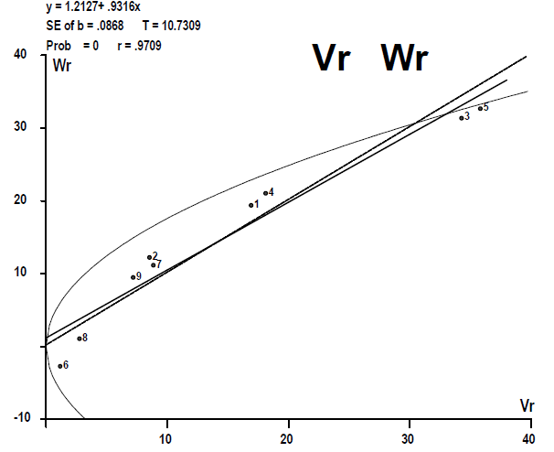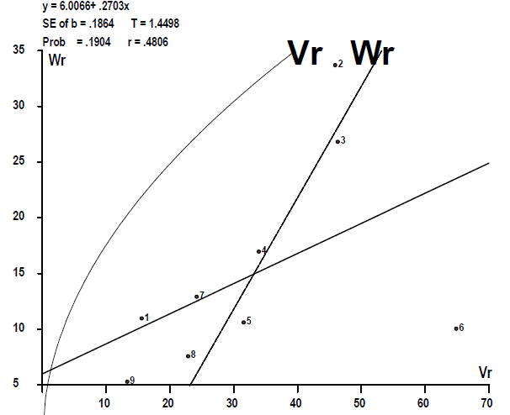
(a) (b)
Fig. 1: Wr-Vr graph for days to first pistillate flower in F₁ (a) and F₂ (b) generations
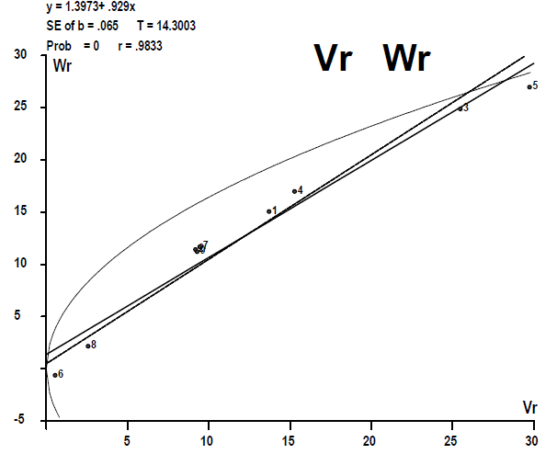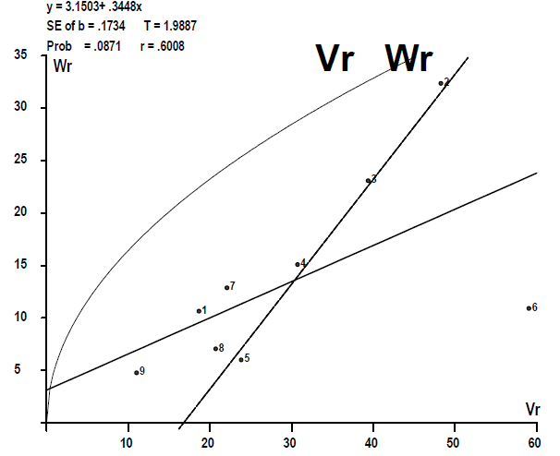
(a) (b)
Fig. 2: Wr-Vr graph for days to first staminate flower in F₁ (a) and F₂ (b) generations
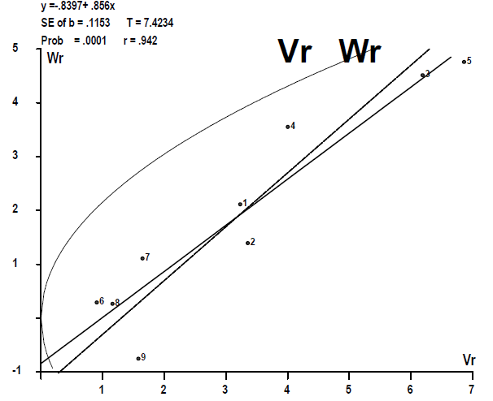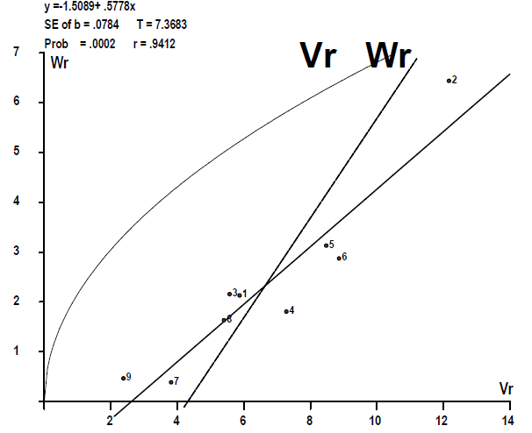
(a) (b)
Fig. 3: Wr-Vr graph for node number upto first pistillate flower in F₁ (a) and F₂ (b) generations
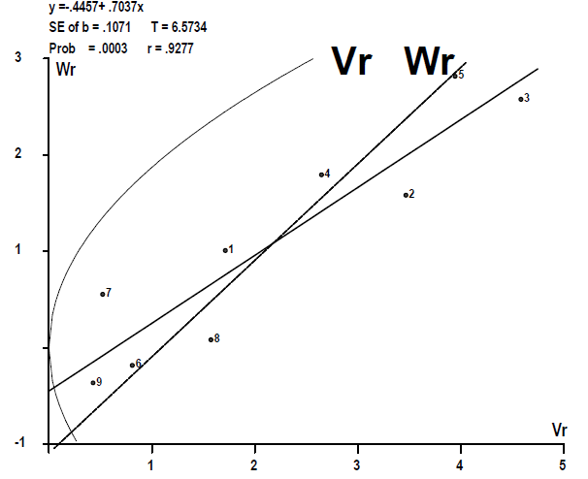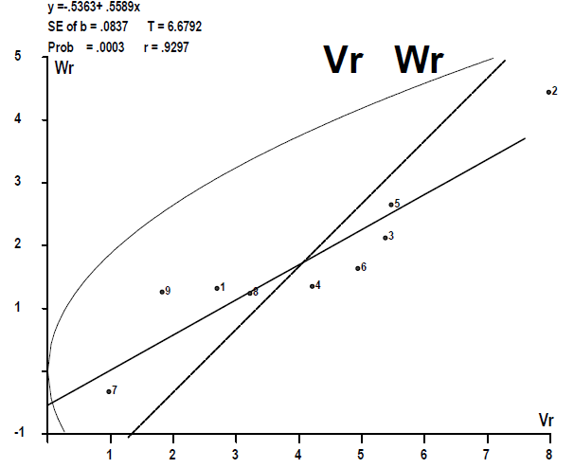
(a) (b)
Fig. 4: Wr-Vr graph for node number upto first staminate flower in F₁ (a) and F₂ (b) generations
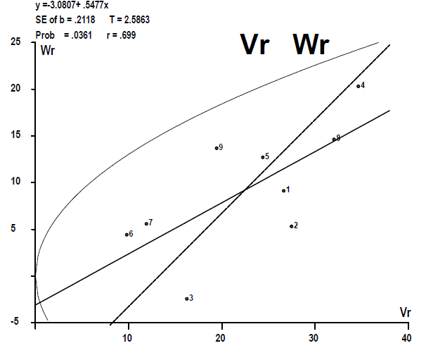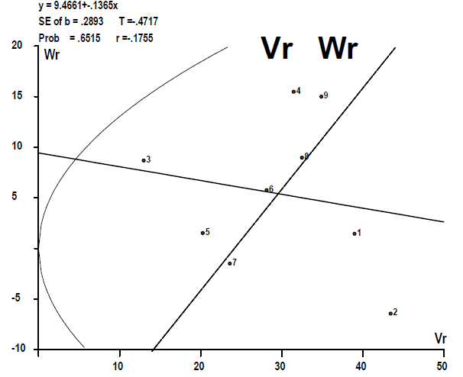
(a) (b)
Fig. 5: Wr-Vr graph for number of nodes on main vine in F₁ (a) and F₂ (b) generations
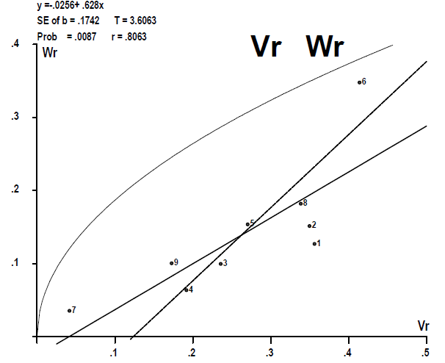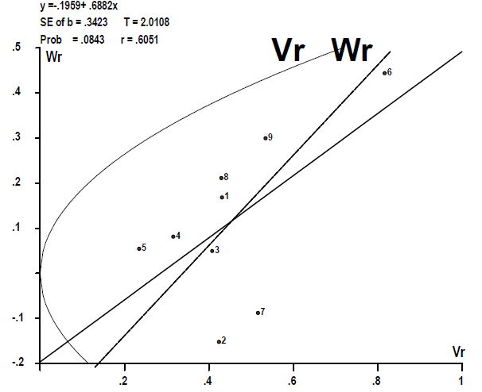
(a) (b)
Fig. 6: Wr-Vr graph for vine length (m) in F₁ (a) and F₂ (b) generations
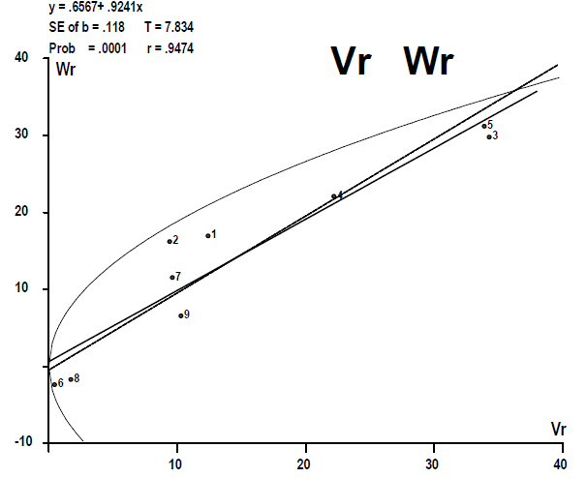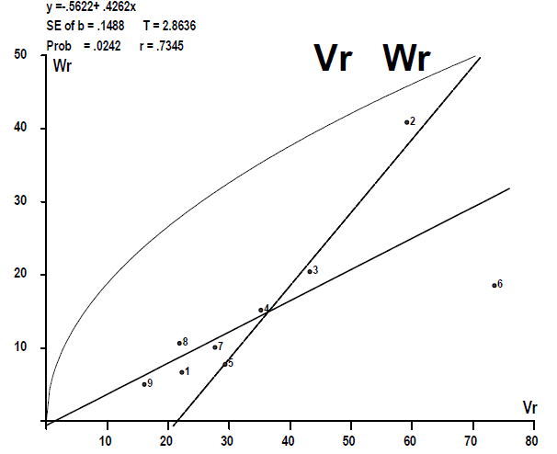
(a) (b)
Fig. 7: Wr-Vr graph for days to first fruit picking in F₁ (a) and F₂ (b) generations
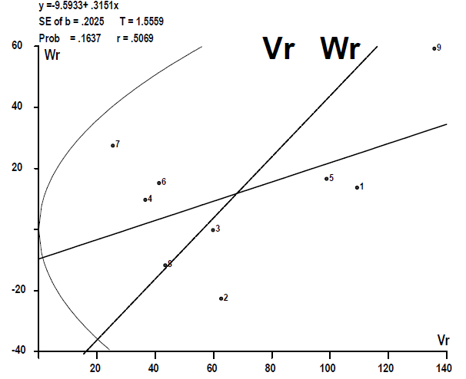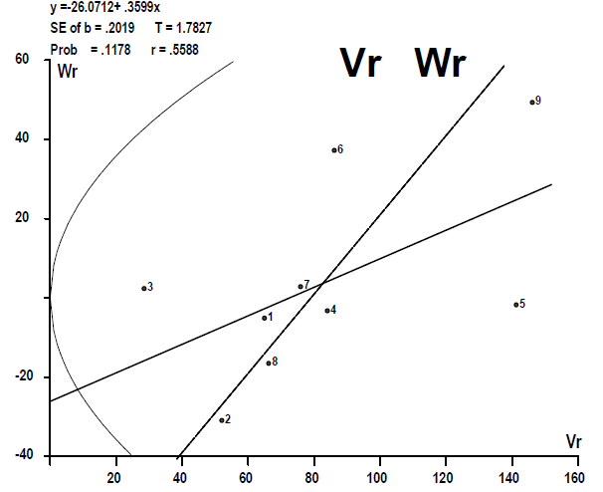
(a) (b)
Fig. 8: Wr-Vr graph for days to last fruit picking in F₁ (a) and F₂ (b) generations
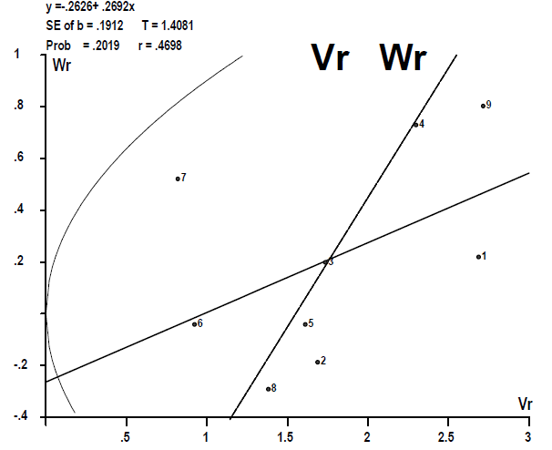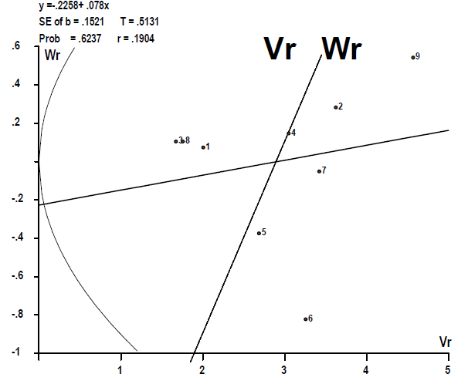
(a) (b)
Fig. 9: Wr-Vr graph for number of picking in F₁ (a) and F₂ (b) generations

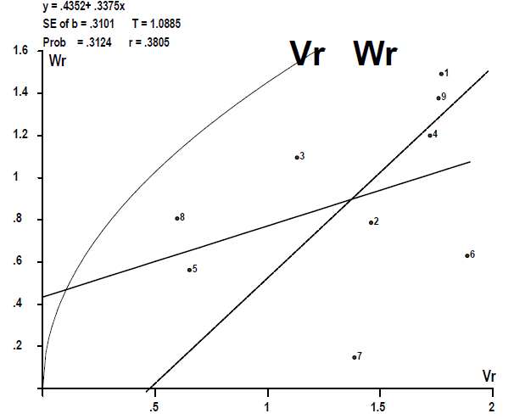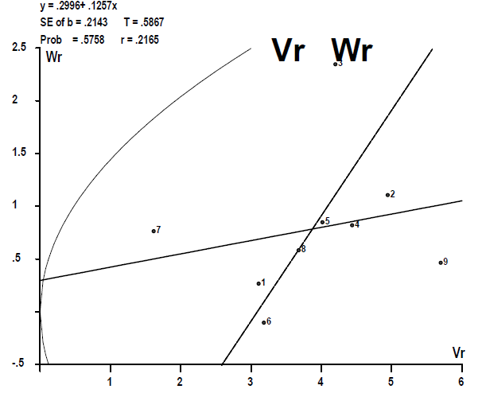
(a) (b)
Fig. 10: Wr-Vr graph for number of fruits per plant in F₁ (a) and F₂ (b) generations
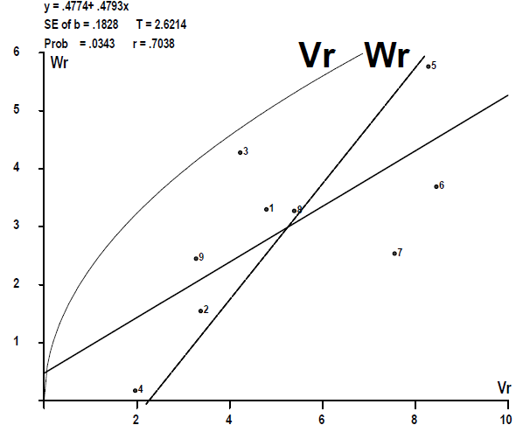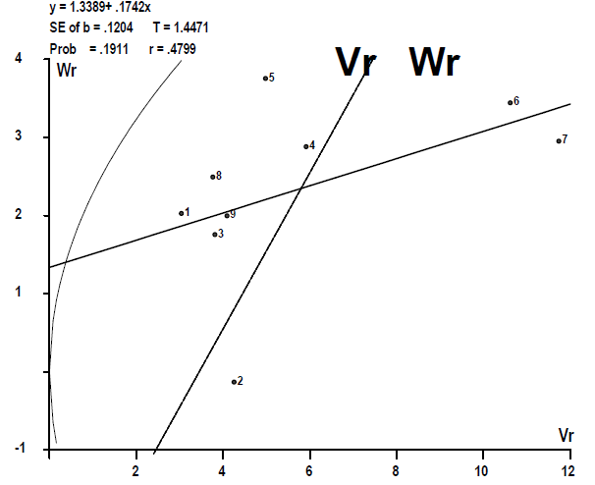
(a) (b)
Fig. 11: Wr-Vr graph for fruit length (cm) in F₁ (a) and F₂ (b) generations
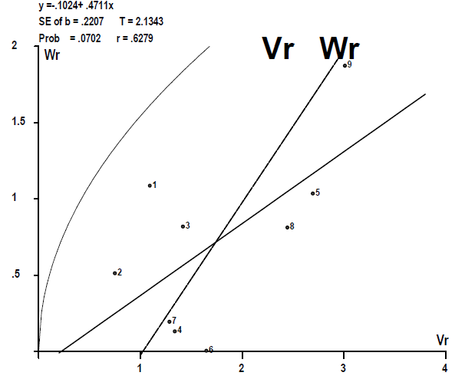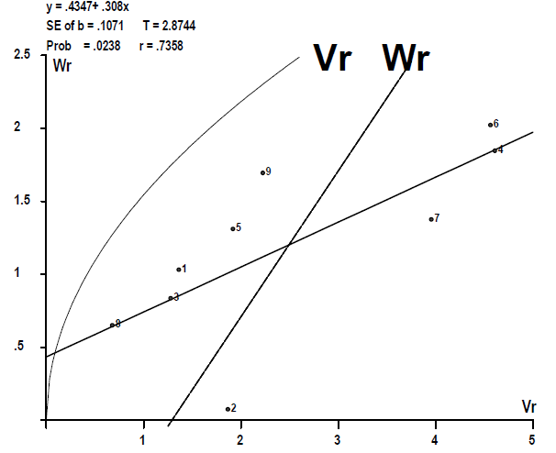
(a) (b)
Fig. 12: Wr-Vr graph for fruit girth (cm) in F₁ (a) and F₂ (b) generations
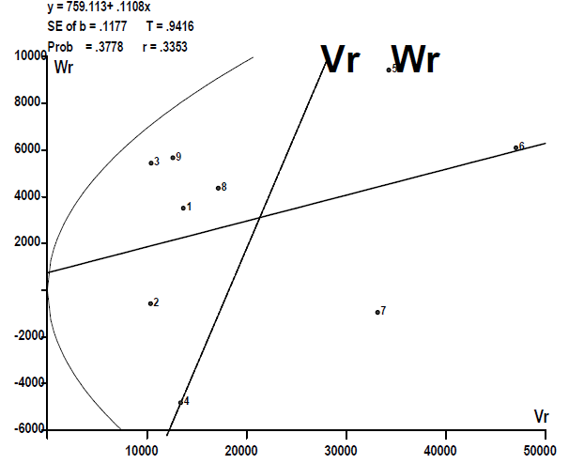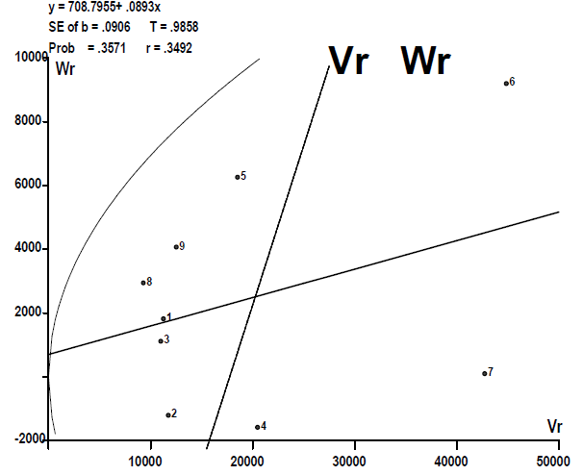
(a) (b)
Fig. 13: Wr-Vr graph for average fruit weight (g) in F₁ (a) and F₂ (b) generations
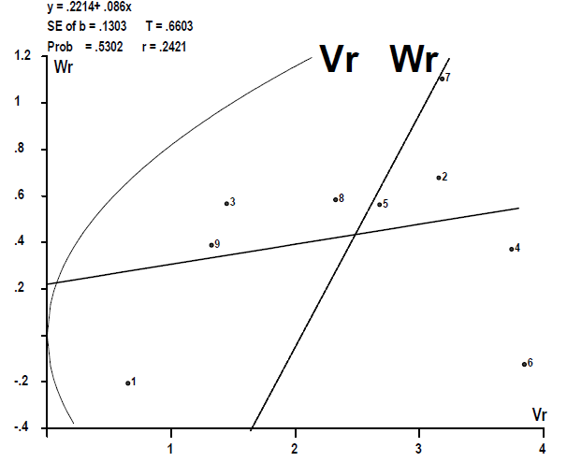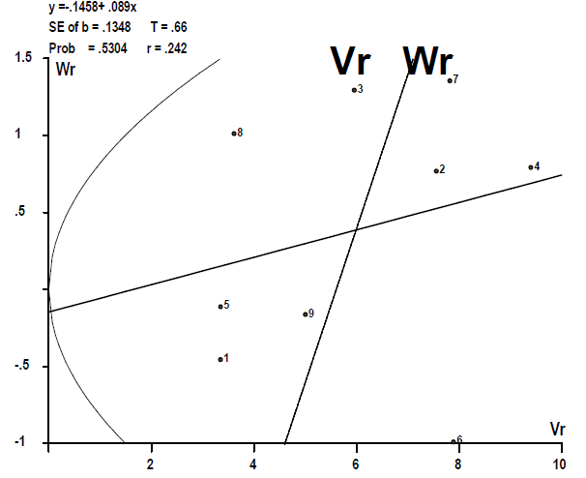
(a) (b)
Fig. 14: Wr-Vr graph for fruit yield (kg/plant) in F₁ (a) and F₂ (b) generations
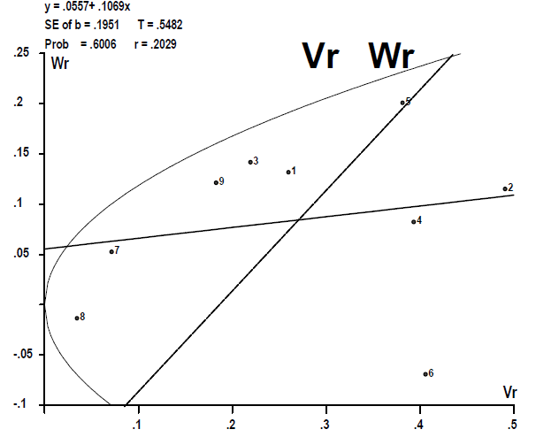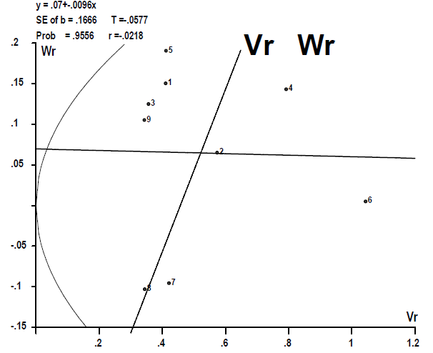
(a) (b)
Fig. 15: Wr-Vr graph for total soluble solids (˚Brix) in F₁ (a) and F₂ (b) generations

