Standardization of media for seed germination and seedling growth of Garcinia indica, an Endemic and Threatened plant of Western Ghats, India
ABSTRACT
Garcinia indica (Thouars) Choisy commonly known as Kokum, is an endemic and vulnerable species of Western Ghats, India. Population of this species is rapidly declining in the wild due to habitat loss and overexploitation of the species for its significant culinary, pharmaceutical and industrial values. The objective of this study was to examine the effects of various media and environmental conditions on the seed germination and seedling growth of G. indica. The study hypothesized that certain media compositions and environmental conditions would promote better seed germination, seedling survival and growth, additionally the seed scarification potentially enhance the seed germination rates. The study demonstrated the effect of natural and polyhouse conditions on seed germination and seedlings growth. The study revealed that the maximum seed germination percentage in cocopeat (81% for non-coated seeds and 61% for coated seeds) followed by soil + cocopeat (64% for non-coated seeds and 57% for coated seeds) and minimum in soil + horn dust (10% for coated or non-coated seeds). The growth in natural environmental condition is better as compared to polyhouse condition with average shoot height of 10.25 cm and average leaf count 7 in sand + cocopeat media. The present study concludes that cocopeat is best medium for seed germination, growth and scarification is effective for increasing the rate of seed germination and seedling vigor.
Keywords: Botanic garden; endemic; Kokum; media composition; seed germination, threatened; Western Ghats.

1. INTRODUCTION
Garcinia indica (Thouars) Choisy, commonly known as Kokum is an endemic species of Western Ghats, India belonging to family Clusiaceae (Guttiferae) and an evergreen, perennial, monopodially branched fruit-bearing tree that has significant culinary, pharmaceutical, and industrial uses (Hemshekhar et al., 2011). The genus epithet Garcinia is derived from Garcias who described it in 1574 (Parasharami et al., 2015). The most widely used part of this plant is the fruit and the fruit rind known as kokum (Pruthi, 1976). It requires a warm and humid tropical climate and commonly found in Karnataka, Goa, Konkan belt of Maharashtra, and the coastal and evergreen forests of northern Kerala (Priya Devi et al., 2013) and thrives well in areas with over 250 cm rainfall. It grows well in lateritic, alluvial soils having depth of 1.0 m and pH of 6.7 (Braganza et al., 2012). This plant produces flowers from November to January, followed by fruiting from December to March (Fig. 1). It is commonly cultivated for its fruit. The National Medicinal Plant Board, India, has identified 'Kokum' as one of the 32 prioritized species of plants for promotion and development (Braganza et al., 2012). G. indica exhibits various pharmacological properties, including anti-oxidant, anti-obesity, anti-arthritis, anti-inflammatory, antibacterial, hepatoprotective, cardioprotective, antidepressant, and anti-anxiety effects (Lim et al., 2021). Traditionally, Garcinia fruits have been used in Ayurvedic medicine to treat ailments such as allergic rashes, burns, chafed skin, and scalds; to manage bleeding piles, tumors, and heart conditions; and as a tonic for heart and liver health (Braganza et al., 2012). Apart from its medicinal properties various parts of the plant are used in food preparation especially the fruits and leaves (Rao, 1914). Because of its significant economic value, its population is declining fast in the wild. The population of this species is rapidly declining due to habitat loss and overharvesting of its fruits and seeds. Despite its economic importance, its population density is gradually reducing in the wild, leaving only a few trees per locality. Apart from this natural seedling regeneration is also hindered by various environmental and physiological factors (Ved et al., 2015). It is abundant almost throughout Goa. In Maharashtra, it is common along the entire coastal forest and Western Ghats. In Karnataka it occurs along the windward side of Western Ghats in Dakshina Kannada, Coorg, Chickamagalur, Shimoga and Uttara Kannada districts. In Tamil Nadu, it is absent in the wild but planted in Nilgiris. It occurs along the coastal and evergreen forests of northern Kerala. The major threat to this plant is habitat destruction in terms of agricultural invasion and road construction (Ved et al., 2015) and unsustainable collection of fruits and seeds for medicinal purposes. Irrespective of various importances, many species of Garcinia are threatened due to habitat destruction. Studies reported that seed germination fails due to various physiological and environmental factors, making the natural propagation and conservation of this species nearly impossible (Mohan et al., 2012).
The species is categorized as Vulnerable (A2cd) as per IUCN Red List criteria (Ved et al. 2015) due to over exploitation and rapid decline of the natural population. Therefore, the conservation of its genetic diversity is imperative (Srivastava et al., 2024). Considering the threat and challenges associated with the natural seed germination of this species in the wild, an experimental setup was designed to standardize the propagation media for better seed germination and seedling growth of Kokum at Acharya Jagadish Chandra Bose Indian Botanic Garden (AJCBIBG), Howrah, West Bengal, which not only serves as a centre for conservation of plant resources but also functions as a living repository of native and selected exotic species, providing a “safe abode” for rare and endemic plants (Hameed et al., 2016). This study aimed to identify the most effective media for seed germination and seedling growth, facilitating the species conservation through rapid multiplication and reintroduction into its natural habitat.
2. MATERIALS AND METHODS
2.1 Sample collection
Under the Assistance to Botanic Garden Scheme (ABG Scheme) of Ministry of Environment, Forest and Climate Change (MoEF&CC), Govt. of India, the seeds of G. indica were collected from the Konkan region of Western Ghats mainly from Amboli Ghat and Sindhudurg district of Maharashtra.

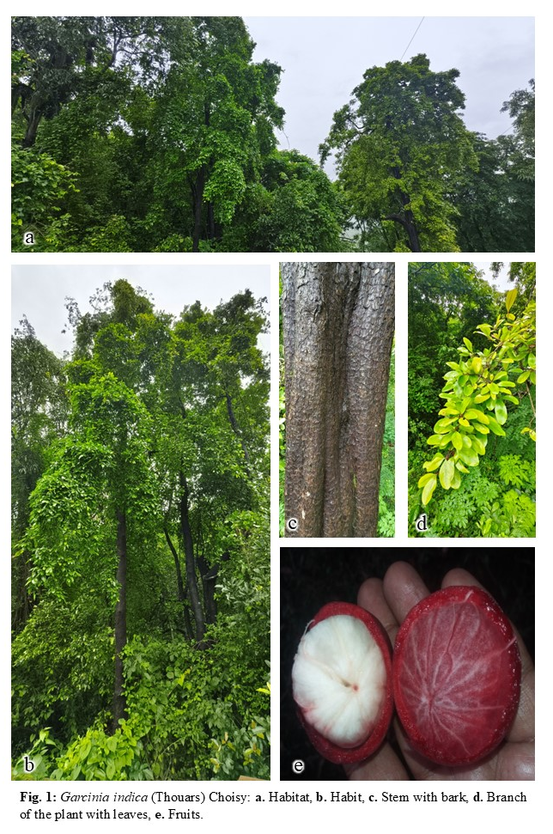
2.2 Experiment site
The experiment to standardize the media for seed germination and seedling growth of G. indica was carried out at AJCBIBG, both in the polyhouse (Fig. 2) of nursery number 1 and under open conditions (Fig. 3) following a Complete Randomized Design (CRD) model.
2.3 Preparation of media compositions
After collection, the seeds were soaked for 6 hr in water for three days continuously so that the seeds get imbibed properly. Twenty three (23) different media compositions were prepared namely, (1) soil (control), (2) cocopeat, (3) vermicompost, (4) leaf litter, (5) leaf litter + bone dust (1:1 volume), (6) leaf litter + horn dust (1:1 volume), (7) cow dung, (8) red soil, (9) sand, (10) mixture of soil, cocopeat, vermicompost, leaf litter, bone dust, horn dust, cow dung, red soil and sand (1:1:1:1:1:1:1:1:1 by volume), (11) perlite, and (12) vermiculite, labelled as S series (S1-S12); (13) soil + cocopeat (1:1), (14) soil + vermicompost (1:1), (15) soil + leaf litter(1:1), (16) soil + bone dust (1:1), (17) soil + horn dust (1:1), (18) soil + cow dung (1:1), (19) soil + red soil (1:1), (20) soil + sand (1:1), (21) mixture of cocopeat, vermicompost, leaf litter, bone dust, horn dust, cow dung, red soil and sand in 1:1:1:1:1:1:1:1 by volume, (22) soil + perlite (1:1) and (23) soil + vermiculite (1:1) were labelled as Z series (Z1-Z11). Each tray was labelled with its corresponding media composition. Finally, seeds (70 seeds per tray) were sown directly in two sets viz. coated (C) and non-coated (NC) seeds (Table 1) on 29th July 2024 (Fig. 2).
2.4 Data collection
Following seed sowing, data on seed germination and seedling growth were recorded every 7 days for 3 consecutive months. Observations made by counting plumules, measuring seedling length upon significant growth, and recording the number of leaves (Fig. 2). The collected data were further analyzed to determine the most effective medium among the 23 different compositions of media. The optimal media identified was then combined with sand in 50:50 ratio and tested under natural environment conditions for seedlings growth.
Table 1. Different media compositions for coated and non-coated seeds.
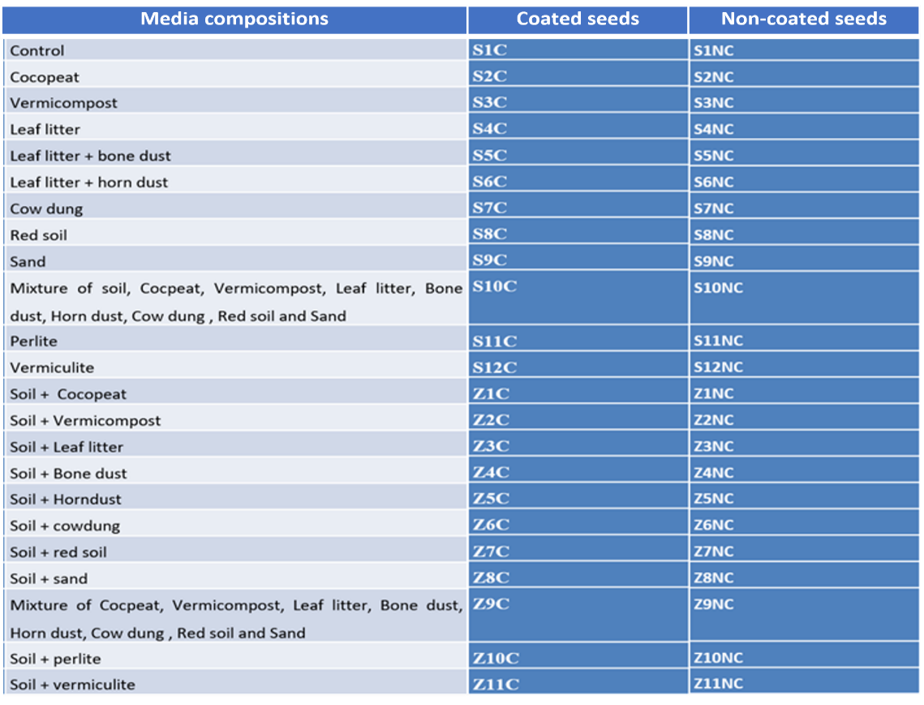

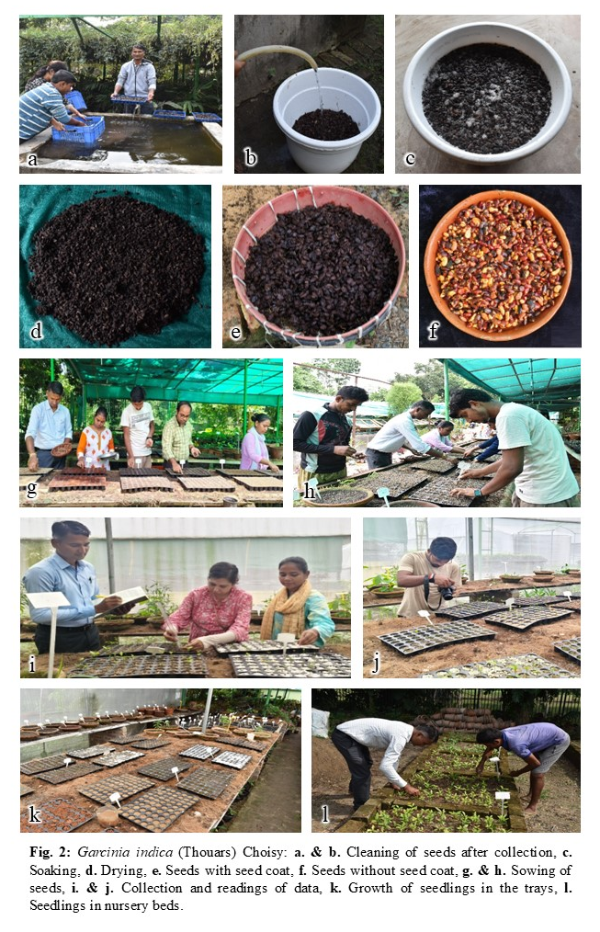
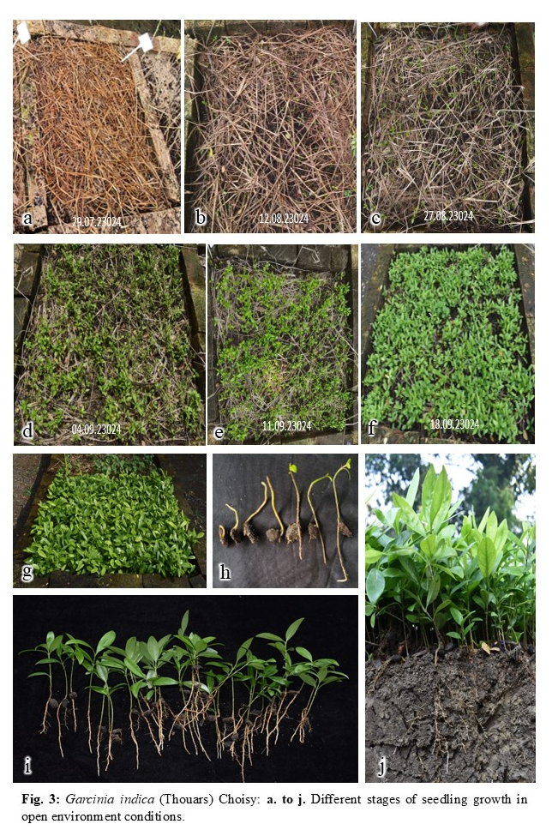
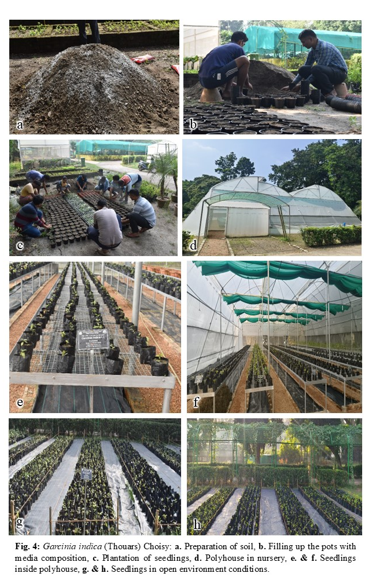
3. RESULTS AND DISCUSSION
The results revealed that out of the 23 media, the maximum seed germination percentage was observed in cocopeat (81% for non-coated seeds and 61% for coated seeds) followed by soil + cocopeat (64% for non-coated seeds and 57% for coated seeds) and minimum in soil + horn dust (10% for both coated and non-coated seeds) (Fig. 5). The maximum average shoot height was recorded 4.61cm (non-coated seeds) and 5.02 cm (coated seeds) in vermiculite under polyhouse condition (Fig. 6). The maximum average leaf count observed was 7 (in soil + cocopeat) for coated seeds and 6 (in cow dung) for non-coated seed (Fig. 7). Further, it was observed that the seedling growth in natural environmental condition is better as compared to polyhouse condition with average shoot height of 10.25 cm and average leaf count 7 (Fig. 3). Soaking of kokum seeds in 50 ppm GA solution for 24 hours significantly increases germination percentage up to 96% at 90 days after soaking. (Pawar et al., 2018). Studies on Andaman Kokum (Garcinia dhanikhariensis S.K. Srivastava) revealed that removal of seed coat significantly enhanced the seed germination with a success rate of 95.9% (Horo et al., 2022). Present study revealed that without using any plant growth regulators, the maximum germination observed was 81% for non-coated seeds and 61% for coated seeds. This propagation technique will helpful to local farmers to propagate kokum without using any plant growth regulators.
When the kokum seedlings achieved proper growth, the seedlings were transplanted into polybags for further growth and seedling establishment. The potting media was prepared using soil treated with fungicide Bavistin and supplemented with nutrient rich farmyard manure, vermicompost and cocopeat to improve water retention and aeration. After potting, the polybags were kept in an open environment for one month to allow proper seedling establishment before being moved to a polyhouse for better care and growth (Fig. 4).
The fully established kokum seedlings were distributed to various botanic gardens and delegates attending the International Symposium on Plant Taxonomy, Ethnobotany, Botanic Gardens and Biodiversity Conservation held on 13-15 February, 2025 at Kolkata, India to promote conservation, research and awareness.
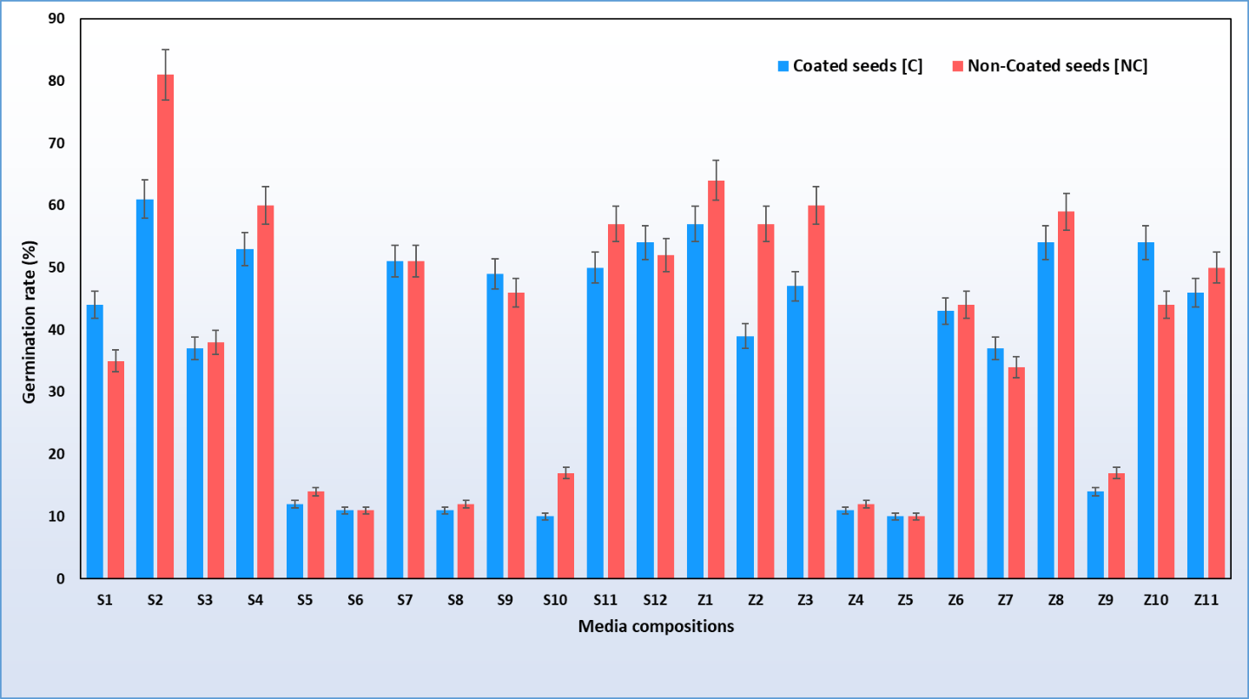
Fig. 5. Seed germination rates (in %) in coated (C) and non-coated (NC) seeds among 23 media compositions (S1 to S12 & Z1 to Z11)
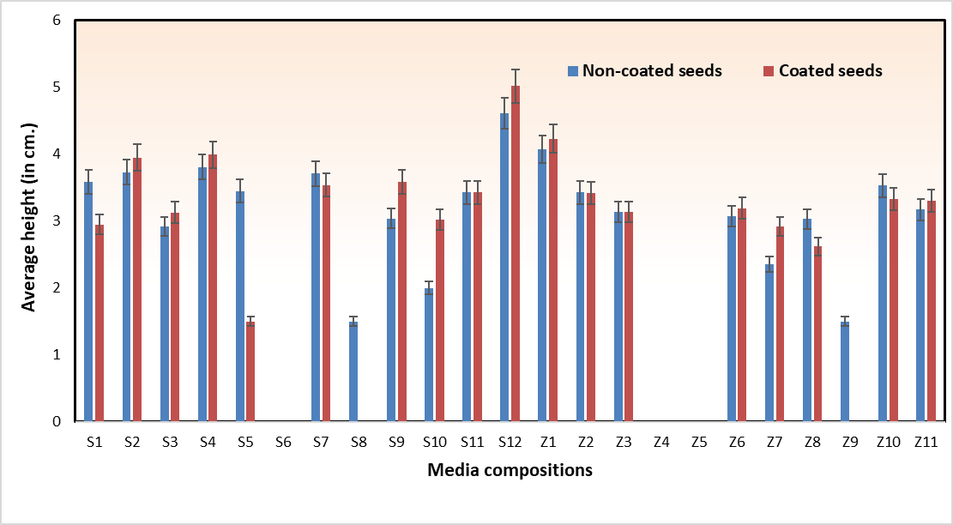

Fig. 6. Average shoot height (in cm.) in coated (C) and non-coated (NC) seeds among 23 media compositions (S1 to S12 & Z1 to Z11)

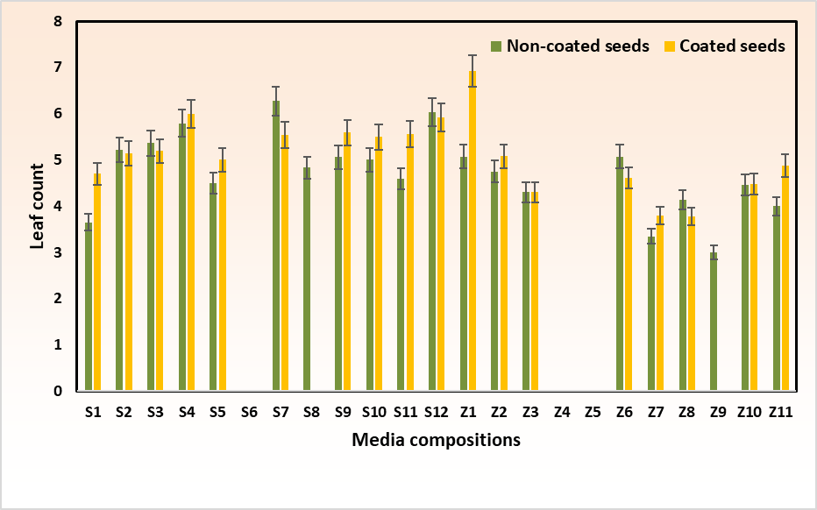

Fig. 7. Average leaf count in coated (C) and non-coated (NC) seeds among 23 media compositions (S1 to S12 & Z1 to Z11)

4. CONCLUSION
The present study concludes that cocopeat is the most effective medium for seed germination, while vermiculite is optimal for seedling growth. Additionally, scarification significantly enhances seed germination rate and seedling vigor. The findings also indicate that growth of Garcinia indica seedlings is optimum under natural conditions using sand + cocopeat medium as compared to polyhouse conditions.
DISCLAIMER (ARTIFICIAL INTELLIGENCE)
Author(s) hereby declare that no generative AI technologies such as ChatGPT, COPILOT, etc. have been used during writing or editing of this manuscript.
REFERENCES
Braganza, M., Shirodkar, A., Bhat, D. J & Krishnan, S. (Eds.). (2012). Resource book on Kokum. Western Ghats Kokum Foundation, Panaji- Goa, India.
Hameed, S. S., Sharief, M. U., Sreekumar, P. V., Mahapatra, H. S., & Pramanik, A. (2016). A preliminary survey of the herbaceous flora of the Acharya Jagadish Chandra Bose Indian Botanic Garden (AJCBIBG), Howrah, WB, India. Annals of Plant Sciences, 5 (5), 1335-1343. DOI:10.21746/aps.2016.05.002
Hemshekhar, M., Sunitha, K., Santhosh, M.S., Devaraja, S., Kemparaju, K., Vishwanath, B.S., Niranjana, S.R., & Girish, K.S. (2011). An Overview on Genus Garcinia: Phytochemical and Therapeutical Aspects. Phytochemistry Reviews, 10(3), 325–351. DOI:10.1007/s11101-011-9207-3
Horo, S., Ranjani, R., Waman, A.A., Jha, S.K., & Bohra, P. (2022). Seed Germination Studies in Andaman Kokum (Garcinia dhanikhariensis S.K. Srivastava): An Endemic Species from Bay Islands, India. Journal of the Andaman Science Association, 27 (Special issue), 95-103.
Lim, S. H., Lee, H. S., Lee, C. H., & Choi, C. I. (2021). Pharmacological activity of Garcinia indica (Kokum): An updated review. Pharmaceuticals, 14(12), 1338. https://doi.org/ 10.3390/ph14121338
Mohan, S., Parthasarathy, U., & Babu, K. N. (2012). In vitro and in vivo adventitious bud differentiation from mature seeds of three Garcinia spp. Indian Journal of Natural Products and Resources, 3(1), 65-72.
Parasharami, V. A., Kunder, G. G., & Desai, N. (2015). Recent pharmacological advances of endangered species of south India: Garcinia indica Choisy. Journal of Scientific Research & Reports, 8(5): 1-10, 2015. DOI: 10.9734/JSRR/2015/14550
Pawar, R.M., Agare, H.R., Golvankar, G.M.& Thorat, S.B. (2018). Effect of soaking of seeds in bioregulators on germination of Kokum seeds. International Journal of Chemical Studies, 6(5), 2588-2591.
Priya Devi, S., Thangam, M., Ramachandrudu, K., Ashok Kumar, J. & Singh, N.P. (2013). Genetic diversity of Kokum (Garcinia indica) in Goa-Tree and fruit characters. Technical Bulletin 33. ICAR Research Complex for Goa (Indian Council of Agricultural Research) Old Goa, Goa, India.
Pruthi, J.S. (1976). Spices and Condiments. National Book Trust, India A-5 Green Park, New Delhi.
Rao, M. R. (1914). Flowering plants of Travancore. International Book Distributors, Dehradun, Uttarkhand.
Srivastava, V., Panis, B., & Agrawal, A. (2024). Droplet vitrification: A lifeline for long-term conservation of threatened species Garcinia indica. In Vitro Cellular & Developmental Biology-Plant, 60(3), 318-332.
Ved, D., Saha, D., Ravikumar, K. & Haridasan, K. (2015). Garcinia indica. The IUCN Red List of Threatened Species. e.T50126592A50131340. https://dx.doi.org/10.2305/IUCN.UK.2015-2.RLTS.T50126592A50131340.en. Accessed on 22 February 2025.

