Evaluation of the acceptability of a local African doughnut-type pastry (mikaté) prepared from a mixture of wheat flour and dessert banana powder

Abstract
African doughnut-type pastries come in many varieties, the most popular in the Congo being banana doughnuts, known vernacularly as mikaté. These are made from a leavened dough obtained from a mixture of ingredients composed mainly of wheat flour and very ripe dessert bananas in the process of degradation. The aim of this study was to produce a powdered dessert banana (Musa accuminata) of the gros Michel variety at ripening stages 2, 3, 4 and 6, to be used to make fritters according to the traditional recipe. The methodology adopted was used to produce the powder, which was characterized. On the other hand, the mixing plan generated known proportions of major ingredients, and enabled the formulation of five composite flours; these were used in the preparation of the doughnuts that were the subject of the sensory evaluation. Results for the banana powder revealed a water content of 7.83% ; an ash content of 3.88% ; a sucrose content of 6.91°Bx ; a glucose content of 6.87°Bx ; and a pH of 4.28. The hedonic test revealed that doughnuts made with 65% wheat flour and 35 % banana powder were best appreciated by 35 % of tasters. The latter products were used to carry out a triangular test to compare the products obtained from the revisited recipe with those from the usual recipe. The results of the one-tailed binomial test indicated a significant difference at a 99.9 % threshold, with 73 % choosing to consume the doughnuts from the usual recipe versus 27 % for the revisited recipe.
Keywords : Ripe banana, African fritter, sensory evaluation, wheat flour

- Introduction
Patisserie is the whole range of operations involved in the preparation of baked or deep-fried pastry-based dishes. These dishes, such as cakes, tarts, cookies and doughnuts, are eaten either as a dessert at the end of a meal, or as a snack or tea (Anonymous 1, 2024). The doughnut, in particular, is a pastry made from flour, water, eggs, oil, sugar and milk (Hatae et al., 2003 ; Adanse John et al., 2021), round in shape, and fried (Adanse John et al., 2021) in fat or oil. It is one of the fermented and fried snacks well known throughout the world (Hatae et al. 2003 ; Rehman et al. 2007 ; M. Sarraf, A.M. Sani And M.M.S. Atash, 2016), but named differently in different countries. In Africa, the term « beignet » has a more specific meaning in relation to its preparation process, and bears similarities to the French beignet in terms of shape, for example, but not in terms of technique. As a result, it is more accurately referred to as an « African doughnut » (Anonymous 2, 2024), and in Congo-Brazzaville is known as a mikaté. The latter is a product made using traditional technology, mostly by women, and is consumed daily, all day long and on all occasions.
Mikatés are basically street products, as they are specially prepared and sold in public places. They are very often made in two ways : plain, essentially formulated from wheat flour, water, sourdough and sugar; or with ripe dessert banana incorporated into the simple dough. These doughnuts are hugely popular thanks to their ready-to-eat nature, relatively accessible cost and high level of satisfaction.
The dessert banana (Musa acuminata) is a fruit derived from the inflorescence of the banana tree. When ripe, it can be eaten straight away, and is much appreciated for its many uses and pleasant taste. It is one of the most affordable products for human consumption, contributing to good health thanks to its immense nutritional and medicinal value (Diawara, 2022), providing sufficient carbohydrates and assimilable fiber, lipids and proteins in small quantities, but rich in minerals such as potassium and magnesium, as well as vitamin C (Aurore et al., 2009). Indeed, banana cultivation (dessert and plantain), mainly in tropical and subtropical regions (Ayo-Omogie and Odekunle, 2019) occupies, on the one hand, the third largest tropical fruit crop in tonnages (Moïse Kwa and Ludovic Temple, 2019 : FAO, 2010), and on the other hand, the 4th most important food commodity worldwide after rice, wheat and milk (Lin-Feng and Xue-Jun, 2017). According to Bakry et al (1997), there is a diversity of bananas depending on the type of cultivar : Cavendish, Figue sucrée, Gros Michel, etc... Moreover, banana ripening is characterized by the breakdown of starch into the soluble sugars sucrose, glucose and fructose, whose ratio to organic acids impacts flavor, the synthesis of volatile compounds responsible for the fruit's aroma, and wall modifications contributing to the loss of fruit firmness (Happi Emaga et al., 2008). To this end, Von Loesecke (1950) classified the ripening of these fruits into eight stages based on skin color. Seven (7) stages of banana ripening are thus generally distinguished in the trade (Li et al., 1997), where stage 7 is characterized by a very ripe fruit with a tiger yellow color and a very soft texture.
Bananas are also processed in many different ways for industrial production. The pulp is used to make flour, powder, sugar, chips and jam (Bonnet-Bruno, 2012). Banana powder is obtained by grinding ripe fruit. Some factories have been set up in banana-producing countries to recover non-exportable fruit and turn it into powder (Kasongo, 2005).
However, in Congo-Brazzaville, it has been observed that bananas at a very advanced stage of ripening or ripening (or even in the process of degradation) are used as raw material in the preparation of doughnut dough. The quality of a food product depends on the quality of the raw material used, and is based on its nutritional, organoleptic, health and environmental components, etc. (Florence Dubois-Brissonnet, Laurent Guillier, 2020). Organoleptic and sanitary qualities can be affected by the presence of microorganism activity. This is because most food products are not sterile, and are likely to support the growth of microorganisms (Florence Dubois-Brissonnet, Laurent Guillier, 2020). As a result, the food becomes unfit for consumption and the safety of the product is no longer guaranteed, which can have consequences in terms of public health, with the potential outbreak of food poisoning of microbiological origin (Masson, 2020). Based on this fact, the aim of this work is to revisit the recipe for banana doughnuts by first producing a powder with dessert bananas at a less advanced stage of ripening to be incorporated into the doughnut batter recipe, and then carrying out a sensory evaluation.
- Materials and methods
2.1. Biological materials
The biological material used in this study is essentially of plant origin (Fig.1). These were dessert banana (Musa acuminata) fingers at maturity stages 2, 3, 4 and 6 of the gros Michel variety. These were purchased from the market at Brazzaville's main railway station, located in the city center, third arrondissement of Poto-poto. The bananas come from one of the country's southern departments, Bouenza. The bananas were taken to the laboratory for processing.
Apart from bananas, our main raw material, we also used other types of plant material purchased from Total's local market in the Bacongo district of south-west Brazzaville as raw materials and baking ingredients. These include wheat flour type 55, Saccharomyces cerevisiae baker's yeast, white crystal sugar, cooking salt, mineral water and vegetable oil for frying.
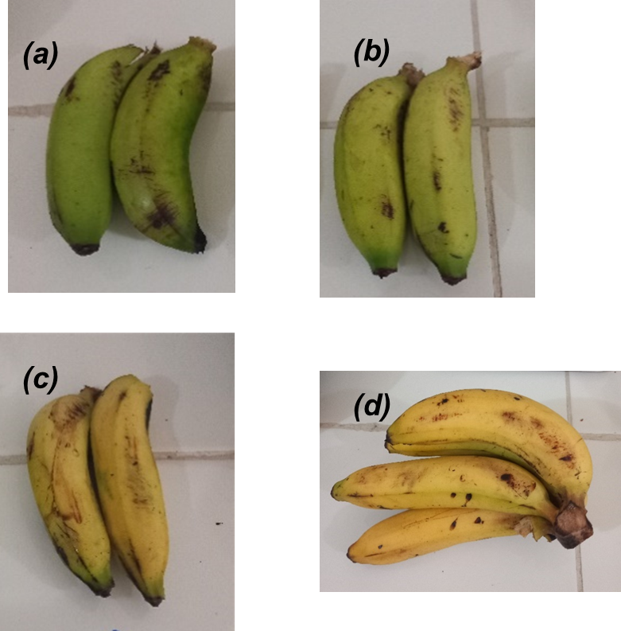
Fig 1. Dessert bananas of the gros Michel variety at maturity stages (a) 2, (b) 3, (c) 4 and (d) 6.
2.2. Laboratory materials/equipment
Small laboratory materials were used, including a RADWAG PS 3500.R2. M [0-3500 g], a BAUMER thermometer [0-250°C], a stopwatch, a SMURFETT electric kettle, a MOULINEX electric blender or grinder, a BIOBASE oven [0-300°C], a Yücel gas stove, model F5C40G2-WH, a RIOU thermowelder and a plastic tablecloth, a traditional stainless steel fryer, and a 250 μm mesh sieve.
2.3. Preparation of dessert banana powders
Dessert banana powders were obtained from several unit operations, firstly using ripe bananas at stage 6, then using a combination of ripe bananas 2, 3 and 4.
The fresh bananas were first sorted after receipt, to separate them from damaged fruit. They were then washed in clean water, wiped with absorbent paper, weighed on a scale and peeled by hand to separate the peel from the pulp. Stage 2, 3 and 4 banana pulps were then blanched at 70°C for 5 minutes to prevent enzymatic browning, before being pureed using an electric grinder. The resulting paste was spread out on greaseproof paper in stainless steel trays before being oven-dried at 70°C for 4 days. Once the purée had dried, it was ground using an electric grinder, sieved using a 250 μm sieve and then stored in a plastic bag.
Finally, after peeling, banana pulp at stage 6 was cut into fine slices using a stainless steel knife, then dried in an oven at 70°C for 3 days. The resulting ripe banana pods were ground using an electric grinder.
2.4. Preparation of wheat-dessert banana composite powders and doughnuts
The composite flour formulation trials were carried out in the agri-food technology laboratory of the National Institute for Research in Engineering Sciences, Innovation and Technology
(INRSIIT), and the doughnut preparation in a kitchen set up on the INRSIIT site, located in the heart of Brazzaville's Scientific City.
The composite flour was prepared by mixing the proportions of the 2 flours, wheat and banana, in accordance with the application of a mixing plan as presented in Table 1.
For this purpose, we used Minitab software, version 2017, to apply a two-factor (K=2) constrained centered mixing design with a degree 2 model (m=2), no process variables and five (05) design points for a total of 750 g of flour. The components involved are the proportions of the different flours, which represent the factors.
For the data on composite flour, the limits expressed in quantities and proportions are the same, as the total mix is equal to 750 g. Thus, the proportions :
- wheat flour between 450 and 600 g ;
- banana flour between 150 and 300 g.
The flours were packaged in plastic containers until the products were prepared and analyzed.
The doughnut samples were produced according to the traditional recipe used by women doughnut producers (diagram in fig 2).

Table 1. Different composite flour formulations for doughnut preparation
 | Types of doughnut
Ingredients | B₁₁ | B₂₅ | B₃₄ | B₄₂ | B₅₃
Wheat flour (g) | 600 | 487,5 | 562,5 | 450 | 525
Banana powder (g) | 150 | 262,5 | 187,5 | 300 | 225
Water (mL) | 600 | 600 | 600 | 600 | 600
Crystal white sugar (g) | 100 | 100 | 100 | 100 | 100
Table salt (g) | 2,5 | 2,5 | 2,5 | 2,5 | 2,5
Baker's yeast (g) | 10 | 10 | 10 | 10 | 10
Legend: B11 : formulation 1 (80 % wheat/ 20 % banana) ; B42 : formulation 2 (60 % wheat/ 40 % banana) ; B53 : formulation 3 (70 % wheat/ 30 % banana) ; B34 : formulation 4 (75 % wheat/ 25 % banana) ; B25 : formulation 5 (65 % wheat/ 35 % banana).
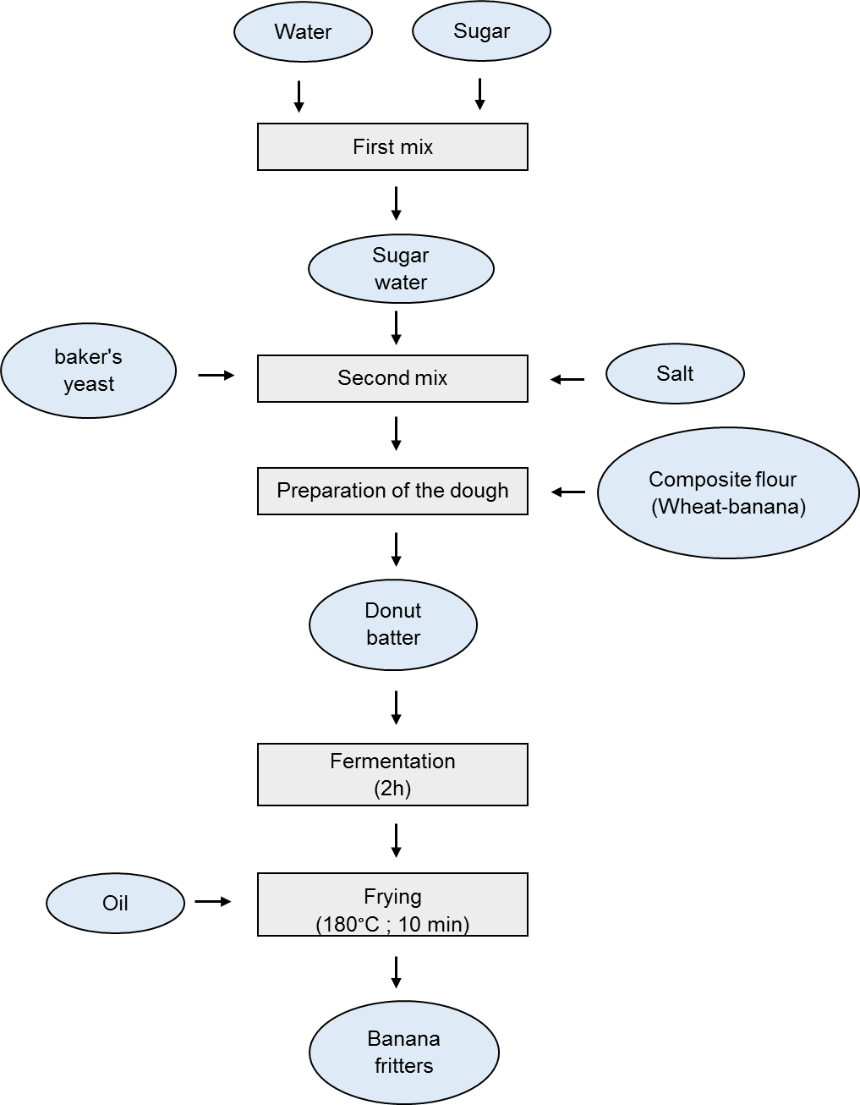
Fig 2. Diagram of the preparation of an African-style doughnut (mikaté)
In a clean bowl, the first step is to pour water into which the sugar is dissolved. The result is a sugar solution, into which salt and baker's yeast were first added. Once all the first ingredients had dissolved, the Wheat-Banana composite flour was gradually incorporated and mixed vigorously to obtain a more or less firm dough with no lumps. After appropriate mixing and kneading, the dough formed was carefully stored for 2 hours in a warm environment before rising (alcoholic fermentation). The dough was then fried in a vegetable oil bath at a temperature of 180°C, in the form of hand-made berlin balls, to produce doughnuts. During frying, the oil bath changes from 180°C to 140°C, stabilizing at this temperature. After 10 min of frying, the operation is stopped and the doughnuts are removed and drained for 10 min on absorbe paper, then served for sensory evaluation. This method was repeated for each flour formulation to obtain different doughnut samples (figure 5).
2.5. Approximate chemical composition of fresh banana and powder
Samples of banana pulp and flour were analyzed in triplicate for moisture and crude ash content, using standard methods of the Association of Official Analytical Chemists (AOAC, 1990). The method described by Soro et al, (2013) was used for pH measurement. Analysis of soluble sugars (glucose and sucrose) was carried out by direct reading using an SGW-733 automatic digital refractometer. Dry matter content was determined by the approved difference method.
2.6. Sensory evaluation of doughnuts
Two sensory tests were carried out to decide which doughnuts were most preferred. The first was a preference test to determine the extent to which tasters liked or disliked the product. A 9-level hedonic scale ranging from «1-dislikes » to «9-loves » to «5-dislikes » was chosen for this purpose. A semi-formed panel of 20 tasters of both sexes, aged between 18 and 60, between students and workers in Brazzaville's Cité Scientifique, who were used to eating banana doughnuts, were recruited according to their motivation and availability to assess the sensory attributes of the doughnuts. The attributes evaluated were color, smell and taste. For the analysis of intentions to eat these doughnuts again (overall acceptability), a 2-point structured scale (1 = I no longer wish to eat doughnuts from the formulation ; 5 = I will certainly eat doughnuts from the formulation...) was used. Five (5) samples coded with 2-digit random numbers including: B11, B25, B34, B42, B53 were presented simultaneously to panelists, who were given the opportunity to clean their mouths with water between each sample.
The second sensory test, which is a discriminative analysis focusing on the triangular test, is designed to compare products and highlight the conformity of batches with the standard. For this, the subject receives three (3) coded samples (A and B) where two (2) products are different or identical and where only one sample is doubled. For example, for two products A and B, six (6) possible sample presentations are proposed: ABB, AAB, ABA, BAA, BBA, BAB.
Thirty (30) trained tasters (men and women) were recruited from the Cité Scientifique in Brazzaville. To avoid measurement bias, the tasters worked blindfolded in a room set up with no air circulation, noise or smell, and under a broken white light directed by the sensory evaluation organizers.
2.7. Statistical analysis of data
Means and standard deviations of all data reported for chemical analyses and sensory scores of formulated doughnuts were calculated. The results of the latter were subjected to a one-factor controlled analysis of variance (ANOVA) to determine whether there were any statistically significant differences (p<0.05). The Tukey test, using Minitab software (Minitab, version 17.0), was used to classify the samples. The software was also used to generate the mixing scheme. Excel version 2010 was also used to calculate the mean and standard deviation, and to generate the graphs.
- Results and discussion
3.1 Obtaining banana powder for the preparation of doughnuts
At the end of the production stages described in the methods section, we did not obtain a flour (fig 3) from the ripe banana pulp at maturity stage 6, as we had expected, but rather a product made up of sticky coarse particles compacting on top of each other, with a caramel odour and a sweet taste reminiscent of sweets in the mouth (figures 3.d and 3.e). On the other hand, with the blend of ripe banana pulps at maturity stages 2, 3 and 4, we obtained flour (figure 4.e) that met the desired quality in terms of its physical characteristics. The yield was 529 g of flour for 893 g of mashed dried banana pulp, i.e. 59.20 %. The operation was repeated four (4) times to obtain sufficient banana flour. The composite flours formulated are illustrated in figure 5a.
Flour blends were formulated by replacing wheat flour with dessert banana flour (maturity grades 2, 3 and 4) at incorporation rates of 20 % for B11, 25 % for B34, 30 % for B53, 35 % for B25 and 40 % for B42.
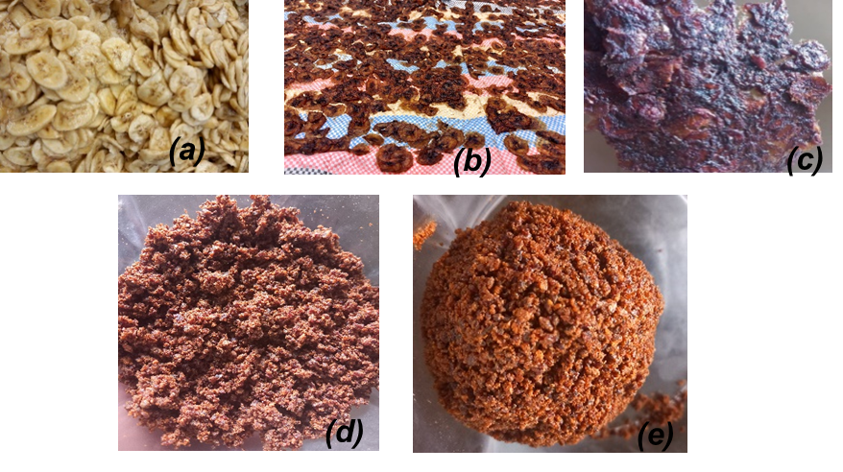
Fig 3. Fresh slices (a), kiln-dried slices (b) and oven-dried slices (c), and crush (d and e) of ripe dessert banana at stage 6
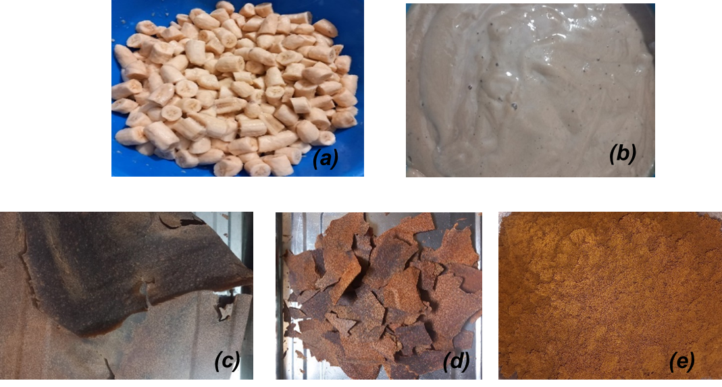
Fig 4. Fresh banana pieces (a), fresh banana puree (b) and oven-dried puree (c and d) and powder (e) of ripe dessert banana at stages 2, 3 and 4
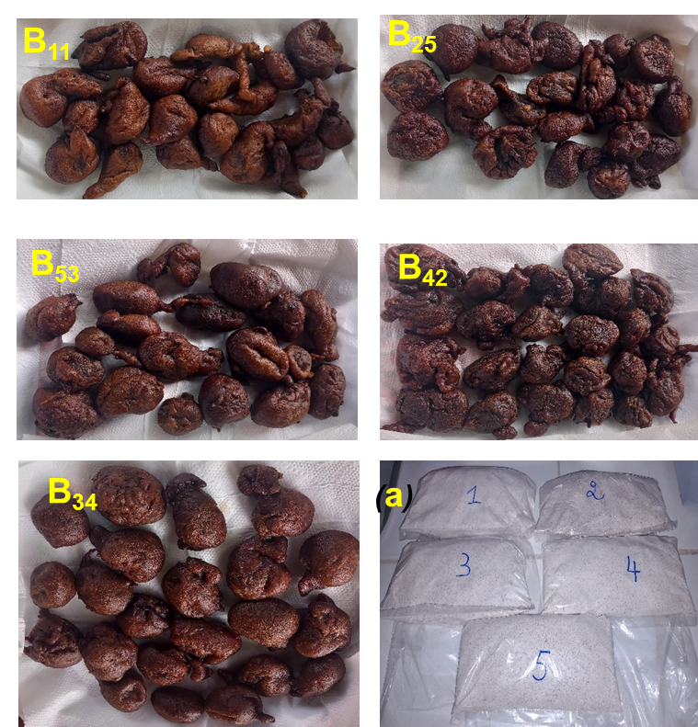
Fig 5. Dessert wheat-banana composite flours (a) and doughnuts from the five formulations
Figure 6 is the one we called 5a, and it's together with the images of the doughnuts.
3.2 Chemical composition of banana pulp and flour
The chemical composition of banana pulp at maturity stages 2, 3 and 4 and of the flour obtained are shown in Table 2.
Table 2. Chemical composition of banana pulp, purée and flour for fritter preparation
Parameters | Stage 2 | Stage 3 | Stage 4 | Mashed potatoes | Powder
TE (%) | 72,32 ± 0,18^{c} | 73,15 ± 0,09^{b} | 73,41 ± 0,28^{b} | 75,23 ± 0,18^{d} | 7,83 ± 0,05ª
MS (%) | 27,66 ± 0,20ª | 26,85 ± 0,09^{b} | 26,59 ± 0,28^{b} | 24,77 ± 0,19^{c} | -
TC (%) | 1,03 ± 0,01^{b} | 1,04 ± 0,01^{b} | 1,07 ± 0,03^{b} | 0,76 ± 0,01^{c} | 3,88 ± 0,16ª
TS (°Bx) | 0,57 ± 0,01e | 1,13 ± 0,04^{c} | 1,57 ± 0,00^{b} | 0,87 ± 0,01^{d} | 6,91 ± 0,00ª
TG (°Bx) | 0,49 ± 0,00e | 1,08 ± 0,05^{c} | 1,53 ± 0,00^{b} | 0,81 ± 0,00^{d} | 6,87 ± 0,00ª
pH | 4,54 ± 0,01^{d} | 4,64 ± 0,01^{c} | 4,68 ± 0,00^{b} | 4,70 ± 0,00ª | 4,28 ± 0,00ª
Legend. TE : water content ; DM : dry matter ; TC : ash content ; TS : sucrose content ; TG : glucose content.
Mean values of triplicate determinations ± standard deviation. Letters indicate significant differences between values in each column, determined by Tukey's test (p≤0.05).
3.2.1. Water content
Determining the water content of food products is one of the most important analyses. It is a quality factor in the preservation of food products. The higher the water content, the greater the risk of microbial proliferation or spoilage.
The water content of the bananas used was 72.32 %, 73.15 %, 73.41 % and 75.23 % for stage 2, 3 and 4 bananas and banana puree respectively. These values are close to the 74% found by Aurore et al. (2009), and also indicate that the riper the pulp, the more water it contains. The high value found for purée may be explained by the shape of the sample (paste), which facilitates evaporation.
The banana powder produced has a water content of 7.83 %. This value is close to that obtained by Haendler (1996) for semi-ripe bananas, i.e. 7.75 %. This low moisture content will enable the powder to keep for a long time, as this value is in line with that set by the FAO (1991) for the best conservation of powders : ≤13 %.

3.2.2. Dry matter content
Dry matter is a parameter that influences the fruit's suitability for preservation, for example, and its quality after cooking (Ngalani and Tchango, 1997).
The dry matter contents of the bananas obtained are 27.66 %, 26.85 %, 26.59 % and 24.77 % respectively for stage 2, 3 and 4 bananas, as well as for the puree. These values are well within the range of dry matter contents recorded by Ngalani and Tchango (1997) for dessert bananas : 22 to 30 %. Also, the dry matter contents of the banana ripening stages used were found to be within the range of those found by Tindall (1986) for the following starches: sweet potato (30 %), cassava (29 %), macabo (25 %), potato (23 %), yams (20 to 24 %).

3.2.3. Ash content
The ash contents of the bananas used revealed 1.03 %, 1.04 %, 1.07 % and 0.76 % for banana samples at stages 2, 3 and 4 respectively, as well as that of the purée obtained. These values are lower than those presented by Haendler (1996) for « Gros Michel » green banana flour (2.00 %). The ash content of the powder produced is estimated at 3.88 %. This value is close to that reported by Haendler (1996) for ripe banana powder (3.08 %), but higher than that obtained from Gros Michel green dessert banana flour (2.00 %). It is also higher than the value obtained by Badila et al. (2009) for green plantain : 2.15 %. According to Lii (1982), sucrose content varies progressively with banana maturity, rising from 1.2 % to 53.2 % for stages 1 to 9 ; hence the difference and increasing variation in sugar content recorded for the banana stages used.
On the other hand, that of the purée revealed a value of 0.87°Bx. This value can be explained by the blending of bananas from three different stages, each with its own content. Once blended and pureed, the sugar was balanced in the puree. We note that the raw material used has a sucrose content of 0.87°Bx.
As for glucose, a simple sugar contained in the banana used, it stands at 0.49°Bx for stage 2 bananas, 1.08°Bx for stage 3, 1.53°Bx for stage 4 and finally 0.81°Bx for the purée resulting from the mixture of stages 2, 3 and 4. The difference in values can be explained by the same reasons as for sucrose. This means that the material used contains 0.81°Bx in terms of glucose.
Finally, the sugar content of the banana powder produced is 6.91°Bx for sucrose and 6.87°Bx for glucose. These values are well above those of the puree used as raw material. This can be explained by the loss of water during the drying of the purée, which resulted in the concentration of the sugar. In addition, these values explain the sweet taste of the powder produced. According to Ngalani and Tchango (1997), increasing the soluble solids content or Brix level modifies the taste qualities of the fruit, which becomes increasingly sweet.

3.2.5. pH
The pH of the banana used ranges from 4.54 to 4.70 for stages 2 to 4, rising to 4.64 for stage 3. The pH of the puree is 4.70. These values are close to those found by Collin and Dalnic (1991) for plantain (cultivar Orishele) : 6.96 to 5.17 for stages 1 to 7. The cited author explains this by the probable presence of organic acids (malic acid and citric acid) in the fruit.
The pH of the banana powder produced is 4.28. This value differs from that of the puree used as raw material, which has a pH of 4.70. We can say that the loss of water caused by the drying of the puree has concentrated the acidity of the powder. This will enable it to keep well.

3.3 Sensory evaluation of doughnuts
3.3.1. Hedonic test
The hedonic test of five samples of prepared doughnuts, illustrated in Fig 5, involved the assessment of three (3) descriptors and the choice of the best formulation from the five (5) available. Consumers rated the samples on a 9-point hedonic scale (1 = I hate, 5 = I don't care, 9 = I like very much), and the results are presented in Table 3, illustrating mean rating values, standard deviations, statistics and approval distribution percentages.
The doughnut prepared with 20 % (B₁₁) banana powder was generally judged the most acceptable by tasters in terms of color, with an average of 6.9. No significant difference in mean values was observed between this sample and the other four (B₄₂ ; B₅₃ ; B₃₄ ; B₂₅). On the other hand, the distribution percentages of descriptor approval (scores 6 to 9), indifference (score 5) and rejection (scores 1 to 4) give a clearer picture of the responses given by panelists using the hedonic scale. There was a large difference in the percentage of approval for B₁₁ (90%) versus the other four (B₄₂ ; B₅₃ ; B₃₄ ; B₂₅). For the odor descriptor, sensory scores ranged from 6.1 (B₅₃) to 6.65 (B₂₅), with the latter showing the lowest percentage rejection value (10 %) and the highest percentage approval value (85 %). No significant differences were observed between the averages for the five doughnut samples. The same observations were made with the taste descriptor, where the B₂₅ formulation doughnut was the best accepted (95 %), with an average score of 7.35; while the B₅₃ formulation doughnut was the least appreciated (65 %), with an average attribute value of 6.2.
Although formulation B₂₅ showed two higher approvals than the other formulations, in the intention to eat the preferred doughnut again test, formulations B₂₅ and B₁₁ both showed the same highest percentage of 5 scores (35 %). In contrast, formulations B₅₃, B₃₄ and B₄₂ showed the lowest percentages of consumption preference (15 %, 10 % and 5 % respectively). Despite a higher and fairer percentage of responses in this category, we retained doughnuts from formulation B₂₅ as a reference for the remainder of the sensory evaluation with the triangular test, as doughnuts from the said formulation scored higher in terms of odor and taste than B₁₁.

Table 3. Average acceptance of banana doughnut samples
Descriptors | Sample | Mean ± Standard deviation | %  Reject | % Indifference | % Approval
 | B₁₁ | 6,9 ± 1,94ª | 10 | 0 | 90
 | B₂₅ | 6 ± 2,13 ª | 40 | 5 | 55
Color | B₃₄ | 6,25 ± 2,17ª | 30 | 5 | 65
 | B₄₂ | 5,8 ± 2,57ª | 35 | 5 | 60
 | B₅₃ | 5,6 ± 2,16ª | 40 | 5 | 55
 | B₁₁ | 6,4 ± 1,70ª | 15 | 10 | 75
 | B₂₅ | 6,65 ± 1,6ª | 10 | 5 | 85
Odor | B₃₄ | 6,25 ± 1,86ª | 15 | 10 | 75
 | B₄₂ | 6,55 ± 1,9ª | 25 | 0 | 75
 | B₅₃ | 6,1 ± 1,86ª | 25 | 15 | 60
 | B₁₁ | 6,95 ± 1,90ª | 10 | 10 | 80
 | B₂₅ | 7,35 ± 1,27ª | 0 | 5 | 95
 | B₃₄ | 6,35 ± 2,03ª | 20 | 10 | 70
Flavor | B₄₂ | 6,55 ± 2,16ª | 25 | 0 | 75
 | B₅₃ | 6,2 ± 2,19ª | 30 | 5 | 65

Means followed by the same letter in the same column, given each attribute, do not differ according to Tukey's test (p > 0.05), % approval - percentage of scores 6 to 9) ; % indifference - percentage of scores 5 ; % rejection - percentage of scores 1 to 4).
We recorded 25 right answers versus 5 wrong answers out of 30 tasters. To this end, statistical processing of the data using the binomial table according to the AFNOR standard indicates that the difference between the recipe.

3.3.2 Triangular test
After processing the data, we indicated the correct answer with a positive sign (+) when the tasters had correctly identified the sample, or with a negative sign (-) in the case of incorrect answers.
The difference between the revisited banana doughnut and the usual recipe is significantly noticeable at a threshold of 99.9 %, because for N=30, the value of K=25 is greater than the value of P=19 (where N : the number of tasters available, P : the number of minimum responses read in the binomial table and K : the number of correct responses obtained).
Also, in order to know the real appreciation and acceptability of the revisited banana doughnuts recipe compared to the usual recipe, the following results were observed:
- 22 or 73 % of panellists liked the banana doughnuts in the usual recipe ;
- only 8 or 27 % liked and accepted the banana doughnuts in the revisited recipe.

- Conclusion
In short, the objective set for the production of banana powder substituted in part in the recipe for a local pastry of the African doughnut type made essentially with wheat flour was achieved. Results showed that doughnuts made with 35 % (B₂₅) banana powder were more acceptable to consumers than those made with 20 %, 25 %, 30 % and 40 % banana flour.
Furthermore, in a triangular test carried out between the doughnuts of the usual recipe and those of the B₂₅ formulation, the tasters were able to identify the different product with a perception threshold of 99.9 % obtained via the binomial table (25 correct answers out of 30). The tasters also showed a 73 % preference for the traditional or usual recipe doughnuts.
In the short and medium term, we plan to continue our research into the production and improvement of banana powder. It would also be necessary to study the impact of ingredient composition and frying on the quality of composite flour fritters.

Disclaimer (Artificial intelligence)

Option 1:

Author(s) hereby declare that NO generative AI technologies such as Large Language Models (ChatGPT, COPILOT, etc.) and text-to-image generators have been used during the writing or editing of this manuscript.

Option 2:

Author(s) hereby declare that generative AI technologies such as Large Language Models, etc. have been used during the writing or editing of manuscripts. This explanation will include the name, version, model, and source of the generative AI technology and as well as all input prompts provided to the generative AI technology

Details of the AI usage are given below:
1. No AI technology was used either for writing this manuscript or for generating the images.
2. We have not used AI in the writing of this manuscript.
3.

References
Adanse John, Antwi-Boasiako Sussana, Kate Bigson, Kwakudua Ruth Sitsofe. Composition and Sensory Properties of Wheat, Plantain and Cocoyam Flour Doughnuts. Eurasian Journal of Agricultural Research 2021; Vol:5, Issue:2, pp:169-183
Anonymous 1. (2024). La pâtisserie et produits de pâtisserie. Accessed January 28, 2024, at 1:00 PM. https://fr.wikipedia.org/wiki/P%C3%A2tisserie (The title of the reference must remain in French)
Anonymous 2. (2024). La définition du beignet. Accessed January 28, 2024, at 1:45 PM. (The title of the reference must remain in French)
AOAC. (1990) Official Methods of Analysis. 15th Edition, Association of Official Analytical Chemists, Washington, DC; 774 pp.
Aurore, G., Parfait, B., and Fahrasmane, L. (2009). Bananas: Raw Materials for Making Processed Food Products. Trends in Food Science & Technology, 20 (2), 78-91.
Ayo-Omogie, H.N. and Odekunle, O.Y., 2019. Substituting Wheat Flour with Banana Flour: Effects on the Quality Attributes of Doughnut and Cookies. Applied Tropical Agriculture, pages 134-142.
Badila, C., Diatewa, M., Ellaly, G.G., and Nguyen, D. (2009). Mise au point d’un procédé de fabrication des farines de banane plantain et de tubercules de patate douce. I : évaluation des caractéristiques chimiques des farines. Annales de l’Université Marien NGOUABI, 2009 ; 10 (4) 57-63 Sciences et Techniques ISSN. (The title of the reference must remain in French)
Bakry, F., Carreel, F., Caruana M.L., Côte F.X., Jenny C., and Tézenas du Montcel H. (1997). Les bananiers. In : Charrier A., Hamon S., Jacquot M. et Nicolas D., eds. L’amélioration des plantes tropicales. Montpellier, France : CIRAD/ ORSTOM, 109-139.
(The title of the reference must remain in French)
Bonnet-bruno, C. (2012). Valorisation de la banane Cavendish FWI, à différents stades physiologiques de récolte pour l’obtention par procédés de chimie verte de molécules d’intérêt biologique impliquées dans des activités anti-ulcères et cardiovasculaires. Thèse pour le Doctorat en Sciences de la vie. Page 34-35.
(The title of the reference must remain in French)

Collin, M.N., and Dalnic, R. (1991). Évolution de quelques critères physicochimiques de la banane plantain (cultivar Orishele) au cours de la maturation. Fruits 46, 1 3-1 7.
Diawara, M. (2022). Propriétés biologiques de bananes de Guinée. Mémoire de thèse de doctorat en Médecine humaine et pathologie. Université de Montpellier, 2022. Pages 28, 66-67. (The title of the reference must remain in French)

FAO. (1991). Racines, tubercules, plantains et bananas dans la nutrition humaine. Collection FAO Nutrition 24. https://www.fao.org/4/t0207f/t0207f00.htm (The title of the reference must remain in French)
Florence Dubois-Brissonnet, Laurent Guillier. Foodborne microbial diseases. Nutrition and Dietetics Papers, 2020, 55 (1), pp. 30-38. 10.1016/j.cnd.2019.12.001. hal-03080053.
Haendler, L. (1996). Produits de transformation de la banane. Fruits, vol. 2r, no. 7, p. 329–342.
The title of the reference must remain in French)

Happi Emaga, T., Wathelet, B., Paquot, M. (2008). Changements texturaux et biochimiques des fruits du bananier au cours de la maturation. Leur influence sur la préservation de la qualité du fruit et la maîtrise de la maturation. Biotechnol. Agron. Soc. Environ. 12(1): 89–98. The title of the reference must remain in French)

Harbers. (1998). Ash analysis. In Food analysis (edited by S.S. Nielsen), pp. 141–150. 2nd Edition, Aspen publishers.
Hatae K., Miyamoto T., Shimada Y., Munekata Y., Sawa K., Hasegawa K. & Kasai M. 2003. Effect of the type of frying oil on the consumer preference for doughnut. Journal of Food Science, 68: 1038–1042.
https://www.196flavors.com/fr/puff-puff/
Kasongo, K. (2005). Etude du taux des multiplications rapides Ex situ chez 3 cultivars acuminata diploïde, triploïde, tétraploïde de bananier après décapitation et utilisation de 6 benzylaminopyrine (BAP) à Kisangani, Mémoire, Faculté des sciences, UNIKIS. 39p. The title of the reference must remain in French)

Li, M., Slaughte, D.C., and Thompson, J.F. (1997). Optical chlorophyll sensing system for banana ripening. Postharvest Biol. Technol., 12: 273-283.
Lii, C.Y., Chang; S.M., and Young, Y.L. (1982). Investigation of the physical and chemical properties of banana starches. J. Food Sci., 47, 1493-1497.
Lin-Feng Li., Xue-Jun Ge. (2017). Origin and Domestication of Cultivated Banana, Ecological Genetics and Genomics, Volume 2, Pages 1-2, ISSN 2405-9854.
Masson, E. (2020). Cahiers de Nutrition et de Diététique , Volume 55, Issue 1, Pages 30-38. The title of the reference must remain in French)
Minitab (1997). Release 12, User Guide: Data Analysis and Quality Tools, Minitab Inc.
Moïse Kwa and Ludovic Temple, 2019. Plantain: Socioeconomic and Technical Issues, Experiences in Intertropical Africa. Éditions Quæ, CTA, Presses agronomiques de Gembloux.
Mozhdeh Sarraf, Ali Mohammadi Sani and Masoomeh Mehraban Sang Atash. 2016. Physicochemical, Organoleptic Characteristics, and Image Analysis of Doughnuts Enriched with Oleaster Flour. Journal of Food Processing and Preservation ISSN 1745-4549
Ngalani, J., A., and Tchango Tchango, J. (1997). Évaluation des qualités physicochimiques du fruit de bananiers d'autoconsommation au Cameroun. Laboratoire de technologie post-récolte CRBP BP 832 Douala Cameroun.
Rehman, S., Paterson, A., Hussain, S., Murtaza, M.A., and Mehmood, S. 2007. Influence of Partial Substitution of Wheat Flour with Vetch (Lathyrus sativus L.) Flour on the Quality Characteristics of Doughnuts. LWT – Food Sci. Technol. 40(1), 73–82.
S. Soro, G. Konan, E. Elleingand, D. N'guessan and E. Koffi, 2013. Formulation of infant foods based on yam flour enriched with soy. African Journal of Food, Agriculture, Nutrition and Development opment, vol. 13, no. 5, Dec. 2013, pp. 8313+.
Tindall, H., D. (1986). Data on non-Musa crops. ln: Vegetables in the tropics. Londres, Royaume-Uni, Macmillan Publishers, 533.
Von Loesecke. (1950). Chemical changes during ripening bananas. Chem. Physiol. Technol., 4, 67-118.

