Original Research Article

From waste to palate: Importance of Banana Peel Ash in Assamese Culinary Tradition

Abstract

Traditionally viewed as waste, Banana peels have been increasingly recognized for their wide-ranging applications. They exhibit strong antioxidant activity, helping to combat oxidative stress. In Assam, banana peel ash has been historically incorporated into local diets, particularly as a natural food additive and functional ingredient. It is commonly used for its alkaline properties, locally known as “Kolakhar”. Despite its traditional importance in Assamese cuisine, there remains a lack of systematic scientific studies investigating its physicochemical properties. This study aims to address this gap by evaluating the pH and alkali element composition of Kolakhar prepared from peels of four banana cultivars belonging to different genomic groups. The study investigated the effect of cultivar type and concentration levels (10%, 20%, and 30%) on the pH of Kolakhar. Furthermore, it analyzed the concentration of four key alkaline elements—potassium, sodium, carbonate and calcium to understand their variability across different cultivars. The findings revealed that alkali element composition in banana peels—potassium, sodium, calcium, and carbonate—varies significantly across cultivars, influenced by their genomic constitution. All the four alkali elements recorded in the order of potassium>carbonate>calcium>sodium and these elements contributed to the alkaline p^{H} of Kolakhar. Among the cultivars tested, Kolakhar prepared from Bhimkal (BB) was found to exhibit the highest quality, based on its mineral content and pH.

Keywords: Banana peels, Kolakhar, mineral content, p^{H}

Introduction
As food waste and environmental crises continue to rise, transforming agricultural by-products into valuable resources has become a crucial focus for sustainability efforts. Traditionally viewed as waste, Banana peels have been increasingly recognized for their wide-ranging applications. They exhibit strong antioxidant activity, helping to combat oxidative stress (Montelongo et al., 2010). Banana peels have also been utilized in the green synthesis of silver nanoparticles, offering an eco-friendly alternative for biomedical applications (Bankar et al., 2010). In agriculture, dried banana peels serve as an affordable livestock feed due to their nutritional value, while their natural antimicrobial properties show effectiveness against various pathogens (Hikal et al., 2022). Additionally, banana peels have reported to be useful in water purification, acting as a natural adsorbent for removing heavy metals and pollutants from contaminated water.
Beyond the direct use of peels, the ash produced from banana peels after burning has demonstrated significant potential. Research shows that banana peel ash exhibits antifungal activity, particularly against scalp fungi, making it suitable for natural antifungal treatments (Prakash et al., 2017). Neat soap, having physical properties as pure potassium hydroxide soap is derivable from the water extract of ashes of plantain and banana peels (Olabanji et al., 2012). Furthermore, banana peel ash has been shown to effectively remove metals from metal-polluted water, offering sustainable options for environmental remediation (Jedidiah, 2019). Studies have also highlighted the pharmacological properties of banana peel ash, including anti-inflammatory, antimicrobial, and analgesic activities, suggesting its potential use in traditional and modern healthcare practices.
In Assam, banana peel ash has been historically incorporated into local diets, particularly as a natural food additive and functional ingredient. It is commonly used for its alkaline properties, which influence the texture, taste, and nutritional profile of various indigenous dishes. This ingredient is locally known as “Kolakhar” in Assam, where “Kol” means banana and “Khar” means alkali. This Kolakhar is traditionally mixed with certain vegetables to enhance softness during cooking, or used in the preparation of ethnic alkaline-based recipes such as "Khar", a signature dish in Assamese cuisine. The use of “Kolakhar” varies depending on the main ingredient of the dish. For instance, when “Kolakhar” is added to a papaya (Omita)-based gravy, the dish is referred to as Omita Khar. Similarly, when incorporated into black gram (mati mah) preparations, it is known as Matimahor Khar, etc. Due to it’s alkalinity, Kolakhar can be used as an antacid (Sarma et al., 2020). Borah et al. (2025) reported that ‘Kolakhar’ improves protein digestibility and nutrient availability in black gram (Vigna mungo L.). Neog and Deka (2013) explained “Kolakhar” as a Salt substitute. It is also used to normalize digestive disorders of stomach (Deka and Talukdar, 2007).
Despite the traditional importance of “Kolakhar” in Assamese cuisine, there remains a lack of systematic scientific studies investigating its physicochemical properties. Understanding the chemical composition of Kolakhar is crucial, as its alkalinity and mineral content not only affect the culinary quality of traditional dishes but may also have implications for human health.
This research aims to address this gap by evaluating the p^{H} and alkali element composition of Kolakhar prepared from peels of four banana cultivars belonging to different genomic groups. The study investigates the effect of cultivar type and concentration levels (10%, 20%, and 30%) on the p^{H} of Kolakhar. Furthermore, it analyzes the concentration of four key alkaline elements—potassium, sodium, carbonate and calcium to understand their variability across different cultivars. By scientifically characterizing the p^{H} and alkali composition of Kolakhar, this study seeks to contribute valuable insights into the nutritional and functional properties of this traditional ingredient, supporting its safe use in food systems and promoting indigenous knowledge of Assamese people.

Methodology
Period and location
The experiment was carried out in the experimental laboratory of Department of Horticulture, Biswanath College of Agriculture, Assam Agricultural University during 2019-2021.
Cultivars used for Kolakhar preparation
Four banana cultivars of different genomic groups selected for the study were:
V₁: Amritsagar (AAA)
V₂: Chenichampa (AAB)
V₃: Kachkal (ABB)
V₄: Bhimkal (BB)
The banana cultivars Amritsagar (AAA), Chenichampa (AAB), Kachkal (ABB), and Bhimkal (BB) are all derived from the species Musa acuminata (A genome) and Musa balbisiana (B genome). Amritsagar is a triploid (3x) with three A genomes (AAA), Chenichampa is a triploid (3x) with two A genomes and one B genome (AAB), Kachkal is a triploid (3x) with one A genome and two B genomes (ABB), and Bhimkal is a diploid (2x) with two B genomes (BB).
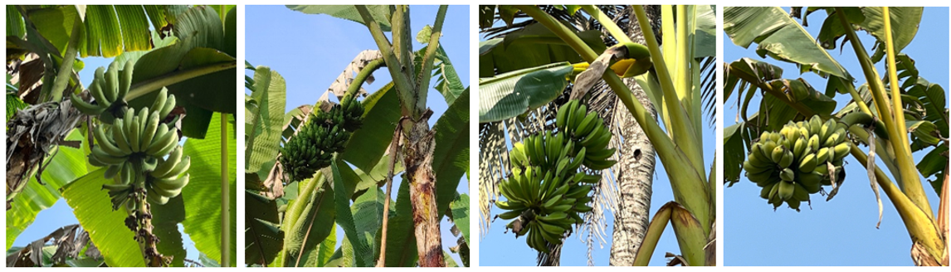
Fig.1: Bunches of the cultivars used for Kalakhar preparation under the study (From left: Amritsagar (AAA), Chenichampa (AAB), Kachkal (ABB) and Bhimkal (BB))
Sample collection
Peels of Amritsagar, Chenichampa and Bhimkal were collected at the ripe stage of the fruits; and peels of Kachkal were collected at the mature green stage. Peels were collected from Biswanath Chariali and Lakhimpur districts of Assam, India.
Sample preparation
The collected banana peels of each cultivars were spread on clean stainless steel trays and dried under the sun for about 5-6 days until moisture removes completely or they become crisp. Then they were burnt into ashes in a clean tray. The ashes thus produced were sieved with the help of a 0.5 mm sieve. These ash samples were then packed separately cultivar wise for further analysis.
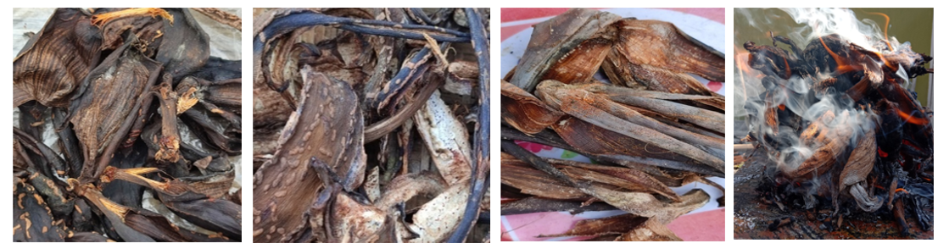
Fig.2: Sun drying of peels of different cultivars and burning of dried peels
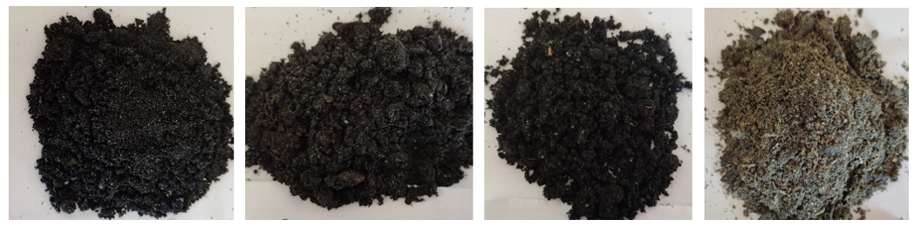
Fig.3: Kalakhar prepared from the four cultivars (From left: Amritsagar (AAA), Chenichampa (AAB), Kachkal (ABB) and Bhimkal (BB))
Chemical analysis
P^{H} of the samples was determined with the method of Saini et al. (2012). Ten grams, twenty grams, and thirty grams of ash were soaked in 100 mL of water to make 10 per cent, 20 per cent, and 30 per cent Kolakhar solution, respectively, and kept overnight. The next day, p^{H} was determined with the help of a digital p^{H} meter.
Calcium content was determined by the method explained by Bordoloi et al. (2025), potassium content was determined by the method of Ward and Johnson (1962), sodium content was determined using the method given by Ward and Johnson (1962) and the method of Clesceri et al. (1989) is used for carbonate estimation.
Statistical design and analysis
The recorded observations were analyzed using analysis of variance (ANOVA) under a completely randomized design (CRD). The significance or non-significance of differences due to different genomic groups was assessed by calculating the corresponding ‘F’ value following the method outlined by Panse and Sukhatme (1985).
Results
The average p^{H} of Kolakhar prepared from peels of different cultivars increased with the increase in concentrations of solutions from 10 per cent to 30 per cent (Table 1). Kolakhar prepared from Bhimkal recorded the highest pH in all three concentrations, which was found to be significantly different from other cultivars, while Kolakhar prepared from Chenichampa (V₂) recorded the lowest pH in all three concentrations of solutions.

Table 1: p^{H} of Kolakhar at different concentrations of 10 per cent, 20 per cent and 30 per cent solution
Cultivars | pH of Kolakhar
Cultivars | 10% | 20% | 30%
V₁: Amritsagar (AAA) | 10.11 | 10.28 | 10.71
V₂: Chenichampa (AAB) | 9.28 | 9.54 | 9.60
V₃: Kachkal (ABB) | 10.58 | 10.78 | 10.81
V₄: Bhimkal (BB) | 12.49 | 12.59 | 12.76
Mean (S) | 10.62 | 10.80 | 10.98
CD (P=0.05) | 0.08 | 0.16 | 0.19
CD: Critical Difference
Kolakhar prepared from Bhimkal peel recorded the significantly highest calcium content (2.61 g/kg), and Kolakhar prepared from Chenichampa recorded the lowest (1.34g/kg). There was no significant difference in sodium content in the ashes of the peels of all four cultivars under the study. Ashes of Bhimkal recorded the highest carbonate content (17.04 g/kg) and differed significantly from all other cultivars, and ashes of Amritsagar recorded the lowest (2.40 g/kg). Bhimkal ashes recorded the highest potassium content (81.42 g/kg), and the lowest potassium content (49.18 g/kg) was recorded by Kolakhar prepared from Amritsagar (Table 2). These alkali elements play an important role in determining the p^{H} of the dried banana samples. All four alkali elements (Calcium, Sodium, Carbonate, and Potassium) were recorded in the order of potassium>carbonate>calcium>sodium.
Table 2: Alkali contents of Kolakhar prepared from peels of different cultivars
Cultivars | Calcium content(g/kg) | Sodium content(g/kg) | Carbonate content(g/kg) | Potassium content(g/kg)
V₁:Amritsagar (AAA) | 1.80 | 0.25 | 2.40 | 49.18
V₂:Chenichampa (AAB) | 1.34 | 0.26 | 4.32 | 64.56
V₃: Kachkal (ABB) | 1.57 | 0.30 | 7.92 | 57.16
V₄: Bhimkal (BB) | 2.61 | 0.34 | 17.04 | 81.42
Mean (S) | 1.83 | 0.29 | 7.92 | 63.08
CD (P=0.05) | 0.60 | 0.14 | 0.56 | 0.46
CD: Critical Difference
Discussion
An increase in p^{H} with rising solution concentrations (from 10% to 30%) appears to be associated with higher levels of alkali components, including potassium, sodium, carbonate, and calcium. The elevated p^{H} observed in Kolakhar can be linked to the greater availability of alkali elements produced during the burning process. The observed increase in p^{H} with rising ash concentration (10–30%) might be attributed to the progressive dissolution of alkali and alkaline earth metal oxides (e.g., K₂O, Na₂O, CaO) and carbonates (e.g., K₂CO₃, CaCO₃) during ash hydration. These compounds hydrolyze in aqueous solutions to release OH⁻ ions (e.g., K₂O + H₂O → 2K⁺ + 2OH⁻; CO₃²⁻ + H₂O ↔ HCO₃⁻ + OH⁻), thereby elevating pH. The high pH disrupts hydrogen bonds and electrostatic interactions in meat proteins and this explains why Kolakhar is traditionally employed as a protein solubilizer and tenderizer in different curries. Bora et al. (2019) previously indicated that p^{H} levels rise with ash concentration (g/L), owing to the formation of hydroxides and carbonates from alkali and alkaline earth metals, which eventually stabilize upon reaching equilibrium. This equilibrium is critical for Kolakhar’s consistency in culinary applications, as excessive alkalinity could impart bitterness or textural degradation in foods. This phenomenon corresponds well with the p^{H} behavior noted in the present study. Additionally, Hazarika and Nath (1992) found that the p^{H} of Kolakhar varied depending on the banana cultivar, with Bhimkal displaying the highest p^{H} values, followed by Kachkal.
The calcium levels measured in Kolakhar prepared from Chenichampa peels were comparable to those reported by Borah et al. (2019). Similarly, sodium contents matched the ranges described by Hassan and Peh (2018). These alkali constituents play a major role in influencing the p^{H} of Kolakhar, with their relative abundance following the sequence: potassium>carbonate>calcium>sodium. The sodium content measured in Kolakhar, though lower than potassium and carbonate levels, aligns with its documented use as a traditional salt substitute in Assamese cuisine. The presence of Na⁺ and K⁺ in Kolakhar, particularly in Musa balbisiana-dominant cultivars, suggests a biochemical rationale for this substitution. A reduction in the concentrations of carbonate, potassium, and sodium was observed with a decreasing proportion of the Musa balbisiana genome and an increasing presence of the Musa acuminata genome among the four cultivars studied. It can be suggested that the varying levels of these alkali elements in banana peels are influenced by the genomic composition of the respective cultivars and M. balbisiana dominant cultivars (e.g. Bhimkal) are optimal for Kolakhar preparation, as their genomic profile ensures the requisite alkali composition for functional efficacy.
Conclusion
Rather than discarding banana peels as organic waste after fruit consumption, their utilization for Kolakhar preparation presents a sustainable and nutrient-rich alternative. The findings reveal that alkali element composition in banana peels—potassium, sodium, calcium, and carbonate—varies significantly across cultivars, influenced by their genomic constitution (e.g., Musa balbisiana vs. Musa acuminata). All four alkaline elements, i.e., calcium, carbonate, potassium, and sodium, contribute to the alkaline p^{H} of Kolakhar. The concentrations of the alkali elements are recorded in the order of potassium>carbonate>calcium>sodium. Suitability of the banana cultivars for Kolakhar preparation decreased with an increase in the Musa acuminata (A) genomic character and a decrease in the Musa balbisiana (B) genomic character. Although Bhimkal remains the traditional choice for Kolakhar preparation due to its higher alkali content, Kachkal can also be used as an alternative. Kolakhar prepared from Bhimkal (BB) was found to be the best in quality among the four selected cultivars based on mineral contents and p^{H}.
Disclaimer (Artificial intelligence)
Authors hereby declare that no generative AI technologies such as Large Language Models (ChatGPT, COPILOT, etc.) and text-to-image generators have been used during the writing or editing of this manuscript.
Reference
Bankar, A., Joshi, B., Kumar, A. R., and Zinjarde, S. (2010). Banana peel extract mediated novel route for the synthesis of silver nanoparticles. Colloids and Surfaces a Physicochemical and Engineering Aspects, 368(1–3), 58–63
Bora, D., Barbora, L. and Mahanta, P. (2019). An assessment of natural base solution prepared from different parts of Musa sp. as scrubbing agent of CO₂ from biogas, Journal of Basic and Applied Engineering Research, 6(1):1-4
Bora, S. S., Hazarika, D. J., Dullah, S., Sharma, D., Gogoi, R., Baruah, M., Sarmah, U., & Barooah, M. (2025). Traditional alkaline condiment ‘Kolakhar’ improves protein digestibility and nutrient availability in black gram (Vigna mungo L.). Journal of Food Measurement & Characterization, 19:2642–2654
Bordoloi, A., Hazarika, D. N., Langthasa, S., Goswami, R. K., Kalita, M. K., & Bordoloi, U. (2025). Exploring the nutritional significance of kolakhar: an in-depth analysis of a traditional Assamese culinary ingredient. Journal of Advances in Biology and Biotechnology, 28(5), 204–211
Clesceri, L.S., Greenberg, A.E. and Trussel, R.R. (1989). Standard method for the examination of water and waste water, 17th edn., American Public Health Association, Washington DC
Deka, D. C. and Talukdar, N. N. (2017). Chemical and Spectroscopic Investigation of Kolakhar and Its Commercial Importance, Indian Journal of Traditional Knowledge, 6(1):72-78
González-Montelongo, R., Lobo, M. G., and González, M. (2009). Antioxidant activity in banana peel extracts: Testing extraction conditions and related bioactive compounds. Food Chemistry, 119(3), 1030–1039
Hassan, P. and Peh, K.K. (2018). Chemical composition of banana peels (Musa sapientum) fruits cultivated in Malaysia using proximate analysis, Research Journal of Chemistry and Environment, 22(2): 108-113
Hazarika, D.N. and Nath, J.C. (1992). Comparative studies of pH content of banana corm ash, Banana Newsletter, 15:5
Hikal, W. M., Hussein, A. H., Bratovcic, A., Tkachenko, K. G., Sharifi-Rad, J., Miroslava, M., Mohammed, E., and Atanassova, M. (2022). Banana Peels: A Waste Treasure for Human Being. Evidence-Based Complementary and Alternative Medicine, 2022, 1–9
Jedidiah, J. (2019). Alkali extracts from banana peels ash used in removing metals from metals polluted water from Abakaliki, Ebonyi state. IOSR Journal of Applied Chemistry (IOSR-JAC), 12(11), 63–68
Neog, S. R. and Deka, D. C. (2013). Salt substitute from banana plant (Musa- balbisiana Colla). Journal of Chemical and Pharmaceutical Research, 5(6): 155-159
Olabanji, I. O., Oluyemi, E. A., & Ajayi, O. S. (2012). Metal analyses of ash derived alkalis from banana and plantain peels (Musa spp.) in soap making. African Journal of Biotechnology, 11(99), 16512–16518
Panse, V.G., and Sukhatme, P.V. (1985). Statistical Methoda for Agricultural Workers, ICAR, New Delhi
Prakash, B., CH, N. S., Melappa, G., and Gavimath, C. (2017). Evaluation of Antifungal activity of Banana peel against Scalp Fungi. Materials Today Proceedings, 4(11), 11977–11983
Saini, R.S., Sharma, K.D., Dhankhar, O.P. and Kaushik, R.A. (2012). Laboratory Manual of Analytical Techniques in Horticulture, Agrobios, pp.33
Sarma, A., Das, M., and Dutta, T. (2020). Traditional alkaline food additives ‘Kola-khar’ extracted from banana rhizome with reference to Musa balbisiana from Assam the state of India. International Journal of Bio-Pharma Research, 9(6), 2671–2677
Ward, G.M. and Johnson, F.B. (1962). Chamical Methods of Plant Analysis, Canada Department of Agriculture Publication, 1064, pp. 19-20

