Numerical Modeling of Electromagnetic and Thermal Interactions in Microwave Ablation Therapy for Liver Cancer

Abstract
Microwave ablation (MWA) is a minimally invasive technique for treating liver cancer, where precise modeling of electromagnetic and thermal interactions is essential for effective therapy planning. This study presents a three-dimensional numerical model integrating the Finite Difference Method (FDM) with the Crank–Nicolson Method (CNM) to solve coupled Maxwell's equations and the Pennes bioheat equation. The model incorporates temperature-dependent thermophysical properties and simulates a coaxial microwave antenna operating between 1–10 GHz. Simulation results show that increasing input power enhances the specific absorption rate (SAR) and tissue temperature. An input of 10 W raises central tissue temperatures beyond 60°C, sufficient for tumor ablation while sparing healthy tissue. The model demonstrates high numerical stability and captures key dynamics such as blood perfusion decline and conductivity variation with temperature. The proposed framework offers a robust and accurate tool for optimizing MWA protocols. It supports treatment planning by predicting energy deposition and temperature profiles with high fidelity and provides a foundation for future patient-specific simulations.

Keywords: Liver tumor, Hyperthermia, Microwave ablation, Finite Difference Method (FDM), Crank-Nicolson Method, Bioheat Equation, Electromagnetic Simulation.

1 Introduction
Hepatocellular carcinoma (HCC) is the most prevalent type of primary liver cancer and ranks among the leading causes of cancer-related deaths globally. Despite advances in imaging, surgical techniques, and systemic therapies, HCC remains difficult to treat due to its late diagnosis, limited eligibility for surgical resection, and frequent recurrence. The standard treatment modalities include surgical resection, liver transplantation, chemotherapy, radiation, and minimally invasive procedures. Among the emerging treatment options, microwave ablation (MWA) has gained attention as a promising minimally invasive thermal therapy that induces localized tissue destruction through electromagnetic energy deposition [1].
To maximize therapeutic efficacy and minimize damage to surrounding healthy tissue, it is crucial to understand the interaction between electromagnetic fields and biological tissues during MWA. This necessitates accurate mathematical modeling to predict the electromagnetic and thermal behavior within the liver, particularly around tumor regions. Numerical simulations offer a cost-effective and efficient tool for evaluating and optimizing MWA procedures under various conditions and geometries.
Several studies have focused on the mathematical modeling of tumor growth and tumor–immune interactions. Early work by Gompertz (1825) laid the foundation for tumor modeling by characterizing tumor growth as a balance between proliferation and cell death. Over time, these models have evolved to incorporate complex biological factors, such as the tumor microenvironment, which includes immune cells, extracellular matrix components, and signaling molecules [2]. In [3], two experimental animal systems were used to evaluate the predictive power of traditional tumor growth models. Interestingly, the most descriptively accurate models were not always the most predictive, especially with sparse data sets. The study also showed how population-based parameter estimation techniques could enhance predictive accuracy.
Recent research has explored the use of fractional-order models to capture memory and hereditary properties in tumor-immune dynamics. For example, the authors in [4] employed the multi-step generalized differential transform method (MSGDTM) to approximate solutions to a fractional-order model incorporating cytotoxic T lymphocytes (CTLs) and their interaction with tumor cells. Similarly, [5] analyzed a fractional tumor–immune model using arbitrary operators and chaotic analysis based on the Mittag-Leffler law, applying the Adams–Bashforth–Moulton and Toufik–Atangana numerical techniques. These models reveal how effector immune response dynamics and fractional derivatives can influence tumor progression.
In [6], a three-dimensional fractional-order cancer model involving tumor cells, healthy cells, and effector cells was studied. The model's equilibrium points and stability were analyzed using Caputo derivatives, showing how chaotic behavior could emerge based on fractional order. Likewise, [7] presented a fractional-order HIV-1 model involving cancer cells and chaotic dynamics. The model used the two-step Adams–Bashforth method for numerical simulation.
Additional work in [8] introduced a chaotic cancer model based on fractional differential equations, examining both commensurate and incommensurate cases. The authors in [9] tackled fuzzy–fractional tumor dynamics using various fuzzification techniques and novel hybrid algorithms to represent tumor heterogeneity. Reference [10] proposed a crossover hybrid fractional cancer model with stability and accuracy confirmed via the Grünwald–Letnikov approximation and higher-order Runge–Kutta methods. In [11] introduced a 3-D discrete-time fractional-order HIV-1 model incorporating AIDS-related cancer cells, demonstrating chaotic dynamics through simulations. Finally, in [12] developed a compartmental model for HIV/AIDS that incorporated diagnosis and access to Pre-Exposure Prophylaxis (PrEP). The model distinguished between individuals with detectable and undetectable viral loads and employed a Bayesian MCMC method to estimate parameters using epidemiological data from Brazil. Simulation results showed that increased PrEP coverage significantly reduced HIV incidence and prevented new infections, highlighting the effectiveness of preventive strategies and the value of mathematical modeling in public health planning.
Building upon these recent developments in tumor and disease modeling, the present study focuses on the integrated simulation of electromagnetic and thermal interactions, aiming to advance the numerical modeling of microwave ablation therapy in liver cancer.
The present study develops a robust numerical framework to simulate the interaction of electromagnetic waves with liver tissue during microwave ablation. The model employs the Finite Difference Method (FDM) for spatial discretization and the Crank–Nicolson Method (CNM) for time integration to solve the coupled Maxwell’s equations and Pennes bioheat equation. Temperature-dependent thermophysical properties of liver tissue are incorporated to reflect realistic physiological responses. The numerical method ensures stability and precision in simulating temperature rise and energy absorption during therapy. This work contributes a reproducible, stable, and accurate modeling tool to support the optimization of microwave ablation in liver cancer treatment and provides a foundation for future extensions toward patient-specific simulation and clinical planning.
2 Numerical Method and Simulation Conditions
This section presents the numerical framework designed to simulate the microwave ablation process in liver tissue containing a tumor. The primary objective of the numerical model is to predict electromagnetic field propagation and resulting thermal effects using a coupled electromagnetic thermal formulation. The simulation is structured to provide a detailed understanding of how microwave energy is distributed and converted into heat within liver tissue, facilitating optimization of ablation parameters for effective tumor destruction.
The Finite Difference Method (FDM) can be used to approximate solutions to partial differential equations. Usually, a regular grid is drawn, and the differential equation is solved at each internal grid point in straightforward, regular study areas. The matrix representation of the problem generated after using the numerical method of differences can be used to solve a system of linear equations and non-linear, time-independent, and dependent problems using numerical methods [13].
The numerical challenge lies in solving a coupled system involving Maxwell’s equations and the Pennes bioheat equation, which describe electromagnetic field interactions and heat transfer. We use the Finite Difference Method (FDM) for spatial discretization and the Crank Nicolson Method (CNM) for time integration to address this. These methods offer both numerical stability and computational efficiency.
We consider a three-dimensional domain that includes a coaxial microwave antenna inserted into liver tissue, with a centrally embedded spherical tumor. Temperature-dependent thermophysical properties are incorporated to reflect biological accuracy. Our model computes temperature rises over time as a function of tissue geometry, antenna placement, frequency, and power level, aiming to determine whether the tumor can be completely ablated while sparing healthy tissue.
The following subsections detail the mathematical formulation, numerical implementation, boundary conditions, and physical assumptions used in the simulation.

2.1 Mathematical Problem Formulation
The microwave ablation problem involves solving a coupled system of partial differential equations to describe the electromagnetic wave propagation and heat transfer in liver tissue with an embedded tumor. The governing equations are:
2.1.1 Electromagnetic Model (Maxwell’s Equations)

$\frac{∂\vec{E}}{∂t}=\left(\frac{1}{∈}\right)∇ × \vec{H}-\left(\frac{σ}{ϵ}\right)\vec{E }$ (1)
$\frac{∂\vec{H}}{∂t}=-\left(\frac{1}{μ}\right)∇ × \vec{E}$ (2)

where $\vec{E}$= (E_{x}, E_{y}, and E_{z}) and $\vec{H}$ =(H_{x}, H_{y}, and H_{z}) represent the electric and magnetic field vectors, respectively. $∈$ is the permittivity of liver tissue, μ is the magnetic permeability, and $σ$is the electrical conductivity, which is included to account for the lossy characteristics of biological tissues.
2.1.2 Thermal Model (Pennes Bioheat Equation)
$ρc\frac{∂T}{∂t}=k∇^{2}T+Q_{met}+ω_{b}c_{b}\left(T-T_{b}\right)+Q_{ext}$ (3)
Where $ρ$ is the density of the tissue (kg/m³), c the specific heat capacity of the tissue (J/kg·°C), T the temperature of the tissue (°C), t is the Time (s), k is thermal conductivity of the tissue (W/m·°C), $Q_{met}$ is the metabolic heat generation (W/m³) that represent the heat produced by tissue metabolism, $ω_{b}$is the blood perfusion rate (1/s), indicating how quickly blood circulates through the tissue, $c_{b}$the Specific heat of blood (J/kg·°C), T_{b}​ is the blood temperature (°C) that assumed to be constant or an external reference temperature, and $Q_{ext}$t​ is the external heat source due to microwave energy, equals to $σ{\left|E\right|}^{2}$ ($σ$ is the electrical conductivity (s/m & E is the electric field magnitude(v/m)).

2.1.3 Boundary Conditions
To ensure an accurate and realistic simulation of the electromagnetic and thermal behavior, the following boundary conditions are applied at the domain boundaries.

- Electromagnetic field boundary conditions:
- The Symmetry boundary condition is at Z=0 and Z=80mm (assumed symmetry).
- The conditions are defined as:
E_{x}(1, :) =E_{x}(2, :) and E_{x}(end, :) = E_{x}(end-1, :)
E_{y}(1, :) =E_{y}(2, :) and E_{y}(end, :) = E_{y}(end-1, :)

This condition enforces symmetry by ensuring that the electric field components at the boundary reflect the values just inside the domain.
- The Scattering Boundary Condition
- Applied at Z=0, Z=80mm, and r=30mm;
- The conditions are defined as
E_{z}(1, :) = E_{z}(2, :)
E_{z}(end, :) = E_{z}(end -1, :)
E_{z}(:, 1) = E_{z}(:, 2).
This condition simulates wave scattering by setting the field values at the boundaries equal to the adjacent internal values, effectively minimizing reflections.
- The Perfect Electrical conductor (PEC) Boundary Condition is applied at specific radii (r = 30 mm), where the condition is E_{x} (:, 1) =0 (implying the electric field is zero at that radius). This condition ensures that the tangential electric field components are zero at the PEC surface, consistent with Maxwell’s boundary conditions for a perfect conductor.
- Temperature Boundary Conditions where the Fixed Initial Temperature is at the start of the simulation, the entire tissue domain is initialized to a constant temperature of 37°C.
- The Convergence Tolerance Condition: A tolerance of |Tⁿ⁺¹ − Tⁿ| < 10⁻⁶ is used for temperature convergence. The simulation loop terminates when the temperature change between iterations falls below this threshold, indicating steady-state or thermal equilibrium.
2.2 Crank-Nicolson Method(CNM)
Many mathematical models in the domains of applied mathematics and engineering are based on partial differential equations. Examining the predictions of mathematical models is crucial since the approximate solution of partial differential equations is crucial, and exact solutions are difficult to obtain. The idea of heat conduction gives rise to parabolic partial differential equations, which are problems with time as a single independent variable. Analytical solutions to such problems are difficult to find; in these situations, numerical methods are helpful. Although many academics have worked on alternative numerical techniques to solve parabolic partial differential equations, finite difference techniques have been the most often used. To solve parabolic equations, a variety of finite difference approximations are employed [14].

2.2.1 Solving Maxwell’s Equations Using Crank-Nicolson
Maxwell’s equations govern the propagation of electromagnetic waves in three-dimensional (3D) space, capturing the interaction between electric and magnetic fields. In this work, a full three-dimensional formulation is adopted to accurately model the complex behavior of electromagnetic wave propagation within biological tissues, specifically liver tissue containing a tumor. The electric field components E_{X}​, E_{y}​, and E_{z}​, and the magnetic field components H_{x}​, H_{y}​, and H_{z}​, are updated at each time step using a finite-difference discretization in space and the Crank-Nicolson method in time. This approach ensures numerical stability and precision, enabling the simulation of realistic field distributions and interactions within the heterogeneous biological medium.

Governing Equations (1) and (2): The time-dependent Maxwell’s equations in an isotropic, homogeneous, and linear medium.

Numerical Discretization: The computational domain is discretized into a uniform Cartesian grid with indices (i,j,k) corresponding to the x, y, and z directions, respectively. The spatial discretization steps are denoted as dx, dy, and dz, while dt represents the temporal step size.
The Crank-Nicolson method is applied to ensure stability and second-order accuracy in both time and space. This implicit scheme averages the field values between the current and subsequent time steps.

Discretized Formulation:

Electric Field Update the discretized update equation for the E_{x​} component at grid point (i, j, k) is given by:

$E_{x}^{n+1}\left(i,j,k\right)=E_{x}^{n}\left(i, j, k\right)+\frac{dt}{2∈}\left[\left(\frac{H_{z}^{n+1}\left(i,j+1, k\right)-H_{z}^{n+1}\left(i, j, k\right)}{dy}-\frac{H_{y}^{n+1}\left(i, j, k+1\right)-H_{y}^{n+1}\left(i, j, k\right)}{dz}\right)+ \left(\frac{H_{z}^{n}\left(i,j+1, k\right)-H_{z}^{n}\left(i, j, k\right)}{dy}-\frac{H_{y}^{n}\left(i,j, k+1\right)-H_{y}^{n}\left(i, j, k\right)}{dz}\right) \right]$ (4)

The Ey​ and Ez​ components are updated analogously by incorporating the respective curl terms of $\vec{H}$

Magnetic Field Update:
Similarly, the magnetic field components are updated using the discretized form of Ampère’s law. For the H_{X} component:

$H_{x}^{n+1}\left(i, j,k\right)=H_{x}^{n}\left(i, j, k\right)-\frac{dt}{2μ}\left[\left(\frac{E_{z}^{n+1}\left(i,j,k\right)-E_{z}^{n+1}(i,j-1,k)}{dy}-\frac{E_{y}^{n+1}\left(i,j,k\right)-E_{y}^{n+1}(i,j,k-1)}{dz}\right)+\left(\frac{E_{z}^{n}\left(i,j,k\right)-E_{z}^{n}(i,j-1,k)}{dy}\right)-\frac{E_{y}^{n}\left(i,j,k\right)-E_{y}^{n}(i,j,k-1)}{dz}\right]$ (5)

The update equations for H_{y}​ and H_{z} follow similarly.

Numerical Implementation: At each time step, the following procedure is executed:
- Magnetic Field Update: The magnetic field components H_{x}, H_{y}, and H_{z}​ are computed using the current and predicted electric fields.
- Electric Field Update: The electric field components E_{x}, E_{y}, and E_{z} ​ are then updated using the newly computed magnetic fields.
- Boundary Application: Boundary conditions are enforced on both electric and magnetic fields to maintain numerical stability and physical fidelity.
This Crank-Nicolson-based finite difference approach provides a robust framework for simulating the coupled electromagnetic behavior within heterogeneous biological tissues, offering insights into microwave ablation treatment efficacy.

2.2.2 Solving 1D Bioheat Equation Using Crank-Nicolson Method

The bioheat equation describes heat transfer in biological tissue, including heat conduction, metabolic heat generation, and heat convection due to blood perfusion. One of the most well-known models is the Pennes bioheat equation [15].

Thermal transport within biological tissues subjected to electromagnetic heating is governed by the Pennes bioheat equation, which accounts for heat conduction, metabolic heat generation, and perfusion-based heat exchange due to blood flow. In this study, the one-dimensional (1D) form of the bioheat equation is employed to model heat distribution in liver tissue containing a tumor undergoing microwave ablation therapy. Equation (3) is expressed above in section 2.1.2 in detail. That’s are the detailed steps for solving the bioheat equation using the Crank-Nicolson method.

- Spatial Discretization: The tissue is discretized into n spatial points, and temperature at each point is tracked over time. The spatial discretization uses the finite-difference method to compute the second derivative:

$∇^{2}T≈ \frac{T_{i+1}-2T_{i}+T_{i-1}}{dx^{2}}$ (6)
- Time Discretization: The Crank-Nicolson scheme averages between time steps, so the discretized form of the bioheat equation is:

$ρc\frac{T_{i}^{n+1}-T_{i}^{n}}{dt}=k\frac{T_{i+1}^{n+1}-2T_{i}^{n+1}+T_{i-1}^{n+1}}{dx^{2}}+\frac{T_{i+1}^{n}-2T_{i}^{n}+T_{i-1}^{n}}{dx^{2}}+…$ (7)

The implicit scheme requires solving a system of linear equations at each time step.
- Precomputing Matrices A and B: The Crank-Nicolson method requires matrix operations. Matrices A and B are precomputed to handle the spatial terms in the bioheat equation; The tridiagonal structure of the matrices ensures that heat is transferred between neighboring spatial points, accounting for both conduction and perfusion effects.

$A=I-\frac{dt}{2ρcdx^{2}}.K$ (8)

$B=I+\frac{dt}{2ρcdx^{2}}.K$ (9)
Where I is the Identity matrix, representing no change across the main diagonal, dt is the Time step size, dx is the Spatial step size, $ρ$ the Density of the tissue, c is the specific heat capacity of the tissue, and K is a matrix representing the second spatial derivative (Laplacian operator in 1D) with n interior points, k will be:

$K=\frac{1}{dx^{2}}\left[\begin{matrix}-2 & 1 & 0 & ⋯ & 0 \\ 1 & -2 & 1 & ⋯ & 0 \\ 0 & 1 & -2 & ⋯ & 0 \\ ⋮ & ⋮ & ⋮ & ⋱ & 1 \\ 0 & 0 & 0 & 1 & -2\end{matrix}\right]$ (10)

- Updating the Temperature: At each time step, the temperature distribution is updated by solving the linear system using the Thomas algorithm (a simplified version of Gaussian elimination).

$T^{n+1}=A^{-1}BT^{n}$ (11)
$AT^{n+1}=BT^{n}+C$ (12)

Where A is the matrix representing the contributions of the next time step, B is the matrix representing the contributions of the current time step, C is the vector that includes source terms, such as the external heat source 𝑄𝑒𝑥𝑡​ and blood perfusion effects, 𝑇^{𝑛+1} the vector of temperatures at the next time step which provides the temperature distribution at each spatial point at the new time step, and 𝑇^{𝑛} the vector of temperatures at the current time step.
Let's say $α=\frac{dt}{2ρcdx^{2} }$ for simplicity. Then the matrices A and B can be written as:

$A={\left[\begin{matrix}1+2α & -α & 0 & ⋯ & 0 \\ -α & 1+2α & -α & ⋯ & 0 \\ 0 & -α & 1+2α & ⋯ & 0 \\ ⋮ & ⋮ & ⋮ & ⋱ & -α \\ 0 & 0 & 0 & -α & 1+2α\end{matrix}\right]}_{n×n}$ (13)

$B={\left[\begin{matrix}1-2∝ & α & 0 & ⋯ & 0 \\ ∝ & 1-2α & α & ⋯ & 0 \\ 0 & α & 1-2α & ⋯ & 0 \\ ⋮ & ⋮ & ⋮ & ⋱ & α \\ 0 & 0 & 0 & α & 1-2α\end{matrix}\right]}_{n×n}$ (14)

2.3 Antenna Design and Liver Geometry
Thermal microwave ablation is a minimally invasive technique where tumor cells are eradicated through localized heating. In this study, a microwave coaxial antenna (MCA) is employed to deliver electromagnetic energy to biological liver tissue, where it is absorbed and subsequently converted into heat. The MCA structure comprises an inner conductor with a diameter of 0.135 mm, a dielectric layer with a diameter of 0.45 mm, and an outer conductor of 0.594 mm diameter, featuring a ring-shaped slot with a height of 0.1 mm. For insulation and mechanical protection, the antenna is enclosed within a plastic catheter of 1.79 mm diameter.
The antenna is inserted to a depth of 46 mm within the liver tissue, which is modeled as a cylindrical domain with a radius of 30 mm and a height of 80 mm. A spherical tumor, characterized by a radius of 5 mm, is embedded centrally within the liver tissue.
Electromagnetic simulations are conducted over a frequency range of 1 GHz to 10 GHz, with increments of 0.1 GHz, to evaluate the antenna's impedance characteristics and radiation patterns.

3. Proposed Algorithm

The proposed algorithm for simulating the microwave ablation process integrates both electromagnetic and thermal analyses through a systematic, iterative approach. Initially, the geometry of the model, including the microwave coaxial antenna and liver tissue, is defined, and the physical properties, such as initial temperature and electromagnetic characteristics, are assigned. As shown in Figure 1, the simulation begins with the electromagnetic field analysis, where Maxwell's equations are solved using the Crank-Nicolson method. In this step, the electric and magnetic fields are updated while appropriate boundary conditions, such as a perfect electric conductor (PEC), symmetry, and scattering conditions, are applied to ensure accurate field distribution. Subsequently, the thermal response of the tissue is evaluated by solving the one-dimensional bioheat equation, also utilizing the Crank-Nicolson method to update the temperature profile within the tissue. Temperature boundary conditions are imposed to simulate realistic thermal behavior. Following each iteration, the temperature-dependent properties of the biological tissues, including density, electrical conductivity, specific heat capacity, and blood perfusion rate, are updated to reflect the impact of heating. A convergence criterion is then checked by evaluating whether the change in temperature between successive iterations falls below a predefined tolerance threshold. If the criterion is not satisfied, the simulation proceeds to the next time step, continuing the iterative coupling between electromagnetic and thermal solutions. Upon convergence, the algorithm outputs key performance indicators, including the antenna impedance, radiation pattern, specific absorption rate (SAR), temperature distribution, and variations in tissue physical properties. This comprehensive approach enables a detailed assessment of tissue response during microwave ablation therapy.

Figure 2 illustrates the schematic configuration employed in the simulation of microwave ablation therapy. Part (a) depicts the three-dimensional geometric model, where a coaxial antenna is inserted vertically into liver tissue, targeting an embedded tumor. The liver tissue is represented as a cylindrical volume with a diameter of 30 mm and a height of 80 mm, while the tumor tissue is modeled as a sphere with a diameter of 14 mm, positioned centrally at a depth of 46 mm from the tissue surface. Part (b) provides a detailed cross-sectional view of the microwave coaxial antenna structure. The antenna, enclosed within a catheter of 1.79 mm diameter, consists of an inner conductor, a dielectric layer, and an outer conductor. The inner conductor has a diameter of 0.135 mm, the dielectric material has a thickness of 0.45 mm, and the outer conductor has a diameter of 0.594 mm. Additionally, a slot with a width of 0.1 mm is included to facilitate the emission of electromagnetic waves. The catheter extends 46 mm into the tissue, ensuring proper energy delivery to the tumor site. This geometric setup forms the basis for analyzing the electromagnetic and thermal behavior of the tissue during microwave ablation.

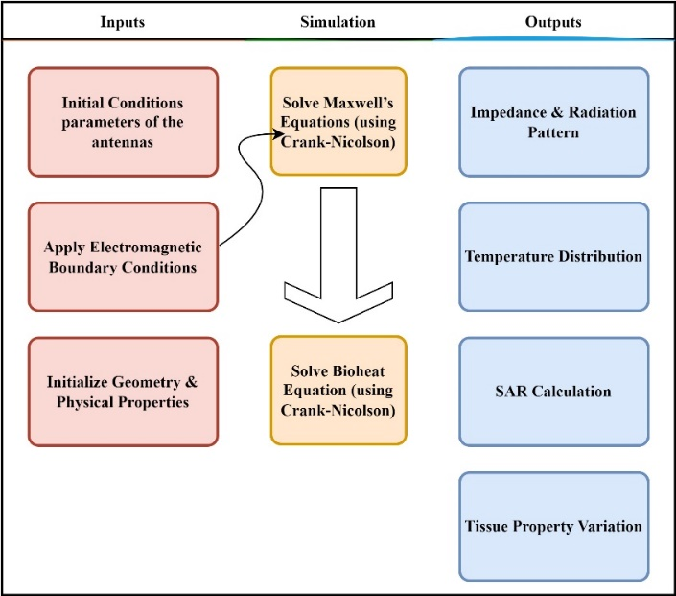
Figure 1. The proposed algorithm flow chart.
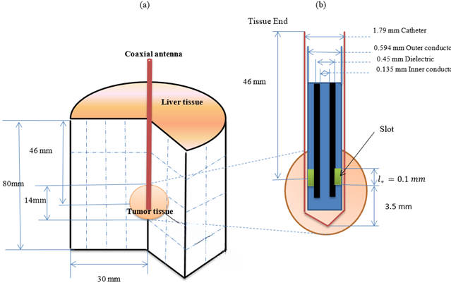

Figure 2. Schematic view of the (a) configuration of the antenna inserted into biological tissue used for microwave ablation therapy. (b) The microwave coaxial antenna enclosed in a catheter is composed of dielectric, inner and outer conductors, and a slot. The tumor is assumed to have a spherical form.

- Numerical Results and Discussion

This section presents the simulation outcomes derived from the proposed model and offers an integrated discussion of the results. Starting with antenna performance, followed by electromagnetic energy deposition, tissue heating response, temperature-dependent thermal property behavior, and a comparative analysis with existing methods.
4.1 Antenna Performance: Impedance and Radiation Analysis
The performance of both AMC and coaxial antennas was evaluated across the frequency range from 1 GHz to 10 GHz. Figure 3(a) illustrates that the impedance characteristics of both antennas are nearly identical, with values increasing gradually and stabilizing at higher frequencies. This similarity confirms the AMC antenna’s capability to replicate the impedance behavior of the coaxial antenna, ensuring consistent energy delivery.

Figure 3(b) compares the radiation patterns of the antennas. Both display similar behavior with resonance peaks near 5 GHz and 9 GHz. These consistent radiation characteristics further validate the use of the AMC antenna in practical applications where similar energy deposition patterns are required.

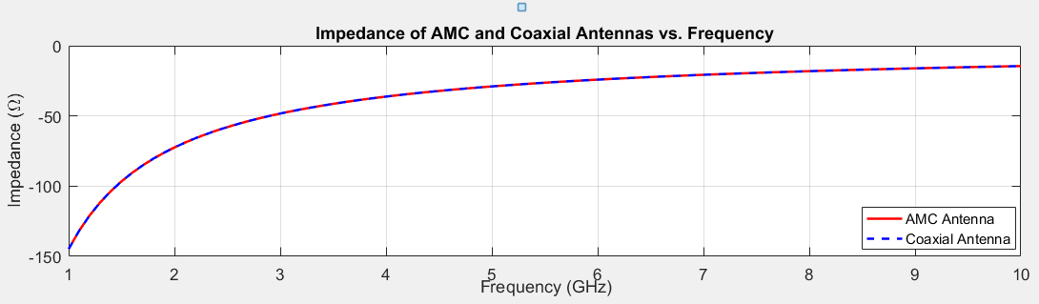
(a) Impedance vs. frequency for AMC and coaxial antennas.
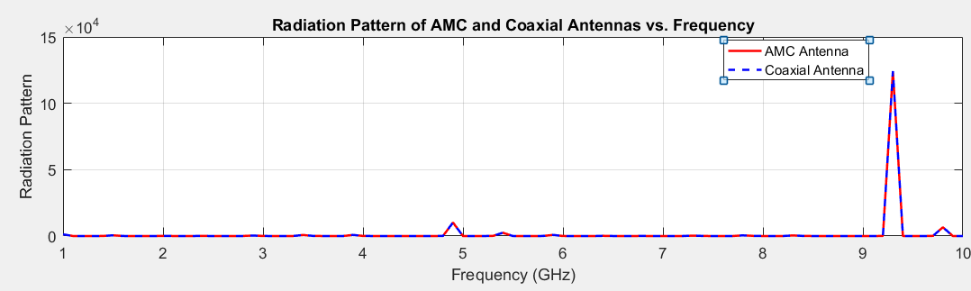
(b) Radiation pattern vs. frequency for both antennas.
Figure 3. (a) Impedance vs. frequency for AMC and coaxial antennas. (b) Radiation pattern vs. frequency for both antennas.

  - Specific Absorption Rate (SAR) and Energy Deposition
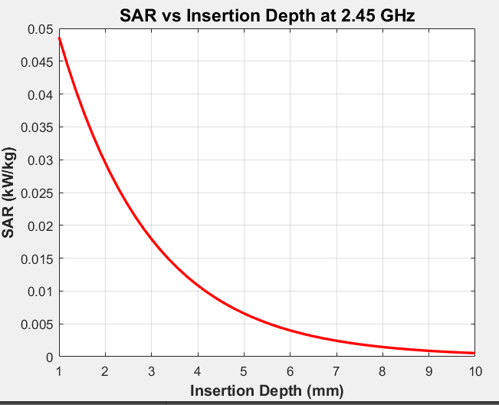
SAR quantifies the rate of electromagnetic energy absorption in tissue and is a direct contributor to heat generation. Figure 4 presents the SAR profile at 2.45 GHz along the insertion depth. The SAR peaks near the antenna tip and decays rapidly with depth, aligning with the expected attenuation behavior in biological media. This distribution highlights localized heating, which is critical for achieving targeted tissue ablation while sparing surrounding healthy regions.

Figure 4: Specific Absorption Rate (SAR) vs. frequency.

4.3 Temperature Distribution in Tissue

The thermal response of tissue was modeled using the Crank Nicolson solution of the bioheat equation, incorporating SAR as the external heat source. Figure 5 shows the spatial temperature distribution, with maximum temperature occurring centrally (~0.5 mm) and decreasing symmetrically towards the boundaries. This pattern indicates efficient energy absorption and centralized thermal focus.
Figure 6 illustrates the temperature evolution as a function of time during microwave ablation. The results demonstrate a steady increase in temperature from approximately 37°C at the start to around 100°C at 50 seconds. This progressive rise indicates consistent microwave energy absorption and confirms the model's ability to achieve therapeutic heating levels. Notably, the temperature exceeds 60°C, commonly associated with irreversible thermal damage, supporting the effectiveness of the proposed simulation framework in capturing key thermal behaviors during ablation
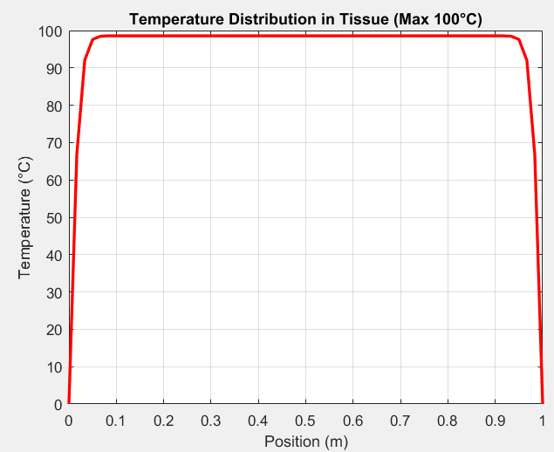
Figure 5: Temperature distribution along the tissue at the end of the simulation.
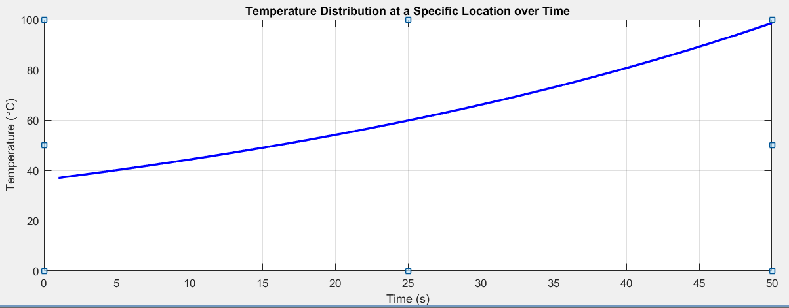
Figure 6: Temperature distribution along the tissue at a Specific location
4.4 Temperature-Dependent Thermo-Physical Properties
Figure 7 and Table 1 summarize key thermo-physical property changes across the 0–100°C range.
Figure 7(a) illustrates the variation of residual water mass with temperature. As temperature increases, the residual water mass decreases significantly, indicating progressive dehydration of the tissue. This reduction is particularly pronounced at lower temperatures and stabilizes at higher temperatures, reflecting the loss of free water content.
In Figure 7(b), the tissue density is shown as a function of temperature. A sharp decline in tissue density is observed with increasing temperature, consistent with the decrease in residual water content. This behavior highlights the temperature-dependent structural changes occurring within the tissue.
Figure 7(c) depicts the temperature dependence of thermal conductivity, specific heat, and blood flow rate. Thermal conductivity and specific heat exhibit slight increases with temperature, suggesting an enhanced capacity of the tissue to conduct and store thermal energy at elevated temperatures. In contrast, the blood flow rate decreases as temperature rises, which may reduce convective heat dissipation and contribute to localized temperature elevation within the tissue.
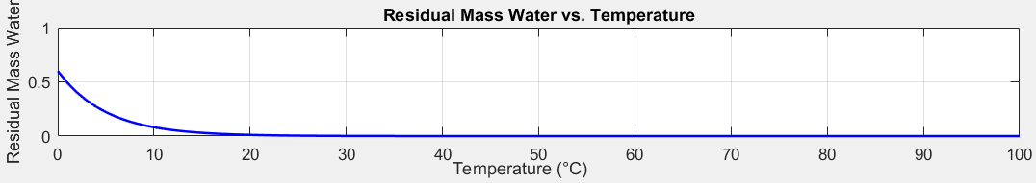
(a) Residual water mass vs. temperature
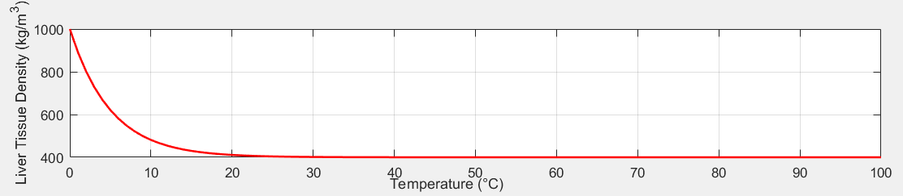
(b) Liver Tissue Density vs. temperature.
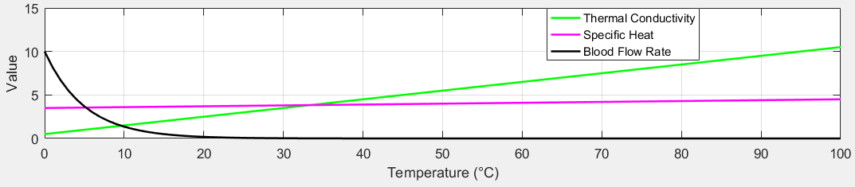
(c) Blood flow rate vs. temperature.
Figure 7: (a) Residual water mass vs. temperature. (b) Liver tissue density vs. temperature. (c) Blood flow rate vs. temperature.
Table 1 summarizes the temperature dependent thermo-physical properties of liver tissue across the 37°C to 100°C range, relevant to microwave ablation. The residual water mass decreases progressively from 0.7419 at 37°C to 0.2798 at 100°C, reflecting tissue dehydration due to thermal exposure. A gradual decline in tissue density is also observed, from 1061.0 kg/m³ to 1028.5 kg/m³, consistent with structural changes and water loss.
The thermal conductivity increases from 0.5170 W/m·K to 0.6145 W/m·K, indicating enhanced heat transfer capacity at higher temperatures. Similarly, the specific heat capacity rises from 3590 J/kg·K to 3915 J/kg·K, suggesting increased energy storage within the tissue. The blood perfusion rate decreases markedly, from 19.70 mL/min at 37°C to approximately 1.06 mL/min at 100°C, representing thermally induced vascular shutdown. These variations are critical for accurately modeling tissue response and heat propagation during microwave ablation. These dynamic changes are crucial for accurate modeling, as they significantly influence the spatial and temporal temperature fields during
Table 1: The changes in various physical properties of liver tissue due to temperature variations
Temperature (°C) | residual_mass_water | liver_tissue_density  kg/m³ | liver_thermal_conductivity  W/m·K | liver_specific_heat  kJ/kg·K | blood_flow_rate  mL/min
37.0 | 0.7419 | 1061.0 | 0.5170 | 3590.0 | 19.6951
40.0 | 0.6883 | 1058.5 | 0.5245 | 3615.0 | 3615.0
45.0 | 0.6386 | 1056.0 | 0.5320 | 3640.0 | 12.5582
50.0 | 0.5924 | 1053.5 | 0.5395 | 3665.0 | 10.0279
55.0 | 0.5496 | 1051.0 | 0.5470 | 3690.0 | 8.0074
60.0 | 0.5099 | 1048.5 | 0.5545 | 3715.0 | 6.3941
65.0 | 0.4731 | 1046.0 | 0.5620 | 3740.0 | 5.1058
70.0 | 0.4389 | 1043.5 | 0.5695 | 3765.0 | 4.0770
75.0 | 0.4072 | 1041.0 | 0.5770 | 3790.0 | 3.2556
80.0 | 0.3778 | 1038.5 | 0.5845 | 3815.0 | 2.5996
85.0 | 0.3505 | 1036.0 | 0.5920 | 3840.0 | 2.0759
90.0 | 0.3251 | 1033.5 | 0.5995 | 3865.0 | 1.6576
95.0 | 0.3016 | 1031.0 | 0.6070 | 3890.0 | 1.3236
100.0 | 0.2798 | 1028.5 | 0.6145 | 3915.0 | 1.0569

  - Comparative Analysis
In [16] Microwave ablation is a cancer treatment that uses electromagnetic waves to heat and destroy tumor cells while sparing healthy tissue. A micro-antenna delivers the radiation, and the treatment requires precise temperature control to avoid damaging normal cells. Numerical simulations using the bio-heat and Maxwell’s equations help analyze key factors like temperature distribution and specific absorption rate (SAR). Results show that while higher power increases SAR and temperature, a 10 W input effectively kills tumor cells without harming surrounding tissue.

In Table 2, our proposed algorithm introduces distinct advantages in terms of computational structure and spatial fidelity. Notably, the proposed method employs a fully three-dimensional finite difference scheme combined with the Crank–Nicolson method, which enhances numerical stability and allows fine control over temporal accuracy without significantly increasing computational cost. In contrast, [16] relies on a two-dimensional axisymmetric FEM formulation, which, while efficient, limits the anatomical realism achievable in complex geometries. Moreover, the regular Cartesian grid structure in our proposed algorithm offers straightforward implementation and easier convergence analysis, making it particularly well-suited for high-resolution simulations in simplified anatomical models. Therefore, despite lacking experimental validation, the proposed approach provides a computationally accessible and inherently stable framework for exploratory modeling of heat distribution in cancerous tissue.

Table 2. Comparison between the proposed algorithm and different schemes.

Metric | Proposed Algorithm | [16]
Input Microwave Power | 10 W, 20 W, 30 W | 10 W, 45 W, 75 W
Frequency | 2.45 GHz | 2.45 GHz
Initial Temperature | 37°C | 37°C (also validated at 8°C)
Max Temperature Reached | ~66°C (at 30 W, center) | ~70°C (at 75 W, 4.5 mm)
SAR Peak Value | ~250 W/kg | ~280 W/kg
Necrosis Threshold | ~50°C sustained for 60s | ~52°C at 4.5 mm in 300s
Spatial Domain | Full 3D | 2D axisymmetric
Numerical Stability | High (implicit CNM) | Depends on mesh and timestep
Modeling Focus | Detailed thermal field evolution | Validated EM-thermal interaction

- Conclusion
This study presents a comprehensive numerical framework for simulating microwave ablation therapy in liver tissue, using the Finite Difference Method and the Crank–Nicolson scheme to solve the coupled Maxwell and Pennes bioheat equations. The model accurately captures the electromagnetic thermal interaction and incorporates temperature-dependent variations in tissue properties critical to ablation behavior.
Key simulation results reveal that the maximum temperature is achieved near the antenna tip, with a steady rise in tissue temperature reaching therapeutic levels (~100°C) over time. The SAR distribution exhibits a sharp peak near the insertion site, confirming localized energy deposition critical for effective tumor destruction. Additionally, the temperature-dependent decline in blood perfusion and tissue density, along with increased thermal conductivity and specific heat, were shown to significantly influence the heat propagation profile.
Antenna analysis demonstrated consistent impedance and radiation characteristics across the 1–10 GHz range, validating the proposed coaxial design's suitability for clinical application. Compared to prior work, the proposed method offers enhanced spatial fidelity, numerical stability, and flexibility through a 3D formulation.
Overall, this model provides essential insights for optimizing antenna design, power settings, and treatment duration in microwave ablation. Future extensions may include patient-specific anatomical modeling and experimental validation to support personalized cancer therapy planning.

Disclaimer (Artificial intelligence)
Option 1:
Author(s) hereby declare that NO generative AI technologies such as Large Language Models (ChatGPT, COPILOT, etc.) and text-to-image generators have been used during the writing or editing of this manuscript.
The authors hereby declare that no generative AI technologies, including but not limited to Large Language Models (e.g., ChatGPT, Copilot) or text-to-image generators, were used in the writing, editing, or preparation of this manuscript.

- References

[1] Satish, Vellavalapalli, and Ramjee Repaka. "Microwave ablation trocar for ablating cancerous tumors: a numerical analysis." Medical & Biological Engineering & Computing 61.5 (2023): 1113-1131.
[2] Gündoǧdu, Hami, and Hardik Joshi. "Numerical Analysis of Time-Fractional Cancer Models with Different Types of Net Killing Rate." Mathematics 13.3 (2025): 536.
[3] Benzekry, S.; Lamont, C.; Beheshti, A.; Tracz, A.; Ebos, J.M.L.; Hlatky, L.; Hahnfeldt, P. Classical mathematical models for description and prediction of experimental tumor growth. PLoS Comput. Biol. 2014, 10, e1003800.
[4] Arshad, Sadia, Ayesha Sohail, and Sana Javed. "Dynamical study of fractional order tumor model." International Journal of Computational Methods 12.05 (2015): 1550032.
[5] Kumar, Sunil, et al. "A chaos study of tumor and effector cells in fractional tumor-immune model for cancer treatment." Chaos, Solitons & Fractals 141 (2020): 110321.
[6] Naik, Parvaiz Ahmad, Jian Zu, and Mehraj-ud-din Naik. "Stability analysis of a fractional-order cancer model with chaotic dynamics." International Journal of Biomathematics 14.06 (2021): 2150046.
[7] Naik, Parvaiz Ahmad, et al. "Chaotic dynamics of a fractional order HIV-1 model involving AIDS-related cancer cells." Chaos, Solitons & Fractals 140 (2020): 110272.
[8] Debbouche, Nadjette, et al. "Chaos in Cancer Tumor Growth Model with Commensurate and Incommensurate Fractional‐Order Derivatives." Computational and Mathematical Methods in Medicine 2022.1 (2022): 5227503.
[9] Qayyum, Mubashir, and Aneeza Tahir. "Mathematical modeling of cancer tumor dynamics with multiple fuzzification approaches in fractional environment." 2023. 1-25.
[10] Sweilam, Nasser, et al. "Numerical Treatments for Crossover Cancer Model of Hybrid Variable-Order Fractional Derivatives." CMES-Computer Modeling in Engineering & Sciences 140.2 (2024).
[11] Nabil, Haneche, and Tayeb Hamaizia. "A three-dimensional discrete fractional-order HIV-1 model related to cancer cells, dynamical analysis and chaos control." Mathematical Modelling and Numerical Simulation with Applications 4.3 (2024): 256-279.
[12] Moya, Erick Manuel Delgado, Ranses Alfonso Rodriguez, and Alain Pıetrus. "A mathematical model for the study of HIV/AIDS transmission with PrEP coverage increase and parameter estimation using MCMC with a Bayesian approach." Bulletin of Biomathematics 2.2 (2024): 218-244.
[13] Duffy, Daniel J. Finite difference methods in financial engineering: a partial differential equation approach. John Wiley & Sons, 2013.
[14] Sharma, T., S. Pathak, and G. Trivedi. "Comparative Study of Crank-Nicolson and Modified Crank-Nicolson Numerical Methods to Solve Linear Partial Differential Equations." Indian Journal of Science and Technology 17.10 (2024): 924-931.
[15] Kabiri, Ali, and Mohammad Reza Talaee. "Analysis of hyperbolic Pennes bioheat equation in perfused homogeneous biological tissue subject to the instantaneous moving heat source." SN Applied Sciences 3 (2021): 1-8.
[16] Selmi, Marwa, Abdul Aziz Bin Dukhyil, and Hafedh Belmabrouk. "Numerical analysis of human cancer therapy using microwave ablation." Applied Sciences 10.1 (2019): 211.

