ANALYZING THE LANDSCAPE AND TRENDS OF LOCAL GOODS: A SYSTEMATIC REVIEW WITH BIBLIOMETRIC INSIGHTS

ABSTRACT
Local goods such as agricultural produce, handlooms, handicrafts, processed foods, and other uniquely produced region-specific products play a vital role in supporting local economies, fostering sustainable development, and preserving cultural heritage. The objective of this systematic literature review with bibliometric insights is to explore the landscape and trends of local goods, guided by the formulation of seven research questions. A literature review was conducted on relevant articles on local goods using the Scopus database, following Preferred Reporting Items for Systematic Reviews and Meta-Analyses (PRISMA) 2020 guidelines, up to December 2024. After applying inclusion-exclusion criteria, 42 records were chosen. Bibliometric analysis was conducted using VOS viewer software to identify significant articles, prominent authors, and primary research themes within the domain of local goods. Qualitative insights and trends in the sphere of local goods were also examined through content analysis. The study's key findings include: Publication Trends, Most Cited Articles, Prominent Journals, Leading Countries, Collaboration Networks, Keyword Analysis, and three major research themes- Role of Local Goods Towards Economy, Consumer Demand for Local Goods, and Local Goods and Geographical Identification. The study acknowledges the limitations in the small number of records on local goods and suggests that future research look at additional databases and widen its data sources beyond Scopus to present a fuller picture of the status of research on local goods. This study enhances knowledge in the field of locally produced goods and extends new areas for research into consumer behavior, the implications of regional economies, and strategies for overcoming barriers to promoting locally made goods.

Keywords: Local Goods, Systematic Literature Review, Bibliometric Analysis, Consumer Behaviour.

INTRODUCTION

Local goods, also referred to as local products, play a significant role in regional economies, sustainable development, and cultural preservation. They embody the unique characteristics of a specific locality and often promote environmental consciousness, social cohesion, and community empowerment. Local goods can be defined as products that are made, produced, or sourced within a specific geographical region and are closely tied to the local culture, traditions, and resources. They can include agricultural products, artisanal crafts, specialty food items, traditional textiles, and other region-specific commodities. Local goods are typically associated with distinct quality, authenticity, and traceability, distinguishing them from mass-produced items. Local goods offer several advantages to both producers and consumers. For producers, they provide economic opportunities, contribute to rural development, and support small-scale enterprises. Local goods often utilize traditional production methods, preserving traditional knowledge and skills while promoting cultural heritage. For consumers, local goods offer a connection to their community, assurance of product quality, and reduced environmental impact through shorter supply chains and reduced transportation.
Local goods often promote sustainable practices, such as organic farming, fair trade principles, and eco-friendly packaging. Moreover, the support for local goods fosters a sense of community and social cohesion, as consumers feel more connected to the people behind the products and the local economy. While local goods possess numerous advantages, they also face certain challenges. Limited market access, competition from global brands, and difficulties in scaling up production are common obstacles faced by local producers. Additionally, pricing and cost considerations may make local goods relatively more expensive compared to mass-produced alternatives. Lack of awareness among consumers about the value of local goods and limited marketing and distribution channels can also hamper their market reach.
Various initiatives and policies have been implemented to promote and support local goods. Governments and non-governmental organizations have introduced programs to enhance market access, provide financial assistance, and facilitate knowledge-sharing among local producers. Localization movements, farmer's markets, and community-supported agriculture programs are some examples of initiatives that encourage the consumption of local goods.
Numerous studies have investigated the economic implications of local goods, including their contribution to regional development, employment generation, and income generation for local producers. Many researchers have focused on the environmental aspects of local goods, exploring their role in promoting sustainable consumption, reducing carbon footprints, and supporting eco-friendly production practices. Several studies have explored the cultural significance of local goods, investigating how they contribute to the preservation of traditional knowledge, skills, and practices. Understanding consumer behavior and preferences towards local goods is a prominent research theme. These studies explore factors influencing consumers' decision-making processes, such as product quality, authenticity, perceived value, and the motivations for supporting local producers.
The research problem addressed in this study is the need to comprehensively explore and understand the landscape of local goods through a systematic literature review and bibliometric analysis. Despite the growing interest in local goods and their significance in regional economies, sustainability, and cultural preservation, there is a lack of a consolidated overview of the existing literature on this topic. A thorough examination of the literature and an analysis of citation patterns and research trends are essential to identify the key themes, influential authors, major publication outlets, and research gaps in the field of local goods. By addressing this research problem, this study aims to provide a comprehensive understanding of the current state of knowledge, highlight emerging areas of research, and contribute to the advancement of the field of local goods, by conducting a systematic literature review on local goods. In order to achieve the objective, the following research questions have been formulated:
RQ 1: What is the trend in the publication output on local goods over the years?
RQ 2: What are the most cited articles in the field of local goods?
RQ 3: What are the prominent journals that publish research on local goods?
RQ 4: Which countries have contributed the most to the literature on local goods?
RQ 5: How has the collaboration network evolved among researchers studying local goods?
RQ 6: What are the main keywords associated with local goods?
RQ 7: What are the key research themes or topics within the literature on local goods?

METHODOLOGY

The research design for this study consists of a systematic literature review combined with bibliometric analysis and content analysis. To collect relevant literature on local goods, the Preferred Reporting Items for Systematic Reviews and Meta-Analyses (PRISMA) 2020 guidelines is followed. The use of bibliometric analysis is also applied as it is becoming a commonly used tool for evaluating and mapping the intellectual framework of a topic of study (Donthu et al., 2021). A comprehensive search was conducted and limited to only Scopus databases as it offers a wider range of publications and many researchers have used Scopus database for performing bibliometric analysis. Bibliometric analysis and systematic literature reviews enable researchers to analyze the structure and performance of scientific knowledge (Zupic & Čater, 2015). The search strategy includes a total of three keywords as TITLE (“Local Goods” OR “Local Products” OR “Indigenous Goods”)
The inclusion-exclusion criteria for the study are defined based on the research objectives and research questions. All searches spanned from database inception until end of December 2024 and limited to article and review type of document, published in English only. The search mainly focused on mapping the existing literature on Local Goods in the field of social sciences, business, management and accounting, and agricultural and biological sciences. There were no limitations to records from specific countries, thus allowing articles from any country to be included for the review. The inclusion-exclusion criteria were applied based on titles, abstracts, and keywords. For maintaining the quality and eligibility of the review, all duplications were checked thoroughly. Abstracts of the articles were checked for the analysis to ensure the quality and relevance of literature included in review process. Based on the inclusion-exclusion criteria, a total of 70 records were screened and only 42 records were included for the review. This information on the 42 reports were compiled in a standardized format using Microsoft Excel Spreadsheet for analysis.
VOS viewer software, a widely used bibliometric analysis tool, was employed to analyse the collected data based on the research questions. Through this software, the study provides visualizations and quantitative analyses to identify influential articles, key authors, and major research themes in the field of local goods. bibliometrics helps in identifying significant papers, authors, journals, and collaborative networks (Aria & Cuccurullo, 2017).
In addition to bibliometric analysis, content analysis was also conducted through the VOS viewer software to extract qualitative insights from the selected records. This analysis involves categorizing the records based on themes or terms or concepts used in the literature to provide a deeper understanding of the research landscape and identify emerging trends, research gaps, and areas of focus within the field of local goods.
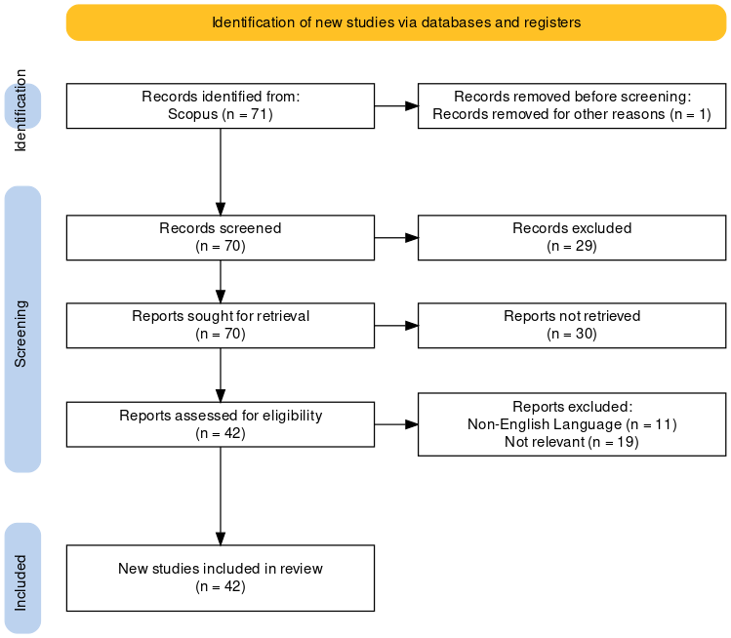
Figure 1: PRISMA flow diagram of search results (Haddaway et al, 2022)

RESULTS AND DISCUSSIONS
3.1. Descriptive Analysis
To answer the research questions RQ1, RQ2, RQ3 and RQ4, a descriptive analysis was conducted.

Figure 2: Publication trend since database inception until end of December 2024
Figure 2 represents the count of articles published over the years. The years 2004, 2006, 2008, and 2009 has one article published each. In 2010, there are two articles published. The year 2013 has the highest count of articles with three publications. In 2014, 2017, and 2018, there is one article published in each of these years. The years 2015, 2016, and 2019 have three articles published each. In the year 2020, there are seven articles published, making it one of the most productive years in terms of publications. The year 2021 surpasses the previous year with eight articles published. In 2022, six articles were published.
Based on the analysis, it can be observed that there is a relatively consistent level of publication activity in recent years, with a notable increase in the number of articles published from 2020 onwards.
Table 1: Most cited articles
Sl. No | Title | No. of Citations
1 | A global investigation into the constellation of consumer attitudes toward global and local products | 299
2 | The impact of accessible identities on the evaluation of global versus local products | 185
3 | Local products and geographical indications: Taking account of local knowledge and biodiversity | 99
4 | E-consumers and local food products: A perspective for developing online shopping for local goods in Poland | 47
5 | Territory, tourism and local products. The extra virgin oil's enhancement and promotion: A benchmarking Italy-Spain | 38
6 | An examination of consumer willingness to pay for local products | 31
7 | Do ethnocentric consumers really buy local products? | 26
8 | Social Movement Organization Leaders and the Creation of Markets for “Local” Goods | 21
9 | Assessment of the results of the strategic orientation on regional and local products in food retail | 18
10 | Examining the role of local products in rural development in the light of consumer preferences-Results of a consumer survey from Hungary | 18
11 | Factors influencing the sale of local products through short supply chains: A case of family dairy farms in Slovakia | 18

Table 1 represents a list of top 11 research article titles along with the number of citations they have received. "A global investigation into the constellation of consumer attitudes toward global and local products" has received 299 citations, making it the highest among the 42 articles under review. "The impact of accessible identities on the evaluation of global versus local products" has received 185 citations. "Local products and geographical indications: Taking account of local knowledge and biodiversity" has received 99 citations.
The number of citations indicates the level of influence and impact that these research articles have had within the academic community. Higher citation counts suggest that these articles have been widely referenced and considered significant contributions to the field.

Figure 3: Top two most productive journals
Figure 3 represents the sum of the number of published articles in top two most productive journals. The review found the presence and visibility of research related to local goods in some top journals such as Journal of International Marketing, Journal of Retailing and Consumer Services and Journal of Marketing. However, the journal "Sustainability (Switzerland)" has published the highest number of 7 published articles and the journal "European Countryside" has published 2 articles. The analysis provides an indication of the emphasis and interest in publishing research on local goods in these two journals.

Figure 4: Top leading countries
Figure 4 represents the contributions from top leading countries in the field of local goods. The United States has the highest number of contributions with 13. Italy follows closely with 11 contributions. Hungary, Indonesia, and Turkey each have 5 contributions. The Netherlands and Spain have 4 contributions each. France and Poland have 3 contributions each.
The data analysis indicates the United States and Italy emerge as leading contributors, with a significant number of publications on the topic. Other countries such as Hungary, Indonesia, and Turkey also demonstrate notable research output.

3.2. Bibliometric Analysis
Co-authorship analysis(countries): To answer RQ 5, a bibliometric analysis was conducted using VOS viewer software. A co-authorship analysis was performed with countries as the unit of analysis. The minimum number of published documents per country was set to 2. As a result, out of 29 countries, 11 met the threshold as is seen in Table 2. However, not all 11 countries were connected. Only 3 countries had the highest set of connections, as shown in Figure 5.
Table 2: Co-authorship analysis(countries)
Sl. No | Country | Documents | Citations | Total link strength
1 | Albania | 2 | 10 | 1
2 | France | 3 | 130 | 0
3 | Hungary | 5 | 43 | 1
4 | Indonesia | 3 | 3 | 0
5 | Italy | 3 | 51 | 1
6 | Netherlands | 3 | 308 | 1
7 | Poland | 3 | 53 | 2
8 | Spain | 4 | 54 | 1
9 | Thailand | 2 | 1 | 0
10 | Turkey | 4 | 28 | 0
11 | United States | 8 | 563 | 1

The data in Table 2 represents the bibliometric analysis of co-authorship patterns between countries in terms of the number of documents, citations, and total link strength and in the context of the research on local goods.
Based on the analysis using VOS viewer software, the United States has the highest number of documents (8) and the highest number of citations (563), indicating a strong research presence and influence in the field of local goods. France, Hungary, Italy, the Netherlands, Poland, Spain, and Turkey also demonstrate a significant number of documents and citations. Albania, Indonesia, and Thailand show lower levels of research output in terms of documents and citations.
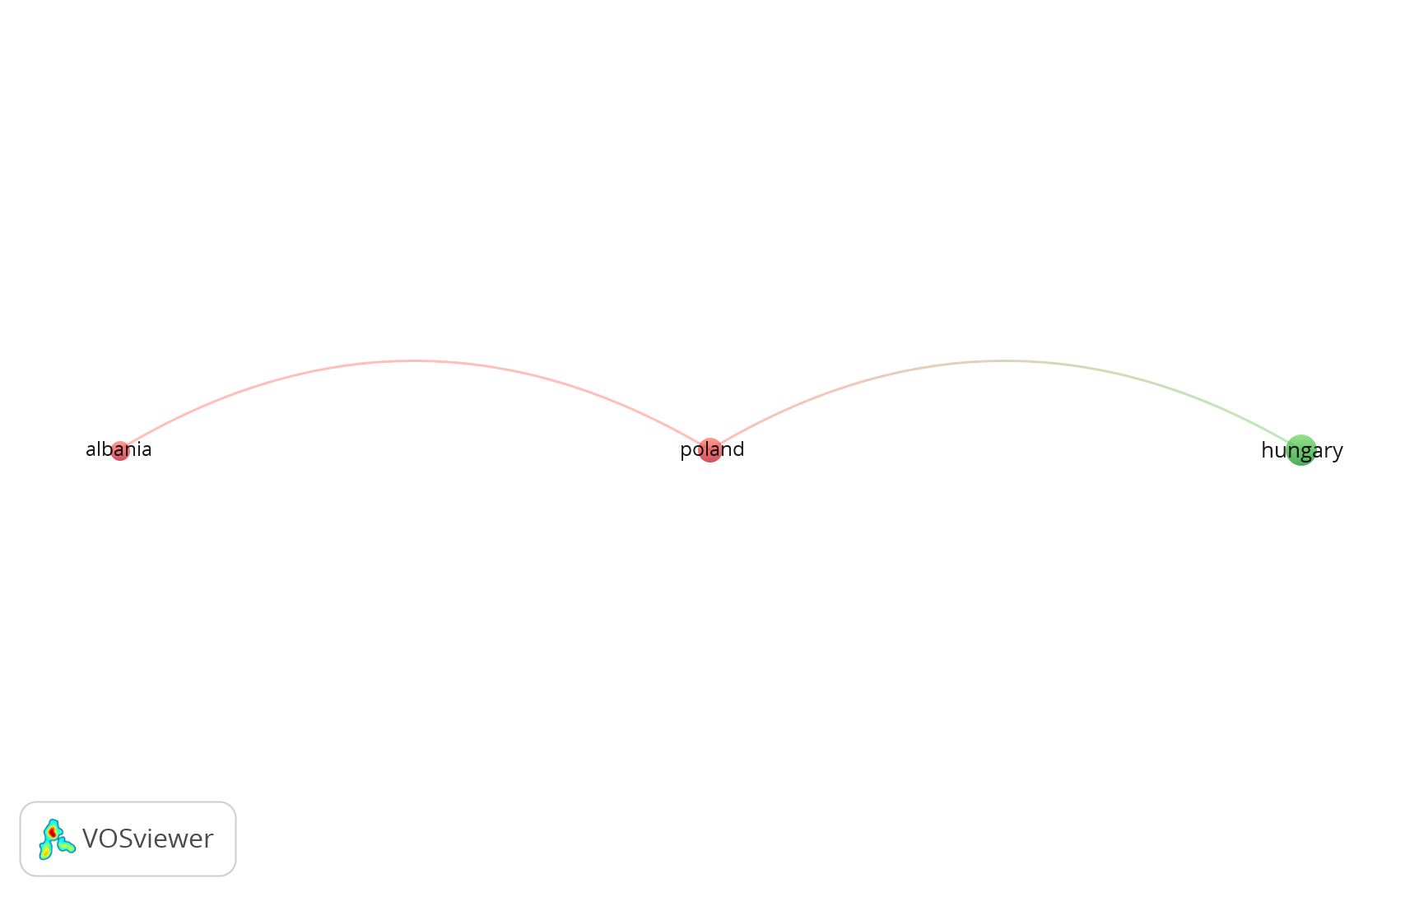
Figure 5: Co-authorship analysis of countries https://tinyurl.com/2fhjem8b
Figure 5 displays a network visualization copied from the VOS viewer of how the countries are connected. The total link strength indicates the level of collaboration between countries, with Poland having the highest link strength of 2 (Albania and Hungary), followed by Albania, Hungary, Italy, the Netherlands, Spain, and the United States with a link strength of 1. France, Indonesia, Thailand, and Turkey have a link strength of 0, indicating a lack of collaborative research between these countries.
Co-authorship analysis(authors): To answer RQ 5, another bibliometric analysis was conducted using VOS viewer software. A co-authorship analysis was performed with authors as the unit of analysis. The minimum number of published documents per author was set to 2 and the minimum number of citations per author was set to 2. As a result, out of 42 authors, 30 met the threshold. Based on the data, the authors seem to have published one document each, with varying citation counts. However, the total link strength for all authors is 0, as shown in Figure 6, indicating no collaboration or co-authorship between them.
Co-occurrence of keywords analysis: To answer RQ 6, a term co-occurrence map based on text data was created. The terms were extracted from Title and Abstract fields. Binary counting method was selected. The minimum number of occurrences of a term was set to 5. As a result, out of 1307 terms, 28 met the threshold. Out of the 28 terms, 60% most relevant terms were selected, which comprised of only 17 terms.
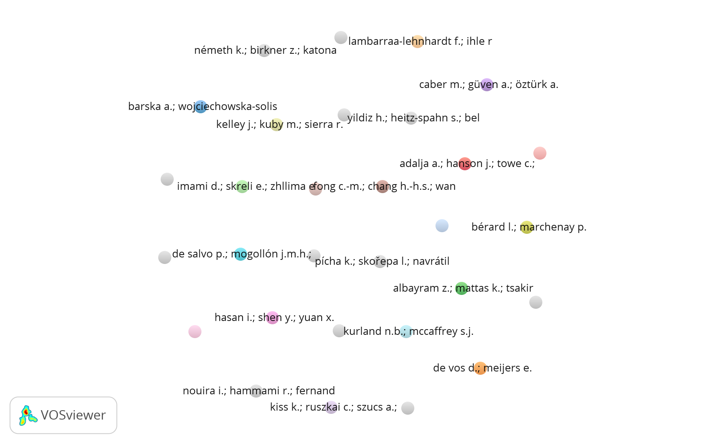
Figure 6: Co-authorship analysis of authors https://tinyurl.com/2mwnt5n4

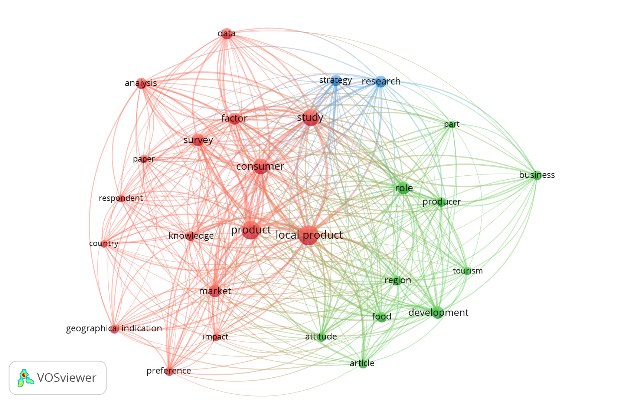
Figure 7: Co-occurrence of keywords https://tinyurl.com/2zg6u9p2
The Figure 7 provides an overview of the frequency of occurrence for various terms in the research on local products. The term "local product" which is a central focus of the study appears most frequently with 36 occurrences, a total link strength of 270 and a relevance score of 0.7428. The term "Product" has 29 occurrences, "Study" and "consumer" are also prominent terms, appearing 25 and 22 times, respectively, suggesting a strong emphasis on empirical investigations and understanding consumer behavior. The term "survey" is mentioned 15 times, indicating the popularity of this research method in studying local products. Also, terms such as "market," "development," "role," and "research" demonstrate their importance in exploring various aspects of local products.
3.3. Key Research Themes
The systematic literature review reveals several key themes in the research on local products. Researchers frequently focus on analyzing various aspects of local products, such as consumer preferences, awareness of local goods, demand for local goods and role of local goods towards economic development. The role of geographical indication is also explored. Following three major focus areas in the field of research on local products has been selected under the study to answer RQ 7.
- Role of Local goods towards economy
Existing literature has explored the role of local commodities in the economy and economic development, showing their potential impact on several different areas of economic growth. Local products are essential for promoting economic activity in the community. According to de Salvo et al., (2013), one such tool for local development could be the development strategies of typical products. This could also aid in the promotion of high-quality tourism by raising awareness of the ways in which locally produced goods serve to carry out a variety of community-based projects (including tourist routes, marketplaces, educational programs, and community gatherings) that can foster and support the development of new social relationships. Local products contribute to the creation of a unique local brand and identity. Areas well-known for regional goods might draw tourists and cultivate a favourable reputation, stimulating economic growth through higher visitor expenditure. Local goods have a significant impact on both daily living and tourism (Gonda et al., 2021). Attention-grabbing products are making an appearance in the tourism industry increasingly often, often serving as the cornerstones of tourist attractions constructed upon them. Not only do regional cuisines contribute to a sense of place, but they are also an important attraction for tourists, which boosts the local economy (Noguer et al., 2021). It is unavoidable to be left unnoticed how the contributions that locally grown, processed, and marketed food (the "Local Food System") has made to local socioeconomic growth and rural tourism (Nemis et al., 2019).
- Consumer demand for Local goods
The literature that has already been published has examined consumer demand for local goods and products, with studies examining the variables that impact customers' preferences and purchase behavior. According to research, several essential factors influence consumer demand for locally produced goods. One important reason is that local goods are authentic and of high quality. When selling local goods, farmers believe that the product itself, its quality, freshness, and location are the most crucial factors (Horská et al., 2020). Food that is grown locally is becoming more and more popular since it is thought to be healthier, unprocessed, and contains fewer preservative ingredients. It also uses fewer natural resources, which reduces its impact on the environment (Barska et al., 2020). Furthermore, sustainability and environmental concerns impact customer desire for locally produced items. Social and community considerations also impact customer desire for locally produced goods. There is a possibility of a home market segment of environmentally conscious consumers who favor food produced sustainably and organically (Lambarraa et al., 2021). Customers frequently value patronizing locally owned businesses, boosting the local economy, and promoting pride and community. Strongly devoted consumers are more likely to buy local items than consumers who exhibit a significant degree of ethnocentrism when it comes to making effective purchases of local goods (Yildiz et al., 2018). People with attitudes that make them interested in local products and inclined to favor them above others are those who like new and local products and prefer what is well-known (Gonda et al., 2021).
- Local goods and Geographical Indication (GI)
The notions of local goods and Geographical Indication (GI) are closely related and highlight the relationship between a product's reputation, quality, and particular place of origin. Locally produced goods and products with a geographic indication have many advantages. They are first and foremost a means of conserving traditional production techniques and cultural heritage. The findings show that customers respond consistently to local products with geographic indications. Customers are more likely to buy local items than non-local ones, and their purchasing decisions are influenced mainly by the products' quality and place of origin (Albayram et al., 2014) ^{[10]}. Geographical indication increases consumer trust and market value. Customers are reassured by the certification about the product's originality, excellence, and uniqueness. Local products recognized with geographical indications have a high impact rate, making them the most successful factor in the growth of tourism (Pamukçu et al., 2021) ^{[11]}. Geographical indication also encourages sustainable practices and rural development. It encourages the preservation of traditional production methods, environmental preservation, and the upkeep of regional ecosystems by safeguarding local items. When it comes to sustainable consumption, geographically indicated (GI) items are a preferable option (Muça et al., 2021) ^{[12]}.

LIMITATIONS AND FUTURE SCOPE

The present review paper has some limitations. First, the number of records on local goods were very limited. Second, the study did not limit articles based on a specific time frame due to the scarcity of the records on local goods. The study includes 42 literature sources extracted from the Scopus database. While efforts have been made to select a representative sample, the relatively small sample size may not capture the entirety of the research on local goods.
Future research can consider expanding the literature sources beyond the Scopus database. Including additional databases, such as Web of Science, PubMed, or subject-specific databases, would provide a more comprehensive overview of the research landscape on local goods. The defined inclusion-exclusion criteria may not be exhaustive. Future researchers can include the excluded criteria to select the literatures for further analysis and more comprehensive view of the research landscape on local goods.

CONCLUSION

The present study provides insights into the current state of knowledge in the field of local goods research, highlighting the trend of co-authorship patterns and collaborations between countries, and the diverse factors influencing local goods research. By addressing the limitations and considering the future scope outlined above, researchers can further enhance the understanding of the landscape of local goods, provide a more comprehensive analysis, and uncover new avenues for exploration in this field of study.
In conclusion, local goods have gained recognition for their cultural significance, economic potential, and environmental benefits. They offer unique products that connect consumers with their community and promote sustainable consumption. Despite the challenges they face, initiatives and policies aimed at supporting local goods have emerged, fostering their growth and market presence. Further research is needed to understand consumer behavior, assess the impact of local goods on regional economies, and explore innovative strategies to overcome existing barriers. By leveraging the knowledge and understanding of local goods, stakeholders can work towards building resilient and vibrant local economies while preserving cultural diversity and promoting sustainable practices.

Disclaimer (Artificial intelligence)
The authors declare that NO generative AI technologies such as Large Language Models (ChatGPT, COPILOT, etc.) and text-to-image generators have been used during the writing or editing of this manuscript.

REFERENCES
Albayram, Z., Mattas, K., & Tsakiridou, E. (2014). Purchasing local and non-local products labeled with geographical indications (GIs). Operational Research, 14, 237-251.
Aria, M., & Cuccurullo, C. (2017). bibliometrix: An R-tool for comprehensive science mapping analysis. Journal of Informetrics, 11(4), 959–975. https://doi.org/10.1016/j.joi.2017.08.007
Barska, A., & Wojciechowska-Solis, J. E-Consumers and Local Food Products: A Perspective for Developing Online Shopping for Local Goods in Poland. Sustainability 2020, 12, 4958.
de Salvo, P., Hernández Mogollón, J. M., Di Clemente, E., & Calzati, V. (2013). Territory, tourism and local products. The extra virgin oil's enhancement and promotion: a benchmarking Italy-Spain. Tourism and hospitality management, 19(1.), 23-34.
Donthu, N., Kumar, S., Mukherjee, D., Pandey, N., & Lim, W. M. (2021). How to conduct a bibliometric analysis: An overview and guidelines. Journal of Business Research, 133, 285–296. https://doi.org/10.1016/j.jbusres.2021.04.070
Gonda, T., Angler, K., & Csóka, L. (2021). The role of local products in tourism. European countryside, 13(1), 91-107.
Haddaway, N. R., Page, M. J., Pritchard, C. C., & McGuinness, L. A. (2022). PRISMA2020: An R package and Shiny app for producing PRISMA 2020-compliant flow diagrams, with interactivity for optimised digital transparency and Open Synthesis Campbell Systematic Reviews, 18, e1230. https://doi.org/10.1002/cl2.1230
Horská, E., Petriľák, M., Šedík, P., & Nagyová, Ľ. (2020). Factors influencing the sale of local products through short supply chains: A case of family dairy farms in Slovakia. Sustainability, 12(20), 8499.
Lambarraa-Lehnhardt, F., Ihle, R., & Elyoubi, H. (2021). How successful is origin labeling in a developing country context? Moroccan consumers’ preferences toward local products. Sustainability, 13(15), 8433.
Muça, E., Pomianek, I., & Peneva, M. (2021). The Role of GI Products or Local Products in the Environment—Consumer Awareness and Preferences in Albania, Bulgaria and Poland. Sustainability, 14(1), 4.
Nemes, G., Csizmadiáné Czuppon, V., Kujáni, K. O., Orbán, É., Szegediné Fritz, Á., & Lajos, V. (2019). The local food system in the ‘genius loci’–the role of food, local products and short food chains in rural tourism. Studies in Agricultural Economics, 121(2), 111-118.
Noguer-Junca, E., Crespi-Vallbona, M., & Fusté-Forné, F. (2021). Sociocultural and gastronomic revaluation of local products: trumfa in the Vall de Camprodon (Catalonia, Spain). International Journal of Gastronomy and Food Science, 26, 100425.
Pamukçu, H., Saraç, Ö., Aytuğar, S., & Sandıkçı, M. (2021). The effects of local food and local products with geographical indication on the development of tourism gastronomy. Sustainability, 13(12), 6692.
Yildiz, H., Heitz-Spahn, S., & Belaud, L. (2018). Do ethnocentric consumers really buy local products?. Journal of Retailing and Consumer Services, 43, 139-148.
Zupic, I., & Čater, T. (2015). Bibliometric methods in management and organization. Organizational Research Methods, 18(3), 429–472. https://doi.org/10.1177/1094428114562629

