Original Research Article

ECOLOGICAL ASSOCIATION AND DIVERSITY OF SELF-RECRUITING WILD FISH SPECIES IN AQUACROP SYSTEMS OF NORTHEASTERN BIHAR

ABSTRACT
In recent times, aquaculture production in northeastern Bihar has been dominated by the cultivation of Makhana (Euryale ferox) and Singhara (Trapa natans). Consequently, fish has become a strategically significant commodity. The majority of wetlands supporting Makhana and Singhara cultivation provide a natural habitat, feeding grounds, and breeding environments for various shellfish and finfish species, particularly during the monsoon season. Exploratory surveys were conducted in the landlocked aquatic systems of the Purnea district located in the northeastern Bihar, to document the dispersal and abundance of self-recruiting finfish and shellfish diversity across different aquatic fields, including rice fields, Makhana crops, and Singhara crops. The local fish market survey was considered to have a solid framework, supported by direct observations, and specific inventories were identified through personal interviews and focus group discussions. The association between aquacrops and fish population diversity was studied across these three aquatic farming systems from January 2021 to December 2022. Economically and medicinally important fish and shellfish species were identified within Makhana and Singhara pond ecosystems, as well as rice fields. These included Pila globosa, Pila virens, Bellamya bengalensis, Lamellidens species, and Parreysia favidens. Additionally, small-to medium-sized freshwater Macrobrachium prawn species such as M. gandaki, M. tiwari, and M. lamerrei were observed. Among true fishes, Clarias magur, Heteropneustes fossilis, and Channa species were the predominant catches. Makhana (Euryale ferox) and Singhara (Trapa natans) crops supported a rich gastropod fauna and demonstrated a strong ecological association with these aquatic plant species. The results provide critical insights into the ecological and economic roles of self-recruiting species (SRS) in traditional aquacrop systems, such as Makhana and Singhara, in northeastern Bihar. The documented decline in species due to pesticide use highlights the urgent need for eco-friendly agricultural policies.
Keywords: Euryale ferox, Trapa natans, Shellfish, Diversity, Aquaculture
INTRODUCTION
The wetland ecosystems of North Bihar contribute significantly to biodiversity, with Makhana and water chestnuts being commercially valuable aquacrops for the country (Raut et al., 2024). Subsequently, fish has turn out to be a deliberately significant commodity. Makhana (Euryale ferox) and Singhara (Trapa natans) are typically cultivated in permanent stagnant water bodies such as ponds, land depressions, lakes, and ditches. These crops require a shallow water depth of 3–6 feet, an air temperature range of 20–35°C, relative humidity between 50–90%, and annual rainfall of 100–250 mm (Mandal et al., 2010; Saurav & Chandran, 2023). Macrophytes such as E. ferox, T. natans, and paddy vegetation play a crucial role in providing habitat and shelter for macroinvertebrates and fish, particularly bottom-dwelling species, Indian major carps, and air-breathing fishes, which rely on these environments for survival and protection (Singh et al., 2017; Kumari & Shubham, 2020; Jhan et al., 1991; Prasad & Sinha, 2024). Currently, aquaculture is recognized as the world's fastest-growing agribusiness, meeting the rapidly increasing global demand for fish and other aquatic food species. According to Saurabh & Chandran (2023), approximately 35,224 hectares of Euryale ferox are cultivated in India, with Bihar accounting for over 90% of global Makhana production (Singh & Agrawal, 2024).
The first author observed that fish harvested sustainably from farmers' aquacrop systems (Makhana and Singhara ponds) without regular stocking are classified as Self-Recruiting Species (SRS). These species function at the intersection of aquaculture and capture fisheries (Little et al., 2004; Shankar et al., 2017; Prasad & Singh, 2024). The importance of wild finfish and shellfish in both natural and managed aquatic habitats for the livelihoods of rural communities has been well documented (Gregory & Guttman, 1996; Shankar et al., 2017). In countries such as Thailand, wild fish caught from natural and modified ecosystems have been found to be more crucial to rural households than intentionally stocked fish species (Saengrut, 1998). In northeastern Bihar, shellfish such as apple snails and small prawns are popular food items among poor and local communities, as well as among migrant Bengali populations. Several researchers (Mishra et al., 1990, 1991, 1992; Nath et al., 2018) have studied the association of insects and gastropods with E. ferox in relation to their pest status. Additionally, Shankar et al. (2017), Singh et al. (2017), and Das, (2018) have explored the prospects of rice-fish farming and other aquatic crop farming in low-lying areas of North Bihar, which serve as refuges and breeding grounds for wild fish. This system has the potential to supplement aquaculture practices and help meet the growing demand for freshwater fish while improving rural nutrition.
Against this background, the present study investigates the availability and diversity of self-recruiting wild indigenous fish species in aquatic crop systems and evaluates their commercial importance for enhancing the nutrition of rural populations in this region.
MATERIALS AND METHODS
Investigational surveys were conducted in selected ponds, including those at Bhola Paswan Shastri Agricultural College (BPSAC) Farm and nearby areas in Purnea, Bihar. The study site is located at 25˚48’47” N latitude and 87˚31’06” E longitude, at an elevation of 62 meters (203±4 feet), as shown on Google Map (Fig.-1). The survey areas included rice fields, Makhana (Euryale ferox), and Singhara (Trapa natans) cultivation fields at BPSAC Purnea, along with nearby farmers' ponds. These ponds receive surface runoff during rainfall, providing natural refuge habitats for aquatic organisms.
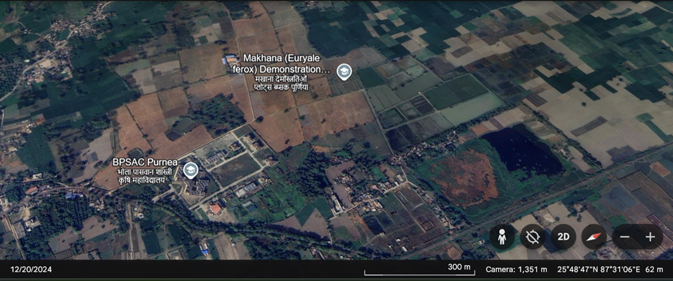
Figure 1: Google map showing the study area BPSAC, Purnea, Agriculture farm, Bihar

Monthly observations and collections of gastropods and fish fauna were conducted across all aquacrop ponds following the revised procedure of Welch from January 2021 to December 2022. The prevalence and role of Self-Recruiting Species (SRS) in Makhana, Singhara, and paddy fields were examined. Monthly surveys were carried out with the assistance of local fishers and supporting staff during this period. The local fish market survey was considered to have a solid framework, supported by direct observations, and specific inventories were identified through personal interviews and focus group discussions. The report explicitly highlights a decline in fish species, attributed to pesticide use.
Additionally, surveys were conducted at the local fish market in Naka Chauk, Purnea, to assess the demand for indigenous Self-Recruiting fish species (SRS). The first author also established a rented room in Naka Chauk, near the fish market in Purnea, Bihar, from April 2019 to July 2023, to facilitate data collection and analysis. Facts and figures related to the demand and supply of shellfish captured from Makhana, Singhara, and paddy fields were also documented.
RESULTS AND DISCUSSION
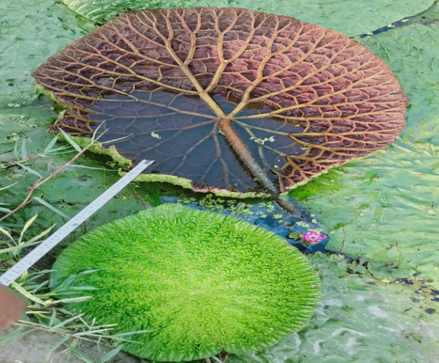
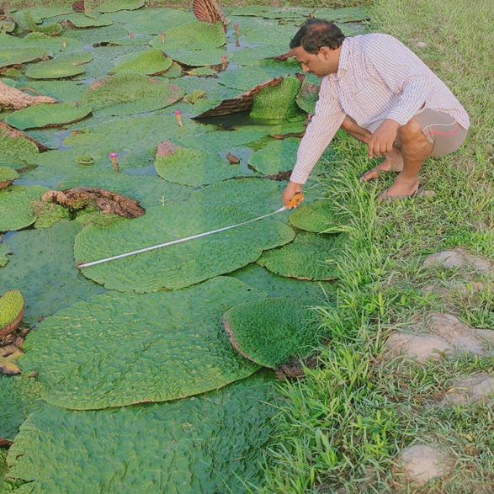
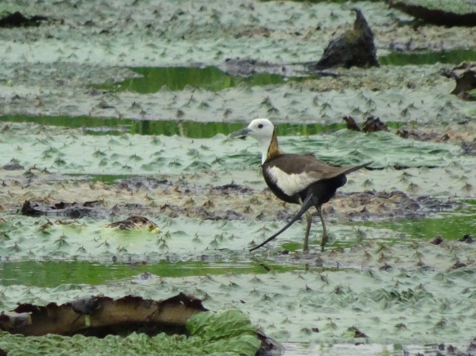
A variety of hydrophytic macrophytes naturally occur in the floodplain wetlands of northeastern (NE) Bihar. The aquatic ecosystems of NE Bihar, particularly those associated with the Mahananda and Koshi rivers, support commercially important macrophytes such as Makhana (Euryale ferox) and water chestnut (Trapa natans). During observations, sestanophagous and detritophagous finfish species such as Clarias magur, Heteropneustes fossilis, and Channa species, along with shellfish like Pila globosa, Pila virens, and Bellamya bengalensis, were found to be highly compatible with Makhana crops. This compatibility is due to the accumulation of decomposed plant residues and fish faecal matter in the ponds, creating a mutually beneficial environment. Similar findings have been reported by Pavlov & Kasumyan (2002) and Raut et al. (2024). In the present study, it was observed that mollusks primarily attached themselves to the lower parts of Makhana leaves during the day, it may seeking shelter from predators (Fig. 2).
d
c
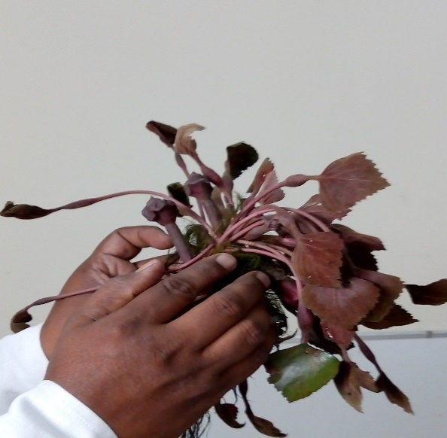
Fig-2:Mollusks attach themselves to the lower parts of Makhana and Singhara leaves during the day to seek shelter from predators. (a) Mollusk on Singhara crop, (b) Predator (Jacana bird) on Makhana leaf, (c) Ventral side of Makhana leaf, (d) Diameter of Makhana leaf.
b
a
Srivastav & Singh (2021) reported that many gastropods are herbivorous, scraping algae particles from substrates. They also noted that some herbivorous species function as grazers and browsers, while others are planktonic feeders. Additionally, certain snails act as scavengers, feeding on dead plant material, while others are predatory. Many species of gastropods are found in macrophyte-dominated wetlands, but only some hold commercial importance, particularly in Makhana (Euryale ferox) and Singhara (Trapa natans) crops. Similar observations and documentation have been reported by various researchers (Mishra et al., 1991; Prasad & Sinha, 2024; Kumari & Shubham, 2020). In the current study, we observed that macrophytes serve as a vital food source for both finfish and shellfish. Gastropods primarily feed on dead plant tissue, while catfish and other carnivorous fish depend on gastropods and snails as part of their diet. Notably, both gastropods and catfish, which exhibit nocturnal behavior, benefit from the shading effect of Makhana and Singhara crops. These crops reduce intense sunlight during the day by covering the water surface with their leaves and stems.
Most previous studies on paddy-cum-fish systems used exotic or omnivorous fish species (Vonvichith et al., 2018). In contrast, this study focused on indigenous, carnivorous species such as Anabas testudineus, catfishes, Pila species (Bellamya bengalensis), and small Macrobrachium species. These species were not intentionally stocked but entered the pond naturally during the rainy season, aligning with the goals of biodiversity conservation and enhancing the market value of the harvested fish.
Raut et al. (2024) suggested that in integrated aquaculture-agriculture systems, such as Makhana cultivation combined with fish farming, it is essential to allocate 10–15% of the water surface as open space for optimal productivity. In Bihar, approximately nine districts Madhubani, Darbhanga, Sitamarhi, Saharsa, Katihar, Purnea, Supaul, Kishanganj, and Araria are the principal regions for Makhana production. Meanwhile, Raut et al. (2024) and Prasad & Sinha (2024) reported that 15 districts, including Katihar, Purnea, Araria, Supaul, Madhepura, Khagaria, Saharsa, Begusarai, Samastipur, Darbhanga, Madhubani, Muzaffarpur, Vaishali, Saran, and Buxar, are the key areas for harvesting and marketing shellfish species, particularly mollusks.
In the present study, it was also observed that part-time or seasonal fishers engage in fishing activities in the wetlands during the monsoon when fishery resources are abundant. The Makhana (E. ferox) and Singhara (T. natans) crops provide a natural refuge for gastropods and catfish, offering them shelter from predators such as birds, including cranes, jacanas, darters, and kingfishers (Prasad, 2023; Prasad, et al., 2025). In the present study, the decaying roots, stems, and leaves of Makhana (Euryale ferox) and Singhara (Trapa natans) were found to create an exceptionally favorable environment, serving as a substrate for egg-laying and larval development of gastropods and catfish. This clearly indicates that gastropods and catfish depend on Makhana and Singhara crops for their essential life activities. These wetlands naturally harbor a rich diversity of shellfish, with more than eight species of shellfish and four species of catfish recorded in the studied water bodies. Das (2018) supports the findings of the present study, noting that wetlands in Northeast India provide natural habitats, breeding environments, and feeding grounds for a variety of aquatic life forms during the monsoon season. In terms of fish species composition, these flooded fields exhibit an enormous diversity of piscine fauna. However, according to local fishermen and villagers, several important indigenous shellfish and catfish species have declined over the past decade due to the direct use of insecticides and pesticides in Makhana and Singhara cultivation. As a result, some shellfish species, such as Pila species, Bellamya bengalensis, Lamellidens species, and Parreysia favidens, as well as crabs and Macrobrachium species (M. gandaki, M. tiwari, M. lamerrei), were found in very low numbers in natural water bodies (Prasad, 2023; Prasad et al., 2023; Prasad et al., 2025). A survey conducted in various freshwater bodies of northeastern (NE) Bihar documented the fish and shellfish species present and their utilization, as listed in Table 1.

Table 1. A diverse assemblage of fish species in aquatic ecosystems and their distinguishing features.
Type of aqua crops | Shellfish and finfish Species | Care/attention | Abundance and Use
Makhana (Euryale ferox) pond | Catfishes, Apple snail, Mussels small prawns spp anabas testudieus, H. fossils | Harvested in dry season, low land, flood prone, Integrated management, accidental entry only | Catfish, snail dominated, High value fish and shell fishes sold / consumption / medicinal uses,
Singhara (Trapa natans) pond | Carps, Puntius sp., Cat fishes, Apple snail, Mussels small prawns sp. and crab | Harvested in dry season, low land, flood prone, Integrated management, accidental entry only | Carps, Puntius sp., Consumption/ sold in local fish market
Rice fields | Catfishes, Pila species (Bellamya bengalensis) small Macrobrachium species. | Not stocked, they inter into pond during rainy season. | Small snail dominated, Consumption/sale to local fish market, medicinal uses

The economic importance and medicinal uses of shellfish species, such as Pila and Bellamya, and catfish species like Heteropneustes fossilis, Clarias magur, and Channa species, was found to be most significant in Makhana (Euryale ferox) cultivation. Pandiarajan et al. (2022) documented that Pila globosa is used in the treatment of bone disorders. According to Adeyeye (1996), pregnant women also consume a high amount of snail haemolymph for its medicinal benefits, particularly to alleviate labour pain and to prevent blood loss during childbirth. In contrast, in Singhara (Trapa natans) crops, Puntius species, carps, and small prawn species were dominant. In the Makhana and Singhara ponds, as well as in low-lying areas such as Katihar and Purnea, which are located near the Koshi and Mahananda rivers, shellfish species like prawns (Macrobrachium gangeticum, M. tiwari, M. lamerrei, M. gandaki) constituted a significant portion of the catch, along with catfish species (Prasad et al., 2023). The present study also observed that several farmers and fishermen managing Makhana and Singhara ponds in Purnea, Bihar, had self-recruiting species (SRS) such as small and medium-sized freshwater prawns, Puntius species (Rs. 100–120 per kg), murrels (Channa species) (Rs. 150–200 per kg), and catfish (Clarias magur) (Rs. 400–500 per kg) and H. fossilis (Rs. 500–600 per kg) as bycatch along with carps. Most of these species were either consumed locally or sold in the city’s Naka Chauk fish market in Purnea at high market value, as detailed in Table 2.
Table 2. SRS of native and exotic fishes in Purnea district Bihar
Species | Native | Status | Economic importance/ uses | Market Price (Rs/kg)
Channa species | Yes | Common | Medicinal / Food | 150-200
Apple snails (P. globosa) | Yes | Common | Medicinal /Food | 100-150
Mussel | Yes | Common | Medicinal /Food | 100-120
Clarias batrachus | Yes | Common | Medicinal/Food | 400-600
Heteropneustes fossilis | Yes | Common | Medicinal | 400-600
M. lameraii, M. tiwari, M. gandaki | Yes | Very rare | Medicinal use/Food | 400-500
Puntius spp. Anabas testudineus | Yes | Very common | Consumption/Food | 100-120
Crab  (Paratelanusa spinigera) | Yes | Common | Consumption/Food | 100-130

Das (2018) documented that harvested fish production after dewatering ponds varied from 200–300 kg per season. The study suggests that there is a similar potential in North Bihar, given the traditional farming systems practiced by the local population. Out of the ten edible freshwater shellfish species recorded in northeastern (NE) Bihar, five were mollusks, namely Pila globosa, Pila virens, Bellamya bengalensis, Lamellidens species, and Parreysia species. Snail meat is considered a superior source of protein, second only to that found in fish and prawns. Both the foot and hepatopancreas of Pila globosa have edible value (Panda et al., 2021). The crustacean species included prawns and crabs such as Macrobrachium gangeticum, M. tiwari, M. gandaki, M. lamerrei, and one species of crab (Paratelanusa spinigera). Additionally, five species of true fish Clarias magur, Heteropneustes fossilis, Channa striatus, and Puntius species were either deliberately or accidentally introduced in NE Bihar. All these introduced fish species were found to be self-recruiting species (SRS) and were commonly observed during the study.
Wild aqua-cropping in rice fields is a widespread practice in North Bihar. Farmers are accustomed to digging trap ponds within the paddy fields. These fields often overflow during July–August, becoming connected to nearby watercourses, which allows the entry of seeds of various wild fish and prawns. This provides a refuge for fish and unintentionally facilitates the entry of wild fish fry or fingerlings into the fields, where they remain until the surrounding open water recedes below the entry point. These indigenous species are highly nutritious and of significant economic importance (Sinha et al., 2024). Shankar et al. (2015) and Mansharamans et al. (2020) reported that the co-culture system, particularly rice-fish cultivation, has beneficial effects on farm income and improves the livelihoods of poor rural communities and progressive farmers. The management and conservation of both commercial and non-commercial self-recruiting fish species (SRS) in farmer-managed aquatic systems (FMAS), particularly during the cultivation of macro-hydrophytes (Makhana, Singhara, and paddy), are essential for maintaining ecological integrity and ensuring the sustained availability of these species (Faruk-UI-Islam, 2007; Shankar et al., 2015).
CONCLUSION
The results provide critical insights into the ecological and economic roles of self-recruiting species (SRS) in traditional aquacrop systems, such as Makhana and Singhara, in northeastern Bihar. It is concluded that small indigenous finfish and shellfish (SIF) are in high demand and possess significant potential for subsistence fisheries. Promoting their use through capture-based aquaculture (CBA) is essential, as farming these species in unmanaged macro-hydrophyte ponds and rice fields requires no major inputs such as commercial feed. These species can be naturally attracted during floods and heavy rains and subsequently managed in ponds for periodic harvesting. The documented decline in species due to pesticide use highlights the urgent need for eco-friendly agricultural policies.
ACKNOWLEDGEMENTS
The authors are thankful to the Hon’ble Vice Chancellor and the Director Research, BAU, Sabour, for the provided financial assistance provided project code no. BAU/SNP/NRM/Rabi/2019-23 and furnished BAU Communication No. 1284/221104.

Disclaimer (Artificial intelligence)
Option 1:
Author(s) hereby declare that NO generative AI technologies such as Large Language Models (ChatGPT, COPILOT, etc.) and text-to-image generators have been used during the writing or editing of this manuscript.
REFERENCES
Amechi, M. 1995. An assessment of by-catch biomass in experimental fish ponds. Asian Institute of Technology. Pathumthani Province, Thailand, M.Sc. Dissertation. 45 p.
Adeyeye E. 1996. Waste yield, proximate and mineral composition of three different types of land snails found in Nigeria. International Journal of Food Nutrition, 47: 111-116.
Das, D. N. 2018. Farming of fishes in rice field in North India. A review: Journal of cold-water fisheries. 1 (1): 27- 41.
Faruk U. I, Islam, A. T. M. 2007. Self-recruiting species in Aquaculture: Their role in rural livelihood in two areas of Bangladesh. D. Phil Thesis, University of Stirling, UK.
Gregory, R. and Guttman H. 1996. Management of rice field fisheries in South East Asia: capture or culture. ILIEA Newsletter, 12, 20-21.
Jha V., Kargupta A.N., Dutta R.N, Jha U.N., Mishra R.K. and Saraswati K.C. 1991. Utilization and conservation of Euryale ferox Salisb. in Mithila (North Bihar), India. Aquatic Botany. 39: 295. 314.
Kumari A. and Shubham. 2020. Association of Gastropods-Hydrophytes in Some Ponds of Darbhanga. Bulletin of Environment, Pharmacology and Life Science 9(12): 23-26.
Kumari A., Singh I. S., Kumar L., Kumar A., Kumar R., and Gupta V. K. 2014. Morphological Characteristics of Makhana Germplasm of Manipur under Darbhanga Conditions. Journal of Agri Search 1(3): 157-160.
Little, D., Lorenzen, K., Amilhat, E., Morales, E., Imminik, A., Faruk, F. and Karapanagiotidis, I. 2004. Self-recruiting species in aquaculture- Their role in rural livelihood Final Technical report.
Lorenzen, K., Garaway C.J., Chamsingh, B. and Warren, T. J. 1998. Effects of access restrictions and stocking on small water bodies fisheries in Laos. J. Fish. Bio. 53:345-357.
Mandal R. N., Saha G. S. and Sarangi, N. 2010. Harvest and processing of makhana (Euryale ferox Salisb.) - A unique assemblage of traditional knowledge. Indian J. Tradit. Knowl. 9, 684-688.
Mansharamans, A., Srivastava A. and Choubey, A. 2020. Rice fish farming system in India is in urgent need conservation and promotion. Down to Earth, 14 April, 2020, 1- 3.
Mishra R. K., Jha V., Kumar R. and Jha B.P. 1990. The pests of Euryale ferox Salisb. In North Bihar. Environment and Ecology, 8(1): 133-36.
Mishra R.K., Jha B.P., Jha V., Singh S.K. and Mahto A. 1992. Insect association of Euryale ferox Salisb. In the ponds of Darbhanga, North Bihar. Journal of fresh water biology 4(3): 199-208.
Mishra R.K., Jha B.P., Singh S.K. and Jha V. 1991. Gastropod-macrophyte association in the ponds of Darbhanga, North Bihar, India. Journal of Eco-biology, 3(1): 23-28.
Nath, P., Kumar, A., Yadav, P.K. and Kumar, R., 2018.Emerging pests of Makhana (Euryal ferox, Salib) crop in Koshi region of Bihar, Int. J. Curr. Microbiol. Appl. Sci.7: 4605-4609.
Pandiarajan S., Samuel S., Iswaran V., and Venkatachalam R. 2022. GC-MS screening and in-silico prediction of Pila globosa extract against the bone diseases in calcitonin receptors. J. Adv. Sci. Res. 13: 69–84.
Panda F., Pati S., Bal A., Mathur S., Nirmaladevi R., and Paital B. 2021. Temporal morphometric analyses of Pila globosa in India for its use in aquaculture and food industry. J. Basic Appl. Zool. 82: 17–19.
Palavai V. and Davidar, P. 2009. A survey of freshwater fishes of Andaman Islands. J. Bom. Nat. His. Soc. 106 (1):11-14.
Pavlov D.S. and Kasumyan A.O. 2002. Feeding diversity in fishes, trophic classification of fish. Journal of ichthyology. 42 (2): 137.
Prasad S. and Sinha M.K. 2024. Progression of Marketing and Utilization Pattern of Fresh Water Molluscan in Bihar. Uttar Pradesh Journal of Zoology Volume 45, Issue 18, Page 402-409, DOI: https://doi.org/10.56557/upjoz/2024/v45i184458.
Prasad S., Nath P. and Chaudhary D.N. 2023. Freshwater prawn diversity (Crustacea Decapoda) in the river Koshi, Eastern Bihar, Asian Journal of Research in Zoology 6 (2):11-18
Prasad, S., Bhusan, M., Kumari, A., Kumar, U.M., and Nath, P., 2025. Diversity and Habitat Ecology of Freshwater Edible Snails, Essence in Food Security and Ethno-Medicine in Bihar, India Uttar Pradesh Journal of Zoology, 46 (8): 55-63. DOI: https://doi.org/10.56557/upjoz/2025/v46i84893
Raut, S., Padala V. K., Singh J., Singh I.S., Ahirwal S., Nair S., Raman R. K., Jana, B. R., Kumar M., Tarate S.B. and Roul R. K. 2024. Enhancing Productivity of the Wetland Ecosystem in North Bihar, India. Indian Farming Digest. 3 (1): 1-5.
Saengrut T. 1998. Role of wild fish in aquatic resource development in the lower chi valley of Thailand. Asian Institute of Technology, Pathumthani Province, Thailand, M.Sc. Dissertation. 100p.
Saurav S.K. and Chandran V. 2023. Dynamics of Makhana cultivation in Bihar: A comprehensive Analysis. Vigyan Varta 4(8): 63-67.
Shankar R.K., Ram N., George G. and Krishna P. 2015. Diversity and Fishery of self-recruiting species in Andaman Island. Journal of Inland Fisheries Society of India. 47 (2):38-43
Singh I. S., Kumar L., Bhatt B. P., Thakur A. K., Choudhary A. K., Anil K. 2017, Integrated Aquaculture with Fox nut: A case study from North Bihar, India, Int. J. Curr. Microbiol. App. Sci. 6 (10):4906-4912.
Singh, M., Agrawal S. K. 2024. Bihar’s Makhana Production Scenario. The Academic, Volume 2 (7): 80-89.
Sinha, A., Gogoi P., Damroy S. 2024. Small indigenous fish (SIF): status and contribution in nutrition and livelihood security of India. A review aquaculture review. 45 (1): 60-67.
Srivastava, A. K. and Singh, V. K. 2021. Feeding behaviour in gastropods molluscs. Journal of Cell & Molecular Biology 5 (1): 100013.
Vonvichith, B., Morika, S., Kawamura, K., and Mori, A. 2018. Factors influence fish productivity in rice paddy aquaculture: A Case study in Vientiane provinece Central Laos. JARQ, 52(4): 359-366.

