Analysis of Diversity and Distribution of Tree Species in Urban Landscape: A Case Study of Chhatrapati Sambhajinagar, India.

Abstract
Urbanization significantly alters ecological dynamics, often compromising biodiversity and essential ecosystem services. Urban green spaces, particularly tree cover, play a pivotal role in mitigating the negative impacts of urban expansion by improving air quality, regulating temperature and supporting local biodiversity. This study investigates the diversity, richness and spatial distribution of tree species in Chhatrapati Sambhajinagar (formerly known Aurangabad), across 20 sites with total area of 10.84 sq. km surveyed using the line transect method between September and December 2024. Results indicate that urban parks exhibit the highest species richness 36.8 species average, while dumping sites had the lowest 9 species average. Nehru udyan recorded the highest tree diversity H' = 3.29, followed by Himayat bagh and Siddharth garden. Whereas, Naregaon dumpsite showed the lowest tree diversity H' = 0.81. High species evenness was observed in Sawangi lake 0.9316, while Walmi lake recorded the lowest. Azadirachta indica and Cassia fistula were the most dominant species across all locations. The study highlights the need for habitat specific conservation efforts, particularly in ecologically degraded sites aimed at enhancing green cover and promoting sustainable urban ecosystem in the city.
Introduction

Significant ecological alterations, impacting ecosystem services and biodiversity are often the causes of urbanization. The tree cover in urban green spaces, play a crucial role in minimizing the adverse effects of urban expansion by enhancing air quality, regulating temperature, and supporting local fauna (Seto et al., 2012; Pickett et al., 2011). Besides, the rapid urbanization in Indian cities has immensely pressurized their green infrastructure (Elmqvist et al., 2013). The rapidly developing Chhatrapati Sambhajinagar city has undergone notable transformations in its urban landscape. This research investigates the diversity, richness and spatial distribution of tree species at 20 distinct sites within the city boundary, aiming to evaluate their ecological roles and status and provide insights for sustainable urban development (Alberti, 2005; Grimm et al., 2008).
Improvement of urban living conditions is relied on urban forests that serves as critical habitat for variety of species offering ecosystem services like reducing heat island effects, filtering air pollutants, and providing psychological benefits to city dwellers (Pataki et al., 2011). As cities in developing countries like India grow rapidly, it’s more important than ever to protect and improve urban green spaces to help tackle the environment problems that comes with urbanization (Andersson et al., 2014). The variety of tree species in city is usually shaped by several factors like how the land was used in the past, local traditions, and the types of economic activities in the area. For example, research shows that cities with a colonial past often have a mix of native and foreign tree species, influenced by the tastes and needs pf different time periods (Zipperer et al., 1997).
In a city like Chhatrapati Sambhajinagar, looking at how these influences have affected its tree diversity is important for planning better conservation efforts. Urban biodiversity also plays a key role in helping cities adapt to climate change. Native tree species, in particular, are known to absorb carbon and help manage water, which makes them essential for building sustainable and climate-friendly cities (Strohbach & Haase, 2012). While exotic species can add beauty to city landscapes, they can sometimes disrupt the local ecosystem and reduce native biodiversity (Pyšek et al., 2010). Even though more people are starting to understand how important urban green spaces are, many Indian cities still struggle with problems like haphazard development, poor upkeep of parks and green areas, and a general lack of awareness about protecting biodiversity (Sharma et al., 2019). These challenges are especially visible in fast-growing cities like Chhatrapati Sambhajinagar, where finding the right balance between development and caring for the development and caring for the environment is still a major issue.
This study looks at the variety of tress species in Chhatrapati Sambhajinagar with the goal of supporting smarter, more informed urban planning decisions. The insights gained are meant to help us better understand how city ecosystem work in Indian urban area and to suggest practical ways to improve and protect urban biodiversity.

Materials and Methods
- Study area

Figure 1. Representation of location of study area.

The tree diversity distribution study was conducted in Chhatrapati Sambhajinagar city formerly known as Aurangabad (Todawat, N. J., 2025), located at 19.8758° N, 75.3393° E. The city experiences a semi-arid climate with an average annual rainfall of 589.51mm. Around 20 locations were selected representing varied habitats to ensure a comprehensive assessment of urban tree diversity and ecological projection. The total of 10.84 sq. km. area was surveyed in the present study.

- Data collection and analysis

Tree species data collected through field surveys conducted between September to December 2024. Each location was surveyed using line transact method. Species were with a height 8ft and above and girth 16 cm and above were recorded and identified using standard taxonomic references (Kirtikar & Basu, 1918) and verified with local experts. The number of individuals were also recorded for each species. The data also consists of tree plantation count from some areas of university, kada office, himayat bagh, and Siddharth garden. Species richness and Shannon diversity index (H') calculated using formula:

$H^{'}=-\sum_{i=1}^{S}{p_{i}\ln\left(p_{i}\right)}$
Where:
- $H^{'}$: Shannon-Weiner Diversity Index
- $S$: Total number of species (species richness)
- $p_{i}$: Proportion of the i-th species in the community (relative abundance)
- $ln$: Natural logarithm

Results
- Biodiversity Heatmap (Shannon Diversity Index & Relative Abundance)

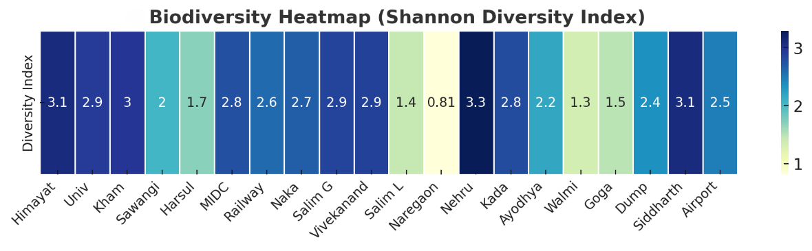
Figure 2. Biodiversity Heat Map

The diversity index of across all the locations were calculated using Shannon diversity index. Highest tree diversity was observed at Nehru udyan (39 species, H' = 3.29) followed by Himayat bagh (58 species, H' = 3.10) and Siddharth garden (32 species, H' = 3.10. Whereas, lowest diversity was observed at Naregaon dumpsite (03 species, H' = 0.81, followed by Walmi lakes (08 species, H' = 1.33, and Salim ali lake (08 species, H' = 1.43). Highest species evenness i.e. relative abundance is observed at Sawangi lake (0.9316), followed by central naka (0.9214) and airport (0.9141). However, lowest evenness Walmi lake.

- Species Richness Across Habitats

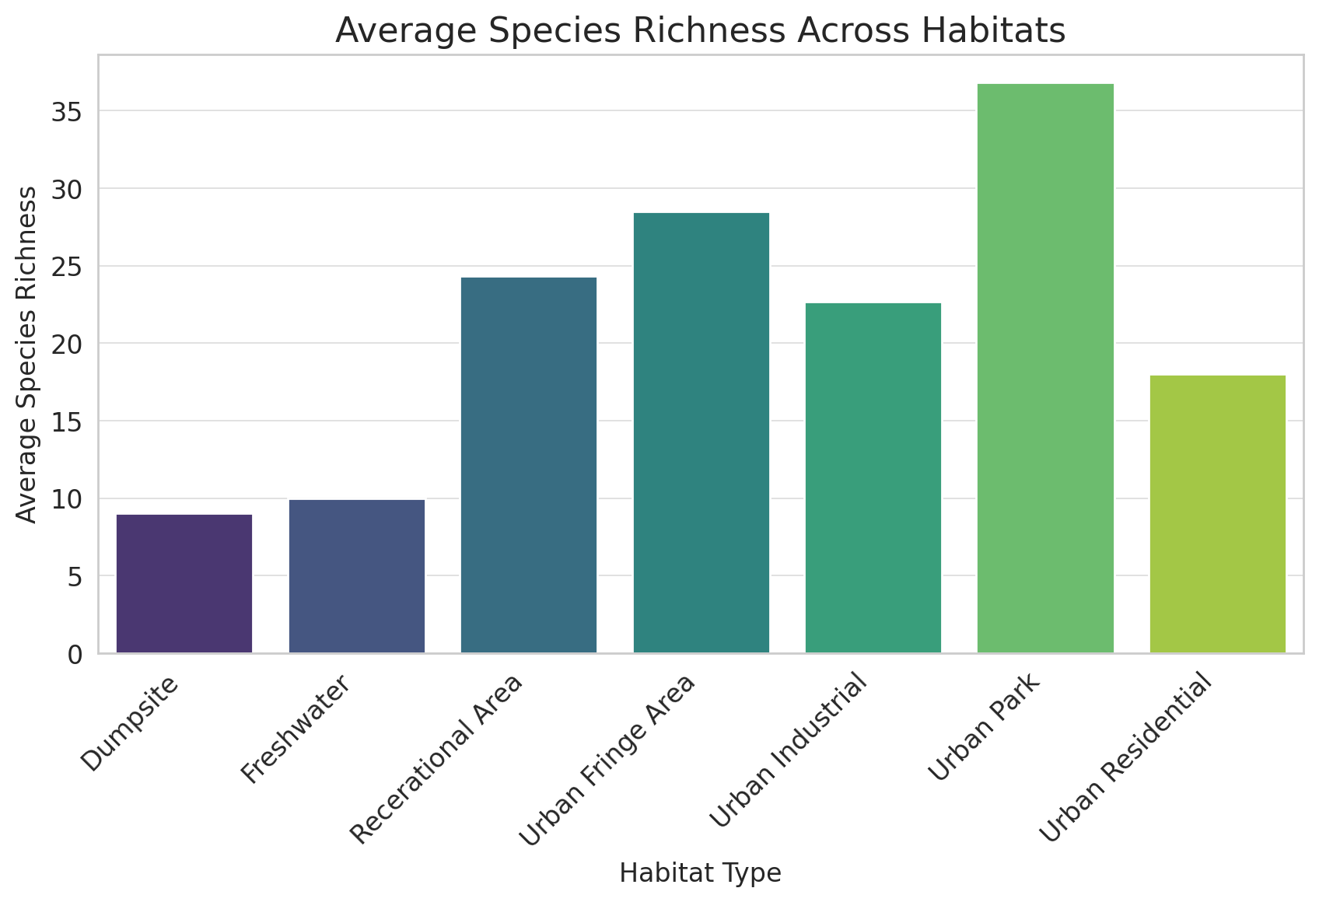
Figure 3. Comparison of species richness across habitats

The comparison of species richness across habitats helped us draw the overall functioning of the city ecosystem though it may significantly vary. It provides insights to boost habitat specific conservations activities. The highest species richness has observed in the urban park’s habitat with an average 36.8 species and maximum 58 species followed by urban fringe areas. Whereas, the lowest species richness has been observed in dumpsite habitat with an average 9 species and minimum 3 species followed by freshwater areas respectively see figure 3. However, most tree species were observed in urban fringe habitat with total of 12,351 trees and least tree species were observed in dumpsite with 37 trees. The industrial areas were found to have lower tree populations 4,305 compared to urban parks 6,976. Overall, Azadirachta indica 2,917 and Cassia fistula 2,803 are the most dominant tree species across all locations. The other dominant species are Tamarindus indica, Leucaena leucocephala and Dalbergia latifolia.

Discussion
- Relationship Between Species Count & Diversity

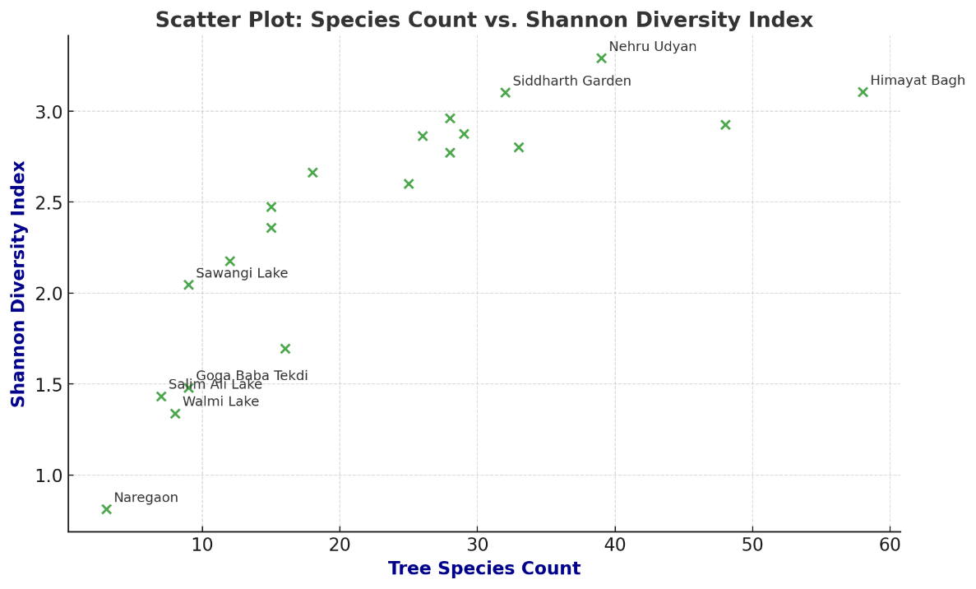
Figure 4. Scatter Plot – Species count vs Shannon Diversity Index

The x-axis represents the number of tree species and y-axis represents the Shannon diversity index. Each green cross pointer represents a location with some key locations labeled. It is observed that species count is inversely proportional to species diversity in the study area as university with 48 species having H' = 2.9269 has a lower diversity index than Nehru udyan with 39 species having H' = 3.2918. This suggests that species distribution matters more than count (Sharma et. al., 2023). While some locations with fewer species have high diversity. Kham eco park has 28 species having H' = 2.9626 and evenness = 0.8891 suggests that species are evenly distributed, leading to higher biodiversity stability. More species generally leads to higher biodiversity, but evenness matters (Divakara et. al., 2021); (Singh et. al., 2023). A moderately species rich but evenly distributed community can demonstrate greater diversity than a species rich but uneven one. Locations like Naregaon and Walmi Lake, which lie on the lower end of diversity spectrum, reflect poor evenness and low richness, indicating a need for conservation efforts and biodiversity restoration (Pandey & Kumar, 2018; Acharya & Panda, 2020). The analysis supports a core ecological concept that, Diversity is not only about how many species are present, but also about how ell those species are balanced. . It is also observed that the high diversity of the trees contributes to the well-being of human health (Zibtseva, O., 2023). A high number of species with dominance by few can yield lower diversity than a moderately rich but evenly distributed community. Tree diversity varies between small towns based on their location and development. There is a need to improve and diversify urban tree plantings to make them more resilient to human pressure and climate change (Zibtseva, O., 2022).

Conclusion
Mature trees together contribute to a balanced ecosystem, promoting the health and continuity of native tree species (Jim, C. Y., & Chen, W. Y., 2009). While some parts of university and Himayat Bagh, a major green space of the city has seen with few non-indigenous tree species (Aronson et. al., 2015). Despite of being a large and historic green areas university campus and Himayat bagh, interestingly the Nehru udyan, located in the urban area of the city has showed highest diversity index and lowest was Naregaon dumpsite. The highest species evenness was observed at Sawangi lake in which is located northeast of the city with low human disturbance. However, the lowest evenness is also at the wetland named Walmi lake located at the southwest of the city this disturbance may affect due to high rate of urbanization across the lake. Further studies on water, soil, ecology and climate change may add more insights. The high species richness in urban parks habitat concludes that there is still a place for local biodiversity to rely and sustain, but needs to be monitored periodically (Nielsen et. al., 2014)
Dumping sites of the city often attracts local biological species for the easy food. These sites also act as breeding grounds in vicinity. Therefore, planting indigenous trees around the dumping sites may provide shelter for local species (Kowarik, 2011. The industrial area of city has seen with low tree population as compared to the area. Local governmental and non-governmental organizations in collaboration with industries should focus intensive tree plantations within area. The overall tree species richness of the city looks good with high tree counts in urban fringes.

Acknowledgement
Authors would like to express sincere gratitude to Garden Department Chhatrapati Sambhajinagar Municipal Corporation, Department of Environmental Science, Dr. Babasaheb Ambedkar Marathwada University and Mr. Kunal Vibhandik for kind support and coordination.
Conflict of Interest
Authors declares no conflict of interest in paper publication.
References
Seto, K. C., Güneralp, B., & Hutyra, L. R. (2012). Global forecasts of urban expansion to 2030 and direct impacts on biodiversity and carbon pools. Proceedings of the National Academy of Sciences, 109(40), 16083-16088.
Pickett, S. T. A., Cadenasso, M. L., & Grove, J. M. (2011). Urban ecological systems: Scientific foundations and a decade of progress. Journal of Environmental Management, 92(3), 331-362.
Elmqvist, T., Fragkias, M., Goodness, J., et al. (2013). Urbanization, Biodiversity and Ecosystem Services: Challenges and Opportunities. Springer.
Alberti, M. (2005). The effects of urban patterns on ecosystem function. International Regional Science Review, 28(2), 168-192.
Kirtikar, K.R. and Basu, B.D. (1918) Indian Medicinal Plants. Sudhindra Nath Basu, M.B. Panini Office, Bhuwanéswari Asrama, Bahadurganj, Allahabad, 800 p.
https://doi.org/10.5962/bhl.title.137025
Grimm, N. B., Faeth, S. H., Golubiewski, N. E., et al. (2008). Global change and the ecology of cities. Science, 319(5864), 756-760.
Pataki, D. E., Carreiro, M. M., Cherrier, J., et al. (2011). Coupling biogeochemical cycles in urban environments: Ecosystem services, green solutions, and misconceptions. Frontiers in Ecology and the Environment, 9(1), 27-36.
Andersson, E., Barthel, S., & Ahrné, K. (2014). Measuring social-ecological dynamics behind the generation of ecosystem services. Ecological Applications, 24(5), 1123-1140.
Zipperer, W. C., Wu, J., Pouyat, R. V., & Pickett, S. T. A. (1997). The application of ecological principles to urban and urbanizing landscapes. Ecological Applications, 7(3), 369-372.
Strohbach, M. W., & Haase, D. (2012). Above-ground carbon storage by urban trees in Leipzig, Germany: Analysis of patterns in a European city. Landscape and Urban Planning, 104(1), 95-104.
Pyšek, P., Jarošík, V., Pergl, J., et al. (2010). The global invasion success of Central European plants is related to distribution characteristics in their native range and species traits. Diversity and Distributions, 16(5), 664-675.
Sharma, R., Goyal, S., & Tiwari, S. (2019). Urban green space dynamics in Indian cities: Implications for urban biodiversity and ecosystem services. Urban Forestry & Urban Greening, 41, 186-194.
Singh, S. K., Singh, J. S., & Verma, P. (2013). Urban vegetation and biodiversity in India: Challenges and opportunities. Tropical Ecology, 54(2), 165-173.
Nagendra, H. (2011). Urban parks and biodiversity in developing countries: A case study from Bangalore, India. Landscape and Urban Planning, 101(4), 431-440.
Haase, D., Frantzeskaki, N., & Elmqvist, T. (2014). Ecosystem services in urban landscapes: Practical applications and governance implications. Ambio, 43(4), 407-412.
Todawat, Navalsingh. (2025). Ethnobotanical study of Traditional medicinal plants used by tribes and rural people in the Chhatrapati Sambhajinagar Region (M.S.) India. 10.13140/RG.2.2.12220.96644.
McKinney, M. L. (2006). Urbanization as a major cause of biotic homogenization. Biological Conservation, 127(3), 247-260.
Pandey, R. K., & Kumar, H. K. H. (2018). Tree species diversity and composition in urban green spaces of Allahabad city (UP). Plant Archives, 18(2), 2687–2692.
Acharya, L., & Panda, P. C. (2020). Structure and composition of tree species in tropical moist deciduous forests of Eastern Ghats of Odisha, India, in response to human-induced disturbances. Environmental Sustainability, 3(3), 273–285.
Divakara, B. N., Nikitha, C. U., & Mahmud, M. A. (2021). Tree species diversity in the southern transect across the rural–urban interface of Bengaluru. In The Rural–Urban Interface of Bengaluru: A Global Perspective pp. 305–321.
Singh, A. K., Singh, J. S., & Singh, H. (2023). Quantifying carbon stock and tree species diversity of green infrastructure of Varanasi, India. International Journal of Plant and Environmental Research, 9(1), 37–45.
Sharma, A., Patel, S. K., & Singh, G. S. (2023). Variation in species composition, structural diversity, and regeneration along disturbances in tropical dry forest of Northern India. Journal of Asia-Pacific Biodiversity, 16(1), 87–99.
Jim, C. Y., & Chen, W. Y. (2009). Ecosystem services and valuation of urban forests in cities. Cities, 26(4), 187-194.
Aronson, M. F. J., Handel, S. N., La Puma, I. P., & Clemants, S. E. (2015). Urbanization promotes non-native woody species and diverse plant assemblages in the New York metropolitan area. Urban Ecosystems, 18(1), 31-45.
Nielsen, A. B., van den Bosch, M., Maruthaveeran, S., & van den Bosch, C. K. (2014). Species richness in urban parks and its drivers: A review of empirical evidence. Urban Ecosystems, 17(1), 305-327.
Kowarik, I. (2011). Novel urban ecosystems, biodiversity, and conservation. Environmental Pollution, 159(8-9), 1974-1983.
Zibtseva, O. (2023). Biodiversity of woody plants on the territory of the town hospital Acta Universitatis Agriculturae et Silviculturae Mendelianae Brunensis, 6. 341 – 351.
Zibtseva, O. (2022).Tree Species Biodiversity in Small Ukrainian Towns. Ekológia (Bratislava), 41(2), 161-171.

