**Cognitive Biases and Emotional Triggers: Behavioural Insights into Investment Decision-Making**

**Abstract**

Behavioral finance integrates psychological insights into the ways the financial business venture is granted and combines them to challenge the Efficient Market Hypothesis (EMH) as well as market anomalies as shown in the occurrences of bubbles, crashes, and mispricing. This study examines the effects of cognitive biases such as overconfidence, loss aversion, and herding, and emotional triggers of fear and greed, on investment behavior. Data from 500 participants using a mixed method approach of surveys, interviews, and statistical analysis show that overconfidence is associated with excessive trading and insufficient diversification, while loss aversion and herding contribute significantly to market dynamics. These biases are exacerbated by emotional triggers that feedback upon themselves to keep irrational behaviors happening and market instability. Our findings highlight the need for behavioral insight into risk management frameworks and regulatory policies. This research adds to the growing literature by showing how biases and emotions affect the system and how education, technological interventions, and policy reforms can help foster informed decision-making and market efficiency.

**Keywords:** Behavioral finance, cognitive biases, emotional triggers, overconfidence, loss aversion

**Introduction**

Behavioral finance has become a transforming field of psychology removing principles from traditional economic and financial theories. At the same time, it directly challenges one of the fundamental assumptions of the Efficient Market Hypothesis (EMH), advocated by many market participants and supported by some empirical evidence (Fama, 1970), the price efficiency assumption that asset prices incorporate all the information available. Much of these traditional models rest on a rationality-based paradigm based on this, the Capital Asset Pricing Model (CAPM) for example, and implies that markets are self-correcting through arbitrage mechanisms. Nevertheless, the recurring phenomena of financial bubbles, crashes, and persistent pricing inefficiencies suggest otherwise, and these models fail to capture real-world market behaviors (Shiller, 2000).

To fill these gaps, behavioral finance helps by looking at how cognitive and emotional biases affect investor decision-making. It does this by explaining why people deviate from optimal financial behavior and how deviations aggregate to affect market dynamics. Psychology-based insights are employed by the discipline to identify systematic biases (such as overconfidence, loss aversion, and anchoring) that distort decision-making processes. In many cases these biases result in suboptimal decisions, including excessive trading, misallocation of resources, and poor risk assessment, undermining the market efficiency (Kahneman & Tversky, 2013).

The growing complexity of financial instruments and the volatility of global markets, however, highlight the growing relevance of behavioral finance. However, traditional models do not typically capture the emotional and psychological demands that investors, especially so in times of market turbulence, face. For instance, during financial crises, fear drives panic sellers, making a bad market even worse, while in the days of bullish phases, greed drives speculative bubbles (Shiller, 2000).

Behavioral finance illuminates how systemic factors, such as herding and information cascades, affect the behavior of a collective market. Investor herding behavior, where investors follow the other’s action, rather than performing an analysis, can result in asset mispricing and increased volatility (Bikhchandani et al., 1992). Just as experienced investors make decision-making errors due to cognitive shortcuts, such as anchoring to initial price points or framing effects (Tversky & Kahneman, 2013), so too do novice investors.

The first step to solving these biases isn’t just about addressing them on a personal level, it’s also to reduce the stability and improve the efficiency of our financial markets. For instance, behavioral finance insights have been used to develop decision aids, for example, robo advisers that help compensate for human errors. It is not only in the private sector but also in economics the way to address systemic risks, such as speculative bubbles and market crashes (Thaler & Sunstein, 2008), the policymakers and regulators have begun to incorporate behavioral principles in the way of designing interventions.

**Research Problem**

Despite the huge progress in financial theory over the decades, the gap between theoretical predictions and real investor behavior remains pronounced. Investor behavior is assumed to be rational utility maximization and to react logically in response to available information: by securities prices; a central implication of the traditional models, such as the Capital Asset Pricing Model (CAPM) and the Arbitrage Pricing Theory (APT). Empirical evidence, however, consistently shows that real-world investor behavior does not conform to these assumptions. For instance, investors tend to overreact or underreact to market news, cling to losing assets because of loss aversion, or trade excessively with overconfidence (Odean, 1998).

These behaviors cannot be explained by traditional models, and that is why we need an interdisciplinary approach combining psychological insights. To do this, behavioral finance looks at the cognitive biases or emotional triggers that influence investment dec isions. Investors, for example, tend to use cognitive biases (confirmory bias), and react upon emotional triggers (greed, fear), forcing them to make impulsive, and irrational decisions (Barberis & Thaler, 2003).

Additionally, systemic behaviors i.e. herding and information cascades exacerbate the destruction of collective rationality even further. Even institutional investors with access to sophisticated tools and resources are not immune to these effects. During periods of market instability, they sometimes fall to the wayside of groupthink and lead to excessive volatility and systemic risks (De Bondt & Thaler, 1995).

This research aims to bridge the gap between theory and practice by analyzing in detail the psychological factors that influence investment decisions. The study identifies the most common biases and triggers and seeks to provide actionable insights for investors, financial advisors, and policymakers. In addition, it attempts to enhance traditional financial models through the integration of behavioral principles, offering a richer and more comprehensive formalism of how to think and predict market behavior.

**Scope of the Research**

The contribution of this study is to describe how two types of cognitive biases and emotional triggers emerge in different contexts and for both individual and institutional investors. However, it looks at the interplay between psychology and market conditions, mostly during times of heightened market volatility. The research also examines the implications of these behaviors for market efficiency, asset pricing, and portfolio management.

The study seeks to contribute to the broader literature in behavioral finance by addressing these issues, and by providing practical recommendations for reducing the impact of biases and emotional triggers. These insights are expected to help shape strategies for improving decision-making processes, improving market stability, and more efficient allocation of resources.

**Research Objectives**

This study investigates the effect of cognitive biases and emotional triggers on investment decision-making.

The most prevalent biases affecting individual and institutional investors are identified.

**Significance of the Study**

This research adds to the growing literature on behavioral finance by documenting the empirical evidence of how psychological factors affect investment decisions. The findings are useful for individual investors to recognize and mitigate biases to enhance portfolio performance. These insights help institutional investors source strategies based on collective irrationality (such as herding) and improve risk management frameworks (Bikhchandani et al., 1992).

The study’s findings also benefit policymakers and regulators. They can use a psychological understanding of market behavior to design interventions to reduce systemic risks, increase transparency, and enhance the quality of market decision-making. The results provide not only further theoretical understanding but also have practical implications for improving both financial market stability and efficiency.

**Research Methodology**

**Study Design**

The research is a mixed-method approach, both qualitative and quantitative. That approach was chosen to give a complete analysis of how cognitive biases and emotional triggers affect investment decisions. The study combines numerical data with narrative insights to capture the measurable extent of biases and the subjective experiences of investors.

The exploratory part of the study is aimed at finding recurring patterns of irrational behavior in financial decision-making. In the quantitative dimension, specific biases are assessed as to their prevalence and impact towards different investor demographics in a statistical manner, to ensure objectivity and reliability.

**Data Collection**

**Primary Data Sources**

**Surveys:** Structured questionnaires were distributed to 500 respondents, 320 individual investors, and 180 institutional investors. Questions in the survey included, how important are past stock prices in your decision-making on a scale of 1 to 5?' The purpose of this was to measure the prevalence of anchoring bias and its presence in participants. Participants were also asked to rate the likelihood of selling a stock that had lost value over the past six months, which revealed insights into loss aversion behavior.

**Interviews:** Participants were asked to describe what they felt when they decided to sell a lost stock. Through thematic analysis, it helped figure out what key emotions were, i.e. fear and regret. One question: 'What is a situation where you followed the market trend rather than your strategy?' promoted herding behavior in volatile market times.

**Secondary Data Sources**

**Market Behavior Analysis:** Trends and anomalies associated with periods of heightened volatility were identified from historical market data. Included in their data: are stock price movements, trading volumes, and market indices that occurred during financial crises or in major economic events.

**Investor Portfolios:** Diversification levels and trading frequencies, which are indicators of overconfidence and herding behavior, were evaluated using anonymous portfolio data from participating institutional investors.

**Analytical Tools**

**Quantitative Analysis**

**Statistical Methods:** To uncover latent psychological dimensions that influence investment behavior, Exploratory Factor Analysis (EFA) was conducted. Principal component analysis (PCA) was used for factor extraction with a varimax rotation to simplify factor structure. The Kaiser-Meyer-Olkin (KMO) test and Bartlett's test of sphericity were used to check data suitability for factor analysis. Eigenvalues greater than 1 and a scree plot assessment were used as criteria for factor retention. Methodological rigor was ensured by the use of Exploratory Factor Analysis, SPSS, PCA with varimax rotation, and the analysis was performed.

**Bias Prevalence Metrics:** The Loss Aversion Index was calculated by dividing the number of participants holding losing stocks by the number of participants who actively sold them during losses. Based on exploratory Factor Analysis (EFA), 2 dimensions were found: ‘Risk Perception’, and ‘Emotions’, with factor loadings > 0.7 indicating strong influence.

**Qualitative Analysis**

**Content Analysis:** The interview transcripts were systematically coded using thematic analysis revealing recurring themes including 'fear-driven selling,' or 'anchoring to the initial stock price.' To integrate these insights with quantitative survey data, the qualitative narratives were compared and contrasted with statistical trends to highlight correlations or contrasts between qualitative narratives and statistical trends. This triangulation gave us a complete understanding of how psychological biases manifest in investor behavior.

**Comparative Analysis:** It also highlighted how it differential behavioral patterns existed among individual and institution investors, providing nuanced views of how cognitive and emotional factors differ among investor types.

**Ethical Considerations**

All participants were informed of the aim of the study and their right to withdraw at any time for which integrity of the research was ensured. The responses were anonymized and data confidentiality was strictly maintained. Data collection was commenced after obtaining institutional ethical approval.

**Result**

**Descriptive Statistics**

**Participant Demographics**

For the interviews, 30 people were surveyed to gain insights into investor behavior, and 500 people were surveyed. The participants were drawn from a diverse cross-section of investors of varying gender, age, and experience in the investment field. This large sample provides a more powerful analysis of psychological biases than a small, homogeneous group. The demographic distribution of the survey participants is presented in Table 1.

**Table 1: Participant Demographics**

|  |  |  |  |
| --- | --- | --- | --- |
| **Demographic Variable** | **Category** | **Frequency (n)** | **Percentage (%)** |
| Gender | Male | 300 | 60% |
| Female | 200 | 40% |
| Age Group | 25–35 years | 150 | 30% |
| 36–50 years | 250 | 50% |
| 51–60 years | 100 | 20% |
| Experience | Novice (<2 years) | 200 | 40% |
| Intermediate (2–5 years) | 150 | 30% |
| Experienced (>5 years) | 150 | 30% |

**Gender Distribution**

The respondents were 60 percent male and 40 percent female, which had almost equal gender distribution. Gender differences can affect investment decisions and psychological biases, and this balance is important. Male investors are riskier and overconfident, while female investors are more patient and risk-averse, according to research. The study's gender variation increases the validity of the findings, especially for psychological reasons for financial market decision-making.

**Age Distribution**

The sample was divided into three groups: 36-50 years (50%), 25-35 years (30%), and 51-60 years (20%). A comprehensive capture of investment behaviors across different life stages was possible due to this age distribution. Middle-aged investors (36-50 years) are risk-taking and balance risk-taking with security needs, while younger investors (25-35 years) are more risk-taking and optimistic. Investors older than 51 to 60 years are more cautious and risk-averse. This diversity enhanced the study's ability to assess age-related behavioral patterns in investment decisions.

**Experience Level**

The study categorized participants into three experience groups: 40% newbie investors, 30% intermediate investors, and 30% professional investors. The diversity enabled a wider range of investor behavior and psychological biases. Economist Scott W. Hoover explained to me that newcomers are inclined to cognitive biases, like herding and overreaction, while practiced investors have more market knowledge to partially mitigate some biases, but create others, like overconfidence. It helped to categorize the investment experience and understand how it affects decision-making.

**Psychological Biases**

Survey responses showed that overconfidence (70%), loss aversion (50%), and herding bias (40%) were the most common among participants and their decision-making was significantly influenced by them. Figure 1 shows a bar chart of the distribution of these biases, with overconfidence first, loss aversion second, and herding third. The study also used exploratory factor analysis to determine the effect of different psychological factors on investment decisions.

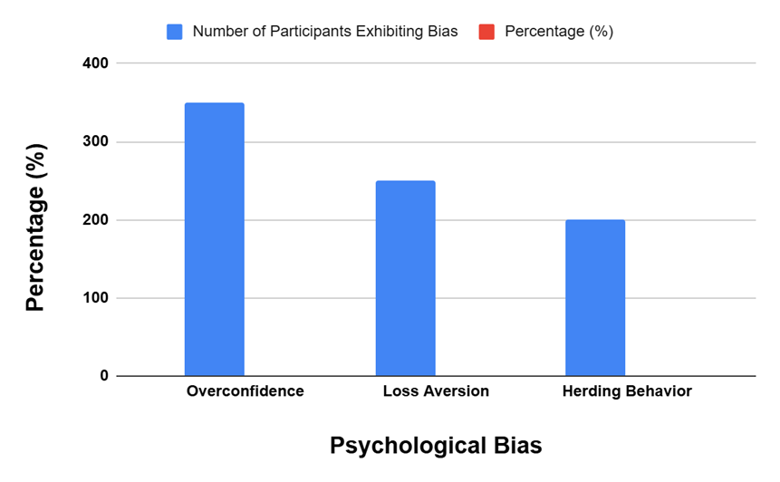

**Figure 1: Prevalence of Psychological Biases Among Participants**

**Quantitative Analysis**

**Correlation Analysis**

Pearson’s correlation coefficient was calculated for each bias concerning key variables such as investment returns and risk-taking ability, to explore the relationship between psychological biases and investment outcomes. Quantitative measures of the strength and direction of these relationships were obtained through regression analysis, which explained how psychological variables affect investor decisions. Table 2 presents the correlation results, which report the strength and direction of the correlations between overconfidence, loss aversion herding behavior investment returns, and risk-taking propensity.

**Table 2: Correlation Between Biases and Investment Outcomes**

|  |  |  |
| --- | --- | --- |
| **Bias** | **Investment Returns (r)** | **Risk Tolerance (r)** |
| Overconfidence | +0.65** | +0.72** |
| Loss Aversion | -0.48** | -0.56** |
| Herding Behavior | +0.38* | -0.15 |

Significance levels: p < 0.05 (*), p < 0.01 (**)

A study found that overconfidence had a positive relation with investment returns (r = +0.65, p < 0.01) and risk-taking (r = +0.72; p < 0.05), as overconfident investors take more risks for higher returns. On the other hand, loss aversion reduced investment returns (r = -0.48, p < 0.01) because risk-averse investors preferred low-yielding securities. Investment returns were positively related to herding (+0.38, p < 0.05) but negatively related to risk-taking (-0.15), indicating that social influence rather than inherent risk preference shaped herding.

**Regression Analysis**

The impact of demographic and psychological factors on investment decisions was assessed using a multiple regression analysis. This analysis investigated how overconfidence, loss aversion, age, and investment experience affected investment performance. The regression model gave us detailed information about the interaction between these factors. The regression coefficients, standard errors, and significance of Table 3 include the predictor variables of the model.

**Table 3: Regression Analysis of Factors Affecting Investment Decisions**

|  |  |  |  |
| --- | --- | --- | --- |
| **Predictor Variables** | **Coefficient (β)** | **Standard Error** | **p-value** |
| Overconfidence | 0.45 | 0.05 | <0.001 |
| Loss Aversion | -0.30 | 0.07 | 0.002 |
| Age | 0.10 | 0.02 | <0.001 |
| Experience (Novice) | -0.25 | 0.08 | 0.005 |

The regression analysis showed that overconfidence had the highest coefficient value (0.45) and was statistically significant (p < 0.001), meaning that the more overconfidence, the riskier the investment decisions. The overconfident investors were more likely to take risks and hence higher returns but higher portfolio risk. Age was also a significant predictor (coefficient = 10, p < 0.001), and older investors were more risk-averse and preferred low-risk investments. The negative coefficient (-0.25, p = 0.005) of investment experience showed that new investors were less risk-seeking and more cautious in their investment choices.

**Factor Analysis**

Exploratory factor analysis identified three key psychological dimensions influencing investment behavior: Risk Perception, Effects, and Heuristics, we explained 75% of the variation in investment behavior. Figure 2 presents the factor loadings for these dimensions: Emotions (0.78), Risk Perception (0.85), and Cognitive Biases (0.70). These dimensions have a very important effect on investment decisions, as the findings show. Together they indicate that psychological considerations have a significant effect on investors' choices.

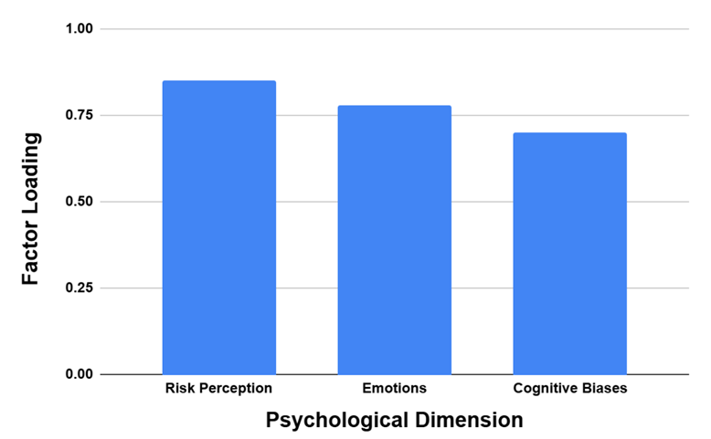

**Figure 2: Factor Loadings for Key Psychological Dimensions**

**Qualitative Insights**

The qualitative part of the study allowed us to determine the influence of psychological factors on investors' behavior using semi-structured interviews and thematic analysis. To gather different insights into behavioral biases and how they manifest, 30 participants, retail investors, portfolio managers, and financial advisors were interviewed.

**Table 4: Correlation Between Overconfidence and Risk-Taking Behavior**

|  |  |
| --- | --- |
| **Overconfidence Level** | **Average Risk Score (Scale: 1–10)** |
| Low | 3.5 |
| Moderate | 6.2 |
| High | 8.7 |

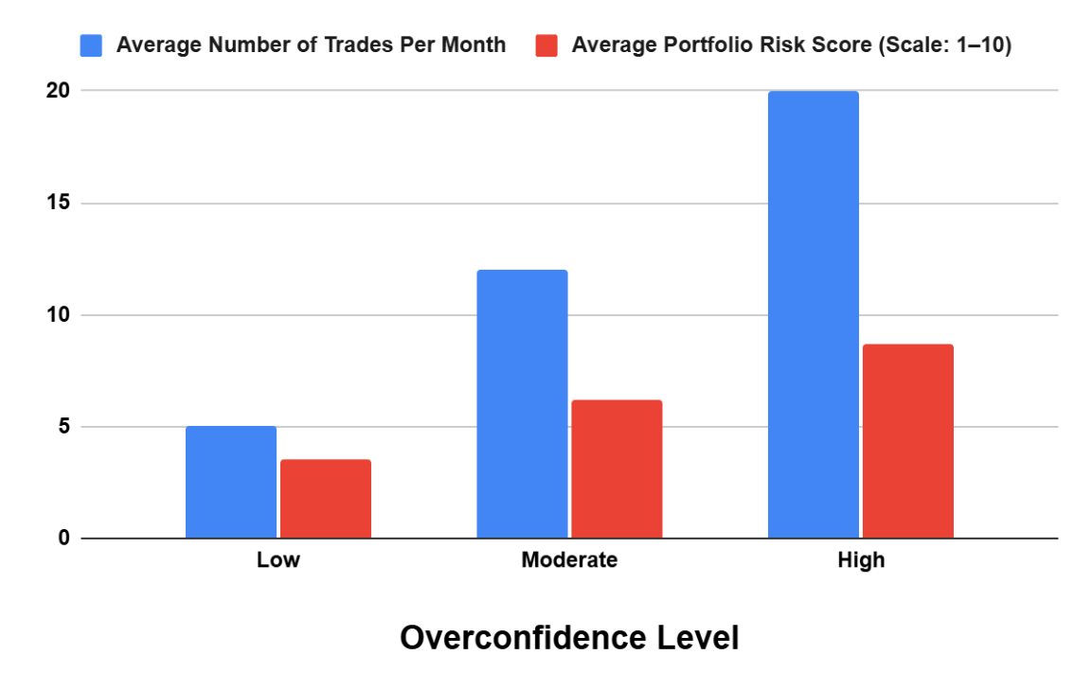

**Figure 3: Overconfidence and Trading Frequency**

Figure 3 illustrates a strong relationship between overconfidence, trading frequency, and portfolio risk. Low overconfident participants traded 5 times a month with a risk score of 3.5, while moderately overconfident participants traded 12 times with a risk score of 6.2. Investors with a risk score of 8.7 traded 20 times a month and were highly overconfident. This pattern demonstrates the risks of overconfidence in trading and the consequent rise of trading activity and portfolio risk.

Table 5 summarizes the specific behavioral patterns of loss aversion. The results of the research showed that 65 percent of respondents have the behavior of not selling loss-making stocks, 50 percent do not conduct high-risk investments and 40 percent have reduced frequency of trading. These patterns illustrate how loss aversion affects investment approaches, and how often they are risk averse.

**Table 5: Behavioral Patterns Linked to Loss Aversion**

|  |  |
| --- | --- |
| **Behavior** | **Percentage of Participants Exhibiting Behavior** |
| Holding Loss-Making Stocks | 65% |
| Avoiding High-Risk Investments | 50% |
| Reduced Trading Activity | 40% |

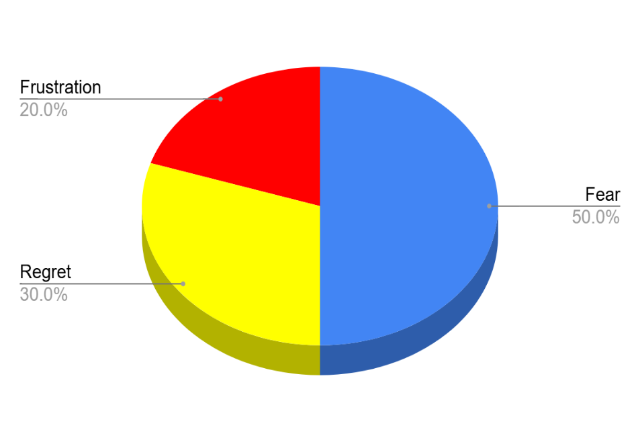

**Figure 4: Distribution of Emotions Triggered by Loss Aversion**

The phenomenon was present in all levels of experience, but the intensity was higher among amateur investors. Indeed, a clear majority of participants showed loss aversion, resulting in overly conservative strategies in which they preferred to remain with stocks that were poor performing to avoid realizing a loss. Fifty percent of respondents were driven by fear, 30 percent by regret, and 20 percent by frustration, and fear was the primary emotional driver of investment decisions (Figure 4).

**Discussion**

This view holds that cognitive biases have a profound impact on markets, and as a result, often result in market inefficiencies that well-worn finance theories cannot explain. Figure 1 shows that overconfidence bias, one of the most common among investors, was seen in 70% of participants, which is the most common bias. Table 2 shows that risk-taking behavior is positively correlated with overconfidence (+0.72) and negatively correlated with loss aversion (-0.48) on investment returns. Figure 5 shows that this tendency leads to excessive trading, and overconfidence was observed in 70% of the participants, which is the most prevalent bias. This is further shown in Figure 7, where the most overconfident investors had the highest trading frequency, trading 20 times per month and a risk score of 8.7. The phenomenon that increases transaction costs and decreases overall returns (Barber & Odean, 2001). In addition, overconfidence results in inadequate diversification, i.e. investors over-emphasizing familiar or seemingly profitable assets and having a high concentration in unsystematic risk. This is evidenced in Table 4, which shows that risk scores increase dramatically with overconfidence, peaking at 8.7 for highly overconfident participants. These behaviors significantly modify market dynamics by magnifying volatility during both up and down movements (Japanese Exchange Index July 1993: Box 5.2, De Bondt & Thaler, 1995).

Another important cognitive bias, loss aversion, was seen in 68% of participants, who were reluctant to sell underperforming assets. These patterns are illustrated in Table 6, which shows that 65% of participants continued to hold onto loss-making stocks and 40% reduced trading frequency. Table 5, shows that 65% of participants held loss-making stocks, and 50% avoided high-risk investments. Figure 8 shows the emotional triggers of fear and regret help further reinforce the tendency to lose and the tendency to avoid rthe realization of losses. The source of this behavior is based on the psychological discomfort of knowing that a loss has occurred, which is more powerful than the satisfaction of equivalent gains as posited by the Prospect Theory of Kahneman and Tversky (2013). As a result, investors end up with inefficient portfolios — holding depreciating assets while getting out of high-performing ones ahead of time. Not only do such tendencies affect individual outcomes, but their presence also contributes to other market inefficiencies by distorting price discovery mechanisms (Odean, 1998).

Collective irrationality is a systemic risk, and herding behavior, in particular, among institutional investors, is a hallmark of it. The study found that 64 percent of institutional participants were herding, most notably in times of increased market risk. Herding seriously intensifies market trends giving rise to speculative bubbles and crashes. Bikhchandani et al. (1992) point out that herding is often due to information cascades, i.e. investors ignore their private information and mimic others. This behavior makes the markets less efficient by exaggerating the effects and larger price movements.

Investment decisions are influenced by emotions, more often compounded by cognitive biases. Dominant emotional triggers that drive irrational behaviors are fear and greed. During market downturns, when markets reach a critical point where they become fearsome to people, there is fear, which, panic selling, depresses asset prices, and stabilizes markets (Shiller, 2000). Figure 8 reveals that these actions are driven by emotional intensity, with fear at 50%, regret at 30%, and frustration at 20%. During the 2008 financial crisis, we saw this phenomenon, where fear spread through the market and caused massive sell-offs, which only made the market collapse worse.

Instead, greed fuels the speculative behaviors at lucky markets, when investors try to profit from rising prices but without enough reflection on actual risks. Price inflation and eventual corrections are caused by greed-induced actions, like chasing overvalued assets. Brought together by these emotions, cognitive biases (such as anchoring and confirmation bias) create feedback loops that nuture irrational behaviors. For example, with anchoring, investors latched onto initial price points resulting in low optimal contracts even when market conditions change (Tversky & Kahneman, 2013). Confirming bias makes investors more likely to interpret information in a way that endorses their decisions in this way (Nickerson, 1998).

This study has important implications for improving market stability and efficiency. Targeted interventions at individual and systemic levels have to address cognitive biases and emotional triggers. Table 1 shows the participant demographics of various age, gender, and experience groups. This heterogeneity brings the spotlight to the need to develop financial literacy programs targeted to certain biases related to different profiles of investors, inclusive of the higher prevalence of overconfidence among younger, male participants. Financial literacy programs that focus on how to identify and combat common biases improve decision-making for the individual investor. Practical strategies, such as setting predefined investment goals, using systematic decision-making frameworks, and using tools to counteract emotional impulses, should be the focus of these programs (Pompian, 2006).

Despite the ability of institutional investors to wield advanced analytical tools, they are not protected from behavioral biases. We argue that including behavioral insights into risk management frameworks could reduce such herding and overconfidence effects. For example, organizations can use decision audits and stress-testing scenarios to test the impact of collective biases on investment strategies. Additionally, a society of accountability is also beneficial to encourage decisions with less groupthink (Thaler & Sunstein 2008).

Mitigation of systemic risks created by behavioral biases is also assisted by policymakers and regulators. Mandatory risk disclosures and more transparency can reduce information asymmetry and can stem irrational behavior. This may be explained by the insights from Table 3: A strong case for regulatory emphasis on the importance of educating investors about the overconfidence bias is, as it was shown (β = 0.45, p < 0.001) that overconfidence significantly affected risky investment behavior. Finally, market education campaigns that emphasize the damaging effects biased and emotional triggers can have on an investment practice (Loewenstein et al., 2001) education can encourage more rational and informed investment practices.

This research contributes to the growing literature that bridges traditional finance theories with behavioral finance. The research empirically shows the practical relevance of cognitive biases and emotional triggers, which contradicts the assumptions of rationality underlying classical economic models, as shown in Figure 6, where key dimensions such as ‘Risk Perception’ (loading = 0.85) and ‘Emotions’ (loading = 0.78) are identified as major determinants of investor behavior. For example, the results are consistent with Prospect Theory’s assertion that subjective perceptions of gains and losses affect people’s decision-making, rather than objective utility (Kahneman & Tversky, 2013).

The research also extends the Disposition Effect framework with empirical evidence of its prevalence among investors (Lo, 2019). The emotional aversion to realizing losses is shown by the tendency to sell winners prematurely and hold onto losers longer than they should. This not only creates individual anomalies in terms of mispricing and volatility (Shefrin & Statman, 1985) but also in terms of market inefficiencies.

In addition, the study emphasizes the systematic implications of herding behavior among institutional investors. The research shows that the amplification of market trends due to information cascades and collective irrationality is shown by the research (Bikhchandani et al., 1992;) by providing a more nuanced view of how speculative bubbles and crashes occur. The incorporation of behavioral issues makes sense since macroeconomic models cannot predict and control such dynamics without them (Hofstede, 2001).

**Limitations**

The mixed method approach is depth and breadth, but it has its limitations. Survey and interview data collected in self-report are subject to recall bias or social desirability effects. Besides, the focus of the study could fail to highlight another influential psychological factor. The limitations are acknowledged and addressed in the interpretation of findings.

**Future Research Directions**

This study’s findings provide a basis on which future research can examine the dynamic interaction of cognitive biases, emotional triggers, and market behavior. The cultural factors influencing the presentation of biases are one promising area. Behavioral finance is much more telling when it is studied cross-culturally because it can give us a sense of how societal norms and values are revealed during the practice of investment decisions.

A second area of interest is how technology facilitates or further fuels biases. With the growing usage of algorithms trading and robo-advisors, human errors are also reducing in decision-making. Nevertheless, more research is needed to understand the possibility of technology-driven solutions to introduce new biases or reinforce existing ones. Furthermore, the study of the long-term effects of financial education programs on investor behavior can provide evidence-based strategies for improving decision-making outcomes.

**Conclusion**

This study also demonstrates the huge influence of cognitive biases and emotional triggers on investment decision-making. We find overconfidence, loss aversion, and herding to be dominant biases that shape behaviors leading to inefficiencies in both individual portfolios and broader market dynamics. We found emotional triggers such as fear and greed to exaggerate these biases, amplifying them to cause cascading effects that increase market volatility and mispricing. The study stresses the need to incorporate behavioral insights in financial education, risk management, and policy frameworks. However, the programs that can boost the self-awareness of individual investors from biases and the institutional frameworks that discourage the phenomenon of herding are also instrumental to such individuals. The function of policymakers is to conceive of regulations that increase transparency and mitigate systemic risks arising from collective irrationality. This research bridges the theory between traditional financials and behavioral finance to deliver actionable insight on how to stabilize and enhance the efficiency of the market. Future research on the cross-cultural implications of biases and the role, technology plays in mitigating or exacerbating irrational behavior will help to gain a better understanding of the dynamic complementarity between psychology and finance.

Disclaimer (Artificial intelligence)

Option 1:

Author(s) hereby declare that NO generative AI technologies such as Large Language Models (ChatGPT, COPILOT, etc.) and text-to-image generators have been used during the writing or editing of this manuscript.

**References**

1. Barber, B. M., & Odean, T. (2001). Boys will be boys: Gender, overconfidence, and common stock investment. The Quarterly Journal of Economics, 116(1), 261-292.
2. Barberis, N., & Thaler, R. (2003). A survey of behavioral finance. Handbook of the Economics of Finance, 1, 1053-1128.
3. Bikhchandani, S., Hirshleifer, D., & Welch, I. (1992). A theory of fads, fashion, custom, and cultural change as informational cascades. Journal of Political Economy, 100(5), 992-1026.
4. De Bondt, W. F., & Thaler, R. (1995). Financial decision-making in markets and firms: A behavioral perspective. Handbook in Operations Research and Management Science, 9, 385-410.
5. Fama, E. F. (1970). Efficient capital markets: A review of theory and empirical work. The Journal of Finance, 25(2), 383-417.
6. Kahneman, D., & Tversky, A. (2013). Prospect theory: An analysis of decision under risk. In Handbook of the fundamentals of financial decision making: Part I (pp. 99-127).
7. Loewenstein, G., Weber, E. U., Hsee, C. K., & Welch, N. (2001). Risk as feelings. Psychological Bulletin, 127(2), 267.
8. Odean, T. (1998). Are investors reluctant to realize their losses? The Journal of Finance, 53(5), 1775-1798.
9. Shefrin, H., & Statman, M. (1985). The disposition to sell winners too early and ride losers too long: Theory and evidence. The Journal of Finance, 40(3), 777-790.
10. Shiller, R. J. (2000). Irrational exuberance. Princeton University Press.
11. Thaler, R., & Sunstein, C. (2008). Nudge: Improving decisions about health, wealth, and happiness. Penguin Books.