ASSESSMENT OF THE IMPACT OF ARTISANAL PETROLEUM REFINING ON SURFACE WATER QUALITY IN RIVERS STATE, NIGERIA

Abstract
Field reconnaissance surveys were carried out in the upland area of Rivers State, Nigeria, to determine areas associated with artisanal petroleum refining, Surface water samples were collected from four Local Government Areas (Emuoha, Etche, Eleme and Omuma LGAs) using sterilized sample bottles, and taken to the laboratory for water quality analyses. Surface water-pH. electrical conductivity (EC), Salinity, dissolved oxygen (DO) and biochemical oxygen demand (BOD) were determined as part of a preliminary assessment. Results show that pH values range from 6.49 to 7.58, indicating slightly acidic to neutral conditions. EC varied from 281.7 to 983.42 µS/cm, while Salinity ranged from 35.28% to 84.96%, with the highest at Eleme Downstream (84.96%). DO fluctuated between 7.86 mg/l and 19.02 mg/l. All values were well within the regulatory limit of 8.5 and i1000 µS/cm for pH and EC respectively. However, the slightly lower pH (slight acidity) and higher turbidity suggest that there was reduced water quality in these areas. It is, therefore, necessary to mitigate the dangers linked to artisanal petroleum refining in the study areas specifically and the entire Nigeria’s Niger Delta region in general, through institutional strengthening and the application of relevant environmental and petroleum-related laws.

Keywords: Artisanal refining; petroleum; Rivers State; Niger Delta; Surface water quality
Introduction
The Niger Delta region, which has River State as one of its central entities, is associated with crude oil extraction and production due to the petroliferous nature of the soil in its oil-bearing communities. However, the marginalization of the host communities has historically fuelled non-violent and violent protests across the region. Violent protests have often straddled communal conflict, insurgency, and criminal acts such as the sabotage of oil installations, crude oil theft, and the artisanal refining of illegally tapped crude oil by small-scale local operators. Oil theft and the illegal refining of stolen crude oil have also been adopted as a form of protest by indigenous ethnic minority groups agitating for oil resource control (Collinns and Wali, 2020; Sam et al., 2024; NOSDRA, 2025; Owordi et al., 2025).
Artisanal refining, commonly referred to as “kpo-fire” in local parlance, involves boiling crude oil under intense heat and collecting the resultant fumes, which are condensed in tanks and utilized locally for lighting, fuel, and transportation purposes. Some typical products of the process include gasoline, automated gas oil, kerosene, etc. Despite the socioeconomic advantages, which include creating jobs, it poses significant environmental and public health concerns (WHO, 2004; Richard et al., 2023). One of such environmental hazards of public health interest is the despoliation of the surface water within the vicinity of the local refinery.
Surface water (such as streams, rivers, ponds, lakes, creeks, lake and sea water) is one of the crucial components of the aquatic environment (DeZuane , 1997; Olubukola et al., 2023; Onuigbo et al., 2025). They sustain ecological systems and provide habitat for many plant and animal species. They also support a myriad of human uses, including drinking water, irrigation, livestock, industrial uses and recreation (Chapman, 1996). Over time, the quality of surface water in the Niger Delta deteriorates as a result of natural and human-related activities such as artisanal petroleum refining. Surface water quality has a significant impact on water supply and oftentimes determines supply options (Ouyang, 2005; Lodder et al., 2010). The quality of surface water can be used to identify the sources and fates of toxic contaminants and pollutants (Dojlido and Best, 1993; Carroll et al., 2006).
Management of water bodies require periodic monitoring and evaluation, and this can be achieved through the collection and analysis of water quality datasets. Water quality values serve as useful and sensitive indicators of changes in the physical, chemical or biological composition of the overall water status (Olubukola et al., 2021). The presence or absence of physical and chemical parameters, such as dissolved oxygen (DO), temperature, dissolved carbon dioxide (DCO), pH, conductivity, chemical oxygen demand (COD) and biological oxygen demand (BOD) in a water body, might be a limiting factor in the productivity of that aquatic ecosystem. The balance of physical, chemical and biological properties of any given water body is thus an essential ingredient for successful production of fish and other aquatic resources. The objective of this work is to assess the level of alterations of surface-water parameters as indicators of the water quality in the areas affected by artisanal petroleum refining, identify the source(s) of contamination and develop appropriate management strategies needed to minimize potential health risks. Moreover, data obtained via assessment and monitoring water quality provides empirical evidence to assist health and environmental institutions in decision making. The assessment of water quality is therefore very pertinent to both public health and aquatic life.

2.0 Materials and Methods
2.1 Description study area
2.1.1 Geo characteristics of study area
Four local government areas (Emuoha, Etche, Eleme and Omuma) were selected out of the 25 constituent local government areas of Rivers State (Fig. 1). These areas belong to the drier “upland” area of the State which constitutes 61% of the landmass. This area witnesses two major seasons which are the dry and rainy seasons. The average humidity of the area is 88 percent while the total annual rainfall in the LGA is 3600 mm. The entire topography of the State is characterized by a maze of effluents, rivers, lakes, creeks, lagoons and swamps criss-crossing the coastal lowland and tidal systems. The area is characterized by high rainfall, which decreases from south to north. Total annual rainfall decreases from about 4,700 mm on the coast to about 1,700 mm in extreme north of the State. Mean maximum monthly temperatures range from 28°C to 33°C, and relative humidity is high throughout the year but decreases slightly in the dry season. An overwhelming majority of the people of the study area are involved in two primary activities: farming and fishing, and the fishing population is almost exclusively dominated by artisanal fishermen (Ogbonna et al., 2023).
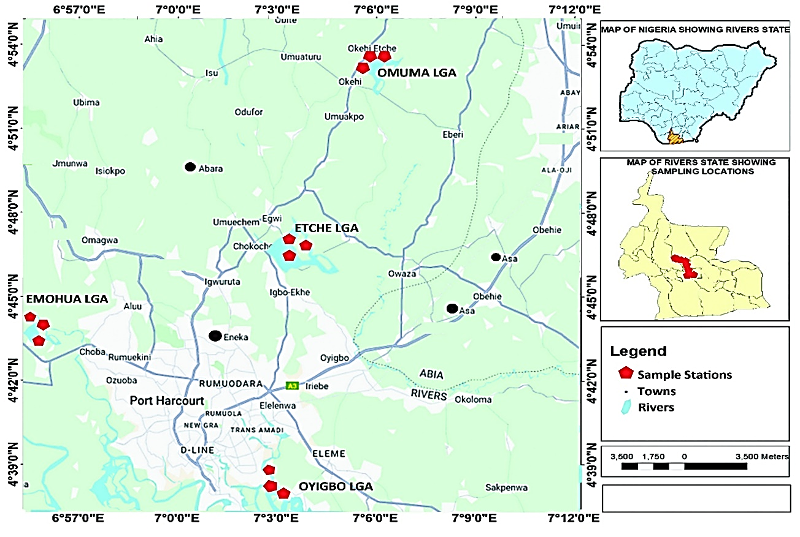
Fig. 1. Location map of study areas where sampling was carried out

2.1.2 Field reconnaissance survey and sample collection
Field reconnaissance surveys of Emoha, Etche, Eleme, and Omuma Local Government Areas of River state in the Sothern Niger Delta province of Nigeria (Fig 1) was carried out with a view to locate areas where artisanal refining (Kpo-fire) was taking place. Water bodies were located within such vicinities and mapped out as potential sample locations (Ogbonna et al., 2023). Sampling was carried in the designated locations with the assistance of a field Guide, after appropriate security clearance. Samples were collected from four local government areas. Omuma LGA was used as control since reconnaissance revealed that the area was not prone to artisanal petroleum refining.
Water samples were later collected from the streams (Plates 1-3) at the designated locations. The sterilized samples bottles were rinsed three times with the sample water before collection, and nitric acid (HNO₃) is added to adjust the pH to below 2 for preservation. The bottles containing the samples were corked, clearly labelled and taken to the laboratory where they then stored at 4°C until analysis was carried out

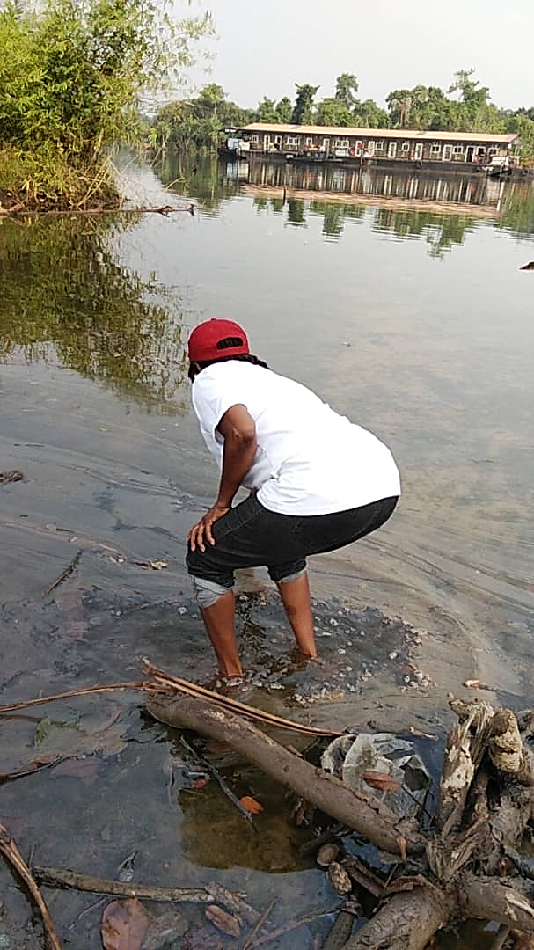
Plate 1: A cross setion of a river in the study area located within the vicinity of artisanal refining
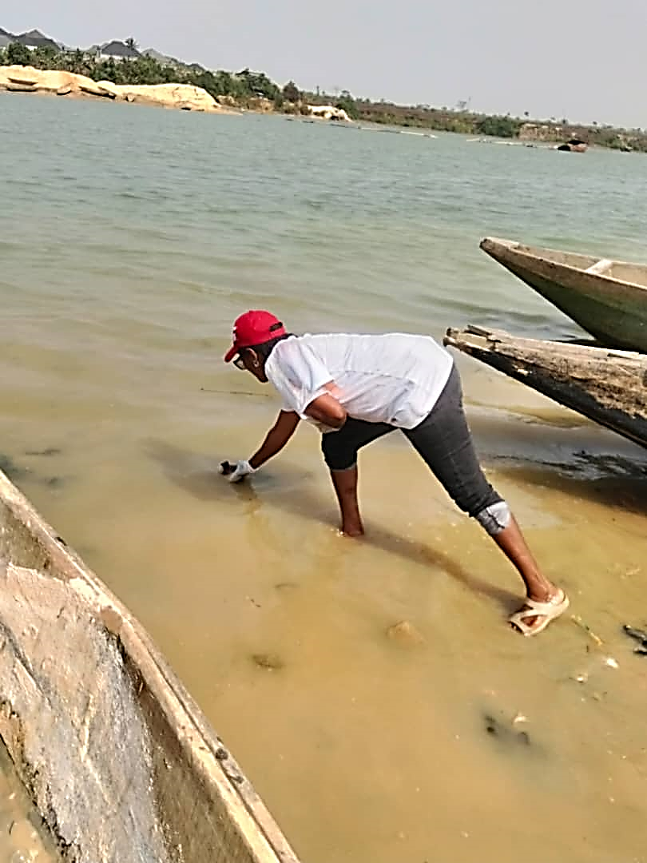
Plate 2: A photographic plate showing one of the rivers at the study site of Emuoha
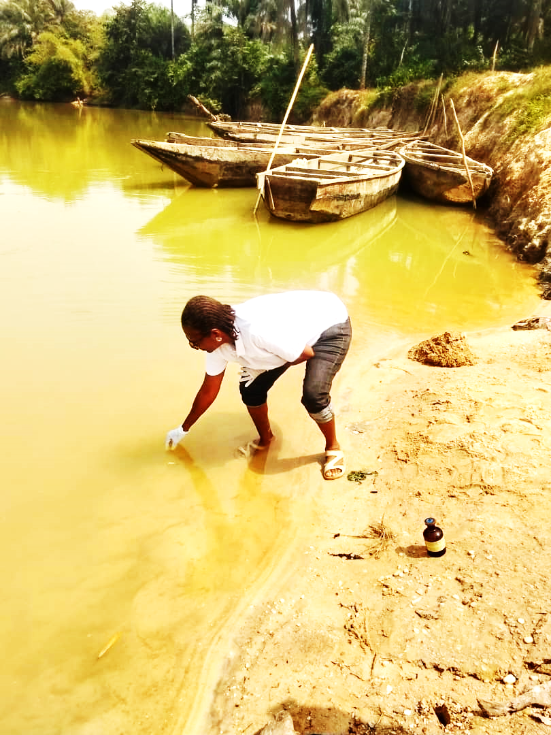
Plate 3: A cross-sectional view of the study site at Eleme in Rivers State

2.2 Laboratory analysis
Water temperature (Mercury-filled Celcius Thermometer), transparency (secchi disc method), turbidity (Nephelometric method, Systronic type No. 131), pH (Electronic digital instrument, model T-MS 30) and electrical conductivity (electrometric method) were estimated at the spot and the rest of the parameters were determined in the laboratory within five hours of collection. Total suspended solids were measured by oven-dried method; total dissolved solids were estimated by filtration and oven dried method. Acidity was measured by titration method; dissolved oxygen (DO) was measured Winkler-azide modification method (APHA, 1985). Free carbon dioxide was measured titration method (APHA, 1985); Alkalinity was measured with titration method (Jenkins and Moore, 1977). Hardness was estimated by following EDTA titration method. Calcium and magnesium were measured by gravimetric method (Saxena and Saxena, 2013). Biochemical oxygen demand (BOD₅) was measured by five-day BOD test (APHA 1992).
2.3 Statistical Analysis
All results obtained were subjected to descriptive statistical analysis by estimating the deviations from the Mean values of three replicate samples.
3.0 Results and Discussion
Results of the water quality parameters assessed (pH, Electrical conductivity, salinity, dissolved oxygen, and biochemical oxygen demand) are shown in Figures 2-6). Figure 2 contains the result oof the mean pH value of 6.67 (±0.14), which indicates slightly acidic to neutral conditions. This is generally acceptable for aquatic ecosystems and human use. The low standard deviation suggests minimal variation across sampling locations.

Fig. 2: pH levels of surface water across the Sampled Stations

Fig. 3: Electrical conductivty of surface water across the sampled stations
Figure 3 shows the spread of electrical conductivity (EC) across the upstream and downstream samples from the different locations. The mean EC value of 667.48 µS/cm (±212.16) indicates a moderate level of dissolved ions in the water. The high standard deviation suggests significant variations in conductivity, which could be due to differences in pollution levels or natural geological influences.
Figure 4 describes the distribution of the various percentage salinity levels in the analysed samples across the locations from where samples were collected. The mean salinity of 55.76% (±15.76) highlights a considerable fluctuation in salt concentration across the sites. Elevated salinity levels may impact aquatic life and water usability for domestic and industrial purposes.
Electrical conductivity and Salinity are relative indices. Salinity is often measured by conductivity. Conductivity in water is affected by the presence of inorganic anions such as Cl⁻¹, HCO₃⁻¹, CO₃⁻², NO₃⁻², SO₄⁻², and PO₄⁻² or Na, Mg, Ca, Fe, and Al cations (Osuji and Uwakwe, 2006). Organic compounds like oil, phenol, alcohol, and sugar do not conduct electricity current very well therefore low conductivity when in water. Conductivity is related to both total concentration of ionized substances in the water and the temperature at which the measurement is made.

Fig. 4: Salinity levels of surface water across the sampled stations
With conductivity being closely related to cation and anion concentration, aquatic life can be affected when it is high (high conductivity presupposes high concentrations, while low conductivity presupposes low concentrations). In coastal areas, river estuaries, bays and harbours where there is an influx of freshwater, salinity values are not only variable, depending upon the climate condition (precipitation) in terrestrial areas, but are also lower than those encountered seaward. In estuarine areas, salinity values will also change with the tides. They will increase at high tide and decrease at low tide.
Figure 5 contains the concentration of dissolved oxygen (DO) across the different sample locations. The average DO concentration of 13.89 mg/L (±3.66) is within a healthy range for most aquatic organisms. However, the variation in DO levels suggests that certain locations may have lower oxygen availability, which could affect aquatic biodiversity.

Fig. 5: Dissolved Oxygn (DO) levels across the sampled locations
Dissolved Oxygen is essential to most aquatic organisms, as it is essential for respiration activities. The distribution of oxygen in freshwater habitats is governed by a balance between inputs from the atmosphere and photosynthesis, and losses due to chemical and biological oxidation. Oxygen distribution is important for the direct needs of many organisms and affects the solubility and availability of many nutrients. It is therefore central to the productivity of aquatic ecosystems (Osuji and Uwakwe, 2006; Sam et al., 2023).
Figure 6 contains the distribution of the biological oxygen demand measured after five days (BOD₅) across the different sampled locations. The BOD₅ values range from 4.82 mg/L in Emohua Downstream to 10.17 mg/L in Etche Downstream, remaining well below the regulatory limit of 30 mg/L. BOD serves as an indicator of organic pollution, and while all recorded values fall within permissible limits, locations like Etche Downstream and Omuma Upstream, which exhibit relatively higher BOD levels, may be experiencing some degree of organic waste contamination (Bebeteidoh et al., 2020).
.

Fig. 6: Biological Oxygen Demand levels across the sampled locations
Generally, the pH values range from 6.49 to 7.58, indicating slightly acidic to neutral conditions, are all below the regulatory limit of 8.5. Electrical Conductivity (EC) varies from 281.7 to 983.42 µS/cm, remaining within the 1000 µS/cm limit. The highest conductivity is recorded at Eleme Midstream (983.42 µS/cm), while the lowest is at Emohua Downstream (281.7 µS/cm). Salinity (%) ranges from 35.28% to 84.96%, with the highest at Eleme Downstream (84.96%). All values are well within the 1000% regulatory limit. Dissolved Oxygen (DO) levels fluctuate between 7.86 mg/l and 19.02 mg/l, falling below the 23 mg/l regulatory limit. The highest DO is observed at Eleme Downstream (19.02 mg/l), while the lowest is at Emohua Downstream (7.86 mg/l). These results indicate that all measured parameters comply with regulatory standards (FMEnv, 1991; EGASPIN-DPR, 2018). The pH remains within an acceptable range, conductivity and salinity levels are safe, and dissolved oxygen concentrations, although below the maximum limit, are still sufficient to support aquatic life.
The results obtained from this study did not also show any significant statistical variation as seen in Table 1. All the results obtained from the upstream, midstream and downstream locations only showed slight variations that were not statistically significant (cf: Table 1).

Table 1: Descriptive Statistical Summary (mean and standard deviation) of the water quality indices analysed for each location
Location | Mean pH ±SD | Mean EC  ±SD (µS/cm) | Mean Salinity  ±SD (%) | Mean±SD  DO (mg/L)
Etche | 6.66±0.4 | 752.93±173.46 | 50.85±8.89 | 15.99±2.4
Eleme | 6.76±0.7 | 872.02±106.95 | 65.93±20.7 | 14.73±3.89
Emohua | 6.69±0.22 | 433.3±137.47 | 54.75±19.34 | 9.96±2.6
Omuma | 6.54±0.06 | 626.5±79.71 | 46.93±5.8 | 16.45±0.92

These values suggest no immediate environmental concern, but continued monitoring is advisable to ensure water quality stability.

4.0 Conclusion and Recommendations
The findings indicate that artisanal refining activities affect some physicochemical parameters of surface and interstitial water, with varying levels of impact. There was a reduction in water quality, characterized by the slightly lower pH (slight acidity) and higher turbidity. It is, therefore, necessary to mitigate the dangers linked to artisanal petroleum refining in the study areas of Rivers State and indeed the entire Nigeria’s Niger Delta region, through institutional strengthening and licensing of the artisanal petroleum operatives in the region and applying the environmental and petroleum-related laws in Nigeria. Furthermore, the enlightenment of the populace on the dangers of the long-term impact of artisanal petroleum refining is crucial to avert the possible public health hazards associated with the elevated water quality indices

Disclaimer (Artificial intelligence)

Option 1:

Author(s) hereby declare that NO generative AI technologies such as Large Language Models (ChatGPT, COPILOT, etc.) and text-to-image generators have been used during the writing or editing of this manuscript.

Option 2:

Author(s) hereby declare that generative AI technologies such as Large Language Models, etc. have been used during the writing or editing of manuscripts. This explanation will include the name, version, model, and source of the generative AI technology and as well as all input prompts provided to the generative AI technology

Details of the AI usage are given below:
1.
2.
3.

References
APHA (1985) Standard Method for the Examination of Water and Wastewater. 16th Edition, American Public Health Association, Washington DC.
APHA. (1992). Standard methods for the examination of water and wastewater. 18th ed. American Public Health Association, Washington, DC.
Bebeteidoh, O.L., Kometa, S., Pazouki, K., Norman, R., 2020. Sustained impact of the activities of local crude oil refiners on their host communities in Nigeria. Heliyon, 6 (6), e04000, https://doi.org/10.1016/j.heliyon.2020.e04000.
Chapman D, (ed.). 1996.Water Quality Assessments: A Guide to the Use of Biota, Sediments and Water. Environmental Monitoring. Second Edition. UNESCO, WHO, and UNEP. E&FN Spon, London UK. https://doi.org/10.1201/9781003062103
Collins, W., Wali, E., 2020. Crude Oil Theft in the Niger Delta: The Oil Companies and Host Communities Conundrum. International Journal of Research and Scientific Innovation (IJRSI) 7(I), 22-32
DeZuane, J., 1997. Handbook of Drinking Water Quality. John Wiley & Sons. 575p. https://doi.org/10.1002/9780470172971
Dojlido, J., Best, G.A., 1993. Chemistry of Water and Water Pollution. Ellis Horwood Limited. New York. 544p. https://books.google.com.ng/books?id=hCRSAAAAMAAJ
EGASPIN-DPR (2018). Environmental Guidelines and Standards for the Petroleum Industry in Nigeria. Department of Petroleum Resources, Lagos. 3rd Edition, 315p.
FMENV (1991). National Environmental Protection (Effluent Limitation) Regulations, S.1.8. Federal Ministry of Environment, FGPL 211/991, 12000.
Jenkins, S.R., Moore, R.C. (1977). A proposed modification to the classical method of calculating alkalinity in natural waters. AWWA 69(1), 56-60. https://doi.org/10.1002/j.1551-8833.1977.tb02544.x
Lodder W.J, Van den Berg, H.H., Rutjes, S.A, de Roda Husman, A.M. Presence of enteric viruses in source waters for drinking water production in The Netherlands. Appl. Environ. Microbiol. 2010;76: 5965–5971. https://doi.org/10.1128/AEM.00245-10.
NOSDRA., 2025. Oil theft responsible for most crude spills. A publication of the National oil Spill Response and Detection Agency, January 26, 2025.
Ogbonna, D.N., Anthony, E.M., Kpormon, L.B., 2023. Physicochemistry and Microbiological Quality of Surface Water Body around Port Terminals in Southern Nigeria. Microbiol. Res, 33(2),.54-60.
Olubukola A.A.R, Edet, E.E., Emmanuel, G.O., 2021. Application of Water Quality Index for the Assessment of Water from Different Sources in Nigeria. Promising Techniques for Wastewater Treatment and Water Quality Assessment. http://dx.doi.org/10.5772/intechopen.98696.
Onuigbo, B.S., Osuji, L.C., Onojake, M.C., 2025. Physico-chemical status of surface water and sediments of bonny River after Fusokiri-6 manifold spill in the Niger Delta. Journal of Applied Chemical Science International 16 (2), 1-9. https://doi.org/10.56557/jacsi/2025/v16i29159
Osuji, L.C., Uwakwe, A.A., 2006. Petroleum industry effluents and other oxygen demanding wastes in Niger Delta, Nigeria. Chem. Biodiv. 3, 705-717. https://doi.org/10.1002/cbdv.200690073.
Ouyang, Y., 2005.Evaluation of river water quality monitoring stations by principal component analysis. Water Res. 39 (12), 2621–2635. https://doi.org/10.1016/j.watres.2005.04.024.
Owordi, J.C., Osuji, L.C., Onojake, M.C., 2025. Soil fertility after an oil pipeline spill in Niger Delta, Nigeria.Asian Journal of Current research 10(2), 153-165. https://doi.org/10.56557/ajocr/2025/ v1029302.
Richard, G., Izah, S. C., Morufu, O.R., Austin-Asomeji, I., 2023. Public and environmental health implications of artisanal petroleum refining and risk reduction strategies in the Niger Delta region of Nigeria. Bio-Research 21(1). https://doi.org/10.4314/br.v21i1.12
Sam, K.S., Onyena, A.P., Zabbey, N., Odoh, C.K., Nwipie, G.N., Nkeeh, D.K., Osuji, L.C., Little, D.I., 2023. Prospects of emerging PAH sources and remediation technologies: insights from Africa. Environmental Science and Pollution Research 30 (14), 39451-39473. https://doi.org/10.1007/s11356-023-25833-9
Sam, K., Pegg, S., Oladejo, A.O., 2024. Mining from the pipeline: Artisanal oil refining as a consequence of failed CSR policies in the Niger Delta. Journal of Environmental Management, 352. https://doi.org/10.1016/j.jenvman.2024.120038
World Health Organization. Water, sanitation and hygiene links to health. 2004. Available at: www.who.int/water_sanitation-health/publications/facts2004/en/index.html

