Evaluation of the hydrocarbon status at Ahoada oil-spill-impacted site in the Niger Delta

Abstract
The amount and distribution of total hydrocarbons (total petroleum hydrocarbons – TPH and polycyclic aromatic hydrocarbons -PAHs) were evaluated following the oil spill at Olaikata-Edoha in Ahoada-East Local Government Area of Rivers State, Nigeria. Both TPH and PAHs were estimated using Gas Chromatography (GC). TPH recorded a hydrocarbon distribution from n-C8-n-C40, consisting of total aliphatic hydrocarbon content and the acyclic isoprenoid hydrocarbons (pristane, phytane). TPH was 3.743m mg/kg at the oil-spill-impacted site against a control reference of 42 mg/kg. PAH also showed a higher concentration of 39.53mg/kg in the contaminated soils, and 4.31mg/kg in the reference control soils. High TPH levels adversely impact soil structure by clogging soil pores, reducing water retention, and disrupting root growth. Such soils become unfit for agriculture as the plants face restricted nutrient and water access, ultimately leading to reduced crop yields. The higher-than-normal concentration of PAHs obtained indicates significant health and ecological risks due to their carcinogenic potential and persistence in the environment. The findings of this work highlight the urgency of remediation efforts to address the elevated PAH and TPH levels to mitigate long-term environmental damage. Remediation techniques such as bioremediation, which employs microbial communities to break down hydrocarbons, could be effective in this context. Phytoremediation, using plants to absorb or degrade hydrocarbons, may also be explored as a means to restore soil health over time.

Keywords: Total petroleum hydrocarbon (TPH); Polycyclic aromatic hydrocarbon (PAH); oil spill; Niger Delta; soil ecosystem

1.0 Introduction
Over the years, crude oil production has been synonymous with oil spill, and as the world grapples with the consequences of increased petroleum production and usage, the degradation of land, water, and air quality by oil spill continues to become evident (Sharma et al., 2024). Oil spill may be defined as the uncontrolled release of crude oil into the environment as a result of operational mishap, equipment failure or intentional damage to oil production facilities, otherwise known as sabotage (Othumpangat and Castranova, 2014). Oil spills may be classified as minor, medium or major, depending on the quantity or concentration of the released oil. Minor spills involve quantities of oil up to 10,000 gallons. Medium spills range from 10,000 to 100,000 gallons, and a major spill involves over 100,000 gallons of oil released (Singh et al., 2020; Jayarathna et al., 2024). Of the 589 spills recorded in 2024 in Nigeria, 285 spills were categorised as ‘Minor’ spills’, involving “up to 25 barrels spilled into inland waters. This shows a reduction from the 520 minor oil spills recorded in 2023. Ten of the spills were categorised as ‘Medium’, involving 25-250 barrels spilled into inland waters, while one of the spills Involving 2,500 barrels spilled on land, swamp, shoreline, and the open sea was categorised as ‘major’ (NOSDRA, 2025). However, 281 of the oil spills could not be categorised; they were smaller the minor sill category (NOSDRA, 2025).

Oil spill affects living resources and ecosystem, and may impair or interfere with other amenities and legitimate uses of the receiving environment Gundlach et al., 1983; Osuji and Onojake 2005; Azuka et al., 2023; Onuigbo et al., 2025b). Spills can cause a significant number of damages to the environment which consequently gives rise to diverse forms of issues for living organisms found in the impacted environment (Subi and Amodu, 2016, Omemu et al., 2022). In 2024, 19,000 barrels of crude oil were spilled, which was approximately three million litres, and 95 oil tanker trucks full. These spills affected both terrestrial and aquatic ecosystem (NOSDRA, 2025). Beyond the immediate ecological impacts, exposure to oil spills has been linked to various health issues, including nausea, vomiting, skin irritation, and certain types of cancer. The effects are observed not only in the general public but also among scientific research teams and personnel in the petroleum industry (Hellström et al., 2007). In oil-producing regions, residents may face exposure to heavy metals like cadmium through tainted vegetables, emphasizing the far-reaching consequences of oil pollution (Jabbar et al., 2022). Essential properties of the soil ecosystem are also known to be altered as a result of oil spills (Lovindeer et al., 2023). Research reports have also highlighted the profound impact of oil spills on croplands, trees, forests, and seedlings (Sharma et al., 2024). Farmlands had been rendered unproductive and minimally productive because of oil spillages. The Creeks, Wetlands, and other water bodies are not left out of the untoward consequences of oil activities in the region; living organisms in the water bodies are chased out of their habitats, and the inhabitants of the host communities are rendered poorer because they cannot engage profitably in their main occupations of fishing and farming (Onojake et al., 2014; Campelo et al.,2021; Igbani et al., 2023; Onuigbo et al., 2025a).
The region worst hit in Nigeria is the Niger Delta, which happens to be the country’s oil and gas. hub The Niger Delta province, which currently ranks among the word’s top 10 producers and Africa’s largest producer of crude petroleum, has 30 percent of the continent’s 60 billion barrels of proven crude oil reserve. Consequently, the region is home to oil refineries, petrochemical plants, liquefied natural gas (LNG) plants, fertilizer plants, steel plants and other related effluent-generating industries. In addition to its large non-renewable natural resource base (petroleum), the region has Africa’s largest and the world’s third largest mangrove forest, an extensive freshwater swamp forest, and a high concentration of biodiversity (Osuji et al., 2010; Lkhumetse et al., 2022; Solomon et al., 2023; Olukaejire et al., 2024).
Oils are very complex mixtures of hydrocarbons and substituted derivatives of hydrocarbons, in which the boiling points of components can vary from a few to several hundred degrees. In most cases, after release into the environment, spilled oil is immediately subjected to a variety of weathering processes including evaporation, dissolution, dispersion, photochemical oxidation, water–oil emulsification, microbial degradation, and adsorption onto suspended particulate materials, further complicating the already complex oil mixtures. The hydrocarbon component of the oil is made up of alkanes, naphthenes and the aromatics, which constitute one of its most toxic hazards (Coutinho et al., 2022). The aromatic hydrocarbon constituents consist of the light molecular weight monoaromatics, commonly known as the BTEX compounds (Benzene, Toluene, Ethyl benzene and xylene isomers). The other one is the polycyclic aromatic hydrocarbons (PAHs) such as naphthalene, fluoranthene and benzopyrene. These compounds are also light and heavy in their molecular composition (Sadauskas-Henrique et al., 2021; Onojake et al., 2021, Sam et al., 2023).
The urgency of addressing the issue of oil pollution in the Niger Delta is underscored by a recent spill at the Ahoada axis of the region. An effective contingency response to the oil spill requires the assessment of the spill impacted site. It is as a result of this need that this work seeks to evaluate the concentration of the released hydrocarbons with a view to ascertaining the extent of pollution at the affected site.

2.0 Materials and Methods
2.1 Geo-characteristic Description of Study Site
The study site at Ahoada (Plate 1) is located in Rivers State, Nigeria, within the oil-rich Niger Delta region. Known for its lush vegetation and tropical rainforest climate, Ahoada is an area of high agricultural potential, yet it faces environmental challenges due to oil exploration and associated pollution. This region, with latitude 5.0833° N and longitude 6.6500° E, is characterized by warm temperatures, high humidity, and seasonal rainfall, which together support diverse ecosystems but also influence how oil contamination impacts soil and water resources. It also lies within a humid, tropical zone with two primary seasons: a rainy season (typically March to October) and a dry season (November to February). The region’s annual rainfall averages between 2,000 to 2,500 mm, which contributes to the area’s dense vegetation and fertile soils, particularly loamy and clay soils that support a wide range of crops. However, these rainfall patterns also mean that oil spills tend to spread through soil and water systems more rapidly, exacerbating the environmental impacts. Figure 1 shows the location of the study site.
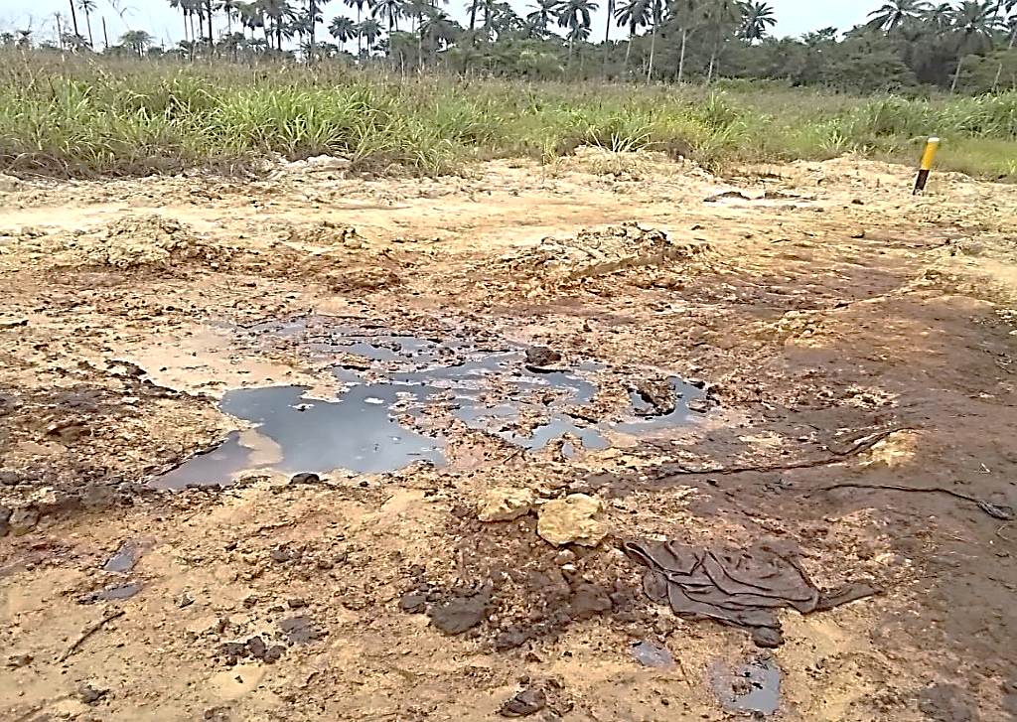
Plate 1. A section of the oil-spill-impacted site at Ahoada in Rivers State, Nigeria

. 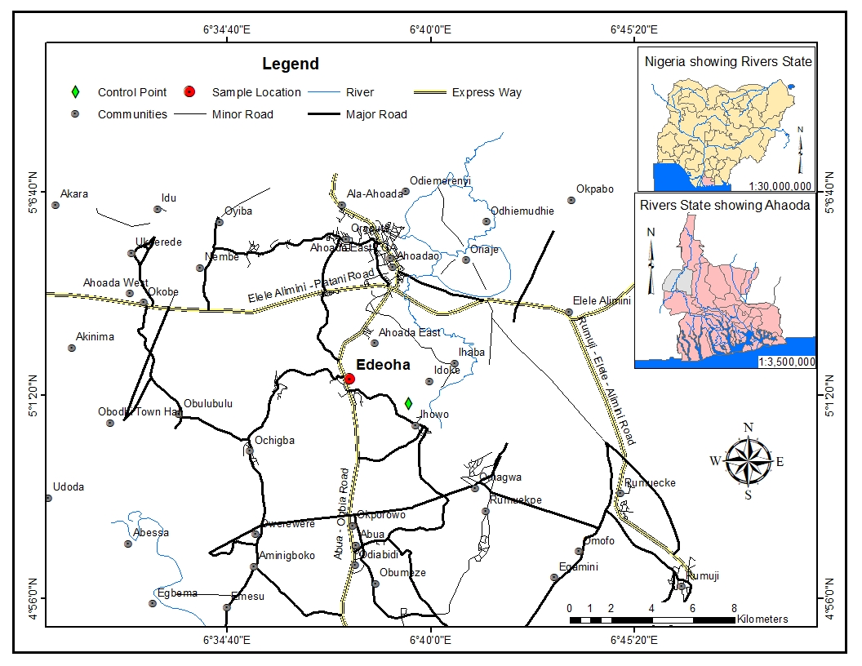
Fig. 1 Map of study area showing the oil-sp9ll-impscted at Olaikata-Edoha in Ahoada-East Local Government Area of Rivers State, Nigeria

2.3 Sampling and Soil Collection
The contaminated soil samples were taken from a recently crude oil polluted site in Olaikata-Edoha in Ahoada-East Local Government Area of Rivers State, Nigeria. The sampling area was 200 by 200 square meters. The sampling area was subdivided into twenty (20) grid plots. Each of the grid plots was further segmented into three staggered quadrats consisting of three sampling points for topsoil and subsoil respectively. Soil samples were taken from each point at 0-15cm from the surface and 15-30cm from the subsurface. Sampling proper was taken from eight (8) of the twenty grid plots, each plot having replicates of three (3) top and subsoils respectively, that is each plot is made up of three points, each point has top and subsoil, this would give a total of six (6) sampling points per plot. All the sampled plots were not analysed but representative samples were taken from the following sampling points 4, 8, 10, 12, 14, 16, 18, and 20. Samples were collected accordingly thus, six (6) each from plots four and eight respectively, while two (2) samples were collected from 10, 12, 14, 16, 18, and 20, two samples (top and subsoils) each were also collected from two control points. A total of twenty-four (24) contaminated samples were analysed alongside four (4) samples from control site. A manually operated Soil sampling auger was used for the soil sample collection, the soil samples were collected after the surface of each sampling points was cleared of non-soil materials. The collected samples, after collection with the manually operated auger were wrapped with Aluminium foil, put in a water-resistant polythene bag, and transferred to the storage container for onward transportation to the laboratory where the analysis was conducted.
The control samples were equally collected from about 50m away from the contaminated portion of the sampling site.

2.4 Hydrocarbon Analysis
The collected soil samples were analysed for benzene, toluene, ethylbenzene, and xylene (BTEX), toluene, total petroleum hydrocarbon (TPH), and polycyclic aromatic hydrocarbons (PAHs) air-dried before analysis. Non-crushable materials and other non-soil materials were selected and discarded; this was followed by grinding a portion of the soil. After grinding, between 5-10 grams of soil samples were weighed, depending on the perceived level of crude oil contamination on the soil samples collected.
All the reagents used, and the solvents (Dichloromethane, and n-hexane) during the extraction and fractionation were of BDH Analar grade. The glass wares used were cleaned thoroughly to prevent cross contamination. For the TPH, the crushed soil sample was extracted with a polar organic solvent, Dichloromethane (DCM) after which the extract was blown down in a vial by exposing the vial to ordinary ambient air to concentrate the hydrocarbon extract. The hydrocarbon extract (TPH) was analysed using the above GC program. The GC is controlled using a ramping program; The GC system was equipped with a 30m capillary column with an internal diameter of 0.530mm, coated with a non-polar phase of Methyl-Siloxane of 0.50um, and a length of 30m. The method used to acquire the data was isothermal oven temperature at 40oC for 3 minutes, and a ramping rate of 20oC per minute for 16 minutes, and the system was held at 5 minutes when it got to the final oven temperature of 320oC. The inlet temperature was set at 280oC, the injected volume was 1.0uL. The total run time per sample was 28 minutes.
The GC system was calibrated with an external and certified n-alkane calibration window of C10 to C45 carbon chain. The concentration of the standard used was 500mg/g TPH in 1ml of Methanol-Chloroform mixture. The TPH in the extracted soil sample was quantified using the n-alkane calibration standard.
For the PAHs, 10grams of the pre-selected and crushed soil sample was weighed and extracted the same way the TPH was extracted using the same extracting solvents, but after extracting as above with DCM, the extracted TPH sample was concentrated in a 10ml vial. To obtain the PAHs, the extracted TPH was cleaned to remove the n-alkanes and monoaromatics from the soil extract by using n-Hexane in a column-coated with activated powdered Silica Gel. The Silica Gel was activated in an oven set at 115oC for about six hours before it was packed in a 25ml glass column. The n-hexane has an affinity for eluting n-alkanes, cyclo-alkanes and monoaromatics from the soil extract that is spotted at the top of the packed activated Silica Gel.
The PAHs are always adsorbed on the Silica Gel as the extracted soil TPH sample is eluted through the Silica Gel-packed column using n-Hexane as the eluting solvent. After eluting the non-PAHs from the packed Silica Gel column using n-Hexane, the adsorbed PAHs on the Silica Gel was eluted into a conical flask using a polar DCM solvent. These extracted PAHs in the conical flask was concentrated to almost dryness and transferred into a 10ml vial and exposed to ambient air until about 2ml volume which was used for injection into the calibrated Agilent GC system. The PAHs extract from the soil was analysed using the same program for analysing the TPH samples. The quantification of the PAHs was done using the pre-calibrated GC system; the calibration standard was certified 16 USEPA priority PAHs mixture.

3.0 Results and Discussion
Results of the hydrocarbon analysis are collected in tables 1 and 2. The result 0f the total petroleum hydrocarbon (TPH) recorded a hydrocarbon distribution from n-C8-n-C40. This contained total aliphatic hydrocarbon content and the acyclic isoprenoids (pristane, phytane). The total petroleum hydrocarbon was 3,743m mg/kg at the oil-spill-impacted site at Ahoada against a control reference of 42 mg/kg. On the one hand, this result provides substantial evidence of contamination with petroleum hydrocarbons. And on the other hand, it shows that the area from the control samples were collected must have had previous history of hydrocarbon contamination as evidenced by the relatively lower concentration of 42.01769mg/kg (Table1).

Table 1. Results of the Total petroleum hydrocarbon (TPH) content of oil-spill-impacted and unimpacted control soils
Hydrocarbon Type | Retention Time | Contaminated sample (mg/kg) | Control Reference (mg/kg)
n-C₈ | 2.613 | - | -
n-C₉ | 4.377 | - | -
n-C₁₀ | 6.588 | - | -
n-C₁₁ | 8.475 | - | -
n-C₁₂ | 10.075 | - | -
n-C₁₃ | 11.465 |  | -
n-C₁₄ | 12.705 | 4.92594e-1 | -
n-C₁₅ | 13.808 | 20.01756 | -
n-C₁₆ | 14.817 | 123.65171 | 1.33548
n-C₁₇ | 15.689 | 153.05823 | 1.56745
Pristane | 15.786 | 92.06233 | 6.25693e-1
n-C₁₈ | 16.966 | 21.31380 | 1.77858e-1
Phytane | 16.993 | 56.86457 | 1.39921e-1
n-C₁₉ | 17.691 | 198.97218 | 4.62015
n-C₂₀ | 18.771 | 122.61899 | 2.39083e-1
n-C₂₁ | 19.492 | 203.74554 | 5.71150
n-C₂₂ | 20.453 | 155.30353 | 5.98781e-1
n-C₂₃ | 21.132 | 208.50840 | 4.38095
n-C₂₄ | 21.834 | 61.77568 | 2.41891e-1
n-C₂₅ | 22.637 | 259.26240 | 3.36875
n-C₂₆ | 23.304 | 98.99963 | 1.38372e-1
n-C₂₇ | 24.024 | 206.67404 | 2.35623
n-C₂₈ | 24.527 | 92.76289 | 1.30796e-1
n-C₂₉ | 25.315 | 151.65804 | 1.39334
n-C₃₀ | 25.762 | 114.20152 | 4.37868e-1
n-C₃₁ | 26.297 | 202.89120 | 9.07799e-1
n-C₃₂ | 26.793 | 190.53534 | 6.29681e-1
n-C₃₃ | 27.616 | 243.67973 | 7.52370e-1
n-C₃₄ | 27.853 | 135.84736 | -
n-C₃₅ | 28.410 | 214.30372 | 1.08357
n-C₃₆ | 28.942 | 108.17134 | 1.98455
n-C₃₇ | 29.807 | 197.64430 | 6.51756
n-C₃₈ | 30.387 | 72.41774 | 3.02667
n-C₃₉ | 31.205 | 34.63861 | 1.80274e-1
n-C₄₀ | 31.895 | 9.47289e-1
Total |  | 3743.02025 | 42.01769

The acyclic isoprenoid hydrocarbons, pristane and phytane had a concentration of 92.06 mg/kg and 56.86 mg/kg for pristane and phytane respectively. These concentrations are significantly higher than the 6,26 x 10-1 and 1.40 x 10-1 mg/kg recorded from the control soils. High TPH levels adversely impact soil structure by clogging soil pores, reducing water retention, and disrupting root growth. Such soils become unfit for agriculture as the plants face restricted nutrient and water access, ultimately leading to reduced crop yields (Wyszkowska et al., 2006, Azuka et al., 2023). Additionally, the high TPH values present a risk for groundwater contamination, as hydrocarbons can leach through the soil profile, potentially affecting surrounding water bodies and posing a risk to both aquatic ecosystems and drinking water sources (Siddique et al., 2003).
The result of the polycyclic aromatic hydrocarbon (PAH) also showed a higher concentration of 39.53mg/kg in the contaminated soils, and 4.31mg/kg in the reference control soils (Table 2). The presence of PAHs even in the minutest concentration is not desirable because of its potential for toxicity.

Table 2. Distribution of polycyclic aromatic hydrocarbons (PAHs) of oil-spill-impacted and unimpacted control soils
PAHs | Retention Time | Amount (mg/kg) | Control (mg/kg)
1,2,3-Trimethylbenzene | 2.169
Naphthalene | 3.407 | - | -
2-Methylnaphthalene | 6.903 | - | -
Acenaphthylene | 8.762 | - | -
Acenaphthene | 10.441 | - | -
Fluorene | 10.761 | - | -
Anthracene | 11.524 | 2.46667e-1 | 3.05392e-1
Fluoranthene | 12.823 | 7.62520e-1 | -
Phenanthrene | 12.933 | 24.49748 | 1.36902
Pyrene | 14.467 | 5.61266e-1 | 2.92245e-2
Benz(a)anthracene | 14.754 | 3.59444e-1 | 3.33898e-2
Chrysene | 16.191 | 1.13346 | 6.94313e-1
Benzo(b)fluoranthene | 16.373 | 2.66431 | 1.20974e-1
Benzo(k)fluoranthene | 16.470 | 4.60886 | 7.66972e-1
Benz[a]pyrene | 17.623 | 2.84564e-1 | 5.61444e-2
Dibenz(a,h)anthracene | 18.043 | 1.82714 | 6.11327e-1
Indeno(1,2,3-cd)pyrene | 19.341 | 1.37995e-1 | 1.95880e-1
Benzo(g,h,i)perylene | 19.688 | 2.45452 | 1.23097e-1
Total |  | 39.53829 | 4.30573

PAHs are a significant component of petroleum products and are notable for their toxicity and persistence in the environment. PAHs are resistant to natural degradation processes, leading to long-term accumulation in the soil. The toxicity, mutagenicity, and carcinogenicity of certain PAH compounds can affect plant and animal health and pose risks to human populations exposed to contaminated soils (Boehm, 2010). The ecological persistence of PAHs means that bioaccumulation is a risk for local flora and fauna, as PAHs can enter the food chain and ultimately reach human populations through agricultural produce and animal products PAHs consist of several hundred compounds containing two or more condensed rings. Among the several hundred different PAHs already identified, sixteen are considered as priority because they are supposed to be more harmful than the others; there is a greater possibility of people being exposed to them. Both natural and anthropogenic sources contribute PAHs to the environment. But crude oil and other petroleum-based products have been found to contribute significant amount of PAHs to the environment (Anyakora and Coker, 2006, Azuka et al., 2023).
They may enter the food chain and create toxic effects on humans. Agriculture soil plays a vital role in providing food for all and maintains balance in the ecosystem environment; however, contamination of soil adversely affects soil fertility and physical and chemical properties (Steliga and Kluk, 2020). The release of petroleum hydrocarbon into topsoil and subsoil has been reported to destroy the soil texture, structure and decreased pore spaces, saturated hydraulic conductivity (Hou et al., 2021; Steliga and Kluk, 2020). It can also affect the soil's biological properties, especially soil microbial degradation, and enzymatic activities, indirectly affecting plants' nutrient availability. Abou-Zeid et al. (2009) conducted a study to evaluate the impact of petroleum hydrocarbon on soil physical and chemical properties. Results indicated that the polluted soil had relatively higher bulk density and absolute density than unpolluted soils. Figures 2 and 3 show one of the sample chromatograms of TPH and PAH respectively.

Fig. 2 and 3: Chromatograms of TPH (upper) and PAH (lower) of one of the samples analysed
The recorded presence of hydrocarbons (TPH and PAHs) supports the proliferation of heterotrophic organisms which feed on carbon. These microorganisms have the tendency to utilize the carbon as available source of energy for growth. Considering the harmful effects of the hydrocarbons to crops and possible alterations of the biogeochemical cycle of the soil ecosystem, there is need for clean-up contingencies and site remediation activities to commence at the affected site.

4.0 Conclusions and Recommendations
The study of hydrocarbon distribution in oil-contaminated soils from Ahoada Local Government Area underscores the severe environmental impacts resulting from hydrocarbon pollution. TPH values provide a measure of all petroleum-based hydrocarbons present in the soil. The TPH range observed (1060 to 3743 mg/kg) is very high, indicative of heavy contamination typically resulting from large spills or multiple smaller spills over time. High TPH levels adversely impact soil structure by clogging soil pores, reducing water retention, and disrupting root growth. Such soils become unfit for agriculture as the plants face restricted nutrient and water access, ultimately leading to reduced crop yields. The higher-than-normal concentration of PAHs obtained indicates significant health and ecological risks due to their carcinogenic potential and persistence in the environment.
The findings highlight the urgency of remediation efforts to address the elevated PAH and TPH levels to mitigate long-term environmental damage. Remediation techniques such as bioremediation, which employs microbial communities to break down hydrocarbons, could be effective in this context. Phytoremediation, using plants to absorb or degrade hydrocarbons, may also be explored as a means to restore soil health over time. Additionally, chemical treatments could be considered for more immediate decontamination efforts. However, the selection of remediation techniques should consider site-specific conditions, as certain methods may not be suitable for soils with particular chemical properties or ecological contexts.

Author(s) hereby declare that NO generative AI technologies such as Large Language Models (ChatGPT, COPILOT, etc.) and text-to-image generators have been used during the writing or editing of this manuscript.

REFERENCES
Abou-Zeid, H.A.M., El-Leboudi, A.E., Mostafa, M.A., Abd-Elmoniem, F.M., El-Behair, U.A., 2009. Effect of pollution with petroleum on some soil characteristics and plant growth. Arab Universities Journal of Agricultural Science 17(1), 267-275. https://doi.org/10.1038/AIS.2009.14891
Ambaye, T.G., Chebbi, A., Formicola, F., Prasad, S., Gomez, F.H., Franzetti, A., Vaccari, M., 2024. Remediation of soil polluted with petroleum hydrocarbons and its reuse for agriculture: Recent progress, challenges, and perspectives. Chemosphere, 293, 133572. https://doi.org/10.1016/j. chemosphere.2022.133572.
Anyakora, C., Coker, H., 2006. Determination of polynuclear aromatic hydrocarbons
(PAHs) in selected water bodies in the Niger Delta. African Journal of Biotechnology, 5(21), 2024-2031. http://www.academicjournals.org/AJB
Azuka M.N, Osuji, L, C., Onojake. M.C. 2023. Hydrocarbon Profile of Oil-Spill-Impacted Soils from Ogoni in Rivers State, Nigeria. Asian Journal of Applied Chemical Research, 13(2):1-15. https://journalajacr.com/index.php/AJACR/ article/view/238

Boehm, P. D., 2010. Polycyclic aromatic hydrocarbons (PAHs). In Oil Spill Environmental Forensics (pp. 313–338). Elsevier. https://doi.org/10.1016/B978-0-12-369523-9.00011-2
Campelo, R.P.de-S., de Lima, C.D.M., de Santana, C.S., da Silva, A.J., Neumann-Leitão, S., Ferreira, B.P., Soares, M.de-O., Júnior, M.de-M., Melo, P.A.M.de-C., 2021. Oil spills: The invisible impact on the base of tropical marine food webs. Marine Pollution Bulletin, 167, 112281, https://doi.org/10.1016/j.marpolbul. 2021.112281
Coutinho, D.M., França, D., Vanini, V., Gomes, A.O., Azevedo, D.A., 2022. Understanding the molecular composition of petroleum and its distillation cuts. Fuel, 311, 122594. https://doi.org/10.1016/ j.fuel.2021.122594
Hellström, T., 2007. Dimensions of environmentally sustainable innovation: the structure of eco‐innovation concepts. Sustainable development, 15(3), 148-159. https://doi.org/10.1002/sd.309
Hou, X., Zaks, T., Langer, R., Dong, Y., 2021. Lipid nanoparticles for mRNA delivery. Nature Reviews Materials, 6(12),1078-1094. https://doi.org/10.1038/s41578-021-00358-0
Igbani F., Tatah G.W and Odekina M.U., 2023. A review on the effects of crude oil spill on aquatic life (Fish) in the Niger Delta, Nigeria, International Journal of Environment and Pollution Research, 12 (1), 75-94. https://doi.org/10.37745/ijepr.13
Jabbar, N.M., Alardhi, S.M., Mohammed, A.K., Salih, I.K., Albayati, T.M., 2022. Challenges in the implementation of bioremediation processes in petroleum-contaminated soils: A review. Environmental Nanotechnology, Monitoring & Management, 18, 100694. https://doi.org/10.1016/j.enmm.2022.100694.
Jayarathna, M.D., Rajapakha, A.U., Samarasekara, S., Vithanage, M., 2024. Oil Spill Response: Existing Technologies, Prospects and Perspectives. Clean Mat 1(1), 78-96. https://doi.org/10.1002/clem.17
Lkhumetse, A.A., Abioye, O.P., Ijah, U.J.J., Bankole, M.T., 2022. A critical review of oil spills in the Niger Delta aquatic environment: causes, impacts, and bioremediation assessment. Environ Monit Assess 194, 816. https://doi.org/10.1007/s10661-022-10424-x
Lovindeer, R., Mynott, S., Porobic, J., Fulton, E.A., Hook, S.E., Pethybridge, H.,Allen, S.E., Latornell, D., Morzaria-Luna, H.N., Melbourne-Thomas, J., 2023. Ecosystem-level impacts of oil spills: A review of available data with confidence metrics for application to ecosystem models. Environ Model Assess 28, 939–960. https://doi.org/10.1007/s10666-023-09905-1
NOSDRA., 2025. Oil theft responsible for most crude spills. A publication of the National oil Spill Response and Detection Agency, January 26, 2025.
Olukaejire, S. J. Ifiora, C. C., Osaro, P. A., Osuji, L. C. and Hart, A. I. 2024. Petroleum exploration in the Niger Delta Region and implications for the environment: A review. Journal of Energy Research and Reviews 16 (5), 19-29. https://doi.org/10.97jenrr/2024/v16i5350
Omemu, O., Abu, G. and Onojake, M. C. 2022. Physico-Chemical Properties of Soil Samples impacted by Hydrocarbons from Selected Sites in The Niger Delta Region of Nigeria. Journal of Applied Chemical Science International, 13 (2), 15-21.

Onojake, M. C., Osakwe, J. O., and Omokheyeke, O. 2013. Source Distribution of Polycyclic Aromatic Hydrocarbons of An Oil Spill Impacted Site in Niger Delta, Nigeria. European Chemical Bulletin, 3(2), 179-182.
Onojake, M. C.., Eromosele, G. O. and Osuji, L. C. 2021. Profiling of Polycyclic Aromatic Hydrocarbons and Diagnostic Ratios of Kpite Oil Spill Impacted Site in Rivers State, Nigeria. Pollution, 7(1), 17-24.

Onuigbo, B.S., Osuji, L.C., Onojake, M.C., 2025a. Physico-chemical status of surface water and sediments of bonny River after Fusokiri-6 manifold spill in the Niger Delta. Journal of Applied Chemical Science International 16 (2), 1-9. https://doi.org/10.56557/jacsi/2025/v16i29159
Onuigbo, B.S., Osuji, L.C., Onojake, M.C., 2025b. Petroleum hydrocarbon pollution in Bonny creek six months after the oil spill from the Fusokiri-6 manifold in the Niger Delta. Asian Journal of Current Research 1-(1), 202-21616 (2), 1-9. https://doi.org/10.56557/ajocr/2025/v10i19155
Osuji, L.C., Erondu, E.S., Ogali, R.E., 2010. Upstream petroleum degradation of the mangroves and intertidal shores: the Niger Delta experience. Chemistry and Biodiversity 7, 116-129. https://doi.org/10.1002/cbdv. 200900203
Osuji, L.C., Onojake, C.M., 2005. Field reconnaissance and estimation of petroleum hydrocarbon and heavy metal contents of soils affected by the Ebocha-8 oil spillage in Niger Delta, Nigeria. Journal of Environmental Management 79, 133-139. https://doi.org/10.1016/j.jenvman.2005.06.004
Othumpangat, S., Castranova, V., 2014. Oil Spills, Ed., Wexler, P., Encyclopedia of Toxicology (Third Edition), Academic Press, Pp. 677-681. https://doi.org/10.1016/B978-0-12-386454-3.00359-6
Sadauskas-Henrique, H., Souza-Bastos, L.R., Silva, G.S., 2021. Chapter Seven - Oil and derivatives, Editor(s): Kibenge, F.S.B., Baldisserotto, B., Chong, R. Aquaculture Toxicology. Academic Press, 133-187. https://doi.org/ 10.1016/B978-0-12-821337-7.00001-3
Sam, K.S., Onyena, A.P., Zabbey, N., Odoh, C.K., Nwipie, G.N., Nkeeh, D.K., Osuji, L.C., Little, D.I., 2023. Prospects of emerging PAH sources and remediation technologies: insights from Africa. Environmental Science and Pollution Research 30 (14), 39451-39473. https://doi.org/10.1007/s11356-023-25833-9
Sharma, K., Shah, G., Singhal, K., Soni, V., 2024. Comprehensive insights into the impact of oil pollution on the environment. Regional studies in Marine science. 74, 103516. https://doi.org/10.1016 /j.rsma.2024.103516
Silva, I.A., Almeida, F.C.G., Souza, T.C., Bezerra, K.G.O., Durval, I.J.B., Converti, A., Sarubbo, L.A., 2022. Oil spills: impacts and perspectives of treatment technologies with focus on the use of green surfactants. Environ. Monit. Assess. 194, 143. https://doi.org/10.1007/s10661-022-09813-z
Singh, H., Bhardwaj, N., Arya, S.K., Khatri, M., 2020. Environmental impacts of oil spills and their remediation by magnetic nanomaterials. Environmental Nanotechnology, Monitoring & Management, 14, 100305, https://doi.org/10.1016/j.enmm.2020.100305
Solomom, M. P., Agbagwa, I. O. and Osuji, L. C. 2023. Status of soil quality in the vicinity of artisanal refining sites in Rivers State, Nigeria. Asian Journal of Environment and Ecology 22 (4), 63-72.178. https://doi.org/ 10.9734/ajee/2023/v22i4508
Steliga, T., Kluk, D., 2020. Application of Festuca arundinacea in phytoremediation of soils contaminated with Pb, Ni, Cd and petroleum hydrocarbons. Ecotoxicol Environ Saf. 194, 110409. https://doi.org/10.1016/ j.ecoenv.2020.110409
Subi, J.C., Amodu, L.O., 2016. Oil Spillage and Environmental Preservation: An Evaluation of SPDC's Community Relations Activities in Ogoni, Nigeria. Covenant University, Ota, Nigeria.
Wyszkowska, J., Kucharski, J., Jastrzębska, E., 2006. The biological properties of soil contaminated with petroleum hydrocarbons and its resistance to the effects of bioremediation measures. Plant Soil Environment, 52(3), 111–120. https://doi.org/10.17221/3383-PSE

