SOIL FERTILITY AFTER AN OIL PIPELINE SPILL IN NIGER DELTA, NIGERIA

Abstract
Studies on soil fertility were carried out following an oil spill incidence caused by crude oil theft at Ahoada East in the Niger Delta region of Nigeria. The objective was to evaluate the state of soil fertility in the affected area which is crucial for developing effective remediation strategies to restore soil health and support sustainable agricultural practices in Ahoada. Soil samples were collected from both oil-impacted and non-impacted control sites, at two depths (0-15cm and 15-30cm), using a stainless-steel auger. Subsequently, laboratory analyses were conducted to evaluate pH, electrical conductivity, chloride, and concentrations of the selected micronutrients such as iron (Fe), manganese (Mn), zinc (Zn), and copper (Cu); and primary macronutrients such as nitrogen (N), phosphorus (P) and potassium (K). Other fertility indicators like Organic carbon and organic matter were also evaluated. Findings revealed a notable decrease in essential nutrients, particularly Cu, Zn, and Mn. The pH values for the contaminated soils varied between 5.3 and 6.65, while the electrical conductivity (EC) ranged from 9 to 48 µS/cm. These and other key indicators were higher in the control soils. However, total organic matter (TOM) ranged from 1.04-12.62% in the contaminated soils, while the control point ranged from 0.86-2.42%, indicating a decrease in TOM. These conditions generally imply low soil fertility, which in turn implies low agricultural productivity and reduced source of livelihood in the affected area. To restore the contaminated area and sustain agricultural productivity, there is need for immediate and efficient clean up exercise, beyond the sand filling observed at the site. The soil-pH should be adjusted to a range of 6.0 – 6.5 by the addition of calcitic lime, followed by the application of appropriate and sufficient inorganic N-P-K fertilizer to restore the carbon to nutrient ratios to the optimum level required to stimulate and sustain microbial activity.
Key words: soil fertility, oil spill, Soil ecosystem, agricultural productivity
Introduction
Soil ecosystem is the bastion of agricultural productivity, and its most important function is to accommodate and sustain plant life. To achieve this, the soil needs to be fertile. However, pollution may give rise to alterations in soil fertility and impair productivity, and one of the common sources of soil pollution in the Niger Delta is oil spill (Ekundayo and Obuekwe, 2000). Oil spills have the potential to cause detrimental effects on the soil ecology. One of the most critical issues is the disruption of soil nutrient status, particularly the primary macronutrients such as nitrogen (N), phosphorus (P), and potassium (K), which are vital for plant growth and agricultural productivity (Smith and Johnson, 2022). In a study conducted for NEST/Ford Foundation in the Niger Delta, NDES (1999) reported that soil fertility loss and declining crop yield, among others, were of “high priority” because these were found to be indirect sources of pressure on natural resources and community structure, especially amongst the poor. Crude oil theft cases represent 84 per cent of the primary causes of oil spill, with the first half of 2024 witnessing the highest rate (NOSDRA, 2025). NOSDRA also reported that between 2021 and 2024, a total of 2,654 incidents were recorded. The challenges of crude oil theft and its impact on terrestrial and aquatic eecosystems are enormous (Collins and Wali, 2020).

The Niger Delta is generally known for its rich biodiversity, supporting various species of plants, animals, and aquatic life. Soil fertility and agricultural suitability have underpinned the livelihoods of local communities, especially in the upland area of the region. However, environmental integrity has been severely compromised due to persistent oil spills, gas flaring, and other industrial operations (Otaiku, 2019; Ugochukwu and Nwankwo, 2022; Osagie et al., 2022). In Ahoada, where agriculture has traditionally been a mainstay of local livelihoods, the contamination of soil by oil spills will obviously have implication for agricultural yield and food security (Chikere et al., 2023). The presence of hydrocarbons in the soil may lead to stunted plant growth, loss of biodiversity, and diminished agricultural yields (Osuji et al., 2010).
When oil spills, it alters the microbial community of the soil which is a key player in the biogeochemical cycle (Falih et al., 2024). The soil contains the flora (e.g., bacteria) and the fauna (e.g., earthworms), otherwise known as soil biota, which aid the mineralization process. Petroleum contamination alters the metabolic activities of these organisms (Obafemi et al., 2018; Wood et al., 2017; Tao et al., 2019; Baoune et al., 2018). The release of crude oil into the environment introduces toxic compounds, such as polycyclic aromatic hydrocarbons (PAHs), heavy metals, and volatile organic compounds, which can persist in soils long after the initial spill event (Haritash and). In response to toxicity and degradation. petroleum contamination alters the structure of the microbial community structure (Mafiana et al., 2021; Ameen et al., 2022; Polyak et al., 2023). Oil penetration into the soil matrix leads to the formation of hydrophobic layers, exacerbating issues related to water retention and affecting the availability of nutrients to plants (Roberts et al., 2024). PAHs from the oil may be absorbed by soil particles due to their high hydrophobicity; thus, they replace water molecules and reduce oxygen and water infiltration in the petroleum-polluted soil (Sakshi and Haritash 2019). The contamination alters the availability of these nutrients, thereby influencing the agricultural potential and ecological balance of the area (Ikem et al., 2023).
Soils contaminated with persistent organic pollutants (POPs) associated with petroleum, such as PAHs, present high potential health risks because of their ability to enter the food chain and their affinity for accumulation in living organisms (Honda and Suzuki 2020; Daâssi et al., 2022). PAHs exhibit persistence in soils (sam et al., 2023); their solubility and biodegradability decrease as their molecular weight and the number of benzene structures increase, making them more toxic (Meador 2008). According to Terytze et al. (1995), PAHs are characterized by a strong sorption affinity to soil organic matter. Further, soil geotechnical characteristics may be affected by hydrocarbon contamination, such as permeability, hydraulic conductivity, and compaction, as well as the biological properties (biomass and enzymes) of the soil matrix (Zahermand et al. 2020; Daâssi et al., 2022). Understanding the changes in the fertility indicators is crucial for developing effective remediation strategies to restore soil health and support sustainable agricultural practices in Ahoada.

2.0 Materials and Methods
2.1 Geo-characteristic Description of Study Site
The study site at Ahoada (Plate 1) is located in Rivers State, Nigeria, within the oil-rich Niger Delta region. Known for its lush vegetation and tropical rainforest climate, Ahoada is an area of high agricultural potential, yet it faces environmental challenges due to oil exploration and associated pollution. This region, with latitude 5.0833° N and longitude 6.6500° E, is characterized by warm temperatures, high humidity, and seasonal rainfall, which together support diverse ecosystems but also influence how oil contamination impacts soil and water resources. It also lies within a humid, tropical zone with two primary seasons: a rainy season (typically March to October) and a dry season (November to February). The region’s annual rainfall averages between 2,000 to 2,500 mm, which contributes to the area’s dense vegetation and fertile soils, particularly loamy and clay soils that support a wide range of crops. However, these rainfall patterns also mean that oil spills tend to spread through soil and water systems more rapidly, exacerbating the environmental impacts.

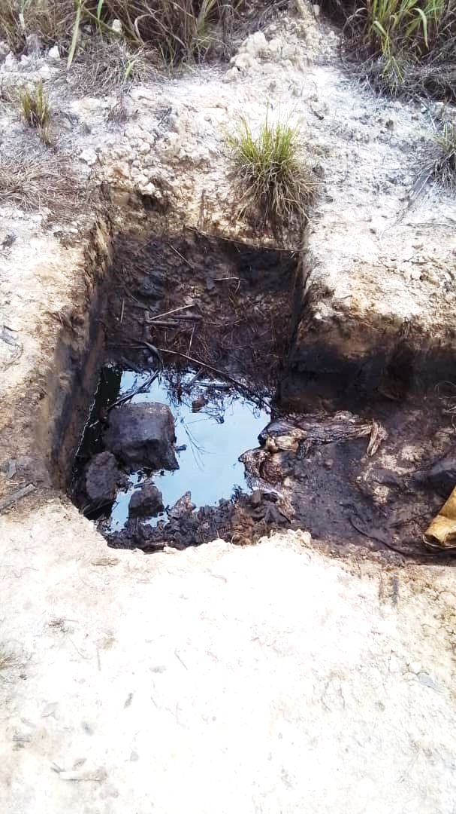
Plate 1. A section of the study site showing the area the spill was induced as a result of the alleged crude oil-theft
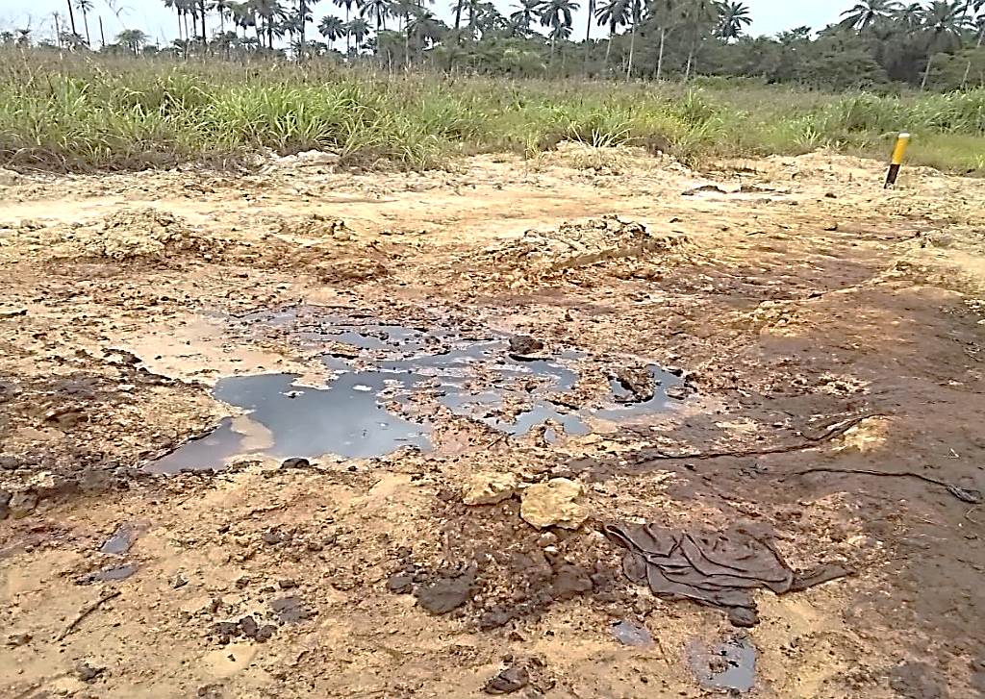
Plate 2. A section of the oil-spill-impacted site at Ahoada in Rivers State, Nigeria

Figure 1 contains the location map of the oil-theft-induced spill siter at Olaikata-Edoha in Ahoada-East Local Government Area of Rivers State, in the Niger Delta region of Nigeria, where soil samples were collected for this study.
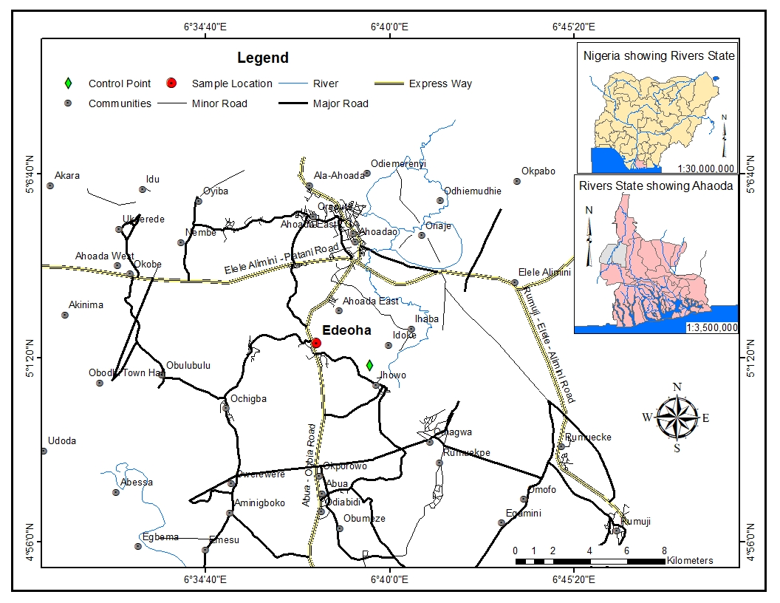Fig. 1: Map of study area showing the location of the oil-spill-impacted site at Olaikata-Edoha in Ahoada-East Local Government Area of Rivers State, Nigeria.

2.2 Sampling and Soil Collection
The contaminated soil samples were taken from a recently crude oil polluted site in Olaikata-Edoha in Ahoada-East Local Government Area of Rivers State, Nigeria. The sampling area was 200 by 200 square meters. The sampling area was subdivided into twenty (20) grid plots. Each of the grid plots was further segmented into three staggered quadrats consisting of three sampling points for topsoil and subsoil respectively. Soil samples were taken from each point at 0-15cm from the surface and 15-30cm from the subsurface. Sampling proper was taken from eight (8) of the twenty grid plots, each plot having replicates of three (3) top and subsoils respectively, that is each plot is made up of three points, each point has top and subsoil, this would give a total of six (6) sampling points per plot. All the sampled plots were not analysed but representative samples were taken from the following sampling points 4, 8, 10, 12, 14, 16, 18, and 20. Samples were collected accordingly thus, six (6) each from plots four and eight respectively, while two (2) samples were collected from 10, 12, 14, 16, 18, and 20, two samples (top and subsoils) each were also collected from two control points. A total of twenty-four (24) contaminated samples were analysed alongside four (4) samples from control site. A manually operated Soil sampling auger was used for the soil sample collection, the soil samples were collected after the surface of each sampling points was cleared of non-soil materials. The collected samples, after collection with the manually operated auger were wrapped with Aluminium foil, put in a water-resistant polythene bag, and transferred to the storage container for onward transportation to the laboratory where the analysis was conducted.
The control samples were equally collected from about 50m away from the contaminated portion of the sampling site.

2.3 Laboratory Analysis
2.3.1 Soil-pH, Temperature, Electrical Conductivity, and Salinity
A preselected, air-dried, and sieved soil samples were weighed, about 10g, put into a beaker, and dissolved in 20ml of distilled water, stirred with a glass rod, and allowed to stand for about 30 minutes; thereafter, a Hach Sension multi-meter instrument for temperature, pH, conductivity, and salinity was inserted into the beaker and the readings for the various parameters were taken (Wang 2013).
2.3.2 Moisture Content Determination
Approximately 5 grams of the contaminate wet soil was weighed in a clean beaker washed with DCM to remove any hydrocarbon, and water to remove any water- soluble component from the beaker. The beaker was weighed empty and weighed with the contaminated soil sample. The beaker with soil sample was transferred into an oven set at 105ºC. The soil sample in the beaker was dried to a constant weight for about six (6) hours. The beaker containing the soil sample was removed from the oven and transferred to a desiccator where the heated and dried contaminated soil sample was cooled to ambient temperature in the absence of ambient moisture. After the cooling, the cooled soil sample and the beaker were weighed, this process was repeated until a constant beaker plus dried contaminated soil weight was achieved. The difference in the weight of the contaminated wet soil sample and the dried contaminated soil sample was determined and converted to percentage, this represents the moisture content of the contaminated soil sample (Dobriyal, et al., 2012).
2.3.3 Heavy Metals
A portion of the preselected air-dried soil sample was weighed after which it was ground and digested with a combination of hydrochloric and nitric acids (HCl and HNO₃) so that the expected analyte was released from the soil matrix. The heavy metals were analysed using already calibrated Atomic Absorption Spectrophotometer (AAS).
2.3.4 Total Organic Carbon (TOC) and Total Organic Matter (TOM)
TOC is the carbon stored in soil organic matter which is derived from the decomposition of plant and animal residues. 5grams of the contaminated soil sample was weighed after removal of some debris. This weighted soil sample was transferred into Pyrex conical flask. 5mls of Potassium Chromate solution was added to 7.5ml of concentrated Sulphuric Acid and added to the weighed contaminated soil sample. The solution was heated for about fifteen (15) minutes to reflux. After the heating the solution was cooled to ambient condition of temperature after which it was diluted to 100mls using distilled water. 0.2M Ferrous Ammonium Sulphate was titrated against the Potassium Chromate solution and concentrated Sulphuric Acid, Ferroin indicator was used. To determine the TOC of the contaminated soil sample, a blank was ran using equivalent quantity of Potassium Chromate titrating it against equivalent quantity of Sulphuric acid as was used for the soil sample, except that the blank does not contain the contaminated soil sample. The titre value was recorded and the TOC percentage was calculated using the formula; Titre value of the blank – Titre value of the sample x 0.003 x 100 divided by sample weight. The TOM content of soil was obtained from the TOC values; the TOM is about twice TOC value hence a reference factor of 1.724 is usually used as a factor to multiply the value of the TOC, and this automatically gives the TOM in the contaminated soil. Empirically, TOC is about 58% of TOM (Oguzie, et al., 2024).
2.3.5 Potassium (K)
For Kjeldahl analysis, 10g of soil, 50ml. of water, 40ml. of Sulphuric acid and 1.0 g of Copper Sulphate or 0.2 g. of Selenium was used as catalyst. This digestion involveK the conversion of orgonic Nitrogen to ammonium sulphate which was later neutralized using Sodium Hydroxide to liberate ammonia.
The Kjeldah digested contaminated soil sample was made up to using 50ml distilled water. The aspirator’s tubing system was flushed with distilled water to rid it of residual analyte. Standard Potassium ion concentration was aspirated into the Spectrophotometer’s burner chamber to calibrate the equipment after which a graph of standard ion concentration was plotted. A wavelength of 760mm was used for the calibration of the system, the prepared sample was aspirated into the Spectrophotometer and the concentration of Potassium in the contaminated soil sample was displayed (Amin, et al., 2004; Osuji and Onojake, 2005).
2.3.6 Total Organic Nitrogen (TON)
TON was determined by converting organic nitrogen to ammonium sulphate after sample preparation and Kjeldahl digestion. Ammonium sulphate would be neutralized with sodium hydroxide. The neutralized sulphate was distilled and passed through boric acid to form ammonium borate which was titrated against Hydrochloric acid causing the release of ammonium; the ammonium released was converted to organic nitrogen and the amount of ammonium converted to organic nitrogen was used to determine organic nitrogen in the soil (Amin, et al., 2004).

2.4 Results and Discussion
The overall trend of lower micronutrient levels, particularly copper (Cu), zinc (Zn), and manganese (Mn), in oil-contaminated plots indicates significant nutrient depletion likely caused by the presence of hydrocarbons in the soil. Essential nutrients critical for plant growth and maintaining soil fertility appear to be less available in these contaminated areas (cf: Tables 1 and 2) . This reduction not only limits the productivity of the soil for agricultural purposes but can also affect the resilience and health of the local ecosystem.
The observed decline in key nutrients and alterations in soil pH and conductivity in contaminated soils signal a compromised soil health profile, with potential implications for crop yield and environmental stability. Lower pH values in contaminated plots suggest increased soil acidity, which can reduce nutrient availability for plants. Additionally, decreased conductivity in these soils may indicate fewer dissolved ions essential for microbial and plant functions. Both of these changes could further disrupt nutrient dynamics, leading to reduced agricultural productivity and challenges in restoring soil fertility (Osuji et al., 2005).
Oil contamination also appears to have caused an imbalance in nutrient availability and the accumulation of heavy metals like lead (Pb) and iron (Fe). While lead is a non-essential, potentially toxic element, high levels of iron may interfere with the absorption of other nutrients, compounding the adverse effects on plant health and growth. Such contamination not only limits crop productivity but could also pose risks to human and animal health through the food chain.
These findings underscore the urgent need for targeted soil management strategies and remediation efforts in Ahoada. Restoring the nutrient balance, adjusting pH, and removing or stabilizing heavy metals are essential steps to mitigate the adverse effects of oil spillage, thus supporting sustainable agriculture and environmental health in the region.

1. pH
The pH values for the control and contaminated sites vary between 5.3 and 6.65. The control plot has a pH of 5.59, indicating slightly acidic conditions. Contaminated plots show slightly lower pH values, except for Plot 7 PT1 TS, which records a pH of 6.65.
The variation in pH could be due to the presence of hydrocarbons, which can influence soil acidity. A lower pH can reduce nutrient availability, particularly essential micronutrients, and may adversely affect plant growth and microbial activity.
2. Electrical Conductivity
Conductivity levels were significantly higher in the control plot (105 µS/cm) compared to contaminated plots, where values ranged from 9 to 48 µS/cm. High conductivity is often associated with increased salt levels, which could influence nutrient availability. Lower conductivity in contaminated plots may indicate changes in soil composition due to oil contamination, which could inhibit the presence of salts and other soluble ions, thus affecting nutrient uptake by plants.
3. Chloride (Cl-)
Chloride concentrations are considerably lower in contaminated plots (2-10 mg/kg) than in the control plot (34 mg/kg). Reduced chloride levels in contaminated soils could be indicative of alterations in soil ionic balance due to oil contamination. This imbalance might affect plant water uptake and soil structure, potentially reducing soil fertility.
4. Copper (Cu)
Copper levels in the control plot are 6.56 mg/kg, significantly higher than in contaminated plots (ranging from 0.98 to 1.65 mg/kg). Copper is essential for plant enzyme systems and reproductive processes. Lower copper concentrations in contaminated plots suggest nutrient depletion, likely a result of oil-induced alterations in soil chemistry, which can hinder crop growth and reduce agricultural productivity.
5. Zinc (Zn)
Zinc levels were also highest in the control plot (25.85 mg/kg) and much lower in the contaminated plots, ranging between 5.47 and 8.41 mg/kg. Zinc is vital for protein synthesis and growth regulation in plants. Its reduced levels in oil-contaminated soils indicate a decrease in soil fertility and potential challenges in achieving optimal plant growth in these areas.
6. Iron (Fe)
Iron concentrations varied widely, with the highest level in Plot 9 PT1 SS (3,909.68 mg/kg) and the lowest in Plot 7 PT1 TS (933.27 mg/kg). The control plot showed a relatively high iron content of 3,040.42 mg/kg. Iron is critical for chlorophyll synthesis and overall plant vitality. The variable iron levels across contaminated plots may reflect inconsistent effects of oil spillage on soil iron content. Increased iron concentrations in certain contaminated plots could be due to local soil conditions or mineral content, while decreased levels may result from oil-induced chemical changes that limit iron availability.
7. Lead (Pb)
Lead levels are slightly elevated in contaminated soils, with the control plot at 6.34 mg/kg and contaminated plots ranging from 4.44 to 7.26 mg/kg. Lead is a toxic metal with no beneficial role in plants. Its presence in elevated amounts in contaminated plots suggests oil contamination may increase the bioavailability of heavy metals, posing potential risks to plant health and, consequently, to human health through the food chain.
8. Manganese (Mn)
Manganese concentrations are significantly higher in the control plot (121.08 mg/kg) than in the contaminated plots, which have values between 3.53 and 5.33 mg/kg. Manganese is essential for photosynthesis and nitrogen metabolism. The reduced manganese levels in contaminated soils highlight a nutrient imbalance that may limit plant growth and soil fertility.

Table 1. Physicochemical properties and micronutrients of spill-impacted soils

S/N | Parameters | Control Plot 5 PT1 TS | Plot 5 PT1 SS | Plot 7 PT1 TS | Plot 7 PT1 SS | Plot 9 PT1 TS | Plot PT1 SS
1 | pH | 5.59 | 5.43 | 5.65 | 6.65 | 5.8 | 5.3
2 | Conductivity (µs/cm) | 105 | 11 | 9 | 14 | 48 | 25
3 | Chloride, Cl- (mg/kg) | 34 | 2 | 2 | 3 | 10 | 8
4 | Copper, Cu (mg/kg) | 6.56 | 1.18 | 0.98 | 1.65 | 1.45 | 1.4
5 | Zinc, Zn (mg/kg) | 25.85 | 6.95 | 5.91 | 5.47 | 6.84 | 8.41
6 | Iron, Fe (mg/kg) | 3,040.42 | 1,556.58 | 933.27 | 1,857.61 | 2,028.02 | 3,909.68
7 | Lead, Pb (mg/Kg) | 6.34 | 5.51 | 4.44 | 5.18 | 5.89 | 7.26
8 | Manganese, Mn (mg/kg) | 121.08 | 5.33 | 3.77 | 3.53 | 5.12 | 4.26

9. Total Organic Matter (TOM)
The TOM of the sampled points was generally low, but with the highest value of 12.62%. The average of the TOM for the contaminated points was 3.90% and that of the control point was 1.69%. The OM ranged from 1.04-12.62% in the contaminated soils, while the control point ranged from 0.86-2.42%, which was quite lower than the value range of the contaminated soil. These agree with what was reported by Oguzie et al. (2024) who reported their study that the TOM of the contaminated soil was 1.15+/-0.03% while that of their reference point was 0.69+/-0.01%, Osuji and Adesiyan (2005) also reported in their investigation of the effect of crude oil contamination on soil physicochemical parameters that the TOM content was enhanced because of TOC enhancement. The TOM obtained in this study was also in agreement with the findings of Osuji, et al., (2005) who reported an increase in the TOM content of the crude oil contaminated soil but opined that the increase was not significant in concentration, which they reported to be supposedly due to natural rehabilitation of the affected soils layer.
The pH values indicate that most plots are slightly acidic to near-neutral. Soil pH affects the availability of nutrients; in acidic soils (pH < 6), phosphorus may become more available, while others, such as calcium and magnesium, may become less accessible. The control sample (pH 5.59) and Plot 7 PT1 TS (pH 6.65) are close to the ideal range for many crops (pH 6–7), which maximizes nutrient availability. Acidic soils, like those with pH around 5.3, might require liming to raise the pH, particularly if crops are sensitive to acidity.
Electrical conductivity (EC) measures ion concentration in the soil solution, indicating salinity or soluble nutrient levels. The control sample has the highest EC (105 µS/cm), which suggests higher ionic content, possibly due to nutrient or salt presence. Low EC levels, as seen in most plots (around 9–48 µS/cm), imply fewer soluble salts or nutrients, which might benefit crops that are salt-sensitive. However, if low EC correlates with low nutrient levels, certain plots might need fertilization to boost productivity.
The highest TON is in Plot 7 PT1 TS (0.270%), suggesting it has the most organic matter, potentially supporting richer plant growth. Lower levels, like 0.111% in Plot 7 PT1 SS, may indicate reduced organic material, leading to limited nitrogen availability.
Phosphorus is essential for root development, flowering, and energy transfer within plants. Values here are uniformly low (below 0.17 mg/kg), with the highest in the control. The low levels indicate a potential deficiency, which could limit plant growth and yield. Fertilization strategies should include phosphorus sources to correct this deficiency.
Sulfate is important for protein synthesis in plants. Sulfate levels are quite low, especially in Plot 5 PT1 TS and Plot 5 PT1 SS, which show no detectable sulfate with the control sample containing the highest concentration (4 mg/kg). Low sulfur may limit protein formation and overall plant health, especially for sulfur-demanding crops like cabbage.
Potassium which plays a vital role in plant stress tolerance, water regulation, and disease resistance. Plot PT1 SS has the highest potassium level (63.10 mg/kg), which is advantageous for potassium-loving crops like tomatoes and potatoes. Lower levels, such as 29.72 mg/kg in Plot 5 PT1 SS, might support basic growth but could require supplementation for optimal yield in potassium-demanding plants (Osuji and Nwoye, 2007).
Calcium levels are highly variable. The control sample has significantly higher calcium (41.00 mg/kg) compared to other plots, which may contribe to better soil structure and nutrient uptake in this sample. Plots with low calcium, such as Plot 5 PT1 SS (0.42 mg/kg), may require calcium amendments for crops that need high calcium levels for growth.
Magnesium is important for photosynthesis, and all plots show adequate levels. The control sample again has the highest magnesium (47.64 mg/kg), likely sufficient for most crops. Lower levels, as seen in Plot 5 PT1 SS (21.10 mg/kg), might still support plant health but could be monitored for magnesium-demanding crops (Osuji et al., 2005).
Table 2. Primary macronutient status of spill-impacted soils
S/N | Parameters | control | Plot 5  PT1 TS | Plot5  PT1 SS | Plot 7  PT1 TS | Plot 7  PT1 SS | Plot 9  PT1 TS | Plot 9  PT1 SS
1 | pH | 5.59 | 5.43 | 5.65 | 6.65 | 5.80 | 5.30 | 5.25
2 | Conductivity (ųs/cm) | 105 | 11 | 9 | 14 | 48 | 25 | 33
3 | TON(%) | 0.145 | 0.189 | 0.142 | 0.270 | 0.111 | 0.148 | 0.175
4 | Phosphorus, P(mg/kg) | 0.17 | 0.10 | 0.10 | 0.13 | 0.15 | 0.14 | 0.14
5 | Sulphate SO42-(mg/kg) | 4 | 0 | 0 | 1 | 2 | 1 | 1
6 | Potassium,K (mg/kg) | 49.79 | 35.58 | 29.72 | 51.75 | 30.97 | 51.59 | 63.10
7 | Calcium, Ca (mg/kg) | 41.00 | 1.15 | 0.42 | 2.67 | 2.80 | 10.03 | 6.48
8 | Magnesium, Mg(mg/kg) | 47.64 | 27.90 | 21.10 | 29.84 | 21.62 | 27.09 | 28.30

Conclusion and Recommendations
Results of studies conducted at the oil spill site at Ahoada East in the Niger Delta, with a view to evaluating the impact of the spill on soil fertility indicators point to possibilities for restoration. Soil-pH, electrical conductivity, chloride, and concentrations of the selected micronutrients such as iron, manganese, zinc, and copper and macronutrients (Nitrogen, phosphorus and potassium) in the soil and other fertility indicators such as TOC and TOM evaluated were within restoration limits. Findings revealed a notable decrease in essential nutrients, particularly Cu, Zn, and Mn. The pH values for the contaminated sites vary between 5.3 and 6.65, while the electrical conductivity (EC) ranged from 9 to 48 µS/cm. These and other key indicators were higher in the control soils. However, the OM ranged from 1.04-12.62% in the contaminated soils, while the control point ranged from 0.86-2.42%. These conditions generally imply low soil fertility, which in turn implies low agricultural productivity and reduced source of livelihood in the affected area. Though primary macronutrients (N, P and K) in the study area were inherently low.
To restore the contaminated area and sustain agricultural productivity, there is need for immediate and efficient clean up exercise. Subsequently, the soil-pH should be adjusted to a range of 6.0 – 6.5 by the addition of calcitic lime, followed by the application of appropriate and sufficient inorganic NPK fertilizer to restore the carbon to nutrient ratios to the optimum required to stimulate and sustain microbial activity. Stimulation of the indigenous microbial growth by cultivating the soil to distribute the nutrients and lime and to aerate the treatment zone. The effective development and implementation of the above recommended remediation strategies are crucial for the restoration of soil health and sustainable agricultural practices at the study site.

Disclaimer (Artificial intelligence)
Option 1:
Author(s) hereby declare that NO generative AI technologies such as Large Language Models (ChatGPT, COPILOT, etc.) and text-to-image generators have been used during the writing or editing of this manuscript.
Option 2:
Author(s) hereby declare that generative AI technologies such as Large Language Models, etc. have been used during the writing or editing of manuscripts. This explanation will include the name, version, model, and source of the generative AI technology and as well as all input prompts provided to the generative AI technology
Details of the AI usage are given below:
1.
2.
3.

REFERENCES
Ameen, F., AlNAdhari, S., Yassin, M. A., Al-Sabri, A., Almansob, A., Alqahtani, N., & Stephenson, S., 2022. Desert soil fungi isolated from Saudi Arabia: Cultivable fungal community and biochemical production. Saudi Journal of Biological Sciences, 29(4), 2409–2420. https://doi.org/10.1016/j.sjbs.2021.12.011
Amin, M., Flowers, T. H. (2004). Evaluation of Kjeldahl digestion method. Journal of Research (Science), 15(2), 159-179.
Chikere, CB., Nwogu, D. C., Okpara, F., Abani, G.N., 2023. Impact of oil spills on agricultural lands in the Niger Delta. Journal of Environmental Science and Engineering, 8(1), 24-34.
Collins, W., Wali, E., 2020. Crude Oil Theft in the Niger Delta: The Oil Companies and Host Communities Conundrum. International Journal of Research and Scientific Innovation (IJRSI) 7(I), 22-32
Daâssi, D., Qabil Almaghribi, F., 2022. Petroleum-contaminated soil: environmental occurrence and remediation strategies. 3 Biotech. 12(6), 139. https://doi.org/10.1007/s13205-022-03198-z
Dobriyal, P., Qureshi, A., Badola, R., Hussain, S.A., 2012. A review of the methods available for estimating soil moisture and its implications for water resource management. Journal of Hydrology, 458, 110-117.
Ekekwe, A.A., Onyekwere, C.P., Obika, C., Nnamdi, A.E., 2022. The role of nutrient management in sustainable agriculture in the Niger Delta. Journal of Sustainable Agriculture, 19(4), 234-245.
Ekundayo, E.O., Obuekwe, O. 2000. Effects of an oil spill on soil physico-chemical properties of a spill site in a typic udipsamment of the Niger Delta Basin of Nigeria. Environ Monit Assess 60, 235–249 . https://doi.org/10.1023/A:1006230025095
Ewetola, E., 2013. Effect of crude oil pollution on some soil physical properties. IOSR Journal of Agriculture and Veterinary Science 6(3), 14-17. https://doi.org/10.9790/2380-0631417.
Falih, K.T., Mohd Razali, S.F., Abdul Maulud, K.N., Abd Rahman, N., Abba, S.I., Yaseen, Z.M., 2024. Assessment of petroleum contamination in soil, water, and atmosphere: a comprehensive review. Int. J. Environ. Sci. Technol. 21, 8803–8832. https://doi.org/10.1007/s13762-024-05622-8
Gao, H., Wu, M., Liu, H., Xu, Y., Liu, Z., 2022. Effect of petroleum hydrocarbon pollution levels on the soil microecosystem and ecological function. Environmental Pollution, 293, 118511. https://doi.org/10.1016/j.envpol.2021.118511.
Haritash, A.K., Kaushik, C.P., 2009. Biodegradation aspects of polycyclic aromatic hydrocarbons (PAHs): A review. J. Hazard Mater. 169, 1–15. https://doi.org/10.1016/j.jhazmat.2009.03.137.
Honda, M., Suzuki, N., 2020 Toxicities of polycyclic aromatic hydrocarbons for aquatic animals. Int J Environ Res Public Health. 17(4), 1363. https://doi.org/10.3390/ijerph17041363.
Ikem, A., Eze, C.O., Adeyemi, A.K., Okafor, B.C., 2023. Impact of oil spills on soil nutrient status in the Niger Delta. Environmental Science & Pollution Research, 30(2), 451-463.
Mafiana, M.O., Kang, X.H., Leng, Y, He, L.F., Li, S.W., 2021. Petroleum contamination significantly changes soil microbial communities in three oilfield locations in Delta state, Nigeria. Environ Sci Pollut Res Int. 8(24), 31447-31461. https://doi.org/10.1007/s11356-021-12955-1
Meador, J.P., 2008. Polycyclic aromatic hydrocarbons. In: Jørgensen, S.E., Fath B.D., editors. Encyclopedia of ecology. Oxford: Elsevier; pp. 2881–2891.
Morales-Bautista CM, Adams RH, Hernández-Barajas JR, Lobato-García CE, Torres-Torres JG., 2016. Characterization of fresh and weathered petroleum for potential impacts to soil fertility. International Journal of Environmental Science and Technology 13, 2689-96. https://doi.org/10.1007/s13762-016-1097-x

NDES, 1999. Niger Delta Environmental Survey Phase 1 Report, Vol.1 Environmental and Socio – Economic Characteristics (Revised Edition). Technical report submitted by Environmental Resource Managers Limited, Lagos. Pp. 101 – 116
NOSDRA., 2025. Oil theft responsible for most crude spills. A publication of the National oil Spill Response and Detection Agency, January 26, 2025.
Oguzie, G.P., Williams, J.O., Aleruchi, O., 2024. Microbiological and physicochemical characteristics of soil contaminated with crude oil in Port Harcourt. Int J Microbiol Appl Sci, 3(1), 303-312.
Osagie, O., Osuji, L.C. and Hart, A. I. 2022. Macronutrient status and physico-chemical properties of soils around the gas flare site at Oyigbo in rivers state, Nigeria. Asian Journal of Current Research 7(2), 24-33. https://doi.org/10.56557/ajocr/2022/v7i27905
Osuji, L. C. and Adesiyan, S. O. 2005.The Isiokpo oil-pipeline leakage: Total organic carbon/organic matter contents of affected soils. Chemistry and Biodiversity 2, 1079-1085. https://doi.org/10.1002/cbdv.200590077
Osuji, L. C., Egbuson, E. J. and Ojinnaka, C. M. 2005. Assessment and treatment of hydrocarbon inundated soils using inorganic nutrient (N-P-K) supplements: II. A case study of Eneka oil spillage in Niger Delta, Nigeria. Environmental Monitoring and Assessment 30, 1-14. https://doi.org/10.1007/s10661-006-6552-6
Osuji, L. C., Erondu, E. S. and Ogali, R. E. 2010. Upstream petroleum degradation of the mangroves and intertidal shores: the Niger Delta experience. Chemistry and Biodiversity 7, 116-129. https://doi.org/10.1002/cbdv.200900203
Osuji, L. C., and Nwoye, I. 2007. An appraisal of the effects of petroleum hydrocarbons on soil fertility: The Owaza experience. African Journal of Agricultural Research 2(7), 318-324.
Osuji, L.C., Onojake, C.M., 2005. Field reconnaissance and estimation of petroleum hydrocarbon and heavy metal contents of soils affected by the Ebocha-8 oil spillage in Niger Delta, Nigeria. Journal of Environmental Management 79, 133-139. https://doi.org/10.1016/j.jenvman.2005.06.004
Otaiku, A.A., 2019. Effects of oil spillage on soils nutrients of selected communities in Ogoniland, south-eastern Niger Delta, Rivers State, Nigeria. International Journal of Ecology and Ecosolution. 6. 23-36. https://doi.org/10.30918/IJEE.63.18.018
Polyak, Y.M,, Bakina, L.G,, Mayachkina, N.V., Chugunova, M.V., Bityutskii, N.P., Yakkonen, K.L., Shavarda, A.L.. 2023. Long-term effects of oil contamination on soil quality and metabolic function. Environ Geochem Health. 46(1),13. https://doi.org/10.1007/s10653-023-01779-2.
Roberts, A.U., Osuji,L.C., Onojake M.C., 2024. Preliminary studies of Elele and Isiokpo oilfields in the Niger Delta: Macronutrient status of spill impacted soils. Journal of Petroleum and Chemical Engineeriong 2(2), 44-49.
Sakshi, S.S.K., Haritash, A.K., 2019. Polycyclic aromatic hydrocarbons: soil pollution and remediation. Inter J Environ Sci Technol. 16, 6489–6512. https://doi.org/10.1007/s13762-019-02414-3.
Sam, K.S., Onyena, A.P., Zabbey, N., Odoh, C.K., Nwipie, G.N., Nkeeh, D.K., Osuji, L.C., Little, D.I., 2023. Prospects of emerging PAH sources and remediation technologies: insights from Africa. Environmental Science and Pollution Research 30 (14), 39451-39473. https://doi.org/10.1007/s11356-023-25833-9
Terytze, K., Kördel, W., Aldag, R., Hanel, J., Hein, D., Keller, E., Klein, M., Kuhnt, G., Müller-Wegener, U., Scheunert, I., Schmidt, M., Spiteller, M., Thvon der Trenck, K.. 1995. Detection and determination limits of priority organic pollutants in soil. Chemosphere. 31(4), 3051–3083. https://doi.org/10.1016/0045-6535(95)00166-6.
Wang, Y., Feng, J., Lin, Q., Lyu, X., Wang, X., Wang, G., 2013. Effects of crude oil contamination on soil physical and chemical properties in Momoge wetland of China. Chinese Geographical science, 23, 708-715
Yadav, K.K., Singh, K.K., Yadav, A.S., Kumar, D., 2023. The ecological impact of oil spills on soil health. Vigyan Varta SP3, 93-96.
Zahermand, S., Vafaeian, M., Bazyar, M.H., 2020. Analysis of the physical and chemical properties of soil contaminated with oil (petroleum) hydrocarbons. Earth Sci. Res. J. 24, 163–168. https://doi.org/10.15446/esrj.v24n2.76217.

