UTILISATION OF OYSTER SHELLS POWDER FOR MODIFICATION OF ACIDIC OILFIELD PRODUCED WATER FOR REUSE AND RE-INJECTION

Abstract
Oysters are bivalve mollusks primarily found around the coastal areas. However, oyster shells are indiscriminately disposed of causing many negative effects on the ecosystem. This study aims to increase its recycling awareness through the utilization of the shells to adjust the pH value of acidic produced water samples C7T, AZ-ST1 & AZ-ST 2 collected from an oilfield in Bayelsa State, Nigeria for reuse and reinjection. Oyster shells were pulverized and characterized using the FTIR technique. The performance of the pulverized oyster shells (POS) was tested for pH modification of produced water for reinjection by using 100g and 200g of the POS placed in a column and allowing 200mL of the untreated produced water samples to pass through each set up and varying contact time (30, 60 & 90 min). The pH level of the UPW samples gradually increased from 6.3-6.5 to reach 8.2-8.5 after 90 min. The study suggests that POS is a potential and sustainable alternative agent for modifying the pH of reinjected produced water to prevent scale formation, corrosion of facilities and reservoir plugging.
Keywords: Produced water, Oyster shells, Reinjection, Reuse.

1.0 Introduction
Oil production generates a large volume of produced water as a predominant byproduct. Produced water constitutes environmental challenges because of the high levels of pollutants (organic and inorganic). Produced water is composed of oil, polycyclic aromatic hydrocarbons (PAHs), polychlorinated biphenyls (PCBs), dissolved solids and heavy metals. These pollutants are harmful to both plants and animals (Ogbonna, and Origbe, 2021; Fakhru’l-Razi, Pendashteh, Abdullah, Biak, Madaeni and Abidin, 2009.
Several treatment technologies are available for managing the various constituents of produced water to facilitate its discharge, injection, or beneficial reuse. (Nasiri, Jafari and Parniankhoy, (2017). Produced water necessitates treatment to remove hazardous constituents before reuse or discharge due to increasing awareness and regulations on managing produced water recovery (Arthur, Dillion and Drazan 2011).
Researchers and oil producing companies are continuously seeking efforts to develop cost-effective and eco-friendly technologies such as bio-adsorption process for managing produced water for reuse in industrial applications, agriculture, domestic and reinjection into reservoirs to improve oil recovery (Arthur et al, 2011; Gargouri, Trabelsi, Abdelhedi and Bouaziz, 2014).
For most companies, reinjection is a cost-effective strategy for managing produced water. However, if not well treated, it could lead to formation damage and production issues. Hence, it is important to ensure that treated produced water meets quality specification to prevent scale formation and reservoir plugging (Arthur et al, 2011; Mohamed, Block, Abou-Sayed and Abou-Sayed, 2016).
The limitations of some conventional produced water treatment techniques are high operating costs and complex technologies (Salem and Thiemann, 2022). However, the quest for sustainable and cost-effective treatment technologies have led to the development of bio-adsorbents for the adsorption process (Yousef, Qiblawey and El-Naas, 2020; De Gisi, Lofrano, Grassi, Notarnicola 2016).
The application of oyster shells as alternative adsorbent holds significant potential for adsorption technology (Zhou, Wang, Sun, Wang and Xu, 2022). Oyster shell, a waste product from the seafood industry, can be utilized for wastewater treatment. This practice aims to promote sustainable practice and minimize the impact of waste on the environment (Bellei, Torres, Solstad and Flores-Colen, 2023).
The aim of this study is to investigate the application of oyster shells for modification of acidic produced water to meet the pH specification for reinjection into reservoirs, while also aligning with the global shift towards sustainable and eco-friendly practices for produced water management.
2.0 Produced Water Treatment Methods
Produced water is a complex mixture that includes water, hydrocarbons, polycyclic aromatic hydrocarbons (PAHs), polychlorinated biphenyls (PCBs), dissolved solids, heavy metals and other pollutants (Fakhru'l-Razi et al., 2009). Produced water is harmful to the environment and must be managed appropriately according to regulation. Produced water often requires treatment to remove impurities and meet standards for reinjection or disposal. In most cases, the treatment process combines several techniques consisting of a primary treatment unit to remove the particles, then a secondary biological or chemical processing treatment and tertiary unit, usually the final stage to improve the water quality and remove the remainder of the undesired components (Cooper et al 2021; Horner, Castle and Rodgers, 2011; Al-Ajmi, Al-Marri, Almomani, Al-Nouss, 2024).
The treatment methods are illustrated in Figure 1.
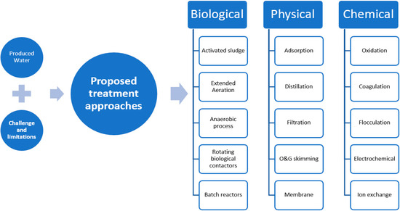

Figure 1. Produced water treatment methods (Al-Ajmi et al., 2024; Saleh, et al., 2020).

2.1 Regeneration of Spent Oyster Shells for Reuse in Water Treatment
Adsorption is a widely recognized, cost-efficient and viable treatment technology characterized by its operational simplicity and economic efficiency in removing
environmental pollutants from wastewater. There is rising demand for increased treatment efficiency and regeneration of adsorbents (Sonker, Shreyash, Tiwary, Shim, and Balathanigaimani, 2022; Kosheleva, Kyzas and Mitropoulos, 2019). Regeneration of adsorbents provide economic and environmental benefits (Fouda-Mbanga, Onotu and Tywabi-Ngeva, 2024). Generally, adsorbent regeneration restores the adsorption capacity of spent adsorbent through desorbing the adsorbates by either thermal treatment, solvent extraction and steam regeneration technique (Fouda-Mbanga et al., 2024; Mo, Pang, Tan, Zhang and Li, 2019).

Phan et al., (2023) regenerated spent oyster shells through thermal treatments at temperatures between 120ºC - 220ºC. The regenerated oyster shell was used for enhancing and stabilizing the pH value of acidified water. When the regenerated oyster shell was examined using a Scanning Electron Microscope (SEM), no major change was observed in the composition and calcite-based layer structure. Consequently, the performance of the regenerated oyster shells was tested for the adjustment of the aqueous pH value of a simulated solution which rapidly increased from 6.3 to 7.7 in the first 2hours, reached the highest value of 7.8 after 24hours and slowly decreased and eventually stabilized at pH value of 7.2 after 5-6 days. The study demonstrated the feasibility of regeneration of waste oyster shells into a low-cost and green material for reuse in water treatment.
2.2 Effect of Oyster Shells Residues on Water Quality for Reinjection
Formation damage caused by suspended solid particles and oil droplets is a complex phenomenon, which requires a number of parameters to be evaluated (Rossini et al., 2020). However, it is generally accepted that formation damage results from a complex interaction between the reinjected water quality, petrophysical and mechanical properties of the reservoir rock in addition to the completions integrity and well design (Ochi and Oughanem, 2018).
The application of oyster shells in wastewater treatment has shown promise in research and pilot scale, however, its application on a commercial scale is not yet widespread (Jung et al., 2016). Oyster shell is rich in calcium carbonates according to experimental studies. However, the presence of calcium carbonate residues in high amounts in reinjected water can lead to scale formation. Therefore, to prevent scale formation during reinjection, addition of calcium carbonate inhibitors should be considered to prevent scale formation and fouling (Pei, Wang and Liu, 2014).
2.3 Produced Water Quality for Reinjection Application
The specification of water for reinjection applications differs from one reservoir to another. However, the typical specifications for reinjection application without causing damage to the reservoir are illustrated below:
Suspended solid <1 mg/L; Particle size of solid < 1 µm; Oil content <5 mg/L
pH 6.5 – 7.5
(Utjok, Setyo, Anita and Gede, 2018)
One of the required quality parameters for produced water reinjection is the final pH level. The concentration, toxicity, and solubility of heavy metals in produced water are impacted by its pH. At pH of less than 4, most metals become more soluble and poisonous as acidity increases and challenging for reuse (Baudendistel et al., 2015). Produced water requires treatment to remove pollutants and prevent fouling by adjusting its pH to meet the required specifications. For produced water reinjection into a reservoir, a general target pH range is between 6.5 and 7.5, though specific regulations and acceptable ranges may vary depending on the reservoir characteristics and local regulations (Graham et al., 2017).
The application of oyster shells to modify the pH of wastewater during treatment have shown promise. A study by Kang et al. (2024) emphasized the sustainable use of waste oyster shells in environmental management, noting that they provide an eco-friendly alternative to synthetic alkaline agents in water treatment. Their study demonstrated that crushed oyster shells effectively adjusted the hydrofluoric-acid rich wastewater pH from pH 2 to pH 6.8, demonstrating oyster shells’ effectiveness in wastewater treatment process.

3.0 Materials and Method
The following materials and equipment were used to conduct the study: Oil field Produced water, Oyster shells, Electric Grinding Machine, Sieve, weighing scale, Retort stand, separating funnel, Glass column chamber, Beakers, Glass wool, Glass funnel, Cyclohexane, Electric oven, Electric grinder, Hach Potable meter, Fourier Transform Infrared Spectrometer.

3.1 Methodology
The setup includes a separating funnel attached to a retort stand and a glass column chamber with a clean glass beaker for collecting the filtrate. 100g of the POS adsorbent was placed in the column chamber and 200mL of the untreated sample was transferred to the separating funnel. The separating funnel was opened, and the produced water was allowed to run through the chamber holding the pulverized oyster shell into a clean glass beaker where the filtrate was collected and analysed. This procedure was repeated with 200g of POS varying the contact time (Chikwe and Ogbole, 2019; Xu, Liu, Oh and Park, J. 2019).

3.2 Sample Preparation and Analysis
The oyster shells were sourced locally from Borikiri Market in Port Harcourt and washed with distilled water. The clean shells were dried in an electric oven at 70-80ºC. The dried oyster shells were pulverised using the electric grinder and sieved using a 75micrometer sieve size. Three produced water samples; AZ-ST1, AZ-ST2, and C7T were collected in a 500mL glass bottle from an oil producing field in Bayelsa State, Nigeria. The water samples produced were transported in a medium-sized ice box and transported to the Laboratory in Port Harcourt. The samples were filtered through using a separating funnel. The filtrate was analyzed for pH using a Hach pH meter.

4.0 Results and Discussion
4.1 FT-IR Analysis of Oyster shells
Figure 2a shows the oyster shell FT-IR spectrum using Perkin Elmer-100. The peaks observed are presented in table 1:
Table 1: The FTIR spectrum bands of POS
S/N | Wave numbers (cm⁻¹) | Observation
1 | 3186.429 | Ca-CO₃ Chelate
2 | 2724. 926 - 2332. 694 | ${HCO}_{3}^{-}$ (carbonate ion) stretching
3 | 1799.051 | C = O stretching
4 | 1462.977 | C-O stretching
5 | 1377. 732 | ${CO}_{3}^{2-}$ (bicarbonate ion) asymmetric stretching
6 | 1168. 984 - 1151. 894 | ${CO}_{3}^{2-}$ (bicarbonate ion) symmetric stretching
7 | 876. 833 - 876. 562 | Out - of - plane vibrational bending of ${CO}_{3}^{2-}$
8 | 722. 306 - 772.076 | In - plane vibrational bending of ${CO}_{3}^{2-}$
9 | 3413. 954 | In – plane NH bending
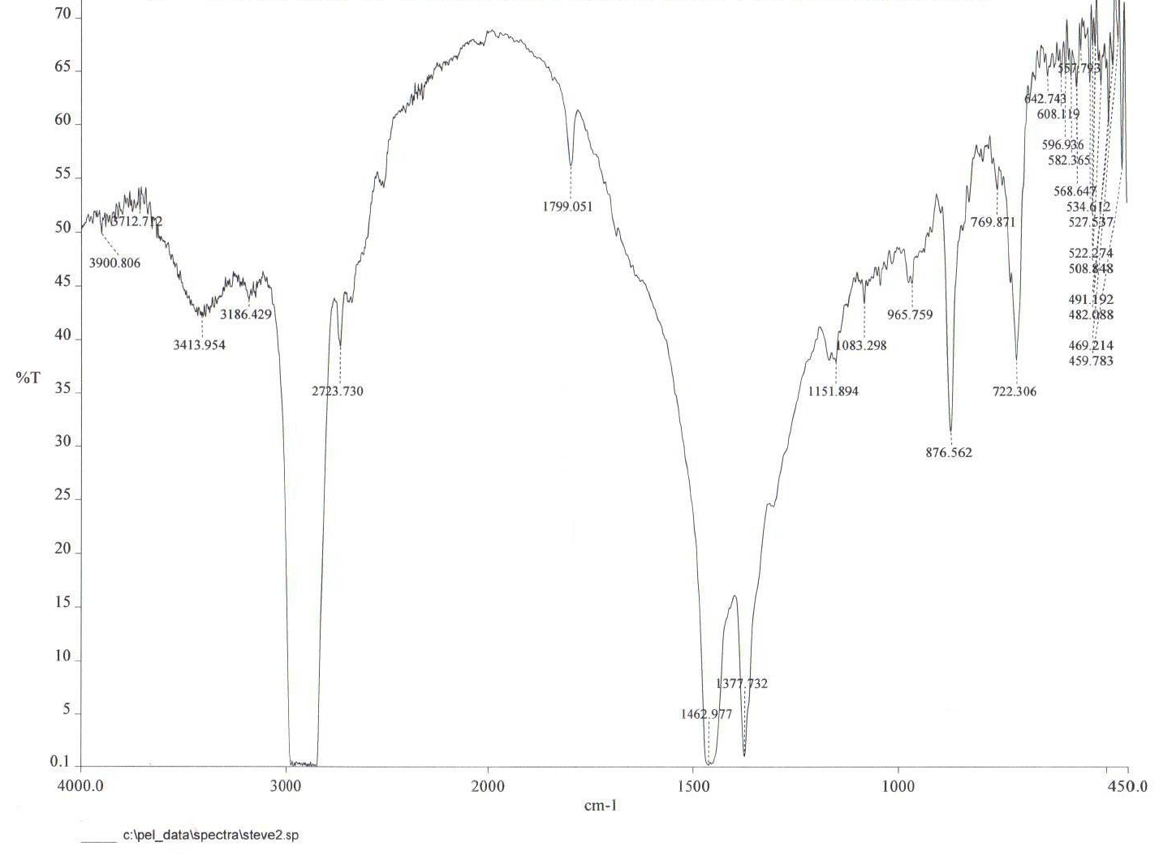

Figure 2a shows the oyster shell FT-IR spectrum
The observed peaks of 3186.429 and 1799. 051 cm⁻¹ indicates presence of Ca-CO₃ Chelate and C = O stretching in the oyster shell respectively. Similarly, at observed peaks of 2724. 926 – 2332. 694 cm⁻¹ showed presence of ${HCO}_{3}^{-}$ (bicarbonate ion). Several spectra bands appeared at 1377. 732 cm⁻¹, 1168.984 – 1151. 894 cm⁻¹ , 876.833 – 876. 562 cm⁻¹ and at 722. 306 – 772. 076 cm⁻¹ revealed carbonate ion (${CO}_{3}^{2-}$) asymmetric stretching, carbonate ion (${CO}_{3}^{2-}$) symmetric stretching, out – of – planes vibrational bending and in - planes vibrational bending of carbonate ion (${CO}_{3}^{2-}$) respectively (Cocean, Postolachi, Garofalide, Bulai, Munteanu and Gurlui, 2022; Chikwe et al., 2019).
4.2 Analysis of Oyster shells with Energy-Dispersive X-ray (EDX) Spectroscopy Coupled with Scanning Electron Microscope (SEM)
The analysis of the pulverized oyster shell with Energy Dispersive X-ray Spectroscopy coupled with a Scanning Electron Microscope (Vega Tescan LMH II, Brno, Czech Republic) is presented in figure 2b showing the morphological structure exhibited in the image of the oyster shell. Oyster shell structure is composed of large number of prismatic layers with micro-pore sizes between 2 and 10 micrometers. This sort of spatial structure is unique for oyster shells creating a good adsorption capacity (Zhou et al., 2022; Lee, Jang, Ryu, Chae, Lee, and Jeon, 2011).
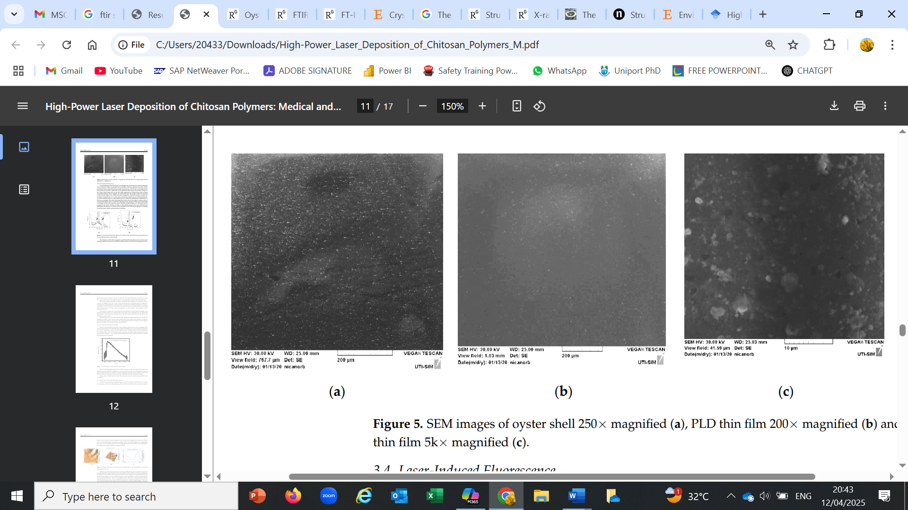

Fig 2b: SEM image of oyster shell (Cocean et al., 2022)

4.3 Sample Analysis (Untreated and Treated Produced Water)
The untreated produced water samples namely, C7T, AZ-ST 1, and AZ-ST 2 were analysed for conductivity and pH and the results presented in table 2.

Table 2: Concentration Levels of Selected Parameters
UNTREATED PRODUCED WATER SAMPLES
PARAMETER | C7T | AZ-ST 1 | AZ-ST 2
Conductivity (mS/cm) | 18.6 | 15.8 | 14.7
pH | 6.3 | 6.4 | 6.5

Figure 3a presents the pH levels of treated produced water (TPW) using 100g of POS after contact time of 30, 60 & 90 minutes. The pH increased from being slightly acidic to neutral in 60 minutes and slightly alkaline in 90 minutes.
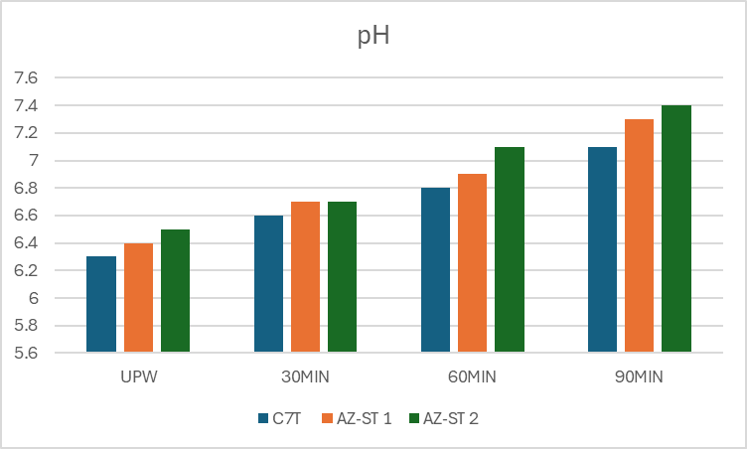
Fig 3a: pH of TPW with 100g of POS

From figure 3b, the introduction of 200g of pulverized oyster shell significantly increased the pH of the treated samples. After 30 minutes, the pH steadily increased to 7.5 – 7.8, suggesting a strong alkalizing effect due to the significant release of calcium carbonate (CaCO₃). The pH steadily increased reaching 8.0–8.2 at after 60 minutes and 8.1–8.4 after 90 minutes. This steady increase indicates dissolution of the oyster shell, ultimately alkalizing the produced water. These results further highlighted the potential of oyster shells as sustainable pH regulator in water treatment applications.
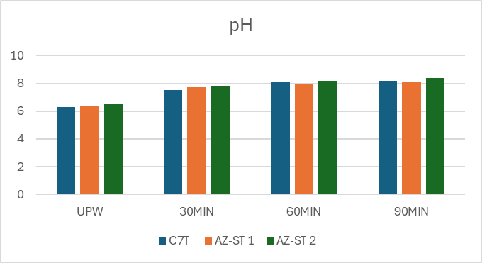
Fig 3b: pH level of TPW using 200g of POS
Research by Lee, Kim, Owens, Park, Kim, and Hong (2018) found that oyster shells are highly effective in neutralizing acidic wastewater due to their high calcium carbonate content. Their study reported that pH levels in acidic wastewater increased from 5.8 to 8.2 within two hours, which aligns with the current study’s findings of a gradual pH increase over time.

5.0 Conclusion
Several approaches have been proposed to provide a strategy for produced water management. Among these strategies, reinjection is the most attractive option as it is considered a more cost-effective alternative rather than discharge. Companies and country regulations have also ensured that treated produced water meets specification to prevent reservoir fouling, formation damage and environmental pollution. Considering the result from this current study, the pH modification of the produced water samples AZ-ST1, AZ-ST 2 and C7T from slightly acidic to neutral and slightly alkaline demonstrates the potential of oyster shells as suitable and sustainable pH modifier of produced water for reuse and reinjection. While oyster shell, rich in calcium carbonates, has shown potential in this regard, according to experimental studies, the presence of calcium carbonate in high amounts in the reinjection water can lead to scale formation. Therefore, to prevent scale formation during reinjection, addition of calcium carbonate inhibitors should be considered to prevent scale formation and fouling (Pei, Wang and Liu, 2014).
It is worth mentioning that the produced water treatment process is an integrated system involving multiple technologies working together to treat wastewater to the required quality that it can be reused or disposed of safely (Al-Ajmi, Al-Marri, Almomani and Al-Nouss, 2024).
Finally, the selection and combination of produced water treatment techniques should be considered from both theoretical and experimental perspectives to develop a robust treatment system. In summary, integrating oyster shells into other treatment methods could improve the pollutant removal efficiency and provide a more efficient and sustainable water treatment process.

Disclaimer (Artificial intelligence)
Option 1: Option 1
Author(s) hereby declare that NO generative AI technologies such as Large Language Models (ChatGPT, COPILOT, etc.) and text-to-image generators have been used during the writing or editing of this manuscript.
Option 2:
Author(s) hereby declare that generative AI technologies such as Large Language Models, etc. have been used during the writing or editing of manuscripts. This explanation will include the name, version, model, and source of the generative AI technology and as well as all input prompts provided to the generative AI technology
Details of the AI usage are given below:
1.
2.
3.

References
Abdel-Shafy, H. I., & Mansour, M. S. M. (2018). Solid waste issue: Sources, composition, disposal, recycling, and valorization. Egyptian Journal of Petroleum, 27(4), 1275–1290. https://doi.org/10.1016/j.ejpe.2018.07.003
Al-Ajmi, F., Al-Marri, M., Almomani, F., & AlNouss, A. (2024). A Comprehensive Review of Advanced Treatment Technologies for the Enhanced Reuse of Produced Water. Water, 16(22), 3306. https://doi.org/10.3390/w16223306
Arthur, J. D. (2011). Management of produced water from oil and gas wells. Working Document of the NPC North American Resource Development Study Paper, 2-17.
Baudendistel, T. A., Farrell, J. W., & Kidder, M. F. (2015, July). To Treat or Not To Treat? Optimized Water Decisions Throughout the Produced-Water Management Cycle. In SPE/AAPG/SEG Unconventional Resources Technology Conference (pp. URTEC-2173857). URTEC.
Bellei, P., Torres, I., Solstad, R., & Flores-Colen, I. (2023). Potential Use of Oyster Shell Waste in the Composition of Construction Composites: A Review. Buildings, 13(6), 1546.

Chikwe, T. N., & Ogbole, S. N. (2019). Remediation of simulated oil contaminated sites using shells of clams and oyster-Total petroleum hydrocarbons of simulated oil contaminated sites, before and after remediation. Nigerian Journal of Chemical Research, 24(1), 57-67.
Cocean, G., Cocean, A., Postolachi, C., Garofalide, S., Bulai, G., Munteanu, B. S., ... & Gurlui, S. (2022). High-power laser deposition of chitosan polymers: medical and environmental applications. Polymers, 14(8), 1537.

De Gisi, S., Lofrano, G., Grassi, M., & Notarnicola, M. (2016). Characteristics and adsorption capacities of low-cost sorbents for wastewater treatment: A review. Sustainable Materials and Technologies, 9, 10-40.
Fakhru'l-Razi, A., Pendashteh, A., & Abdullah, L. C. (2009). Review of technologies for oil and gas produced water treatment. Journal of Hazardous Materials, 170(1), 530-551.
Fouda-Mbanga, B. G., Onotu, O. P., & Tywabi-Ngeva, Z. (2024). Advantages of the reuse of spent adsorbents and potential applications in environmental remediation: A review. Green Analytical Chemistry, 100156.
Gargouri, B., Gargouri, O. D., Gargouri, B., Trabelsi, S. K., Abdelhedi, R., & Bouaziz, M. (2014). Application of electrochemical technology for removing petroleum hydrocarbons from produced water using lead dioxide and boron-doped diamond electrodes. Chemosphere, 117, 309-315.
Graham, E. J. S., Dean, C. A., Yoshida, T. M., Twary, S. N., Teshima, M., Alvarez, M. A., ... & Laur, P. M. (2017). Oil and gas produced water as a growth medium for microalgae cultivation: A review and feasibility analysis. Algal Research, 24, 492-504.
Kang, Y., Wang, W., & Huang, M. J. (2018). Adsorption of heavy metals by oyster shells: A review. Journal of Environmental Science and Health, Part C, 36, 1-13.
Lee, H. H., Kim, S. Y., Owens, V. N., Park, S., Kim, J., & Hong, C. O. (2018). How does oyster shell immobilize cadmium?. Archives of Environmental Contamination and Toxicology, 74, 114-120.
Lin, H., Hou, Q., Luo, Y., Hu, G., Yu, J., & Yu, R. (2022). Reutilization of waste oyster shell as filler for filter for drinking water pretreatment: feasibility and implication. Journal of Environmental Management, 315, 115142.
Kang, S. B., Ko, G.-I., Min, B.-C., Wang, Z., Kim, S. M., & Won, S. W. (2024). Recycling of Waste Oyster Shells for Fluoride Removal from Hydrofluoric Acid Wastewater. Recycling, 9(5), 86. https://doi.org/10.3390/recycling9050086

Kosheleva, R. I., Kyzas, G. Z., & Mitropoulos, A. C. (2019). Low-cost materials in gas-phase adsorption. In Interface Science and Technology (Vol. 30, pp. 125-149). Elsevier.

Mo, L., Pang, H., Tan, Y., Zhang, S., & Li, J. (2019). 3D multi-wall perforated nanocellulose-based polyethylenimine aerogels for ultrahigh efficient and reversible removal of Cu (II) ions from water. Chemical Engineering Journal, 378, 122157.
Mohamed, I. M., Block, G., Abou-Sayed, O., & Abou-Sayed, A. S. (2016, September). Industrial waste injection feasibility in North Dakota. In SPE Annual Technical Conference and Exhibition? (p. D031S043R001). SPE.

Nasiri, M., Jafari, I., & Parniankhoy, B. (2017). Oil and gas produced water management: a review of treatment technologies, challenges, and opportunities. Chemical engineering communications, 204(8), 990-1005.
Ochi, J., & Oughanem, R. (2018, February). An experimental investigation of formation damage induced by PWRI in unconsolidated sands. In SPE International Conference and Exhibition on Formation Damage Control (p. D021S009R002). SPE.
Ogbonna, D. N., & Origbe, M. E. (2021). Distribution of polycyclic aromatic hydrocarbons in surface water and fishes in Bodo/Bonny River Nigeria. International journal of environment and climate change, 11(6), 90-99.
Pei, G., Wang, C., & Liu, L. (2014). Experimental study on the cause of inorganic scale formation in the water injection pipeline of Tarim oilfield. Journal of Chemistry, 2014(1), 619834.

Phan, H. T., Dinh, K. Q., Nguyen, S. H., Nguyen, Y. M., Nguyen, K. D., Le, H. V., & Nguyen, N. H. (2023). Recycling of Waste Oyster Shells for the Treatment of Acidified Water toward Stabilization of Aquaculture Environment. Chemical Engineering Transactions, 106, 919-924.

Saleh, I.A.; Zouari, N.; Al-Ghouti, M.A. Removal of pesticides from water and wastewater: Chemical, physical and biological treatment approaches. Environ. Technol. Innov. 2020
Salem, F., & Thiemann, T. (2022). Produced water from oil and gas exploration—problems, solutions and opportunities. Journal of Water Resource and Protection, 14(2), 142-185.

Salvador, F., Martin-Sanchez, N., Sanchez-Hernandez, R., Sanchez-Montero, M. J., & Izquierdo, C. (2015). Regeneration of carbonaceous adsorbents. Part I: thermal regeneration. Microporous and Mesoporous Materials, 202, 259-276.
Shah, I. K., Pre, P., & Alappat, B. J. (2013). Steam regeneration of adsorbents: an experimental and technical review. Chemical Science Transactions, 2(4).
Sonker, M., Shreyash, N., Tiwary, S. K., Shim, W. G., & Balathanigaimani, M. S. (2022). Cost-effective adsorbents. In Nano-Enabled Technologies for Water Remediation (pp. 515-553). Elsevier.
Rossini, S., Roppoli, G., Mariotti, P., Renna, S., Manotti, M., Viareggio, A., & Biassoni, L. (2020, January). Produced Water Quality impact on injection performance: predicting injectivity decline for waterflood design. In International Petroleum Technology Conference (p. D031S083R001). IPTC.
Veil, J. A., Puder, M. G., & Elcock, D. (2004). A white paper describing produced water from production of crude oil, natural gas, and coal bed methane. United States Department of Energy.
Wang, H., Zhang, M., Luo, Z., Wang, Y., Wen, X., & Wang, Z. (2024). Effects of calcined oyster shell powder composited with iron salt on the simultaneous removal of phosphorus and arsenic during algal bloom control process. Algal Research, 80, 103546.
Wang, Z., Li, K., & Huang, Y. (2017). Adsorption of organic pollutants by oyster shells: A review. Journal of Environmental Science and Health, Part C, 35, 12-23

Xu, X., Liu, X., Oh, M., & Park, J. (2019). Oyster shell as a low-cost adsorbent for removing heavy metal ions from wastewater. Pol. J. Environ. Stud, 28(4), 2949-2959.
Yousef, R., Qiblawey, H., & El-Naas, M. H. (2020). Adsorption as a process for produced water treatment: A review. Processes, 8(12), 1657.

Zhou, Z., Wang, Y., Sun, S., Wang, Y., & Xu, L. (2022). Preparation of PVA/waste oyster shell powder composite as an efficient adsorbent of heavy metals from wastewater. Heliyon, 8(12).

