Review Article

Biomarkers for Tuberculosis Diagnosis and Monitoring: A Review of Translational Progress

Abstract
Tuberculosis (TB) still presents a major threat to public health, and accurate diagnosis of tuberculosis, monitoring TB treatment, as well as TB drug resistance are still challenging goals. Research in biomarkers—both host, pathogen pathogen-derived—has led to novel frontiers in the diagnosis and management of TB. These advancements contribute to faster diagnosis, customized treatment plans, and better monitoring of response to therapy. Direct pathogen-based markers, such as M. tuberculosis DNA, lipoarabinomannan (LAM), and mycobacterial proteins, that directly demonstrate infection, have the most potential, particularly in resource-poor settings. Cytokines such as interferon-gamma (IFN-γ) and inflammatory markers, such as C-reactive protein (CRP), are endogenous biomarkers that mirror responses of the immune system and may play a role in the management of treatment, especially in immunocompromised populations, such as patients with HIV. These progresses notwithstanding, the application of a biomarker-centered approach on a large scale remains a major obstacle, due to technical, economic, and regulatory constraints. Furthermore, various performances among the biomarkers in different populations limit clinical utility. Future studies in this area should aim to create point-of-care diagnostics, multi-biomarker panels, and to integrate the device with digital health technology platforms for real-time monitoring. These methods have the potential to substantially improve TB control, particularly in low- and middle-income countries. If current challenges can be overcome and research horizons broadened, biomarker-driven diagnosis and monitoring strategies may have key contributions in global TB control.

I. Introduction
Tuberculosis (TB) still carries a large burden of contagious cause of death globally, and has approximately 10.6 million new cases and 1.3 million deaths reported just in 2022 (1). Even though the disease has a cure, TB persists to be a major threat to public health, especially in low-resource settings where there is a limited amount of resources(2). The most difficult challenge in controlling TB is precise and accurate diagnosis, especially in immunocompromised populations with HIV co-infection, children, and people living with extrapulmonary TB. The conventional method of diagnosis, such as sputum smear microscopy, culture, and chest radiography, struggles with sensitivity, specificity, and practicality limitations, particularly in resource-constrained environments(3).
Recent research has mainly delved into the identification and development of biomarkers that are measurable indicators of biological processes or disease states, which can facilitate the diagnosis and prognosis of TB. These biomarkers can revolutionize the management of TB by fostering early detection, differentiating latent infection from active one, monitoring response to treatment, and predicting relapse or cure (4). The discovery of promising host- and pathogen-derived biomarkers has been accelerated by. Frontiers in molecular biology, omics technologies, and systems immunology(5). These advances are significant in tackling gaps in diagnosis for non-sputum-producing patients and modernizing the management of multidrug-resistant tuberculosis. In this review, we aimed to give a directed overview of the current terrain of TB biomarkers, highlighting the diagnostic and treatment monitoring potential (6). We were able to expatiate both host-derived and pathogen-derived biomarkers, evaluate their clinical usage, and delve into the translational challenges that could be hindering implementation. This review aims to enhance future research directions and support the incorporation of biomarker-based approaches into global TB control strategies by highlighting recent progress and remaining gaps (2).

II. A Review of Biomarkers in Tuberculosis
Biomarkers are considered to be measurable pointers of biological and pathogenic processes, or pharmacological responses to a therapeutic intervention. When it comes to infectious diseases like tuberculosis (TB), biomarkers have surfaced to be a turning point tool in the progress of diagnostic accuracy, disease classification, prognosis, and therapeutic monitoring (7). The complex burden of TB varies from latent infection to different active forms of the disease, and response to treatment has made it compulsory the need for a dynamic and integrative approach to diagnostics, and biomarkers are at the pinnacle of this paradigm shift (8).
We broadly classify the biomarkers in TB based on their functional roles, which include diagnostic, prognostic, predictive, and monitoring biomarkers. Biomarkers used in detecting the presence of an active form of the disease, mostly in a non-invasive way that surpasses the limitations of conventional sputum-based tests are called Diagnostic biomarkers while Prognostic biomarkers are those whose goal is to predict the chances of disease progression from latent TB infection (LTBI) to the active one which is essential p for preventive measures to be put in place. Predictive biomarkers are useful in identifying patients who are possibly going to respond favorably to a particular treatment; conversely, monitoring biomarkers help evaluate responses to therapy and detect treatment failure or relapse early(9).
TB ranges from asymptomatic latent infection to highly symptomatic infections, which are contagious active disease and pose a crucial difficulty for current diagnostic algorithms. Latent TB infection is hard to find because it lacks symptoms that are clinically obvious and a detectable bacterial load using conventional microbiological methods (10). In addition, TB in immunosuppressed patients, like those living with HIV or in extrapulmonary sites, worsens diagnosis. As a result, there is an urgent need for biomarkers that are capable of meticulously classifying the spectrum of the disease, helping to identify upcoming TB patients, and guiding personalized patient management(11).
An ideal biomarker of TB would ordinarily demonstrate high sensitivity and specificity, and should be useful in a diverse setting and be compatible with point-of-care diagnostics settings. It is also assumed to be vigorous through various geographical locations and epidemiological circumstances, and should be adjustable to uniformity and versatility. In clinical practice, these potential biomarkers encounter barriers regarding inconsistency in the immune response of the host, diversity in the pathogen, and differences in host genetics or co-infections(12). These barriers pose the need for multi-faceted approaches, systems-level analysis (e.g., transcriptomics, proteomics, metabolomics), and machine learning models to understand complex biomarker data.
The discovery of numerous promising biomarker candidates, particularly through high-throughput "omics" platforms and integrative bioinformatics pipelines, has been improved by technological advancements. Nevertheless, the translational application of biomarkers into the clinical setting remains arduous(13). Authentication in large, diverse cohorts, demonstration of added value over existing diagnostics, and considerations for regulatory approval and cost-effectiveness are important approaches in its clinical implementation. Biomarkers present a revolutionary potential to bridge gaps in diagnostics and care of TB. Biomarkers hold promise for catalyzing a new era in TB diagnosis and management, a data-driven approach that is minimally invasive and globally accessible by enabling faster, more precise, and improved patient outcomes.

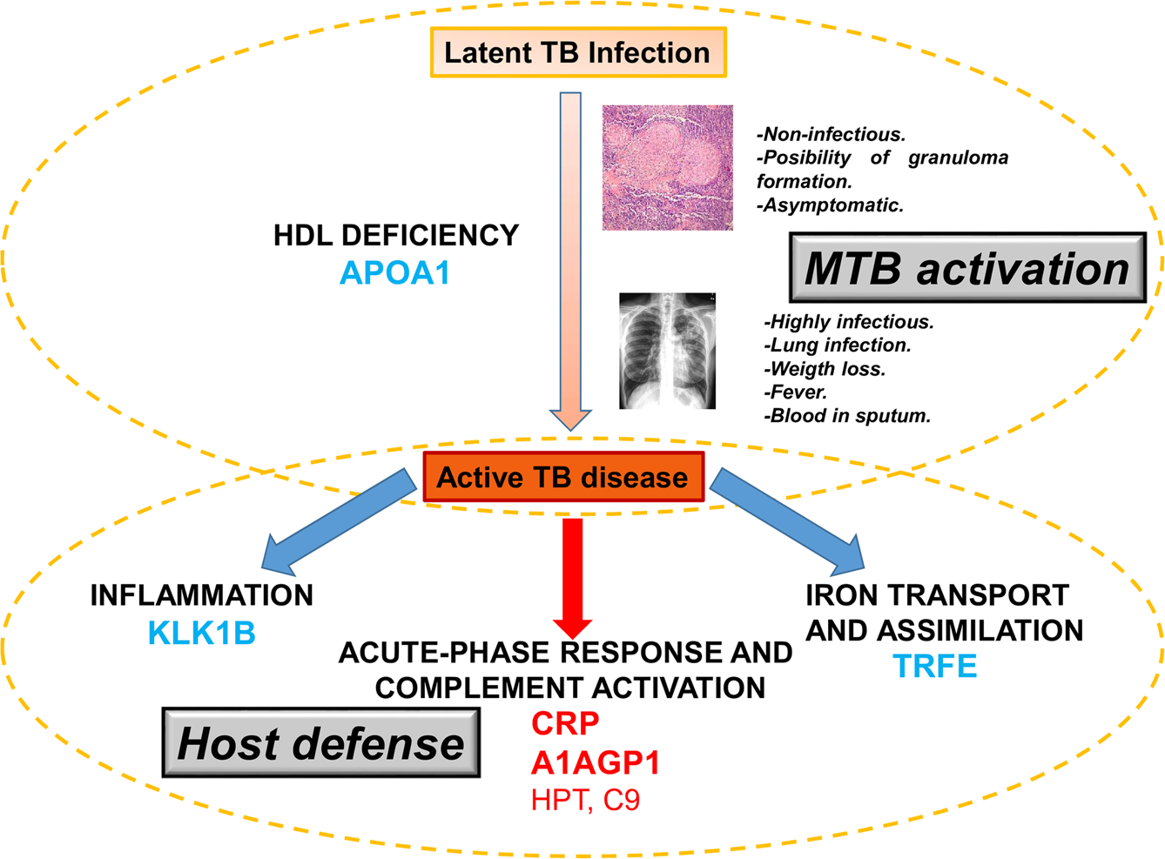
Fig 1: Schematic representation of the processes and proteins detected as modulated during the progression of the TB from a latent asymptomatic infection to an active disease. Proteins in blue are decreased in active TB patients, whereas proteins in red are increased in this group versus both LTBI and uninfected contacts. Proteins in bold were also detected as significantly modulated in an independent cohort by targeted antibody-based techniques. Mateos et al (2020). Serum proteomics of active tuberculosis patients and contacts reveals unique processes activated during Mycobacterium tuberculosis infection. Sci Rep 10, 3844. https://doi.org/10.1038/s41598-020-60753-5

III. Host-Derived Biomarkers
The host immune response to Mycobacterium tuberculosis (Mtb) infection offers a rich reservoir of potential biomarkers for the diagnosis and monitoring of TB. Contrary to traditional diagnostics that focus on direct detection of the pathogen, the host-derived biomarkers mirror the physiological and immunological changes that happen during different stages of TB infection and treatment. These biomarkers, which consist of transcriptomic, proteomic, and metabolomic signatures, are essential in situations where sputum-based diagnosis is not as effective as it should be, e.g, in children, HIV patients, and in the cases of extrapulmonary TB(14).

Table 1: Summary of Key Biomarkers for Tuberculosis Diagnosis and Monitoring
Biomarker | Type | Sample Type | Diagnostic Role | Monitoring Role | Clinical Relevance
IFN-γ | Cytokine | Blood (IGRA) | LTBI and active TB discrimination | Limited | Widely used in IGRA (e.g., QuantiFERON), but cannot distinguish all stages.
IP-10 | Chemokine | Blood | Active TB detection | Potential marker for treatment response | Higher levels in active TB than LTBI; promising in children and HIV patients
CRP | Acute phase protein | Blood | Non-specific but supportive | Useful in monitoring therapy | Elevated in active TB; declines with treatment
lipoarabinomannan (LAM) | Mycobacterial antigen | Urine | Useful in HIV+ TB patients | Limited | Point-of-care test in advanced HIV; WHO endorsed
miR-155, miR-29a | microRNAs | Serum/plasma | Experimental | Under investigation | Differentially expressed in TB; possible future diagnostics
IL-6, TNF-α | Cytokines | Blood | Adjunct markers | Possible treatment monitoring | Associated with inflammation; not specific to TB
CD27, CD38 (on T cells) | Surface markers | PBMCs (flow cytometry) | Distinguishing active vs latent | Yes | Part of the immune profiling panels for TB diagnosis

A. Transcriptomic Signatures
One major cornerstone in the search for host biomarkers in TB is Transcriptomics, due to its potential to detect vigorous changes in gene expression in infection responses (15). Transcriptional signatures that are blood-based have demonstrated crucial promise in distinguishing active TB from latent TB infection (LTBI), other respiratory diseases, and in envisaging the progression disease before the beginning of clinical symptoms (16).
Numerous transcriptomic signatures have become more popular in current literature. The Sweeney3 signature is one mostly studied and it is a three-gene panel (GBP5, DUSP3, and KLF2) that meritoriously differentiates active TB from other disease state, and has a high sensitivity and specificity potential. RISK6 is another common example, and it is a six-gene signature authenticated in multiple cohorts and has shown strong performance in its ability to identify subclinical and early onset of TB (17). These signatures are not just helpful in providing diagnostic clarity, they also have strong potential as prognostic tools that are capable of recognizing individuals who are at higher risk of disease progression from LTBI to active disease(18).
Moreover, the Zak16 signature is a 16-gene panel that has been proven to predict progression of active TB up to about 18 months even before clinical manifestation of symptoms (19). These gene expression profiles are very promising for intervention in early diagnosis, which enables proactive treatment and potentially interrupts transmission chains before disease onset (20). The use of RNA-sequencing and microarray platforms, although powerful, poses challenges related to cost, technical complexity, and standardization, limiting immediate implementation in resource-poor settings. However, efforts are underway to translate these findings into simplified, PCR-based assays suitable for field use(2).

B. Protein-Based Biomarkers
Aside from gene expression, protein biomarkers give a more direct explanation of immune activity and are mostly adjustable in clinical translation. Among these, cytokines and chemokines have evolved as the major entrants (21). For example, Interferon gamma-induced protein 10 (IP-10) has been rigorously examined as both a diagnostic and monitoring biomarker. It has been proven to possess higher sensitivity than interferon-gamma release assays (IGRAs) in identifying active TB, particularly in individuals infected with HIV and young children (22). High levels of IL-6, TNF-α, and IL-1β are also mostly seen in cases of active TB. This directly relates to the severity of the disease and bacterial load(23).
Another well-established biomarker that reflects systemic inflammation is the C-reactive protein (CRP), which is an acute-phase protein. Although CRP is non-specific, it has a rapid kinetic mechanism and low cost that makes it useful as a multi-marker diagnostic approach. Ferritin is also an iron-storage protein that has been associated with active TB and immune activation(24). It is paramount to note that the combinations of multiple protein markers majorly outpace single markers when it comes to accuracy in diagnosis. For example, panels that combine IP-10, CRP, and other cytokines have demonstrated high discriminatory power both in adults and pediatric populations(25).
Efforts have been put in place commercially to integrate those kinds of markers into multiplex lateral flow assays and ELISA-based platforms. Nevertheless, like transcriptomic markers, protein biomarkers need arduous authentication through different population characteristics (22). And epidemiological settings. Factors like as co-infections, nutritional status, and genetic background may have an impact on the expression of biomarkers and must be accounted for while developing the test(26).
C. Other Omics-Based Biomarkers: Metabolomics and Lipidomics
Currently, one of the most powerful tools that have evolved is metabolomics and lipidomics. They are found to help uncover host-response signatures that reflect TB-induced alterations in metabolic pathways (27). These tools capture changes in small-molecule metabolites or lipid profiles in biofluids such as blood, urine, and exhaled breath condensate(28).
Research has shown that many metabolic alterations in TB patients include alterations in the metabolism of tryptophan, lipid catabolism, and amino acid biosynthesis (29). For example, high levels of kynurenine, which causes a downstream product of tryptophan metabolism, have been seen in active TB and may reveal immune-mediated catabolism through the IDO pathway (30). Likewise decrease in phospholipids and an increase in triglycerides in the plasma of TB patients indicate Mtb’s manipulation of host lipid metabolism for its survival and persistence(31).
Urine-based metabolomics is specifically attractive due to its non-invasive nature. Metabolite panels obtained from urine samples have the potential for differentiating TB from other respiratory infections and for monitoring response to treatment. A study reported a five-metabolite urine panel to achieve over 80% sensitivity and specificity for the diagnosis of active(32).
Lipidomics has shown distinct signatures that require host and pathogen-derived lipids, such as mycolic acids and lipoarabinomannan fragments. These lipid markers are being used not just for diagnosis but also for the understanding of disease mechanisms and outcomes of treatment(33,34). However, omics technologies provide an unrivaled complexity and discovery potential; their incorporation into clinical workflows is still emerging. Their widespread use is being limited by complexity, cost, and the need for bioinformatics expertise (35). However, frontiers in portable devices, biosensor technologies, and machine learning–based analysis are progressively bridging the gap in diagnostic laboratory research and point-of-care applicability(36).
Host-derived biomarkers that traverse transcriptomic, proteomic, and metabolomic domains have great potential in revolutionizing the diagnosis, treatment, and monitoring of TB. Transcriptomic signatures provide early and specific means of disease detection, protein markers provide easy-to-use and scalable tools, and metabolomics gives deep insights into host-pathogen interactions(37). Evolving research should continue to refine and validate these biomarkers, and delve into their convergence into multi-modal diagnostic platforms to make a pivotal transformation in the global fight against TB. Coordinated efforts across discovery science, clinical validation, and health systems integration are required to achieve this goal and ensure these tools are not only scientifically robust but also practically deployable in high-burden settings(38). 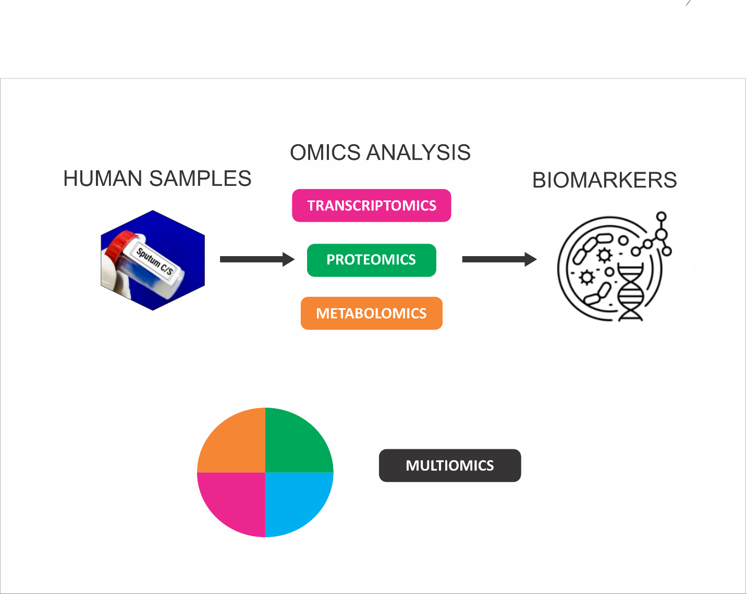Figure 2: Multi-Omics Approach for Biomarker Discovery in Tuberculosis Treatment Monitoring.

V. Biomarkers for Treatment Monitoring
An important aspect of managing tuberculosis (TB) is the ability to monitor treatment efficacy and detect early onset of treatment failure or relapse. Although conventional methods like as sputum smear microscopy and culture are still essential in monitoring bacterial load, they mostly lack the sensitivity and rapid turnaround time that is needed for deciding in real-time. As a result of this, identifying reliable biomarkers that can help monitor response to treatment and predict relapse is now a very important aspect for researchers to delve into(39).

A. Early Predictors of Treatment Success or Failure
Most of the host-derived and pathogen-derived biomarkers have been seen to have the potential to determine early responses to TB therapy. For example, C-reactive protein (CRP), which is a marker of systemic inflammation, has been used to monitor the reduction of inflammation in response to TB treatment(40). High levels of CRP usually signify active disease and inflammation, and being reduction while undergoing therapy can be categorized as an early indicator of the success of treatment. On the other hand, a frequent increase in the levels of CRP regardless of treatment could mean a failure in treatment or the formation of drug resistance(32).
Interferon-gamma (IFN-γ) and IP-10 are host-derived biomarkers that have been studied in longitudinal treatment monitoring. They are cytokines that have been reported to decrease in response to effective TB therapy and can be measured to speculate on therapeutic success. Although these markers seem sensitive to changes in the immune response, they are mostly nonspecific and may be triggered by other infections or inflammatory conditions(41).

B. Biomarkers for Monitoring Drug Resistance
Drug resistance, especially multi-drug-resistant (MDR) and extensively drug-resistant (XDR) TB, makes the treatment of TB more shows a significant challenge to TB treatment. Monitoring for resistance during treatment is essential in guiding and adjusting therapy to ensure improved patient outcomes. Conventional methods for examining resistance, like phenotypic method of detection and molecular testing, which include (e.g., Xpert MTB/RIF), warrant specific laboratory structures and it is time time-consuming(42).
Recent research has delved into biomarkers that can be used to easily spot resistance during treatment. For example, mycobacterial DNA mutations that cause resistance to rifampicin and isoniazid can be easily detected on time hence helping health care professionals adjust treatment accordingly. Furthermore, metabolomic profiles from sputum and urine samples can be examined a potential indicators of how effective a drug is, especially where changes in specific metabolites may be associated with the formation of drug resistance(43).

C. Monitoring Relapse and Recurrence
Relapse or recurrence of TB can be seen even after several months or years of completing treatment, which has made long-term management more complicated. As a result of this, biomarkers that can predict relapse before the onset of clinical symptoms are of utmost importance. Transcriptomic signatures that continue after successful treatment, giving a way of means of noticing subclinical infection or residual bacterial presence that might lead to relapse, have been reported recently. An example is the RISK6 signature, which is insightful in identifying patients who are prone to relapse, despite completing the standard six-month treatment regimen(44).
Moreover, the continuity of biomarkers that are pathogen-derived, such as LAM, in body fluids may present ongoing infection or failure to completely kill the pathogen, even when clinical symptoms are no longer obvious(45).

D. Limitations and Future Directions
Even though biomarkers are very promising in revolutionizing treatment options for TB patients, integrating them into clinical practice still poses a great challenge due to several factors, including cost, accessibility, and variability in patient outcomes(33). Further research is essential to recognize more specific and reliable biomarkers that can successfully predict treatment outcomes and are highly sensitive and specific across different populations. Additionally, there is an ongoing interest in the development of multiplex biomarker panels that can combine host and pathogen biomarkers and offer a more comprehensive and precise picture of the progress of treatment(46).
Biomarkers for monitoring TB are inestimable for combating therapeutic responses, identifying drug resistance, and predicting relapse. To improve TB treatment regimens and patient outcomes, continued innovation in biomarker discovery and validation is paramount(47)

VI. Implementation Challenges and Future Directions
Regardless of how innovative biomarkers are in TB treatment, incorporating them into routine clinical practice faces a lot of barriers. To address this limitation, it is necessary to realize the full potential that biomarker-based approaches have in controlling TB globally. We discussed the key challenges and suggested possible future directions to help overcome these barriers, to facilitate the incorporation of biomarkers into the routine management of TB(48).

A. Technical and Methodological Challenges
Technical complexity is one of the most substantial challenges when it comes to implementing TB biomarkers in the everyday routine management of TB. A lot of hopeful biomarkers, especially those derived from advanced technologies such as next-generation sequencing, proteomics, and metabolomics, need refined equipment, technical expertise, and a well-structured laboratory. Most of these are not available in low-resource communities that seem to have a high TB burden(49).
For example, while RNA-based assays have shown high accuracy in detecting TB, their high cost and it requires to rely on advanced bioinformatics tools, and the need for well-established laboratory infrastructures have made them not useful in poor LMIC(50). Although metabolomic and proteomic techniques are highly sensitive and specific, they require expensive reagents and advanced analytical competencies that may not be accessible in places that are not fully equipped(51).
Solving this problem requires assays that are simplified, portable, and cost-effective, and can be used in local regions that have little or no access to good infrastructure(52). Techniques like lateral flow assays, loop-mediated isothermal amplification (LAMP), and point-of-care diagnostic devices seem insightful in tackling these challenges by offering rapid, on-site diagnostics with less equipment and reduced cost. Continued innovation and adaptation of high-throughput techniques for field use will be critical to overcoming these technical barriers(51).

B. Variability in Biomarker Performance
Both host- and pathogen-derived biomarkers show inconsistency in their pattern of sensitivity and specificity across different populations. This disparity is impacted by diverse factors, such as co-infections (e.g., HIV), nutritional status, genetic diversity, and differences in geographical location in strains of the pathogen(53). For example, although the Xpert MTB/RIF assay has demonstrated high sensitivity in areas with higher disease burden, its ability to perform well could be hampered by the presence of rifampicin resistance mutations that are still localized or by disparity in the bacterial load. Likewise, in HIV-positive patients, LAM testing is more sensitive, but not so in populations with mild or non-severe TB, which presents a major challenge to its universal use as a diagnostic tool(54).
TB disease is heterogeneous, and the differences between pulmonary and extrapulmonary TB make the application of biomarkers more complicated. When it comes to detecting pulmonary TB, some biomarkers may be more effective than others, while other biomarkers may be well adapted for extrapulmonary cases(55). Addressing this requires a multi-biomarker panel that combines different host- and pathogen-derived markers, which could give vigorous and comprehensive diagnostic potential and enhance both sensitivity and specificity across various patient populations. Nonetheless, implementing such panels involves carrying them out in a variety of locations to facilitate their generalization(56).

C. Regulatory and Standardization Challenges
The discovery of clinical applications of biomarkers is a long process with many barriers within the regulatory process. Before the test is conducted in each country, it must undergo laborious clinical validation to ensure they are safe and effective before approval for routine use. This can last from months to years, which can subsequently delay the availability of revolutionary technologies(57).
Moreover, standardizing biomarker assays poses a great challenge. For biomarkers to be extensively accepted, international validation is compulsory to confirm their reliability across different settings and populations. Inconsistencies in results can be a result of differences in testing platforms, reagent quality, and assay protocols, which can reduce the usage of biomarkers in clinical practice(58).
International partnerships like those adopted by the World Health Organization (WHO) and the Stop TB Partnership are essential for progressing the standardization of TB diagnostic tests. These organizations can offer guidance on the evaluation of biomarkers, help complement the protocol of testing, and ensure that new assays meet global health standards(59).

D. Financial and Logistical Barriers
The extensive usage of biomarker-based diagnostics and monitoring tools experiences major financial and logistical limitations. Although biomarker testing could be more accurate and less resource-intensive compared to conventional methods, its original cost could still be exorbitant, especially in low-income countries(60). Reagent and devices cost, and training personnel, can make it harder for healthcare professionals to scale up new diagnostic technologies, despite holding the potential of long-term savings(61).
Furthermore, integrating biomarker-based tests into already existing health infrastructures needs significant investment in capacity building. Training healthcare professionals, safeguarding adequate supply chains for reagents, and developing appropriate referral chains are necessary for effectively implementing TB biomarkers(60). Addressing these financial and logistical challenges could benefit from Public-private partnerships and global funding initiatives, such as those provided by the Global Fund and the Bill and Melinda Gates Foundation.

E. Future Directions
Overcoming these aforementioned challenges, revolutionizing the future of TB biomarker research involves a multi-pronged approach. Key future directions may include:
- Point-of-Care Diagnostics Development: Progressive innovation in portable and low-cost diagnostic equipment that can be used in localized settings is paramount in making TB diagnostics more globally accessible
- Focusing on Multi-Biomarker Panels: Integrating multiple biomarkers will enable researchers to improve the accuracy of diagnosis via various manifestations of TB and patient populations.
- Integrating Digital Health: using mobile health platforms and artificial intelligence for real-time interpretation of biomarker data can modernize the process of decision-making decision particularly in a resource-limited environment.
- Field Studies Expansion: Large-scale, multi-country studies are important in validating biomarkers in diverse populations and ensuring their applicability through a wide range of clinical settings.
Although there are notable barriers to the extensive adoption of biomarkers in diagnosis and monitoring of TB, persistent research and development, alongside strategic investments in health infrastructure, can be of help in tackling this, menace Addressing technical, regulatory, and financial challenges, biomarker-based approaches is capable of revolutionizing the global fight against TB(53).

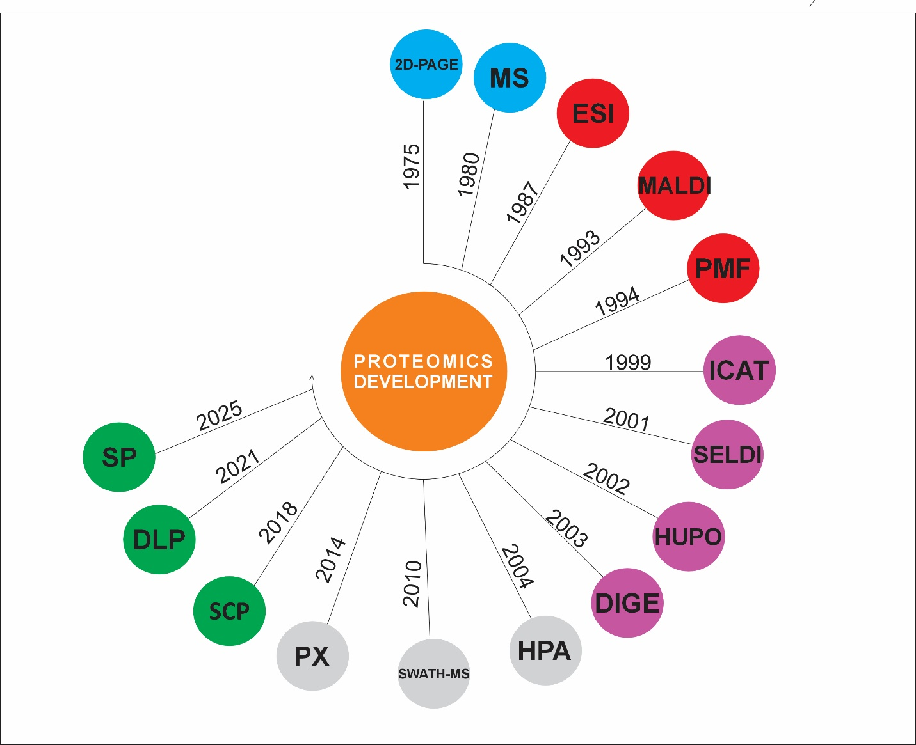Figure 3 represents the timeline of proteomic technologies and protein database development. MS, mass spectrometry; 2D-PAGE – Two-Dimensional Polyacrylamide Gel Electrophoresis MS – Mass Spectrometry,
ESI – Electrospray Ionization, MALDI – Matrix-Assisted Laser Desorption/Ionization,
PMF – Peptide Mass Fingerprinting, ICAT – Isotope-Coded Affinity Tag
NSELDI-TOF – Surface-Enhanced Laser Desorption/Ionization Time of Flight,
HUPO – Human Proteome Organization, DIGE – Difference-Gel 2D-Electrophoresis,
HPA – Human Protein Atlas, SWATH-MS – Sequential Window Acquisition of All Theoretical Mass Spectra,
PX – ProteomeXchange, SP - Single-Cell Proteomics, DLP -Deep Learning in Proteomics,
SP - Spatial Proteomics.

Conclusion
Identifying and using biomarkers in the diagnosis and management of tuberculosis (TB) offers an insightful approach in the global fight against TB. Whether biomarkers are host-derived or pathogen-derived, they provide vital knowledge into the presence of active TB, efficacy of treatment and formation of drug resistance, and also the chances of relapse. These markers majorly facilitate precise diagnosis, enable speedy detection, and encourage more tailored treatment options, which are paramount in location that carries a higher disease burden(62).
Mycobacterium tuberculosis DNA, lipoarabinomannan (LAM), and mycobacterial proteins are pathogen-derived biomarkers that show direct evidence of infection and contribute to precise monitoring and diagnosis of TB. These biomarkers help detect drug resistance and provide essential details regarding the management of multidrug-resistant and extensively drug-resistant strains of TB. Cytokines and inflammatory markers are host-derived biomarkers that, as pointers of the immune response to the pathogen, give additional information about diagnosis and prognosis, mostly in immunocompromised patients(8).
Regardless of the hope the TB biomarkers give, their implementation is still a challenge in terms of technical complexity, performance variability, regulatory bodies, and financial limitations. Tackling these challenges needs an innovative approach in diagnostic technologies, the production of cost-effective and portable testing methods, and international measures to regularize the global usage of biomarkers.
Future research endeavors should focus on the incorporation of multiple biomarkers into composite panels, to facilitate accuracy in the diagnosis different diverse populations, and progressive development of point-of-care solutions. Joint effort will greatly be of help in showing that biomarkers have the potential to transform TB diagnosis and treatment, thereby helping in the fight against one of the greatest challenges facing modern medicine.

Disclaimer (Artificial intelligence)
Option 1:
Author(s) hereby declare that NO generative AI technologies such as Large Language Models (ChatGPT, COPILOT, etc.) and text-to-image generators have been used during the writing or editing of this manuscript.
Option 2:
Author(s) hereby declare that generative AI technologies such as Large Language Models, etc., have been used during the writing or editing of manuscripts. This explanation will include the name, version, model, and source of the generative AI technology and as well as all input prompts provided to the generative AI technology.
Details of the AI usage are given below:
1. option 1
2.
3.

REFERENCE
1. Sudre P, ten Dam G, Kochi A. Tuberculosis: a global overview of the situation today. Bull World Health Organ. 1992;70(2):149–59.
2. Adekambi T, Ibegbu CC, Cagle S, Kalokhe AS, Wang YF, Hu Y, et al. Biomarkers on patient T cells diagnose active tuberculosis and monitor treatment response. J Clin Invest [Internet]. 2015 May 1 [cited 2025 May 2];125(5):1827–38. Available from: http://www.jci.org/articles/view/77990
3. MacLean E, Broger T, Yerlikaya S, Fernandez-Carballo BL, Pai M, Denkinger CM. A systematic review of biomarkers to detect active tuberculosis. Nat Microbiol [Internet]. 2019 Feb 25 [cited 2025 May 2];4(5):748–58. Available from: https://www.nature.com/articles/s41564-019-0380-2
4. Dheda K, Perumal T, Moultrie H, Perumal R, Esmail A, Scott AJ, et al. The intersecting pandemics of tuberculosis and COVID-19: population-level and patient-level impact, clinical presentation, and corrective interventions. Lancet Respir Med [Internet]. 2022 Jun [cited 2025 May 3];10(6):603–22. Available from: https://linkinghub.elsevier.com/retrieve/pii/S2213260022000923
5. Hur YG, Kang YA, Jang SH, Hong JY, Kim A, Lee SA, et al. Adjunctive biomarkers for improving the diagnosis of tuberculosis and monitoring therapeutic effects. J Infect [Internet]. 2015 Apr [cited 2025 May 2];70(4):346–55. Available from: https://linkinghub.elsevier.com/retrieve/pii/S016344531400334X
6. Moreno Guillén S, Rodríguez-Artalejo F, Ruiz-Galiana J, Cantón R, De Lucas Ramos P, García-Botella A, et al. Tuberculosis in Spain: An opinion paper. Rev Esp Quimioter [Internet]. 2023 Nov 27 [cited 2025 May 3];36(6):562–83. Available from: https://seq.es/abstract/rev-esp-quimioter-2023-november-2-2/
7. Sable SB, Posey JE, Scriba TJ. Tuberculosis Vaccine Development: Progress in Clinical Evaluation. Clin Microbiol Rev. 2019 Dec 18;33(1):e00100-19.
8. Goletti D, Petruccioli E, Joosten SA, Ottenhoff THM. Tuberculosis Biomarkers: From Diagnosis to Protection. Infect Dis Rep [Internet]. 2016 Jun 24 [cited 2025 May 2];8(2):6568. Available from: https://www.mdpi.com/2036-7449/8/2/6568
9. Shu CC, Wu MF, Hsu CL, Huang CT, Wang JY, Hsieh SL, et al. Apoptosis-associated biomarkers in tuberculosis: promising for diagnosis and prognosis prediction. BMC Infect Dis [Internet]. 2013 Dec [cited 2025 May 2];13(1):45. Available from: https://bmcinfectdis.biomedcentral.com/articles/10.1186/1471-2334-13-45
10. Gosain TP, Chugh S, Rizvi ZA, Chauhan NK, Kidwai S, Thakur KG, et al. Mycobacterium tuberculosis strain with deletions in menT3 and menT4 is attenuated and confers protection in mice and guinea pigs. Nat Commun [Internet]. 2024 Jun 27 [cited 2025 May 3];15(1):5467. Available from: https://www.nature.com/articles/s41467-024-49246-5
11. Wallis RS, Pai M, Menzies D, Doherty TM, Walzl G, Perkins MD, et al. Biomarkers and diagnostics for tuberculosis: progress, needs, and translation into practice. The Lancet [Internet]. 2010 May [cited 2025 May 2];375(9729):1920–37. Available from: https://linkinghub.elsevier.com/retrieve/pii/S0140673610603595
12. Leo S, Narasimhan M, Rathinam S, Banerjee A. Biomarkers in diagnosing and therapeutic monitoring of tuberculosis: a review. Ann Med [Internet]. 2024 Dec 31 [cited 2025 May 2];56(1):2386030. Available from: https://www.tandfonline.com/doi/full/10.1080/07853890.2024.2386030
13. Dai Y, Shan W, Yang Q, Guo J, Zhai R, Tang X, et al. Biomarkers of iron metabolism facilitate clinical diagnosis in Mycobacterium tuberculosis infection. Thorax [Internet]. 2019 Dec [cited 2025 May 2];74(12):1161–7. Available from: https://thorax.bmj.com/lookup/doi/10.1136/thoraxjnl-2018-212557
14. Sigal GB, Segal MR, Mathew A, Jarlsberg L, Wang M, Barbero S, et al. Biomarkers of Tuberculosis Severity and Treatment Effect: A Directed Screen of 70 Host Markers in a Randomized Clinical Trial. EBioMedicine [Internet]. 2017 Nov [cited 2025 May 2];25:112 21. Available from: https://linkinghub.elsevier.com/retrieve/pii/S2352396417304176
15. Cox H, Salaam-Dreyer Z, Goig GA, Nicol MP, Menardo F, Dippenaar A, et al. Potential contribution of HIV during first-line tuberculosis treatment to subsequent rifampicin-monoresistant tuberculosis and acquired tuberculosis drug resistance in South Africa: a retrospective molecular epidemiology study. Lancet Microbe [Internet]. 2021 Nov [cited 2025 May 3];2(11):e584–93. Available from: https://linkinghub.elsevier.com/retrieve/pii/S2666524721001440
16. Koleske BN, Jacobs WR, Bishai WR. The Mycobacterium tuberculosis genome at 25 years: lessons and lingering questions. J Clin Invest [Internet]. 2023 Oct 2 [cited 2025 May 3];133(19):e173156. Available from: https://www.jci.org/articles/view/173156
17. Santucci P, Aylan B, Botella L, Bernard EM, Bussi C, Pellegrino E, et al. Visualizing Pyrazinamide Action by Live Single-Cell Imaging of Phagosome Acidification and Mycobacterium tuberculosis pH Homeostasis. Ehrt S, editor. mBio [Internet]. 2022 Apr 26 [cited 2025 May 3];13(2):e00117-22. Available from: https://journals.asm.org/doi/10.1128/mbio.00117-22
18. Whitworth HS, Aranday-Cortes E, Lalvani A. Biomarkers of Tuberculosis: A Research Roadmap. Biomark Med [Internet]. 2013 Jun [cited 2025 May 2];7(3):349–62. Available from: https://www.tandfonline.com/doi/full/10.2217/bmm.13.53
19. Domínguez J, Boeree MJ, Cambau E, Chesov D, Conradie F, Cox V, et al. Clinical implications of molecular drug resistance testing for Mycobacterium tuberculosis: a 2023 TBnet/RESIST-TB consensus statement. Lancet Infect Dis. 2023 Apr;23(4):e122–37.
20. Churchyard GJ, Houben RMGJ, Fielding K, Fiore-Gartland AL, Esmail H, Grant AD, et al. Implications of subclinical tuberculosis for vaccine trial design and global effect. Lancet Microbe. 2024 Oct;5(10):100895.
21. Cobelens F, Suri RK, Helinski M, Makanga M, Weinberg AL, Schaffmeister B, et al. Accelerating research and development of new vaccines against tuberculosis: a global roadmap. Lancet Infect Dis. 2022 Apr;22(4):e108–20.
22. Bullen CK, Singh AK, Krug S, Lun S, Thakur P, Srikrishna G, et al. MDA5 RNA-sensing pathway activation by Mycobacterium tuberculosis promotes innate immune subversion and pathogen survival. JCI Insight. 2023 Oct 23;8(20):e166242.
23. Zimmer AJ, Lainati F, Aguilera Vasquez N, Chedid C, McGrath S, Benedetti A, et al. Biomarkers That Correlate with Active Pulmonary Tuberculosis Treatment Response: a Systematic Review and Meta-analysis. McAdam AJ, editor. J Clin Microbiol [Internet]. 2022 Feb 16 [cited 2025 May 2];60(2):e01859-21. Available from: https://journals.asm.org/doi/10.1128/jcm.01859-21
24. Xia Q, Lee MH, Walsh KF, McAulay K, Bean JM, Fitzgerald DW, et al. Urinary biomarkers of mycobacterial load and treatment response in pulmonary tuberculosis. JCI Insight [Internet]. 2020 Sep 17 [cited 2025 May 2];5(18):e136301. Available from: https://insight.jci.org/articles/view/136301
25. Huddart S, Asege L, Jaganath D, Golla M, Dang H, Lovelina L, et al. Continuous cough monitoring: a novel digital biomarker for TB diagnosis and treatment response monitoring. Int J Tuberc Lung Dis [Internet]. 2023 Mar 1 [cited 2025 May 2];27(3):221–2. Available from: https://www.ingentaconnect.com/content/10.5588/ijtld.22.0511
26. Petruccioli E, Scriba TJ, Petrone L, Hatherill M, Cirillo DM, Joosten SA, et al. Correlates of tuberculosis risk: predictive biomarkers for progression to active tuberculosis. Eur Respir J [Internet]. 2016 Dec [cited 2025 May 2];48(6):1751–63. Available from: https://publications.ersnet.org/lookup/doi/10.1183/13993003.01012-2016
27. Viney K, Lowbridge C, Morishita F, Rahevar K, Oh KH, Islam T, et al. Evaluation of the 2016-2020 regional tuberculosis response framework, WHO Western Pacific Region. Bull World Health Organ. 2021 May 1;99(5):330-341A.
28. Clifford V, Tebruegge M, Zufferey C, Germano S, Forbes B, Cosentino L, et al. Cytokine biomarkers for the diagnosis of tuberculosis infection and disease in adults in a low-prevalence setting. Tuberculosis [Internet]. 2019 Jan [cited 2025 May 2];114:91–102. Available from: https://linkinghub.elsevier.com/retrieve/pii/S1472979218301707
29. Lungu PS, Kerkhoff AD, Muyoyeta M, Kasapo CC, Nyangu S, Kagujje M, et al. Interrupted time-series analysis of active case-finding for tuberculosis during the COVID-19 pandemic, Zambia. Bull World Health Organ. 2022 Mar 1;100(3):205–15.
30. Kontsevaya I, Lange C, Comella-Del-Barrio P, Coarfa C, DiNardo AR, Gillespie SH, et al. Perspectives for systems biology in the management of tuberculosis. Eur Respir Rev Off J Eur Respir Soc. 2021 Jun 30;30(160):200377.
31. Nogueira BMF, Krishnan S, Barreto‐Duarte B, Araújo‐Pereira M, Queiroz ATL, Ellner JJ, et al. Diagnostic biomarkers for active tuberculosis: progress and challenges. EMBO Mol Med [Internet]. 2022 Dec 7 [cited 2025 May 2];14(12):e14088. Available from: https://www.embopress.org/doi/10.15252/emmm.202114088
32. Jacobs R, Tshehla E, Malherbe S, Kriel M, Loxton AG, Stanley K, et al. Host biomarkers detected in saliva show promise as markers for the diagnosis of pulmonary tuberculosis disease and monitoring of the response to tuberculosis treatment. Cytokine [Internet]. 2016 May [cited 2025 May 2];81:50–6. Available from: https://linkinghub.elsevier.com/retrieve/pii/S104346661630028X
33. Walzl G, McNerney R, Du Plessis N, Bates M, McHugh TD, Chegou NN, et al. Tuberculosis: advances and challenges in the development of new diagnostics and biomarkers. Lancet Infect Dis [Internet]. 2018 Jul [cited 2025 May 2];18(7):e199–210. Available from: https://linkinghub.elsevier.com/retrieve/pii/S1473309918301117
34. Goletti D, Lee M, Wang J, Walter N, Ottenhoff THM. Update on tuberculosis biomarkers: From correlates of risk, to correlates of active disease and of cure from disease. Respirology [Internet]. 2018 May [cited 2025 May 2];23(5):455–66. Available from: https://onlinelibrary.wiley.com/doi/10.1111/resp.13272
35. McQuaid CF, Clark RA, White RG, Bakker R, Alexander P, Henry R, et al. Estimating the epidemiological and economic impact of providing nutritional care for tuberculosis-affected households across India: a modelling study. Lancet Glob Health. 2025 Mar;13(3):e488–96.
36. Alonzi T, Petruccioli E, Aiello A, Repele F, Goletti D. Diagnostic tests for tuberculosis infection and predictive indicators of disease progression: Utilizing host and pathogen biomarkers to enhance the tuberculosis elimination strategies. Int J Infect Dis [Internet]. 2025 Mar [cited 2025 May 2];107880. Available from: https://linkinghub.elsevier.com/retrieve/pii/S1201971225001031
37. Golichenari B, Nosrati R, Farokhi-Fard A, Faal Maleki M, Gheibi Hayat SM, Ghazvini K, et al. Electrochemical-based biosensors for detection of Mycobacterium tuberculosis and tuberculosis biomarkers. Crit Rev Biotechnol [Internet]. 2019 Nov 17 [cited 2025 May 2];39(8):1056–77. Available from: https://www.tandfonline.com/doi/full/10.1080/07388551.2019.1668348
38. Morris TC, Hoggart CJ, Chegou NN, Kidd M, Oni T, Goliath R, et al. Evaluation of Host Serum Protein Biomarkers of Tuberculosis in sub-Saharan Africa. Front Immunol [Internet]. 2021 Feb 25 [cited 2025 May 2];12:639174. Available from: https://www.frontiersin.org/articles/10.3389/fimmu.2021.639174/full
39. Lawal OP, Egwuatu EC, Akanbi KO, Orobator ET, Eweje OZ, Omotayo EO, et al. Fighting Resistance With Data: Leveraging Digital Surveillance to Address Antibiotic Misuse in Nigeria. Path Sci [Internet]. 2025 Mar 31 [cited 2025 May 2];11(3):1009. Available from: https://pathofscience.org/index.php/ps/article/view/3486
40. Pierneef L, Van Hooij A, De Jong D, Tjon Kon Fat EM, Van Meijgaarden KE, Petruccioli E, et al. Host biomarker-based quantitative rapid tests for detection and treatment monitoring of tuberculosis and COVID-19. iScience [Internet]. 2023 Jan [cited 2025 May 2];26(1):105873. Available from: https://linkinghub.elsevier.com/retrieve/pii/S2589004222021460
41. Ambreen A, Khaliq A, Naqvi SZH, Tahir A, Mustafa M, Chaudhary SU, et al. Host biomarkers for monitoring therapeutic response in extrapulmonary tuberculosis. Cytokine [Internet]. 2021 Jun [cited 2025 May 2];142:155499. Available from: https://linkinghub.elsevier.com/retrieve/pii/S104346662100079X
42. Khambati N, Olbrich L, Ellner J, Salgame P, Song R, Bijker EM. Host-Based Biomarkers in Saliva for the Diagnosis of Pulmonary Tuberculosis in Children: A Mini-Review. Front Pediatr [Internet]. 2021 Oct 25 [cited 2025 May 2];9:756043. Available from: https://www.frontiersin.org/articles/10.3389/fped.2021.756043/full
43. Kim J, Park H, Park SB, Lee EJ, Je MA, Ahn E, et al. Identification of MicroRNAs as Potential Blood-Based Biomarkers for Diagnosis and Therapeutic Monitoring of Active Tuberculosis. Diagnostics [Internet]. 2022 Feb 1 [cited 2025 May 2];12(2):369. Available from: https://www.mdpi.com/2075-4418/12/2/369
44. Jacobs R, Malherbe S, Loxton AG, Stanley K, van der Spuy G, Walzl G, et al. Identification of novel host biomarkers in plasma as candidates for the immunodiagnosis of tuberculosis disease and monitoring of tuberculosis treatment response. Oncotarget. 2016 Sep 6;7(36):57581–92.
45. Yong YK, Tan HY, Saeidi A, Wong WF, Vignesh R, Velu V, et al. Immune Biomarkers for Diagnosis and Treatment Monitoring of Tuberculosis: Current Developments and Future Prospects. Front Microbiol [Internet]. 2019 Dec 18 [cited 2025 May 2];10:2789. Available from: https://www.frontiersin.org/article/10.3389/fmicb.2019.02789/full
46. Zhao Y, Yang X, Zhang X, Yu Q, Zhao P, Wang J, et al. IP-10 and RANTES as biomarkers for pulmonary tuberculosis diagnosis and monitoring. Tuberculosis [Internet]. 2018 Jul [cited 2025 May 2];111:45–53. Available from: https://linkinghub.elsevier.com/retrieve/pii/S1472979217304602
47. Maphanga C, Manoto S, Ombinda-Lemboumba S, Ismail Y, Mthunzi-Kufa P. Localized surface plasmon resonance biosensing of Mycobacterium tuberculosis biomarker for TB diagnosis. Sens Bio-Sens Res [Internet]. 2023 Feb [cited 2025 May 2];39:100545. Available from: https://linkinghub.elsevier.com/retrieve/pii/S2214180422000745
48. Preez ID, Luies L, Loots DT. Metabolomics Biomarkers for Tuberculosis Diagnostics: Current Status and Future Objectives. Biomark Med [Internet]. 2017 Feb [cited 2025 May 2];11(2):179–94. Available from: https://www.tandfonline.com/doi/full/10.2217/bmm-2016-0287
49. Ndzi EN, Nkenfou CN, Mekue LM, Zentilin L, Tamgue O, Pefura EWY, et al. MicroRNA hsa-miR-29a-3p is a plasma biomarker for the differential diagnosis and monitoring of tuberculosis. Tuberculosis [Internet]. 2019 Jan [cited 2025 May 2];114:69–76. Available from: https://linkinghub.elsevier.com/retrieve/pii/S1472979218302774
50. McNerney R, Maeurer M, Abubakar I, Marais B, Mchugh TD, Ford N, et al. Tuberculosis Diagnostics and Biomarkers: Needs, Challenges, Recent Advances, and Opportunities. J Infect Dis [Internet]. 2012 May 15 [cited 2025 May 2];205(suppl_2):S147–58. Available from: https://academic.oup.com/jid/article-lookup/doi/10.1093/infdis/jir860
51. Pitaloka DAE, Syamsunarno MRAA, Abdulah R, Chaidir L. Omics Biomarkers for Monitoring Tuberculosis Treatment: A Mini-Review of Recent Insights and Future Approaches. Infect Drug Resist [Internet]. 2022 May [cited 2025 May 2];Volume 15:2703–11. Available from: https://www.dovepress.com/omics-biomarkers-for-monitoring-tuberculosis-treatment-a-mini-review-o-peer-reviewed-fulltext-article-IDR
52. Heyckendorf J, Georghiou SB, Frahm N, Heinrich N, Kontsevaya I, Reimann M, et al. Tuberculosis Treatment Monitoring and Outcome Measures: New Interest and New Strategies. Clin Microbiol Rev [Internet]. 2022 Sep 21 [cited 2025 May 2];35(3):e00227-21. Available from: https://journals.asm.org/doi/10.1128/cmr.00227-21
53. Guo J, Zhang X, Chen X, Cai Y. Proteomics in Biomarker Discovery for Tuberculosis: Current Status and Future Perspectives. Front Microbiol [Internet]. 2022 Apr 26 [cited 2025 May 2];13:845229. Available from: https://www.frontiersin.org/articles/10.3389/fmicb.2022.845229/full
54. Dos Santos DCM, Lovero KL, Schmidt CM, Barros ACMW, Quintanilha AP, Barbosa AP, et al. Serological biomarkers for monitoring response to treatment of pulmonary and extrapulmonary tuberculosis in children and adolescents. Tuberculosis [Internet]. 2020 Jul [cited 2025 May 2];123:101960. Available from: https://linkinghub.elsevier.com/retrieve/pii/S147297922030127X
55. Jayakumar A, Vittinghoff E, Segal MR, MacKenzie WR, Johnson JL, Gitta P, et al. Serum biomarkers of treatment response within a randomized clinical trial for pulmonary tuberculosis. Tuberculosis [Internet]. 2015 Jul [cited 2025 May 2];95(4):415–20. Available from: https://linkinghub.elsevier.com/retrieve/pii/S1472979215207184
56. Chung W, Lee K, Jung Y, Kim Y, Park J, Sheen S, et al. Serum CXCR3 ligands as biomarkers for the diagnosis and treatment monitoring of tuberculosis. Int J Tuberc Lung Dis [Internet]. 2015 Dec 1 [cited 2025 May 2];19(12):1476–84. Available from: http://openurl.ingenta.com/content/xref?genre=article&issn=1027-3719&volume=19&issue=12&spage=1476
57. Mateos J, Estévez O, González-Fernández Á, Anibarro L, Pallarés Á, Reljic R, et al. Serum proteomics of active tuberculosis patients and contacts reveals unique processes activated during Mycobacterium tuberculosis infection. Sci Rep [Internet]. 2020 Mar 2 [cited 2025 May 2];10(1):3844. Available from: https://www.nature.com/articles/s41598-020-60753-5
58. Gong Z, Gu Y, Xiong K, Niu J, Zheng R, Su B, et al. The Evaluation and Validation of Blood-Derived Novel Biomarkers for Precise and Rapid Diagnosis of Tuberculosis in Areas With High-TB Burden. Front Microbiol [Internet]. 2021 Jun 14 [cited 2025 May 2];12:650567. Available from: https://www.frontiersin.org/articles/10.3389/fmicb.2021.650567/full
59. Ayomide IT, Promise LO, Christopher AA, Okikiola PP, Esther AD, Favour AC, et al. The Impact of Antimicrobial Resistance on Co-INFECTIONS: Management Strategies for HIV, TB and Malaria. Int J Pathog Res [Internet]. 2024 Nov 29 [cited 2025 May 2];13(6):117–28. Available from: https://journalijpr.com/index.php/IJPR/article/view/326
60. Parida SK, Kaufmann SHE. The quest for biomarkers in tuberculosis. Drug Discov Today [Internet]. 2010 Feb [cited 2025 May 2];15(3–4):148–57. Available from: https://linkinghub.elsevier.com/retrieve/pii/S1359644609003444
61. Matuku-Kisaumbi P. The Role of TB Biomarkers in Diagnosis, Prognosis and Prevention of Tuberculosis. In: Bueno De Mesquita J, editor. Infectious Diseases [Internet]. IntechOpen; 2025 [cited 2025 May 2]. Available from: https://www.intechopen.com/chapters/89675
62. Wallis RS, Kim P, Cole S, Hanna D, Andrade BB, Maeurer M, et al. Tuberculosis biomarkers discovery: developments, needs, and challenges. Lancet Infect Dis [Internet]. 2013 Apr [cited 2025 May 2];13(4):362–72. Available from: https://linkinghub.elsevier.com/retrieve/pii/S1473309913700343

