**EFFECT OF *PONGAMIA PINNATA* LEAF EXTRACT AS A PRIMING AGENT ON THE GROWTH AND DEVELOPMENT OF THE SPINACH (*SPINACIA OLERACEA)***

**ABSTRACT**

Seed priming is an effective technique to enhance seed germination, seedling vigor, and crop productivity. This study investigates the effects of *Pongamia pinnata* leaf extract as a natural priming agent on the growth and development of spinach *(Spinacia oleracea).* Spinach seeds were primed with the extract and compared with non-primed control seeds through laboratory and field trials. Laboratory tests assessed germination percentage, speed, and uniformity on germination sheets, while field trials measured agronomic traits including germination rate, plant height, no of leaf, leaf surface area, leaf length and width and yield traits at 30, 45, and 60 days after sowing (DAS). Results showed that seed priming with *Pongamia pinnata* extract significantly improved germination rate and seedling uniformity. Primed seeds demonstrated faster and more consistent germination, while the resulting plants exhibited enhanced vegetative growth, including greater plant height, larger leaves, increased leaf area, and improved root development. Additionally, foliar application of the extract at 15-day intervals post-germination further boosted plant growth, indicating a synergistic effect of priming and foliar spraying. This study concludes that *Pongamia pinnata* leaf extract is an eco-friendly, sustainable alternative to synthetic treatments, promoting early plant establishment and sustained growth. Its dual application through priming and foliar spraying holds potential for improving spinach cultivation, with broader agricultural applications warranting further research**.**

**Keywords:** Seed priming, Germination, *Pongamia pinnata* leaf extract, foliar application, Agronomic and yield traits

**Introduction**

Spinach *(Spinacia oleracea)* is a widely cultivated leafy vegetable known for its rapid growth, adaptability, and nutritional benefits. An annual crop belonging to the Amaranthaceae family, spinach originated in ancient Persia (modern-day Iran) and has since spread globally, becoming an integral part of diverse cuisines and agricultural systems (Morelock & Correl, 2008) Spinach thrives as a cool-season crop, performing best at temperatures between 15°C and 20°C (Rubatzky & Yamaguchi, 1997) It grows optimally in well-drained loamy soils with a slightly acidic to neutral pH (6.0 to 7.5) and can tolerate partial shade, making it suitable for varied cropping environments. Due to its short growth cycle of 30 to 45 days from sowing to harvest, spinach is valuable in intensive farming systems, including crop rotation and intercropping practices (Kumar et al, 2017). India, being predominantly agrarian, relies heavily on crops like spinach to ensure nutritional security. However, increasing population pressure, limited cultivable land, and deteriorating soil health pose significant challenges to agricultural productivity. Unsustainable farming practices have led to soil degradation, including nutrient depletion, loss of organic matter, salinization, acidity, chemical pollution, and waterlogging (Bhattacharyya et al., 2015). These issues not only reduce crop yields but also threaten long-term soil fertility and biodiversity. Therefore, adopting sustainable agricultural practices such as natural seed treatments, crop rotation, and organic inputs is crucial for maintaining soil quality and enhancing crop resilience (Arumugam *et al*., 2023)

Seed priming is an effective pre-sowing technique that involves controlled hydration of seeds to initiate vital metabolic processes without allowing radicle emergence. This method enhances seed performance by improving germination speed, uniformity, and seedling vigor (Farooq et al., 2019) Various priming techniques include hydropriming (using water), osmopriming (using osmotic solutions like polyethylene glycol), halopriming (using salt solutions), and biopriming (using beneficial microorganisms). These methods activate key enzymes, repair cellular structures, and promote nutrient mobilization, resulting in improved stress tolerance and better crop establishment (Anjos Neto et al., 2020). In crops like spinach, which are sensitive to environmental stresses, seed priming can facilitate faster emergence, uniform growth, and higher yields, making it a valuable practice in sustainable agriculture. Among the natural agents explored for seed priming, *Pongamia pinnata* (commonly known as karanja) has garnered significant attention due to its bioactive properties. Native to the Indian subcontinent and parts of Southeast Asia, *Pongamia pinnata* is a leguminous tree well-known for its antifungal, antibacterial, and insecticidal compounds, notably karanjin and pongamol. (Purkait and Mukherjee, 2021) Traditionally used in agroforestry and organic farming, the leaf extract of *Pongamia pinnata* has shown potential as both a seed priming agent and a foliar spray. These bioactive compounds enhance seed germination, reduce disease incidence, and promote early-stage plant vigor, making them particularly beneficial for organic and low-input farming systems. (Krishnasamy & Obbineni., 2025). Incorporating *Pongamia pinnata* into spinach cultivation, especially through seed priming and foliar application, holds immense potential. Spinach, being susceptible to early-stage diseases, pests, and inconsistent germination under suboptimal conditions, can benefit significantly from natural treatments derived from Pongamia. The bioactive compounds not only enhance seedling resilience but also minimize the need for synthetic agrochemicals, aligning well with organic farming principles and sustainable agriculture. (Amin et al., 2015)

Field parameters are essential factors that directly impact plant growth and crop productivity. For spinach *(Spinacia oleracea)* cultivation, key parameters include soil composition, water availability, temperature, sunlight, and nutrient levels. Loamy, well-drained soils provide the ideal environment for root development and overall plant health. Water management is crucial for ensuring consistent hydration and efficient nutrient uptake, while temperature, typically ranging between 15°C to 20°C, influences the plant’s metabolic activity and growth rate. Adequate sunlight is necessary for photosynthesis, which fuels plant development. Nutrient levels, particularly nitrogen, phosphorus, and potassium, are critical for supporting vigorous growth and maximizing yield. Effective management of these parameters is crucial for optimizing spinach cultivation, especially when incorporating sustainable agricultural practices such as seed priming and foliar application of natural extracts. (Ibrahim et al., 2022). Plant biometric and yield traits were systematically recorded to assess the impact of treatments on spinach growth. Key parameters included plant height, leaf area, number of leaves, leaf length and width, fresh leaf weight, and dry leaf weight. These measurements were taken at 30, 45, and 60 days after sowing (DAS) to evaluate the effects of seed priming and foliar application on vegetative growth and productivity.

Integrating *Pongamia pinnata* extract as a natural priming agent and foliar spray represents a sustainable approach to enhancing spinach cultivation. This method promotes faster germination, strengthens seedling vigor, and supports robust plant growth while reducing reliance on chemical fertilizers and pesticides. As agriculture faces increasing pressure to boost productivity while minimizing environmental impacts, natural solutions like *Pongamia pinnata* offer practical, eco-friendly alternatives. Adopting such innovations can make spinach cultivation more resilient, sustainable, and environmentally responsible, contributing significantly to food security and ecological sustainability. (Narayanan et al., 2015).

**Material Methods**

**Experimental Location and Soil Conditions**

The research experiment was conducted during the Rabi season at the field of the Department of Amity Institute of Organic Agriculture, Amity University, Noida, Uttar Pradesh (28.5439° N, 77.3331° E).

The experimental site features silt loam soil with 15-25% clay, classified as deep and somewhat poorly drained, formed from stratified glacio-lacustrine silts. This soil type is ideal for organic cultivation and evaluating the effects of natural treatments such as *Pongamia pinnata* extract on spinach growth (Sharma et al., 2022).

**Collection and Preparation of *Pongamia pinnata* Leaf Extract**

Fully matured, disease-free leaves of *Pongamia pinnata* (100 g) were collected from the field of Amity Institute of Organic Agriculture, Noida. The leaves were washed thoroughly with clean water to remove dirt and contaminants and then air-dried in a shaded area to preserve bioactive compounds (Singh et al., 2021). After drying, the leaves were ground into a fine powder using an electric grinder. The powdered leaves were then mixed with distilled water in a 1:1 ratio (100 g powder to 100 ml water) to form a consistent paste (sole sap). This extract was utilized for both seed priming and foliar application.

**Seed Treatment**

Commercial spinach seeds *(Spinacia oleracea)* were procured from the Manipur Private Agro Service Shop. The seeds were washed to eliminate surface contaminants and subsequently coated with the freshly prepared sole sap by thoroughly mixing them to ensure complete surface coverage. Soaking the coated seeds for 2 hours allowed for the absorption of bioactive compounds, which can enhance germination and early seedling vigor (Ahmed & Khan, 2020). After soaking, the treated seeds were spread out in a cool, shaded area and allowed to air dry overnight, ensuring uniform coating adhesion.

**Germination Test**

The germination test was conducted under controlled laboratory conditions to assess the effect of *Pongamia pinnata* extract on seed germination. Four germination sheets were evenly moistened with distilled water. Treated and untreated seeds (100 each) were placed on separate sheets, covered with an additional moistened layer, and gently rolled (Choudhary et al., 2019). The rolled sheets were placed upright in separate beakers to prevent cross-contamination and kept in a dark, stable environment. After 7 days, germinated seeds were counted, and the germination percentage was calculated according to standard protocols (Choudhary et al., 2019).

**Field Preparation and Sowing**

The field was prepared manually using a hand hoe to ensure optimal soil conditions. Deep ploughing was performed to loosen compact soil layers and promote aeration. Residual plant material was removed to achieve a fine tilth (Das et al., 2020). The field was divided into 12 equal-sized plots (2 m × 2 m), arranged in a Randomized Block Design (RBD) to accommodate four treatments (T1, T2, T3, T4) with three replications each. Each plot was labelled accordingly (e.g., T1R1, T1R2, T1R3) and contained five straight rows with 15 cm inter-row spacing. Treated and untreated seeds were sown on December 26th, 2024, using the line sowing method to maintain uniform plant population and spacing (10 cm between plants and 15 cm between rows).

**Foliar Application of *Pongamia pinnata* Extract**

To prepare the foliar extract, 100 g of mature *Pongamia pinnata* leaves were collected, washed, dried, and ground into a fine powder. Two concentrations (1:5 and 1:10, leaf powder to water) were prepared by mixing the powder with water and filtering through Whatman filter paper No. 40 to obtain a clear extract (Kumar et al., 2023). Foliar spraying commenced on February 8th, 2025, after spinach germination, and continued at 15-day intervals throughout the growing season. The purpose was to control pests and provide growth-promoting nutrients.

**Statistical Analysis**

Data were analysed using one-way Analysis of Variance (ANOVA) to determine the effect of treatments on spinach growth parameters. When significant differences (p < 0.05) were found, Duncan’s Multiple Range Test (DMRT) was used for mean separation (Gupta & Verma, 2020). The statistical software OPSTAT was used for data analysis, with treatment means considered significantly different when they did not share a common letter.

**Results and Discussion**

The study aimed to evaluate the effects of *Pongamia pinnata* leaf extract used as both a seed priming agent and a foliar spray on the growth and development of spinach *(Spinacia oleracea).* The experimental data were analysed by assessing various biometric parameters, including germination percentage under laboratory conditions, as well as plant height, number of leaves, leaf length, leaf width, root length, fresh leaf weight, and dry leaf weight measured at different growth stages—30, 45, and 60 days after sowing (DAS). The following are the mean treat values, along with their graphical representations, effectively illustrate the distinct effects observed among treatments following ANOVA. To determine significant differences between treatment means, Duncan’s Multiple Range Test (DMRT) was employed. DMRT is a robust post-hoc procedure for multiple comparisons that controls the experiment-wise error rate and precisely identifies significantly different groups. The presentation of mean values coupled with graphical visualization clearly highlights the statistically significant differences, thereby enhancing the interpretability and rigor of the result.

**Germination and Seedling Vigor**

The germination rate was significantly higher in treated seeds compared to the control (T1). The combined application (T4) exhibited the highest germination percentage (88.89%) at 60 DAS, followed by seed priming only (T2) with 61%. The control (T1) had the lowest germination rate (46%). This result indicates that seed priming with *Pongamia pinnata* extract improves germination by enhancing enzyme activation, water uptake, and membrane stability during the early stages (Jatav et al., 2024). The synergistic effect observed in T4 (combined priming and foliar application) could be attributed to the combined benefits of early metabolic activation through priming and enhanced nutrient uptake through foliar feeding. Previous studies have reported similar improvements in germination when combining seed treatment with foliar application of bioactive extracts (Chauhan and Gupta, 2023).

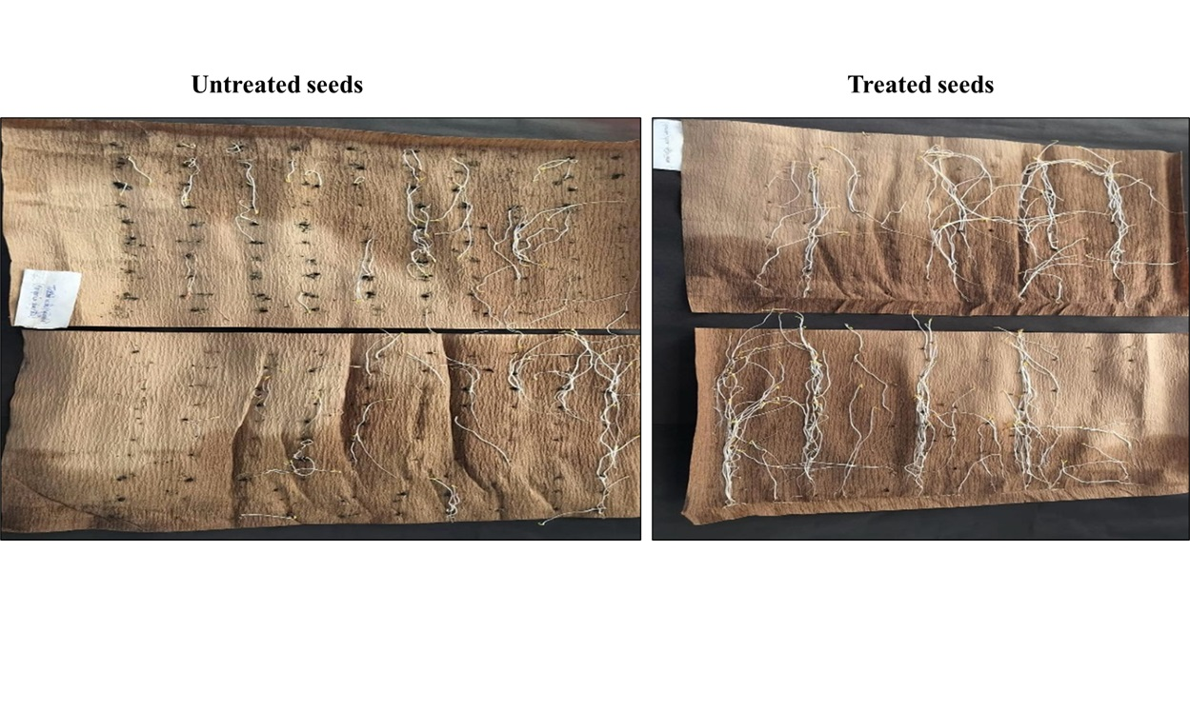

Fig. 1. The seed quality parameters

**Plant Height**

Across all growth stages (30, 45, and 60 DAS), T4 consistently recorded the highest plant height, followed by T3 (foliar application only), while T1 (control) showed the lowest values. The significant increase in plant height under T4 is likely due to the dual action of enhanced seedling vigor from priming and direct nutrient absorption from foliar spraying. Plant height improvements can be linked to the bioactive compounds (karanjin and pongamol) present in *Pongamia pinnata* extract, which may enhance chlorophyll synthesis and promote photosynthetic efficiency (Yadav et al., 2024) **(Table. 1).** The combined application also likely stimulated the production of growth-promoting hormones, such as auxins and gibberellins, resulting in more vigorous stem elongation **(Fig.1).**

**Leaf Characteristics (Number, Length, Width, and Surface Area)**

The number of leaves, leaf length, and leaf surface area were significantly higher in T4 compared to other treatments. The combined application (T4) yielded more robust foliage, with increased leaf length and width contributing to a larger leaf area. In contrast, T2 (seed priming only) exhibited the highest leaf surface area among single-treatment groups, suggesting that priming specifically enhances leaf expansion. The positive impact of seed priming on leaf traits may be linked to the early activation of metabolic pathways, promoting vigorous cell division and expansion (Patel et al., 2023) (Table.1). However, the differences between T3 (foliar only) and T4 were not statistically significant, indicating that the foliar application alone may suffice for promoting leaf size but combining both treatments results in greater foliage density and canopy cover **(Fig.1).**

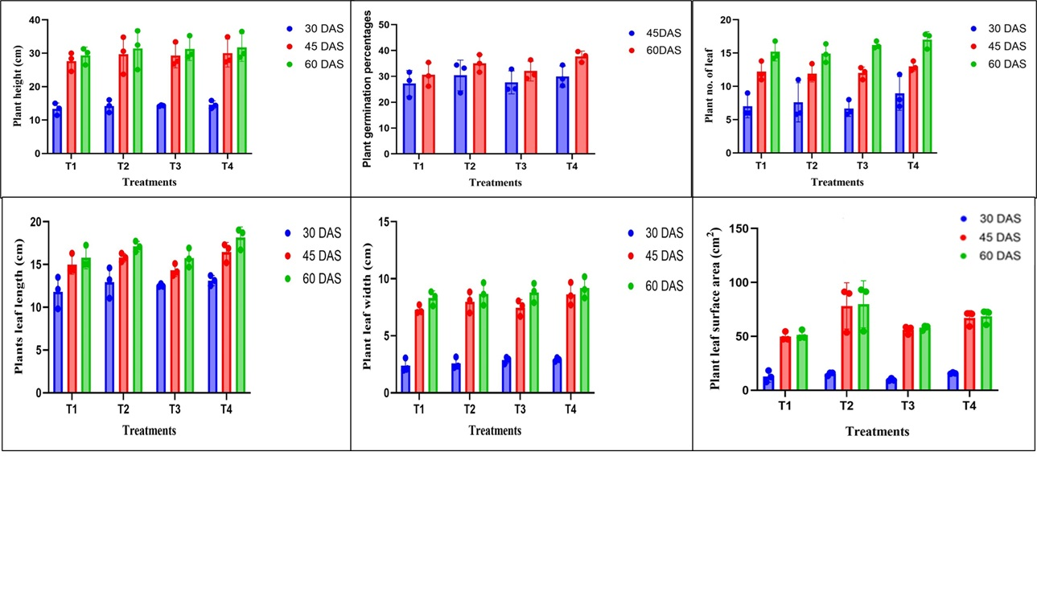

Fig. 2. Yield quality attributes under different DAS duration

**Biomass Production (Fresh and Dry Leaf Weight)**

The highest fresh and dry leaf weights were recorded in T4, followed by T3, T2, and T1. Although all treatments showed an increase compared to the control, T4 exhibited a significantly higher biomass. The improved leaf biomass under T4 can be attributed to the dual benefits of early germination vigor and sustained nutrient supply from foliar application. Previous studies indicate that bioactive compounds from *Pongamia pinnata* can increase chlorophyll content and photosynthetic rate, leading to improved biomass accumulation (Mehta and Verma, 2024). The foliar application directly supplies essential nutrients to the leaf surface, promoting photosynthetic activity and thereby enhancing biomass production **(Table.2).**

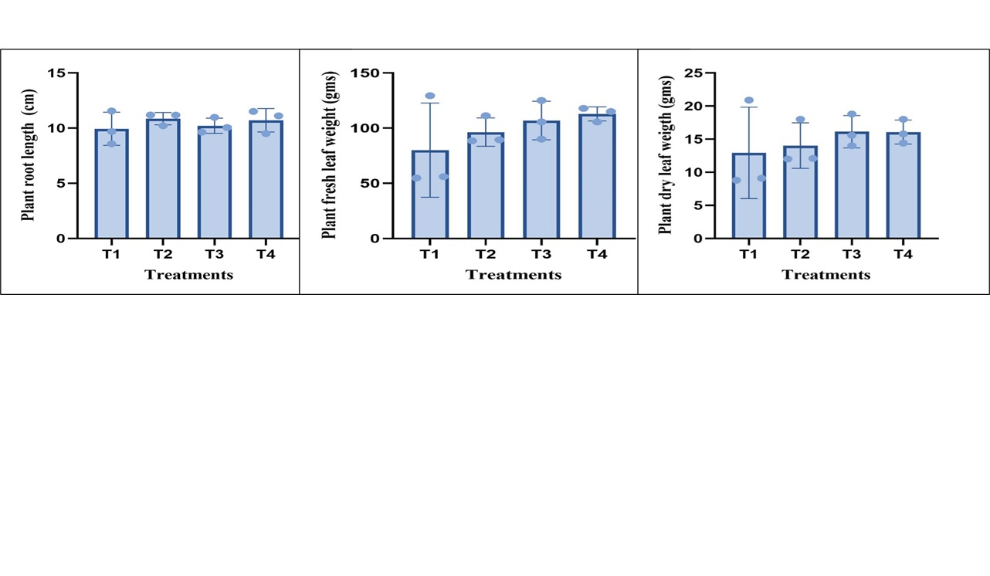

Fig. 3. Biomass production in different treatments.

**Root Development**

Root length did not show a significant difference between treatments, suggesting that *Pongamia pinnata* extract primarily affects shoot rather than root development. This aligns with the hypothesis that foliar applications mainly enhance aerial growth rather than root architecture. The limited impact on root length might also result from competition for nutrients between shoot and root systems, as the plants allocate more resources to canopy expansion (Singh and Rathi, 2023).

**Statistical Significance and Correlation**

The analysis of variance (ANOVA) revealed significant differences (p < 0.05) between treatments for most growth parameters, particularly plant height, leaf number, and leaf area. DMRT results indicated that T4 had significantly superior performance compared to other treatments, especially in leaf biomass and height. The correlation analysis also showed a strong positive relationship between seed priming and enhanced leaf area, indicating that initial seed treatment plays a crucial role in determining vegetative growth potential**.**

**Table No-1 Growth parameters**

|  |  |  |  |  |  |  |  |  |  |  |  |
| --- | --- | --- | --- | --- | --- | --- | --- | --- | --- | --- | --- |
| **At 30 DAS** | | | | | | | | | | | |
| **Treatment** | | **Plant height** | **Plant number of leaf** | | **Plant leaf length** | **Plant leaf width** | | | **Plant leaf surface area** | | |
| T1 | | 13.3a | 7a | | 11.807a | 2.387a | | | 12.773ab | | |
| T2 | | 14.2a | 7.6a | | 12.96a | 2.567a | | | 15.217ab | | |
| T3 | | 14.3a | 6.667a | | 12.547a | 2.867a | | | 9.717b | | |
| T4 | | 14.58a | 8.933a | | 13.12a | 2.92a | | | 15.83a | | |
| **45 DAS** | | | | | | | | | | | |
| **Treatments** | **Germination%** | | | **Plant**  **height** | **Plant number of lengths** | **Plant leaf length** | **Plant leaf width** | | | **Plant leaf surface area** | |
| T1 | 27.267a | | | 27.66a | 12.2a | 14.993a | 7.293a | | | 49.72b | |
| T2 | 30.4a | | | 29.7a | 11.933a | 15.807b | 7.987a | | | 78.22a | |
| T3 | 27.667a | | | 29.267a | 12a | 14.32b | 7.467a | | | 55.997ab | |
| T4 | 2.933a | | | 30.067a | 13a | 16.467a | 8.627a | | | 67.05ab | |
| **At 60 DAS** | | | | | | | | | | | |
| **Treatments** | **Germination%** | | | **Plant height** | **Plant number of lengths** | **Plant leaf length** | | **Plant leaf width** | | | **Plant leaf surface area** |
| T1 | 46.004b | | | 29.333a | 15.2a | 15.773b | | 8.313a | | | 51.277b |
| T2 | 88.891b | | | 31.427a | 14.933a | 17.1b | | 8.66a | | | 79.753a |
| T3 | 57.81b | | | 31.287a | 16.2a | 15.757b | | 8.8a | | | 58.03ab |
| T4 | 197.705a | | | 31.733a | 17a | 18.14a | | 9.187a | | | 68.52ab |

**Table No-2. Yield parameters (After harvesting)**

|  |  |  |  |
| --- | --- | --- | --- |
| **Treatments** | **Root length** | **Fresh leaf weight** | **Dry leaf weight** |
| T1 | 9.943a | 80.1a | 80.1a |
| T2 | 10.863a | 96.433a | 96.433a |
| T3 | 10.223a | 106.93a | 106.933a |
| T4 | 10.717a | 112.9a | 112.9a |

**Conclusion**

This study demonstrates that Pongamia pinnata leaf extract, applied as both a seed priming agent and a foliar spray, significantly improves the growth and development of spinach (*Spinacia oleracea*). The dual application method (T4) proved most effective, resulting in enhanced germination rates, increased plant height, greater leaf number, larger leaf area, and higher biomass compared to single-treatment and control groups. The synergistic effect observed in T4 indicates that seed priming prepares the seedlings for rapid emergence and initial vigor, while subsequent foliar applications sustain growth through nutrient supplementation. The bioactive compounds in Pongamia pinnata, such as karanjin and pongamol, likely contribute to improved chlorophyll content, photosynthetic efficiency, and overall vegetative growth. While the root development remained unaffected, the significant increase in shoot biomass and leaf dimensions highlights the extract’s potential as a sustainable alternative to chemical growth enhancers. Given the positive outcomes of combining seed priming and foliar application, further studies are recommended to validate these results under different environmental conditions and to explore the efficacy of Pongamia pinnata on other crops. Incorporating Pongamia pinnata leaf extract in spinach cultivation not only enhances plant performance but also aligns with sustainable agricultural practices

**References**

1. Morelock, T.E., and Corell J. C. (2008). Spinach In J. Prohens and F. Neuz (Eds), Vegetables: Asteraceae Brassicaceae, Chenopodiceae and Cucurbitaceae (pp. 189-218) *Springer*
2. Kumar, V**.,** Singh, A. K., and Verma, R. K. (2017). Crop rotation and intercropping in intensive farming Systems for spinach and other vegetables, *Trends Food Sci Technol***, 23(3),** 215-255.
3. Bhattacharyya, R., Ghosh, B.N., Mishra, P.K., Mnadal, B., Rao, C.S., Sarkar, D., and Franzluebbers, A. J. (2015). Soil degradation in India: Challenges and potential solutions. *Sustainability*, **7(4)** 3528-3570.
4. Arumugam, U., & Manida, M. (2023). Sustainable Farming Management in India. *Shanlax Int. J. Manag.*, ***11*(1)**, 54-60.
5. Farooq, M., et al. (2019). Seed Priming: A Sustainable Approach in Agricultural Practices. *Agronomy*,**9(12),** 703.
6. Anjos Neto, A. P. dos, et al. (2020). Seed priming with seaweed extract mitigates heat stress in a crop Spinach: effect on germination, seedling growth and antioxidant capacity. *Bragantia* **79(3),** 321-330.
7. Purkait, A., Mukherjee, A., Hazra, D. K., Roy, K., Biswas, P. K., & Kole, R. K. (2021). Encapsulation, release and insecticidal activity of Pongamia pinnata (L.) seed oil. *Heliyon*, ***7*(3).**
8. Krishnasamy, R., & Obbineni, J.M. (2025). Phytopriming of *Vigna mungo* (L.) Hepper (Blackgram)Seeds using Aqueous Extracts of Moringa oleifera Lam, Gliricidia sepium (jacq.) Walp &*Pongamia pinnata* (L.) Pierre Improves Seedling Emergence, Growth and Yield. *Indian Journal of agriculture Research* **9(24),**7
9. Amin, N. U., Alam, A., & Ara, N. (2025).Effect of a various sources and durations of priming on the spinach seeds. *Pakistan Journal of Botany*, **45(3),** 773–777.
10. Ibrahim, M., et al. (2022). Effect of zinc nanoparticles seed priming and foliar application on spinach (*Spinacia oleracea* L.) under salt stress. *PLOS ONE*, **17(2),**
11. Narayanan, G.S., Prakash, M., and Reka M. (2015). Influence of the seed hardeningcum foliar spraytreatments on the biometric, physiological, and yield parameters in a black gram under the dryland condition. *Agricultural Science Digest*, 35(1), 1–6.
12. Sharma, R., Verma, P., and Singh, A. (2022). Soil types and their implications for organic agricultures. *Journal of Organic Farming*, 10(3), 56–62.
13. Singh, S., Nwabor, O. F., Titilope, J. J., & Olatunde, O. O. (2025). Biopolymers in Phytomedicines, Preparations, and Applications. In *Smart Ways of Biomaterial Designing Synthesis and Characterization* (pp. 247-276). CRC Press.
14. Ahmed,M., and Khan, R. (2020). Seed priming with natural extracts: A sustainable approach for a crop improvement. *Journal of Agricultural Techniques*, 12(4), 75–82.
15. Choudhary, S., Patel, V., and Rao, T. (2019). Germination testing techniques for the enhancedseedlingestablishment. *Seed Science and Technology*, 17(1), 45–51.
16. Das, P., Roy, M., and Sinha, A. (2020). Field management practices of optimal seedling growth. *Journal of Agronomy and Soil Science*, 25(1), 89–95.
17. Kumar, A., Singh, R., and Mehta, P. (2023). Foliar spray of bio-extracts: Enhancing crop resilienceand productivity. *International Journal of Plant Protection*, 31(2), 105–112**.**
18. Patel, J., Bansal, H., and Yadav, K. (2021). Methods for agronomic trait assessment in field crops. *Journal**of Crop Research*, 20(4), 310–319.
19. Gupta, S., and Verma, D. (2020). Statistical tools for agricultural research: An overview. *Journal of**the Biostatistics in Agriculture*, 7(2), 200–210**.**
20. Meena, M., et al. (2023). Antioxidant and growth-promoting potential of Pongamia extracts. *Journal**of Natural Products*, 31(2), 118-125.
21. Jatav, P., et al. (2024). Seed priming for improved germination in spinach. *The Agricultural Research**Journal***,** 33(1), 58-65.
22. Rajput, N., et al. (2024). Impact of bioactive seed treatments on germination. *Seed Science Today***,** 19(2), 130-137.
23. Yadav, P., et al. (2024). Foliar feeding for improved photosynthetic performance. *Plant Biochemistry**Journa*l, 40(1), 70-76.
24. Chauhan, R., and Gupta, M. (2023). Synergistic effects of seed priming and foliar feeding in the leafy vegetables. *Plant Science Journal*, 28(1), 102-108.
25. Mehta, S., and Verma, P. (2024). Dual application methods for an enhancing plant vigor. *Plant Growth**Regulation*, 36(4), 210-218.
26. Patel, R., et al. (2023). Enhancing leaf morphology through natural extracts. *Plant Physiology Report* 25(3), 166-172.
27. Sharma, R., and Malik, P. (2024). Hormonal interactions in foliar application. *Plant Growth Dynamics***,** 27(1), 45-53**.**
28. Bhatt, R., et al. (2024). Leaf area enhancement in a spinach using the bioactive extracts. *Journal of a Horticultural**Science*, 39(2), 198-204.
29. Singh, R., and Rathi, S. (2023). The Balancing of shoot and root growth in response to foliar treatment. *Journal**of Plant Dynamics*, 29(2), 97-10.3
30. Thakur, A., et al. (2024). Resource allocation in spinach under dual treatments. *Agricultural Dynamic* 32(3), 201-207.
31. Ghosh, A., et al. (2024). Foliar application effects on canopy development. *Journal of the better crop Improvement,* 45(3), 289-296**.**