Computational Analysis of Blast-Responsive Pi9 Gene Family in Finger Millet (Eleusine coracana): Unravelling Defences Against Magnaporthe grisea

Abstract:
The Pi9 gene, an element belonging to Nucleotide-Binding Site Leucine-Rich Repeat (NBS-LRR) family, a positive regulator and critical in plant defence mechanism against blast fungus in millets & rice. Despite the fact that NBS-LRR genes are found across various plant species, including millets, no studies have specifically investigated Pi9 gene in Eleusine coracana genome that can be used effectively to combat blast disease causing up to 80% yield loss. Previous findings regarding the Pi9 gene in rice may not be directly applicable to finger millet as they are different genomes and the distinct evolutionary origins of Magnaporthe grisea strains affecting them. Subsequently, research on Pi9 gene in finger millet in the view of breeding, marker development, allele mining are present but our study provides foundation for deeper understanding of the gene family members which is essential to develop tolerant varieties. Here, we identified nine EcPi9 gene homologs and divided into three clades based on their ancestral cleavage. Various Insilco tools were used to determine gene and protein assets including subcellular localisation, cis regulating elements, conserved motif and domain analysis, etc. EcPi9 homologs are closely related to rice and sorghum with reference to evolutionary and synteny analysis. CpG island prediction revealed that methylated sites present align according to their phylogeny. Functional validation of transcripts was done through GO studies and TFs prediction. Current study characterized EcPi9 gene members, their roles in defence against blast and provides valuable resources for future research.
Key words:Pi9 Gene, Eleusine coracana, Computational Analysis, Blast disease, Biotic Stress.

Background:
Magnaporthe grisea (anamorph: Pyricularia grisea)a hemi-biotrophic fungus (Takan et al., 2012) also known cereal killer causes blast disease (Fernandez et al., 2018). One such super cereal is finger millet (Eleusine coracana), an important C4 crop renowned for its great nutritional content and resilience in unfavourable environments. Its productivity is hindered up to 90% by blast disease and threatening world food safety (Navya et al., 2023). Blast disease was first detected in rice and host-pathogen interactions were highly explored (Cho et al., 2007) for development of blast resistant varieties. According to previous reports blast disease in finger millet is originated from wild grasses. Blast pathotypes infecting finger millet may or may not be present in rice, determining its infectivity is specific to the individual hosts thereby host cell response to the pathogen may also differ (Nayaka et al., 2021). Moreover, finger millet is a highly self-pollinated crop which limits hybridisation and traditional breeding (Nagaraja et al., 2025). Hence there is a need to uncover molecular mechanisms causing resistance and susceptibility for the blast disease in finger millet
Plants evolved immunity towards pathogens via Pattern-triggered immunity and resistance or R-protein mediated immunity. Plant resistance genes (R-genes) which directly or indirectly identify effector proteins of pathogen and initiates second layer immunity (ETI) when pathogen escapes first line defence (PTI) (Qian et al., 2021). One such R gene is Pi9, originated from Oryza minuta,a Nucleotide-binding site leucine-rich repeat (NBS-LRR) gene family member belongs to class 2 of R-genes according to Martin et al. 2003, specifically coiled-coil group (CNL) (Shi et al, 2023). It is one of the genes that display widespread resistance which confer durable resistance to numerous strains of blast fungus (Li et al, 2019). Pi9 detects the pathogen and interacts with Avr-Pi9, an effector protein produced by M. oryzae in the vicinity of host cell in order to disturb the PTI. Avr-Pi9maintains its stability by associating with ANIP1, ubiquitin-like protein degrading TFs like WRKY in rice thereby weakens host immune response during infection. Pi9 stabilizes this protein while Avr-Pi9 dissociates them making Pi9 available (Shi et al., 2023). Pi9 have been targeted for genetic improvement in rice for enhanced blast resistance conferring the importance of Pi9 gene towards blast resistance (Tian et al., 2019). Recent report says that Avr-pi9 protein may get mutated to make host more vulnerable and gets unnoticed by host and escapes PTI (Lu et al., 2023). Even though Pi9 gene is well-explored in rice, number of homolog genes, cellular location, functional aspects, and binding sites may differ from genome to genome but are mostly conserved (Lyons et al., 2008). Hence, studying Pi9 gene in finger millet is essential due to the crop's unique genetic and ecological characteristics, its susceptibility to blast disease, and its growing importance in food security. Moreover, recent advances in omics and availability of whole genome sequence of Eleusine coracana (Sood et al., 2024) and In-silico studies paves foundation for further exploration and deeper understanding of host resistance mechanisms which helps in development of blast resistant varieties by molecular breeding and genome editing.
Materials and Methods
Gene characterisation:
In Finger millet, EcPi9 genes were identified using protein sequences which are retrieved from Phytozome database,OsPi9 (DQ285630- GenBank) gene from Oryza sativa used for blast P against Eleusine coracana protein database. The selection criteria for the hits were >50% similarity and an E value below 1E-5. To anticipate the domain present, the potential EcPi9 genes were uploaded in motif finder tool. Among outcomes, the genes containing the NB-LRR Domain were selected, while remaining genes were considered unnecessary.
Gene structure prediction:
Required genomic sequences, CDS sequences data of Eleusine coracana were collected from Phytozome database. Exon- Intron structure patterns were predicted.
Sub cellular localization:
Subcellular localization of the EcPi9 protein homologs were identified.
Motif & conserved domain analysis:
To predict conserved motif patterns, unlike default parameters we applied 10 number of motifs, 2 to 20 motif places, and 6 to 20 widths (Bailey et al.,2010). The functional domain analysis was done and the data was represented using Tbtool II.0.
Physical mapping:
The location of genes was noted and used for mapping them on chromosome. The evolutionary relationship was done by aligning the amino acid sequences of the EcPi9 genes from Eleusine coracana with Sorghum bicolor, Zea mays, Oryza sativa, Panicum virgatum, Seteria viridis, Arabidopsis thaliana, Paspalum vaginatum, Brassica rapa, Brachypodium distachyon, Prunus persicum, Populus trichocarpa, Hordeum vulgare for construction of Newick Phylogenetic tree employing neighbour joining method with selecting 1000 bootstrap replicates (Kumar et al.,2016) and this tree was developed.
Collinearity among species:
Synteny analysis between Eleusine coracana vs O. sativa, S. bicolor,P. virgatum, S. italica,A. thaliana, P. vaginatum, B. rapa, B. distachyon, P. persicum, P. trichocarpa, H. vulgare was done using dual synteny plot by Tbtool II.0.
Promoter element prediction:
Promoter sequences which are 1500 bp upstream to genomic sequences of all candidate genes were taken from Phytozome database. Cis regulatory elements are predicted with these downloaded promoter sequences.
Protein parameters:
Various protein parameters like aliphatic indexes, isoelectric point, size and length of protein, gravy (grand average of hydropathy) was determined.
Protein structure:
The 2- dimensional structures of homologues protein were predicted (Viswanadha et al, 2025). The 3-dimensional protein structures of EcPi9 transcripts were predicted. For evaluating and analysing the stability of the protein structure predicted was done via Ramachandran plots. SOUSI server determined the presence of transmembrane structures in proteins.
Prediction of protein-protein interactions:
The PPI (protein-protein interactions) of these homologs have been observed to understand their binding affinities and regulatory mechanisms.
Transcriptional factor prediction:
All EcPi9 genes transcription factor link sites were predicted. The data was saved and represented as a network connecting EcPi9 genes & TFs.
Gene Ontology:
GO analyses were conducted to explore diverse functions, encompassing Biological Process, Molecular Function, and Cellular Component categories.
CpG Islands prediction:
To analyse the presence of methylated regions in the promoter regions (upstream 2000 bp of genomic sequence) of homolog genes (Li et al., 2002) and results were noted.
The tools/ databases/websites used in this study are provided as supplementary material Table1.
Results:
Computational Study of Gene Assets: An In-Silico Approach
After searching a publicly accessible database - Phytozome against Eleusine coracana genome with a characterised OsPi9 gene sequence, the study identified nine sequence entries with a predicted Pi9 gene. Repeated sequences carrying the same proteins as well as non-representative transcripts were eliminated from the study to reduce redundancy. After eliminating less comparable proteins and ones having anticipated E-values over <1E-5, we identified nine homolog genes in finger millet genome. Table 1 includes more details about the selected transcripts.
The basic gene characteristics like location of gene, subcellular localisation, chromosome number, exons/ introns and pseudo names given were tabulated (Table 1) for better understanding.
Notably, Except for EcPi9.1, which had a single UTR region near the 3' end of the strand, the gene architecture of these comprised exclusively exons and introns and no untranslated regions. (Fig 1a). The NB-ARC and Leucine Rich Repeats superfamily of functional domains, as well as their sequence patterns, were discovered when the gene sequences were further examined for motif patterns and conserved domain analysis. The evolutionary groups of gene homologs coincide with the motif patterns (Fig 1b & 1c).
The study used Tbtool for retrieving the chromosome lengths of complete finger millet genome in order to ascertain the chromosomal positioning of the EcPi9 homologs. All the genes are highly concentrated on 6 & 7 chromosomes only (Fig. 2a). During the chromosomal evolution, it was more likely that homolog genes came from the identical progenitor gene.
To look into the patterns of evolution among Pi9 members in finger millet, we employed nine EcPi9 genes to build a hierarchy of these in MEGA 11.0 using 1000 bootstraps and complete deletion parameters. The phylogenetic tree (Fig. 2b) categorized the 9 homolog genes into three clans, suggesting unique phylogenetic lines of descent, with bootstrap values verifying each. One group had five members, while other two groups each had two members. Some genes on the identical chromosome grouped together in the evolutionary tree, suggesting that tandem duplication occurrences had possibly taken place on the same chromosome.
In order to fully investigate the family's evolutionary relationships, species with thorough annotations (Eleusine coracana, Sorghum bicolor, Seteria viridis, Arabidopsis thaliana, Paspalum vaginatum,Oryza sativa, Brassica rapa, Brachypodiumdistachyon, Prunus persicum, Panicum virgatum, Populus trichocarpa, Zea mays, Hordeum vulgare) were chosen in our study. 32 sequences overall that displayed more than 50% similarity to EcPi9 genes were chosen, aligned using the MUSCLE multiple alignment method, and then utilized to build a collective Newick tree (Fig. 2c) via the Neighbour-joining method. These are divided into three groups, and the concentration of all EcPi9 homologs in a single clade demonstrates their unique genetic connection with other closely related species. S. viridis, H. vulgare, P. vaginatum, O. sativa formed a clade with E. coracana.
In order to find and subsequently analyse intraspecies syntenic genes, Tbtool II.0 was opted to create this graphic (Fig. 3a) According to the research results, for these gene pairs, a total of three distinct syntenic blocks were found with the genomes of S. bicolor and two with O. sativa, for other related species that were opted, no syntenic lines were generated.
The distribution of cis elements in promoter regions were predicted. Light responsive, methyl jasmonate responsive, hormonal responsive, other stress responsive along with wound responsive elements were generated (Fig. 3b). Light responsive elements are highly occurred in them among all elements followed by MeJA ones. The number of occurrences for each promoter element in homolog genes were displayed as a heatmap (Fig. 3c). Methylated regions in the promoter regions were analysed through CpG Island prediction. four islands found in EcPi9.1 and EcPi9.3. EcPi9.4, EcPi9.5, EcPi9.8, EcPi9.9 have one methylated island region each while EcPi9.6 and EcPi9.7 had no islands. It's interesting to note that methylated sections of proteins that are paralog pairs based on evolutionary study are similar (Table 2), (supplementary material fig.1). The CpG Islands observed for EcPi9.1 was displayed as (Fig. 5b).
Insights into Gene Regulation and Protein Aspects:
The properties such as Gravy, length, size and isoelectric point of proteins were determined (Table 3). The 2D structure of Pi9.1 is shown in (Fig. 4a), and their features, such as the percentage of random coils, beta turns, and alpha helices, are recorded in Table 4 with 984 a.as, EcPi9.1 is the longest protein, while EcPi9.3 is the shortest with 220 a.as. Compared to EcPi9.1, EcPi9.3 has a greater proportion of alpha helices while being smaller. The protein with highest alpha helices is EcPi9.8. Interestingly, EcPi9 transcripts have no beta turns in their protein forms. There are no transmembrane structures involved, and the 3D-structure (Fig. 4b) predictions also yielded disease resistant protein, pathogen interacting protein from rice, NB-ARC-containing forms which correspond to their conserved domains and functional properties. The templates, their similarity % and description are provided in (Table 5) Ramachandran plots served to check these structures, where all proteins fall in 80–94% allowed regions (supplementary material fig. 2).
The study predicted the protein-protein interaction networks of EcPi9 proteins. EcPi9 homologs did not interact with one another, although EcPi9.1 did interact with three clusters of proteins in the network. Other NB-ARC domain containing and F- box containing proteins were interacted (Fig. 4c). Furthermore, the interaction network assessment revealed that Pi9 members have roles in a variety of biological processes, especially plant natural immune responses, cellular process regulation and defence mechanisms.
As there is no related expression data available for finger millet, Functional aspects were analysed by gene ontology studies and transcriptional factor predictions. Diverse TFs, such as WRKY, MYB, MYB-related, NAC, bHLH, YABBY, LFY, WOX, and others (Fig. 5), were present, suggesting that it serves as a resistant gene and is engaged in defence processes in plants.
Relating with predicted function based on TFs binding gene ontology studies also revealed the same. EcPi9.1 demonstrated every molecular function, biological process involved, and cellular component. While certain proteins, such as EcPi9.3, EcPi9.8, and EcPi9.9, are uncharacterized and lack GO-Ids, others include the NB-ARC domain properties and contribute to disease resistance (Table 6).
Discussion:
Cereals constitute a significant portion of feedstock and are essential parts of the human meal. It's vital to continue producing enough to satisfy demand. Pi9 genes aid in plant adaptation to blast-stress conditions and are engaged in a number of biological and developmental processes (Chen et al., 2025).Prior studies focused solely on NBS-LLR domain proteins, identifying 116 genes in finger millet that are involved in plant development (Balamurugan et al., 2024). Research on EcPi9 class members in E. coracana is less so far. Here, we explored EcPi9 in E. coracana for the first time. New avenues for enhancing E. coracana productivity and increasing its resilience to blast stress will be made possible by the current investigation of EcPi9 gene activities.
The distribution of EcPi9 genes across chromosomes 6 and 7 was revealed by the chromosomal localization analysis which is similar in rice (Saxena et al., 2025). There is a substantial correlation between the number of tandem repeat events and the closeness and complexity of the gene family. The growth and functional variation among gene family are significantly impacted by these occurrences (Cannon et al., 2004).
According to our data, the majority of proteins have the NBS-ARC domain and the six motifs in their N-terminal regions, which is in line with earlier research (Balamurugan et al, 2024). Functional diversity of them is further supported through the presence of 3–10 motifs in protein paralogs. Interestingly, the motif NBS-ARC was found primarily in the Pi9 subfamily, indicating that it may play a part in the functioning of this subgroup. Similar results have already been documented in rice, where particular motifs were linked to genes that respond to stress (Sinha et al., 2023) and in soyabean (Afzal et al., 2022).Nine of the 153 cis-acting regions found in nine EcPi9 genes in this study are linked to MYB proteins, suggesting that MYB might act as an upstream transcriptional modulator of EcPi9 expression. As frequently observed in a variety of plant species, we also discovered 9 promoters with 61 light response elements and 33 methyl jasmonate responsive elements, suggesting such genes could be linked to biotic stress responses (Singh et al., 2024). light responsive elements also contribute towards broad spectrum resistance as studied earlier by Liu et al., 2019 in rice.Additionally, we discovered CREs within promoter regions of Pi9 homologs linked with responsiveness to gibberellin, ABA, auxin, salicylic acid, and ATP-binding. Numerous studies have shown that phytohormones and cis-acting regions affected by MeJA are essential for regulating the expression of EcPi9 genes.
Phylogeny analysis revealed that all homologs of E. coracana formed clade with rice which shows that role of EcPi9 genes may be correlated with that of O. sativa ones and these genes showed synteny blocks with only O. sativa and S. bicolor.
Remarkably, EcPi9s were recently hypothesized as mediator of pathogen infection and PAMP-induced plant immunity in rice (Zhai et al., 2022). Avr-Pi9 also affects the transcription factor WRKY, blocking the subsequent process of phytoalexin synthesis, which serves as an antifungal (Nguyen-Ngoc et al., 2023). Presence of other TFs like MeJA, bHLH, MYB & related, NAC, YABBY are both biotic and abiotic stress responsive involving methyl jasmonate mediated plant pathogen interaction pathway and production of monoterpenoids are related to homologs (Jain et al., 2017). Monoterpenoids also acts as fungicides which is crucial for plants under infection (Huang et al., 2025).
Incorporating comprehensive and long-lasting resistance is now a key focus for breeders to combat rice blast (Pedrozo et al., 2025). We detected 11 potential protein-protein interactors for EcPi9.1. These members were found to be abundant in GO such as 'response to stress', 'defence responsive', and 'response to pathogen infection', indicating that EcPi9.1 may serve in these physiological functions. GO analysis further indicates that finger millet Pi9 family gene products have nucleotide binding activity and contribute in disease resistance via NB-ARC domain-containing proteins. This shows that the Pi9 genes have a role in metabolic processes and immunology, ultimately affecting the plant's overall strength when exposed to pathogens.
This research contributed to a better understanding of Pi9's involvement in regulating the resistance in plants. The constituent proteins of EcPi9 gene family were determined using Insilico, and their gene structures, protein characteristics, functional aspects, and significance were examined. In recent times, Pi9 family members have been expressed and described in most crops, and some of their cellular functions have been investigated. Numerous research has pointed out Pi9's contribution to blast control (Soujanya et al., 2023), leading to a better knowledge and awareness of Pi9's significance in plant development and defence systems. There have been very few studies on the role of Pi9 in controlling plant stress tolerance, though, with most of the appropriate research concentrating on plant species like rice (Tang et al., 2024) and minimal on other impacted crops like millets. On the other hand, our research has limitations as well. Our study's main goal is to find and forecast the activity of Pi9 gene family members in finger millet with the help of computational biology. In addition, the discovery of EcPi9 upstream regulators offers novel concepts and emphatical support for downstream target genes and TFs that control plant growth, development along with response to biotic stress. Clarifying about characteristics of gene role and elucidating the process of gene functional expression require more investigation. These methods will enable the deployment of EcPi9 genes in E. coracana genome editing programs and offer an in-depth comprehension of the regulatory networks comprising these genes. After identifying more detailed processes, the phenotypic effect of particular Pi9 genes under blast infection scenarios can be evaluated using CRISPR/Cas9, Prime tool, genetic manipulation, or RNAi (RNA interference) techniques.

Conclusion:
Blast stress drastically decreased ragi quality and productivity while also having a detrimental impact upon Terpenoids, antioxidants, phytoalexins, and lipids in the ragi plant. In particular, this work was the first to identify and comprehensively examine the Pi9 gene family in Eleusine coracana, identifying nine genes that are likely to be centered in nucleus and cytoplasm. With respect to exon–intron distribution and motif composition, members of every subset in EcPi9s exhibit a high degree of conservation, according to gene organization and conserved motif study. In phylogenetic analysis, the nine candidate genes—which are found on chromosome 6 and 7—are separated into three clusters. There are plenty of cis-elements associated with biotic stress responses, indicating that finger millet responds to pathogen infections in a variety of ways. The comprehensive genome-wide analysis of the finger millet Pi9 genes is revealed by this investigation. Our results support further research exploring their action and mechanisms for regulation based on transcription factors of EcPi9s in Eleusine coracana defence mechanisms under biotic stress as well as additional development and abiotic stresses.

Data availability:
The dataset supporting the findings of this article are included within the article.
Statements and declaration:
No conflict of interest is there among authors in any aspects.
Acknowledgments:
Mr. J. Viswanadha Naik expresses gratitude to the University Grants Commission (UGC) for providing research fellowship. Ms. K. Anjana Priyadarshani acknowledges the DBT-JRF Programme for funding her research fellowship.
Funding:
No additional financial resources were provided or obtained.
Figures:
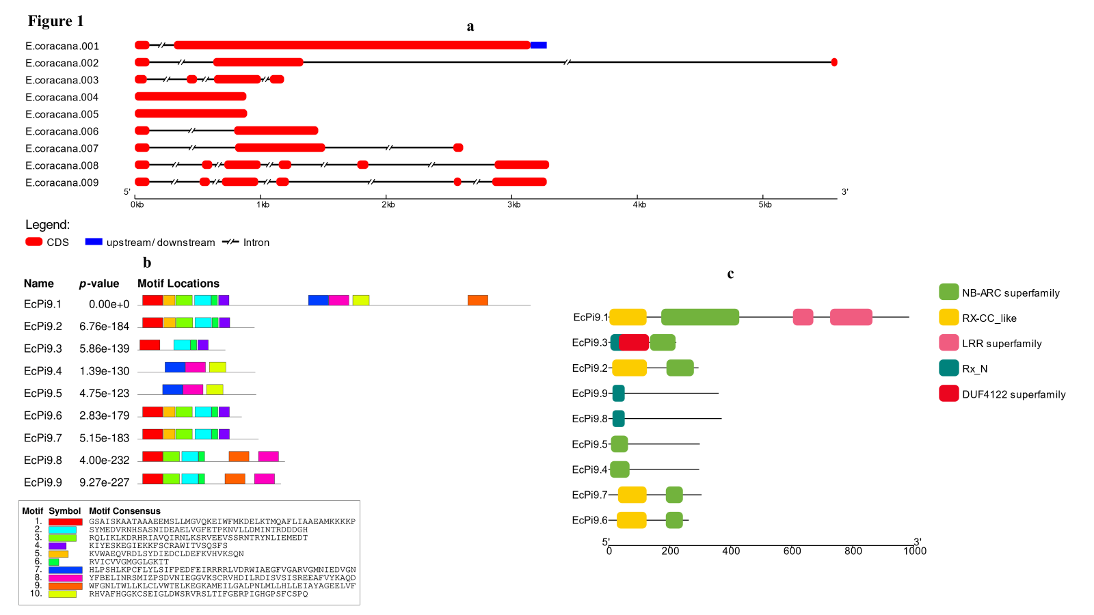
EcPi9.1 EcPi9.2 EcPi9.3 EcPi9.4 EcPi9.5 EcPi9.6 EcPi9.7 EcPi9.8 EcPi9.9
Figure 1- a) Gene structure analysis showing CDS (red), UTRs (blue), introns as split lines. b) distribution of motifs across protein sequences of EcPi9transcripts. c)conserved domain analysis of all genes where NB-ARC domain is present in all.
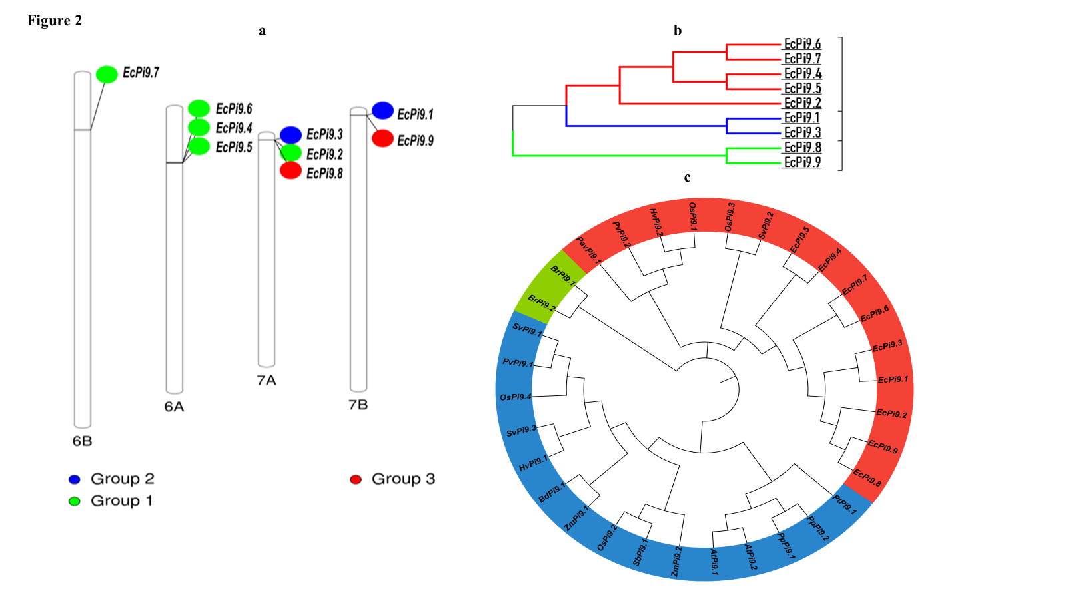
Figure 2 – a) distribution of genes across finger millet genome, genes are concentrated on 6 and 7 chromosomes. b) tree showing ancestral relationships among themselves, each colour represents a group. c) evolutionary analysis of EcPi9genes with other related species.
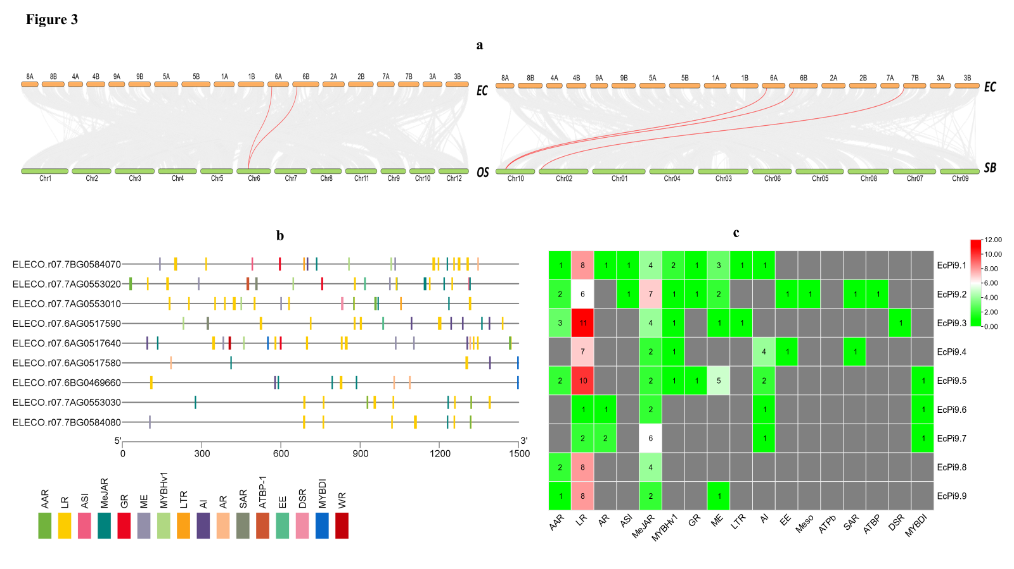
Figure 3 – a) collinearity of E. coracana with O. sativa and S. bicolor, pink lines indicates synteny blocks among species. b) the distribution of cis regulatory elements in the promoter regions of EcPi9 homologs. c) the heatmap showing frequency of specific cis elements occurrence for each homolog.
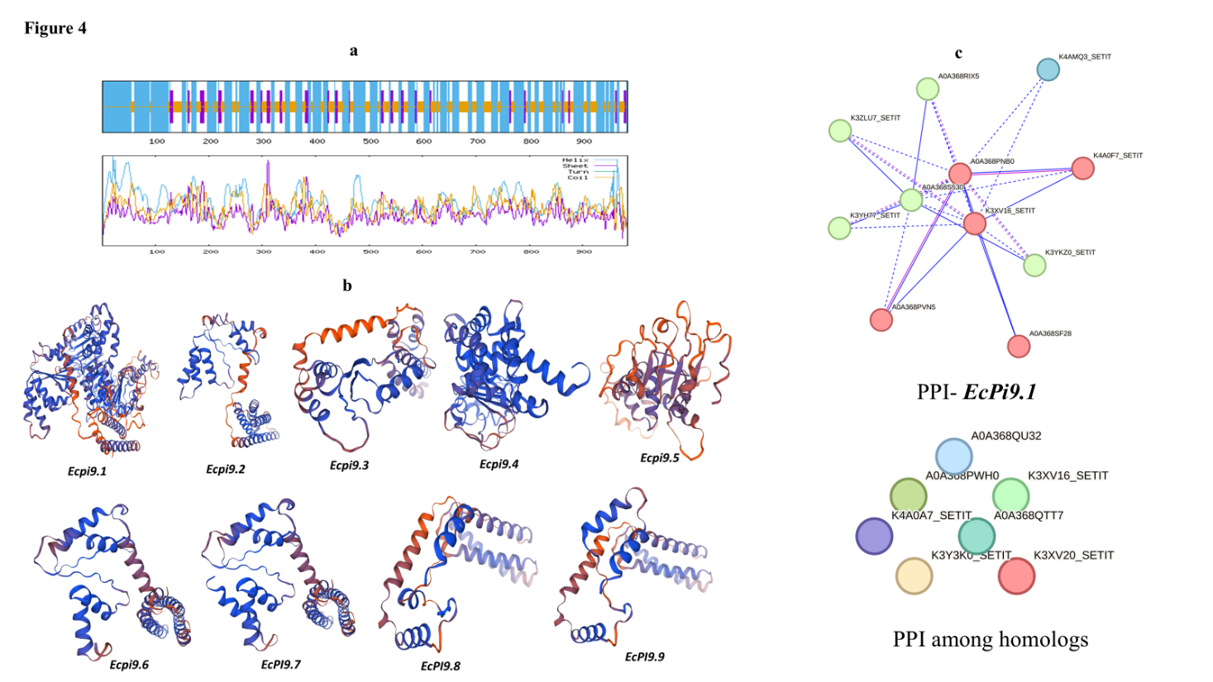

Figure 4 – a) 2D structure of EcPi9.1 protein each coloured peaks indicates the pattern of components. b) predicted 3D models of all candidate proteins. c) network showing protein- protein interactions among all selected proteins and also that of EcPi9.1 protein.
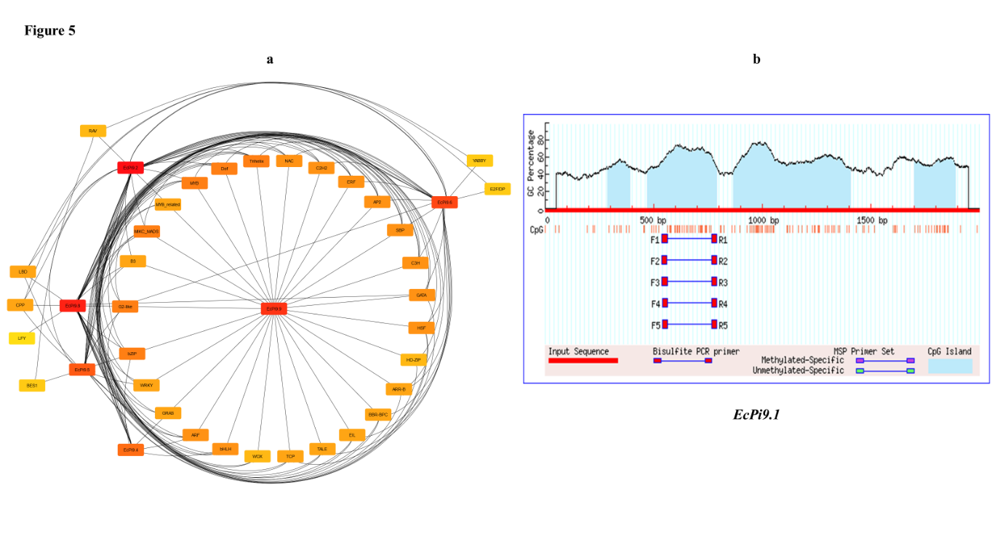
Figure 5- a) Network showing Tfs predicted for EcPi9 genes. b) graph showing methylated regions in the promoter region of EcPi9.1 gene where blue colour indicates CpG islands.
Tables:
Table 1- Gene Characters of EcPi9 Homologs Selected.
Transcript ID | EcPi9 Gene name | Exon/Intron | Chromosome | Start | End | Strand | Localization
ELECO.r07.7BG0584070 | EcPi9.1 | 2/1 | 7B | 1029396 | 1032546 | reverse | Plasma Membrane
ELECO.r07.7AG0553020 | EcPi9.2 | 3/2 | 7A | 1038696 | 1044289 | reverse | Cytoplasm
ELECO.r07.7AG0553010 | EcPi9.3 | 4/3 | 7A | 1032958 | 1034146 | reverse | Chloroplast
ELECO.r07.6AG0517590 | EcPi9.4 | 1/0 | 6A | 11456404 | 11457292 | forward | Cytoplasm
ELECO.r07.6AG0517640 | EcPi9.5 | 1/0 | 6A | 11485862 | 11486756 | forward | Nucleus
ELECO.r07.6AG0517580 | EcPi9.6 | 2/1 | 6A | 11454737 | 11456197 | forward | Nucleus
ELECO.r07.6BG0469660 | EcPi9.7 | 3/2 | 6B | 11806582 | 11809196 | forward | Nucleus
ELECO.r07.7AG0553030 | EcPi9.8 | 6/5 | 7A | 1048662 | 1051960 | reverse | Cytoplasm
ELECO.r07.7BG0584080 | EcPi9.9 | 6/5 | 7B | 1039812 | 1043091 | reverse | Cytoplasm

Table 2- Details Regarding CpG Islands
Predicted.
S. No | Transcript ID | Gene name | Island | Start | End | Length
1 | ELECO.r07.7BG0584070 | EcPi9.1 | 1 | 287 | 393 | 107 bp
1 | ELECO.r07.7BG0584070 | EcPi9.1 | 2 | 472 | 791 | 320 bp
1 | ELECO.r07.7BG0584070 | EcPi9.1 | 3 | 867 | 1048 | 542 bp
1 | ELECO.r07.7BG0584070 | EcPi9.1 | 4 | 1700 | 1892 | 193 bp
2 | ELECO.r07.7AG0553020 | EcPi9.2 | 1 | 447 | 618 | 172 bp
2 | ELECO.r07.7AG0553020 | EcPi9.2 | 2 | 1180 | 1439 | 260 bp
2 | ELECO.r07.7AG0553020 | EcPi9.2 | 3 | 1661 | 1875 | 215 bp
3 | ELECO.r07.7AG0553010 | EcPi9.3 | 1 | 47 | 306 | 260 bp
3 | ELECO.r07.7AG0553010 | EcPi9.3 | 2 | 699 | 1174 | 476 bp
3 | ELECO.r07.7AG0553010 | EcPi9.3 | 3 | 1339 | 1536 | 198 bp
3 | ELECO.r07.7AG0553010 | EcPi9.3 | 4 | 1627 | 1775 | 149 bp
4 | ELECO.r07.6AG0517590 | EcPi9.4 | 1 | 203 | 574 | 372 bp
5 | ELECO.r07.6AG0517640 | EcPi9.5 | 1 | 600 | 710 | 111 bp
6 | ELECO.r07.6AG0517580 | EcPi9.6 | 0 | No CpG Islands found
7 | ELECO.r07.6BG0469660 | EcPi9.7 | 0
8 | ELECO.r07.7AG0553030 | EcPi9.8 | 1 | 1653 | 1896 | 244 bp
9 | ELECO.r07.7BG0584080 | EcPi9.9 | 1 | 1661 | 1895 | 235 bp

Table 3- Protein Parameters of EcPi9 Transcripts.
Gene | No. of a.a's | Molecular Weight | PI | GRAVY
EcPi9.1 | 984 | 111008 | 8.61 | -0.182
EcPi9.2 | 293 | 33408.7 | 8.79 | -0.365
EcPi9.3 | 220 | 25088.9 | 6.01 | -0.26
EcPi9.4 | 295 | 33407.1 | 8.7 | -0.002
EcPi9.5 | 297 | 33882.6 | 8.24 | -0.332
EcPi9.6 | 261 | 29339.7 | 7.6 | -0.317
EcPi9.7 | 303 | 34010.9 | 7.6 | -0.36
EcPi9.8 | 369 | 42388.3 | 6.13 | -0.293
EcPi9.9 | 359 | 41393.1 | 7.75 | -0.383
Table 4- 2D Structure Prediction Results.
Gene | Sequence Length | Alpha Helix % | Extended Strand % | Beta Turn % | Random Coil %
EcPi9.1 | 984 | 55.39 | 9.04 | 0 | 35.57
EcPi9.2 | 293 | 66.53 | 8.53 | 0 | 29.91
EcPi9.3 | 220 | 63.18 | 11.36 | 0 | 25.45
EcPi9.4 | 295 | 51.19 | 9.83 | 0 | 38.98
EcPi9.5 | 297 | 52.86 | 10.1 | 0 | 37.04
EcPi9.6 | 261 | 67.82 | 8.05 | 0 | 24.14
EcPi9.7 | 303 | 67.33 | 8.25 | 0 | 24.42
EcPi9.8 | 369 | 73.44 | 4.88 | 0 | 21.68
EcPi9.9 | 359 | 67.97 | 3.06 | 0 | 28.97

Table 5- 3D Structure Prediction and Their Description.
Gene | Template | % Identity | Description
EcPi9.1 | A0A5J9TPM6.1.A | 71.35% | NB-ARC domain-containing protein
EcPi9.2 | A0A453QFD7.1.A | 70.07% | Disease resistance protein RPM1
EcPi9.3 | A0A5J9TPR9.1.A | 74.77% | NB-ARC domain-containing protein
EcPi9.4 | Q5VN81.1.A | 70.51% | Pathogen interacting protein from rice
EcPi9.5 | 9fyc.1.A | 42.06% | CSEP0372 putative effector protein
EcPi9.6 | A0A6G1CY30.1.A | 80.77% | AAA+ ATPase domain-containing protein
EcPi9.7 | A0A6G1CY30.1.A | 81.88% | AAA+ ATPase domain-containing protein
EcPi9.8 | A0A4U6UYJ6.1.A | 73.10% | AAA+ ATPase domain-containing protein
EcPi9.9 | A0A4U6UYJ6.1.A | 71.57% | AAA+ ATPase domain-containing protein

Table 6- Gene Ontology Studies of EcPi9 Genes.
Gene | Biological Process | Molecular Function | Cellular Component | Description
EcPi9.1 | GO:0006952 | GO:0043531 | GO:0016020 | NBS-LRR type R protein Pizh-1
EcPi9.2 | GO:0006952 | GO:0043531 | - | Rx N-terminal domain-containing protein
EcPi9.3 | - | - | - | Uncharacterized protein
EcPi9.4 | GO:0006952 | GO:0043531 | - | NB-ARC domain-containing protein
EcPi9.5 | GO:0098542 | GO:0043531 | - | NB-ARC domain-containing protein
EcPi9.6 | GO:0006952 | GO:0043531 | - | Disease resistance N-terminal domain-containing protein (Fragment)
EcPi9.7 | GO:0006952 | GO:0043531 | - | AAA+ ATPase domain-containing protein
EcPi9.8 | - | - | - | Uncharacterized protein
EcPi9.9 | - | - | - | Uncharacterized protein

References –
Afzal, M., Alghamdi, S. S., Nawaz, H., Migdadi, H. H., Altaf, M., El-Harty, E., ... & Sohaib, M. (2022). Genome-wide identification and expression analysis of CC-NB-ARC-LRR (NB-ARC) disease-resistant family members from soybean (Glycine max L.) reveal their response to biotic stress. Journal of King Saud University-Science, 34(2), 101758.
Bailey, T. L., Bodén, M., Whitington, T., &Machanick, P. (2010). The value of position-specific priors in motif discovery using MEME. BMC bioinformatics, 11, 1-14.
Balamurugan, A., Mallikarjuna, M. G., Bansal, S., Nayaka, S. C., Rajashekara, H., Chellapilla, T. S., & Prakash, G. (2024). Genome-wide identification and characterization of NBLRR genes in finger millet (Eleusine coracana L.) and their expression in response to Magnaporthe grisea infection. BMC Plant Biology, 24(1), 75.
Cannon, S. B., Mitra, A., Baumgarten, A., Young, N. D., & May, G. (2004). The roles of segmental and tandem gene duplication in the evolution of large gene families in Arabidopsis thaliana. BMC plant biology, 4, 1-21.
Chen, Q., Hu, Y., Shen, W., & Zhang, A. (2025). Evaluation of Rice Blast Resistance and R Gene Analysis in Japonica Rice Varieties Tested in the Anhui Region. Agronomy, 15(5), 1008.
Cho, Y. C., Kwon, S. W., Choi, I. S., Lee, S. K., Jeon, J. S., Oh, M. K., ... & Kim, Y. G. (2007). Identification of major blast resistance genes in Korean rice varieties (Oryza sativa L.) using molecular markers. Journal of crop science and biotechnology, 10(4), 265-276.
Fernandez, J., & Orth, K. (2018). Rise of a cereal killer: the biology of Magnaporthe oryzae biotrophic growth. Trends in microbiology, 26(7), 582-597.
Huang, H., Huang, C., Fang, Q., Wu, Y., Kuang, Y., Zhang, J., ... & Peng, D. (2025). Novel Design of Pyrazolyl-Containing Monoterpene Compounds to Enhance Antifungal Efficacy Against Rhizoctonia solani. Journal of Agricultural and Food Chemistry.
Jain, P., Singh, P. K., Kapoor, R., Khanna, A., Solanke, A. U., Krishnan, S. G., ... & Sharma, T. R. (2017). Understanding host-pathogen interactions with expression profiling of NILs carrying rice-blast resistance Pi9 gene. Frontiers in Plant Science, 8, 93.
Kumar, A., Mishra, P., Baskaran, K., Shukla, A. K., Shasany, A. K., & Sundaresan, V. (2016). Higher efficiency of ISSR markers over plastid psbA‐trnH region in resolving taxonomical status of genus Ocimum L. Ecology and evolution, 6(21), 7671-7682.
Li, L. C., & Dahiya, R. (2002). MethPrimer: designing primers for methylation PCRs. Bioinformatics, 18(11), 1427-1431.
Li, W., Chern, M., Yin, J., Wang, J., & Chen, X. (2019). Recent advances in broad-spectrum resistance to the rice blast disease. Current opinion in plant biology, 50, 114-120.
Liu, M., Zhang, S., Hu, J., Sun, W., Padilla, J., He, Y., ... & Zhang, Z. (2019). Phosphorylation-guarded light-harvesting complex II contributes to broad-spectrum blast resistance in rice. Proceedings of the National Academy of Sciences, 116(35), 17572-17577
Lu, L., Wang, Q., Shi, Z., Li, C., Guo, Z., & Li, J. (2023). Emergence of rice blast AVR-Pi9 resistance breaking haplotypes in Yunnan province, China. Life, 13(6), 1320.
Lyons, E., & Freeling, M. (2008). How to usefully compare homologous plant genes and chromosomes as DNA sequences. The Plant Journal, 53(4), 661-673.
Martin, G. B., Bogdanove, A. J., & Sessa, G. (2003). Understanding the functions of plant disease resistance proteins. Annual review of plant biology, 54(1), 23-61.
Nagaraja, T. E., Bhat, S., & Nandini, C. (2025). Current Scenario of Crop Improvement of Finger Millet [Eleusine coracana (L.)] in India: A Review. Agricultural Reviews, 46(1).
Navya HM, Karibasappa, Jahanara K, Tathagath W, Prabhurajeshwar (2023) Bioagents for the Management of Blast Disease of Finger Millet (Eleusine coracana): A Brief Review. Agricultural Reviews. https://doi.org/doi 10.18805/ag.R-2633
Nayaka, S. C., Hosahatti, R., Prakash, G., Satyavathi, C. T., & Sharma, R. (Eds.). (2021). Blast Disease of Cereal Crops. Fungal Biology. doi:10.1007/978-3-030-60585-8
Nguyen-Ngoc, H., Nguyen, C. Q., Vo, K. A. T., Nguyen, T. T. T., Nghiem, D. T., Ha, N. T., ... & Le Dang, Q. (2023). Insight into the role of phytoalexin naringenin and phytohormone abscisic acid in defense against phytopathogens Phytophthora infestans and Magnaporthe oryzae: In vitro and in silico approaches. Physiological and Molecular Plant Pathology, 127, 102123.
Pedrozo, R., Osakina, A., Huang, Y., Nicolli, C. P., Wang, L., & Jia, Y. (2025). Status on Genetic Resistance to Rice Blast Disease in the Post-Genomic Era. Plants, 14(5), 807.
Qian, L. H., Wang, Y., Chen, M., Liu, J., Lu, R. S., Zou, X., ... & Zhang, Y. M. (2021). Genome-wide identification and evolutionary analysis of NBS-LRR genes from Secale cereale. Frontiers in Genetics, 12, 771814.
Saxena, H., Murugaiyan, V., Ghimire, B., Robiso, C. J., De Asis, E. J., Yanoria, M. J., ... & Ali, J. (2025). Unravelling Candidate Genes Associated With Blast Disease Resistance in an Elite Green Super Rice Varietal Panel Using Genome‐Wide Association Study. Plant Pathology.
Shi, X., Xiong, Y., Zhang, K., Zhang, Y., Zhang, J., Zhang, L., ... & Liu, W. (2023). The ANIP1-OsWRKY62 module regulates both basal defense and Pi9-mediated immunity against Magnaporthe oryzae in rice. Molecular plant, 16(4), 739-755.
Singh, K., Gupta, R., Shokat, S., Iqbal, N., Kocsy, G., Pérez‐Pérez, J. M., &Riyazuddin, R. (2024). Ascorbate, plant hormones and their interactions during plant responses to biotic stress. Physiologia Plantarum, 176(4), e14388.
Sinha, P., Kumar T, D., Sk, H., Solanki, M., Gokulan, C. G., Das, A., ... & Sundaram, R. M. (2023). Fine mapping and sequence analysis reveal a promising candidate gene encoding a novel NB-ARC domain derived from wild rice (Oryza officinalis) that confers bacterial blight resistance. Frontiers in Plant Science, 14, 1173063.
Sood, S., Babu, K., Joshi, D. C., &Pattanyak, A. (2024). Allele Mining for Key Traits in Finger Millet. In Allele Mining for Genomic Designing of Cereal Crops (pp. 239-250). CRC Press.
Soujanya, T., Madamsetty, S. P., Hemalatha, V., KN, Y., Bandela, E., AS, H. P., ... &Ponnuswamy, R. (2023). Improving hybrid rice parental lines for blast resistance by introgression of broad‐spectrum resistance genes Pi54 and Pi9 by marker‐assisted selection. Plant Breeding, 142(3), 300-311.
Takan, J. P., Chipili, J., Muthumeenakshi, S., Talbot, N. J., Manyasa, E. O., Bandyopadhyay, R., ... &Sreenivasaprasad, S. (2012). Magnaporthe oryzae populations adapted to finger millet and rice exhibit distinctive patterns of genetic diversity, sexuality and host interaction. Molecular biotechnology, 50, 145-158.
Tang, L., Song, J., Cui, Y., Fan, H., & Wang, J. (2024). Detection and Evaluation of Blast Resistance Genes in Backbone Indica Rice Varieties from South China. Plants, 13(15), 2134.
Tian, D., Guo, X., Zhang, Z., Wang, M., & Wang, F. (2019). Improving blast resistance of the rice restorer line, Hui 316, by introducing Pi9 or Pi2 with marker-assisted selection. Biotechnology & Biotechnological Equipment, 33(1), 1195-1203.
Zhai, K., Liang, D. I., Li, H., Jiao, F., Yan, B., Liu, J., ... & He, Z. (2022). NLRs guard metabolism to coordinate pattern-and effector-triggered immunity. Nature, 601(7892), 245-251.

Supplementary material
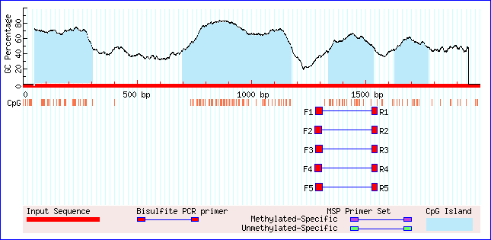
Figure 1: CpG Islands
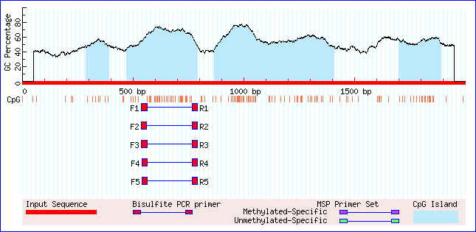
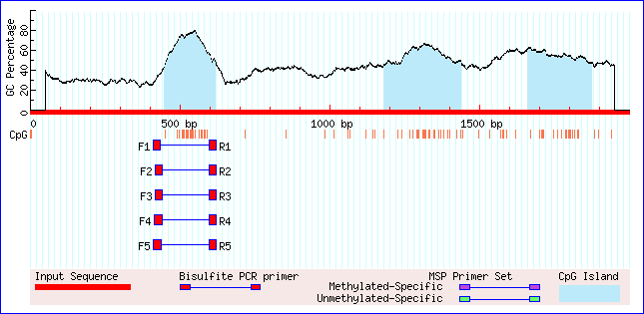
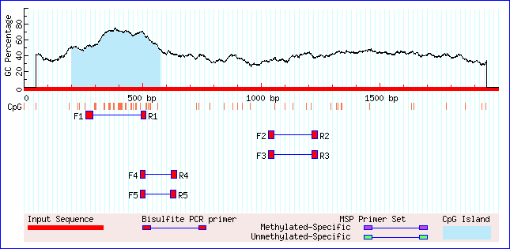
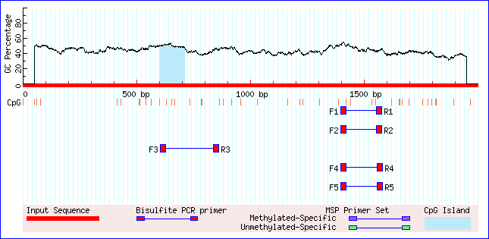
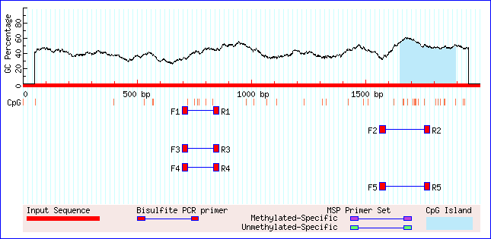
EcPi9.1 EcPi9.2 EcPi9.3
EcPi9.4 EcPi9.5 EcPi9.8

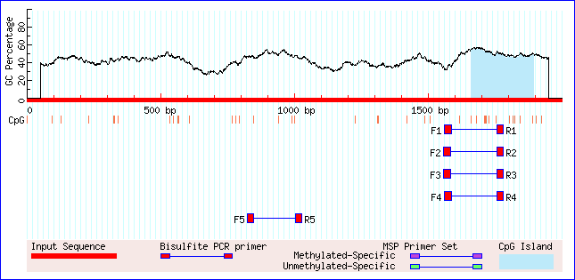

EcPi9.9

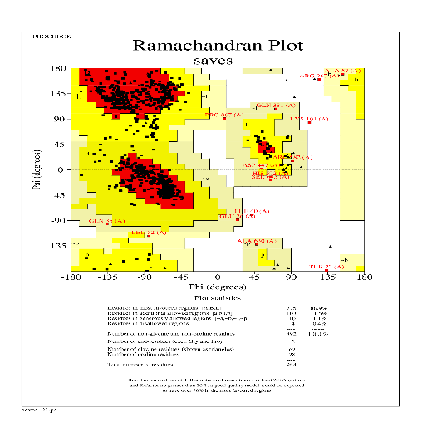
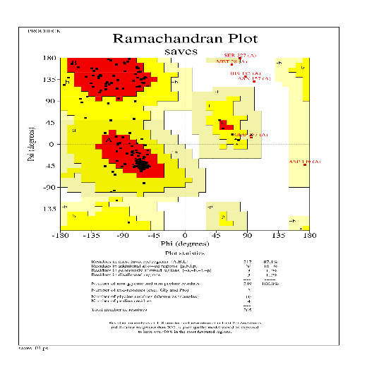
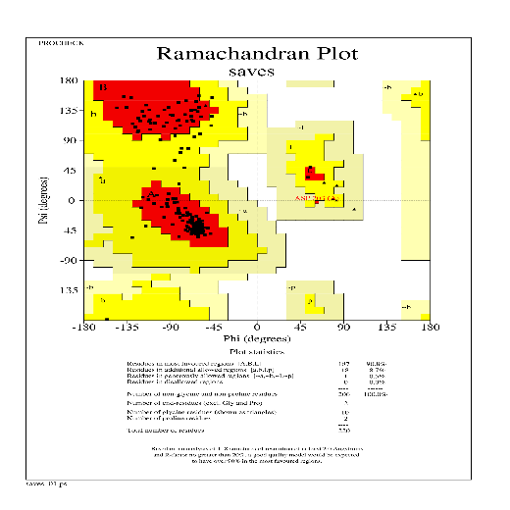
Figure 2- Ramachandran plots
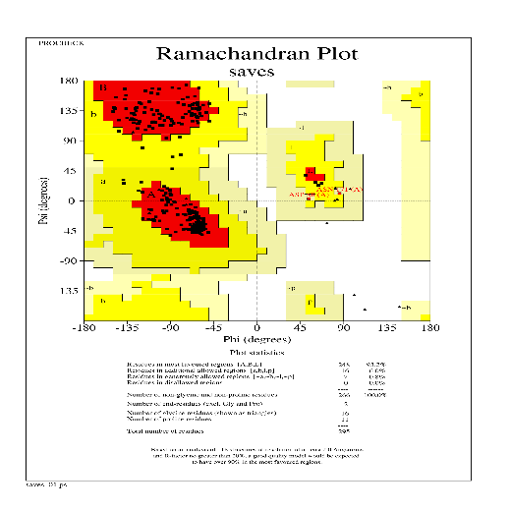
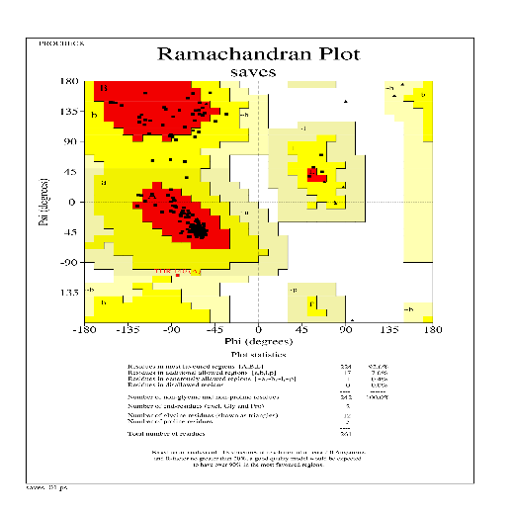
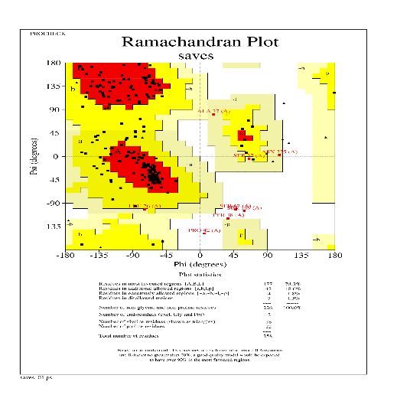
EcPi9.1 EcPi9.2 EcPi9.3
EcPi9.4 EcPi9.5 EcPi9.6
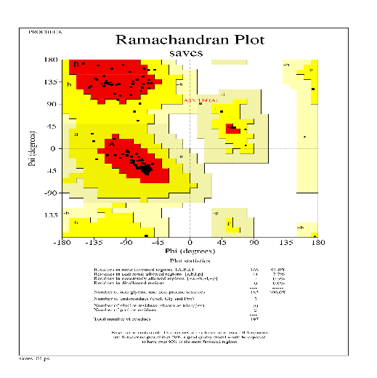
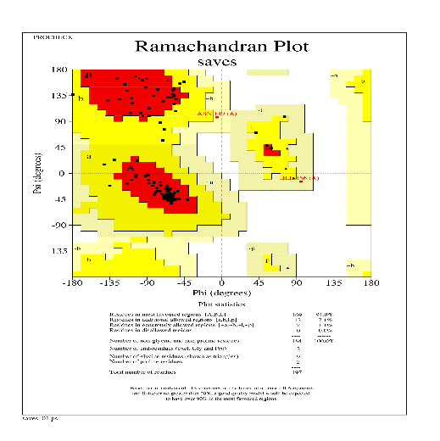
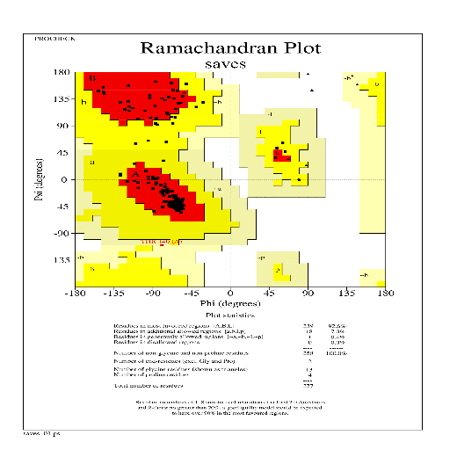
EcPi9.7 EcPi9.8 EcPi9.9

Table 1- Web servers or tools or databases used in materials and methods.

Abbreviations
NBS-LRR | Nucleotide-Binding Site Leucine-Rich Repeat
PTI | Pattern Triggered Immunity
coiled-coil group (CNL) | CC-NBS-LRR protein
NB LRR | Nucleotide Binding, Leucine Rich Repeats
CDS | Coding DNA sequence
PI | Isoelectric Point
NB ARC | Nucleotide-binding domain, Apaf-1, R proteins, and Ced-4.
AAR | cis-acting element involved in the abscisic acid responsiveness
AI | cis-acting regulatory element essential for the anaerobic induction
AR | auxin-responsive element
CC | cis-acting regulatory element involved in circadian control
DSR | cis-acting element involved in defence and stress responsiveness
EE | cis-regulatory element involved in endosperm expression
GR | gibberellin-responsive element
LR | part of a conserved DNA module involved in light responsiveness
LTR | cis-acting element involved in low-temperature responsiveness
MeJAR | cis-acting regulatory element involved in the MeJA-responsiveness
ME | cis-acting regulatory element related to meristem expression
Meso | element involved in differentiation of the palisade mesophyll cells
MYBDI | MYB binding site involved in drought-inducibility
MYBHv1 | MYBHv1 binding site
SAR | cis-acting element involved in salicylic acid responsiveness
PB | protein binding site
WR | wound-responsive element
MYBLR | MYB binding site involved in light responsiveness
ASI | enhancer-like element involved in anoxic specific inducibility
ATBP-1 | binding site of AT-rich DNA binding protein (ATBP-1)

