Nutritional Status, Phytochemical Constituents and in-silico Study of Bioactive Compounds Isolated from Turmeric (Curcuma longa L.) Against Monosodium Glutamate

Abstract
Monosodium Glutamate (MSG) is a widely used flavor enhancer that contributes an umami taste to food. While MSG naturally occurs in some foods, its synthetic version has raised concerns due to potential toxic effects when consumed in excess. Chronic exposure may lead to increased lipid peroxidation, disrupted calcium homeostasis, and reactive-oxygen species (ROS) formation, all of which contribute to inflammation and cellular damage. In contrast, Glutathione S-transferases (GSTs) are essential detoxification enzymes that conjugate glutathione to various electrophilic compounds, mitigating cellular damage from both endogenous and exogenous toxicants. Amid rising concerns over synthetic additives, natural alternatives like spices have attracted attention for their therapeutic benefits. Turmeric (Curcuma longa L.) is a culinary spice that has been used for thousands of decades for the prevention and treatment of various diseases. It is specifically used as a food preservative, coloring material, and aromatic stimulant. Turmeric has been used to manage and also treat several common diseases including inflamed tissues, viral infections such as cough, catarrh, diabetic injuries, liver disorders, and rheumatism. This study sought to investigate the proximate composition, mineral content, phytochemical and bioactive compound profile of Turmeric using HPLC-UV spectroscopy. Computational studies including molecular docking, induced-fit docking, MM/GBSA calculations, and ADMET profiling, were employed to evaluate the interaction between Turmeric bioactive compounds and GSTs. The findings suggest that turmeric is embedded with a lot of minerals, phytochemicals, flavonoids, polyphenol amongst many others. These natural compounds might modulate GST activity, offering potential protective effects and could significantly impact human health.
Keywords: Proximate composition, Glutathione S-transferases, Reactive-oxygen species, Phenolic compounds, Computational studies, Binding affinity.

1.0 Introduction
Since ancient times, Human beings used plants as a cure for diseases. Plant metabolites have been used in many ways including human therapy, veterinary, agriculture, scientific research, and many other fields. About 80% of people in developing nations use traditional medicine, which is based on medicinal plants, to obtain potentially effective and potent medications, according to the World Health Organization (WHO) (Chanda & Ramachandra 2019). Spice is a class of plants that represent the medicinal effect. They are mostly aromatic compounds found useful in a wide array of fields such as traditional medicine, food preservatives, industries, and so on (Evuen et al., 2022). Over time, there has been an increase in the research on dietary minerals as a result of their utmost importance in preventing disease and with notable developments in the field of mineral research (Evuen et al., 2022). Curcuma longa is a rhizomatous herbaceous perennial plant that belongs to the Zingiberaceae family. It belongs to the class Liliopsdia, Genus Curcuma, and species C. longa. Its botanical name was derived from Kirkum a Persian word 21 meaning Saffron because both saffron and turmeric have a bright yellow color. Its powder is used for the treatment of cough, liver disorders, abdominal disorders, and anorexia (Razzaq et al., 2020). It also promotes blood circulation, alleviates depression, and serves as a natural flavoring agent that strongly affects food’s color, and taste (Kocaadam, & Şanlier, 2017). It was reported that the oral intake of C. longa powder aids digestion and also reported using extracts from the rhizome as a condiment for cooking (Iweala, et al., 2023). Furthermore, several studies have shown that C. longa and its bioactive compounds possess numerous pharmacological activities such as antioxidant, hepatoprotective, anti-osteoarthritis, anti-inflammatory, anticancer, anti-arthritic, neuroprotective, antidiabetic, antidiarrheal activity, anti-microbial, anti-atherosclerotic, antidepressant, anti-aging, wound healing, and memory enhancing activities. The use of Turmeric in traditional medicine is supported by the presence of 22 more than 300 biologically active components such as polyphenols, sesquiterpenes, diterpenes, triterpenoids, sterols, and alkaloids (Iweala, et al., 2023). Turmeric powder has recently been utilized as a traditional remedy for gastrointestinal disorders, particularly those related to the liver and biliary system, diabetic wounds, rheumatism, inflammation, sinusitis, anorexia, coryza, cough, and digestive disorders.
Anticancer, antidiabetic, antioxidant, hypolipidemic, anti-inflammatory, antimicrobial, anti-fertility, anti-venom, hepatoprotective, nephroprotective, anticoagulant, and anti-HIV activity are some of the ways that turmeric helps fight AIDS (Chanda & Ramachandra 2019). As the global trend towards organic production continues, plants remain the most effective and safest bio-reserve of feed supplements that, if thoroughly investigated, will aid in preventing the issues of adverse effects linked to the frequent use of synthetic medication (Olayinka, 2024). Hence, this study highlighted the proximate and nutritional analysis, the phytochemical constituents, mineral contents, and most importantly the bioactive component extracted from the dried rhizome of the plant.
2.0 Materials and Methods
2.1 Materials
Turmeric (Curcuma longa was procured from Oja-Oba, Akure, Ondo state, Nigeria. Authentication of the plant sample was carried out at the Herbarium of The Federal University of Technology, Akure, (FUTA), Nigeria, with Authentication Number: 0429. About fifty sticks of turmeric were thoroughly washed, air-dried, ground into powder and was kept at temperature of 4 °C for further analysis. Reagents such as Folin-Denis, sodium tungstate, phosphomolybdic acid, orthophosphoric acid, and sodium carbonate, were purchased from Sigma Chemical Co. (St. Louis, MO, USA) and Sigma-Aldrich (Stein-heim, Germany). All other chemicals and reagents used were of analytical grades and the water used was glass-distilled.
2.2 Methods
2.2.1 Determination of nutritional composition and phytochemical profiles of Curcumi longa

- Proximate composition: The proximate composition (ash, fat, protein, carbohydrate, moisture and crude fiber) was determined according to standard method (AOAC, 1990).
- Mineral composition: Minerals (Na, Ca, P, Fe, Mg, Cu and Zn) was determined in aliquots of ash solution by established flame atomic absorption spectrophotometry procedures using a Perkin-Elmer atomic absorption spectrophotometer (model 372) (AOAC, 1990)).
- Tannin content: Tannin was determined using a previously reported method of Adeseko et al. (2022) with a little modification. One gram of turmeric powder was measured into a 50 mL beaker and 2 mL of 50% methanol will be added and covered with paraffin, then placed in a water bath at 77-80° C for 1 hour. It was thoroughly shaken to ensure a uniform mixing. The extract used a double layered Whatman No 4 filter paper in to a 100 mL volumetric flask. The absorbance of the Tannic acid standard solution as well as the tumeric was read after colour development on a UV spectrophotometer at 760 nm.
- Saponin content: Saponin content was determined with a little modification as reported by Adeseko et al. (2022). About 1 g of the turmeric powder was measured into 250 mL beaker and 100 mL of isobutyl alcohol was added. The absorbance of the samples as well as standard solutions was read in a UV V6300 spectrophotometer at 380 nm.
- Phytate content: Phytate was determined as described by Adeseko et al. (2022). Briefly, 2 g of the turmeric powder was measured into 250 mL conical flask. Hydrochloric acid (2% applied at 100 mL) was added to sample in the conical flask for 3 hours then filtered through a double layer hardened filter paper. Each filtrate (50 mL) was placed in 250 mL conical flask and 100 mL of distilled water was added. This was titrated with standard iron (III) chloride solution which contained 0.00195 g iron per mL.
- Total Flavonoid content (TFC): The TFC of the samples was determined using a colorimeter assay (Adeseko et al., 2022). Turmeric powder (0.2 g) was added to 0.3 mL of 5% NaNO₂ and after 5 min, 0.6 mL of 10% AlCl₃ was also added. This was followed by the addition of 2 mL of 1 M NaOH. Then, after 6 min, 2.1 mL of distilled water was added. The absorbance of the mixture was read at 510 nm against the blank reagent. QUE (0-240 mg/mL) was used to generate a standard curve and the flavonoid content of the Turmeric was expressed as mg Quercertin equivalent
2.2.2 Identification and quantification of phenolic compounds in Curcumi longa
The phenolic composition of Turmeric powder was analyzed using an ultra-high performance liquid chromatography system equipped with a Hybrid Quadrupole-TOF mass spectrometer with an ESI source (UHPLC-ESI-QTOF-MS/MS) (Adeseko et al., 2022). UHPLC separations were performed on appropriate column (e.g., Shim-pack GIST C18 column (2.1 × 75 mm, 2 μm) and the column temperature was maintained at 35 ℃. Samples were injected at 5 μL with flow rate of 0.3 mL/min. The composition of mobile phase was 0.1% formic acid in water (A) and acetonitrile (B). The gradient elution process was conducted as follows: 0 min, 3% B; 5 min, 8% B; 6 min, 20% B; 20 min, 35% B; 23 min, 50% B; 24–26 min, 100% B; and 26–30 min, 3% B. The electrospray ionization mass spectrum was performed by QTOF-MS/MS at negative ionization mode with an ESI source. Other necessary parameters - scanning range (80 – 1500), collision energies (−40 ± 20 eV), electrospray voltage (−4500 V) and the temperature of ion source (550 ℃) was set. The identified compounds were compared with MassBank, ChemSpider, and literatures. Major phenolics including quercetin, kaempferol, hydroxybenzoic acid, turmerone, luteolin, caffeic acid, procatechuic acid, gallic acid, coumaric acid, ferulic acid and vanillic acid were also quantified.
The structures of the identified polyphenol were built for in silico studies using ChemSketch and optimized into 3D with MMFF94 force field and docked with AutodockVina algorithm into crystal structure of PPO. The PPO-polyphenol complex was subjected to molecular dynamics simulation to provide insight into the binding modes of PPO with polyphenol. For in silico study, Pymol was used to visualize the PPO while Liglot was used to analyse the PPO-polyphenol binding interaction.

2.2.3 Statistical Analysis

Data obtained from this study were subjected to analysis of variance (ANOVA) using the statistical package (SPSS 21.0). Results were expressed as Mean ± S.E.M. of three replicate determinations. Mean values of various groups were significantly compared by Tukey’s Multiple Range Test and a probability of p<0.05 was considered significant.
3.0 Results and Discussion
3.1 Proximate and mineral composition of Curcuma longa
Table 1 revealed the proximate composition of the sample (turmeric powder). The carbohydrate, crude fiber, and moisture content were significantly higher than the rest of the composition. The crude ash content has the lowest level of the proximate composition.
Table 1: Proximate composition of the sample (Turmeric powder)
Parameters | Turmeric
Protein (%) | 9.18 ± 0.48
Moisture (%) | 11.01 ± 0.01
Fat (%) | 7.57 ± 0.94
Fibre (%) | 12.57 ± 0.10
Ash (%) | 5.66 ± 0.49
CHO (%) | 54.02 ± 1.07
Data represent the mean± standard deviation of replicate readings (n =3).
As presented in Table 1, the proximate analysis displayed the results for crude fat, crude ash, moisture, protein, and carbohydrate. This is similar to the work of Olayinka (2023) who reported that turmeric is a good protein and carbohydrate source. The fiber content can contribute to the prevention of excess cholesterol absorption and cleanse the digestive tract of humans. This agrees with the report of Ikpeama et al., (2014), that fiber is known to prevent against metabolic condition called hypercholesterolemia (Olayinka, 2023). The high moisture content indicates that turmeric will take longer to dry and it is easily subjected to microbes hence, it is difficult to preserve when fresh. The proximate result compared well with the work of Abara et al (2021); and Ahaotu and Lawal (2019) on the Determination of proximate and minerals content of Turmeric (C. longa Linn) leaves and rhizomes.
3.2 Mineral Constituent of Curcuma longa
The micro-elements (P, Na, Mg, and Ca) are represented in mg/100 g. The level of phosphorous is significantly higher than the rest of the micro-elements. Similarly, Iron (Fe) displayed the highest level of macro-elements (Cu, Zn, and Fe) which are represented in parts per million.
Since spices are known to include essential nutrients needed for the development and maintenance of many bodily physiological functions, a deficiency in these nutrients can result in several diseased conditions. In this present study, phosphorus displayed the highest level among the elements followed by sodium and then calcium.
Table 2: Mineral component of Curcuma longa
Parameter | Turmeric
P (mg/100g) | 100.34 ± 5.83
Na (mg/100g) | 31.58 ± 0.03
Mg (mg/100g) | 0.97 ± 0.02
Ca (mg/100g) | 2.95 ± 0.07
Cu (ppm) | 0.54 ± 0.00
Zn (ppm) | 1.04 ± 0.00
Fe (ppm) | 1.29 ± 0.00
Data represent the mean± standard deviation of replicate readings (n =3).
This aligns with Abara et al (2021) which indicates the distinctive activities of minerals in the body. Calcium is very crucial in blood clotting, neuronal function, muscle contraction, bone and teeth formation, or repairs. Potassium regulates the blood pressure and heart rate. Phosphorous, which is the most abundant of the elements plays an important role in the maintenance of healthy bones and teeth. It is also important as it is one of the constituents of the cell membrane (Sunmola et al., 2021). Higher phosphorous content in the sample can be attributed to the high phosphorous content of the soil or the high pH of the soil. Iron is undoubtedly involved in the constitution of hemoglobin, myoglobin, and many other enzymes. They also help to prevent stunting and cardiomyopathy. The small amount of iron present in this study also aligns with Sunmola et al. (2021) and Oshomoh et al. (2016) who reported that it could be attributed to several factors including climate, geographical location, soil type, and so on (Sunmola et al., 2021).
3.3 Phytochemical constituents of Curcuma longa
The results of the quantitative phytochemical constituents of the C. longa powder are shown in Table 3. Saponin, and tannin are shown in mg/g. Saponin showed the highest level (212.70 ± 0.64) compared to others followed by tannin with 0.32 ± 0.02 mg/g. Similarly, flavonoid has 31.09 ± 1.20 mg/g in Quercetin equivalent and alkaloid has 17.90 ± 0.42 in percentage.
The phytochemical screening of Turmeric powder revealed the presence of alkaloids, flavonoids, tannins, and saponins. Saponins are the glycosidic compounds found in most plants, they give plants their unique bitter taste and foaming properties (Shad et al., 2013). Saponins have been reported to have anticholesterolemic, anticancer, and antidiabetic properties (Oboh et al., 2023). The high level of saponins in turmeric is similar to the report of Evuen et al (2022) in their comparative study on phytochemical constituents in culinary spices in Nigeria.
Table 3: Phytochemical constituents of Curcuma longa
Parameters | Turmeric
Alkaloid (%) | 17.90 ± 0.42
Saponin (mg/g) | 212.70 ± 0.64
Flavonoid (mg(QE)/g) | 31.09 ± 1.20
Tannin (mg/g) | 0.32 ± 0.02
Data represent the mean± standard deviation of replicate readings (n =3).
Tannin has been reported as an antimicrobial agent. It was also found that the development of many microorganisms can be hindered by tannins (Oluwafemi et al., 2022). Reports have also shown different physiological effects including anti-irritant effects, anti-parasitic, antimicrobial, and so on (Oluwafemi et al., 2022). Flavonoids have been reported to inhibit the initiation, promotion, and development of tumors and they are known for their antioxidant effects (Ezeonu & Ejikeme, 2016). Hence, the presence of flavonoids at high levels showed a promising antioxidant property and ability to scavenge free radicals. According to reports from several studies, alkaloids possess a wide range of biological properties including antibacterial, anticancer, and anti-hyperglycemic activities. Alkaloid-containing plants are known to evoke a bitter taste even though they are responsible for several metabolic activities (Ezeonu & Ejikeme, 2016).
3.4 Identification and Quantification Phenolic compounds in Curcuma longa by HPLC Analysis
The HPLC chromatogram of the methanol extract of C. longa displayed twenty peaks each representing their phenolic components (Figure 1). The properties of the various phenolic compounds in the extracts and the retention times of various constituent peaks in HPLC-UV spectra are highlighted in Table 4. Phenolic compounds at varying concentrations were detected and quantified in the extracts of C. longa. The predominant compounds include hydroxybezoic acid (31.10 mg/100g); protocatechuic acid (5.56 mg/100g); gallic acid (8.96 mg/100g); caffeic acid (8.92 mg/100g); ferulic acid (5.29 mg/100g), quercertin (155.16 mg/100 g), kaempferol (61.56 mg/100 g), zingerone (21.83 mg/100g), turmerone (12.45 mg/100 g), coumaric acid (11.23 mg/100 g), stigmasterol (10.61mg/100 g), beta-sitosterol (6.83 mg/100), luteolin (4.761 mg/100 g), beta-caryophyllene (8.56 mg/100g), beta-phyllandrene (2.917 mg/100g), 3-carene (4.64 mg/100 g), sabinene (4.631 mg/100 g) and vanillin (5.81 mg/100 g).
According to the report of Ajanaku et al (2022), zingerone is one of the high-potential therapeutic candidates for the treatment of various diseases including atherosclerosis, Parkinson’s disease, and Alzheimer's disease. It also can scavenge free radicals, reactive oxygen species, and other oxidants (Ajanaku et al., 2022). Terpenes identified from C. longa include sabinene, 3-carene, beta-phyllandrene, and beta-caryophyllene. Beta-caryophyllene has been reported to decrease the growth and proliferation rate of many cancerous cells, including ovarian cancer, lung cancer, and so on (Ahmed et al., 2021). Curcumin, one of the main bioactive compounds isolated from C. longa is reported to act as an anti-tumor through its interaction with nucleic acids. It possesses scavenging ability, anti-inflammatory properties, and anti-osteoarthritis. Curcumin and various curcuminoids also help in the treatment of several skin diseases and other wound-healing activities with their antioxidant, antimicrobial, and anti-inflammatory properties (Ajanaku et al., 2022). Other compounds isolated include sterols (stigmasterol and beta-sitosterol), flavonoids (quercetin, kaempferol, rhamnetin, luteolin), and sesquiterpenoid (tumerone).
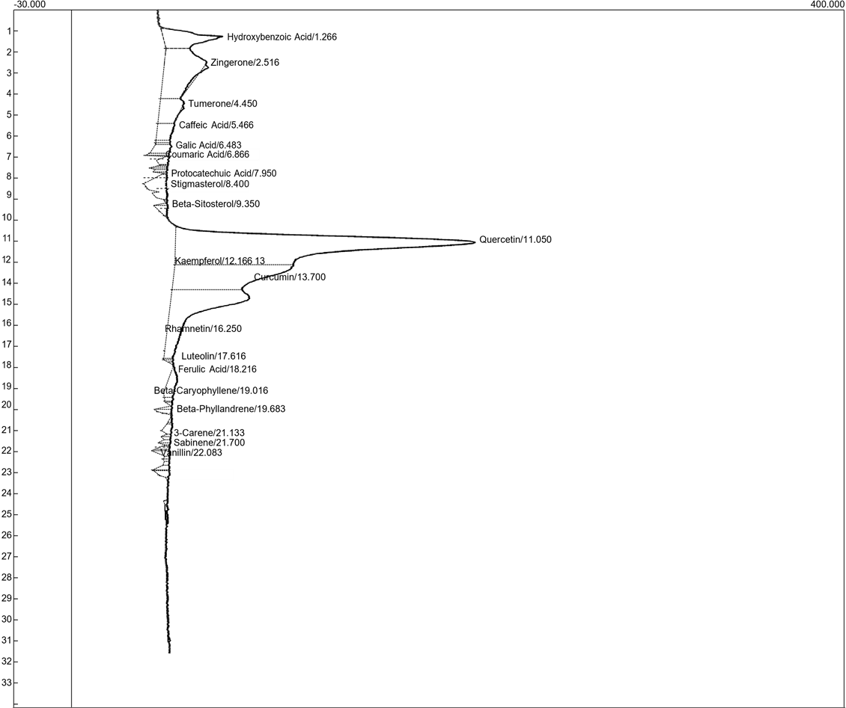
Figure 1: HPLC-UV spectra of Curcuma longa extract
Table 4: Retention times of constituent peaks in HPLC-UV spectra
Identified constituents | Retention | Area | Height
Hydroxybenzoic Acid | 1.266 | 1006.3250 | 31.097
Zingerone | 2.516 | 2326.4940 | 21.831
Tumerone | 4.450 | 753.2120 | 12.446
Caffeic Acid | 5.466 | 383.9290 | 8.918
Gallic Acid | 6.483 | 228.1960 | 8.958
Coumaric Acid | 6.866 | 66.9970 | 11.230
Protocatechuic Acid | 7.950 | 149.6685 | 5.555
Stigmasterol | 8.400 | 99.5050 | 10.609
Beta-Sitosterol | 9.350 | 94.1730 | 6.830
Quercetin | 11.050 | 8781.2405 | 155.164
Kaempferol | 12.166 | 3448.2800 | 61.556
Curcumin | 13.700 | 2986.4300 | 40.798
Rhamnetin | 16.250 | 110.2740 | 5.538
Luteolin | 17.616 | 279.6610 | 4.761
Ferulic Acid | 18.216 | 62.9375 | 5.294
Beta-Caryophyllene | 19.016 | 56.5055 | 8.553
Beta-Phyllandrene | 19.683 | 75.1425 | 2.917
3-Carene | 21.133 | 93.3760 | 4.642
Sabinene | 21.700 | 76.4970 | 4.631
Vanillin | 22.083 | 58.0310 | 5.805
Data represent the mean± standard deviation of replicate readings (n =3).
3.5 Binding affinity of the bioactive compound against Human glutathione transferase
The glide docking score of the bioactive compounds isolated from Curcuma longa targeted against Human glutathione S-transferase represented in Table 5 showed that curcumin, one of the main bioactive compounds has the highest binding affinity with -7.58 kcal/mol, followed by quercetin with -7.14 kcal/mol. Monosodium glutamate has the second to the lowest value of 3.48 kcal/mol. The first five compounds that displayed a good binding energy were subjected to induce-fit docking in which the result is shown in Table 6.
Table 5: Glide docking score of extracted bioactive compounds from Curcuma longa against Human glutathione S-transferase
S/N | PubChem ID | Compound name | Docking score (Kcal/mol)
 | 969516 | Curcumin | -7.58
 | 5280343 | Quercetin | -7.14
 | 5280863 | Kaempferol | -7.02
 | 5281691 | Rhamnetin | -7.02
 | 5280445 | Luteolin | -5.96
 | 72 | Protocatechuic Acid | -5.68
 | 54670067 | Ascorbic Acid | -5.65
 | 689043 | Caffeic Acid | -5.30
 | 46780424 | Galic Acid | -5.24
 | 31211 | Zingerone | -5.19
 | 135 | Hydroxybenzoic Acid | -4.90
 | 445858 | Ferulic Acid | -4.79
 | 5281515 | Beta-Caryophyllene | -4.54
 | 5280794 | Stigmasterol | -4.51
 | 1183 | Vanillin | -4.47
 | 323 | Coumaric Acid | -4.37
 | 558173 | Tumerone | -4.25
 | 18818 | Sabinene | -4.23
 | 26049 | 3-Carene | -4.05
 | 23672308 | Monosodium glutamate | -3.48
 | 222284 | Beta-Sitosterol | -3.39
Data represent the mean± standard deviation of replicate readings (n =3).

Table 6: Induce-fit docking score of the isolated compounds against Human glutathione S-transferase
S/N | Compound Name | IFDScore (Kcal/mol)
 | Luteolin. | -472.23
 | Rhamnetin. | -469.47
 | Curcumin. | -469.34
 | Quercetin. | -468.33
 | Kaempferol. | -466.39
Data represent the mean± standard deviation of replicate readings (n =3).
3.6 MM/GBSA ΔG free binding energies
Table 7 showed the ΔG free binding energies of the bioactive compounds against human glutathione S-transferase. The results are represented in dG Bind, dG Bind Lipo, dG Bind solvent, dG bind vdW. Curcumin showed the best result of the bioactive compounds.
Table 7: MM/GBSA ΔG free binding energies of bioactive compounds isolated from Curcuma longa against the target protein
S/N | Compound Name | MMGBSA dG Bind | MMGBSA dG Bind Hbond | MMGBSA dG Bind Lipo | MMGBSA dG Bind Solv GB | MMGBSA dG Bind vdW
 | Curcumin. | -64.02 | -2.55 | -16.06 | 25.31 | -36.97
 | Rhamnetin. | -48.56 | -1.9 | -10.6 | 22.19 | -30.91
 | Quercetin. | -47.94 | -1.89 | -10.3 | 22.31 | -30.24
 | Kaempferol. | -44.85 | -2.03 | -12.18 | 18.77 | -29.98
 | Luteolin. | -43.62 | -1.83 | -7.21 | 18.47 | -28.25
Data represent the mean± standard deviation of replicate readings (n =3).
3.7 ADMET Profiling of bioactive compounds
As represented in Table 8, the ADMET (Absorption, Distribution, Metabolism, Excretion, and Toxicity) which is crucial for evaluating safety and efficacy. After assessing the ADMET properties using the Rule of Five, most of the compound passed the rule of five indicating their safety and efficacy.
Table 8: ADMET profiling of the bioactive compounds
Compound Name | mol MW | Donor HB | Acceptor HB | QPlogPo/w | QPlogHERG | QPlogBB | QPlog Kp | QPlog Khsa | Percent Human Oral Absorption | Rule Of Five
Curcumin. | 368.385 | 2 | 7 | 2.803 | -6.267 | -2.248 | -3.007 | 0.001 | 82.392 | 0
Kaempferol. | 286.24 | 3 | 4.5 | 1.041 | -5.201 | -1.893 | -4.641 | -0.191 | 63.637 | 0
Luteolin. | 286.24 | 3 | 4.5 | 0.926 | -5.023 | -1.955 | -4.888 | -0.198 | 61.205 | 0
Quercetin. | 302.24 | 4 | 5.25 | 0.367 | -5.109 | -2.419 | -5.544 | -0.343 | 51.649 | 0
Rhamnetin. | 316.267 | 3 | 5.25 | 1.218 | -5.152 | -1.945 | -4.582 | -0.158 | 65.908 | 0

Molecular weight of the molecule (Range: 130.0–725.0)
Predicted octanol/water partition coefcient. (Range: − 2.0–6.5)
Number of hydrogen bond donors (Range: 0.0–6.0)
Number of hydrogen bond acceptors (Range: 2.0–20.0)
PSA: Van der Waals surface area of polar nitrogen and oxygen atoms. Range from 7.0 to 200.0
Number of violations of Lipinski’s rule of five (Range: maximum is 4)
QPlogKhsa: Prediction of binding to human serum albumin. Range from – 1.5 to +1.5
QPlogHERG: Predicted IC50 value for blockage of HERG K+ channels. Concern below –5
QPlogBB: Predicted brain/blood partition coefficient. Range from – 3.0 to 1.2
Molecular docking studies, Post docking analyses, and binding free energy
The molecular docking scores and the IFD scores for the bioactive compounds reveals their binding affinity and stability against human glutathione S-transferase. Curcumin, rhamnetin, quercetin, kaempferol, luteolin displaying the highest values in kcal/mol indicate their strong interactions with human GST at their active site, reflecting high binding affinity when compared to the control monosodium glutamate which has a very low binding affinity. The IFD method enables the receptor to change its binding pocket so that its conformation is more suitable and close to the ligand shape and binding mode (Elekofehinti et al., 2021). Unlike the glide score in which curcumin has the highest binding affinity, the result of IFD revealed that luteolin and rhamnetin displayed more favorable interaction with hGST with IFD scores of -472.23 kcal/mol and -469.67 kcal/mol respectively. To account for additional critical factors influencing the binding beyond glide docking and induce-fit docking, MM-GBSA calculations were conducted on the 5 hit compounds.
MM-GBSA analysis improves binding energy calculations' accuracy compared to molecular docking energies by using a more theoretically sound methodology instead of depending on empirical scoring functions that are frequently employed in molecular docking (Al Khzem et al.,2025). The five compounds exhibited binding free energy (dG_{Bind}) values ranging from 43.62 and -64.02 in kcal/mol. The results showed the significant contributions to the ligand-binding were non-polar salvation terms (ΔG_{lipo}), van der Waals (ΔG_{vdW}) and covalent energy (ΔG_{covalent}).

Molecular visualization
The 2D visualization of the protein-ligand interaction (Figure 2) showed the bonding interaction between the protein (GST) and the hit compounds. Curcumin (Figure 2A) has 4 H-bonds, two with TYR 212, ILE107, and 2 H-bond with VAL55, and also a pi-pi staking with PHE220. Quercetin (Figure 2B) also have H-bonds with THR68 and TYR212 but also include VAL55 and GLN54. Kaempferol (Figure 2C) has a pi-pi staking with PHE220 and 4 H-bond with amino acid residues TYR212, ILE107, THR68, and VAL216. Rhamnetin (Figure 2D) forms 4 hydrogen bonds with ILE107, TYR212, and VAL55, and GLN45. Luteolin (Figure 2E) forms 2 H-bond with GLY14, pi-cation with ARG15, and pi-pi stacking with PHE220. Overall, all hit compounds showed similar H-bond with ILE107, TYR212, and VAL55. All the hydrogen bonds react with amino acids in the GST active site.
ADMET Profiling
There are several rules that are employed to determine the drug likeness of compounds, with Lipinski Rule of Five (RO5) being the most popular. Lipinski Rule of Five state that for a compound to be considered a drug-like molecule, it must not violate more than one of the following criteria: molecular weight < 500 Da, octanol–water partition coefficient < 5, hydrogen bond donor ≤ 5, hydrogen bond acceptor ≤ 10 (Lipinski et al., 2012). From the result of this study (Table 8), all the compounds obeyed the rules. The physicochemical properties calculated by QikProp are shown in Table 8. The pharmacokinetic properties of the compounds were analyzed by predicting the binding to human serum albumin (QPlogKhsa), blood brain partition coefficient (QPlogBB), and percentage of Human Oral absorption. All compounds fall within the recommended range for molecular weight, predicted octanol-water partition coefficient, number of hydrogen bond donors and acceptors. All the hit compounds were within the recommended range for QPlogKhsa, QPlogBB and also in the range for the blockage of HERG K+ channels. The parameters that were considered include eye corrosion, carcinogenicity, eye irritation, micronuclear, hepatotoxicity, Ames mutagenesis, and PPAR gamma. The results from this study (Table 8) indicate that all the five hit compounds showed significant moderations for these parameters.

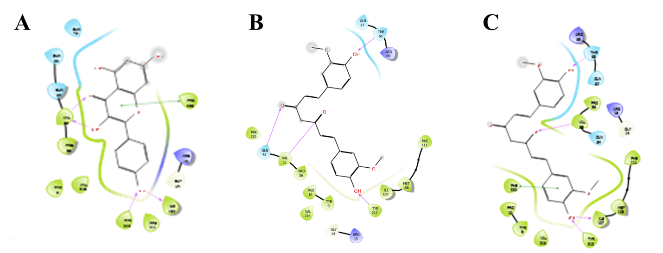
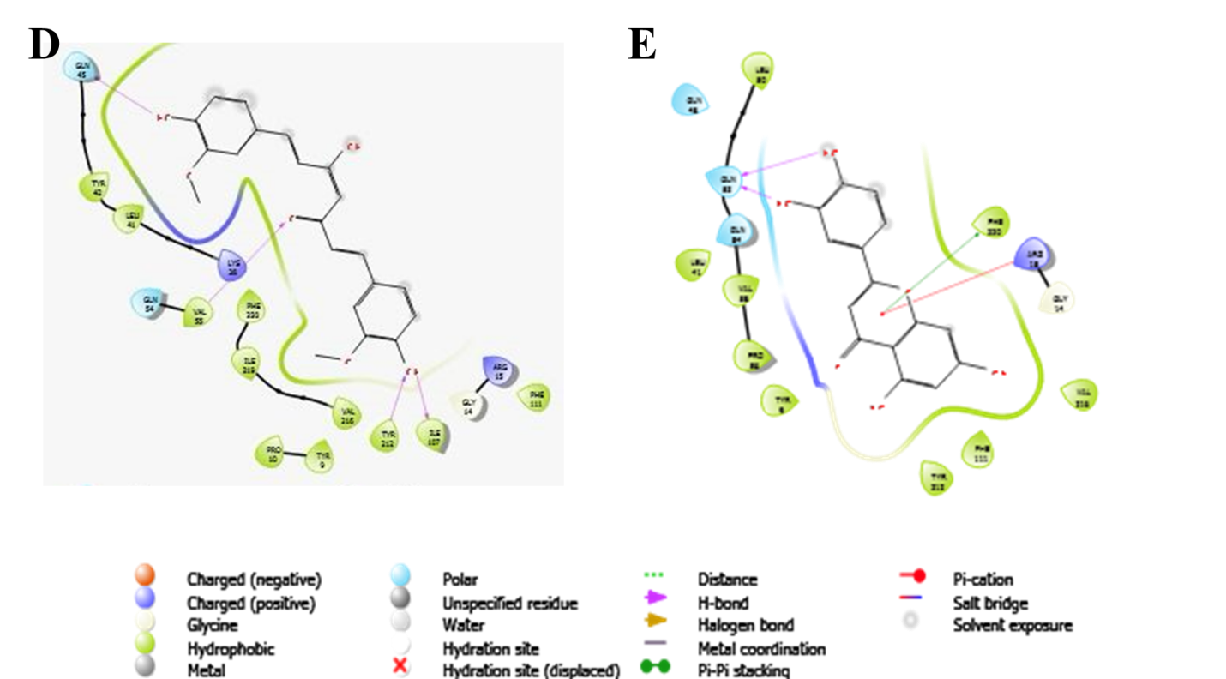
Figure 2: 2D visualization of Protein-ligand interactions of the five lead compounds using Ligand interaction wizard of Maestro v12.5. The ligands are represented in (A) Curcumin (B)
Conclusion
This study revealed the ethnomedicinal properties of C. longa that could be explored as pharmaceutical products. However, to broaden our horizon on the pharmacological and biological potency of this underutilized spice, there is a need for human clinical trials and quality control studies to establish effective and safe doses of C. longa and its major bioactive constituent-curcumin for prolonged use for managing/treating several degenerative diseases.

References
Abara, P. N., Adjeroh, L. A., Nwachukwu, M. O., & Osinomumu, I. D. (2021). Differentiation between two spices: Zingiber officinale (ginger) and Curcuma longa (turmeric); their proximate, mineral and vitamin contents. Journal of Scientific Research, 7(1), 17-24.
Ahaotu, E. O. & Lawal, M., (2019). Determination of proximate and minerals content of turmeric (Curcuma longa Linn) leaves and Rhizomes. Journal of Food, Nutrition, and Packaging, 6, 1-4.
Ahmed, E. A., Abu Zahra, H., Ammar, R. B., Mohamed, M. E., & Ibrahim, H. (2021). Beta-Caryophyllene Enhances the Anti-Tumor Activity of Cisplatin in Lung Cancer Cell Lines through Regulating Cell Cycle and Apoptosis Signaling Molecules. Molecules, 27(23), 8354. https://doi.org/10.3390/molecules27238354
Ajanaku, C.O., Ademosun, O.T., Atohengbe, P.O., Ajayi, S.O., Obafemi, Y.D., Owolabi, O.A., Akinduti, P.A. and Ajanaku, K.O., (2022). Functional bioactive compounds in ginger, turmeric, and garlic. Frontiers in nutrition, 9, p.1012023.
Al Khzem, A.H., Shoaib, T.H., Mukhtar, R.M., Alturki, M.S., Gomaa, M.S., Hussein, D., Tawfeeq, N., Bano, M., Sarafroz, M., Alzahrani, R. and Alghamdi, H., (2025). Repurposing FDA-Approved Agents to Develop a Prototype Helicobacter pylori Shikimate Kinase (HPSK) Inhibitor: A Computational Approach Using Virtual Screening, MM-GBSA Calculations, MD Simulations, and DFT Analysis. Pharmaceuticals, 18(2), p.174.
Albrahim, T., & Binobead, M. A. (2018). Roles of Moringa oleifera Leaf Extract in Improving the Impact of High Dietary Intake of Monosodium Glutamate-Induced Liver Toxicity, Oxidative Stress, Genotoxicity, DNA Damage, and PCNA Alterations in Male Rats. Oxidative medicine and cellular longevity, 2018, 4501097. https://doi.org/10.1155/2018/4501097
AOAC (1984). 14th edition. Association of Official Analytical Chemists, INC. 1111, North Nineteenth Street, Suite 210, Arlington, NA 22209, USA.
Association of Official Analytical Chemists (AOAC) Official Methods of Analysis 15th ed. (1990)
Bayram, H. M., Akgöz, H. F., Kızıldemir, Ö., & Öztürkcan, S. A. (2023). Monosodium glutamate: Review on preclinical and clinical reports. Biointerface Research in Applied Chemistry.
Chanda, S., & Ramachandra, T. V. (2019). Phytochemical and pharmacological importance of turmeric (Curcuma longa): A review. Research & Reviews: A Journal of Pharmacology, 9(1), 16-23.
Ejikeme, C., Ezeonu, C. S., & Eboatu, A. N. (2014). Determination of Physical and Phytochemical Constituents of some Tropical Timbers Indigenous to Niger-delta area of Nigeria. European Scientific Journal, 10(18), 247-270.
Elekofehinti, O. O., Iwaloye, O., Josiah, S. S., Lawal, A. O., Akinjiyan, M. O., & Ariyo, E. O. (2021). Molecular docking studies, molecular dynamics and ADME/tox reveal therapeutic potentials of STOCK1N-69160 against papain-like protease of SARS-CoV-2. Molecular Diversity, 25, 1761-1773.
Evuen, U. F., Okolie, N. P., & Apiamu, A. (2022). Evaluation of the mineral composition, phytochemical and proximate constituents of three culinary spices in Nigeria: a comparative study. Scientific Reports, 12(1), 20705.
Ezeonu, C. S., & Ejikeme, C. M. (2016). Qualitative and quantitative determination of phytochemical contents of indigenous Nigerian softwoods. New Journal of Science, 2016(1), 5601327.
Gottardo, F. M., da Silva, A. P. A., dos Santos, L. R., Colla, L. M., & Reinehr, C. O. (2022). Use of monosodium glutamate in foods: the good, the bad, and the controversial side. ABCS Health Sciences, 47, e022305-e022305.
Ikpeama, A., Onwuka, G. I., & Nwankwo, C. (2014). Nutritional composition of Tumeric (Curcuma longa) and its antimicrobial properties. International Journal of Scientific and Engineering Research, 5(10), 1085-1089.
Iweala, E. J., Uche, M. E., Dike, E. D., Etumnu, L. R., Doku nmu, T. M., Oluwapelumi, A. E., & Ugbogu, E. A. (2023). Curcuma longa (Turmeric): Ethnomedicinal uses, phytochemistry, pharmacological activities and toxicity profiles—A review. Pharmacological ResearchModern Chinese Medicine, 6, 100222.
Kocaadam, B., & Şanlier, N. (2017). Curcumin, an active component of turmeric (Curcuma longa), and its effects on health. Critical Reviews in Food Science and Nutrition, 57(13), 2889-2895.h
Köksal, Z., & Şenol, H. (2025). Anticholinesterase and carbonic anhydrase inhibitory activities of natural carnosic acid derivatives: A comprehensive in vitro and in silico study. Archiv Der Pharmazie, 358(3), e2400909.
Lipinski, C. A., Lombardo, F., Dominy, B. W., & Feeney, P. J. (2012). Experimental and computational approaches to estimate solubility and permeability in drug discovery and development settings. Advanced drug delivery reviews, 64, 4-17.
Liu, L., Zheng, S., Yang, D., & Zheng, J. (2023). Genome-wide in silico identification of glutathione S-transferase (GST) gene family members in fig (Ficus carica L.) and expression characteristics during fruit color development. PeerJ, 11, e14406.
Mohamed, M. A., El-Nahrawy, W. A., Zaher, A. M., & Amer, A. S. (2022). Therapeutic role of nanocurcumin versus monosodium glutamate toxicity. Egyptian Academic Journal of Biological Sciences, B. Zoology, 14(1), 55-65.
Oboh, H. A., Chinma, C. E., Olumese, F. E., Oseren, K., Aluyor, A., Savage, O. T., & Oghosa, O. J. (2023). Comparison of nutritional composition, antinutritional factors, and antioxidant potentials of orange-fleshed sweet potato leaves. International Journal of Nutrition and Food Sciences, 12(6), 184-192.
Olayinka, I. O. (2023). Proximate, Mineral Composition and Phytochemical Analyses of Turmeric (Curcuma Longa) Powder. Nigerian Journal of Animal Production, 874-878.
Oluwafemi, A. G., Ajayi, O. B., & Oseni, O. A. (2022). Phytochemical screening, nutritional composition, and antioxidant activities of turmeric (Curcuma longa) found in Ado-Ekiti, Nigeria. J Appl Life Sci Int, 25(1), 1-8.
Onisuru, O., & Achilonu, I. (2025). High-throughput virtual screening and empirical validation of probable inhibitors of Plasmodium falciparum and vivax glutathione transferase using bromosulfophthalein as the benchmark ligand. International Journal of Biological Macromolecules, 140526.
Onobrudu, D., & Nwiloh, B. (2020). Monosodium glutamate alter hepatic functions, redox potential and lipid metabolism: Omega 3 fatty acids ameliorative intervention. GSC Biol. Pharm. Sci, 3, 101-110.
Osborne and Voogt, (1987). Calculation of caloric value. The analysis of nutrients in food. Academic Press, London, P.239.
Oshomoh, E. O., Udinyiwe, O. C. and Idu, M. (2016). Nutritional compositions and antimicrobial sensitivities of Aqueous extracts of Zingiber officinale ROSC and Allium sativum L on oral microorganisms. African Scientist, 17 (1)81 – 91
Pearson, D. (1976). Laboratory Techniques in Food Analysis. Butter Worth and Co. Publishing Ltd: 117.
Razzaq, P.A., Iftikhar, M., Faiz, A., Aman, F., Ijaz, A., Iqbal, S., Khalid, A. and Sarwar, S. (2020. A comprehensive review on antidiabetic properties of turmeric. Life Sci. J, 17, pp.26-39.
Ritika, A., Ritika, G., Nikita, J., Bableen, K., Arunima, M., Minakshi, B., Anu, S., Nitin, A. and Dinesh, K. (2021). In silico prediction, characterization and molecular docking studies on Glutathione-S-transferase as a molecular sieve for toxic agrochemicals explored in survey of North Indian farmers. Heliyon, 7(9).
Shad, M. A., Nawaz, H., Rehman, T., & Ikram, N. (2013). Determination of some biochemicals, phytochemicals, and antioxidant properties of different parts of Cichorium intybus L.: A comparative study. J Anim Plant Sci, 23(4), 1060-1066.
Sunmola, T. A., Tuleun, C. D., Orayaga, K. T., & Aheemen, T. (2021). The Proximate Composition, Antinutritional Factors, and Selected Minerals in Yellow and White Ginger (Zingiber officinale) and Local Turmeric (Curcuma longa). Malaysian Journal of Animal Science, 24(2).

