Original Research Article
Spatial Transcriptomics Analysis of Neuroinflammatory Pathways Associated with Parkinson’s Disease Genes

Abstract
This study explores the spatial organization of Parkinson’s disease (PD)-related genes and neuroinflammatory markers in the brain using high-resolution MERFISH spatial transcriptomic data. We focused on spatial relationships among core cell types—dopaminergic, astrocytic, vascular, and immune—and their associations with cells expressing high levels of PD and inflammation-related genes. Neighborhood enrichment and density correlation analyses revealed strong co-localization of astrocytes and vascular cells, while dopaminergic and immune cells were spatially segregated. Spatial expression maps showed regionally restricted gene activity, and combined analysis of cell types and gene-high expressing cells highlighted spatially structured neighborhoods. Clustering of gene-high groups across three brains yielded reproducible gene modules enriched in immune response and neurotransmitter regulation pathways. These findings reveal consistent spatial interactions and transcriptional modules that may underlie PD-related neuroinflammation, offering insights into disease-associated tissue architecture.

Introduction
Parkinson’s disease (PD) is a progressive neurodegenerative disorder marked by the loss of dopaminergic neurons in the substantia nigra, a region of the midbrain crucial for movement control (Dauer & Przedborski, 2003). This neuronal degeneration manifests in hallmark motor symptoms, including tremors, bradykinesia, and rigidity (Jankovic, 2008). In addition to motor impairment, patients often suffer from non-motor symptoms such as cognitive decline, mood disorders, and sleep disturbances, all of which significantly impact quality of life (Chaudhuri et al., 2006; Sveinbjornsdottir, 2016). Although aging is a major risk factor, PD arises from a complex interplay of genetic predispositions and environmental exposures (Kalia & Lang, 2015). Despite extensive research into its etiology, the molecular mechanisms underlying PD remain only partially understood, and available treatments largely focus on symptom management rather than modifying disease progression (Poewe et al., 2017).
Among emerging themes in PD research is the recognition of neuroinflammation as a key pathological process. Inflammatory responses involving microglia, astrocytes, and pro-inflammatory cytokines have been observed in both human PD brains and experimental animal models (Halliday & Stevens, 2011; Hirsch & Hunot, 2009; Tansey & Goldberg, 2010). These immune-like processes are thought to contribute to neuronal vulnerability and degeneration, particularly in dopaminergic populations (Gao & Hong, 2008; McGeer & McGeer, 2004). However, traditional transcriptomic approaches such as bulk RNA-seq and even single-cell RNA-seq are limited in their ability to capture the spatial context in which inflammatory and neuronal interactions occur (Burgess, 2019; Marx, 2021).
Recent advances in spatial transcriptomics now enable the simultaneous measurement of gene expression and cellular localization, allowing researchers to investigate molecular interactions directly within tissue architecture. One such technology, MERFISH (Multiplexed Error-Robust Fluorescence In Situ Hybridization), offers single-cell resolution imaging of hundreds to thousands of transcripts, preserving spatial information across intact tissue sections (Chen et al., 2015). MERFISH has been shown to be highly scalable and accurate in profiling transcriptomes at subcellular resolution, making it a powerful tool for studying spatial gene regulation in the nervous system (Moffitt et al., 2016; Zhang et al., 2021). These technologies are revolutionizing how we study the spatial organization of tissues, especially in the brain, where cellular heterogeneity and organization are critical for function. This innovation opens the door to exploring how disease-related genes and cell types are spatially organized within brain microenvironments, providing crucial insights into PD pathophysiology.
In this study, we use MERFISH-based spatial transcriptomics data from healthy mouse brains to explore the spatial organization of PD-related genes and neuroinflammatory markers. We analyze spatial proximity and co-enrichment among dopaminergic, astrocytic, vascular, and immune cells, alongside cells expressing high levels of PD or inflammation-associated genes.
We selected seven genes of interest based on their relevance to PD and neuroinflammation. Th (tyrosine hydroxylase) and Slc6a3 (dopamine transporter, DAT) are canonical markers for dopamine synthesis and reuptake in dopaminergic neurons (Gainetdinov & Caron, 2003; Nagatsu et al., 1964). Drd1 (dopamine receptor D1) represents downstream signaling within dopamine pathways and is particularly active in the striatum, a region implicated in PD motor symptoms (Beaulieu & Gainetdinov, 2011). Nr4a2 (Nurr1) is a transcription factor essential for the development and survival of midbrain dopaminergic neurons, and mutations in NR4A2 have been linked to familial and sporadic forms of PD (Le et al., 2003). On the immune side, Gfap is a hallmark of reactive astrocytes and a key marker of gliosis (Eng, 1985). Il1rap encodes a co-receptor required for IL-1-mediated immune signaling, contributing to neuroinflammatory responses (Zarezadeh Mehrabadi et al., 2022). Tnfaip8l3, a member of the TNF-α-induced protein family, is responsive to TNF-α signaling and may modulate inflammation and neuronal viability. Collectively, these genes span both neurotransmitter and immune signaling networks, enabling a comprehensive analysis of neuro-immune spatial interactions.
Through neighborhood enrichment analysis, spatial density correlation, and consensus clustering across brains, we identify robust gene-cell neighborhoods and spatial gene modules. We then functionally interpret these gene groups using Gene Ontology enrichment to uncover potential mechanistic links between spatial organization and disease-relevant pathways.
This work aims to provide foundational spatial insights that may inform future studies of PD pathology, particularly in identifying regions or cell-type niches predisposed to neurodegeneration and inflammation.

Experimental Methods
Data Acquisition and Preprocessing
We used high-resolution MERFISH (Multiplexed Error-Robust Fluorescence In Situ Hybridization) datasets from the Allen Brain Cell Atlas (ABCA), specifically the Zhuang-ABCA-1, Zhuang-ABCA-2, and Zhuang-ABCA-3 mouse brains (Zhang et al., 2023). These datasets provide single-cell gene expression data with associated spatial coordinates for approximately 1100 genes. Cells were annotated with class labels and neurotransmitter identities, which were used to group cell types.
Gene expression data were log-transformed and normalized per cell. For visualization and spatial analysis, only cells from high-quality annotated sections were retained. Each brain was processed separately to preserve intra-brain spatial structure.
Cell-Type Spatial Analysis
We selected four core cell types for baseline spatial analysis: dopaminergic, astrocytic, vascular, and immune. These categories were derived from class labels and neurotransmitter identities in the dataset. We applied Squidpy’s neighborhood enrichment function to assess spatial co-occurrence patterns among these core groups. Additionally, we performed a parameter sweep varying the number of nearest neighbors (5, 15, 45) to assess robustness.
Spatial Density Correlation
To assess broader spatial distribution trends, we binned the tissue sections into a 2D grid and computed normalized densities for each cell type within each bin. Pearson correlation coefficients between the normalized cell-type densities were used to assess spatial similarity across tissue sections.
Visualization of Cell-Type Density
For anatomical interpretation, spatial density maps of core cell types were generated on an example brain section (ABCA-1). Both raw and normalized versions were shown to highlight true cell enrichment independent of cell abundance.
Gene Selection and Expression Mapping
Seven genes associated with Parkinson’s disease or inflammation (e.g., Th, Drd1, Nr4a2, Gfap, Il1rap, Tnfaip8l3, Slc6a3) were selected based on their relevance and presence in the dataset. Gene expression maps were created for each gene using a representative section per brain. These visualizations were used to qualitatively assess spatial localization patterns.
Neighborhood Analysis with Gene-High Groups
Cells with expression above the 70th percentile for each selected gene were labeled as gene-high. These groups were included in neighborhood enrichment analyses along with the four core cell types, resulting in a 12×12 matrix of spatial interactions. Separate matrices were generated for each brain.
Clustering and Functional Enrichment
To isolate transcriptional modules, we subset the neighborhood z-score matrix to include only the eight gene-high groups and computed a consensus matrix by averaging across brains. Hierarchical clustering was applied to identify spatially co-enriched gene modules. Cluster 1, the largest module, was analyzed for Gene Ontology (GO) term enrichment using standard GO tools.

Results
1. Baseline Spatial Architecture of Brain Tissue
Neighborhood enrichment analysis among core cell types revealed that astrocytic and vascular cells are highly spatially co-enriched, while dopaminergic and immune cells tend to segregate. This pattern was observed across all three brains.

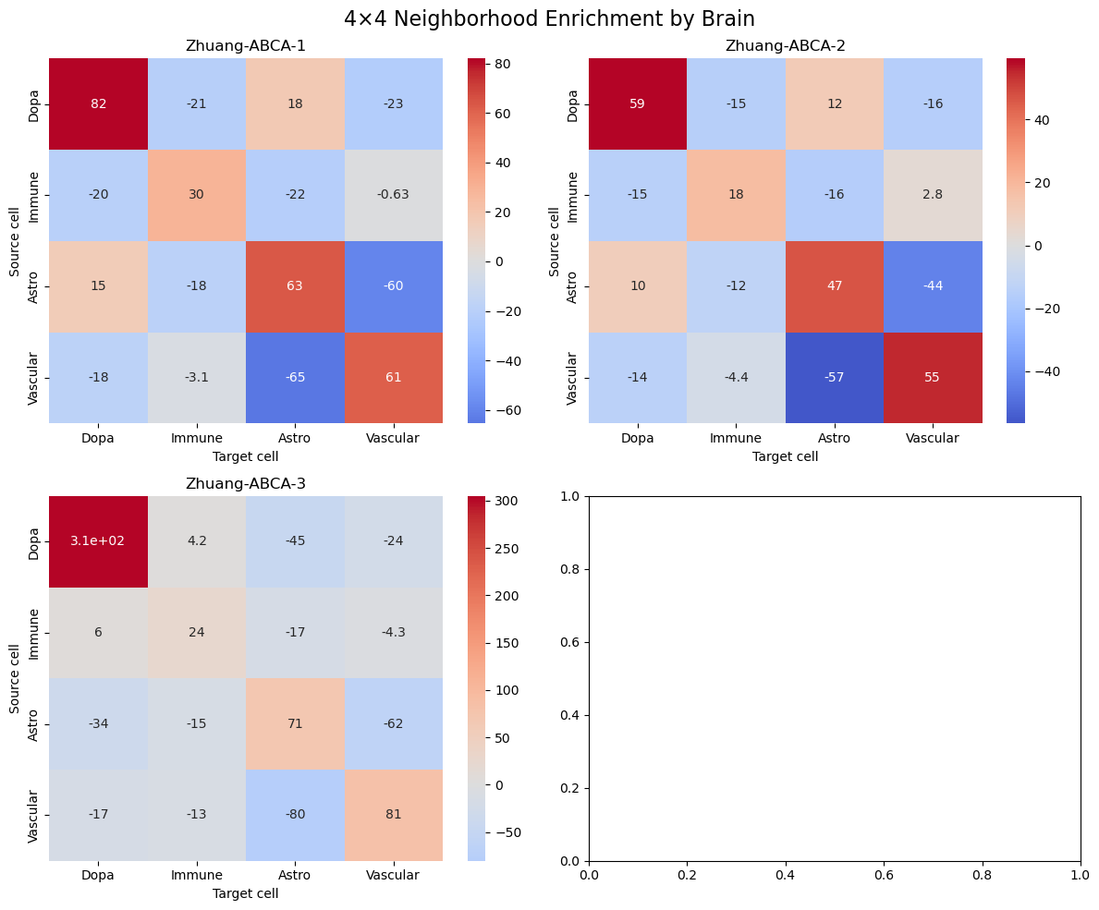
Figure 1: Heatmap of spatial neighborhood enrichment z-scores among core brain cell types (Dopa, Astro, Vascular, Immune) across three mouse brains. Astrocytes and vascular cells showed strong co-localization, while dopaminergic neurons were spatially segregated from vascular and immune cells.
Varying the neighborhood radius (5, 15, 45) showed that enrichment patterns remain stable, confirming that core spatial interactions are robust to parameter changes.
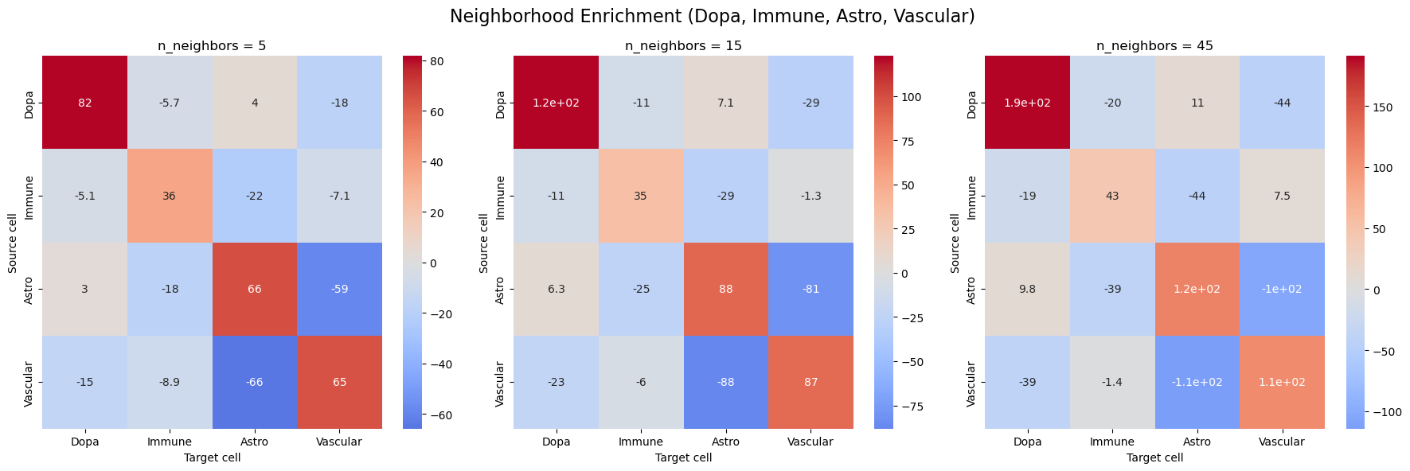
Figure 2: Neighborhood enrichment results with varying neighbor parameters (n = 5, 15, 45). Core interaction trends such as Dopa–Dopa and Astro–Vascular remain robust across scales.
Normalized spatial density correlations showed strong positive correlation between astrocytic and vascular cells, and low correlation with immune or dopaminergic cells, validating results from the neighborhood analysis.
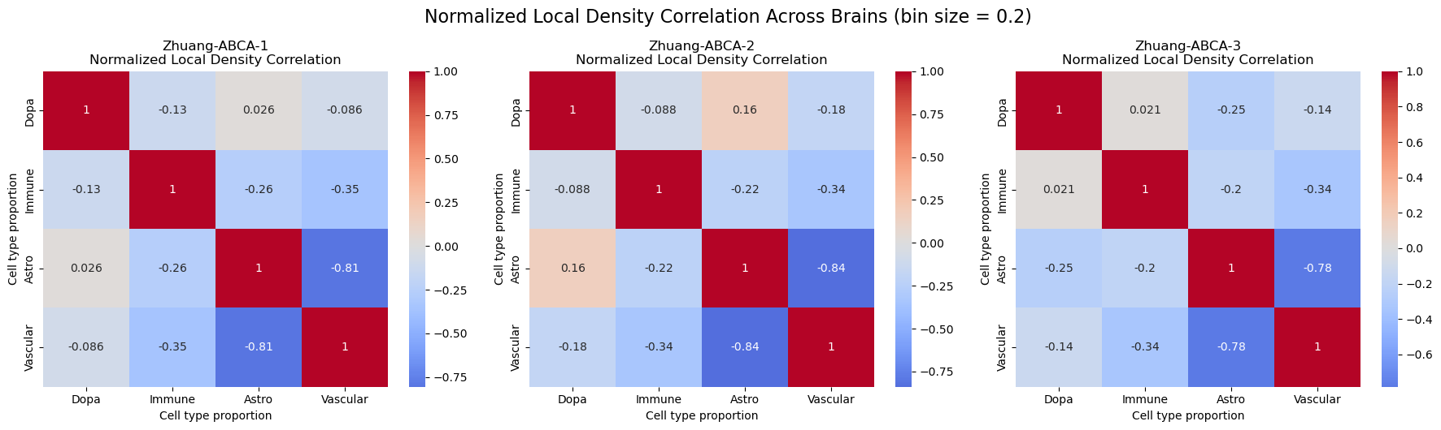
Figure 3: Heatmap of spatial density correlations between cell types after normalization. Astrocytes and immune cells show positive co-regionality, while Dopa neurons are anti-correlated with immune and vascular populations.
Example section was visualized to show the cell type densities.
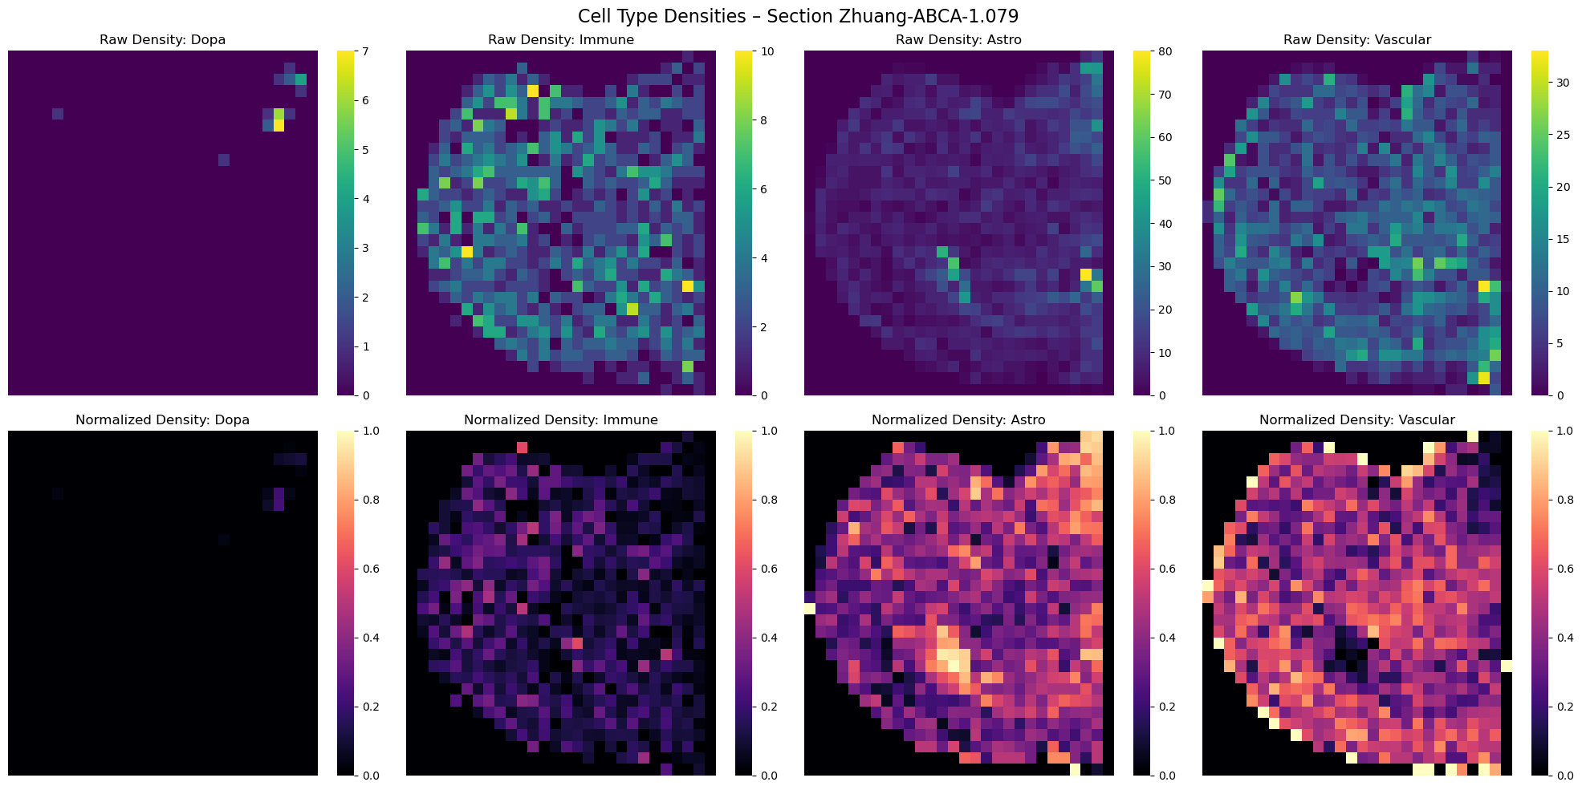
Figure 4: Raw and normalized cell type density maps Representative tissue section (ABCA-1.079) showing spatial density distributions of core cell types. Normalized maps highlight the anatomical clustering and separation of distinct cell populations.
3. Spatial Expression of Parkinson's and Inflammation Genes
Spatial expression overlays of seven Parkinson’s and inflammation-related genes across individual brain sections were visualized. Genes such as Th and Drd1 show focal hotspots, while others like Gfap and Il1rap demonstrate broader glial and immune activation. Note that spatial signals reflect only individual sections and may not capture full-brain expression patterns.
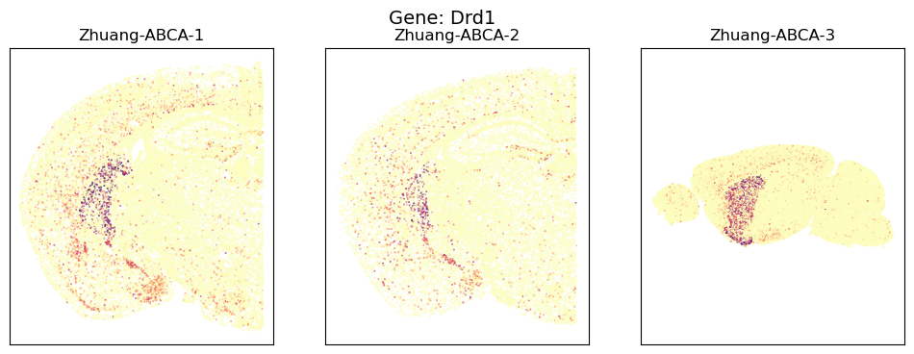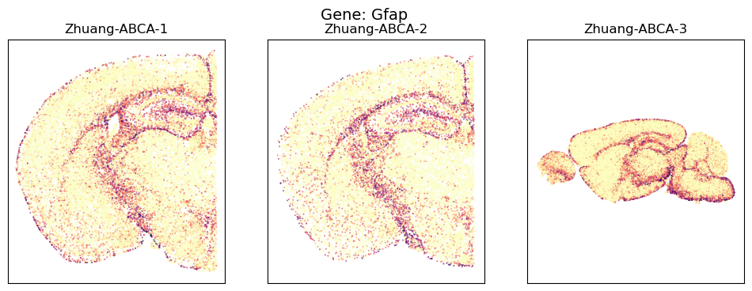
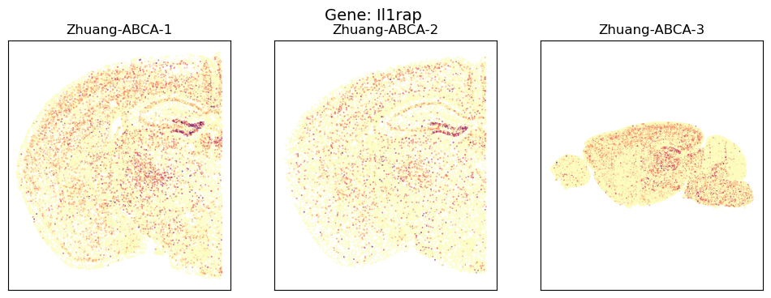
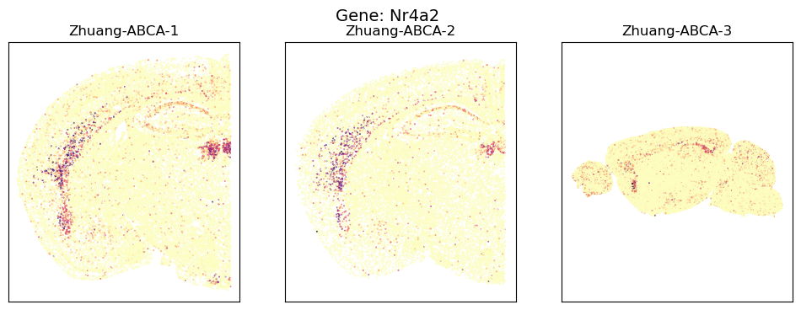
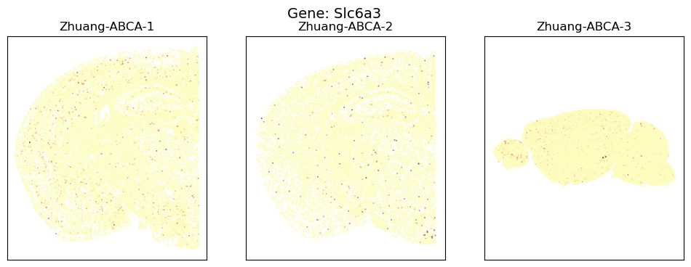
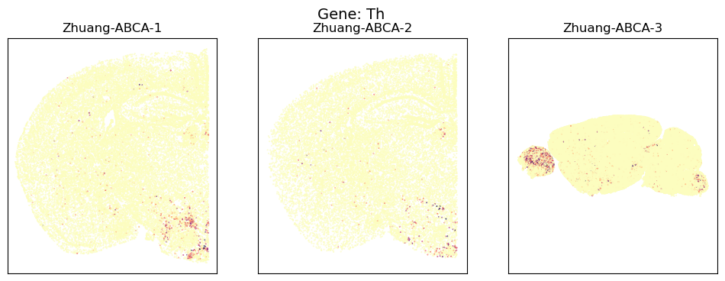
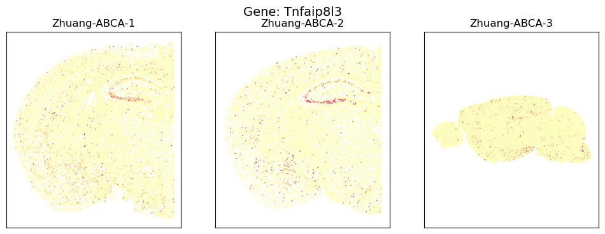
Figure 5: Spatial expression overlays of seven Parkinson’s and inflammation-related genes across individual brain sections. Genes such as Th and Drd1 show focal hotspots, while others like Gfap and Il1rap demonstrate broader glial and immune activation. Note: spatial signals reflect only individual sections and may not capture full-brain expression patterns.
4. Gene + Cell-Type Neighborhood Interaction Matrix
A 12×12 neighborhood enrichment matrix shows how gene-high cells interact with core brain cell types. Strong co-enrichment was observed between Gfap high and astrocytes, Il1rap high and immune cells, and Th high with dopaminergic cells.
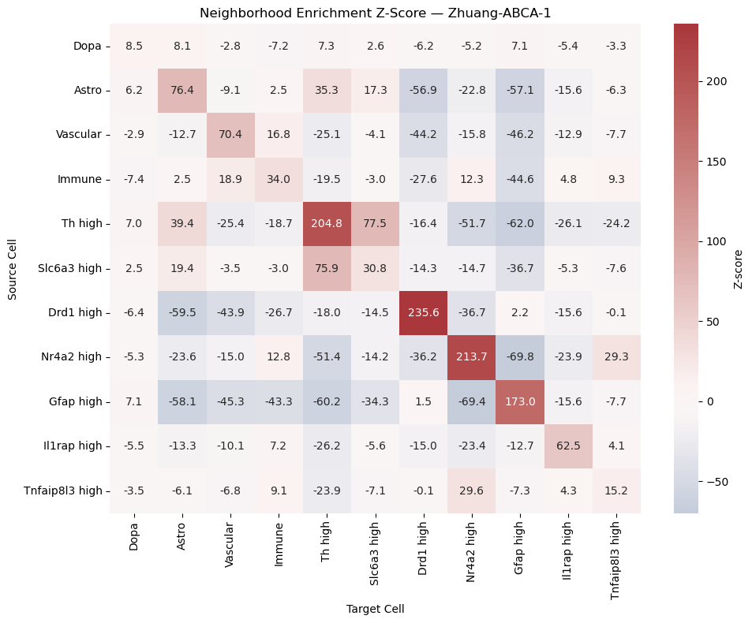
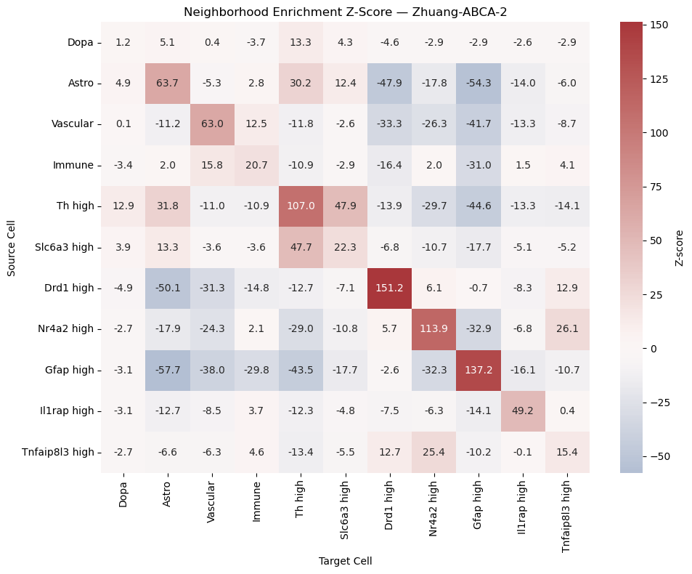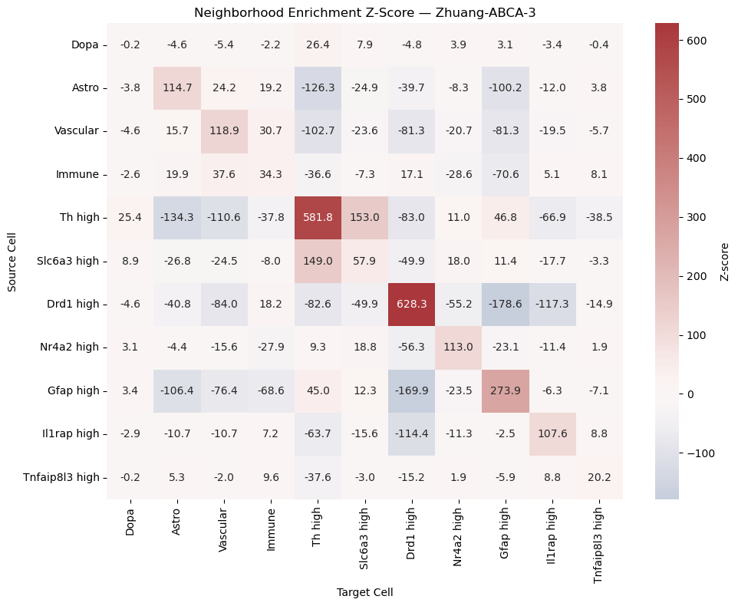
Figure 6: Enrichment matrix showing spatial interaction patterns between cell types and high-expressing gene groups. Dopaminergic and immune-related gene-high cells exhibit proximity to corresponding functional cell types.
5. Gene Module Discovery & Functional Interpretation
Hierarchical clustering of gene-high groups based on spatial interaction z-scores revealed three distinct modules. These clusters were consistent across brains, suggesting stable gene co-enrichment modules.
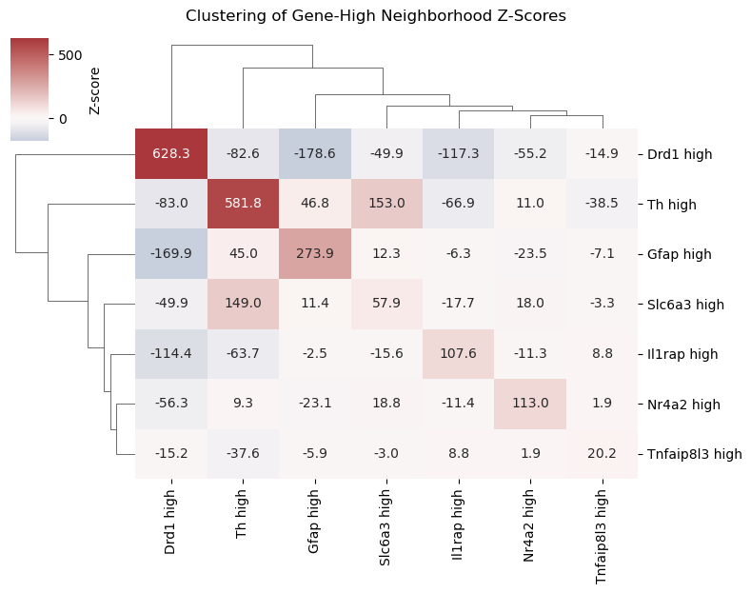
Figure 7: Clustering based on neighborhood enrichment z-scores reveals three distinct spatial modules among gene-high groups. Modules suggest functional segregation of dopaminergic and inflammation-related genes.
Gene Ontology enrichment for Cluster 1 genes highlighted biological processes such as T cell activation, cytokine receptor binding, and neurotransmitter secretion, suggesting this spatial module may mediate immune-dopaminergic cross-talk.
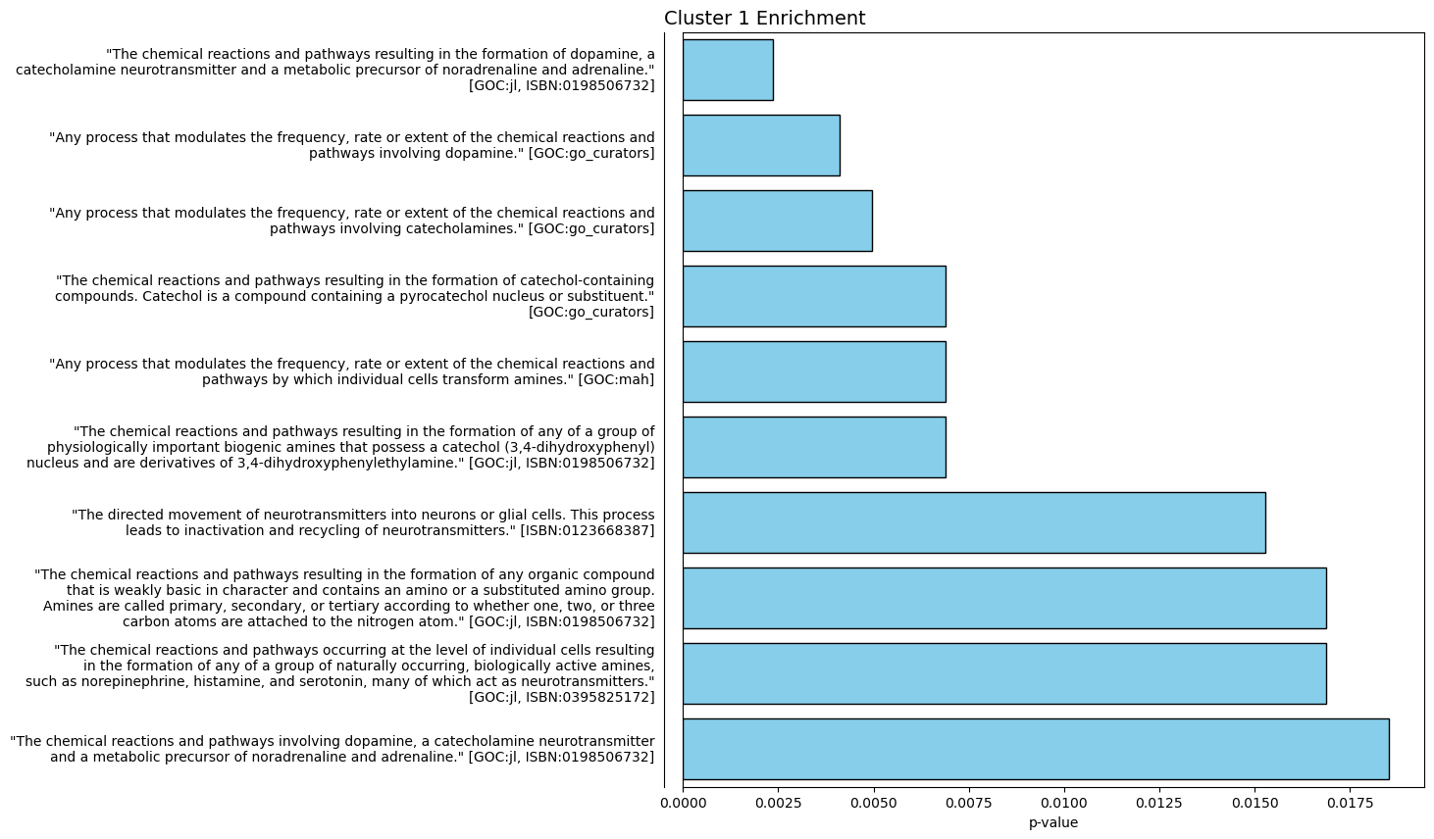
Figure 8: Gene Ontology enrichment analysis for Cluster 1 genes identifies key biological processes such as cytokine signaling and synaptic regulation. These functions may reflect convergent roles of genes in neuroinflammatory contexts.
Discussion
The neighborhood enrichment analysis among core cell types revealed a consistent and biologically meaningful spatial organization across all three mouse brains. Astrocytes and vascular cells were often found in close proximity, consistent with their joint roles in forming the blood-brain barrier and regulating brain homeostasis. In contrast, dopaminergic neurons and immune cells were spatially separated, suggesting distinct tissue niches or functional separation under homeostatic conditions. This provides a foundational map for understanding where disease processes might emerge if these boundaries are disrupted.
In the parameter sensitivity analysis (Figure 2), we observed that the overall spatial trends—particularly the co-localization of astrocytes and vascular cells—remained stable across a wide range of neighborhood definitions. This robustness indicates that the spatial organization we observed is not merely an artifact of local neighborhood size and highlights the reliability of the underlying biological signal.
The spatial density correlation analysis (Figure 3) further validated these patterns. After normalizing cell densities to account for tissue composition differences, we observed positive correlations between astrocytic and vascular cell distributions and clear spatial separation from immune cells. This cross-validation of neighborhood-level and region-level spatial interactions strengthens the evidence for non-random, tissue-scale cellular organization.
Although spatial gene expression overlays in Figure 4 illustrate anatomical localization, they are limited to a single representative section per brain. Therefore, the broader conclusions drawn from gene expression patterns are derived from analysis of the entire brain datasets.
Figure 6 explored how gene-high groups, defined by elevated expression of selected Parkinson’s and neuroinflammatory markers, interact spatially with core cell types. These gene-high cells exhibited strong spatial interactions with specific cell types: for example, Gfap high cells clustered near astrocytes and Tnfaip8l3 high cells showed affinity with immune-rich regions. These findings indicate that gene expression levels are not only molecularly but also spatially contextualized, reinforcing the importance of considering spatial proximity in gene regulatory studies.
The consensus matrix and hierarchical clustering (Figure 7) revealed reproducible gene modules that exhibit coordinated spatial interaction patterns across multiple brains. These gene-high groups were not randomly distributed but formed robust co-enriched neighborhoods. Cluster 1 emerged as the largest and most spatially cohesive module.
Gene Ontology enrichment analysis for Cluster 1 (Figure 8) indicated that this module is functionally associated with immune signaling and neurotransmitter regulation. Enriched pathways included T cell activation, cytokine receptor interaction, and dopamine-related synaptic transmission. These annotations strongly align with the dual themes of neuroinflammation and dopaminergic dysfunction central to Parkinson’s disease. The GO terms highlight how spatially organized gene expression can provide clues to functional coordination, and in turn, to mechanisms of disease progression.
These findings suggest that spatially organized transcriptional modules may underlie the functional landscapes of neuroinflammation and Parkinson’s disease pathology. The spatial signatures observed across cell types and gene modules represent potential architectural patterns that may be disrupted in disease contexts.
There are important limitations to consider in interpreting these results. First, the study uses spatial transcriptomic data from healthy mouse brains rather than PD models or human tissue, which limits the direct translational inference. Second, the sample size is constrained to three brains, which may not capture the full spectrum of biological variability. Additionally, the 1100-gene MERFISH panel, while informative, excludes many known PD-related genes, which restricts the scope of gene-module detection. Finally, regional interpretations are limited because anatomical region annotations were not available in this dataset.
Conclusion
This study demonstrates the power of spatial transcriptomics to uncover biologically meaningful patterns in brain tissue. By examining the spatial relationships between core brain cell types and PD/inflammation-related genes, we uncovered consistent modules of gene-cell co-localization. The results highlight strong spatial coupling between astrocytes and vascular cells, while dopaminergic and immune cells remain spatially separated. Additionally, we show that gene-high groups form coherent and reproducible spatial clusters that correlate with biological pathways of inflammation and neurotransmission.
These findings contribute new perspectives on how gene expression and cell-type neighborhoods are spatially organized in the brain, offering a framework for future studies that aim to understand and potentially target neuroinflammatory pathways in Parkinson’s disease.

Reference
Beaulieu, J.-M., & Gainetdinov, R. R. (2011). The physiology, signaling, and pharmacology of dopamine receptors. Pharmacological Reviews, 63(1), 182–217. https://doi.org/10.1124/pr.110.002642
Burgess, D. J. (2019). Spatial transcriptomics coming of age. Nature Reviews Genetics, 20(6), 317–317. https://doi.org/10.1038/s41576-019-0129-z
Chaudhuri, K. R., Healy, D. G., Schapira, A. H. V., & National Institute for Clinical Excellence. (2006). Non-motor symptoms of Parkinson’s disease: Diagnosis and management. The Lancet. Neurology, 5(3), 235–245. https://doi.org/10.1016/S1474-4422(06)70373-8
Chen, K. H., Boettiger, A. N., Moffitt, J. R., Wang, S., & Zhuang, X. (2015). Spatially resolved, highly multiplexed RNA profiling in single cells. Science, 348(6233), aaa6090. https://doi.org/10.1126/science.aaa6090
Dauer, W., & Przedborski, S. (2003). Parkinson’s disease: Mechanisms and models. Neuron, 39(6), 889–909. https://doi.org/10.1016/s0896-6273(03)00568-3
Eng, L. F. (1985). Glial fibrillary acidic protein (GFAP): The major protein of glial intermediate filaments in differentiated astrocytes. Journal of Neuroimmunology, 8(4–6), 203–214. https://doi.org/10.1016/s0165-5728(85)80063-1
Gainetdinov, R. R., & Caron, M. G. (2003). Monoamine transporters: From genes to behavior. Annual Review of Pharmacology and Toxicology, 43, 261–284. https://doi.org/10.1146/annurev.pharmtox.43.050802.112309
Gao, H.-M., & Hong, J.-S. (2008). Why neurodegenerative diseases are progressive: Uncontrolled inflammation drives disease progression. Trends in Immunology, 29(8), 357–365. https://doi.org/10.1016/j.it.2008.05.002
Halliday, G. M., & Stevens, C. H. (2011). Glia: Initiators and progressors of pathology in Parkinson’s disease. Movement Disorders: Official Journal of the Movement Disorder Society, 26(1), 6–17. https://doi.org/10.1002/mds.23455
Hirsch, E. C., & Hunot, S. (2009). Neuroinflammation in Parkinson’s disease: A target for neuroprotection? The Lancet. Neurology, 8(4), 382–397. https://doi.org/10.1016/S1474-4422(09)70062-6
Jankovic, J. (2008). Parkinson’s disease: Clinical features and diagnosis. Journal of Neurology, Neurosurgery, and Psychiatry, 79(4), 368–376. https://doi.org/10.1136/jnnp.2007.131045
Kalia, L. V., & Lang, A. E. (2015). Parkinson’s disease. Lancet (London, England), 386(9996), 896–912. https://doi.org/10.1016/S0140-6736(14)61393-3
Le, W.-D., Xu, P., Jankovic, J., Jiang, H., Appel, S. H., Smith, R. G., & Vassilatis, D. K. (2003). Mutations in NR4A2 associated with familial Parkinson disease. Nature Genetics, 33(1), 85–89. https://doi.org/10.1038/ng1066
Marx, V. (2021). Method of the Year: Spatially resolved transcriptomics. Nature Methods, 18(1), 9–14. https://doi.org/10.1038/s41592-020-01033-y
McGeer, P. L., & McGeer, E. G. (2004). Inflammation and neurodegeneration in Parkinson’s disease. Parkinsonism & Related Disorders, 10 Suppl 1, S3-7. https://doi.org/10.1016/j.parkreldis.2004.01.005
Moffitt, J. R., Hao, J., Wang, G., Chen, K. H., Babcock, H. P., & Zhuang, X. (2016). High-throughput single-cell gene-expression profiling with multiplexed error-robust fluorescence in situ hybridization. Proceedings of the National Academy of Sciences of the United States of America, 113(39), 11046–11051. https://doi.org/10.1073/pnas.1612826113
Nagatsu, T., Levitt, M., & Udenfriend, S. (1964). TYROSINE HYDROXYLASE. THE INITIAL STEP IN NOREPINEPHRINE BIOSYNTHESIS. The Journal of Biological Chemistry, 239, 2910–2917.
Poewe, W., Seppi, K., Tanner, C. M., Halliday, G. M., Brundin, P., Volkmann, J., Schrag, A.-E., & Lang, A. E. (2017). Parkinson disease. Nature Reviews. Disease Primers, 3, 17013. https://doi.org/10.1038/nrdp.2017.13
Sveinbjornsdottir, S. (2016). The clinical symptoms of Parkinson’s disease. Journal of Neurochemistry, 139 Suppl 1, 318–324. https://doi.org/10.1111/jnc.13691
Tansey, M. G., & Goldberg, M. S. (2010). Neuroinflammation in Parkinson’s disease: Its role in neuronal death and implications for therapeutic intervention. Neurobiology of Disease, 37(3), 510–518. https://doi.org/10.1016/j.nbd.2009.11.004
Zarezadeh Mehrabadi, A., Aghamohamadi, N., Khoshmirsafa, M., Aghamajidi, A., Pilehforoshha, M., Massoumi, R., & Falak, R. (2022). The roles of interleukin-1 receptor accessory protein in certain inflammatory conditions. Immunology, 166(1), 38–46. https://doi.org/10.1111/imm.13462
Zhang, M., Eichhorn, S. W., Zingg, B., Yao, Z., Cotter, K., Zeng, H., Dong, H., & Zhuang, X. (2021). Spatially resolved cell atlas of the mouse primary motor cortex by MERFISH. Nature, 598(7879), 137–143. https://doi.org/10.1038/s41586-021-03705-x
Zhang, M., Pan, X., Jung, W., Halpern, A., Eichhorn, S. W., Lei, Z., Cohen, L., Smith, K. A., Tasic, B., Yao, Z., Zeng, H., & Zhuang, X. (2023). A molecularly defined and spatially resolved cell atlas of the whole mouse brain (p. 2023.03.06.531348). bioRxiv. https://doi.org/10.1101/2023.03.06.531348

