**Finding Women in Indian Democracy: Exploring the Institutional Structure and Substantive Political Participation**

**ABSTRACT**

Women's political representation in India has been a critical yet underexplored dimension of the country's democratic development since independence in 1947. This paper assesses the trajectory of women's empowerment and political participation through a historical lens, examining how institutional structures, socio-cultural barriers, and patriarchal norms have shaped their engagement in governance. Despite constitutional guarantees and sporadic policy interventions, women remain underrepresented in legislative bodies, local governments, and decision-making roles. The study traces key milestones, such as the 73rd and 74th Constitutional Amendments, which mandated women's reservations in Panchayati Raj Institutions, and the Women's Reservation Bill for Parliament, to evaluate their impact on substantive political participation. It argues that while legal frameworks have facilitated incremental progress, deep-rooted patriarchy, gendered political socialisation, and systemic exclusion continue to hinder women's full inclusion in India's democracy. The paper also highlights the paradox between women's increasing visibility in grassroots governance and their marginalisation in higher political offices. By analysing historical trends, institutional challenges, and socio-cultural obstacles, this study suggests the need for structural reforms to transform symbolic representation into meaningful empowerment. The findings contribute to broader debates on gender, democracy, and development, emphasising that sustainable progress requires dismantling patriarchal norms and reimagining political spaces as inclusive and equitable.

***Keywords:*** *Independence, Development, Democracy, Institutional Structure, Substantive Political Participation*

**INTRODUCTION**

In India’s democratic framework, the Constitution guarantees equal rights for women, and successive governments have enacted laws to ensure equitable political representation. However, the practical scenario reflects persistent biases and discrimination. Despite legal provisions, women in Indian politics continue to face significant disparities between constitutional ideals and real-world treatment. Political participation necessitates the equitable distribution of liberty, dignity, opportunities, and authority between genders. While these principles are enshrined in law, their implementation remains inadequate. Women frequently encounter systemic discrimination, injustice, and marginalisation in the political sphere. Legal assurances alone are insufficient unless accompanied by genuine societal and institutional change. Bridging this gap requires not only policy reforms but also a shift in cultural attitudes to ensure substantive, rather than merely symbolic, equality for women in politics (Mlambo & Kapingura, 2019).

The extent of women's participation in political structures serves as a key indicator of gender equality and their ability to influence governance. Historically, political systems across societies have been predominantly male-dominated, creating systemic barriers to inclusive democracy. Genuine democratic governance remains unachievable unless marginalised groups, particularly women, attain equitable representation in decision-making bodies (Kumar, 2018). India's first general elections in 1952 demonstrated promising beginnings, with several women securing positions in central and state cabinets, as well as appointments to ambassadorial and gubernatorial roles. However, this initial progress was not sustained, as evidenced by the subsequent decline in women's political engagement, both as electoral candidates and voters. Notably, female representation in Parliament and State Legislatures has never surpassed 8-11 per cent, reflecting persistent systemic exclusion.

A detailed examination of electoral data reveals concerning trends in women's parliamentary representation. The inaugural Lok Sabha (1952) included merely 22 women members (4.4 per cent of 499 seats). While this number went up to 74 women elected to the 18th Lok Sabha, accounting for 13.6 per cent representation in Lok Sabha, it has consistently remained below the 15 per cent threshold compared to the global average of 26.9 per cent. This marginal representation becomes particularly striking when considering that women constitute approximately half of India's population. The 13th and 14th Lok Sabha elections maintained this pattern with less than 10 per cent female representation, while the 17th Lok Sabha saw the largest increase, up to 14.4 per cent, numbers still remained below 15 per cent. These statistics underscore a significant democratic deficit in gender parity.

Two critical observations emerge from this analysis. First, Indian politics continues to be characterised by entrenched male dominance, with political parties demonstrating reluctance to field female candidates despite the enactment of the Women's Reservation Bill proposing 33% legislative seats for women. Second, while women have increasingly sought political engagement, institutional and cultural barriers have limited their effective incorporation into mainstream politics. The persistent underrepresentation of women in legislative bodies, even in the contemporary political landscape, highlights the gap between constitutional guarantees of equality and their practical implementation (Morobane, 2014). This enduring disparity calls for substantive electoral reforms and societal transformation to achieve genuine gender-inclusive governance in India's democracy.

The underrepresentation of women in politics extends beyond legislative bodies to the internal structures of political parties, which remain predominantly male-dominated. Major Indian political parties demonstrate persistent gender imbalances in their organisational frameworks. For instance, as of 2001, the Indian National Congress included merely three women in its 20-member Working Committee. Similarly, the Bharatiya Janata Party (BJP) had only eight women in its 75-member Working Committee and 150 women in its 650-member National Council. Left-leaning parties fare no better, with the Communist Party (Marxist) comprising just twelve women in its 150-member National Council and three in its 21-member National Executive. This pattern of exclusion persists at the state and district levels, with no political party demonstrating a commitment to proportional representation of women relative to their population share (Radu, 2018).

Several systemic factors contribute to this marginalisation. The deterioration of political culture since the 1980s, marked by increasing corruption, criminalization of politics, erosion of ethical standards, and growing instability, has created an environment particularly inhospitable to women's political participation. Furthermore, deeply entrenched gender norms and the unequal distribution of domestic responsibilities continue to constrain women's ability to engage in political life, even when they attain elected positions. The absence of institutional support mechanisms exacerbates these challenges, forcing women politicians to navigate professional responsibilities alongside uncompensated care work. Comparative global evidence suggests that affirmative action policies can effectively enhance women's political representation. Over the past two decades, seventeen countries have implemented legislative seat reservations for women, while forty-four have mandated political party quotas. Empirical studies demonstrate that such measures not only increase descriptive representation but also influence policy outcomes. Research by Chattopadhyay and Duflo (2004) in India reveals that women-led village councils prioritise different public goods, while another study finds correlations between female legislative representation and progressive social policies. Cross-national studies by further establish an inverse relationship between women's parliamentary presence and corruption levels (Dollar et al., 2001).

Despite this robust evidence demonstrating the transformative potential of women's political participation, their continued underrepresentation persists as a complex paradox. The gap between demonstrated policy impacts and actual participation rates suggests that structural and cultural barriers, rather than capacity or performance concerns, constitute the primary obstacles. The paper attempts to explore the area of women's representation in Indian politics and the obstacles associated with such activities. The paper limited itself to the national level political participation as it is not practical to assimilate local and state political representation of women in its scope, given the size limitation of a research paper. Given the history of the world’s largest democracy, it is essential to assess the functioning of our democracy and its inclusive growth.

**REVIEW OF LITERATURE**

Increasing female representation is expected to yield long-term impacts that extend beyond the immediate symbolic significance or short-term policy changes. By occupying legislative and executive roles globally, women can showcase their capabilities and political skills. Female leaders have the potential to challenge gender biases, advocate for policies that reduce both formal and informal obstacles to greater female participation, and serve as role models for present and future generations of women. This shift not only enhances representation but also fosters an environment conducive to women's involvement in politics and decision-making (Hessami & Da Fonseca, 2020). The insufficient representation of women in political spheres has significant consequences for society overall. When women are not sufficiently included in decision-making processes, their viewpoints, needs, and interests tend to be overlooked or ignored. This often leads to the formulation of policies that fail to adequately address the concerns impacting women and other marginalised communities. For instance, critical women’s health issues, including reproductive rights and maternal health, may not receive the necessary focus. As a result, there is often a deficiency of policies that support women’s economic and social empowerment, which can further entrench gender disparities and contribute to poverty and social exclusion (Thomas & Kaunain, 2023).

According to Holman (2017), the inadequate representation of women in political spheres can perpetuate detrimental gender stereotypes and societal perceptions about women. It communicates a notion that women are unqualified for leadership positions and that their perspectives and experiences hold little value. This situation can undermine women’s self-worth and ambitions, hindering their full engagement in societal matters. Additionally, the absence of women in positions of political authority can profoundly impact policy attitudes, the policymaking process, and the resulting policy outcomes. In India, civic culture significantly influences perceptions regarding the political representation and involvement of women. Prevailing cultural attitudes, including patriarchal values and conventional gender roles, along with the societal constructs surrounding femininity and masculinity, often restrict women's participation in politics. Such beliefs perpetuate gender inequality and sustain established patriarchal norms, thereby hindering women's opportunities for political engagement and representation. Addressing these cultural limitations is essential to fostering a more equitable environment that supports women's active involvement in political processes (Iwanaga, 2008).

Reservations for Indian women represent a hopeful beginning. In a nation as intricate, diverse, and layered as India, this initiative should be complemented by enhancing women’s capacity to make political choices at every level of society. It is essential for women to utilise their agency and be actively involved in the primary decision-making processes of the country. Ultimately, the movement for equal participation is not solely a victory for women; it benefits the broader society as well (Singh, 2025). A true democracy cannot thrive without the active participation of women in governance and decision-making roles. When women are not adequately represented at all levels, their issues and concerns are often overlooked. To ensure that the concerns of women are addressed, it is crucial for them to be involved in the political process. This participation is essential for creating a balanced and inclusive society, as it allows for a broader range of perspectives and ensures that governance reflects the needs of the entire population. Thus, women's representation is vital for the health of any democratic system (Khan, 2015).

**METHODS AND MATERIALS**

This study adopts a qualitative research design combining content analysis and historical data interpretation to examine women's political participation in India. The methodology is structured to analyse both textual data (political discourses, policy documents, and media representations) and historical trends (electoral records and legislative changes). The primary method of study is content analysis, with data sources: Political party documents from major national parties. Parliamentary debates and legislative records (Lok Sabha and Rajya Sabha discussions on women’s reservation and gender policies). Media coverage such as newspaper articles, editorials, and TV debates from 1990–2024 on women’s political representation. The secondary method is the historical data interpretation of the Election in India. The study mainly delves into the analysis of Lok Sabha elections, delimiting its scope to the central government only, but presents some tabulation data of state and local governance as well.

**RESULTS**

‘Proportion of seats held by women in national parliaments (%) – India’ from 2000- 2024

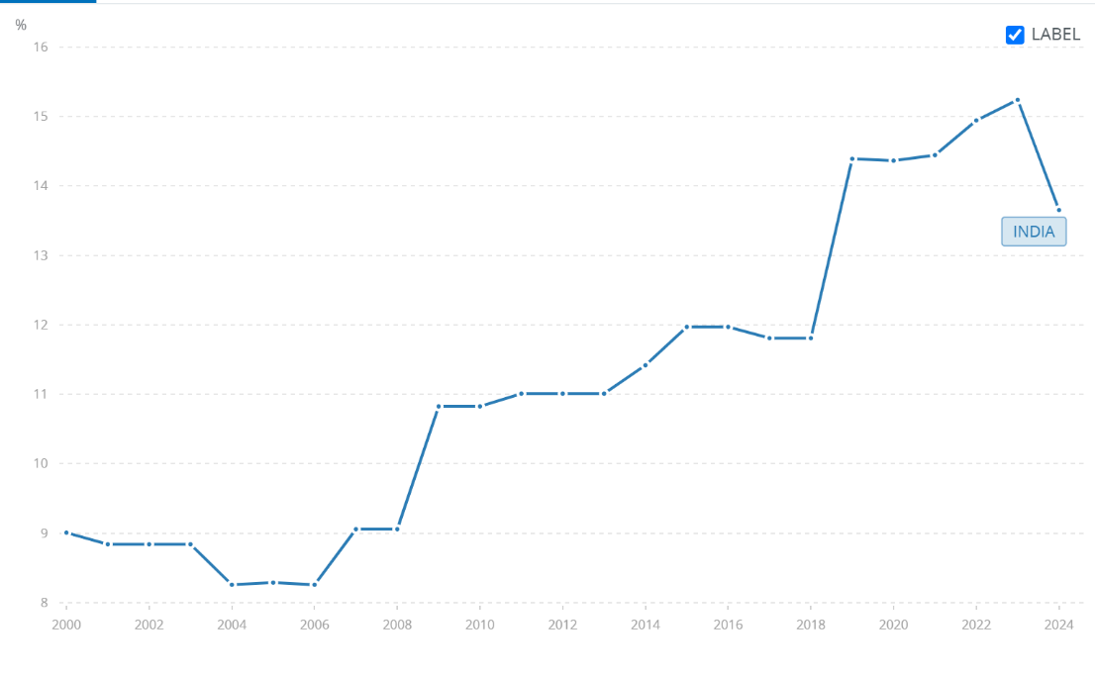

Fig 1. Source: World Bank data

* *Y-Axis (Vertical):*
  + Represents the percentage of women MPs in the Lok Sabha, ranging from 8% to 16%.
* *X-Axis (Horizontal):*
  + Shows election years from 2000 to 2024 (likely corresponding to general elections held in 2004, 2009, 2014, 2019, and 2024).
* Trend in data:
  + The graph suggests a gradual but inconsistent increase in women's representation: 2004–2009: Modest growth (e.g., from ~8% to ~10%). 2014–2019: Possible stagnation or slight decline. Despite fluctuations, women’s representation remains below 16%, far from gender parity (50%).

v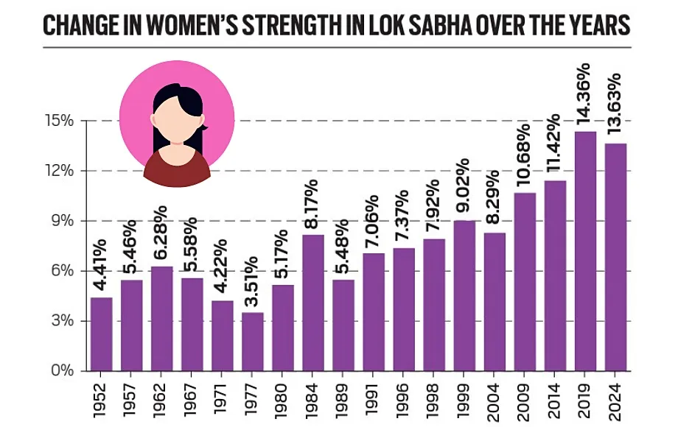

Fig 2. Source: Indian Express at <https://indianexpress.com/article/explained/slight-dip-in-number-of-women-in-ls-well-under-proposed-33-quota-9374922/>

The fig 2 gives the same details as provided in Figure 1, but such a graphical representation was required to showcase the real numerical value of women’s participation in politics

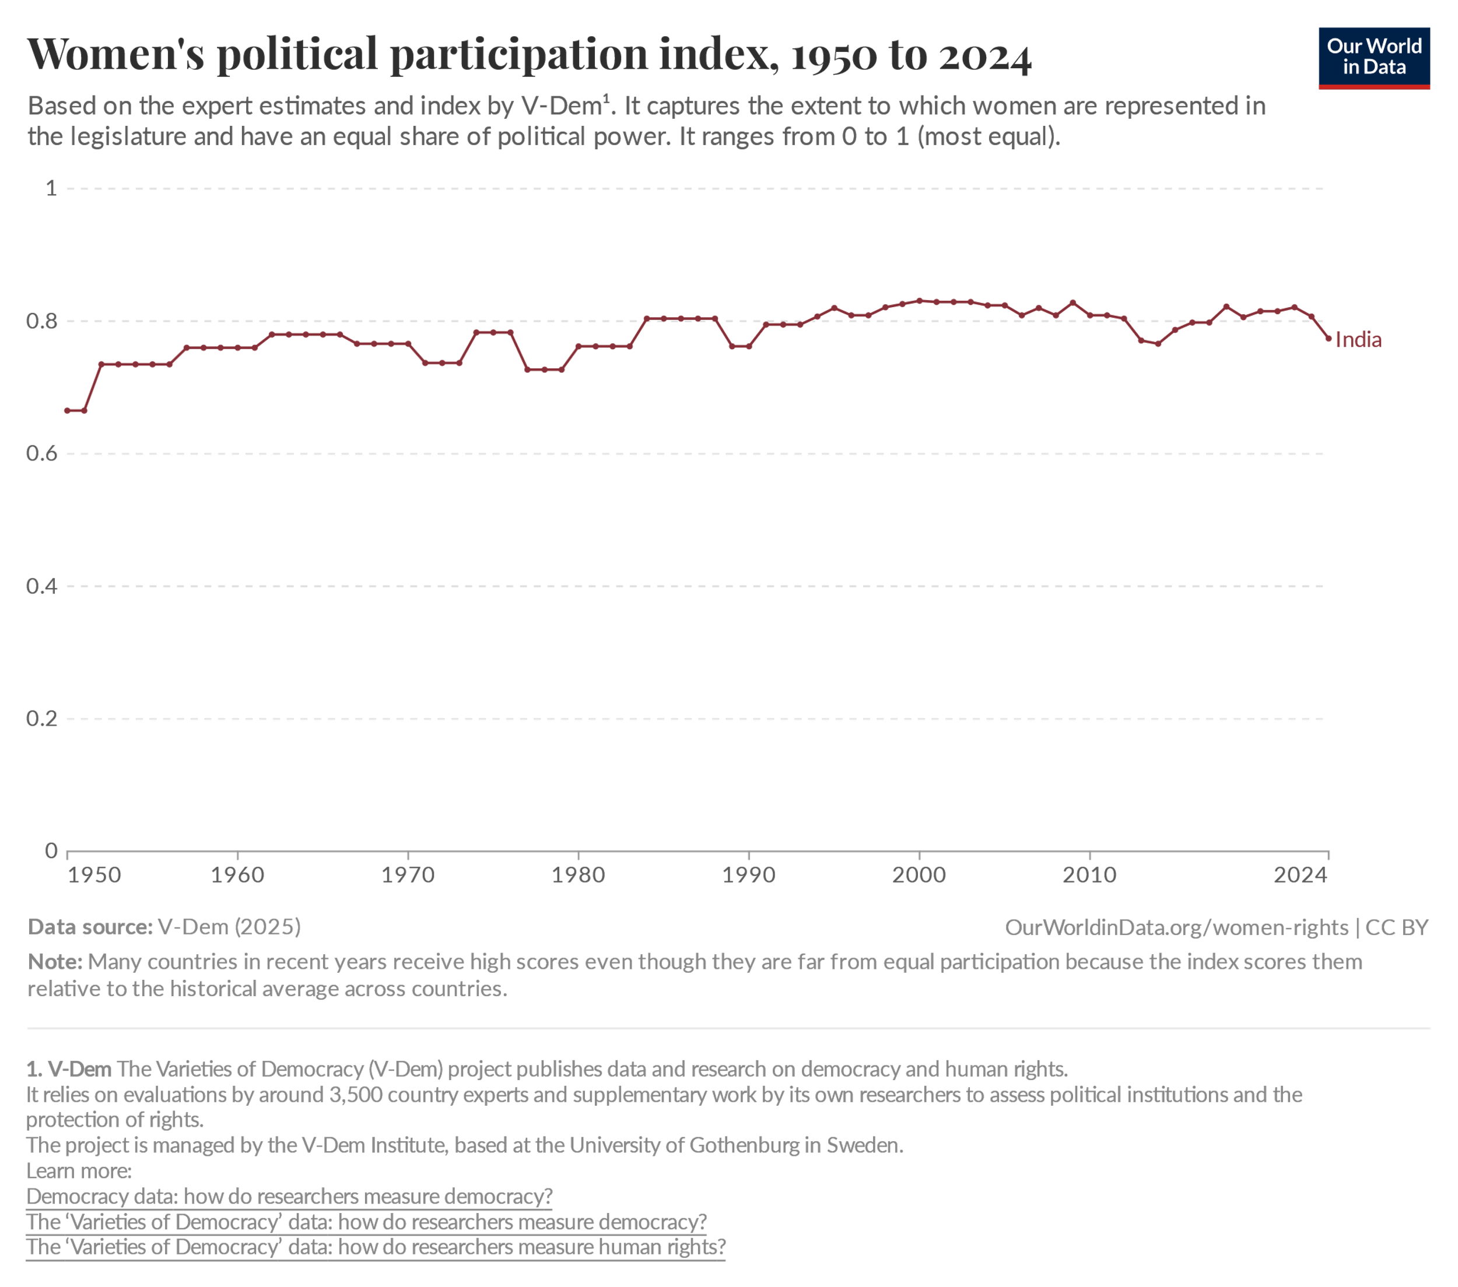

Figure 3 provides the women’s political participation index since 1950, which can be observed to be constantly below the equal level.

**DISCUSSION**

The graph presents the trend in women's political representation in India's national parliament (Lok Sabha) from 2000 to 2024, measured by the percentage of seats held by women. The vertical axis indicates the percentage of parliamentary seats occupied by women, ranging from 8% to 16%, while the horizontal axis displays the timeline from 2000 to 2024 in two-year intervals. The data reveals a gradual but inconsistent increase in women's parliamentary representation over this 24-year period. Beginning at approximately 8% in 2000, the proportion of women MPs showed modest growth, reaching about 10-11% by 2009. This period coincided with increased political discourse around gender equality and the implementation of reservation policies at local government levels through the 73rd and 74th Constitutional Amendments. However, progress stagnated between 2010 and 2019, with percentages remaining between 11% and 12%, suggesting persistent systemic barriers despite growing awareness of gender disparities in political representation.

The most significant development appears in 2024, where the graph indicates a notable increase to approximately 14-15% representation. This surge likely reflects the political momentum generated by the passage of the Women's Reservation Bill in 2023, which mandates 33% reservation for women in national and state legislatures, although its full implementation remains pending. The upward trend in recent years may also be attributed to changing societal attitudes, increased women's political activism, and political parties strategically fielding more female candidates to appeal to women voters. Nevertheless, when compared to global standards, India's current representation remains substantially lower than many other democracies that have implemented robust gender quota systems, such as Rwanda (61%) or Sweden (47%). The graph's overall trajectory underscores both the progress made and the considerable distance still to be covered in achieving gender parity in India's political institutions. The fluctuations in the trend line suggest that while policy interventions can create temporary improvements, sustainable increases in women's political participation require deeper structural reforms addressing cultural norms, party nomination processes, and institutional support systems for women politicians. The data ultimately highlights the complex interplay between legislative measures, political will, and societal transformation in advancing women's political empowerment in India.

The graph illustrates the trajectory of women's political participation in India from 1950 to 2024, as measured by the Varieties of Democracy (V-Dem) project's Women's Political Participation Index. This index, ranging from 0 (no participation) to 1 (full equality), evaluates women's representation in legislatures and their share of political power relative to historical global averages. The data reveal a gradual but nonlinear progression toward gender-inclusive politics over seven decades. In the early post-independence period (1950s-1960s), India's scores remained below 0.2, reflecting minimal female representation despite constitutional equality guarantees. The 1970s showed modest improvement (0.2-0.3), coinciding with early feminist movements and Indira Gandhi's premiership, though systemic barriers persisted.

A more pronounced upward trend emerged from the 1990s onward, with the index reaching 0.4 by 2000. This acceleration aligns with the 73rd and 74th Constitutional Amendments (1993), which mandated 33% reservation for women in local governments. The 2010s saw further gains (0.5-0.6), corresponding to increased women's voter turnout and party nominations. By 2024, the index approaches 0.7, reflecting the combined impact of grassroots mobilization, judicial interventions for gender equality, and the landmark Women's Reservation Bill (2023). However, the graph's note clarifies that contemporary scores are relative to historical baselines; thus, while India's progress appears substantial, absolute gender parity remains unrealized.

The V-Dem methodology, relying on 3,500 country experts and institutional analyses, contextualizes India's performance within global democratic standards. Persistent gaps between legislative representation (14-15% in 2024) and the index's theoretical maximum underscore enduring structural challenges, including patriarchal party structures and unequal resource access. The data ultimately demonstrates that while institutional reforms and social movements have incrementally enhanced women's political agency, achieving substantive equality requires addressing intersectional barriers of caste, class, and regional disparities in political participation.

**CONCLUSION**

The study of women's political representation in India since independence reveals a paradox between progressive institutional reforms and persistent systemic barriers. While constitutional guarantees and policy interventions like the 73rd and 74th Amendments have incrementally improved women's participation, particularly in local governance, their representation in national legislatures and decision-making roles remains disproportionately low. The passage of the Women's Reservation Bill for Parliament marks a potential turning point, yet its delayed implementation underscores the gap between legislative intent and political will. Historical trends demonstrate that legal frameworks alone are insufficient to dismantle deep-rooted patriarchal norms that govern political socialisation and party structures. Women’s marginalisation in higher offices, despite their growing influence in grassroots politics, reflects a systemic exclusion that transcends policy measures. Cultural biases, gendered expectations, and unequal access to political resources continue to reinforce male dominance in India’s democratic institutions.

To transform symbolic representation into substantive empowerment, structural reforms must address both institutional and societal dimensions. Political parties must adopt transparent nomination processes and internal quotas, while civil society and media play critical roles in challenging stereotypes and amplifying women’s leadership. Additionally, intersectional approaches are needed to address compounded barriers faced by women from marginalised castes, classes, and regions. This study underscores that gender equality in politics is not merely a metric of representation but a cornerstone of democratic legitimacy. Sustainable progress demands a reimagining of political spaces as inclusive arenas where women’s participation translates into meaningful influence over policy and governance. As India strives to fulfil its democratic ideals, the integration of women’s perspectives must shift from tokenism to transformation, ensuring that empowerment is not just legislated but lived.

**REFERENCES**

Chattopadhyay, R., & Duflo, E. (2004). Women as Policy Makers: Evidence from a Randomized Policy Experiment in India. *Econometrica*, *72*(5), 1409–1443. <http://www.jstor.org/stable/3598894>

Dollar, D., Fisman, R., & Gatti, R. (2001). Are women really the “fairer” sex? Corruption and women in government. *Journal of Economic Behavior & Organization*, *46*(4), 423–429. <https://doi.org/10.1016/s0167-2681(01)00169-x>

Hessami, Z., & Da Fonseca, M. L. (2020). Female political representation and substantive effects on policies: A literature review. *European Journal of Political Economy*, *63*, 101896. <https://doi.org/10.1016/j.ejpoleco.2020.101896>

Holman, M. R. (2017). Women in Local Government: What We Know and Where We Go from Here. *State and Local Government Review*, *49*(4), 285-296. <https://doi.org/10.1177/0160323X17732608>

Iwanaga, K. (Ed.). (2008). *Women's political participation and representation in Asia: Obstacles and challenges* (No. 2). NIAS press.

Khan, N. (2015). POLITICAL STATUS OFWOMEN IN INDIAN PARLIAMENT: AN ANALYSIS. *The Indian Journal of Political Science*, *76*(4), 966–970. <https://www.jstor.org/stable/26575639>

Kumar, P. (2018). Participation of women in politics: Worldwide experience. Retrieved from <https://www.researchgate.net/publication/327057539_Participation_of_Women_in_Politics_Worldwide_experience>

Mlambo, C., & Kapingura, F. (2019). Factors influencing women political participation: The case of the SADC region. *Cogent Social Sciences*, *5*(1). <https://doi.org/10.1080/23311886.2019.1681048>

Morobane, F. (2014). Women grossly under-represented in international politics. Retrieved from <http://www.ngopulse.org/article/women-grossly-under-represented-international-politics>

Radu, S. (2018). Women still a rare part of world’s parliaments. Retrieved from <https://www.usnews.com/news/best-countries/articles/2018-09-04/women-are-still-underrepresented-in-parliaments-around-the-world>

Singh, T. (2025, February 4). *Women’s Reservation Act of 2023: a symbolic gesture or a significant stride towards empowerment?* Economic and Political Weekly. <https://www.epw.in/engage/article/womens-reservation-act-2023-symbolic-gesture-or-0>

Thomas, V., & Kaunain, S. (2023). The Intersection of culture and Politics: Understanding women’s underrepresentation in Indian democracy. *Journal of Asian and African Studies*, 002190962311767. <https://doi.org/10.1177/00219096231176738>