**Research on the Multimodal Translation of Traditional Chinese Medicine Videos from the Perspective of Reception Aesthetics**

**Abstract:** In recent years, short online videos have experienced rapid growth. However, Traditional Chinese Medicine (TCM) videos have yet to fully leverage multimodal translation to enhance audience understanding and acceptance of TCM culture, often becoming lost in the vast sea of information. This paper selects three typical TCM knowledge segments from high-viewership TCM videos (over 1.34 million views) published by CCTV English on YouTube as research objects. Based on reception aesthetics theory, a qualitative analysis is conducted to examine the interaction between language translation and other modalities, identifying successful practices in the multimodal translation process. The study aims to offer practical insights for translators to improve the quality and efficiency of multimodal translation in TCM short videos, and to enable the target audience to better understand and appreciate Chinese TCM culture.

**Keywords:** Reception Aesthetics; Traditional Chinese Medicine(TCM); Short Videos; Multimodal Translation

1. **Introduction**

Traditional Chinese Medicine (TCM), a cornerstone of Chinese culture for over 5,000 years, represents the accumulated wisdom of generations of medical practitioners. TCM continues to play a vital role in health maintenance and disease treatment, particularly demonstrating its unique strengths in syndrome differentiation during the COVID-19 pandemic, becoming an essential pillar in pandemic prevention and control. As globalization progresses, cultural exchanges between nations have intensified, and TCM culture has garnered growing international attention and appreciation. The dissemination and international exchange of TCM have become both an inevitable trend and an urgent necessity. However, this process faces a lot of challenges and risks.

The overseas dissemination of TCM culture in the past primarily focused on the English translation of TCM classics and the introduction of practical skills such as acupuncture and massage. However, the significant differences in geographical location and lifestyle between China and the West have led to notable disparities in thinking patterns, cultural backgrounds, and linguistic expressions, which, to some extent, limited the effectiveness of TCM's international dissemination. Specifically, the uniqueness of the TCM language lies in its combination of high abstraction, professionalism, and rich literary connotation, all of which pose challenges in accurately translating TCM terminology into English. Furthermore, the fundamental difference between the theoretical systems of Chinese and Western medicine—TCM emphasizes a holistic view and the yin-yang balance, while Western medicine focuses on localized analysis and empirical science—further complicates the understanding of TCM concepts by target audiences dominated by Western medical thinking, forming another barrier to the transmission and communication of TCM culture.

With its multimodal information transmission features, TCM short videos present both enormous prospects and difficult obstacles. Short videos have quickly gained popularity as digital products have been more widely used. TCM short videos precisely meet the modern demand for fragmented learning, allowing people to learn and access TCM knowledge anytime, anywhere. Moreover, their diverse and rich content, covering high-quality information in areas such as health maintenance and fitness, has earned them great favour among a broad audience. This has created several opportunities for the dissemination and popularization of TCM culture. Unfortunately, the majority of TCM videos fade into obscurity, as a result of their failed attempts to completely utilize multimodal translation techniques to help target audiences quickly and easily comprehend and absorb TCM knowledge, making it difficult to effectively disseminate the TCM culture.

To adapt to the new media environment and enhance cultural dissemination through short videos, it is essential to analyze popular TCM videos with high viewership to learn what makes them successful. This study focuses on a series of short videos on TCM culture published by CCTV English on YouTube, covering topics such as health preservation, acupuncture, and herbal medicine, which has more than 1.34 million views on YouTube. By selecting three sections with the most representative TCM knowledge, this research analyzes the multimodal translation practices in these videos from the perspective of reception aesthetics and explores how to better utilize multimodal translation to facilitate the dissemination of TCM culture.

1. **Academic Overview of Reception Aesthetics**

Reception Aesthetics is a literary criticism theory that originated in Germany in the 1960s, emphasizing the important role of readers in literary creation and dissemination. Reception Aesthetics posits that the meaning and value of a literary work are formed in the process of reading and understanding by the reader, rather than simply existing in the text or the author's intention (Chen, 2021). This theory’s development can mainly be attributed to German literary theorists Hans Robert Jauss and Wolfgang Iser (Chen, 2018). They combined Gadamer's hermeneutics with Husserl's phenomenology to form the theoretical system of Reception Aesthetics. Later, it absorbed Martin Heidegger's principles of "fusion of horizons" and borrowed Jean-Paul Sartre's idea of restoring the reader’s position. They argued that the meaning of a literary work arises from both the text itself and the reader’s contribution, affirming the reader's interpretation and evaluation of the work's aesthetic value. Jauss argued, "The reader is an active agent in the historical construction of meaning. The historical life of a literary work is unimaginable without the active participation of the reader" (Jauss, 1989, p. 43). Iser, on the other hand, believed that the meaning of a work only arises in the reading process, as a product of interaction between the work and the reader (Iser, 1987). A breakthrough in Reception Aesthetics is the establishment of the central role of the reader. According to this view, before reading a work, a reader is not completely blank but has a series of conscious or unconscious preparations, such as aesthetic experience, life experience, cultural level, and appreciation ability, which form a pre-existing understanding structure and knowledge framework, known as the "horizon of expectations." The reader constructs meaning and, through understanding, aligns their reading and aesthetic experience with the "horizon of expectations," ultimately achieving a "fusion of horizons" and thereby appreciating the meaning and aesthetic value of the work (She & Jiang, 2023).

In the information transmission of short videos, viewers are the receivers of information. The translation of TCM is primarily about disseminating and exchanging the outstanding culture of the Chinese nation. To facilitate the understanding of TCM culture by the audience, translators need to consider their "horizon of expectations" in the translation process to achieve a "fusion of horizons." The horizon of expectations refers to the standpoint, perspective, and method through which the information receiver understands and interprets the work. Therefore, in the multimodal translation of TCM culture in short videos, it is essential to preserve the cultural elements while also aligning with the expectations of the target language audience. First, the translator should respect the differences in aesthetic reading and cultural thinking between the source and target language audiences and use expressions familiar to foreign readers to ensure that the conveyed information is smooth and comprehensible. Second, translators should appropriately retain the characteristics and philosophical connotations of TCM culture in the translation, flexibly use multimodal information, and apply suitable translation techniques to handle cultural gaps, helping the audience understand the functions and effects of TCM.

1. **Overview of Multimodality Studies**

Modality refers to the channels or media used for communication, including linguistic, technological, visual, color, and musical semiotic systems (Zhu, 2007). Multimodality, on the other hand, refers to the integration and interaction of different modalities in the communication process to construct meaning (Kress & Van Leeuwen, 2001). For instance, the design of semiotic products or events often involves multiple semiotic resources working together to convey complex messages (Ketola, 2015). Common modalities include visual, auditory, tactile, olfactory, and gustatory modalities.

In China, Li Zhanzi (2003) was the pioneer scholar to introduce the concept of multimodality to the academic realm, thus paving the way for later research. Subsequently, an increasing number of academic works have come into existence. Scholars like Zhu Yongsheng (2007), Zhang Delu (2009, 2018), and Feng Dezheng (2017) have taken on research into multimodal discourse analysis from perspectives such as systemic functional linguistics and social semiotics. Through these efforts, a theoretical framework for multimodal discourse analysis has been developed, and its application in a variety of domains has been made easier. In cross-cultural communication, translation plays a pivotal role. Integrating multimodality into translation studies not only boosts the accuracy of information conveyance but also improves the quality and efficacy of translations. The origins of multimodal translation studies can be traced back to Jakobson’s (1959) tripartite classification of translation. In this classification, intersemiotic translation refers to "the interpretation of verbal signs through non-verbal sign systems." This theory provides a foundation for multimodal translation research.

Currently, multimodality research is on the rise worldwide. In China, it predominantly centers on educational contexts (e.g., Zhang Delu & Wang Lu’s 2010 study) and translation studies. Specific areas of multimodal translation research include: subtitling translation (Li, 2009), examining the interplay of text and audiovisual information; corpus-based interpreting studies (Liu & Hu, 2015), analyzing interactions between speech and language; comic translation (Huang & Zhu, 2018), concentrating on the integration of visual and textual elements; advertising translation (Ju, 2020), exploring the synergy of imagery, text, and brand culture; and multimodal translation study also reached to some specialized texts.

With the rise of digital media, traditional text-based communication can no longer meet the needs of modern audiences. Multimodal symbols such as images, audio, and video have become essential components of contemporary communication. Multimodal translation, or intersemiotic multimodal translation, involves the integration of various information sources—textual, visual, auditory, and video—during the translation process to achieve a more comprehensive and multi-dimensional form of communication. Different from traditional translation which mainly depends on verbal information, multimodal translation uses multiple modalities to better overcome cultural and linguistic obstacles, making communication more vivid, complete, and efficient.

As new media and technology continue to progress, multimodal translation is becoming more accessible and prevalent, providing strong support for global cross-cultural communication. Consequently, multimodal translation research has gained significant momentum in recent years and is expected to develop substantially in the future.

1. **Characteristics of TCM Terminology and Translation Challenges**

The translation of TCM short videos primarily centers on how to better interpret and disseminate TCM terminology and culture.

**4.1 Language Conversion Challenges**

TCM terminology is highly generalized and abstract at the linguistic level. Ancient Chinese philosophy and culture have had a profound and lasting impact on TCM, providing a traditional and unique perspective on the human body and its study. Based on long-term clinical practice, TCM grasps the commonalities, characteristics, and patterns of pathology from a holistic and macroscopic perspective, hence possessing a high level of generalization and abstraction (Zhou Yan, Liu Qiufen, 2021). For example, terms such as "精" (essence), "气" (qi), "经络" (meridians), and "三焦" (triple energizer) are unique abstract concepts in TCM theory, with no direct equivalents in English. Even terms similar to those in Western medicine may refer to different subjects, such as "脏腑" (zang-fu) mainly refers to functions of related organs in TCM, rather than specific anatomical organs described in Western medicine. TCM language is also highly condensed, showing a character of "limited words with infinite meanings." For instance, "望、闻、问、切" (inspection, auscultation, inquiry, and palpation) are the four diagnostic methods in TCM, each principle encapsulated in a single character that conveys the essence and soul of TCM diagnostics. What’s more, the Chinese language tends to be paratactic, while English is more hypotactic. Therefore, translators must not only fully understand the original text but also consider the characteristics of both languages, flexibly using variations in vocabulary and sentence structure. To enhance the understanding of audiences, translators can utilize multimodal approaches, such as the use of illustrations or animations to better present translation.

**4.2 Inaccurate Expression of Professional Terminology and Concepts**

Considering the transformation of meaning, TCM terminology is highly specialized even in medical and pharmacological contexts. TCM is a highly practical and specialized discipline closely related to people's lives and health, hence its language is a form of medical language (Zhou & Liu, 2021). For example, terms like "手少阳" (Hand Shaoyang) and "心包经" (Pericardium Meridian) are specialized TCM terms. Incorrect or ambiguous translations of these terms can lead to loss of original information, ambiguity, or misunderstanding; in severe cases, it may even result in misdiagnosis or mistreatment, causing serious consequences and hindering the international dissemination of TCM. Moreover, the expression and understanding of terms or concepts may vary in different languages. Translators need to have a complete understanding of medical knowledge and verify corresponding concepts through multiple sources to ensure accurate translation. Besides, translators may use multimodal information to enhance the accuracy and comprehensibility of terminology, such as by directly showcasing pictures of exact points or presenting TCM tools and procedural steps through video visuals.

**4.3 Difficulty in Cultural Transmission**

TCM integrates the essence of many ancient Chinese philosophical schools and is deeply rooted in the profound cultural soil of the Chinese nation, giving TCM language a strong classical literary flavor. TCM language contains a plethora of rhetorical devices such as metaphors and personifications. For example, "金蝉衣" (golden cicada slough) refers to the shell of a cicada, primarily produced in Zhejiang and Fujian provinces. The vivid and descriptive name "golden cicada slough" is gained from its intact form, golden color, and superb quality. Due to differences in cultural backgrounds, values, and beliefs between China and the West, the target culture may lack corresponding cultural content, making it difficult to understand or accept the intended connotations, thus failing to achieve a fusion of horizons and losing the audience's interest. Therefore, when translating, it is essential for translators to consider the religious beliefs, social customs, and historical events of the target audience. After all the above, translators can better understand audiences’ expectations and needs, and flexibly use multimodal information to interpret cultural connotations, meeting the audience's viewing expectations to disseminate information. Using multimodal strategies, such as incorporating explanatory subtitles or audio commentary, can further assist in addressing cultural default issues and facilitate a "fusion of horizons" for the target audience.

1. **Analysis of Multimodal Translation of TCM Short Videos from the Perspective of Reception Aesthetics**

Translators must adopt the audience's perspective in order to enhance the dissemination and cultural universality of TCM. Translation with a strong sense of audience awareness enables makes it possible to reach the grassroots and the general public in the modern period. (Gao, 2019). Elites constitute only a small portion of society, and focusing solely on elite culture is detrimental to the spread of TCM culture. Translators are prompted to investigate more what kind of translation can more effectively appeal to particular target audiences by considering the opinions of the audiences. A greater balance between the source and translated texts is made possible by this understanding, which guarantees that the audience's cultural, habitual, and interest-related characteristics are honored throughout the translation process. For the general public, they do not expect to encounter standardized, elitist, or euphemistic expressions in such videos. Instead, translations that retain the genuine essence of the resource material are more likely to provide the audience a realistic feeling, thereby enhancing the dissemination effectiveness of the translation. When translating terms that are difficult to understand in TCM culture, it is advisable to utilize multimodal information such as contextual meanings, situational contexts, images, audio, and video to attract audiences. Such terms can be handled and translated more appropriately with this method.

**5.1 Introduction to TCM Tools—The Medicine Grinder**

The following table presents some of the multimodal translation data extracted from a video introducing the TCM tool "medicine grinder":

**Table 1. Multimodal Translation Data from the TCM Tool "Medicine Grinder" Introduction Video**

|  |  |  |  |
| --- | --- | --- | --- |
| TCM Term | Chinese and English Subtitle Content | Other Multimodal Content | Comprehensive Multimodal Data Analysis |
| Medicine Grinder | Chinese: 那这是什么？ 很漂亮。 English: What’s this? So beautiful. | Video: The camera zooms in on a hand pointing to a tool. Audio: The host asks with surprise. | The Chinese subtitle is simple and easy to understand. When translated into English, it follows a literal translation method, making the English subtitles clear and concise, so that the meaning is immediately apparent. The subtitles also correspond to other multimodal information, i.e., the image of the tool. |
| Chinese: 这个是碾药的东西。 English: This is for crushing things. | Video: The camera shifts to show the tool fully displayed in the center of the screen. Audio: The presenter answers patiently. | The video displays the complete shape of the tool, while the audio and subtitles introduce its function. This ensures a clear understanding of the tool's purpose. |
| Chinese: 然后像这种比较脆比较软的就会用那个来碾。 English: The soft or crisp medicinal materials need this tool. | Video: A girl holds an item in her hand. Image: The screen zooms in on the tool; the top right corner displays an image of a stone tool with the words "药碾" (Medicine Grinder) and "Medicine Grind", as shown in figure 1.  Audio: The presenter provides a detailed explanation. | The visual elements highlight the tool while also introducing its material composition, with another stone medicine grinder appearing in the scene to indicate that multiple materials can be used for the tool. |
| Chinese: 把这个药放进去，然后这样推一下，然后就碾。 English: Put the medicinal materials in it, and push like this. | Image: The girl places the medicine into the grinder. Video: The girl demonstrates how to operate the medicine grinder. Audio: The presenter gives a detailed explanation. | The video clearly shows how the medicine grinder is used, making the operation process easy to follow for the audience. |

**Figure 1. Image of the Medicine Grinder Tool**

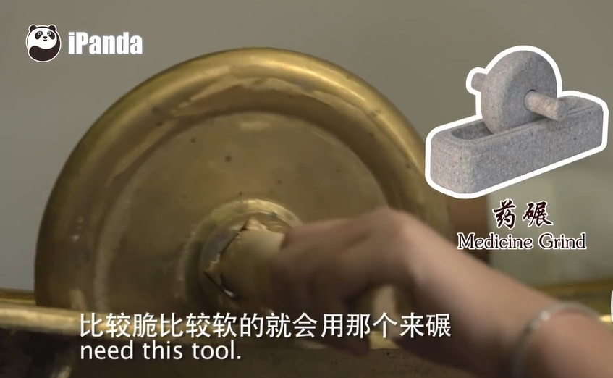

In TCM short videos, the language should prioritize the audience by being colloquial, accessible to the general public, and using short, simple sentences that are easy to understand. In this segment, the Chinese subtitles are straightforward and comprehensible, and the English translation adopts the literal translation approach, resulting in equally concise and clear subtitles. Words such as "crushing" and "grind" effectively convey the meaning of "碾," enabling target audiences, even with little knowledge of TCM, to quickly grasp the function of the "药碾" (medicine grinder) while watching the video. The visuals, through zooming in and centering on tools like the medicine grinder, allow the audience to see important details. This helps guide viewers' attention to key information, enhancing the efficiency of information absorption. The audio is used appropriately, with the host's surprised questions and the presenter's patient responses creating an emotional resonance and making the material livelier. The presenter's detailed explanations further facilitate the audience's understanding and acceptance of the content. Through the coordination of audio and video, the steps for using the medicine grinder are demonstrated in detail, allowing viewers to clearly understand each operation, and facilitating practice and learning, which aids in practical application and learning.

The video shows how to use the medication grinder, the pictures show its appearance and composition, and the text explains its use. Collectively, they successfully shaped the concept of the medicine grinder. The multi-angle presentation helps audiences in better accepting and understanding of the thematic content. At the content level, This video segment successfully combines text, graphics, video, and audio to create a multimodal translation by achieving a synergy of many modes and meanings. As a result, audiences that speak English may be able to gain a clear and comprehensive understanding of the medicine grinder, including its applications, materials, and operational methods.

**5.2 The Four Diagnostic Methods of TCM: "Inspection, Auscultation, Inquiry, and Palpation" – "Inspection"**

The following table contains part of the multimodal translation corpus extracted from the introduction video of the "Inspection" diagnostic method:

**Table 2. Multimodal Translation Corpus from the "Inspection" Diagnostic Introduction Video**

|  |  |  |  |
| --- | --- | --- | --- |
| **TCM Term** | **Chinese and English Subtitles** | **Other Multimodal Content** | **Comprehensive Multimodal Corpus Analysis** |
| 望（即望诊） | Chinese: 望诊包括了四个方面：就是神、色、形、态 English: Inspection contains four aspects: spirit, complexion, physical conditions, and actions. | Image: The scene focuses on the expert's explanation, with the expert extending four fingers. Video: The expert rolls back one finger as each aspect of observation is presented. Audio: The expert introduces steadily and in detail. | This subtitle translation uses a literal approach after fully understanding the original meaning, helping English speakers better grasp which aspects are included in the four diagnostic methods of TCM. Especially, "态" refers to actions rather than attitude, making the translation clear and concise. The expert's four fingers reinforce the idea of "4," making it clear there are four aspects. |
| Chinese: 中医认为五官对应着五脏。 English: Traditional Chinese medicine believes that the five sense organs of the face are reflections of five major inner organs. | Video: A cartoon version of a doctor wearing glasses appears, sitting at a desk labelled "中医" (Chinese Medicine). Image: The left side displays a cartoon human figure with clear facial features. | Emphasizes "TCM" or "the TCM system"; the human figure vividly illustrates the five sense organs and the corresponding five internal organs. |
| Chinese: 眼对应肝、 English: The eyes reflect the liver’s health. | Image: The cartoon human figure on the left shows the position of the liver, with a small liver illustration displayed; the right side shows the text "眼" (Eye) and "肝" (Liver) from top to bottom, corresponding to the eyes and liver on the left figure (see Figure 2). Audio: A cheerful female voice introduces the content. | The subtitle translation is brief and clear; the lively image attracts viewers' interest. |
| Chinese: 口对应脾、 English: Lips reflect the spleen. | Image: The cartoon human figure on the left shows the position of the spleen, with a small spleen illustration; the right side displays "口" (Lips) and "脾" (Spleen) from top to bottom, corresponding to the lips and spleen on the left figure. | The subtitle translation is brief and clear; "口" is translated as "lips," accurately conveying its intended meaning instead of the literal "mouth." The vivid imagery enhances understanding. |
| ... | ... | ... |
| Chinese: 因此，医生可以通过观看一个人的面部就能看出人体内部是否有健康问题。 English: Thus, a doctor can tell just by looking at the face if there is any health problem internally. | Image: A human figure displaying facial features. | The subtitle translation is concise and clear; the lively image deepens understanding. |

**Figure 2. The Eyes Reflecting Liver Health**

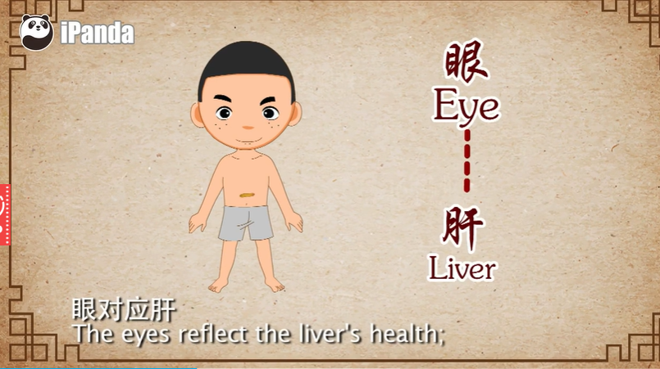

In this segment of the video, the audience may easily understand the meanings of TCM terminology thanks to the clear and basic language, and concise English subtitles that predominantly employ literal translation. Simultaneously, the translation preserves the authentic essence of TCM concepts, including the four aspects of "Inspection" and the correspondence between the five sense organs and the five internal organs. However, the target audience's horizon of expectations may be exceeded by some of the specialized terminology found in TCM culture. For example, according to TCM theory, the term "口" (which originally meant "mouth") corresponds to "唇" (lips). However, this term may fall outside the target audiences’ anticipatory horizon, due to their limited familiarity with TCM. If translated literally as "mouth," it would distort the term's intended meaning and mislead the audience. Moreover, in the accompanying visuals, "口" corresponds to "唇," which could confuse the audience, widening the aesthetic distance and making it more difficult for them to understand the idea of "口对应脾" (lips reflect the spleen). Therefore, the official translation, prioritizing the audience's perspective, renders it as "lips," ensuring accurate cross-linguistic information transmission.

The audience's visual impression is improved by the expert's hand gestures and related visual demonstrations, which vividly illustrate the four aspects of inspection and the relationship between the five sense organs and the five internal organs. The audience's comprehension and memorization of the material are reinforced by the vibrant and clear illustration of the correspondence between the five sense organs and the five internal organs through a comic-style human body diagram with identified associated organs. The interplay of static cartoon images, dynamic hand gestures, and the appearance and disappearance of subtitles creates a dynamic and captivating presentation, keeping the audience from finding the video boring. What’s more, the light and cheerful audio, combined with the visuals, fosters a pleasant emotional atmosphere, which enhances the audience's interest and engagement with the content.

The "image complements text" approach is the main approach used in this section, transforming abstract concepts into concrete representations and enriching the sensory experience. This approach enables the audience to gain a deeper understanding and facilitates more effective learning of the relevant knowledge.

**5.3 Moxibustion Video—Suspended Moxibustion**

The following table presents some of the multimodal translation data extracted from the video introducing suspended moxibustion:

**Table 3. Multimodal Translation Data from the Suspended Moxibustion Video**

|  |  |  |  |
| --- | --- | --- | --- |
| TCM Term | Chinese and English Subtitle Content | Other Multimodal Content | Comprehensive Multimodal Data Analysis |
| 悬灸(Suspended Moxibustion ) | Chinese: 现在我给您灸的是另一种灸法，叫悬灸。 English: Now I am applying suspended moxibustion on you. | Video: The doctor holds the moxibustion stick in the air, applying it to the patient. Image: The doctor is shown holding the moxibustion stick suspended above the treatment area. | The direct translation of “悬灸” as “suspended moxibustion” is very visual. However, due to cultural differences, the audience may struggle to imagine the exact context. The video visually demonstrates what suspended moxibustion looks like. |
| Chinese: 离穴位1到3厘米 English: It is normally 1cm to 3cm away from acupoints. | Video: The doctor holds the moxibustion stick 1–3 cm away from the treatment area. Audio: The doctor explains carefully. | This clearly demonstrates the distance of 1–3 cm between the moxibustion stick and the acupoints, helping viewers understand the technique. |
| Chinese: 然后顺时针方向 English: And we move it in a clockwise direction. | Video: The doctor moves the moxibustion stick in a clockwise motion. | The visual demonstration of the clockwise motion helps viewers understand how the procedure is carried out. |

**Figure 3. Image of Suspended Moxibustion**

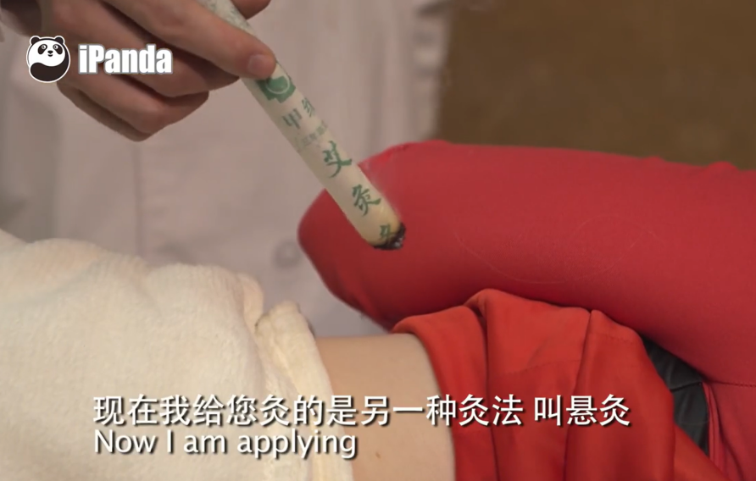

The Chinese-to-English subtitles in this video segment are concise and straightforward, and the language is expressed clearly. The audience may rapidly comprehend the equivalent English terminology in TCM thanks to the literal translation method, which raises the possibility of cross-cultural understanding. The subtitle "悬灸" is literally translated as "suspended moxibustion," which helps the intended audience in better understanding. However, the target viewers may struggle to form a clear mental image, which could cause confusion or misunderstanding, because they lack the language expertise of the source text and the cultural background of TCM. The official translation, considering the audience's perspective and their horizon of expectations, addresses the problem by providing background information in the audio and subtitles, such as the name origin of "悬灸" and the fact that the moxa stick is suspended 1-3 centimeters above the treatment area. By doing this, the audience's expectations are gently modified and the gaps in their knowledge are reduced. Combined with the video's demonstration of the specific operation of "suspended moxibustion," the audience gains a deeper understanding of its background and key operational key points.

The doctor's use of the suspended moxibustion stick creates a dynamic aesthetic, elevating the audience's viewing experience and fostering a sense of visual beauty. The picture also displays the distance between the acupoints and the moxibustion stick, giving viewers a better grasp of how it works and making the film more appealing. The patient of the physician and thorough justifications in the audio, which evokes an emotional response and increases the video's trustworthiness by letting viewers feel the doctor's professionalism and concern.

In conclusion, the visual, aural, and linguistic presentation of this multimodal content is excellent. Through a variety of techniques, it successfully illustrates the idea and workings of suspended moxibustion while simultaneously showcasing the doctor's skill and empathy. This improves the video's overall appeal and aesthetics.

**Ⅵ. Conclusion**

The integration of multimodal elements, including textual, visual, and aural components, is becoming more and more important in the digital age for the spread of ideas and information. The way audiences interact with content is shaped by multimodal discourse, which has become the dominating trend in information transmission. The international transmission of TCM culture has drawn more attention as globalization has accelerated, and the multimodal translation of TCM promotional short videos has become a crucial part of TCM culture's external communication strategy.

The study reveals that by adopting an audience-centered approach, and flexibly employing multimodal methods of information delivery, the translated text may align with the audience's expectations while maintaining an appropriate aesthetic distance, thereby balancing cultural authenticity and accessibility, further promoting the global spread of TCM culture. Multimodal translation can significantly enhance the comprehension and acceptance of the target audience. Under the guidance of reception aesthetics, translators prioritize the sensory experience of the target audience may ensure that the translated content resonates with their cultural and linguistic expectations. This allows for the preservation of TCM cultural elements to attract viewers without imposing excessive aesthetic burdens, thus presenting TCM culture succinctly and effectively. To meet the demands of the TCM cultural translation market in short videos, translators must not only possess solid professional knowledge of TCM but also enhance their translation skills, cultural literacy, audience awareness and multimodal-information-organization ability.

However, this research has limitations: the sample size is limited, necessitating an expansion of the research scope to include a broader range of subjects; and audience reception is limited by the absence of section-specific audience feedback data. Future research could involve a greater data pool and integrate advanced capabilities such as search ability, information organization ability, data analysis, and artificial intelligence technologies to explore the development and application of automated multimodal translation tools. Such advancements would further improve the efficiency and effectiveness of TCM culture dissemination, fostering greater global appreciation and understanding of its value.

**References**

1. Chen, R. (2021). Research on translation strategies for corporate blockchain white papers from the perspective of reception aesthetics. Jiangsu Foreign Language Teaching and Research, (01), 64-66.
2. Chen, W. (2018). An overview of reception aesthetics and translation studies in China. Journal of Kunming University of Science and Technology (Social Sciences Edition), 18(01), 90-98.
3. Feng, D. (2017). Basic questions of multimodal discourse analysis. Journal of Beijing International Studies University, 39(03), 1-11+132.
4. Gao, Y. (2019). Translating abstracts of research articles on Chinese medicine from the perspective of target audience’s awareness. Journal of Basic Chinese Medicine, 25(09), 1303-1306.
5. Huang, G., & Zhu, L. (2018). A case study of intersemiotic translation based on Confucius Speaks. Shanghai Journal of Translators, (1), 84-88.
6. Iser, W. (1987). The Act of Reading: A Theory of Aesthetic Response. Baltimore and London: The Johns Hopkins University Press.
7. Jauss, H. R. (1989). Toward an Aesthetic of Reception. Minneapolis: University of Minnesota Press.
8. Ju, X. (2020). 视觉语法视角下公益广告的多模态话语分析——以《没有医院就没有希望》公益广告为例 [Multimodal discourse analysis of public service advertisements from the perspective of visual grammar: A case study of the advertisement "Without hospitals, there is no hope"]. Today's Massmedia, (2), 88-90.
9. Ketola, A. (2016). Towards a multi-modally oriented theory of translation: A cognitive framework for the translation of illustrated technical texts. Translation Studies, 9(1), 69.
10. Kress, G., & van Leeuwen, T. (2001). Multimodal Discourse: The modes and media of contemporary communication. London: Edward Arnold.
11. Li, M. (2009). Subtitle translation of the movie In the Heat of the Sun in a multimodal context. Movie Literature, (7), 150-151.
12. Li, Z. (2003). Social semiotic approach to multimodal discourse. Foreign Languages Research, (05), 1-8+80.
13. Liu, G. (2023). 论新媒体环境下面向受众的中国文化对外翻译 [On the translation of Chinese culture for foreign audiences in the new media environment]. Cultural Journal, (11), 199-204.
14. Liu, J., & Hu, K. (2015). The compilation and use of multimodal interpreting corpora. Foreign Languages in China, (5), 77-85.
15. She, D., & Jiang, X. (2021). A study on the English translation of traditional Chinese medicine culture in Dream of the Red Chamber from the perspective of reception aesthetics. Journal of Jiamusi Vocational Institute, 37(08), 87-88.
16. Wang, J. (2019, December 2). People's Daily comment: Equal emphasis on traditional Chinese and Western medicine, letting the ancient gem shine again. Retrieved from <http://opinion.people.com.cn/n1/2019/1202/c1003-31483858.html>
17. YouTube. (2018). [Traditional Chinese Medicine]. Retrieved from <https://www.youtube.com/playlist?list=PLjyx3gz4xlUGfes3UwXnS6BUf0K3sBG9H>
18. Zhang, D. (2009). 多模态话语分析综合理论框架探索 [On a synthetic theoretical framework for multimodal discourse analysis]. Foreign Languages in China, 6(01), 24-30.
19. Zhang, D., & Wang, L. (2010). The synergy of different modes in multimodal discourse and their realization in foreign language teaching. Foreign Language Research, (2), 97-102.
20. Zhou, Y., & Liu, Q. (2021). 新时代视域下中医药翻译原则 [Principles of TCM translation in the new era]. Overseas English, (19), 232-233.
21. Zhu, Y. (2007). Theory and methodology of multimodal discourse analysis. Foreign Language Research, (5), 83.