**Petroleum Hydrocarbons from Artisanal Refinery in Niger Delta and Impact on Surface Water Quality**

**ABSTRACT**

Artisanal petroleum refining in Nigeria is considered an organized and well-orchestrated environmental crime that is propelling disputes and security problems within the Niger Delta. This work therefore sought to determine the amount of hydrocarbon incursion into the marine ecosystems located in the vicinity of artisanal refineries. Surface water samples were collected from previously identified areas of Emuoha, Etche, and Eleme Local Government Areas of Rivers State, and a reference control sample was collected from Omuma Local Government Area. The samples were later taken to the laboratory for hydrocarbon analyses. Total petroleum hydrocarbon (TPH) and polycyclic aromatic hydrocarbons (PAHs) were determined using Agilent 6890N Gas Chromatograph - Flame Ionization Detector (GC-FID) instrument. The highest TPH concentration of 1,913.6 mg/l was recorded in the samples from the artisanal refining area of Emuoha. PAHs varied in different concentrations with the highest concentration of 172.42mg/l of phenathrene recorded in Etche. Data obtained provided insight into the varying distribution of PAHs across different water sources, highlighting the potential pollution hotspots, particularly in Eleme and Etche, where higher concentrations of multiple PAHs were recorded. The affected areas of Eleme and Etche are critical zones requiring urgent environmental and health interventions; Emohua showed relatively lower risk. Exposure to petroleum hydrocarbons can lead to severe health complications, including respiratory problems due to inhalation of volatile compounds, skin and eye irritation from direct contact, and long-term carcinogenic effects from prolonged exposure to PAHs. There is need to implement effective policies, pollution control strategies, and community health protection measures in the study areas to mitigate the associated public health risks.

**Keywords:** Total petroleum hydrocarbons (TPH); Polycyclic Aromatic hydrocarbons (PAHs); Artisanal petroleum refining; Rivers State; Niger Delta; Surface water quality

1. **INTRODUCTION**

Surface water is the ubiquitous source for the majority of water needs, including drinking and domestic purposes, industrial and research activities, irrigation and agricultural production, horticulture, livestock farming and aquatic life management including fish and fisheries (Syeed et al., 2023). The decline in surface water quality has become a global issue of concern because of its inherent ability to cause major alterations to the hydrological cycle (Chapman, 1996; Olubukola, 2021). Polluted water is an important vehicle for the spread of diseases. In developing countries about 1.8 million people, mostly children, die every year as a result of water-borne diseases (WHO, 2004). Impaired surface water quality always results in an unhealthy socio-economic environment (Dojlido and Best, 1993; DeZuane, 1997). The quest for survival as well as the unprecedented increase in population and rapid rate of urbanization have resulted to all sorts of despoliation of the environment. (Osuji and Achugasim, 2007)

In Nigeria, the Niger Delta region has been the worse-hit by these activities because the region is a rich reservoir petroleum hydrocarbon which produces crude oil. Over the past decades since the commercial discovery of crude oil in Nigeria in 1956, the Niger Delta region, has been associated with crude oil extraction and production in her oil-bearing communities (Ogbuigwe, 2018). However, the marginalization of the host communities has historically fuelled non-violent and violent protests across the region. Violent protests have often straddled communal conflict, insurgency, and criminal acts such as the sabotage of oil installations, crude oil theft, and the artisanal refining of illegally tapped crude oil by local small-scale operators. According to Nigeria’s National Oil Spill Detection and Response Agency (NOSDRA), oil theft cases represent 84 per cent of the primary causes of oil spill, with the first half of 2024 witnessing the highest rate (NOSDRA, 2025). NOSDRA also reported that between 2021 and 2024, a total of 2,654 incidents were recorded. The challenges of crude oil theft and its impact on terrestrial and aquatic eecosystems are enormous (Collins and Wali, 2020).

Crude oil theft and the illegal refining of stolen crude oil have also been adopted as a form of protest by indigenous ethnic minority groups agitating for oil resource control (Collinns and wali, 2020; Sam et al., 2024; NOSDRA, 2025). The result of the stolen crudes and the refining thereof is the onset of artisanal refineries in the niger delta. This has led to pollution of the aquatic systems located within the vicinity of the operations. Water bodies in these areas which constitute the blue space of the Niger delta and source of recreation and biodiversity, have either been contaminated or polluted. Unfortunately, polluted water is an important vehicle for the spread of diseases. In developing countries about 1.8 million people, mostly children, die every year as a result of water-borne diseases (WHO, 2014; Richard et al., 2023).

The most mobile or perhaps widest spread pollutant associated with artisanal refining is petroleum hydrocarbons. These complex chemical compounds majorly consist of paraffinic, naphthenic and aromatic hydrocarbons. The aromatics, especially the polycyclic aromatic hydrocarbons (commonly called PAHs) are very recalcitrant and can spread trough the atmosphere, and finally deposited on the water bodies (Sam et al., 2023). In water management practices, water quality values serve as useful and sensitive indicators of changes in the physical, chemical or biological composition of the overall water status (Cambers and Ghina, 2005). The study therefore was aimed at evaluating the presence of petroleum hydrocarbons in the surface water of some areas in Rivers associated with artisanal refining. Data obtained via assessment and monitoring of water quality provide empirical evidence that can assist health and environmental decision making.

**2. MATERIALS AND METHODS**

**2.1 Description of the study area**

**2.1.1 Geo-characteristics of study area**

Four local government areas (Emuoha, Etche, Eleme and Omuma) were selected out of the 25 constituent local government areas of Rivers State (Fig. 1). These areas belong to the drier “upland” area of the State which constitutes 61% of the landmass. This area witnesses two major seasons which are the dry and the rainy seasons. The average humidity of the area is 88 percent while the total annual rainfall in the LGA is 3600 mm. The entire topography of the State is characterized by a maze of effluents, rivers, lakes, creeks, lagoons and swamps criss-crossing the coastal lowland and tidal systems. The area is characterized by high rainfall, which decreases from south to north. Total annual rainfall decreases from about 4,700 mm on the coast to about 1,700 mm in extreme north of the State.

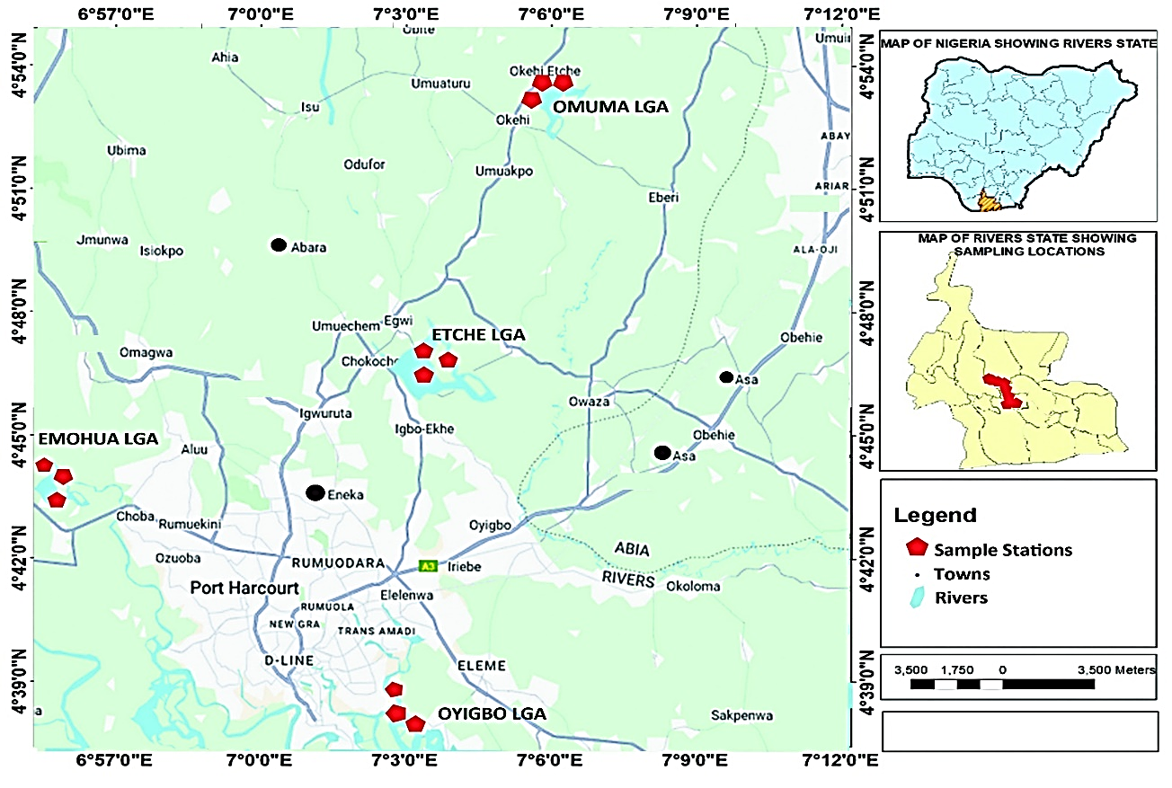

**Fig. 1. Map of study area showing the location where samples were collected**

 Mean maximum monthly temperatures range from 28°C to 33°C, and relative humidity is high throughout the year but decreases slightly in the dry season. An overwhelming majority of the people of the study area are involved in two primary activities: farming and fishing, and the fishing population is almost exclusively dominated by artisanal fishermen (Ogbonna et al., 2023).

**2.1.2 Field reconnaissance survey and sample collection**

Field reconnaissance surveys of Emoha, Etche, Eleme, and Omuma Local Government Areas of River state in the Sothern Niger Delta province of Nigeria (Fig 1) was carried out with a view to locate areas where artisanal refining (Kpo-fire) was taking place. Water bodies were located within such vicinities and mapped out as potential sample locations (Ogbonna et al., 2023). Sampling was later carried in the designated locations with the assistance of a field Guide, after appropriate security clearance. Of the four LGAs where samples were collected, Omuma LGA was used as reference control since reconnaissance revealed that the area was not prone to artisanal petroleum refining.

Water samples were later collected from the streams at the designated locations. Plate 1 shows a cross-sectional view of one of the sites used for this study. The sterilized samples bottles were rinsed three times with the sample water before collection, and nitric acid (HNO₃) is added to adjust the pH to below 2 for preservation. The bottles containing the samples were corked, clearly labelled and taken to the laboratory where they then stored at 4°C until analysis was carried out

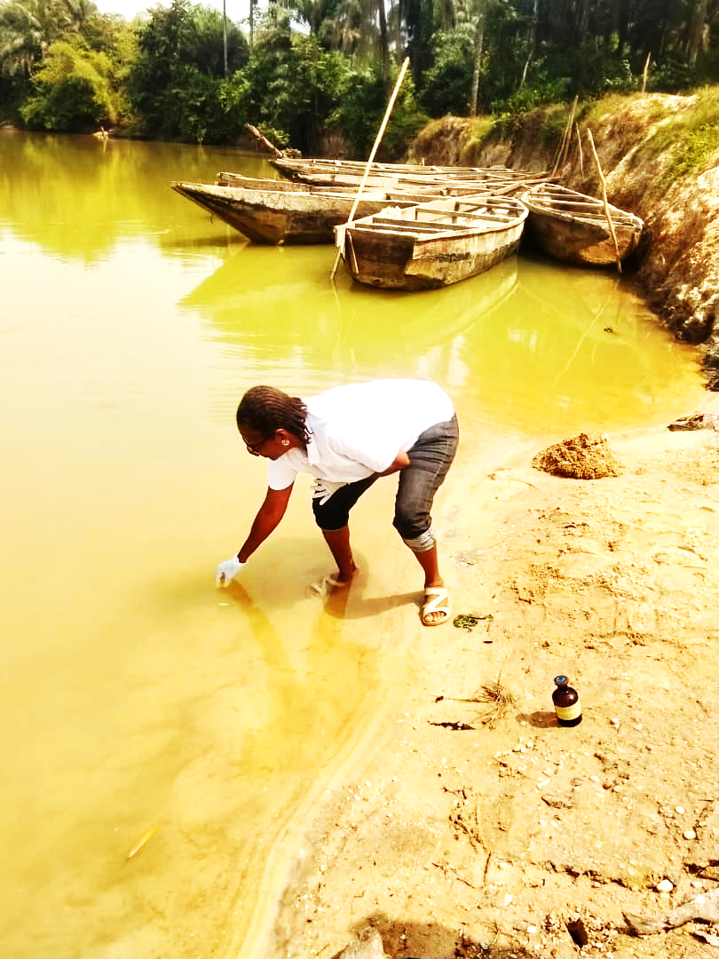

**Plate 1: A cross-sectional view of one the study sites in Rivers State, Nigeroia**

**2.2 Description of artisanal petroleum refinery**

Artisanal refining also known as “Kpofire” as colloquially called is a small-scale or subsistent distillation of crude petroleum over a specific range of boiling points, to produce useable products such as kerosene, fuel and diesel (Oke, 2020). The operation involves the use of rudimentary equipment to process the illicitly obtained crude oil. Figure I is one of the sites of artisanal refining camp in Rivers State. At this camp, the crude oil is allowed 3 h in storage facilities (Fig. 2) to allows for gas content reduction by evaporation, after which it is fed into the refining oven, where heat is generated to different degrees to enable separation of the mixture into fractions according to their boiling points (distillation process). Vapours from the boiling crude oil are channelled out of the oven by means of several pipes connected through a condenser or cooler (Figure 1), from where a single pipe with larger diameter conveys the condensed product to the receiver in which the desired products are collected

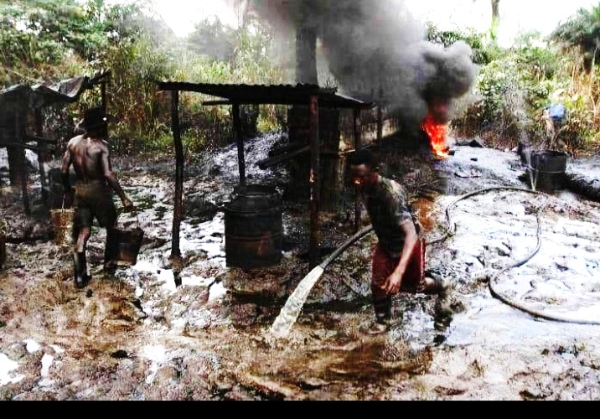

**Plate 2. An artisanal refining site or camp in the study area of Rivers State in Niger Delta, Nigeria**

This type of Illegal oil refining operation (cf: Plate 2) is considered organized and well-orchestrated environmental crime that is propelling disputes and security problems within Niger Delta. According to report by UNEP in 2011 on the environmental impact of oil production in Ogoniland, illegal refining operations are the main reason for water and air contamination in this area, with dangerous impact on health and the entire bionetwork system (UNEP, 2011). Artisanal refining has also led to the destruction of fish habitats in the mangroves of the Niger Delta and high levels of contamination of the swamps and rivers making them unsuitable for fishing (Bebeteidoh et al., 2020).

**2.3 Petroleum hydrocarbon analyses**

Fifty milliliters (50ml) of water sample was measured with a measuring cylinder, into a separatory flask. 50ml of DCM was added in a ratio of 1:1. The sample was shaken vigorously and vent to remove excess pressure and allowed to settle for 2minutes. Solvent phase was extracted and the sample was dried by adding 5g of anhydrous sodium sulphate. The sample was concentrated into 2ml volume by passing through a gentle stream of Nitrogen gas or rotary evaporator, and fractionated into Aliphatic and Aromatic using column chromatography packed with glass wool and silica gel. The packed column was preconditioned with hexane. For Aliphatic (TPH), 2ml of the concentrate was introduced into the column and eluted with 10ml of hexane. The eluent was further concentrated into final 2ml volume. The final 2ml was introduced into a vial bottle and capped. The sample was ready to be run with GC. For Aromatics (PAH), to the same column, 10ml of DCM was introduced and eluted. The 10ml eluents was further concentrated into a final 2ml. The final 2ml was introduced into a vial bottle and capped. The sample was ready to be run with GC.

**2.2.1 Sample separation and detection**

The separation and detection of compounds in the samples were carried out using Agilent 6890N Gas Chromatograph - Flame Ionization Detector (GC-FID) instrument. The amount of PAH and TPH was resolved at a particular chromatogram in ppm (mg/l)

**2.2.2 Quality Control**

1. The instrument was allowed to attain the set temperature for the method.
2. The column was baked by pressing oven temperature on the GC, then the desired temperature was regulated not beyond oven temp limit. After baking for 1hr re-set oven temperature back to the initial state.
3. The instrument was allowed to attain set temperature.
4. A solvent blank was run for the method to be analyzed (PAH=DCM, TPH=hexane, BTEX=methanol).
5. A standard was run and monitored to make sure the result obtained for the standard corresponds with the previous standard used to calibrate the instrument.
6. Gas Chromatograph equipment calibration was performed within 6months or when there is a major maintenance which affects the hardware or software and when calibration material is different from the stored calibration.
7. Standards 5.0mg/l (or 50mg/kg) for low range and 20mg/l (or 200mg/kg) for high range were chosen as quality control standard.
8. For every batch of samples analyzed, one spike analysis was carried out, low or high depending on the concentration range of the sample analyzed.

Spiking: To a known weight of the sample e.g. 5g

A concentration of TPH or PAH was added which was at least 10 times the concentration of the MDL e.g. 0.5mg spiked sample was treated the same way as the sample.

Expected Concentration = 0.5mg /5g X 1000

= 100mg/kg

Percentage Recovery = (Spike sample result – Sample result) / Expected result X 100

1. For every 10 samples or each batch of samples, whichever is less, one of the samples was analysed with low concentration or one sample with high concentration as a duplicate. The acceptable limit for low concentration samples is 75% to 125% while for high concentration samples (repeatability) is 90 to 110%. If the duplicate analysis exceeds the limit, the analysis was repeated.

Repeatability = [1 - (X1 - X2)/Mean] x 100%

Where:

Mean = (X1 + X2)/2, mg/kg

X1 = TPH content in sample, mg/kg

X2 = TPH content in duplicate sample, mg/kg

For every 10 samples or each batch of samples, whichever is less, a mid-point check standard or any other standard was analyzed to ensure that calibration has not drifted. If the mid-point check standard is outside 95 to 105% of the expected concentration, the analysis was repeat.

**3. RESULTS AND DISCUSSION**

Total Petroleum Hydrocarbon (TPH) concentrations across different sampling locations in Omuma, Eleme, Etche, and Emohua, as well as a Main Stream site area contained in Table 1, while the polycyclic aromatic hydrocarbons (PAHs) are contained in Table 2.. TPH is a measure of petroleum contamination in environmental samples, commonly associated with oil spills, industrial discharges, and hydrocarbon pollution sources. In general, the highest recorded TPH concentration is found at Eleme Downstream (8626 mg/l), suggesting significant petroleum pollution in this location. On the other hand, the lowest TPH concentration is observed at the Main Stream (250.3 mg/l), which is drastically lower than all other sites. This could imply that the main stream is relatively free from hydrocarbon contamination, possibly benefiting from better dilution and self-purification processes. Omuma Upstream recorded the highest TPH concentration of 4636 mg/l in the Omuma area, indicating a potential contamination source upstream. Both Omuma Downstream (4147 mg/l) and Omuma Midstream (3829 mg/l) showed slightly lower but still significant contamination levels, with a slight decrease downstream that might suggest natural degradation, dilution, or sedimentation of hydrocarbons. In the Eleme region, Eleme Downstream (8626 mg/l) exhibited the highest TPH concentration in the entire dataset, pointing to a major pollution source or accumulation in this location. Eleme Upstream with TPH concentration of 5630 mg.l and Eleme Midstream with 4814 mg/l also had high TPH levels, but there is a slight decrease midstream before a drastic rise downstream. The increasing contamination downstream suggests that pollution sources may be located midstream, with accumulation occurring in the downstream section.

In Etche, both Etche Midstream (6343 mg/l) and Etche Downstream (6343 mg/l) had identical TPH values, suggesting stable contamination levels. Etche Upstream (3403 mg/l) has significantly lower TPH levels, implying a source of contamination between the upstream and midstream sites. In Emohua, Emohua Upstream (2859 mg/l) had the lowest TPH value in this region, while Emohua Midstream with TPH concentration of 3710 mg/l showed an increase, indicating possible hydrocarbon input between upstream and midstream

**3.1 TPH levels across sampled locations**

The numerical values across various locations and categories (as presented in Table 1 and Figures 2-5), represent concentrations of substances or measurements at different sampling points. Referring to the total values, some key observations emerge. The highest recorded value in the dataset is 1914 mg/l at Eleme Downstream (C18), suggesting a significant peak in concentration at this location. Other high values include 1614 mg/l at Eleme Downstream (C10) and 1479 mg/l at Eleme Upstream (C15), reinforcing Eleme as a hotspot for high readings. Comparing locations, Eleme Downstream consistently shows elevated values across multiple categories, indicating a potential concentration of contaminants or elements. Etche Downstream and Midstream also exhibit relatively high values, particularly in categories C9, C13, C15, C18, and C19. Omuma Downstream and Upstream display a mix of moderate and high values, with notable figures such as 891.3 mg/l (C8) and 986.1 mg/l (C10) in Omuma Upstream.

On the other end of the spectrum, some locations have multiple dashes, indicating either the absence or undetectable levels of certain elements. The smallest recorded positive number is 26.85mg/l at Main Stream (C12), demonstrating very low presence in that category. Examining distribution patterns, Main Stream exhibits consistently lower values across most categories, suggesting minimal impact. In contrast, Omuma, Etche, and Emohua show varied intensities, with peaks appearing in specific categories rather than across all measurements. From these observations, Eleme Downstream appears to be the most affected site, recording the highest values and multiple peaks across different categories. Main Stream remains relatively stable with lower values, while Omuma, Etche, and Emohua present fluctuating intensities. If these figures represent pollution levels, the data suggests that industrial or anthropogenic activities might be more concentrated in Eleme and Etche regions.

**Table 1: TPH LEVELS ACROSS SAMPLED LOCATIONS**

|  |  |  |  |  |  |  |  |  |  |  |  |  |
| --- | --- | --- | --- | --- | --- | --- | --- | --- | --- | --- | --- | --- |
|  | Omuma Down Stream | Omuma Midstream | Omuma Upstream | Eleme Upstream | Eleme Mid-stream | Eleme Downstream | Etche Downstream | Etche Mid Stream | Etche Upstream | Emohua Upstream | Emohua Midstream | Main stream |
| C8 | - | - | 891.35159 | - | - | 847.25136 | - | - | - | - | - | - |
| C9 | - | - | - | 1210.7481 | 748.4931 | - | 548.36119 | 548.36119 | - | - | 755.4154 | 63.63721 |
| C10 | 1114.47217 | 1012.47311 | 986.05894 | - | - | 1613.86942 | - | - | 551.6849 | 411.5371 | - | - |
| C11 | - | - | - | - | 490.1527 | - | - | - | - | - | - | - |
| C12 | 858.24859 | 788.24859 | - | 578.87362 | - | - | - | - | 782.1421 | 719.8563 | 973.5831 | 26.85396 |
| C13 | - | - | - | - | 926.2186 | 1146.14251 | 864.49281 | 864.49281 | - | - | - | - |
| C14 | - | - | 774.13683 | 791.38496 | - | - | - | - | - | 315.1396 | 669.1427 | - |
| C15 | - | - | - | 1479.1453 | - | - | 713.37853 | 713.37853 | 974.7319 | - | 524.9535 | 42.13014 |
| C16 | 317.15291 | 501.15091 | 652.47118 | - | 839.442 | 1552.96802 | 421.01462 | 421.01462 | - | 530.4131 | - | - |
| Pr | - | - | - | - | - | - | - | - | - | - | 349.0139 | 33.52583 |
| C17 | - | - | 420.21542 | - | - |  | 895.85735 | 895.85735 | - | 395.3179 | - | - |
| C18 | - | - | 911.85351 | 678.59785 | 1042.257 | 1913.62835 | 767.13043 | 767.13043 | - | - | - | 46.17461 |
| Ph | - | - | - | - | - | - | - | - | - | - | - | - |
| C19 | 575.41305 | 475.41305 | - | - | - | 1552.14871 | 978.85138 | 978.85138 | 653.241 | 487.2135 | 438.3518 | 37.95538 |
| C20 | - | - | - | 891.14628 | - | - | - | - | 441.4296 | - | - | - |
| C21 | 1281.64711 | 1051.64712 | - | - | 767.3586 | - | 1154.24167 | 1154.24167 | - | - | - | - |

**3.2 Level of PAHs across study locations**

The chats below presents the concentration levels of various polycyclic aromatic hydrocarbons (PAHs) across different sampling locations, namely Omuma, Eleme, Etche, and Emohua (Table 2) contain measurements taken at upstream, midstream, and downstream points within each area. The PAHs include Naphthalene, Acenaphthylene, Acenaphthene, Fluorene, Phenanthrene, Anthracene, Fluoranthene, Pyrene, Benz(a)anthracene, Chrysene, Benzo(b)fluoranthene, Benzo(k)fluoranthene, and Benzo(a)pyrene (cf: Table 2).

Naphthalene levels vary significantly, with the highest concentration recorded at Eleme Midstream (136.6 mg/l), followed by Emohua Midstream (148.7 mg/l). It is absent in Omuma Upstream, Eleme Downstream, and Etche Midstream and Upstream. Acenaphthylene is detected at most locations, with the highest concentration at Etche Upstream (139.6 mg/l), whereas it is absent in Eleme Midstream and Emohua Midstream and Downstream. Acenaphthene appears only in Etche Upstream (44.30 mg/l), Emohua Upstream (94.30175), and Emohua Downstream (134.4 mg/l), showing its limited presence.

Fluorene is prominent in Omuma Upstream (98.04 mg/l) and Eleme Midstream (82.91 mg/l), whereas it is absent at several points, including Eleme Upstream and all Emohua locations. Phenanthrene reaches its peak in Etche Upstream (172.4 mg/l) and Midstream (152.4 mg/l), whereas it is undetected at Eleme Upstream and Downstream, and Omuma Midstream. Anthracene is found at select locations, including Eleme Upstream (96.24 mg/l) and Midstream (98.69 mg/l), along with Etche Downstream (82.85 mg/l) and Midstream (83.62 mg/l), but is absent elsewhere.

Fluoranthene is recorded only at Eleme Midstream (54.15 mg/l) and Etche Downstream (111.2 mg/l). Pyrene shows significant variability, peaking at Omuma Upstream (157.9 mg/l) and Emohua Midstream (124.1 mg/l), while absent in several areas. Benz(a)anthracene appears in Etche Downstream (42.06 mg/l, Etche Midstream (40.06 mg/l), and Emohua Upstream (115.5 mg/l), but is missing from all Omuma and Eleme locations.

Chrysene is widespread, with high values in Omuma Upstream (189.4 mg/l), Etche Downstream (171.2 mg/l), and Eleme Midstream (116.3 mg/l), though absent in some locations like Emohua Downstream. Benzo(b)fluoranthene is completely undetected across all locations. Benzo(k)fluoranthene appears in Omuma Downstream (21.95 mg/l) and Midstream (19.85 mg/l) but is absent elsewhere. Lastly, Benzo(a)pyrene is observed in Eleme Upstream (81.51 mg/l) and Midstream (152.53849), as well as Etche Midstream (72.14628) and Upstream (75.14628), while it is missing from most Omuma locations.

This data provides insight into the varying distribution of PAHs across different water sources, highlighting potential pollution hotspots, particularly in Eleme and Etche, where higher concentrations of multiple PAHs are recorded.

**Fig 2: Level naphthalene across the sampled stations**

**Fig 3: Level of acenapthene across the sampled stations**

**Fig 4: Level of phenanthrene across the sampled stations**

**Fig 5: Level benzo(a)pyrene across the sampled stations**

The Figures represent the distributions of both the low molecular weight PAhs (such as Naphthalene) and the high molecular weight of these PAHs (such as Benzopyrene) across the sampled areas contained in Figs 2 and 5 respectively. The chromatograms for total petroleum hydrocarbons and polycyclic aromatic hydrocarbons are shown in Figures 6 and 7 respectively

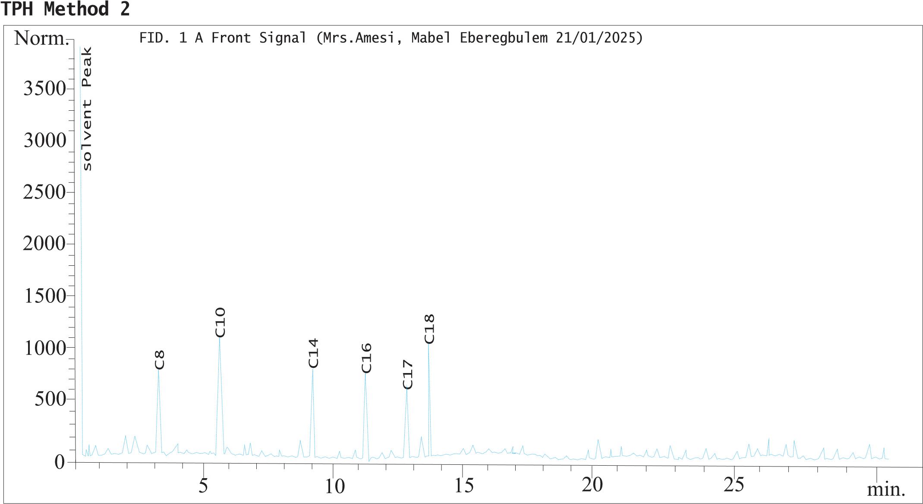

**Fig 6: Representative chromatogram of TPH of one of the sampled stations**

**Fig. 7: Representative chromatogram of PAHs of one of the sampled stations**

50

0

5

10

15

20

25

30

min.

100

150

200

250

300

350

~~.~~

Norm

Acenapthylene

Naphthalene

Solvent peak

Benzo(a)pyrene

Anthracene

Pyrene

Chrysene

FID. 1 A Front Signal (Mrs. Amesi Mabel Eberegbulem 20/01/2025)

**Table 2:** **Summary of PAHs Levels across Study Locations**

|  |  |  |  |  |  |  |  |  |  |  |  |  |
| --- | --- | --- | --- | --- | --- | --- | --- | --- | --- | --- | --- | --- |
|  | Omuma Downstream | Omuma Midstream | Omuma Upstream | Eleme Upstream | Eleme Mid-stream | Eleme Downstream | Etche Down Stream | Etche Midstream | Etche Upstream | Emohua Upstream | Emohua Midstream | Emohua Downstream |
| Naphthalene | 53.85902 | 56.95902 | - | 86.73918 | 136.6027 | - | 53.64283 | - | - | 36.25039 | 148.712 | - |
| Acenapthylene | 71.35181 | 69.35181 | 132.8632 | 131.8018 | - | 3.17401 | 48.21305 | 39.58193 | 139.58193 | - | - | 72.85613 |
| Acenapthene | - | - | - | - | - | - - | - | 44.30175 | 94.30175 | - | - | 134.35726 |
| Fluorene | 40.73615 | 38.70655 | 98.04156 | - | 82.90638 | 8.53185 | 76.73513 | - | - | - | - | - |
| Phenanthrene | 26.09804 | 24.19704 | 77.25146 | - | 121.2514 | - | - | 152.41859 | 172.41859 | 84.59183 | 95.40185 | - |
| Anthracene | - | - | - | 96.24108 | 98.69301 | - | 82.85498 |  | 83.62513 | - | 69.71636 | - |
| Fluoranthene | - | - | - | - | 54.14638 | - | 111.1572 | - | - | - | - | - |
| Pyrene | 32.37102 | 30.35102 | 157.9401 | 75.35171 | 78.01627 | - | - | - | - | 52.36054 | 124.0826 | 98.21048 |
| Benz(a)anthracene | - | - | - | - | - | - | 42.05803 | 40.05643 | - | 115.4822 | - | - |
| Chrysene | 64.54726 | 62.34726 | 189.4369 | 68.0592 | 116.2691 | 5.95083 | 171.1675 | 151.94174 | 151.94174 | 61.63958 | 87.5161 | 87.51847 |
| Benzo(k)fluoranthene | 21.95017 | 19.85217 | - | - | - | - | - | - | - | - | - | - |
| Benzo(a)pyrene | - | - | - | 81.51471 | 152.5385 | - | - | 72.14628 | 75.14628 | - | 119.7433 | - |

**4. CONCLUSION**

The findings of this work highlight Eleme Downstream, Etche Downstream, and Omuma Upstream as critical zones requiring urgent environmental and health interventions, while Emohua Downstream and Main Stream show relatively lower risk. Understanding these risk variations is crucial for implementing effective policies, pollution control strategies, and community health protection measures. Exposure to hydrocarbons can lead to severe health complications, including respiratory problems due to inhalation of volatile compounds, skin and eye irritation from direct contact, and long-term carcinogenic effects from prolonged exposure to polycyclic aromatic hydrocarbons (PAHs). Contaminated water sources can also contribute to gastrointestinal issues and organ damage. The possible sources of contamination in high-risk areas such as Eleme Downstream, Etche Downstream, and Omuma Upstream may include industrial pollution from refineries and chemical plants, oil spills and pipeline leakages in oil-rich regions, and urban or agricultural runoff carrying harmful hydrocarbons into water bodies. To mitigate these risks, regular environmental monitoring should be conducted to track contamination trends, while stricter pollution control measures must be enforced to regulate industrial and petroleum discharges. Water treatment strategies should be implemented to ensure safe drinking water, and local communities should be educated on the risks of hydrocarbon exposure and protective measures.

**REFERENCES**

Bebeteidoh, O.L., Kometa, S., Pazouki, K., Norman, R., 2020. Sustained impact of the activities of local crude oil refiners on their host communities in Nigeria. Heliyon, 6 (6), e04000, <https://doi.org/10.1016/j.heliyon.2020.e04000>.

Cambers G., Ghina, F., 2005. Water Quality, an Introduction to Sandwatch. An Educational Tool for Sustainable Development. United Nations Educational, Scientific and Cultural Organization (UNESCO): Paris, France. p. 25-31.

Chapman D, (ed.). 1996.Water Quality Assessments: A Guide to the Use of Biota, Sediments and Water. Environmental Monitoring. Second Edition. UNESCO, WHO, and UNEP. E&FN Spon, London UK. <https://doi.org/10.1201/9781003062103>

Collins, W., Wali, E., 2020. Crude Oil Theft in the Niger Delta: The Oil Companies and Host Communities Conundrum. International Journal of Research and Scientific Innovation (IJRSI) 7(I), 22-32

DeZuane, J., 1997. Handbook of Drinking Water Quality. John Wiley & Sons. 575p. <https://doi.org/10.1002/9780470172971>

Dojlido, J., Best, G.A., 1993. Chemistry of Water and Water Pollution. Ellis Horwood Limited. New York. 544p. <https://books.google.com.ng/books?id=hCRSAAAAMAAJ>

Jiang, J., Tang, S., Han, D., Fu, G., Solomatine, D., Zheng, Y., 2020. A comprehensive review on the design and optimization of surface water quality monitoring networks. Environmental Modelling & Software, 132, 104792. <https://doi.org/10.1016/j.envsoft.2020.104792>.

NOSDRA., 2025. Oil theft responsible for most crude spills. A publication of the National oil Spill Response and Detection Agency, January 26, 2025.

Ogbonna, D.N., Anthony, E.M., Kpormon, L.B., 2023. Physicochemistry and Microbiological Quality of Surface Water Body around Port Terminals in Southern Nigeria. Microbiol. Res, 33(2),.54-60.

Ogbuigwe, A. Refining in Nigeria: history, challenges and prospects. Appl Petrochem Res 8, 181–192 (2018). <https://doi.org/10.1007/s13203-018-0211-z>

Oke, M. (2020). Investigation of air emissions from artisanal petroleum refineries in the Niger-Delta Nigeria. Heliyon. <https://doi.org/10.1016/J.HELIYON.2020.E05608>

Olubukola A.A.R, Edet, E.E., Emmanuel, G.O., 2021. Application of Water Quality Index for the Assessment of Water from Different Sources in Nigeria. Promising Techniques for Wastewater Treatment and Water Quality Assessment. <http://dx.doi.org/10.5772/intechopen.98696>.

Onuigbo, B.S., Osuji, L.C., Onojake, M.C., 2025b. Petroleum hydrocarbon pollution in Bonny creek six months after the oil spill from the Fusokiri-6 manifold in the Niger Delta. Asian Journal of Current Research 1-(1), 202-21616 (2), 1-9. [https://doi.org/10.56557/ajocr/2025/ v10i19155](https://doi.org/10.56557/ajocr/2025/%20v10i19155)

Osuji, L. C. and Achugasim, O. 2007. Environmental degradation of polluting aromatic and aliphatic hydrocarbons: A case study Chemistry and Biodiversity 4, 424-429. [https://doi.org/ 10.1002/cbdv.200790034](https://doi.org/%2010.1002/cbdv.200790034)

Richard, G., Izah, S., Raimi, M., Austin-Asomeji, I., 2023. Public and environmental health implications of artisanal petroleum refining and risk reduction strategies in the Niger Delta region of Nigeria. Bio-research 21(1):2705-3822. <https://doi.org/10.4314/br.v21i1.12>

Sam, K.S., Onyena, A.P., Zabbey, N., Odoh, C.K., Nwipie, G.N., Nkeeh, D.K., Osuji, L.C., Little, D.I., 2023. Prospects of emerging PAH sources and remediation technologies: insights from Africa. Environmental Science and Pollution Research 30 (14), 39451-39473. <https://doi.org/10.1007/s11356-023-25833-9>

Sam, K., Pegg, S., Oladejo, A.O., 2024. Mining from the pipeline: Artisanal oil refining as a consequence of failed CSR policies in the Niger Delta. Journal of Environmental Management, 352. <https://doi.org/10.1016/j.jenvman.2024.120038>

Syeed, M.M.M., Hossain, Md.S., Karim, Md.R., Uddin, M.F., Hasan, M., Khan, R.H., 2023. Surface water quality profiling using the water quality index, pollution index and statistical methods: A critical review. Environmental and Sustainability Indicators, 18, 100247. <https://doi.org/10.1016/j.indic.2023.100247>.

[UNEP., 2011. Report on Environmental Assessment of Ogoniland. United Nations Environmentak Programme Repot. https://www.unep.org.](C:\\Users\\PAC2\\Desktop\\bluetooth downloads\\UNEP. 2011. United Nations Environmentak Programme Repot.  https:\\www.unep.org)

World Health Organization. Water, sanitation and hygiene links to health. 2004. Available at: [www.who.int/water_sanitation-health/publications/facts2004/en/index.html](http://www.who.int/water_sanitation-health/publications/facts2004/en/index.html)