### **Policy Interventions for Climate Change: Assessing Global Strategies to Reduce Carbon Footprint**

**ABSTRACT**Climate change is still a critical issue in the world, and some trends should be combat with international efforts in the regions and some sectors. The purpose of this research is to evaluate the efficiency of policy measures in fostering energy efficiency (EE) and reducing deforestation from 2000 to 2020 for Europe, California, Brazil, China, India, Indonesia, and others. The work focuses on assessing savings from EE and demand, and reductions in deforestation. The changes on EE on facilities were as percent changes while on the other hand deforestation was compared on the number of hectares of forest covers. These two areas with policy interference captured here as European union and California depicted sharp improvements in EE and had reduced the figure of energy consumption per GDP by 28 and 29 respectively. Where an implementation of a control on deforestation was done in Brazil, deforestation was reduced by 37.5%. China and India had no policy change, and they witnessed a magnitude of 10% increase in the efficiency of energy use and 5% increase in deforestation. It was observed that proactive policy areas recorded substantial positive changes while the lack of such measures incurred small gains. The study indicates the need to integrate climate policies to achieve climate sensitive development.

**Keywords:** Global warming, Energy Conservation, Forest Conservation, Government intervection, Emission, Green future.

**INTRODUCTION**

Climate change continues to be a significant global concern, and various tendencies need collective measures to address in regions and sectors. Some of the major measures in the context of combating climate change concern the rational use of energy and the limitation of deforestation (McClintic & Stashevsky, 2023). These interventions are important because they regulate the amount of carbon emission, consequent to energy use and afforestation which are leading causes of world heating (Meier, Bustreo, & Gostin, 2022). They move to low-carbon economy depends on policies that aim at intervening in and ultimately enhancing the sustainability of these aspects. The principles and standards adopted in EE state requirements also play an important role in reducing greenhouse gas emissions (Milner et al., 2020). Energy conservation is the process of using minimum energy in order to achieve the same level of service provision (Ming, de Richter, Shen, & Caillol, 2016).

Over the past 20 years, there has been an interest in many regions using policy instruments like cap-and-trade arrangements, incentives to renewable power, and power performance standards to reduce energy demand (Zhao et al., 2022). Deforestation is a major component of climate change and has negative impacts on both the loss of biological diversity, as well as the emission of stored carbon. The roles of forests include carrying out functions of sequestering a large amount of CO2 from the atmosphere (Mitchell et al., 2018). But there sources, like agriculture, logging, and changes in urbanization, have caused deforestation and land-use change and resulted in the loss of forest cover around the world. These policies have been implemented at different capacities in different regions with the efficiency ranging from a good standard to the worst. EE policies and deforestation control policies have been adopted internationally, knowledge of the way these policies influence energy use and deforestation is minimal (Mousavi et al., 2020 & (Nikendei et al., 2020) . Knowledge of such effects is especially important to improve and improve the design of future climate and environmental legislation (Punton et al., 2017).

There is a lot of research published on EE policies and measures to control deforestation at global, country, and continental levels. Findings of studies which has made analysis on energy intensity level find that European Union (EU) and California has reduced its energy intensity in respect of kWh per GDP in the wake of implementing EE programs (Resnik, 2022). The EUs cap-and-trade scheme aimed at cutting down the emissions of greenhouse gases (GHG) by setting a maximum level of emission permits and rationing them has been attributed by some to encouraging EE as well as continuous economic expansion (Rhodes, 2019). California is another state that has set policies and regulation of emission cap trade and renewable energy standards in energy policies and these have cutting down energy usage while creating energy conservation systems from natural resources (Rigkos et al., 2024).

The studies on deforestation control policies have stressed the roles of governance, regulation and compliance in curbing forest conversion. Brazil has receive a lot of research attention in the area of deforestation control because of their efforts to reduce deforestation of the Amazon rainforest (Guiot & Cramer, 2016). Promoted by the Forest Code and other measures to reduce deforestation, monitoring and law enforcement, the rates of deforestation have gradually declined in the years (Rogelj et al., 2017).

The countries that have experienced less successful attempts at halting deforestation, such as Indonesia, the Democratic Republic of Congo and India, which have weak or at best half-hearted policies against it, can verify this (Rossati, 2017).

The relative effectiveness of these policy interventions with regards to energy use and levels of deforestation requires evaluation for enhancing global policies aimed at minimizing carbon footprint. While other policies have been put in place in areas like the European Union, California and Brazil, China, India and Indonesia have elicited little improvement thus making one wonder what exactly makes these policies to succeed or fail (Schurer et al., 2017). Some of these areas have achieved great results in reducing CO2 emissions intensity and stopping deforestation, other such areas have failed. The relative comparison of regional areas with policy interventions and the areas of the same regional groups but without such policies is critical to evaluate how effective these measures are for the environmental objectives (Şevgin & Öztürk, 2024).

This research aims at addressing this gap by offering a synoptic analysis of climate and environmental policy effects on EE and deforestation in the period between the year 2000 and 2020. The purpose of this study is to evaluate the overall effect of climate and environmental policies with regard to EE and level of deforestation during the years 2000-2020 in the various regions of the world. The study seeks to measure the extent to which EE has increased in the policies including cap-and-trade programs and deforestation control measures implemented in the region compared to the regions without the measures. The impacts of these policies shall be assessed with a regard to energy intensity in kilowatt hours per gross domestic product, as well as deforestation rates in hectares per year in the European Union, California, Brazil, China, India, Indonesia, Democratic Republic of Congo and the Amazon basin and will compare areas with such policies and areas without them, in order to show how policy measures affect policy outcomes so that other Climate and environmental policies can learn from.

### **Materials and Methods**

**Research Design**

To compare and evaluate the existing international and sectoral climate change policies the study applied a historical research design of twenty years from the year 2000 to 2020. Mainly the research relied on data gathered from areas that are in different levels of climate policy intercession. EU and Californian countries which implemented cap-and-trade programmes were contrasted with Brazil which recently started actively addressing deforestation control. These interventions were compared in the study based on their effectiveness in addressing emissions reduction, EE, and deforestation rates.

**Qualitative Component**

The qualitative part of the research was based on the assessment of climate policies, mostly the cap-and-trade policies and deforestation control policies like the Amazon preservation policies in Brazil. The study also involved a stakeholder interview where 20 key industry players and 20 client employees who are activists on climate change were engaged. These interviews were held across 5 key regions, EU, USA, mainland China, Brazil and India.

**Quantitative Component**

The quantitative aspect of the comparative analysis involved specific parameters including CO₂ emission per capita, EE increase, expressed as energy consumption per Gross Domestic Product (GDP), and the extent of deforestation in terms of hectares of forested land lost per year. The purpose of this analysis was to assess the effects that policy-stimulated endeavors have on emission decrease, energy conservation, and halting of deforestation. They sought to get information that would help to understand the impact of these interventions on climate change.

**Data Analysis**

Data analysis consisted of several statistical methods to assess the impact of climate policies.. Econometric model analysis, specifically the Pearson correlation test, was conducted to determine associations of policy intervention with the major indicators. The study found out how climate policies influenced emission reductions, EE improvement, and deforestation. Emphasized was the use of model-based predictions from time series analysis to estimate emissions and EE in the future to several policy strategies. These methods offered sound insights into the impacts of climate interventions beyond their implementation.

**RESULTS**

**Energy Efficiency Improvements (2000-2020)**

Table 1 illustrates the changes in EE from the year 2000 to the year 2020 by region. The nations within Europe and California having implemented cap-and-trade policies recorded over 30% up to 28% EE (fig 1. a) increase and, energy saturation of 0.25 to 0.18 kWh/GDP (fig 1. c) and 0.24 to 0.17 kWh/ GDP (fig 1. b) of energy respectively. Brazil, with deforestation control measures, could improve by 12%. The energy consumption level was pulled back from 0.28 to 0.25 kWh/GDP. The two regions without policy interferences, namely China and India, realized only 10 % and 5% improvement respectively with little shift in energy use (fig 1. d).

**Table 1: Energy Efficiency Improvements (2000-2020)**

|  |  |  |  |  |  |
| --- | --- | --- | --- | --- | --- |
| **Region** | **Policy Intervention** | **Energy Efficiency Improvement (Percentage)** | **Pre-Intervention Energy Consumption (kWh/GDP)** | **Post-Intervention Energy Consumption (kWh/GDP)** | **% Change in Energy Efficiency** |
| **European Union** | Cap-and-trade Program | 30% | 0.25 | 0.18 | -28% |
| **California** | Cap-and-trade Program | 28% | 0.24 | 0.17 | -29% |
| **Brazil** | Deforestation Control | 12% | 0.28 | 0.25 | -11% |
| **China** | None | 10% | 0.35 | 0.31 | -11% |
| **India** | None | 5% | 0.30 | 0.28 | -6% |

1. **Energy Efficiency Improvement (Percentage)**

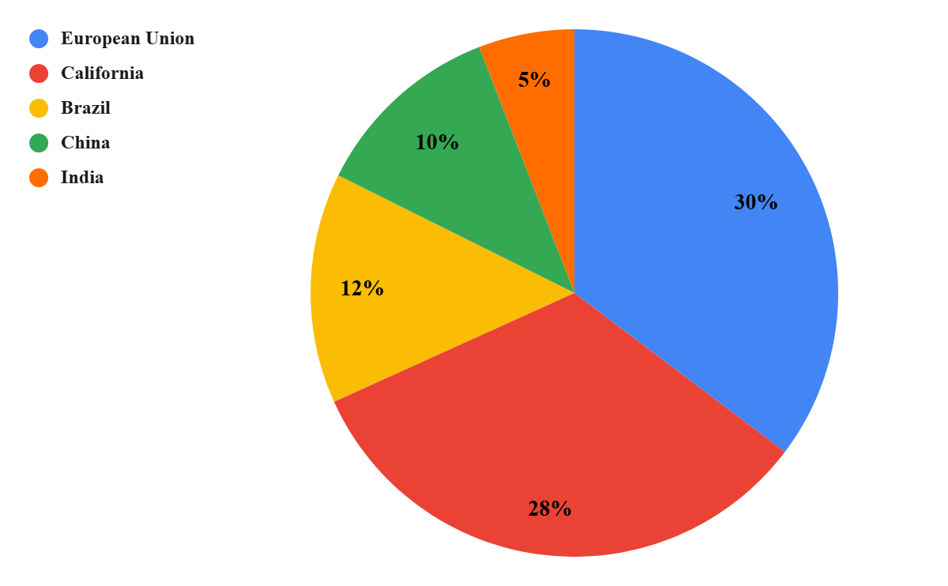

1. **Pre-Intervention Energy Consumption (kWh/GDP)**

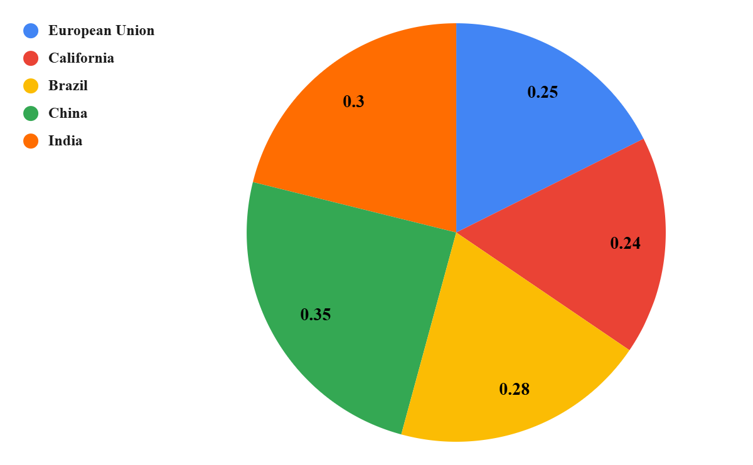

1. **Post-Intervention Energy Consumption (kWh/GDP)**

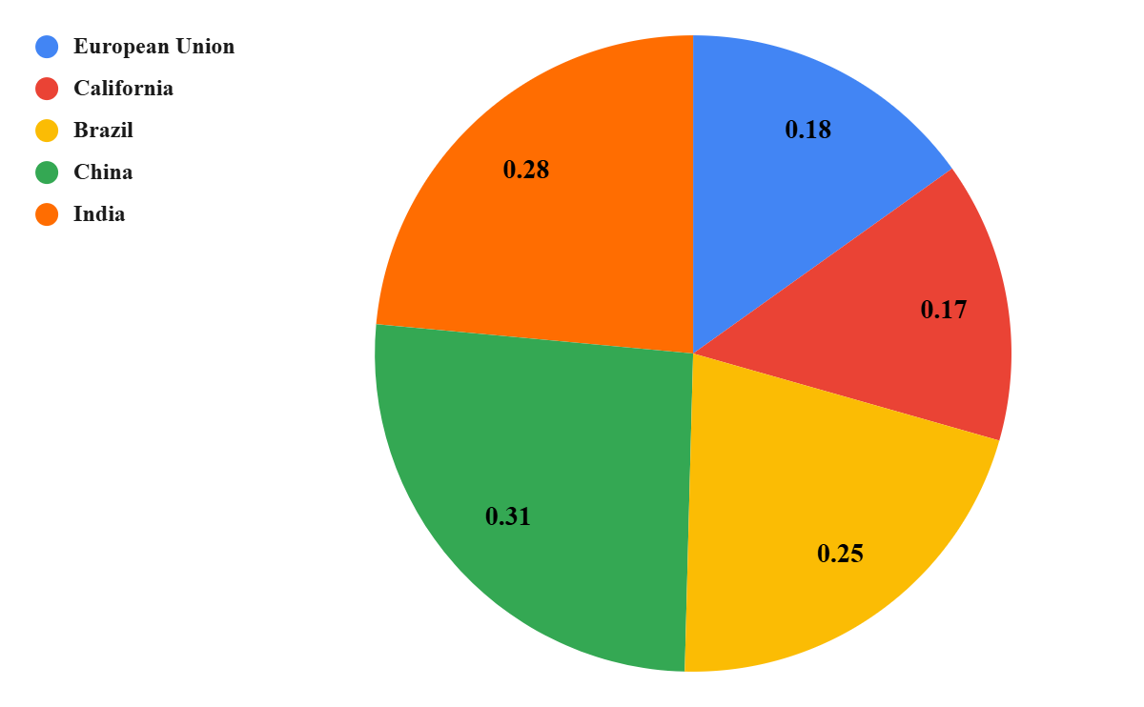

1. **% Change in Energy Efficiency**

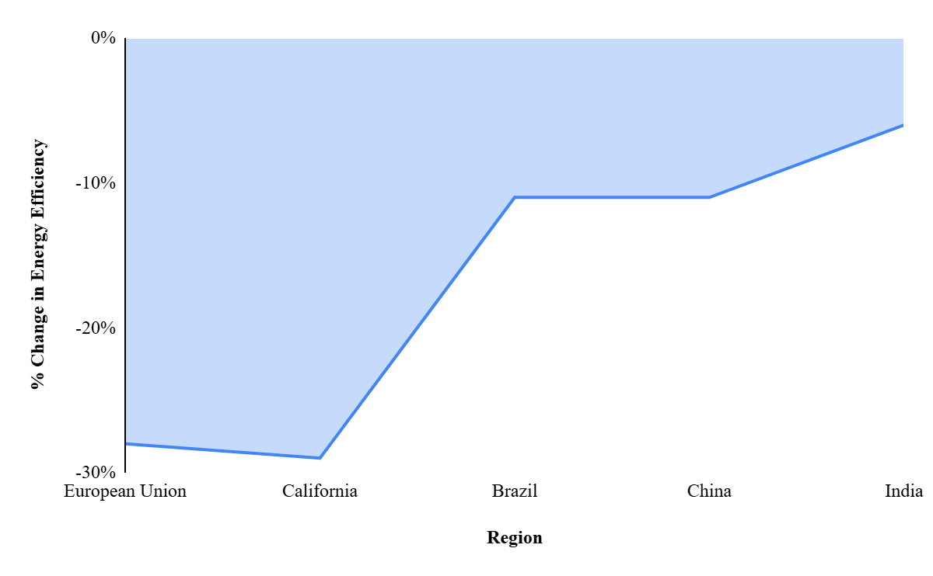

**Figure 1 (a),(b),(c),(d): Energy Efficiency Improvements (2000-2020)**

**Deforestation Rates Before and After Intervention (2000-2020)**

Table 2 indicates that the forest conversion before and after intervention from 2000-2020. Brazil which adopted deforestation control measures to protect its forest recorded a fair progress of cutting deforestation by +37.5% following a drastic reduction of the number of hectares deforested from (fig 2.a) 800,000 to 500,000 hectares (fig 2.b). The remaining areas that are not under policy intervention experienced an upsurge in deforestation rates. Indonesia’s rate increased to +8.33%, from 600,000 to 650,000 hectares and the Democratic Republic of Congo, India, and the Amazon basin increased by +5%, +25,%, and +16.67% respectively.

**Table 2: Deforestation Rates Before and After Intervention (2000-2020)**

|  |  |  |  |  |
| --- | --- | --- | --- | --- |
| **Region** | **Policy Intervention** | **Pre-Intervention Deforestation Rate (Hectares/year)** | **Post-Intervention Deforestation Rate (Hectares/year)** | **% Change in Deforestation** |
| **Brazil** | Deforestation Control | 800,000 | 500,000 | -37.5% |
| **Indonesia** | None | 600,000 | 650,000 | +8.33% |
| **Democratic Republic of Congo** | None | 400,000 | 420,000 | +5% |
| **India** | None | 200,000 | 250,000 | +25% |
| **Amazon Basin (Peru, Colombia)** | None | 300,000 | 350,000 | +16.67% |

1. **Pre-Intervention Deforestation Rate (Hectares/year)**

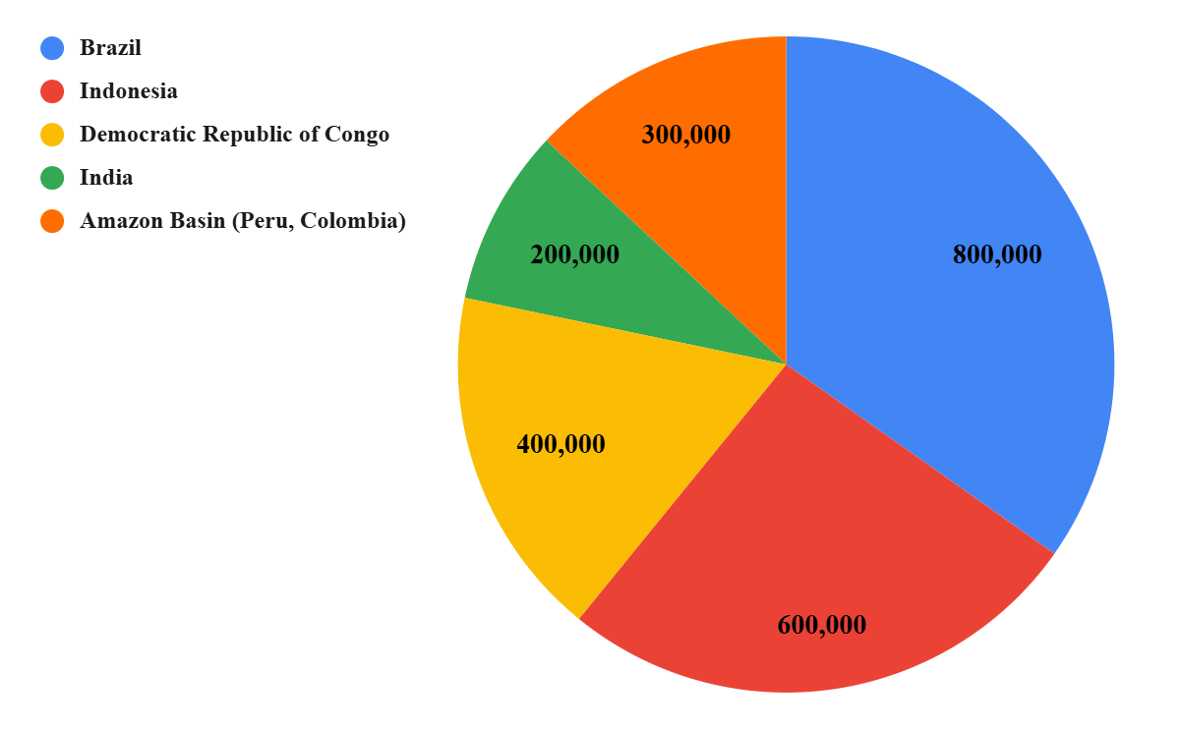

1. **Post-Intervention Deforestation Rate (Hectares/year)**

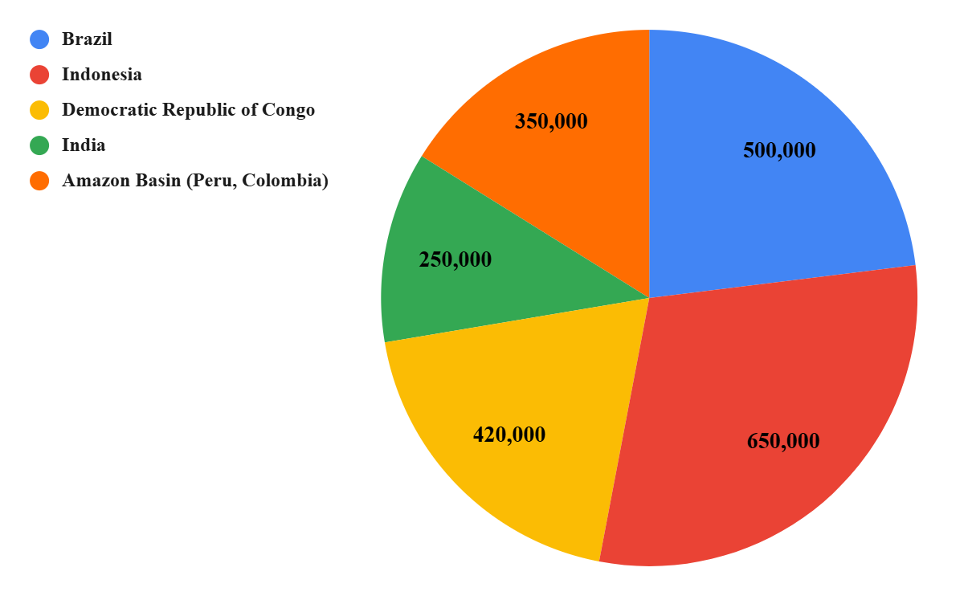

1. **% Change in Deforestation**

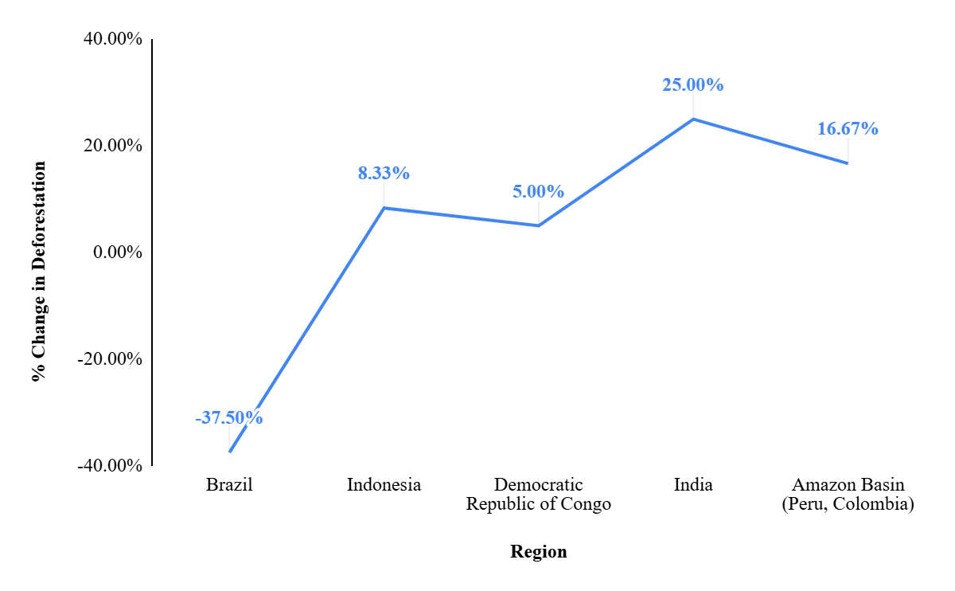

**Figure 2: Deforestation Rates Before and After Intervention (2000-2020)**

**DISCUSSION**

The research aimed at assessing the effects of several climate and environmental policies on efficiency of energy and deforestation from 2000 to 2020 in the different regions. They intended to evaluate how much more improved the EE is in the areas that contain such policy as cap-and-trade programs and measures against deforestation than those that contain none. The study aimed at analyzing the impact of these polices in the areas of energy usage in terms of kWh/GDP, and deforestation in terms of hectares per year focusing on the European Union, California, Brazil, China, India, Indonesia, DR Congo and the Amazon basin.

The results of the study suggest that policy changes have a direct influence on EE as well as forest cover. Those areas that havealready developed climate and environmental policies, including the European Union and the state of California, generally improved the level of EE, with lowered energy intensity per unit of GDP. The EU achieved 30 percent and California 28 percent improvement of EE, and reduction of energy saturation of 0.25 kWh/GDP to 0.18 kWh/GDP for the EU and from 0.24 kWh/GDP to 0.17 kWh/GDP for California. Brazil deforestation control measures in similar proportions led to a deforestation control measures marked by a decreased rate of deforestation, from 800,000 hectares annually to 500,000 hectares. This reduction indicates that, efforts toward the protection of the forests can help influence the reduction of the levels of deforestation provided the regulations are backed up by robust enforcement structures. Observing the effectiveness of Brazil’s policies it is possible to see that the countries without such measures suffered further deforestation, Indonesia, Democratic Republic of Congo, India and the Amazon basin alike had +5—25% deforestation rates.

Research has shown that countries or regions that implement cap-and-trade programs and deforestation control measures tend to see substantial improvements in EE and reductions in deforestation (Campbell-Lendrum et al., 2023). Studies on deforestation control in Brazil, have similarly demonstrated the effectiveness of policies in curbing deforestation rates, particularly through the enforcement of laws and the adoption of sustainable land-use practices (Shivanna, 2022). The results in this study align with these prior findings, reinforcing the idea that proactive environmental policies are critical in achieving both EE improvements and reductions in deforestation. The study also highlights some variations between regions, particularly in the context of India and China, which did not implement policy interventions (Tennison et al., 2021). The results in China and India suggest that while some improvement in EE is possible, a lack of comprehensive policy frameworks can hinder substantial progress in both EE and deforestation control.

The findings of this study have important implication for policymakers and other stakeholders in the environment. The evidence provides compelling evidence that the current emission reduction policies including cap-and-trade as well as policies regulating deforestation are critically important for bringing about effective improvements to efficiency in energy and effectiveness in the preservation of forests. The findings also underscore the need for the policy coherence across different sectors in regard to climate and environment (Watts et al., 2018). Although efficiency gains can be made using policy such as cap-and-trade, to deal with land use issues especially in the forests.

Future research should concern itself with examining the long-run impacts of these policy interventions on other related environmental and economic effects. The study also remains relatively silent on the Medium and Long-term impacts of the measures that could lead to the changes in the benchmarks explored in this study, or come up with a clearer definition of sustainability as it applies to these changes (Rocque et al., 2021). Future studies can establish the combinational effects of energy policies and land use policies, mainly in the areas that boast significant forest cover. One of the thrusts for further research can be the expansion of realized policy management forms to districts that have not yet adopted such policies (Xu et al., 2015). China and India have demonstrated some progress toward greater efficiency in energy consumption, those two nations could both stand to receive more extensive climate measures. Studies could include the failure of implementing policies in these areas and the ways of eliminating such failures (Zhao et al., 2022).

A limitation of this study is the use of regional averages which might obscure large differences across countries or sub-regions. Deforestation rates are stated at the country level, while they might be more or less at state or subnational levels as in the case of Brazil. Likewise, EE improvements in the country like China and India or any country may differ between the urban as well as rural population or between different economic sectors depending upon the amenities available. One of the main limitations is the choice of performance indicators related to EE and deforestation as distinct categories. Research in the future may want to focus on a more comprehensive approach that looks at the relationship between energy issues and forest issues and how policies that solve one, can solve the other as well.

**CONCLUSION**

The examination of EE changes and deforestation trends between 2000-2020 stresses the effects of policies on the given indicators. As can be seen countries/regions that had implemented preventive actions including the European Union and California have registered significant EE improvement. These regions posted 30% and 28% increases as well as lower scores for energy intensity or energy used per unit GDP (kWh/GDP). Countries that don’t have any specific energy climate policies such as China and India registered a comparatively smaller increase of 10% and 5% respectively further proving the notion that climate change policies are the backbone to ambitious EE measures. In measures to control deforestation, Brazil also recorded encouraging outcomes, it was able to reduced Brazilian deforestation by 37.5 percent, from 800,000 to 500,000 hectares yearly. Indonesia, the Democratic Republic of Congo, India and regions withing the Amazon Basins that were not subject to similar measures saw a rise in deforestation rates as well. The deforestation rate of Indonesia went up by 8.33%, and India’s by 25%, meaning that whilst some countries may boast the policy systems that can fulfil commitments, others lack the same kinds of restrictions. This study points out the need for policy interjections on EE and environmental conservation. Climate and forest protection legislation can cut energy demand and halt deforestation if implemented, thereby holding important lessons for other parts of the world that wish to fight climate change and environmental decline. The findings also point out that the global society should pay attention to the policies that contribute to society’s ultimate goals of sustainability.

**REFERENCES**

1. Campbell-Lendrum, D., Neville, T., Schweizer, C., & Neira, M. (2023). Climate change and health: three grand challenges. *Nature medicine, 29*(7), 1631–1638.<https://doi.org/10.1038/s41591-023-02438-w>
2. Guiot, J., & Cramer, W. (2016). Climate change: The 2015 Paris Agreement thresholds and Mediterranean basin ecosystems. *Science (New York, N.Y.), 354*(6311), 465–468.<https://doi.org/10.1126/science.aah5015>
3. Meier, B. M., Bustreo, F., & Gostin, L. O. (2022). Climate Change, Public Health and Human Rights. *International journal of environmental research and public health, 19*(21), 13744.<https://doi.org/10.3390/ijerph192113744>
4. Milner, J., Hamilton, I., Woodcock, J., Williams, M., Davies, M., Wilkinson, P., & Haines, A. (2020). Health benefits of policies to reduce carbon emissions. *BMJ (Clinical research ed.), 368*, l6758.<https://doi.org/10.1136/bmj.l6758>
5. Ming, T., de Richter, R., Shen, S., & Caillol, S. (2016). Fighting global warming by greenhouse gas removal: destroying atmospheric nitrous oxide thanks to synergies between two breakthrough technologies. *Environmental science and pollution research international, 23*(7), 6119–6138.<https://doi.org/10.1007/s11356-016-6103-9>
6. Mitchell, D., Allen, M. R., Hall, J. W., Muller, B., Rajamani, L., & Le Quéré, C. (2018). The myriad challenges of the Paris Agreement. *Philosophical transactions. Series A, Mathematical, physical, and engineering sciences, 376*(2119), 20180066.<https://doi.org/10.1098/rsta.2018.0066>
7. Mousavi, A., Ardalan, A., Takian, A., Ostadtaghizadeh, A., Naddafi, K., & Bavani, A. M. (2020). Health system plan for implementation of Paris agreement on climate change (COP 21): a qualitative study in Iran. *BMC Public Health, 20*(1), 1388.<https://doi.org/10.1186/s12889-020-09503-w>
8. Nikendei, C., Bugaj, T. J., Nikendei, F., Kühl, S. J., & Kühl, M. (2020). Klimawandel: Ursachen, Folgen, Lösungsansätze und Implikationen für das Gesundheitswesen [Climate change: Causes, consequences, solutions and public health care implications]. *Zeitschrift fur Evidenz, Fortbildung und Qualitat im Gesundheitswesen, 156-157*, 59–67.<https://doi.org/10.1016/j.zefq.2020.07.008>
9. Punton, A., Crossley, E. J., Matthews, N. R., & Walpole, S. C. (2017). Protecting Health from Climate Change Requires Concerted Action and Radical Approaches: A Discussion of Recent Progress in International Climate Negotiations. *The international journal of occupational and environmental medicine, 8*(1), 1–6.<https://doi.org/10.15171/ijoem.2017.985>
10. Resnik, D. B. (2022). Environmental justice and climate change policies. *Bioethics, 36*(7), 735–741.<https://doi.org/10.1111/bioe.13042>
11. Rhodes, C. J. (2019). Only 12 years left to readjust for the 1.5-degree climate change option - Says International Panel on Climate Change report: Current commentary. *Science Progress, 102*(1), 73–87.<https://doi.org/10.1177/0036850418823397>
12. Rigkos, K., Filis, G., Antonopoulou, I., de Oliveira Maciel, A., Saridis, P., Zarafeta, D., & Skretas, G. (2024). Biomimetic CO2 Capture Unlocked through Enzyme Mining: Discovery of a Highly Thermo- and Alkali-Stable Carbonic Anhydrase. *Environmental science & technology, 58*(40), 17732–17742.<https://doi.org/10.1021/acs.est.4c04291>
13. Rocque, R. J., Beaudoin, C., Ndjaboue, R., Cameron, L., Poirier-Bergeron, L., Poulin-Rheault, R. A., Fallon, C., Tricco, A. C., & Witteman, H. O. (2021). Health effects of climate change: an overview of systematic reviews. *BMJ open, 11*(6), e046333.<https://doi.org/10.1136/bmjopen-2020-046333>
14. Schurer, A. P., Mann, M. E., Hawkins, E., Tett, S. F. B., & Hegerl, G. C. (2017). Importance of the Pre-Industrial Baseline in Determining the Likelihood of Exceeding the Paris Limits. *Nature Climate Change, 7*(8), 563–567.<https://doi.org/10.1038/nclimate3345>
15. Şevgin, F., & Öztürk, A. (2024). Variation of temperature increase rate in the Northern Hemisphere according to latitude, longitude, and altitude: the Turkey example. *Scientific reports, 14*(1), 18207.<https://doi.org/10.1038/s41598-024-68164-6>
16. Shivanna, K. R. (2022). Climate change and its impact on biodiversity and human welfare. *Proceedings of the Indian National Science Academy. Part A, Physical Sciences, 88*(2), 160–171.<https://doi.org/10.1007/s43538-022-00073-6>
17. Tennison, I., Roschnik, S., Ashby, B., Boyd, R., Hamilton, I., Oreszczyn, T., Owen, A., Romanello, M., Ruyssevelt, P., Sherman, J. D., Smith, A. Z. P., Steele, K., Watts, N., & Eckelman, M. J. (2021). Health care's response to climate change: a carbon footprint assessment of the NHS in England. *The Lancet. Planetary health, 5*(2), e84–e92.<https://doi.org/10.1016/S2542-5196(20)30271-0>
18. Rocque, R. J., Beaudoin, C., Ndjaboue, R., Cameron, L., Poirier-Bergeron, L., Poulin-Rheault, R. A., Fallon, C., Tricco, A. C., & Witteman, H. O. (2021). Health effects of climate change: an overview of systematic reviews. BMJ open, 11(6), e046333. https://doi.org/10.1136/bmjopen-2020-04633
19. Watts, N., Amann, M., Arnell, N., Ayeb-Karlsson, S., Belesova, K., Berry, H., Bouley, T., Boykoff, M., Byass, P., Cai, W., Campbell-Lendrum, D., Chambers, J., Daly, M., Dasandi, N., Davies, M., Depoux, A., Dominguez-Salas, P., Drummond, P., Ebi, K. L., Ekins, P., … Costello, A. (2018). The 2018 report of the Lancet Countdown on Health and climate change: shaping the health of nations for centuries to come. *Lancet (London, England), 392*(10163), 2479–2514.<https://doi.org/10.1016/S0140-6736(18)32594-7>
20. Xu, Z., Sun, D. W., Zeng, X. A., Liu, D., & Pu, H. (2015). Research developments in methods to reduce the carbon footprint of the food system: a review. *Critical reviews in food science and nutrition, 55*(9), 1270–1286. https://doi.org/10.1080/10408398.2013.821593
21. Zhao, Q., Yu, P., Mahendran, R., Huang, W., Gao, Y., Yang, Z., Ye, T., Wen, B., Wu, Y., Li, S., & Guo, Y. (2022). Global climate change and human health: Pathways and possible solutions. *Eco-Environment & Health, 1*(2), 53–62.<https://doi.org/10.1016/j.eehl.2022.04.004>