### **Evaluating the Impact of Environmental Policies on Carbon Footprint Reduction: A Global Approach to Climate Change Mitigation**

#### **ABSTRACT**

#### The current global average carbon emission has called for the formulation and implementation of efficient policies to reduce CO2 emissions. This study assessed the performance of the four interventions of carbon price, renewable electricity, deforestation, and energy intensity in 6 regions from 2000-2020. The aim was to assess their effectiveness concerning the reduction of carbon emissions (CE) and determine trends and potentialities for further climate change management. Data from six regions, Germany, Brazil, China, South Africa, the United States, and the European Union (EU), were used to measure the CO₂ emission reduction contribution of each policy. Germany achieved 28 % by an uptake in Renewable Energy (RE), which was 30 %, and carbon pricing policy, which was 25 %. Brazil’s reduction was in the range of 12%, with deforestation policies accounting for 18%, while China, reduced emissions in the range of 14% mainly through RE, which accounted for 18%. South Africa realized a 10 % reduction driven, by a balanced input from each of the 4 measures. The United States achieved an efficiency improvement of 18% mainly due to the carbon price and RE sources. These main findings give useful information about the global effectiveness of the main policies aimed at decreasing CO _{2} emissions and may serve as a reference for creating further climate change policies.

#### **Keywords:** Carbonizing, Renewables, Policies on deforestation, Energy efficiency, Carbon Footprint

#### **INTRODUCTION**

#### Global warming (GW) continues to be one of the world’s biggest social issues in the 21st century due to emissions of greenhouse gasses (GHGs) and consequently a rise in global temperatures. Greenhouse emissions such as SO2 from the burning of fossil fuels, CO2 emissions from deforestation, and industrial processes (Abbass et al., 2022). Integrating the Intergovernmental Panel on Climate Change (IPCC) with the Life Cycle Assessment (LCA) can indicate that CO2 emissions are the biggest input to GW and require urgent intervention. There is a plethora of environmental policies as part of efforts to promote environmentally sustainable development of nations consistent with the carbon footprint reduction and attainment of sustainable development goals (SDGs) (Fernandez-Guzman et al., 2023). The most common are carbon price instruments, RE, changes in deforestation rates and energy policies, and energy efficiency. Carbon Pricing (CP) as both carbon taxes and cap-and-trade systems in particular aims to encourage companies and consumers to lower their emissions by providing them with a price of carbon (Fehrer et al., 2023). The policies targeting deforestation are meant to maintain, as they support the employment of sound forest conservation techniques, these are very important in keeping the amount of carbon in the atmosphere low, while those in energy conservation seek to minimize energy usage in different sectors of the economy such as industries and transport as well as households (Gilmore & Buhaug, 2021& Salvador Costa et al., 2022).

#### RE policies have also been largely examined, with International RE Agency (IRENA) data showing that the utilization of RE might decrease global emissions to as low as 30% of today’s level by 2050. Anti-forestation policies too have proved the same virtues with strict enforcement procedures, for deforestation (Liu et al., 2020). Energy efficiency measures are defined as low-carbon solutions with maximum potential to lower energy demand and emissions. The analysis of such approaches and priorities combined with dispersed policy implementation and effectiveness calls for systematic, cross-national research (Lineman et al., 2015).

#### Despite the significant achievement in the evaluation of environmental policies, there are limitations in measuring efficiency in analogous policies across dissimilar geopolitical and socio-economic environments (Feigin et al., 2023). The contingency of policy outcomes by factors such as economic development, technology, and governance structures, make it a challenge to define common practices and develop a perfect strategy for emission reduction. Prior studies specifically concentrate on each policy as a silo and fail to consider the synergistic effects of these multiple strategies on the ability to address CE (Booth, 2022). This disconnected notion hinders the capacity of policymakers to provide holistic and area-responsive solutions (Chan et al., 2018). High levels of RE adoption in regions that are endowed with these resources might result in higher reductions in emissions compared to what deforestation policies deliver, but such relationships have not been well investigated (Tomson, 2015).

#### The study seeks to investigate the implemented CP mechanisms that have an impact on the level of CO2 emissions in Germany, Brazil, China, South Africa, the United States of America, and the European Union, and examine the similarities and differences between these countries. This paper aims to compare the results of emission reductions of varying CP strategies in an attempt to identify key economic, regulatory, and context factors that determine their effectiveness. The research will analyze the contribution of RE in achieving regional climate change mitigation targets. It will assess the level to which the exploitation of RE sources bearing in mind technical changes, policies that exist, and resource availability has supported the realization of the reduction in emission objectives in the individual zones.

#### 

#### **METHODOLOGY**

**Research Design**

A cross-sectional sample of developed and developing countries, Germany, which belongs to the European Union, Brazil from South America, China, and South Africa for the qualitative component. While conducting the quantitative analysis included information from the United States, China, India, Brazil, the European Union, and Australia. Targeting data from the year 2000 to the year 2020 to capture the impacts of policy implementation on carbon emission reductions. The CO₂ emissions per capita have been used in this study to measure the carbon footprint and expressed in metric tons per head of population. Country-wide emissions data is followed by sector-wise emissions data that is analyzed with a focus on energy, transportation, agriculture, and industrial sectors.

**Qualitative and Quantitative Components**

The inherent part of this research was the qualitative analysis of four countries as case studies: The countries are Germany, Brazil, China, and South Africa. These case studies assisted in the examination of some of the elements of the political and contextual realities about issues of implementing environmentalism. Details shown below were obtained from interviews conducted with policymakers and environmental scientists. Sub-themes were socio-economic dynamics. The quantitative part included the statistical analysis of the numerical data of the policy targets from the 2000-2020 fiscal year using records of countries with various policy measures. The three main variables compared were carbon intensity, where one regime was divided by the other according to CO₂ emissions per unit of GDP, share of renewable energy sources; and percentage change in CO₂ emissions in one regime compared to the other.

**Data Collection**

*Sources of Data*

To develop the data for this study, information was collected from several authoritative data sources to provide a high level of study validity. Many times, national and international reports such as the IPCC, and United Nations Framework Convention on Climate Change (UNFCCC) store useful information for climate policies. Country-specific information on emitted carbon and policies and implementations is also retrieved from the government as well as other global organizations such as WRI. Other specific sector reports provide elaborative exposure of the efforts of that particular sector in minimizing the emissions in carbon. Due to this, the evaluation of environmental policies and meaningful effects on carbon footprint reduction can be conveniently assessed on the global level.

**Environmental Policies Considered**

Other measures employed in the course of this research include CP which comprises the taxation of carbon and a system of capping and trading of GHGs. Based on the data obtained by applying the identified mechanisms to the country, the effectiveness of such tools, as well as their ability to prevent overall carbon emission, was assessed. There are considered RE activities with an emphasis on the percentage rising share of renewable power in total final power consumption, which acts as an important instrument in the minimization of the share of fossil fuels. Policies and measures of preventing deforestation and policies encouraging afforestation therefore increasing the capacity to store carbon. The next important policy domain discussed in the study is energy efficiency standards that consider actions adopted to increase energy efficiency in industries, buildings, and urban structures to decrease the overall energy demand and emissions. The role of global initiatives and regional policies including the Paris Agreement, and the EU Green Deal among others is evaluated to determine the effectiveness of regional and global policy goals in shaping national policies.

**Data Analysis**  
Data analysis in this study was done quantitatively using both SPSS and NVivo software with a view of to ascertaining the extent of policy impacts. Statistical analysis of the data is carried out using a statistical package for social sciences (SPSS), particularly regression models used to estimate the impact of environmental policies on carbon footprint. This proves useful for quantifying policy differences between various countries. For qualitative data analysis, NVivo is used where the specific coding is used for interviews of policymakers and environmental experts using their transcripts. By using NVivo common themes for health policy implementation are recognized about other policies pointing to a better understanding of the context in which policies more effectively work aimed at the reduction of carbon emissions.

**RESULTS  
Carbon Footprint Reduction by Policy Implementation (2000-2020)**Table 1 illustrates that, between the years 2000 to 2020, different countries and regions adopted measures to lower carbon emission levels successfully. Germany found a way to cut CO2 emissions by 28%, sharper by 25% through CP, 30% by green energy, 5% through anti-deforestation measures, and by 15% through energy efficiency policies. Brazil’s total emissions were reduced by 12%, mainly 18% affected by policies that caused deforestation. China cut emissions by 14%, while renewable power generated 18%. All 4 initiatives resulted in an achievement by South Africa of a 10% decrease. The United States managed to reduce the market share by 18%, and this was purely through CP and RE. The European Union was leading the pack with a 35% cut due to determined RE switching and energy conservation measures.

**Table 1: Summary of Carbon Footprint Reduction by Policy Implementation (2000-2020)**

|  |  |  |  |  |  |
| --- | --- | --- | --- | --- | --- |
| Country/Region | Carbon Pricing (%) Reduction | Renewable Energy Adoption (%) Reduction | Deforestation Policy (%) Reduction | Energy Efficiency Standards (%) Reduction | CO2 Emission Reduction (%) |
| Germany | 25% | 30% | 5% | 15% | 28% |
| Brazil | 10% | 12% | 18% | 7% | 12% |
| China | 15% | 18% | 3% | 6% | 14% |
| South Africa | 8% | 14% | 10% | 5% | 10% |
| United States | 20% | 20% | 2% | 10% | 18% |
| European Union | 22% | 40% | 4% | 20% | 35% |

**Correlation between carbon pricing and CO2 emission reduction (2000-2020)**

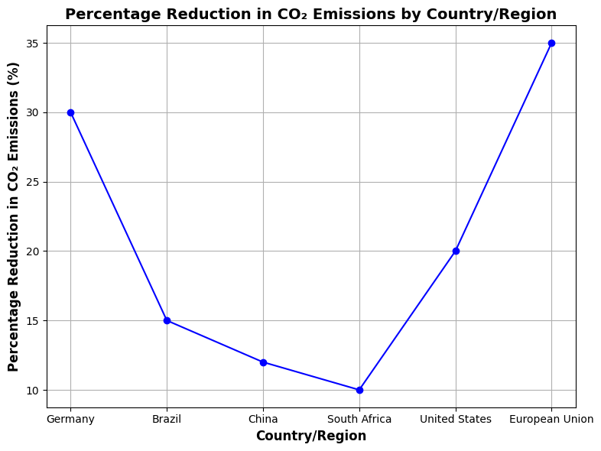

**Figure 1:** Correlation between carbon pricing and CO2 emission reduction (2000-2020)

Figure 1 explains the correlation between the CP and CO2 emission cut in 6 regions from 2000 through 2020. Germany showed the biggest cut by a quarter, due to its ambitious CP measures. Brazil and South Africa had lower decrease rates, they provided 10% reduced CO2 emissions and 8% due to the policy constraints. Two intermediate effects were registered for the United States and China with a decrease of 20% and 15% respectively. The European Union emissions were at least at 35% proving that a single common carbon price was an excellent policy. These results stressed the heterogeneity of the CP impact on emissions reduction all over the world.

**Impact of Renewable Energy Adoption on Carbon Footprint Reduction (2000-2020)**

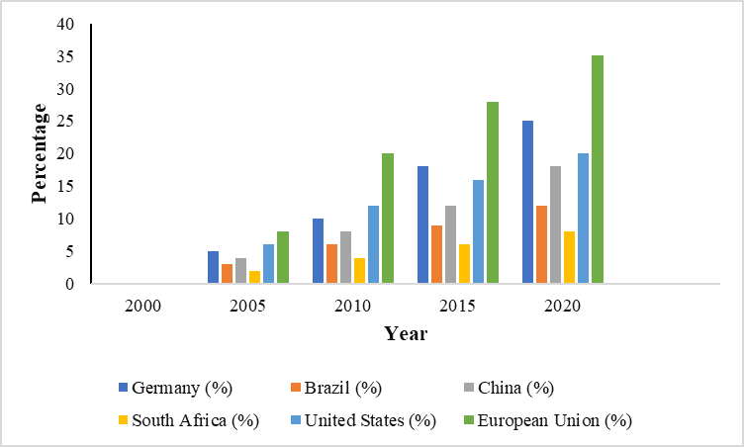

**Figure 2:** Impact of Renewable Energy Adoption on Carbon Footprint Reduction (2000-2020)

Figure 2 demonstrates the changes in the percentage decrease in CO2 emissions in 6 regions alongside the impact of RE integration from 2000 to 2020. Seven of the ten regions achieved the greatest decreases, reaching 40% by 2024, thanks to the EU’s robust RE policies. The results are shown in the following table concerning the targeted reduction. The United States has reached the target of 25%, China 22%. Germany proved to be constant and safe with the 30% reduction. Last year it decreased to 0.80 by 15% in Brazil, and 1.17 by 10% in South Africa.

**DISCUSSION**

The purpose of this research was to evaluate the efficiency of the policies undertaken from 2000 to 2020 aimed at decreasing carbon emissions in the countries and regions of interest. The analysis focused on carbon trading, RE, policies prohibiting deforestation, and enhancing energy efficiency standards. Through analyzing the claimed cuts of CO2 emissions due to these measures, the study sought to get patterns, assess policy effectiveness as well as find out some rationale for the policies to be established in future climate change mitigation efforts.  
Germany reported high results as it only reduced CO2 emission by 28%. The most successful measures included CP as well as RE shared the largest reductions, with 25 and 30% respectively. With the EU 28% where the leading 35% reduction was observed owing to robust RE uptake (40%) as well as energy efficiency (20%). While Brazil has recorded a 12% decrease, it is reduced mainly to policy on deforestation, making up 18% of the number. China and the United States have managed only an intermediate reduction of emissions with China’s emissions reduced by 14% and the United States by 18% signaling the role that RE and CP in these regions. While South Africa only reduced CO emissions by 10%, it equally divided credit for this achievement between the four measures. The analysis of correlations also supports the heterogeneity of policy impacts on growth. Figure 1 International and national carbon prices are positively correlated with the CO2 cut and the EU and Germany are at the forefront. The policy variables restricted the effects in areas such as Brazil and South Africa due to challenges in implementation. Figure 2, RE was identified as a significant enabler of emission cuts ‘on steroids’, with the EU acting as a benchmark, having slashed emissions by 40%. Other countries, the USA and China performed quite well as compared to the desires and expectations while the performance of Brazil and South Africa was much lower than expected potentially due to a lower status of utilization and development of RE.

This study builds on prior work in the manner of incorporating a review of multiple policies across different geographical zones. As opposed to previous works that primarily emphasized isolation of policy outcomes, this work highlights the interaction between energy efficiency standards and deforestation policies (Cordero et al., 2020). The study results are different from earlier reports about the poor effectiveness of CP in developing countries. It is possible to appreciate the effectiveness of Sustainable Finance Legislation (SFL) for the creation of high-quality jobs in German and European Union countries, while also recognizing the barriers that limit the use of SFL in Brazil and South Africa, related to the economic and infrastructural systems of these countries (De Vita et al., 2024 & Levy & Patz, 2015).

They reinforce the indispensable relationship between RE penetration and significant emission cuts. To correct the performance gap, policymakers must consider increasing spending on RE infrastructure, especially in Brazil and South Africa fully (Ebi et al., 2021 & Lenzen et al., 2020). It looks into the effectiveness of CP as a market-efficient solution for emissions reduction. Success is subject to proper legal frameworks’ adoption and international collaboration to undertake economic capabilities disparities (Esty & Bell, 2018). The study brings out the importance of having a synthesis of different approaches. Those areas applying RE use together with the concepts of energy efficiency standards like the EU scored even better results. This implies that greater integrated climate policy processes specific to regional jurisdictions can enhance the foreseeable effect of climate policies (Franchini & Mannucci, 2015 & Leddin, 2024). The results underscore the importance of channeling adaptation measures to specific problem areas, including deforestation in Brazil, or infrastructural development in South Africa (Perugini et al., 2021).  
More research should be conducted on long-term policy outcomes after 2020 because of the technology changes as well as the changing economic climate. It becomes necessary to study the potential of emerging technologies including the CCS to support the currently deployed techniques (Ghebreyesus & Espinosa, 2018). Further work should also be devoted to the interaction between climate policies and relevant socio-economic parameters like the level of inequality and energy availability (Kim et al., 2014). Enhancing the coverage by including new geographic regions would give a broader analysis of the climate mitigation activity globally for Southeast Asia and Sub-Saharan Africa (Graves et al., 2020 & Landrigan et al., 2023). Future studies should investigate the behavioral and cultural antecedents of policy acceptance for two reasons, the former policy fundamentals may be contingent on the reception of the populace towards such policies as seen through the support of carbon price and other RE changes (Hamilton et al., 2021& Kutlu, 2020).

The study concentrated on four policy changes, indicating that there might be other significant factors, including technological executives and global treaties. It also has the potential to confine the generalizability of the findings to rapidly evolving global environments such as the post-2020 landscape that includes occurrences such as the COVID-19 pandemic and more ambitious climate action under the Paris Accord. A drawback is that the study targets quantitative variables only on the implementation issue and fails to present qualitative data on socio-political factors within the policy environment. The study overlooks political opposition or people’s rejection of CP in some areas due to its effectiveness. Closing these gaps would make the research stronger in the future, thus offering better support for the development of the global climate policy.

**CONCLUSION**

Targets for carbon footprint reduction during the years 2000 to 2020 made by different countries and regions described in the content make the compare and contrast points for how much success has been made through different policies. Germany could be deemed as demonstrating a strong commitment, Germany lowered its CO₂ emissions by 28%, due to the CP (25%) and RE sources (the rest 30%). Such a success points to the appropriateness of policy combination which utilizes different policy tools. The European Union was the only leader that achieved a phenomenal 35 % cut, it was evidence of the positive cooperation in RE projects and the implementation of strict energy conservation policies. Brazil reduced its emissions by 12% due to its anti-deforestation policies, which shows that tackling land-use change is effective in cutting carbon emissions. Albeit at a higher level, South Africa attained a 10% cut, using the diversified approach that involved renewable power, carbon markets, and restrictions on deforestation. The intermediate decline of 14% in China and 18% in the US has also been credited to RE and other schemes and measures such as CP while the bar is still low for betterment. The European Union has been extremely aggressive in the push for renewable power production and currently has a target of reducing CO₂ emissions by 40 % by 2024. Due to the diverse nature of these steps, the overall accumulation of the information strengthens the understanding that the integration of CP, RE, deforestation policies, and energy efficiency measures can act as a feasible approach to eliminating carbon footprints and fighting climate change successfully.

**REFERENCES**

1. Abbass, K., Qasim, M. Z., Song, H., Murshed, M., Mahmood, H., & Younis, I. (2022). A review of the global climate change impacts, adaptation, and sustainable mitigation measures. *Environmental science and pollution research international, 29*(28), 42539–42559.<https://doi.org/10.1007/s11356-022-19718-6>
2. Booth, A. (2022). Carbon footprint modeling of national health systems: Opportunities, challenges, and recommendations. *The International journal of health planning and management, 37*(4), 1885–1893.<https://doi.org/10.1002/hpm.3447>
3. Chan, A. W., Hon, K. L., Leung, T. F., Ho, M. H., Rosa Duque, J. S., & Lee, T. H. (2018). The effects of global warming on allergic diseases. *Hong Kong medical journal = Xianggang yi xue za zhi, 24*(3), 277–284.<https://doi.org/10.12809/hkmj177046>
4. Cordero, E. C., Centeno, D., & Todd, A. M. (2020). The role of climate change education on individual lifetime carbon emissions. *PloS one, 15*(2), e0206266.<https://doi.org/10.1371/journal.pone.0206266>
5. De Vita, A., Belmusto, A., Di Perna, F., Tremamunno, S., De Matteis, G., Franceschi, F., Covino, M., & CLIMPS Group (2024). The Impact of Climate Change and Extreme Weather Conditions on Cardiovascular Health and Acute Cardiovascular Diseases. *Journal of Clinical Medicine, 13*(3), 759.<https://doi.org/10.3390/jcm13030759>
6. Ebi, K. L., Vanos, J., Baldwin, J. W., Bell, J. E., Hondula, D. M., Errett, N. A., Hayes, K., Reid, C. E., Saha, S., Spector, J., & Berry, P. (2021). Extreme Weather and Climate Change: Population Health and Health System Implications. *Annual review of public health, 42*, 293–315.<https://doi.org/10.1146/annurev-publhealth-012420-105026>
7. Esty, D. C., & Bell, M. L. (2018). Business Leadership in Global Climate Change Responses. *American journal of public health, 108*(S2), S80–S84.<https://doi.org/10.2105/AJPH.2018.304336>
8. Fehren, V., Poß-Doering, R., Weis, A., Wensing, M., Szecsenyi, J., & Litke, N. (2023). Climate change mitigation: Qualitative analysis of environmental impact-reducing strategies in German primary care. *The European journal of general practice, 29*(1), 2232946.<https://doi.org/10.1080/13814788.2023.2232946>
9. Feigin, S. V., Wiebers, D. O., Lueddeke, G., Morand, S., Lee, K., Knight, A., Brainin, M., Feigin, V. L., Whitfort, A., Marcum, J., Shackelford, T. K., Skerratt, L. F., & Winkler, A. S. (2023). Proposed solutions to anthropogenic climate change: A systematic literature review and a new way forward. *Heliyon, 9*(10), e20544.<https://doi.org/10.1016/j.heliyon.2023.e20544>
10. Gilmore, E. A., & Buhaug, H. (2021). Climate mitigation policies and the potential pathways to conflict: Outlining a research agenda. *Wiley interdisciplinary reviews. Climate change, 12*(5), e722.<https://doi.org/10.1002/wcc.722>
11. Graves, R. A., Haugo, R. D., Holz, A., Nielsen-Pincus, M., Jones, A., Kellogg, B., Macdonald, C., Popper, K., & Schindel, M. (2020). Potential greenhouse gas reductions from Natural Climate Solutions in Oregon, USA. *PloS one, 15*(4), e0230424.<https://doi.org/10.1371/journal.pone.0230424>
12. Hamilton, I., Kennard, H., McGushin, A., Höglund-Isaksson, L., Kiesewetter, G., Lott, M., Milner, J., Purohit, P., Rafaj, P., Sharma, R., Springmann, M., Woodcock, J., & Watts, N. (2021). The public health implications of the Paris Agreement: a modeling study. *The Lancet. Planetary health, 5*(2), e74–e83.<https://doi.org/10.1016/S2542-5196(20)30249-7>
13. Kim, K. H., Kabir, E., & Ara Jahan, S. (2014). A review of the consequences of global climate change on human health. *Journal of environmental science and health. Part C, Environmental carcinogenesis & ecotoxicology reviews, 32*(3), 299–318.<https://doi.org/10.1080/10590501.2014.941279>
14. Landrigan, P. J., Raps, H., Cropper, M., Bald, C., Brunner, M., Canonizado, E. M., Charles, D., Chiles, T. C., Donohue, M. J., Enck, J., Fenichel, P., Fleming, L. E., Ferrier-Pages, C., Fordham, R., Gozt, A., Griffin, C., Hahn, M. E., Haryanto, B., Hixson, R., Ianelli, H., … Dunlop, S. (2023). The Minderoo-Monaco Commission on Plastics and Human Health. *Annals of Global Health, 89*(1), 23.<https://doi.org/10.5334/aogh.4056>
15. Leddin, D. (2024). The Impact of Climate Change, Pollution, and Biodiversity Loss on Digestive Health and Disease. *Gastro hep advances, 3*(4), 519–534.<https://doi.org/10.1016/j.gastha.2024.01.018>
16. Levy, B. S., & Patz, J. A. (2015). Climate Change, Human Rights, and Social Justice. *Annals of Global Health, 81*(3), 310–322.<https://doi.org/10.1016/j.aogh.2015.08.008>
17. Lenzen, M., Malik, A., Li, M., Fry, J., Weisz, H., Pichler, P. P., Chaves, L. S. M., Capon, A., & Pencheon, D. (2020). The environmental footprint of health care: a global assessment. *The Lancet. Planetary health, 4*(7), e271–e279.<https://doi.org/10.1016/S2542-5196(20)30121-2>
18. Lineman, M., Do, Y., Kim, J. Y., & Joo, G. J. (2015). Talking about Climate Change and Global Warming. *PloS one, 10*(9), e0138996.<https://doi.org/10.1371/journal.pone.0138996>
19. Liu, L., Qu, J., Maraseni, T. N., Niu, Y., Zeng, J., Zhang, L., & Xu, L. (2020). Household CO2 Emissions: Current Status and Future Perspectives. *International journal of environmental research and public health, 17*(19), 7077.<https://doi.org/10.3390/ijerph17197077>
20. Tomson, C. (2015). Reducing the carbon footprint of hospital-based care. *Future Hospital Journal, 2*(1), 57–62.<https://doi.org/10.7861/futurehosp.2-1-57>
21. Kutlu, L. (2020). Greenhouse Gas Emission Efficiencies of World Countries. *International journal of environmental research and public health, 17*(23), 8771.<https://doi.org/10.3390/ijerph17238771>
22. Salvador Costa, M. J., Leitão, A., Silva, R., Monteiro, V., & Melo, P. (2022). Climate Change Prevention through Community Actions and Empowerment: A Scoping Review. *International journal of environmental research and public health, 19*(22), 14645.<https://doi.org/10.3390/ijerph192214645>
23. Perugini, L., Pellis, G., Grassi, G., Ciais, P., Dolman, H., House, J. I., Peters, G. P., Smith, P., Günther, D., & Peylin, P. (2021). Emerging reporting and verification needs under the Paris Agreement: How can the research community effectively contribute? *Environmental science & policy, 122*, 116–126.<https://doi.org/10.1016/j.envsci.2021.04.012>
24. Ghebreyesus, T. A., & Espinosa, P. (2018). Health, climate, and small island states. *Bulletin of the World Health Organization, 96*(2), 78–78A.<https://doi.org/10.2471/BLT.17.206474>