Integrated management of sterility mosaic disease(SMD) of redgram and virus - vector relationship in the context of weather parameters

Abstract
The treatments were found to be more effective in comparison to untreated control. However, the Seed treatment imidacloprid 70 % WS @ 5 g/kg seed+ spraying of fenazaquin 5 EC @ 0.1% provided the maximum control (PDI 10.00) of the sterility mosaic disease and the vector population was decreased to 3 when compared to control (PDI 50.00). The SMD, incidence of redgram was positively correlated with maximum temperature and negatively correlated with Relative humidity and rainfall. The maximum temperature 24 % and Maximum RH 22 % is positively related to SMD incidence.

Keywords: Redgram - Sterility mosaic disease- virus - vector relationship

Introduction:
Pigeonpea [Cajanus cajan (L.) Millsp.], also referred to as red gram or arhar, is a perennial shrub, with its centre of origin located in India. It is an important grain legume crop predominantly grown in the Indian subcontinent as an important source of dietary protein. Worldwide, pigeonpea is cultivated on approximately 6.22 million hectares, and 75% of this land area is presently in India (FAOSTAT, 2014). Its cultivation is increasing in semi-arid areas because of the crop’s ability to thrive under prolonged drought and in degraded lands (Upadhyaya et al., 2012). The crop is mainly grown as an annual using cultivars with different durations to maturity: 90 days (short), 120 days (medium) and 180 days (long). It is also cultivated as a perennial crop in several regions of India. Fresh pods are consumed as a vegetable; dried mature grains are used for cooking or in processing. About 15 viruses are reported to naturally infect pigeonpea (Kumar et al., 2008). Sterility mosaic disease (SMD), caused by Pigeonpea sterility mosaic virus (PPSMV), is the economically most important viral disease in India, causing an estimated annual loss of more than US$300 million (Reddy et al., 1998). The main objective of the present study is to find the integrated management strategy for the management of sterility mosaic disease of redgram and virus vector relationship
Materials and Methods:
The experiment was laid out in a randomized completely block design with plot size of 4.0m × 4.0m. the SMD susceptible pigeonpea variety ICP 8863 was sown in the month of July 2022 at National Pulses Research centre, Vamban with a spacing of 60 cm between row and 20 cm between plants. All the ten treatments were replicated thrice. Improved package of practice were followed for raising the crop. The pesticide sprayed at the recommended concentration at 25, 40, 60 days after sowing (DAS). Observations on disease incidence in each replication were recorded, one day before spraying and 15 and 30 days after the 3 sprays. The mean per cent increase in diseased plants was calculated in each treatment similarly, mite vector population was recorded on the day of spraying (before) and 2 days after each spray. Mean per cent reduction in mite population was calculated from each treatment. Mite population was counted by collecting 3 leaves randomly in each replication and by observing under stereo binocular microscope. Mite population/leaf were calculated by averaging the total counts
Simple correlation coefficients were estimated as follows,
Where,
r_{xy} = correlation coefficient between the traits x and y.
Cov_{.xy} = covariance between the traits ‘x’ and ‘y’.
var_{x} = Variance of the trait ‘x’.
var_{y} = Variance of the trait ‘y’.
x = variable x and
y = variable y
The significance of the correlation estimates was tested by using the formula.
Where,
r = Correlation co-efficient
n = Number of paired observation
t_{cal} = r / SE
By comparing the ‘t’ calculated value with ‘t’ table values at 5 per cent and 1 per cent levels at (n - 2) degrees of freedom, the significance was worked out.
Regression coefficient
regression coefficient (b_{i})
The regression coefficient is the regression of the performance of each genotype under different environment on the environmental means of all the genotypes. This was estimated as follows.
b_{i} =
Where,
 | = | the sum of products of environmental index (I_{j}) with corresponding mean of that genotype at each environment (Y_{ij})
 | = | the sum of squares of the environmental index (I_{j})
- For each value of regression coefficient I_{j}² is common and equal to
S _{j} I_{j}² = I_{i}² + . . + I_{i}² + .. I₄₅²
- On the other hand S_{j} Y_{ij} I_{j} for each genotype is the sum of products of environmental index (I_{j}) with the corresponding mean () of that genotype in each environment.
These values were obtained in the following manner
[] x [ I_{j}] = [S_{j} Y _{ij} I_{j}] = [S]
Where,
[] = Matrix of means
[I_{j}] = Vector for environmental index and
[S] = Vector for sum of products (ie) S_{j} Y_{ij} I_{j}
(c) Then b_{i} values for each genotype was calculated by dividing S_{ij}Y_{ij}I_{j} for each genotype by S_{j} I_{j} ²
Where,
I_{j} = environmental index of j^{th} environment which can be calculated as follows.

Results and Discussion
All the treatments were found to be more effective in comparison to untreated control. However, the Seed treatment imidacloprid 70 % WS @ 5 g/kg seed+ spraying of fenazaquin 5 EC @ 0.1% provided the maximum control (PDI 10.00) of the sterility mosaic disease and the vector population was decreased to 3 when compared to control (PDI 50.00).
The results indicated that among the treatments, Seed treatment imidacloprid 70 % WS @ 5 g/kg seed+ spraying of fenazaquin 5 EC @ 0.1% recorded the yield of 920 kg/ha and the untreated control plot recorded the yield of 700kg/ha. Chemical control measures such as i) dressing seed with 25 per cent Carbofuran or 10 per cent Aldicarb at 3 g kg-1 seed and ii) spraying acaricides or insecticides like karathane, chinomethionate, metasystox at 0.1 per cent to control the mite vector in early stages of plant growth were suggested (Reddy et al., 1998). Lakshmikantha (1992) and Singh (1992) effectively controlled eriophyid mite vector by two sprays of wettable sulphur @ 2.5 g/ litre of water, 60 and 90 days after sowing. De et al. (1996) observed that seed dressing with carbosulfan @ 1.5 g/kg or soil application of phorate @ 1.5 kg ai/ha followed by foliar sprays with dicofol at 30 and 45 days after sowing was highly effective in minimising the incidence of sterility mosaic

Table 1. Correlation coefficient for Sterility Mosaic Disease disease
Disease | T max | T min | RH | RF | SS | WS
SMD | 0.23 | 0.22 | -0.50 | 0.55 | 0.12 | 0.87
The SMD, incidence of redgram was positively correlated with maximum temperature and negatively correlated with Relative humidity and rainfall
Fig. 1.correlation and regression coefficient of redgram sterility mosaic virus disease
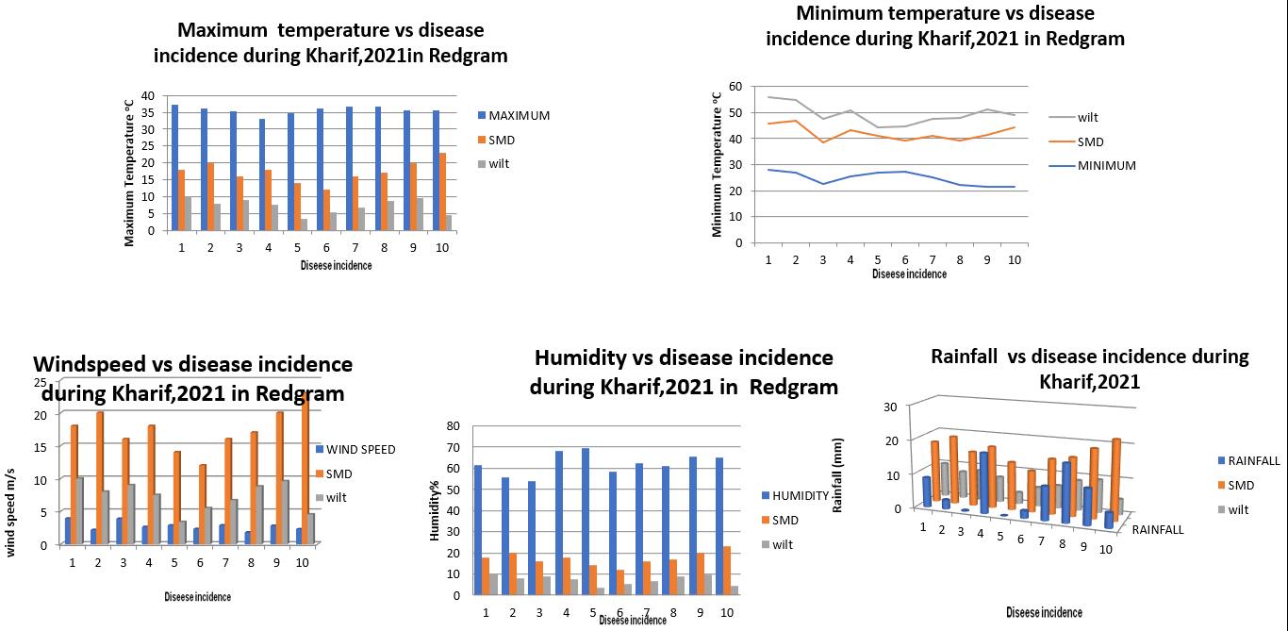
Table 2. Regression analysis of weekly environmental condition on Sterility Mosaic Disease in Redgram
Weather parametrs | SMD- R-Square
Max Temp | 24.00
Min Temp | 22.00
Max RH | 24.00
Min RH | 23.00
RF | 16.00
The maximum temperature 24 % and Maximum RH 22 % is positively related to SMD incidence
All the treatments were found to be more effective in comparison to untreated control. However, the Seed treatment imidacloprid 70 % WS @ 5 g/kg seed+ spraying of fenazaquin 5 EC @ 0.1% provided the maximum control (PDI 10.00) of the sterility mosaic disease and the vector population was decreased to 3 when compared to control (PDI 50.00).
The results indicated that among the treatments, Seed treatment imidacloprid 70 % WS @ 5 g/kg seed+ spraying of fenazaquin 5 EC @ 0.1% recorded the yield of 920 kg/ha and the untreated control plot recorded the yield of 700kg/ha.
The weather parameter is highly correlated with the sterility mosaic disease incidence the highest range of percent disease index (PDI 25.22) was found during the second standard week of Kharif season.2021-22 in redgram

Table 3. Integrated management of sterility mosaic disease of redgram
S.No | Treatments | PDI | Yield  Kg/ha | Vector population
 | T1 Seed treatment imidacloprid 70 % WS @ 5 g/kg seed + spraying of of neem kernel aqueous extract @ 5 % | 15.0 | 840 | 5
2. | T2. Seed treatment imidacloprid 70 % WS @ 5 g/kg seed + spraying of sulphur 80 % WP @ 0.25 % | 22.72 | 790 | 4
3. | T3 Seed treatment imidacloprid 70 % WS @ 5 g/kg seed + spraying of fenpyroximate 5 EC @ 0.1% | 17.39 | 734 | 2
4. | T4. Seed treatment imidacloprid 70 % WS @ 5 g/kg seed+ spraying of fenazaquin 5 EC @ 0.1% | 10.00 | 920 | 3
5. | T5. Untreated control | 50.0 | 700 | 5
 | SE(d) | 2.80 | 11.6 | 0.27
 | CD | 6.46 | 26.76 | 0.64

Conclusion
Seed treatment imidacloprid 70 % WS @ 5 g/kg seed+ spraying of fenazaquin 5 EC @ 0.1% provided the maximum control (PDI 10.00) of the sterility mosaic disease and the vector population was decreased to 3 when compared to control (PDI 50.00). When the mite population before and after the sprays of chemicals were compared, all the chemicals were found to reduce the mite population by more than 50 per cent .
Reference
Reddy, M. V., T. N. Raju. and J. M. Lenne .1998. Diseases of Pigeonpea. In: The pathology of food and pasture legumes (Eds. D. J. Allen and J. M. Lenne). CAB International ICRISAT, pp 517- 558.
Lakshmikantha, B. P. 1992. Studies on Aceria cajani Channa Basavanna (Acari : Eriophyidae), a vector of pigeonpea (Cajanus cajan) sterility mosaic disease. M.Sc. (Agri.) Thesis, Uni. Agri. Sci., Bangalore, 70pp.
De, R. K., V. Dhar and Y. S. Rathore .1996. Control of mosaic in pigeonpea with insecticides and acaricides. Indian J. Pulses Res., 9(1) : 87-89.

Kumar, P.L. , Jones, A.T. and Waliyar, F. 2008. Virus diseases of pigeonpea In: Characterization, Diagnosis and Management of Plant Viruses. Vol. 3: Vegetable and Pulse Crops (Rao G.P., Kumar P.L. and Holguin‐Pena R.J., eds), pp. 235–258. Texas, USA: Studium Press. [Google Scholar]
Upadhyaya, H.D. , Kashiwagi, J. , Varshney, R.K. , Gaur, P.M. , Saxena, K.B. , Krishnamurthy, L. , Gowda, C.L.L. , Pundir, R.P.S. , Chaturvedi, S.K. , Basu, P.S. and Singh, I.P. (2012) Phenotyping chickpeas and pigeonpeas for adaptation to drought. Front Physiol. 3, 179. [DOI] [PMC free article] [PubMed] [Google Scholar]

