Palpebral blepharoptosis secondary to botulinum toxin application: comparison of the efficacy of different therapeutic approaches

Abstract
Palpebral blepharoptosis secondary to applying botulinum toxin type A is a common complication in dermatocosmetics worldwide. Although most cases resolve spontaneously, the process can be slow and generate high patient dissatisfaction. The treatment of this condition is complex due to its nature and the limitations in the therapeutic options available. This review article focuses on the mechanism of action of botulinum toxin, the pathophysiology of blepharoptosis, and prevention and treatment strategies for this complication. By better understanding the clinical and therapeutic aspects involved, we seek to improve the care and satisfaction of patients experiencing this complication.
Keywords: ptosis palpebral, toxina botulínica tipo A, apraclonidina, brominidina, oximetazolina, fenilefrina
Introduction
Botulinum toxin (BTX) has emerged as a revolutionary tool in aesthetic medicine and therapeutics¹. It is a potent neuromuscular inhibitor with high specificity, which produces chemical denervation and blocks the release of acetylcholine in the motor plate². Its use ranges from correcting facial wrinkles to treating debilitating neurological disorders; BTX has proven to be a therapeutically and aesthetically relevant option. BTX is synthesized from the gram-positive bacterium Clostridium botulinum. Eight serotypes of botulinum toxin (A, B, C1, C2, D, E, F, and G) vary in chemical structure and size. Types A, B, E, and F are the main serotypes that affect humans².
BTX type A is frequently used in the clinic because of its availability, immunological aspect, safety, and efficacy. Its mechanism of action blocks the release of acetylcholine at the peripheral cholinergic nerve endings by breaking the SNAP-25 complex, a protein necessary to fix and release acetylcholine from the vesicles located in the nerve endings. It inhibits the fusion of the sensitive factor to its receptor protein in the neuromuscular plate². Although focal chemical denervation causes muscle atrophy, the affected tissue generates new acetylcholine receptors, facilitating the nerve to regenerate its endings and reconnect with the muscle (reinnervation). This mechanism allows the reorganization of axonal terminals, reestablishing neuromuscular communication and, consequently, the capacity for movement. Therefore, the process is considered reversible, with gradual functional recovery³.
The onset of effect occurs between 6 and 36 hours after transdermal injection; muscle weakness begins between 48 and 72 hours and achieves its maximum effect between 5 and 14 days. Recovery from paralysis occurs approximately 90 days post-application, and a new application is needed at 4 to 6 months to maintain the clinical effect². The U.S. Food and Drug Administration (FDA) authorized using BTX to treat blepharospasm, hemifacial spasm, and strabismus in 1989⁴. Since its discovery, botulinum neurotoxin has evolved from a poison to a versatile tool in managing various clinical and cosmetic conditions⁵.
In aesthetic medicine, BTX is approved to treat frontalis, procerus, and superciliary muscle wrinkles, lateral canthal lines, and severe axillary hyperhidrosis. Its off-label use has increased considerably, contributing to its popularity in procedures such as brow lift, reduction of the nasal bridge line, and nasal tip lift. It is used in the lower face to correct the gummy smile and vertical perioral wrinkles by relaxing specific facial muscles. BTX has been used successfully to improve the appearance of the neck and modify facial contour by reducing the size of the masseter muscle⁶. In treating hypertrophic and keloid scars, the toxin has demonstrated benefits in reducing scar size and improving associated symptoms such as itching and pain⁷.
n 2002, the FDA authorized the use of BTX type A for the cosmetic treatment of the glabellar area⁸. Since that date, cosmetic applications in the facial area have been extended, especially in the upper third and recently in the middle and lower third of the face (rabbit lines, nasolabial folds, upper lip, and chin); it is also indicated for paralysis of the VI pair^{9,10}. This work aims to present a review of palpebral blepharoptosis secondary to BTX application and compare the treatment efficacy of different therapeutic approaches.
Possible adverse effects in the use of BTX
As a drug, it is safe. In general, adverse effects are infrequent, mild, and not permanent. To date, no irreversible clinical effects have been described¹¹. However, the following adverse effects have been reported². Due to excessive application or improper technique, the excessive elevation of the eyebrow's tail may occur, creating a perpetual gesture of surprise or defiance known as “Mephisto eyebrows”. Palpebral ptosis or drooping of the eyebrow reveals poor drug distribution. Disproportionate reactions include involuntary twitching or total muscle paralysis. Facial asymmetry is the most obvious result.
By diffusion or migration of the neurotoxin, local dissemination may occur and affect nearby muscles, glands, or nerves, causing unexpected complications. In rare cases, the toxin spreads through the circulatory or lymphatic system to distant organs, affecting non-target muscles. Rare symptoms include epiphora, headache, and diplopia due to diffusion to ocular muscles. Pain, inflammation, bleeding at the puncture site, ecchymosis, and/or itching in the treated area may occur due to the injection. This infusion is too deep, or poor choice of injection sites for essential vessels.
Ptosis can affect eyelids and eyebrows, with an average of 13.4% of reported cases of eyebrow ptosis¹². Ectropion, diplopia, xerophthalmia, and lagophthalmos are also described after high doses of neurotoxin are applied to the lateral canthal area². There are some subtle differences in the formulations' toxopharmacological properties, which should not be used interchangeably (see Table 1)¹¹.
Palpebral blepharoptosis secondary to BTX application
Palpebral blepharoptosis is an abnormal upper eyelid position located 1.5 to 2.0 mm below the corneal limbus, which can affect both visual function and facial esthetics. This disorder is mainly associated with alterations in the levator muscle of the eyelid, although its pathophysiology involves complex interactions between adjacent muscles and structures¹³. The orbicularis oculi muscle is divided into three segments with specific roles: pretarsal, preseptal, and orbital. Each segment of the muscle plays a particular role in palpebral physiology. The pretarsal contributes to the tone of the palpebral margin, maintaining its position and firmness. The preseptal is responsible for involuntary blinking and smooth eyelid closure at rest. The orbital participates in the energetic and sustained closure of the eyelid, such as during forced blinking or eye protection¹⁴.
Ptosis is not explained solely by an imbalance between the protractor and retractor muscles. Studies suggest that botulinum toxin selectively weakens the pretarsal portion of the orbicularis, altering the balance of palpebral forces. This effect favors eyelid retraction towards a drooping position, like that observed in patients with facial nerve palsy. The interaction between the elevator muscle and the pretarsal orbicularis reveals a dynamic control network, where dysfunction of one muscle segment can trigger abnormal compensations in others. This complex model explains why ptosis requires multidisciplinary approaches, from detailed anatomical evaluation to therapies that restore muscle balance¹⁴.
In a multicenter FDA study conducted by Allergan, the incidence of blepharoptosis induced by botulinum neurotoxin type A was estimated at 5.4% among inexperienced injectors and <1% among experienced injectors11; there is no immediate treatment for its complete resolution; this occurs as a spontaneous resolution, with periods of variable duration in each patient. In most cases, the degree of ptosis is incomplete, and the effect is more severe if associated with frontalis muscle treatment¹⁴. Ptosis degrees range from severe too mild with barely perceptible asymmetries. Near the mild end of the spectrum, microptosis, and the compensatory mechanisms that accompany it often result in aesthetic asymmetry, which may motivate patients to seek treatment¹⁴.
Facial symmetry is particularly evident in the periorbital region, and even mild ptosis can increase the perception of facial asymmetry. In patients with this mild or microptosis, surgery is rarely indicated from a functional perspective and may result in secondary aesthetic complications, such as contour asymmetry or crease abnormalities. Non-surgical treatments may be advisable in these situations. One of these treatments is botulinum neurotoxin in mild ptosis¹⁴.
Prevention
The application of Onabotulinumtoxin A to treat glabellar wrinkles can cause eyelid ptosis. According to the manufacturer's data, this complication occurs in 3.2% of cases, although other studies report incidences between 2% and 5.4%. This adverse effect is related to several factors that increase the risk of its occurrence^{15, 16}.
The probability of developing palpebral ptosis depends on four main aspects: a) Patient characteristics: Advanced age, thick or short eyebrows, prolonged sun exposure (from outdoor work), less elastic or thicker skin, and dependence on the frontalis muscle are factors that increase the risk; b) Medical conditions: Previous facial surgeries, neurological diseases such as myasthenia gravis or multiple sclerosis, history of ptosis or Bell's palsy; c) Product properties: The quality and dilution of the toxin may influence the results; d) Treatment technique: The location of the injections, the dose applied and the technical precision are determinants of the results; e) Treatment technique: The location of the injections, the dose applied and the technical precision are determinants of the results; f) Treatment technique: The quality and the dilution of the toxin may influence the results¹⁵.

The diffusion of botulinum toxin from the frontal region to the orbit occurs mainly by gravitational effect and passive diffusion through the orbital septum, affecting the elevator muscle of the upper eyelid. Facial anatomy shows that the frontal periosteum surrounding the orbit is the most direct route for this diffusion. Therefore, keeping this periosteum intact during the procedure is crucial to prevent the toxin from reaching the orbit and causing palpebral ptosis. Botulinum toxin type A is easily dispersed in thin tissues such as those under the superciliary corrugator muscle. Its fixation is faster when applied over a larger muscle surface. A parallel injection technique allows more muscle tissue to be covered without infiltrating the deep planes, which reduces diffusion into the periosteum. Although diffusion cannot be controlled entirely, it can be improved with injections parallel to the periosteum and in a retrograde direction, which favors the fixation of the toxin to the muscle and avoids ptosis¹⁶.

Injection of Onabotulinum with a puncture parallel to the frontal periosteum, following the anatomy of the superciliary corrugator muscle, reduces the incidence of ptosis without affecting treatment efficacy. This has been demonstrated in a retrospective study that compared two injection techniques using methylene blue to visualize diffusion. The results showed that the parallel injection did not infiltrate the periosteum, while the perpendicular technique did (Figure 1) ¹⁶.

Suggested treatments
When ptosis is mild, explaining to the patient that the effect is temporary is often sufficient. Lower eyelid ptosis can occur from over-treating the palpebral area of the orbicularis muscle, affecting the function of the eyelid. There is no specific treatment, and the treatment usually resolves within weeks. If ectropion develops, it is essential to consult an ophthalmologist to prevent corneal damage. Eyelid ptosis usually improves in 3 to 4 weeks, faster than eyebrow ptosis, which can take about 6 weeks¹⁵.
One study revealed that ptosis occurs in 5.4% of cases, but this is usually due to the injector's inexperience. In experienced hands, the incidence is less than 1%. The patient consults between 3 and 7 days after the treatment, noticing drooping of the eyebrow or eyelid, which can be subtle and manifest as heaviness in the eyelid or eyebrows, difficulty opening the eye completely, or difficulty applying make-up. In severe cases, ptosis can restrict vision¹⁵.
- Electrostimulation
Muscle stimulation can reduce the duration of blepharoptosis by performing muscle exercise or mechanical or electrical stimulation. A trick well-known by many practitioners is to pass the back of an electric toothbrush over the muscle for several minutes a day, which consists of placing the back of the active brush on the upper part of the eyelid for several minutes a day^{13,15}.
- Oxymetazoline hydrochloride
Oxymetazoline hydrochloride 0.1% is the only drug approved by the FDA to treat acquired ptosis in adults. Initially used for nasal congestion, it acts as an adrenergic agonist that stimulates the eyelid muscle, raising it by 1 to 2 mm. It is helpful for mild to moderate ptosis, including age-related cases or cosmetic Botox. It is applied one drop daily to the affected eye and is safe for prolonged use, unlike nasal oxymetazoline. Common side effects are mild, such as eye irritation or headache, involving a few patients. Its use should be assessed individually, especially in pregnancy, lactation, or patients with cardiovascular disease or arterial hypertension^{8,9}.
- Apraclonidine and brominidine
Before oxymetazoline, apraclonidine 0.5% was standard for botulinum toxin-induced ptosis. This α2-adrenergic agonist, used in glaucoma, stimulates the superior tarsal muscle, elevating the eyelid 1-2 mm. Although effective, risks include mydriasis and angle-closure glaucoma, with contact dermatitis and ocular irritation being more common. Apraclonidine can be prescribed in drops (1-2 drops thrice daily), contracting Müller's muscle. While it is used for Horner's syndrome, its application for botulinum toxin ptosis is less well documented, and some physicians are hesitant because of its side effects. Although some dermatologists recommend it, its availability is limited. Internationally, it is considered the first line. Still, in places such as Mexico, where it is unavailable, brimonidine is valued as an alternative, an α2-adrenergic agonist with similar effects and fewer adverse reactions^{13,15,17}.
In Figure 1, brimonidine was applied as an alternative treatment due to the lack of apraclonidine in Mexico. Apraclonidine is a 2-adrenergic agonist with the same therapeutic effect without adverse reactions. Adverse reactions to consider are rare and include allergic conjunctivitis or pruritus. Brimonidine (2 mg/ml) in ophthalmic drops can treat palpebral ptosis in the international bibliography and is feasible in our environment. However, there are no studies that evaluate its efficacy in comparison with apraclonidine¹⁷.
- Transdermal injection of botulinum toxin in the pretarsal, medial and lateral eyelid
Botulinum toxin can be injected into the pretarsal orbicularis oris muscle to correct mild palpebral asymmetries. One study showed that transdermal injections of three units of BoNT-A, 2 mm above the lash line, improved the eyelid position, increasing the reflex margin distance (MRD) by 0.9 mm. Treatment is successful if the difference in MRD between the two eyes is less than 0.5 mm and tarsal shelf exposure is reduced. Although it improves aesthetics, its efficacy in functional ptosis is uncertain. Higher doses may improve DRM but increase the risk of lagophthalmos, keratitis, or worsening of ptosis by diffusion to the Mueller/elevator complex. Treatment should be individualized, considering brow elevator muscle intervention. Elevating the eyebrow may also influence the position of the upper eyelid^{12,14}. When ptosis is mild, informing the patient about the duration of the effect may be sufficient.
- Phenylephrine
Preoperative response to topical phenylephrine is a valuable indicator for successful repair of ptosis by Müller muscle resection (MMR)^{18,19}. A topical 2.5% or 10% phenylephrine hydrochloride solution is applied to the superior conjunctival fornix during the phenylephrine test. Exposure to this selective α1-adrenergic agonist causes contraction of the Müller muscle innervated by the sympathetic nervous system and elevation of the eyelid, regardless of levator function. Patients in whom the ptotic eyelid is elevated are considered ideal candidates for surgical correction of MMR. Given their mechanism of action, phenylephrine drops have also been recommended to reverse BoNT-A-induced ptosis alone or in combination with other therapeutic agents¹³.
In a nonrandomized clinical trial with 20 healthy subjects, MRD-1 was measured before, 30, 60, and 120 minutes after administration of a drop of 0.2% brimonidine, 0.12% phenylephrine, or 0.05% naphazoline in the left eye²0. While the authors observed no statistically significant differences in mean MRD-1 between the brimonidine and phenylephrine groups when comparing baseline to the study time points, naphazoline administration demonstrated a mean increase in MRD-1 of 0.56 (+/- 0.11 mm) after 30 minutes compared to baseline¹³.

- Anticolinesterases
Anticholinesterases have successfully treated ptosis induced by botulinum neurotoxin type A⁵. A case of unilateral palpebral ptosis following Dysport injection into glabellar and frontal wrinkles. Since the patient had a history of local allergic reactions to α-adrenergic eye drops, she was treated with 60 mg of oral pyridostigmine. After 30 minutes, the eyelid began to elevate, and after 2 hours, she no longer felt the palpebral heaviness. The effects lasted approximately 4 to 8 hours, and she was advised to continue with 60 mg tablets daily (every 6 to 8 hours as needed) for 2 weeks. Of note, the glabellar and frontal wrinkles were unaffected. The ptosis resolved thoroughly after 3 weeks. Although local treatment with α-adrenergic eye drops is more common for BoNT-A-induced ptosis, the authors suggest systemic therapy with oral acetylcholinesterase inhibitors in certain patients, carefully considering dosage and potential side effects¹⁴.
Pyridostigmine is the most used drug to alleviate ocular deficits. Highly effective for palpebral ptosis but not for diplopia and related motor manifestations. The other limitation is that the response to pyridostigmine decreases over time. The dose is initiated at 30-60 mg three times per day and can be increased to 90-120 mg every 3-4 hours daily when it is effective and without adverse effects. Complications are related to muscarinic effects, particularly abdominal cramps, nausea, vomiting, and diarrhea, which occur in at least one-third of patients. These adverse effects can be corrected with atropine or glycopyrrolate. Acetylcholine inhibitors are contraindicated in patients with gastrointestinal disorders³, three bradyarrhythmias, reactive airway disorders, and prostatic hypertrophy²¹.
Conclusion
In conclusion, botulinum toxin (BT) is a particular neuromuscular inhibitor that induces chemical denervation by blocking the release of acetylcholine in the motor plate. One of the most frequent complications associated with its application in the area between the eyebrows, specifically in the procerus and superciliary muscles, is secondary blepharoptosis. This complication can vary significantly depending on the experience of the professional administering the injection and can be mitigated by proper application techniques and accurate anamnesis. Among the treatments reviewed, oxymetazoline is one of the FDA-approved methods, noted for its greater visible cosmetic satisfaction in treating blepharoptosis. However, there are other therapeutic approaches that still require further scientific evidence for validation, such as the use of pyridostigmine, an anticholinesterase that has shown promising results in some instances. Although these drugs have demonstrated limited but satisfactory impact, their potential as adjuvant treatment for blepharoptosis secondary to botulinum toxin application in the upper frontal facial third could motivate future research for FDA approval.
References
- Gonzalez, C., Rengifo, J., Macias-Arias, P., Duque-Clavijo, V., Noreña-Rengifo, BD. (2024). High-Resolution ultrasound for complications of botulinum toxin use: a case series and literature review. Cureus. 61(2), 220. D: 10.7759/cureus.63232.
- Rojas-Rondón, I., Llamas-Meriño, J., Ramírez-García, L., Gómez-Cabrera, C., Rodríguez-Salinas, G., Álvarez-Mesa N. (2016). Aplicaciones de la toxina botulínica en afecciones palpebrales. Revista cubana de oftalmología. 29(2), 316-331.
- Fagien, S., (2016). Temporary management of upper lid ptosis, lid malposition, and eyelid fissure asymmetry with botulinum toxin type A. Plastic and Reconstructive Surgery. 114(7), 1892-902. Doi: 10.1097/01.prs.0000142744.55379.8d.
- Frevert, J. (2015). Pharmaceutical, biological, and clinical properties of botulinum neurotoxin type A products. Drugs R D. 15(1), 1-9. Doi: 10.1007/s40268-014-0077-1.
- Karami, M., Taheri, A., Mansoori, P. (2007). Treatment of botulinum toxin-induced eyelid ptosis with anticholinesterases. Dermatol Surg. 33(11), 1394-5. Doi: 10.1111/j.1524-4725.2007.33299.x.
- Phan, K., Younessi, S., Dubin, D., Lin, M. J., Khorasani, H. (2022). Emerging off-label esthetic uses of botulinum toxin in dermatology. Dermatologic Therapy. 35(1), e15205. Doi: 10.1111/dth.15205.
- Tawfik, A. A., Ali, R. A. (2023). Evaluation of botulinum toxin type A for treating post burn hypertrophic scars and keloid in children: An intra-patient randomized controlled study. Journal of Cosmetic Dermatology. 22(4), 1256-60. Doi: 10.1111/jocd.15634.
- Mukamal, R., De-Angelis K. (2021). First prescription fix for droopy eyelid. American Academy Of Ophtalmology. Available in: https://www.aao.org/salud-ocular/noticias/primera-soluci%c3%b3n-oftalmol%c3%b3gica-con-prescripci%c3%b3n-pa.
- Bradley, E. A., Bradley, D. J. (2020). Oximetazoline for ptosis. JAMA Ophtalmology.138(11), 1176-77. Doi: 10.1001/jamaophthalmol.2020.3833.
- Taha, M., Li, Y., Morren, J. (2023). Oxymetazoline hydrochloride eye-drops as treatment for myasthenia gravis related ptosis: a description of two cases. Cureus. 15(3), e36351. Doi: 10.7759/cureus.36351.
- Choudhury, S., Baker, M. R., Chatterjee, S., Kumar, H. (2021). Botulinum toxin: an update on pharmacology and newer products in development. Toxins (Basel).13(1), 58. Doi: 10.3390/toxins13010058.
- Sethi, N., Singh, S., De-Boulle, K., Rahman, E. (2021). A Review of complications due to the use of botulinum toxin A for cosmetic indications. Aesthetic Plastuc Surgery. 45 (3), 1210-20. Doi: 10.1007/s00266-020-01983-w.
- Nestor, M. S., Han, H., Gade, A., Fischer, D., Saban, Y., Polselli, R. (2021). Botulinum toxin-induced blepharoptosis: Anatomy, etiology, prevention, and therapeutic options. J Cosmet Dermatol. 20(10), 3133-3146. Doi: 10.1111/jocd.14361.
- Mustak, H., Rafaelof, M., Goldberg, RA., Rootman, D. (2018). Use of botulinum toxin for the correction of mild ptosis. The Journal of Clinical and Aesthetic Dermatology. 11(4), 49-51.
- King, M. (2016). Management of Ptosis. The Journal of Clinical and Aesthetic Dermatology. 9(12), E1-E4.
- Tomas-Bas, C., Thomas-Halaby, F. (2020). Experiencia en la prevención de la ptosis palpebral secundaria al tratamiento de arrugas glabelares con OnabotulinumtoxinA. Revista de Cirugía Plástica Iberolatinoamericana. 46 (3), 361-6.
- Soria-Orozco, M., Jiménez-Záragoza, D., Gutiérrez-Flores, H. (2025). Management with topical brimonidine of palpebral ptosis secondary to the application of botulinum toxin: Therapeutic pearl. Dermatología Revista Mexicana. 69(1), 73-6.
- Grace-Lee, N., Lin, L. W., Mehta, S., Freitag, S. K. (2015). Response to phenylephrine testing in upper eyelids with ptosis. Digital Journal of Ophthalmology. 21(3), 1-12. Doi: 10.5693/djo.01.2015.05.001.
- Glatt, H. J., Fett, D. R., Putterman, A. M. (1990). Comparison of 2.5% and 10% phenylephrine in the elevation of upper eyelids with ptosis. Ophthalmic Surgery. 21(3), 173-6.
- Mendonça, T. B., Lummertz, A. P., Bocaccio, F. J., Procianoy, F. (2017). Effect of low concentration, nonmydriatic selective alpha-adrenergic agonist eyedrops on upper eyelid position. American Society for Dermatologic Surgery. 43(2), 270-4. Doi: 10.1097/DSS.0000000000000967.
- Naranjo-Férnandez, R.M., Estévez-Miranda, Y., Méndez-Sánchez, T. J., Dorrego-Oduardo, M. D., Rúa-Martínez, R. (2013). Myasthenia gravis and ocular myasthenia gravis. Revista cubana de oftalmología. 26(2), 653-667.

Table 1. Conventional formulations of botulinum toxin and their indications ¹¹.
TRADE NAME | STRAIN | INDICATION
BOTOX | Onabotulinum | Blepharospasm, hemifacial spasm, strabismus, cervical dystonia, migraine, upper limb spasticity, NDO bladder, OB bladder, adult lower limb spasticity, forehead wrinkling
XEOMEEN | Incobotulinum | Cervical dystonia, blepharospasm, expression lines, spasticity of the upper extremities, sialorrhea in adults.
DYSPORT | Abobotulinico | Cervical dystonia, expression lines, wrinkles, upper limb spasticity in adults, lower limb spasticity in children and adults.
MIOBLOC/ NEUROBLOC | Rimabotulinica | Cervical dystonia

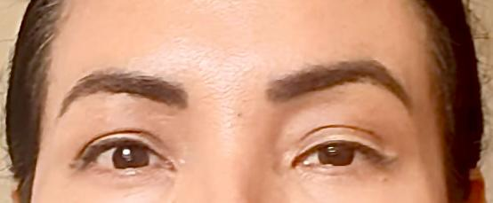
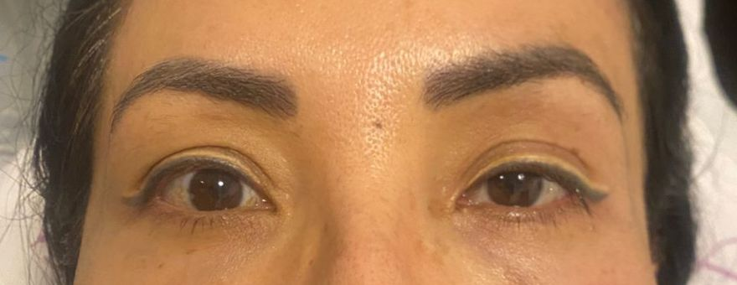

a) b)
Figure 1. a) Blepharoptosis of the left eye prior to application of brimonidine eye drops; b) Clinical improvement of left ptosis after 30 min of administration of 2 drops of brimonidine (2 mg/ml).

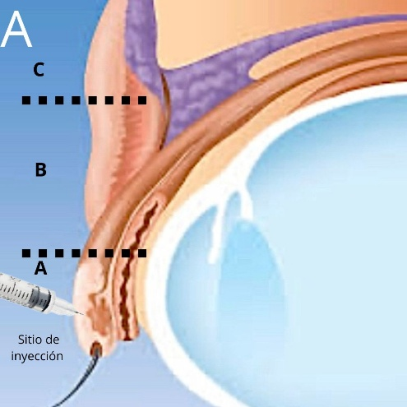
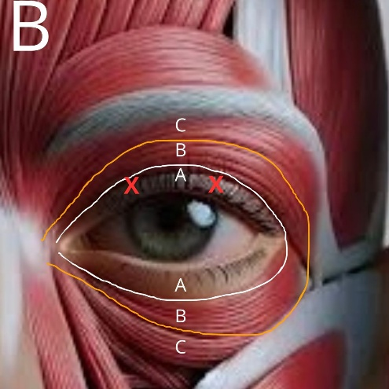

Figure 2. A) The sagittal cross-section of the upper eyelid illustrates the three divisions of the orbicularis oculi muscle. The puncture for mild ptosis is approximately 2 mm above the lash line. B) Anatomy of the orbicularis oculi muscle. Puncture sites for mild ptosis are indicated by the two red X marks, 2 mm above the lash line over the medial and lateral limbus¹⁴.

