Original Research Article

Synergistic Integration of Artificial Intelligence for Advanced Desalination and Sustainable Water Reclamation in Addressing Global Water Scarcity

ABSTRACT
Global water scarcity, intensified by population growth, climate change, and industrial demands, necessitates innovative and sustainable water resource management. Advanced desalination and sustainable water reuse are increasingly vital solutions, augmenting freshwater sources and bolstering water security worldwide. The evolving roles of these technologies in addressing the escalating global water crisis are being examined, with emphasis placed on recent technological advancements and practical implications. Desalination, the conversion of saline water into a virtually inexhaustible resource, is crucial for arid and coastal regions. Progress is focused on enhancing energy efficiency through novel membranes, advanced energy recovery, and renewable energy integration. Innovations in reverse osmosis, forward osmosis, and membrane distillation are improving performance and sustainability. Sustainable brine management, minimizing environmental impact and exploring resource recovery, is also critical. Complementing desalination, sustainable water reuse treats and repurposes wastewater, offering a resilient and environmentally responsible approach. Advancements in treatment technologies ensure the safe removal of diverse contaminants, enabling reclaimed water use for agriculture, industry, and even potable consumption. Emphasis is placed on cost-effective, energy-efficient treatment minimizing environmental footprints and addressing public perception. The synergistic integration of desalination and water reuse within comprehensive water management strategies offers enhanced reliability and resilience. Hybrid systems optimize resource utilization and mitigate drought impacts. Analyzing successful case studies from water-scarce regions reveals best practices. Artificial Intelligence is being explored for its transformative potential in optimizing desalination processes through intelligent control and predictive maintenance, enhancing energy efficiency. In water reclamation, AI algorithms can improve treatment efficacy by real-time monitoring and adaptive adjustments for contaminant removal. The synergistic integration of AI with these technologies promises more efficient and sustainable solutions to global water scarcity. Economic, social, and environmental considerations highlight the need for supportive policies, technological innovation, and public engagement for sustainable and equitable implementation, ensuring global access to clean water resources.

KEYWORDS
Artificial Intelligence (AI), Desalination, Water Reuse, Water Reclamation, Global Water Scarcity, Sustainable Water Management, AI for Water Treatment, Advanced Desalination Technologies, Integrated Water Solutions.

INTRODUCTION
The world’s expanding population (Biswas and Tortajada 2018) significantly increases the need for clean water for various sectoral water uses (such as irrigation, residential, energy, and industry purposes). Climate change has led to a rise in the frequency and severity of hydro-climatic extremes, such as floods and droughts. One of the UN Sustainable Development Goals (SDGs) for 2030, "clean accessible water for all," may be difficult to manage sustainably because of these developments (UN 2015).
Previous evaluations of water scarcity have largely concentrated on the amount of water available. A common way to measure water scarcity or stress involves looking at how much freshwater is used compared to the total freshwater resources that exist (Van Vliet et al., 2021). A significant majority of the global population lives in areas facing water scarcity. In many places, the amount of water being taken exceeds what can be sustainably used, leading to the depletion of water sources. Non-renewable groundwater is essentially being over-extracted, putting many of the world's underground water reserves at risk. Pollution has further reduced the availability of usable water by damaging its quality. On the demand side, population growth and increased water usage are making shortages worse. On the supply side, pressures are also increasing as water becomes less accessible due to changing rainfall patterns, and rising temperatures increase evaporation and the need for water. Insufficient water supply has a severe impact on densely populated regions, especially where water resources are already limited (Ghernaout & Elboughdiri, 2020). The 21st century is increasingly defined by the escalating challenge of global water scarcity. Driven by an unprecedented confluence of factors including rapid population growth, the intensifying and erratic impacts of climate change, and burgeoning industrial and agricultural demands, access to clean and reliable water resources is becoming a critical constraint on human well-being, economic development, and environmental sustainability. This escalating crisis necessitates a paradigm shift in how water resources are managed, demanding innovative and, crucially, sustainable solutions to augment traditional supplies and ensure water security for a growing global population. Among the most promising and increasingly vital strategies in this endeavor are the advanced technologies of desalination and sustainable water reclamation. Desalination, the process of removing dissolved salts and minerals from saline water sources such as seawater, brackish water, and treated wastewater effluent, offers a virtually inexhaustible, albeit energy-intensive, pathway to generate freshwater, particularly for arid coastal regions and island nations facing inherent limitations in conventional water resources. Concurrently, sustainable water reclamation, involving the treatment and repurposing of wastewater for beneficial uses ranging from irrigation and industrial processes to indirect and even direct potable applications, presents a resilient and environmentally responsible approach to water resource augmentation, reducing reliance on increasingly stressed natural freshwater sources and minimizing wastewater discharge.
However, the widespread and effective implementation of both desalination and water reuse technologies is not without its challenges. Desalination processes have historically been associated with high-energy consumption, significant capital costs, and potential environmental impacts related to brine disposal. Similarly, water reuse initiatives can face public perception barriers, require stringent treatment protocols to ensure water quality and safety, and necessitate robust monitoring and regulatory frameworks. To overcome these hurdles and unlock the full potential of these technologies in addressing global water scarcity, innovative approaches and optimization strategies are paramount. In this context, the synergistic integration of Artificial Intelligence (AI) emerges as a transformative frontier in the field of water resource management. AI, with its capabilities in data analysis, pattern recognition, predictive modeling, and automated control, holds immense promise for enhancing the efficiency, sustainability, and cost-effectiveness of both advanced desalination and sustainable water reclamation processes. By leveraging AI algorithms, it becomes possible to optimize complex operational parameters in desalination plants, leading to reduced energy consumption, improved water recovery rates, and proactive maintenance scheduling, thereby minimizing downtime and operational costs. Furthermore, AI can play a crucial role in the design and development of novel membrane materials with enhanced performance characteristics and reduced fouling propensity. In the realm of water reclamation, AI offers powerful tools for real-time monitoring of water quality, optimization of treatment processes for the removal of a wide array of contaminants (including emerging micro pollutants), and prediction of system performance under varying influent conditions. AI-driven control systems can adapt treatment parameters dynamically, ensuring consistent effluent quality while minimizing the use of chemicals and energy. Moreover, AI can facilitate the development of sophisticated risk assessment models and early warning systems to safeguard public health and environmental integrity in water reuse applications. This research critically examines the evolving and increasingly interconnected roles of advanced desalination and sustainable water reclamation in addressing the escalating global water crisis. It places a particular emphasis on exploring the transformative potential of the synergistic integration of Artificial Intelligence to optimize these crucial technologies. This paper looked closely at the newest technologies. This paper also studied how AI can be used in different parts of desalination and water reuse. This paper thought about how this affects the economy, society, and the environment. The goal of this study is to help create better, more sustainable, and stronger ways to manage water for a world that does not have enough water. In the end, this paper want a future where everyone has enough clean water.

LITERATURE REVIEW
Global water scarcity is a complex issue that includes both financial barriers to getting freshwater and physical restrictions on its availability. This problem is being made worse by the growing demand for freshwater around the world, which is being caused by intensive farming methods, fast urbanization, industrialization, and population growth. The issue is made worse by climate change, which creates more uncertainty due to changes in precipitation patterns, extended droughts, and the melting of important glacier deposits. Unchecked water scarcity has serious repercussions, including affecting human health by limiting access to safe drinking water and sanitation, endangering food security by limiting agricultural production, impeding economic growth because of industries that depend on water, and even escalating geopolitical instability as countries vie for limited resources. Exploration and application of creative alternative water sources are required since conventional water management techniques, which concentrate on the extraction and conservation of surface and groundwater, are becoming less and less adequate to meet the rising demand. Reusing and desalinating water have become viable options that could improve water security in areas that are at risk and supplement traditional supplies. Desalination opens up a huge, previously unusable water supply by eliminating dissolved salts and minerals from brackish water, seawater, or treated wastewater. By completing the water cycle, water reuse- which entails treating wastewater to a level appropriate for useful applications—offers a resource-efficient and sustainable solution.
Addressing Global Water Scarcity through the Synergistic Integration of Artificial Intelligence for Sustainable Water Reclamation and Advanced Desalination Climate change and population expansion have made the world's water shortage worse, calling for creative approaches to water management. Sustainable water reclamation and advanced desalination are essential for boosting freshwater supply. In order to maximize their integration, this study looks at recent research on their developments and the emerging role of artificial intelligence (AI) (Team, 2025). Energy recovery systems and innovative membrane materials are helping desalination technologies advance toward greater energy efficiency. Sustainable brine management and the possibility of cutting-edge technologies like membrane distillation and forward osmosis for particular usage are further areas of research attention (Orfi et al., 2025). With advanced treatment techniques for eliminating a variety of pollutants, sustainable water reclamation is progressing and opening up a range of advantageous uses, including potable applications. Advanced oxidation techniques and membrane bioreactors are important research topics, as are methods to increase public support for water reuse (Turning Wastewater Into a Resource: Advancing Sustainable Water Management, 2025). The integration of AI offers significant potential for optimizing both desalination and water reclamation (Mahadeva et al., 2023). In order to enhance energy efficiency and water recovery, artificial intelligence (AI) algorithms are being investigated for intelligent process control, predictive maintenance, and fouling mitigation in desalination facilities. AI makes proactive and effective treatment possible in water reclamation by offering real-time water quality monitoring, improved chemical dosage, and effluent quality prediction (Alenezi & Alabaiadly, 2025). A viable avenue for improved water security and resource optimization is the cooperative integration of AI with hybrid desalination-reuse systems. In order to effectively solve global water scarcity, future research should focus on developing strong, explainable AI models, resolving issues with data availability, and investigating the socioeconomic and policy ramifications of putting these integrated, AI-driven solutions into practice.

METHODOLOGY
A systematic literature search was conducted across several prominent academic databases and research platforms, including the Scopus Index, PubMed, Academia, Research Gate, and Google Scholar. These platforms were chosen for their extensive coverage of peer-reviewed scientific literature, including journals, conference proceedings, and scholarly books, as well as grey literature and pre-prints available on research-sharing sites. The search strategy involved the use of a combination of keywords and Boolean operators to identify relevant publications. Keywords included terms such as "desalination," "water reuse," "water reclamation," "artificial intelligence," "machine learning," "optimization," "energy efficiency," "membrane technology," "treatment processes," "brine management," "water scarcity," "sustainable water management," and various combinations thereof. The search was not limited by publication date initially to capture foundational research, but a subsequent focus was placed on more recent publications to identify cutting-edge advancements and current trends in the field. The findings from these database searches were carefully screened for relevance based on their titles, abstracts, and, where necessary, full text. Studies that directly addressed the application of AI in either desalination or water reuse, as well as those focusing on advancements in the core technologies themselves and their integration for water scarcity mitigation, were prioritized. Additionally, a manual search of the reference lists of key articles was undertaken to identify any further relevant publications that may not have been captured through the initial database searches.
Beyond primary research articles, secondary sources played a crucial role in providing broader context, statistical data, and policy perspectives. This investigation relied on an intensive offline and online literature review to collect this secondary data. Resources consulted included scholarly books providing foundational knowledge on desalination, water reuse, and artificial intelligence; reports published by governmental organizations and international organizations (e.g., United Nations, World Bank, World Health Organization) offering macro-level data, policy frameworks, and case studies related to water scarcity and its solutions. Scientific journals beyond the initial database search, as well as reputable national and international newspapers, were examined for relevant news, analyses, and perspectives on the societal and political aspects of water scarcity and the adoption of desalination and water reuse technologies. Finally, relevant online sites of research institutions, industry consortia, and non-governmental organizations working in the water sector were explored for up-to-date information, reports, and initiatives. The data and insights gathered from both primary and secondary sources were critically evaluated and synthesized to provide a comprehensive understanding of the current state of the art, identify key research gaps, and inform the subsequent stages of the research. This multi-pronged approach ensured a robust and well-informed foundation for investigating the synergistic integration of AI for advanced desalination and sustainable water reclamation in addressing the complex challenge of global water scarcity.

GLOBAL SURFACE WATER QUALITY:
Numerous anthropogenic activities are putting increasing strain on the quality of surface water worldwide, endangering both ecosystem integrity and human health (United Nations Environment Programme, n.d.). The main causes of this deterioration include untreated home wastewater, pesticide and fertilizer-containing agricultural runoff, and pollution from industrial outflow (Un-Water, 2017). As a result, many areas struggle to preserve healthy aquatic habitats and obtain safe drinking water (WHO, 17 April 2025). Widespread contamination with organic pollutants, pathogens, heavy metals, and newly discovered contaminants including medicines is revealed by monitoring activities. By changing precipitation patterns, raising water temperatures, and increasing the frequency of extreme weather events, climate change makes the problem worse by affecting pollution concentrations and ecosystem resilience. Stricter laws, better wastewater treatment facilities, sustainable farming methods, and increased international monitoring and data exchange are all necessary components of integrated efforts to address this challenge. A sustainable future and water security depend on maintaining and improving the quality of the world's surface waters (GEMStat. 2025). Overall, consistent water quality hotspots are found for organic pollution, salinity, and nutrients (figure 01), however the effects of various water quality elements (pollutants) on sectoral uses may vary. This is consistent with earlier extensive water quality assessments encompassing many water quality elements and is caused by common pollution sources and contributing sectors (Van Vliet et al., 2021).
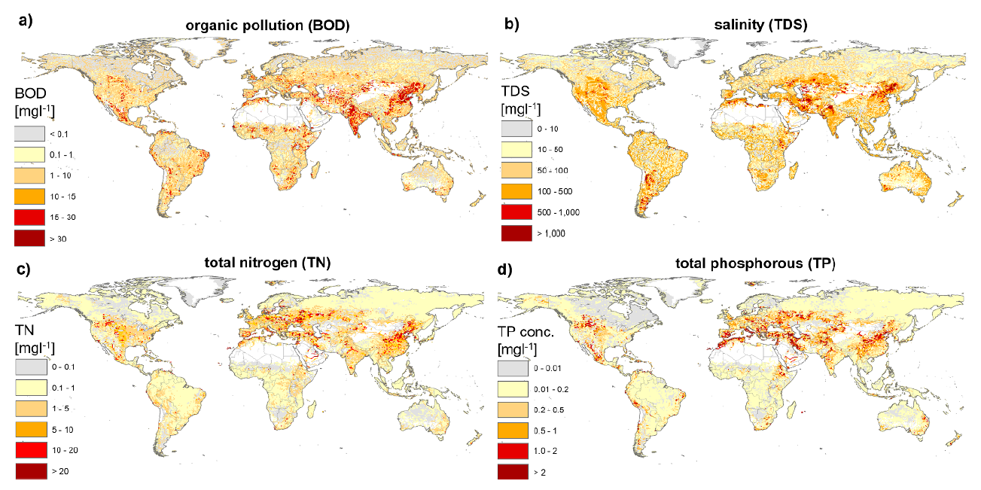
Figure 01: Hotspots for surface water quality worldwide. Total dissolved solids (TDS) (b), total nitrogen (TN) (c), total phosphorous (TP) (d), and biochemical oxygen demand (BOD) (a) all show the average simulated in-stream values for simulated organic contamination. White (masked) areas are those where the water availability is less than one m³ s⁻¹ (Source: Van Vliet et al., 2021).
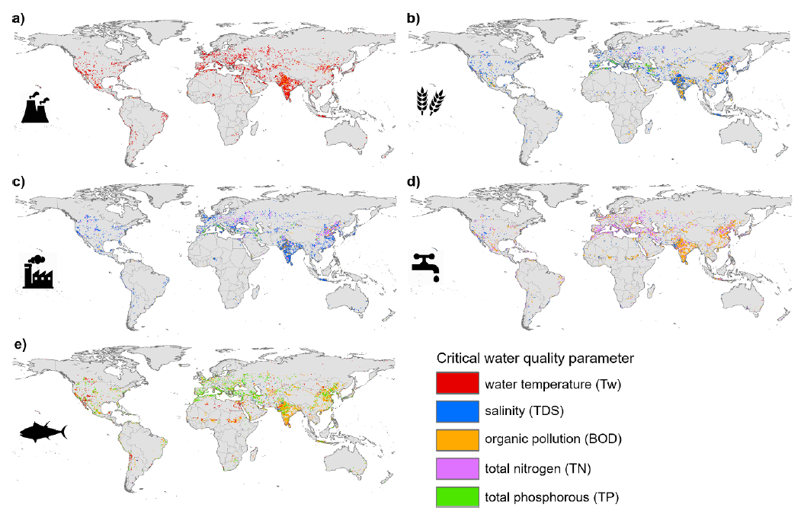
Figure 02: Primary factors affecting water quality that are crucial for freshwater ecosystems and human uses in areas with limited water supplies. maps showing the components of water quality that most strongly contributed to the rise in water scarcity for energy (a), irrigation (b), manufacturing (c), domestic uses (d), and freshwater ecosystems (e).

High water temperatures are the main cause of the rise in water scarcity for the energy (thermoelectric) sector (figure 02(a)), with increasing water scarcity mostly in eastern China, India, the US, Europe, and portions of Australia. In the majority of locations, high salinity (TDS) levels primarily limit the use of irrigation and manufacture (figures 02(b) and (c); 72% and 77% of the area used for irrigation and manufacturing, respectively). Numerous essential components of water quality, such as high levels of organic pollution (BOD) in eastern Asia, high levels of TN primarily in Europe, and high levels of salt (TDS) primarily in arid places (such as the western United States), contribute to the rise in domestic water shortage (figure 02(d)). Particularly for BOD (45%) and phosphorus (42%), surface water quality limits for ecosystem health are surpassed (figure 02(e)) (Van Vliet et al., 2021).

GLOBAL WATER SCARCITY
A growing problem that affects billions of people globally, global water scarcity that poses serious risks to economic stability, food security, and human health. Climate change, population increase, agricultural needs, industrialization, and inadequate water management are some of the many interrelated variables that contribute to it (Understanding the Global Water Crisis: Causes and Solutions, n.d.). Through changed rainfall patterns, protracted droughts, and the melting of glaciers- essential freshwater sources- climate change exacerbates water scarcity. The demand for water for home, agricultural, and industrial applications is rising due to the world's population growth and fast urbanization, frequently surpassing the availability (Un-Water, n.d.-b). The issue is made worse by the fact that agriculture, the sector that uses the most freshwater, frequently uses ineffective irrigation techniques (Omolere, 2024b). Due to excessive consumption and pollution, industrial operations further deplete water supplies, making them unfit for human use (Funk, 2025). Significant water loss results from leaks and unequal distribution due to poor infrastructure and poor management (Conti & Conti, 2025). The ramifications of water scarcity are extensive. Millions of people die each year from waterborne illnesses brought on by a lack of access to clean water, especially children (Water For People, 2024c). Food instability and possible resource disputes result from agricultural output being hampered by reduced water availability. In many areas, women and girls are disproportionately responsible for collecting water, which restricts their access to economic and educational opportunities. The growing crisis of global water scarcity necessitates that innovative solutions are explored. Artificial intelligence presents a powerful toolkit by which the securing and management of this vital resource can be revolutionized. Through the intelligent optimization of processes like desalination and water reclamation, a more sustainable path to address the looming challenges can be forged.

HOW DOES SALINE WATER FORM?
Salty water has a lot of dissolved salts in it. We measure how much salt is in the water by weight. We use a unit called "parts per million" or ppm. If water has 10,000 ppm of salt, it means that for every 100 parts of water by weight, 1 part is salt. So, one percent of the water's weight is from the dissolved salts. We can categorize salty water based on how much dissolved salt it contains, measured in parts per million (ppm). Water with less than 1,000 ppm is considered freshwater. Slightly salty water has a salt concentration between 1,000 ppm and 3,000 ppm. Moderately salty water ranges from 3,000 ppm to 10,000 ppm. Water that is highly salty has a concentration between 10,000 ppm and 35,000 ppm. For reference, ocean water typically contains about 35,000 ppm of salt (Desalination, 2018b).

UNDERSTANDING THE IMPORTANCE OF DESALINATION
Desalination is a key technical answer in a world where water is becoming scarcer. The process of extracting salt and other minerals from brackish water, saltwater, or treated wastewater in order to create fresh, drinkable water fit for industrial, agricultural, and human use is known as desalination. The increasing demands on our limited freshwater supplies are the primary cause of desalination's significance. In many parts of the world, population growth, industrialization, and climate change are making water stress worse. Access to naturally occurring freshwater sources is frequently restricted, especially in coastal areas and arid or semi-arid regions. Desalination provides a dependable and climate-independent source of water by allowing access to the ocean's enormous reserves. Desalination can also improve water security by lowering reliance on precipitation and far-off freshwater sources, which are susceptible to droughts and geopolitical conflicts. In comparison to certain tainted surface or groundwater sources, it can also offer water of a superior quality. Although brine discharge must be carefully managed and the process might be energy-intensive, technological developments are constantly increasing efficiency and reducing environmental effects. Desalination will surely become more and more important in guaranteeing a sustainable water future for numerous towns and enterprises around the world as freshwater scarcity becomes a more urgent global issue.

DESALINATION IS BECOMING A MORE PRACTICAL WAY TO FILL A GAP IN WATER DEMAND
In many areas, desalination is increasingly viewed as a practical way to close the widening gap between the availability and demand of water. Reliance on increasingly depleted freshwater supplies can be decreased by using this technology to access abundant resources like brackish and saltwater. For water-scarce areas and even to enhance current supplies in other regions, desalination is becoming a more viable option as technology develops and costs may come down. In light of expanding global water needs and climate variability, this move toward desalination reflects a growing understanding of its potential to improve water security.

- An overview of desalination:
Water is desalinated, usually for industrial or municipal applications, to remove salt. Seawater (salt content ranging from 30,000 to 50,000 milligrams per liter) or brackish water (less than 10,000 milligrams per liter) are the two sources from which it is made. Although brackish water desalination has a chance to create cheaper water, it is unlikely to be a major new supply source due to its small volume and near-full utilization in the majority of dry parts of the world. The oceans, on the other hand, hold more than 97% of the planet's water resources, making them a virtually limitless source of raw materials for seawater desalination (World Bank, 2019).

- Desalination is becoming a more viable and popular option for water delivery:
Desalination has gained popularity in recent decades due to rising water scarcity and drastically falling costs. It began in a few wealthy but water-short states, especially in the Gulf Cooperation Council (GCC), where the availability of inexpensive energy also made adoption easier. Due to increased demand and business innovation, desalination has become a more viable choice as its cost has dropped dramatically over time. Over 300 million people were supplied with clean water from 18,426 desalination units that were reportedly operating in more than 150 countries in 2018. These plants produced 87 million cubic meters of water each day. The Middle East market, which is currently expanding, accounts for nearly half of this capacity (44%), while other regions—particularly Asia (especially China), the US, and Latin America—are expanding even more quickly (World Bank, 2019).

- The strategic use of desalination:
Despite significant reduction in cost, desalination remains largely more expensive and needs to be used strategically to address a limited range of problems. However, today the instances of these problems are fast expanding. Desalination is proving appropriate for certain markets that require high quality and complete reliability of service and in which customers or governments can afford to pay the higher cost. The production of high-quality drinkable water through desalination can meet the demands of big cities with dense populations that are willing to pay for a high-quality water supply that is available around-the-clock. Desalination can also give high-value industries, businesses, and tourists a consistent supply of vast amounts of water. The value of water is usually highest in these uses, when demand is increasing due to urbanization, demographic changes, and earnings. Certain places where the alternatives are expensive or where there is a high danger of supply failure are particularly interested in desalination. Desalination, however, requires a specific place (World Bank, 2019).

- Using desalination to reduce risk:
Desalination is an effective risk management technique as well. Its oceanic raw material is almost infinite. Therefore, desalination is drought-proof and a smart strategy to mitigate the hazards of climate change. Desalination is an excellent way to mitigate external dangers like reliance.

DESALINATION METHODS
Desalination, a process of removing salt from water, can be done using two main approaches: thermal and membrane. These can also be combined into hybrid systems. Thermal desalination involves heating saltwater until it evaporates, then collecting the freshwater that condenses from the steam. Two common thermal methods are multistage flash distillation (MSF) and multiple effect distillation (MED). Both work by passing saltwater through a series of chambers, with the pressure decreasing in each subsequent chamber, aiding evaporation. Membrane methods mimic the natural process of osmosis. Reverse osmosis (RO) is the most frequently used membrane technique. In RO, saltwater is forced through special membranes that filter out the salt. Because seawater passes directly through these RO membranes, they can get blocked easily. Therefore, seawater reverse osmosis (SWRO) plants typically include extra treatment steps before the RO process, which are not usually needed in thermal desalination. Membrane technologies can also be used to clean wastewater. Thermal desalination plants process large amounts of seawater but typically recover only a small portion as freshwater, usually between 10 percent and 20 percent. In contrast, seawater reverse osmosis (SWRO) systems have a much higher recovery rate, producing 30 percent to 50 percent freshwater (World Bank, 2019). After desalination, the water often undergoes further treatment, such as adjusting its pH and disinfection, to make it safe for drinking. Hybrid desalination plants use a combination of a thermal process (either MSF or MED) and a seawater reverse osmosis (SWRO) system.

THERMAL HEATING FOR DESALINATION
The first method used to remove salts from water on an industrial scale was desalination, which uses heating (boiling, evaporating, and condensing). The basic principle is that water can be turned into vapor by applying heat. Pollutants and salts are eliminated when such vapor condenses into pure water. Multiple Effect Distillation (MED) and Multistage Flash Distillation (MSF) continue to be the most often used thermal techniques in terms of process setups.

- Multistage Flash Distillation (MSF):
Multistage Flash Distillation MSF is still the most resilient desalination method. Furthermore, it maintains its highest level of efficiency when handling enormous production capacities. From the first (hot) step to the final (cold), the MSF method consists of a series of steps or cells maintained at decreasing pressures (World Bank, 2019; Ghernaout & Elboughdiri, 2020). Figure 03 illustrates how SW enters the chambers on the right side through tubes in the upper section, where it is heated by the water vapor produced at each stage.
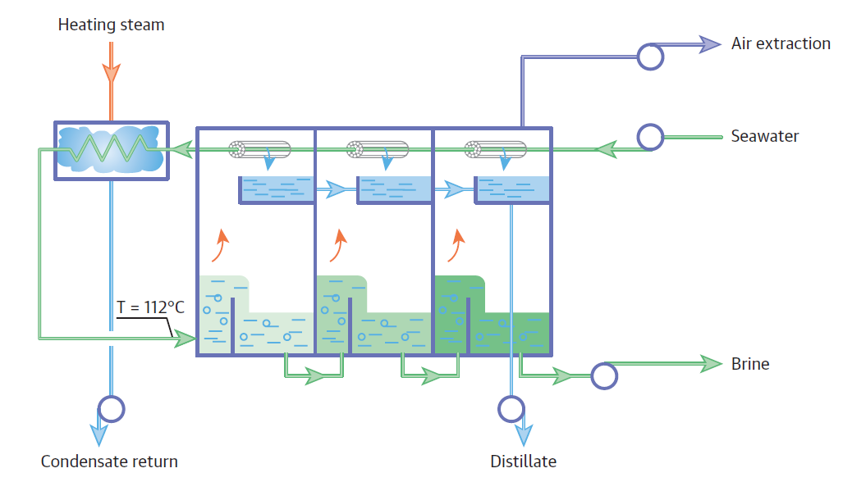
Figure 03: An overall layout of a facility for multistage flash distillation (MSF) (Source: World Bank, 2019; Ghernaout & Elboughdiri, 2020).

- Multiple Effect Distillation (MED):
Similar to MSF, MED operates as an evaporation-based phenomena. Through a series of compartments, the salty water flows. The pressure in each subsequent chamber decreases over time. The heat released during the MED technique acts as a heating source as the vapor created in one chamber condenses in the subsequent chamber (Ghernaout & Elboughdiri, 2020). Additionally, the tube bundle at the top of each chamber (the dark blue track in Figure 04) is often sprayed with feed water.
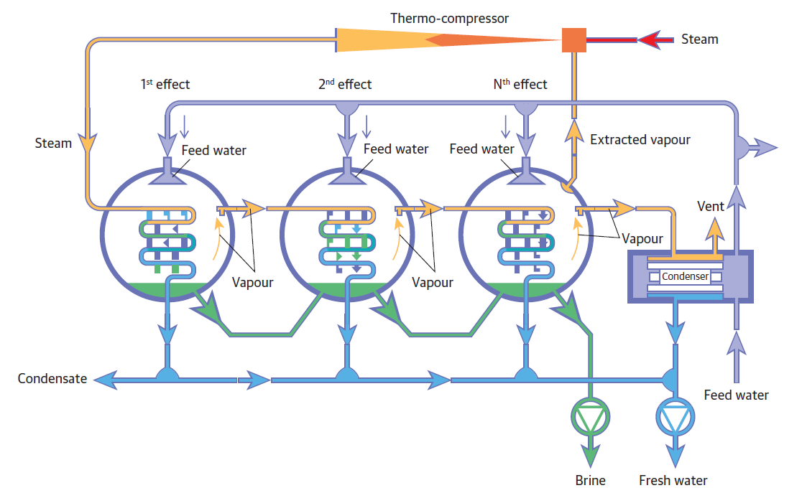
Figure 04: An example of the desalination process using Multiple Effect Distillation (MED) (Source: World Bank, 2019; Ghernaout & Elboughdiri, 2020).

- Multiple Effect Distillation (MED) with Thermal Vapor Compressor (TVC):
By adding a vapor compressor, Multiple Effect Distillation (MED) performance could be improved. In fact, a portion of the steam generated in the final chamber might be extracted for reuse by combining a Thermal Vapor Compressor (TVC) with a MED system. After being coupled with the external steam for compression below high pressure, the extracted steam will serve as a source of heat in the first chamber. Given the potential for significant energy cost reductions from such improvement, MED-TVC seems to be the most widely used MED technology available today (Ghernaout & Elboughdiri, 2020).

MEMBRANE DESALINATION
Osmosis is a natural phenomenon that is used in membrane techniques. Actually, in processes like osmosis and dialysis, membranes play a critical role in the separation of salts. Through the development of membranes that selectively permit or prohibit the flow of salts, this idea has been adopted for industrial use in water treatment. Electro Dialysis (ED), Reverse Osmosis (RO), Nano Filtration (NF), and Electro Dialysis Reversal EDR are membrane techniques that are commercially available. The only membrane technology now in use is RO. The industrial level does not make extensive use of the remaining membrane processes. The World Bank (2019) states that whereas ED and EDR use electrical current to remove salt, NF and RO actually use pressure (Ghernaout & Elboughdiri, 2020).
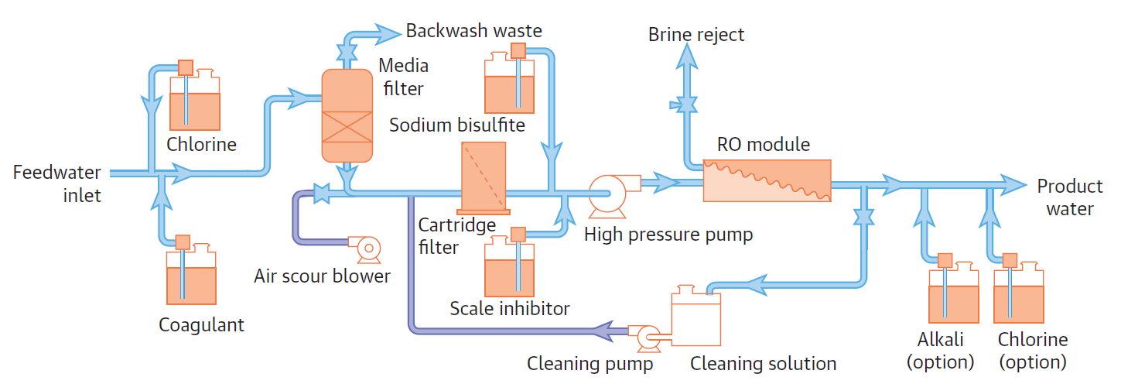
Figure 05: An illustration of the desalination process using reverse osmosis (RO) (Source: World Bank, 2019; Ghernaout & Elboughdiri, 2020).
RO is still a commonly used water treatment method. It primarily removes ions, molecules, and larger particles using a semipermeable membrane (Ghernaout, 2017). Osmotic pressure is beaten by an applied pressure during RO passage because of the chemical potential differences in water. For instance, the osmotic pressure that forms on the membrane when SW (i.e., salinity of 35,000 mg/L) is present on one side of the membrane and potable water (i.e., salinity of 500 mg/L) is present on the other side is around 24 bars (World Bank, 2019). According to Ghernaout (2017), RO has the ability to retain a variety of suspended and solubilized chemical molecules from water, as well as biological ones, primarily microbes. For this reason, it is used in water treatment and desalination areas. Pure water is allowed to flow to the opposite side of the membrane while the solute remains on the pressured portion. Such a membrane must allow smaller water molecules to flow easily through the pores while preventing larger ones from doing so (World Bank, 2019). To preserve concentrate (or brine) from purified water, the supply water is pumped beneath high pressure across a semipermeable membrane, as shown in Figure 05.
The RO process is contrary to what occurs in osmosis, as its name suggests. To saline water, a pressure greater than the osmotic pressure is applied. Salts are thus retained as freshwater passes over the membranes. Saline water is forced toward semipermeable membranes by an elevated-pressure pump at pressures between 65 and 75 times that of the atmosphere. The membranes are designed to allow water molecules to pass through them while retaining salts that have been dissolved. Both BW (brackish water reverse osmosis, or BWRO) and seawater reverse osmosis (SWRO) desalination could be accomplished with the RO technique. In a membrane process, between 40 and 60 percent of the SW is typically recovered as filtered water. Water recovery for BW desalination may range between 50% and 90% (World Bank, 2019; Ghernaout & Elboughdiri, 2020; Ghernaout, 2017). RO devices require specific equipment not used in thermal desalination machines to prepare the source SW because RO membranes can be easily obstructed by scattered materials and mineral scaling compounds (Messaoudene et al., 2018). To make it suitable for human consumption, purified water then undergoes a further step known as post-treatment, which mostly consists of disinfection and pH adjustment (Ghernaout & Elboughdiri, 2020). Wastewater can also be treated using membrane methods. Because membrane processes have the ability to retain contaminants other than salts, such as organic pollutants, microalgae, bacteria, and viruses, they could be used not only to remove salts from BW or SW supplies but also to treat used water (Ghernaout & Elboughdiri, 2020b; Ghernaout et al., 2020; Ghernaout, Elboughdiri, & Arni, 2020).

COMBINED PROCESSES
Combined desalination facilities combine an SWRO desalination system with a thermal desalination facility (either MSF or MED). In addition to sharing a common intake and outfall, the combined thermal and SWRO plants are typically situated next to a power generating station. Most often, hybrids are used when the demand for water or electricity varies significantly during the day or across seasons. This enables the combined plant to take advantage of inexpensive energy when it is available, yet to meet the necessary water production levels by alternating between SWRO and thermal technology, depending on which system produces the most affordable product at the moment.

DESALINATION ENGINEERING IS INNATE IN NATURE
The most obvious natural process for extracting salts from water is the evaporation of water across seas and oceans, which is the primary component of the water cycle (Figure 06). 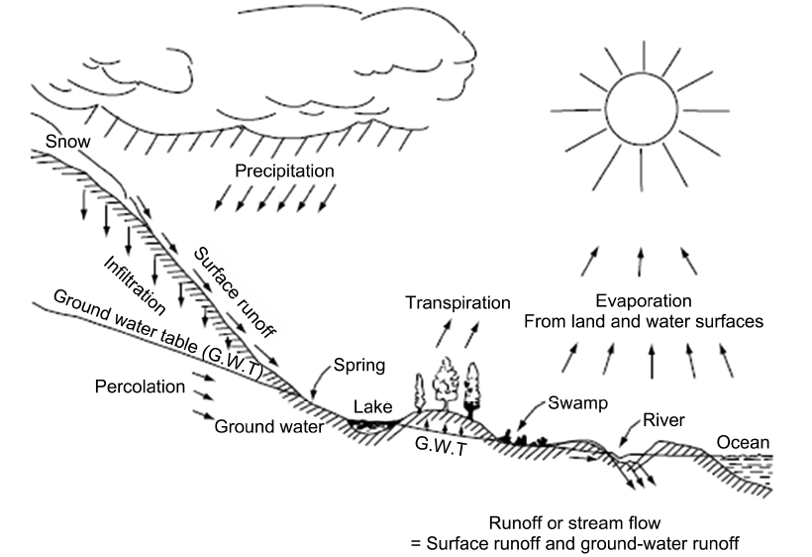
Figure 06: The Hydrologic Cycle (Source: Ghernaout & Elboughdiri, 2020; Tompeck & Jones, 2006)
There are several sources of information for the open-sky SW distillation simulation (World Bank, 2019; Ghernaout & Elboughdiri, 2020).
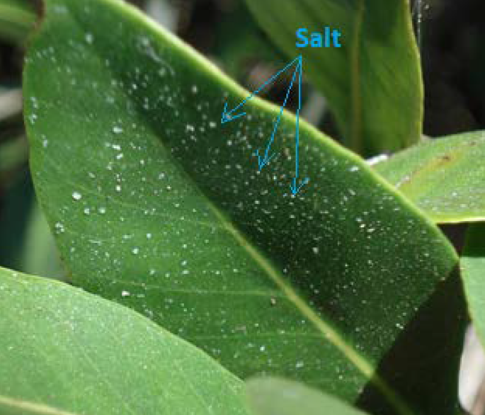
Figure 07: Salt Crystals on Black Mangrove (Source: Ghernaout & Elboughdiri, 2020; Black Mangrove — the Department of Environment and Natural Resources, n.d.).
The formation of sea ice is still another phenomenon. In contrast to SW, this phenomena creates ice with a small amount of salt (World Bank, 2019). Desalination occurs in the plant kingdom as well (Figure 07) (Department of Environment and Natural Resources, n.d.; Black Mangrove). Mangrove trees do, in fact, flourish in SW, releasing salt through their roots and foliage. Additionally, reeds and willow trees effectively remove salt from water by absorbing it along with other contaminants. Wetlands built for industrial purposes use this natural desalination process to treat used water from cities. Unbelievably, the animal kingdom might as well desalinate. Pelicans, peterels, albatrosses, gulls, and terns are among the seabirds that use a gland that releases highly concentrated brine close to the nostrils above the mouth to distill SW. The brine is subsequently expelled via the bird's "sneeze." When birds are far from land, this enables them to consume salty ocean water (World Bank, 2019).

PROSPECTS FOR PRICES AND TECHNOLOGIES
Desalination technology has advanced, and costs continue to decline significantly (World Bank, 2019). The cost of desalination decreased by more than half between 1980 and 2005 (Figure 08). Even though desalination is still more expensive than conventional water treatment methods, further price reductions could drive the industry closer to closure over the next 20 years.
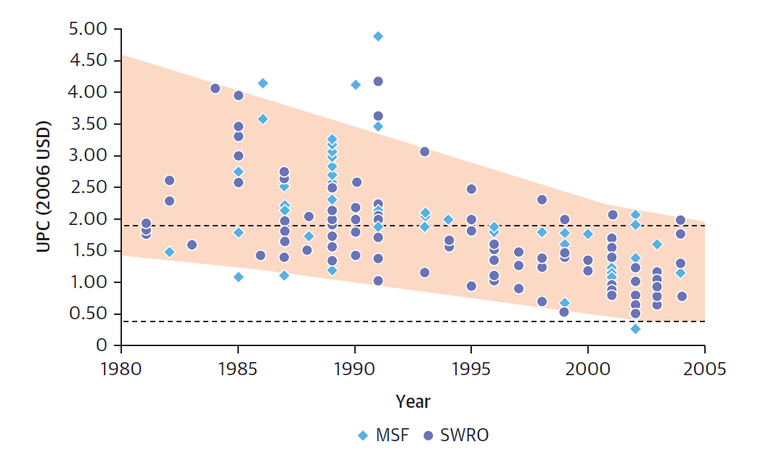
Figure 08: Trends in the cost of desalination of Multistage Flash (MSF) distillation and Seawater Reverse Osmosis (SWRO) plants (Source: World Bank, 2019; Ghernaout & Elboughdiri, 2020).

Even though desalination is still more expensive than conventional methods of treating water, further price reductions could drive the industry over the next 20 years. The most likely areas for such advancements include energy efficiency and sourcing, brine management, pretreatment, and desalination engineering. It is anticipated that SWRO will see further significant price reductions, with prices expected to decline by up to two-thirds over the next 20 years as a result of technological advancements in membrane design and system integration (World Bank, 2019; Ghernaout & Elboughdiri, 2020). Even though very little more improvement in thermal approaches is expected, SWRO will continue to become more competitive by improving performance in key price factors. One of these cost-cutting components is the improvement in membrane production, which has doubled over the past 20 years. Improvements are happening quickly because newly enlarged membrane components offer flexibility and choice while enabling trade-offs between energy costs and productivity. Actually, it is expected that improvements in membrane performance rather than energy recovery will strengthen SWRO's standing as the most cost-effective method under most conditions (World Bank, 2019).

DESALINATION AND WATER REUSE
In the majority of cases, desalination produces drinkable water or water for initial use in other industries. Reverse osmosis technology, however, is being used more and more to close water cycles and is an essential component of many water recycling programs. It has emerged as the primary water desalination technology for brackish water desalination, the reclamation of wastewater treatment plant effluents for high-quality uses, and seawater applications, where thermal desalination processes continue to be crucial (Hochstrat et al., 2010).
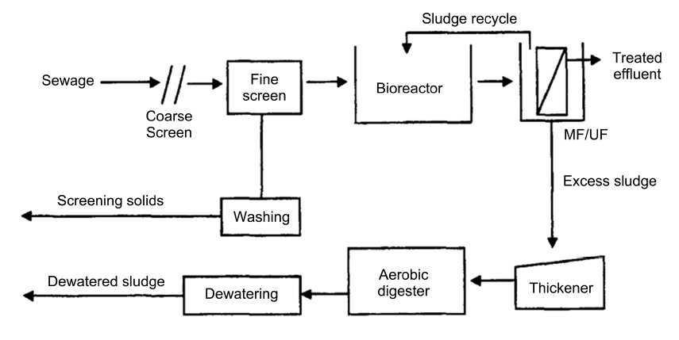
Figure 09: Process Flow Diagram for the Membrane bioreactor option (MBR): Small Plants (Source: Côté et al., 2004; Ghernaout & Elboughdiri, 2020).
Researchers compared the costs of SW desalination and water reuse (Côté et al., 2004). An RO stage was added to the process flow diagrams depicted in Figure 09 in order to treat water of comparable quality.
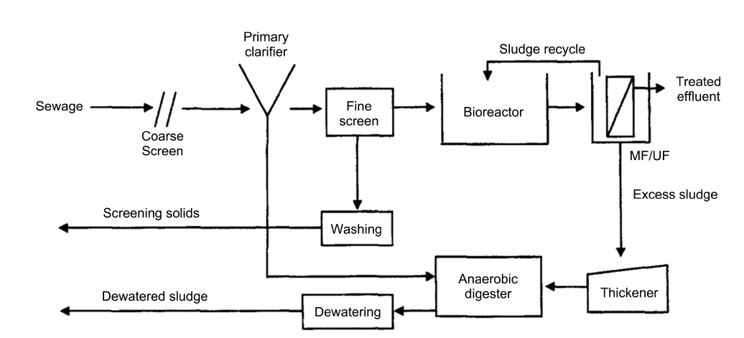
Figure 10: Process Flow Diagram for the Membrane bioreactor option (MBR): Large Plants (Source: Côté et al., 2004; Ghernaout & Elboughdiri, 2020).
In this case, remaining nutrients like nitrate and dissolved organic carbon must be removed by RO (Côté et al., 2004).

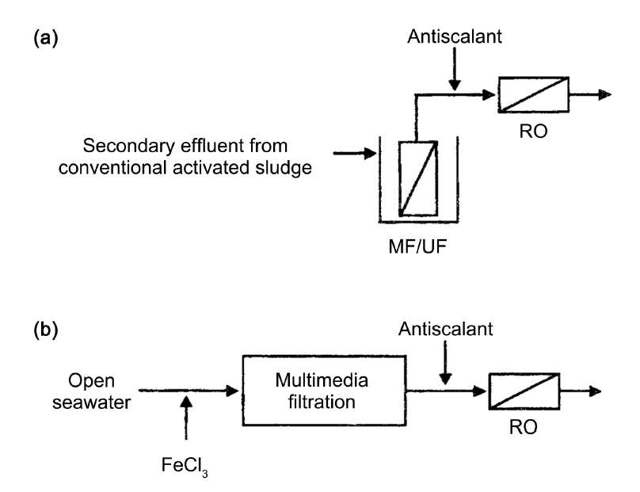
Figure 11: Process flow diagrams for comparison of water reuse and SW desalination: (a) water reuse; (b) SW desalination (Source: Côté et al., 2004; Ghernaout & Elboughdiri, 2020).

AI TOWARDS WATER DESALINATION: A NEW ERA OF EFFICIENCY AND SUSTAINABILITY
Synergistic AI integration occurs when AI collaborates with humans or other systems. This potent combination enhances strengths and produces outcomes that are beyond the scope of any one person acting alone. It encourages teamwork for increased productivity and creativity. A paradigm shift in the management of water resources is required due to the growing worldwide water scarcity crisis, which is being caused by a combination of population growth, climate change, and industrial expansion. Particularly in desert and coastal areas, desalination—the process of extracting salts and minerals from saline water sources—has become an essential technology to supplement freshwater supplies. Traditional desalination techniques, however, present serious difficulties due to their high-energy requirements and possible negative environmental effects. Now leading a revolution in the desalination industry, artificial intelligence (AI) presents previously unheard-of chances to boost productivity, cut expenses, streamline processes, and advance sustainability across the desalination lifecycle (E3S Web of Conferences, n.d.). Water desalination is increasingly using a variety of computer methods that fall under the umbrella of artificial intelligence (AI), such as machine learning (ML), deep learning (DL), neural networks, and genetic algorithms. Optimizing current desalination procedures, especially Reverse Osmosis (RO), the industry leader, is one of AI's most important applications. Modern desalination facilities produce enormous amounts of data, which machine learning algorithms may examine to find intricate relationships between operating factors like pressure, flow rate, temperature, and energy usage. In order to optimize energy consumption while preserving the required quality and quantity of desalinated water, AI-driven predictive control systems can dynamically modify these parameters in real-time in response to changing feed water conditions and energy prices. Significant operational cost and carbon footprint reductions result from this clever control. The buildup of organic and inorganic contaminants on RO membranes, known as membrane fouling, is a significant operational issue that lowers efficiency and calls for regular membrane replacement and cleaning. AI provides advanced methods for fouling prediction and mitigation. By properly predicting the beginning and severity of fouling, machine learning models based on sensor data—such as pressure drop, flow rate, and water quality indicators—allow for the proactive application of cleaning procedures and the optimal dosage of antiscalant chemicals. In order to visually evaluate membrane fouling and guide focused cleaning tactics, prolonging membrane lifespan and lowering chemical use, AI-powered image analysis approaches are also being investigated (Genesis Water Technologies, 2024).
AI is revolutionizing the design and development of improved desalination materials in addition to streamlining current processes. Large databases of material properties can be analyzed using ML algorithms, which can also be used to model the performance of new membrane materials with improved permeability, selectivity, and fouling resistance. This speeds up the development of next-generation membranes that use less energy and function more effectively (Cao, 2023). An further viable route to sustainable water production is the combination of desalination and renewable energy sources. However, desalination plants face operating difficulties due to the sporadic nature of solar and wind electricity. In order to guarantee a steady and economical water supply, artificial intelligence (AI) algorithms can be extremely helpful in maximizing the energy consumption of desalination plants that are fueled by renewable energy sources. They can also forecast energy availability and modify plant operations accordingly (IGI Global, 2025). In order to lessen desalination's need on fossil fuels and its negative environmental effects, this clever integration is essential. AI's use in desalination is not restricted to certain plant functions. The development of AI-powered digital twins of complete desalination plants would enable thorough modeling, optimization, and predictive maintenance for every plant component. These digital twins can offer insightful information for long-term planning, risk assessment, and process enhancements. Even though artificial intelligence (AI) in desalination is still in its infancy, research and development is moving quickly forward. AI's enormous potential to make desalination a more effective, economical, and ecologically friendly way to deal with the world's increasing water scarcity problem is being shown by pilot projects and practical applications (SWAN - SWAN Forum, 2025). The impact of AI on the desalination sector is anticipated to develop rapidly as data becomes more accessible and AI algorithms get more complex, opening the door to a more sustainable and water-secure future for everybody.

THE MULTIFACED ROLE OF ARTIFICIAL INTELLIGENCE IN ENHANCING DESALINATION AND WATER RECLAMATION FOR GLOBAL WATER SECURITY
- Optimizing Core Treatment Processes:
- Enhanced Efficiency in Desalination:
- Intelligent control of operational parameters (pressure, flow, chemicals):
AI algorithms, especially machine learning models, to dynamically modify settings for best results, are analyzing real-time operating data from Reverse Osmosis (RO) and other desalination plants. For example, under varying feed water conditions, neural network-based predictive control techniques are demonstrating promise in reducing energy usage while preserving desirable water quality (Alenezi & Alabaiadly, 2025b).
- Maximizing water recovery rates and minimizing energy consumption:
Water recovery can be optimized without sacrificing membrane integrity or raising energy consumption because to AI's ability to recognize intricate relationships between input parameters and output efficiency. In order to create adaptive operational rules that strike a compromise between these conflicting goals, reinforcement learning algorithms are being investigated.
- Prediction and mitigation of membrane fouling:
The onset and severity of membrane fouling are being predicted using artificial intelligence (AI) approaches, such as computer vision and machine learning on sensor data. This lowers operating costs and increases membrane longevity by enabling proactive cleaning schedules and the adjustment of anti-fouling chemical dosages (Shahouni et al., 2024b).
- Advanced Management in Water Reclamation:
- Real-time water quality monitoring and adaptive treatment adjustments:
Numerous water quality metrics can be analyzed in real-time by AI-powered sensor networks and machine learning models, allowing for the quick identification of anomalies and the estimation of treatment efficacy. One To guarantee the best possible pollutant removal, this enables dynamic modifications to treatment procedures (such as aeration and chemical addition) (Tinelli & Juran, 2019).
- Optimized chemical dosing and resource utilization:
To minimize chemical consumption and sludge creation while guaranteeing efficient pollutant removal, artificial intelligence (AI) algorithms can evaluate both historical and real-time data to optimize the dose of chemicals used in various treatment stages (e.g., coagulation, disinfection) (Nagpal et al., 2024).
- Improved removal of conventional and emerging contaminants:
AI models can be trained on large datasets to identify complex relationships between treatment parameters and the removal efficiency of both conventional pollutants and emerging contaminants like pharmaceuticals and microplastics, leading to more targeted and effective treatment strategies.
- Ensuring Operational Reliability and Sustainability:
- Predictive Maintenance and Fault Detection:
- Anticipating equipment failures in both desalination and reclamation plants: AI algorithms, particularly time series analysis and machine learning, are being applied to sensor data (e.g., vibration, temperature, pressure) to predict potential equipment failures (e.g., pump malfunctions, valve issues) before they occur. This enables proactive maintenance, minimizing costly downtime and ensuring continuous water supply (Alenezi & Alabaiadly, 2025b).
- Minimizing downtime and reducing maintenance costs: By predicting failures and optimizing maintenance schedules, AI contributes to significant reductions in operational costs and ensures the reliable and uninterrupted functioning of water treatment facilities (AI In Water Management: Balancing Innovation and Consumption, 2025).
- Sustainable Resource Management:
- Optimizing energy consumption and reducing environmental footprints: As highlighted above, AI plays a crucial role in minimizing energy use in both desalination and water reclamation, directly contributing to a reduced carbon footprint (Alenezi, A., & Alabaiadly, Y.2025).
- Facilitating efficient brine management in desalination: AI can be used to model and optimize brine concentration processes and explore potential pathways for resource recovery from brine, such as the extraction of valuable minerals, contributing to a more circular economy approach (Tech, 2024).
- Enabling Advanced System Integration and Design:
- Optimization of Hybrid Systems:
- Intelligent control of integrated desalination and water reuse facilities: AI can analyze complex interactions within hybrid systems, optimizing the flow and treatment processes between desalination and water reuse plants to maximize overall water production efficiency and minimize waste streams.
- Maximizing the synergy between different water treatment technologies: AI can identify optimal operating conditions for each component of a hybrid system to leverage their respective strengths and compensate for their weaknesses.
- Design of Novel Materials and Processes:
- Accelerating the discovery of advanced membrane materials: AI and machine learning are being used in materials science to analyze vast databases of material properties and simulate the performance of novel membrane materials for desalination with enhanced permeability, selectivity, and fouling resistance.
- Aiding in the development of more efficient treatment systems: AI can assist in the design and optimization of entire water treatment plant layouts and process flow diagrams for both desalination and water reuse, considering factors like energy efficiency, cost-effectiveness, and resilience.
- Strengthening Monitoring, Prediction, and Decision-Making:
- Enhanced Water Quality Monitoring:
- Real-time analysis and anomaly detection in source and treated water: AI algorithms can analyze data from advanced sensor networks to detect subtle changes in water quality that might indicate contamination or process inefficiencies, enabling rapid response (Frontiers | Artificial Intelligence Applications to Water Quality Modeling, n.d.).
- Development of early warning systems for contamination: By learning patterns from historical data and real-time sensor readings, AI can develop predictive models to forecast potential contamination events, allowing for preventative measures to be taken (Zhao et al., 2021).
- Data-Driven Decision Support:
- Analyzing complex data for informed water resource management: AI can integrate data from various sources (e.g., weather patterns, water demand forecasts, plant performance data) to provide comprehensive insights for water resource managers (Takyar & Takyar, 2023).
- Predicting water demand and optimizing resource allocation: Machine learning models can forecast future water demand with greater accuracy, enabling better planning and allocation of water resources, including the optimized operation of desalination and water reuse facilities (Filho et al., 2024).

THE SYNERGISTIC POWER OF ARTIFICIAL INTELLIGENCE FOR WATER SECURITY
The growing worldwide problem of water scarcity necessitates creative and comprehensive solutions. This study demonstrates the enormous potential of a combined strategy by carefully integrating artificial intelligence (AI) into cutting-edge desalination and environmentally friendly water reclamation techniques. A strong route to successfully address this urgent situation is provided by this synergistic integration (Alenezi & Alabaiadly, 2025c). AI offers previously unheard-of possibilities for desalination and water reuse process optimization due to its ability to evaluate enormous datasets and spot complex patterns. Artificial intelligence (AI) systems can dynamically modify desalination operating parameters, reducing energy use and optimizing water recovery. Predictive maintenance powered by AI can also foresee and lessen equipment breakdowns, guaranteeing operational dependability and cutting expenses. Even more efficiency and a smaller environmental effect are anticipated with the development of innovative membrane materials created by AI (Dangayach et al., 2024).

AI also makes it possible to monitor water quality in real time during the reclamation process, which allows for adaptive modifications to treatment procedures and guarantees the safe removal of contaminants for a variety of reuse applications. The sustainability and safety of water reuse projects can be improved by AI's ability to detect possible contamination events, optimize chemical dosing, and reduce waste output (Koleary & Koleary, 2025). Advanced desalination, sustainable water reclamation, and artificial intelligence come together to produce a potent synergy that enhances the advantages of each strategy. By implementing this integrated approach, water management might become more economical, efficient, and ecologically conscious, opening the door to a more water-secure future for the world's expanding population. To fully realize the transformative potential of this important junction of water technology and artificial intelligence, more research and development is required (Alenezi & Alabaiadly, 2025c).

THE EVOLVING LANDSCAPE: LIMITATIONS OF AI IN DESALINATION AND WATER RECLAMATION
Artificial intelligence (AI) has the potential to revolutionize sustainable water reclamation and enhanced desalination, but its use is not without restrictions. It is essential to acknowledge these limitations in order to maintain a balanced viewpoint and to direct future research and development initiatives. The availability and quality of data is a major challenge. Large, high-quality datasets are essential for building accurate and dependable models in AI, especially machine learning and deep learning. Comprehensive and uniformly organized data across many plants and operating situations might be hard to come by in the water treatment industry. It's possible that historical data lacks the precise variables required for sophisticated AI analysis, is inaccurate, or is incomplete. Additionally, the data gathered frequently mirrors existing operating paradigms, which may restrict AI's capacity to find genuinely innovative and game-changing solutions. Water systems' complexity and unpredictability present another obstacle. Many interrelated elements, such as changing raw water quality, changing ambient circumstances, and complex biological and chemical interactions, affect the desalination and water reclamation processes. It's still difficult to create AI models that can effectively represent this complexity and generate reliable predictions in a variety of situations. When confronted with real-world variability, an over-reliance on simple models trained on small datasets might result in imprecise forecasts and less-than-ideal control measures. Limitations also exist in interpretability and explainability. The "black box" nature of some sophisticated algorithms, such as deep neural networks, can make it difficult to understand why a specific choice was made, even though AI models can achieve great prediction and control accuracy. Adoption may be hampered by this lack of transparency, particularly in crucial applications where responsibility and trust are crucial. Process optimization, troubleshooting, and regulatory compliance all depend on an understanding of the fundamental mechanics underlying AI advice.
Another limitation is the requirement for specialized infrastructure and skills. AI-powered system implementation and maintenance call for qualified staff with knowledge of both AI technologies and water treatment procedures. For smaller or resource-constrained sites, the initial outlay for sensors, data gathering devices, and computational infrastructure may be prohibitive. Furthermore, there may be substantial technological difficulties when integrating AI with legacy systems that are already in place. It is impossible to ignore potential biases and ethical issues. Because AI models are trained on past data, they may unintentionally mirror preexisting biases in data gathering or operating procedures. This may result in AI systems that reinforce or even magnify these prejudices, which could have unjust or unsustainable effects. To reduce these risks, careful consideration must be given to data curation, model building, and validation. Lastly, standards and regulatory frameworks for the application of AI in water treatment are still developing. Uncertainty might arise and prevent broad adoption if there are unclear rules and norms. For AI-driven systems to be reliable and safe, it is essential to set up strong validation procedures and performance indicators. In conclusion, although artificial intelligence (AI) has enormous potential to transform desalination and water reclamation, its current use is constrained by issues with data quality and availability, water system complexity, interpretability, the requirement for specialized knowledge and infrastructure, ethical issues, and the changing regulatory environment. Unlocking the full potential of AI for a water-secure future will require addressing these constraints through ongoing research, data sharing programs, the creation of explainable AI methodologies, capacity building, and the implementation of precise norms.

RESULT AND DISCUSSION

This study underscores the significant potential of a combined approach, integrating Artificial Intelligence (AI) with sophisticated desalination and sustainable water reclamation methods, to effectively tackle the growing global challenge of water scarcity. Our analysis reveals that AI, encompassing machine learning, deep learning, and other computational techniques, offers novel avenues for enhancing the efficiency, lowering operational costs, streamlining processes, and improving the long-term viability of both desalination and water reuse practices. In the realm of desalination, AI presents considerable advantages in optimizing fundamental treatment stages, particularly Reverse Osmosis (RO). By analyzing real-time operational data, AI-driven algorithms can dynamically adjust operational parameters such as pressure, flow rate, and chemical dosing. This intelligent control leads to notable reductions in energy consumption while maintaining the required water quality standards. Furthermore, AI's capability to forecast and mitigate membrane fouling, a key operational impediment, through the analysis of sensor data and image processing, can extend the lifespan of membranes and minimize the use of chemicals. Beyond process optimization, AI is accelerating the discovery of innovative membrane materials characterized by enhanced permeability and resistance to fouling, paving the way for more energy-efficient desalination technologies. The fusion of AI with renewable energy sources provides a pathway to decrease desalination's reliance on fossil fuels, thereby bolstering its environmental sustainability through optimized energy consumption based on the fluctuating availability of renewable sources. The concept of employing AI-powered digital twins for entire desalination facilities offers a robust tool for comprehensive modeling, optimization, and proactive maintenance, promising substantial improvements in long-term planning and operational dependability.
Concerning sustainable water reclamation, AI plays a vital role in improving treatment effectiveness and resource management. Real-time monitoring of water quality via AI-enabled sensor networks allows for adaptive modifications to treatment procedures, ensuring the effective removal of both conventional and emerging contaminants. AI algorithms can optimize the dosage of chemicals, minimizing their consumption and the production of sludge. The capacity of AI to analyze complex datasets enables the identification of optimal treatment strategies for a wide range of pollutants, leading to more targeted and efficient water reuse.
Beyond the optimization of individual processes, AI facilitates the synergistic integration of desalination and water reuse within comprehensive water management frameworks. Intelligent control of combined systems, uniting desalination and water reuse facilities, allows for the maximization of water production efficiency and the minimization of waste streams. AI can also assist in the design of novel, more efficient integrated water treatment systems.
However, the successful deployment of AI in these areas hinges on addressing several crucial limitations. The availability and quality of extensive, consistently formatted datasets are essential for training reliable AI models. The inherent complexity and variability of water systems necessitate the development of AI models capable of adapting to dynamic conditions and intricate interactions. Ensuring the interpretability and explainability of decisions made by AI is vital for building trust and facilitating adoption, especially in critical applications. The requirement for specialized expertise and infrastructure can present a barrier to implementation, particularly in settings with limited resources. Addressing ethical considerations and potential biases present in historical data is crucial to ensure equitable and sustainable outcomes. Finally, the evolving regulatory landscape and the need for standardization for AI in water treatment require further development to provide clarity and promote widespread adoption. Overcoming these limitations through ongoing research focused on explainable AI, initiatives for data sharing, capacity building, and the establishment of clear guidelines will be essential to fully realize the transformative potential of AI in achieving a water-secure future. The economic, social, and environmental advantages of AI-enhanced desalination and water reclamation necessitate collaborative efforts among policymakers, researchers, industry stakeholders, and the public to ensure sustainable and equitable implementation on a global scale.

FUTURE RESEARCH DIRECTIONS IN ARTIFICIAL INTELLIGENCE ENHANCED DESALINATION AND WATER RECLAMATION
One possible approach to tackling the world's water shortage is the cooperative use of artificial intelligence (AI) to sustainable water reclamation, enhanced desalination, and other technologies. Even though the current study shows a lot of promise, there are still many opportunities to further improve these interconnected systems and realize their full transformational potential. To clear the path for a more water-secure future, future research should concentrate on expanding the capabilities of AI, improving integration techniques, and resolving current constraints (Alenezi & Alabaiadly, 2025c).

- Advancing AI Algorithms and Models:
Future research needs to delve into the development of more sophisticated and robust AI algorithms specifically tailored for the complexities of water treatment. This includes:
- Explainable AI (XAI): Building trust and promoting adoption by water professionals will require the development of AI models that offer clear and intelligible justification for their judgments. Techniques that enable users to understand the "why" behind AI recommendations for predictive maintenance and operational modifications should be the main focus of future research.
- Physics-Informed Neural Networks (PINNs): AI models can be made more accurate, resilient, and generalizable across various plant designs and water qualities by including basic physical and chemical principles that regulate water treatment processes (Li et al., 2024).
- Federated Learning: Exploring federated learning approaches that allow AI models to be trained on decentralized data from multiple water treatment facilities while preserving data privacy could unlock valuable insights from diverse operational experiences.
- Reinforcement Learning (RL): Further investigation into the application of RL for dynamic and adaptive control of entire integrated desalination and water reclamation systems, optimizing for multiple objectives such as energy efficiency, water quality, and cost-effectiveness under varying conditions.
- Multi-Agent Systems (MAS): Exploring the use of MAS to coordinate and optimize the operation of distributed networks of desalination and water reclamation plants, considering factors like local water demand, energy availability, and environmental constraints.

- Enhancing Data Integration and Quality:
The efficacy of AI heavily relies on the availability of high-quality data. Future research should focus on:
- Advanced Sensor Technologies and Data Acquisition: Creating and implementing sensor networks that are more complete, dependable, and economical in order to record a greater variety of pertinent parameters in water treatment operations.
- Data Fusion and Harmonization: Researching methods to effectively integrate and harmonize data from diverse sources, including real-time sensor readings, historical operational logs, and external environmental data.
- Addressing Data Scarcity and Imbalance: Investigating techniques like synthetic data generation and transfer learning to train robust AI models even with limited or imbalanced datasets, particularly for novel contaminants or emerging operational challenges.
- Standardized Data Platforms and Protocols: Developing standardized data platforms and protocols for the water industry to facilitate data sharing and collaboration for AI model development and validation (He et al., 2025).

- Optimizing Synergistic Integration Strategies:
Future research should explore novel ways to optimize the integration of AI with desalination and water reclamation technologies:
- Hybrid System Optimization: Developing AI-driven control strategies for hybrid desalination-reclamation systems that dynamically allocate water production and treatment capacities based on real-time demand, energy prices, and water quality considerations.
- Brine Management and Resource Recovery: Investigating the application of AI to optimize brine concentration processes and identify economically viable pathways for resource recovery from desalination brine, contributing to a circular economy approach.
- Energy-Water Nexus Optimization: Developing AI models that holistically optimize the energy consumption of water treatment processes, considering the integration with renewable energy sources and grid management strategies.
- Digital Twins for Integrated Systems: Creating and validating comprehensive digital twins of integrated desalination and water reclamation facilities, leveraging AI for real-time monitoring, predictive maintenance across all components, and scenario-based optimization for long-term planning and resilience.

- Addressing Limitations and Enabling Widespread Adoption:
Future research must also address the current limitations of AI in this field:
- Explainability and Trust: Focusing on developing XAI techniques that are readily understandable and actionable for water treatment operators, building trust in AI-driven recommendations.
- Robustness and Reliability: Investigating methods to ensure the robustness and reliability of AI models under various operational conditions and in the presence of uncertainties and anomalies (Jayakumar et al., 2024).
- Scalability and Cost-Effectiveness: Researching cost-effective AI deployment strategies and scalable solutions that can be adopted by water treatment facilities of varying sizes and resources.
- Regulatory Frameworks and Standardization: Collaborating with regulatory bodies to develop guidelines and standards for the validation and deployment of AI-driven systems in the water sector.

By pursuing these future research directions, the synergistic integration of AI with advanced desalination and sustainable water reclamation can be further refined and optimized, paving the way for more efficient, resilient, and equitable solutions to the growing global challenge of water scarcity. The continued innovation in AI and its thoughtful application within the water sector hold the key to a more water-secure future for all (Alenezi & Alabaiadly, 2025c).

CONCLUSION
In conclusion, the exploration into the integration of artificial intelligence with sophisticated desalination and sustainable water reclamation technologies presents a compelling vision for addressing the escalating global crisis of water scarcity. The findings suggest that the strategic incorporation of AI offers substantial advantages across the spectrum of water treatment, from the production of potable water from saline sources to the effective purification and reuse of wastewater. By leveraging the analytical capabilities of AI, significant enhancements in energy efficiency and operational reliability can be achieved within desalination processes through intelligent predictive maintenance. Likewise, AI empowers water reclamation through real-time monitoring and adaptive control, ensuring the safe and expanded utilization of treated water as a valuable resource. The convergence of these advanced technologies, augmented by AI, establishes a potent synergy that transcends incremental improvements, holding the potential to fundamentally reshape water resource management strategies. The intelligent automation and predictive forecasting afforded by AI can pave the way for water management systems that are not only more economically viable and environmentally sustainable but also demonstrably more dependable in the face of increasing demand and environmental pressures. This is particularly salient given the growing global population and the intensifying impacts of climate change, which are placing unprecedented strain on existing freshwater resources.

Nevertheless, the widespread and successful deployment of this integrated approach necessitates a concerted effort to overcome existing impediments. Ensuring the availability of comprehensive, high-quality data for the effective training of AI models remains a critical prerequisite. Furthermore, establishing transparency and interpretability in the decision-making processes of AI algorithms will be crucial for fostering trust and facilitating seamless adoption by water treatment professionals. Addressing the imperative for specialized expertise in this interdisciplinary field and proactively mitigating potential biases embedded within AI systems are also essential considerations that warrant careful attention. Ultimately, despite the presence of these challenges, the synergistic collaboration between artificial intelligence and advanced water treatment methodologies represents a significant stride forward in the pursuit of global water security. This integration offers a promising and innovative pathway for supplementing conventional water sources, optimizing the efficiency of resource utilization, and constructing more resilient and adaptable water systems capable of meeting the complex and evolving needs of a world increasingly confronted by the realities of water scarcity, both for the present and for future generations.

REFERENCES

AI in water management: Balancing innovation and consumption. (2025, March 25). White & Case LLP International Law Firm, Global Law Practice. https://www.whitecase.com/insight-our-thinking/ai-water-management-balancing-innovation-and-consumption

Alenezi, A., & Alabaiadly, Y. (2025). Artificial Intelligence Applications in Water Treatment and Desalination: A Comprehensive review. Water, 17(8), 1169. https://doi.org/10.3390/w17081169

An official website of the United States government. Desalination. (2018, August 30). USGS. https://www.usgs.gov/special-topics/water-science-school/science/desalination

Biswas, A. K., Tortajada, C., & Rohner, P. (2018). Assessing global water megatrends. In Water resources development and management. https://doi.org/10.1007/978-981-10-6695-5

Black Mangrove — The Department of Environment and Natural Resources. (n.d.). The Department of Environment and Natural Resources. https://environment.bm/black-mangrove#:~:text=Black%20Mangrove%20(Avicenn%20ia%20germinans)&text=If%20you%20look%20closely%20at,that%20would%20kill%20%20other%20plants

Cao, Z. (2023). Artificial intelligence enhanced water desalination. Figshare.
https://doi.org/10.1184/R1/23635695.v1

Conti, C., & Conti, C. (2025, March 14). Global Water Crisis: Causes, Effects, and Community-Led Solutions. Outreach International. https://outreach-international.org/blog/global-water-crisis/

Côté, P., Masini, M., & Mourato, D. (2004). Comparison of membrane options for water reuse and reclamation. Desalination, 167, 1–11. https://doi.org/10.1016/j.desal.2004.06.105

Dangayach, R., Jeong, N., Demirel, E., Uzal, N., Fung, V., & Chen, Y. (2024). Machine Learning-Aided inverse design and discovery of novel polymeric materials for membrane separation. Environmental Science & Technology. https://doi.org/10.1021/acs.est.4c08298

E3S Web of Conferences. (n.d.). https://www.e3s-conferences.org/

Filho, J. V., Scortegagna, A., De Sousa Dias Vieira, A. P., & Jaskowiak, P. A. (2024). Machine learning for water demand forecasting: Case study in a Brazilian coastal city. Water Practice & Technology, 19(5), 1586–1602. https://doi.org/10.2166/wpt.2024.096

Frontiers | Artificial Intelligence applications to Water quality Modeling. (n.d.). Frontiers. https://www.frontiersin.org/research-topics/62872/artificial-intelligence-applications-to-water-quality-modeling

Funk, B. (2025, January 21). What is Water Scarcity? Causes, Impacts, and Solutions Explained | Eden Green. Eden Green. https://www.edengreen.com/blog-collection/what-is-water-scarcity

Genesis Water Technologies. (2024, November 11). Innovative Water Treatment Technologies- Genesis Water Technologies. https://genesiswatertech.com/

GEMStat. (2025). GEMStat - The global water quality database. United Nations Environment Programme. https://gemstat.org/

Ghernaout, D., & Elboughdiri, N. (2020). Desalination in the context of water Scarcity Crisis: dares and perspectives. OALib, 07(11), 1–21. https://doi.org/10.4236/oalib.1106963

Ghernaout, D. (2017). Short communication: requiring reverse osmosis membranes modifications – an overview. American Journal of Chemical Engineering, 5(4), 81. https://doi.org/10.11648/j.ajche.20170504.15

Ghernaout, D., & Elboughdiri, N. (2020b). Disinfection By-Products (DBPs) control Strategies in electrodisinfection. OALib, 07(05), 1–14. https://doi.org/10.4236/oalib.1106396

Ghernaout, D., Elboughdiri, N., Ghareba, S., & Salih, A. (2020). Coagulation process for removing algae and algal Organic Matter—An Overview. OALib, 07(04), 1–21. https://doi.org/10.4236/oalib.1106272

Ghernaout, D., Elboughdiri, N., & Arni, S. A. (2020). New insights towards disinfecting viruses – short notes. Journal of Water Reuse and Desalination, 10(3), 173–186. https://doi.org/10.2166/wrd.2020.050

Hawash, A. (2025, March 9). Improving energy efficiency in desalination processes - Carewater Solutions. Carewater Solutions.
https://carewater.solutions/en/improving-energy-efficiency-in-desalination-processes/#:~:text=By%20relying%20on%20clean%20energy,making%20them%20more%20environmentally%20friendly

He, M., Sandhu, P., Namadi, P., Reyes, E., Guivetchi, K., & Chung, F. (2025). Protocols for water and environmental modeling using machine learning in California. Hydrology, 12(3), 59. https://doi.org/10.3390/hydrology12030059

Hochstrat, R., Wintgens, T., Kazner, C., Melin, T., & Gebel, J. (2010). Options for water scarcity and drought management—the role of desalination. Desalination and Water Treatment, 18(1–3), 96–102. https://doi.org/10.5004/dwt.2010.1347

IGI Global. The Use of Artificial Intelligence in a Desalination Plant Powered by Renewable Energy. IGI Global Scientific Publishing: International Academic Publisher. (2025). https://www.igi-global.com/

Jayakumar, D., Bouhoula, A., & Al-Zubari, W. K. (2024). Unlocking the potential of artificial intelligence for sustainable water management focusing operational applications. Water, 16(22), 3328. https://doi.org/10.3390/w16223328

Koleary, & Koleary. (2025, February 28). The role of AI in water quality management. WCP Online. https://wcponline.com/2025/03/01/the-role-of-ai-in-water-quality-management/

Li, H., Spelman, D., & Sansalone, J. (2024). Unit Operation and Process Modeling with Physics-Informed Machine Learning. Journal of Environmental Engineering, 150(4). https://doi.org/10.1061/joeedu.eeeng-7467

Magazine, S. W. (2025, March 31). Desalination at a turning point: the search for energy efficiency. Smart Water Magazine. https://smartwatermagazine.com/news/smart-water-magazine/desalination-a-turning-point-search-energy-efficiency

Mahadeva, R., Patel, V., Ghosh, A., Dixit, S., Suthar, B., Gupta, V., Awaar, V. K., Bharadwaj, Y., Gupta, M., Haranatti, J. S., & Arora, R. (2023). Artificial Intelligence in Water Desalination: A Novel Approach for Global Sustainability. E3S Web of Conferences, 430, 01193. https://doi.org/10.1051/e3sconf/202343001193

Messaoudene, N. A., Naceur, M. W., Ghernaout, D., Alghamdi, A., & Aichouni, M. (2018). On the validation perspectives of the proposed novel dimensionless fouling index. International Journal of ADVANCED AND APPLIED SCIENCES, 5(7), 116–122. https://doi.org/10.21833/ijaas.2018.07.014

Magazine, S. W. (2025, March 31). Desalination at a turning point: the search for energy efficiency. Smart Water Magazine. https://smartwatermagazine.com/news/smart-water-magazine/desalination-a-turning-point-search-energy-efficiency

Mahadeva, R., Patel, V., Ghosh, A., Dixit, S., Suthar, B., Gupta, V., Awaar, V. K., Bharadwaj, Y., Gupta, M., Haranatti, J. S., & Arora, R. (2023). Artificial Intelligence in Water Desalination: A Novel Approach for Global Sustainability. E3S Web of Conferences, 430, 01193. https://doi.org/10.1051/e3sconf/202343001193

Messaoudene, N. A., Naceur, M. W., Ghernaout, D., Alghamdi, A., & Aichouni, M. (2018). On the validation perspectives of the proposed novel dimensionless fouling index. International Journal of ADVANCED AND APPLIED SCIENCES, 5(7), 116–122. https://doi.org/10.21833/ijaas.2018.07.014

Nagpal, M., Siddique, M. A., Sharma, K., Sharma, N., & Mittal, A. (2024). Optimizing wastewater treatment through artificial intelligence: recent advances and future prospects. Water Science & Technology, 90(3), 731–757. https://doi.org/10.2166/wst.2024.259

Omolere, M. P. (2024, February 28). Why global water security matters in 2024 | Earth.Org. Earth.Org. https://earth.org/global-water-crisis-why-the-world-urgently-needs-water-wise-solutions/

Orfi, J., Sherif, R., & AlFaleh, M. (2025). Conventional and Emerging Desalination Technologies: Review and Comparative Study from a Sustainability Perspective. Water, 17(2), 279. https://doi.org/10.3390/w17020279

Reducing Desalination Energy Costs with AI Optimisation in Israel. SWAN - SWAN Forum. (2025, April 17). SWAN Forum. https://swan-forum.com/

Samiul Islam, F. A. (2025). Clean Coal Technology: The Solution to Global Warming by Reducing the Emission of Carbon Dioxide and Methane. American Journal of Smart Technology and Solutions, 4(1), 8–15. https://doi.org/10.54536/ajsts.v4i1.4021

Samiul Islam, F. A. (2025). Impact of Climate Change and Sea Level Rise on Coastal Zone of Bangladesh. American Journal of Innovation in Science and Engineering, 4(1), 112–122. https://doi.org/10.54536/ajise.v4i1.4556

Samiul Islam, F. A. (2025). Enhancing Indoor Environmental Air Quality through Smoke Ventilation in Buildings. American Journal of Civil Engineering and Constructions, 1(1), 1–15. Retrieved from https://journals.e-palli.com/home/index.php/ajcec/article/view/4739

Shahouni, R., Abbasi, M., Dibaj, M., & Akrami, M. (2024). Utilising artificial intelligence to predict membrane behaviour in water purification and desalination. Water, 16(20), 2940. https://doi.org/10.3390/w16202940

Space-Age Water Conservation | NASA spinoff. (n.d.). https://spinoff.nasa.gov/page/space-age-water-conservation-nasa

Takyar, A., & Takyar, A. (2023, November 2). Leveraging AI and ML for efficient data integration. LeewayHertz - AI Development Company. https://www.leewayhertz.com/ai-in-data-integration/

Team, H. (2025, February 4). Innovative water technologies solutions to global water crisis. H2O Global News. https://h2oglobalnews.com/innovative-water-technologies-solutions-to-the-global-water-crisis/

Tech, G. W. (2024, August 21). AI in Seawater Desalination Plant Optimization: A Detailed Guide. Genesis Water Technologies. https://genesiswatertech.com/blog-post/ai-in-seawater-desalination-plant-optimization/

Tinelli, S., & Juran, I. (2019). Artificial intelligence-based monitoring system of water quality parameters for early detection of non-specific bio-contamination in water distribution systems. Water Science & Technology Water Supply, 19(6), 1785–1792. https://doi.org/10.2166/ws.2019.057

Tompeck, M., & Jones, P. (2006). Water treatment. In CRC Press eBooks (pp. 1311–1328). https://doi.org/10.1201/noe0849398438.ch87

Transforming our world: the 2030 Agenda for Sustainable Development | Department of Economic and Social Affairs. (n.d.). https://sdgs.un.org/2030agenda

Turning Wastewater into a Resource: Advancing Sustainable Water Management. (2025, April 2). Idw - Informationsdienst Wissenschaft e.V. Nachrichten Aus Der Wissenschaft. https://nachrichten.idw-online.de/2025/04/02/turning-wastewater-into-a-resource-advancing-sustainable-water-management

Understanding the global water Crisis: causes and solutions. (n.d.). Wilo. https://wilo.com/en/Pioneering/Stories/Water-Shortage-and-the-Global-Water-Crisis_42816.html

United Nations Environment Programme. (n.d.). UNEP - UN Environment programme. Water Quality. UNEP - UN Environment Programme. https://www.unep.org/

Un-Water. (2017). UN-Water | The United Nations World Water Development Report 2017. Wastewater: The Untapped Resource. UNESCO. Coordinating the UN’s work on water and sanitation. UN-Water. https://www.unwater.org/

Un-Water. (n.d.-b). Water Scarcity | UN-Water. UN-Water. https://www.unwater.org/water-facts/water-scarcity

Van Vliet, M. T. H., Jones, E. R., Flörke, M., Franssen, W. H. P., Hanasaki, N., Wada, Y., & Yearsley, J. R. (2021). Global water scarcity including surface water quality and expansions of clean water technologies. Environmental Research Letters, 16(2), 024020. https://doi.org/10.1088/1748-9326/abbfc3

Water For People. (2024c, August 22). The Global Water Crisis | Water for People. Water for People. https://www.waterforpeople.org/crisis/

Water recovery systems - NASA. (n.d.). NASA. https://www.nasa.gov/ames/space-biosciences/water-recovery-systems/#:~:text=Some%20of%20the%20water%20recovery,%2C%20electrolysis%2C%20and%20biofilm%20mitigation.

Water quality. (2024, November 5). NASA Earthdata. https://www.earthdata.nasa.gov/topics/ocean/water-quality#:~:text=We%20also%20have%20tools%20and,Water%20Quality%20Data%20Catalog

Water resources. (2024, October 10). NASA Earthdata. https://www.earthdata.nasa.gov/topics/human-dimensions/water-resources

WHO. (2025, April 17). Guidelines for Drinking-water Quality: Fourth edition incorporating the first and second addenda. World Health Organization. https://www.who.int/

World Bank. (2019). The role of desalination in an increasingly Water-Scarce world. In World Bank [Report]. https://documents1.worldbank.org/curated/en/476041552622967264/pdf/135312-WP-PUBLIC-14-3-2019-12-3-35-W.pdf

Zhao, C., Gao, Q., Song, J., Wang, Y., & Sun, F. (2021). Research on design of the Safety supervision System for desalinated seawater entering urban Water supply Network. Water, 13(15), 2017. https://doi.org/10.3390/w13152017

