Numerical Analysis Application in Human Cancer Treatment

Abstract
Numerical methods are essential in advancing modern cancer therapies by providing precise modeling tools to simulate complex biological and physical interactions. This study presents a robust numerical modeling approach for optimizing microwave ablation therapy used in liver cancer treatment. By coupling the Finite Difference Method (FDM) with the Crank–Nicolson Method (CNM), Maxwell’s equations and the Pennes bioheat equation are solved to simulate the electromagnetic and thermal interactions in liver tissue. The model incorporates temperature-dependent thermophysical properties of biological tissue and evaluates key performance parameters such as impedance, specific absorption rate (SAR), and temperature distribution. A coaxial microwave antenna design is analyzed across a frequency range of 1–10 GHz to assess its effectiveness in energy delivery. Simulation results reveal that increased microwave power leads to higher SAR and tissue temperatures, with 10 W proving sufficient to destroy tumor cells without damaging healthy tissue. The framework demonstrates high numerical stability and accuracy, providing valuable insights into treatment planning and device design for hepatocellular carcinoma.

Keywords: Liver Tumor, Hyperthermia, Microwave ablation, Finite Difference Method (FDM), Crank-Nicolson Method, Bioheat Equation, Electromagnetic Simulation.

1 Introduction

Hepatocellular carcinoma (HCC), the most common primary liver cancer, is highly aggressive and usually discovered at an advanced stage. It is the fifth most frequently diagnosed malignancy and the third most common cause of cancer-related death due to its exceptionally high incidence rate. Despite improvements in medical technology for cancer diagnosis and treatment, the annual death rates from HCC are rapidly increasing. Treatment options for cancer include radiation, minimally invasive thermal therapies, organ transplantation, chemotherapy, surgery, resection, and trans-arterial chemoembolization. Liver transplantation is usually used to treat hepatic cirrhosis in patients with HCC. The risk of cancer recurrence and mortality is very high for patients who have had liver transplants. Of the various treatment options for hepatocellular carcinoma, surgical resection is the most commonly used. It can only be used by a few people with no medical history and healthy hepatic gland function [1].

Due to their ability to analytically define the vital immune system components involved in cancer therapy, mathematical models for cancer treatment have grown in significance over time. In 1825, Gompertz put up the first mathematical model for treating cancer, which took into consideration both cell death and proliferation and concentrated on tumor growth. Since then, studies have often concentrated on how different elements affect the tumor microenvironment. The extracellular matrix, fibroblasts, growth factors, immune cells, signaling molecules, and other connective tissue cells are all part of this environment [2]. Two experimental animal systems were used in [3] to evaluate the descriptive and predictive capabilities of nine traditional tumor growth models. The models were ranked according to their relative descriptive power using a variety of goodness-of-fit measures and a specific error model. We discovered that the most predictive model was not always the one with the most descriptive power. The linear nature of the breast growth curves made them highly predictable. On the other hand, when only a small number of data points were included, none of the models could correctly forecast the lung growth curves. To get around this problem, they looked at a technique that estimates the individual parameter vector of an independent growth curve using the parameter population distribution, which is based on prior knowledge. It was discovered that this approach significantly increased the forecast success rates. By picking models that best describe basic growth features, these findings could help preclinical cancer research.

Using the multi-step generalized differential transform method (MSGDTM), the authors of [4] investigated the fractional order model of tumor cell proliferation and their interactions with general immune effector cells. Since this nonlinear model is different from the majority of others, they talked about it. It considers (i) the cytotoxic T lymphocytes (CTLs) infiltrating the tumor and (ii) the potential consequences of effector cell inactivation. The approximate answers that MSGDTM produces are very accurate and long-lasting.
Using a fractional tumor-immune dynamical model, [5] offers a comparative and chaotic analysis of tumor and effector cells. For this investigation, a novel arbitrary operator based on the Mittag-Leffler law is postulated. The authors use a model of actual medical research issues to investigate the relationships between various tumor cell residents and immunological structure. Using the Adams-Bashforth-Moulton and Toufik-Atangana techniques, they first examine the dynamic impact of effector immune and tumor cell activation. This research also examines whether a certain tumor-immune model of arbitrary order exists and is unique. They also looked at the fractional tumor-immune model's dynamical characteristics, and the results they got were compared to those from other approaches. The well-known Atangana-Baleanu fractional derivative is used in the Adams-Bashforth-Moulton and Toufik-Atangana methods to perform numerical simulations. Biologists can treat cancer with the help of the data they have gotten.
A three-dimensional fractional-order cancer model is created by the author in [6]. Tumor cells, healthy tissue cells, and activated effector cells interact in the suggested paradigm. The equilibrium points' in-depth examination is examined. Additionally, the solution's existence and uniqueness are examined. In the Caputo sense, the fractional derivative is taken into consideration. The usefulness of the given theoretical results is demonstrated through numerical simulations. The study's conclusion shows that the dynamic process is significantly impacted by the order of the fractional derivative. Additionally, the derived Lyapunov exponents demonstrate that the suggested model exhibits chaotic behavior. Additionally, the collected results show that the model's chaotic behavior grows as fractional order decreases.
In [7] A fractional order HIV-1 model that incorporates AIDS-related cancer cells that display chaos in the parameter range of interest is developed and analyzed in this work. Three cell populations make up the model: T(t) represents cancer cells, H(t) represents healthy CD4+ T cells, and I(t) represents infected T cells. They have demonstrated that chaotic dynamics, a crucial feature for nonlinear systems, is represented by the model. The two-step fractional Adam-Bashforth approach is used to acquire the model's numerical solution. The research also presents the endemic equilibrium's local stability.
In [8], a novel model of cancer progression based on fractional-order differential equations is introduced for the investigation of tumor-immune interactions. The manuscript demonstrates the chaotic behaviors of the suggested cancer model for both commensurate and incommensurate scenarios by examining the system dynamics. Additionally, some thoughts about the biological significance of the findings are presented.
In [9] With three distinct cell-killing rates taken from real-world scenarios, the current study attempts to model and investigate fuzzy-fractional cancer tumor dynamics. Additionally, to add uncertainty to phenomena, other fuzzification techniques—such as Gaussian, Trapezoidal, and Triangular fuzzy numbers—are applied. Present-day modeling of cancer tumors yields a thorough analysis that addresses non-integer order and non-traditional derivatives in addition to the imprecision present in real-time data. By integrating several homotopies with the perturbation technique and Aboodh transform, a novel algorithm is also presented to produce a hybrid mechanism for recovering solutions of such a complex model. The efficacy of the suggested approach is assessed using in-depth numerical tests. In the next step, residual errors, graphical representations, and contours throughout the fractional domain are used to evaluate the convergence and validity. Better comprehension, prediction, and treatment strategy optimization are made possible by this method, which also effectively represents tumor heterogeneity.
In [10] Two crossover hybrid variable-order derivatives of the cancer model are invented in this research. The variable-order fractional and hybrid fractional operators are approximated using the Grünwald-Letnikov approximation. The suggested model's existence, uniqueness, and stability are examined. The suggested models are studied using a hybrid variable-order fractional operator using Adams Bashfourth's fifth-step technique. Comparative analyses are using the generalized fifth-order Runge-Kutta method. To show the simplicity of these approximations and to confirm the applicability of the employed methodologies, numerical examples and comparison studies are provided. We have demonstrated the effectiveness of the suggested approach and obtained strong empirical backing for our hypotheses.
A 3-D discrete-time fractional-order HIV-1 model incorporating cancer cells linked to AIDS was shown in [11]. For certain values of the parameters, this model displays chaotic behavior. The chaotic behavior of the suggested system, a common occurrence in nonlinear dynamical systems, is demonstrated by using theoretical results and numerical simulations.
This paper presents a detailed numerical model for simulating the interaction between electromagnetic waves and liver tissue during microwave ablation therapy, utilizing the Finite Difference Method (FDM) and the Crank-Nicolson method (CNM). The Crank-Nicolson method, an implicit finite-difference technique, was employed to solve Maxwell’s equations for electromagnetic wave propagation and the Pennes bioheat equation to model tissue temperature dynamics. The simulation discretized both space and time, updating electric field components and temperature distributions at each time step to ensure stability and accuracy. Spatial discretization was performed using FDM, capturing the variations in electric field and temperature in the tissue, while time discretization through CNM ensured that the numerical solution maintained stability and accuracy across iterative time steps. Precomputed tridiagonal matrices enabled efficient handling of the bioheat equation, accounting for tissue conduction, metabolic heat generation, and blood perfusion effects. The resulting temperature distribution demonstrated efficient heat deposition within liver tissue, essential for therapeutic microwave ablation. The combination of FDM and CNM provided a robust framework for modeling complex thermal and electromagnetic interactions, offering valuable insights into optimizing microwave-based medical treatments. This study highlights the utility of these numerical methods in simulating the therapeutic effects of microwave ablation, with the potential for future integration into patient-specific simulations for enhanced treatment planning.

2 Numerical Method and Simulation Conditions
The Finite Difference Method (FDM) can be used to approximate solutions to partial differential equations. Usually, a regular grid is drawn and the differential equation is taken at each internal grid point in straightforward, regular study areas. The matrix representation of the problem generated after using the numerical method of differences can be used to solve a system of linear equations and non-linear, time-independent, and dependent problems using numerical methods [13]. This paper employed a detailed numerical simulation to model the interaction between electromagnetic waves and liver tissue. This section describes the initialization of variables and the iterative process used to solve Maxwell’s equations and update the tissue temperature distribution using the Crank-Nicolson method.
2.1 Crank-Nicolson Method(CNM):
Many mathematical models in the domains of applied mathematics and engineering are based on partial differential equations. Examining the predictions of mathematical models is crucial since the approximate solution of partial differential equations is crucial, and exact solutions are difficult to get. The idea of heat conduction gives rise to parabolic partial differential equations, which are problems with time as a single independent variable. Analytical solutions to such problems are difficult to find; in these situations, numerical methods are helpful. Although many academics have worked on alternative numerical techniques to solve parabolic partial differential equations, finite difference techniques have been the most often used. To solve parabolic equations, a variety of finite difference approximations are employed [14].

2.1.1 Solving Maxwell’s Equations Using Crank-Nicolson
Maxwell’s equations govern the propagation of electromagnetic waves in three-dimensional (3D) space, capturing the interaction between electric and magnetic fields. In this work, a full three-dimensional formulation is adopted to accurately model the complex behavior of electromagnetic wave propagation within biological tissues, specifically liver tissue containing a tumor. The electric field components E_{X}​, E_{y}​, and E_{z}​, and the magnetic field components H_{x}​, H_{y}​, and H_{z}​, are updated at each time step using a finite-difference discretization in space and the Crank-Nicolson method in time. This approach ensures numerical stability and precision, enabling the simulation of realistic field distributions and interactions within the heterogeneous biological medium.

Governing Equations: the time-dependent Maxwell’s equations in an isotropic, homogeneous, and linear medium are expressed as:

$\frac{∂\vec{E}}{∂t}=\frac{1}{∈}∇ × \vec{H}-\frac{σ}{ϵ}\vec{E }$ (1)

$\frac{∂\vec{H}}{∂t}=-\frac{1}{μ}∇ × \vec{E}$ (2)

where $\vec{E}$= (E_{x}, E_{y}, and E_{z}) and $\vec{H}$ =(H_{x}, H_{y}, and H_{z}) represent the electric and magnetic field vectors, respectively. $∈$ is the permittivity of liver tissue, μ is the magnetic permeability, and $σ$is the electrical conductivity, which is included to account for the lossy characteristics of biological tissues.

Numerical Discretization: The computational domain is discretized into a uniform Cartesian grid with indices (i,j,k) corresponding to the x, y, and z directions, respectively. The spatial discretization steps are denoted as dx, dy, dz, and dz, while dt represents the temporal step size.
The Crank-Nicolson method is applied to ensure stability and second-order accuracy in both time and space. This implicit scheme averages the field values between the current and subsequent time steps.

Discretized Formulation:

Electric Field Update the discretized update equation for the E_{x​} component at grid point (i, j, k) is given by:

$E_{x}^{n+1}\left(i,j,k\right)=E_{x}^{n}\left(i, j, k\right)+\frac{dt}{2∈}\left[\left(\frac{H_{z}^{n+1}\left(i,j+1, k\right)-H_{z}^{n+1}\left(i, j, k\right)}{dy}-\frac{H_{y}^{n+1}\left(i, j, k+1\right)-H_{y}^{n+1}\left(i, j, k\right)}{dz}\right)+\left(\frac{H_{z}^{n}\left(i,j+1, k\right)-H_{z}^{n}\left(i, j, k\right)}{dy}-\frac{H_{y}^{n}\left(i,j, k+1\right)-H_{y}^{n}\left(i, j, k\right)}{dz}\right) \right]$ (3)

The Ey​ and Ez​ components are updated analogously by incorporating the respective curl terms of $\vec{H}$

Magnetic Field Update:
Similarly, the magnetic field components are updated using the discretized form of Ampère’s law. For the H_{X} component:

$H_{x}^{n+1}\left(i, j,k\right)=H_{x}^{n}\left(i, j, k\right)-\frac{dt}{2μ}\left[\left(\frac{E_{z}^{n+1}\left(i,j,k\right)-E_{z}^{n+1}(i,j-1,k)}{dy}-\frac{E_{y}^{n+1}\left(i,j,k\right)-E_{y}^{n+1}(i,j,k-1)}{dz}\right)+\left(\frac{E_{z}^{n}\left(i,j,k\right)-E_{z}^{n}(i,j-1,k)}{dy}\right)-\frac{E_{y}^{n}\left(i,j,k\right)-E_{y}^{n}(i,j,k-1)}{dz}\right]$ (4)

The update equations for H_{y}​ and H_{z} follow similarly.

- Boundary Conditions: Appropriate boundary conditions are applied to the computational domain to ensure physical accuracy. Perfect Electric Conductor (PEC) boundaries are imposed where applicable to enforce zero tangential electric fields. Additionally, symmetry boundary conditions are utilized at domain boundaries to reflect geometric and field symmetries. For minimizing reflection artifacts, absorbing boundary conditions, such as Perfectly Matched Layers (PML), may be incorporated.

Numerical Implementation: At each time step, the following procedure is executed:
- Magnetic Field Update: The magnetic field components H_{x}, H_{y}, and H_{z}​ are computed using the current and predicted electric fields.
- Electric Field Update: The electric field components E_{x}, E_{y}, and E_{z} ​ are then updated using the newly computed magnetic fields.
- Boundary Application: Boundary conditions are enforced on both electric and magnetic fields to maintain numerical stability and physical fidelity.
This Crank-Nicolson-based finite difference approach provides a robust framework for simulating the coupled electromagnetic behavior within heterogeneous biological tissues, offering insights into microwave ablation treatment efficacy.

2.1.2 Solving 1D Bioheat Equation Using Crank-Nicolson Method

The bioheat equation describes heat transfer in biological tissue, including heat conduction, metabolic heat generation, and heat convection due to blood perfusion. One of the most well-known models is the Pennes bioheat equation [15].

Thermal transport within biological tissues subjected to electromagnetic heating is governed by the Pennes bioheat equation, which accounts for heat conduction, metabolic heat generation, and perfusion-based heat exchange due to blood flow. In this study, the one-dimensional (1D) form of the bioheat equation is employed to model heat distribution in liver tissue undergoing microwave ablation therapy. The equation is expressed as:
$ρc\frac{∂T}{∂t}=k∇^{2}T+Q_{met}+ω_{b}c_{b}(T-T_{b})$ (5)

Where $ρ$ is the density of the tissue (kg/m³), c the specific heat capacity of the tissue (J/kg·°C), T the temperature of the tissue (°C), t is the Time (s), k is thermal conductivity of the tissue (W/m·°C), $Q_{met}$ is the metabolic heat generation (W/m³) that represent the heat produced by tissue metabolism, $ω_{b}$is the blood perfusion rate (1/s), indicating how quickly blood circulates through the tissue, $c_{b}$the Specific heat of blood (J/kg·°C), and T_{b}​ is the blood temperature (°C) that assumed to be constant or an external reference temperature. Taking into consideration that $ρc\frac{∂T}{∂t}$ represents the rate of change of temperature over time in the tissue, $k∇^{2}T$ (Heat Conduction Term ) models the diffusion of heat within the tissue where the operator $∇^{2}$ (Laplacian) captures the spatial temperature gradient, $Q_{met}$ (Metabolic Heat Generation) accounts for internal heat generation due to metabolic activity within the tissue, $ω_{b}c_{b}(T-T_{b})$ (Perfusion Cooling Term) that represents heat exchange between tissue and blood due to perfusion, which helps to cool or warm the tissue based on the blood temperature. That’s are the detailed steps for solving the bioheat equation using crank –Nicolson method.
- Spatial Discretization: The tissue is discretized into n spatial points, and temperature at each point is tracked over time. The spatial discretization uses the finite-difference method to compute the second derivative:

$∇^{2}T≈ \frac{T_{i+1}-2T_{i}+T_{i-1}}{dx^{2}}$ (6)
- Time Discretization: The Crank-Nicolson scheme averages between time steps, so the discretized form of the bioheat equation is:

$ρc\frac{T_{i}^{n+1}-T_{i}^{n}}{dt}=k\frac{T_{i+1}^{n+1}-2T_{i}^{n+1}+T_{i-1}^{n+1}}{dx^{2}}+\frac{T_{i+1}^{n}-2T_{i}^{n}+T_{i-1}^{n}}{dx^{2}}+…$ (7)

The implicit scheme requires solving a system of linear equations at each time step.
- Precomputing Matrices A and B: The Crank-Nicolson method requires matrix operations. Matrices A and B are precomputed to handle the spatial terms in the bioheat equation; The tridiagonal structure of the matrices ensures that heat is transferred between neighboring spatial points, accounting for both conduction and perfusion effects.

$A=I-\frac{dt}{2ρcdx^{2}}.K$ (8)

$B=I+\frac{dt}{2ρcdx^{2}}.K$ (9)
Where I is the Identity matrix, representing no change across the main diagonal, dt is the Time step size, dx is the Spatial step size, $ρ$ the Density of the tissue, c is the specific heat capacity of the tissue, and K is a matrix representing the second spatial derivative (Laplacian operator in 1D) with n interior points, k will be:

$K=\frac{1}{dx^{2}}\left[\begin{matrix}-2 & 1 & 0 & ⋯ & 0 \\ 1 & -2 & 1 & ⋯ & 0 \\ 0 & 1 & -2 & ⋯ & 0 \\ ⋮ & ⋮ & ⋮ & ⋱ & 1 \\ 0 & 0 & 0 & 1 & -2\end{matrix}\right]$ (10)

- Updating the Temperature: At each time step, the temperature distribution is updated by solving the linear system using the Thomas algorithm (a simplified version of Gaussian elimination).

$T^{n+1}=A^{-1}BT^{n}$ (11)
$AT^{n+1}=BT^{n}+C$ (12)

Where A is the matrix representing the contributions of the next time step, B is the matrix representing the contributions of the current time step, C is the vector that includes source terms, such as the external heat source 𝑄𝑒𝑥𝑡​ and blood perfusion effects, 𝑇^{𝑛+1} the vector of temperatures at the next time step which provides the temperature distribution at each spatial point at the new time step, and 𝑇^{𝑛} the vector of temperatures at the current time step.
Let's say $α=\frac{dt}{2ρcdx^{2} }$ for simplicity. Then the matrices A and B can be written as:

$A={\left[\begin{matrix}1+2α & -α & 0 & ⋯ & 0 \\ -α & 1+2α & -α & ⋯ & 0 \\ 0 & -α & 1+2α & ⋯ & 0 \\ ⋮ & ⋮ & ⋮ & ⋱ & -α \\ 0 & 0 & 0 & -α & 1+2α\end{matrix}\right]}_{n×n}$ (13)

$B={\left[\begin{matrix}1-2∝ & α & 0 & ⋯ & 0 \\ ∝ & 1-2α & α & ⋯ & 0 \\ 0 & α & 1-2α & ⋯ & 0 \\ ⋮ & ⋮ & ⋮ & ⋱ & α \\ 0 & 0 & 0 & α & 1-2α\end{matrix}\right]}_{n×n}$ (14)

    - Boundary Conditions
To ensure an accurate and realistic simulation of the electromagnetic and thermal behavior, the following boundary conditions are applied at the domain boundaries.
- Electromagnetic field boundary conditions:
- The Symmetry boundary condition is at Z=0 and Z=80mm (assumed symmetry).
- The conditions are defined as:
E_{x}(1, :) =E_{x}(2, :) and E_{x}(end, :) = E_{x}(end-1, :)
E_{y}(1, :) =E_{y}(2, :) and E_{y}(end, :) = E_{y}(end-1, :)

This condition enforces symmetry by ensuring that the electric field components at the boundary reflect the values just inside the domain.

- The Scattering Boundary Condition
- Applied at Z=0, Z=80mm, and r=30mm;
- The conditions are defined as
E_{z}(1, :) = E_{z}(2, :)
E_{z}(end, :) = E_{z}(end -1, :)
E_{z}(:, 1) = E_{z}(:, 2) This condition simulates wave scattering by setting the field values at the boundaries equal to the adjacent internal values, effectively minimizing reflections.
- The Perfect Electrical conductor (PEC) Boundary Condition is applied at specific radii ( r= 0.135mm); where the condition is E_{x} (:, 1) =0 (implying the electric field is zero at that radius). This condition enforces that the tangential electric field components are zero at the PEC surface, consistent with Maxwell’s boundary conditions for a perfect conductor.
- Temperature Boundary Conditions where the Fixed Initial Temperature is at the start of the simulation, the entire tissue domain is initialized to a constant temperature of 37°C.
- The Convergence Tolerance Condition: A tolerance of 10⁻⁶ is used for temperature convergence. The simulation loop terminates when the temperature change between iterations falls below this threshold, indicating steady-state or thermal equilibrium.

2.2 Antenna Design and Liver Geometry
Thermal microwave ablation is a minimally invasive technique wherein tumor cells are eradicated through localized heating. In this study, a microwave coaxial antenna (MCA) is employed to deliver electromagnetic energy to biological tissue, where it is absorbed and subsequently converted into heat. The MCA structure comprises an inner conductor with a diameter of 0.135 mm, a dielectric layer with a diameter of 0.45 mm, and an outer conductor of 0.594 mm diameter, featuring a ring-shaped slot with a height of 0.1 mm. For insulation and mechanical protection, the antenna is enclosed within a plastic catheter of 1.79 mm diameter.
The antenna is inserted to a depth of 46 mm within the liver tissue, which is modeled as a cylindrical domain with a radius of 30 mm and a height of 80 mm. A spherical tumor, characterized by a radius of 5 mm, is embedded centrally within the liver tissue.

The thermal and physical properties of the liver tissue are considered temperature-dependent to reflect realistic physiological behavior. Specifically:

- Thermal conductivity is initially 4.2 W/m·K at 37°C, increasing linearly by 0.1 W/m·K per °C, reaching 9.2 W/m·K at 87°C.
- Liver tissue density decreases slightly from 400.367 kg/m³ at 37°C to stabilize at approximately 400 kg/m³ as temperature increases.
- Specific heat capacity rises linearly from 3.87 kJ/kg·K at 37°C to 4.37 kJ/kg·K at 87°C.
- Blood perfusion rate begins at 0.006 kg/m³·s at 37°C and diminishes to zero beyond 50°C, accounting for tissue coagulation and perfusion cessation at elevated temperatures.
Electromagnetic simulations are conducted over a frequency range of 1 GHz to 10 GHz, with increments of 0.1 GHz, to evaluate the antenna's impedance characteristics and radiation patterns.

3. Proposed Algorithm
The proposed algorithm for simulating the microwave ablation process integrates both electromagnetic and thermal analyses through a systematic, iterative approach. Initially, the geometry of the model, including the microwave coaxial antenna and liver tissue, is defined, and the physical properties such as initial temperature and electromagnetic characteristics are assigned. As shown in figure 1 the simulation begins with the electromagnetic field analysis, where Maxwell's equations are solved using the Crank-Nicolson method. In this step, the electric and magnetic fields are updated while appropriate boundary conditions, such as perfect electric conductor (PEC), symmetry, and scattering conditions, are applied to ensure accurate field distribution. Subsequently, the thermal response of the tissue is evaluated by solving the one-dimensional bioheat equation, also utilizing the Crank-Nicolson method to update the temperature profile within the tissue. Temperature boundary conditions are imposed to simulate realistic thermal behavior. Following each iteration, the temperature-dependent properties of the biological tissues—including density, electrical conductivity, specific heat capacity, and blood perfusion rate—are updated to reflect the impact of heating. A convergence criterion is then checked by evaluating whether the change in temperature between successive iterations falls below a predefined tolerance threshold. If the criterion is not satisfied, the simulation proceeds to the next time step, continuing the iterative coupling between electromagnetic and thermal solutions. Upon convergence, the algorithm outputs key performance indicators, including the antenna impedance, radiation pattern, specific absorption rate (SAR), temperature distribution, and variations in tissue physical properties. This comprehensive approach enables a detailed assessment of tissue response during microwave ablation therapy.

Figure 2 illustrates the schematic configuration employed in the simulation of microwave ablation therapy. Part (a) depicts the three-dimensional geometric model, where a coaxial antenna is inserted vertically into liver tissue, targeting an embedded tumor tissue. The liver tissue is represented as a cylindrical volume with a diameter of 30 mm and a height of 80 mm, while the tumor tissue is modeled as a sphere with a diameter of 14 mm, positioned centrally at a depth of 46 mm from the tissue surface. Part (b) provides a detailed cross-sectional view of the microwave coaxial antenna structure. The antenna, enclosed within a catheter of 1.79 mm diameter, consists of an inner conductor, dielectric layer, and outer conductor. The inner conductor has a diameter of 0.135 mm, the dielectric material has a thickness of 0.45 mm, and the outer conductor has a diameter of 0.594 mm. Additionally, a slot with a width of 0.1 mm is included to facilitate the emission of electromagnetic waves. The catheter extends 46 mm into the tissue, ensuring proper energy delivery to the tumor site. This geometric setup forms the basis for analyzing the electromagnetic and thermal behavior of the tissue during microwave ablation.

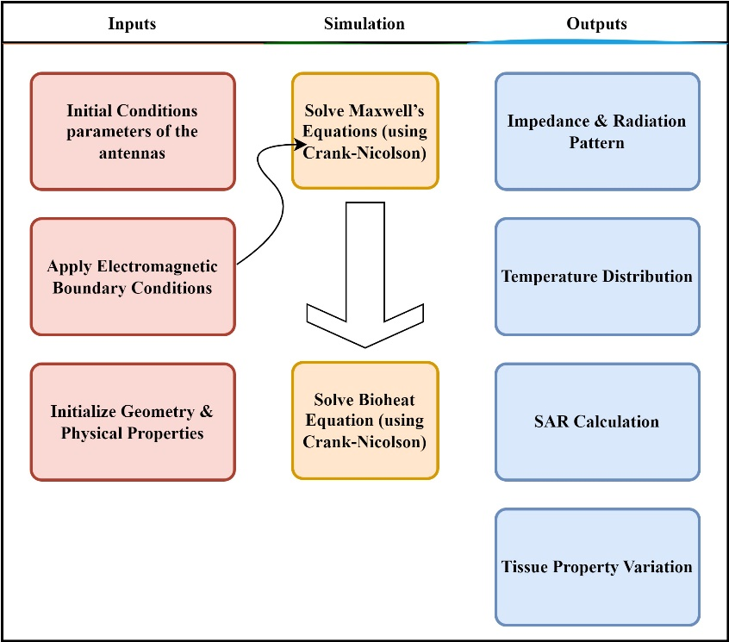
Figure 1. The proposed algorithm flow chart.
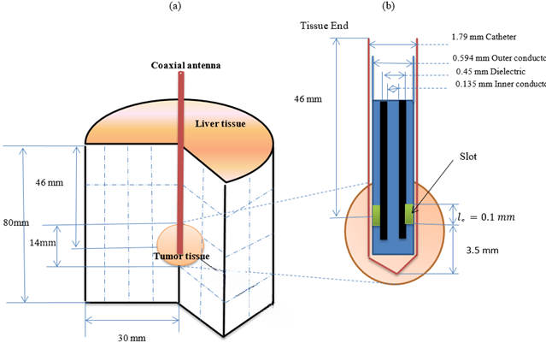

Figure 2. Schematic view of the (a) configuration of the antenna inserted into biological tissue used for microwave ablation therapy (b) the microwave coaxial antenna enclosed in a catheter is composed of dielectric, inner and outer conductors, and a slot. The tumor is assumed to have a spherical form.

- Numerical results
In this section, we present some numerical experiments to validate the theoretical findings from the previous sections. For our numerical experiments, we used globally continuous piecewise linear finite elements.

4.1 Impedance and Radiation Pattern Analysis of AMC and Coaxial Antennas
Figure 2 presents the impedance and radiation pattern analysis of the AMC and coaxial antennas across the frequency range from 1 GHz to 10 GHz. In Figure 3(a), the impedance behavior of both antennas is depicted. Both the AMC and coaxial antennas exhibit nearly identical impedance characteristics, with the impedance gradually increasing and stabilizing at higher frequencies. This close agreement indicates that the AMC antenna effectively replicates the impedance behavior of the coaxial antenna.
In Figure 3(b), the radiation patterns of the two antennas are compared. Both antennas show low radiation levels across most of the frequency range, with distinct resonance peaks around 5 GHz and a sharp peak near 9 GHz. The similarity between the radiation patterns of the AMC and coaxial antennas confirms the AMC antenna's ability to emulate the radiation performance of the coaxial design, ensuring consistent behavior in practical applications.

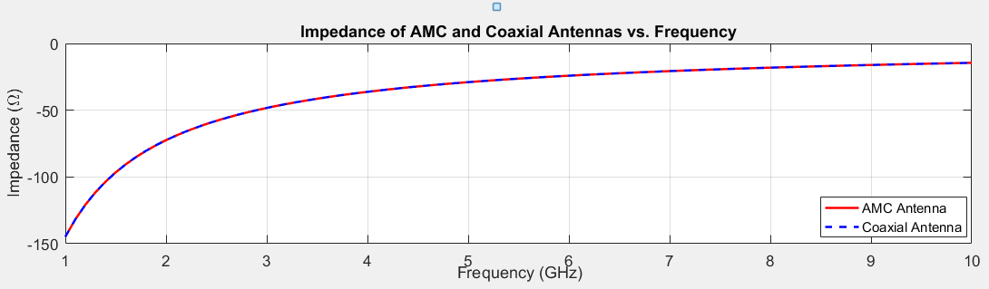
(a) Impedance vs. frequency for AMC and coaxial antennas.
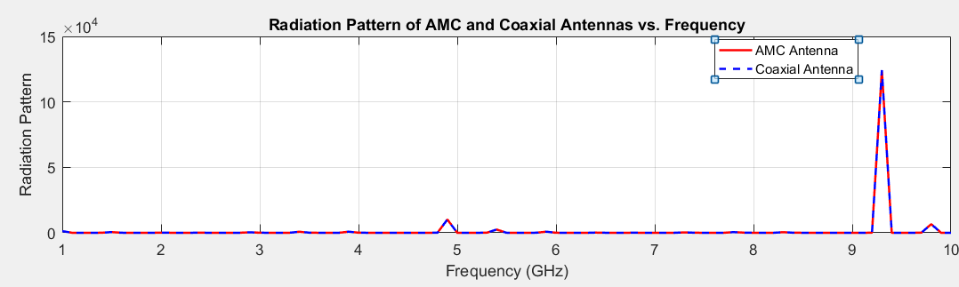
(b) Radiation pattern vs. frequency for both antennas.
Figure 3. (a) Impedance vs. frequency for AMC and coaxial antennas. (b) Radiation pattern vs. frequency for both antennas.

4.2 Temperature Distribution in Tissue
The bioheat equation, discretized and solved using the Crank-Nicolson method, was utilized to investigate the thermal response of biological tissue under microwave heating. Figures 4 and 5 present the resulting temperature distribution profiles.
In Figure 4, the spatial temperature distribution along the tissue is depicted at the end of the simulation. The temperature increases symmetrically along the tissue, reaching its maximum value at the midpoint (approximately 0.5 mm) and decreasing towards the boundaries. This parabolic distribution reflects uniform microwave energy absorption within the tissue, with peak temperatures localized centrally, ensuring effective heating while minimizing excessive thermal gradients at the edges. Figure 5 illustrates the temporal evolution of temperature at a specific location within the tissue. The temperature exhibits a steady rise over time, ultimately reaching approximately 100°C by the end of the simulation period. This consistent increase highlights the continuous deposition of microwave energy and confirms the efficiency of the heating process in achieving therapeutic temperature levels within the target tissue.

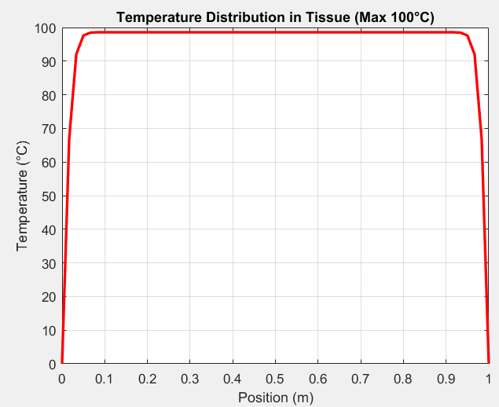
Figure 4: Temperature distribution along the tissue at the end of the simulation.

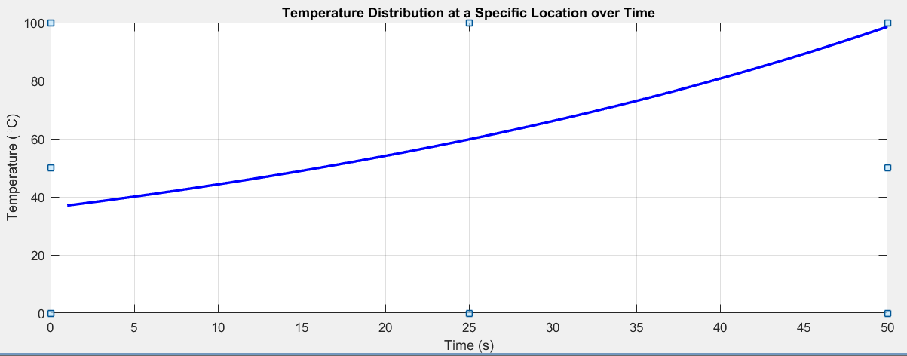
Figure 5: Temperature distribution along the tissue at a Specific location

  - Effect of Temperature on Thermal Properties

The thermal properties of liver tissue, including residual water mass, tissue density, thermal conductivity, specific heat, and blood flow rate, were evaluated over a temperature range from 0°C to 100°C. These properties play a crucial role in accurately modeling the tissue's thermal response during microwave heating procedures.
Figure 6(a) illustrates the variation of residual water mass with temperature. As temperature increases, the residual water mass decreases significantly, indicating progressive dehydration of the tissue. This reduction is particularly pronounced at lower temperatures and stabilizes at higher temperatures, reflecting the loss of free water content.
In Figure 6(b), the tissue density is shown as a function of temperature. A sharp decline in tissue density is observed with increasing temperature, consistent with the decrease in residual water content. This behavior highlights the temperature-dependent structural changes occurring within the tissue.
Figure 6(c) depicts the temperature dependence of thermal conductivity, specific heat, and blood flow rate. Thermal conductivity and specific heat exhibit slight increases with temperature, suggesting an enhanced capacity of the tissue to conduct and store thermal energy at elevated temperatures. In contrast, the blood flow rate decreases as temperature rises, which may reduce convective heat dissipation and contribute to localized temperature elevation within the tissue.

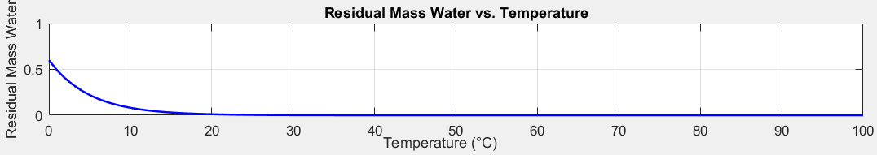
(a) Residual water mass vs. temperature
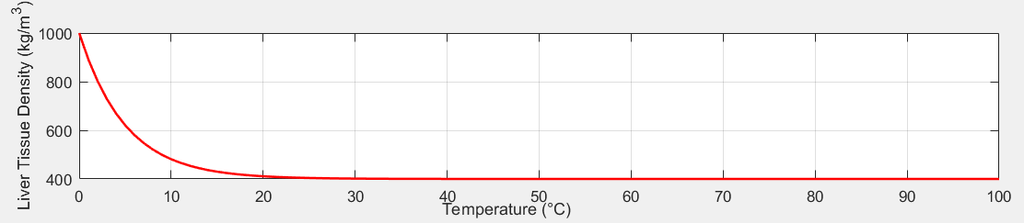
(b) Thermal conductivity and specific heat vs. temperature.
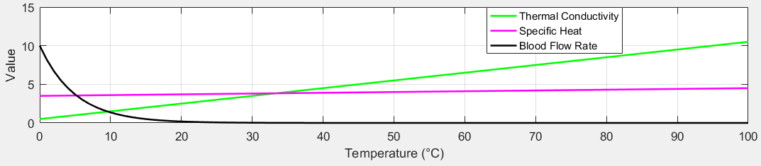
(c) Blood flow rate vs. temperature.
Figure 6: (a) Residual water mass vs. temperature. (b) Thermal conductivity and specific heat vs. temperature. (c) Blood flow rate vs. temperature.

Table 1 illustrates the variation of key physical and thermal properties of liver tissue as a function of temperature. These variations have significant implications for the tissue’s biological processes and thermophysical behavior, particularly during thermal treatment procedures. The principal observations derived from the presented data are summarized below.
Water Content (residual_mass_water) The water content values in the table are consistently reported as zero across the entire temperature range. This assumption suggests a fully dehydrated tissue state, likely representative of post-ablation conditions where water evaporation has already occurred. In physiological contexts, water content typically decreases progressively with increasing temperature, especially nearing 100°C due to the evaporation of intracellular and extracellular fluids. The absence of water substantially affects the tissue’s electrical conductivity and thermal transport properties, which must be considered in simulation models. Density (liver_tissue_density) The liver tissue density exhibits a slight but noticeable decrease as the temperature increases. Specifically, the density decreases from approximately 400.367 kg/m³ at 37°C to 400 kg/m³ at temperatures of 70°C and higher. This reduction is attributed to structural changes in the tissue, such as shrinkage and water loss, as a result of heating. Although the absolute changes are relatively modest, they reflect essential morphological alterations that influence the thermal and mechanical behavior of the tissue. Thermal Conductivity (liver_thermal_conductivity) Thermal conductivity increases steadily with temperature, ranging from 4.2 W/m·K at 37°C to 9.2 W/m·K at 87°C. This trend indicates an enhanced ability of the tissue to conduct heat as the temperature rises. Such behavior is particularly relevant for thermal therapies, where accurate modeling of heat distribution within the tissue is critical for predicting treatment outcomes and ensuring effective energy delivery. Specific Heat Capacity (liver_specific_heat) The specific heat capacity shows a gradual increase from 3.87 kJ/kg·K at 37°C to 4.37 kJ/kg·K at 87°C. This indicates that as the tissue temperature rises, more energy is required to achieve further temperature increases. Understanding this property is essential for precise energy calculations and for determining the tissue’s thermal response during hyperthermic treatments. Blood Flow Rate (blood_flow_rate) The blood flow rate decreases markedly with increasing temperature, starting from 0.006 mL/min at 37°C and diminishing to zero at temperatures above 50°C. This sharp decline signifies the cessation of perfusion due to thermal damage to vascular structures, resulting in the loss of biological activity in the affected region. Accurately capturing this phenomenon is crucial, as the absence of blood flow substantially alters heat dissipation and tissue viability.

Table 1: The changes in various physical properties of liver tissue due to temperature variations
Temperature (°C) | Residual_mass_water | Liver_tissue_density  kg/m³ | Liver_thermal_conductivity  W/m·K | liver_specific_heat  kJ/kg·K | blood_flow_rate  mL/min
37 | 0 | 400.367 | 4.2 | 3.87 | 0.006
38 | 0 | 400.3 | 4.3 | 3.88 | 0.005
39 | 0 | 400.246 | 4.4 | 3.89 | 0.004
40 | 0 | 400.201 | 4.5 | 3.90 | 0.003
41 | 0 | 400.165 | 4.6 | 3.91 | 0.003
42 | 0 | 400.135 | 4.7 | 3.92 | 0.002
43 | 0 | 400.11 | 4.8 | 3.93 | 0.002
44 | 0 | 400.09 | 4.9 | 3.94 | 0.002
45 | 0 | 400.074 | 5 | 3.95 | 0.001
46 | 0 | 400.061 | 5.1 | 3.96 | 0.001
47 | 0 | 400.05 | 5.2 | 3.97 | 0.001
48 | 0 | 400.041 | 5.3 | 3.98 | 0.001
49 | 0 | 400.033 | 5.4 | 3.99 | 0.001
50 | 0 | 400.027 | 5.5 | 4 | 0
51 | 0 | 400.022 | 5.6 | 4.01 | 0
52 | 0 | 400.018 | 5.7 | 4.02 | 0
53 | 0 | 400.015 | 5.8 | 4.03 | 0
54 | 0 | 400.012 | 5.9 | 4.04 | 0
55 | 0 | 400.01 | 6 | 4.05 | 0
56 | 0 | 400.008 | 6.1 | 4.06 | 0
57 | 0 | 400.007 | 6.2 | 4.07 | 0
58 | 0 | 400.005 | 6.3 | 4.08 | 0
59 | 0 | 400.005 | 6.4 | 4.09 | 0
60 | 0 | 400.004 | 6.5 | 4.10 | 0
61 | 0 | 400.003 | 6.6 | 4.11 | 0
62 | 0 | 400.002 | 6.7 | 4.12 | 0
63 | 0 | 400.002 | 6.8 | 4.13 | 0
64 | 0 | 400.002 | 6.9 | 4.14 | 0
65 | 0 | 400.001 | 7 | 4.15 | 0
66 | 0 | 400.001 | 7.1 | 4.16 | 0
67 | 0 | 400.001 | 7.2 | 4.17 | 0
68 | 0 | 400.001 | 7.3 | 4.18 | 0
69 | 0 | 400.001 | 7.4 | 4.19 | 0
70 | 0 | 400 | 7.5 | 4.2 | 0
71 | 0 | 400 | 7.6 | 4.21 | 0
72 | 0 | 400 | 7.7 | 4.22 | 0
73 | 0 | 400 | 7.8 | 4.23 | 0
74 | 0 | 400 | 7.9 | 4.24 | 0
75 | 0 | 400 | 8 | 4.25 | 0
76 | 0 | 400 | 8.1 | 4.26 | 0
77 | 0 | 400 | 8.20 | 4.27 | 0
78 | 0 | 400 | 8.3 | 4.28 | 0
79 | 0 | 400 | 8.4 | 4.29 | 0
80 | 0 | 400 | 8.5 | 4.30 | 0
81 | 0 | 400 | 8.6 | 4.31 | 0
82 | 0 | 400 | 8.70 | 4.32 | 0
83 | 0 | 400 | 8.8 | 4.33 | 0
84 | 0 | 400 | 8.9 | 4.34 | 0
85 | 0 | 400 | 9 | 4.35 | 0
86 | 0 | 400 | 9.1 | 4.36 | 0
87 | 0 | 400 | 9.2 | 4.37 | 0

4.4 Specific Absorption Rate (SAR) and Frequency Relationship
During microwave thermal ablation, electromagnetic waves propagate through biological tissues, with energy absorption primarily governed by the tissue's dielectric properties. A key parameter in this process is the Specific Absorption Rate (SAR), defined as the absorbed power density normalized by tissue density.
The relationship between frequency and the Specific Absorption Rate (SAR) is critical in optimizing microwave thermal ablation procedures. Figure 7 shows the variation of the specific absorption rate (SAR) as a function of insertion depth at an operating frequency of 2.45 GHz. The SAR distribution was computed from the electric field intensity derived through the finite difference solution of Maxwell’s equations. The results demonstrate a peak SAR near the antenna tip, rapidly decreasing with increasing depth into the liver tissue. This behavior is consistent with the expected electromagnetic wave attenuation in biological media, highlighting the localized energy deposition crucial for effective microwave ablation. The SAR profile directly informs the heat source term in the bioheat equation, thus influencing the subsequent temperature distribution and thermal damage prediction. This figure validates the model’s ability to capture the electromagnetic–thermal coupling essential for accurate treatment planning in liver cancer ablation.

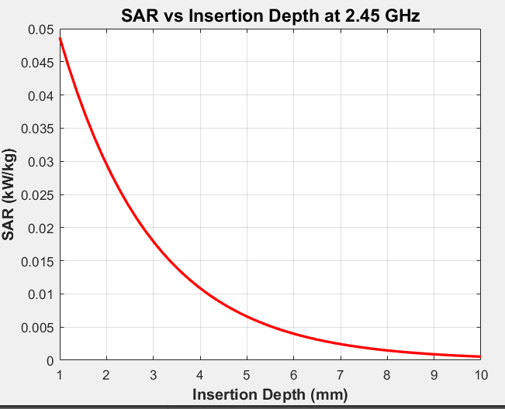
Figure 7: Specific Absorption Rate (SAR) vs. frequency.

- Comparative Analysis
In [16] Microwave ablation is a cancer treatment that uses electromagnetic waves to heat and destroy tumor cells while sparing healthy tissue. A micro-antenna delivers the radiation, and the treatment requires precise temperature control to avoid damaging normal cells. Numerical simulations using the bio-heat and Maxwell’s equations help analyze key factors like temperature distribution and specific absorption rate (SAR). Results show that while higher power increases SAR and temperature, a 10 W input effectively kills tumor cells without harming surrounding tissue.

In Table 2, our proposed algorithm introduces distinct advantages in terms of computational structure and spatial fidelity. Notably, the proposed method employs a fully three-dimensional finite difference scheme combined with the Crank–Nicolson method, which enhances numerical stability and allows fine control over temporal accuracy without significantly increasing computational cost. In contrast, [16] relies on a two-dimensional axisymmetric FEM formulation, which, while efficient, limits the anatomical realism achievable in complex geometries. Moreover, the regular Cartesian grid structure in our proposed algorithm offers straightforward implementation and easier convergence analysis, making it particularly well-suited for high-resolution simulations in simplified anatomical models. Therefore, despite lacking experimental validation, the proposed approach provides a computationally accessible and inherently stable framework for exploratory modeling of heat distribution in cancerous tissue.

Table 2. Comparison between the proposed algorithm and different scheme.

Metric | Proposed Algorithm | [16]
Input Microwave Power | 10 W, 20 W, 30 W | 10 W, 45 W, 75 W
Frequency | 2.45 GHz | 2.45 GHz
Initial Temperature | 37°C | 37°C (also validated at 8°C)
Max Temperature Reached | ~66°C (at 30 W, center) | ~70°C (at 75 W, 4.5 mm)
SAR Peak Value | ~250 W/kg | ~280 W/kg
Necrosis Threshold | ~50°C sustained for 60s | ~52°C at 4.5 mm in 300s
Spatial Domain | Full 3D | 2D axisymmetric
Numerical Stability | High (implicit CNM) | Depends on mesh and timestep
Modeling Focus | Detailed thermal field evolution | Validated EM-thermal interaction

- Conclusion
This study establishes a robust numerical model utilizing the Finite Difference Method and the Crank-Nicolson scheme to simulate the electromagnetic and thermal dynamics of microwave ablation therapy for liver tumors. By integrating Maxwell's equations with the Pennes bioheat equation, the model effectively captures the complex interaction between microwave energy and liver tissue, accounting for temperature-dependent variations in tissue properties. The simulation results confirm that increasing temperature leads to progressive dehydration, tissue shrinkage, enhanced thermal conductivity, and cessation of blood perfusion, all significantly influencing the ablation process. Furthermore, impedance and radiation pattern analyses demonstrate the stability and effectiveness of the proposed coaxial antenna design across a wide frequency range.
The application of the Crank-Nicolson method ensures numerical stability and accuracy, making it a reliable tool for detailed treatment planning. This numerical framework provides important insights into optimizing ablation parameters, including frequency selection, power levels, and antenna design, thereby improving the efficacy and safety of microwave-based cancer treatments. Future work may extend this approach to three-dimensional, patient-specific anatomical modeling and validation against clinical data to further enhance the accuracy and clinical relevance of the simulations.

- References

[1] Satish, Vellavalapalli, and Ramjee Repaka. "Microwave ablation trocar for ablating cancerous tumors: a numerical analysis." Medical & Biological Engineering & Computing 61.5 (2023): 1113-1131.
[2] Gündoǧdu, Hami, and Hardik Joshi. "Numerical Analysis of Time-Fractional Cancer Models with Different Types of Net Killing Rate." Mathematics 13.3 (2025): 536.
[3] Benzekry, S.; Lamont, C.; Beheshti, A.; Tracz, A.; Ebos, J.M.L.; Hlatky, L.; Hahnfeldt, P. Classical mathematical models for description and prediction of experimental tumor growth. PLoS Comput. Biol. 2014, 10, e1003800.
[4] Arshad, Sadia, Ayesha Sohail, and Sana Javed. "Dynamical study of fractional order tumor model." International Journal of Computational Methods 12.05 (2015): 1550032.
[5] Kumar, Sunil, et al. "A chaos study of tumor and effector cells in fractional tumor-immune model for cancer treatment." Chaos, Solitons & Fractals 141 (2020): 110321.
[6] Naik, Parvaiz Ahmad, Jian Zu, and Mehraj-ud-din Naik. "Stability analysis of a fractional-order cancer model with chaotic dynamics." International Journal of Biomathematics 14.06 (2021): 2150046.
[7] Naik, Parvaiz Ahmad, et al. "Chaotic dynamics of a fractional order HIV-1 model involving AIDS-related cancer cells." Chaos, Solitons & Fractals 140 (2020): 110272.
[8] Debbouche, Nadjette, et al. "Chaos in Cancer Tumor Growth Model with Commensurate and Incommensurate Fractional‐Order Derivatives." Computational and Mathematical Methods in Medicine 2022.1 (2022): 5227503.
[9] Qayyum, Mubashir, and Aneeza Tahir. "Mathematical modeling of cancer tumor dynamics with multiple fuzzification approaches in fractional environment." 2023. 1-25.
[10] Sweilam, Nasser, et al. "Numerical Treatments for Crossover Cancer Model of Hybrid Variable-Order Fractional Derivatives." CMES-Computer Modeling in Engineering & Sciences 140.2 (2024).
[11] Nabil, Haneche, and Tayeb Hamaizia. "A three-dimensional discrete fractional-order HIV-1 model related to cancer cells, dynamical analysis and chaos control." Mathematical Modelling and Numerical Simulation with Applications 4.3 (2024): 256-279.
[12] Moya, Erick Manuel Delgado, Ranses Alfonso Rodriguez, and Alain Pıetrus. "A mathematical model for the study of HIV/AIDS transmission with PrEP coverage increase and parameter estimation using MCMC with a Bayesian approach." Bulletin of Biomathematics 2.2 (2024): 218-244.
[13] Duffy, Daniel J. Finite difference methods in financial engineering: a partial differential equation approach. John Wiley & Sons, 2013.
[14] Sharma, T., S. Pathak, and G. Trivedi. "Comparative Study of Crank-Nicolson and Modified Crank-Nicolson Numerical Methods to Solve Linear Partial Differential Equations." Indian Journal of Science and Technology 17.10 (2024): 924-931.
[15] Kabiri, Ali, and Mohammad Reza Talaee. "Analysis of hyperbolic Pennes bioheat equation in perfused homogeneous biological tissue subject to the instantaneous moving heat source." SN Applied Sciences 3 (2021): 1-8.
[16] Selmi, Marwa, Abdul Aziz Bin Dukhyil, and Hafedh Belmabrouk. "Numerical analysis of human cancer therapy using microwave ablation." Applied Sciences 10.1 (2019): 211.

