Factors of the insalubrity of the commune of Boundiali and production of compost as an alternative for the sustainable management of municipal solid waste.

ABSTRACT
The lack of control over the quantity of municipal solid waste produced and the management of this waste remain a major problem for cities in developing countries in particular, those of Côte d'Ivoire. Boundiali, one of the communes of the Bagoué region is not on the sidelines of this situation. This mismanagement is a potential source of environmental and human pollution. This study was initiated in order to propose a response to this pollution due to solid waste, to analyze the environmental situation and the pollution of the municipal space in relation to solid waste. Thus, it was a question of identifying the factors favoring insalubrity in the commune, to highlight the impact of insalubrity on the socio-economic development of the commune and to make recommendations on a possibility of production compost as a solution for the sustainable management of this waste. To achieve this, the study was based on field observations, surveys of 30 households in the municipality, interviews with services of the town hall, the Service Platform (PFS) and documentary research. The results obtained from this study reveal that the factors favoring the insalubrity of the commune are multiple with very visible harmful effects in terms of human and economic health. Also, a well-structured production of compost from household solid waste can contribute significantly to improving sanitation in the commune of Boundiali. Moreover, it can constitute an opportunity for economic development and a sustainable response to the problem of the continuous impoverishment of the soil caused by erosion and bad agricultural practices.
Keywords: Compost, development, sanitation, Bagoué, Boundiali, Ivory Coast.

INTRODUCTION
Urban waste management is one of the most important challenges facing public authorities in the cities of developing countries. It has been shown that in the cities of developing countries, waste production ranges from 0.21 - 0.9 kg/hab/day, with an average of around 0.75 kg/hab/day (Okot-Okumu and Nyenje, 2011; Nabembezi, 2011). In terms of composition, fermentable matter is predominant, reaching 40-50 % or even more, compared with 25 % in Europe (Farinet and Niang, 2004).
Côte d'Ivoire, located in West Africa, is faced with this situation, which is particularly critical in large cities where population growth, coupled with changes in consumption patterns, are increasing waste production and aggravating collection and disposal problems (Koné, 2008). You only have to drive through any city in Côte d'Ivoire to see piles of waste and garbage along the roads and in certain public spaces. Such is the case of towns in the Bagoué region, specifically the commune of Boundiali, with a population of 92,792 (RGPH, 2021), which will continue to grow as a result of development. Waste disposal in this area is currently carried out by simple dumping, without appropriate facilities.
This waste is a potential source of so-called environmental diseases, closely linked to the state of environmental degradation (WHO, 2007 ; Sy et al., 2011). The United Nations Environment Programme (UNEP) reports that three diseases - diarrhoea, malaria and acute respiratory infection - account for 60 % of known environmental impacts on health in developing countries (Bagalwa et al., 2013 ; Opio-Odongo, 2013). In addition, they hinder the economic and social development of communities (Koné, 2008 ; Kouadio et al., 2006 ; Wagtaff, 2002). Côte d'Ivoire's epidemiological profile presents alarming statistics. Malaria accounts for 50 % of consultations in primary health care facilities, and 20 % of infant deaths are due to pneumonia. Diarrhoeal diseases often reach extremely high proportions. For example, ascariasis in some areas reaches a prevalence rate of 71.6 %, and hookworm prevalence can be as high as 100 % (WHO, 2010). In addition, the biogas produced by these waste dumps is thought to be responsible for a significant production of greenhouse gases, which are the cause of climate change (ADEME, 2011).
In order to put a stop to this dramatic situation, it is necessary to find a sustainable alternative for household waste management in the commune of Boundiali. With this in mind, the main objective is to show the causes and impacts of insalubrity, and how composting could provide an answer to the question of sustainable waste management in the commune of Boundiali. Specifically, the aim is (1) to identify the factors contributing to insalubrity in the commune of Boundiali; (2) to highlight the impact of insalubrity on the socio-economic development of the commune of Boundiali; (3) to show the importance of compost production in the quest for salubrity in the commune of Boundiali.

I/ DATA AND METHODS

1.1/ Description of the study area
The study covered the commune of Boundiali, located in the far north of Côte d'Ivoire, in the Bagoué region, of which it is the regional capital. It is one of two communes in the Boundiali department, along with Kasséré. It is one of the seven (7) communes of the Bagoué region, with its fourteen (14) sub-prefectures (Figure 1). The commune of Boundiali is separated to the east by the commune of Korhogo, to the west by the communes of Madinani and Séguela, to the south by the communes of Dianra and Kani, and to the north by the commune of Kolia.
Created by decree n°292 of March 16, 1978, the commune of Boundiali covers an area of 78.5 km², with a population of 92,792 (RGPH, 2021). In addition to the urban area, the commune covers the villages of Niagnon, Nondara, Tombougou-Samorosso, N'dara, Ouazomon, Gbando and Guinguereni.

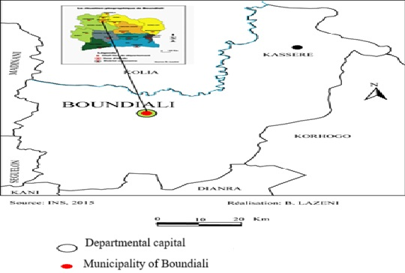
Figure 1 : Geographical location of the Commune of Boundiali

1.2. Materials and methods
Documentary research, combined with observations and fieldwork, enabled us to obtain data on the factors contributing to insalubrity in the commune of Boundiali, as well as data on the impact of insalubrity on the commune's socio-economic development.
Documentary research enabled us to refer to other literature and documents directly or indirectly related to the problem at hand. Interviews and field surveys were carried out in August 2022 with local development stakeholders, including the town hall, the public health institute, the services platform (PFS), the cotton mill and the farming population. They provided primary information on the state of insalubrity in the commune and its socio-economic impacts.
To demonstrate the importance of compost production in the quest for sanitation in the commune of Boundiali, a field survey was carried out based on participant observation, interviews and a survey of 30 farming households. Participant observation enabled us to understand the composting process, from waste collection to the production of humus (compost) and its use on farms. The survey method was based on simple random sampling as in the work of Sy et al. (2014).
In terms of materials, the study relied on computer equipment such as cameras for snapshots, the information from the various surveys was processed manually using the PC/HP computer. Data processing was carried out using Word 2013 and Excel 2013 software.

II/ RESULTS AND DISCUSSION

2.1/ Factors favouring insalubrity in the commune of Boundiali
The results of the study on the factors contributing to insalubrity in the commune showed that these factors are divided into two categories: anthropic factors and natural factors.
Concerning anthropogenic factors, they constitute the major causes of insalubrity in the communal space. The diagnosis identified a number of anthropogenic factors, notably the explosion of the urban population, poor domestic practices, the absence of pre-collection facilities and the shortcomings of the urban profile.
Indeed, with regard to the urban population explosion, recent population data for the last twenty years show that the communal population has almost quadrupled from 29 848 habitants in 1998, to 92 792 habitants in 2021 (RGPH, 1998 ; 2021). This demographic boom would thus obviously contribute to the evolution of insalubrity, all the more so as, according to figures from the town hall's technical department, the average daily production of waste is estimated at 0.61 kg per inhabitant/day in 2021.
Taking this figure in relation to the total population, the commune manages a daily production of around 56 tonnes/day. These results are backed up by those of Aina (2006), who has shown that the phenomena of rural exodus and the metropolization of towns are major contributors to urban insalubrity. The commune of Boundiali being the regional capital, we are witnessing the installation of several industries and other services that favor this phenomenon of metropolization, resulting in insalubrity and its corollaries on health and the environment. Ahmed & Ali (2006) and Agdag (2009) have shown that solid waste production is directly linked to urbanization and economic development.
In addition to the explosion of the urban population, the commune is faced with the existence of poor domestic practices. Figure 2 illustrates these bad domestic practices through the dumping of waste in public places (streets, gutters, etc.). It is also characterized by the construction of anarchic buildings that are detrimental to the aeration and healthiness of the urban environment.
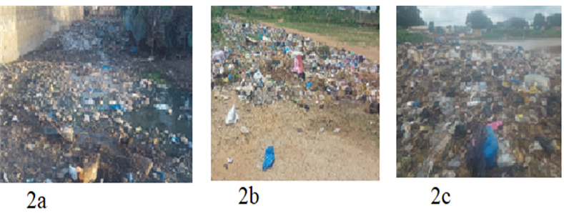
Figure 2 : Illegal dumping of garbage in the town of Boundiali, Fangayogo (2a), Loworo (2b), Haïdara, Korhogo railway station (2c).
According to field observations, the anarchic dumping of waste in public places is particularly encouraged by the absence of pre-collection and refuse collection sites in the commune. There is also a lack of refuse collection boats. It was also noted that the municipality and its partners in the Platform for Services (PFS) carry out irregular and sector-based waste collection (downtown). According to the results of the household survey, there are also other structures such as the Non-Governmental Organization (NGO) “FAFA service”, which offer home pre-collection at a cost of 1 000 F CFA/month/household.
The anarchic dumping of waste in public places is further encouraged by the lack of awareness of civic-mindedness and a culture of cleanliness. In addition, field observations have shown that the urban profile is particularly deficient, as housing in the commune of Boundiali is of the grouped type, with very little green space or spacing between buildings. This settlement pattern is particularly conducive to insalubrity and inappropriate domestic practices, such as the anarchic construction of buildings that block rainwater drainage channels, or the dumping of household excreta and wastewater into gutters (Figure 3).

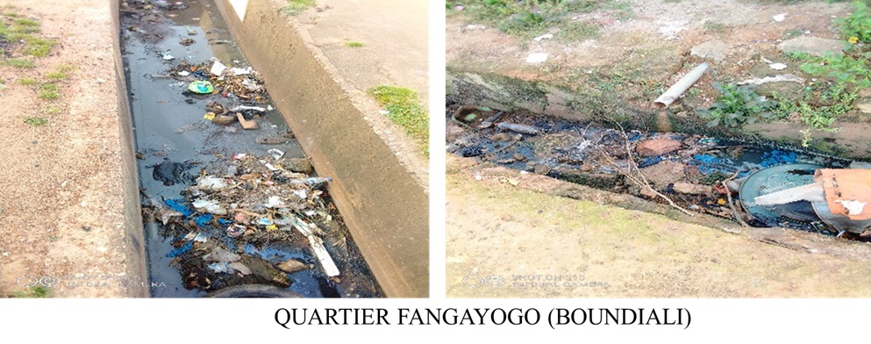
Figure 3 : Obstruction of rainwater drainage channels by garbage in the town of Boundiali, Fangayogo district.

Regarding natural factors or minor causes, the results of field observations on natural factors contributing to insalubrity in the commune of Boundiali showed that agents such as rainwater, wind and vegetation contribute to insalubrity. Indeed, the impact of stormwater and wind is intimately linked to that of human activity, as they are responsible for transporting the domestic waste produced by people (households and businesses) from unhealthy areas to healthy ones. “See for yourself: my yard is always full of garbage from commercial restaurants, even though I don't own one,” says a local resident in the Haidara district, more than 100 m from a coffee kiosk, who noticed the presence of food packaging from the kiosk in front of his yard after a rainstorm.
In addition, observations of the landscape by local residents show a perpetual scene of plastic bags suspended in the grass due to the effect of the wind. Figure 4 illustrates this scene in the Haïdara district.
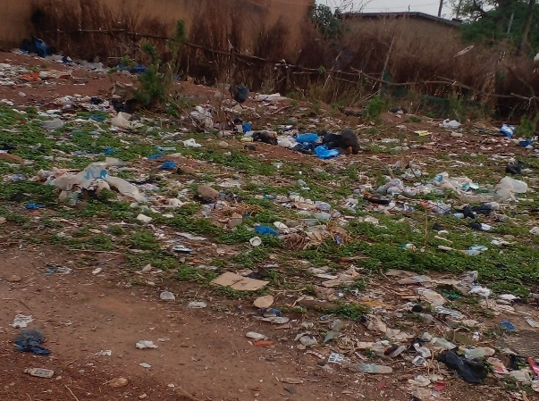
Figure 4 : Plastic waste landscape in the Haïdara district
Thus, these natural factors can be considered as minor causes, as their contribution to the insalubrity of the communal area is more that of agents than producers (with the exception of vegetation). Vegetation also contributes to insalubrity through the presence of weeds, which are nests for vectors of disease, parasites or microbes (dust, mosquitoes, rodents, excreta, etc.). These natural factors contribute to the unhealthy state of the local environment.

2.2/ Highlighting the impact of insalubrity on the socio-economic development of the Boundiali commune.
The results of the field surveys enabled us to assess the adverse effects of insalubrity on socio-economic development in the commune of Boundiali. These adverse effects can be observed at health (disease), economic and social levels.

2.2.1/ Health impact of insalubrity in the commune
The health impact of insalubrity is assessed by taking into account the diseases it causes. To this end, surveys have revealed the presence of infectious and non-infectious diseases linked to the degradation of the urban environment. These diseases mainly concern malaria, acute respiratory infections (ARI), diarrhea and dermatoses. In 2016, the Direction Départementale de la Santé recorded 46,406 suspected cases of malaria, including 8,837 cases in the commune of Boundiali. Over the same period, the commune recorded 648 cases of acute respiratory infections, 293 cases of dermatosis and 83 cases of diarrhea. Drescher et al. (2006) and Yeo et al. (2020) have shown that insalubrity contributes to flooding, air pollution and the spread of disease vectors.
Better still, WHO (2007) points out that over 80 % of diseases in developing countries are linked to unsanitary environments (Dongo, 2006 ; Bagalwa et al., 2013). In addition, animals such as dogs, rodents, sheep and poultry wandering around garbage heaps in search of food, represent health risks in that they can transmit diseases and epidemics such as rabies, typhoid fever and plague (WHO, 2007).

2.2.2/ Economic impact of insalubrity
The results of the survey show that the expenditure incurred by insalubrity includes sanitation and waste removal costs, which concern both the municipality and the population.
At municipal level, more than 95 million CFA francs have been spent on sanitation over the past three years (Figure 5). In 2020, this represented 11% of budget revenues collected, with a 33% increase over 2018 according to the Town Hall Accounting Department in 2022.

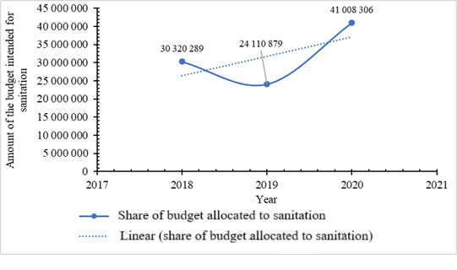
Figure 5 : Evolution of municipal sanitation expenditure from 2018 to 2020 (Service Comptable de la Mairie, 2022).
The graph shows a linear trend in sanitation-related expenditure. Although there was a relative drop in 2019, certainly due to the low level of revenue collected, it still represents a loss of income for the commune.
As far as the population is concerned, the expenses incurred by insalubrity are essentially linked to health. Indeed, all the cases of disease recorded generate expenditure for the population, the evaluation of which could not be taken into account in the present study. However, if we add to this the still high rate of self-medication (treating oneself without medical advice) in poor countries (70 %), it's clear that insalubrity has a considerable negative impact on people's daily lives (Figure 6).
Figure 6 presents a cause-and-effect relationship. It shows how, in an unhealthy living environment, the presence of disease vectors, parasites and microbes causes illness; generates health expenditure; degrades people's standard of living and limits their access to consumer goods and services. Poor waste management (unhealthy environment) generates health costs and limits access to consumer goods and services. These results are backed up by those of Kouadio et al. (2006), who showed that the direct costs associated with malaria represent on average 12 to 14 % of household income, with active members also losing 4 to 7 days' work. The economic stress associated with this disease is all the greater when populations live on less than one US dollar per capita per day, coupled with little assistance from the community. Households adopt therapeutic itineraries that are supposed to be less costly, but they do not take into account the cost-effectiveness of these remedies.

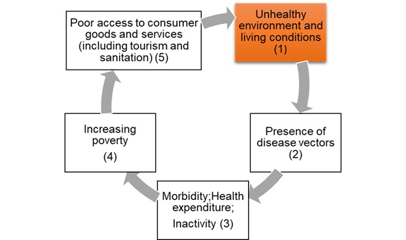
Figure 6 : Socio-economic consequences of insalubrity (Study data, 2022).

2.2.3/ Social consequences of insalubrity
Clearly, the commune remains the key player in community development planning. To this end, it undertakes actions to develop basic socio-economic infrastructures (education, health, infrastructure) for the benefit of the population. However, the survey revealed that the commune's insufficient budgetary resources limit its development actions for the benefit of communities. Under these conditions, spending on sanitation becomes detrimental in terms of lost revenue in the pursuit of development and social well-being. It can also be detrimental to the commune's image as a tourist destination, due to the lack of adequate infrastructure.
Similarly, people's access to consumer goods and services is closely linked to their standard of living. However, in Côte d'Ivoire, the poverty rate in 2020 is estimated at 39.40% in urban areas and 48.70 % in rural areas. Even if this rate has declined compared to 2015 (46.30 % in urban areas and 60 % in rural areas) (Coulibaly et al., 2019), it remains high. Thus, in their aspirations to access consumer goods and services, unsanitary conditions become a loss of income for these populations. On the one hand, this loss of income linked to health expenditure is particularly aggravated by inactivity (of the patient) and the resulting deterioration in the standard of living. On the other hand, it is assessed in terms of the availability of basic socio-economic infrastructure to meet the needs expressed. Indeed, the lack of this infrastructure in the municipality results in additional expenses for the populations linked to travel to localities that have them. Moreover, the recurrence of diseases combined with uncontrolled spending on care becomes a hindrance to the development of individuals (KONAN, 2023). The latter find themselves surviving from day to day under this burden and without the possibility of "creating" or "recreating" themselves. Thus, due to the unsanitary conditions, populations find themselves facing unimaginable consequences (WHO, 2007 ; Sy et al., 2011).

2.3/ Proposal for the possibility of compost production in the quest for sanitation in the commune of Boundiali.
In the current context where the whole world is interested in organic farming and is promoting organic amendment as a source of fertilizers for sustainable agriculture, unlike chemical fertilizer, it appears imperative to encourage the production of compost from household solid waste. According to some researchers, organic matter represents more than 70 % of the municipal solid waste flow in developing countries such as Côte d'Ivoire (Mrayyan et al., 2006 ; Yeo et al., 2020).
Let us add that according to field observations, we note that most minor dumpsites in the backyards of certain small families or unserviced spaces are sometimes very fertile places after the waste is completely decomposed. Also, some researchers have confirmed that composts of urban origin represent a source of organic matter that can be used in agriculture (Houot et al., 2009).
Thus, in order to improve the cleanliness of the commune of Boundiali while providing economic added value to the establishment of sustainable development conditions, solid waste management will go through different stages. This involves collecting all waste generated by the population, sorting it and recovering the recyclable part and, finally, proceeding with the agronomic recovery of the organic part. Hence the meaning of carrying out composting tests using household solid waste from the commune of Boundiali.
Concretely, it will first involve carrying out a pilot phase from 10 families located in all neighborhoods (Number of inhabitants ≥ eight (8) people/household) according to the map of the commune of Boundiali (Figure 7). Thus, the collected waste will be weighed, sorted and the recovered organic matter will then be used to carry out composting tests. Finally, this compost produced will be made available to certain farmers to carry out growth tests on certain crops.

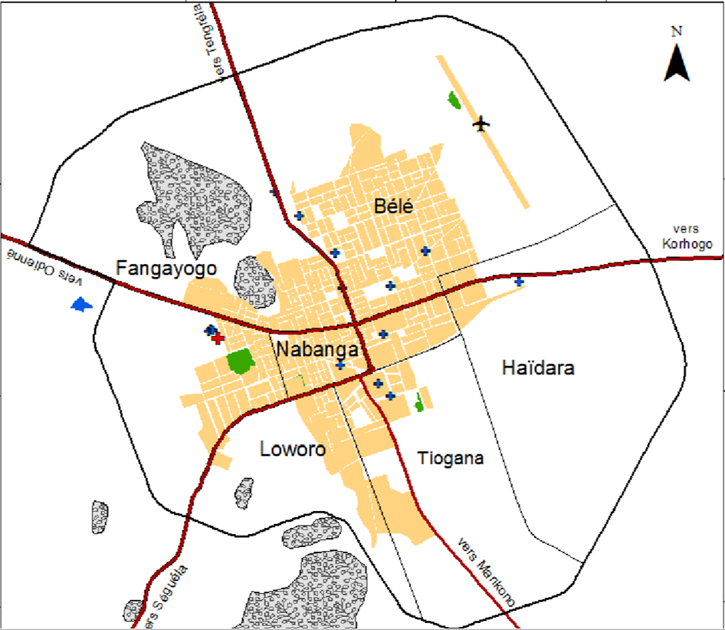
Figure 7 : Map of the City of Boundiali (Study data, 2022).
Laboratory characterization methods to assess their agronomic value will be carried out. Long-term field trials will be conducted to measure the effects of their repeated contributions. Repeated contributions of compost improve the stability of the soil structure. They stimulate biological activity, and make it possible to obtain yields equivalent to those obtained with conventional mineral fertilization.

CONCLUSION
This study has highlighted the factors that promote insalubrity in the commune of Boundiali, the impacts on socio-economic development and the possibility of producing compost for sustainable management of this waste in this commune.
During this study, we used documentary research associated with observations, field surveys and interviews with the various stakeholders involved in household waste management in the commune of Boundiali (the town hall, the public hygiene institute, the service platform (PFS) ...).
From these field investigations, it appears that the factors promoting insalubrity in the commune of Boundiali are of both anthropogenic and natural origins.
The impacts on the socio-economic development of the population are visible. Indeed, more than 80 % of the diseases prevalent are linked to the insalubrity of the environment because the expenses incurred for a health issue are essentially linked to insalubrity. For the commune, according to the Accounting Department of the Town Hall, in 2020, expenses related to sanitation covered 11 % of budget revenues with an increase of 33 % compared to 2018.
In a context where the whole world is interested in organic farming, also for the cleanliness of the commune of Boundiali, it appears imperative to encourage the production of compost from household solid waste as a source of fertilizers for sustainable agriculture, unlike chemical fertilizer. It appears that organic matter represents more than 70 % of the municipal solid waste flow. This can bring economic added value in the sustainable management of solid waste and for sustainable development of cities.

Ethical approval and consent to participate
The study was approved by all authors and tacitly or explicitly by the responsible authorities where the work was carried out.
Data availability
The datasets used and/or analyzed during the current study are available from the corresponding author upon reasonable request.

REFERENCES
- Ahmed A. S., & Ali M. (2006). People as partners : Facilitating people’s participation in public–private partnerships for solid waste management. Habitat International, 30 (4) :781-796.
- Bagalwa M., Karume K., Mushagalusa N. G., Ndegeyi K., Birali M., Zirirane N., Masheka Z. and Bayongwa C. (2013). Potential risks of household waste on the health of rural populations: the case of Irhambi Katana (South Kivu, Democratic Republic of Congo), VertigO - the electronic journal in environmental sciences [Online], Volume 13, Issue 2.
- Coulibaly M., Traore D., Ake F. D. A., Anoh K. P. (2019). "Deterioration of the Living Environment and Health Risks in the Plaque 1 and 2 Neighborhoods in the Municipality of Abobo (Abidjan, Ivory Coast)", Research Laboratory on the Dynamics of Environments and Societies (LARDYMES) of the Department of Geography, Faculty of Human and Social Sciences, University of Lomé, À H כֿ H כ, pp. 172-186
- Dongo K. (2006). Analysis of Deficiencies in the Management of Urban Drainage and Solid and Liquid Waste in the Precarious Neighborhoods of Yopougon, Abidjan, Ivory Coast: Mapping-GIS, Modeling and Socioanthropological Approach, Single Thesis, University of Cocody, Abidjan, 230 pages.
- Farinet J-L. and Niang S. (2004). Recycling Waste and Effluents in Urban Agriculture. In: Smith, O., Moustier, P., Mougeot, L. & Fall, A., eds. Sustainable Development of Urban Agriculture in French-Speaking Africa. Issues, Concepts, and Methods. CRAD & CRDI 143-173.
- Houot S., Cambier P., Deschamps M., Benoit P., Bodineau G. (2009). Composting and Agricultural Recovery of Urban Waste. Agronomic Innovations. 69-81.
- KONAN Kouakou Attien Jean-Michel (2023). Sanitation and Household Waste Management in the City of Man (West Côte d'Ivoire): Social and Health Risks for the Population. DaloGéo, a scientific journal specializing in Geography, Jean Lorougnon Guédé University, issue 009, ISSN 2707-5028, 30-40p.
- Koné B. (2008). Lagoon Pollution, Health and Environmental Risks in Three Peri-Urban Villages in the Municipality of Yopougon (Abidjan, Ivory Coast), Single Doctoral Thesis, University of Abobo-Adjamé, Abidjan, 286 p.
- Kouadio A. S., Cissé G., Brigit Obrist, Kaspar Wyss, and Zingsstag J. (2006). "Economic Burden of Malaria on Poor Households in Disadvantaged Neighborhoods of Abidjan, Ivory Coast," VertigO - the Electronic Journal in Environmental Sciences [Online], Special Issue 3 | December 2006, published online June 13, 2008.
- URL: http://journals.openedition.org/vertigo/1776 ; DOI: https://doi.org/10.4000/vertigo.1776
- Mrayyan B., Hamdi M. R. (2006). Management approaches to integrated solid waste in industrialized zones in Jordan: A case of Zarqa City. Waste Management, 26, 195–205.
- Nabembezi D. (2011). Solid Waste Management Study in Bwaise II Parish, Kawempe Division, 68 p.
- Opio-Odongo J. (2013). Africa Environment Outlook (AEO 3): Our Environment, Our Health; Summary for Policymakers, UNEP, 32 pages. https://searchworks.stanford.edu/view/10385706.
- Okot-Okumu J. and Nyenje R. (2011). Municipal solid waste management under decentralization in Uganda. Habitat International, 35, 537–543.
- World Health Organization (WHO), (2007). Preventing disease through a healthy environment, 19 p.
- World Health Organization (WHO) (2010). Communicable Diseases: Epidemiological Profile, Côte d'Ivoire, 294 p.
- RGPH (1998). Population Status and Structure, Report, National Institute of Statistics of Côte d'Ivoire, Volume IV: Volume 1, 118 p.
- RGPH (2021). General Population and Housing Census. https://plan.gouv.ci/assets/fichier/RGPH2021-RESULTATS-GLOBAUX-VF.pdf. Accessed 21/02/2025.
- Sy I., Koita M., Traoré D., Keita M., Lô B., Tanner M., and Cissé G. (2011). Health and environmental vulnerability in disadvantaged neighborhoods of Nouakchott (Mauritania): analysis of the conditions for the emergence and development of diseases in Sahelian urban environments. VertigO - the electronic journal in environmental sciences [online], 11, 2-17.
- Sy I., Keita M., Traoré D, Koné B., Bâ K., Wedadi O. B., Fayomi B., Bonfoh B., Tanner M. & Cissé G. (2014). Water, hygiene, sanitation and health in precarious neighborhoods in Nouakchott (Mauritania): contribution to the ecohealth approach in Hay Saken », VertigO, (accessed February 4, 2019), URL: http://journals.openedition.org/vertigo/14999.
- Yeo D., Dongo K., Mertenat A., Lüssenhop P., Körner I. and Zurbrügg C. (2020). Material Flows and Greenhouse Gas Emissions Reduction Potential of Decentralized Composting in Sub-Saharan Africa: A Case Study in Tiassalé, Ivory Coast. International Journal of Environmental Research and Public Health, 17, 7229; doi:10.3390/ijerph17197229.

