UTILISATION OF OYSTER SHELLS POWDER FOR MODIFICATION OF ACIDIC OILFIELD PRODUCED WATER FOR REUSE AND RE-INJECTION

Abstract
Oysters are bivalve mollusks primarily found around the coastal areas. However, oyster shells are indiscriminately disposed of causing many negative effects on the ecosystem. This study aims to increase its recycling awareness through the utilization of the shells to adjust the pH value of acidic produced water samples C7T, AZ-ST1 & AZ-ST 2 collected from an oilfield in Bayelsa State, Nigeria for reuse and reinjection. Oyster shells were pulverized and characterized using the FTIR technique. The performance of the pulverized oyster shells (POS) was tested for pH modification of produced water for reuse and reinjection by using 100g and 200g of the POS placed in a column and allowing 200mL of the untreated produced water samples to pass through each set up under varying contact time (30, 60 & 90 min). The pH level of the UPW samples gradually increased from 6.3-6.5 to reach 8.2-8.5 after 90 min. The study suggests that POS is a potential and sustainable alternative agent for modifying the pH of reinjected produced water to prevent scale formation and reservoir plugging.
Keywords: Produced water, Oyster shells, Reinjection, Reuse, pH, Scaling.

1.0 Introduction
Oil production generates a large volume of produced water as a predominant byproduct. Produced water constitutes environmental challenges because of the high levels of pollutants (organic and inorganic). Produced water is composed of oil, polycyclic aromatic hydrocarbons (PAHs), polychlorinated biphenyls (PCBs), dissolved solids and heavy metals. These pollutants are harmful to both plants and animals (Fakhru’l-Razi, Pendashteh, Abdullah, Biak, Madaeni and Abidin, 2009.
Several treatment technologies are available for managing the various constituents of produced water to facilitate its discharge, injection, or beneficial reuse. (Nasiri, Jafari and Parniankhoy, (2017).
Produced water necessitates treatment to remove hazardous constituents before reuse or discharge due to increasing awareness and regulations on managing produced water recovery (Arthur, Dillion and Drazan 2011). Simultaneously, Researchers and oil producing companies are continuously seeking efforts to develop cost-effective and eco-friendly technologies such as bio-adsorption process for managing produced water for reuse in industrial applications, agriculture, domestic and reinjection into reservoirs to improve oil recovery (Arthur et al, 2011; Gargouri, Trabelsi, Abdelhedi and Bouaziz, 2014).
For most oil producing companies, reinjection is a cost-effective strategy for managing produced water. However, if not well treated, it could lead to reservoir production issues. Hence, the primary goal is to ensure that the treated produced water meets quality specifications to prevent scale formation and reservoir plugging (Arthur et al, 2011; Mohamed, Block, Abou-Sayed and Abou-Sayed, 2016).
The limitations of some conventional produced water treatment techniques such as chemical, membrane, filtration etc. are high operating costs, complex technologies and environmental impacts (Salem and Thiemann, 2022). However, Researchers and oil companies quest for sustainable and cost-effective treatment technologies have led to the development of bio-adsorbents for the adsorption process (Yousef, Qiblawey and El-Naas, 2020; De Gisi, Lofrano, Grassi, Notarnicola 2016).
For instance, the application of oyster shells as alternative adsorbent holds significant potential for adsorption technology (Zhou, Wang, Sun, Wang and Xu, 2022; Chikwe and Ogbole, 2019). Oyster shell, a waste product from the seafood industry, can be utilized for wastewater treatment. This practice will promote sustainable practices and minimize waste (Bellei, Torres, Solstad and Flores-Colen, 2023).
This study aims to investigate the effectiveness of oyster shells for enhancing the pH level of acidic produced water to meet the water quality specification for reinjection into oil reservoir for improved oi recovery, while also aligning with the global shift towards sustainable and eco-friendly practices for produced water management (Cooper, McCall, Stokes, McKay, Bentley, Rosenblum and Katz 2021).

2.0 Produced Water Treatment Objectives
Produced water is a complex mixture that includes water, hydrocarbons, polycyclic aromatic hydrocarbons (PAHs), polychlorinated biphenyls (PCBs), dissolved solids, heavy metals and other pollutants (Fakhru'l-Razi et al., 2009). Produced water is harmful to the environment and must be managed appropriately according to regulation. Therefore, produced water should be treated to meet the specifications for reuse (Cooper et al 2021; Horner, Castle and Rodgers 2011).
Produced water often requires treatment to remove impurities and meet quality standards before reinjection.
Common treatments methods include; Filtration, Adsorption, Oil-Water Separation, Chemical Treatment and Conditioning to reduce scaling potential, or stabilize the produced water for reuse or reinjection (Baudendistel, Farrell and Kidder, 2015; Mohamed et al, 2016)
2.1 specifications of Produced Water for reinjection application
The specification of water for reinjection applications differs from one reservoir to another. However, the typical specifications for reinjection application without causing damage to the reservoir are illustrated below:
Suspended solid <1 mg/L
Particle size of solid < 1 µm
Oil content <5 mg/L
pH 6.5 – 7.5
(Utjok, Setyo, Anita and Gede, 2018)
One of the required specifications for treated water for reinjection is the final pH level. The concentration, toxicity, and solubility of heavy metals in produced water are impacted by its pH. At pH of less than 4, most metals become more soluble and poisonous as acidity increases and challenging for reuse (Baudendistel et al, 2015). Produced water requires treatment to remove pollutants and prevent fouling by adjusting its pH to meet the required specifications. For produced water reinjection into a reservoir, a general target pH range is between 6.5 and 7.5, though specific regulations and acceptable ranges may vary depending on the reservoir characteristics and local regulations (Graham, Dean, Yoshida, Twary, Teshima, Alvarez and Laur 2017).
The use of oyster shells to adjust the pH of wastewater during treatment have shown promising results. For example, a previous study by Kang et al. (2024) emphasized the sustainable use of waste oyster shells in environmental management, noting that they provide an eco-friendly alternative to synthetic alkaline agents in water treatment. Their study demonstrated that crushed oyster shells effectively adjusted the hydrofluoric-acid rich wastewater pH from pH 2 to pH 6.8, demonstrating oyster shells’ effectiveness in industrial wastewater treatment process.

3.0 Materials and Method
The following materials and equipment were used to conduct the study: Oil field Produced water, Oyster shells, Electric Grinding Machine, Sieve, weighing scale, Retort stand, separating funnel, Glass column chamber, Beakers, Glass wool, Glass funnel, Cyclohexane, Electric oven, Electric grinder, Hach Potable meter, Fourier Transform Infrared Spectrometer.

3.1 Methodology
The setup includes a separating funnel attached to a retort stand and a glass column chamber with a clean glass beaker for collecting the filtrate. 100g of the POS adsorbent was placed in the column chamber and 200mL of the untreated sample was transferred to the separating funnel. The separating funnel was opened, and the produced water was allowed to run through the chamber holding the pulverized oyster shell into a clean glass beaker where the filtrate was collected and analysed. This procedure was repeated on the produced water samples varying the contact time (Chikwe and Ogbole, 2019; Xu, Liu, Oh and Park, J. 2019).

3.2 Sample Preparation and Analysis
The oyster shells were sourced locally from Borikiri Market in Port Harcourt and washed with distilled water. The clean shellAs were dried in an electric oven at 70-80ºC. The dried oyster shells were pulverised using the electric grinder and sieved using a 75micrometer sieve size.
Samples labelled AZ-ST1, AZ-ST2, and C7T were collected from an oil producing field in Bayelsa State, Nigeria. The produced water samples were filtered through a weighed standard glass fiber using a separating funnel. The filtrate was analyzed for pH using a pH meter.

4.0 Results and Discussion
4.1 FT-IR Analysis of Oyster shells
Figure 1a shows the FT-IR spectra of the pulverized oyster shells. The Oyster shell FT – IR result wave numbers and ascribed functional groups are presented in table 1. The peak observed at 1799. 051 cm⁻¹ indicates presence of C = O stretching in the oyster shell. The peak occurring at 2724. 926 – 2332. 694 cm⁻¹ showed presence of ${HCO}_{3}^{-}$ (bicarbonate ion). The several spectra bands appearing at 1377. 732 cm⁻¹, 1168.984 – 1151. 894 cm⁻¹, 876.833 – 876. 562 cm⁻¹ and at 722. 306 – 772. 076 cm⁻¹ reveals presence of carbonate ion (${CO}_{3}^{2-}$) asymmetric stretching, carbonate ion (${CO}_{3}^{2-}$) symmetric stretching, out – of – planes vibrational bending and in - planes vibrational bending of carbonate ion (${CO}_{3}^{2-}$) (Zhou, Wang, Sun, Wang and Xu, 2022; Chikwe and Ogbole, 2019).

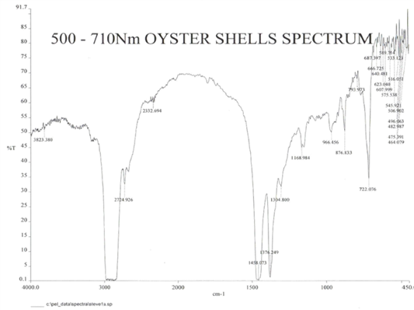

Fig 1a: FTIR Spectrum of the POS

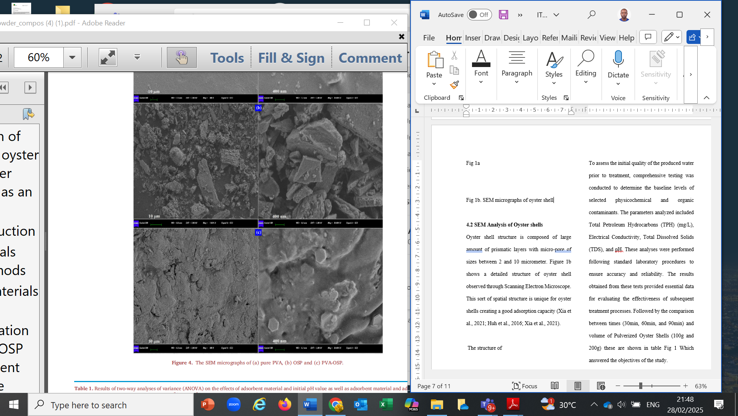
Fig 1b. SEM micrographs of oyster shell (Zhou et al, 2022)
4.2 SEM Analysis of Oyster shells
Oyster shell structure is composed of large amount of prismatic layers with micro-pore sizes between 2 and 10 micrometer. Figure 1b shows a detailed structure of oyster shell observed through

Scanning Electron Microscope. This sort of spatial structure is unique for oyster shells creating a good adsorption capacity (Zhou et al, 2022; Lee, Jang, Ryu, Chae, Lee, and Jeon, 2011).
4.3 Untreated and Treated Produced Water Analyses
To evaluate the quality of the produced water samples prior to treatment with oyster shells, comprehensive testing was conducted to determine the some physico-chemical parameters including the pH level of all the produced water samples pre and post treatment as shown in table 1. These analyses were performed following standard laboratory procedures to ensure accuracy and reliability. The results obtained from the study provided essential data for evaluating the pH of the treated produced in comparison with standard specification for reinjecting treated produced water.
Table 1: Concentration Levels of Selected Parameters
UNTREATED PRODUCED WATER SAMPLES
PARAMETER | C7T | AZ-ST 1 | AZ-ST 2
Conductivity (mS/cm) | 18.6 | 15.8 | 14.7
pH | 6.3 | 6.4 | 6.5

The untreated produced water samples namely; C7T, AZ-ST 1, and AZ-ST 2 were analysed for conductivity and pH parameters. The pH of the untreated produced water samples vary from 6.3 to 6.5, suggestive of slightly acidic conditions and below the permissible limits for reuse and reinjection. Hence, the need for treatment and enhancement of pH.
This procedure was repeated on the produced water samples varying the following parameters:
- Mass of the oyster shell
b. Contact Time (i.e. time taken by the produced water sample to be in contact with the oyster shell column.
The filtrates from these different variations or set-ups were then collected and analysed.
Varying the mass (100g and 200g) and contact time (30, 60 & 90 min), figure 2 presents the pH levels of produced water for three locations (C7T, AZ- ST 1, and AZ- ST 2) using 100g of the adsorbent (POS) over the selected contact time. Initially, the pH of untreated produced water (UPW) samples ranged from 6.3 to 6.5. Starting the treatment process by using a 100g mass of POS and varying the contact time, there was a slight increase in the pH across all three samples indicating a minor shift towards alkalinity. For instance, after 30min, pH values for the filtrates were 6.6 in C7T, 6.7 in AZ-ST1 and 6.7 in AZ-ST2. Similarly, at 60minutes, the pH increased to 6.8, 6.9 and 7.1 respectively. At 90 minutes, the pH stabilizes around neutrality with pH values of 7.2 in CT7, 7.3 in AZ-ST1 and 7.4 in AZ-ST 2 indicating a buffering effect or chemical equilibration over time.
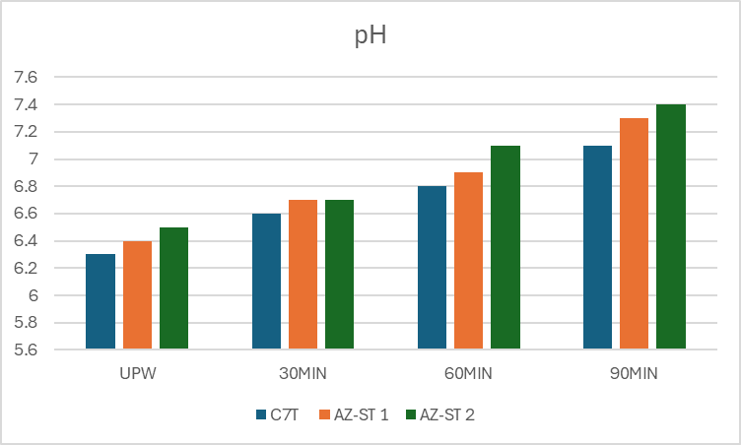

Fig 2: pH increase using 100g of POS
From figure 3, the introduction of 200g of pulverized oyster shell significantly increased the pH of the filtrate samples (C7T, AZ- ST 1, and AZ- ST 2) over time. Initially, the pH values ranged from 6.3 to 6.5, indicating slightly acidic conditions. After 30 minutes, there was a sharp rise to approximately 7.5 – 7.8, suggesting a strong alkalizing effect due to the significant release of calcium carbonate (CaCO₃). The pH of the filtrate steadily increased reaching 8.0–8.2 at after 60 minutes and 8.1–8.4 after 90 minutes. This steady increase indicates dissolution of the oyster shell, ultimately alkalizing the produced water. These results further highlight the potential of oyster shells as sustainable pH regulator in water treatment applications.
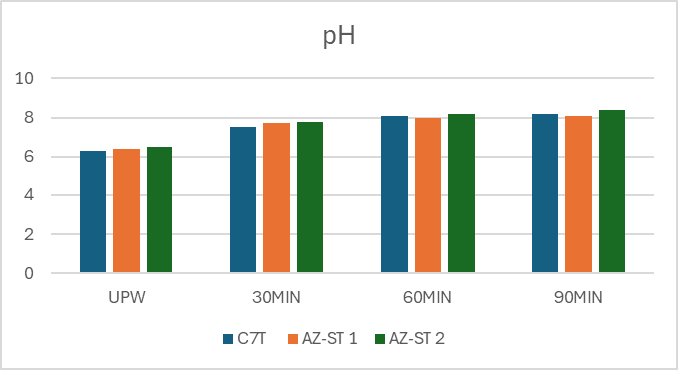
Fig 3: pH increase using 200g of POS
Research by Lee, Kim, Owens, Park, Kim, and Hong, (2018) found that oyster shells are highly effective in neutralizing acidic wastewater due to their high calcium carbonate content. Their study reported that pH levels in acidic wastewater increased from 5.8 to 8.2 within two hours, which aligns with the current study’s findings of a gradual pH increase over time.

5.0 Conclusion
Several approaches have been proposed to provide a strategy for produced water management. Among these strategies, reinjection is the most attractive option as it is considered a more cost-effective alternative rather than discharge. Oil companies have also ensured that produced water is treated to the required specification prior to reinjection to prevent reservoir fouling and plugging issues.
From this current study, the untreated produced water samples had pH levels between 6.3–6.5 (slightly acidic). However, upon treatment with pulverized oyster shells, the pH of the filtrates increased to 7.2-7.5 and 8.2-8.5 after 90 minutes using 100g and 200g pulverized oyster shells respectively. The increase in pH demonstrates the potential of oyster shells as suitable and sustainable pH enhancement bio-agents for modifying the acidity of produced water for reuse and reinjection.
References
Abdel-Shafy, H. I., & Mansour, M. S. M. (2018). Solid waste issue: Sources, composition, disposal, recycling, and valorization. Egyptian Journal of Petroleum, 27(4), 1275–1290. https://doi.org/10.1016/j.ejpe.2018.07.003
Arthur, J. D. (2011). Management of produced water from oil and gas wells. Working Document of the NPC North American Resource Development Study Paper, 2-17.
Baudendistel, T. A., Farrell, J. W., & Kidder, M. F. (2015, July). To Treat or Not To Treat? Optimized Water Decisions Throughout the Produced-Water Management Cycle. In SPE/AAPG/SEG Unconventional Resources Technology Conference (pp. URTEC-2173857). URTEC.
Bellei, P., Torres, I., Solstad, R., & Flores-Colen, I. (2023). Potential Use of Oyster Shell Waste in the Composition of Construction Composites: A Review. Buildings, 13(6), 1546.

Chikwe, T. N., & Ogbole, S. N. (2019). Remediation of simulated oil contaminated sites using shells of clams and oyster-Total petroleum hydrocarbons of simulated oil contaminated sites, before and after remediation. Nigerian Journal of Chemical Research, 24(1), 57-67.
De Gisi, S., Lofrano, G., Grassi, M., & Notarnicola, M. (2016). Characteristics and adsorption capacities of low-cost sorbents for wastewater treatment: A review. Sustainable Materials and Technologies, 9, 10-40.
Fakhru'l-Razi, A., Pendashteh, A., & Abdullah, L. C. (2009). Review of technologies for oil and gas produced water treatment. Journal of Hazardous Materials, 170(1), 530-551.
Gargouri, B., Gargouri, O. D., Gargouri, B., Trabelsi, S. K., Abdelhedi, R., & Bouaziz, M. (2014). Application of electrochemical technology for removing petroleum hydrocarbons from produced water using lead dioxide and boron-doped diamond electrodes. Chemosphere, 117, 309-315.
Graham, E. J. S., Dean, C. A., Yoshida, T. M., Twary, S. N., Teshima, M., Alvarez, M. A., ... & Laur, P. M. (2017). Oil and gas produced water as a growth medium for microalgae cultivation: A review and feasibility analysis. Algal Research, 24, 492-504.
Kang, Y., Wang, W., & Huang, M. J. (2018). Adsorption of heavy metals by oyster shells: A review. Journal of Environmental Science and Health, Part C, 36, 1-13.
Lee, H. H., Kim, S. Y., Owens, V. N., Park, S., Kim, J., & Hong, C. O. (2018). How does oyster shell immobilize cadmium?. Archives of Environmental Contamination and Toxicology, 74, 114-120.
Lin, H., Hou, Q., Luo, Y., Hu, G., Yu, J., & Yu, R. (2022). Reutilization of waste oyster shell as filler for filter for drinking water pretreatment: feasibility and implication. Journal of Environmental Management, 315, 115142.
Kang, S. B., Ko, G.-I., Min, B.-C., Wang, Z., Kim, S. M., & Won, S. W. (2024). Recycling of Waste Oyster Shells for Fluoride Removal from Hydrofluoric Acid Wastewater. Recycling, 9(5), 86. https://doi.org/10.3390/recycling9050086
Mohamed, I. M., Block, G., Abou-Sayed, O., & Abou-Sayed, A. S. (2016, September). Industrial waste injection feasibility in North Dakota. In SPE Annual Technical Conference and Exhibition? (p. D031S043R001). SPE.

Nasiri, M., Jafari, I., & Parniankhoy, B. (2017). Oil and gas produced water management: a review of treatment technologies, challenges, and opportunities. Chemical engineering communications, 204(8), 990-1005.

Salem, F., & Thiemann, T. (2022). Produced water from oil and gas exploration—problems, solutions and opportunities. Journal of Water Resource and Protection, 14(2), 142-185.
Veil, J. A., Puder, M. G., & Elcock, D. (2004). A white paper describing produced water from production of crude oil, natural gas, and coal bed methane. United States Department of Energy.
Wang, H., Zhang, M., Luo, Z., Wang, Y., Wen, X., & Wang, Z. (2024). Effects of calcined oyster shell powder composited with iron salt on the simultaneous removal of phosphorus and arsenic during algal bloom control process. Algal Research, 80, 103546.
Wang, Z., Li, K., & Huang, Y. (2017). Adsorption of organic pollutants by oyster shells: A review. Journal of Environmental Science and Health, Part C, 35, 12-23

Xu, X., Liu, X., Oh, M., & Park, J. (2019). Oyster shell as a low-cost adsorbent for removing heavy metal ions from wastewater. Pol. J. Environ. Stud, 28(4), 2949-2959.
Yousef, R., Qiblawey, H., & El-Naas, M. H. (2020). Adsorption as a process for produced water treatment: A review. Processes, 8(12), 1657.

Zhou, Z., Wang, Y., Sun, S., Wang, Y., & Xu, L. (2022). Preparation of PVA/waste oyster shell powder composite as an efficient adsorbent of heavy metals from wastewater. Heliyon, 8(12).

