Engineering Immunity: Biotechnological Paradigms in Modern Vaccine Development

Abstract
The field of vaccine development has evolved in recent years, with the integration of biotechnology, which has brought about new models for engineering immunity. This paper examines the groundbreaking biotechnological advancements that have changed the course of vaccines in production, design, and efficacy. Modern technologies like mRNA, viral vectors, and synthetic biology have brought about more targeted and personalised immunisation therapies. The molecular mechanisms behind these innovations were reviewed, including antigen presentation, immune modulation, and the optimisation of adjuvants, as well as the challenges of ensuring long-term immunity. Ethical, regulatory, and logistical implications of these biotechnological tools were also considered in terms of pandemic and emerging infectious and chronic conditions. In addition, the promise and possibility of engineering immunity through biotechnology were highlighted, laying the foundation for the next generation of vaccines capable of addressing complex health challenges.
- Introduction
The evolution of vaccine development remains one of the most important advancements in medical science, which has contributed greatly to the control and elimination of different infectious diseases. Traditional methods of vaccine development, which include live-attenuated, inactivated, or subunit approaches, which were pioneered by Edward Jenner in the 18th century, to the global campaigns that nearly eliminated polio in the 20th century, has been in use for a very long time(1).
These methods were effective but then had limitations in terms of turnaround time, specificity, scalability, and adaptability, particularly when targeting new and emerging pathogens that have complex immunological challenges. Rapid advances in vaccine development over the last two decades have led to a big change or shift in the context of vaccine development. This discovery has improved the development of vaccines beyond empirical vaccine design to more precise, rational, and modular approaches. By linking molecular biology, genomics, synthetic biology, and nanotechnology, biotechnology makes use of tools that offer streamlined antigen identification, enhanced immune responses, and optimized vaccine delivery systems(2).
Modern immunization strategies rely on the principle of engineering immunity. Vaccines are now being designed to not only prevent diseases but also to trigger specific types of immune responses that are modified to suit the nature of that pathogen or the needs of the population. This has been made possible by biotechnological innovations such as viral vectors, programmable RNA sequences, nanoparticle delivery systems, and synthetic adjuvants that regulate the immune system specifically. Due to this effect, it’s now possible to design vaccines that focus on certain regions of viruses, to offer broader protection, and develop cancer vaccines that instruct the immune system to take note of specific antigens and even pursue universal vaccines for families for viruses like influenza or coronaviruses(3).
However, challenges like long-term immunity, manufacturing scalability, cold-chain logistics, and equitable global distribution accompany these scientific advancements. Notwithstanding, linking biotechnology into vaccine design brings regulatory and ethical considerations to the forefront, including concerns around safety testing, public perception, and data confidentiality, especially as AI-driven approaches are becoming very common.
This paper aims to investigate the innovative biotechnological tools that are changing the course of vaccine development and to examine their impact on the emerging paradigm of immunity engineering. Through this diverse lens, the paper highlights the possibility of engineered immunity to address both current and future public health challenges in a more effective, equitable, and sustainable manner

- Fundamentals of immunity engineering
The body relies on a complex network of cells and molecules to detect and neutralize foreign invaders, known as the immune system. It’s the body’s primary defense against foreign pathogens. Vaccines make use of the natural defense by introducing antigens or harmless components of pathogens to sensitize the immune system without causing disease. This stimulates both innate and adaptive immune responses, leading to the production of memory cells that give long-lasting protection in case of future exposure. The important mechanisms in vaccine-induced protection include antigen recognition by dendritic cells and B cells, activation of helper and cytotoxic T cells, and the production of antibodies and effector cells. Memory B and T cells play an important role in making sure that there is a rapid and robust response during encounters with pathogens(4).
The traditional method of vaccine development has been known to be effective but faced several challenges, such as extended timelines of development, difficulty in isolating certain pathogens, lower efficiency in immunosuppressed individuals, and the risk of adverse reactions from live attenuated or inactivated vaccines. Furthermore, the traditional approach to vaccine development struggles to keep pace with rapidly changing or mutating viruses for complex pathogens like hiv and malaria. These limitations highlight the need for more precise, adaptive, and technologically advanced solutions, laying the framework for immunity engineering through technological innovation(5).

- Cutting-edge biotechnological advances in vaccine development
- Messenger RNA (mRNA) vaccines
Messenger RNA (mRNA) vaccines represent a radical transformation in immunization technology. It involves delivering a synthetic mRNA encoded with a pathogen-specific antigen into a host cell. Inside the host cell, the mRNA is translated into a protein, which is then presented on the cell surface, triggering an immune response that includes antibody production and T-cell activation. The major advantages of mRNA vaccines are their speed and adaptability in development, as they are not meant to be cultured(6).
The global development of mRNA vaccines during the COVID-19 pandemic, particularly the Pfizer-BioNTech and Moderna vaccines, showcased their safety, efficacy, and scalability. They not only offer high levels of protection but have set new standards for rapid response during public health emergencies. From a future perspective, mRNA vaccines guarantee a broad range of applications, which include vaccines for influenza, Zika, cytomegalovirus, and even cancer immunotherapy. Their versatility, due to their modular design, enables quick updates in responses to viral mutations, making them well-suited for targeting emerging infectious diseases(7).

Mechanism of mRNA vaccines
Step 1. Vaccine injection
The vaccine is administered intramuscularly, and it contains a synthetic mRNA encoding the protein, which is usually encapsulated in a lipid nanoparticle for protection and delivery.
Step 2. Cellular uptake
The lipid nanoparticle comes in contact with the host cell, and the mRNA is delivered into the cytoplasm without getting to the nucleus.
Step 3: Translation of mRNA
The mRNA is translated by the host cell ribosomes into a viral spike protein. This protein is then presented on the surface using a major histocompatibility complex molecule.
Step 4. Immune activation
The foreign protein is recognized by the immune system, and helper T cells and B cells are activated. Neutralizing antibodies are produced by B cells, while T cells are responsible for eliminating infected cells.
Step 5. Immunological memory
The memory B cells and T cells formed enable a rapid and effective response upon future exposure to the virus.
Step 6. Degradation
The mRNA is eventually destroyed by natural cellular processes and does not enter the host genome.
Modern immunization has been revolutionized by messenger RNA (mRNA) vaccines by making use of the body’s machinery to mount an immune defense. Figure 1 shows a simplified overview of the immunological process initiated by mRNA vaccines, from cellular uptake of the mRNA strand to the activation of adaptive immune responses that offer protection against viral pathogens(8).

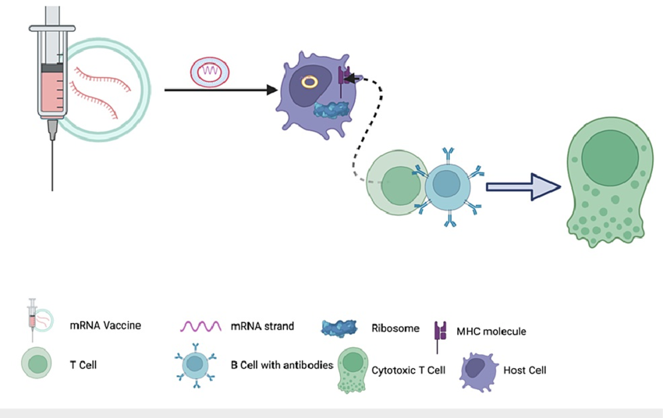
Figure 1: Mechanism of mRNA Vaccine-Induced Immune Response. The mRNA, encapsulated within a lipid nanoparticle, is phagocytosed by dendritic cells for further translation into antigen proteins. These antigens are presented on the dendritic cell's surface using MHC molecules, resulting in the activation of T cells and B cells. Ultimately, this coordinated process generates humoral immunity and cytotoxic cell response (Ankrah et al., 2023). Clinical Analysis and Applications of mRNA Vaccines in Infectious Diseases and Cancer Treatment. Cureus. 15.

- Viral vector vaccines
Viral vector vaccines make use of genetically engineered viruses, especially adenovirus, as vectors to deliver genetic materials that have a target antigen encoded in their cells into host cells. The machinery of the host cell produces the antigen, and an immune response is elicited, which is to the natural infection but does not cause any disease. Examples of successful viral vector vaccines include the AstraZeneca/Oxford and Johnson &Johnson COVID-19 vaccines. These vaccines have shown effectiveness in global immunization efforts, mostly in places where cold-chain requirements for mRNA vaccines posed logistical challenges. Strong cellular and humoral immunity and a relatively stable production process are the advantages offered by these viral vectors(9). However, some populations are immune to some vector virus and which can reduce the efficacy of the vaccine, and also manufacturing complexity and rare side effects, such as blood clotting issues, are major challenges.

Mechanism of viral vector vaccines
Step 1. Insertion of the target gene
A gene from the target virus is inserted into a harmless virus, often known as an adenovirus. The modified virus, known as the vector, is administered through injection. It is delivered into the human cell while carrying the genetic code for the target antigen.
Step 2. Antigen production.
The vector releases the genetic code inside the cell, and the cell's machinery is tasked with the production of the viral protein.
Step3. Immune system activation
The antigen is presented on the cell surface, sensitizing the immune system. T cells and B cells are activated, leading to antibody production and memory cells for long-term protection(10).
Viral vector vaccines use a modified virus to deliver genetic material into host cells, enabling the body to produce specific antigens that trigger a targeted immune response. Figure 2 outlines the step-by-step process by which viral vector vaccines stimulate immunity:

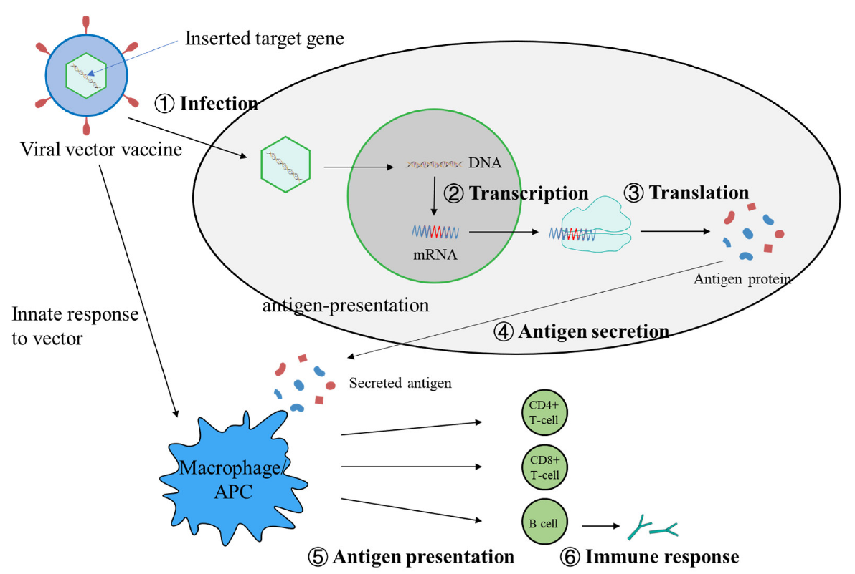

Figure 2. The mechanism of viral vector vaccines induces specific cellular and antibody responses. A modified virus delivers a target gene into host cells, where it is transcribed and translated into antigen proteins. These proteins are either secreted or presented on the cell surface. Antigen-presenting cells then activate T cells and B cells, triggering a full immune response. (Deng et al., 2022) Viral Vector Vaccine Development and Application during the COVID-19 Pandemic. Microorganisms. 10(7):1450. doi: 10.3390/microorganisms10071450

- Synthetic biology and nanotechnology
Synthetic biology plays a major role in modern vaccine design by ensuring that vaccines with genetic circuits, synthetic antigens, and self-assembling protein structures that mimic natural pathogens are developed. This level of advancement allows for more precise and efficient targeting of immune responses and the rapid generation of vaccine candidates tailored to meet specific threats. Nanotechnology enhances the performance of vaccines through the use of nanoparticles that embody and carry antigens or genetic materials. These nanoscale carriers can be engineered to improve scalability, control release kinetics, and target specific immune cells, thereby boosting immunogenicity while reducing adverse effects(11).
The use of nanomaterials, such as lipid nanoparticles used in mRNA vaccines, has helped ensure the efficient delivery and uptake of vaccine components. Additionally, nanocarriers make use of strategies such as co-delivery of antigens and adjuvants, leading the way for more potent and personalized vaccines. Together, these advancements are changing the knowledge of what vaccines can achieve by offering flexible and robust platforms for the next generation of immunization tools(12).
Nanoparticle-based vaccines offer advanced delivery methods that enhance antigen stability, improve immune responses, and allow for targeted delivery. Figure 3 presents several nanoscale platforms used in modern vaccine development.

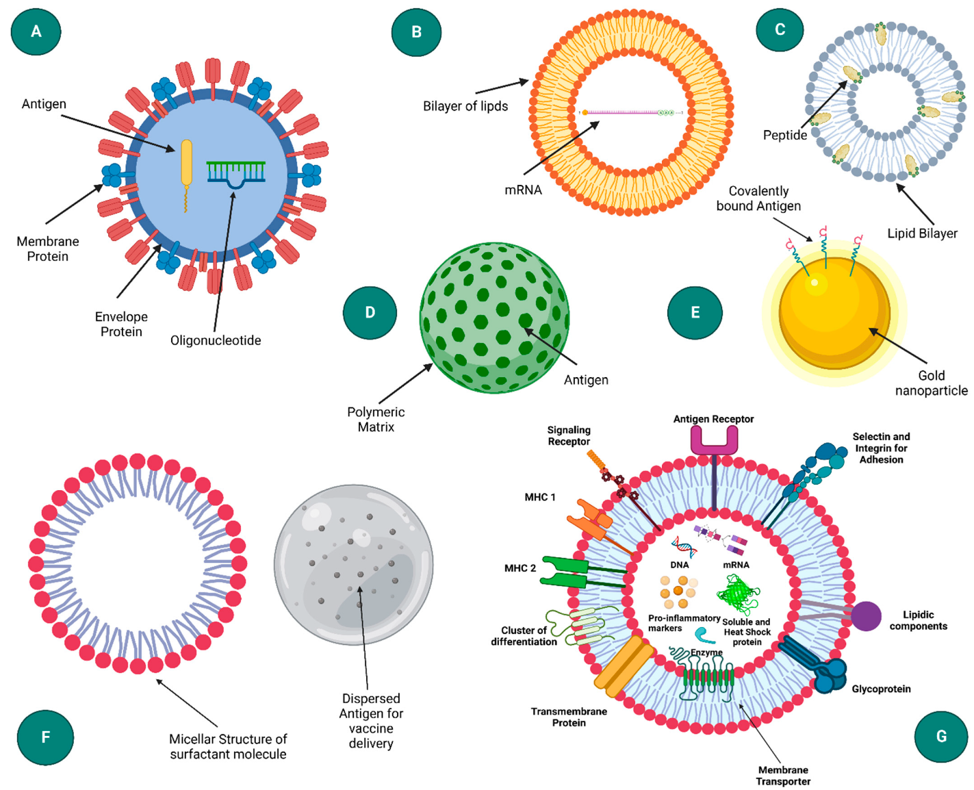
Figure 3: Different Nanoparticle-Based Vaccine Delivery Systems. The image shows different nanoparticle-based vaccine delivery systems. These include (A) virus-like particle, (B) liposome, (C) ISCOM (Immune stimulating complexes), (D) polymeric nanoparticle, (E) Inorganic nanoparticle, (F) emulsion, and (G) exosome (Baruah et al., 2022). Nanoparticle-Based Delivery Systems for Vaccines. Vaccine, 10(11): 1946. https://doi.org/10.3390/vaccines10111946

4. Molecular mechanisms and immunological considerations
- Antigen presentation and immune activation
The potential of the immune system to recognize and respond to foreign antigens is important to ensure that vaccines are effective. Antigen-presenting cells APCs, such as dendritic cells and macrophages, and B cells are central to this process, and they play a critical role in bringing about an immune response. Antigens from pathogens and vaccines are captured by the antigen-presenting cells and are presented on their surface through a major histocompatibility complex molecule(13).
This presentation sensitizes naïve T cells, especially CD4+ and CD8+ T cells, which initiates the broader immune response. The major goal of modern vaccine platforms is to improve antigen presentation to bring about better T cell activation and long-term immunity(14). MRNA vaccines assist endogenous antigen production inside host cells, leading to a more natural and robust MHC class I and II presentation. In addition, viral vectors and nanoparticle-based vaccines can be made to target specific APCs or present antigens into an intracellular environment that favours optimal presentation. These strategies are important for bringing about potent cellular responses, mostly for pathogens where T-cell immunity is important.(15)
- Adjuvants: enhancing immunity
Substances added to vaccines to improve their potency, thereby boosting the body’s immune response to an antigen, are regarded as adjuvants. They improve the magnitude, duration, and quality of the response. Aluminum salt (alum is a traditional adjuvant that has been used for over a decade now to enhance antibody production and boost a stronger humoral response. Adjuvant designs produced in recent times are now more focused on their ability to elicit heterogeneous immune profiles, which include better cellular responses. Modern adjuvants such as AS01 (used in the Shingrix vaccine) and MF59 (used in some influenza vaccines) can activate innate immune sensors like toll-like receptors and inflammasomes(16).
Simultaneously improving antigen uptake, processing, and presentation by antigen-presenting cells and supporting robust T-cell responses. With biotechnology, synthetic and biomimetic adjuvants are now being designed to tailor specific immune outcomes. Biotechnological advances now allow for the design of synthetic or biomimetic adjuvants tailored to specific immune outcomes. To improve efficiency and safety, nanoparticle-based adjuvants can now deliver antigens simultaneously and immune stimulators directly to APCs. Complex diseases like cancer or emerging infections require these modern vaccine adjuvants in their vaccine platforms to ensure a balanced and long-lasting immunity(17).
- Long-term immunity and memory
The major goal of any vaccine is long-lasting immunity without the need for subsequent boosting. Long-lasting immunity relies on the extent to which memory B cells and T cells are produced upon exposure to pathogens. It can be influenced by factors such as antigen type, delivery methods, adjuvant use, and the immune status of the individual. These variables are enhanced with the use of biotechnological strategies. For example, antigen expression can be sustained by the use of modern strategies like mRNA and viral vector vaccines to create stronger cell populations. Even with all these improvements, certain factors hinder the development of vaccines that seek long-term protection across different populations. Challenges like antigenic drift in mutating viruses, immunosenescence, and many others. Resolving these issues will involve innovations in vaccine formulation and a better understanding of immune memory dynamics(18).
5. Global health implications and challenges
A. Pandemics and emerging infectious diseases
The fight against pandemics and emerging infectious diseases has been made possible using biotechnological tools. Its speed and ability to adapt allow for the timely development of vaccines, their testing, and deployment, especially during global health crises. It was seen in the outbreaks of diseases like Ebola, Zika, and, more recently, COVID-19, that these technologies reduced the timeline from antigen identification to vaccine availability. A proper case study is the COVID-19 pandemic, where mRNA-based vaccines were produced within a short time, which was a breakthrough in the history of vaccine development. This was made possible by research that has occurred in years past in fields such as genomics, synthetic biology, and immunology, as well as clinical trial designs and regulatory collaboration. This feat showcased the ability of biotechnology to revolutionize the field of vaccine development, thereby saving millions of lives within a short period(19).
B. Global accessibility and equity
The distribution of vaccines, especially in less developed countries, was revealed during the COVID-19 pandemic. Despite the tremendous success encountered, high-income countries were seen to have secured the majority of early vaccine supplies, while many low-income countries faced significant delays. This inequality highlights the importance of equal distribution of modern vaccines. Global access challenges include affordability, patent protections, manufacturing capacity, and cold-chain logistics. Ethical concerns are being raised because life-saving vaccines remain inaccessible to vulnerable populations due to geopolitical and economic barriers. Systemic inequalities still exist even after initiatives like COVAX sought to address these gaps. Future vaccine strategies must focus on equitable distribution, support regional manufacturing, and include policies that foster open access to technology to achieve true global health security. Only through such inclusive approaches can the full promise of biotechnology be realized for all(19).

6. Regulatory and ethical considerations
Biotechnological vaccines pose new challenges for regulatory bodies because they are tasked with ensuring the safety, efficacy, and ethical compliance of these vaccines within a short time. The regulatory body must ensure that public health needs are met within a short period, with the thorough evaluation of long-term effects, manufacturing, consistency, and quality control. Vaccine development and deployment are key ethical issues. Safety testing should be done during preclinical and clinical trials, and it’s important to shield participants to ensure public confidence when delivering experimental vaccines. When testing vulnerable populations, informed consent remains a foundational principle. It is worth noting that ethical concerns were raised about the transparency, data sharing, and equitable access to research benefits during the COVID-19 pandemic(20).
Another important factor to note is public trust because the success of vaccine development is dependent on public perception of biotechnology-based immunization strategies. Public trust is another critical factor in the success of biotechnology-based immunization programs. Misinformation, vaccine hesitancy, and skepticism about new technologies are challenges that restrict uptake and public health goals. Public awareness strategies that expose scientific transparency, address cultural concerns, and engage communities are important for fostering confidence in these advanced vaccine platforms(21).
7. Future directions and potential
A new era has begun in vaccine development, and subsequently, the future will be marked by personalized and precision-based approaches. The next generation of vaccines will be developed to fit into each individual’s genetic profile, immune system variations, and specific disease risk. In cancer immunotherapy, personalized vaccines are already under investigation; they make use of patient-specific tumor antigens to sensitize the immune system to target malignancies with high precision. This approach offers great hope for not only cancer but also autoimmune conditions and infectious diseases with variable host responses(22).
The impact of biotechnology will be improved by the integration of other cutting-edge technologies like artificial intelligence and machine learning. They can predict antigenic targets, optimize vaccine formulations, and streamline clinical trial design. Additionally, biotechnology goes beyond disease prevention. Chronic diseases like diabetes, cardiovascular disorders, and neurodegenerative conditions are now being treated using biotechnological tools(23). New avenues to utilize the body’s immune system for long-term disease control are being offered by therapeutic vaccines and immunomodulating biologics. With time, as the field grows, interdisciplinary collaboration and the continuous investment in research and development will be useful. Ethical, regulatory, and societal considerations must be put in place to make sure that these tools are distributed equitably, implemented, and accessible worldwide.

8. Conclusion
The landscape of vaccine development has been successfully transformed by biotechnological innovations, offering a wide range of precision, speed, and the ability to adapt in fighting against infectious and non-infectious diseases alike. From the use of mRNA vaccines and viral vector vaccines to the use of synthetic biology and nanotechnology, advanced tools are used by modern vaccines to improve antigen delivery, immune activation, and long-term protection. This groundbreaking feat has not only shortened vaccine production timelines, as seen in the COVID-19 pandemic, but has also enhanced vaccine efficacy, safety, and accessibility of vaccines. By fusing biotechnology into immunization strategies, there a great potential to change the face of global public health, leading to timely responses to emerging pathogens, upholding personalized vaccine approaches, and incorporating real-time data from genomics and artificial intelligence. Interdisciplinary innovation, ethical responsibility, and equitable access remain the future of immunity engineering. Its success will rely on robust regulatory frameworks, public trust, and international collaboration as long as biotechnology becomes more integrated in health care systems. In the long run, the use of advanced vaccine design to engineer immunity is a good tool for global health equity, disease prevention, and improvement of human resilience. By making use of biotechnological tools, the fight against disease becomes seamless, and the future of public health is transformed for generations to come.

REFERENCES
1. Karch CP, Burkhard P. Vaccine technologies: From whole organisms to rationally designed protein assemblies. Biochem Pharmacol. 2016 Nov 15;120:1–14.
2. Ghattas M, Dwivedi G, Lavertu M, Alameh MG. Vaccine Technologies and Platforms for Infectious Diseases: Current Progress, Challenges, and Opportunities. Vaccines (Basel). 2021 Dec 16;9(12):1490.
3. Kennedy RB, Ovsyannikova IG, Lambert ND, Haralambieva IH, Poland GA. The personal touch: strategies toward personalized vaccines and predicting immune responses to them. Expert Rev Vaccines. 2014 May;13(5):657–69.
4. Marshall JS, Warrington R, Watson W, Kim HL. An introduction to immunology and immunopathology. Allergy, Asthma & Clinical Immunology. 2018 Sep 12;14(2):49.
5. Brisse M, Vrba SM, Kirk N, Liang Y, Ly H. Emerging Concepts and Technologies in Vaccine Development. Front Immunol. 2020 Sep 30;11:583077.
6. Demongeot J, Fougère C. mRNA COVID-19 Vaccines—Facts and Hypotheses on Fragmentation and Encapsulation. Vaccines (Basel). 2022 Dec 24;11(1):40.
7. Leong KY, Tham SK, Poh CL. Revolutionizing immunization: a comprehensive review of mRNA vaccine technology and applications. Virology Journal. 2025 Mar 12;22(1):71.
8. Chaudhary N, Weissman D, Whitehead KA. mRNA vaccines for infectious diseases: principles, delivery and clinical translation. Nat Rev Drug Discov. 2021 Nov;20(11):817–38.
9. Travieso T, Li J, Mahesh S, Mello JDFRE, Blasi M. The use of viral vectors in vaccine development. NPJ Vaccines. 2022 Jul 4;7:75.
10. Deng S, Liang H, Chen P, Li Y, Li Z, Fan S, et al. Viral Vector Vaccine Development and Application during the COVID-19 Pandemic. Microorganisms. 2022 Jul 18;10(7):1450.
11. Tan X, Letendre JH, Collins JJ, Wong WW. Synthetic biology in the clinic: engineering vaccines, diagnostics, and therapeutics. Cell. 2021 Feb 18;184(4):881–98.
12. Parvin N, Joo SW, Mandal TK. Enhancing Vaccine Efficacy and Stability: A Review of the Utilization of Nanoparticles in mRNA Vaccines. Biomolecules. 2024 Aug 20;14(8):1036.
13. Ayomide IT, Promise LO, Christopher AA, Okikiola PP, Esther AD, Favour AC, et al. The Impact of Antimicrobial Resistance on Co-INFECTIONS: Management Strategies for HIV, TB and Malaria. International Journal of Pathogen Research. 2024 Nov 29;13(6):117–28.
14. Ndubueze OD, Lawal OP, Fatawu RT, et al. CD4 profile of positive HIV/AIDS patients undergoing antiretroviral drug therapy attending general hospital Alkaleri, Bauchi State, Nigeria. J Hum Virol Retrovirol. 2025;12(1):16‒21. DOI: 10.15406/jhvrv.2025.12.00282

15. Rijkers GT, Weterings N, Obregon-Henao A, Lepolder M, Dutt TS, van Overveld FJ, et al. Antigen Presentation of mRNA-Based and Virus-Vectored SARS-CoV-2 Vaccines. Vaccines (Basel). 2021 Aug 3;9(8):848.
16. Moni SS, Abdelwahab SI, Jabeen A, Elmobark ME, Aqaili D, Ghoal G, et al. Advancements in Vaccine Adjuvants: The Journey from Alum to Nano Formulations. Vaccines (Basel). 2023 Nov 9;11(11):1704.
17. Saleemi MA, Zhang Y, Zhang G. Current Progress in the Science of Novel Adjuvant Nano-Vaccine-Induced Protective Immune Responses. Pathogens. 2024 Jun;13(6):441.
18. Pollard AJ, Bijker EM. A guide to vaccinology: from basic principles to new developments. Nat Rev Immunol. 2021 Feb;21(2):83–100.
19. Hemmeda L, Shabani MM, Kolawole BO, Muhammad SA, Fatima K, Siddiqui A, et al. Third wave of COVID-19 pandemic in Africa: Challenges and recommendations. Annals of Medicine and Surgery [Internet]. 2022 Aug [cited 2025 May 13];80. Available from: https://journals.lww.com/annals-of-medicine-and-surgery/fulltext/2022/08000/third_wave_of_covid_19_pandemic_in_africa_.189.aspx
20. Jalilian H, Amraei M, Javanshir E, Jamebozorgi K, Faraji-Khiavi F. Ethical considerations of the vaccine development process and vaccination: a scoping review. BMC Health Serv Res. 2023 Mar 14;23:255.
21. Lawal O, Oyebamiji HO, Kelenna IJ, Chioma FJ, Oyefeso E, Adeyemi BI, et al. A Review on Usage of Digital Health Literacy to Combat Antibiotic Misuse and Misinformation in Nigeria: Review Article. Journal of Pharma Insights and Research. 2025 Apr 5;3(2):258–69.
22. Lawal OP, Ahmed NK, Ilesanmi TA, Anthony GI, Nwosu SN, Ogungbemiro FO, et al. The Impact of Antimicrobial Resistance on Cancer Treatment: A Systematic Review of Current Evidence and Future Directions. Asian Journal of Research in Medical and Pharmaceutical Sciences. 2024 Sep 16;13(4):9–27.
23. Lawal OP, Taiye AF, Okafor CE, Elechi KW, Orobator ET, Kolapo TJ, et al. The Automated Insulin Delivery System in Nigeria: Advances, Challenges, And Future Prospects in Closed-Loop Insulin Delivery Systems. Journal of Medical Science, Biology, and Chemistry. 2025 Jun 30;2(1):64–74.

