Integrating Real-Time Data and Machine Learning in Predicting Infectious Disease Outbreaks: Enhancing Response Strategies

Abstract
The field of infectious disease prediction and public health response is changing as a result of the integration of real-time data with machine learning (ML). To enhance early diagnosis, forecast illness trajectories, and optimize intervention options, this paper examines how real-time data, from social media and environmental signals to mobility and electronic health records, can be successfully combined with machine learning approaches. The potential of key machine learning models, such as reinforcement learning, deep learning, and supervised learning, to improve forecasting accuracy and facilitate dynamic decision-making is investigated. There is a critical discussion of issues such as algorithmic opacity, privacy problems, data inconsistencies, and a lack of standards. The COVID-19 pandemic case study demonstrates how these tools have already aided in resource allocation and policy planning. A forward-looking outlook on developments in data collecting, explainable AI, and the necessity of global cooperation is presented in the manuscript's conclusion. When taken as a whole, these elements emphasize how crucial it is to combine technology and international collaboration to fortify public health systems and better prepare for future epidemics.

I. Introduction
Global health security is seriously threatened by the growing frequency and intensity of infectious disease outbreaks. The shortcomings of the current surveillance and response systems have been made clear by incidents like the COVID-19 pandemic, the Ebola outbreak in West Africa, and recurrent seasonal influenza outbreaks. Infectious diseases can spread quickly across borders in an era of fast urbanization and globalization, frequently surpassing the capacity of the public health infrastructure to respond adequately. This has highlighted how urgently new, dynamic, predictive methods of managing and detecting outbreaks are needed(1).

In the past, compartmental models like the Susceptible-Infectious-Recovered (SIR) framework and its variations have been a major component of infectious disease modeling. These models, which are based on stochastic or deterministic mathematical equations, have shed important light on the dynamics of disease transmission. They have played a crucial role in forecasting peak infection periods, estimating reproduction numbers (R0), and directing vaccination tactics. These conventional models, however, frequently rely on static characteristics and historical data, which may limit their applicability in situations that move quickly and require flexibility and timeliness(2).

In response to these restrictions, there has been a surge of interest in incorporating real-time data streams and machine learning (ML) approaches into infectious disease forecasting. Real-time data—from hospital admissions and social media trends to mobility and environmental factors—provides a constantly updated picture of the elements influencing disease spread. When used with machine learning algorithms, this data can help computers recognize trends, adjust to new information, and produce more accurate short-term projections than many traditional models. Unlike rule-based techniques, ML models may learn complex, nonlinear relationships between variables, which is especially useful in understanding the multifactorial drivers of illness progression(3).
The combination of real-time data and machine learning signals a paradigm shift in epidemic intelligence. This integrated strategy has the potential to improve outbreak prediction, allow for earlier interventions, and facilitate more effective public health decision-making. As a result, it is becoming increasingly important to investigate how these technologies might be strategically deployed to improve global pandemic preparedness and response methods(4).

2. Objective of the Review
This review's main goal is to investigate how the prediction and control of infectious disease outbreaks can be drastically altered by combining real-time data with machine learning (ML) models. Even though they are fundamental, traditional epidemiological models frequently lack the flexibility needed to process and adjust to quickly changing data streams. On the other hand, machine learning provides a potent substitute for detecting early outbreak indicators, calculating disease trajectories, and improving public health interventions almost instantly when combined with timely and varied data inputs(5).
By concentrating on the collaborative application of machine learning algorithms and real-time data sources, such as electronic health records, mobility data, environmental sensors, and digital platforms, this review seeks to examine the state of data-driven outbreak prediction today. To demonstrate how these technologies can improve situational awareness, facilitate quicker decision-making, and eventually lessen the impact and spread of infectious diseases, we adopt this lens(6). This paper will discuss the main obstacles to putting real-time machine learning-based forecasting systems into place, in addition to highlighting the possible advantages. These include concerns about model interpretability, privacy, integration, data quality, and the necessity of interdisciplinary cooperation. The review offers a fair assessment of infectious disease modeling's prospects in the digital era by stressing both the advantages and disadvantages.

II. The Role of Real-Time Data in Infectious Disease Prediction
The use of real-time data has considerably improved the capabilities of infectious disease forecasting, providing dynamic insights that were previously unavailable through standard surveillance methods. Real-time data is information acquired and processed virtually instantly, allowing for fast analysis and response. This form of data improves disease tracking's temporal resolution, allowing for early detection of outbreaks and response before they escalate. Several sorts of real-time data are crucial for infectious illness prediction(7).

1. Types of Real-Time Data
Epidemiological Data:
Epidemiological data such as confirmed case reports, hospitalizations, test positivity rates, and mortality records provide the foundation of disease surveillance. When regularly updated, these indicators provide a direct estimate of illness burden and allow for trend analysis. Modern electronic health records (EHRs), syndromic surveillance systems, and automated reporting platforms now provide near-real-time access to this data, minimizing reporting delays and improving epidemic monitoring(8).
Mobility Data:
Mobility data from GPS tracking, mobile phone usage, public transportation networks, and app-based services provides insights into how people travel and congregate, and during outbreaks, this data can be used to assess the effectiveness of interventions like lockdowns or to predict where new hotspots may emerge due to population displacement or mass gatherings. Population movement is a central factor in the transmission of infectious diseases, especially those that spread through person-to-person contact(9).
Social Media & Digital Surveillance:
Digital surveillance systems like Google Flu Trends (now defunct) and FluTracker have shown that user-generated content can be used to monitor community health trends, and social media platforms like Twitter and Facebook, as well as search engines like Google, are unconventional but valuable sources of health-related data. Increases in search queries for symptoms, posts about illness, or spikes in specific hashtags can occur before formal case reports(10).
Wearables and IoT Devices:
New avenues for gathering health data have been made possible by the development of wearable technology and the Internet of Things (IoT). Smartwatches, fitness trackers, and smartphone health apps are examples of devices that can continuously monitor physiological indicators like body temperature, heart rate, sleep patterns, and physical activity levels. These biomarkers may be early indicators of infection, offering individualized surveillance capabilities and enhancing population health (11).
2. Importance of Real-Time Data
The speed and precision of real-time data are its main advantages, as they are crucial for monitoring the swift spread of infectious diseases. Real-time inputs can reflect current conditions and developing dangers, unlike retrospective data, which is sometimes delayed by reporting lags. Health authorities can react proactively rather than reactively because of the early recognition of unhealthy patterns made possible by this immediacy(12).
Implementing focused interventions like contact tracking, quarantine regulations, and vaccination programs requires early outbreak detection. More effective resource allocation, such as sending medical staff and supplies to high-risk locations, is made possible by real-time data. By regularly adjusting input parameters, it also aids in the optimization of predictive models, enhancing both short-term projections and long-term scenario planning(13).

Additionally, real-time data encourages legislators and public health authorities to be more situationally aware. Decision-makers can obtain a comprehensive picture of the epidemic landscape by combining data from several sources, including clinical, behavioral, and environmental sources. This multifaceted understanding helps lessen the overall impact of an outbreak, improve planning, and speed up reaction times(14).

3. Examples from Recent Outbreaks
COVID-19:
Mobility data was essential for monitoring compliance with social distancing protocols and forecasting future hotspots during the COVID-19 epidemic. Changes in population mobility patterns in reaction to lockdowns were found using data from sources such as Apple Maps and Google Mobility Reports. Using this data, epidemiologists were able to predict case surges, simulate transmission rates, and assess the real-time effects of public health initiatives(15).
Ebola:
Real-time data collecting methods, like SMS communication networks and mobile-based reporting, were crucial to case monitoring and containment during the West African Ebola outbreak in 2014–2016. Particularly in isolated locations with inadequate healthcare infrastructure, health professionals were able to expedite isolation and contact tracing efforts by using digital platforms to promptly report suspected cases(16).
Zika Virus:
Researchers used geotagged data from social media sites and travel logs to map the geographical distribution of illnesses during the Zika outbreak in the Americas. Authorities were able to focus vector control operations in high-risk areas and provide prompt travel recommendations by using real-time analysis of microcephaly cases and travel-related transmissions(17).
Predicting infectious diseases has been transformed by the incorporation of real-time data from several fields. It improves the flexibility and effectiveness of public health systems by facilitating quicker detection and more accurate responses. Digital data streams will only grow in importance in epidemic intelligence as they become more and more commonplace(18). The main types of real-time data sources are compiled in Table 1, which also shows how each one helps improve outbreak prediction skills in different situations.
Table 1: Key Real-Time Data Sources and Their Applications in Outbreak Prediction
Data Source | Description | Application in Outbreak Prediction
Epidemiological Data(19) | Case reports, hospitalizations, and test results | Trend analysis, burden estimation, and outbreak detection
Mobility Data(20) | GPS tracking, mobile phone data, and transportation records | Forecasting spread, evaluating intervention effectiveness
Social Media & Digital Surveillance(10) | Twitter, Facebook, Google Trends | Early detection signals, monitoring public sentiment
Wearables & IoT Devices(11) | Smartwatches, health apps, fitness trackers | Personalized health monitoring, early infection detection
Environmental & Climate Data(21) | Weather patterns, air quality sensors | Predicting vector-borne disease risk, climate-adaptive planning

III. Machine Learning Techniques in Infectious Disease Prediction

1. Overview of Machine Learning in Epidemiology
In the realm of managing and predicting infectious diseases, machine learning (ML) is becoming a game-changing tool. Traditional epidemiological methods frequently find it difficult to meet the needs for prompt and precise outbreak forecasting as the volume, velocity, and variety of health-related data continue to increase. More flexible and adaptive modeling of disease dynamics is made possible by machine learning (ML), a data-driven alternative that excels at processing complicated, high-dimensional, and frequently non-linear facts(3).
ML models learn directly from data, in contrast to traditional compartmental models like SIR (Susceptible-Infected-Recovered) or SEIR (Susceptible-Exposed-Infected-Recovered), which rely on preset equations and assumptions about transmission parameters. This distinction is crucial because, although mathematical models seek to explain the mechanisms of disease spread using established biological and epidemiological principles, machine learning models concentrate on identifying patterns in data, which allows them to extract insights even in cases where the underlying processes are not entirely understood. Because of this, machine learning has emerged as a potent addition to conventional modeling, particularly in situations involving a lot of data and real-time processing(22).

2. Machine Learning Models Used in Disease Prediction
Supervised Learning
One of the most popular machine learning models for infectious disease modeling is supervised learning. Labeled datasets with known input attributes and outcomes (such as case counts and mortality) are used to train these algorithms. Typical methods include:
Regression Models: Linear and logistic regression are frequently used to evaluate the impact of variables like weather, demographics, and movement on disease transmission(23).
• Models like Decision Trees and Random Forests excel at capturing non-linear correlations and are easy to interpret. Random forests, in particular, are used to rank feature importance and increase prediction resilience via ensemble learning(24).
• Support Vector Machines (SVMs) can forecast outbreak risk using environmental and behavioral factors.
Unsupervised Learning
Unsupervised learning algorithms identify patterns or groupings in data without labeling the outcomes. These are particularly valuable for detecting new clusters of infection or defining illness patterns.
• Clustering approaches (e.g., K-means, DBSCAN) can discover illness hotspots and segment affected regions based on similar epidemiological parameters. For example, unsupervised models might detect areas with similar outbreak trajectories or behavioral reactions(25).
Deep learning
Deep learning models, specifically artificial neural networks (ANNs), convolutional neural networks (CNNs), and recurrent neural networks (RNNs), are intended to represent very complicated interactions in large-scale datasets. These are especially valuable for combining multimodal data sources like clinical reports, time-series epidemiology data, and satellite images.
Long Short-Term Memory (LSTM) networks, a form of RNN, are especially good at time-series forecasting and have been widely employed in predicting daily case counts and hospitalization rates during outbreaks like COVID-19.
• CNNs are used to predict vector-borne diseases like dengue and malaria using geographical and meteorological data(26).
Reinforcement Learning
Reinforcement Learning (RL) trains models to make decisions based on rewarding desired outcomes. Infectious disease researchers have used RL to design adaptive intervention options.
• RL models can optimize policy decisions, including lockout timing, testing procedures, and vaccination regimens. These systems can mimic a variety of events and develop the best response techniques over time(27).

3. Case Studies of Machine Learning Applications
COVID-19 Predictions
During the COVID-19 pandemic, ML models were essential in projecting infection rates, mortality, and healthcare system burden. Time-series models with LSTM and other deep learning architectures were utilized to forecast future case numbers and ICU occupancy. The researchers also used gradient boosting machines (e.g., XGBoost) to identify major risk variables for serious disease using patient data. These concepts influenced hospital readiness and resource distribution in various nations(28).
Epidemic Simulation
ML models have also been combined with simulation environments to predict disease spread in a variety of scenarios. Agent-based modeling, when paired with machine learning, enables the simulation of individual behaviors and interactions, providing granular insights into outbreak dynamics. For instance, predictive models were utilized to simulate how changes in human movement or mask compliance could impact transmission curves in urban versus rural environments(4).
Real-Time Interventions
Artificial intelligence-powered decision-support technologies are increasingly being created to help public health organizations in real time. For example, platforms that combine mobility data, real-time case updates, and machine learning forecasting models have been utilized to offer targeted containment actions. In other areas, AI algorithms were used to drive vaccination priority, identifying high-risk groups and localities where inoculation would have the most impact on transmission reduction(29).
Machine learning has proven to be a versatile and effective technique for infectious illness prediction, particularly when combined with real-time data sources. By allowing for rapid analysis of broad and complicated datasets, machine learning improves the speed, accuracy, and adaptability of public health interventions. As computational techniques advance, their role in epidemic forecasting will become more important, pushing advances in surveillance, intervention planning, and health-system resilience. Figure 1 depicts the primary distinctions between classic epidemiological models and machine learning-based prediction workflows, emphasizing ML's expanding capabilities in exploiting real-time data for adaptive and responsive forecasting(4).
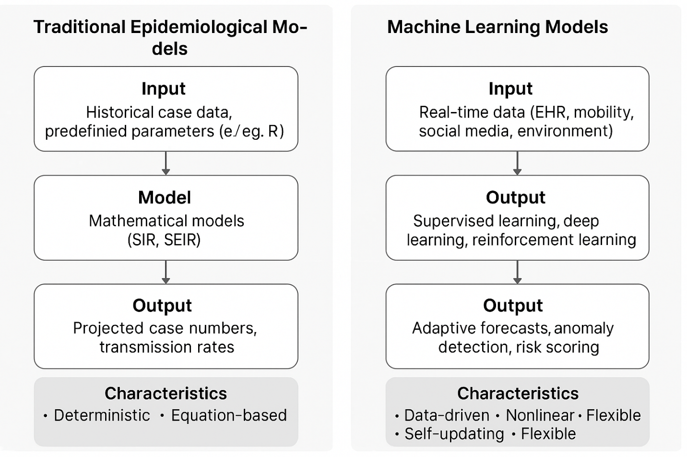
Figure 1: A comparison between machine learning-based prediction workflows and conventional epidemiological models. This image shows how machine learning-based workflows, which use real-time data inputs and adaptive algorithms for epidemic prediction, differ from classic epidemiological modeling approaches, which depend on static parameters and deterministic equations. The main variations in data inputs, modeling techniques, outputs, and general features are depicted in the diagram.

IV. Integration of Real-Time Data and Machine Learning
An important development in the diagnosis and treatment of infectious diseases is the combination of machine learning (ML) and real-time data. ML and real-time data both have individual benefits, but when combined, they provide a potent, synergistic system that can produce outbreak forecasts that are timely, highly accurate, and adaptive. Public health systems can become more proactive in preventing the spread of epidemics due to this convergence, which also improves the capacity to identify and address disease threats more successfully(30).

1. Synergy between Real-Time Data and ML
Dynamic machine learning models rely heavily on real-time data. Up-to-date data, including case counts, mobility patterns, testing rates, and social behavior measures, can be regularly fed into these algorithms to provide forecasts that are always changing. Integrated systems that use real-time data, as opposed to static models, may adjust to new developments nearly instantly, providing decision-makers with insights based on the most recent circumstances(31).
For example, real-time mobility data from sources like Google or Apple is increasingly being combined with machine learning models like gradient boosting machines or long short-term memory (LSTM) networks to create epidemic forecasting dashboards. These platforms can predict ICU demand, hospital bed occupancy, and new case counts several days ahead of time. They facilitate quick and well-informed decision-making by offering both forecasts and visualizations of the potential effects of various intervention scenarios on illness outcomes(32).
Continuous improvement and responsiveness are made possible by the feedback loop this integration creates, in which real-time data informs model predictions, which in turn inform policy, which influences the data. When it comes to diseases that spread quickly or are impacted by shifting environmental and behavioral factors, this collaboration is crucial. The typical process for incorporating real-time data into a machine learning pipeline is depicted in Diagram 1, which highlights the cyclical nature of data collection, modeling, and feedback that facilitates responsive and adaptable public health actions(33).

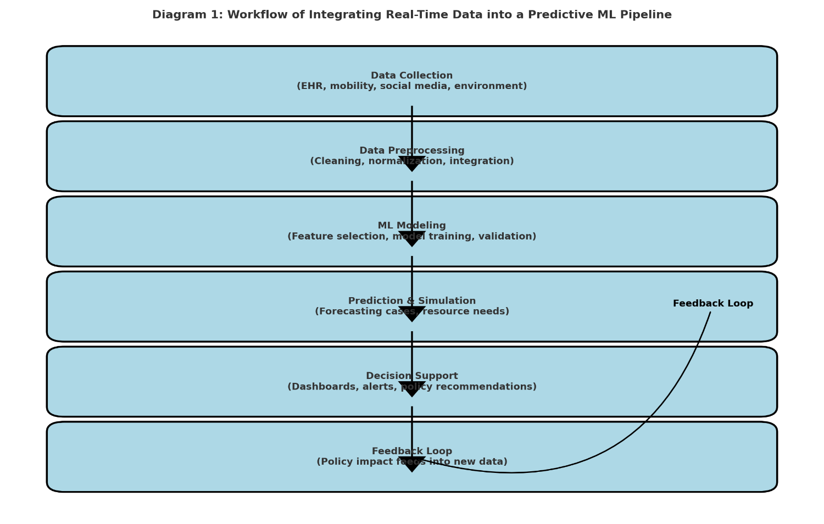
Diagram 1: Process for Including Real-Time Data in a Pipeline for Predictive Machine Learning. The sequential process of incorporating real-time data into a predictive machine learning pipeline for infectious disease forecasting is depicted in this diagram. From data collection and preprocessing to modeling, simulation, decision support, and the feedback loop that guarantees ongoing model improvement based on policy impacts and fresh data, it highlights important phases.

2. Benefits of Integration
The increased precision of epidemic forecasts is among the most important advantages of combining real-time data with machine learning. Models can swiftly adapt to new patterns, identify irregularities, and account for delays in conventional surveillance reporting by consuming high-frequency data. This makes it possible to forecast more precisely, not just nationally but even at the city or district level(4).
The capacity of many machine learning algorithms to train continuously is a second benefit. The models get better over time as more data becomes available, particularly during an ongoing outbreak. When dealing with novel pathogens and when beginning parameters are unknown, this self-updating method is quite helpful. As ML systems gain knowledge of disease-specific transmission traits, their accuracy in short- and long-term predicting increases(3).

There are also significant advantages for the decision-making process. Actionable recommendations, such as where to focus vaccination campaigns, deploy targeted lockdowns, or distribute medical resources, can be given by integrated machine learning systems to public health authorities. By simulating intervention outcomes, these models assist policymakers in evaluating the effects of various policy options before implementation. Reactive decision-making based only on lagged surveillance data is in sharp contrast to this proactive competence(34).

3. Examples of Integrated Systems
COVID-19 Mobility Data Models:
Several governments and research teams used Google Mobility Reports in conjunction with machine learning models during the COVID-19 outbreak to predict new hotspots and calculate the cost on the healthcare system. For instance, to forecast local transmission surges, mobility data was a crucial input in LSTM and random forest models. Decisions regarding the deployment of temporary medical facilities, commercial limitations, and school closures were influenced by these forecasts(35).
BlueDot and HealthMap:
Two innovative platforms that are prime examples of integrated systems for early outbreak detection are BlueDot and HealthMap. BlueDot forecasts the global spread of infectious diseases using natural language processing (NLP), machine learning (ML), and real-time data sources like news articles and airline ticketing data. Interestingly, it was among the first to warn of the COVID-19 outbreak in Wuhan, China. To track and depict disease threats worldwide in almost real time, Boston Children's Hospital created HealthMap, which combines digital media, public health reports, and machine learning algorithms(36).
The COVID-19 Forecast Hub:
The U.S. Centers for Disease Control and Prevention (CDC) coordinates the COVID-19 Forecast Hub, which uses a variety of machine learning techniques to compile estimates from dozens of modeling teams. The platform provides ensemble forecasts that reflect a consensus view of anticipated case and mortality trajectories by combining a variety of model outputs with real-time epidemiology data. Reliability is increased, and state and federal decision-making is supported by this multi-model integration(37).
The field of infectious illness prediction is changing as a result of the combination of machine learning with real-time data. Public health initiatives are becoming more precise, efficient, and timely because of synergistic systems that are always learning and adapting. Global epidemic preparedness and response will depend heavily on the combined use of data availability and machine learning capabilities as they continue to advance(3).

V. Challenges in Integrating Real-Time Data and Machine Learning
Public health surveillance that incorporates real-time data and machine learning (ML) has revolutionary potential, especially when it comes to responding to epidemics. The lack of standardized frameworks, computing difficulties, ethical concerns, and data quality are just a few of the many intricate obstacles that come with implementing such systems at scale. To fully utilize ML in a prompt and efficient pandemic response, these issues must be resolved(38).
1. Data Quality and Consistency
Making sure the data is consistent and of high quality is one of the main obstacles to incorporating real-time data into machine learning models. Inaccuracies, biases, and incompleteness are common problems with real-time data sources, which include everything from social media feeds to electronic health records and mobility tracking. For instance, health records may be delayed or improperly classified, and data gathered via internet platforms may overrepresent particular groups. These discrepancies may result in inaccurate conclusions or unsuccessful public health initiatives(39).
A further challenge is the variation in data quality among sources and geographical areas. While rural or underdeveloped areas frequently lack reliable systems, resulting in data gaps, urban locations with advanced data infrastructure may generate more timely and detailed information. Equitable health solutions may be undermined by ML models that perform well in some domains but badly in others as a result of this discrepancy.
Systemic discrepancies also plague public health reporting. Definitions, timelines, and reporting procedures for cases, hospitalizations, and deaths may differ throughout jurisdictions. It takes a lot of preprocessing, data cleaning, and normalization work to align these disparate datasets into a logical input for machine learning models; these processes are error-prone and resource-intensive(40).

2. Ethical and Privacy Concerns
Real-time epidemic surveillance raises serious ethical questions, particularly when private information is at stake. Online activity, medical records, and mobility data can all provide personal information about a person. Such data poses serious privacy hazards even if it can offer important insights into the spread of disease.
Frameworks for data exchange that are both ethical and legal are still developing. Strict guidelines on the collection, processing, and sharing of data are enforced by laws like the General Data Protection Regulation (GDPR) in Europe. Public health officials may try to loosen some of these regulations during emergencies to respond more quickly, but doing so puts individual rights and public safety at odds(41).

It's a constant struggle to protect individual privacy while preserving openness about data usage. Effective data anonymization and strong access constraints must be included in systems while preserving the ability to conduct insightful analysis. To prevent abuse and negative public reaction, the delicate balance between privacy, which safeguards civil liberties, and transparency, which fosters public trust, must be carefully managed.
3. Computational and Algorithmic Limitations
It takes a significant amount of computer equipment to handle the enormous amount of real-time data produced during an epidemic. Data overload can result from the continuous flow of information, making it challenging to separate important signals from irrelevant ones. When data streams contain a diverse range of forms and modalities, including text, pictures, and time-series data, this difficulty is exacerbated.
Interpretability of the model is another important problem. Many of the most advanced machine learning models, especially deep learning systems, operate as "black boxes"—they make predictions without offering precise justifications. The inability to comprehend how a model came to be hinders the trust and usefulness of public health experts and policymakers. Models that are clear and easy to understand are necessary for public accountability and efficient decision-making(42).

There is also the issue of generalizability. Machine learning algorithms that were trained using data from a particular outbreak or geographic area might not be able to adjust well to new diseases or various situations. Geographical location, population dynamics, and the capability of the health system are just a few of the variables that might affect how pathogens behave. For models to be effective in dynamic and uncertain contexts, they must be adaptable and fast to recalibrate(41).

4. Lack of Standardization
The absence of common data formats and integration protocols is a major obstacle to the smooth integration of real-time data and machine learning. Combining data from several sources becomes a disjointed and error-prone procedure in the absence of standard frameworks. Delays in data harmonization can lead to slower reaction times, which is especially troublesome when handling urgent public health emergencies(43).
There is also a lack of interoperability amongst academic institutions, technology firms, and public health organizations. Effective cooperation may be hampered by each entity's use of proprietary systems and data standards. Deploying real-time machine learning solutions across various stakeholders and geographical locations would be greatly improved by the establishment of universal standards for data collection, structuring, and exchange(44).

In conclusion, there are still several important obstacles to overcome, even though real-time data and machine learning present previously unheard-of possibilities for epidemic monitoring and intervention. To guarantee that these technologies can be used in future public health initiatives in an efficient, equitable, and responsible manner, it is imperative to address concerns about data quality, ethics, computational limitations, and standards. An outline of the main obstacles to incorporating machine learning and real-time data in infectious disease modeling is given in Table 2, along with recommendations for ways to overcome each one.

Table 2: Key Challenges in Integrating Real-Time Data and Machine Learning with Proposed Mitigation Strategies
Challenge | Description | Mitigation Strategy
Data Quality & Consistency | Incomplete, biased, or inaccurate data | Data validation, cross-referencing multiple sources
Ethical & Privacy Concerns | Risk of personal data exposure | Anonymization, transparent data governance
Computational & Algorithmic Limitations | Model interpretability, scalability issues | Use of explainable AI, cloud-based infrastructure
Lack of Standardization | No universal data formats or protocols | Adoption of open data standards, interoperability frameworks

VI. Enhancing Response Strategies with Real-Time Data and Machine Learning
The way public health systems prepare for, handle, and lessen the effects of infectious disease epidemics is changing as a result of real-time data integration with machine learning (ML). By offering immediate, data-driven insights that facilitate quicker decision-making and more focused actions, these technologies facilitate the transition from reactive to proactive measures(45).
1. Early Warning and Prediction
Predicting the spread of disease and detecting outbreaks early are two of the most revolutionary uses of real-time data and machine learning. Through the integration of several data sources, including mobility data, epidemiological reports, environmental conditions, and even social media activity, machine learning models can identify new patterns that indicate the beginning of an outbreak. By identifying hotspots before case numbers increase, these predictive tools enable health authorities to react more swiftly and efficiently(46).

Based on population density, transport patterns, and healthcare facilities, geospatial machine learning models can predict the probable course of disease propagation. Decisions on the locations of testing, surveillance, and early containment measures are influenced by these insights. Predictive analytics, for example, has been used to forecast future case counts and geographic spread days or weeks ahead of time during outbreaks of diseases like influenza or dengue, enabling more flexible public health responses(47).
2. Optimizing Intervention Strategies
ML-driven solutions provide the real-time optimization of intervention options in addition to early detection. The effects of different policy choices, such as targeted lockdowns, mask requirements, or travel restrictions, can be simulated by governments and health organizations under various epidemiological scenarios. Policymakers can use these simulations to evaluate trade-offs and put policies into place that limit negative health effects while preventing needless economic disruption.
Allocating resources also heavily relies on real-time forecasts. By predicting hospital admissions, intensive care unit (ICU) demand, and regional healthcare requirements, machine learning (ML) models can direct the allocation of vital supplies like vaccinations, ventilators, and personal protective equipment (PPE). Authorities can reduce system overload and reaction latency by pre-positioning workers and resources in high-burden locations(48).
3. Case Study: COVID-19 Response
An excellent example of how machine learning and real-time data can improve reaction tactics was given by the global COVID-19 epidemic. Predictive models played a crucial role in identifying high-risk groups and guiding vaccination distribution strategies throughout the pandemic. ML tools assisted in prioritizing frontline workers, elderly people, and communities with high transmission rates by examining demographic, comorbidities, and location-based risk factors.
Real-time dashboards that combine data from worldwide sources to present up-to-date information on case counts, hospitalizations, and resource availability include those created by Johns Hopkins University and national public health organizations. These dashboards allowed governments to make near-real-time strategy adjustments and proved essential to public communication and policy direction(49). Machine learning-based predictions can help predict outbreaks while taking into account uncertainties in real-world data, as seen in Graph 1, which compares COVID-19 case patterns predicted by ML models with actual reported cases.

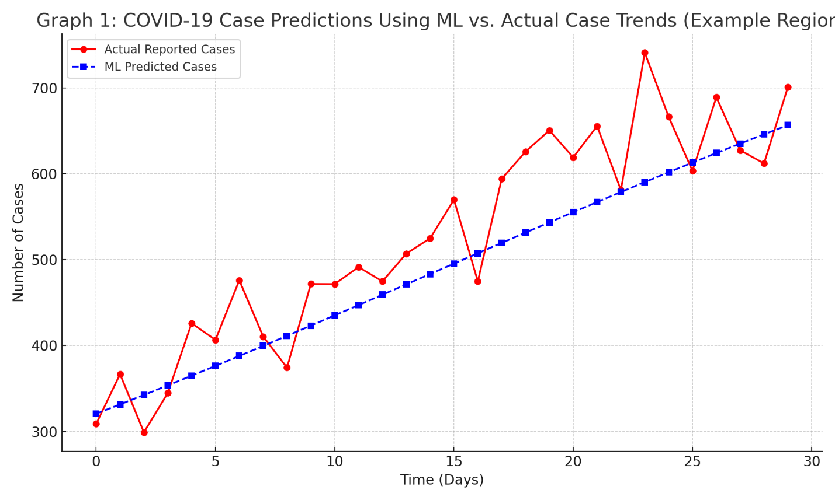
Graph 1: Machine Learning-Based COVID-19 Case Predictions versus Real Case Trends in a Sample Area. This graph contrasts actual reported case trends over a 30-day period in a sample region with COVID-19 case forecasts produced by a machine learning algorithm. While real-world factors cause volatility in actual case data, the ML model exhibits a smoother forecast trajectory. The graph illustrates ML forecasting's responsiveness and limitations in dynamic outbreak scenarios.
In conclusion, ML and real-time data are essential resources for enhancing epidemic response and readiness. These tools improve the speed and accuracy of public health initiatives, from predicting outbreaks to directing budget allocation and improving therapies. Better handling of upcoming health emergencies will depend on their ongoing growth and integration.
VII. Future Directions and Research Opportunities
The future of infectious disease surveillance and response looks bright as long as real-time data and machine learning (ML) continue to advance. But this advancement needs to be complemented by developments in data gathering, algorithm creation, international cooperation, and thoughtful evaluation of moral dilemmas.

1. Advancements in Data Collection
Disease modeling is expected to change as a result of new real-time data sources. Rapidly gathered genetic sequencing data during outbreaks can improve early diagnosis and response by exposing patterns of pathogen evolution and dissemination. Furthermore, wearable technology and mobile health apps provide constant streams of behavioral and physiological data, facilitating early symptom detection and individualized monitoring.
It will also be more crucial than ever to incorporate climate and environmental data into machine learning models. Patterns of rainfall, temperature, and humidity have a big impact on how vector-borne illnesses like dengue and malaria spread. By including these factors, predictive models will be more accurate and climate-adaptive health planning will be supported(41,50).
2. Improved Machine Learning Algorithms
It is crucial to create ML models that are more precise and comprehensible. Future studies will probably concentrate on hybrid models that improve prediction quality and transparency by fusing data-driven methodologies with domain expertise. Public health choices based on machine learning outputs will be easier to comprehend and defend with the use of explainable AI tools.
The use of multi-scale modeling is another important development. More cogent and coordinated responses will be possible with machine learning (ML) systems that can concurrently assess and produce insights at the local, national, and international levels, particularly during pandemics that spread quickly across borders(51).
3. Global Collaboration and Data Sharing
Improving the forecasting of epidemics requires international cooperation. Standardized reporting systems and open-access databases are examples of shared platforms for real-time data transmission that will assist test models across a range of populations and environments and enable prompt responses. Global initiatives can guarantee that even low-resource nations benefit from cutting-edge technologies, avoid duplication of effort, and promote trust(52).
4. Challenges for the Future
Individual privacy protection will become more difficult as data gets more linked. To guarantee responsible use, transparent data governance systems and moral supervision procedures will be crucial. The use of predictive models in policy decisions also presents ethical challenges for public health authorities, especially when those models have an impact on behavioral limitations or resource distribution.
In order to create robust, flexible public health systems that can efficiently and fairly handle new risks, it will be essential to combine technology, data, and international collaboration(53).

Conclusion
This review emphasizes how important machine learning and real-time data are to improving the precision, adaptability, and responsiveness of infectious disease forecasting. Public health organizations can transition from reactive to proactive, focused interventions by combining adaptive algorithms with continually updated data sources. During significant outbreaks like COVID-19, these tools have already proven useful in facilitating resource management and decision-making in real time. To fully realize their promise, though, enduring issues like data privacy, algorithmic openness, and international standardization must be resolved.Going forward, enhancing global health security will require consistent predictive modeling research and innovation in addition to robust international data-sharing mechanisms. Even low-resource areas will profit from these advancements if investments are made in collaborative infrastructure and interoperable technologies. In the end, a future where epidemics may be predicted and controlled more successfully than ever before is promised by the combination of digital technology and epidemiological knowledge.

REFERENCES

1. Zhang XX, Jin YZ, Lu YH, Huang LL, Wu CX, Lv S, et al. Infectious disease control: from health security strengthening to health systems improvement at the global level. Global Health Research and Policy. 2023 Sep 5;8(1):38.
2. Grassly NC, Fraser C. Mathematical models of infectious disease transmission. Nat Rev Microbiol. 2008;6(6):477–87.
3. Al Meslamani AZ, Sobrino I, de la Fuente J. Machine learning in infectious diseases: potential applications and limitations. Ann Med. 56(1):2362869.
4. Zhao AP, Li S, Cao Z, Hu PJH, Wang J, Xiang Y, et al. AI for science: Predicting infectious diseases. Journal of Safety Science and Resilience. 2024 Jun 1;5(2):130–46.
5. Zhang X, Zhang D, Zhang X, Zhang X. Artificial intelligence applications in the diagnosis and treatment of bacterial infections. Front Microbiol [Internet]. 2024 Aug 6 [cited 2025 May 13];15. Available from: https://www.frontiersin.org/journals/microbiology/articles/10.3389/fmicb.2024.1449844/full
6. Lawal OP, Egwuatu EC, Akanbi KO, Orobator ET, Eweje OZ, Omotayo EO, et al. Fighting Resistance With Data: Leveraging Digital Surveillance to Address Antibiotic Misuse in Nigeria. Path of Science. 2025 Mar 31;11(3):1009–17.
7. Desai AN, Kraemer MUG, Bhatia S, Cori A, Nouvellet P, Herringer M, et al. Real-time Epidemic Forecasting: Challenges and Opportunities. Health Secur. 2019 Aug 1;17(4):268–75.
8. Shen Y, Liu Y, Krafft T, Wang Q. Progress and challenges in infectious disease surveillance and early warning. Medicine Plus. 2025 Mar 1;2(1):100071.
9. Okmi M, Ang TF, Mohd Zaki MF, Ku CS, Phan KY, Wahyudi I, et al. Mobile Phone Network Data in the COVID-19 era: A systematic review of applications, socioeconomic factors affecting compliance to non-pharmaceutical interventions, privacy implications, and post-pandemic economic recovery strategies. PLoS One. 2025 Apr 29;20(4):e0322520.
10. Lawal O, Oyebamiji HO, Kelenna IJ, Chioma FJ, Oyefeso E, Adeyemi BI, et al. A Review on Usage of Digital Health Literacy to Combat Antibiotic Misuse and Misinformation in Nigeria: Review Article. Journal of Pharma Insights and Research. 2025 Apr 5;3(2):258–69.
11. Jafleh EA, Alnaqbi FA, Almaeeni HA, Faqeeh S, Alzaabi MA, Al Zaman K. The Role of Wearable Devices in Chronic Disease Monitoring and Patient Care: A Comprehensive Review. Cureus. 16(9):e68921.
12. Kostkova P, Saigí-Rubió F, Eguia H, Borbolla D, Verschuuren M, Hamilton C, et al. Data and Digital Solutions to Support Surveillance Strategies in the Context of the COVID-19 Pandemic. Front Digit Health. 2021 Aug 6;3:707902.
13. Osei E, Mashamba-Thompson TP. Mobile health applications for disease screening and treatment support in low- and middle-income countries: A narrative review. Heliyon. 2021 Mar 1;7(3):e06639.
14. Kruk ME, Gage AD, Arsenault C, Jordan K, Leslie HH, Roder-DeWan S, et al. High-quality health systems in the Sustainable Development Goals era: time for a revolution. Lancet Glob Health. 2018;6:e1196–252.
15. Hemmeda L, Shabani MM, Kolawole BO, Muhammad SA, Fatima K, Siddiqui A, et al. Third wave of COVID-19 pandemic in Africa: Challenges and recommendations. Annals of Medicine and Surgery [Internet]. 2022 Aug [cited 2025 May 13];80. Available from: https://journals.lww.com/annals-of-medicine-and-surgery/fulltext/2022/08000/third_wave_of_covid_19_pandemic_in_africa_.189.aspx
16. Erikson SL. Cell Phones ≠ Self and Other Problems with Big Data Detection and Containment during Epidemics. Med Anthropol Q. 2018 Sep;32(3):315–39.
17. Grubaugh ND, Saraf S, Gangavarapu K, Watts A, Tan AL, Oidtman RJ, et al. Travel Surveillance and Genomics Uncover a Hidden Zika Outbreak during the Waning Epidemic. Cell. 2019 Aug 22;178(5):1057-1071.e11.
18. Meckawy R, Stuckler D, Mehta A, Al-Ahdal T, Doebbeling BN. Effectiveness of early warning systems in the detection of infectious disease outbreaks: a systematic review. BMC Public Health. 2022 Nov 29;22:2216.
19. Hernandez JBR, Kim PY. Epidemiology, Morbidity, And Mortality. In: StatPearls [Internet]. Treasure Island (FL): StatPearls Publishing; 2025 [cited 2025 May 13]. Available from: http://www.ncbi.nlm.nih.gov/books/NBK547668/
20. Mueller SA, Paltra S, Rehmann J, Ewert R, Nagel K. Comparing GPS and cell-based mobile phone data to identify activity participation during the COVID-19 pandemic. EPJ Data Sci. 2024 Dec;13(1):1–23.
21. Caminade C, McIntyre KM, Jones AE. Impact of recent and future climate change on vector‐borne diseases. Ann N Y Acad Sci. 2019 Jan;1436(1):157–73.
22. Sturniolo S, Waites W, Colbourn T, Manheim D, Panovska-Griffiths J. Testing, tracing and isolation in compartmental models. PLoS Computational Biology. 2021 Mar 4;17(3):e1008633.
23. Castro HM, Ferreira JC. Linear and logistic regression models: when to use and how to interpret them? J Bras Pneumol. 48(6):e20220439.
24. Yaqoob A, Verma NK, Mir MA, Tejani GG, Eisa NHB, Mamoun Hussien Osman H, et al. SGA-Driven feature selection and random forest classification for enhanced breast cancer diagnosis: A comparative study. Sci Rep. 2025 Mar 30;15(1):10944.
25. Chaudhry M, Shafi I, Mahnoor M, Vargas DLR, Thompson EB, Ashraf I. A Systematic Literature Review on Identifying Patterns Using Unsupervised Clustering Algorithms: A Data Mining Perspective. Symmetry. 2023 Sep;15(9):1679.
26. Taye MM. Understanding of Machine Learning with Deep Learning: Architectures, Workflow, Applications and Future Directions. Computers. 2023 May;12(5):91.
27. Reinforcement learning for healthcare operations management: methodological framework, recent developments, and future research directions | Health Care Management Science [Internet]. [cited 2025 May 13]. Available from: https://link.springer.com/article/10.1007/s10729-025-09699-6
28. Alassafi MO, Jarrah M, Alotaibi R. Time series predicting of COVID-19 based on deep learning. Neurocomputing (Amst). 2022 Jan 11;468:335–44.
29. Maleki Varnosfaderani S, Forouzanfar M. The Role of AI in Hospitals and Clinics: Transforming Healthcare in the 21st Century. Bioengineering. 2024 Apr;11(4):337.
30. Hudu SA, Alshrari AS, Abu-Shoura EJI, Osman A, Jimoh AO. A Critical Review of the Prospect of Integrating Artificial Intelligence in Infectious Disease Diagnosis and Prognosis. Interdiscip Perspect Infect Dis. 2025 Mar 6;2025:6816002.
31. Woodman RJ, Mangoni AA. A comprehensive review of machine learning algorithms and their application in geriatric medicine: present and future. Aging Clin Exp Res. 2023;35(11):2363–97.
32. Liu J, Zhang Z, Fan X, Zhang Y, Wang J, Zhou K, et al. Power system load forecasting using mobility optimization and multi-task learning in COVID-19. Appl Energy. 2022 Mar 15;310:118303.
33. Wynn DC, Maier AM. Feedback systems in the design and development process. Res Eng Design. 2022 Jul 1;33(3):273–306.
34. Magazzino C, Mele M, Coccia M. A machine learning algorithm to analyse the effects of vaccination on COVID-19 mortality. Epidemiol Infect. 2022 Sep 12;150:e168.
35. Deng Y, Lin H, He D, Zhao Y. Trending on the use of Google mobility data in COVID-19 mathematical models. Advances in Continuous and Discrete Models. 2024 Jul 5;2024(1):21.
36. Rahman MM, Khatun F, Uzzaman A, Sami SI, Bhuiyan MAA, Kiong TS. A Comprehensive Study of Artificial Intelligence and Machine Learning Approaches in Confronting the Coronavirus (COVID-19) Pandemic. Int J Health Serv. 2021 Oct 1;51(4):446–61.
37. Cramer EY, Huang Y, Wang Y, Ray EL, Cornell M, Bracher J, et al. The United States COVID-19 Forecast Hub dataset. Sci Data. 2022 Aug 1;9:462.
38. Mennella C, Maniscalco U, De Pietro G, Esposito M. Ethical and regulatory challenges of AI technologies in healthcare: A narrative review. Heliyon. 2024 Feb 29;10(4):e26297.
39. Cross JL, Choma MA, Onofrey JA. Bias in medical AI: Implications for clinical decision-making. PLOS Digit Health. 2024 Nov 7;3(11):e0000651.
40. Jiang J (Xuefeng), Cram P, Qi K, Bai G. Challenges and dynamics of public health reporting and data exchange during COVID-19: insights from US hospitals. Health Aff Sch. 2024 Jan 9;2(1):qxad080.
41. Zhao IY, Ma YX, Yu MWC, Liu J, Dong WN, Pang Q, et al. Ethics, Integrity, and Retributions of Digital Detection Surveillance Systems for Infectious Diseases: Systematic Literature Review. J Med Internet Res. 2021 Oct 20;23(10):e32328.
42. Arnold M, Goldschmitt M, Rigotti T. Dealing with information overload: a comprehensive review. Front Psychol. 2023 Jun 21;14:1122200.
43. Torab-Miandoab A, Samad-Soltani T, Jodati A, Rezaei-Hachesu P. Interoperability of heterogeneous health information systems: a systematic literature review. BMC Med Inform Decis Mak. 2023 Jan 24;23:18.
44. Walker DM, Tarver WL, Jonnalagadda P, Ranbom L, Ford EW, Rahurkar S. Perspectives on Challenges and Opportunities for Interoperability: Findings From Key Informant Interviews With Stakeholders in Ohio. JMIR Med Inform. 2023 Feb 24;11:e43848.
45. Hudu SA, Alshrari AS, Abu-Shoura EJI, Osman A, Jimoh AO. A Critical Review of the Prospect of Integrating Artificial Intelligence in Infectious Disease Diagnosis and Prognosis. Interdiscip Perspect Infect Dis. 2025 Mar 6;2025:6816002.
46. Aiello AE, Renson A, Zivich P. Social media- and internet-based disease surveillance for public health. Annu Rev Public Health. 2020 Apr 2;41:101–18.
47. Pezanowski S, Koua EL, Okeibunor JC, Gueye AS. Predictors of disease outbreaks at continental-scale in the African region: Insights and predictions with geospatial artificial intelligence using earth observations and routine disease surveillance data. Digit Health. 2024 Nov 5;10:20552076241278939.
48. Heidari A, Jafari Navimipour N, Unal M, Toumaj S. Machine learning applications for COVID-19 outbreak management. Neural Comput & Applic. 2022 Sep 1;34(18):15313–48.
49. Rasmussen-Torvik LJ. Recognizing the importance of COVID-19 data wrangling. J Clin Invest. 132(19):e164375.
50. Yu LJ, Ji PS, Ren X, Wang YH, Lv CL, Geng MJ, et al. Inter-city movement pattern of notifiable infectious diseases in China: a social network analysis. The Lancet Regional Health - Western Pacific. 2025 Jan 1;54:101261.
51. Meng X, Hua Q, Xu R, Shi Y, Zhang Y, Yan M, et al. A prospective study on the cardiorespiratory effects of air pollution among residents of the Tibetan Plateau. Hygiene and Environmental Health Advances. 2024 Dec 1;12:100115.
52. Desai AN, Kraemer MUG, Bhatia S, Cori A, Nouvellet P, Herringer M, et al. Real-time Epidemic Forecasting: Challenges and Opportunities. Health Secur. 2019 Aug 1;17(4):268–75.
53. Mühlhoff R. Predictive privacy: towards an applied ethics of data analytics. Ethics Inf Technol. 2021 Dec 1;23(4):675–90.

