In-vitro regeneration potential of Tinospora cordifolia (Wild.) Miers using nodal explant grown in Murashige and Skoog (MS) medium

ABSTRACT
This study aims to analyze the effects of various shoot-promoting growth hormones on the micropropagation of above-ground plant parts of Tinospora cordifolia. Tinospora cordifolia is a valuable medicinal plant with diverse therapeutic properties, including immunomodulatory, anti-inflammatory, and antioxidant activities. The plant's extracts are in high demand for pharmaceutical applications, and micropropagation can ensure a consistent supply of high-quality plant material. The experiment will be conducted applying Murashige and Skoog (MS) media which is augmented with varying concentrations of: (BAP), Thidiazuron (TDZ) and Kinetin. Various parameters are recorded throughout the experiment, including the number of days to primordia initiation, shoot count, node count, shoot length, leaf count, and intensity of callus formation. Among the three hormones tested, BAP and kinetin exhibited a more favorable response compared to the other hormone in MS media.

Keywords: MS (Murashige and Skoog) medium, Tinospora cordifolia, 6-Benzylaminopurine, TDZ, In-vitro, Kinetin
Introduction
Tinospora cordifolia (Willd.) is a significant medicinal plant species, globally utilized for different therapeutic purposes, especially in India, as noted by Handique (2014). Tinospora cordifolia is a significant medicinal climber which belongs to the family of Menispermaceae, renowned for its medicinal properties in the Ayurved, particularly within the system of drug Ayurvedic, as highlighted by Panwar et al. (2018). Tinospora cordifolia is a deciduous, large climbing shrub found throughout India, up to at an altitude of 300 meters particularly in tropical regions. The stem is succulent, long, and fleshy, with a climbing habit. Adventitious roots come out from the branches. Bark is mainly creamy white to grey in colour. Leaves are exstipulate, simple, alternate and petiolate, measuring in length approx. 15 cm, with a heart-shaped, half-round and partially twisted morphology (Mittal et al., 2014). In the Ayurvedic system, Tinospora cordifolia is utilized as a "Rasayana" to improve and boost immunity and resistance against infections (Shivakumar et al., 2014). It is extensively employed in Ayurvedic medicine due to its diverse therapeutic properties, including anti-diabetic, anti-periodic, anti-allergic, anti-spasmodic, and anti-inflammatory effects, as well as its general tonic benefits. Tinospora cordifolia is utilized in the production of pharmaceutical and nutraceutical products due to its diverse array of bioactive compounds, including secondary metabolites such as berberine, protoberberine, and palmatine. These compounds are used in the formulation of antidiabetic products (Preety et al., 2017). Various secondary metabolites are produced in response to elicitation by compounds such as salicylic acid (SA), methyl jasmonate (MeJA) and jasmonic acid (JA) (Singh and Dwivedi, 2018). Tinospora cordifolia is currently an exhausted plant species, listed among the emphasized medicinal plants by the National Medicinal Plants Board (NMPB), Government of India. The micropropagation technique is very important for its mass propagation and also for conservation (Singh et al., 2009). This study investigated the micropropagation of Tinospora cordifolia using nodal cuttings, with various shoot growth-promoting hormones added in MS medium.

MATERIALS AND METHODS
Preparation of media: For the in-vitro cultivation of Tinospora cordifolia in controlled laboratory situations, MS medium augmented with varying growth regulators concentrations were utilized. MS medium comparatively have a higher concentration of nitrogen as ammonia. Stock solutions were prepared for the nutrient media using double-distilled water (DDW) and analytical-grade chemicals (Himedia Laboratories, India) to ensure greater accuracy and convenience.
Different types of growth regulators were used viz KN, BAP and TDZ. Growth regulator stock solutions were prepared and utilized as required for the specific medium. Conventional approach was followed to prepare 1L batches, utilizing this compound in conjunction with other compounds for the culture’s initiation. The stock solution components were combined in the recommended proportions to prepare full-strength media. The final volume was then adjusted to the desired level using double-distilled water. The media pH was adjusted and verified using a pH meter to ensure an optimal range of 5.5-5.8.

Table 1- Shoot growth hormones of different treatments used in this experiment.

Hormones | Treatment | Concentration  (mg. L⁻¹)
TDZ | T1 | 0.2
TDZ | T2 | 0.5
TDZ | T3 | 1.0
KN | T4 | 0.2
KN | T5 | 0.5
KN | T6 | 1.0
KN | T7 | 2.0
KN | T8 | 3.0
KN | T9 | 4.0
BAP | T10 | 0.2
BAP | T11 | 0.5
BAP | T12 | 1.0
BAP | T13 | 2.0
BAP | T14 | 3.0
BAP | T15 | 4.0

Sterilization techniques: Standard sterilization procedures were implemented for both explants and all glassware and plasticware.

Preparation of plant materials and inoculation: Plant specimens were obtained from local nurseries and cultivated in the greenhouse facility at the Plant Physiology Department, Institute of Agricultural Sciences, Banaras Hindu University, Varanasi, in 2019. The selected elite plants exhibited optimal health, were pest- and disease-free, and demonstrated high biomass yield. Buds with young leaves were harvested from these elite plants. Nodal segments, approximately 2.5-3.0 cm in length, were excised. The explants were then subjected to running tap water to remove surface debris for 15-20 minutes. The explants were then treated with a 10-minute wash in a liquid detergent solution (Tween 20, Himedia Laboratories, India). Subsequently, they were disinfected by sequential submersion in Bavistin solution 0.05% (w/v) for 3-5 minutes, followed by 0.1% (w/v) solution mercuric chloride of for an additional 2 minutes. Again, explants were washed with double-distilled water to remove any residual mercuric chloride. Prior to inoculation, the explants were trimmed to a final length of 1.5-2.0 cm. Under aseptic conditions, the explants were then transferred to sterilized nutrient media, following standard protocols.

Culture Conditions: The cultures were incubated with a temperature of 25 ± 2°C and a 16:8-hour light-dark photoperiod in a controlled environment. The cultures were illuminated by cold white fluorescent tubes (Philips TL D 50 W) with a radiance of 45-50 μmol m^-2 s^-1. To maintain a sterile environment, access to the growth room was strictly limited to prevent contamination from external sources. The culture room's relative humidity was maintained at approximately 60%. Following inoculation, the MS media cultures were regularly monitored for growth and development. The growth room and shelves were regularly sanitized, and the culture tubes were disinfected by wiping them with a 70% alcohol-dampened cotton swab. The initiation of primordia was monitored and recorded within the first 7-10 days post-inoculation. In contrast, data for the remaining parameters were collected after 40 days of inoculation. The data collected were analysed using IBM SPSS Statistics 26, and means were compared using Duncan's Multiple Range Test (DMRT). The findings were then visualized in graphs using GraphPad Prism⁸.

RESULTS AND DISCUSSION

Number of days taken for initiation of shoot primordia: Primordia emergence was observed within a week. This study examined the effects of three different hormones on primordia initiation, which occurred on varying days and at different concentrations (Fig 1, Plate 1). The timing of primordia initiation varied across distinct concentrations of TDZ (0.2, 0.5, and 1.0 mg/L), KN (0.2, 0.5, 1.0, 2.0, 3.0 and 4.0 mg/L) and BAP (0.2, 0.5, 1.0, 2.0, 3.0, and 4.0 mg/L). The shortest time to primordial emergence was recorded on Murashige and Skoog 1962 (MS) medium with 1.0 mg/L TDZ (4.44 ± 0.24 days) and 1.0 mg/L BAP (4.71 ± 0.35 and 4.71 ± 0.28 days), outperforming the 0.5 mg/L kinetin treatment. In contrast, the longest time to primary emergence was observed with 4.0 mg/L BAP (5.33 ± 0.21 days), followed by 3.0 mg/L Kinetin (5.00 ± 0.30 days) and 0.2 mg/L TDZ (5.11 ± 0.20 days). A study by Panwar et al. (2018) found that primordia induction in Tinospora cordifolia occurred on medium including cytokinin (BAP or KN) within 10-14 days in nodal explants cultured. Optimal primordia initiation was recorded on MS medium containing 2.0 mg/L BAP. Among the three hormones tested, kinetin exhibited the best performance, inducing primordia emergence more rapidly across all concentrations. Primordia emergence occurred rapidly in nearly all treatments, as illustrated in Figure.1. Minerva and Kumar (2012) performed similar experiment through development of shoots from culture of MS media which is obtained from callus of flower petals of Gerbera jamesonii. There are several mechanisms which promotes primordia initiation: hormonal balance, cell division and gene expression.

Figure 1: Number of days taken for Primordia Initiation in Tinospora cordifolia

Number of Nodes per explant: This parameter is crucial because each node of Tinospora cordifolia can develop into a complete leaf, which serves not only as a vital photosynthetic organ but also as a repository of various secondary metabolites with medicinal properties. Nodal explants were developed on Murashige and Skoog medium augmented with varying concentrations of TDZ (0.2, 0.5, and 1.0 mg/L), KN (0.2, 0.5, 1.0, 2.0, 3.0, and 4.0 mg/L) and BAP (0.2, 0.5, 1.0, 2.0, 3.0, and 4.0 mg/L) specifically for node induction. Node counts were recorded at 10, 20, 30, and 40 days after inoculation across all tested concentrations. From fig.2 and plate. 2. after 40 days of inoculation, the highest node count was recorded on MS medium added with 0.2 mg/L BAP (4.00 ± 0.95 nodes), followed by 3.0 mg/L BAP (2.37 ± 0.53 nodes) and 0.5 mg/L KN (1.75 ± 0.41 nodes). In contrast, the lowest number of nodes per culture was observed with 0.2 mg/L KN (1.11 ± 0.11), followed by 1.0 mg/L BAP (1.12 ± 0.12) and 0.2 mg/L TDZ (1.25 ± 0.16). In contrast, the lowest number of nodes per culture was recorded with 0.2 mg/L KN (1.11 ± 0.11), followed by 1.0 mg/L BAP (1.12 ± 0.12) and 0.2 mg/L TDZ (1.25 ± 0.16). Study on Stereospermum personatum by Shukla et al. (2008) found that MS medium incorporated with 4.44 µM BAP yielded the maximum number of nodes per developing shoot, with an average of 4.4 ± 0.3 nodes. There are many factors that are responsible for increase in number of nodes per explant like cytokinin activity that promotes cell division and shoot formation, regulation of apical dominance where BAP leads to breaks apical dominance that allows more growth of lateral buds as well as form nodes and enhanced shoot proliferation which leads to growth of axillary buds responsible for node formation. Conversely, the fewest nodes per culture were recorded with 0.2 mg/L KN (1.11 ± 0.11), closely followed by 1.0 mg/L BAP (1.12 ± 0.12) and then 0.2 mg/L TDZ (1.25 ± 0.16).

Figure.2: Number of Nodes per explant in Tinospora cordifolia DAI= Days After Inoculation

Number of Leaves per explant: The impact of MS medium included plant growth regulators on leaf induction in Tinospora cordifolia nodal explants was evaluated, specifically examining the number of leaves per culture. The concentration of exogenously supplied hormones is a key factor influencing leaf production, with varying levels significantly impacting the number of leaves. Leaves are a crucial photosynthetic organ and abundant source of secondary metabolites with medicinal properties. The increase in the number of leaves due to TDZ and BAP hormones because of- (1) cytokinin activity where it promotes cell division and shoot formation (2) regulation of leaf development that influence leaf initiation, expansion and differentiation (3) enhanced shoot proliferation that stimulate axillary buds leads to increase the leaf formation. In Tinospora cordifolia, the alternate phyllotaxy results in a single, broadly ovate-shaped leaf lamina emerging from each node. After 40 days of inoculation, the highest number of leaves was noted at 0.2 mg/L BAP, with an average of 4.00 ± 1.09 leaves, followed by 1.0 mg/L TDZ (2.12 ± 0.66 leaves) and 1.0 mg/L KIN (1.71 ± 0.42 leaves). The lowest number of leaves was observed at 0.2 mg/L TDZ, with an average of 0.14 ± 0.14 leaves, closely followed by 0.5 mg/L TDZ (0.16 ± 0.16 leaves) and 4.0 mg/L BAP (0.28 ± 0.18 leaves). Additionally, it was identified that 3.0 mg/L BAP and 0.5 mg/L kinetin yielded identical results, with an average of 1.62 ± 0.53 leaves. No leaf production was recorded in nodal explant cultures grown on Murashige and Skoog medium added with 4.0 mg/L BAP, as recorded 40 days after inoculation (Figure 3). Choudhury and Handique (2013) also worked on Tinospora cordifolia which showed similar results. They were using nodal cuttings supplemented with different growth regulators like KN, TDZ and BAP.

Figure.3: Number of Leaves per explant in Tinospora cordifolia DAI= Days After Inoculation

Number of shoots per plant: The above-ground portions of the plant, particularly the shoots, contain high concentrations of secondary metabolites such as berberine, palmatine, and tinocordiside. Consequently, the shoots numbers may be a crucial physical attribute in determining the potential of regenerated plants to produce increased amounts of these valuable compounds. Shoot production from nodal segments commenced after 17-19 days of inoculation. Notably, 1.0 mg/L KN induced the maximum shoot growth in MS media, yielding an average of 2.14 ± 0.6 stems, closely followed by 3.0 mg/L BAP (2.12 ± 0.35 shoots) and 1.0 mg/L TDZ (2.12 ± 0.29 shoots). In contrast, the lowest shoot count was noted at 0.2 mg/L TDZ and 4.0 mg/L BAP, both yielding an average of 1.00 ± 0.00 shoots. Additionally, treatments T1, T2, T4, T11, and T15 produced relatively few multiple shoots (Fig-4 Plate-4). Shoot number responses varied significantly across different cytokinin types and even within the same cytokinin. Notably, kinetin demonstrated a strong overall performance in explant shoot regeneration. There are several factors responsible for the increase in the number of shoots per plant, including cytokinin activity, which promotes cell division and shoot formation. Additionally, cytokinin regulates apical dominance by breaking it, thereby allowing lateral buds to grow and form shoots. Furthermore, enhanced shoot proliferation stimulates the growth of axillary buds, leading to shoot formation. These factors collectively contribute to an increase in shoot number per plant. Similar results were obtained from Choudhury and Handique (2013) where highest number of shoots recorded in MS medium containing BAP 2.0 mg/L (2.23 shoots) as well as medium having Kinetin 4.0 mg/L (1.6 shoots).

Figure. 4: Number of shoots per explant in Tinospora cordifolia DAI= Days After Inoculation

Length of shoot (cm) per explant: An increase in shoot length was observed 17-20 days after inoculation in nodal explants. Notably, MS medium with low BAP concentrations promoted better shoot length enhancement, likely due to its role in facilitating cell division and enlargement (Fig.5 Plate.5). The shortest shoot length was observed at 4.0 mg/L BAP, with an average length of 2.12 ± 0.20 cm, closely followed by 0.2 mg/L TDZ (2.21 ± 0.10 cm). Additionally, 0.2 mg/L KIN and 0.5 mg/L kinetin yielded identical shoot lengths. The MS medium having 0.2 mg/L BAP produced the longest shoots, with an average length of 3.75 ± 0.99 cm, followed by 2.0 mg/L KIN (3.06 ± 0.46 cm) and 0.5 mg/L KIN (2.97 ± 0.32 cm). The increase in shoot length due to BAP hormone can be attributed to its ability to promote cell elongation and cell division, leading to enhanced shoot growth and development. As a result, BAP stimulates the growth of shoots, ultimately increasing their length and contributing to overall plant development. Among the three hormones tested, kinetin exhibited the best overall performance across all concentrations. Similar experiment was conducted by Mittal and Sharma (2017), observed that highest shoot length was achieved in MS medium containing 1.0 mg/L BAP (9.3 ± 0.48 cm).

Figure.5: Length of shoot per explant in Tinospora cordifolia DAI= Days After Inoculation

Callus formation: This study utilized nodal explants cultured in Murashige and Skoog media with varying concentrations of plant growth hormones to induce callus growth. The choice of tissue for initiating callus formation depends on the plant species and the type of tissue available for explant culture. Callus cultures are typically supported by a gel medium composed of agar, macronutrients, and micronutrients. Concentrations of 1.0 mg/L TDZ, 0.2 mg/L 6-benzylaminopurine (BAP), 2.0 mg/L kinetin, and 3.0 mg/L BAP effectively induced robust callus growth in full-strength MS medium. Callus formation was poor in treatments T1, T4, and T12, with some showing no response altogether. In contrast, BAP demonstrated a strong overall performance in promoting callus growth (Fig-6 Plate-6). The increase in callus formation due to BAP hormone can be attributed to its ability to promote cell division and proliferation. BAP, as a cytokinin, stimulates the growth of undifferentiated cells, leading to increased callus formation. This is because cytokinin like BAP play a key role in regulating cell cycle and promoting cell growth, resulting in the formation of callus tissue.

Figure.6: Callus formation in Tinospora cordifolia

Conclusion
This study micropropagation of Tinospora cordifolia (Wild.) Miers in MS medium found that 0.2 mg/L BAP yielded the maximum number of nodes among all concentrations tested. In contrast, the response in leaf number varied significantly depending on the type of hormone used. Several factors influence explant growth. Notably, 0.2 mg/L BAP yielded the highest number of leaves, while MS medium containing 3.0 mg/L BAP and 1.0 mg/L TDZ produced the maximum stems, likely due to the hormones' properties promoting cell enlargement and division. Fifteen to twenty days after inoculation, stem length increased in all concentrations of Murashige and Skoog medium, with 0.2 mg/L BAP and 2.0 mg/L kinetin producing the longest stems. The medium having 2.0 mg/L kinetin, 1.0 mg/L TDZ, 0.2 mg/L BAP, and 3.0 mg/L BAP resulted in a high callus formation rate, with 100% success.
Among the three hormones (TDZ, BAP and KN) tested, BAP demonstrated superior performance in MS media.

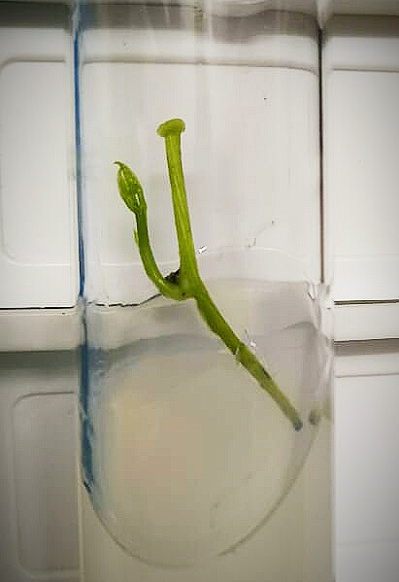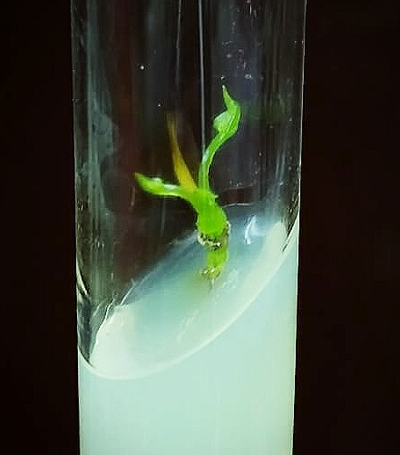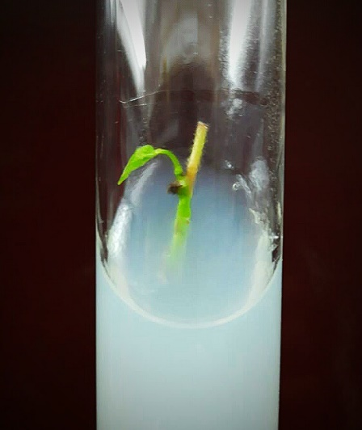
Figure 6: Number of days for Primordia initiation at 1.0 mg/L KN, 1.0 mg/L TDZ and 3.0 mg/L BAP concentrations of hormones
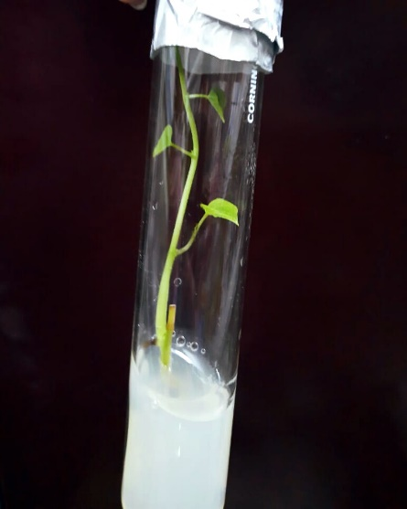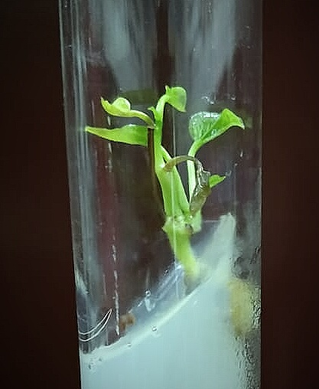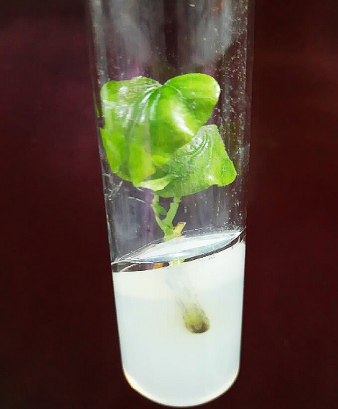
Figure 7: Number of nodes of Tinospora cordifolia at 0.2 mg/L BAP, 1.0 mg/L TDZ and 0.5 mg/L KN concentrations of hormones
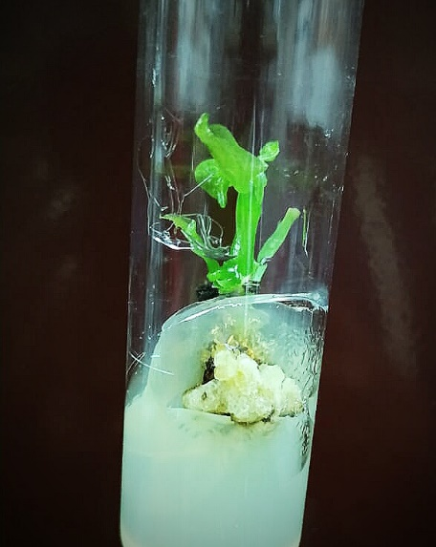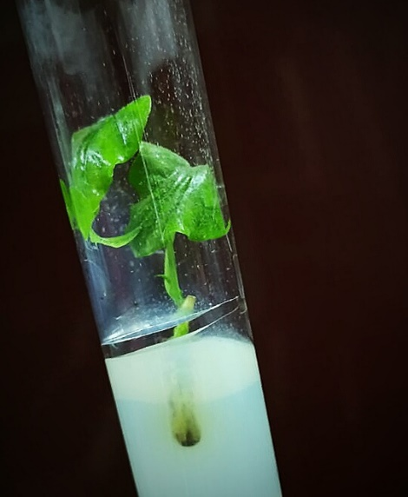
Figure 8: Number of leaves of Tinospora cordifolia at 3.0 mg/L BAP, 0.5 mg/L KN and 1.0 mg/L TDZ concentrations of hormones
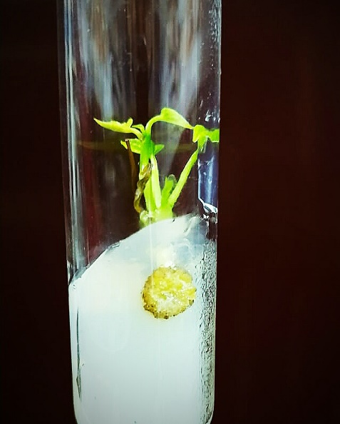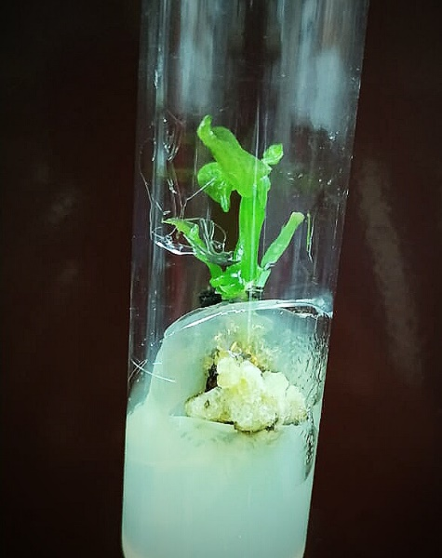
Figure 9: Number of stems of Tinospora cordifolia at 1.0 mg/L KN, 3.0 mg/L BAP and 1.0 mg/L TDZ concentrations of hormones
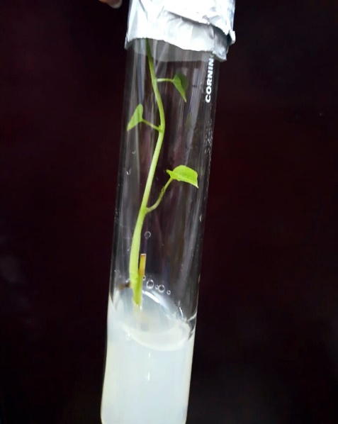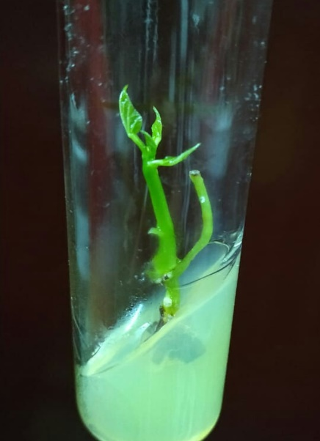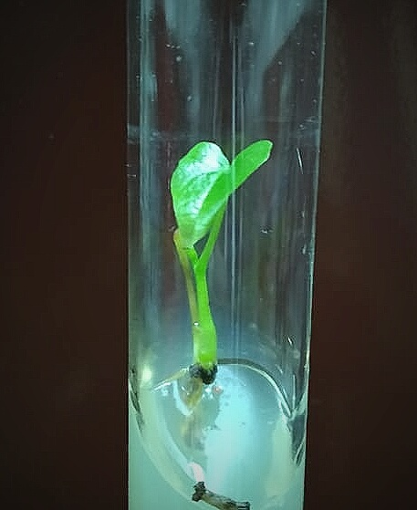
Figure 10: Length of stem of Tinospora cordifolia at 0.2 mg/L BAP, 0.5 mg/L KN and 1.0 mg/L TDZ concentrations of hormones
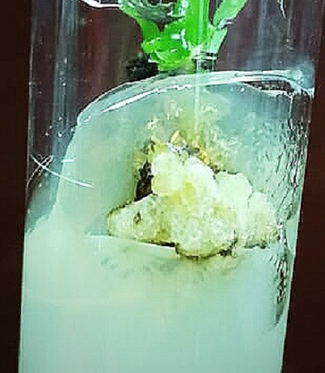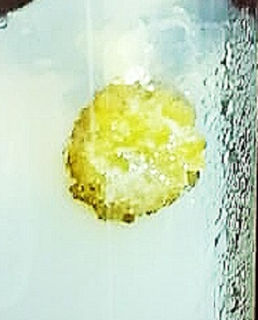
Figure 11: Callus formation of Tinospora cordifolia at 3.0 mg/L BAP, 2.0 mg/L KN and 1.0 mg/L TDZ concentrations of hormones

Disclaimer (Artificial intelligence)
Author(s) hereby declare that NO generative AI technologies such as Large Language Models (ChatGPT, COPILOT, etc.) and text-to-image generators have been used during the writing or editing of this manuscript.
References

- Handique, P. J. (2014). In vitro propagation and medicinal attributes of Tinospora cordifolia: a review. Austin J Biotechnol Bioeng, 1(5), 5.
- Sultana, C. S., & Handique, P. J. (2013). TDZ enhances multiple shoot production from nodal explants of Tinospora cordifolia-a commercially important medicinal plant species of NE India. Res J Biotech, 8, 31-36.
- Minerva, G. and Kumar, S. (2012). Micropropagation of Gerbera (Gerbera jamesonii Bolus). Methods in Molecular.

- Mittal, J., Sharma, M. M. and Batra, A. (2014). Tinospora cordifolia: a multipurpose medicinal plant-A. Journal of Medicinal Plants, 2(2).
- Mittal, J. and Sharma, M. M. (2017). Enhanced production of berberine in In vitro regenerated cell of Tinospora cordifolia and its analysis through LCMS QToF. 3 Biotech, 7, 1-12.
- Panwar, D., Patel, A. K. and Shekhawat, N. S. (2018). An improvised shoot amplification and ex vitro rooting method for offsite propagation of Tinospora cordifolia (Willd.) Miers: a multi-valued medicinal climber. Indian journal of plant physiology, 23(1), 169-178.
- Pretty, D. and Nalini, S. (2017). Evaluation of hepatoprotective potential of Tinospora cordifolia extracts in fructose- induced Experimental diabetic rats. International Journal of Pharma and Bio Sciences, 8(3). doi: 10.22376/ijpbs.2017.8.3. b830-838.
- Shukla, Susmita, S. K. Shukla, and S. K. Mishra. "In vitro plant regeneration from seedling explants of Stereospermum personatum DC: a medicinal tree." Trees 23 (2009): 409-413.
- Singh, A., Sah, S. K., Pradhan, A., Rajbahak, S. and Maharajan, N. (2009). In vitro study of Tinospora cordifolia (Willd.) Miers (Menispermaceae). Botanica Orientalis: Journal of Plant Science, 6, 103-105.
- Singh, V. K. and Padmanabh, D. (2010). Efficient in vitro shoot multiplication of Gymnema sylvestre R. Br.-an antidiabetic medicinal plant. Indian Journal of Plant Physiology, 15(3), 250-254.
- Sivakumar, V., Rajan, M. D., Sadiq, A. M. and Jayanthi, M. (2014). In vitro micropropagation of Tinospora cordifolia (Willd.) Miers ex Hook. F. & Thoms-An important medicinal plant. Journal of Pharmacognosy and Phytochemistry, 3(2).
- Usha, P. R., Naidu, M. U. R. and Raju, Y. S. N. (2003). Evaluation of the antiretroviral activity of a new polyherbal drug (Immu-25) in patients with HIV infection. Drugs in R & D, 4(2), 103-109.

- Vellingiri, B., Jayaramayya, K., Iyer, M., Narayanasamy, A., Govindasamy, V., Giridharan, B., Ganesan, S., Venugopal, A., Venkatesan, D., Ganesan, H. and Rajagopalan, K. (2020). COVID-19: A promising cure for the global panic. Science of The Total Environment, 138277.

- Wakhlu, A. K. and Sharma, R. K. (1999). Micropropagation of Heracleum candicans Wall: a rare medicinal herb. In Vitro Cellular & Developmental Biology-Plant, 35(1), 79-81.

