Review Article
Biotechnological Advancements in Seed Quality Enhancement: A Comprehensive Review

ABSTRACT
Seed quality directly affects crop yields, germination rates, and plant vigour, so it is essential to agricultural productivity and food security. Conventional techniques for improving seed quality, like hybridization, selective breeding, and seed treatment, have advanced agriculture but have drawbacks in terms of accuracy, efficiency, and resistance to environmental stresses. Recent advances in biotechnology have transformed seed research by providing novel strategies to improve crop resilience and seed quality. This review thoroughly examines a number of biotechnological approaches that have greatly enhanced seed trait selection, disease resistance, and stress tolerance, such as genetic engineering, marker-assisted selection (MAS), and "omics" technologies (genomics, proteomics, and metabolomics). Furthermore, emerging technologies such as genome editing (CRISPR-Cas9), artificial intelligence (AI) applications in predictive breeding, nanotechnology for seed treatment, and synthetic biology for tailored crop development are examined for their transformative potential in agricultural sustainability. While these technologies offer promising solutions, challenges such as regulatory frameworks, ethical concerns, public acceptance, and accessibility in developing regions remain substantial barriers to widespread adoption. Leveraging biotechnological discoveries for future agricultural development will require addressing these issues through interdisciplinary research, regulatory changes, and technology improvements. In order to ensure global food security, this review attempts to give a thorough grasp of the most recent developments in seed quality enhancement as well as the future course of biotechnological applications.

Keywords- Genetic engineering, Marker-assisted selection (MAS), Biotechnology, Nanotechnology, Stress tolerance, Biofortification, RNA interference (RNAi)

- INTRODUCTION
A key factor in agricultural performance is seed quality, which affects plant vigor, germination rates, and total crop yields. The ability to produce high-quality seeds ensures better crop establishment, yield potential, and resilience to environmental stressors. Due to the time and genetic precision constraints of traditional seed augmentation methods, sophisticated biotechnological alternatives are required. Biotechnological innovations have enabled precise modifications to enhance seed viability, improve stress resistance, and increase nutritional content. The advent of genome editing, marker-assisted selection, and advanced 'omics' technologies has expanded the capabilities of seed science, providing solutions to agricultural challenges (Varshney et al., 2014). The purpose of this review is to examine how contemporary biotechnology can improve seed quality and its possible uses in sustainable agriculture.

Traditional breeding methods have been used by farmers and scientists for generations to enhance seed quality and guarantee improved crop production. These techniques include seed treatment, hybridization, and selective breeding. Selective breeding has been widely used to enhance traits such as yield, disease resistance, and adaptability to different climates. However, traditional breeding relies on naturally occurring genetic variation and requires numerous generations to obtain desired features, making it a time-consuming procedure. A more sophisticated strategy is hybridization, which entails crossing plants with complementary qualities to create offspring with improved attributes; nonetheless, genetic limitations still apply to this process (Collard & Mackill, 2008).
Seed treatment technologies such as chemical coatings, biological inoculants, and priming procedures have been developed to boost germination rates and resistance to diseases. Chemical treatments using fungicides and insecticides protect seeds from soil-borne diseases and pests, whereas biological treatments introduce beneficial microbes to enhance root development and nutrient uptake. Seed priming, which involves controlled hydration and drying, has been shown to enhance seedling vigor and uniformity. Despite their success, these approaches have issues relating to sustainability, environmental impact, and long-term effectiveness, stressing the need for more advanced biotechnological solutions (Zhao et al., 2019).
Genetic engineering has emerged as a powerful tool for directly manipulating plant genomes to introduce desirable traits. Unlike traditional breeding methods, genetic engineering allows for precise modifications through techniques such as recombinant DNA technology, gene editing with CRISPR-Cas9, and RNA interference (RNAi). These innovations have led to the development of genetically modified crops with enhanced pest resistance, improved nutrient content, and greater adaptability to environmental stressors (Chen et al., 2019). Recombinant DNA technology enables scientists to insert specific genes into a plant’s genome to confer beneficial traits. This approach has been widely applied in the development of insect-resistant Bt crops, which produce proteins derived from Bacillus thuringiensis to combat pests. The creation of Golden Rice, which is biofortified with vitamin A to address nutritional deficiencies in developing nations, is another noteworthy accomplishment (Conner et al., 2003).
CRISPR-Cas9 technology has revolutionized genetic engineering by allowing precise gene modifications without introducing foreign DNA. This technique has been used to enhance seed traits such as drought tolerance, disease resistance, and seed longevity. RNAi technology, another promising approach, enables the silencing of undesirable genes to improve seed quality attributes such as reduced allergenicity and enhanced resistance to viral infections (Li et al., 2022). The creation of Bt crops, which generate insecticidal proteins derived from Bacillus thuringiensis, and Golden Rice, which is enhanced with vitamin A to prevent malnutrition, are notable examples of genetic engineering's use in seed modification. In order to meet global agricultural concerns, genetic engineering has also proven crucial in the production of biofortified wheat, salt-resistant rice, and drought-tolerant maize. Additionally, the development of climate-resilient crops which can tolerate drought, salinity, and severe temperatures has been made possible in large part by genetic engineering. Research on genetic modification to increase seed longevity has also showed promise, allowing seeds to remain viable for extended periods of time under difficult storage circumstances (Mittler, 2006).
Additionally, climate-resilient crops that can tolerate high temperatures, salt in the soil, and drought conditions have been developed thanks in large part to genetic engineering. Research on genetic modification to increase seed lifespan has also showed promise, allowing seeds to survive for extended periods of time under difficult storage circumstances. Genetic engineering has enabled advancements in seed nutritional content in addition to insect resistance and climatic tolerance. Scientists have effectively increased the amounts of vital amino acids, vitamins, and minerals in crops including rice, maize, and soybeans. This is especially helpful for tackling the issues of food security and hunger in poor nations. The creation of edible vaccines based on genetically modified seeds, which contain antigenic proteins capable of eliciting immunological responses in both humans and animals, is another noteworthy breakthrough. This innovation may offer scalable and reasonably priced vaccine delivery options in isolated and resource-constrained locations.
Furthermore, genetic engineering is being combined with synthetic biology techniques to create new seed characteristics that are not seen in nature. Researchers can control seeds to have higher germination rates, postpone senescence, or even be able to fertilize themselves by building artificial gene circuits. By enhancing crop sustainability and lowering the need for chemical inputs, these innovations have the potential to completely transform agriculture. In the future, AI-driven automation and predictive modelling are anticipated to significantly revolutionize genetic engineering. Large genetic databases may be analysed using AI-assisted gene editing technologies to find the best gene targets for alteration, speeding up and improving breeding. The broad use of genetic engineering will probably be essential to ensuring the world's food supplies and reducing the effects of climate change on agriculture as legal frameworks alter and public acceptance of genetically modified crops increases.
- MARKER-ASSISTED SELECTION (MAS)
In contemporary plant breeding, marker-assisted selection (MAS) is a potent technique that improves the precision and efficiency of choosing desired genetic features in seeds. This method utilizes genetic markers connected to specific genes that govern critical agronomic properties, such as disease resistance, yield potential, and stress tolerance (Fig. 1). Breeders can drastically cut down on the time and resources needed to create high-quality seed varieties by identifying these markers and choosing superior plants early on (Collard & Mackill, 2008).
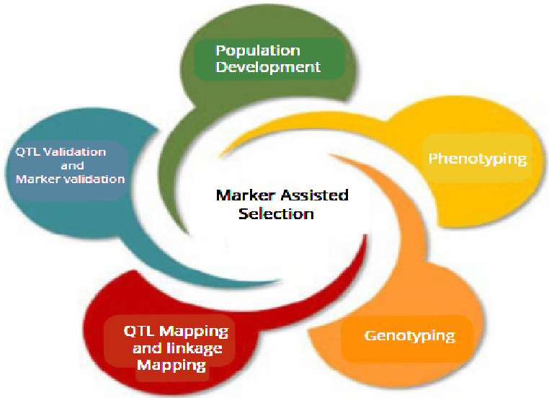
Fig. 1. Some significant steps of marker-assisted selection (MAS) (Zahid et al., 2022).
MAS involves several important phases. First, molecular markers connected to desirable qualities are found through genetic mapping. To find out which individuals have the desired markers, breeding populations are then genotyped. Finally, plants carrying the beneficial genetic markers are selected and used for further breeding. In contrast to traditional breeding techniques, which only use phenotypic selection, MAS enables faster and more accurate crop improvement. This method has been effectively used to improve traits like pest tolerance, drought resistance, and better nutritional profiles in a variety of crops, including rice, wheat, and maize (Varshney et al., 2014). One of the significant advantages of MAS is its ability to expedite breeding programs by reducing dependency on environmental conditions for trait evaluation. It also reduces the possibility of unwanted traits being inadvertently acquired, which is a concern linked with traditional breeding. With advancements in sequencing technologies and bioinformatics, MAS is expected to play a crucial role in future crop improvement strategies, particularly when integrated with genome editing and other modern breeding techniques.
Faster breeding cycles, less dependence on environmental testing, and increased trait selection accuracy are some benefits of MAS. In order to improve grain quality, increase drought resilience, and create pest-resistant cultivars, this approach has been frequently used in crops like rice, wheat, and maize. It is anticipated that MAS will further develop and be combined with other biotechnological methods for improving seed quality as molecular biology advances. MAS may be used to a wide range of crops and breeding goals. MAS has been used in rice breeding to increase resistance to bacterial blight and blast, two significant diseases that limit rice output worldwide. Similarly, in the breeding of wheat, MAS has played a key role in creating rust-resistant cultivars, decreasing the need for chemical fungicides, and enhancing yield stability. Through the discovery of drought-tolerant genes in maize, MAS has made it possible to create hybrids that thrive in water-limited environments.
The use of MAS in plant breeding has increased because to the increasing availability of molecular markers. New quantitative trait loci (QTLs) linked to important seed quality attributes have been found by breeders thanks to developments in whole-genome sequencing and high-throughput genotyping. Researchers can enhance nutrition profiles, germination rates, and seed viability by combining QTL mapping with MAS. For instance, research on barley and soybeans has shown QTLs associated with the oil and protein content of the seeds, opening the door for the targeted breeding of high-value seed types.In addition to main staple crops, MAS is being used more and more to enhance the quality of seeds for legume and horticultural crops. The creation of tomato cultivars with longer marketability has been made easier by molecular markers associated with fruit firmness and shelf life. MAS has been used to increase the nutritional makeup of seeds and provide resistance to root rot in legumes like chickpeas and lentils.
It is anticipated that the efficiency of MAS would be increased by its combination with other biotechnological technologies like transcriptome analysis and CRISPR-Cas9 genome editing. Breeders may more precisely modify desired features while reducing unwanted genetic changes by combining MAS with precision gene editing. Transcriptomic research also aids in the identification of gene expression patterns linked to seed quality, which helps to improve MAS-based breeding techniques.
Despite its benefits, MAS has certain issues that must be resolved before it can be widely used. Small-scale breeding projects may not be able to afford the expense of genotyping and generating genetic markers, especially in underdeveloped nations. Another constraint is the lack of well-characterized markers for complicated polygenic characteristics. To fully profit from this technology, efforts must be made to increase the size of genomic databases, lower the cost of sequencing, and provide MAS techniques that are easy to use. Breeding programs may be further optimized in the future by combining MAS with machine learning (ML) and artificial intelligence (AI) (Fig. 2). The effectiveness of MAS in choosing better seed characteristics can be increased by using AI-driven prediction models to evaluate genetic datasets and find the best marker-trait relationships. Furthermore, MAS-derived seed types may benefit from improved traceability and intellectual property protection thanks to blockchain technology, which might promote plant breeding innovation. To sum up, MAS has transformed plant breeding by providing a quicker, more accurate, and resource-efficient way to choose desired seed characteristics. Global crop development efforts have already been revolutionized by its applications in disease resistance, stress tolerance, and nutritional enhancement. MAS is positioned to have an even bigger impact on the direction of seed research and sustainable agriculture as developments in genomics, bioinformatics, and artificial intelligence continue to emerge.
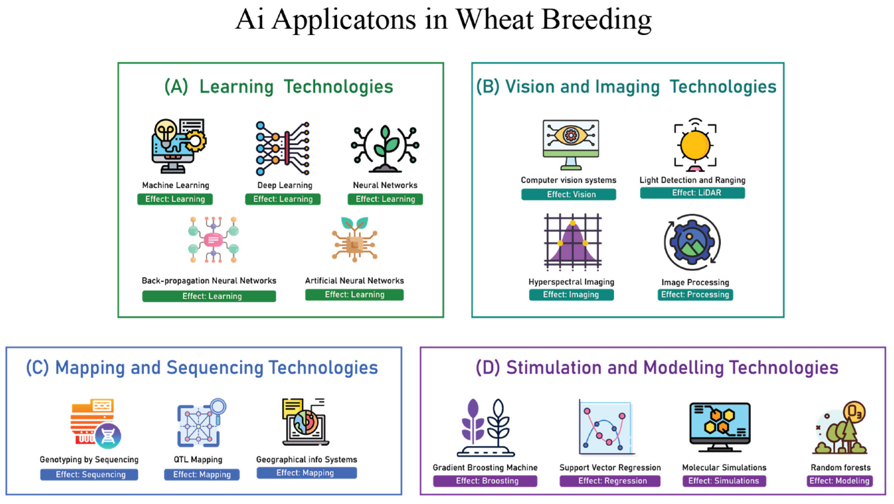
Fig. 2. Applications of Artificial Intelligence (Mushtaq et al., 2024)

- APPLICATION OF OMICS TECHNOLOGIES
The use of "omics" technologies to improve seed quality has transformed plant breeding by offering important new information about the metabolic, proteomic, and genetic aspects that affect seed performance. Through the integration of proteomics, metabolomics, and genomes, researchers have been able to create targeted breeding techniques for improved seed attributes, such as increased nutritional content, improved resilience to environmental stressors, and higher germination rates. Finding the genes causing seed quality is largely dependent on genomics, the study of an organism's entire genetic makeup. Advances in next-generation sequencing (NGS) technologies have enabled researchers to sequence plant genomes rapidly, leading to the discovery of key genes linked to seed viability, dormancy, and stress tolerance. Breeders have been able to create superior seed varieties with accuracy and efficiency by using genomic selection techniques to improve seed characteristics in crops like maize, rice, and wheat. Additionally, genome-wide association studies (GWAS) have facilitated the identification of genetic markers associated with desirable traits, making it possible to implement marker-assisted selection (MAS) more effectively in plant breeding programs.
Proteomics, the large-scale study of proteins, has yielded important improvements in understanding seed biology. Since proteins govern essential biochemical pathways in plants, analyzing seed proteomes has revealed critical regulatory mechanisms influencing seed germination, longevity, and stress adaptation. Proteomic profiling has been widely used to compare seed protein compositions between different crop varieties, allowing breeders to select seeds with higher nutritional value and better storage potential. Proteomic analyses of wheat and soybean seeds, for example, have revealed proteins implicated in pathogen resistance and seed dormancy regulation, resulting in the creation of improved seed varieties with increased disease tolerance. Deeper understanding of the biochemical processes influencing seed development and quality has been made possible by metabolomics, the thorough examination of metabolites within seeds. Researchers have discovered bioactive substances that support seed health by metabolomic profiling, such as vitamins, antioxidants, and secondary metabolites that strengthen resistance to oxidative stress and infections. Scientists can improve breeding programs and seed treatments to increase seed vigor and nutritional composition by examining metabolic signatures. Recent research on barley and maize has shown how metabolomic engineering affects the starch and oil content of seeds, underscoring the potential of metabolic changes to increase crop value and marketability.
Apart from these fundamental 'omics' fields, the development of epigenomics has further broadened our comprehension of the regulation of seed quality. Histone acetylation and DNA methylation are two examples of epigenetic changes that are essential for regulating gene expression without changing the underlying genetic code. These changes have been connected to the longevity, environmental adaptation, and dormancy of seeds. Researchers can create epigenetically modified crops that preserve genetic stability while retaining desired features by utilizing epigenomic data.
Developments in bioinformatics and artificial intelligence (AI) have also aided in the integration of "omics" technologies. Large volumes of genomic, proteomic, and metabolic data can now be processed by researchers thanks to AI-driven data analysis tools, which makes predictive modelling for seed trait selection easier. To speed up the breeding process even further, machine learning techniques have been used to find the best gene expression patterns linked to high-quality seeds. The creation of stress-tolerant crops has been one of the most important practical uses of "omics" technology in seed research. Extreme temperatures, drought, and soil salinity all have an impact on seed viability, making climate change a serious danger to global food security. Scientists have successfully created crops that can survive challenging environmental conditions by applying multi-omics techniques. For instance, proteomic research on legumes has revealed proteins that increase seed resilience under abiotic stress conditions, while genomic and metabolomic analysis has produced rice cultivars with improved drought tolerance.
Even with these impressive developments, there are still obstacles in the way of completely incorporating "omics" technology into conventional farming methods. For small-scale farmers and researchers in poor nations, the high expenses of proteome profiling, metabolomic analysis, and genome sequencing provide a financial obstacle. Furthermore, to guarantee consumer acceptability and adherence to biosafety rules, the ethical and regulatory issues surrounding genetic changes and metabolomic engineering must be carefully considered. Future studies should integrate real-time metabolic and genomic monitoring systems to optimize multi-omics techniques for seed enhancement. Our capacity to decipher intricate biological data will be further improved by developments in nanotechnology and AI-driven analytics, which will result in more accurate and effective seed breeding methods. Translation of 'omics' research into useful applications for global agriculture will also need multidisciplinary cooperation between molecular biologists, agronomists, and computational scientists.
To sum up, 'omics' technologies have transformed seed research by offering previously unheard-of insights into the metabolic, proteomic, and genomic etc. (Fig. 3). Targeted breeding techniques made possible by the use of genomics, proteomics, and metabolomics have produced better seed types with higher germination rates, higher nutritional content, and increased resistance to stress. Future developments in bioinformatics, artificial intelligence, and epigenomics might improve 'omics'-based seed improvement techniques, despite ongoing obstacles. Researchers and breeders can support sustainable crop production in the face of environmental difficulties and global food security by incorporating these cutting-edge technologies into contemporary agriculture. A number of new technologies are revolutionizing agriculture and seed research. These developments use advances in data science, material engineering, and molecular biology to boost resilience, boost yield, and improve seed quality. Genome editing, artificial intelligence (AI) and machine learning (ML), nanotechnology, synthetic biology, and sophisticated imaging technologies are some of the most exciting developments. These innovative methods have the potential to completely transform seed science and guarantee sustainable farming methods.
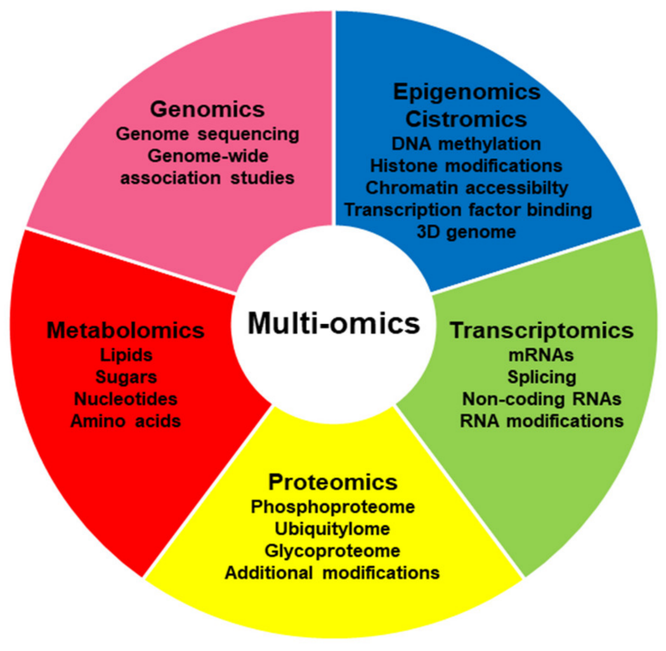
Fig. 3. Omics to Multi-Omics Approaches (Nevedomskaya & Haendler, 2022)

- CRISPR-Cas9 AND OTHER GENOME EDITING TECHNOLOGIES
CRISPR-Cas9 and other genome editing technologies have made it possible to precisely alter plant genomes in order to add desired seed qualities. CRISPR-Cas9 enables targeted changes inside the plant's genome, in contrast to conventional genetic engineering techniques that need the transfer of foreign genes (Sandhya et al., 2020). By improving drought tolerance, raising nutritional content, and granting disease resistance, this accuracy has made it easier to increase seed quality. Recent uses of CRISPR-based genome editing have produced rice strains resistant to bacterial blight, soybean seeds with better oil profiles, and wheat variants with improved grain composition. It is anticipated that future developments in gene-editing techniques, like as base editing and prime editing, would improve seed trait modification while reducing unwanted genetic changes. By evaluating enormous datasets to forecast the best breeding practices and improve seed quality, AI and ML are becoming more and more important in the field of seed research. To find better seed types with higher yield potential, AI-driven algorithms may analyse genetic data, environmental data, and agronomic performance measures. Additionally, ML models are being used to automate quality control in seed production, forecast germination rates, and evaluate the viability of seeds (Xia et al., 2019). By combining AI and remote sensing technology, researchers can track crop growth and seedling establishment in real time, improving breeding program decision-making. Precision breeding is further improved by the use of AI-powered phenotyping technologies, which make it possible to quickly identify important seed characteristics at an early development stage.
By improving nutrition delivery, boosting disease resistance, and lengthening seed longevity, nanotechnology is transforming seed treatment. Nano-coatings can improve germination while shielding seedlings from environmental challenges including pests, salt, and dehydration. In order to guarantee ideal growing circumstances, nanoparticles can also be utilized to directly supply vital nutrients to the seed. To improve the nutritional value of crops and lessen micronutrient shortages in human diets, for example, nanoscale fertilizers containing iron and zinc have been effectively used. Furthermore, it is possible to create nanocarriers that would release bioactive substances in a regulated way, enhancing seed defence against bacterial and fungal diseases. The creation of environmentally benign and biodegradable nano-coatings may offer long-term solutions for enhancing seed performance as nanotechnology research progresses.
Scientists can now create unique seed features that maximize agricultural output thanks to synthetic biology, which is quickly becoming a game-changing breakthrough in seed research. Researchers can create seeds with improved stress tolerance, higher nutritional value, and longer shelf life by reprogramming plant metabolic pathways. Nitrogen-fixing cereals have been produced using synthetic biology techniques, which lessen reliance on chemical fertilizers and support sustainable agriculture. Additionally, biofortified seeds high in vital vitamins and amino acids are being produced using metabolic engineering techniques. The production of self-repairing seeds that trigger stress-protection mechanisms in response to environmental changes may be made possible in the future via synthetic biology, which would lessen yield losses brought on by climatic unpredictability.
The evaluation of seed quality has been transformed by the use of cutting-edge imaging technologies, including X-ray computed tomography (CT), magnetic resonance imaging (MRI), and hyperspectral imaging (Singh et al., 2025). Without endangering seed viability, these non-destructive methods enable researchers to examine structural integrity, identify internal flaws, and study seed composition. The diagnosis of pollutants and nutritional deficits is made easier by hyperspectral imaging, which offers comprehensive spectral information on seed biochemistry. High-resolution observation of seed shape is provided by MRI and CT imaging, which makes it possible to identify problems like fungal infections or mechanical damage early on. Breeders may use AI-driven analysis in conjunction with these imaging modalities to apply high-throughput screening techniques that guarantee higher seed quality in commercial production.
A new option for improving seed tracing and guaranteeing transparency in the agriculture supply chain is blockchain technology. Breeders and farmers can monitor the genetic heritage, quality standards, and storage history of seeds by putting blockchain-based seed certification systems into place. This strategy fosters confidence among stakeholders while lowering the possibility of fake seeds making their way into the market. Blockchain-enabled smart contracts can help ensure fair trade by facilitating safe transactions between buyers and seed suppliers. Blockchain applications in seed science might increase regulatory compliance and boost the effectiveness of seed delivery as digital agriculture grows. In order to provide synergistic advances in seed quality and agricultural sustainability, seed science's future rests in integrating these cutting-edge technologies. High-yield, stress-tolerant seed types may be developed more quickly if genome editing and AI-driven predictive modelling are combined. Innovations in synthetic biology combined with seed coverings based on nanotechnology may result in climate-resilient, self-fertilizing crops that need little outside assistance. Additionally, blockchain technology in conjunction with sophisticated imaging techniques may improve quality control procedures and expedite seed certification procedures. Although these developments provide great prospects, obstacles including legal restrictions, moral dilemmas, and significant implementation costs must be resolved to guarantee the broad use of cutting-edge technologies in seed science. To create established rules and make sure that technical advancements are in accordance with the objectives of global food security, cooperation between scientists, legislators, and business executives will be crucial. Comparison of Biotechnological Approaches in Seed Quality Enhancement tabulated in Table 1.
Table 1. Comparison of Biotechnological Approaches in Seed Quality Enhancement
Approach | Key Features | Advantages | Challenges
Genetic Engineering | Direct modification of plant genomes using recombinant DNA, CRISPR-Cas9, RNAi | Precision in trait selection, enhanced resistance, improved nutritional content | Ethical concerns, regulatory barriers, potential environmental risks
Marker-Assisted Selection (MAS) | Use of molecular markers to identify and select desirable traits | Faster breeding cycles, increased accuracy, reduced reliance on environmental conditions | High genotyping costs, requires advanced infrastructure
'Omics' Technologies | Genomics, proteomics, and metabolomics for seed trait analysis | Holistic understanding of seed biology, improved trait selection | Complex data interpretation, high-cost sequencing and analysis
Emerging Technologies | AI-driven breeding, nanotechnology, synthetic biology | Enhanced automation, increased stress resilience | Integration challenges, regulatory uncertainties, public acceptance

- CHALLENGES AND FUTURE PROSPECTS
Even with the impressive developments in biotechnology seed improvement, a number of obstacles need to be overcome before it can be widely used. Commercialization of genetically modified seeds is hampered by regionally specific regulatory frameworks. Bringing biotechnologically improved seeds to market takes longer and costs more because of strict biosafety laws, labelling specifications, and drawn-out approval procedures. Especially for smaller agricultural businesses and emerging nations with limited resources, these legislative restrictions frequently deter investment in R&D. Market adoption and regulatory choices are still influenced by public opinion and ethical concerns about genetically modified organisms (GMOs). Customers' and farmers' distrust is exacerbated by misinformation and ignorance on the advantages and safety of genetically modified seeds. Strong public involvement, open risk assessments, and science-based communication techniques are needed to address these issues in order to foster confidence and guarantee well-informed decision-making.
Another major obstacle to the use of biotechnological technologies in seed modification is the high expense of research and development. Significant financial resources are needed for the production of genetically modified seeds, which also include field testing, regulatory testing, intellectual property protection, and intensive laboratory research. In areas with low resources, where better seed types may have the biggest effects on food security and agricultural sustainability, this cost aspect restricts accessibility. Careful management is also required for environmental issues pertaining to gene flow, biodiversity effect, and unforeseen repercussions. Concerns over genetic contamination and the loss of natural genetic variety are raised by the possibility that genetically modified crops would cross-pollinate with their wild cousins. Furthermore, depending too much on engineered features for pest resistance might result in the development of resistant insect populations, which would call for integrated pest management techniques to reduce ecological concerns over the long run.
'Omics' technologies and AI-driven prediction models should be the focus of future research to increase the accuracy of seed quality enhancement. Researchers may speed up breeding operations and lessen their reliance on trial-and-error techniques by using machine learning algorithms to examine large datasets and find genetic markers linked to desired seed qualities. AI-driven automation in genomic selection and seed phenotyping may improve breeding efficiency even further and shorten the time needed to generate new seed varieties. Another interesting line of inquiry for future studies is how the seed microbiota contributes to resilience. The microbial populations linked to seeds are essential for nutrient intake, stress tolerance, and seed germination. The creation of bio-enhanced seeds with increased resistance to abiotic stresses and infections may be made possible by developments in microbiome engineering, which would lessen the need for chemical inputs and promote more environmentally friendly farming methods. Enhancing breeding accuracy and speeding up trait selection will need the development of high-throughput phenotyping methods. By enabling non-destructive study of seed quality parameters, technologies including robotic phenotyping tools, drone-assisted monitoring, and hyperspectral imaging are transforming the field of seed evaluation. By facilitating the early identification of favourable seed features, these technologies can optimize selection criteria and enhance agricultural performance.
Overcoming regulatory and accessibility obstacles will need more cooperation between scientists, legislators, and industry stakeholders. By easing technology transfer, offering financial possibilities, and simplifying regulatory processes, public-private partnerships may spur innovation. Initiatives to increase capacity in poor nations can also guarantee fair access to biotechnological developments, enabling smallholder farmers to profit from better seed types. In the future, seed science might undergo a major transformation due to the confluence of blockchain technology, nanotechnology, and synthetic biology. The development of specialized seed characteristics with increased resistance and production may be made possible via synthetic biology techniques. Applications of nanotechnology in nutrient delivery and seed coating can enhance agricultural establishment and seed germination. By guaranteeing openness in seed supply chains and safeguarding intellectual property rights, blockchain technology can improve seed traceability.
The effective incorporation of these new technologies into seed research will ultimately necessitate a multidisciplinary strategy that strikes a balance between innovation and socioeconomic, ethical, and environmental factors. Biotechnological developments will be essential in tackling issues related to food security and advancing sustainable agriculture as the demand for premium seeds rises globally. Future developments in seed science may be structured to benefit farmers and consumers globally by encouraging international cooperation, funding state-of-the-art research, and guaranteeing the appropriate application of biotechnological advancements.

- CONCLUSION
Biotechnological advancements have made great progress in improving the quality of seeds by providing solutions for increased nutritional content, durability, and germination. Further advancements in seed quality will be fuelled by these technologies' integration with artificial intelligence, nanotechnology, and synthetic biology as they develop further. For broad acceptance, it will be essential to address accessibility, environmental, and regulatory issues. Biotechnological approaches have the potential to significantly contribute to global food security and sustainable agricultural practices for future generations with more study, responsible application, and supportive policy. In order to develop next-generation seed types with increased yield potential, better nutritional profiles, and more adaptability, seed scientists must integrate a variety of fields, from molecular biology to artificial intelligence. Researchers and farmers can build a robust and productive agricultural system that can satisfy the needs of global food security while reducing the effects of climate change by embracing these innovations. In the end, biotechnology in seed science is a potent instrument to guarantee sustainable farming methods and sustain the world's expanding population in the ensuing decades.

DISCLAIMER (ARTIFICIAL INTELLIGENCE)
Author(s) hereby declare that NO generative AI technologies such as Large Language Models (ChatGPT, COPILOT, etc.) and text-to-image generators have been used during the writing or editing of this manuscript.

REFERENCES
Borrill, P., Harrington, S. A., & Uauy, C. (2019). Applying the latest advances in genomics and phenomics for trait discovery in polyploid wheat. The Plant Journal, 97(1), 56-72.
Chen, K., Wang, Y., Zhang, R., Zhang, H., & Gao, C. (2019). CRISPR/Cas genome editing and precision plant breeding in agriculture. Annual Review of Plant Biology, 70, 667-697.
Collard, B. C., & Mackill, D. J. (2008). Marker-assisted selection: An approach for precision plant breeding in the twenty-first century. Philosophical Transactions of the Royal Society B: Biological Sciences, 363(1491), 557-572.
Conner, A. J., Glare, T. R., & Nap, J. P. (2003). The release of genetically modified crops into the environment. The Plant Journal, 33(1), 19-46.
Dwivedi, S. L., Scheben, A., Edwards, D., Spillane, C., & Ortiz, R. (2017). Breeding climate-resilient crops: Opportunities and challenges. Advances in Agronomy, 148, 1-47.
Garg, M., Sharma, N., Sharma, S., Kapoor, P., Kumar, A., Chunduri, V., & Arora, P. (2018). Biofortified crops generated by breeding, agronomy, and transgenic approaches are improving lives of millions of people around the world. Frontiers in Nutrition, 5, 12.
Holme, I. B., Wendt, T., & Holm, P. B. (2013). Intragenesis and cisgenesis as alternatives to transgenic crop development. Plant Biotechnology Journal, 11(4), 395-407.
Hossain, M. S., Persicke, M., & Kalinowski, J. (2017). Genetic and metabolic engineering in seed quality improvement. Biotechnology Journal, 12(7), 1700081.
Jaganathan, D., Ramasamy, K., Sellamuthu, G., Jayabalan, S., & Venkataraman, G. (2018). CRISPR for crop improvement: An update review. Frontiers in Plant Science, 9, 985.
Kole, C., Muthamilarasan, M., Henry, R., Edwards, D., Sharma, R., & Abberton, M. (2015). Application of genomics-assisted breeding for generation of climate resilient crops: Progress and prospects. Frontiers in Plant Science, 6, 563.
Li, J., Li, H., Zhang, L., Zhang, S., Wang, X., & Xu, J. (2022). Applications of nanotechnology in seed science: Prospects and challenges. Journal of Agricultural and Food Chemistry, 70(12), 3562-3575.
Mittler, R. (2006). Abiotic stress, the field environment and stress combination. Trends in Plant Science, 11(1), 15-19.
Mushtaq, M. A., Ahmed, H. G. M. D., & Zeng, Y. (2024). Applications of artificial intelligence in wheat breeding for sustainable food security. Sustainability, 16(13), 5688.
Nevedomskaya, E., & Haendler, B. (2022). From omics to multi-omics approaches for in-depth analysis of the molecular mechanisms of prostate cancer. International Journal of Molecular Sciences, 23(11), 6281.
Papanikolaou, S., Pantazis, S., & Tsaftaris, A. (2021). Artificial intelligence in plant breeding and seed quality enhancement: Current status and future prospects. Computers and Electronics in Agriculture, 187, 106305.
Ray, D. K., Mueller, N. D., West, P. C., & Foley, J. A. (2013). Yield trends are insufficient to double global crop production by 2050. PLoS ONE, 8(6), e66428.
Ricroch, A., Clairand, P., & Harwood, W. (2017). Use of CRISPR systems in plant genome editing: Toward new opportunities in agriculture. Emerging Topics in Life Sciences, 1(2), 169-182.
Sandhya, D., Jogam, P., Allini, V. R., Abbagani, S., & Alok, A. (2020). The present and potential future methods for delivering CRISPR/Cas9 components in plants. Journal of Genetic Engineering and Biotechnology, 18(1), 25.
Schmidt, S. M., & Belisle, M. (2019). From plant breeding innovations to genome editing: Regulatory challenges in the EU. Plant Cell Reports, 38(5), 825-833.
Singh, S. K., Jha, R., Pandey, S., Mohan, C., Ghosh, S., Singh, S. K., ... & Singh, A. (2025). Artificial Intelligence-based Tools for Next-Generation Seed Quality Analysis. Crop Design, 100094.
Tester, M., & Langridge, P. (2010). Breeding technologies to increase crop production in a changing world. Science, 327(5967), 818-822.
Varshney, R. K., Terauchi, R., & McCouch, S. R. (2014). Harvesting the promising fruits of genomics: Applying genome sequencing technologies to crop breeding. PLoS Biology, 12(6), e1001883.
Wang, W., Mauleon, R., Hu, Z., Chebotarov, D., Tai, S., Wu, Z., ... & Alexandrov, N. (2018). Genomic variation in 3,010 diverse accessions of Asian cultivated rice. Nature, 557(7703), 43-49.
Xia, Y., Xu, Y., Li, J., Zhang, C., & Fan, S. (2019). Recent advances in emerging techniques for non-destructive detection of seed viability: A review. Artificial Intelligence in Agriculture, 1, 35-47.
Zahid, G., Iftikhar, S., Farooq, M. U., & Soomro, S. A. (2022). Advances in DNA based Molecular Markers for the Improvement of Fruit Cultivars in Pakistan-A Review. Sarhad Journal of Agriculture, 38(3).
Zhao, C., Zhang, Y., Du, J., Guo, X., Wen, W., Gu, S., ... & Fan, J. (2019). Advances in seed priming to enhance stress tolerance of crops. Plant Physiology and Biochemistry, 147, 303-311.

