Original Research Article

Efficient In Vitro Propagation and Optimized Multiple Shoot Induction of Caralluma bhupenderiana an Endangered Medicinal Plant

ABSTRACT
Caralluma bhupenderiana is one of the medicinally important species within the Apocynaceae family. Recent in vitro studies revealed its medicinal properties particularly antioxidant and anti-inflammatory activities. C. bhupenderiana is considered an endemic, as it faces threats from habitat loss and overharvesting for medicinal and culinary uses. These challenges should be addressed using micropropagation techniques. Our study focuses on standardizing the protocol for inducing multiple shoots under in vitro conditions. Stem explants of C. bhupenderiana were treated with various concentrations of surface sterilants (Sodium Hypochlorite, Mercuric Chloride, Hydrogen Peroxide) initially and cultured onto different nutrient media (Gamborg’s B5 medium, Woody Plant Medium & Murashige and Skoog medium). Within the tested chemicals, mercuric chloride (0.1% w/v) for 5 minutes exhibited a healthy shoot response (80%), and MS medium showed the highest shooting with 86.66% compared to others. Additionally, the MS media was supplemented with cytokinins (6-Benzylaminopurine-BAP and Kinetin-Kn) to optimize the shoot sprouting. Where BAP (3.0 mg/l) was found to be the best for inducing shoots with a mean shoot number of 4.66±0.14. Then Ms media containing auxins (Naphthalene Acetic Acid, Indole-3-Acetic Acid, Indole-3-Butyric Acid, Isopentenyl Adenine and 2,4-Dichlorophenoxyacetic Acid) and BAP was tested to induce multiple shoots from single explant of C. bhupenderiana. The peak growth of 93.3% was shown by BAP (3.0 mg/l) + IAA (2.0 mg/l) with a maximum mean shoot number of 21.00 ± 0.07 and the longest mean shoot length of 6.75 ± 0.03 cm. Further, the regenerated shoots were sub-cultured onto half-strength MS media provided with auxins (IAA, IBA and NAA). Rooting with 100% was observed in ½ MS + NAA (0.1mg/l) with an optimal mean number of 12.06 ± 0.06 roots per shoot. 70% of the in vitro grown C. bhupenderiana plants were acclimatized.

KEY WORDS: C. bhupenderiana, Micropropagation, Multiple Shoot Induction, In vitro.

ABBREVIATIONS:
NaOCl – Sodium Hypochlorite
HgCl₂ – Mercuric Chloride
H₂O₂ – Hydrogen Peroxide
B₅ Medium – Gamborg’s B5 Medium
WPM – Woody Plant Medium
MS Medium – Murashige and Skoog Medium
BAP – 6-Benzylaminopurine
Kn – Kinetin
NAA – Naphthalene Acetic Acid
IAA – Indole-3-Acetic Acid
IPA – Isopentenyl Adenine
IBA – Indole-3-Butyric Acid
2,4-D – 2,4-Dichlorophenoxyacetic Acid
- INTRODUCTION
Caralluma bhupenderiana Sarkaria belongs to Apocynaceae family. It is the most significant medicinal plant in the Caralluma genus with extremely high therapeutic value. Most of the species found are endemic to the southern parts of India and are further rich in terms of medicinal values (Singh, 2016). It possesses a high number of bioactive compounds including phenols, quinines, flavonoids, esters, and saponins (Alodaini et al., 2025; Amrati et al., 2025; Jesudass et al., 2025) responsible for its therapeutic activity. Despite its high medicinal value, its endangered status has not been much focused. According to the recent ethnobotanical survey these species are now at the brink of its extinction due to rapid urbanisation and overharvesting from the wild (Ugraiah et al., 2011). These issues need to be addressed without delay to avoid the extinction of this species in its natural habitat. In addition to the natural conservation techniques, alternative protocols for mass production and multiplication of these plant species are needed.
Micropropagation is a versatile tool extensively used for abrupt and rapid clonal propagation, which is genetically identical and is free from diseases compared to traditional methods (Gupta at al., 2022). It incorporates in vitro production and multiplication through tissue culture protocols utilising various parts of the plants known as explants. Explants are generally meristems, nodes, stems, roots, leaves and flowers, which are potent for regeneration into a completely new plant (totipotency) (George et al., 2008). Furthermore, it involves surface sterilization as the preliminary step to avoid the sources of contamination caused by fungus, microbes and other environmental impurities. This process helps in the elimination of these contaminants successfully, which is a crucial step in maintaining aseptic conditions. Mercuric chloride, sodium hypochlorite and hydrogen peroxide are the most widely used surface sterilization agents (Aruna et al., 2012; Bošnjak Mihovilović et al., 2024; Laxmi, G. V., & Dharmalingam et al., 2024; Ratnam, 2021).
Nutrient medium provides macronutrients, micronutrients along with the carbon (sucrose) and vitamins source for the plant vegetative growth under in vitro conditions. Murashige & Skoog in 1962 (MS media), Gamborg et al., in 1968 (B5 media) and McCown & Sellmer, in 1987 (Woody Plant Medium -WPM) formulated the nutrients essential for the plant growth and experimentally cultured for tobacco, soybean and woody plants (Murashige and Skoog, 1962; Gamborg et al., 1968; McCown and Sellmer, 1987). Plant hormones such as auxins (Naphthalene Acetic Acid, Indole-3-Acetic Acid, Indole-3-Butyric Acid, Isopentenyl Adenine and 2,4-Dichlorophenoxyacetic Acid) and cytokinins (6-Benzylaminopurine and Kinetin) promote cell elongation and stimulate cell division, regulating the plant growth and development. These optimised culture media have been widely accepted in the field of plant tissue culture. This technique is indispensable for the conservation of endangered plant species providing a reliable method in preserving their germplasm and brisk multiplication within a limited period (Chandana et al., 2018).
To avoid the eradication of C. bhupenderiana from the wild and to be listed under the critically endangered species under IUCN Red Data Book like closely allied Caralluma wilhelmii (Ratcliffe and Darbyshire, 2024) a conservation protocol must be developed. To protect the plants from total extinction, no existing research except from our earlier studies (Pachipala et al., 2023) was done on in vitro production and multiplication through tissue culture protocols for C. bhupenderiana. The current study provides more comprehensive evidence in establishing the micropropagation protocols which not only facilitates rapid multiplication of the plants but also assists in restoring the species and promoting ex-situ conservation.

- MATERIALS AND METHODS
Caralluma bhupenderiana plants were collected from Vallandu hills, Tamil Nadu, India. They were raised in earthen pots at shade net house, Vikrama Simhapuri University, SPSR Nellore, Andhra Pradesh, India. The plants were authenticated by taxonomist, Dr. S. Karuppaswamy. Department of Botany, The Madura College, Madurai, Tamil Nadu-625011.
  - Explant Collection and Surface Sterilization
Fresh young stems with 10 to 12 nodes of C. bhupenderiana were chosen as explants for micropropagation. Initially for the process of surface sterilization, the collected nodal explants were washed under tap water. Followed by Tween-20 for 2-3 minutes and again rinsed with water until the foam completely dissipated. It helps to remove impurities adhere to the surface initially and then explants were subjected to rinsing with NaOCl (5-20% w/v) for 1 minute, HgCl2, (0.01-0.3% w/v) for 1-10 minutes and H2O2 (15%-30% w/v) for 1-5 minutes separately, next by rinsing with sterile double distilled water (2-3 times) to evaluate the appropriate sterilant for optimal growth conditions. Afterwards, the explants were treated with 70% ethanol for 60 seconds and then with sterile water for 2-3 times to eliminate the ethanol residues.
  - Growth Media Optimization
To determine the most suitable culture medium for organogenesis, three different nutrient (MS, WPM and B5) media were utilized. They were fortified with BAP (3 mg/l) to culture the nodal explants of C. bhupenderiana. The media was prepared according to the established protocols (Murashige and Skoog, 1962; Gamborg et al., 1976; McCown and Sellmer, 1987).
  - Multiple Shoot Induction, Rooting and Culture Conditions
The nodal explants of C. bhupenderiana were inoculated on standard MS medium (full strength) fortified with cytokinins, Benzylaminopurine (BAP) and Kinetin (Kn) for shoot induction. Different concentrations ranging from 0.5- 4 mg/l of BAP and Kn were employed. The pH was maintained at 5.7 by adjusting it using 1N NaOH or 1N HCl and was subsequently autoclaved for 20 minutes at 121°C under 15 psi. For each concentration, 45 replicates (n) were maintained and incubated at 25±2°C, with a photoperiod of 16h light and 8 h dark. The shoot response in terms of sprouting frequency (%), number of shoots per explant, along with the shoot length were measured after two weeks from the day of inoculation.
Shoot multiplication was investigated by adding auxins to the MS medium in addition to BAP. Auxins such as Indole-3-acetic acid (IAA), Indole-3-butyric acid (IBA), Indole-3-pyruvic acid (IPA), α-Naphthalene acetic acid (NAA) and 2,4-Dichlorophenoxyacetic acid (2,4 – D) with different concentrations (0.1 mg/l to 2.0 mg/l) were supplied to MS media along with BAP (1 mg/l to 3 mg/l) to culture explants. Later, shoot sub-culturing was done every two weeks.
Shoots measuring 5 to 6 cm were separated and individually shifted onto the rooting medium. The media involves half-strength MS supplemented with different auxins IAA, IBA and NAA at low concentrations 0.1, 0.2 and 0.3 mg/l. The transferred fresh cultures were incubated with a 16 h photoperiod and rooting response- frequency (%), number of roots and root length were determined after three weeks of incubation.
  - Acclimatization
After successful rooting, the in vitro grown plantlets were withdrawn from the culture bottles and gently washed under running tap water to remove any residues. Then, these plants were placed in small cups containing soil, sand and coco peat (1:1:1 ratio) for hardening (Figure 7). They were covered with polythene bags to maintain the moisture (85%) and placed at 25°C with 16h photoperiod. To provide nutrients, they were sprayed with ½ strength MS media, weekly once for the next 30 days of period. Finally, the hardened plants were transferred to pots filled with black soil and manure and misted with water every alternative day. The total duration of the study was 16 weeks from incubation of explants to acclimatization.
Data analysis
To denote the shooting response from the nutrient media statistically, a mean of 45 replicates was calculated with the positive responses. The multiple shooting of C. bhupenderiana from hormones supplemented media, was determined by calculating the mean along with Standard Error (SE) for all the 45 replicates. Analysis of variance (ANOVA) was performed using GraphPad Prism initially to assess the differences among the group means followed by Tukey test to make two-way comparisons between the group means at p < 0.05 significance. The results were annotated with a letter (a, b, c, d, e, f), where any two group means shares the same letter are statistically insignificant.

- RESULTS AND DISCUSSION

  - Surface Sterilization and Nutrient Media
Out of the three different chemicals employed for surface sterilization, mercuric chloride at lower concentrations (0.1% w/v) for 5 minutes showed healthy shoot proliferation (80%) (Table 1). Explants treated with H2O2 exhibited 30% shoot proliferation. Whereas no response was observed from NaOCl treatments. Among the three nutrient media administered, MS media demonstrated the highest shoot induction with 86.66%. While B5 and WPM media exhibited 53.3% and 33.33% for shoot induction (Table 2; Figures 1,2).
The current findings, highlights HgCl2, as the ideal sterilant compared to NaOCl and H2O2 in surface sterilization of C. bhupenderiana. MS media is considered the most effective nutrient media for the growth of explants. As the macronutrient composition in MS media with highest nitrogen availability may have significant effect in C. bhupenderiana shoot development. These results align with the research findings of other Apocynaceae members like C. pauciflora (Kiranmai et al., 2012), C. adscendens var. attenuata (Aruna et al., 2012), Caralluma edulis (Patel et al., 2014), B. truncato-coranata (Kalimuthu et al., 2013), C. tuberculata (Rehman, et al., 2014), Hemidesmus indicus (Shekhawat et al., 2016), Rauwolfia serpentina, Alstonia scholaris (Ratnam, 2021).

Table 1: Percentage of response to different surface sterilants used for nodal explants of C. bhupenderiana.
Surface Sterilant | Concentration of sterilant used (%) | Duration of exposure (Minutes) | Percentage of response (%) | Nature of response of nodal explants
NaOCl | 20 | 1 | - | No response
NaOCl | 10 | 1 | - | No response
NaOCl | 5 | 1 | - | No response
HgCl2 | 1.00 | 1 | - | No response
HgCl2 | 0.50 | 1 | - | No response
HgCl2 | 0.30 | 1 | 30 | Cultures were contaminated
HgCl2 | 0.10 | 1 | 10 | Cultures were contaminated
HgCl2 | 0.01 | 1 | - | Cultures were contaminated
HgCl2 | 0.30 | 3 | 45 | Delayed shoot proliferation
HgCl2 | 0.10 | 3 | 25 | Cultures were contaminated
HgCl2 | 0.01 | 3 | 5 | Cultures were contaminated
HgCl2 | 0.30 | 5 | 40 | Delayed shoot proliferation
HgCl2 | 0.10 | 5 | 80 | Healthy shoot proliferation
HgCl2 | 0.10 | 10 | 45 | Cultures were contaminated
H2O2 | 30 | 1 | 5 | Cultures were contaminated
H2O2 | 15 | 1 | - | -
H2O2 | 30 | 3 | 25 | Cultures were contaminated
H2O2 | 15 | 3 | 5 | Cultures were contaminated
H2O2 | 30 | 5 | 30 | Cultures were contaminated
H2O2 | 15 | 5 | 10 | Cultures were contaminated

Table 2: Influence of various media on multiple shoot induction

Medium | No. of Positive responses | Multiple shoot induction (%)
B5 Medium | 24 | 53.3
WPM Medium | 15 | 33.33
MS Medium | 39 | 86.66
Note: Total number of replicates (n = 45)

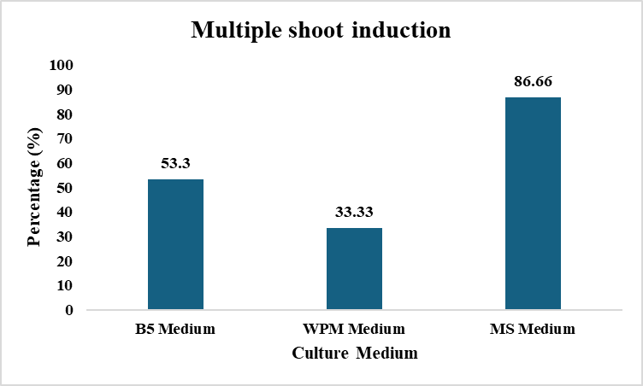
Figure 1: Effect of nutrient culture media on shoot induction in C. bhupenderiana.

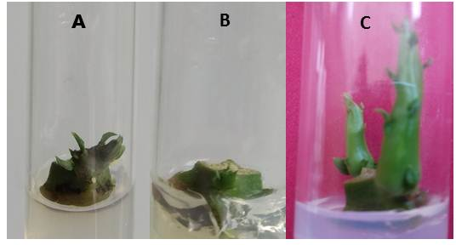

Figure 2: Effect of different types of media on Multiple shoot induction of Caralluma bhupenderiana A: B5 medium Multiple shoot induction (3 mg/l BAP), B: WPM medium shoot induction (3 mg/l BAP), C: MS medium shoot induction (3 mg/l BAP).

  - Multiple Shoot Induction
After two weeks, 80% shoot sprouting frequency was observed in MS + 3.0 mg/l BAP which exhibited an average of 4.66 ± 0.14 shoot number per explant and a mean length of 3.04 ± 0.11 cm, surpassing other concentrations. Whereas shoot sprouting frequency of 53.3 % was seen in Kn (3.0 mg/l) with maximum mean shoot number of 2.25 ± 0.16 per explant. The optimal mean length of the shoots (1.74 ± 0.07 cm) was noted in 2.0 mg/l Kn (Table 3, Figure 3 i & ii).
Optimal shooting response of C. bhupenderiana was observed from both the cytokinins (BAP, Kn) at the end of second week, which is considered as expeditious response. The shooting response parameters such as frequency, means of shoot number per explant and shoot length gradually increased simultaneously with the increase in BAP concentrations from 0.5 mg/l to 3 mg/l. But further rise in BAP to 4 mg/l hindered the shoot growth, indicating the BAP at higher concentrations will be ineffective in promoting the shoot response aligns with the research findings of Kanta Rani et al., (2011) in Catharanthus rouses and Ranganatha et al., (2024) in Hemidesmus indicus. Same trend was observed with the concentrations of Kinetin. However, the shooting response from BAP, resulted considerable high with respect to Kn. The effect of BAP>Kn corresponds with the previous studies on C. bhuphenderiana in vitro shooting from explants (Ugraiah et al., 2011).

Table 3: Influence of cytokinins on shoot sprouting and multiplication from nodal explants of C. bhupenderiana.

Plant growth regulator (mg/l) | Shoot sprouting frequency (%) | Mean shoot no. per explant ± SE | Mean length of shoots (cm) ± SE
BAP
0.5 | 46.6 | 1.85±0.14^{b} | 1.28±0.18^{c}
1.0 | 53.3 | 2.25±0.16^{b} | 1.62±0.12^{c}
2.0 | 60 | 2.44±0.17^{b} | 2.22±0.14^{b}
3.0 | 80 | 4.66±0.14ª | 3.04±0.11ª
4.0 | 66.6 | 1.8±0.13^{b} | 1.58±0.07^{c}
KN
0.5 | 33.3 | 0.80±0.20^{b} | 0.68±0.17^{c}
1.0 | 40 | 1.16±0.16^{b} | 1.61±0.10^{c}
2.0 | 46.6 | 1.71±0.18^{b} | 1.74±0.07^{b}
3.0 | 53.3 | 2.25±0.16^{b} | 1.56±0.11^{c}
4.0 | 40 | 1.33±0.21^{b} | 0.96±0.12^{c}

Means ± SE, n=45. Means followed by the same letter are not significantly different by the Tukey test at 0.05% probability level, NR - No response

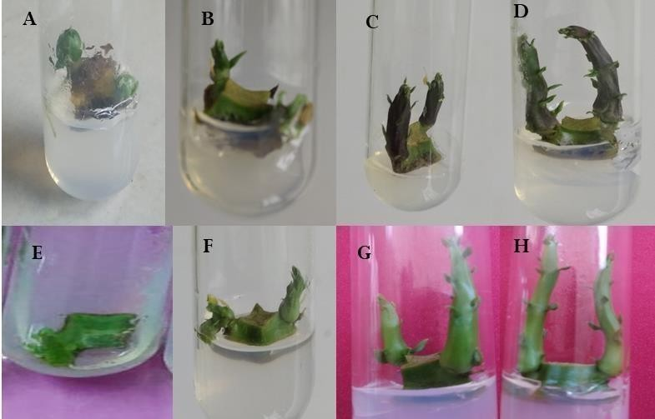
Figure 3 (i): Response of shoot induction under the influence of different cytokinins (BAP, Kn) for two weeks. A - D: Response of shoot induction on MS + 3 mg/l, Kn E- H: Response of Shoot induction on MS + 3mg/l BAP

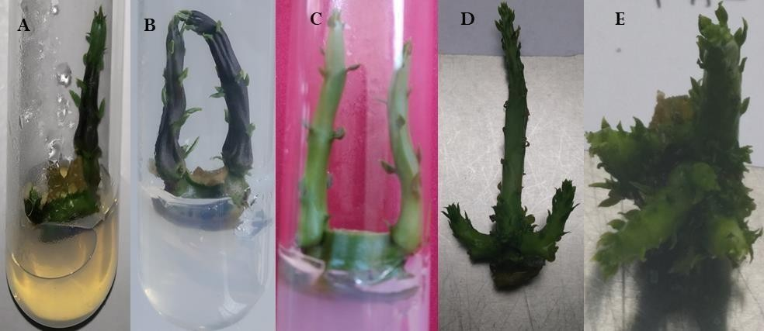
Figure 3 (ii): Individual effect of various concentrations of BAP and Kn on shoot formation in mature nodal explants of C.bhupenderiana cultured on MS medium for four weeks. A: MS+ 2 mg/l Kn, B: MS+3 mg/l Kn, C: MS+ 4 mg/l BAP, D- MS+ 2mg/l BAP, E: MS+ 3mg/l BAP.

The peak shoot sprouting frequency of 93.3% from the explants of C. bhupenderiana was recorded in MS + BAP (3.0 mg/l) + IBA (0.1 mg/l) with utmost mean number of shoots per explant (21.00 ± 0.07) and the highest mean shoot length of 6.75 ± 0.03 cm (Table 4, Figure 4D-H). The subsequent highest values of sprouting frequency were, 86.6%, 80% with mean shoot numbers of 7.92 ± 0.07, 8.91 ± 0.08 and mean shoot lengths 5.30 ± 0.10 cm, 6.14 ± 0.05 cm was observed in other auxins, IAA (0.1 mg/l) and IPA (0.1 mg/l) respectively (Table 5, Figure 5A-C). Meanwhile, other auxins, except 0.1 mg/l NAA (Table 4, Figure 4A) and 2,4-D (except 0.1 and 0.5 mg/l) (Table 5, Figure 5D) all other concentrations produced callus instead of shoot proliferation.
The complementation of auxin along with the cytokinin promoted the shoot response far better relative to cytokinin alone. The effect of auxins at low concentrations boosted the shooting response above 90%. Among the auxins supplemented, IBA exhibited the highest response in combination with BAP in multiple shoot induction. These results align with recent findings of Tripathi and Pal, (2023) and Shekhawat et al., (2016) in other Apocynaceae members, Rauvolfia serpentina and Hemidesmus indicus respectively. However, it contradicts with the results from the studies of Ugraiah et al., (2011).
Other auxins (IAA and IPA) also exhibited, inducing shoots to a noteworthy extent except NAA and 2,4-D. Where, both NAA and 2,4-D induced shoot response at low concentrations but induced callus formation as the concentration increased further. But these results contradict with other findings reported that BAP + NAA as best for shoot response in C. edulis (Patel et al., 2014), B. truncato- coranata (Kalimuthu et al., 2013), Carissa macrocarpa (Jassim, 2018) and BAP + 2,4-D in C. tuberculata from shoot tips (Rehman et al., 2014). On the other hand, the findings agree with reports of Kiranmai et al., 2015 where 2,4-D in combination with BAP boosts callus production. The order of shoot response for C. bhupenderiana is IBA > IAA > IPA > 2,4-D > NAA (auxins) in combination with BAP+ MS medium.

Table 4: In vitro response of different concentrations of BAP in combination with different concentrations of NAA and IBA on proliferation of shoot buds from mature nodal explants of C. bhupenderiana.
Plant growth regulators (mg/l) |  |  | Shoot sprouting frequency (%) | Mean shoot no. per explant ± SE | Mean length of shoots (cm) ± SE | Basal callusing
BAP | NAA | IBA
1 | 0.1 | - | - | CP CP CP CP  NR NR | CP CP CP CP  NR NR | +
1 | 0.5 | - | - | CP CP CP CP  NR NR | CP CP CP CP  NR NR | +
1 | 1.0 | - | - | CP CP CP CP  NR NR | CP CP CP CP  NR NR | ++
1 | 2.0 | - | - | CP CP CP CP  NR NR | CP CP CP CP  NR NR | +++
1 | - | 0.1 | - | CP CP CP CP  NR NR | CP CP CP CP  NR NR | -
1 | - | 0.5 | - | CP CP CP CP  NR NR | CP CP CP CP  NR NR | -
1 | - | 1.0 | 33.3 | 1.80 ± 0.20^{d} | 1.28 ± 0.11^{d} | -
1 | - | 2.0 | 20 | 0.66 ± 0.33^{d} | 0.56 ± 0.29^{d} | -
2 | 0.1 | - | 33.3 | 0.80 ± 0.33^{d} | 0.56 ± 0.29^{d} | -
2 | 0.5 | - | - | CP CP  CP | CP CP  CP | ++
2 | 1.0 | - | - | CP CP  CP | CP CP  CP | ++
2 | 2.0 | - | - | CP CP  CP | CP CP  CP | +++
2 | - | 0.1 | 86.6 | 12.15 ± 0.15^{b} | 6.73 ± 0.14ª | -
2 | - | 0.5 | 53.3 | 3.25 ± 0.16^{d} | 3.75 ± 0.14^{c} | -
2 | - | 1.0 | 40 | 2.33 ± 0.21^{d} | 3.75 ± 0.14^{d} | -
2 | - | 2.0 | 33.3 | 1.60 ± 0.24^{d} | 1.66 ± 0.10^{d} | -
3 | 0.1 | - | 33.3 | 2.40 ± 0.24^{d} | 2.26 ± 0.13^{d} | -
3 | 0.5 | - | - | CP CP CP | CP CP CP | +
3 | 1.0 | - | - | CP CP CP | CP CP CP | ++
3 | 2.0 | - | - | CP CP CP | CP CP CP | +++
3 | - | 0.1 | 93.3 | 21.00 ± 0.07ª | 6.75 ± 0.03ª | -
3 | - | 0.5 | 71 | 12.10 ± 0.11^{b} | 5.18 ± 0.07^{b} | -
3 | - | 1.0 | 62 | 5.60 ± 0.22^{c} | 3.98 ± 0.11^{c} | -
3 | - | 2.0 | 46 | 2.16 ± 0.16^{d} | 1.63 ± 0.16^{d} | -
Means ± SE, n = 45. Means followed by the same letter are not significantly different by the Tukey test at 0.05% probability level; -ve sign indicates no callusing, No. of +ve signs represent the intensity of callusing; NR- No response; CP - Callus production.
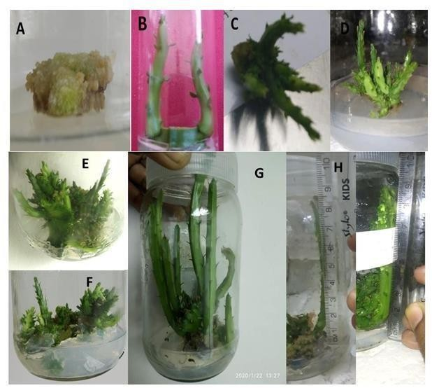
Figure 4: In vitro response of different concentrations of BAP in combination with different concentrations of NAA and IBA on proliferation of shoot buds from mature nodal explants of C. bhupenderiana. A: BAP (2 mg/l) + NAA (2 mg/l) – Proliferation of callus, B: Multiple shoot induction with BAP (1 mg/l) + IBA (1mg/l), C: BAP (2 mg/l) + IBA (0.5mg/l), D: BAP (3 mg/l) + IBA (0.1 mg/l) following subculture, E & F: BAP (3 mg/l) + IBA (0.1 mg/l) following 2 subcultures G & H: Shoots ready for rooting.

Table 5: In vitro response of different concentrations of BAP in combination with different concentrations of IAA, IPA and 2,4-D on proliferation of shoot buds from mature nodal explants of C. bhupenderiana.

Plant growth  regulators (mg/l) |  |  |  | Shoot sprouting frequency  (%) | Mean shoot no. per explant ± SE | Mean length of shoots (cm) ± SE | Basal callusing
BAP | IAA | IPA | 2,4-  D
1 | 0.1 |  |  | - | NR | NR | -
1 | 0.5 |  |  | 46.6 | 0.85 ± 0.14^{f} | 0.91 ± 0.04^{d} | -
1 | 1.0 |  |  | 40 | 1.16 ± 0.16^{f} | 0.81 ± 0.09^{d} | -
1 | 2.0 |  |  | 20 | 1.00 ± 0.00^{f} | 1.16 ± 0.16^{d} | -
1 | - | 0.1 |  | 60 | 3.22 ± 0.14e | 2.56 ± 0.12^{d} | -
1 | - | 0.5 |  | 53.3 | 1.75 ± 0.16^{f} | 1.56 ± 0.11^{d} | -
1 | - | 1.0 |  | 53.3 | 1.25 ± 0.16^{f} | 1.40 ± 0.15^{d} | -
1 | - | 2.0 |  | 33.3 | 0.80 ± 0.20^{f} | 0.76 ± 0.19^{d} | -
1 |  |  | 0.1 | 40 | 1.33 ± 0.21^{f} | 1.56 ± 0.10^{d} | -
1 |  |  | 0.5 | CP | CP | CP | ++
1 |  |  | 1.0 | CP | CP | CP | ++
1 |  |  | 2.0 | CP | CP | CP | +++
2 | 0.1 |  |  | 53.3 | 2.25 ± 0.16^{f} | 1.71 ± 0.06^{d} | -
2 | 0.5 |  |  | 66.6 | 5.10 ± 0.10^{d} | 3.43 ± 0.09^{d} | -
2 | 1.0 |  |  | 53.3 | 4.12 ± 0.12e | 2.97 ± 0.12^{d} | -
2 | 2.0 |  |  | 40 | 3.16 ± 0.16e | 2.50 ± 0.08^{d} | -
2 | - | 0.1 |  | 46.6 | 3.71 ± 0.18e | 2.80 ± 0.13^{d} | -
2 | - | 0.5 |  | 66.6 | 3.20 ± 0.13e | 2.64 ± 0.08^{d} | -
2 | - | 1.0 |  | 53.3 | 3.12 ± 0.12e | 2.10 ± 0.16^{d} | -
2 | - | 2.0 |  | 40 | 1.66 ± 0.21^{f} | 1.66 ± 0.06^{d} | -
2 |  |  | 0.1 | 46.6 | 1.71 ± 0.18^{f} | 1.45 ± 0.08^{d} | -
Means ± SE, n = 45. Means followed by the same letter are not significantly different by the Tukey test at 0.05% probability level; ‘-ve’ sign indicates no callusing, No. of ‘+ve’ signs represent the intensity of callusing; NR- No response; CP - Callus production.
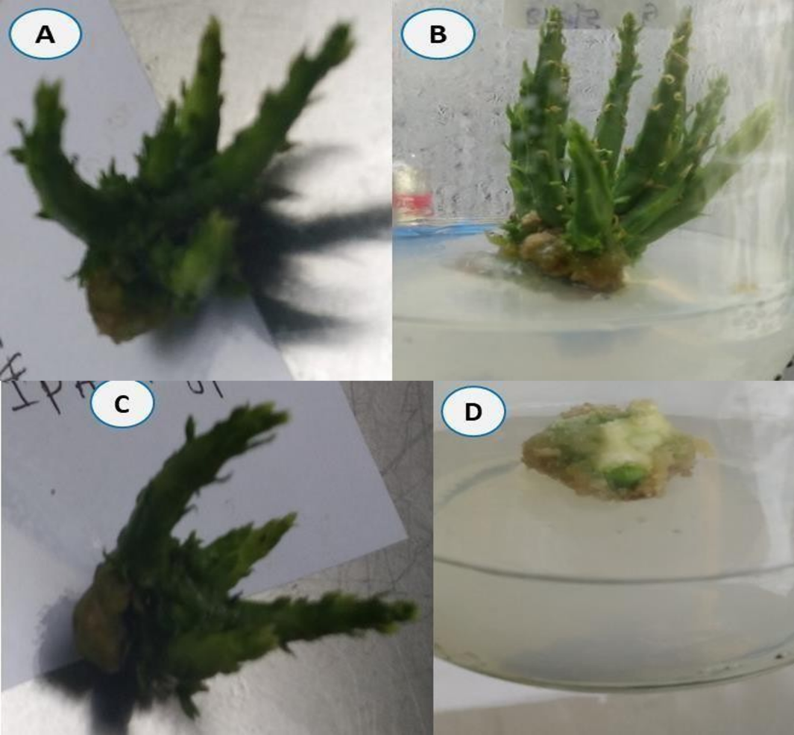

Figure 5: In vitro response of different concentrations of BAP in combination with different concentrations of IAA, IPA and 2,4-D on proliferation of shoot buds from mature nodal explants of C. bhupenderiana. A: MS +3 mg/l BAP + 0.1 IAA, B: MS + 3 mg/l BAP + 0.1mg/l IAA (after sub-culture), C: MS + 3 mg/l BAP + 0.1 mg/l IPA, D: MS + 2 mg/l BAP +0.5mg/l 2,4-D.

  - Rooting and Acclimatization
After three weeks of incubation, rooting was observed in all the three auxins (IAA, IBA and NAA) supplemented to the half-strength MS media. Among them, 100% rooting was shown by ½ MS + 0.1mg/l NAA (Figure 6) with the highest mean number of roots per shoot (12.06 ± 0.06) and the highest average root length (3.00 ± 0.02 cm). Next followed by 93.3% (0.2 mg/l NAA) and 86.6% (0.1 mg/l IAA, 0.2 mg/l IBA) of rooting frequency. The in vitro regenerated C. bhupenderiana plants got acclimated from the controlled conditions to the normal environment with 70% survival rate (Figure 7).
Auxins are most used for in vitro rooting. All the auxins promoted the root growth, notably NAA stimulated a 100% response compared to other auxins. These findings match with the results in Asclepiadaceae members like Decalepis hamiltoni (Reddy et al., 2001), Decalepis arayalpathra (Sudha et al., 2005), Caralluma adscendens (Aruna et al., 2009), Ceropegia intermedia (Karuppusamy et al., 2009), Caralluma tuberculata (Rehman et al., 2014).

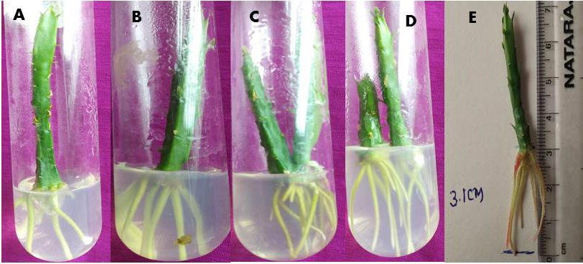
Figure 6: Rooting response of C. bhupenderiana in half strength MS medium supplemented with different concentrations of various auxins. A: 1/2 MS+ 0.1mg/l IAA, B: 1/2 MS+ 0.2 mg/l IBA, C: 1/2 MS+ 0.1 mg/l NAA D: 1/2 MS+ 0.2 mg/l NAA, E: Measurement of root length.

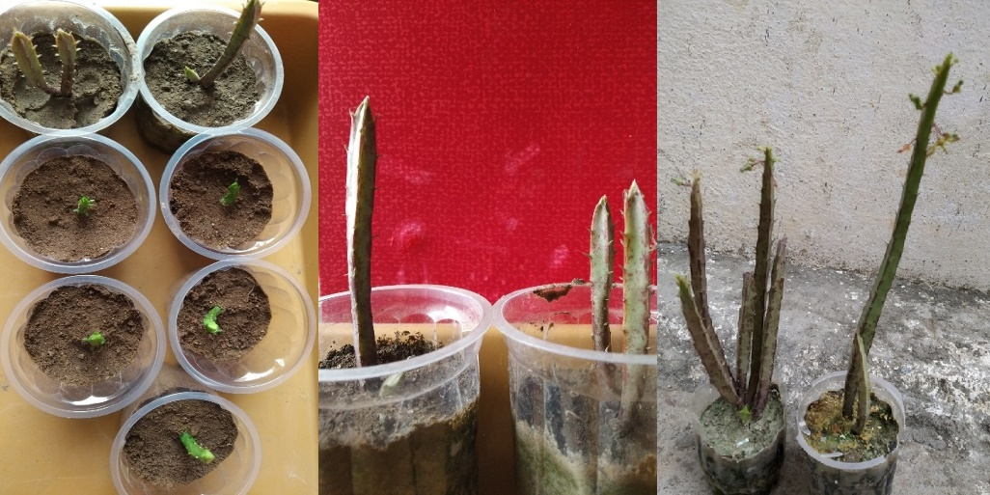
Figure 7: Acclimatization of in vitro grown C. bhupenderiana in small cups containing soil, sand and coco peat with 1:1:1 ratio for hardening.

- CONCLUSION
The current study highlights the in vitro propagation of Caralluma bhupenderiana. The optimized growth parameters will not only provide sustainable cultivation protocols but also ensure to preserve the valuable traits in the wild, while simultaneously supporting the commercialization of Caralluma species. Outputs from the present research will be a valuable resource for the conservation as well as propagation of C. bhupenderiana on a large scale which benefits commercial growers and herbal companies developing products out of Caralluma species.

DISCLAIMER (ARTIFICIAL INTELLIGENCE): Author(s) hereby declare that NO generative AI technologies such as Large Language Models (ChatGPT, COPILOT, etc.) and text-to-image generators have been used during the writing or editing of this manuscript.
CONSENT: Not applicable.
ETHICAL APPROVAL: Not applicable.

REFERENCES
Alodaini, H. A., Alarjani, K. M., Alkubaisi, N. A., Aziz, I. M., Alsayed, M. F., Almarfadi, O. M., ... & Aboul‐Soud, M. A. (2025). Caralluma tuberculata (Chongan): Chemical Profiling, Antioxidant, Anticancer, Antibacterial and Antidiabetic Potential supported by In Silico Evidence. ChemistrySelect, 10(13), e202405946.
Amrati, F. E. Z., Lim, A., Slighoua, M., Chebaibi, M., Mssillou, I., Drioiche, A., ... & Bousta, D. (2025). Unraveling the hepatoprotective and anti-pancreatic cancer potential of Caralluma europaea: a comprehensive in vivo, in vitro and in silico evidence. Drug and Chemical Toxicology, 48(1), 120-135.
Aruna, V., Kiranmai, C., Karuppusamy, S., & Pullaiah, T. (2009). Micropropagation of three varieties of Caralluma adscendens via nodal explants. Journal of plant Biochemistry and Biotechnology, 18, 121-123.
Aruna, V., Kiranmai, C., Karuppusamy, S., & Pulliah, T. (2012). Influence of aseptic seedling explants on in vitro shoot multiplication of Caralluma adscendens var. attenuate Wight. Afr J Plant Sci, 6, 290-294.
Bošnjak Mihovilović, A., Kereša, S., Lazarević, B., Topolovec Pintarić, S., Martinko, K., Marković, Z., ... & Habuš Jerčić, I. (2024). The Use of Sodium Hypochlorite and Plant Preservative Mixture Significantly Reduces Seed-Borne Pathogen Contamination When Establishing In Vitro Cultures of Wheat (Triticum aestivum L.) Seeds. Agriculture, 14(4), 556.
Chandana, B. C., Kumari Nagaveni, H. C., Lakshmana, D., Shashikala, S. K., & Heena, M. S. (2018). Role of plant tissue culture in micropropagation, secondary metabolites production and conservation of some endangered medicinal crops. J. Pharmacogn. Phytochem, 3, 246-251.
Gamborg, O. L., Miller, R., & Ojima, K. (1968). Nutrient requirements of suspension cultures of soybean root cells. Experimental cell research, 50(1), 151-158.
Gamborg, O. L., Murashige, T., Thorpe, T. A., & Vasil, I. K. (1976). Plant tissue culture media. In vitro, 12(7), 473-478.
George, E. F., Hall, M. A., & Klerk, G. J. D. (2008). Plant tissue culture procedure-background. In Plant Propagation by Tissue Culture: Volume (1), 1-28. Dordrecht: Springer Netherlands.
Gupta, S., Singh, A., Yadav, K., Pandey, N., & Kumar, S. (2022). Micropropagation for multiplication of disease-free and genetically uniform sugarcane plantlets. In Advances in plant tissue culture , 31-49). Academic Press.
Jassim, E. H. (2018). Micro propagation of Carissa macrocarpa L. plant in vitro. Plant Archives, 18 (2), 2412-2416.
Jesudass, J. S., Sivaprakasam, B., Kulanthaivel, S. R., Muthukrishnan, A., Chinnaiyan, R., Ramasamy, R., ... & Balasubramani, R. (2025). Computational Identification of Bioactive Molecules from Caralluma stalagmifera L. as Potential VEGFR2 Inhibitors for Endometriosis Treatment. Journal of Pharmaceutical Innovation, 20(1), 1-21.
Kalimuthu, K., & Prabakaran, R. (2013). Preliminary phytochemical screening and GC-MS analysis of methanol extract of Ceropegia pusilla. International Journal of Research in Applied, Natural and Social Sciences, 1(3), 49-58.
Kalimuthu, K., Sasikala, T., & Prabakaran, R. (2013). Regeneration of multiple shoot from callus in Boucerosia truncato-coronata (Sedw.) Gravely & Mayur. Int. J. Biotech. Res, 3(3), 53-60.
Kanta Rani, K. R., Pushpa Kharb, P. K., & Renu Singh, R. S. (2011). Rapid micropropagation and callus induction of Catharanthus rouses in vitro using different explants. CABI Databases, 699-704.
Karuppusamy, S., Kiranmai, C., Aruna, V., & Pullaiah, T. (2009). In vitro conservation of Ceropegia intermedia-an endemic plant of south India. African Journal of Biotechnology, 8(17).
Kiranmai, C., Aruna, V., & Pullaiah, T. (2012). In Vitro Propagation of Caralluma pauciflora by shoot tip culture. Journal of Tropical Medicinal Plants, 13(2).
Laxmi, G. V., & Dharmalingam, K. (2024). In Vitro Protocols for Micropropagation of Catharanthus roseus (L.) G. Don. Micropropagation of Medicinal Plants: Volume 2, 170.
McCown, B. H., & Sellmer, J. C. (1987). General media and vessels suitable for woody plant culture. In Cell and tissue culture in forestry: general principles and biotechnology (pp. 4-16). Dordrecht: Springer Netherlands.
Murashige, T., & Skoog, F. (1962). A revised medium for rapid growth and bio assays with tobacco tissue cultures. Physiologia plantarum, 15(3).
Pachipala, G., Vemula, R., Reddy, P. V. B., Karuppusamy, S., & Chadipiralla, K. (2023). In vitro Callus Regeneration of Caralluma bhupenderiana Sarkaria-An Endangered and Endemic Medicinal Plant. Current Trends in Biotechnology and Pharmacy, 17(3), 959-967.
Patel, A. K., Phulwaria, M., Rai, M. K., Gupta, A. K., Shekhawat, S., & Shekhawat, N. S. (2014). In vitro propagation and ex vitro rooting of Caralluma edulis (Edgew.) Benth. & Hook. f.: an endemic and endangered edible plant species of the Thar Desert. Scientia Horticulturae, 165, 175-180.
Ranganatha, M., Sharma, A., Rangaswamy, B. E., Kumar, S., & Rao, N. N. (2024). Direct regeneration and genetic transformation studies in Hemidesmus indicus (L.) R. Br.(Indian Sarsaparilla). Plant Cell, Tissue and Organ Culture (PCTOC), 158(1), 2.
Ratcliffe, S. & Darbyshire, I. 2024. Caralluma wilhelmii. The IUCN Red List of Threatened Species 2024: e.T220978582A221000441. https://dx.doi.org/10.2305/IUCN.UK.2024-1.RLTS.T220978582A221000441.en. Accessed on 06 April 2025.
Ratnam, D. P. S. K. (2021). Studies on phytochemical, antimicrobial activity and micro propagation of medicinal plants from Eastern Ghats of Andhra Pradesh. Asian Journal of Pharmacy and Technology, 11(2), 111-115.
Reddy, B. O., Giridhar, P., & Ravishankar, G. A. (2001). In vitro rooting of Decalepis hamiltonii Wight & Arn., an endangered shrub, by auxins and root-promoting agents. Current science, 1479-1482.
Rehman, R. U., Chaudhary, M. F., Rizvi, Z. F., HAQ, I. U., & Zia, M. (2014). In vitro propagation of chungah (Caralluma tuberculata NE Brown). Pak J Bot, 46(6), 2189-94.
Rehman, R. U., Chaudhary, M. F., Rizvi, Z. F., HAQ, I. U., & Zia, M. (2014). In vitro propagation of chungah (Caralluma tuberculata NE Brown). Pak J Bot, 46(6), 2189-94.
Shekhawat, M. S., & Manokari, M. (2016). In vitro regeneration frequency, micro-morphological studies and ex vitro rooting of Hemidesmus indicus (L.) R. Br.: a multi-potent endangered climber. Indian Journal of Plant Physiology, 21, 151-160.
Singh, J. P., Kumar, S., Venkatesan, K., & Kulloli, R. N. (2016). Conservation status and utilization of Caralluma edulis: an important threatened medicinal plant species of the Thar Desert, India. Genetic Resources and Crop Evolution, 63, 721-732.
Sudha, C. G., Krishnan, P. N., Pushpangadan, P., & Seeni, S. (2005). In vitro propagation of Decalepis arayalpathra, a critically endangered ethnomedicinal plant. In Vitro Cellular & Developmental Biology-Plant, 41, 648-654.
Tripathi, N., & Pal, R. J. (2023). Micropropagation Of Medicinal Plant Sarpagandha (Rauwolfia Serpentina) Invitro. World Journal of Pharmaceutical Research, 12(15), 1200-1212.
Ugraiah, A., Sreelatha, V. R., Reddy, P. K., Rajasekhar, K., Rani, S. S., Karuppusamy, S., & Pullaiah, T. (2011). In vitro shoot multiplication and conservation of Caralluma bhupenderiana Sarkaria-an endangered medicinal plant from South India. African Journal of Biotechnology, 10(46), 9328-9336.

