Type of Article: Original Research Article.

IMPACT OF GLOBAL CLIMATE CHANGE IN THE DISTRIBUTION AND THE RANGE
DYNAMICS OF ENDEMIC ORCHID (Habenaria suaveolens) Dalzell IN NORTHERN WESTERN GHATS OF INDIA

Abstract
Climate change and human activity have significantly contributed to the decline of biodiversity worldwide. Orchids, in particular, are sensitive to disturbances and may respond rapidly to the impacts of climate change than many other plant species. Due to their complex biology and the pressures placed on their habitats, orchids are considered a highly vulnerable group of plants. The lateritic plateaus of northern Western Ghats support a variety of life forms and are quite fragile in nature. The slightest pressure on the habitat affects all the flora and fauna thriving in these microhabitats. Habenaria suaveolens is one of the endemic orchids that can be found growing in these habitats only. In the present study, we examine the effect of climate change on the distribution of three threatened H. suaveolens utilizing ecological niche modeling for present and future climatic scenarios (SSP 245 & SSP 585) to identify key environmental determinants and population parameters. A total of 26 occurrence records were used to study the SDM model using the MIROC6 global climatic model. The result revealed that only 19.50% (7921 km²) is highly suitable for the species in the current period. The highly suitable area reduces from 57.99% (SSP245) to 74.12% (SSP585) in 2090. Moreover, the total suitable habitat gets confined to less than 1000 km² in future climatic conditions. The major environmental variable that predicts the distribution of the species are Bio17 (Precipitation of driest quarter), Bio1 (Annual Mean Temperature), Bio2 (Mean Diurnal Range), and aspect. Recently, the species is becoming less in population due to man-made activities like grazing, trampling, quarrying, tourism, etc., in and around the lateritic plateaus, leading to disturbances in the habitat. This study has provided a baseline data about the contiguous distribution of the species and its potentially suitable habitats in the future for conservationists to take precautionary steps for the protection of the species. Hence, a strategic plan can be compiled based on this to conserve these highly habitat specific plants.
Keywords: Ecologically Suitable Habitat, Endemic, H. suaveolens, MaxEnt, Western Ghats.

INTRODUCTION
Climate change coupled with anthropogenic activities negatively affect the biodiversity of both flora and fauna [1]. The “flat table top hills” or commonly known as lateritic plateaus, are known for their complex life forms and constitute a microhabitat for a wide variety of plants and animals. These plateaus harbour a large endemism and have been recently subjected to immense pressure due to several man-made activities [2]. These changes pose a significant threat to the region’s biodiversity. To safeguard these biodiversity rich sites and stimulate regional economic growth, it is crucial to grasp the intricate relationship between species distribution and climate change. By deepening our understanding of how climate impacts the habitats of various species, we can pinpoint potential areas in a changing environment. This insight will empower us to craft innovative and adaptive conservation strategies that not only preserve our natural treasures but also enhance the livelihoods of communities that depend on them.
Species distribution Modeling (SDM) has developed over the last 30 years as a widely used tool used conservation assessment and projecting future global change impacts [3]. It uses the

combination of species presence data with characteristics such as bioclimatic, edaphic, topographic, and other parameters [4, 5, 6]. Among various SDM algorithms, the Maximum Entropy (MaxEnt) model [7] combines machine learning and maximum entropy principles to predict the potential distribution areas of species [8]. It is one of the most popular and widely used model in niche modeling in various studies.
Habenaria suaveolens Dalzell., (Fig.1) is an endemic orchid found in the Northern Western Ghats, specifically on lateritic rocky plateaus [9]. It grows 8–27 cm tall and has an ovoid-oblongoid tuber (1.5–2 cm) with fleshy roots. The plant features 3–5 subradical, oblong-lanceolate leaves. The flower spike is 5–8 cm long, with 3–5 white, faintly fragrant flowers arranged secund or sub-secund. The spur is 8–10 mm long, slightly bent at the base, and subclavate at the apex, white at the base and turning greenish towards the top. It is a highly variable species with regard to the size of the plant and the shape of the lip [10,11]. The natural distribution of H. suaveolens is very narrow; it is distributed in some limited lateritic rocky plateaus of Goa, Karnataka, and Maharashtra states. These unique plateaus have a narrow range in the (WGs) and provide unique micro-environments to this species. These plateaus look reddish in colour due to a high composition of oxides of iron and aluminium. The soil cover is very thin on the plateaus and appears almost barren during winter and summer seasons. The early phase of the monsoon starts in June when the vegetative growth of this plant starts. The climax flowering season was observed from the end of July to the beginning of September.
This study specifically aims to (1) to know the current population status in different lateritic plateaus, (2) identify the most critical environmental variables affecting the distribution of the species and (3) predict current and future suitable habitats for H. suaveolens under climate scenarios. The findings of the study will be useful in developing conservation and management measures for H. suaveolens in Northern WGs of India. The research goal is to provide deeper insights for the conservation and management of H. suaveolens.
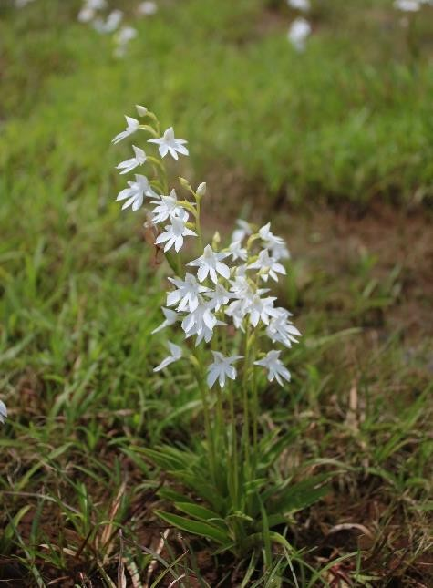
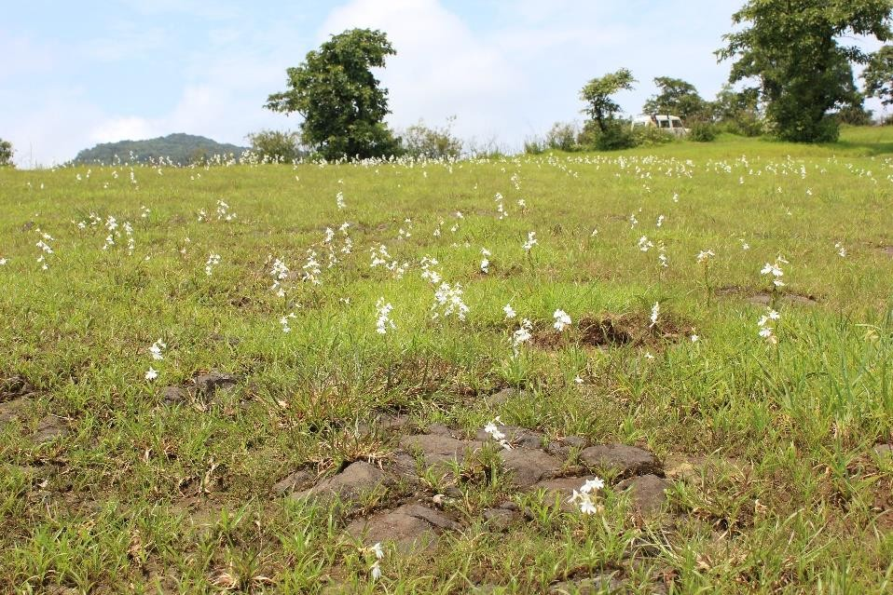
A
B

Fig. 1: Habenaria suaveolens (A) flowering stage, (B) Habitat.

MATERIALS AND METHODS

Species Data
In this study, occurrence records of H. suaveolens were collected mainly from field surveys during 2012 to 2024, herbarium records (BSI, BLAT, SUK), and literature surveys [9]. These occurrence records were mainly from, Ahmednagar district (Kalsubai Hill), Ratnagiri district (Gothane plateau), Satara district (Mahabaleshwar, Panchgani, Kaas plateau, Thoseghar), Kolhapur district (Barki, Morjai, Radhanagari, Ambolighat- Ramghat road, Pargad Road), Sindhudurg district

(Vengurla, Malvan); Goa (Surla) and Karnataka [9]. Geo-coordinates were assigned for the occurrences that lacked the latitude and longitude.

Population Assessment
To assess the population status of the species in lateritic plateaus, a rapid sampling was also done in the twelve sites. These sites were located in elevations ranging between 600 and 1400 meters. Random sampling was conducted within these plateaus. We laid a maximum of 20 quadrats at each site of a 1 × 1 m size. A total of 240 quadrats were laid in different sites. In each plateau, four quadrats were laid in four directions (east, west, north, and south), and an additional four quadrats were laid at the centre of the plateau. A five-meter distance was maintained between the two quadrats. The total number of individuals of H. suaveolens and its associated species was recorded in each 1 × 1 m quadrat. From these counts, the density, frequency, and abundance were calculated for each site [12,13]. Species distribution pattern within the study area was analysed using abundance/frequency (A/F) ratio, where the ratio of A/F<0.025 refers to regular distribution, 0.025 to 0.050 as random distribution, and >0.050 as contiguous [14,15].

Environmental Variables & Future Climatic Scenario Data
The environmental variables were downloaded from WorldClim version 2.1 (www. worldclim.org/data/worldclim21.html, released in January 2020), with 30 30-second spatial resolutions, which include 19 bioclimatic variables. Along with these 3 topographical variables, i.e., aspect, elevation & slope, were also used [16]. Digital Elevation Model (DEM) (www.earthdata.nasa.gov) of 30m resolution was used to generate the topographic layers. Pearson’s correlation test was used to eliminate overfitting of the model. Finally, 10 variables with ≥0.8 were used for the model running (Table 1). The current climate was represented by historical climate data from 1970 to 2000, and future environmental variables corresponding to the recent period were divided into four periods with a 20–year interval from 2021 to 2100 to predict the future potential distribution of H. suaveolens under two shared socioeconomic pathways (SSPs): 245 and 585. These SSP scenarios are the updated versions of RCP scenarios. The MIROC6 (Model for Interdisciplinary Research on Climate) Global Climate Model (GCM) was used for the analysis.
Table 1. Bioclimatic & Topographic variables (≥0.8) used in ENM analysis.

Code | Environmental variables | Units
Bio1 | Annual Mean Temperature | C̊
Bio2 | Mean Diurnal Range | C̊
Bio3 | Isothermality (Bio2/Bio7) (x 100) | -
Bio12 | Annual precipitation | mm
Bio14 | Precipitation of driest month | mm
Bio17 | Precipitation of driest quarter | mm
Bio18 | Precipitation of warmest quarter | mm
Bio19 | Precipitation of coldest quarter | mm
Topographical variables
Aspect |  | ᵒ
Slope |  | %

Model building and validation
MaxEnt software (version 3.4.1) was used in this study to generate a model for the potential distribution of H. suaveolens since it has a better modeling effect even when there are fewer occurrence records [7]. In the present study, we employed the maximum entropy model (MaxEnt version 3.3.3) due to its demonstrated superior performance with small sample sizes compared to other modeling methods. The maximum number of background points was kept at 10000, . To reduce model overfitting and over-prediction, regularization multiplier value was set to 0.1 [7], with 5000

iterations, and the rest of the values were kept as default. In our model, we selected 75% geo- coordinates for model training and 25% for model testing, keeping other values as default. The model was replicated 10 times using subsampling techniques. Jackknife analyses were performed to determine variables that reduce the model's reliability when omitted. Partial Receiving Operator Curve (AUC) to evaluate model performance, and it indicates the stability of the model. The AUC values vary from 0 to 1. 0.5 shows model performance not better than random, values <0.5 indicate worse than random, 0.5-0.7 good, 0.7-0.9 better, and >0.9 as excellent performance [17]. Further, the prediction results were analysed using ArcGIS 10.2.2. The habitat suitability map was divided into 3 levels i.e. unsuitable habitat, poorly suitable, and highly suitable, using the natural breaks (Jenks) in the suitability probabilities.

RESULTS
H. suaveolens is found growing at an elevation between 600-1400 m in the lateritic plateaus of northern WGs. The population study was conducted in different areas of Maharashtra & Goa. Among the surveyed sites, Pargad Road (Kolhapur) had the highest species density frequency i.e. 7.1±2.03 individuals/m² and 65% respectively; whereas the Panchgani Plateaus had the lowest species density with 0.4±0.19 individuals/m². The lowest frequency was found for Surla Sada (North Goa) with 15%. Contiguous distribution was found in all the population sites as indicated by A/F ratio (Table 2). The species coexists with a variety of other orchid species, including Habenaria grandifloriformis Blatt. & McC., H. heyneana Lindl., H. rariflora A. Rich., and Peristylus densus (Lindl.) Santapau & Kapadia. Additionally, it associates with several other angiosperm species, such as Aponogeton satarensis Sundararagh., A.R. Kulk. & S.R. Yadav, Cyanotis tuberosa Schult. & Schult.f., Dipcadi ursulae var. ursulae, Eriocaulon minutum Hook.f., E. sedgwickii Fyson, Murdannia lanuginosa (Wall. ex C.B. Cl.) Brueck., Senecio belgaumensis C.B. Clarke, Utricularia albocaerulea Dalz., Utricularia lazulina P. Taylor, and Rotala malampuzhensis Nair ex C.D.K. Cook. In addition to these species, common grasses such as Dimeria spp., Dichanthium spp., and Ischaemum spp. were also observed in the habitats.

Table 2. Availability of H. sauveolens in different lateritic plateaus of Northern WGs.

State | District | Locality | Elevatio n (m) | Density (D/m²) | Frequenc y | Abundanc e | A/F Ratio
Maharashtr a | Satara | Vanna  lake_1 | 1400 | 2.8±0.84 | 50 | 5.5 | 0.11
Maharashtr a | Satara | Vanna  lake_2 | 1400 | 1.3±0.40 | 45 | 2.8 | 0.061  7
Maharashtr a | Satara | Panchgani_  1 | 1290 | 0.4±0.19 | 20 | 1.8 | 0.087  5
Maharashtr a | Satara | Panchgani_  2 | 1290 | 0.7±0.23 | 35 | 1.9 | 0.053  1
Maharashtr a | Kolhapur | Laxmi dam Radhanaga  ri | 1140 | 3.0±1.0 | 45 | 6.6 | 0.145  7
Maharashtr a | Kolhapur | Pargad road_1 | 700 | 7.1±2.03 | 65 | 10.9 | 0.168
Maharashtr a | Kolhapur | Pargad  road_2 | 700 | 7.0±1.45 | 65 | 10.7 | 0.164  5
Maharashtr a | Kolhapur | Tilari  site_1 | 600 | 3.1±1.20 | 55 | 5.6 | 0.102  5
Maharashtr a | Kolhapur | Tilari  site_2 | 600 | 3.1±0.82 | 55 | 5.6 | 0.102  5

 | Sindhdurg h | Jalvadi- Chaukaul_  1 | 690 | 1.9±0.87 | 30 | 6.3 | 0.211  1
 | Sindhdurg h | Jalwadi-  Chaukaul_ 2 | 690 | 1.7±0.72 | 30 | 5.5 | 0.183  3
Goa | North  Goa | Surla sada | 700 | 0.6±0.38 | 15 | 3.7 | 0.244  4
A total of 25 locations were used for model running. The average test for AUC value is 0.881 with a standard deviation of 0.115 (Fig. 2). The outcome of the jackknife test provides information on the key environmental variables in the distribution of the species. Environmental variables like Bio17 (Precipitation of driest quarter), Bio1 (Annual Mean Temperature), Bio2 (Mean Diurnal Range), and aspect contribute 85.7% towards the distribution of the species. Furthermore, 14.3% is contributed by remaining variables i.e. slope, bio3 (Isothermality (Bio2/(Bio7 × 100)), bio18 (Precipitation of Warmest Quarter), bio19 (Precipitation of Coldest Quarter) & bio14 (Precipitation of Driest Month)(Table 3, Fig. 2). This suggests that precipitation and temperature are the major climatic factor that determines the distribution of H. suaveolens in the WGs of India.

Table 3: Importance of each dominant environmental variable in the MaxEnt Model.

Variable | Description | Contribution (%)
bio17 | Precipitation of driest quarter | 62.1
bio1 | Annual Mean Temperature | 10.8
bio2 | Mean Diurnal Range | 7.3
aspect | Aspect | 5.5
slope | Slope | 4.3
bio3 | Isothermality (Bio2/Bio7) (x 100) | 4.1
bio18 | Precipitation of warmest quarter | 3.8
bio19 | Precipitation of coldest quarter | 1.8
bio14 | Precipitation of driest month | 0.3

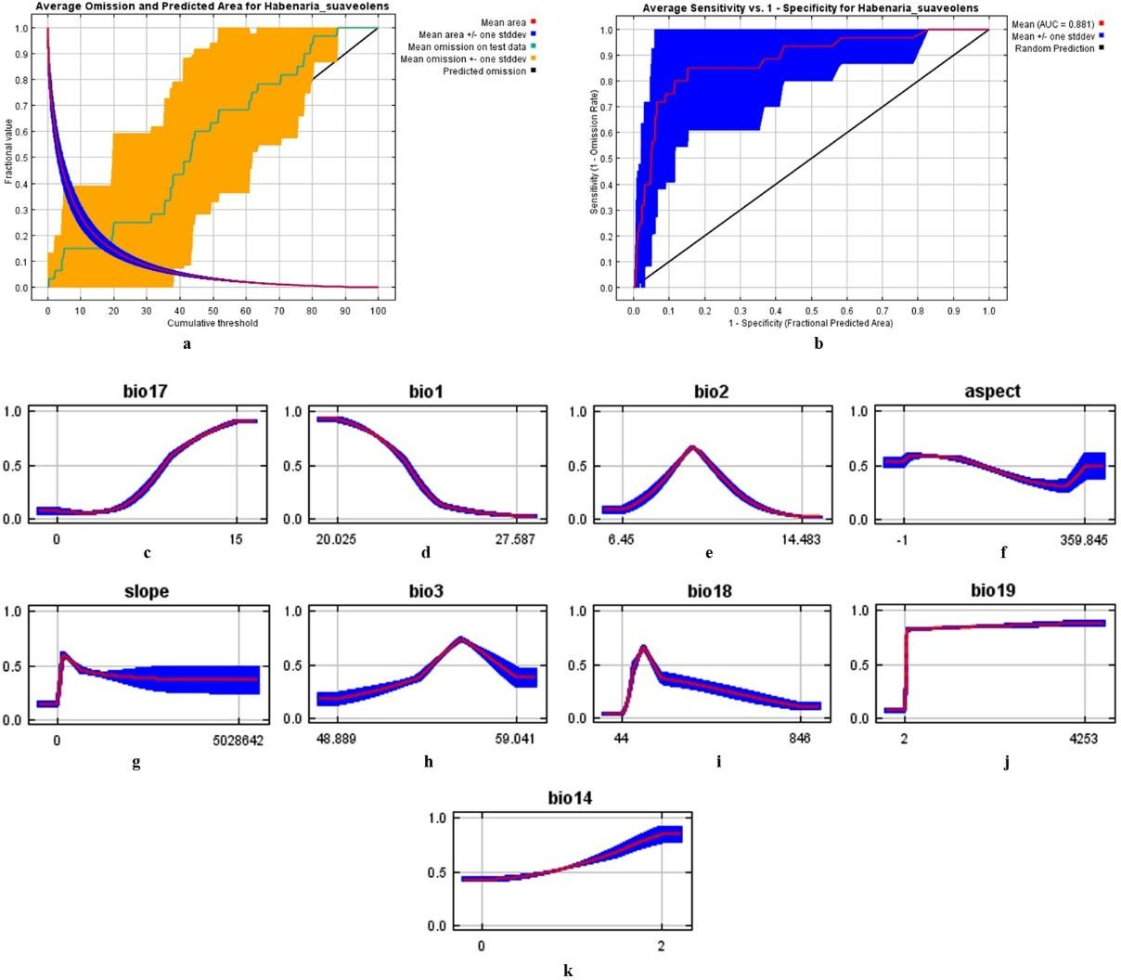

Fig.2: Validation of current climate model of H. suaveolens, (a) Omission Rate, (b) ROC Curve, (c- k) Response curves of different environmental & topographic variables.
The potential distribution of the species is found to be located in the northern WGs of India. These regions which are highly suitable for the plant includes the lateritic plateaus of Maharashtra & Karnataka. These regions were divided into 3 categories with the help of ArcGIS 10.2.2. They are Unsuitable, Poorly Suitable, and Highly Suitable. Under current climatic conditions, total suitable habitat was predicted to be 7921 km², out of which only 29. 91% (2369 km² belongs to highly suitable area and 70.08% (5551 km²) as poorly suitable area. The total area of suitability is 19.50% of the entire area of northern WGs (Figure 3). The future potential distribution of the species was calculated under two SSP scenarios for the years 2021-2040 (2030), 2041-2060 (2050), 2061-2080 (2070),
2081-2100 (2090). In SSP2-45 (2030-2090) scenarios, the highly suitable area decreases by 32.67% to 57.99%, whereas in the case of the poorly suitable area, the area decreases by 3.56% to 18.77%.Moreover, the total suitability area decreases by 2422 km² (30.57%) in 2090. A major change can be found in the case of SSP5-8.5. The high and poor suitable area decreases by 37.31% to 74.12% & 2.77% to 22.15% from 2030-2090. Furthermore, the total suitable area shifts from -13.11% to - 37.70% in 2030-2090 (Table 4; Figure 3 & 4).

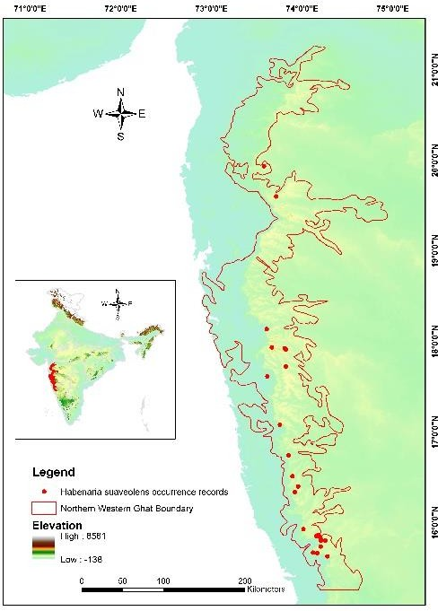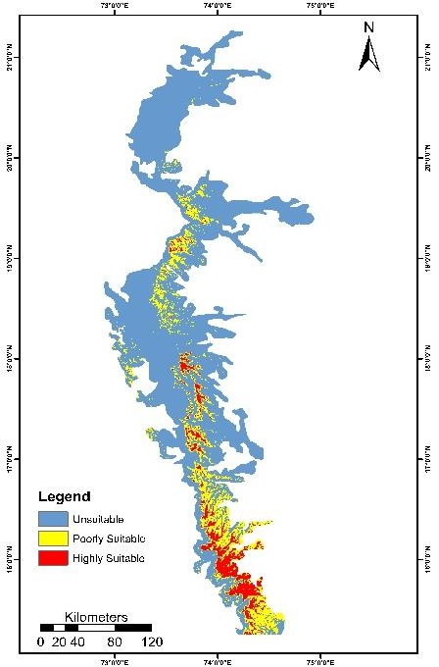
A
B

Fig. 3: (A) Occurrence records of H. suaveolens in northern WGs, (B) Predicted current distribution of the species in northern WGs.
In 2100, the area of suitability will change significantly and will be concentrated more in the South of Northern WGs towards Karnataka & Goa. More specifically, districts like Satara (Mahabaleswar, Panchghani, Kas Plateau), Kolhapur (Chandgad, Tilari, Pargad), Goa (Surlasada), and Belgaum ( Kankumbi, Chigul) possess suitable habitat for H. suaveolens and will be more suitable in the future (Figure 5). The protected areas will face a loss of suitable habitat in both scenarios. However, protected areas alone cannot support all species affected by climate change. Much habitat now exists in landscapes primarily dominated by human activities [18]. On the contrary, a little bit of gain in the suitable habitat can be seen in some parts of the WGs, such as Hatgad (Nasik), Kalsubai Wildlife Sanctuary, Harischandgad (Ahmadnagar), Phansagad (Raigarh), Saputara (Dang, Gujarat) will become suitable for the species.
Table 4: MaxEnt predicted area of suitability in northern WGs

Area | Curr ent | 2030 |  | 2050 |  | 2070 |  | 2090
Area | Curr ent | SSP2- 4.5 | SSP5- 8.5 | SSP2- 4.5 | SSP5- 8.5 | SSP2- 4.5 | SSP5- 8.5 | SSP2- 4.5 | SSP5- 8.5
Highly suitable  Area (km²) | 2369 | 1595 | 1485 | 1390 | 1248 | 1139 | 746 | 995 | 613
Poorly suitable  Area (km²) | 5551 | 5353 | 5397 | 5087 | 4266 | 4579 | 4262 | 4504 | 4321
Total Suitable | 7921 | 6948 | 6882 | 6477 | 5514 | 5718 | 5008 | 5499 | 4934
Area (km²) |  | (12.28 | (13.11 | (18.23 | (30.38 | (27.81 | (36.77 | (30.57 | (37.70
(% Change) |  | ) | ) | ) | ) | ) | ) | ) | )

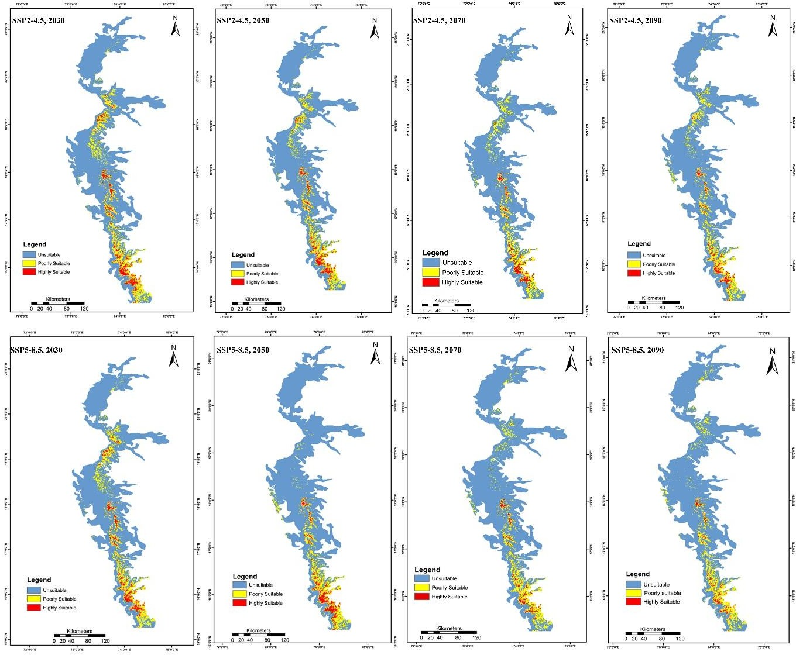
Fig.4: Potential distribution of H. suaveolens in northern WGs in different climatic scenarios.

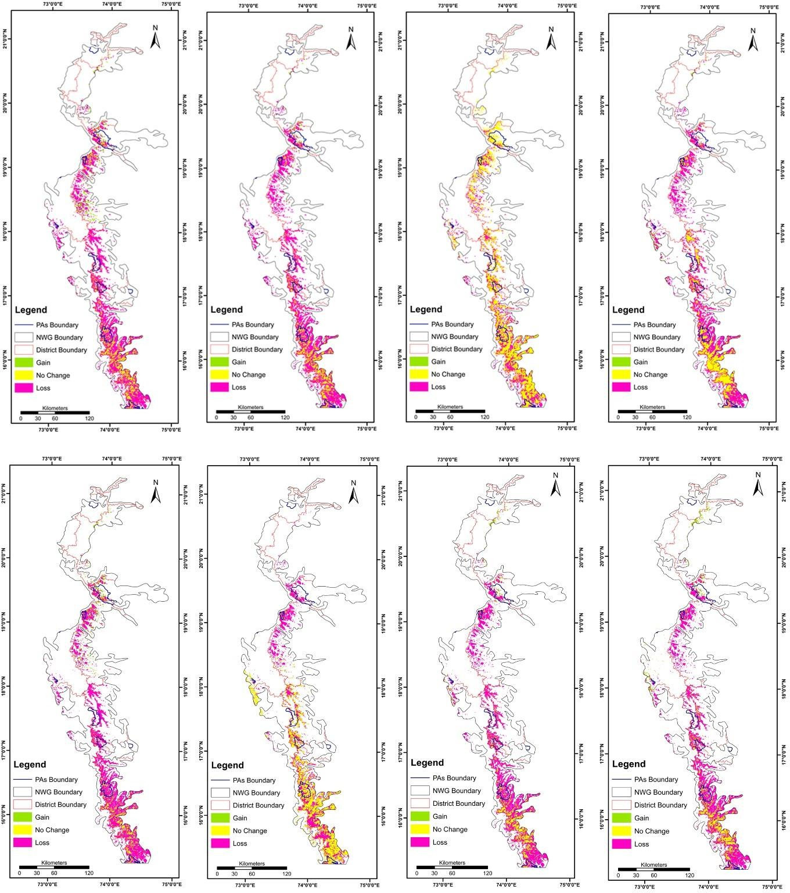
Fig.5: Predicted range change in case of H. suaveolens in northern WGs.

DISCUSSION
The distribution of H. suaveolens is restricted to the northern WGs of India. It is predominantly found on the lateritic plateaus in the higher regions of the WGs, which provide unique micro- environments conducive to its growth and regeneration [9]. These plateaus are rare and are often isolated, earning them the name "terrestrial islands" [19]. The soil on these plateaus is shallow, making the area appear almost barren during the winter and summer months. However, as the monsoon begins in June, the plant enters its active vegetative growth phase [11]. In the past, this plant thrived abundantly in regions like Panchgani, Changgad, and Satara, where it contributed richly to the local ecosystem. However, due to severe anthropogenic pressures, such as the surge in tourism,

soil trampling by visitors, extensive quarrying, uncontrolled grazing by livestock, and rapid developmental activities, the species has become increasingly rare in these once-thriving habitats [20]. The population analysis study reveals a higher density of the species between 600-700 m. The population density of the species varies from 0.4±0.19 to 7.1±2.03 ind./m^{2,} and the distribution pattern is contiguous throughout the study area, highlighting the species' reliance on specific microhabitats, seasonal changes, and reproductive processes [21]. In short, the observed low population density and contiguous distribution pattern of the plant indicate both its limited availability and endangered status within the study area. Therefore, this species is at a significantly heightened risk of extinction [22]. In order to mitigate the extinction risk, the species was added to the CITES and also protected under the Wildlife Protection Act (1972). Besides, in some localities such as Kas Plateau, a UNESCO Heritage Site, the species is under protection. Similarly, Mahabaleshwar and Panchgani table land area was declared as an eco-sensitive zone by the government of India in 17th July 2001, and imposes restrictions on industries, operations, processes and other developmental activities in the region that have a detrimental effect on the environment. Moreover, Thakur and Dongarwar (2022) [23] pioneered protocols to tackle the regeneration challenges of Habenaria panchganiensis (=H. suaveolens) by facilitating early asymbiotic germination of its seeds using cytokinin in various culture media. To ensure the protection of this species and foster its thriving in its natural habitat, it is imperative to conduct further research on micropropagation. Additionally, effective site-specific habitat management must be prioritized for successful ex-situ conservation.
Our study predicts the current and future habitat suitability of the endemic orchid H. suaveolens in India. 25 valid occurrence points were used to build the model. The AUC value of 0.881 indicates the fitness of the model between the environmental variables and the suitable habitats. The jackknife test indicates that H. suaveolens is very sensitive to any slightest changes in Precipitation of Coldest Quarter (Bio19), Annual Mean Temperature (Bio1), Precipitation of Driest Quarter (Bio17), Mean Diurnal Range (Mean of monthly (max temp - min temp)) (Bio2). Under current climatic conditions, the suitable habitat majorly covers Satara, Kolhapur, and Raigarh districts of Maharashtra and the border areas of Goa & Karnataka. However, the model predicts new suitable habitat in Pune district (Mulshi, Mave, Junnar, Valhe, Khed, Ambegaon), Belgavi (Bhimgad WLS, Chapoli, Amgaon), Uttar Kannada (Amgaon). In the future, the suitable habitat will shift towards the northern parts of the study area, including small stretches of Maharashtra and Gujarat. It may be due to the climatic shift towards higher precipitation and temperature in the changing scenarios. Based on our model prediction the the habitat suitability of H.suaveolens may decrease drastically. The majority of the current suitable areas will become unsuitable, but certain areas will become suitable under the changing climatic scenarios. In both scenarios, the highly suitable area will decline and will become confined to less than 1000 km². Previous studies by Jalal & Singh (2017)[9] correlate with our study regarding the current distribution of the H. suaveolens in WGs of India. In summary, the predictions generated by MaxEnt hold great promise for uncovering additional locations where the species may thrive, even if they have not yet been documented. These newly identified suitable areas unveil exciting opportunities for the species to expand its reach and flourish in newer habitats.

CONCLUSION
In this study, we employed an optimized version of MaxEnt to explore the dynamic shifts in the distribution pattern of H. suaveolens across both recent and future periods. Furthermore, we ventured to predict potential suitable habitats under a variety of future scenarios, shedding light on this species' adaptability in an ever-changing world. The results highlight a significant reduction in the distributional area under both SSP245 & SSP585 scenarios. The study also provides comprehensive information on population density, distribution of the species, which will help

conservationists in protecting the species. In summary, it is crucial to conserve the species in its suitable habitat as well as focus on the development of protocols for ex-situ conservation.

ACKNOWLEDGMENTS
The authors express their gratitude to the Director of the Botanical Survey of India. Authors also extend their thanks to the Ministry of Environment, Forest and Climate Change, Govt. of India for financial assistance. The authors are also grateful to the curators and in-charges of BSI, BLATT & SUK for their assistance during the herbarium consultation process.
- COMPETING INTERESTS: The authors declare no conflict of interest.
- AUTHORS’ CONTRIBUTIONS: All authors contributed equally to the conceptualization, methodology, data collection, analysis, writing, and review of the manuscript. All authors read and approved the final manuscript.
- Declaration
All authors have agreed to the manuscript's submission to the Journal of Global Ecology and Environment. The authors confirm that the manuscript is original, has not been submitted or published elsewhere, and does not infringe on any copyright or intellectual property rights.
Disclaimer (Artificial intelligence)
Option 1:
Author(s) hereby declare that NO generative AI technologies such as Large Language Models (ChatGPT, COPILOT, etc.) and text-to-image generators have been used during the writing or editing of this manuscript.
Option 2:
Author(s) hereby declare that generative AI technologies such as Large Language Models, etc. have been used during the writing or editing of manuscripts. This explanation will include the name, version, model, and source of the generative AI technology and as well as all input prompts provided to the generative AI technology
Details of the AI usage are given below:
1.
2.
3.

REFERENCES
- Vignesh, A., Menaka, C., Amal, T.C. & Vasanth, K. (2024). Plant ecosystems and sustainable development in the Western Ghats, India. Journal of Ecology, 2(2), 1-4.
- Watve, A. (2013). Status review of Rocky plateaus in the northern Western Ghats and Konkan region of Maharashtra, India with recommendations for conservation and management. Journal of Threatened Taxa, 5(5), 3935-3962
- Franklin, J. (2023). Species distribution modelling supports the study of past, present and future biogeographies. Journal of Biogeography, 50, 1533–1545. https://doi.org/10.1111/jbi.14617
- Cotrina Sánchez, A., Rojas Briceno, N.B., Bandopadhyay, S., Ghosh, S., Torres Guzman, C., Oliva, M., Guzman, B.K., & Salas Lopez, R. (2021). Biogeographic distribution of Cedrela spp. genus in Peru using MaxEnt modeling: A conservation and restoration approach. Diversity, 13(6): 261.
- Guisan, A, & Zimmermann, N.E. (2000). Predictive habitat distribution models in ecology. Ecological Modelling, 135(2-3),147-186.
- Kong, F., Tang, L., He, H., Yang, F., Tao, J., and Wang, W. (2021). Assessing the impact of climate change on the distribution of Osmanthus fragrans using Maxent. Environmental Science and Pollution Research, 28(26), 34655–34663.
- Phillips, S.J., Anderson, R.P. & Schapire, R.E. (2006). Maximum entropy modeling of species geographic distributions. Ecological Modelling, 190, 231–259.
- Elith, J., Phillips, S. J., Hastie, T., Dudík, M., Chee, Y. E., & Yates, C. J. (2011). A statistical explanation of MaxEnt for ecologists. Diversity and distributions, 17(1), 43-57.
- Jalal, J.S. & Singh, P. (2017). Ecological Niche for Conservation of Habenaria suaveolens Dalzell and Endangered Orchid Species Endemic to Western Ghats: A Case Study. Journal of Orchid Society of India, 31: 77-83.
- Santapau, H., & Kapadia, Z. (1966). The Orchids of Bombay. Manager of Publications, Delhi.
- Jalal, J.S. & J. Jayanthi. 2013. Does Habenaria panchganiensis Santapau & Kapadia (Orchidaceae) Exist? Taiwania, 58(4), 316‒320.
- Curtis, J.T. & McIntosh, R.P. (1950) The interrelations of certain analytic and synthetic phytosociological characters. Ecology, 31, 434-455. https://doi.org/10.2307/1931497
- Mishra, R. (1968). Ecology field book. Oxford and IBH, Delhi, New Delhi.
- Kershaw, K.A. (1973) Quantitative and Dynamic Plant Ecology. Elbsd and Edward Arnold, London

- Singh, L., Bhatt, I.D., Negi, V.S., Nandi, S.K., Rawal, R.S. & Bisht, A.K. (2021). Population status, threats, and conservation options of the orchid Dactylorhiza hatagirea in Indian Western Himalaya. Regional Environmental Change, 21, 1-16.
- Fick, S.E.; Hijmans, R.J. (2017). WorldClim 2: New 1-km spatial resolution climate surfaces for global land areas. International Journal of Climatology, 37, 4302–4315.
- Melo-Merino, S.M., Reyes-Bonilla, H. & Lira-Noriega, A. (2020). Ecological niche models and species distribution models in marine environments: A literature review and spatial analysis of evidence. Ecological Modelling, 415, p.108837.
- Maron, M., McAlpine, C.A., Watson, J.E., Maxwell, S. & Barnard, P. (2015). Climate‐ induced resource bottlenecks exacerbate species vulnerability: a review. Diversity and Distributions, 21(7), pp.731-743.
- Lekhak, M. M. & Yadav, S.R. (2012). Herbaceous vegetation of threatened high altitude lateritic plateau ecosystems of Western Ghats, Southwestern Maharashtra, India. Rheedea, 22, 39–61.
- Thakur, U. & Dongarwar, N. (2024). Species Distribution, Phenology of Habenaria panchganiensis; A Critically Endangered Orchid of Western Ghats. Indian Forester, 150 (4), 396-400. 10.36808/if/2024/v150i4/169732.
- Odum, E.P. & Barrett, G.W. (1971) Fundamentals of ecology. Saunders, Philadelphia
- Samant, S.S. (1966). Conservation of rare endangered plants: the context of Nanda Devi Biosphere Reserve. In: P.S. Ramakrishnan, A.N. Purohit, K.G. Saxena, K.S. Rao & R.K. Maikhuri (Eds., pp.521–545), Conservation and management of biological resources in Himalaya. Oxford and IHB publishing company, New Delhi.
- Thakur U. & Dongarwar N. (2022). Delignification of Seeds and Culture as a Tool for Early Asymbiotic Seed Germination in Habenaria panchganiensis, A Critically Endangered Terrestrial Orchid of Western Ghats (India). Applied Biological Research, 24(4), 405-412.

