POTENTIALS AND CHALLENGES OF ECOTOURISM IN RIVERS STATE: A STUDY OF OKRIKA, OYIGBO AND CHOBA COMMUNITIES IN RIVERS STATE.

Abstract: This study examined the potententials and challenges of ecotourism in Okrika, Oyigbo and Choba in Rivers State.The aim of the study was to identify the potentials of ecotourism in the three study locations. The study covered the Okrika Town coastline, Imo River in Oyigbo and New Calabar River in Choba community. Data was collected using structured questionanaires and oral interviews with fisherfolks/hunters/farmers and as well as visual observation of study areas. The data gathered was analyzed for biodiversity (terrestrial and aquatic animals) and ecotourism features distribution in percentage, and suitability of each study location for ecotourism was rated. Okrika was rated highest with 78.6% and 100% percentage distribution for biodiversity and ecotourism features, respectively while Oyigbo and Choba were rated medium with (57.1% and 50%), and (57.1% and 66.7%) percentage distribution for biodiversity and ecotourism features, respectively. Aquatic animals and fishes found in Okrika study location include whales, sharks, dolphins, sea turtles, periwinkles, sardine, golden fish. While some freshwater fishes and animals common in the New Calabar (Choba) and Imo Rivers (Oyigbo) include African catfish, crocodile, alligator, water snail, prawn, grabs, tilapia, pythons, water antelope etc. Some common ecotourism features identified in the study area include sea, river, beaches, mangrove forests, cool breeze and cultural activities. Based on the findings, the various study locations have a potential for the establishment of coastal ecotourism. Therefore, government at both the local and state levels in collaboration with the communities are encouraged to invest in coastal ecotourism as a means of diversifying the economy and creating employment for the youths, and as well as conserving the bioresources in these locations.

Keywords: Ecotourism, coastal tourism, biodiversity, questionnaires, interviews

1. INTRODUCTION
Ecotourism as a field of study is considered as a sub-component of sustainable tourism. Tourism is "the pursuit by individuals, groups, or organizations of visiting and staying in one or more places outside of their normal environment for the purpose of recreation, business, or other non-work-related activities that do not directly result in financial gain for the enterprise" (World Tourism Organization, WTO, 2010). That is, tourism is the sum of all the activities, services, and industries that come together to provide a visitor with a memorable experience when out of home. These include transportation, lodging, food and drinks, shopping, recreation, activity centers, and other hospitality services (Parks and Recreation Management, 2012). For nations best suited to host tourists, the sector brings much revenue and foreign exchange. As a subcategory of nature tourism, ecotourism promotes local communities, honors indigenous traditions, conserves endangered species, and reduces negative impacts to the environment (Fikile et al., 2024).
Particularly in those natural-resource-endowed developing nations, it has become one of the most financially lucrative forms of tourism (Magigi and Ramadhani, 2013). The tourism sector is now the world's largest. Physical development, infrastructure upgrade, employment opportunities, and value addition to lower-valued locally available resources have all been the result of people making leisure trips. Since visitors to natural attractions are seldom exposed to crowds, such places have been rated highest for recreation and environmental consciousness. Tourism has been discovered to be therapeutically rewarding to visitors, and exposure to nature, particularly plants and animals, enhances environmental literacy (Ana and Ajewole, 2011). Furthermore, the sight of vegetation hastens the healing process for ill people. When everything is uniform, people get bored. They love going to pristine locations where they can learn something new, gain exciting experience, and see animals in the wild, especially the rare, threatened, endemic, or common ones; features such as varied water fall levels and water rates, lakes of varied sizes and colors, springs of varied temperatures, and birds with varied plumage colors and sounds (Ijeomah, 2017).
The desire to engage with "the rurality of the rurals" and "the naturalness" of the outdoors is another way of putting it (Ijeomah and Aiyeloja, 2010).
The planet's growing capitalist nature has led to the commoditization of many once-free resources; as a result, visitors are now expected to pay for their sense of sight, sound, touch, and smell (Ijeomah and Herbert, 2012). Tourist spending has spurred a plethora of investments in ecotourism, with many parties involved keen to reap the rewards. Consequently, ecotourism has grown in popularity and, when overseen correctly, may be a tool for reducing poverty and fostering national development. Countries without natural attractions are beginning to construct man-made attractions, like zoos, to compete with those that do, because only those with strong tourism potentials can bring in big bucks. Still, sightseers like to see cultural and natural elements unaltered. Consequently, this research provides a synopsis of Nigeria's ecotourism assets, draws attention to the dangers that can prevent them from being fully utilized, and addresses the obstacles that prevent the country from making use of its natural tourist attractions for its own development.
The International Ecotourism Society (TIES) defines ecotourism as "responsible tourism" that helps local communities while also protecting natural regions.
Sustainable tourism includes ecotourism (Xu et al., 2023). When it comes to ecotourism and sustainable development, sustainable tourism is a prime example.
Sustainable tourism focuses on three areas:
- High quality—a meaningful experience for tourists and better living conditions for locals in host communities as a result of enhanced cultural understanding, less poverty, and improved environmental conditions (Keong, 2020; Bengtsson et al., 2018).
- Persistence—renewal and maintenance of natural resources are ensured by operating at the optimal level of exploitation;
- A fair distribution of benefits among stakeholders to strike a balance between the demands of the tourism sector, environmental conservation, and local communities (To corroborate the role of ecotourism in sustainable development (Xaba et al., 2024).
1.1 Coastal Ecotourism
Dated back to the early eighties, River tourism, a subset of adventure and ecotourism, was hugely popular around the globe, with numerous rivers in wealthy nations like the US, UK, CAN, and AU being used for the purpose. This is an area where these nations have also achieved significant strides. The knowledge was then disseminated to South America, Africa, and Asia, with a partial focus on Africa, resulting in the growth of river tourism in these areas. River ecotourism in rural areas is best exemplified by countries like India, Nepal, etc (Nealy, 1986).
Tourists visiting coastal regions are known as coastal tourists. Swimming, fishing, boating, sunbathing, and surfing are just a few of the many popular coastal activities. The distinctive combination of land and sea resources is the foundation of coastal tourism. This combination offers a wide range of amenities, including water, beaches, scenic beauty, mangroves, cultural and historical diversity, and a variety of activities in the coastal zone and coastal waters. To support this, tourism infrastructure like hotels, resorts, restaurants, and dive shops has been developed (Markovic et al., 2009). Many people believe that coastal tourism is a better option for the environment than other forms of income generation, since it is less exploitative and more diverse. The essence of every tourist offering is in the environment, be it man-made or not. Whether it's to make way for tourists or as a result of the tourism production process, the environment is always undergoing some kind of transformation whenever tourism takes place (Cooper and Wanhill, 1998).
The contribution of tourism to the development of nations across the globe is substantial and multifaceted. Despite her wealth of tourist potential, Nigeria has failed to properly embrace this industry, preventing her from capitalizing on its advantages and fostering growth in other areas of her economy. From a sustainability and conservation perspective, though, tourism poses both significant potential and threats. Unchecked commercial development and economic activity brought on by tourism can damage environmental assets and put more demand on already-depleted natural resources (Nelson, 2007).
To address the socio-economic challenges facing local communities, ecotourism directly influences sustainable development through resource management. This is achievable by preserving the community’s cultural integrity, ecological processes, and life-supporting systems (Baloch et al., 2023; Mnisi and Ramoroka, 2020).
The contribution of tourism to the development of nations across the globe is substantial and multifaceted. Despite her wealth of tourist potential, Nigeria has failed to properly embrace this industry, preventing her from capitalizing on its advantages and fostering growth in other areas of her economy. From a sustainability and conservation perspective, though, tourism poses both significant potential and threats. Unchecked commercial development and economic activity brought on by tourism can damage environmental assets and put more demand on already-scarce natural resources (Nelson, 2007). In light of the present need from some schools of thought for sustainable tourist development, this clarifies why coastal tourism resources, even when managed effectively, are so delicate. According to the World Tourism Organization, sustainable tourism development is defined as progress that satisfies the demands of both current and future visitors and host communities without compromising either. The World Travel and Tourism Council (2010) estimates that 8.8% of the world's employment, or 258 million people, are directly or indirectly tied to the tourism industry. It also accounts for 9.1% of global GDP, or $6 trillion, 5.8% of global exports, or 1.1 trillion dollars, and 4.5 percent of global investment, or $652 billion.
In Nigeria, in a bid to diversify the economy and reduce the pressure of overdependence on oil and gas resources, there is serious need to harness the vast natural resources in the waters and coastlines through ecotourism to generate income and create employment. In Nigeria, with its vast tourism potentials especially the coastlines and the abundant resources embedded in it, there has been little or no exploitation in the area of ecotourism over the years. Rivers State which is one of the Niger Delta states with large amount of oil and gas (hydricarbon) deposits, is also very rich in other natural resources such as beaches, aquatic animals and fishes distributed in the oceans, rivers, lakes and swamps found in the state.Rivers State has 23 Local Government Areas (LGAs) that host a large amount of coastlines and waterfronts. Hence, a component of this paper looks at the assessment of rivers/coastlines ecotourism potentials of some selected locations in three L.G.As including, Okrika, Oyigbo and Obio/Akpor (Choba Community).
1.2 Biodiversity (fauna) Ecotourism
Species of non-domesticated vertebrates, including fish, birds, and mammals, are together known as wildlife. Wild animals can range in size from microscopic creatures that can only be seen under a microscope to gigantic prehistoric beasts like dinosaurs (Umar, 2022). All non-domesticated animals and plants, as well as birds, reptiles, fish, amphibians, and insects are considered wildlife. Anything non-domesticated that is alive, whether it's a plant or an animal (Harris and Brown, 2009; Zhou et al., 2016).
The primary goal of keeping animals in captivity is to ensure their well-being and the survival of related species (Lu, 2009; Zhou et al., 2016). An integral part of environmental education is conservation education, the overarching goal of which is to increase public understanding of the need to protect biodiversity and to influence individual actions and perspectives in this direction through educational and experiential means (Zhou et al., 2016).
Rivers State which is one of the Niger Delta states comprises of tropical rainforest inhabited by various unique wildlife and bioresources in addition to its hydrocarbon deposits making it a potential ground for ecotourism when conserved and managed sustainably. The forest cover of some locations in the state is predominantly thick with canopies especially sacred and conserved forests where there is little or no exploitaton providing favourable habitats for different types of wildlife. Hence, a component of this paper looks at the the assessment of some possible wildlife and ecotourism potentials of some selected locations in three L.G.As including, Okrika, Oyigbo and Obio/Akpor.

2. MATERIALS AND METHODS

2.1 Description of the Study area
Rivers State is one of the 36 States of Nigeria. It is located at the Niger Delta area of the South-South geopolitical zone and lies at latitudes 4°4313411 North, Longitude 6°551 1511East on the map of Nigeria. The average annual high temperature in Rivers State is 31.7°C, with a low of 22.6°C. In the research area, the relative humidity ranges from 67% to 72% on an annualized basis at 1500 GMT. Radiation in the research region ranges from 12.60 to 16.50 mm per year, whereas evaporation is 2.30 to 7.80 mm per year on average. The Atlantic Ocean forms the southern boundary of Rivers State, while Anambra, Imo, and Abia States form the northern ones. On the western side, it borders Bayelsa and Akwa Ibom. The state's terrain is characterized by interconnecting creeks around distributaries of the River Niger, including the Imo, Urashi, Aba, Bonny, kwa Ibo, ancient Calabar, and Cross rivers; the state is rich in culture, gas, oil, and natural resources. A wide variety of ethnic groups call Rivers State home. These include the Andoni, Abua, Ekpeye, Engenni, Okirika, Etche, Ikwere, Kalabari, Ogoni, Ogba/Egbema/Ndoni, and many more. Along with Pidgin English, which is widely spoken and utilized in radio and television broadcasts, the most spoken languages are Ijaw and Ikwere. The study was conducted in three Local Government Areas (LGAs) in Rivers State, namely, Okrika, Oyigbo and Obio/Akpor (Figure 1). The choice of the selected locations was based on a perceived potential biodiversity abundance and a unique mix of the presence of terrestrial and aquatic (Rivers, Lakes and Swamps) habitats gathered from preliminary screening carried out prior to commencement of the research.
2.2 Data collection, analysis and presentation
Data was obtained through the deployment of structured questionnaires and oral interviews conducted with fisherfolks, hunters and farmers in each of the study locations (Plate 9).Forty (40) questionnaires on biodiversity and ecotourism were administered in each location resulting in a total 0f 120, out of which 100 were rertieved.
The data collected were analyzed in form of percentage distribution and rated as low (0-39%), medium (40-69%) and high (70-100%), and results presented in tables (Tables 1 and 2) and charts (Figures 2 and 3). Photographs were taken during the survey to validate the study (Plates 1-9).

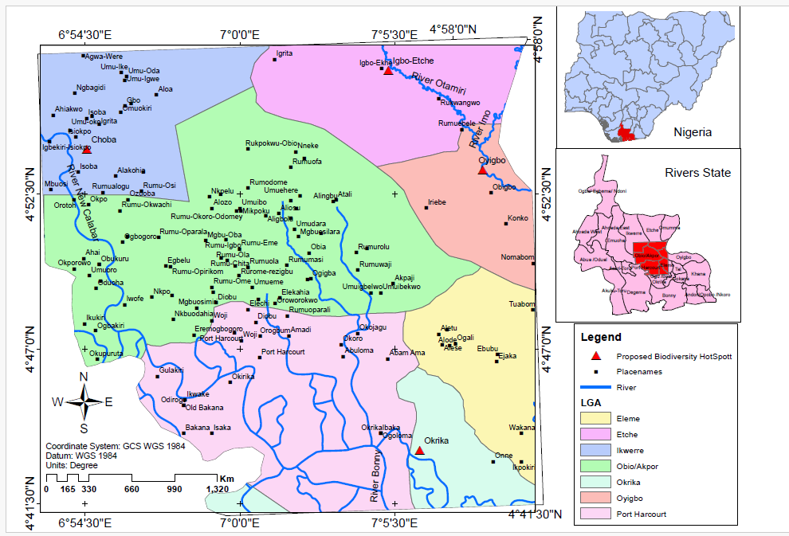
Figure 1: Map of Rivers State Showing Study Locations

3. RESULTS AND DISCUSSION
3.1 Biodiversity
Table 1 and figure 2 show the biodiversity (fauna) species distribution and rating in Okrika, Oyigbo and Choba. Okrika, Oyigbo and Choba recorded 78.6%, 57.1% and 57.1% percentage distribution with high, medium and medium rating, respectively. The difference in the percentage distribution could be as a result of variable environmental conditions, the nature and type of habitats that constitute the various study locations.

Table 1: Biodiversity distribution and rating across study locations
 | Species | Okrika | Oyigbo | Choba
1 | Whale | y | n | n
2 | Shark | y | n | n
3 | Dolphin | y | n | n
4 | Sea turtle | y | n | n
5 | Sardine | y | n | n
6 | Golden fish | y | n | n
7 | African catfish | n | y | y
8 | Tilapia | y | y | y
9 | Crocodile | y | y | y
10 | Alligator | y | y | y
11 | Python | y | y | y
12 | Water antelope | n | y | y
13 | Crab | y | y | y
14 | Water snail | n | y | y
 | Percentage distribution (%) | 78.6 | 57.1 | 57.1
 | Rating | High | Medium | Medium
*y= yes, n= no
*High= 0-39, Medium= 40-69, Low=70-100

Figure 2: Chart showing biodiversity (fauna) species distribution across locations

3.2 Ecotourism
Table 2 and figure 3 show the ecotourism features distribution and rating in Okrika, Oyigbo and Choba. Okrika, Oyigbo and Choba recorded 100%, 50% and 66.7% percentage distribution with high, medium and medium rating, respectively. The difference in the percentage distribution could be as a result of the nature and type of habitats that constitute the various study locations.

Table 2: Ecotourism features distribution and rating across study locations
 | Ecotourism Features | Okrika | Oyigbo | Choba
1 | Sea | y | n | n
2 | River | y | y | y
3 | Beach | y | n | n
4 | Mangrove forest | y | n | y
5 | Cool breeze | y | y | y
6 | Cultural activities | y | y | y
 | Percentage distribution (%) | 100 | 50 | 66.7
 | Rating | High | Medium | Medium
*y= yes, n= no
*High= 0-39, Medium= 40-69, Low=70-100

Figure 3: Chart showing ecotourism features distribution across locations

The ecotourism features and wildlife with potential for attraction include oceans, rivers, waterfronts, lakes, beaches, mangrove forests, swamps and wildlife (Plates 1-9).
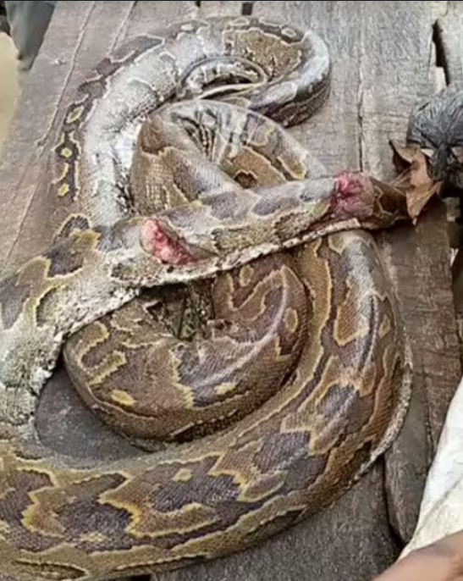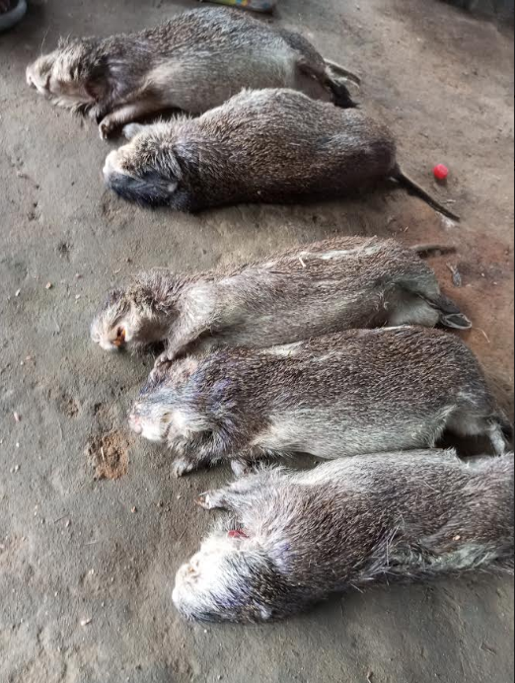
Plate 1: Python at Oyigbo study site Plate 2: Grasscutters at Oyigbo study site
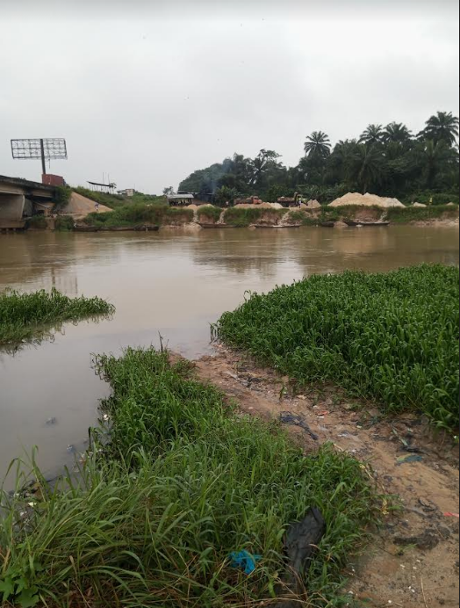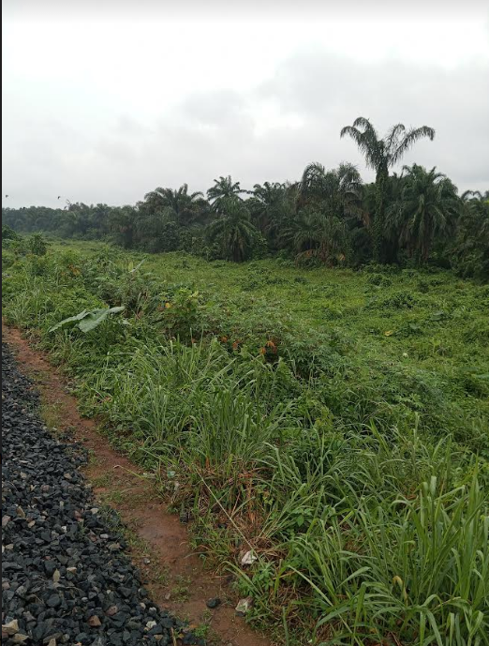
Plate 3: Imo River coastline at Oyigbo study site Plate 4: Raffia palm swamp at Oyigbo study site
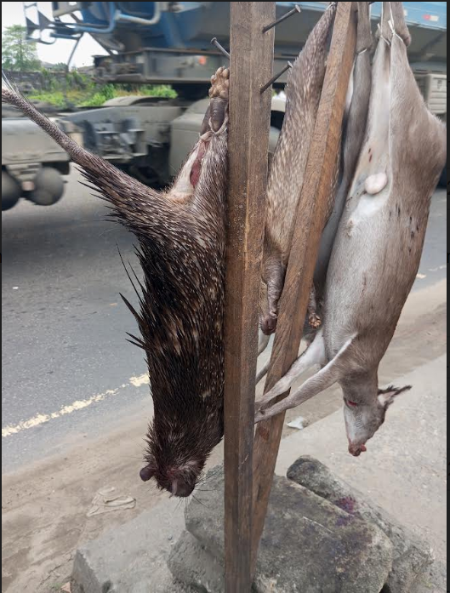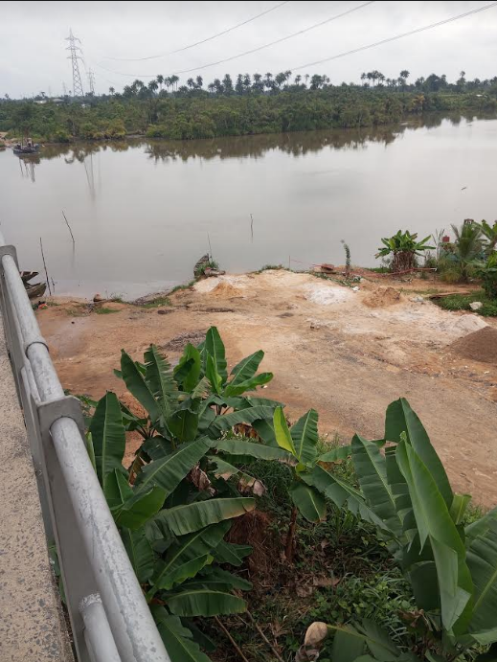
Plate 5: Antelope and Porcupine at Choba study site Plate 6: New Calabar river coastline at Choba study site
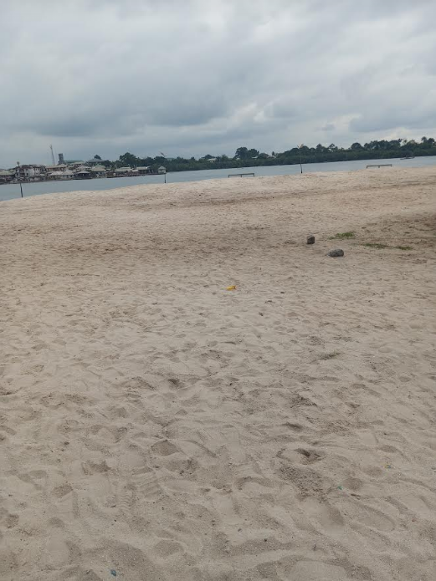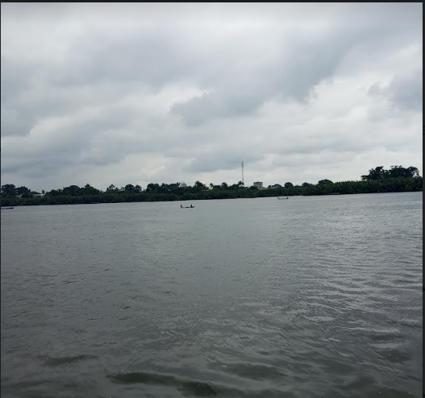
Plate 7: Beach and river at Okrika study site Plate 8: Coastal mangroves at Okrika study site
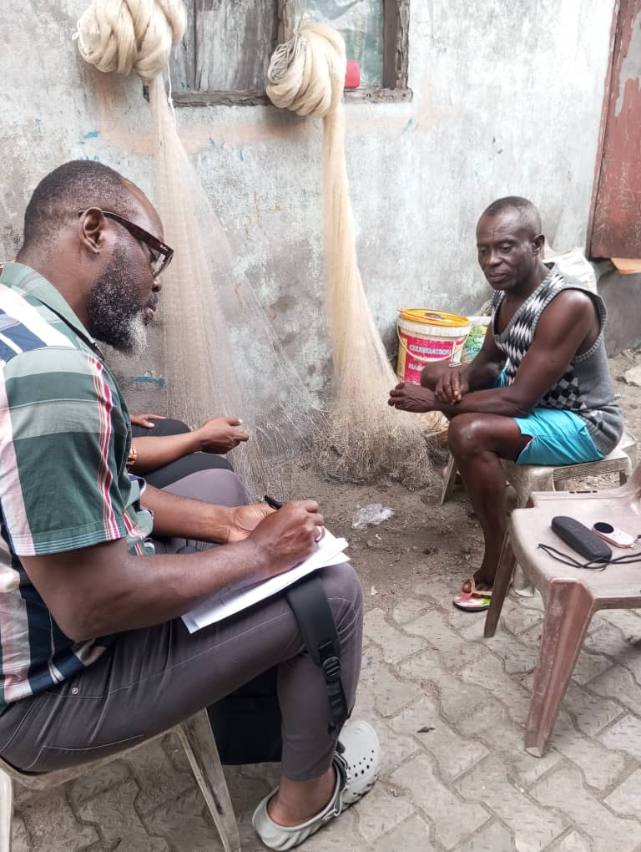
Plate 9: Interviews with fisherman at Okrika study site

3.3 Discussions
The study revealed that Okrika, Oyigbo and Choba had potential for ecotourism development as defined by the biodiversity percentage and ecotourism features distribution and rating (Tables 1 and 2).
3.3.1 Coastal Ecotourism
3.3.1.1 Accessibility
The Okrika town waterfront is approximately 3.5km long drive from the Port Harcourt Refinery junction in east west road. In addition to road network, it can also be accessed by river from the Marine Base of Port Harcourt through Abuloma and Kalio coastal settlements.
The New Calabar river is located in Choba Community behind the Delta Campus of the University of Port Harcourt by the east west road in Obio/Akpor Local Government Area of Rivers State. The river is accessible by road from both Emouha Local Government Area and Choba with other internal road networks linking Ozuoba Community. Apart from road access, the river can be accessed by waterways through Ozuoba and other connecting Communities.
The Imo River is located along the Aba Road in Oyigbo Local Government Area of Rivers State. The river is accessible by road from both Aba in Abia State and Eleme Local Government Area with other internal road networks linking Port Harcourt in Rivers State. In addition, the river can be accessed by boat from different linking communities along the coastlines of Oyigbo and beyond.
The coastlines and waterfronts in these study locations have good potential for tourism because of the presence of beaches in Okrika, free flowing rivers suitable for rafting, boat regatta and other cultural activities.
3.3.1.2 Beaches
There are well established beaches around the shorelines of some settlements in the Okrika Local Government Area, Rivers State. Some common beaches include Okochiri beach, Abam beach and Kalio beach etc. The beaches are composed of shells, clear water, fishes, crabs, well polished white sand and water turtle. These beaches can be developed to attract tourists and resorts built for the comfort of the tourists. The beaches in the coastal communities serve several purposes ranging from relaxation to aquatic resources exploitation (Plate 7). In New Calabar and Imo Rivers, the shorelines are sandy in some locations but do not qualify to be classified as a standard beach. However, tourists and researchers can visit these locations for adventures and research studies.
3.3.1.3 Rafting
According to Barry et al., (2006), raft is one of the means of waterways transportation used for human displacement, hunting, carrying food and equipment. The rafting history in coastal settlements in the Niger Delta is dated back to the inception of these settlements several decades ago. In the Niger Delta where the terrain is chraracterize by oceans, seas, rivers, lakes and swamps, the first and major means of transportation was water transportation.Over the years, people in the coastal communities of Rivers State including the study locations of this research such as Okrika, Oyigbo and New Calabar Rivers have always had river stransportation as their primary source of transportation before the advent of road tranportation following economic and technological advancement. The people in these locations have had canoes, local boats (wooden engine boats) and rarely speed boats as their primary means of water transportation. Canoeing or boating on white water rivers is called rafting. Nature provides the perfect setting for the thrilling adventure and leisure activity of rafting. Consequently, it is a type of ecotourism that encompasses adventure and sport tourism.
The seas and rivers surrounding the Okrika island as well as the Imo and New Calabar Rivers are free flowing water bodies suitable for various rafting activities. At present, several types of boats ply these coastal ways for various econonomic activities. In addition to canoes, local boats and speed boats, other sea resources exploitation boats such as vessels, seatrucks, houseboats, sand mining boats and other marine boats are operational in these coastlines. Consequently, these waterbodies are very suitable for various waterway sports and expedition and adventurous trips. Tourists can ride on specially designed windy boats as they take in the breathtaking scenery of mangrove forests and other aquatic rainforest species as they bob on the waves of the river (Everard et al., 2004). This adventure ecotourism activity is a prime example of a fun and thrilling kind of leisure vacation. Hence they are good potential destinations for aquatic eoutorism through rafting (Plates 3, 6 and 8).
3.3.1.4 Waterfront Development
The primary occupation of indigenes in the coastal settlements of Okrika, Imo River and New Calabar River waterfronts are fishing, hunting and farming which serve as source of well-being and income generation. The waterfronts of these locations are rich in fishes, aquatic animals, mangrove forests, beaches, cool breeze, waves etc.
The Okrika waterfront has a unique setting and vista view. Some of the unique features include a landing jetting made of concrete that serve as a terminal anchor and landing for boat transportation, the community Paramount ruler’s reception building well-built beside the landing jetty as well as a good road network near the shoreline that provides a long walking or motoring view of the entire landscape of the coastline. In addition, the land terminal of the landing jetty has a waiting building for travelers on waterways, and as well as an offloading and commercial exchange point for various seafood from fishermen. Different residential and commercial buildings are found giving it a unique aerial view. Some waterfront aquatic resources exploitation activities found here include sand dredging and fishing. Similarly, the Imo River and the New Calabar River shared similar housing and urban built-up pattern. There are also various fishing and aquatic exploitation activities around these waterways which are suitable for waterfront ecotourism development to generate employment and increase income generation for both the community and the state (Plates 3, 6 and 7).
3.3.1.5 Boat Regatta and cultural activities
Since tourism involves visiting locations for sightseeing, relaxation and catching fun, boat regatta and cultural activities carried out on the waterways during end of the year or seasonal annual festivals by these study locations need to be encouraged. In Okrika, some cultural activities practiced by the people include Odum festival (Boa festival), Beach festival, Cultural dance and Iria festival (traditional wrestling festival) etc. The Odum (Boa) festival is display of Boa snake which is known to be common in the locality carried out once over several years (5 to 10 years), while other festivals were reported to be annual. These festivals are carried out to display the rich bioresources and culture of the people. In Oyigbo and Choba communities some of the cultural activities carried out include traditional dance, traditional wrestling, street carnivals and masquerading which are celebrated annually to mark the end of the year. During these festival activities, people come from far and near to take part and catch fun especially indigenes who have been away from town for a long time. These events carried out both on the waterways and on land are usually intriguing and colourful and as well promote unity and togetherness of the people (Plates 1, 3, 6 and 8).
3.3.1.6 Aquatic Resources Tourism
The Oceans and Rivers within the Okrika settlements are rich in divers and unique aquatic resources that the people depend for food and income generation. Some unique sea animals that are found in the waterways include Whales, Sharks, Dolphins, Sea Turtles, Periwinkles, Sardine, Golden fish etc. While some freshwater fishes and animals common in the New Calabar and Imo Rivers include African catfish, Crocodiles, Allegator, Water snail, Prawn, Grabs, Tilapia, Pythons etc. (Plates 1 and 5).

3.3.1.7 Mangrove Forest
The mangroves are the dominant forests on the shores of most rivers within the Okrika and the New Calabar Rivers coastal settlements. The mangroves provide a beautiful horticultural landscape along the coastlines. Other services and benefits of mangroves include source of firewood, fishing grounds, wood for building by the local residents of the host communities. Other environmental services include carbon sink, shoreline protection, breeding grounds for fishes etc. Some aquatic biodiversity of ecotourism values found in the locations include crocodile, oyster, crabs, fish, rivers, periwinkles, snakes, birds, monkeys, monitor lizard etc (Plates 6 and 8).
3.3.2.Wildlife Ecotourism
The study reveals the presence of some unique aquatic animals such as whales, sharks, dolphins, sea turtles, and as well as animals including antelopes, crocodiles, alligators and pythons found in the study area. Apart from the food provisioning services provided by these animals to indigenes of these communities, they also have ecotourism potential for income generation and employment creation.
3.3.3 Challenges of Ecotourism
3.3.3.1 Insecurity: Just like every other part of the country where pockets of insecurity challenges are found, the study locations are not in exception. Information obtained from the field data gathering revealed that there are some security concerns such as kidnapping, robbery and communal and land disputes amongst residents but at a low rate. Irrespective of the level of insecurity, government at both the local and state levels need to ensure the safety of lives and property by providing effective and efficient crime fighting outlets and policing within the communities and the proposed ecotourism potential destinations in order to attract tourists without fear of being kidnapped or harassed during their visits to these locations.
3.3.3.2 Power supply: There is no steady power supply in these locations except in Oyigbo due to the presence of the Afam VI Power Plant. Steady or improved power supply is needed to run other aspects of the tourism establishments as well as to make the stay of tourists enjoyable. The government at all levels needs to ensure there is improved power supply across these locations by providing power generating installations as wells as solar panels to improve power supply.
3.3.3.3 Over-exploitation: Since the people depend on these aquatic resources and animals for their wellbeing and survival, there has been unregulated exploitation of these resources over the years which resulted in the decline of some species of the abundant resources (Symes et al., 2018). Fishing activities are unregulated and carried out daily by fishermen using different fishing tools and techniques that could be unsustainable for some types of fishes. Also, the unregulated sand dredging activities have resulted in hydrogeological changes in the ecosystem causing some aquatic species to migrate out of their primary habitat resulting in depletion or loss of species.
3.3.3.4 Lack of community-based regulations: The study conducted across the locations revealed lack of the management of community-based forests and natural resources exploitation. The various communities have active leadership structures ranging from Paramount rulers, Community Development Committee to Youth and Women bodies, yet no documented or rolled out structure to regulate biodiversity exploitation was observed in Okrika and Choba locations. Hunters and fishermen go at will to harvest or exploit these resources. However, in Oyigbo, there are associations for hunters and fishermen where they are obliged to register with before commencing exploitation but without any regulation for the process or exploitation (Umar, 2022).
3.3.3.5 Poor hospitality facilities: The study revealed the presence of hotels and restaurants in these locations. However, the quality of services was observed not to meet international standards that is likely to attract foreign tourists. Also, the number of hotel and restaurant services were less compared to what is found in Port Harcourt. Hence, there is need for more private and government investments in the hospitality sector in order to boost the quality of services to attract both in-country and foreign tourists to these locations. In addition, Government also needs to create the enabling environment and partner with credible foreign investors in the hospitality sector to upgrade the quality of services in the communities.
3.3.3.6 Poor environmental management policies: The study showed that there are no environmental management policies enforced and implemented at the community level. It was gathered from the study that various streams of waste are being discharged either directly or indirectly into the rivers and oceans through various industrial activities without carrying out a proper quality assurance and control checks prior to discharge. The sand dredging activities and effluent discharge tend to pollute the waterbodies without the effective monitoring of these activities. Local and State government environmental management laws should be implemented in collaboration with community leadership of the various communities to tackle environmental problems in the coastlines of the study area.
3.3.3.7 Lack of political will: Government of Rivers State needs to show readiness and will to diversify the economy through ecotourism. Overtime, the government has shown little or no commitment in diversifying the economy though tourism (Yuan, 2020). Government at all levels needs to see beyond oil and gas as the sole source of income rather begin to explore other means to increase the revenues of the states and the country. Ecotourism is one of the means governments need to explore and make conscious efforts to grow the state income, which is in line with the findings of Xu et al., (2023). This study has highlighted possible ecotourism potential destinations which government has to embrace and explore. Hence, government at both the local and state level needs to elect leaders that have the political will and effective financial management skills to derive the process of economic diversification through ecotourism. According to Nkomo and Adanlawo (2024), most local governments lack strategic orientation because they lack advanced skills, which is necessary for effective ecotourism planning.

4. CONCLUSION
The study revealed that Okrika recorded the highest biodiversity and ecotourism features distribution and rated as the location with the most ecotourism potential, followed by Choba and Oyigbo. Aquatic animals and fishes as well as other features found in Okrika study location include whales, sharks, dolphins, sea turtles, periwinkles, sardine, golden fish. While some freshwater fishes and animals common in the New Calabar and Imo Rivers include African catfish, crocodile, allegator, water snail, prawn, grabs, tilapia, pythons, water antelope etc. Ecotourism features identified in the study area include sea, river, beaches, mangrove forests, cool breeze, cultural activities, waterfronts and wildlife. Rivers and seas were proposed for ecotourism activities such as rafting, canoing, boat regatta and cultural activities, waterfront development, fishing and sight-seeing.
5.0 RECOMMENDATIONS
1. Government should consider establishing coastal ecotourism across the identified locations based on the findings from this study as way of enlarging the internally generated revenue base and create employment for the people.
2. For effective functionality of the proposed ecotourism activities, government should address some identified challenges and limitations such insecurity, lack of political will, poor hospitality facilities, epileptic power supply, poor environmental management policies etc to attract tourists to the proposed destinations.
3. Regulations and effective monitoring processes should be put in place by the Local and State Goverernments in collaboration with the leadership of the communities to effectively manage biodiversity over-exploitation and encourage conservation.

REFERENCES
Ana, GR; Ajewole, OI (2011).Urban Forestry and Public Health, Pp.69 - 103 In: A.A. and Ijeomah, H.M. (eds.) (2011) Book of Reading in Forestry, Wildlife Management and Fisheries. Top Base Nigeria Limited, Lagos, in Conjunction with Green Canopy Consultants, Port Harcourt, Rivers State.
Barry, E; Jim, S; Mark, H (2006). White water rescue technician. 30-48.
Baloch, Q. B., Shah, S. N., Iqbal, N., Sheeraz, M., Asadullah, M., Mahar, S., & Khan, A. U. (2023). Impact of tourism development upon environmental sustainability: a suggested framework for sustainable ecotourism. Environmental Science and Pollution Research, 30(3), 5917-5930.
Bengtsson, S. E., Barakat, B., Muttarak, R., Kebede, E. B., & Lutz, W. (2018). The role of education in enabling the sustainable development agenda. Routledge.
Cooper, C; Wanhill, S (1998). Tourism Development: Environ. Sci. Comm. Issues. New York: John Willey and Sons.
Everard, B; Hudson,H; Lodge, G (2004). Studying the effect of participation in outdoor activities on engendering lasting active lifestyles E. O. Council: 1-5.
Fikile, X., and Eyitayo, F.A. (2024). The Potential Role of Ecotourism in Sustainable Development: A Systematic Review. Journal of Ecohumanism. 4(3): 3356 – 3367. ISSN: 2752-6798 (Print) | ISSN 2752-6801 (Online) https://ecohumanism.co.uk/joe/ecohumanism
Harris, JD; Brown, PL (2009). Wildlife: Destruction, Conservation and Biodiversity. Nova Sci. Publ.
Ijeomah, HM (2017). Tourism and Terrorism in the Contemporary World: Ecodestinations of Nigeria in Perspective. In: Adekunle, V A J; Ogunsanwo, OY; Akinwole, AO (eds) Harnessing the Uniqueness of Forests for Sustainable Development in a Diversifying Economy. Proceedings of the 39th Annual Conference of the Forestry Association in Nigeria held in Ibadan, Oyo State 20-24 February, 2017. pp. 921-936.
Ijeomah, HM; Aiyeloja, AA (2010). Ecotourism: An instrument for combating Renewable natural resources Degradation pp.441 – 470.
Ijeomah, HM; Aiyeloja, AA (2010). Ecotourism: An instrument for combating Renewable natural resources Degradation pp.441 - 470 In: Ijeomah, HM; Aiyeloja (Eds.) 2010. Practical Issues in Forest and Wildlife Resources Management. Green Canopy Consultants, Port Harcourt, Rivers State, 625pp.
Ijeomah, HM; Eniang, EA (2018). Ecotourism and National Development in Nigeria: Prospects and Challenges.Proceedings of 6th NSCB Biodiv. Confer.; Uniuyo 2018 (1 - 12pp.)
Ijeomah, HM; Herbert, BC (2012). Reality of Tourism Management: Business Viability and Tourists’ Behaviour in Plateau State, Nigeria. J. (Cultur Revista de Cultura e Turismo)6(3):18 -35, www.uesc.br/revistas/culturaeturismo.
Keong, C. Y. (2020). Global Environmental Sustainability: Case Studies and Analysis of the United Nations’ Journey toward Sustainable Development. Elsevier.
Lu, C.P. (2009). Introduction to Animal Protection. 3rd ed. Beijing: Higher Education Press. (in Chinese).
Magigi, W; Ramadhani, H (2013). Enhancing Tourism Industry through Community Participation: A Strategy for Poverty Reduction in Zanzibar, Tanzania. J. Environ. Protec. 4, 1108-1122.
Markovic, M; Salta, A; Skkaricie, Z; Trumbric, I (2009). Sustainable Coastal Tourism: An Intergrated Planning and Management Approach Milan France: United Nations Environmental Programme (UNEP).
Mnisi, P., & Ramoroka, T. (2020). Sustainable community development: A review On The socio-economic status of communities practicing ecotourism In South Africa. International Journal of Economics And Finance, 12(2), 505-519.
Nealy, W (1986). Kayak the animated manual of intermediate and advanced white water techniques. United States of America: Menasha Ridge Press.
Nelson-Fred, MA (2007). East Africa: Trends in Coastal Tourism and Strategies for Promoting Sustainable Development. Washington DC: Wor. Wildl. Fund.
Nkomo, N. Y., & Adanlawo, E. F. (2024). The impact of unemployment on alcohol consumption: A panel data analysis. International Journal of Innovative Research and Scientific Studies, 7(4), 1365-1373.
Parks and Recreation Management (2012). Heritage tourism and Museum Management, Northern Arizona University, USA, p.3 Online Lesson http://www.prm.nau.edu/prm300).
Symes, W. S., Edwards, D. P., Miettinen, J., Rheindt, F. E. and Carrasco, L. R. (2018). Combined impacts of deforestation and wildlife trade on tropical biodiversity are severely underestimated. Nature Communications 9: 4052. (Accessed 23 December 2021)
Umar, A.M (2022). Ecotourism in Nigeria, challenges and prospects: a review. Gadau J.Pure and Appl. Sci., 1(1): 12-17.
World Tourism Organization (2010). Tourism Satellite Account Capacity Building Program, Workshop II, World Tourism Organization, Manila, Philippines, Asia.
World Travel and Tourism Council (2010). Tourism Economic Research 2010, World travel of tourism council, London (Retrieved From;) www.wttc.orgHall/eng/Tourism_Research/Economic_Research/)
Xaba, F., Adanlawo, E. F., & Nkomo, N. Y. (2024). Ecotourism initiatives contribution to improved livelihoods: A case of Umkhanyakude District Municipality. International Journal of Innovative Technologies in Economy, 2 (46)).
Xu, L., Ao, C., Liu, B., & Cai, Z. (2023). Ecotourism and sustainable development: a scientometric review of global research trends. Environment, Development and Sustainability, 25(4), 2977-3003.
Yuan, J. M. F. C. (2020). Promoting conservation & community development through ecotourism Experiences from valued conservation landscapes on the Tibetan plateau (Qinghai Province, China).
Zhou, X; Wan, X; Jin, Y; Wei ZW (2016). Concept of scientific wildlife conservation and its dissemination. Zool. Resear. 37(5): 270–274.

