Environmental factors responsible for gastro-intestinal parasitosis in primary school children in the Fondonera, West – Cameroon

ABSTRACT
The aim of this study was to determine the risk factors responsible for gastrointestinal parasitosis in children under 15 years of age, in order to contribute to the development of strategies to combat these parasitoses in Fondonera. Stools from 524 children, 52 soil samples and 13 drinking water samples were analyzed using standard techniques. The data collected were imported into SPSS version 22. The Chi-square test (x²) enabled us to compare the prevalences. A multi-variate logistic model (Survey sheet) was used to evaluate risk factors for parasitic infestation. Tests were performed at 95% confidence levels. Ascaris spp eggs were identified in 14.3% of soil samples collected in school playgrounds and 8.3% in home playgrounds, posing a risk to children who enjoy playing in these areas. 66.6% of drinking water samples were contaminated with Ascaris spp and hookworm eggs. Eggs of Ascaris spp (17.2%), Trichuris spp (3.8%), hookworms (1.9%) and the protozoan Entamoeba spp (9.4%) were detected in the stools of 123 children, representing a prevalence of 23.4%. School and age significantly affected the degree of infestation with Ascaris spp and Trichuris spp (P<0.05). Open defecation was the main risk factor. Nearly ¼ of school children in Fondonera are infested, this is a danger to the life, school performance and development of these children. To improve the living conditions of these children, the public authorities should take a particular interest in sanitation in this locality, raising awareness of good hygiene practices and multiplying deworming campaigns.

Keywords: Gastrointestinal parasites, Risk factors, children 0-15, Fondonera, Cameroon

INTRODUCTION
Gastrointestinal parasitoses represent a real public health problem in developing countries (WHO, 2015; Ngangnang and Khan Payne, 2017). In sub-Saharan Africa, South America, China and East Asia, more than 270 million pre-school children and 600 million school-age children still lived in areas where transmission of these parasites is intensive (WHO, 2015). The pronounced incidence of these parasitoses in these regions is due to several factors such as climatic conditions favorable to the development of parasites, precarious hygiene, poor quality of drinking water, migrations, high population densities etc (Tagajdid, 2012; Lehman et al., 2012).
The population most affected by gastrointestinal parasitosis and most vulnerable is generally made up of school-age children, particularly the youngest (WHO, 2015). For these children are going through a period of strong physical growth and rapid metabolism marked by an increase in their nutritional requirements (Wabo Poné et al., 2012; Mahmud et al., 2013; Abossie et al., 2014), they are in the midst of learning and are constantly exposed to contact with contaminated soil or water, probably without knowing the need for good personal hygiene (Crompton et al., 2004). Clinical manifestations observed in these infested children include diarrhea, anorexia, nausea, stomach ache, anemia, stunted growth, reduced intellectual performance and even death (Menan et al., 1991; WHO, 2002). These pathologies threaten the socio-economic development of these developing countries with very high morbidity and mortality rates, causing enormous consequences on the medical level through the disorders they cause in parasitized subjects on the one hand, and on the economic level through the costly therapeutic and preventive measures they impose (Keiser and Utzinger, 2010).
In Cameroon, especially in rural areas like Fondonera, gastrointestinal parasitosis is still one of the main health problems, especially among children, even though the government has set itself the target of eliminating helminthiasis morbidity in children by 2021 at the latest, through regular deworming of school-age and pre-school children (Ntangmo Tsafack et al., 2022, 2023). This situation leads us to wonder whether this is not a case of "deworming - reworming". Hence the need to search the environment for potential niches for these parasites, as well as for risk behaviors predisposing to contamination, in order to contribute to the development of strategies for the eradication of these gastro-intestinal parasitoses in Fondonera and, by extension, in Cameroon in general.

- MATERIAL AND METHODS

2.1 Presentation of the study area
The Fondonera Group is located in the Santchou Arrondissement, Menoua Department, West Cameroon Region (Figure 1). It is located 30 km from the town of Dschang, in the extreme south-east of the Menoua Department. The Group's main feature is its high mountains, which rise to between 800 and 1,700 meters above sea level. It covers an area of 120 km², with a cosmopolitan population estimated at over 21,000. The climate is equatorial, characterized by a long rainy season (mid-March to mid-October) interspersed with short dry seasons (AprilMay and July-August) and a dry season from November to February. The present study was carried out in the eight primary and nursery schools of the Fondonera Group (Figure 2) in the Santchou
Arrondissement.

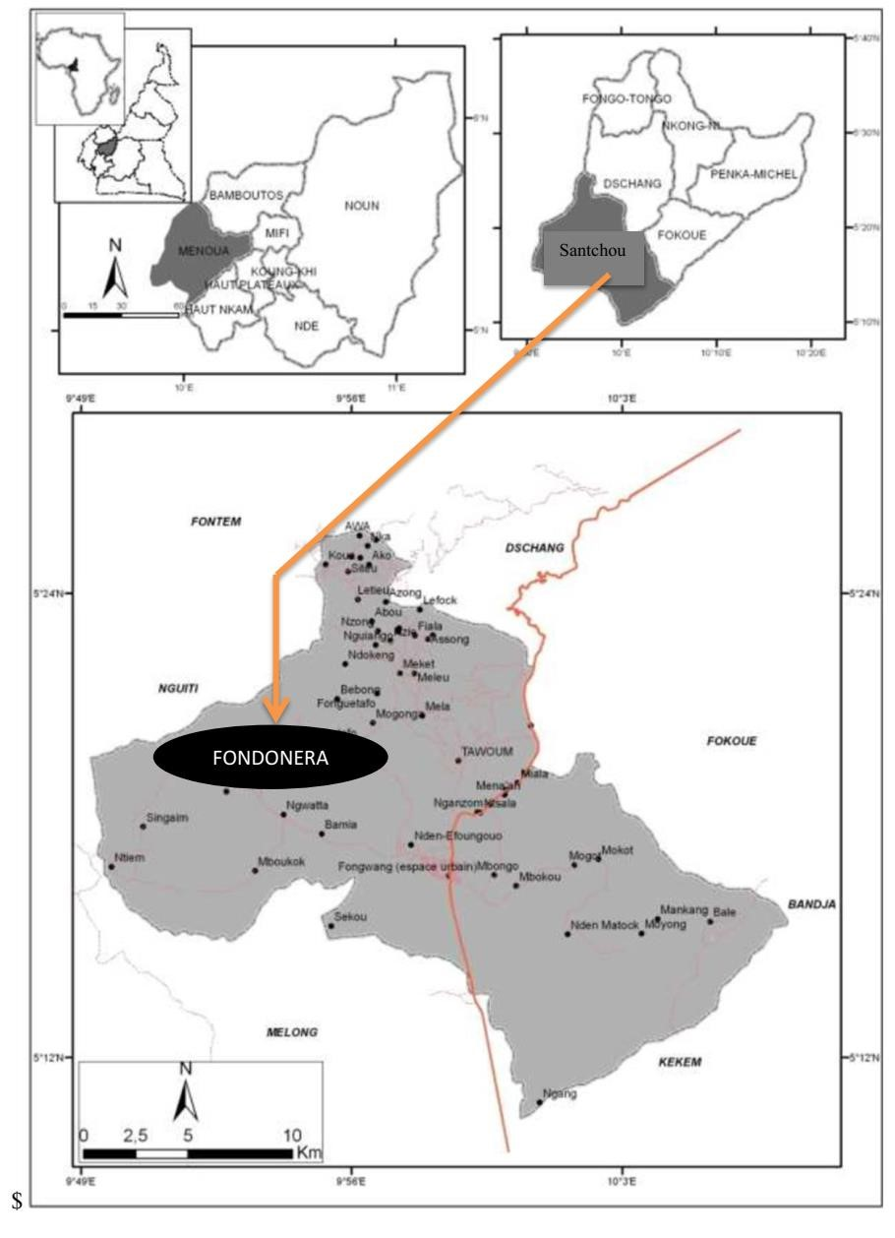

Figure 1: Study area; Groupement Fondonera in the Arrondissement of Santchou (Commune de Santchou, 2015).
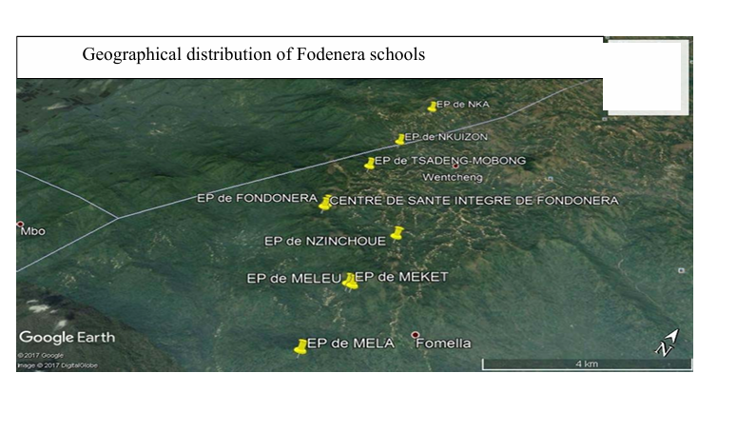
Figure 2: Distribution map of elementary school in the Fondoner Group a study population

2.2 Assessing students' hygiene levels
A questionnaire was submitted to students meeting the predefined inclusion criteria, and then completed with the help of teachers who had a better understanding of student behavior on school premises. The questionnaire consisted of four parts. The first part concerned the identification of the pupil; the second part included current anthropometric indications of nutritional status; the third concerned knowledge of parasitic diseases linked to lack of hygiene and the agents responsible; the fourth part focused on the pupil's state of health; and the fifth part provided information on the initiation of antiparasitic treatment at school and at home.

Sampling and analysis of soil, water and buttocks

Determining the minimum size of the population to be assessed
The population of the Fondonera group is cosmopolitan, made up of students and residents of the group. The exogenous population is made up of people who do not live in the group. Our sample size was determined using Singh's (2014) statistical formula below:
N = Z²×P×Q/E2 N = the sample size; Z = 1.96 which is the 95% confidence level; E = sampling error or precision at 5%; P = prevalence of people infected with gastrointestinal parasites; 1-P = percentage of people not infected with gastrointestinal parasites. In the absence of epidemiological data in the group, the relative prevalence of people infected with gastrointestinal parasites is considered to be 50%.
N=1.9622×0.50×0.50/.052 =384
The minimum size of our sample was estimated at 384 people.
The choice of soil and drinking water samples was made on the basis of the degree of parasitaemia of the infested subjects on coprological examination of the faeces.

Inclusion criteria
The children who took part in this study were recruited according to the following criteria
-be a pupil in the primary schools of the group
-aged between one and 15 years
-have the approved consent of both parent and child.

Exclusion criteria
Any child whose parent refused to give consent or who withdrew was excluded from the study; inability to defecate.

53 soil samples (0-3cm), of which 28 were taken from school grounds and 24 from home yards. 13 samples of drinking water were collected from pupils' homes using 1.5-liter plastic bottles. After obtaining ethical clearance from the Comité National d'Ethique de la Recherche pour la Santé Humaine (CNERSH), stool samples were taken from 524 pupils at 8am and 12pm, from those whose parents had given their consent. A brief description of the work was given to the parents, and parents who agreed were asked to sign the sheet. All samples were transported in a refrigerated enclosure to the Unité de Recherche de Biologie et d'Ecologie Appliquées (URBEA) at the University of Dschang for analysis.
The search for parasitic elements in the soil was carried out using the quantitative method of Bailenger (1962) in Amahmid (2004). This is a two-phase technique based on the presence of two immiscible phases, one aqueous to dilute the sample and the other organic, which is emulsified and then separated by centrifugation.
The parasitological study of the water was qualitative, and the search for parasitic elements was also carried out using the sedimentation technique employed by de Bailenger (1962) in Amahmid (2004). This technique is based on the concentration of settleable elements, including parasite eggs, larvae and cysts.
The search for parasitic elements in feaces was carried out using the Willis Technique, which is a separation technique based on separating eggs from feces, and concentrating them by means of fluid flotation under appropriate specific gravity (Soulsby, 1982).
All observations were made using a microscope with a X10, X40 and X100 objectives for cysts. Eggs and cysts were identified on the basis of morphological criteria such as size, shape, nature of shell or membrane, and color (Soulsby, 1982).

Determination of Prevalence
The parameter studied is prevalence (P). It is expressed by the following formula (Thienpont et al., 1979):
P = Nombre d′individus infestés X100
Nombre d’individus examinés

2.4 Statistical analysis
The data collected were recorded in the laboratory notebook and Microsoft Office Excel 2013, then imported into SPSS version 22 (Statistical Package for Social Sciences) for statistical testing. The Chi-square test (x²) enabled us to compare the prevalences of gastrointestinal parasites according to age, gender and even school. A multi-variate logistic model (Survey sheet) was used to evaluate risk factors for parasitic infestation according to socio-demographic characteristics and hygiene and sanitation conditions. Tests were performed at 95% confidence levels.

3 RESULTS

3.1 Assessment of hygiene levels related to infestations
87.2% of of pupils suffering from at least one water-borne illness do not wash their hands before and after meals and after defecation, compared with 12.8% who do. 96.2% of parasitized pupils report drinking water of dubious quality (marigot water). 30.1% of sick students have no latrine at home and defecate in the open air. Of all these hygiene-related parameters, there was a significant relationship with gastrointestinal parasite infestations (p<0.05) in terms of non-washing of hands, origin of drinking water, etc.

Table 1: Assessment of hygiene levels related to gastrointestinal parasite infestations.
Parameters assessed |  | N (p) | p-value
Hand hygiene
 | No | 116 (87.2) | 0.032*
 | Yes | 17 (12.8)
Dirty food consumption
 | No | 21 (15.8) | 0.472
 | Yes | 112(84.2)
Barefoot walking
 | No | 1 (0.8) | 0.625
 | Yes | 132 (99.2)
Origin of drinking water
 | Marigot | 128 (96.2) | 0*
 | Source | 5 (3.8)
open defecation
 | No | 40 (30.1) | 0.014*
 | Yes | 93 (69.9)
Legend: (N): number of cases and (p): percentage

3.2 Parasitological quality of the schoolyard soils studied
Of 28 soil samples collected from elementary school playgrounds, 4 were contaminated with Ascaris spp eggs, giving an overall prevalence of 14.3% (Table 6).

Table 2: Percentages of nematode-positive samples identified in school yards
Schools

Parasite | EP  Mela  (p) | EP Meket  (p) |  | EP  Meleu  (p) | EP  Tsadeng  (p) | EP  Nkuinzon  (p) | EP  Nka  (p) | EP  Nzinchoué  (p) | Total (p)
Nematode
Ascaris spp | 25% |  | 25% | 50% | 0% | 0% | 0% | 0% | 14.3%
p: Percentages of positive samples, PS: public school
The Meleu EP courtyard was the most contaminated with Ascaris spp nematode eggs (50% positive samples), followed by Meket and Mela EP courtyards 25% positive samples. But no significant difference was observed between the degree of infestation by Ascaris spp and the contaminated schools (p>0.5).

3.3 Parasitological quality of home soils
Out of 24 soil samples collected from the yards of homes in four neighbourhoods (i.e. 6 samples per home), 2 samples were contaminated with Ascaris spp eggs, giving a total prevalence of 8.3% (Table 3). The degree of infestation of household soils varied significantly from one home to another (p<0.05). Household floors in the Mela and Meleu districts were contaminated by one of the three types of eggs detected in the pupils

Table 3: Percentage of nematode-positive samples identified in home yards
 |  | Neighborhoods (Homes)
 | Mela (p) | Meleu (p) | Nzinchué (p) | Tsadeng (p) | Total (p) | p-value
Parasite
Ascaris spp | 16.7% | 16.7% | 0% | 0% | 8.3% | 0.046
p: Percentage of positive samples

3.4. Parasitological quality of drinking water in homes inspected
Of the 13 drinking water samples collected from homes, 66.6% were contaminated with two of the three types of nematode eggs identified in schoolchildren in Tsadeng and Nzinchoué (table 4). No significant difference was observed between the degree of contamination of drinking water between homes (p>0.05).

Table 4: Percentage of samples positive for nematode eggs in drinking water
 |  | Homes
Parasites | Meleu  (P) | Tsadeng  (P) | Nzinchou  (P) | Totals (P) | p-value
Ascaris spp | 0% | 100% | 0% | 33.3% | 0.223
Hookworms | 0% | 0% | 100% | 33.3% | 0.223

3.5 Prevalence of infestations by age group
Age did not significantly influence infestations with Entamoeba spp and hookworms (p˃0.05). On the other hand, age significantly influenced infestations with Ascaris spp and Trichuris spp (p≤0.05), as shown in Table 5.

Table 5: Prevalence of parasites identified according to age group
 | Age range
Parasites | (2 – 5) n (p) | (5 – 9) n (p) | (10-14) n (p) | Total n (p) | p-value
Protozoa
Entamoeba spp | 13 (14.9%) | 27(7.7%) | 9(10.2%) | 49(9.4%) | 0.113
Nematodes
Ascaris spp | 12 (13.8%) | 53 (15.2%) | 25 (28.4%) | 90 (17.2%) | 0.009
Trichuris spp | 6 (6.9%) | 8 (2.3%) | 6 (6.8%) | 20 (3.8%) | 0.037
Hookworms | 0 (0.0%) | 6 (1.7%) | 4 (4.5%) | 10 (1.9%) | 0.081
Total | 31 | 94 | 44 | 169
Legend: (n): number of positive cases and (p): prevalence
3.6. Distribution of infestations by school.
Coprological analysis of feces revealed that 123 children (23.5%) harbored three nematodes and one protozoan (Table 1). The nematodes identified from their eggs belonged to the genera Ascaris, Trichuris and Ankylostoma, and the protozoan cysts to the genus Entamoeba (Figure 3A, 3B, 3C, 3D). The most prevalent nematode was Ascaris (17.2%) and the least prevalent was Ancylostoma spp (1.9%). Entamoeba spp (9.4%) was the only protozoan encountered.
Four types of parasite were identified in the stool samples of children from EP Mela, EP Meket, EP Meleu and EP Nka, followed by three types of parasite in EP Tsadeng and EP Nzinchoué, and a nematode in EP Nkuinzon (Table 6). The stool samples from EP Nguingo were free from any contamination. For all types of parasite detected, infestations varied significantly from one school to another

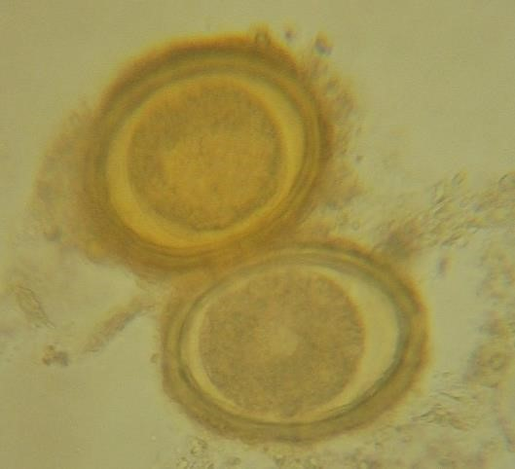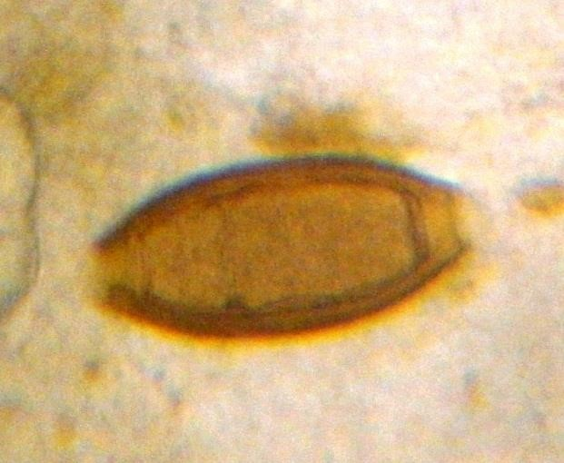

A
Eggs
of Ascaris spp

B Eggs

of
Trichuris
spp

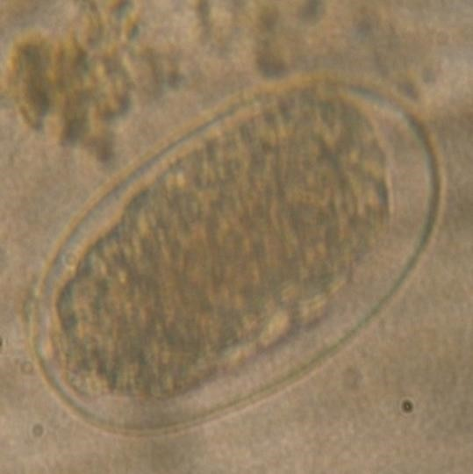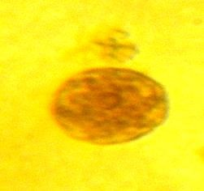

C Hookworm egg D Entamoeba spp. cyst
Figure 3A, B, C, D: Parasitic elements detected

Table 6: Prevalence of parastes found in the various schools studied
Schools | EP Mela n (p) | EP Meket n (p) | EP Meleu n (p) | EP Tsadeng  n (p) | EP  Nkuinzon n (p) | EP Nka n (p) | EP  Nguiango n (p) | EP  Nzinchoué n (p) | Total n (p) | p-value
Protozoa
Entamoeba spp | 20(24.4) | 5(11.4) | 10(16.1) | 0(0) | 0(0) | 10(14.1) | 0(0) | 4(3.4) | 49(9.4) | 0
Nematodes
Ascaris spp | 21(25.6) | 11(25) | 17(27.4) | 14(24.1) | 2(14.3) | 9(12.7) | 0(0) | 16(13.8) | 90(17.2) | 0
Trichuris spp | 4(4.9) | 1(2.3) | 4(6.5) | 7(12.1) | 0(0) | 1(1.4) | 0(0) | 3(2.6) | 20(3.8) | 0.014
Hookworms | 2(2.4) | 4(9.1) | 2(3.2) | 1(1.7) | 0(0) | 1(1.4) | 0(0) | 0(0) | 10(1.9) | 0.018
Observed totals | 47(57.3) | 21(47.7) | 33(53.2) | 14(24.1) | 2(14.3) | 21(29.6) | 0 | 23(19.8) | 161(30.7)
Total examined | 82 | 44 | 62 | 58 | 14 | 71 | 77 | 116 | 524

Legend: EP= Public school; (n): number of positive cases and (p): prevalence in %.

4. DISCUSSION

Several risk behaviors have been identified that predispose children to gastrointestinal infestations
Investigations into the association between the prevalence of gastrointestinal parasites and risk factors revealed several risk factors that predispose children to parasitic infestations, namely : Presence or absence of latrines: a significant relationship was recorded between infestations by gastrointestinal parasites and schools, with 30.1% of patients not using latrines and 69.9% of patients having latrines. Unhygienic latrines are responsible for the dissemination of nematode eggs (Ascaris spp and Trichuris spp) and protozoan cysts (Entamoeba spp) via transport from faecal matter to contaminated foodstuffs or goods exposed to the open air by the real transport agent, the fly. In homes, the existence of toilets has been marked by the presence of pigsties, veritable hiding places for parasite eggs and cysts (Missaye et al., 2013).
Not washing hands before, after eating and after defecation: a significant relationship was recorded with these factors and gastrointestinal parasite infestations. That is, 87.2% of positive cases did not wash their hands before and after eating, and after defecation. This risky behavior could facilitate the ingestion of protozoan cysts (Entamoeba spp) and nematode eggs (Ascaris spp and Trichuris spp) during meals (Nmor et al., 2009). To minimize the risks, some people build local plank toilets less than 10 meters from the house. In-house toilets are almost non-existent.
The origin of drinking water has a significant influence on gastrointestinal parasite infestations. 96.2% use marigot water of dubious quality as drinking water. Standpipes are almost non-existent. It should be noted that the quality of drinking water is a source of many waterborne diseases, such as hookworm, ascariasis and strongylosis, which release infective larvae (L3) into the aquatic environment (Ntangmo Tsafack et al., 2022, Pokam et al., 2023).
These results are similar to those of Missaye et al., 2013) who identified the absence of toilets, the quality of water consumed and living conditions as risk factors predisposing children to helminthiasis in northern Ethiopia. This result differs from those of Judd et al, (2007) who noted education level and residence as risk factors. Cheikhrouhou et al (2009) in Sfax, and Chukwuma et al (2009) in Nigeria, found that the mother's low level of education predisposed the child to parasitic infestations. Others, like Nmor et al. (2009), found that the location of water supplies and finger sucking were factors predisposing children to gastrointestinal parasite infestations. In contrast, Kelechi et al. (2015) findings on geo helminths in Nigerian elementary chool revealed that gender is the most important risk factor. Sanitation is increasingly marked in our study.

Over 14.3% of school soil samples and 8.3% of home soil samples were contaminated with Ascaris spp. eggs.
Ascaris spp eggs were detected in the soil of 3 schools in the Fondonera Group, representing a prevalence of 14.3%. Assuming that they originate from humans/schoolchildren, we can speculate on the low contamination rate observed in the present work. In our opinion, this is due to the multiple annual deworming campaigns organized in schools over the past few years. Another reason could be the teaching of hygiene lessons and moral education in Cameroon's primary and nursery schools. On the other hand, these results appear higher than those obtained (0%) by Ngatou (2014) on the analysis of soil samples taken from schools in the town of Bazou in the Ndé Department in West Cameroon; moreover, in the work of Nkouayep et al. (2017) in ten primary and nursery schools in the town of Dschang, they found that Ascaris spp. eggs were more frequent in the soil (3.5%), followed by those of Trichuris spp. (2%), Capillaria spp. (1.5%), Cooperia spp. (0.5%) and hookworms (0.25%), marking the difference with the results of the present work, this predominance of nematode eggs in the various works would be due to their resistance to environmental conditions and precarious sanitary and hygienic conditions (Messaad et al., 2013). Indeed, Ascaris spp. eggs are known to be more resistant to environmental conditions than other nematode eggs. These Ascaris spp eggs were also found during parasitological examinations of stools: 21(25.0%) for EP Mela; 17(27.4%) for EP Meleu and 11 (25.8) for EP Meket. These results differ from those obtained by Shrestha et al (2006) and Bojar and Klapec (2012) who, in addition to the nematodes mentioned above, identified Strongyloïdes stercoralis in their work carried out in Kathmandu, Nepal, but the frequencies of the geohelminths identified were relatively higher than those obtained in the present work. Ascaris were the most prevalent (56.1%), followed by Trichuris spp (17.5%) and Ankylostoma (15.8%). This is in line with the biology of these parasites. It's worth noting that school playgrounds, where children find pleasure in having fun, constitute a major risk factor for infestations by soil-borne nematodes in particular, and gastrointestinal parasites in general.
Soil samples from two homes were contaminated with the eggs of a single nematode, Ascaris spp (4.2%). This may be explained by the existence of pigsties and children's defecation in the yard and around the house. The results of studies carried out by Uga et al. (1995; 1997), Stojcevic et al. (2010) and Tavalla et al. (2012) on school soil contamination in Nepal, Croatia and Tehran respectively, in addition to nematodes and cestodes, noted the presence of protozoan oocysts and cysts (Eimeria spp. Isospora spp. , Cryptosporidium sp. and Giardia sp.).

66.6% of drinking water samples were contaminated with nematode eggs, but no significant relationship was observed with homes.
66.6% of the drinking water collected from homes was contaminated with nematode eggs. This high prevalence can be explained by the low level of sanitation in the village, and the small sample size. The less representative the sample, the higher the prevalence. The nematodes Ascaris spp and hookworms were detected in these waters. This observation corroborates that of Sangaré et al (2015) in Bobo Dioulasso, Burkina Faso (BF), who showed an overall prevalence of gastrointestinal parasitosis of 65.3%, the majority of which (53%) was transmitted by drinking water of poor quality. It is also similar to that of Habbari (1992), Belghyti et al. (2003), El guamri and Belghyti (2007) and Benel et al. (2012), who noted, in addition to nematodes, the presence of cestodes, with a predominance of nematode eggs in the waters of the cities of Kénitra and Sidi Yahia du Gharb.
The predominance of nematode eggs is due to their easy transmission, resistance to environmental conditions and high contamination capacity (Messaad et al., 2013). No trematode eggs were identified, which could be explained by the fact that, due to their density, these eggs tend to sink into the mud (Akpo et al., 2013). This result differs from those of Alouini (1993), Bouhoum et al. (1997) and Raweh et al. (2010) highlighted the presence of E.histolytica/dispar during their work in Tunisia, Marrakech, and Kenitra in Morocco respectively. These authors also reported the presence of the flagellate Giardia lamblia, which was not observed.

Over 23.5% of elementary school children in the Fondonera cluster are infested with gastrointestinal parasites.
The overall prevalence of gastrointestinal infestations among elementary school children in the cluster is 23.5%. This prevalence can be explained by the low level of hygiene and sanitation observed in this locality, which is dangerous for the lives, school performance and development of these children. This prevalence is higher than that found by Benouis et al (2013) at the C.H.U de Guadeloupe in Algeria, Benouis et al (2012) in Oran and EL Guamri et al., (2009) in Morocco, where prevalences of 19.96%, 19.96 and 14.17% respectively were observed. On the other hand, it is close to those reported by Volgelberg (2010) in Algiers, Cheikhrouhou et al (2009) in the Sfax region of Tunisia, Shrestha et al (2006) and Ngangnang and Khan Payne (2017) in Nkondjock-Cameroon where prevalences of 26.76%; 26.6%; 26.6%; 21% and 24.5% were observed respectively. Furthermore, Asrat et al., (2011) (79.8%) in Ethiopia; Ngonjo et al (2012) (48.9%) in Kenya and Kelechi et al (2015) (30.3%) in Nigeria also found in their work on gastrointestinal parasitosis in schoolchildren a prevalence relatively higher than that of the present work. Compared with these latter authors, the low prevalence obtained in the present work would find its justification in the daily emphasis placed on the teaching of Hygiene and Moral Education lessons in Cameroon's primary and nursery schools, and deworming campaigns. It is important to note that Black African countries are the most affected, due to socio-economic factors, poor hygiene and the consumption of contaminated food and water.

Four types of gastrointestinal parasites are responsible for infestations in Fondonera elementary school.
Four types of gastrointestinal parasites were identified: one protozoan (Entamoeba spp) and three nematodes (Ascaris spp, Trichuris spp and hookworms). The most frequent is Ascaris spp, with a prevalence of 17.2%, followed by Entamoeba spp (9.4%), Trichuris spp (3.8%) and hookworms (1.9%). This observation corroborates that obtained by Ngangnang et al. (2017) in Nkondjock Cameroon. Indeed, these authors obtained a prevalence of 1.2% for Ascaris spp and 0.51% for Trichuris pp, but they had obtained a prevalence of hookworms higher than ours, i.e. 5.08%. Similarly, Nkengazong et al (2010) in a study in South-West Cameroon obtained prevalences of 26.4%, 31%, 1.5% and 0.9% respectively for Ascaris lumbricoides, Trichuris trichiuris, hookworms and Strongyloides stercoralis. Similar studies carried out in the Nigerian town of Ebenebe highlighted the presence of Ascaris spp (54.1%), hookworms (45.5%), Trichuris spp (18%) and Strongyloides stercoralis larvae (5%) Kelechi et al. (2015). However, our results do not corroborate those obtained by Adou-bryn (2001) in Côte d'Ivoire, where Entamoeba coli (22.4%) was the most frequent, followed by Trichuris trichiura (9.5%). The differences observed in these various studies are due to socio-cultural differences, to climatic and geographical variations, to relative promiscuity that varies from one region to another, and also to the methods used for coprological examination. Generally speaking, it appears that Ascaris spp is the most frequent in stools. This may be due to the fact that Ascaris eggs have a lipoprotein shell in their inner layer, making them more resistant to adverse environmental conditions than Trichuris eggs. Another possible reason is linked to the biology of these parasites: Ascaris females lay relatively large numbers of eggs (200,000 eggs/day) compared to females of other parasites (2,000 to 14,000 eggs/day) (Wabo poné, 2008 and Soulsby, 1982).

Age has a significant influence on infestations of Ascaris spp. and Trichuris spp. P>0.05
The most infested subjects were those aged 5 to 9, followed by those aged 9 to 14 and finally 2 to 5, i.e. 94, 44 and 31 infested subjects respectively. A significant difference was observed between infestations with Ascaris spp and Trichuris spp (p<0.05). This influence can be explained by the fact that this age group is more often than not left on their own to look after their personal hygiene.
Another reason, according to the WHO(2011), is that children aged between 5 and 14 may or may not be attending school.
There was no significant difference between Entamoeba spp and hookworm infestations and age groups (p>0.05). This could be explained by the fact that age is a predictive factor for infestation, since as age increases, the rate of infestation decreases. On the other hand, the results compared with those obtained by Mbuh et al (2010) in Buea and Nji et al (2010) in Douala found that the most parasitized subjects were in the 6 to 12 age bracket. This observation would be justified by the fact that at this age interval, children are less and less supervised by parents and expose themselves to the risk of infestation (Lehman et al., 2012).
Our results corroborate those of Nmor et al. (2009) in Nigeria, who found that the most infested age group was 5 to 7 years, with Ascaris spp prevalence decreasing with age. This variation is thought to be linked to the standard of living and occupation of parents, which determine the type of attention they pay to their children. The same observation was made by Belghyti (2006) in Morocco, and Ndiaya et al. (2014) in Senegal, and inappropriate individual hygiene measures were blamed (Mohammed, 2017)

Students' place of study influences the degree of gastrointestinal parasite infestation
We found a significant difference between the prevalences of gastrointestinal parasites in different schools, which may reflect the insalubrity and ignorance of basic hygiene rules by the majority of the school population. The most infested school was EP Mela (57.3%), followed by EP Meleu (53.2%), EP Meket (47.7%), EP Nka (29.6%), EP Tsadeng (24.1%), EP Nzinchoué (19.8%), EP Nkuinzon (14.3%) and finally EP Nguiango, which was free of any contamination. This high prevalence in EP Mela can be explained by the demographic, sociological and climatic characteristics of the locality. The prevalence of parasites observed in these schools can be explained by the very high pupil/toilet ratio in some schools, which also encourages pupils to defecate in the vicinity of classrooms. To this we can add the presence in some schools of poorly maintained garbage cans, which attract flies - the main vector for the transmission of amoebae and geo-helminths. These results do not corroborate those obtained by Tibila (2015) in Burkina Faso, who found that the distribution of schools shows a strong disparity for E. histolytica / dispar, T. intestinalis, denoting poor individual and collective hygiene conditions, insufficient drinking water, and to some extent the lack of latrines for certain schools.
The absence of parasitism at EP Nguiango can be explained by regular deworming, the use of water from the Health Center for drinking and the proximity of the Fondonera Integrated Health Center. Zonta et al., (2014), in their work in Burkina Faso, found that in certain schools, the least access to drinking water (66.7% accessibility) was paradoxically the lowest prevalence of parasitosis (55%), but they think this is linked to the standard of living and/or hygiene of the population in this area. Numerous studies have shown that drinking water can be tampered with at source, multiplying the risk of contamination (Ntangmo Tsafack et al 2022, 2023; Pokam et al., 2023,).

5. CONCLUSION
At the end of our study, the main objective of which was to determine the dominant risk factor responsible for the transmission of gastrointestinal parasites in primary school children in Fondonera, we found that, four genera of gastrointestinal parasites were identified in these children, namely one protozoan (Entamoeba spp) and three helminths (Ascaris spp, Trichuris spp and hookworms). The overall prevalence of infestations is relatively high, which may in the long run be a great paradox for the development of these children if nothing is done in this area in the near future. Of these parasites, the genus Ascaris spp was the most prevalent. Of the schools sampled, Mela Public School had the highest prevalence. Only Ascaris spp was identified in the soil samples and was most prevalent in the soil collected from homes. Moreover, in addition to this parasite, the Ankylostoma genus was identified in drinking water with very high prevalences; this exceeds the standard set by the WHO, whose objective is to eliminate all helminthic pathologies by 2021 and to ensure that children are regularly treated. The poor quality of drinking water, open defecation, poor hygiene practices and contamination of the ground in children's play areas (school playgrounds and homes) by parasitic forms are the main environmental factors responsible for gastrointestinal parasitosis in this locality. The public authorities should therefore raise awareness of good hygiene and sanitation practices, provide people with drinking water, and include hygiene and sanitation in strategies to combat water- and food-borne diseases.

Limitations of the study
- This study has certain limitations. Sampling of soil, faeces and water was carried out only once, and the seasonal effect was not assessed. The active or inactive nature of the parasitic forms detected in the environment was not assessed. Further research into the environmental resistance of parasitic eggs, or the effects of hygiene education at school on long-term infection rates is needed. In addition, the potential role of socio-economic factors in influencing parasite prevalence deserves to be explored in future studies in order to guide targeted public health interventions. It would be interesting to assess the effectiveness of the deworming campaigns, and whether they could be scaled up or improved for broader impact.

CONFLICTS OF INTEREST
The authors of this study declare that they have no conflict of interest in relation to the research presented.

DISCLAIMER (ARTIFICIAL INTELLIGENCE)
Author(s) declared that NO generative AI technologies such as Large Language Models (ChatGPT, COPILOT, etc) and text-to-image generators have been used during writing or editing of this manuscript.

DATA AVAILABILITY
All the data used in this manuscript are available and can be made available to the publisher if necessary

ETHICAL CONSIDERATIONS.
The study was authorized by the Department of Animal Biology of the University of Dschang. The consent of the participants was has been obtained as well as ethical clearance (N° 2018/05/1004/CE/CNERSH/SP), and anonymity was preserved during data collection. The research protocol was approved by a subcommittee of teachers of the Faculty of Science of the University of Dschang.
.
FUNDING
The authors declare that no funding was received for the conduct of this research or for the preparation of this article. The study was carried out without external financial support.

6. REFERENCES
Abossie A, Seid M. (2014). Assessment of the prevalence of intestinal parasitosis and associated risk factors among primary school children in Chencha town, Southern Ethiopia. BMC public health.;14:1-8.

Adou-Bryn, D. (2001). Overall prevalence of orally transmitted parasitic infections in Toumodi (Ivory Coast). Black African Medicine, (48): 349-398.
Akpo, Y. (2006). Assessment of the pollution of domestic wastewater collected and treated at the Camberene wastewater treatment plant (Dakar). Dissertation for a postgraduate degree in advanced studies of animal production. Faculty of Science and Technology. Dakar, 44p.
Alouini, Z. (1993). Flow of parasite load in five wastewater treatment plants in Tunisia. Water Sciences Review, 6 (10): 453-462.
Amahmid O. (2004). Health impact of wastewater reuse in agriculture and effect of its treatment on protozoan cysts and crop hygiene quality. Cadi Ayyad University, Semlalia Faculty of Sciences, Semlalia-Marrakech.
Asrat, A., Tewodros, D., Alemayehu, W. (2011). Prevalence and risk factors of IPs among Delgi school children, Northern Gonder, Ethiopia. Journal of Parasitology and Vectoriology. 3(5), 75-81.
Belghyti, D., El Kharrim, K., Bachikh, J., Gabrion, C. (2003). Parasitological characterization of wastewater from Lake Fouarat (Kenitra, Morocco) and evaluation of the epidemiological level in a rural population in contact with these waters. Proceedings of the Inst.Agron. Vet, 21(4): 155-17.
Benel, H.F., Elkharrim, K., Sadek S., Elmarkhi M., Belghyti D. (2012). Parasitological analysis of raw wastewater from the city of Sidi Yahia du Gharb (Morocco). Science Lib Editions Mersenne, 4: 1-11.
Benouis, A. (2012). Epidemiological study of human intestinal parasitoses in the Oran region. Contribution of complementary techniques to direct coprological examination for diagnostic confirmation. Master's thesis, Faculty of Sciences, University of Oran, Algeria. 104p.
Bojar, H. Klapec, T. (2012). Contamination of soil with eggs of geohelminths in recreational areas in the Lublin Region of Poland. Annals of Agricultural and Environmental Medicine, 19 (2): 267-270.
Bouhoum, K. (1997): Epidemiological study of intestinal helminthiasis in children in the water spreading areas of Marrakech / Fate of protozoan cysts and helminth eggs in different extensive wastewater treatment systems. State Doctoral Thesis. Faculty of Sciences of Marrakech. 227p.
Cheikhrouhou, F., Trabelsi, H., Sellami, H., Makni, F., Ayadi, A. (2009). Intestinal parasitosis in the Sfax region (southern Tunisia) A retrospective study. Rev Tun Infectiol, 3(12): 14-18.
EL Guamri, Y., Belghyti D., Cisse M., EL Kharrim K., Sylla I., Raweh S., Barkia H., Hassouni, T., Jamber A. (2007). Physicochemical and parasitological study of wastewater intended for irrigation in the peri-urban area of Fouarat (Kenitra, Morocco). African Agronomy, 19 (3): 251–261.
El Guamri, Y., Belghyti, D., Achicha, A., Tiabi, M., Aujjar, N., Barkia, A., El-Fellaki, E., Mousahel, R., Bouachra, H., and Lakhal, A. (2009). Retrospective epidemiological survey on intestinal parasitosis at the El Idrissi Provincial Hospital (Kenitra, Morocco) 10-year assessment (1996–2005). Annals of Clinical Biology, 2 (167): 191–202.
Habbari (1992),
Habbari, K. H. (1992). "Impact of Wastewater Use on the Epidemiology of Helminthic Infections and Growth in Children in El Azouzia." 3rd Cycle Th. Fac. Sci. Marrakech, 95p.
Keiser, J., Utzinger, J. (2010). Food-borne Trematodiases. Clinical Microbiology Reviews, 22 (3): 466-483.
Kelechi, K., Emeka, O., Charles, N., Francis, M., Alfreda, C. I., Seline, O. (2015). Prevalence and Pattern of Soil-Transmitted Helminthic Infection among Primary School Children in a Rural Community in Imo State. Nigeria. Journal of Tropical Medicine, 4p.
Lehman, L.G., Kouodjip, N., Bilong Bilong, C.F. (2012). Diagnosis of intestinal parasitic infections using fluorescence microscopy. Médecine D’Afrique Noire, 59(7), 378-385.
Mahmud M.A, Spigt M, Mulugeta Bezabih A, Lopez Pavon I, Dinant GJ, Blanco Velasco R. (2014). Risk factors for intestinal parasitosis, anaemia, and malnutrition among school children in Ethiopia. Pathogens and global health. 2013 Mar 1;107(2):58-65.
Mbuh, J.V., Helen N., Ntonifor, James T.O. (2010). The incidence, intensity, and host morbidity of human parasitic protozoan infections in gastrointestinal disorder-out patients in Buea Sub-Division, Cameroon. Journal of Infection Developing Countries, 4(1): 38-43.
Menan, E.I.H., Nébavi, N.G.F., Adjetey, T.A.R., Assavo, N.N. (1997). Profile of intestinal helminthiases in school-aged children in the city of Abidjan. Bulletin Social Pathologie, 90(1): 51-54.
Messaad, S., Belghyti, D., Diouane, A., Rhajaoui, M. (2013). Study of the parasite load in wastewater from the city of Salé (Morocco). Science Library Editions Mersenne. 5:1-11.
Missaye,, A., Dagnew, M., Alemu, A. et al. (2013). Prevalence of intestinal parasites and associated risk factors among HIV/AIDS patients with pre-ART and on-ART attending Dessie Hospital ART clinic, Northeast Ethiopia. AIDS Res Ther 10, 7 (2013). https://doi.org/10.1186/1742-6405-10-7
Mohammed, H.F. (2017). Study of the prevalence of intestinal parasitoses in children diagnosed in the medical parasitology and mycology laboratory of the Tlemcen University Hospital. Dissertation End of studies for the Doctor of Pharmacy degree. 154p.
Ndiaye, A.R., Diallo, I., Klotz, F. (2014). Internal Medicine Department, Main Hospital, PO Box 3006, Dakar, Senegal. Hepato-Gastroenterology Department, Main Hospital, PO Box 3006, Dakar, Senegal. Army Health Service Training School (EASSA), Val-de-Grâce, 1, place Laveran, 75230 Paris cedex 05, France.
Ngangnang, G.R., Vincent, K. P., Etung K., Megwi, L., Yamssi, C., Mpoame, M. (2017). Prevalence of Soil-Transmitted Helminths (STH) in Nursery, Primary and Secondary Schools in Nkondjock Sub-division: A School Level-Based Cross Sectional Study, International Journal of Chinese Medicine, 1(3): 88-91.
Ngangnang, G.R., Vincent Khan.P. (2017). Prevalence and Intensity of Gastro-Intestinal Helminthiasisamong School Age Children in Nkondjock, Littoral-Cameroon. International Journal of Biomedical Engineering and Clinical Science. 3(6): 85-89.
Ngonjo, T.W., Kihara, J.H., Gicheru, M., Wanzala, P., Njenga, S.M. and Mwandawiro, C.S. (2012). Prevalence and intensity of intestinal parasites in school age children in Tika District, Kenya, African Journal of Health Sciences. 21:153-160.
Nji, F.Z., Ndifor, F.C. (2010). Tropical city environments and disease infection: the case of Douala, Cameroon. J. Hmm. Ecol., 2010, 30 (2), 123-130
Nkengazong, L., Njiokou, F., Wanji, S., Teukeng, F., Enyong, P. and Asonganyi, T. (2010). Prevalence of soil transmitted helminths and impact of Albendazole on parasitic indices in Kotto Barombi and Marumba II villages (South-West Cameroon). African Journal of Environmental Science and Technology, 4 (3):115-121.
Nmor, J.C., Onojafe, J.O., Omu, B.A. (2009). Anthropogenic indices of soil transmitted helminthiasis among children in Delta State, Southern Nigeria. Iranian Journal of Public Health, 38(3): 31-38.
Ntangmo Tsafack H., Pokam D.G.R., Akwa T.E., Wandji K.J.,WambaF.R., Temgoua E., 2023. Assessment of filtration capacity of different filters used in the West Region of Cameroon for quality improvement of drinking water, Sustainable Water Resources Management, 10-159 https://doi.org/10.1007/s40899-024-01144-w
Ntangmo Tsafack H., Temgoua E. and Njine T. (2012). Physicochemical and bacteriological quality of vegetable watering water in Dschang Town, Cameroon. Journal of Environmental Protection. 3: 949-955
Ntangmo Tsafack, H., Temgoua, E., Nono Kwekap, C. H., Saah Fokou, C., Wamba, F. R., & Kenfack, S., 2022. Health risk associated with the collection, transport, and storage practices of drinking water by the population of the Dschang city, West-Cameroon. World Water Policy, Wiley, 1–20. https://doi.org/10.1002/wwp2.12070
Ntangmo Tsafack H., Auberlin M.T., Wamba F.R., Joko Tamoufé S., Azeufack J., Azinwi Tamfuh P., Temgoua E., (2023). Consequences of hygiene and sanitation limitations on physicochemical, bacteriological and parasitological quality of water for vegetable irrigation purpose in the Mbouda lowlands, Cameroon western highlands. Irrigation and Drainage, 1–14. Available from: https://doi.org/10. 1002/ird.2896
Pokam D.G.R., Ntangmo Tsafack H., Wandji K.J., Wamba F.R., Foyet V.J., Temgoua E., (2024). Promoting the potabilization of drinking water at home using local materials as an alternative solution for combating waterborne diseases: Socioeconomic feasibility study in Dschang, West Cameroon. World Water Policy, https://doi.org/10.1002/wwp2.12176
Raweh, S., ELKharrim, K., Cisse, M., EL Guamri, Y., Abchir, Y., Belghyti, D. (2010). Parasitological aspect of wastewater discharged into the lower Sebou (Kenitra, Morocco). World Journal of Biological Research, 3 (1): 18-29.
Sangaré, I., Sanata, B., Mamoudou, C., Adama, Z., Rabila B., Constant, S., Bienvenue, K. Yaméogo, R., Sanou, F., Drabo, R., Dabiré, K., Robert, T., Guiguemdé., A. (2015). Prevalence of intestinal opportunistic parasitic infections in the University Hospital of Bobo-Dioulasso, Burkina Faso. Infectious Diseases of Poverty, 4(32). 6p.
Shrestha, A. Rai, S.K. Basnyat, S.R. Rai, C.K., Shakya, B. (2006). Soil-transmitted helminthiasis in Kathmandu, Nepal. Katmandu University, Medical Journal, 3p.
Soulsby E.J.L. (1982). Helminths, arthropods and protozoa of domesticated animals. Helminths, arthropods and protozoa of domesticated animals. 7th edition, Baillere Tindal, London. 809p.
Tagajdid, R., Lemkhente, Z., Errami, M., El Mellouki, W.L., Mimouni, B. (2012). Intestinal parasite carriage in schoolchildren in Salé, Morocco. Bulletin of the Society of Exotic Pathology, 105(1): pp. 40-45.
Tavalla M., Oormazdi H., Akhlaghi L., Razmjou E., Moradi L. M., Shojaee S., Hadighi R., Meamar A.R. (2012). Prevalence of parasites in soil samples in Tehran public places. African Journal of Biotechnology 11 (20): 4575-4578.
Tibila, K. (2015). Intestinal Parasitosis in Schools and Detection of Giardia Intestinalis by Real-Time PCR in Burkina Faso (BF). Thesis for the Master II in Molecular Biology and Applied Molecular Genetics at the University of Ouagadougou. 83p.
Uga, S., Nagnaen, W., Chongsuvivatwong, V. (1997). Contamination of Soil with Parasite Eggs and Oocysts in Southern Thailand, Southeast Asia. Journal of Tropical Medicine and Public Health, 28 (3): 14-17.
Vogelberg, C., Stensvold, C.R., Monecke, S. et al. (2010). Blastocystis sp, subtype 2 detection during recurrence of gastrointestinal and urticarial symptoms. Parasitology International, (159):469-471.
Wabo Poné, J., Mpoame, M., Nkeng, E.A.P., Bilong Bilong, C. F. (2012). Prevalence and intensity of infections of three neglected tropical diseases in patients consulted at a traditional health care center in Dschang West Cameroon. Tropical Parasitology, 2 (1):1-5.
WHO. (2015). Control of helminth infections in school-aged children; WHO guide. Soil-transmitted helminth infections. Fact sheet No. 366 http://www.who.int/mediacentre/factsheets/fs366/fr/
Witty, C. J., Carroll, B., Armstrong, M., Dow, C., Snashall, D., Marshall, T. & Chiodini, Woda, N. M. P. (2008). Study of intestinal polyparasitism at the INRSP in the health district of Bamako-Mali. Thesis presented and publicly defended before the Faculty of Medicine, Pharmacy and Odontostomatrology, Bamako. Mali, 137p.
Zonta, M. L., Oyhenart, E. E.& Navone, G.T. (2014).Socio-Environmental Variables Associated With Malnutrition And Intestinal Parasitoses In The Child Population Of Misiones, Argentina. American Journal of Human Biology, 26: 609-16.

