***Case report***

**ANAPHYLACTIC REACTION DUE TO FERRIC CARBOXYMALTOSE: A CASE REPORT**

**Abstract**

This case report describes a 24-year-old female patient admitted with severe iron deficiency anemia, presenting with generalized weakness, easy fatigability, and decreased appetite. The patient was initially treated with oral iron supplements, intravenous iron sucrose, and blood transfusion. However, the patient developed adverse reactions to both blood transfusions and iron sucrose. Subsequently, ferric carboxymaltose (FCM) was administered, but the patient experienced symptoms suggestive of an anaphylactic reaction, including hypotension, respiratory distress, and decreased oxygen saturation. The FCM dose was reduced and eventually discontinued. The causality assessment for both iron sucrose and FCM was determined to be 'Possible' using the WHO UMC scale and Naranjo scale. This case highlights the rare but potentially life-threatening anaphylactic reactions associated with intravenous iron preparations, emphasizing the need for healthcare providers to remain vigilant during administration and to be prepared to manage such reactions promptly. This study underscores the importance of pharmaceutical care and adherence to administration guidelines to minimize the risks of intravenous iron therapies.

**Key words:** Iron deficiency anemia, Intravenous iron therapy, Ferric carboxymaltose, Anaphylactic reaction, Adverse drug reaction, Iron sucrose, Blood transfusion, Causality assessment, WHO UMC scale, Naranjo scale, Patient safety, Intravenous iron preparations.

**Introduction**

Anaphylactic reaction, or anaphylaxis is a severe and potentially life-threatening systemic hypersensitivity reaction characterized by the rapid activation of mast cells and basophils, leading to the release of various mediators. It occurs rapidly after exposure to an allergen from certain foods (such as nuts or shellfish) and medications, insect stings or latex. The immune system responds by releasing chemicals such as autocoids, causing a widespread inflammatory response throughout the body. Symptoms can be urticaria and edema, respiratory distress, gastrointestinal issues, rapid pulse, hypotensive shock and in severe cases, loss of consciousness.1

Anaphylactic reactions can be broadly categorized into IgE-mediated and non-IgE-mediated types. IgE-mediated reactions are the most common and well-understood form of anaphylaxis, typically involving mast cells and basophils as the principal effector cells.1

Intravenous iron preparations, including ferric carboxymaltose (FCM) and iron sucrose, can cause hypersensitivity reactions, including anaphylaxis, though the incidence varies between formulations.2 For anaphylaxis/anaphylactic shock, FCM had a lower reporting odds ratio (ROR05 8.77) than iron sucrose (ROR05 17.60) in the US FDA Adverse Event Reporting System database.3 FCM also had no associated deaths, while iron sucrose caused 4.7% of the deaths.3 In European countries, FCM has been associated with a lower reporting rate of severe hypersensitivity reactions than other iron formulations.2 Ferric carboxymaltose (FCM) is a third-generation intravenous iron preparation that is free of dextran. It offers the advantage of quickly normalizing hemoglobin levels and replenishing iron stores, as it can be administered rapidly and at high doses.4

**Case Presentation**

A 24-year-old female patient was admitted to Ballari Medical College and Research Centre, Ballari (Karnataka) with chief complaints of generalised weakness, easy fatigability and decreased appetite since 15 days. On examination, the patient was conscious and oriented, BP-120/80mmHg, PR- 89 bpm, P/A-soft, non- tender, CVS- S1S2+, R/S-B/L NVBS+.

**Past medication History**

No comorbidities

**Personal history**

Habits- Nil, mixed diet, decreased appetite, good sleep, regular bowel and bladder.

**Table 1 Laboratory Investigations**

|  |  |  |  |
| --- | --- | --- | --- |
| **Laboratory test** | **Lab parameters** | **D1** | **D3** |
| Hematology | Hemoglobin  RBC  Hematocrit  Platelets  WBC  ESR | 5.9 g/dL (reduced)  1.87 million/cumm (reduced)  11.4 % (reduced)  2.64 lacs/cumm  4010 cells/cumm (reduced)  65 mm/hr (increased) | **5.0**  **2.88**  **19.9**  2.53  8630 |
|  | LDH  Serum ferritin  Serum folic acid  Vitamin B12  Retic count | 199 U/L (reduced)  1.03 ng/mL (reduced)  5.32 ng/mL  577.3 pg/mL  0.4% | |
| Thyroid profile | FT3  FT4  TSH | 3.26 pg/mL  1.18 pg/mL  1.36 | |
| Peripheral smear only | Dimorphic anemia of severe degree with marked anisopoiklocytosis. | | |
| USG Abdomen and pelvis | Normal study | | |

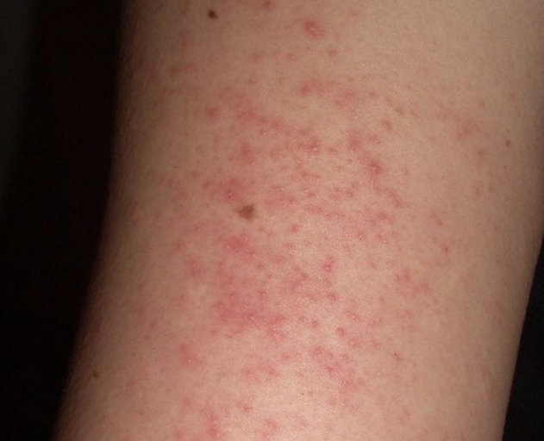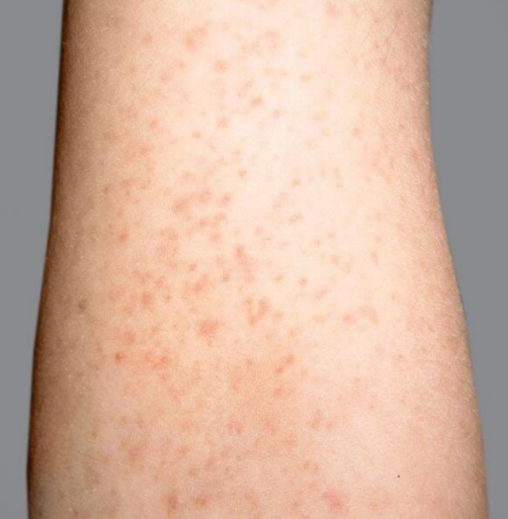

**Figure No 01 Figure No 02**

Fig No 1 & 2: Rashes over upper limbs



**Figure No 03**

Fig No 03: Periorbital edema

Provisional diagnosis: severe anemia secondary to iron deficiency

**Final diagnosis: Iron deficiency anemia**

**Treatment:** She was started with the following medications

Table 2 : Prescribed medication for the patient

|  |  |  |  |  |  |
| --- | --- | --- | --- | --- | --- |
| **S.NO** | **Name of the drug** | **Dose** | **Route** | **Frequency** | **Days** |
| 1 | Pantoprazole | 40 mg | IV | 1-0-0 | D1-D6 |
| 2 | Ondansetron | 4mg | IV | 1-0-1 | D1-D6 |
| 3 | 1 pint PRBC |  | IV | 1-0-0 | D1 |
| 4 | Iron folic acid | 333 mg | PO | 1-0-1 | D1-D6 |
| 5 | Folic acid | 5 mg | PO | 0-1-0 | D1-D6 |
| 6 | Iron sucrose | 200mg in 100ml NS | IV | 1-0-0 | D1-D4 |
| 7 | Methylcobalamin | 1500mcg in 100ml NS | IV | 0-1-0 | D1-D6 |
| 8 | Ferric carboxymaltose | 1g in 100ml NS | IV | 1-0-0 | D5-D6  500mg on D6 |
| 9 | Hydrocortisone | 200 mg | IV | 1-0-0 | D2 |
| 10 | Chlorpheniramine | 4 mg | IV | 1-0-0 | D2 |

**Table 3 : Discharge medication**:

|  |  |  |  |  |
| --- | --- | --- | --- | --- |
| **S.NO** | **Name of the drug** | **Dose** | **Route** | **Frequency** |
| 1 | Iron folic acid | 333 mg | PO | 1-0-1 |
| 2 | Folic acid | 5 mg | PO | 0-1-0 |
| 3 | B complex |  | PO | 0-1-0 |
| 4 | Ondansetron | 4mg | PO | 1-0-1 |

**Discussion**

Anemia is the inability of the blood to carry enough oxygen eventually leading to hypoxia of body tissues and organs resulting in fatiguability, breathlessness etc. Iron, a vital component of haemoglobin molecule, is crucial for oxygen transport. Iron deficiency is the leading cause of anemia, affecting 32.9% of the global population and contributing significantly to morbidity worldwide, leading to microcytic and hypochromic red blood cells, as observed on a peripheral blood smear. The underlying causes of iron deficiency can vary depending on age, sex, and socioeconomic factors and may include inadequate dietary intake, impaired absorption, or blood loss. Patients with anemia often report nonspecific symptoms such as fatigue and shortness of breath during physical activity.5

Treatment for iron deficiency anemia (IDA) involves oral iron supplementation, which is the first-line treatment. However, intravenous (IV) iron is used when oral iron is ineffective, poorly tolerated or unsuitable. IV iron carries a risk of infusion-related reactions (IRRs), ranging from mild to severe. Common IV iron formulations include iron sucrose (IS), low molecular weight iron dextran (LMWID), ferumoxytol, ferric gluconate, ferric carboxymaltose, and the recently approved ferric derisomaltose.6

Intravenous Iron Sucrose can notably increase hemoglobin levels and other red blood cell parameters. Common side effects include headache, dizziness, nausea, vomiting, tingling sensations, swelling and muscle pain.7

Ferric carboxymaltose (FCM) is an intravenous iron formulation consisting of a polynuclear iron (III)-hydroxide core stabilized by carboxymaltose. FCM works by being gradually taken up mainly by the hepatic reticuloendothelial system, followed by effective delivery of iron to the endogenous transport system for heme synthesis in new erythrocytes. This controlled release mechanism helps balance effectiveness and safety, as compounds that release iron too rapidly can cause toxicity.8

In the present case a female patient of 24 years old admitted with a complaint of easy fatigability, generalised weakness and decreased appetite since 15 days. She had no comorbidities, so based on the patients sign and symptoms the physician has advised her for CBC, serum ferritin, folic acid, vitamin B12, Thyroid profile, peripheral smear and USG abdomen. In which her **CBC, LDH, serum ferritin levels decreased**. Peripheral smear revealed **severe dimorphic anemia with marked anisopoiklocytosis.**

Treatment was initiated with Iron folic acid, Folic acid, methylcobalamine, Iron sucrose to treat anemia. Proton pump inihibitors to treat GI irritation, ondansetron to treat nausea and vomiting, 1-pint PRBC transfusion was done on her 1st day of admission.

The patient developed rashes on the face and bilateral upper limbs, along with peri-orbital edema, following a PRBC transfusion. The physician recommended discontinuing the PRBC transfusion and prescribed Inj. Hydrocortisone and Chlorpheniramine. On day 4 of iron sucrose administration, the patient developed abdominal pain, vomiting, and diarrhea, prompting withdrawal of the drug. Inj. Ferric Carboxymaltose was then initiated, but the patient experienced adverse effects, including hypotension, Sudden respiratory distress, SpO2 had dropped to 85%, dizziness and nausea (similar to case reported by Bijalwan S, Randhawa GK et.al., and Arici AM et.al.,) As a result, the dose was reduced by half and eventually stopped.

The Causality assessment (WHO UMC scale and Naranjo scale) was ‘Possible’ for both Iron Sucrose and Ferric carboxymaltose. The treatment was initiated as per standard treatment guidelines. After prompting improvement in health condition, the patient was discharged from the hospital with the following medications Iron folic acid, folic acid and B complex to treat severe anemia, ondansetron to treat nausea and vomiting. Physician advised patient to review after 10 days.

The patient showed heightened sensitivity to iron preparations and blood products, suggesting an increased risk of anaphylaxis. However, no clear predisposing factors were identified except for gender, possibly due to its influence on immune responses.

**Some key advantages of FCM over other intravenous iron formulations include:**

* Single high-dose administration: FCM can be given as a single high-dose, 15-minute infusion, which improves convenience and potentially reduces healthcare costs
* Rapid iron store replenishment: FCM is effective for rapidly correcting iron deficiency anemia in various patient populations
* Generally well-tolerated: FCM has demonstrated a favorable safety profile in clinical trials and real-world settings
* Low risk of hypersensitivity reactions: Severe hypersensitivity reactions were reported in <1% of prospective trials, comparable to other modern formulations

**Conclusion**

Anaphylactic reactions to intravenous iron preparations, specifically ferric carboxymaltose and iron sucrose, are rare but potentially life-threatening. This study emphasizes the importance of promptly recognizing and managing this reaction. These findings underscore the need for healthcare providers to remain vigilant when administering these iron preparations and be prepared to manage infusion related reactions swiftly. While both ferric carboxymaltose and iron sucrose remain valuable treatment options for iron deficiency anemia, careful patient selection and adherence to administration guidelines are crucial to minimize the risks. Further research is warranted to develop strategies such as appropriate dilution, rate of IV infusion in identifying high-risk patients and exploring the early symptoms and causes of anaphylactic response to iron preparations. This knowledge will contribute to enhance patient safety and optimize the use of intravenous iron therapy in clinical practice.

**Declaration of conflicting interests**

The author(s) declared no potential conflicts of interest with respect to the research, authorship, and/or publication of this article.

**Ethics approval**

Our institution does not require ethical approval for reporting individual cases or case series.

**Informed consent**

Written informed consent was obtained from the patient(s) for their anonymized information to be published in this article.

Disclaimer (Artificial intelligence)

Option 1:

Author(s) hereby declare that NO generative AI technologies such as Large Language Models (ChatGPT, COPILOT, etc.) and text-to-image generators have been used during the writing or editing of this manuscript.

Option 2:

Author(s) hereby declare that generative AI technologies such as Large Language Models, etc. have been used during the writing or editing of manuscripts. This explanation will include the name, version, model, and source of the generative AI technology and as well as all input prompts provided to the generative AI technology

Details of the AI usage are given below:

1. Option 1: Author(s) hereby declare that NO generative AI technologies such as Large Language Models (ChatGPT, COPILOT, etc.) and text-to-image generators have been used during the writing or editing of this manuscript.

2.

3.

**References**

1. Muñoz-Cano R, Goikoetxea MJ, Valero AL, Araujo G, Pascal M, Bartra J, et al. Mechanisms, Cofactors, and Augmenting Factors Involved in Anaphylaxis. Frontiers in Immunology. 2017 Sep 26;8(1).
2. Ehlken B, Nathell L, Gohlke A, Toussi M, Bocuk D, Wohlfeil S. Evaluation of the Reported Rates of Severe Hypersensitivity Reactions Associated with Ferric Carboxymaltose and Iron (III) Isomaltoside 1000 in Europe Based on Data from EudraVigilance and VigiBaseTM between 2014 and 2017. Drug Safety. 2018 Dec 10;42(3):463–71.
3. Trumbo H, Goodnough LT, Numan S, Kaluza K. Frequency and Associated Costs of Anaphylaxis- and Hypersensitivity-Related Adverse Events for Intravenous Iron Products in the USA: An Analysis Using the US Food and Drug Administration Adverse Event Reporting System. Drug Safety. 2020 Nov 25;44(1):107–19.
4. Arici AM, Kumral Z, Gelal A, Akdeniz B. Fatal anaphylactic reaction due to ferric carboxymaltose: A case report. Anatol J Cardiol. 2020 Aug;24(2):115-117. doi: 10.14744/AnatolJCardiol.2020.38996. PMID: 32749249; PMCID: PMC7460686.
5. Warner MJ, Kamran MT. Iron Deficiency Anemia. [Updated 2023 Aug 7]. In: StatPearls [Internet]. Treasure Island (FL): StatPearls Publishing; 2025 Jan-. Available from: <https://www.ncbi.nlm.nih.gov/books/NBK448065/>
6. Ayesha Butt, Tinatin Muradashvili. Iron Infusion Reactions: Risk Factors and Real-World Experience; [Volume 138, Supplement 1](https://www.sciencedirect.com/journal/blood/vol/138/suppl/S1), 23 November 2021, Page 4154. Available from: <https://doi.org/10.1182/blood-2021-151048>
7. Bijalwan S, Randhawa GK, Kohima Aggarwal DD. A Rare Case Report of Toxic Epidermal Necrolysis with Iron Sucrose/first line Anti-tuberculosis Treatment Drugs. Volume 6, Issue 5; May: 2022; Page No. 20-23. Available from: <https://doi.org/10.32553/ijmsdr.v6i5.940>
8. Funk, F., Ryle, P., Neiser, S., Canclini, C., & Geisser, P. (2011). The new generation of intravenous iron: chemistry, pharmacology, and toxicology of ferric carboxymaltose. *Arzneimittelforschung*, *60*(06), 345–353. <https://doi.org/10.1055/s-0031-1296299>