Contamination of pre-washed fresh vegetables intended for sale in the commune of Foumbot in West Cameroon by human intestinal parasites forms (helminths and protozoa)

Abstract
The aim of this study was to determine the impact of the quality of vegetables sold in the main markets of Foumbot on the resurgence of waterborne diseases in this commune. 100 samples of vegetables whose leaves, roots and fruit are eaten raw were collected and analysed.50 per market (the central and fresh food markets) were taken and analysed following standardized methods. Eggs of Ascaris spp., Ankylostoma spp., Strongyloides spp., nematode larvae, ciliate trophozoites. eggs of Fasciola hepatica and trematode eggs have been detected on all types of vegetables. Ciliate trophozoites (51%) and nematode larvae (31%) had the highest prevalences, while Fasciola hepatica eggs (1%) and trematode eggs (1%) had the lowest prevalences. Vegetables sold in Foumbot are thought to be partly responsible for the persistence of water-borne diseases in the locality. The public authorities should therefore take vegetable quality into account when devising strategies to combat water-borne diseases in general.

Keywords: Market garden products, Parasites, Health risk, Waterborne disease, Foumbot, Cameroon

1. INTRODUCTION
Waterborne diseases are widespread throughout the world and constitute a real public health problem. The morbidity and mortality associated with these diseases affect both developing and developed countries and are estimated to be responsible for around 2.2 million deaths per year in children under five (Newell et al., 2010; Moussa et al., 2018). The World Health Organization (WHO) estimates that around 2.3 billion people are affected by waterborne diseases worldwide each year, and that 1.8 million people die, 90% of them children under the age of 5, mainly in developing countries (WHO, 2019). Access to drinking water and sanitation has long been an issue for many countries, and according to a WHO report, 3,319 million people in sub-Saharan Africa still do not have access to drinking water and 695 million do not have access to basic sanitation (Dorine et al., 2019).
Diarrhea diseases are major causes of mortality in developing countries, and many cases are attributable to poor-quality water, inadequate sanitation and poor hygiene. In Cameroon, it causes around 15% to 20% of annual mortality (Moussa et al., 2013). The main factors influencing the prevalence of parasitic infections are habitat and the high consumption of raw vegetables and fruit, which are generally of poor quality (Hajjami et al., 2013; Saah, 2019; Ntangmo Tsafack et al., 2019, 2021, 2022, 2023). This is the case for cosmopolitan parasitoses such as Ascariasis caused by Ascaris lumbricoides which affects more than a quarter of the world's population amoebiasis caused by Entamoeba histolytica which affects 10% of the world's population.
As for the poor quality of these vegetables, the poor quality of irrigation water, agricultural inputs, poor packaging of vegetables from the field to the market, poor display of vegetables on the market, and the poor quality of water used to wash vegetables are the factors generally blamed (Ntangmo Tsafack et al., 2013, 2021, 2022, 2023 Vouffo, 2017; Saah, 2019).
Market gardening in the lowlands is a fast-growing activity that not only provides a means of subsistence for poor households, but also contributes to food security in several of the country's towns. Despite the advantages that militate in favor of their development, the sanitary quality of the vegetables remains a subject of many questions, since they are cultivated mainly in the lowlands, which receive waste of all kinds. Numerous studies around the world have made the link between the poor sanitary quality of vegetables produced and consumed and water-borne diseases in Nigeria, Iran, and Cameroon (Abdol et al., 2016; Ntangmo tsafack et al., 2019).
The commune of Foumbot does not present data on the quality of irrigation water, vegetables sold and water used to wash vegetables in markets, and one might wonder whether the latter might not be partly the cause of the persistence of waterborne diseases in this commune. The aim of this study was to determine the parasitological quality of vegetables sold in the commune of Foumbot, in order to provide data that can help in the development of strategies to combat food-borne diseases.

2. MATERIAL AND METHODS
2.1 Presentation of the study area
Located in the West-Cameroon region, Noun Department, the Foumbot municipality is located at 5.50803˚ latitude north and 10.6325˚ longitude west, with a population of 77,130 inhabitants and an area of 579 km² (Fig 1). It is located in the so-called tropical Sudano-Guinean climate zone and has two seasons: a rainy season which ranges from mid-March to mid-November and a dry season which ranges from mid-November to mid-March. The average rainfall in this area varies between 2500 and 5000 mm of rain per year (Mfokou, 2018). The main boundary on the west side of this municipality is marked by the Noun River, the main hydrographic resource of Foumbot. The soils are mostly of volcanic origin; but mainly made up of tropical ferruginous soils that are not very leached and black with a high agronomic value (Communes and united towns of Cameroon, 2014 in Mfokou, 2018). It is an essentially rural area because agriculture remains at more than 84% of the primary economic activity most practiced by the population. The municipality has mainly two markets namely; the central market and the B market or fresh food market which is the main supplier of Cameroonian markets and the sub-region in market garden products and others.
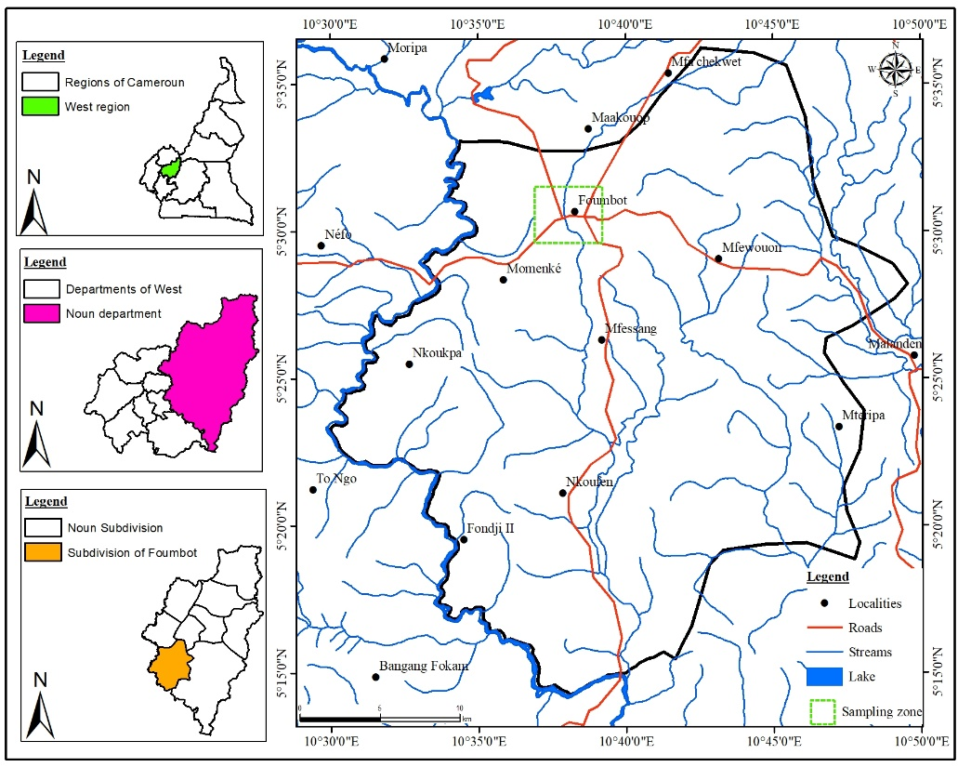
Fig. 1. Location map of Foumbot municipality (extract from the National Institute of Cartography data base, 2021, field data)

2.2 Sampling of vegetables
Three groups of vegetables consisting of leafy vegetables, roots and fruits were chosen. Carrots, celery, basil, parsley, lettuce, tomato, African eggplant, cucumbers, peppers, chillies were purchased from traders at the market. These vegetables were chosen because they are the most sold and available at any time of the year and can be eaten raw. 100 vegetable samples were collected, i.e. 10 samples per type of vegetable (5 samples per market), including 50 in the central market and 50 others in the fresh food market. The different vegetables were purchased from the different sellers having the desired vegetables, then placed in a refrigerated enclosure and transported to the laboratory for analysis.

2.4 Parasitological analysis of vegetables
The parasitological analysis of the vegetable samples was done to detect the presence of pathogenic parasites. It was done using the flotation concentration technique.
One hundred (100) grams of each vegetable sample were washed in 1 litter of distilled water. The water from washing was then sieved with a fine mesh sieve, and left to sediment for 8 hours. The sedimented residues were centrifuged at 2500 rpm for 15 min. Once the pellet was obtained, the supernatant was poured and then saline solution added to the pellet until a meniscus was formed. After about 10 to 15 minutes, the upper part of the meniscus was harvested by placing a coverslip on it, then placed face down on a slide and examined using a microscope with 10X and 40X objectives. A few drops of Lugol's were added to the slide to improve the morphological details of the parasites. For each sample, 2 slides were analysed. The first slide contained a drop of pellet and the second slide the result of flotation.
The parameters evaluated were the prevalence of contamination of the samples by parasites and the parasite load of the vegetables.

2.5 Analysis of collected data
All collected data were entered and recorded in Microsoft Excel 2016 software and then exported to SPSS version 25 software for analysis. The one-way ANOVA test (analysis of variance) was used to compare the mean parasite contamination levels, among samples for all analyses, differences were considered significant for values of P < 0.05.

3. RESULTS
3.1 Frequency of contamination of vegetables by markets
Almost all of the 50 vegetable samples examined in both markets were contaminated by at least one parasite form. African eggplant, basil, carrot, celery, cucumber and pepper were the most contaminated in both markets (Table 1 and 2 ). Pepper and tomato did not contain any parasitic organism in the fresh food market (Table 2 ).

Table 1. Frequency of parasite contamination of vegetables sold in the central market
Type of vegetable | Number of samples | Number and percentage of positive samples ( %) | Number of pathogens identified
Type of vegetable | Number of samples | Number and percentage of positive samples ( %) | 1 | 2 to 5
African egg plant | 5 | 5(100) | 2(40) | 3(60)
Basil | 5 | 5(100) | 0(0) | 5(100)
Carrot | 5 | 5(100) | 2(40) | 3(60)
Celery | 5 | 5(100) | 4(80) | 1(20)
Cucumber | 5 | 5(100) | 2(40) | 3(60)
Lettuce | 5 | 4(80) | 3(75) | 1(25)
Parsley | 5 | 4(80) | 2(50) | 2(50)
Pepper | 5 | 3(60) | 3(100) | 0(0)
Chilies | 5 | 5(100) | 1(20) | 4(80)
Tomato | 5 | 1(20) | 2(100) | 0(0)
TOTAL | 50 | 43(86) | 21(48,84) | 22(51,16)

Table 2. Frequencies of parasite contamination of vegetables sold in the fresh food market
Type of vegetable | Number of samples | Number and percentage of positive samples (%) | Number of pathogens identified
Type of vegetable | Number of samples | Number and percentage of positive samples (%) | 1 | 2 of 5
African egg plant | 5 | 5(100) | 4(80) | 1(20)
Basil | 5 | 5(100) | 2(40) | 3(60)
Carrot | 5 | 5(100) | 0(0) | 5(100)
Celery | 5 | 5(100) | 2(40) | 3(60)
Cucumber | 5 | 5(100) | 3(60) | 2(40)
Lettuce | 5 | 3(60) | 3(100) | 0(0)
Parsley | 5 | 2(40) | 2(100) | 0(0)
Pepper | 5 | 0(0) | 0(0) | 0(0)
Chilies | 5 | 5(100) | 1(20) | 4(80)
Tomato | 5 | 0(0) | (0) | 0(0)
TOTAL | 50 | 35(70) | 17(48,57) | 18(51,43)

3.2 Prevalence of contamination of vegetables by different parasites
Parasites belonging to helminths (86%) and protozoa (53%) were identified as contaminants on vegetables. Seven (07) parasite types were identified namely the eggs of Ascaris spp. (Fig 1), Ankylostoma (Fig 5) spp, Strongyloides spp (Fig 2), Fasciola hepatica (Fig 3), nematode larvae (Fig 4), trematode eggs (Fig 6)and ciliate trophozoites. Except for the prevalence of Fasciola and trematode eggs, the prevalence of other types of parasites varied significantly from one vegetable to another (P˂0.05) (Table 3 ). Ascaris sp eggs, Ankylostoma sp, Strongyloides sp, nematode larvae and ciliate trophozoites were identified on almost all vegetables with prevalences varying from 10% to 100%; on the other hand, Fasciola hepatica eggs were detected only on parsley and trematode eggs only on lettuce.

Table 3. Prevalence of contamination of vegetables by different parasites
Variable n=10 | Parasites identified and their frequencies (%) in the vegetables  Helminthes Protozoas
Variable n=10 | Eggs of Ascaris sp | Eggs of Ankylostoma sp | Eggs of Strongyloides sp | Eggs of Fasciola hepatica | Trematode eggs | Nematode larvae | Ciliate trophozoites
African egg plant | 5(50) | 0 | 0 | 0 | 0 | 2(20) | 10(100)
Basil | 5(50) | 2(20) | 1(10) | 0 | 0 | 6(60) | 7(70)
Carrot | 6(60) | 0 | 10(100) | 0 | 0 | 5(50) | 2(20)
Celery | 2(20) | 3(30) | 1(10) | 0 | 0 | 9(90) | 6(60)
Cucumber | 2(20) | 0 | 5(50) | 0 | 0 | 0 | 9(90)
Lettuce | 0 | 0 | 0 | 0 | 1(10) | 0 | 7(70)
Parsley | 0 | 1(10) | 2(20) | 1(10) | 0 | 3(30) | 2(20)
Pepper | 1(10) | 0 | 0 | 0 | 0 | 2(20) | 0
Chilies | 0 | 6(60) | 1(10) | 0 | 0 | 2(20) | 10(10)
Tomato | 0 | 0 | 0 | 0 | 0 | 2(20) | 0
Total | 21(21) | 12(12) | 20(20) | 1(1) | 1(1) | 31(31) | 53(53)
P-value | 0.00 | 0,00 | 0,00 | 0,42 | 0,42 | 0,00 | 0,00
n = number of samples examined per type of vegetable

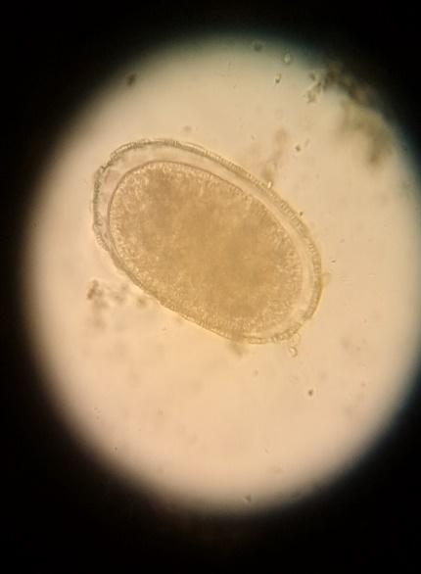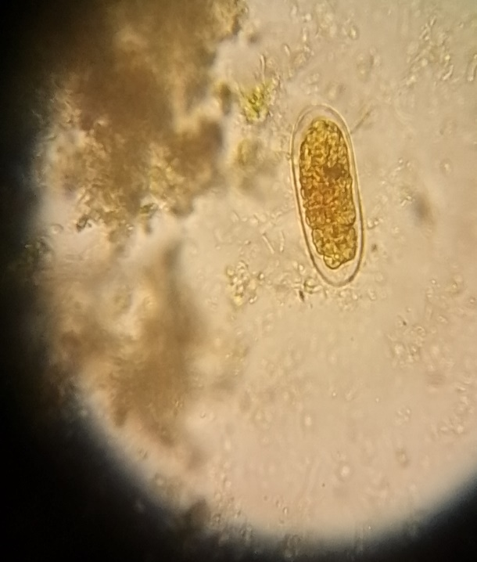
Fig 1. Ascaris egg Fig 2. Strongylyloides egg
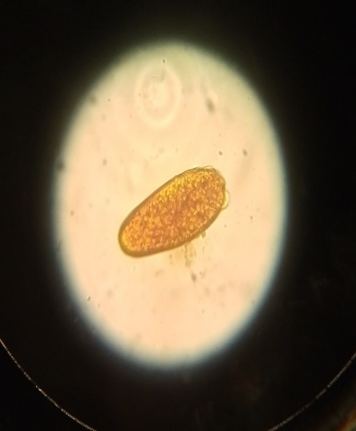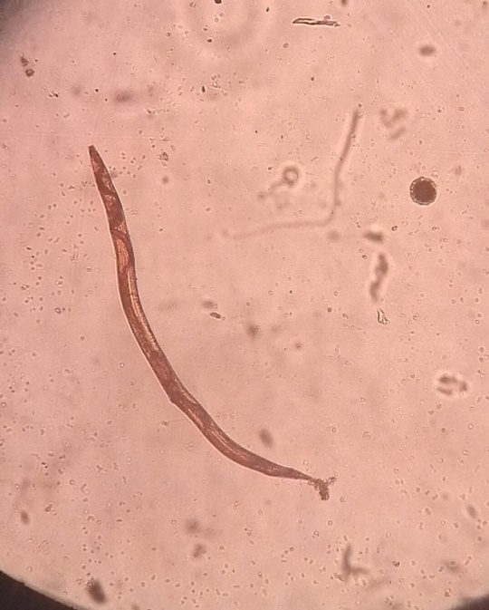
Fig 3. Fasciola hepatica Fig 4. Nematode larva
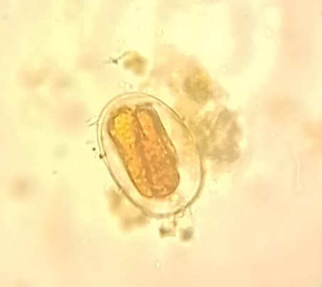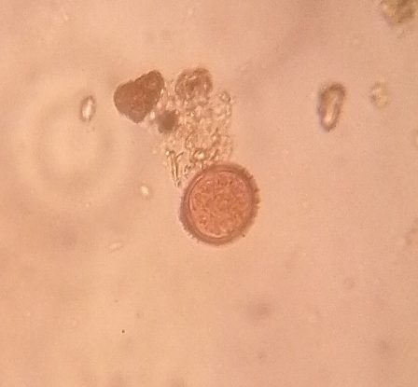
Fig 5. Ankylostoma egg Fig 6. Trematode egg
3.3 Parasite load on vegetables
Carrots had the highest contamination of Ascaris sp eggs (31.5/100g), celery the highest load in Ankylostoma spp eggs (1.30/100g) and nematode larvae (12.10/100g), cucumbers had the highest load in Strongyloides spp eggs (3.60/100g and peppers in ciliate trophozoites (270/100g). (table 4).

Table 4. Parasite load on vegetables
Mean parasite counts in 100g of fresh matter of vegetable (n/100g)
Type of vegetable | Eggs of Ascaris spp | Eggs of Ankylostoma spp | Eggs of Strongyloides spp | Eggs of Fasciola hepatica | Eggs of trematodes | Larvae of nematodes | Ciliate trophozoites
African egg plant | 0.80±1.03 | 0.00 | 0.00 | 0.00 | 0.00 | 0.30±0.67 | 222.10±269.88
Basil | 9.90±17.27 | 0.70±1.88 | 0.40±1,26 | 0.00 | 0.00 | 8.30±13.09 | 27.20±31.06
Carrot | 31.50±39.01 | 0.00 | 2.30±1.25 | 0.00 | 0.00 | 9.50±18.14 | 1.00±2.16
Celery | 8.20±19.05 | 1.30±2.40 | 0.40±1.26 | 0.00 | 0.00 | 12.10±18.71 | 13.90±25.51
Cucumber | 12.80±33.46 | 0.00 | 3.60±5.48 | 0.00 | 0.00 | 0.00 | 145.50±296.54
Lettuce | 0.00 | 0.00 | 0.00 | 0.00 | 0.10±0.31 | 0.00 | 154.80±305.42
Parsley | 0.00 | 0.20±0.63 | 0.20±0.42 | 0.10±0.31 | 0.00 | 0.50±0.85 | 2.40±5.58
Pepper | 0.30±0.94 | 0.00 | 0.00 | 0.00 | 0.00 | 0.20±0.42 | 0.00
Chilies | 0.00 | 1.20±1.22 | 0.10±0.31 | 0.00 | 0.00 | 0.20±0.42 | 270.00±333.55
Tomato | 0.00 | 0.00 | 0.00 | 0.00 | 0.00 | 0.20±0.42 | 0.00
P-value | 0.003 | 0.014 | 0.000 | 0.446 | 0.446 | 0.008 | 0.004
n = average number of parasites
4. DISCUSSION
According to the World Health Organization (2003), vegetables intended for human consumption must not contain any parasite. In view of this standard, the results of this study show that vegetables sold in the markets of Foumbot are of poor parasitological quality. Several studies have highlighted the risk to public health linked to the consumption of vegetables and fruits (Nkengazong et al., 2016).
Almost all (78%) of the vegetables analysed were contaminated and the parasites found on the vegetables were the eggs of Ascaris spp., Ankylostoma spp., Strongyloides spp., Fasciola hepatica, nematode larvae, trematode eggs and ciliate trophozoites. However, these results remain higher than those obtained by Dankwa et al. (2018) in the Cape Coast (Ghana), Luz et al. (2017) in Jequitinhonha (Brazil) and Ntangmo et al (2022) in Dschang (Cameroon). This variation in prevalence may be due to the number and type of vegetable samples analysed, the methods of harvesting and handling vegetables and the sampling period. Indeed, inadequate cultivation methods, including the absence of crop rotation and the use of non-potable water for irrigation, promote the proliferation of pests in the soil. In addition, poor treatment of vegetables during harvesting, transport and packaging, often carried out in dirty bags, contributes to cross-contamination. These practices, combined with insufficient awareness among producers and vendors on the importance of hygiene, explain why the levels of contamination observed in this study are higher than those reported in other research, thus highlighting the need to improve sanitary standards throughout the value chain of market garden products.
Among the vegetable samples analysed, the most contaminated were African eggplants, basils, carrots, celery, cucumbers and peppers. This contamination was gross for carrots. This result is in agreement with that of Kame-ngasse et al (2023) in the Mfoundi division and Ntangmo et al (2021) in the city of Bafoussam and can be explained by several factors intrinsic to their culture and morphology. As root vegetables, carrots are in direct contact with the soil, which exposes them to a variety of pathogens present in the environment, including those from animal droppings and organic residues. In addition, the rough and uneven surface of carrots promotes the accumulation of microbes and makes their washing less effective, thus allowing increased adhesion of pathogens. The most frequently identified helminth was the nematode larva with the highest abundance. This observation is consistent with that of Nkengatong et al. (2016) who, in a systematic review, revealed that the nematode larva was one of the most prevalent in vegetables. This result is close to that of Kame-ngasse et al (2023) in the Mfoundi division where the larvae found were 7.76% but remains however lower than that of our study. This result can be explained by the fact that environmental conditions and agricultural practices in Foumbot municipality favour the proliferation of nematode larvae. High humidity and tropical temperatures create an environment conducive to the survival and reproduction of these parasites in the soil. In addition, the use of untreated organic fertilizers, often contaminated with eggs or larvae, as well as inadequate irrigation practices, can contribute to their introduction and dissemination in crops. Compared to other regions, such as the one studied by Kame-ngasse et al. (2023), where contamination rates were lower, the combination of these factors in the Foumbot municipality could explain why nematode larvae are more abundant there, highlighting the need to improve agricultural management practices to reduce the risks of parasite contamination. The presence of protozoa and helminths in this study could be due to lack of potable water, poor hygiene levels and close contact with infected reservoir animals (Tsegahun et al., 2023).
Varied contamination rates of helminths and protozoa have been obtained from studies related to contaminants in vegetables and fruits: 61.6% in Fako Division (Akoachere et al., 2018), 13.21% in Buea (Judith et al., 2018), 39.1% in Ethiopia (Getaneh et al., 2020), 40% in Nigeria (Amaechi et al., 2016; Ola-Fadunsin et al., 2022) with an overall incidence rate of 30% in vegetables and 20% in fruits (Nkengazong et al., 2016). The observed difference could be related to the number of samples collected, the sensitivity of the analytical techniques used, the period and duration of the study as well as variations in the geographical distribution of parasites, the health and socio-economic status of the community. Fominyam et al. (2023) showed that vegetables, highly recommended for human consumption, are important sources of multiple human infectious diseases.
According to Minader, the market in the municipality of Foumbot is the main supplier of market garden and other products to Cameroonian markets and the sub-region. Since these vegetables do not meet SCISCOM and WHO standards, this could mean that vegetables sold in the markets of Foumbot could be partly responsible for the persistence of waterborne diseases in the locality, in Cameroon and in the sub-region.

5. CONCLUSION
Water-borne diseases are a recurring problem in both developing and developed countries, and in order to overcome this problem it is necessary to focus on the sanitary quality of vegetables. The aim of this study was to determine the parasitological quality of vegetables sold in the commune of Foumbot in order to provide data that could help in the development of strategies to combat food-borne diseases.
The study showed that the parasitological quality of vegetables sold in Foumbot markets is poor. Parasitic forms such as eggs of Ascaris spp, Ankylostoma spp, Strongyloides spp, Fasciola hepatica and trematodes, nematode larvae and ciliate trophozoites were detected. This shows the limits of hygiene and sanitation in this locality, and represents a real danger for consumers of these vegetables, which are also eaten raw. These vegetables are thought to be partly responsible for the persistence of water-borne diseases in the area. To protect the population, the public authorities should monitor the conditions under which these vegetables are produced and sold. Consumers of these vegetables should wash them well before eating them.

DISCLAIMER (ARTIFICIAL INTELLIGENCE)
Author(s) declared that NO generative AI technologies such as Large Language Models (ChatGPT, COPILOT, etc) and text-to-image generators have been used during writing or editing of this manuscript.

LIMITATION OF THE STUDY
This study has certain limitations. Sampling was carried out only once, and the seasonal effect was not assessed. The active or inactive nature of the parasitic forms detected was not assessed. Further research into the environmental resistance of parasitic forms is needed. Number of samples, although sufficient for a first assessment, could be expanded for a more representative analysis of different markets and vegetable varieties.

ETHICAL APPROVAL:
The study was authorized by the Department of Animal Biology of the University of Dschang. The research protocol was approved by a subcommittee of teachers of the Faculty of Science of the University of Dschang.

COMPETING INTEREST
Authors declared that no competing interests exist

FUNDING
The authors declare that no funding was received for the conduct of this research or for the preparation of this article. The study was carried out without external financial support.

REFERENCES
Abdol K.N., Mohammad J.M. ; Ahmad R.Y., Mehdi V., Majid F.., Soghra B., Monavar D.(2015). Microbial Contamination of Raw Vegetables in Ahvaz, Iran during 2014-2015. Archives of Hygiene Sciences Volume 5, Number 3
Akoachere, J.F.T.K., Tatsinkou, B.F., Nkengfack, J.M. (2018). Bacterial and parasitic contaminants of salad vegetables sold in markets in Fako Division, Cameroon and evaluation of hygiene and handling practices of vendors. BMC Res. 11 (1): 1–7 https://doi.org/10.1186/s13104-018-3175-2
Dankwa, K., Siaw, D.O., Obboh, E.K., Singh, B., Nuvor, S.V. (2018). Parasitic profile of fresh vegetables sold in selected markets of the Cape Coast Metropolis in Ghana. Annu. Res. Rev. Biol.; 8 (6): 1–7 https://doi.org/10.9734/ARRB/2018/43840
Dorine D T., Noel V., Claude N.N., Maurice E.E., Samuel N.C. (2019). Access to drinking water and sanitation: the case of the district municipality of Douala V (Cameroon). Pan African Medical Journal 33: 244
Fominyam, B.T., Toche, G.B.A., Brendaline, K., Augustine, E.B., Atembeh, N., Enoh, E., Makoge, J.E., Nkengazong, V., L. (2023). Parasitic contamination of commonly consumed fresh fruits sold at Tiko and Limbe Municipality Markets, South West Region of Cameroon. Food Sci. Nutrit. Res; 6 (1): 1–7
Hajjami K., Ennaji M.M., Amdiouni H., Fouad S. and Cohen N. (2013). Parasistic contamination on fresh vegetable consumed in Casablanca city (Morocco) and Risk for Consumer. International Journal of Science and Technology, 2(7): 543- 549.
Judith, L.N., Chrisantus, A.A., Ngum, C.N., Desdemona, N.N. (2018). Parasitic helminths of medical importance and yeast infection on fruits sold in the markets and streets of Buea, Fako Division, South West Region, Cameroon. World J. Pharm. Med. Res.; 4 (6): 257–263
Kame-Ngasse G. I., Ebogo-Belobo J. T., Kamwa-Ngassam I., Watat S. V., Atembeh-Noura E., Tchinda-Tiecheu E., Tsafack J., Nkengazong L. (2023). Parasitological assessment of some fruits and vegetables commonly sold in retail outlets in the Mfoundi Division of Cameroon. Parasite Epidemiology and Control; 22: e00313.
Luz J. G. G., Barbosa M. V., Carvalho A. G., Resende S. D., Martins H. R. And Dias J. V. L. (2017). Contamination by intestinal parasites in vegetables marketed in an area of Jequitinhonha Valley, Minas Gerais, Brazil. Revista de Nutrição Campinas; 30(1):127-136
Moussa D., Bouba G., Daniel EM., Zébazé T.S.H., Nola M., and Njiné T. (2013). Survival and Growth of Vibrio cholerae, Escherichia coli, and Salmonella Spp. in Well Water Used for Drinking Purposes in Garoua (North Cameroon). International Journal of Bacteriology Volume 2013
Moussa D., Bouba G., Zebaze T.S.H.,., Zoua W., Moïse N., Thomas N. (2018). Assessment of Salmonella sp. and Vibrio cholerae contamination of well water in Garoua, North Cameroon. Africa SCIENCE 14(4) 209 – 224
Moussa D., Nola M., Gake B., Ebang MD., Njine T. (2011). Faecal Contamination of Well Water in Garoua (Cameroon): Importance of Household Storage and Sanitary Hygiene. International Journal of Research in Chemistry and Environment Vol. 1(97-103)
Newell D. G., Koopmans M., Verhoef L., Duizer E., Aidara-KaneA., Sprong H., et al (2010). Food borne diseases: The challenges of 20 years ago still persist while new ones continue to emerge. International Journal of Food Microbiology, 1:3–15.
Nkengazong, L., Ngo Ngue, T.N., Nukenine, N.E., Ngue, M., Moyou-Somo, R. (2016). Study of neglected tropical diseases (NTDs): gastrointestinal parasites in school children of Lolodorf neighborhood, South Region, Cameroon. Int. J. Too much. Say. Health; 20 (1): 1–11 11. https://doi.org/10.9734/IJTDH/2016/29273
Ola-Fadunsin, S.D., Adebanjo, A.O., Abdullah, D.A., Hussain, K., Sanda, I.M., Rabiu, M., et al. (2022). Epidemiology and public health implications of parasitic contamination of fruits, vegetables, and water in Kwara Central, Nigeria. Ann. Parasitol; 68 (2): 339–352 https://doi.org/10.17420/ap6802.440
Ntangmo T. H., Azeufack J., Meli T. A., Wamba F. R., Joko Tamoufé S., Azinwi T. P., Temgoua E., (2022). Consequences of hygiene and sanitation limitations on parasitological and bacteriological quality of the washing water for vegetables and vegetables sold in the city of Dschang. (West of Cameroon). International. Newspaper. Biological. Chemical. Science. 1-17
Ntangmo T. H., Kenfack S., Wamba F. R., Temgoua E. (2021). Bacteriological and parasitological quality of ready-to-eat raw fruits and vegetables (4th Range products) sold in the streets of the city of Bafoussam, West Cameroon. International. Journal. Biological. Chemical. Sciences. 13(4): 175
Ntangmo T. H., Temgoua E. and Njine T. (2012). Physico-chemical and bacteriological quality of the vegetable watering water in the Dschang Town, Cameroon. Journal of Environmental Protection. 3: 949-955
Ntangmo T.H., Temgoua E. and Njine T. (2019). Persistence of E. coli, helminth eggs and protozoan cysts contained in urban wastewater from irrigation of market garden crops in Dschang, West-Cameroon. International. Journal. Biological. Chemical. Sciences. 13(5): 81-90
Ntangmo T. H., Meli Tchoffo A., Wamba F. R., Joko Tamoufé S., Azeufack J., Azinwi Tamfuh P., Temgoua E. (2023). Consequences of hygiene and sanitation limitations on physicochemical, bacteriological and parasitological quality of water for vegetable irrigation purpose in the Mbouda lowlands, Cameroon Western Highlands. 1-14 wileyonlinelibrary.com/journal/ird
WHO (2019). Water, sanitation and health: water-related diseases
Saah F.C.A. (2019). Parasitological and Bacteriological Quality of Vegetables Sold in the City of Mbouda (West Cameroon). Thesis defended for the purpose of obtaining a master's degree in Animal Biology, Parasitology option, at the University of Dschang, 65p.
Tsegahun A., Deribew G., Demissew S., Tassew T. S., Yosef E. A., and Berhanu Y. (2023). Parasitic contamination and microbiological quality of fresh vegetables commonly consumed and marketed in the Debre Berhan city, Ethiopia. Res Rep Trop Med. ; 12(17):11786302231154755. https://doi: 10.1177/11786302231154755. PMID: 36798697
Vouffo T.A. (2017). Parasitological and bacteriological quality of vegetables sold in Dschang (West, Cameroon). Master's thesis, University of Dschang, Faculty of Sciences, 71P.

