DEVELOPMENT AND CHARACTERIZATION OF A PTFE-BASED ELECTROCHEMICAL CELL PROTOTYPE
Short communications
Abstract:
This work reports the design, fabrication, and functional evaluation of a PTFE-based electrochemical cell prototype engineered for applications involving corrosive environments and high-purity requirements. The design was developed and optimized using SolidWorks® software to minimize reagent consumption and maximize structural efficiency. The prototype was manufactured through conventional machining and incorporated concentric O-ring seals to enable localized and scalable electrochemical etching. Functional validation using crystalline silicon substrates and a HF:ethanol electrolyte confirmed the cell’s sealing integrity, chemical resistance, and suitability for synthesizing porous silicon with high reproducibility. The prototype demonstrated durability over repeated anodization cycles, underscoring its potential for both research and industrial applications. A comparative analysis of electrochemical cell types highlighted PTFE’s superior chemical stability, while acknowledging its cost and manufacturing constraints. Future directions include the development of hybrid PTFE/graphene composites and modular systems to enhance conductivity, reduce cost, and enable broader applicability in advanced electrochemical processes.
Key Word: Design, Manufacturing, Prototype, Electrochemical Cell, Porous Silicon

- Introduction
Electrochemistry constitutes a foundational discipline underpinning a broad range of technologies, including energy storage, materials synthesis, and analytical chemistry applications [1]. Central to these processes are electrochemical cells, which facilitate the investigation of redox reactions and electron transfer phenomena at conductive interfaces [2]. The effective design of such systems necessitates the selection of materials that ensure chemical inertness, high corrosion resistance, and reliable sealing, thereby minimizing measurement artifacts and ensuring reproducibility in electrochemical analyses [3].
Polytetrafluoroethylene (PTFE), commercially known as Teflon, has established itself as a preferred material for the construction of electrochemical cells due to its exceptional chemical resistance to acids, bases, and organic solvents, as well as its intrinsic electrical insulating properties and minimal surface reactivity [3,4]. The incorporation of PTFE in electrochemical prototypes enhances system durability and experimental reliability, particularly in applications demanding chemically aggressive environments or high-purity conditions, such as electrocatalysis and corrosion analysis [5,6].
This study reports the design and fabrication of a Teflon-based electrochemical cell prototype, emphasizing the optimization of its geometry, sealing efficiency, and adaptability to various experimental configurations. The selection criteria for materials, the machining methodology, and preliminary performance evaluations are presented in detail, with the aim of providing a robust, chemically resilient, and cost-effective solution suitable for both research laboratories and industrial-scale applications.

- Material And Methods
Design and simulation
Multiple cell configurations were designed and simulated using SolidWorks® software, enabling three-dimensional visualization and structural optimization of the prototype. The selected design prioritized both material efficiency for fabrication and minimal reagent consumption during the anodization process, thereby enhancing the overall sustainability and practicality of the electrochemical system (Fig. 1).
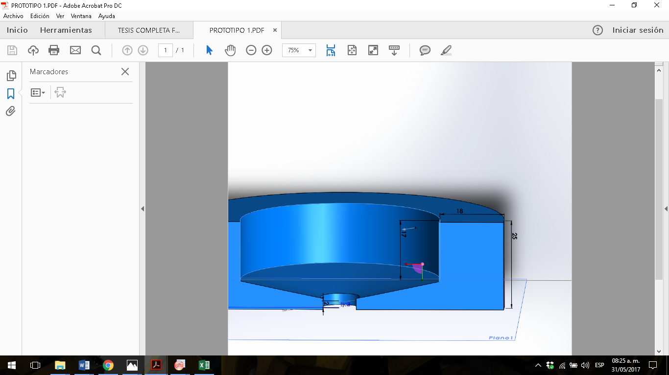  a) | 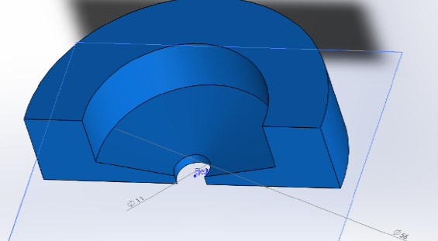  b)
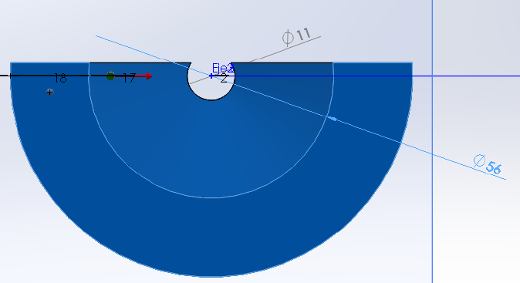  c) | 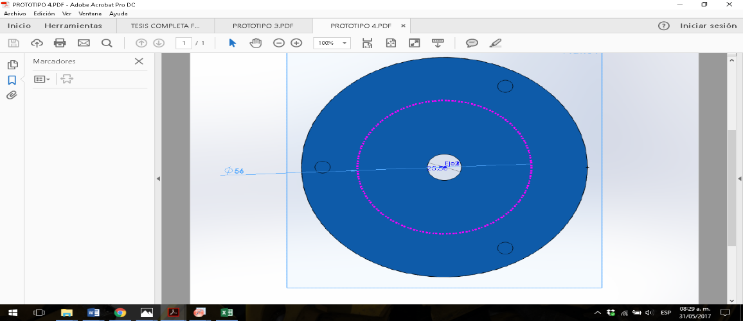  d)
Figure 1. Electrochemical cell design, a) three-dimensional view, b) top profile of the electrochemical cell design. c) top profile view of the electrochemical cell design and d) bottom profile view of the electrochemical cell design.

Manufacturing
Following the design phase, digital simulation, and optimization of the isometric configuration, the selected prototype was fabricated using conventional machining techniques, including lathe turning and milling operations. The manufacturing sequence is depicted in Fig. 2.
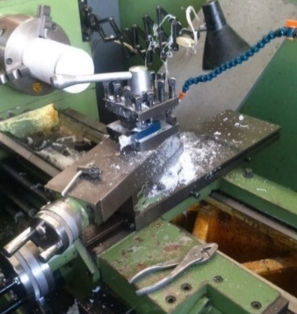  a) | 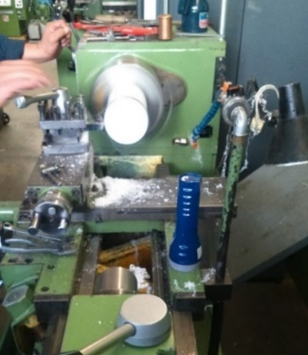  b)
Figure 2. Fabrication of the electrochemical cell, a) profile view and b) front view.

- Results and Discusión

An additional enhancement to the anodization protocol involved the implementation of concentric O-rings, which enabled precise confinement of the electrochemical reaction zones on the silicon surface. This configuration allowed for controlled anodization over defined areas, facilitating electrochemical patterning at variable scales according to experimental requirements.
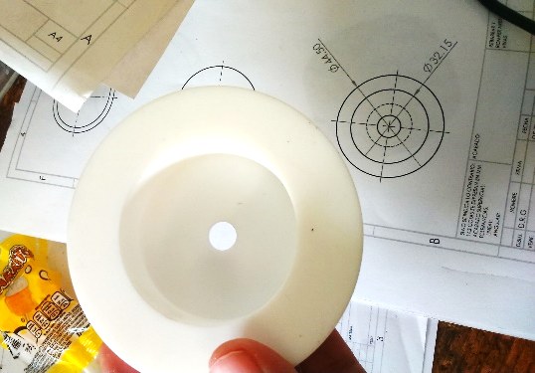  a) |   b)
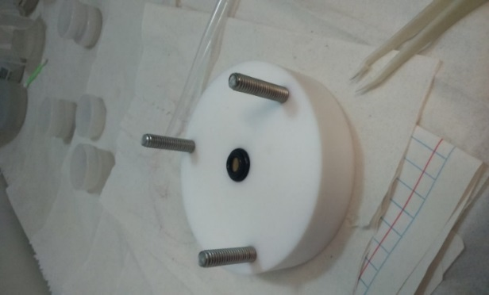  c) | 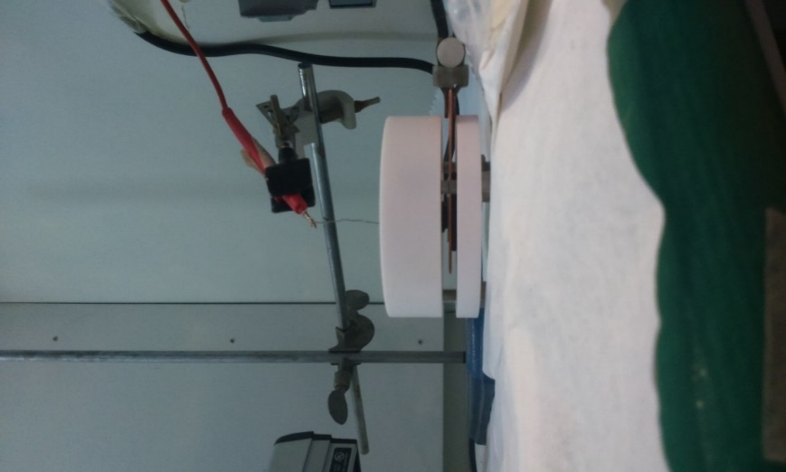  d)
Figure 3. a) top and bottom part after lathe work, b) finished model, c) electrochemical cell top and concentric O-ring and d) finished and assembled electrochemical cell.

Electrochemical cell in operation
To validate the functionality of the electrochemical cell, a system was assembled using crystalline silicon as the anode and a platinum wire as the cathode. The current was supplied by a Keithley 2400 source and regulated via LabVIEW software (Fig. 4). The flow of current through the HF:ethanol electrolyte confirmed successful anodization of the silicon surface, resulting in the formation of Porous Silicon (PS). This procedure served to verify the integrity of the cell's sealing, its chemical resistance to HF, and its electrical compatibility for the synthesis of nanostructured materials, specifically PS in this instance.
Figure 4. Electrochemical anodizing system.

The procedure was identically applied to both p-type and n-type silicon wafers, with the primary distinction being the utilization of a UV lamp in lieu of direct solar illumination. This protocol was systematically repeated across various silicon substrates to evaluate their functional response under consistent processing conditions (see Fig. 5).
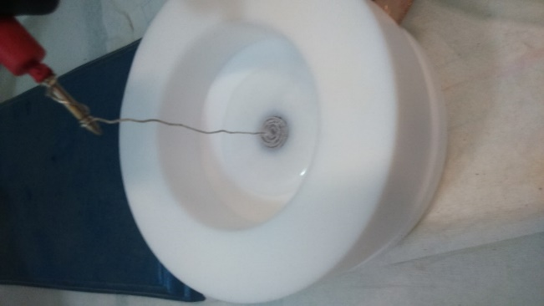  a) | 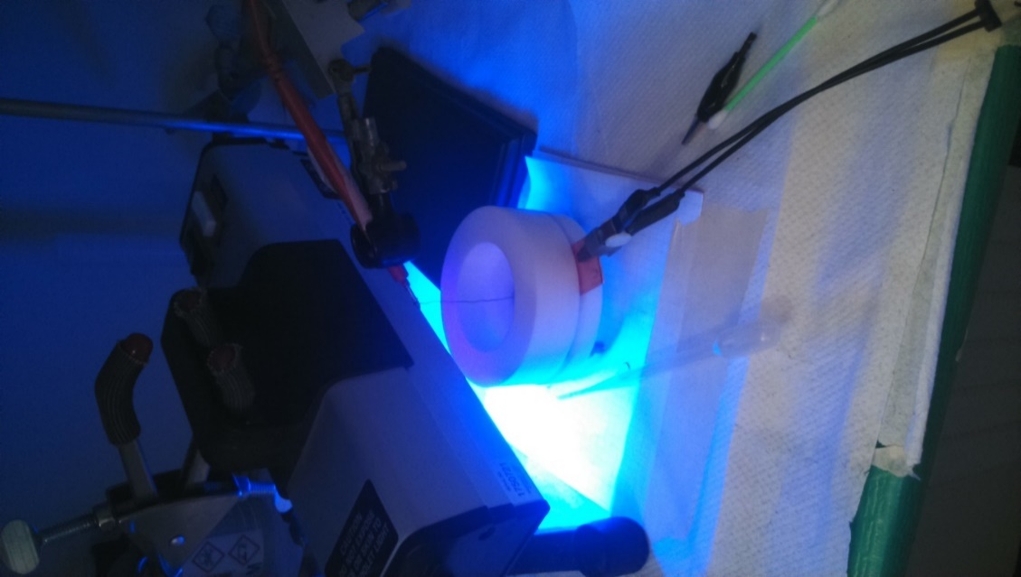  b)
Figure 5. Electrochemical cell anodizing a) p-type silicon and b) n-type silicon.

Attack speed
To perform the anodizing tests with a higher control, crystalline silicon type P (doped with Boron), resistivity 0.01-0.02 Ωm, orientation (100), using a solution of HF and Ethanol (3:7), both sides polished.
In this way the attack speed is of utmost importance, because thanks to this we can determine the thickness d (table 1) of the porous silicon thin film created with certain conditions or parameters already known. This is the speed with which the electrochemical anodizing advances through the crystalline silicon. Then, the attack velocity equation is:
$V=\frac{d}{t}$ (1)
Table 1. Calculation of thicknesses according to the current and mass of each sample, with constant time and electrochemical solution.

 |  |  | Thickness
Current (mA) | m1  (gr) | m3  (gr) | cm | nm
1 | 0.2961 | 0.2956 | 0.000143123 | 1431.229426
5 | 0.3707 | 0.3693 | 0.000400744 | 4007.442393
10 | 0.4145 | 0.4124 | 0.000601116 | 6011.16359
20 | 0.406 | 0.4028 | 0.000915987 | 9159.868327
30 | 0.3948 | 0.3897 | 0.001459854 | 14598.54015
40 | 0.3689 | 0.3628 | 0.0017461 | 17460.999
50 | 0.4244 | 0.4166 | 0.002232718 | 22327.17905

Images of porous silicon
Figure 6 shows the porous silicon samples resulting from the electrochemical cell and the anodizing of the crystalline silicon, thus demonstrating the efficiency of the prototype and the concentric Orings for electrochemical etching.
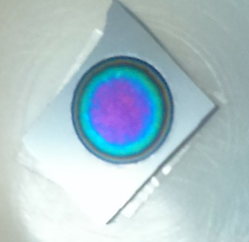  a) | 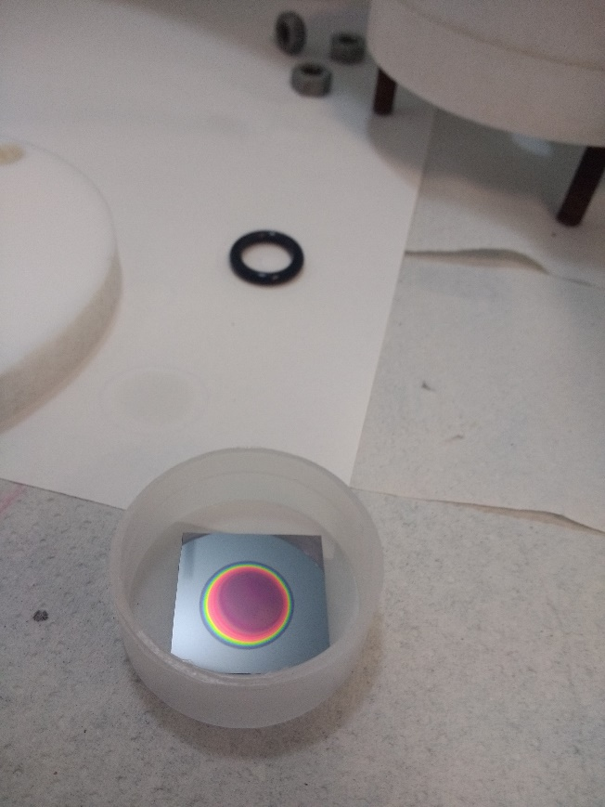  b)
Figure 6. Porous silicon multilayers a) n-type and b) p-type porous silicon.
Posterior a este experimento se realizaron 25 anodizados más donde se observó que no ha tenido desgaste la celda electroquímica y el sistema de anodizado sigue funcionando de manera correcta, por tal motivo se comprueba el funcionamiento del sistema de anodizado.

Different electrochemical cells were analyzed to produce Table 2, which shows the results of the analysis.
Table 2. Comparative table of the different types of electrochemical cells
Cell Type | Typical Materials | Advantages | Limitations | Main Applications | References
Glass Cell | Glass, silicone gaskets | - Low cost  - Transparency for spectroelectrochemistry | - Fragile  - Reactivity with HF or alkalis | Electroanalysis, corrosion studies | [2,5]
PTFE (Teflon) Cell | PTFE, Viton® seals | - Extreme chemical resistance  - Leak-proof | - High cost  - Difficult machining | Electrosynthesis, acidic/alkaline media | This work, and [3,4]
Stainless Steel Cell | AISI 316, EPDM gaskets | - Robustness  - High pressure/temperature resistance | - Corrosion in halides  - Magnetic interference | Fuel cells, industrial electrolysis | [7]
Flow Cell | Graphite, polymers (PEEK) | - High performance  - Flow control | - Complexity  - Risk of clogging | Redox batteries, continuous synthesis | [8,9]
Microfluidic Cell | PDMS, glass/chemicals | - Miniaturization  - Low sample volume | - Leak sensitivity  - Limited scalability | Biosensors, lab-on-a-chip systems | [10,11]

In terms of chemical resistance, PTFE (Teflon) electrochemical cells exhibit outstanding stability in highly corrosive environments, including concentrated acids, alkalis, and organic solvents [3,4]. Despite their superior performance, their elevated cost and machining complexity present significant limitations for laboratories operating under financial constraints. Glass cells, while economically accessible and widely employed in electroanalytical applications, are inherently fragile and susceptible to degradation in the presence of hydrofluoric acid or concentrated alkaline solutions, thereby limiting their versatility [2,5]. Conversely, stainless steel cells (AISI 316) are well-suited for high-pressure, high-temperature industrial applications—such as alkaline electrolysis and fuel cell systems [7]. However, their vulnerability to chloride-induced corrosion and the potential for magnetic interference in sensitive electrochemical techniques (e.g., voltammetry) render them less suitable for fundamental and precision research.
Continuous flow electrochemical cells, commonly fabricated from materials such as graphite or polyether ether ketone (PEEK), present significant advantages for scalable applications, including redox flow batteries and organic electrosynthesis [8,9]. These systems enable enhanced mass transport and process control; however, their implementation is often constrained by operational complexity, necessitating auxiliary components such as pumps and flow sensors. Furthermore, their propensity for clogging in particulate-laden media limits their practicality in laboratories lacking dedicated fluid handling infrastructure.
Microfluidic electrochemical cells, typically composed of PDMS and glass substrates, represent a notable advancement in system miniaturization, facilitating analytical procedures with minimal reagent and sample volumes [5]. Their integration into biosensing platforms and lab-on-a-chip technologies has been extensively demonstrated [11]. Nonetheless, limitations persist, particularly concerning scalability and long-term operational stability. Issues such as fluid leakage, material degradation, and contamination over extended durations may adversely affect reproducibility and hinder their application in continuous or high-throughput processes.
- Conclusions
A prototype electrochemical cell exhibiting high resistance to both acidic and alkaline media was developed and validated for functional performance. The incorporation of concentric O-ring seals enabled spatially confined electrochemical processing, facilitating localized surface modification across various geometries. This design demonstrated high efficiency, reproducibility, and repeatability—essential metrics for both fundamental investigations and applied electrochemical research. For industrial-scale processes, stainless steel and continuous flow systems offer mechanical robustness and scalability, while microfluidic platforms continue to dominate in high-sensitivity analytical applications. An emerging research direction involves the synthesis of hybrid PTFE/graphene composites, which may offer enhanced electrical conductivity and chemical resistance while mitigating cost. Additionally, the development of modular architectures with interchangeable components tailored to specific reactive environments may further optimize system versatility.
In the long term, advances in materials science may enable the fabrication of electrochemical cells that combine extreme chemical resistance with optical transparency, thus enabling real-time, in situ analysis of light-sensitive materials such as Bragg reflectors and optical filters.
References
[1]. Awasthi S, Pandey SK, Pandey CP, Balani K. Progress in Electrochemical and Electrophoretic Deposition of Nickel with Carbonaceous Allotropes: A Review. Adv Mater Interfaces 2020;7. https://doi.org/10.1002/admi.201901096.
[2]. Compton, R. G., Kätelhön, E., Ward, K. R., & Laborda, E. (2020). Understanding Voltammetry: Simulation of Electrode Processes (2nd ed.). World Scientific Publishing. https://www.worldscientific.com/worldscibooks/10.1142/q0471
[3]. Drobny, J. G., & Ebnesajjad, S. (2023). Technology of Fluoropolymers: A Concise Handbook (3rd ed.). CRC Press.
[4]. Oh H, Kim GS, Hwang BU, Bang J, Kim J, Jeong KM. Development of a feasible and scalable manufacturing method for PTFE-based solvent-free lithium-ion battery electrodes. Chemical Engineering Journal 2024;491. https://doi.org/10.1016/j.cej.2024.151957.
[5]. Zhang H, Liu Y, Wang X, Feng K, Wang Q, Chen Z, et al. Research Progress in Ionic Liquid-Based Electrolytes for Electrochromic Devices. Molecules 2025;30:973. https://doi.org/10.3390/molecules30040973.
[6]. Raveendran, A., Chandran, M., & Dhanusuraman, R. (2023). A comprehensive review on the electrochemical parameters and recent material development of electrochemical water splitting electrocatalysts. RSC Advances, 13(6), 3843–3876. https://doi.org/10.1039/D2RA07642J.
[7]. Elsherbini M, Wirth T. Electroorganic Synthesis under Flow Conditions. Acc Chem Res 2019;52:3287–96. https://doi.org/10.1021/acs.accounts.9b00497.
[8]. International Journal of Hydrogen Energy, Volume 50, Issue 20, 2025, Pages 15000-15015.
https://doi.org/10.1016/j.ijhydene.2025.01.123
[9]. Cabana J, Alaan T, Crabtree GW, Huang PW, Jain A, Murphy M, et al. NGenE 2022: Electrochemistry for Decarbonization. ACS Energy Lett 2023;8:740–7. https://doi.org/10.1021/acsenergylett.2c02587.
[10]. Fan, Z. H., & Harrison, D. J. (2023). Celebrating the 30th Anniversary of a Pioneering Microfluidics Paper. Lab on a Chip, 23(17), 3737–3740.
[11]. Matreux, T., Mast, C. B., & Braun, D. (2023). Heat flows enrich prebiotic building blocks and enhance their reactivity. Nature, 615(7953), 290–296. https://doi.org/10.1038/s41586-024-07193-7

